**NASA DEVELOP National Program**



USGS at Colorado State University – Fort Collins, CO

*Spring 2016*

Gunnison National Forest Agriculture

Mapping Spruce Beetle Outbreak Severity and Distribution in Gunnison National Forest Using Landsat and Integrative Spatial Modelling

 **Technical Report**

Rough Draft – Feb 18, 2016

Eric Rounds (Project Lead)

Sarah Carroll

Oliver Miltenberger

Peder Engelstad

Dr. Paul Evangelista, Natural Resource Ecology Laboratory (Science Advisor)

Tony Vorster, Bioenergy Alliance Network of the Rockies (Mentor)

Brian Woodward, DEVELOP - Fort Collins Center Lead

# I. Abstract

[Placeholder - do not put anything here until the final draft submission. The abstract in the project summary is where the working draft of the abstract should “live”]

**Keywords**

Spruce Beetle, Landsat, NAIP, Remote Sensing, Tree Mortality, Support Vector Machine, Random Forest

# II. Introduction

Spruce beetle (*Dendroctonus rufipennis*) infestations have proliferated in the American west affecting nearly 1.4 million acres of forest since 1996 (Ciesla 2014). These outbreaks are occurring in increasing frequency and severity, causing widespread spruce mortality. This increase in spruce mortality may result in less favorable habitat for native wildlife (Klenner & Arsenault 2009), increased wildfire risk (Jenkins et al. 2008), and increased hazards for visitors of national forests. Identifying the extent and location of the ongoing outbreak in Colorado forests is a high priority for land managers.

Current United States Forest Service (USFS) Gunnison District management of spruce beetle killed trees relies on rough, non-analytic estimates from annual aerial surveys. Due to constraints of this qualitative survey method and a low number of ground truth plots, these surveys produce low accuracy, low resolution maps, particularly so for spruce beetle caused mortality (Johnson et al. 2006). Additionally, there is a conspicuous gap in analysis of spruce beetle outbreaks as the majority of previous studies and surveys have focused on pine bark beetles. Those studies that have focused on spruce beetle outbreak have yet to determine a highly accurate and broadly applicable method for mapping the spread of spruce beetle (DeRose et al. 2011, Hart & Veblen 2015, Meddens et al. 2013).

As a part of the Agriculture category of the DEVELOP National Application Area, this project aims to fill and improve the knowledge gap in spruce beetle outbreak research and provide forest management professionals with the tools and information necessary to make adaptive and efficient management decisions. To accomplish this, the study utilizes NASA Landsat 8 (OLI & TIRS) and Landsat 5 (TM) imagery with ancillary datasets as inputs into an integrative spatial model to produce comprehensive, fine-scale maps of spruce mortality across southwestern Colorado for 2006-2013 and 2015. The resulting maps display the percent cover represented by dead spruce at 30-meter resolution.

Project end-users at the USFS Gunnison District will utilize this data to prioritize and plan dead tree removal operations and resiliency treatments to unaffected stands. End-users at the Gunnison NF District will use these maps and associated data products to inform ongoing studies of movement and habitat ecology for the federally threatened Canadian lynx *(Lynx canadensis)*. Project partner Bioenergy Alliance Network of the Rockies (BANR) is assessing the feasibility of using beetle-kill wood as a feedstock for biofuels. Detailed maps of spruce mortality will be used by BANR to locate potential feedstock supply areas, and the results of this project would contribute a new geographical region and tree species to their ongoing research. Overall, the multi-date comprehensive map products produced by the project will be instrumental to future spruce beetle studies aiming to investigate outbreak causes and understand mechanisms of spread in Colorado forests.

The study area stretches across eighteen counties, seven national forests, and private lands to produce a spatially continuous map of tree mortality for the southwest region of Colorado (figure 1). The study is focused on spruce-fir communities dominated by Englemann Spruce (*Picea engelmannii*), Douglas fir (*Pseudotsuga menziesii),* and subalpine fir (*Abies lasiocarpa)* in the Sawatch and San Juan mountain ranges (Wiken et al., 2011). We selected imagery captured during the summer through early fall months (June 20th-October 9th) to maximize sun cover and minimize cloud and snow cover. This time frame was utilized for the years 2006, 2013, and 2015 to increase the utility of our results by including temporal variation.

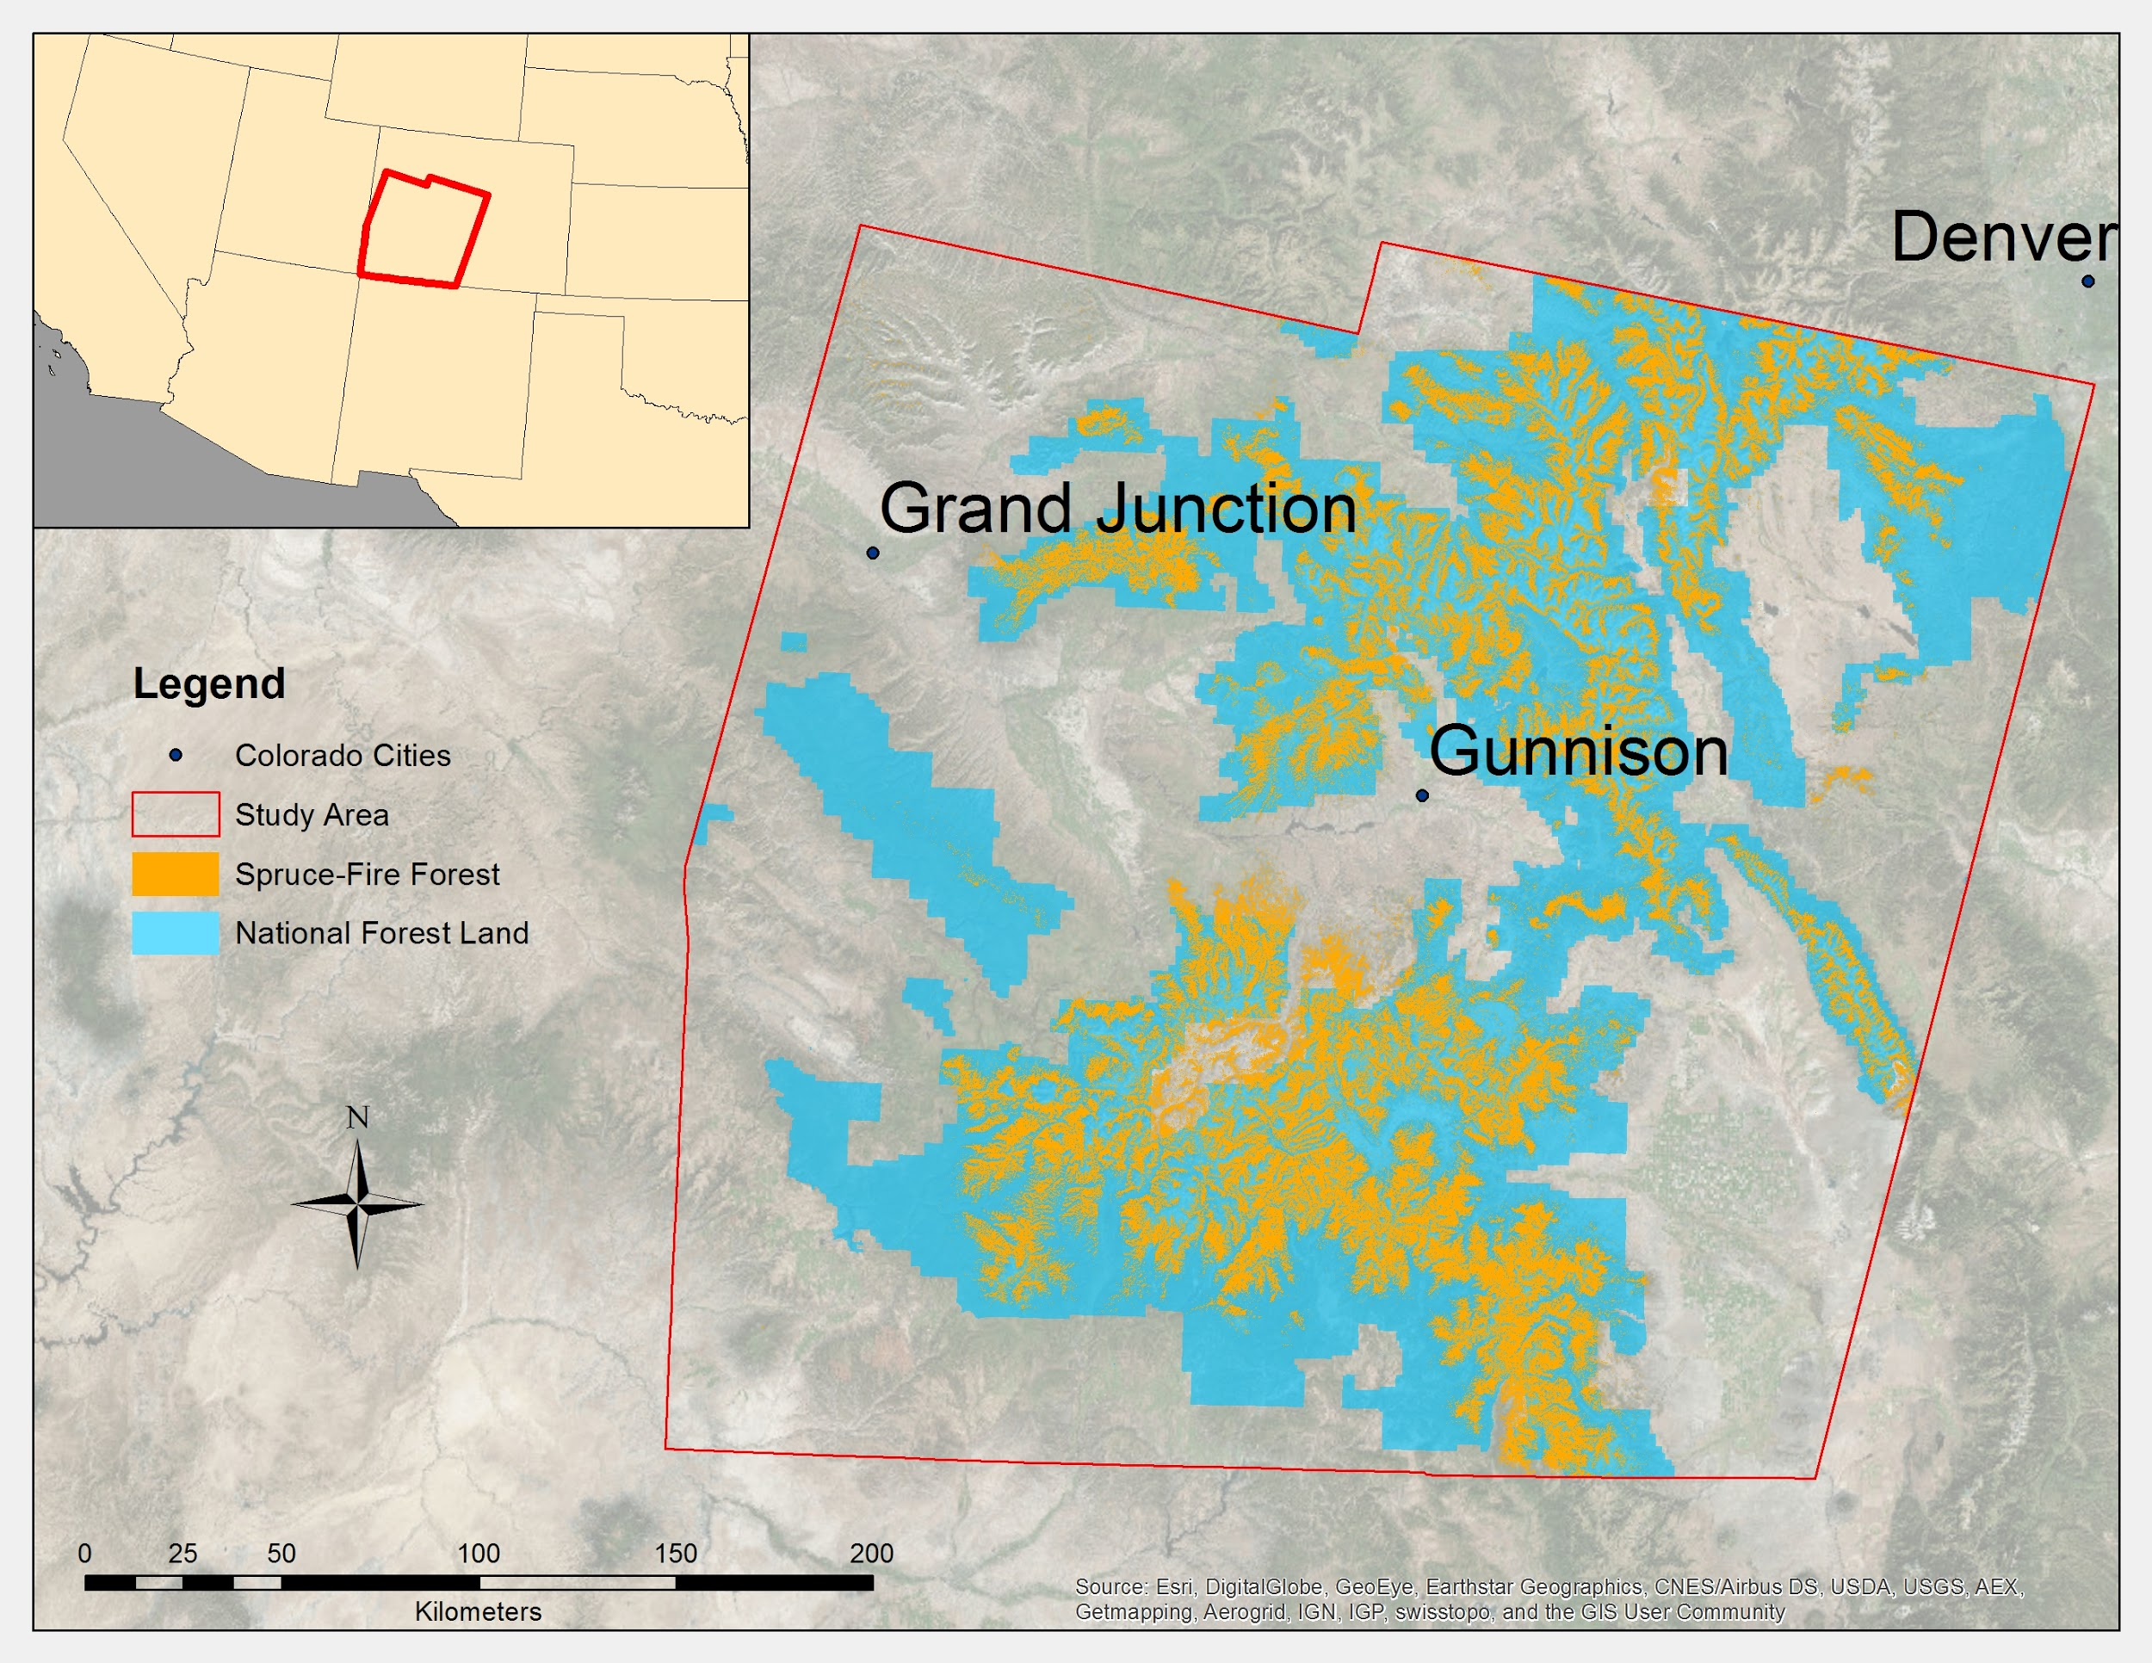

*Figure1. Study area in southwest Colorado*

# III. Methodology

**Data Acquisition**

Landsat 8 (OLI & TIRS) and Landsat 5 (TM) imagery was downloaded from the USGS Earth Resources Observation and Science (EROS) Center Science Processing Architecture (ESPA) on demand interface (USGS, 2016). We downloaded twelve Landsat Surface Reflectance Higher Level Image Products from 2006, 2013, and 2015 for scenes (path/row) 34/33, 34/34, 35/33, and 35/34. In addition to all bands, these products were ordered to include NDVI (Normalized Difference Vegetation Index) and NDMI (Normalized Difference Moisture Index). Shuttle Radar Topography Mission (SRTM) data was also downloaded from USGS Earth Explorer, providing the team with a 30-meter, one-arc second digital elevation model (DEM) of the study area. NAIP imagery was ordered from the USDA’s Aerial Photography Field Office. The most recently available existing vegetation type cover data was downloaded from the USGS LANDFIRE program website (USGS, 2015). All data was projected in WGS 1984 UTM Zone 13N.

**Data Pre-processing**

To capture the reference data necessary to train the zero-inflated model, we constructed an overlay grid in ArcMap. To accomplish this, we used the extract by mask tool to select areas in southern Colorado identified as Spruce-Fir by LANDFIRE’s “Existing Vegetative Type” data. In order to reduce the size of the raster file and eliminate island pixels that were too small to be considered a forest stand, we identified contiguous cell clusters greater than 8 pixels in total (Region Group tool). Within this refined raster, we randomly and evenly assign 2000 sampling points (Create Spatially Balanced Points tool). These points were then assigned XY coordinates (Add XY Coordinates tool).

Because the Zero-Inflated Model relies on averaged spectral values from Landsat raster pixels, we extracted cells of the same size (30m2) wherever our sampling points fell (Extract by Point tool) and then converted the extracted cells into polygons (Raster to Polygon tool). These polygons were used as a mask to extract a 10 x 10 grid of cells from a random raster (Create Random Raster, Extract by Mask tools). The extracted grid cells were then converted to points (Raster to Point tool), creating a unified sampling position in the center of each 10 x 10 cell. This process created and visualized 100 evenly spaced sampling points within each Landsat-equivalent, 30m2 cell.

By layering this 10 x 10 grid over our 1 meter resolution NAIP imagery, the team visually inspected all points to determine percentage average mortality for each sampling unit (30 meter cell). Points were collaboratively classified until the results were consistent between team members. Each of the 100 points in the 10x10 grid were classified as either [0] Dead Tree, [1] Living Tree, [2] Living Non-Tree, or [3] Other (including red phase, shadow, rock, and bare ground).

https://ssl.gstatic.com/ui/v1/icons/mail/images/cleardot.gif

To prepare imagery for model input several pre-processing steps were completed. Because all twelve Landsat images were not temporally homogenous, it was necessary to process each scene independently. In addition to the indices included in the Landsat data, four other indices were derived from Landsat bands using the Raster Calculator tool and the Landsat Processing toolbox in ArcMap. The Tasseled Cap (TC) transformation was calculated to obtain greenness (TCG), brightness (TCB), and wetness (TCW). From these three indices a Disturbance Index (DI) was calculated (DI= TCB- TCG -TCW) using the Raster Calculator in ArcMap. These indices were chosen for their utility in characterizing the target spectral responses based on previous remote sensing of vegetation and bark beetle mapping studies (DeRose et al. 2011, Hart & Veblen 2015, Healy et al. 2005, Meddens et al. 2013). However, we created an additional set of indices using raster calculator to subtract 2013 indices from corresponding 2006 indices. This produced rasters that capture any spectral change within pixels from the years 2006-2013. We chose to use imagery from 2006 because the outbreak was significantly less extensive at this time in the study area, and so it provided a logical baseline for change detection. Lastly, we generated slope and aspect rasters from a 30-meter one-arc second DEM.

After all raster layers were generated they were stacked as a single image composite in ArcMap. The 2015 stack (Table 1, Appendix) is composed of Landsat bands, vegetation indices, slope, aspect, and elevation rasters. The 2013 stack (Table 2, Appendix), however, contains the said rasters as well as the 2013/2006 differenced rasters. When the final stacks were completed they were clipped to the spruce-fir forest study area extent using the Extract by Mask tool in ArcGIS and saved to the ERDAS Imagine (.img) file format. Finally, a point shapefile containing the pixel locations of the corresponding reference data was used to extract the spectral values from each band in the stack composite using the Extract Multi Values to Points tool in ArcMap. Before running the model, these spectral values were organized to relate them to their corresponding value of tree mortality to create the final data input file. This process was repeated for each scene independently for both the 2013 and 2015 image composites resulting in a total of 8 final data input files.

**Zero-Inflated Model**

The stacked image composite and the final input data file were run through a two-step Zero-Inflated Model developed by Savage et al. (2015) in RStudio. This modeling process minimizes the errors that often accompany data containing many zeros; such as forest cover type data (Savage et al. 2015). Step one involves the input of all reference data into a Random Forest model, resulting in a binary (BIN) map of mortality presence (1) or absence (0) for each pixel. For step two, all non-zero (species present) data was used in a Support Vector Machine (SVM), creating a continuous (i.e. percent mortality at the pixel level) (CON) map of mortality distribution in the study area. The two associated maps (BIN & CON) for each species are then combined to only include the continuous output data where the binary map is (1). Any pixel marked as (0) will include no data. The result is a map displaying the percent mortality value for each pixel (30m resolution) in the study area.

# IV. Results & Discussion

Final Maps coming soon...

**Errors & Uncertainty**

It was difficult to find twelve cloud free, snow free scenes for the study area, let alone find such images that had also been captured on the exact same date. For this reason the imagery used ranged from June-October for all years, and for one scene the best available image within the desired time frame was from the summer of 2014. This image was included in the 2013 composite. Because the images are not temporally homogenous, there is the possibility that the indices used to generate our results could be significantly different between scenes. For example, moisture indices (NDMI) will vary between scenes with snow cover and those without.

**Future Work**

Hart and Veblen (2015) suggest that recently infested spruce trees may be identifiable by a unique spectral signature. Future studies could compare year by year imagery to differentiate spruce life-stage signatures, further clarifying the gradient of spruce stand vulnerability. Additionally, our end products could be combined with additional datasets from other drivers of spruce beetle population dynamics such as woodpeckers (Fayt, Machmer & Steeger 2005) or fire history (Kulakowski et al 2003). These studies could be utilized by land managers to adopt more proactive strategies to anticipate and combat future beetle outbreaks.

# V. Conclusions

Coming Soon

# VI. Acknowledgments

This project was made possible through support and mentorship of select individuals and organizations. We extend a kind thanks to the following:

* Dr. Paul Evangelista, Colorado State University, Natural Resource Ecology Laboratory
* Tony Vorster, CSU, NREL, Bioenergy Alliance Network of the Rockies
* Brian Woodward, NASA DEVELOP- Fort Collins Center Lead
* Shannon Savage, Spatial Sciences Center of Montana State University

Any opinions, findings, and conclusions or recommendations expressed in this material are those of the author(s) and do not necessarily reflect the views of the National Aeronautics and Space Administration.

This material is based upon work supported by NASA through contract NNL11AA00B and cooperative agreement NNX14AB60A.

# VII. References

Ciesla, William M. “2014 Report on the Health of Colorado’s Forests.” Colorado State

Forest Service: Fort Collins, CO (2014).

DeRose,Justin R., James N. Long, and R. Douglas Ramsey. “Combining dendrochronological data and the disturbance index to assess Engelmann spruce mortality caused by a spruce beetle outbreak in southern Utah, USA.” *Remote Sensing of Environment* 115.9 (2011):2342-2349.

Fayt, Philippe, Marlene M. Machmer, and Christoph Steeger. "Regulation of spruce bark

beetles by woodpeckers—a literature review." *Forest Ecology and Management* 206.1 (2005): 1-14.

Hart, Sarah J., and Thomas T. Veblen. "Detection of spruce beetle-induced tree

mortality using high-and medium-resolution remotely sensed imagery." *Remote Sensing of Environment* 168 (2015): 134-145.

Healey, Sean .P, Warren B. Cohena, Yang Zhiqiangb, Olga N. Krankinab. “Comparison of Tasseled Cap-based Landsat data structures for use in forest disturbance detection.” *Remote Sensing of Environment* 97.3 (2005): 301-310.

Jenkins, Michael J.,Wesley Page, Elizabeth Hebertson, and C. Arik Jorgensen. "Bark beetles, fuels, fires and implications for forest management in the Intermountain West." *Forest Ecology and Management* 254.1 (2008): 16-34.

Johnson, E. W., and J. Ross. *USDA Forest Service Rocky Mountain Region Forest Health*

*Aerial Survey Accuracy Assessment 2005 Report*. Technical Report R2-06-08, 2006.

Klenner, Walt, and André Arsenault. "Ponderosa pine mortality during a severe bark

beetle (Coleoptera: Curculionidae, Scolytinae) outbreak in southern British Columbia and implications for wildlife habitat management." *Forest ecology and management* 258 (2009): S5-S14.

Kulakowski, Dominik, Thomas T. Veblen, and Peter Bebi. "Effects of fire and spruce

beetle outbreak legacies on the disturbance regime of a subalpine forest in Colorado." *Journal of Biogeography* 30.9 (2003): 1445-1456.

Meddens, Arjan JH, et al. "Evaluating methods to detect bark beetle-caused tree mortality using single-date and multi-date Landsat imagery." *Remote Sensing of Environment* 132 (2013): 49-58.

USGS. (2016). “LSDS Science Research and Development (LSRD).” US Department of the Interior, Geological Survey, May 2010. 16 February 2016. <http://espa.cr.usgs.gov/>.

USGS. (2015). “LANDFIRE: land fire existing vegetation type cover”. US Department of the Interior, Geological Survey, January 2015. 26 January 2016. http://www.landfire.gov/

Savage, Shannon L., Rick L. Lawrence, and John R. Squires. "Predicting relative species

composition within mixed conifer forest pixels using zero-inflated models and Landsat imagery." *Remote Sensing of Environment* 171 (2015): 326-336.

Wiken, E., F. J. Nava, and G. Griffith. "North American Terrestrial Ecoregions–Level III.”

*Commission for Environmental Cooperation, Montreal, Canada*." (2011): 88-92.

# VIII. Content Innovation

**Glossary Terms:**

**Composite Band –** A data management tool in ArcMap that creates a single raster stack from a selection of multiple bands.

**Create Random Raster-** A data management tool in ArcMap that creates a raster dataset of random values within defined parameters.

**Extract Multi Values to Points-** A spatial analyst tool in ArcMap that extracts cell values at locations identified by a point feature class and records those values in the attribute table of the point feature class.

**Landsat –** Started in the 70s, Landsat is a joint USDA and NASA program that provides multi-spectral moderate resolution (30m) satellite imagery for the whole globe.

**National Agriculture Imagery Program (NAIP) –** A USDA program that began in 2003 that gathers 1-meter resolution aerial imagery of the continental US during the agricultural growing season every 2-3 years.

**Raster Calculator –** A spatial analyst tool that is used to perform Map Algebra calculations on raster pixel values.

**Raster to Point-** A conversion tool in ArcMap that converts a raster dataset to point features.

**Support Vector Machine (SVM) –** A classification and regression analysis method that utilizes learning algorithms to interpret data.

**Shuttle Radar Topography Mission (SRTM) –** This is a joint project between the NGA and NASA that gathered topographic digital elevation data for the majority of the globe at 30-meter resolution.

**Zero-Inflated –** A method used to model data that has a high number of zero values, or absence data, in order to reduce or remove the bias effects of zero heavy data in presence and absence data.

Planning to make map products available on ArcGIS Online.

# IV. Appendices

|  |  |
| --- | --- |
| **2015** Image Stack Band Number | Landsat (year-band or derived index)/ Raster Data Source |
| 1 | Landsat 8 2015 Blue |
| 2 | Landsat 8 2015 Green |
| 3 | Landsat 8 2015 Red |
| 4 | Landsat 8 2015 NIR |
| 5 | Landsat 8 2015 SWIR1 |
| 6 | Landsat 8 2015 SWIR2 |
| 7 | Landsat 8 2015 TIRS 1 |
| 8 | Landsat 8 2015 TIRS 2 |
| 9 | Landsat 8 2015 NDVI |
| 10 | Landsat 8 2015 NDMI |
| 11 | Landsat 8 2015 TCWET |
| 12 | Landsat 8 2015 TCGRE |
| 13 | Landsat 8 2015 TCBRI |
| 14 | Landsat 8 2015 DI |
| 15 | DEM, 30-meter (SRTM) |
| 16 | Slope |
| 17 | Aspect |

Table 1. *A 17-band composite image used for model input.*

|  |  |
| --- | --- |
| **2013** Image Stack Band Number | Landsat (year-band or derived index)/ Raster Data Source |
| 1 | Landsat 8 2013 Blue |
| 2 | Landsat 8 2013 Green |
| 3 | Landsat 8 2013 Red |
| 4 | Landsat 8 2013 NIR |
| 5 | Landsat 8 2013 SWIR1 |
| 6 | Landsat 8 2013 SWIR2 |
| 7 | Landsat 8 2013 TIRS 1 |
| 8 | Landsat 8 2013 TIRS 2 |
| 9 | Landsat 8 2013 NDVI |
| 10 | Landsat 8 2013 NDMI |
| 11 | Landsat 8 2013 TCWET |
| 12 | Landsat 8 2013 TCGRE |
| 13 | Landsat 8 2013 TCBRI |
| 14 | Landsat 8 2013 DI |
| 15 | (Landsat 8 2013 Blue) - (Landsat 5 2006 Blue) |
| 16 | (Landsat 8 2013 Green) - (Landsat 5 2006 Green) |
| 17 | (Landsat 8 2013 Red) - (Landsat 5 2006 Red) |
| 18 | (Landsat 8 2013NIR) - (Landsat 5 2006 NIR) |
| 19 | (Landsat 8 2013 SWIR1) - (Landsat 5 2006 SWR1) |
| 20 | (Landsat 8 2013 SWIR 2) - (Landsat 5 2006 SWIR2) |
| 21 | (Landsat 8 2013 TIRS1) - (Landsat 5 2006 TIR) |
| 22 | DEM, 30-meter (SRTM) |
| 23 | Slope |
| 24 | Aspect |

Table 2. *A 24- band image composite used for model input*