Tennessee Valley Energy
Assessing the Hydrothermal Outputs of Nuclear Power Plants Along the Tennessee River with NASA Earth Observations


Technical Report
Final Draft – November 22nd, 2019

Lisa Dong (Project Lead)
Jessica Ding
Rachel Smith
Samuel Tatum

Dr. Jeffrey Luvall, NASA Marshall Space Flight Center (Science Advisor)
Dr. Robert Griffin, The University of Alabama in Huntsville (Science Advisor)

1. Abstract
Aquatic ecosystems are susceptible to biodiversity loss due to increased water temperatures, which can select for heat-tolerant species and lead to a loss of locally adapted species that have a narrow temperature range. Regulations concerning heated effluent from nuclear power plants are administered by the EPA in order to avoid damage to surrounding ecosystems. This project utilized thermal infrared data from NASA’s Earth observations along the Tennessee River to help improve river temperature predictive models used by the Tennessee Valley Authority’s Browns Ferry Nuclear Plant. To do this, the team highlighted spatial and temporal variation in river surface temperature as a result of seasonal change, flow rate, ambient air temperature, and plant power output. Results from the BFNP study area indicated that from 2013 to 2018, the change in water temperature between upstream and downstream locations (ΔT) increased by 3.546°F (p<0.01). ΔT decreased by 2.22°F (p<0.01) from 2018 to 2019. However, it is unclear if this variation can be attributed to the BFNP expansion. The results also demonstrated that river flow rate had the greatest impact on ΔT (p<0.001), while air temperature and power output did not significantly affect ΔT. These visualizations provided a new perspective on the behavior of thermal effluent at different locations along the Tennessee River, at different flow rates, and after the BFNP power upgrade.
Keywords
thermal remote sensing, ECOSTRESS, ASTER, Landsat 8, freshwater surface temperature, nuclear power

2. Introduction
  - Background Information
The thermoelectric power sector is a source of freshwater thermal pollution. Nuclear power plants stationed along rivers utilize water to dissipate waste heat using two types of cooling systems–once-through and recirculating (Logan & Stillwell, 2018). Once-through cooling systems work by taking in water from adjacent water bodies, cycling the water through the plant once, then discharging it back into the source. Recirculating cooling systems reuse water by circulating it through a closed loop, which results in less water consumption. Thermal effluent from once-through cooling systems is typically 46-54°F higher than ambient water temperatures and can cause greater ecological damage compared to recirculating cooling systems due to the greater volume of water discharged (Madden, Lewis, & Davis, 2013; Verones et al., 2010). Changes in the water temperature surrounding nuclear plants could result in a loss of locally adapted species, lead to changes in species distribution, and alter habitat ranges of aquatic organisms (Beitinger et al., 2017). A study found that the Tennessee River basin is especially vulnerable to species loss, due to its high level of aquatic biodiversity and the prevalence of once-through cooling systems (Madden et al., 2013).

Regulatory guidelines regarding the discharge of thermal effluent are stated in section 316(a) of the Clean Water Act (CWA). This law requires each point source to have a National Pollutant Discharge Elimination System (NPDES) permit, which is administered by state environmental agencies (Madden et al., 2013). The NPDES permit for the Browns Ferry Nuclear Plant (BFNP) limits thermal discharge as detected at a depth of 5 feet (ft), 2400 ft downstream of the discharge source (McGinty, 2007). This permit states that 1-hour average temperatures cannot exceed 93 °F, daily average temperatures cannot exceed 90 °F, and daily average temperature rise relative to ambient cannot exceed 10 °F (Tennessee Valley Authority, n.d.).
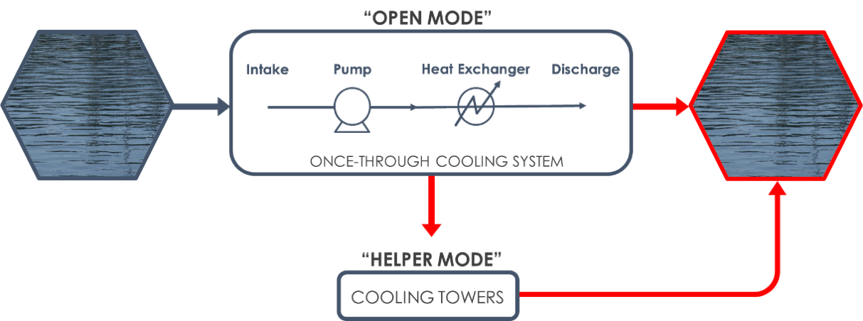
Figure 1. This diagram illustrates the operation modes employed by Browns Ferry Nuclear Plant to treat cooling water before discharge into Wheeler Reservoir (Art, 2014; Peters, 2018).
The BFNP draws water from the Tennessee River in its cooling systems, outlined in Figure 1 (McGinty, 2007). In “open mode,” water from the river is pumped into the turbine generator condensers, then discharged back into the river via three diffuser pipes. If the temperature of the water is within one degree of the NPDES hourly limit, “helper mode” is employed. The water is directed to the cooling towers to further cool the water before discharging it into the reservoir. If “helper mode” is insufficient to keep river temperature from reaching the NPDES limit, the Tennessee Valley Authority (TVA) reduces power output, or is forced to shut down one or more units in order to maintain compliance (McGinty, 2007).

Monitoring methods at BFNP involve taking in situ water temperatures from five thermistors (two upstream and three downstream), with readings taken every hour, averaged from depths of 3, 5, and 7 ft to account for thermal stratification. These instruments cannot capture the spatial variation in temperature across a large extent. Remote sensing provides a means of measuring the surface temperature of water using thermal infrared (TIR) radiative imaging which captures long wave thermal radiation ranging from 8 to 14 µm. Many studies have used satellite imagery to measure sea surface temperature (Anding & Kauth, 1970); however, river and stream surface temperature monitoring typically require higher imaging resolution due to spatial constraints. Handcock et al. (2006) found that spatial resolution needed to provide at least 3 pixels across a stream width to accurately measure surface temperatures. Furthermore, this pixel minimum only applies to well-mixed areas – increased thermal stratification makes it difficult to predict temperatures below the skin layer (Handcock et al. 2012).

2.2 Project Partners & Objectives
The Tennessee Valley Authority (TVA) is a federal corporation that manages the BFNP and supplies energy to two million homes in seven southeastern states (NRC, 2017). The BFNP completed an Extended Power Uprate (EPU) in September of 2019–this increased the power output of each unit to 120% of its originally licensed thermal power and was predicted to increase mean water temperatures in the Wheeler Reservoir (McGinty, 2007). The team utilized data from 2013-2019 to ascertain the impact of BFNP’s expansion on water surface temperature. The objectives for this project included the following: to evaluate seasonal changes in water surface temperature with time series visualizations, to evaluate the accuracy of NASA Earth observations (EO) thermal data collected over BFNP and Sequoyah Nuclear Plant (SNP), to assess the performance of the TVA’s Deflt3D model, and to guide the TVA through the methodologies used in this project by creating a tutorial. Finally, for public engagement purposes, the project was illustrated with an interactive ArcGIS story map. The results of this project provided further definition and coverage to current TVA monitoring methods by assessing the effects of seasonal variation, nuclear power plant location, and the BFNP expansion on water surface temperature. These tools helped aid the TVA in responsible effluent management and promoted ecologically-minded decision making.

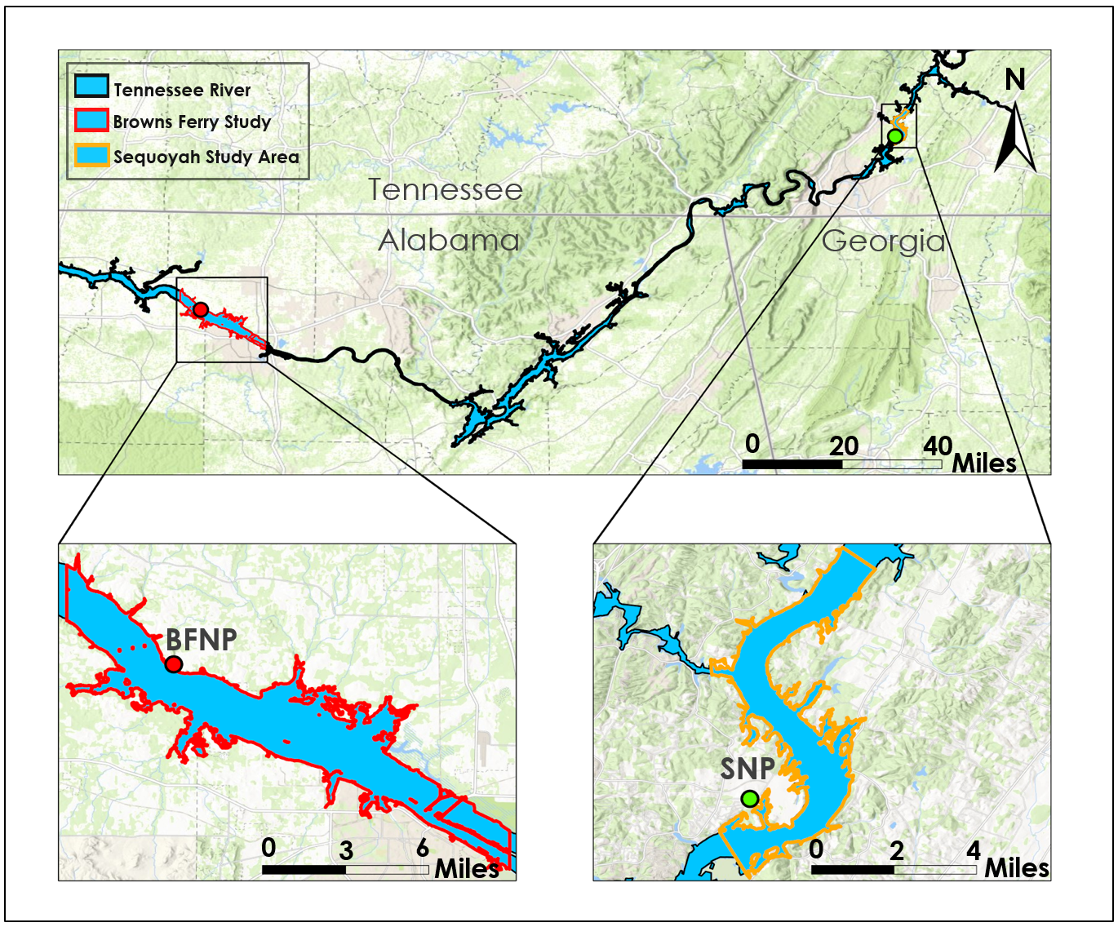
Figure 2. Study area for BFNP and SNP.

3. Methodology
3.1 Data Acquisition
Figure 2 portrays the Tennessee River from BFNP to SNP, as well as the extent of the two individual areas the team focused on for data extraction. After discussing the goals of this project with the TVA, the team clipped the BFNP study area extent to approximately 17 miles of the river. For SNP, the extent was 0.5 miles upstream and 1 mile downstream of the discharge zone. This extent included the three temperature stations at SNP, while also giving preference to the downstream effluent area. The team used level 2 surface temperature products produced from the International Space Station’s Ecosystem Spaceborne Thermal Radiometer Experiment on Space Station (ISS ECOSTRESS), Landsat 8’s Thermal Infrared Sensor (TIRS), and Terra’s Advanced Spaceborne Thermal Emission and Reflection Radiometer (ASTER) Thermal Infrared (TIR) bands. The team downloaded the data from Application for Extracting and Exploring Analysis Ready Samples (AppEEARS), Earthdata, and United States Geological Survey (USGS) Earth Explorer. The team used AppEEARS for ECOSTRESS data acquisition because it automatically converted swath files into GeoTIFF, eliminating the need for conversion scripts. The team used USGS Earth Explorer to acquire TIRS data based on image availability. In addition, Earth Explorer’s image preview function allowed for pre-download filtering of heavily clouded images. The team acquired ASTER data from Earthdata. Detailed information about each of these satellites is provided in Table 1. Please refer to Appendix A1 for specific image dates obtained from each satellite. The team also received ancillary data from the TVA for in situ water temperature, meteorological station air temperature, BFNP power output, as well as Delft3D model data (Appendix Tables A3-A4).
Table 1. NASA satellite data used in the project.
Earth Observations
Satellite | Product Resolution | Product Name | Data Source | Image Dates
ISS ECOSTRESS | 70m, 3-5 day | SDS_LST (ECO2LSTE.001) | AppEEARS | 06/18-09/19
Landsat 8 TIRS | 100m (resampled to 30 m), 16 day | U.S. Landsat 4-8 ARD, Provisional Surface Temperature | EarthExplorer | 01/13-09/19
Terra ASTER | 90m, 16 day | ASTER L2 Surface Temperature V003 | Earthdata | 01/13-09/19

3.2 Data Processing
The team obtained land surface temperature data from Landsat 8 TIRS, Terra ASTER, and ISS ECOSTRESS in GeoTIFF format. Some ECOSTRESS images needed to be georeferenced due to the varying orbit of the International Space Station, which caused the images to shift slightly. Since all EO data acquired were already calculated for land surface temperature and had been atmospherically corrected, the team only had to convert the temperature values to Fahrenheit. For Landsat 8 TIRS and Terra ASTER data, the values had to be scaled by 0.1 prior to conversion from Kelvin to Fahrenheit (US Geological Survey, 2013; NASA LP DAAC, 2001). ISS ECOSTRESS thermal imagery was already scaled by AppEEARS and therefore required only a simple conversion from Kelvin to Fahrenheit (ECOSTRESS Land Surface, 2019). All conversions were completed using Raster Calculator and automated using Model Builder in ArcGIS Pro. Images that were spatially and temporally adjacent were mosaicked, and raster images were extracted using the study area shapefiles. Additionally, the Set Null tool was used to remove high and low temperature pixels representative of cloud and land contamination. The Set Null tool helped to emphasize spatial variation in water temperatures by decreasing the range of the color ramp. In addition to data processing for the EO data, the team also georeferenced the Delft3D images that the TVA provided. Figure 3 shows a simplified flowchart of the process.
Data Acquisition Image Processing Statistical Analysis Results
- EO vs. in situ
- EO vs. Model
- Variable Analysis
- Time Series

- ANOVA
- Tukey’s HSD
- Pearson’s Correlation
- t-test

- Georeference
- Values to ºF
- Raster Calculator
- Model Builder

- AppEEARS
- Earthdata
- EarthExplorer

Figure 3. Methods summary
3.3 Data Analysis
3.3.1 Earth Observations vs. In Situ Data
In order to test the accuracy of remote sensing to measure water surface temperature, the team compared satellite thermal infrared imagery with in situ measurements. The team evaluated the accuracy of the satellites by looking at the difference in temperatures measured by the satellite and temperature stations. This was represented in histograms. The team further analyzed the differences in the relationship between in situ and satellite temperatures during the summer and winter seasons. The extracted temperatures gathered from Landsat 8 TIRS, ISS ECOSTRESS, and Terra ASTER were compared with temperature data collected at a 6-inch depth by thermistors at BFNP. As mentioned by Handcock et al. (2012), remote sensing only measures temperatures that are within 4 inches of the water surface; therefore, it was necessary to assume that temperatures at 6-inch depth were the same at 4 inches from the water’s surface. The team used Pearson’s correlation to represent the relationship between in situ temperatures and satellite-obtained temperatures.

3.3.2 Earth Observations vs. Model: ISS ECOSTRESS
The goal of this analysis was to test whether the model was able to capture the spatial temperature variation over the BFNP study area. The September 6th, 2019 model image was compared with the ECOSTRESS image from the same date. The team obtained temperature values for 100 randomly generated points from the model image and ECOSTRESS image, then compared the two using a one tailed t-test and Pearson's correlation. Since the model images were PNG files, the team extracted the temperature values with HEXCODES of the point location in comparison with the TVA’s color ramp. However, it should be noted: this method may have caused inaccuracies in the temperatures obtained.

3.3.3 Earth Observations Comparison: Landsat 8 TIRS & ISS ECOSTRESS
Due to low temporal resolution, the closest satellite images that the team obtained with regards to time were ISS ECOSTRESS on September 8th, 2019 at 5:41 am and Landsat 8 TIRS on September 7th, 2019 at 5:55 am. In order to compare the two satellites, the team had to prove that the two model images from September 7th, 2019 at 6:00 am and September 8th, 2019 at 5:55 am had no significant difference. The team conducted an Analysis of Variance (ANOVA) using temperature values from 100 randomly generated points to compare the four images. Additional analysis included Tukey’s Honest Significant Difference (HSD), which focused on significant differences between pairs of images. Finally, Pearson’s correlation test was used to compare the treatment pairs. Refer to Appendix Table A5 for a representation of treatment pairs.

3.3.4 Variable Analysis
This analysis evaluated the impact of BFNP power output, river flow rate, and air temperature on ∆T (temperature change between upstream ambient water and downstream effluent-effected water) through Pearson’s correlation and a multiple regression test. The team generated maps depicting days with high and low flow rates. From these maps, the team analyzed the spatial distribution of water surface temperature due to flow rate.

3.3.5 Seasonal Time-Series
To visualize seasonal water temperature variation at BFNP, the team used ASTER imagery from the same point in time throughout 2017, all taken near 3:50 GMT in their respective seasons. The dates for these images include March 16, May 19, October 26, and November 20. The team also conducted further analyses on the effect of flow rate on ∆T between winter and summer.

3.3.6 Yearly: Repeated Measures
Next, this project focused on the change in ∆T prior to and after the BFNP expansion. Since there was limited satellite imagery, the team was only able to obtain three images, taken from approximately the same date and time over the years 2013, 2018, and 2019. These images, in GMT, were from September 22nd at 6:58, September 20th, 2018 at 8:05, and September 7th, 2019 at 5:55. The team conducted the analyses by using 30 random points from downstream temperatures and 30 random points from upstream temperatures. The team conducted an ANOVA to analyze differences in ∆T between the images from the years 2013, 2018, and 2019. A Tukey’s HSD was used to find significant differences in ∆T between year pairs. The polygons for the point collection zones are featured in Figure 4.
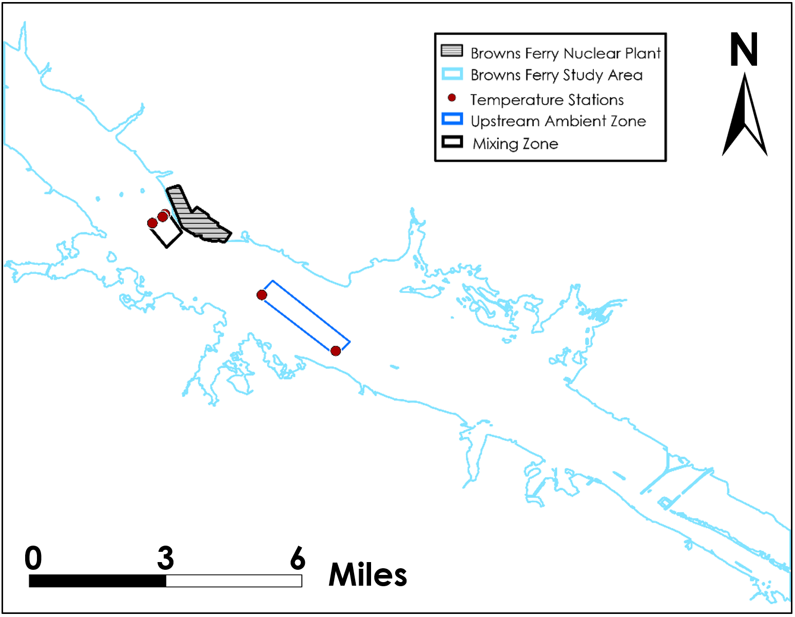
Figure 4. Map of polygons for data analysis. The Mixing Zone represented the downstream temperatures and the Upstream Ambient Zone represented the upstream temperatures.

4. Results & Discussion
4.1 Analysis of Results
4.1.1 Earth Observations vs. In Situ Data
The relationship between temperatures derived from satellite sensors and temperatures collected by in situ stations was analyzed through Pearson’s correlation. Overall, EO data and in situ data at BFNP were closely correlated, with an R value of 0.9833. The team also found that 95% (or 2 standard deviations) of the Earth Observation (EO) temperatures taken at BFNP were within -5.71 to 4.87 °F of in situ data (mean=0.42, s=2.6). Individually, the satellite sensors performed similarly in terms of accuracy–Landsat 8 TIRS had the highest R value of 0.9928, Terra ASTER had an R value of 0.9798, and ISS ECOSTRESS had an R value of 0.9862. However, the in situ temperature data was only available from 5 stations, so the team’s analysis of satellite performance was limited to these five points. NASA Earth Observations did not perform as well at SNP as they did at BFNP when compared with in situ data. 95% of EO temperature values (or 2 standard deviations) were within -9.8 and 6.5 °F of in situ data (mean = -1.6, s = 4.1). One explanation for this discrepancy is that SNP has temperature stations near the shore in contrast to BFNP. Since SNP temperature station were located near the riverbank, it is likely that satellite pixels that contained the temperature stations were mixed with land and water surfaces. This was not a problem at BFNP, where temperature stations were located sufficiently far from the riverbanks. Please refer to Appendix Figure B1-B2 for histograms of Earth Observations vs. in situ.

Figure 6. Linear regression of all Earth observation pixel temperatures compared to corresponding
temperature station data.

Furthermore, the relationship between EO and in situ temperature data was weaker in the summer and stronger in the winter. The average difference between EO and in situ temperatures in the summer was 1.6 °F, and the R value was 0.7604. The average difference between EO and in situ temperatures in the winter was 0.2 °F, and the R value was 0.8726. Furthermore, the standard deviation of the difference between means was 2.6 °F in the summer, compared to 1.5 °F in the winter. Based on these results, the satellite sensors performed better in the winter compared to the summer. This may be a result of higher flow rates in the winter – average river flow rate past BFNP was 67692 cubic feet per second (cfs) in the winter, while the average flow rate was only 35914 cfs in the summer. This difference could also be due to more homogenous surface temperature distributions in the winter, and more heterogeneity in summer water surface temperature distributions.
(a) Summer EO & in situ Relationship (b) Winter EO & in situ Relationship
Figure 7. Linear regression of summer (left) and winter (right) Earth observations temperatures compared with in situ temperature data.

4.1.2 Earth Observations vs. Model: ISS ECOSTRESS
The graph in Appendix Figure B4 shows water surface temperatures sampled from 100 random points of an ISS ECOSTRESS image taken on September 6th, 2019. The red line represents temperatures predicted by the Delft3D model, while the purple line represents temperature data from the ECOSTRESS image. Based on the graph, it is evident that the model consistently predicted higher temperatures compared to ECOSTRESS at the same points. On average, temperatures from the model images were 3.55°F higher compared to temperatures measured by ECOSTRESS (p=6.64e-17). However, the graph shows that data points from ECOSTRESS and Delft3D followed similar patterns, which suggests that the model was able to capture the spatial variability in temperature across the Browns Ferry study area. Furthermore, the Pearson’s correlation test between model and ECOSTRESS data yielded an R value of 0.823, which demonstrates a strong positive correlation between the two datasets. A visual comparison of Model vs. ECOSTRESS for September 6th, 2019 is located in Appendix Figure B3. Note: the color ramp for the satellite/sensor images were created to be similar as possible to the model but were made visually. This means that the color representation shown in the maps may have inaccuracies.

4.1.3 Earth Observations vs. Model: Landsat 8 TIRS & ISS ECOSTRESS
Based on temperatures sampled from the hundred random points (one point was removed due to land contamination), the team found that water surface temperatures predicted by the model images from September 7th and September 8th, 2019 were closely correlated, with an R value of 0.9425. Furthermore, the ANOVA conducted with the randomly sampled points of the EO and Delft3D images on September 7th and 8th showed no significant difference between the two model images (p>.01, Table 2). Based on these results, the team chose to compare satellite performance between Landsat 8 TIRS on September 7th, and ISS ECOSTRESS on September 8th, in addition to comparing the model images to their corresponding EO images (Table 2). Looking at Table 3, the results showed that all pairings of EO and model data were significantly different from each other except for the model vs. model comparison. The results of the Pearson’s correlation tests showed that the model images were most strongly correlated with each other (R=0.9425, Table 3), while the Landsat 8 TIRS and ISS ECOSTRESS images were the least strongly correlated (R=0.712, Table 3). The comparisons between the Delft3D model and EO data on September 7th and September 8th had R values of 0.8345 and 0.8530, respectively (Table 3). Based on these results, it was evident that the Delft3D model predicted more similar temperatures between September 7th and September 8th, while data from Landsat 8 TIRS and ISS ECOSTRESS showed a significant difference between temperatures collected on September 7th and September 8th (p<0.01, Table 2). Line graphs comparing the EO data to model data can be found in Appendix Figures B3-B6. A visual comparison of Model vs. ECOSTRESS & Model vs. Landsat is located in Appendix Figure B3. Note: the color ramp for the satellite/sensor images were created to be similar as possible to the model but were made visually. This means that the color representation shown in the maps may have inaccuracies.

Table 2. Tukey’s HSD for Model, ECOSTRESS, & Landsat Comparisons
Treatment Pairs | p-value
Model 9/7 vs. Model 9/8 | p>.01
Model 9/7 vs. Landsat 9/7 | P<.01
Model 9/8 vs. ECOSTRESS 9/8 | P<.01
Landsat 9/7 vs. ECOSTRESS 9/8 | P<.01

Treatment Pairs | Pearson’s Correlation
Model 9/7 vs. Model 9/8 | 0.9425
Model 9/7 vs. Landsat 9/7 | 0.8345
Model 9/8 vs. ECOSTRESS 9/8 | 0.853
Landsat 9/7 vs. ECOSTRESS 9/8 | 0.712
Table 3. Pearson’s Correlation for Model, ECOSTRESS, & Landsat Comparisons

4.1.4 Variable Analysis
The overall relationship between flow rate, air temperature, and power output on water surface temperature was demonstrated through a multiple regression with an R value of 0.6781 and an R² value of 0.4598. The results showed that there was a negative correlation for ∆T vs. flow rate and no correlation for ∆T vs. power output (Appendix Figure B7 & B8). ∆T vs air temperature had a positive correlation, but was not significant (Figure B6 & Table B7). The R² value indicated that these variables only accounted for 45.98% of the variability in water surface temperature. Furthermore, the results of the multiple regression showed that flow rate was the only variable that had a significant impact on water surface temperature (p=0.003509), while air temperature and power output did not impact water surface temperatures as substantially (p=0.119401 and p=0.8323066, respectively).

The team also created flow comparison maps to demonstrate the spatial distribution of water surface temperature during times of high and low river flow rate past BFNP. The team compared images taken on April 13th, 2019 for low flow and April 29th, 2019 for high flow (Figure 8). On April 13th, 2019 the thermal effluent downstream of BFNP spread out more due to the lower flow rate, which caused the water to be heated more by solar radiation. The lower flow rate of 40538 cfs (Table 4) corresponded to a higher ∆T of 4.5°F. On April 29th, 2019, thermal effluent from BFNP spread out less because of the higher flow rate. A relatively high flow rate of 107671 cfs (Table 4) was associated with a lower ∆T of 3.0F. Based on the images, it was evident that during times of low river flow rate, thermal effluent from BFNP stayed near the discharge location, resulting in higher water surface temperatures and a greater ∆T. The temperature distribution was also greater during times of low flow rate, due to more pronounced temperature differences on those days. This could be seen through the standard deviations listed in Table 4.
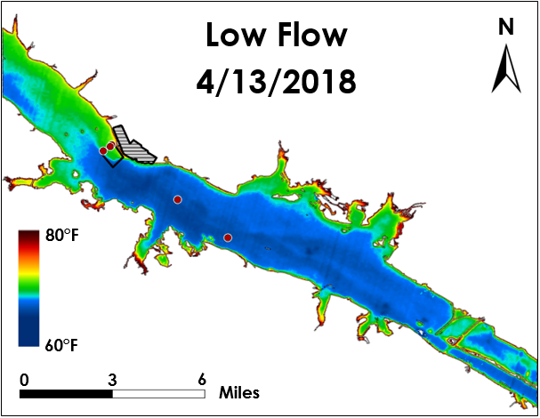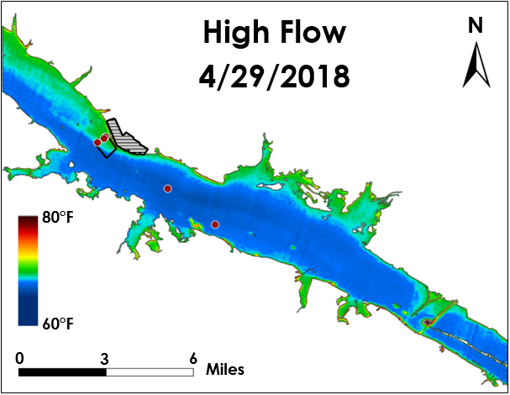
(a) Landsat 8 TIRS Low Flow (b) Landsat 8 TIRS High Flow
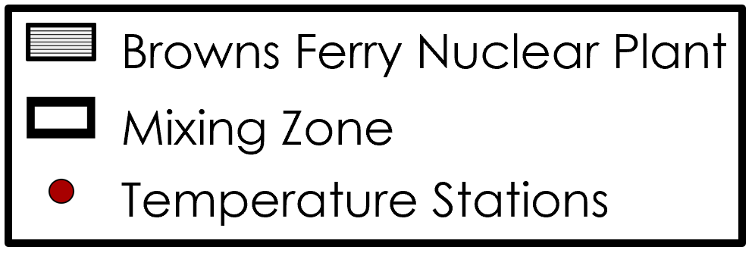
Figure 8. Spatial variation in water surface temperature for low flow rate vs. high flow rate (from Landsat 8 TIRS, April 2018).

Table 4. Landsat high and low flow
Date & Time (GMT) | Flow (cfs) | LST Standard Deviation (°F)
4/29/18 16:04 | 107671.0 | 1.76
4/13/18 18:16 | 40538.0 | 3.42

4.1.5 Seasonal Time-Series
The team created seasonal time series maps with ASTER images taken at the same point in time throughout the year from March, May, October, and November (Appendix Figure C1). The images were all taken near 3:50 GMT. ∆T and standard deviation values for each map are listed in Appendix Table C1. The satellite data collected in March and November had lower ∆Ts, which corresponded to higher flow rates during the spring and winter. The EO data collected in May and October demonstrated higher ∆Ts relative to May and October, likely (while not definitively), due to the lower flow rates. Among the four images, October demonstrated the highest standard deviation in water surface temperatures across the Tennessee River based on EO data. This was in line with results from the team’s flow rate analysis, which indicated a wider distribution in water surface temperatures on days with lower flow rates.

In addition, the team also created a seasonal time series map of ECOSTRESS between February 13th, 2019 and August 30th, 2019. The winter map had four times more flow than the summer map which also caused differences in spatial variation where the low flow’s effluent had greater spatial spread. These maps are located in Appendix Figure C2 with their corresponding flow rates. In the variable analyses, the team found that flow rate had a negative correlation with ∆T. This meant that as flow increased, ∆T decreased. Taking flow rate into account, it made sense that February had a lower ∆T of 0.9°F, while August had a ∆T of 3.4°F.
4.1.6 Yearly: Repeated Measures
The team conducted an ANOVA to determine whether change in ∆T between downstream and upstream temperature stations was statistically significant over the years. ∆T was calculated from satellite data collected in September of 2013, 2018, and 2019. The ∆T was 2.178°F in 2013, 5.724°F in 2018, and 3.504°F in 2019. The maps for each image of each year can be found in Appendix Figure C3. Based on this data, it is evident that there was an increase in ∆T from 2013 to 2018, and a decrease in ∆T from 2018 to 2019 (p<0.01). The maps showing the change between the maps from 2013 to 2018 and 2018 to 2019 are located in Appendix Figure C4. Seeing as 2013 was prior to the expansion at BFNP, the lower ∆T was expected. However, the team expected to see an increase in ∆T from 2018 to 2019 due to the completion of the expansion at BFNP. The lower ∆T seen in 2019 compared to 2018 did not support the hypothesis that ∆T would be greater following the expansion. The TVA stated that the expansion did increase the ∆T at BFNP by 3-5 °F, so these conflicting results could be due to the limited temporal availability of satellite imagery.

4.2 Future Work
In the future, these methodologies can be used to conduct further analysis of Delft3D model images in comparison with satellite imagery. In addition, data describing the distribution of aquatic wildlife both upstream and downstream of nuclear power plants can be incorporated into EO data analysis in order to gain a better understanding of the ecological impacts of thermal effluent. The TVA is not only interested in using Earth observations to monitor water temperature, but also to understand other factors within the context of the Tennessee River and the operation of their nuclear plants. For example, the TVA’s Hydrothermal Group have discussed the problem of eel weed overgrowth clogging their intake systems. The European Space Agency’s Sentinel-2 satellite can be used to detect plant growth along the Tennessee River, which will help the TVA increase proactive mitigation of aquatic vegetation interference with power plant operations. These are only a sample of the myriad of opportunities for the TVA to incorporate Earth observations in their fluvial monitoring efforts.

5. Conclusions
This project supplemented the TVA’s current methods of monitoring water surface temperature by providing a better understanding of spatial patterns and seasonal variation across the Wheeler Reservoir. In particular, EO thermal data was able to demonstrate spatial variation in water surface temperatures near BFNP, which helped the TVA assess the performance of their Delft3D model. The map products the team produced (seasonal time series, yearly time series, and model comparison) helped visualize spatial variation in temperatures during different seasons and across multiple years. Through statistical analyses, the team determined that river flow rate was most strongly correlated to ΔT, with higher flow rates corresponding to lower ΔTs. Furthermore, river flow rate had the strongest impact on ΔT, while power output and air temperature did not significantly contribute to the variation seen in ΔT. The effect of flow rate on spatial variation in water surface temperature was also represented through the maps. The team compared images taken in September of 2013, 2018 and 2019 in which ∆T increased from 2013 to 2018, but decreased from 2018 to 2019. Due to the low temporal resolution of EO data, the team was only able to compare one image from each year in this analysis. These images were taken at three specific points in time and did not represent long-term trends in water surface temperature, which limited the team’s ability to fully assess the impact of the Browns Ferry Nuclear Plant expansion. In addition, the limited number of in situ temperature stations resulted in minimal points of comparison between the TVA’s in situ data and EO raster data. The satellite accuracy assessment was conducted using temperature station data collected at Browns Ferry and Sequoyah; therefore, more in situ measurement points would have been necessary in order to provide more accurate results. Despite these limitations, the team was able to demonstrate how NASA Earth observations could be implemented to better understand variations in water surface temperatures due to thermal effluent from nuclear power plants.

6. Acknowledgments
Our team thanks the following people for their generous support:
- Dr. Jeffrey Luvall – NASA Marshall Space Flight Center
- Dr. Robert Griffin – University of Alabama in Huntsville
- Cole Krehbiel – Innovate! Inc., Contractor to the USGS
- Colleen Montgomery – Tennessee Valley Authority Hydrothermal Group
- Lana Bean – Tennessee Valley Authority
- Dr. Matthew Boyington – Tennessee Valley Authority
- Madison Murphy – NASA DEVELOP, Alabama – Marshall
- Christine Evans – University of Alabama in Huntsville
- Helen Baldwin – NASA SERVIR
- Maggie Klug – University of Alabama in Huntsville

Any opinions, findings, and conclusions or recommendations expressed in this material are those of the author(s) and do not necessarily reflect the views of the National Aeronautics and Space Administration.

This material is based upon work supported by NASA through contract NNL16AA05C.

7. Glossary
BFNP – Browns Ferry Nuclear Power Plant
CWA – Clean Water Act
Earth observations – Satellites and sensors that collect information about the Earth’s physical, chemical, and biological systems over space and time
ECOSTRESS – ECOsystem Spaceborne Thermal Radiometer Experiment on Space Station
∆T – Change in temperature from upstream temperature stations to downstream locations
GeoTIFF – Geostationary Earth Orbit Tagged Image File Format
In Situ Measurement – A measurement taken at a stationary location
NPDES – National Pollutant Discharge Elimination System
SNP – Sequoyah Nuclear Power Plant
TIR – Thermal Infrared
TIRS – Thermal Infrared Sensor

TVA – Tennessee Valley Authority

8. References
Anding, D. & Kauth, R. (1970). Estimation of sea surface temperature from space. Remote Sensing of Environment, 1, 217-220. https://doi.org/10.1016/S0034-4257(70)80002-5

Beitinger, T. L., Bennett, W. A., & McCauley, R. W. (2000). Temperature Tolerances of North American Freshwater Fishes Exposed to Dynamic Changes in Temperature Temperature tolerances of North American freshwater fishes exposed to dynamic changes in temperature. Environmental Biology of Fishes, 58(February). https://doi.org/10.1023/A

“Browns Ferry Nuclear Plant.” TVA, www.tva.gov/Energy/Our-Power-System/Nuclear/Browns-Ferry-Nuclear-Plant.

ECOSTRESS Land Surface Temperature and Emissivity Daily L2 Global 70 m V001 – ECO2LSTE
Hook, S., Hulley, G. (2019). ECOSTRESS Land Surface Temperature and Emissivity Daily L2 Global 70 m V001 [Data set]. NASA EOSDIS Land Processes DAAC. doi: 10.5067/ECOSTRESS/ECO2LSTE.001
ESRI 2019. ArcGIS Desktop 10.5.1. Redlands, CA: Environmental Systems Research Institute.
Handcock, R. N., Gillespie, A. R., Cherkauer, K. A., Kay, J. E., Burges, S. J., & Kampf, S. K. (2006). Accuracy and uncertainty of thermal-infrared remote sensing of stream temperatures at multiple spatial scales. Remote Sensing of Environment, 100(4), 427–440. Retrieved from: https://doi.org/10.1016/j.rse.2005.07.007
Handcock, R. N., Torgersen, C. E., Cherkauer, K. A., Gillespie, A. R., Tockner, K., Faux, R. N., & Tan, J. (2012). Thermal Infrared Remote Sensing of Water Temperature in Riverine Landscapes. Fluvial Remote Sensing for Science and Management, 85–113. Retrieved from: https://doi.org/10.1002/9781119940791.ch5
Logan, L., Stillwell, A. (2018). Probabilistic assessment of aquatic species risk from thermoelectric power
plant effluent. Applied Energy, 210, 434-450. Retrieved from: http://dx.doi.org/10.1016/j.apenergy.2017.09.027

Madden, N., Lewis, A., Davis, M. (2013). Thermal effluent from the power sector: an analysis of once-through cooling system impacts on surface water temperature. Environmental Research Letters. Retrieved from: https://doi.org/10.1088/1748-9326/8/3/035006
McGinty, T. J. (2007). Tennessee Valley Authority; Browns Ferry Nuclear Plant; Final Environmental
Assessment and Finding of No Significant Impact Related to the Proposed License Amendment To
Increase the Maximum Reactor Power Level. Federal Register, 72(28), 6612–6620. Retrieved from:
https://www.federalregister.gov/documents/2007/02/12/E7-2342/tennessee-valley-authority-
browns-ferry-nuclear-plant-final-environmental-assessment-and-finding-of
NASA LP DAAC. (2001). ASTER Level 2 Surface Temperature Product [Data set]. NASA LP DAAC, accessed 6 February 2017. https://doi.org/10.5067/ASTER/AST_08.003
The Nuclear Regulatory Commission. (2017, August 16). NRC Approves Extended Power Uprate for Browns
Ferry Nuclear Plant. [Press release] Retrieved from:
https://www.nrc.gov/reading-rm/doc-collections/news/2017/17-037.pdf
Section 404 of the Clean Water Act: An overview. (2003). Washington, D.C.: United States Environmental
Protection Agency, Wetlands, Oceans, and Watersheds. Retrieved from: https://www.epa.gov/cwa-404/overview-clean-water-act-section-404

Spaceborne, A., Emission, T., & Radiometer, R. (2001). Advanced Spaceborne Thermal Emission and Reflection
Radiometer ASTER Higher-Level Product User Guide. Retrieved from: https://asterweb.jpl.nasa.gov/content/03_data/04_Documents/ASTERHigherLevelUserGuideVer2May01.pdf

Tennessee Valley Authority. (n.d.). Browns Ferry Nuclear Plant Supplemental Environmental Report. Retrieved from: https://www.nrc.gov/docs/ML1528/ML15282A237.pdf
Tennessee Valley Authority; Browns Ferry Nuclear Plant, Units 1, 2, and 3. (2017). [Docket Nos. 50–259, 50–260, and 50–296; NRC–2016–0244]. Retrieved from: https://www.federalregister.gov/documents/2017/05/31/2017-11184/tennessee-valley-authority-browns-ferry-nuclear-plant-units-1-2-and-3

US Geological Survey Earth Resources Observations and Science Center. (2015). Landsat 8 TIRS Land Surface Temperature. [Image collection]. https://www.doi.org/10.5066/F71835S6

Verones, F., Hanafiah, M. M., Pfister, S., Huijbregts, M. A. J., Pelletier, G. J., & Koehler, A. (2010).
Characterization Factors for Thermal Pollution in Freshwater Aquatic Environments. Environmental
Science & Technology, 44(24), 9364–9369. Retrieved from: https://doi.org/10.1021/es102260c

9. Appendices

Appendix A

Table A1. BFNP sample times and sensor for each image considered
Sample Date & Time (GMT)
ISS ECOSTRESS | Landsat 8 TIRS | Terra ASTER
8/13/2018 16:49 | 9/22/2013 6:58 | 4/10/2014 16:42
8/27/2018 11:07 | 12/27/2013 17:02 | 5/7/2015 3:51
2/13/2019 15:28 | 5/20/2014 9:06 | 11/17/2016 3:50
7/25/2019 23:07 | 1/12/2014 17:18 | 3/16/2017 3:56
8/20/2019 13:03 | 10/3/2017 20:55 | 5/19/2017 3:56
8/30/2019 16:18 | 4/13/2018 18:16 | 10/26/2017 3:56
9/1/2019 8:09 | 4/29/2018 16:04 | 11/20/2017 3:50
9/2/2019 15:28 | 5/15/2018 11:22 | 5/7/2018 16:43
9/6/2019 13:49 | 10/6/2018 6:25 | 1/10/2019 3:50
9/8/2019 5:41 | 6/16/2018 3:18 | 3/23/2019 16:42
9/12/2019 4:03 | 2/8/2018 4:51
9/16/2019 2:24 | 9/20/2018 8:05
9/21/2019 8:07 | 12/3/2018 22:13
9/22/2019 7:19 | 6/3/2019 13:20
 | 9/7/2019 5:55

Table A2. SNP sample times and sensor for each image considered
Sample Date & Time (GMT)
ISS ECOSTRESS | Landsat 8 TIRS | Terra ASTER
8/24/2018 12:07 | 2/22/2014 8:17 | 10/15/2015 16:36
8/27/2018 11:08 | 9/10/2017 20:36 | 3/16/2016 16:29
2/13/2019 15:29 | 10/12/2017 15:55 | 5/6/2017 16:29
7/25/2019 23:07 | 5/8/2018 12:38 | 9/17/2017 3:51
7/28/2019 5:36 | 8/31/2019 7:56 | 3/6/2018 16:30
8/30/2019 16:18 |  | 10/7/2018 16:36
9/1/2019 8:09 |  | 10/22/2018 3:51
9/3/2019 14:40
9/7/2019 13:01
9/9/2019 4:52
9/12/2019 4:03
9/16/2019 2:25
9/22/2019 7:19

Table A3. In situ ancillary data from January 2013 to September 2019 provided by the TVA.
Ancillary Data
In Situ Data Type | Specifications
Temperature Station | Water temperature measurements taken at depths of 6in, 3ft, 5ft, and 7ft. Temperatures reported hourly.
Power Generation | Power output by BFNP. MW generated reported at 15-minute intervals.
Air Temperature | Air temperature data collected by TVA meteorological stations. Temperatures reported hourly.

Table A4. Model-based ancillary data provided by the TVA.
Ancillary Data
Model | Specifications |  | Dates, GMT
Delft3D Images | Images from Deltares Delft3D model predicting water surface temperature. Available from May-Present 2019 | 09/06/2019, 2:00 pm 09/07/ 2019, 6:00 am 09/08/2019, 6:00 am
Delft3D Flow Data | Hourly flow rate past BFNP in cubic feet per second, calculated by Deltares Delft3D Model. | Jan. 2013- Sep. 2019

Table A5. The table below shows the model and satellite comparisons. September 7th, 2019 is represented as "A" and September 8th, 2019 is represented as "B".
Comparison
Model A | Model B
Landsat A | ECOSTRESS B
Model B | ECOSTRESS B
Model A | Landsat A

Appendix B

(a) Satellite & in situ temperature difference at Browns Ferry

(b) Satellite & in situ temperature difference at Sequoyah
Figure B1. Temperature accuracy histograms for all samples at BFNP and SNP. The temperature difference is the temperature measured by the satellite minus the temperature measured by the temperature station.

(a) Satellite & in situ temperature difference by sensor at Browns Ferry

(b) Satellite & in situ temperature difference by sensor at Sequoyah
Figure B2. Temperature accuracy histogram with individual sensor results at BFNP and SNP

Delft3D Imagery Satellite/Sensor Imagery
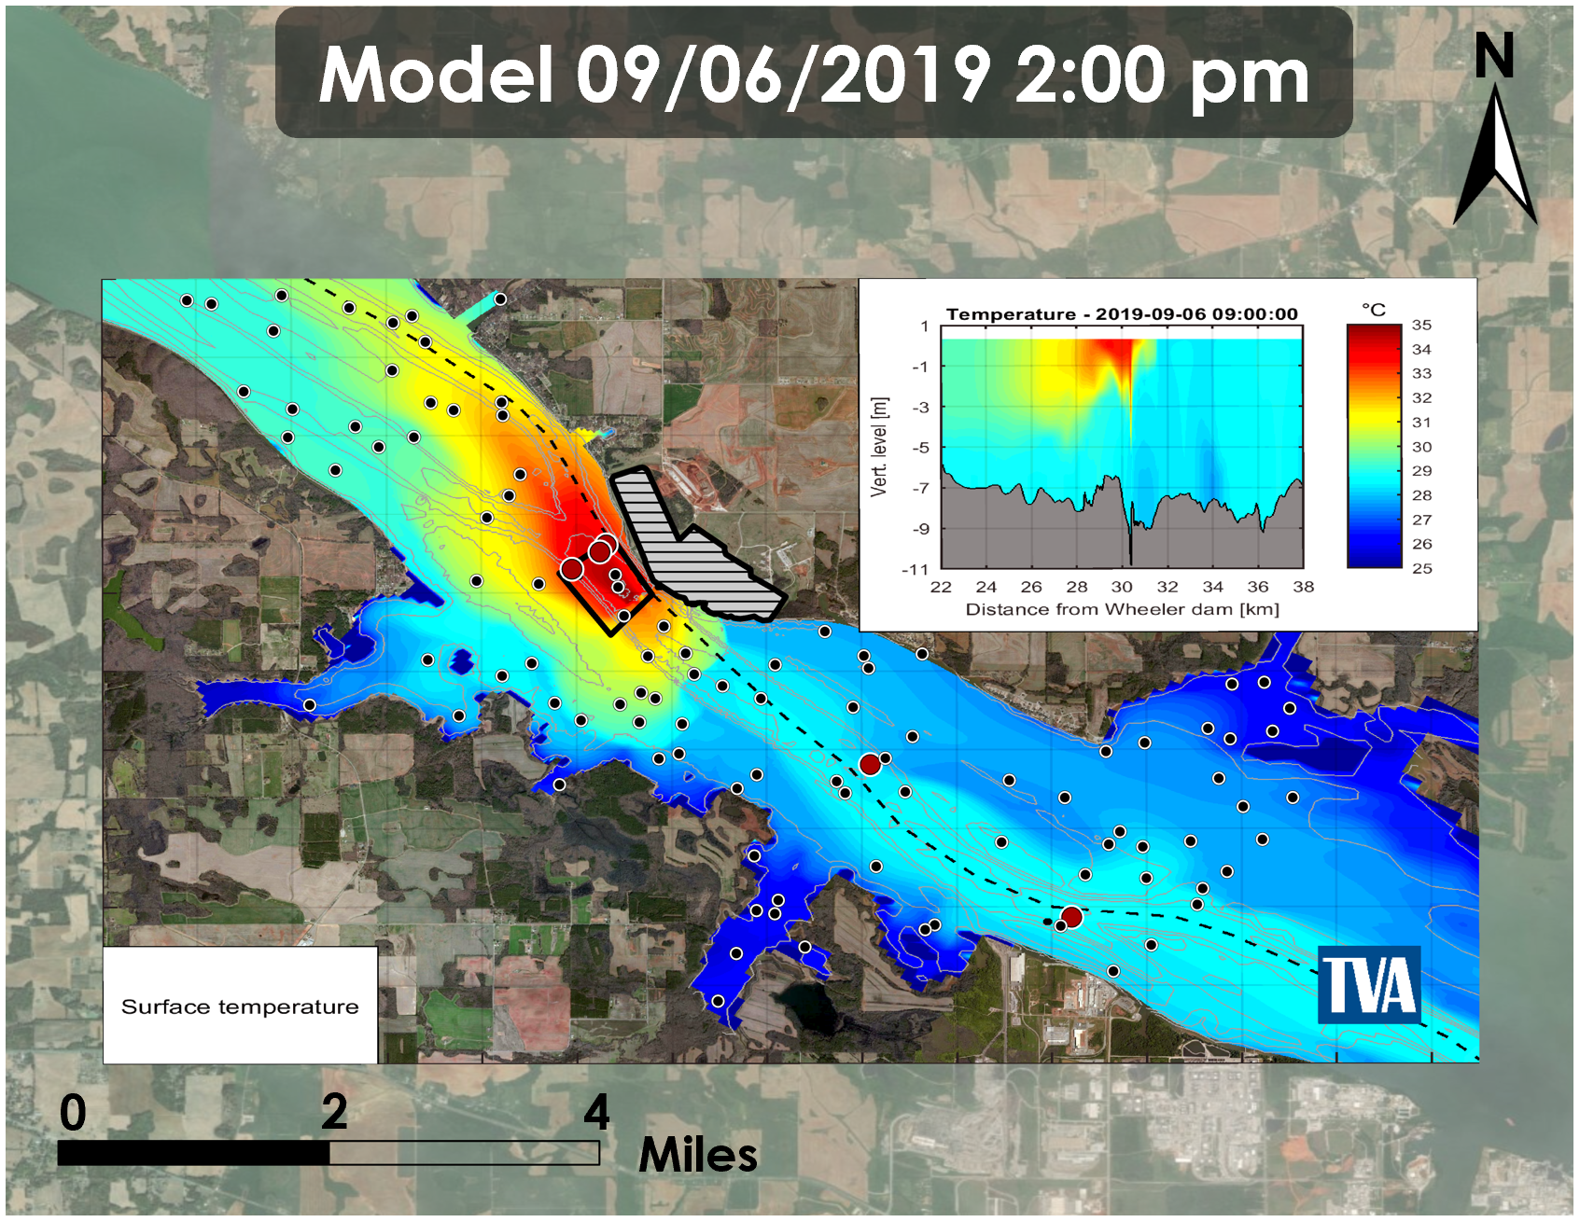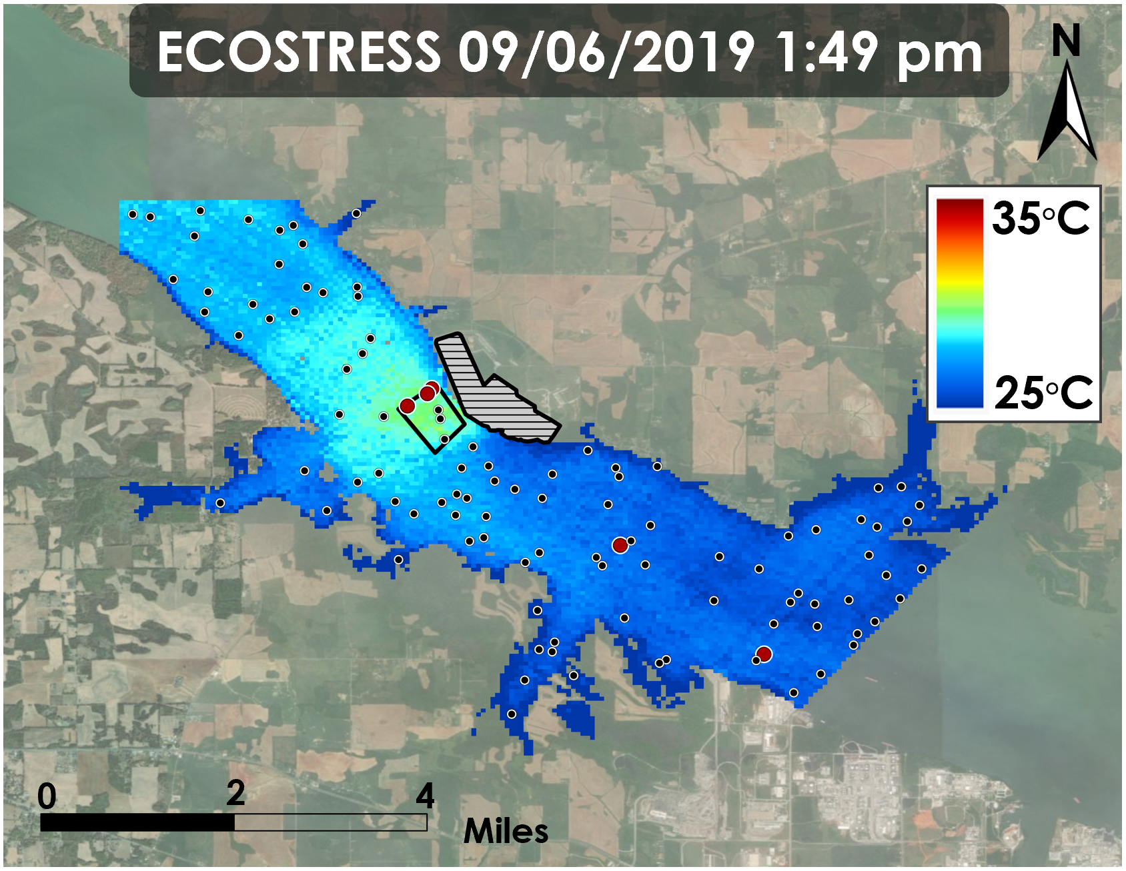
(a) Model Water Surface Temperature 9/6/19 (b) ECOSTRESS Water Surface Temperature 9/6/19
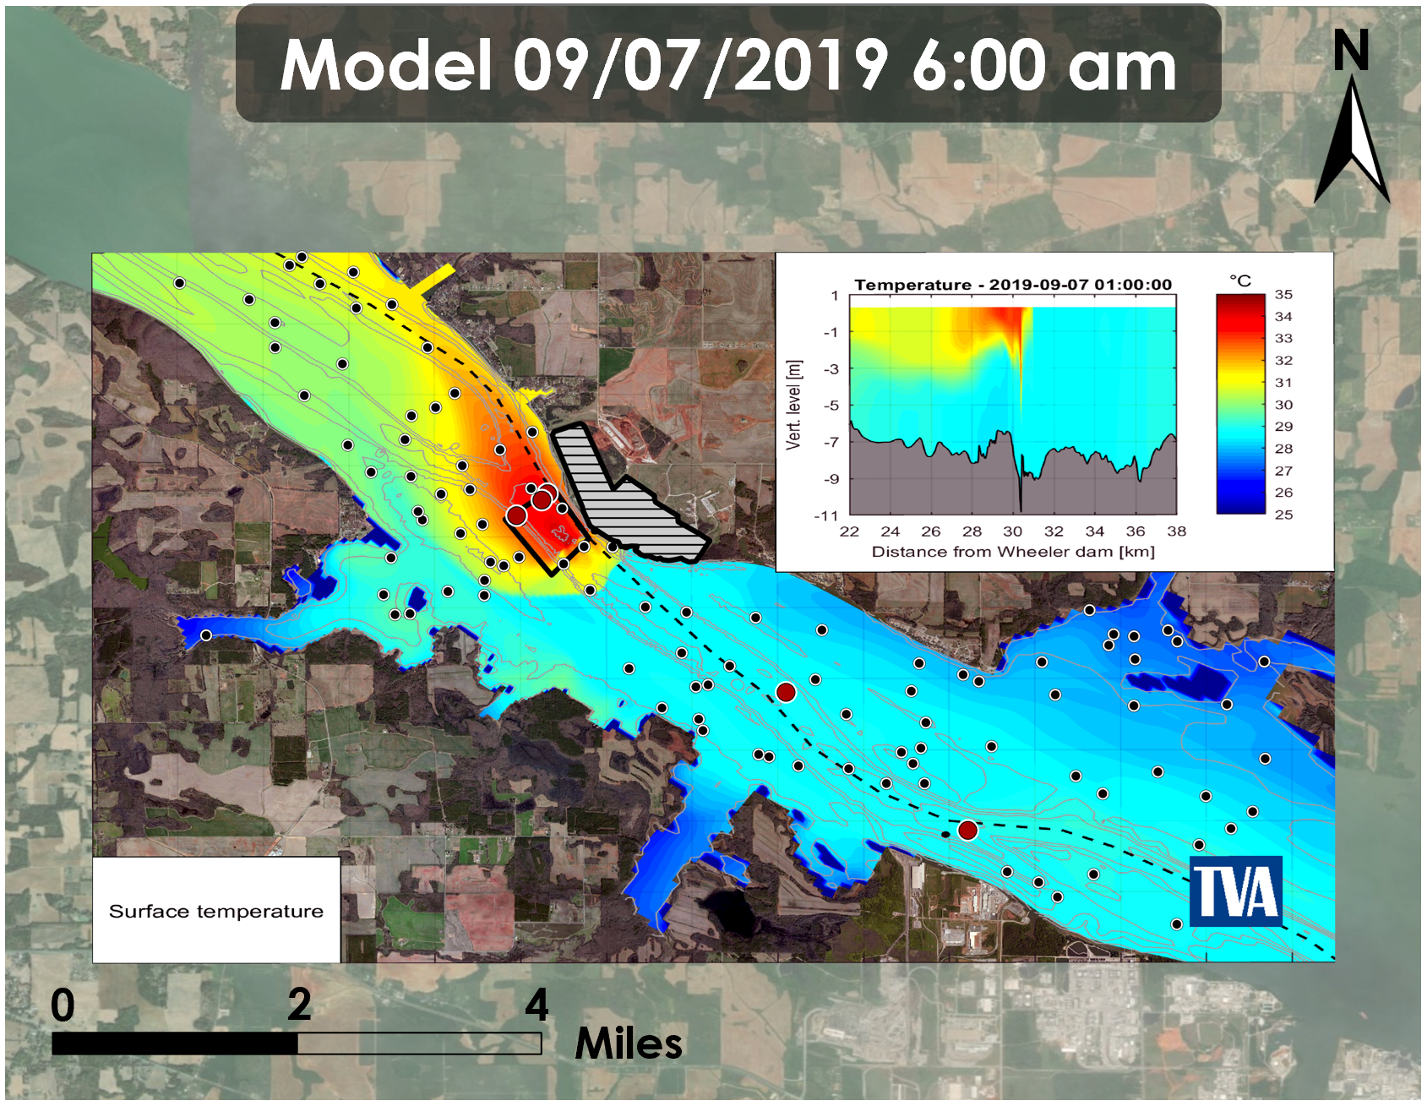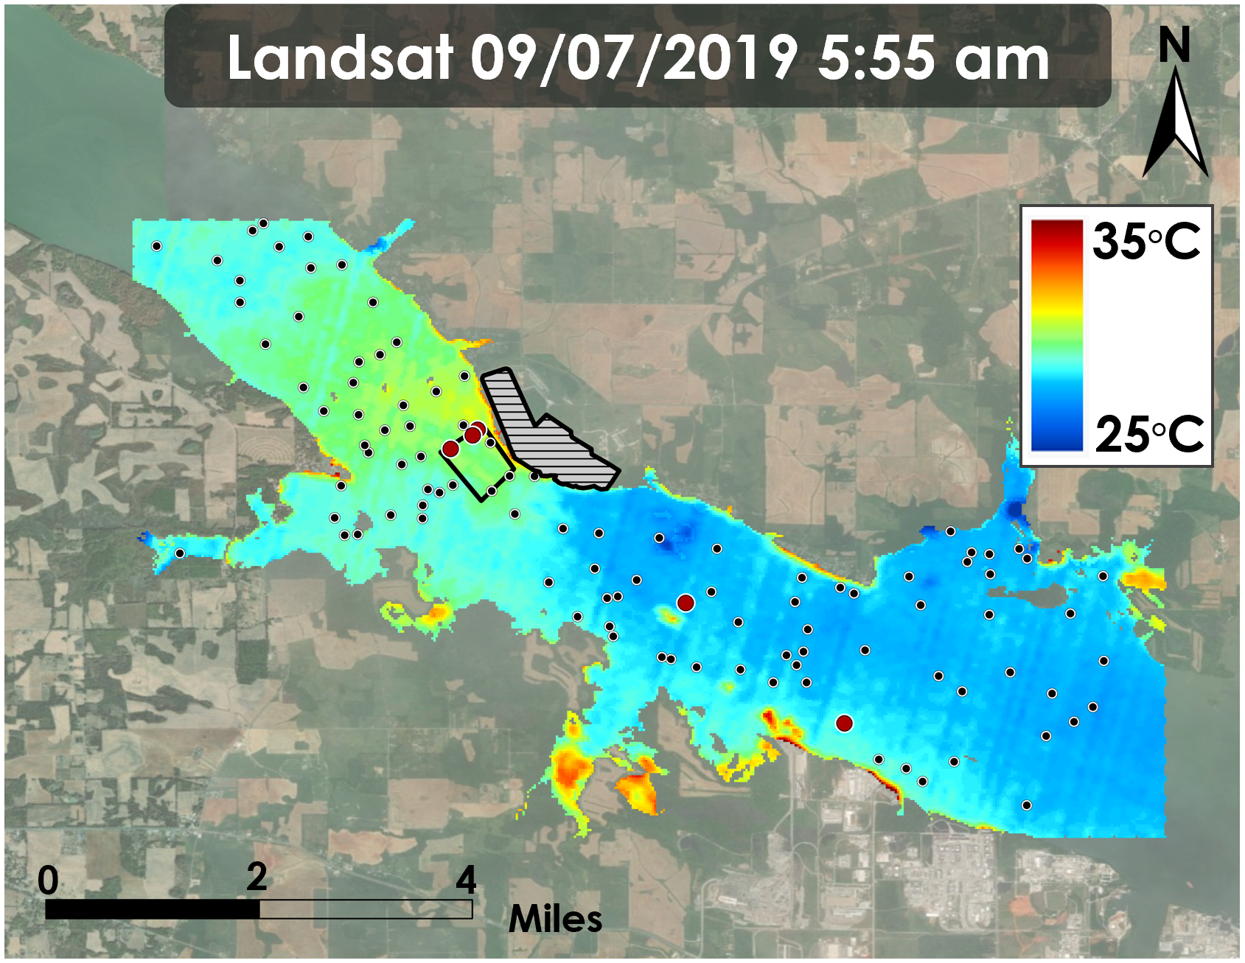
(c) Model Water Surface Temperature 9/7/19 (d) Landsat Water Surface Temperature 9/7/19
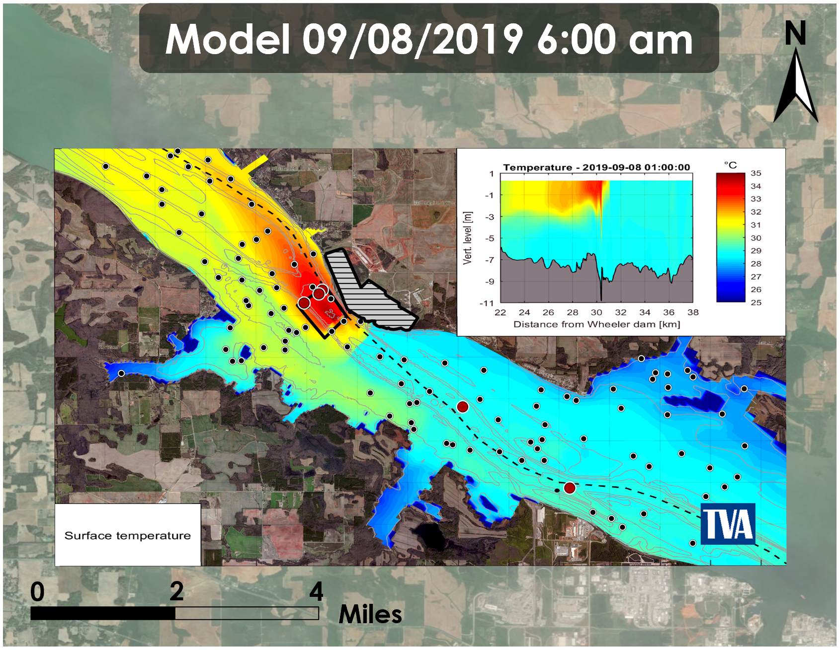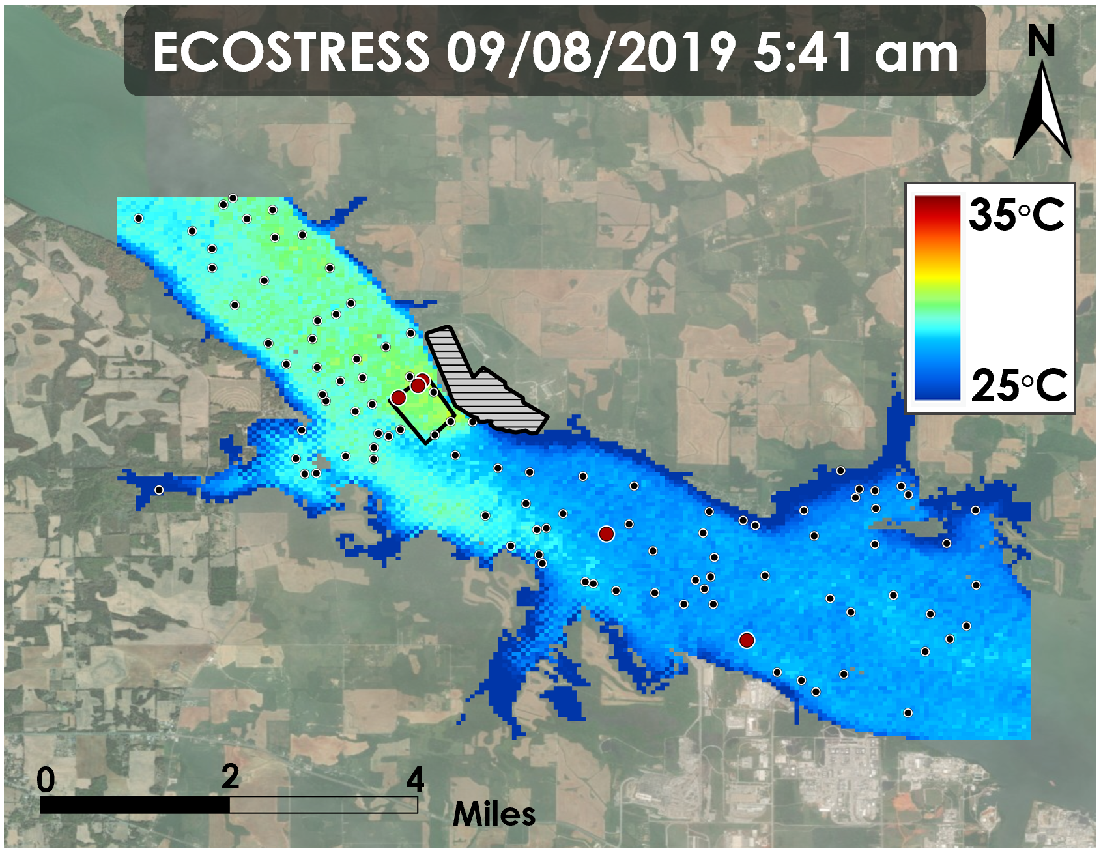
(e) Model Water Surface Temperature 9/8/19 (f) ECOSTRESS Water Surface Temperature 9/8/19
Figure B3. Delft3D model images compared to thermal infrared satellite imagery (from ECOSTRESS & Landsat 8 TIRS, 2018).

Figure B4. ECOSTRESS vs. Model on September 6^{th,} 2019 at 2:00 pm

Figure B5. ECOSTRESS vs. Model on September 8th, 2019

Figure B6. Landsat 8 TIRS vs. Model on September 7th, 2019

Table B7. Multiple regression testing for variables vs. ∆T
Variables | p-value | R²
Flow Rate | 0.003509
Air Temperature | 0.119401 | 0.4598
Power Output | 0.823066

Figure B7. ∆T vs. Flow Rate

Figure B8. ∆T vs. Air Temperature

Figure B9. ∆T vs. Power Output

Appendix C

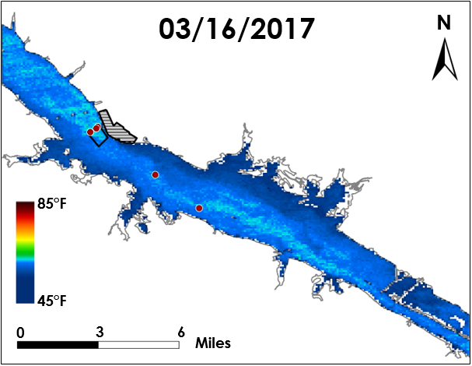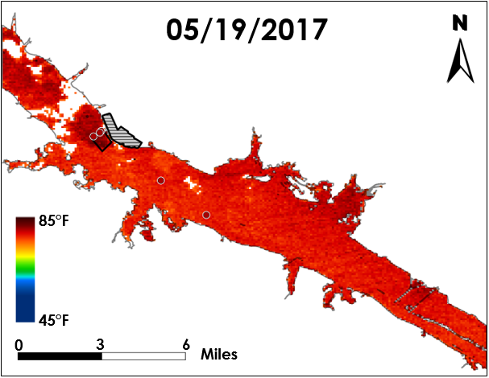
(a) ASTER March (b) ASTER May 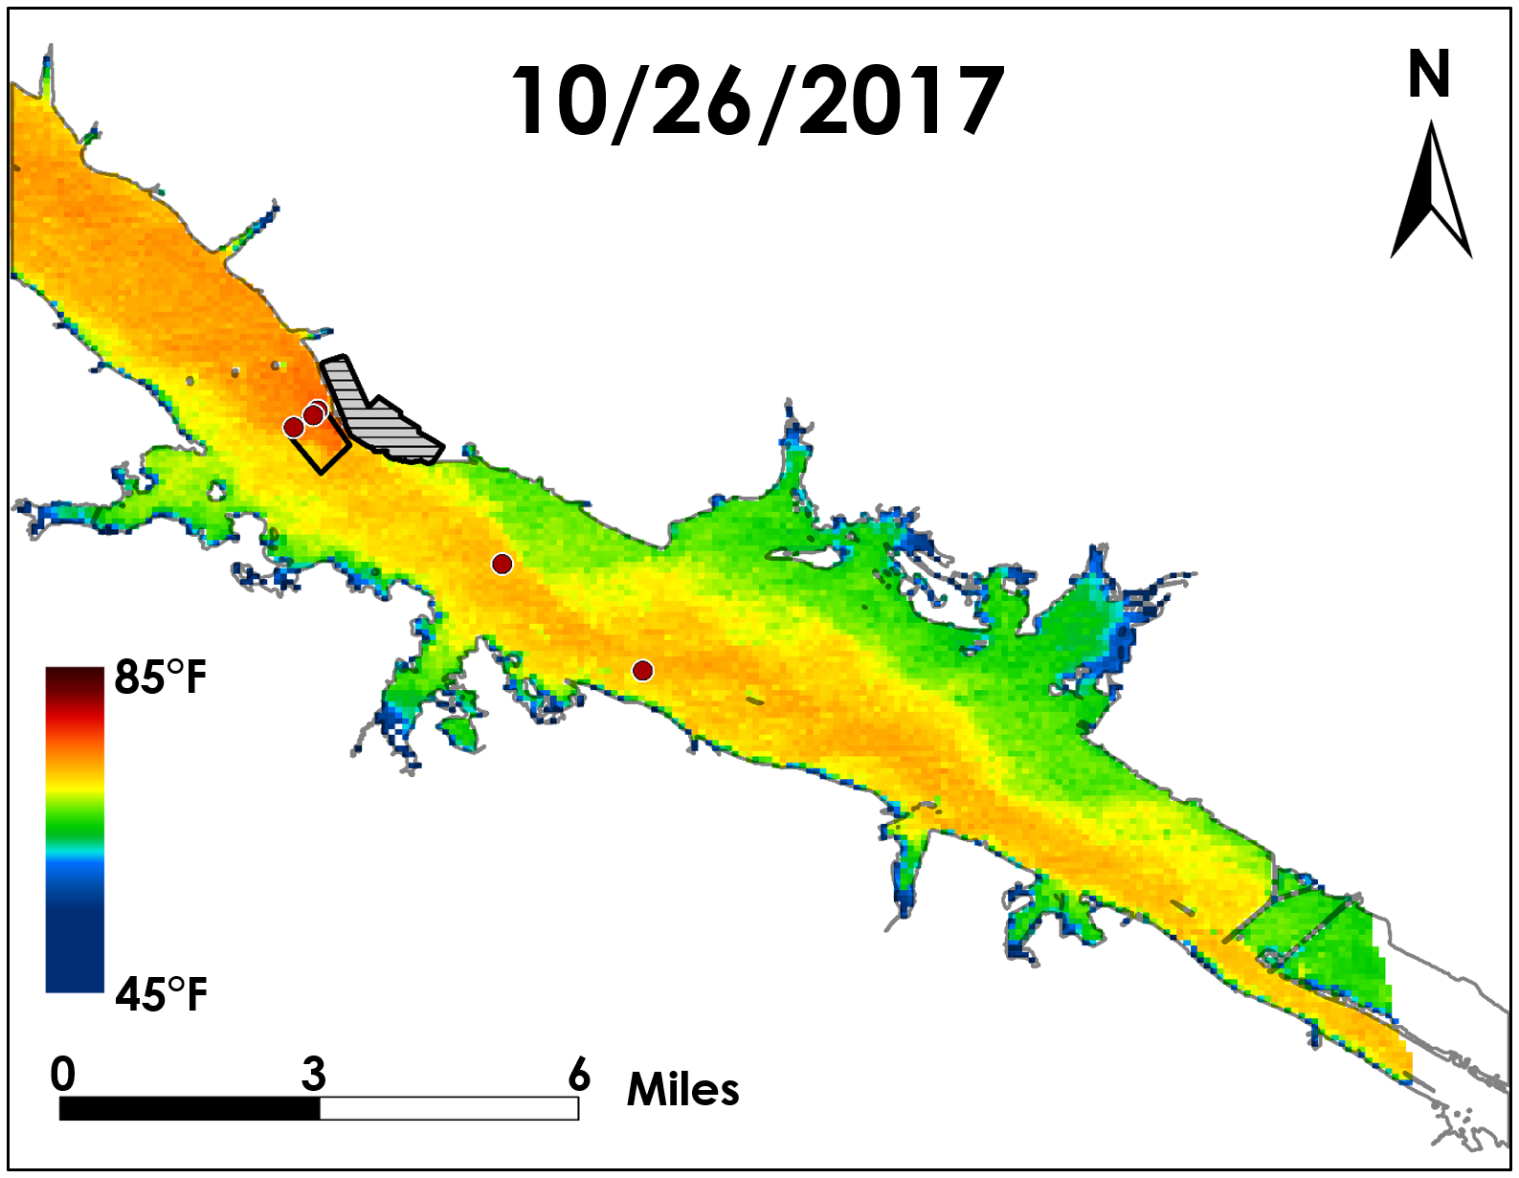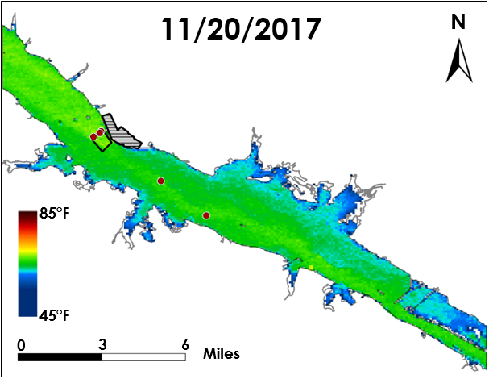
(c) ASTER October (d) ASTER November
Figure C1. ASTER seasonal time series maps at BFNP (from Terra ASTER, March, May, October, & November 2017).

Table C1. Seasonal Terra ASTER imagery corresponding conditions
Date & Time (GMT) | Flow (cfs) | LST Standard Deviation (°F)
3/16/2017, 3:56 | 49775 | 4.56
5/19/2017, 3:56 | 38414 | *2.68
10/26/2017, 3:50 | 27963 | 5.27
11/20/2017, 3:56 | 48306 | 4.92
*Low relative standard deviation potentially caused by hazy, clouded image
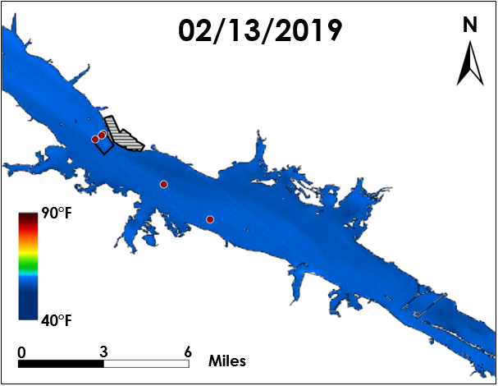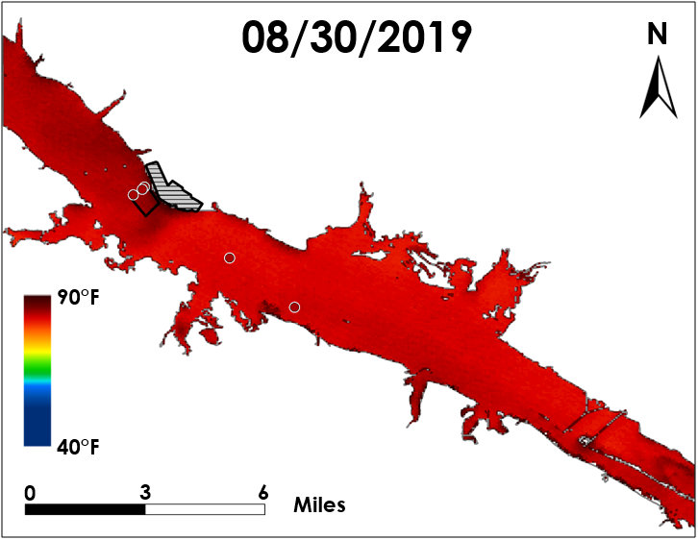
(a) ECOSTRESS Winter (b) ECOSTRESS Summer
Figure C2. ECOSTRESS seasonal time series maps at BFNP (from ISS ECOSTRESS, April & August 2019).

Table C2. Seasonal ECOSTRESS imagery corresponding conditions
Date & Time (GMT) | Flow (cfs) | LST Standard Deviation (°F)
2/13/2019, 3:28 | 100440.0 | 0.97
8/30/2019, 4:18 | 25677.0 | 1.67

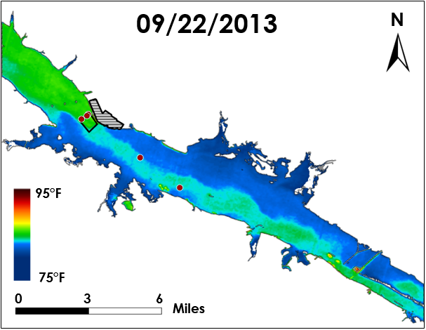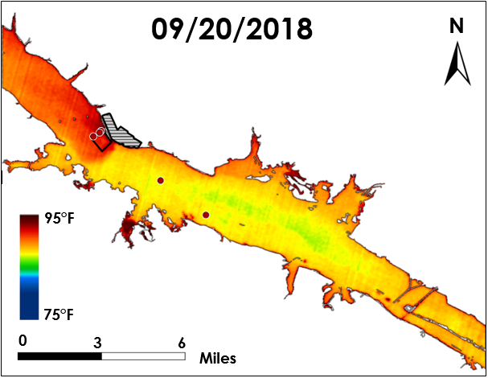
(a) Landsat 8 TIRS 2013 (b) Landsat 8 TIRS 2018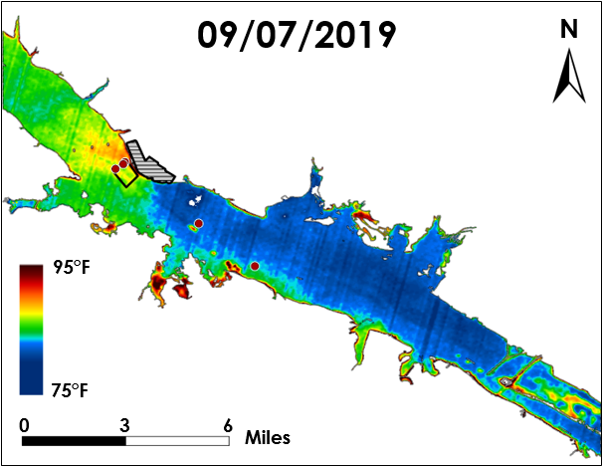
(c) Landsat 8 TIRS 2019
Figure C3. Yearly repeated measures: water surface temperature maps at BFNP (from Landsat 8 TIRS, 2013, 2018, 2019).

Table C3. Yearly repeated measures corresponding conditions
Date & Time (GMT) | Flow (cfs) | Air Temperature (°F) | Power (MW)
9/22/2013, 6:58 | 26602 | 56.93 | 3362
9/20/2018, 8:05 | 17401 | 72.95 | 3218
9/07/2019, 5:55 | 20596 | 78.98 | 3760

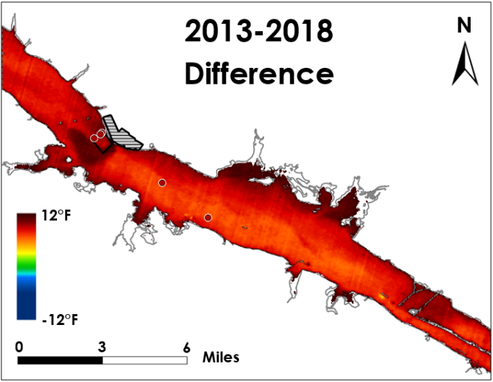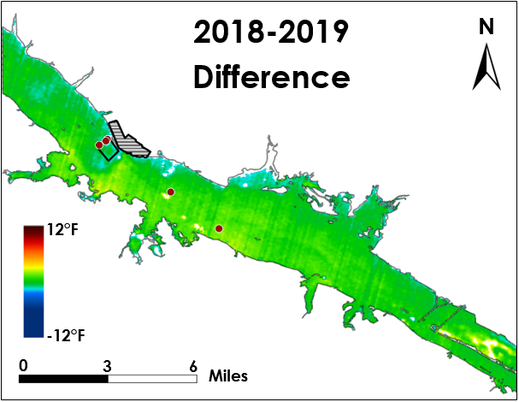
(a) Landsat 8 TIRS (2018 minus 2013) (b) Landsat 8 TIRS (2019 minus 2018)
Figure C4. Change in water surface temperature between images (from Landsat 8 TIRS, 2013, 2018, & 2019).

