**NASA DEVELOP National Program**



NASA Langley Research Center

**Summer 2016**

**Short Title: Western US Water Resources**

**Subtitle:** Utilizing NASA Earth Observations to Analyze Vegetation Productivity Shifts Relative to Climate Change and Drought in Capitol Reef National Park

**VPS Title:** Pivotal Moments: Drought Response in the West

**Project Team & Partners**

**Project Team:**

Kelly Meehan (Project Lead), kelly.s.meehan@nasa.gov

Molly Spater

Teresa Fenn

Thomas Smith

Kaylie Taliaferro

Grant Jaccoud

**Advisors & Mentors:**

Dr. Kenton Ross (NASA DEVELOP National Program Science Advisor)

**Partner Organizations:**

|  |  |  |  |
| --- | --- | --- | --- |
| **Organization** | **POC (Name, Position/Title)** | **Partner Type** | **Boundary Org?** |
| National Park Service, Inventory & Monitoring Program, Northern Colorado Plateau and Greater Yellowstone Networks | David Thoma, Ecologist | End-User | Yes |
| USGS Southwest Biological Science Center | Seth Munson, Plant Ecologist | End-User | Yes |

**Project Details**

**Applied Sciences National Application Addressed:** Water Resources

**Study Area:** Capitol Reef National Park, UT

**Study Period:** Jan 2000 – Dec 2015

**Earth Observations & Parameters:**

Terra, Moderate Resolution Imaging Spectroradiometer (MODIS) – NDVI

**Ancillary Datasets Utilized:**

* Satellite-Based Change Recognition and Tracking (*ForWarn*) – 8 day NDVI product
* MOD16, MODIS evapotranspiration
* NPS Inventory & Monitoring Program – Grazing/Non-Grazing shapefile &Vegetation Classes shapefile
* USGS National Elevation Data Set (NED) – Elevation
* PRISM – Spatial Climate Data – Precipitation and Temperature
* ClimateWNA – Climate Data for Water Balance Model
* gSSURGO – Soil Type and Soil Moisture Data for Water Balance Model

**Models Utilized:**

* AET and Deficit scripts written by Derek Churchill, University of Washington

**Software Utilized:**

* R Studio – MODIS image processing, AET and Water Deficit variable calculation from Water Balance scripts, statistical analysis, and creation of change in NDVI variable
* ArcMap 10.4.1 – spatial analysis of Terra MODIS and PRISM data, model building for clipping and reprojecting images, pivot point map creation, raster manipulation/analysis
* Python – MODIS reprojection
* TerrSet – analyze time lag, time series analysis

**Project Overview**

**80-100 Word Objectives Overview:**

Assist land managers of national parks in the western United States plan for and adapt to the impacts of a changing climate by employing NASA Earth observations to determine climate variables that can best forecast change in vegetation productivity. Various climate pivot points were utilized as indicators of sensitivity and various vegetation types vulnerable to drought and warming environmental conditions were identified. Results and information derived from this analysis will allow national parks to conserve and protect the beauty and resources that they provide to the country.

**Abstract:**

A changing climate has been an issue of growing concern over recent decades. Drought frequency has increased and water availability has become limited, especially in the western United States. With semi-arid regions typically becoming warmer and dryer, knowledge on how to identify shifts in vegetation productivity, which are early warning signs of changes in ecosystem stability, are of great interest to national park land managers. Guided by project partners from the National Park Service (NPS) and the United States Geological Survey (USGS), this project utilized a climate pivot point framework to assess the capacity of vegetation in Utah’s Capitol Reef National Park to resist drought when water is scarce. Multiple climatic variables including precipitation, temperature, evapotranspiration, and water deficit were analyzed against the normalized difference vegetation index (NDVI) across a 15 year time span from 2000 to 2015. This project will benefit our partners by providing information about which vegetation types are the most vulnerable to climate change and drought. The framework of this analysis can be replicated for other national parks and can be used by land managers to make critical decisions.

**Keywords:**

Climate Pivot Points, NDVI, MODIS, Vegetation Shifts, Water Scarcity

**Community Concerns:**

* Much of the American West has experienced drought in 11 of the past 14 years. The current drought directly affects more than 64 million people in the Southwest and Southern Plains, with many more indirectly affected due to impacts on agricultural regions.
* Recent warming and prolonged drought have provoked widespread decline of vegetation cover across deserts, grasslands, and low/high elevation forests in the western United States.
* Over one-third of terrestrial ecosystems are water limited because evapotranspiration losses are higher than received precipitation amounts.
* Semiarid regions are prone to potentially irreversible land degradation or desertification, characterized by shrub encroachment, invasion by exotic species, loss of soil fertility, and loss of total perennial vegetation cover.
* Such changes in plant cover can reduce productive capacity and diversity, alter food and habitat for wildlife and domestic livestock, and lead to the loss of soil resources.

**Current Management Practices & Policies**:

Currently, both the NPS Inventory & Monitoring program and the USGS Southwest Biological Science Center utilize vegetation monitoring data collected by the NPS and other agencies to assess vegetation responses to climate change for use in management decisions. They have recently begun utilizing MODIS and Landsat imagery to assess vegetation shifts at a local scale. However, it has been recognized that there is an opportunity to expand this work to broader study areas, such as the entirety of a national park. A large portion of their current practice consists of onsite data collection, which is exceedingly labor intensive and costly. Typically, vegetation measurements are collected by small teams of field workers that calculate plant species canopy cover by assessing vegetative abundance in quadrat plots and across transect lines. Additionally, landform and soil characteristics are derived from geologic maps and soil surveys. The nearest long-term weather stations are utilized to collect climate measurements for the time frame of interest.

**Decision Support Tools & Benefits:**

|  |  |  |  |
| --- | --- | --- | --- |
| **End-Product** | **Earth Observations Used** | **Benefit & Impact** | **Software**  **Release** |
| Vegetation Productivity Map (NDVI) Time Series | MODIS | Will serve as a visual representation of productivity trends among different vegetation types. | 1 |
| Pivot Point Map classified by vegetation type | MODIS | Will highlight to land managers actionable, near-term information with which to make key decisions regarding future changing climate conditions. | 1 |
| MODIS Processing Script | MODIS | Will aid in collecting and processing MODIS imagery. | 3 |

**Project VPS/Booklet Imagery**

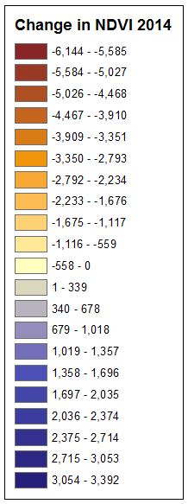

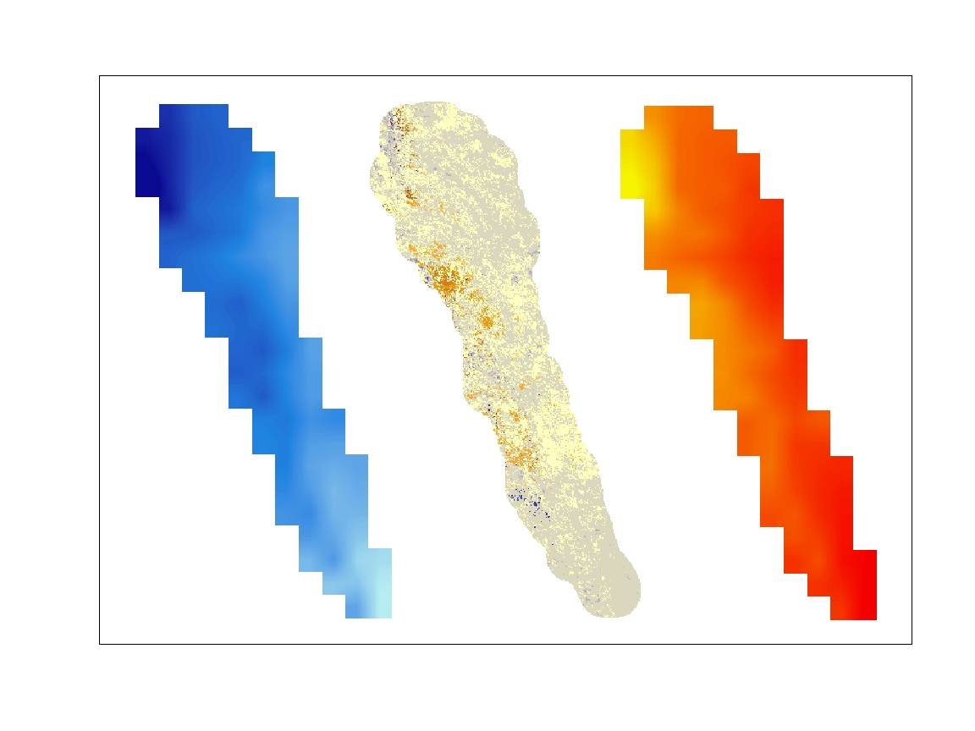

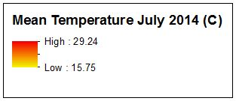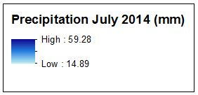

**Caption:** 2014 Precipitation, Temperature, and Change in NDVI (Scaled by 10,000) for 2014 for Capitol Reef National Park. Image Credit: Western US Water Resource Team.

**Image:** 2016Sum_LaRC_WesternUSWater_VPS