**NASA DEVELOP National Program**

****NASA Marshall Space Flight Center

**Fall 2015**

**Short Title: Lake Victoria Water Resources**

**Subtitle:** Spatio-Temporal Analysis of Lake Victoria Water Hyacinth and Algal Blooms Using NASA Earth Observations for Improved Water Management

**VPS Title:** Lake Victoria’s Water Quality: Past, Present, and Future

**Project Team & Partners**

**Project Team:**

Jeanné le Roux (Project Lead), jr0020@uah.edu

Daryl Ann Winstead

Austin Vacek

Christina Fischer

Sara Amirazodi

**Advisors & Mentors:**

Dr. Jeffrey Luvall (NASA at National Space Science and Technology Center)

Dr. Robert Griffin (University of Alabama Huntsville)

**Partner Organizations:**

SERVIR Coordination Office (Collaborator), POC: Africa Flores; Boundary Organization

SERVIR - Africa Team: Regional Centre for Mapping of Resources for Development (RCMRD) (Collaborator), POC: Dr. Robinson Mugo; Boundary Organization

Regional Centre for Mapping of Resources for Development (RCMRD) (Collaborator), POC: James Wanjohi Nyaga; Boundary Organization

**Project Details**

**Applied Sciences National Applications Addressed:** Water Resources

**Study Area:** Lake Victoria in Kenya

**Study Period:** August 2000 to Present

**Earth Observations & Parameters:**

EO-1, Hyperion - surface reflectance

Landsat 5, TM - surface reflectance

Landsat 7, ETM+ - surface reflectance

Landsat 8, OLI and TIRS - surface reflectance

**Ancillary Datasets Utilized:**

* RCMRD - *In situ* measurements and observations of the presence hyacinth

**Models Utilized:**

* USGS Normalized Difference Water Index (NDWI)
* Modified Normalized Difference Water Index (MNDWI)
* Normalized Difference Vegetation Index (NVDI)

**Software Utilized:**

ArcGIS - raster manipulation/analysis, image enhancement & map creation of Landsat TM, ETM+, OLI, EO-1 Hyperion

ENVI Classic 5.0 - raster manipulation/ analysis of EO-1 Hyperion

**Project Overview**

**80-100 Word Objectives Overview:**

Impaired water conditions in Lake Victoria have contributed to the proliferation of harmful algal blooms, as well as the invasive plant species *Eichhornia crassipes*, commonly known as the water hyacinth. The water hyacinth impacts local fishing, transportation, and human health. In addition, it is possible to identify the presence of water hyacinth from remote sensing platforms. By investigating the historical water quality and extent of hyacinth, a better understanding of the behavior and preferences of this species in Lake Victoria will be achieved.

**Abstract:**

Lake Victoria has a surface area of 68,800 square km, making it the largest lake in Africa. The lake is surrounded by Kenya, Tanzania, and Uganda and is home to more than 30 million people, making it one of the most densely populated rural areas in the world. These people rely on the lake for all aspects of their lives, including fishing, agriculture, and industrial applications. However, the increasing population has negatively impacted water quality through sewage, agricultural, and industrial run off. Furthermore, the introduction of *Eichhornia crassipes*, or water hyacinth, has been detrimental to the local communities by blocking fishing access and providing breeding grounds for disease carrying mosquitoes and snails. Ongoing efforts between SERVIR Africa and the Regional Centre for Mapping of Resources for Development (RCMRD) have been assessing and monitoring water quality parameters, such as chlorophyll concentration, temperature, and turbidity, for Lake Victoria using the Moderate Resolution Imaging Spectrometer (MODIS) sensor on the Aqua satellite. This project seeks to include the use of the Hyperion, Operational Land Imager (OLI), Enhanced Thematic Mapper Plus (ETM+), and Thematic Mapper (TM) on the Earth Observing-1 (EO-1), Landsat 8, 7, and 5 satellites, respectively, to assess surface reflectance, chlorophyll-a, and water hyacinth presence in addition to current monitoring activities. The study will focus on the Winam Gulf region of Lake Victoria in Kenya, since this area experiences abundant water hyacinth activity and has been identified by RCMRD as an area of focus. The data collected will be used to create a preliminary algorithm to detect water hyacinth, to be utilized by SERVIR and RCMRD for their ongoing efforts. This algorithm will then be applied on imagery ranging from August 2000 to the present to provide a historical context of the range of water Hyacinth in the Winam Gulf.

**Community Concerns:**

* Excess nutrients such as phosphorus and nitrogen from agricultural runoff, industrial waste, soil erosion sediments, and domestic sewage; contribute to harmful algal blooms that pose health risks to both aquatic life and humans.
* People who consume contaminated water and fish may develop liver and kidney damage, skin rashes, and neurological and respiratory issues, according to the EPA.
* Acute water hyacinth outbreaks can halt fishing operations, especially in Kenya.
* Water hyacinth, which covers about 90% of Lake Victoria’s shoreline, has been blamed for $150 million per year in economic losses because of the invasion’s negative effects on fish populations and the lake’s business flow, according to the U.S. Department of State.
* Schistosomiasisis a devastating tropical parasitic disease. The infectious form of the parasite is secreted by snails living in fresh water, resulting in contamination. Water hyacinth provides shade, reduced temperature fluctuations, and food for snails carrying the parasite, serving as a breeding ground. As a result, schistosomiasis poses a severe threat to populations living near water hyacinth infested waters.

**Current Management Practices & Policies**:

The RCMRD is an intergovernmental organization that strives to provide services on a demand driven basis. Currently RCMRD and other assisting institutes are measuring the water quality of Lake Victoria using standard methods (i.e. *in situ* measurements, observations, etc.). These methods are expensive, time consuming, and only collect data from a single location across Lake Victoria. Improvements in remote sensing techniques are ongoing at RCMRD with the collaboration of SERVIR to monitor water quality in Lake Victoria.

**Decision Support Tools & Benefits:**

|  |  |  |
| --- | --- | --- |
| **End-Product** | **Earth Observations Used** | **Benefit & Impact** |
| Hyacinth-Vegetation Detection Algorithm | Landsat 5 TM, Landsat 7 ETM+, Landsat 8 OLI and TIRS, EO-1 Hyperion | Determine areas of Lake Victoria in need of mitigation and help collaborators prioritize study efforts |
| Aquatic Vegetation Time Series Maps | Landsat 5 TM, Landsat 7 ETM+, Landsat 8 OLI and TIRS, EO-1 Hyperion | Determine areas of Lake Victoria in need of mitigation and help collaborators prioritize study efforts |

**Project Imagery**

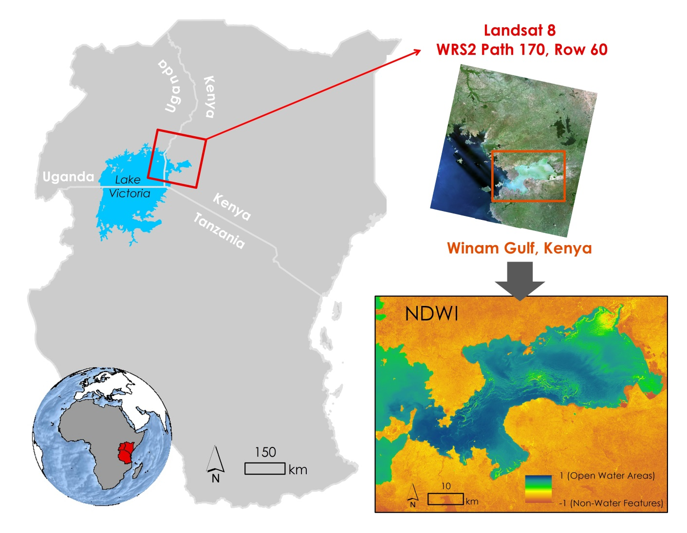

**Caption:** A wetness index highlighting areas with high chlorophyll activity in the focus study area. Image Credit: Lake Victoria Water Resources Team.

**Image:** 2015Fall_MSFC_LakeVictoriaWaterResources_HighlightImage.jpg

**Software Release Requirements**

What category do the tools your project is creating fall within? Category I