Jobos Bay Water Resources
Using Earth Observations to Analyze Shoreline Changes and Understand the Effects of Sea Level Rise in Southern Puerto Rico


Technical Report
Final Draft – August 12th, 2021

Olivia Spencer (Project Lead)
Ethan McGhee
Taylor Conklin
Dr. Liliana M. Hernández González
Andrew Altizer

Advisors:
Dr. Juan Torres Pérez, NASA Ames Research Center
Dr. Kenton Ross, NASA Langley Research Center

1. Abstract
Jobos Bay is located on the southern coast of Puerto Rico, which is known for intense hurricane seasons and increased seasonal storm surge. Scientists at Jobos Bay National Estuarine Research Reserve (JBNERR) are concerned that sea level rise will exacerbate coastal damage from these weather events. Using NASA Earth observations, our team analyzed coastal change, land use land cover change (LULC), mangrove forest extent, and water quality of Jobos Bay. Using Google Earth Engine, we evaluated coastal change and mangrove forest habitat within the study region by classifying NASA Earth observation imagery. We created historic LULC composite images to observe how land use changes over time and improve understanding of urbanization in the watershed. Leveraging previous water quality studies, our team compared water quality datasets generated by the Optical Reef and Coastal Area Assessment (ORCAA) tool to in situ sensors provided by JBNERR partners to understand the overall quality of water in the study area with respect to turbidity, chlorophyll-a, sea surface temperature, and colored dissolved organic matter (CDOM) concentrations. We discovered that 17% of the reserve has shifted from land to water since 1997 and lost 4.85 square kilometers of mangrove habitat over the past decade. Results from this study will inform the scientists of JBNERR and community members of the regional impacts of sea level rise. Being the first comprehensive study done in the estuary in nearly a decade, this serves as a baseline for future conservation efforts and research in the estuary.

Key Terms
climate change, remote sensing, mangroves, water-quality, Landsat, ORCAA, GEE, shoreline

2. Introduction
2.1 Background Information
Puerto Rico, located in the Caribbean and home to 3.2 million people, is experiencing sea-level rise (SLR), coastal erosion, water quality impairments, and changes in land cover. Earthquakes and intense hurricanes (e.g., Hurricane Irma and Hurricane María) have also impacted the Island in recent years, causing extensive floods, loss of human life and serious negative effects to its economy and biodiversity. Some of the most vulnerable ecosystems on the Island are its coastal wetlands and mangrove forests. Mangrove forests provide a range of benefits resulting in about $1.6 billion each year in ecosystem services globally (Costanza et al. 1997). However, over the last 50 years, the world has lost 20%-35% of mangrove extent due to degradation, deforestation, and natural events (Goldberg et al. 2020; Polidoro et al. 2010). In some regions, no loss has occurred since 2000, but in others, this loss continues, although at a much-reduced rate (Hamilton and Casey, 2016). A study measuring mangrove habitat for all of Puerto Rico conducted between 1997 and 2002 found that of 97 habitat sites, 47 increased, 30 did not change, and 20 decreased when measuring extent. (Martinuzzi, Gould, Lugo, & Medina, 2009).

Mangroves serve as habitat to diverse species and are known to minimize coastal erosion, protect communities and habitats from storm surges, and improve water quality. Likewise, scientists can use mangroves to study coastal dynamics as their position within the intertidal zone is primarily influenced by SLR. However, several studies indicate that fringe mangroves, for example, might not resist the highest scenarios of SLR between 0.52 and 0.97 m by 2100 (Koch et al. 2015; Sasmito et al. 2016). In Puerto Rico, the rate of SLR has increased from +0.175 cm/yr since 1995 to +0.725 cm/yr since 2005, and it is projected to rise more than 0.3 m by 2050 due to the melting of the polar ice caps as a result of climate change (Jury, 2018). As SLR continues to affect coastal communities, understanding coastal processes will aid policymakers in preventing loss and disruption in coastal regions. Moreover, mangrove’s extent is affected by other factors such as nutrients, sediments, and freshwater inputs from streams and rivers. These inputs are also dependent on land use land cover changes (LULC) in a watershed. Therefore, to enhance mangrove’s resilience and implement management practices, it is crucial to have a holistic understanding of historical human-induced and natural disturbances to the study area.

The southeastern coast of Puerto Rico, between Guayama and Salinas, has the second-largest estuary on the Island, Jobos Bay National Estuarine Research Reserve (JBNERR). The Reserve has key ecological features and marine habitats, including mangrove forests, seagrasses, coral reefs, and salt marshes, which are subject to natural and anthropogenic stressors. Changes in irrigation practices, a reduction in rainfall, point pollution sources from nearby industries, and an increase in urbanization have caused the death of mangroves in the Mar Negro Unit of the Reserve and water quality impairments (Kuniansky and Rodriguez, 2010). The region also has highly exposed coastlines and relatively low relief, making it especially vulnerable to SLR and potential coastal inundation. These challenges require the JBNERR staff to follow approaches that allow timely and accurate detection of changes in shoreline, mangrove extent, and water parameters that affect mangrove’s productivity such as turbidity and chlorophyll-a. Traditional methods for measuring shoreline changes in coastal environments relied on costly and time-consuming field surveys (Mitri et al. 2020). Multi-temporal imagery from satellites such as Landsat 7 Enhanced Thematic Mapper (ETM+), Landsat 8 Operational Land Imager (OLI), and Sentinel-2 MultiSpectral Instrument (MSI) allow the implementation of time-series analyses of coastal disturbances and the production of results in a relatively short time (Mitri et al. 2020). For this reason, this study used satellite remote sensing data to map environmental conditions from 1996 to 2021 that affect conservation practices in the Jobos Bay watershed.

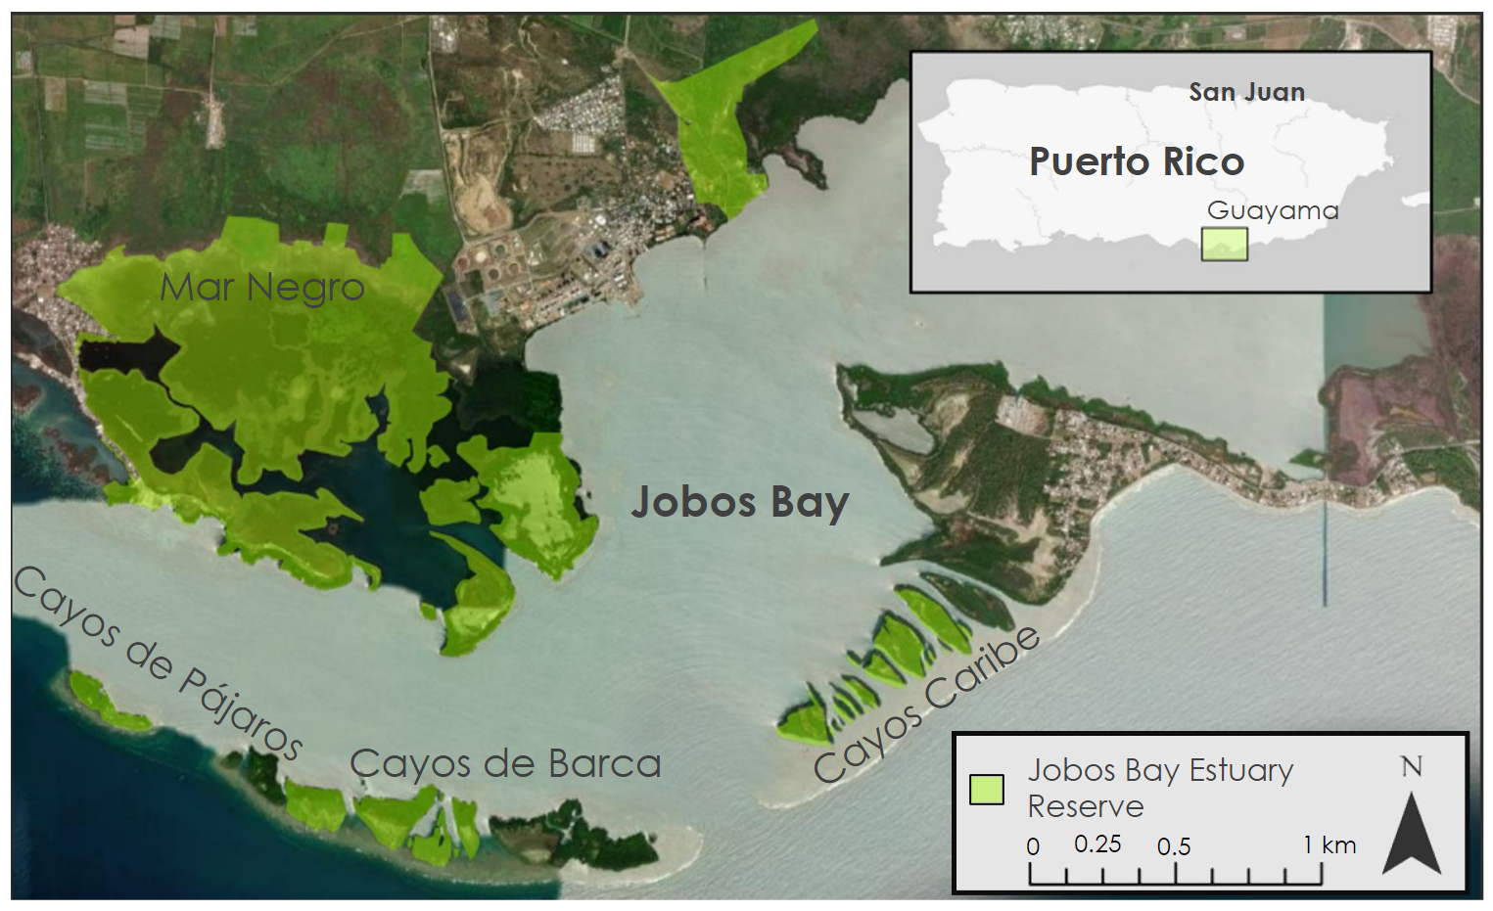
Figure 1. Study area of Jobos Bay, Puerto Rico. (Data source: Caribbean Landscape Conservation Cooperative, 2015).

2.2 Project Partners & Objectives
In order to support coastal protection efforts in Southern Puerto Rico, our team partnered with JBNERR, which is managed by the Puerto Rico Department of Natural and Environmental Resources and the National Oceanic and Atmospheric Administration (NOAA) Office of Coastal Management. Reserve staff conducts research and provides outreach and monitoring services to manage Puerto Rico’s coastal resources, local watersheds, and wetlands. Currently, they use drone imagery and in situ field collections to inform their decision-making. In situ measurements include water quality parameters (e.g., salinity, turbidity, and dissolved oxygen) collected using automatic sondes and a weather station for meteorological data. This project’s goal is to use NASA Earth observations to contribute to JBNERR’s mission of protecting Jobos Bay. Specifically, we aimed to observe coastal change of Jobos Bay over time, provide updated land use and land cover (LULC) composite imagery, highlight local mangrove extent change over time, and evaluate water quality parameters including turbidity and chlorophyll-a levels in the Jobos Bay watershed. This will enhance understanding of how shorelines, land cover, and water quality have changed over time in order to better protect natural resources and wildlife.

3. Methodology
3.1 Data Acquisition
To complete our project objectives of observing coastal change and mangrove extent over time, evaluating water quality parameters, and creating high-resolution LULC maps, we used multiple satellites and ancillary datasets. A list of the observation platforms and sensors we used in this work is shown in Table 1. Additionally, we obtained ancillary datasets from the U.S. Army Corps of Engineers (USACE), NOAA, and Esri to assist in the map creation process. The team downloaded a 2018 topobathy Light Detection and Ranging (LiDAR) dataset by USACE via NOAA to be used in water quality parameter visualizations. For LULC mapping, we downloaded land cover data from the Esri 2020 Land Cover dataset and the NOAA Coastal Change Analysis Program (C-CAP) (Karra, Kontgis et al. 2021; NOAA Office for Coastal Management).
We utilized data acquired between 2017 to 2021 from Sentinel-2 MSI satellites to produce a time series analysis of water quality parameters in Jobos Bay. Due to the sheer volume of imagery, downloading the images on local computers was an impracticable method for data acquisition. With this in mind, the team decided to acquire the satellite imagery using Google Earth Engine (GEE). GEE is a cloud-based service that archives a variety of remote sensing datasets, which provides the opportunity to utilize Google’s advanced computing infrastructure to conduct the analysis. The team processed the data within GEE to create a time series analysis using images from Sentinel-2. We filtered the dataset to only include images of the Jobos Bay study area. Additionally, our partners provided us with in situ water quality and meteorological data that includes turbidity, salinity, and chlorophyll-a measurements collected through the NERRS from four stations within Jobos Bay over five years, from 2017 to 2021 (NOAA National Estuarine Research Reserve System). We also utilized GEE to observe land use changes in Jobos Bay and its surrounding areas. To highlight land cover changes, we acquired Sentinel-2 imagery with <20% cloud cover for desired region and time frame of the study. We also obtained a total of 1,029 atmospherically corrected surface reflectance images from Landsat 5 Thematic Mapper (TM), Landsat 7 ETM+, and Landsat 8 OLI satellites to visualize coastal changes in Jobos Bay between 1997 to 2020. These images are from the Collection 1, Tier 1 Landsat data products.

Table 1. Satellite and sensor parameters used to evaluate water quality, land use changes, and coastal change in Jobos Bay.
Satellite & Sensor | Variable | Resolution | Dates
Sentinel-2 MSI | Chlorophyll-a, turbidity, and CDOM | 10 meters, 30 meters | 2017-04-01 to 2021-07-30
Landsat 5 TM | NDWI and MNDWI | 30 meters | 1996-01-01 to 2013-01-01
Landsat 7 ETM+ | NDWI, MNDWI, NDVI, Simple Ratio, Ratio54, Ratio35, GCVI | 30 meters | 1999-01-01 to 2020-12-31
Landsat 8 OLI | Turbidity, NDWI, MNDWI, NDVI, Simple Ratio, Ratio54, Ratio35, GCVI | 30 meters | 2013-04-11 to 2020-12-31

3.2 Data Processing

3.2.1 Coastal Change
Prior to conducting analysis, we loaded surface reflectance images from Landsat 5 TM, Landsat 7 ETM+, and Landsat 8 OLI into GEE and applied cloud and cloud-shadow masking algorithms provided by GEE, which assigns cloud cover pixels to “no data” in order to prevent misclassification. We filtered the cloud masked images to the study area and period to create composite collections. Spectral bands selected for this analysis had wavelengths in the green, near-infrared, and short-wave infrared spectrum. Therefore, we renamed these bands “green”, “NIR”, and “SWIR”, respectively. Afterwards, we merged composite collections for each satellite into a single collection to calculate the Normalized Difference Water Index (NDWI) (Mcfeeters, 1996) and the Modified Normalized Difference Water Index (MNDWI) (Xu, 2007). These spectral water indices are used to detect surface water extent and differentiate between land and water features in remotely sensed images. We calculated NDWI and MNDWI as follows:

$NDWI = \frac{Green - NIR}{Green + NIR}$ (1)

$MNDWI = \frac{Green - SWIR}{Green + SWIR}$ (2)

Subsequently, we reclassified the water indices by assigning 0 to pixels less than zero, representing the land, and 1 to pixels greater or equal to zero, identifying water features. We merged the raster collections of NDWI and MNDWI into one collection then parsed it into years from 1997 to 2020. Then, we determined the mean value between both indices to obtain a single raster collection per year. This single raster collection represented the coastline of Jobos Bay for a given year. We applied a threshold to each raster collection to correct for visual artifacts in satellite imagery. The threshold we applied is as follows: if the pixel value is less than 0.12, then the pixel value is equal to 0, and if the pixel value is greater than 0.88, then pixel value is equal to 1. These thresholded images are mostly binary with some intermediate values showing the interface between land and water. After processing the images in GEE, we exported them as GeoTIFFs and uploaded them into ArcGIS Pro.

3.2.2 Water Quality
The team created a shapefile mask using a 2018 topobathy LiDAR dataset by the USACE via NOAA. Using this mask, our team removed bathymetry values between zero and two meters of depth to eliminate incorrect readings from the final outputs. In order to accurately compare the in-situ and remote sensing water quality data, we averaged the in-situ turbidity data daily, the in-situ sea surface temperature data weekly, and the in-situ chlorophyll-a data monthly. Additionally, the team removed any outlying in-situ data with a z-score higher than 3 or lower than -3.

3.2.3 Mangrove Extent
Our team created a composite image of Jobos Bay Estuary and surrounding landscapes using Landsat 8 and Landsat 7 data. We selected an image collection for the ten-year range of 2010 to 2020. This image collection was then clipped to the area of the study region, as well as filtered for lowest cloudy days. Next, using a “median pixel” process in (GEE), we flattened the collection into one image and the median value for the stacked pixels are calculated and represented in the new raster. Once flattened, we uploaded the image into GEE and processed the image for each time series with a random forest classification model developed by NASA’s Applied Remote Sensing Training (ARSET) program. This model runs a set of seven (7) known mangrove spectral analysis indices, shown in Table A1, against land cover types identified and supervised by our team. The model then returns its confidence value and geospatial reference points as an exported GeoTIFF to confirm or deny accuracy. Our team executed an accuracy classifier plugin inside of QGIS, which we then utilized to visualize the geospatial reference points exported by the self-learning machine model. We compared these points to the imagery and evaluated how well the machine-learned classification worked by assigning “1” or “0” for “yes” and “no'' respectively to each point to confirm or deny if the point is mangrove or not. Once done, the value of accuracy is displayed as a percentile out of a total of 300 points checked. We reclassified and supervised the imagery until a threshold of >90% accuracy was reached.

3.2.4 LULC
We created a Land Use/Land Cover change composite imagery for Jobos Bay (Figure K1) using European Space Agency (ESA) Sentinel-2 data at 10-meter resolution. We chose this dataset as it allows for a more accurate composite to be created in comparison with Landsat imagery. After the imagery was collected, we clipped it to the study area and filtered for lowest cloudy days using GEE. This cloud removal smooths reflectance values of clouds and reduces data uncertainty over longer periods of time. We used a “Median pixel” algorithm in Google Earth Engine (GEE) that flattens the image collection. We calculated the layered pixels to represent the median value for the stacked pixels as a single image. The team then used that image to design a LULC classification theme with ten classes that closely matched the thematic composite created by NOAA’s C-CAP for their 2010 30 Meter Land Cover product of Puerto Rico. The GEE random forest classification plugin creates classification points and polygons and the composite is made using a machine learning algorithm. The machine-created output was then analyzed for accuracy, comparing points of known land cover type to points of machine learned land cover type. This process of create> run> refine> validate was repeated until a satisfactory accuracy of 70.1% was reached.

3.3 Data Analysis

3.3.1 Coastal Change
After obtaining classified images showing water and land for each year in the study period, we used ArcGIS Pro to quantify the coastal changes from 1997 to 2020 in Jobos Bay. We calculated the change by using the Raster Calculator tool and subtracting the “final” raster from the “initial” raster. Following this approach, we were able to produce maps showing annual and three-year coastal changes within Jobos Bay. Calculating annual change allowed us to create a yearly time lapse to visualize coastal change throughout the study period. Likewise, we created a 23-year difference raster to visualize and quantify the major coastal changes within the Bay during our study period. In addition, we determined the percentage of the JBNERR area that changed from land to water or from water to land to understand the erosion and accretion (i.e., build-up of sediments) cycles in Jobos Bay. The team also correlated annual coastal changes with major natural and anthropogenic events that occurred within the Jobos Bay watershed.

3.3.2 Water Quality
The team created time-series analyses for the in-situ chlorophyll-a, turbidity, and sea surface temperature data at all four stations from 2010 to 2021. Additionally, we used the ORCAA tool to generate time-series analyses for the same water parameters, as well as CDOM, for the geometries we drew within GEE from 2017 to 2021. To analyze these two sets of data, we created linear regressions to compare the in-situ data to the remote sensing data for each of the water parameters at each of the stations and calculated their respective correlation coefficients.

To display the turbidity and CDOM water parameters from 2017 to 2021, our team modified the 2019 ORCAA tool to collect a median average among different time ranges. Our partners were interested in comparing the wet and dry seasons, so our analysis was focused on averaging the parameters between April through October for the wet season and December through March for the dry seasons. Additionally, in-situ meteorological wind direction data provided by JBNERR was analyzed over a year's time range, using recordings from July 2020 to July 2021, which is shown in Figure I2.

3.3.3 Mangrove Extent
Using the composite images processed in GEE, we highlighted and compared the observed mangrove extent for 2010 against the extent observed for 2020. The two observations identified that overall mangrove habitat has been lost since 2010, but in the most recent three years (2018, 2019, 2020) has shifted towards annual growth. Mangrove habitat was observed at steady rates of decline from 2010 to 2017 with greater than average loss observed in years 2013 and 2017. Mangrove extent saw a shift to steady growth from 2018 to 2020 after recovering from Hurricane Maria which correlates to increased conservation efforts and improved water quality in Mar Negro. However, sizeable regions on the Eastern shores of Jobos Bay and the Western shores of Mar Negro saw more than average loss (Figure J1) despite overall growth in the estuary in the last 3 years. These anomalous regions are known areas of anthropogenic activities and could possibly correlate human activities with mangrove loss. To further understand what is driving that loss, we increased the resolution of composite images and compared them to standard visual imagery to understand urban sprawl within mangrove habitat vicinity. Additionally, we compared the regions that saw major mangrove loss to land change observations and water quality observations. Our team specifically chose imagery collection periods for the 11 months before and after Hurricane Maria made landfall in September of 2017 for analysis in this study (Figures, J2 and J3). Using this comparison, we compared the NDVI index values for Jobos Bay Estuary on a composite to visualize the change in mangrove habitat caused by tropical cyclones.

3.3.4 LULC
We created a 10-m resolution LULC product for JBNERRs records. We analyzed the accuracy and fidelity of our work by comparing it to several other data sets. First, we acquired the Esri 2020 Land Cover (Figure K1) product equivalence for our study region and time, which was derived from ESA Sentinel-2 imagery (Karra, Kontgis et al. 2021). Despite the finer resolution of the Esri product, our team was able to compare our results to that of an industry leader and see how we performed in our analysis. The composite created by the team far exceeded the composite Esri had produced in both accuracy and effective resolution (perhaps due to aggressive image segmentation in the Esri product). One difficulty with the increased resolution was seen in the varying types of “sediment” covered land: mudflats, dirt roads, agricultural, and barren land. To better represent the reality versus what the data suggested, it was observed that the machine learning algorithm was classifying mudflats along the southern barrier islands as agricultural regions. Knowing no agricultural regions exist on these islands, a mask was created, and those regions were reclassified to mudflats. This post-processed composite represented the land coverage best for 2020 and we compared it to the land coverage map (Figure K2) created by NOAA’s Coastal Change Analysis Program (C-CAP). The comparison allowed our team to derive statistics that JBNERR can use to understand how land is changing and being utilized in the Jobos Bay watershed.

4. Results & Discussion
4.1 Analysis of Results

4.1.1 Coastal Change
The coastal change analysis conducted for JBNERR shows significant changes in the Mar Negro Unit since 1997 (Figure 2). While the majority of land has not experienced drastic change, 8% of the Reserve has seen a major shift towards land with 17% showing a major shift towards water. These results suggest that this estuarine wetland ecosystem is experiencing coastal inundation and erosion. In general, the northwestern and southern parts of Mar Negro have shifted from land to water. In contrast, the east region of Mar Negro has seen an increase in land cover. This increase in land cover is associated with the extension of black mangroves (Avicennia germinans) and red mangroves (Rhizophora mangle) in the region in recent years due to restoration efforts conducted by JBNERR staff at the beginning of the 2000s.

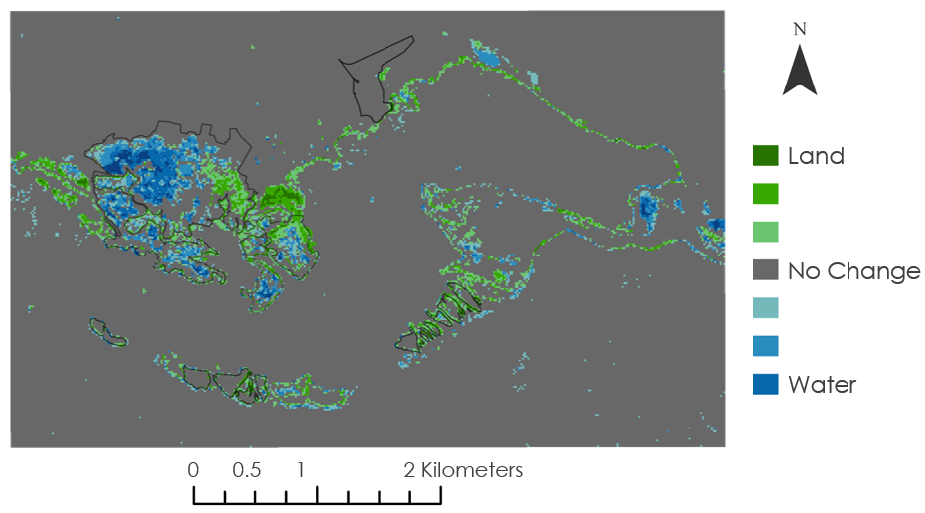
Figure 2. Coastal change analysis for the last 23-years in JBNERR from 1997 to 2020. The formal boundaries of the Reserve are shown in black. Green color indicates changes towards increasing land and blue shows changes towards increasing water.
The three-year coastal changes in JBNERR indicates that Jobos Bay is a highly dynamic ecosystem as it can be influenced by many factors such as tidal, river flow, sea-level rise, and anthropogenic events (Figure L1). Therefore, we compared changes in coastal land cover classes with major natural and human-derived events during the 23-year period. These events are identified by dashed lines in Figure 4. Water pixels are in blue at the top of the graph, and land pixels are in green color at the bottom. These land cover classes are defined by the thresholded values for NDWI and MNDWI. In 2016, for example, Puerto Rico experienced a severe drought that could have caused the decrease in water in Jobos Bay. Also, we can observe an increase in water after Hurricanes Maria and Irma struck the island in 2017.
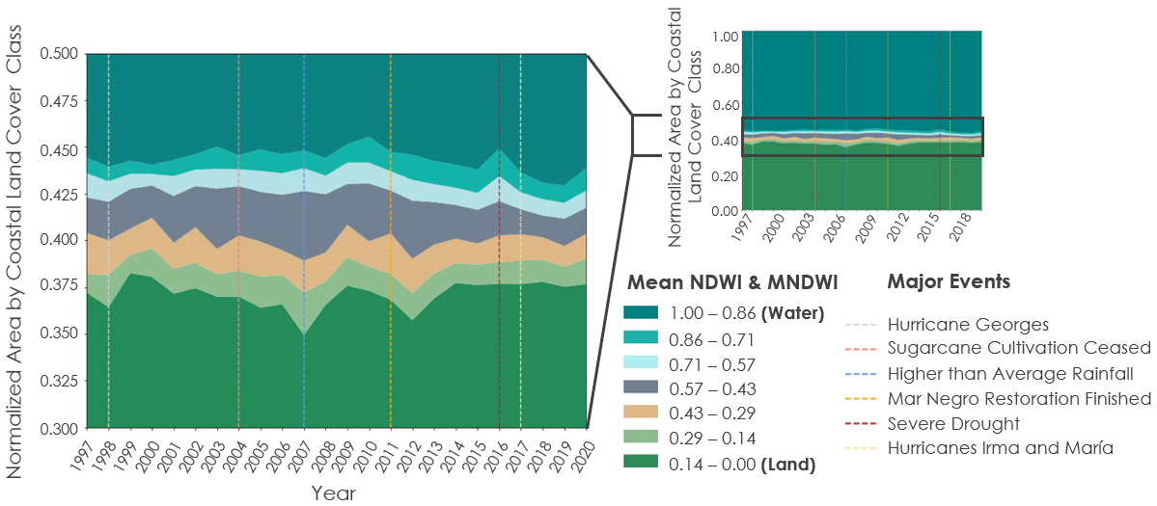
Figure 3. Changes in coastal land cover classes correlated with major natural and anthropogenic events during the 23-year period. Major events are indicated by vertical dashed lines.
4.1.2 Water Quality
The water quality analysis conducted for JBNERR shows a gradual increase in turbidity and CDOM values from 2017 to 2021 (Figure 4 & Figure I1). While major events such as Hurricane Maria in the wet season of 2017 highlight extreme values throughout the bay, the general trend shows the northeast inlet displaying higher values of turbidity and the northern bay displaying higher values of CDOM. Several factors can explain this phenomenon. Meteorological factors such as wind cardinal direction and heightened boat activity can explain the increase in turbidity values. Jobos Bay’s wind heavily favors the eastern cardinal direction (Figure I2), and the main port in Jobos Bay is located in this area. Both of these factors contribute to heightened turbidity values. Additionally, the West Indian Manatee (Trichechus manatus) populations are commonly found in the northern bay and the northeastern inlet, contributing both to turbidity and CDOM concentrations. CDOM is more concentrated in the northern bay as it is located adjacent to the national reserve (Reserva Nacional de Investigación Estuarina de Bahía de Jobos), which produces more decaying organic matter than other regions of Jobos Bay.

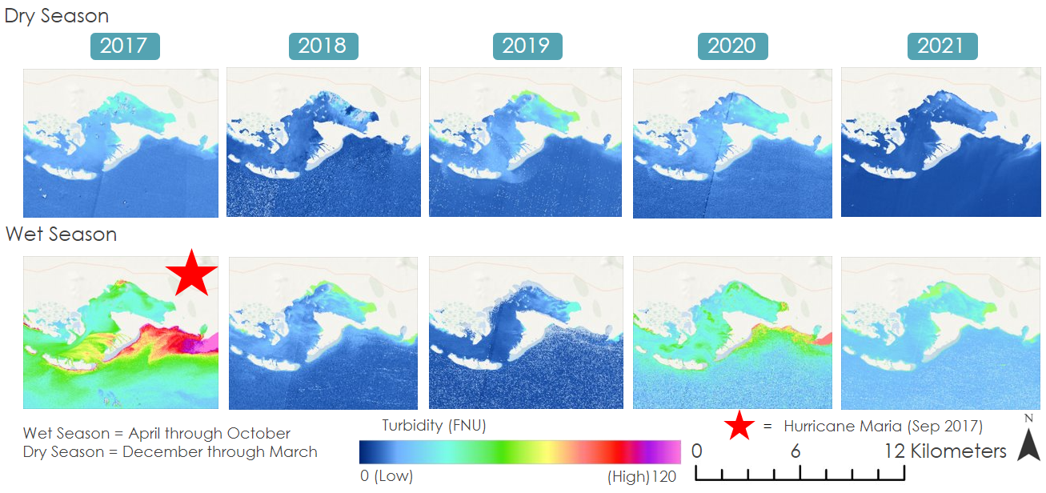
Figure 4. Turbidity concentrations averaged by Wet & Dry seasons from 2017 – 2021.
In addition to the visualizations of turbidity and CDOM, the comparisons between the in-situ (Figures C1-4) and ORCAA-generated (Figures 5, D1-2, E1-3, F1-3, and G1-3) remote sensing time-series analyses allowed us to assess the feasibility of remote sensing techniques for analyzing water quality within small areas such as Jobos Bay. The linear regression comparing the two datasets for turbidity (Figures H1-3) and chlorophyll-a (Figures H7-9) showed low correlation values for all three stations, with R values for turbidity being 0.27, -0.012, and 0.028, and R values for chlorophyll-a being -0.23, -0.26, and -0.37, for Stations 10, 19, and 20, respectively. Sea surface temperature (Figures H4-6), on the other hand, had strong correlation values, with Stations 10, 19, and 20 having R values of 0.75, 0.89, and 0.76, respectively. This is a good indicator that using remote sensing to evaluate turbidity and chlorophyll-a within Jobos Bay will not produce accurate data. Remote sensing provides us with more accurate sea surface temperature values, however the correlations between the in-situ and remote sensing data are not extremely high, indicating that there may be limitations in using remote sensing for this parameter.
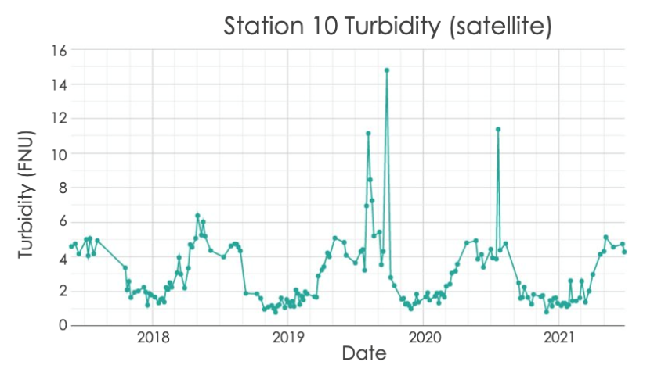
Figure 5. Turbidity time-series analyses generated in GEE by the ORCAA tool from April 1st, 2017, to July 1st, 2021, at Station 10.

While conclusions for turbidity and CDOM were accurately represented for the study area as a whole, smaller sub-areas of interest produced errors and inconclusive results. This may be partly explained by reflection from the shallow sea floor benthic reflectance, which can distort satellite-derived water quality parameters. Because ORCAA does not include an algorithm to correct water quality parameters for benthic reflectance within the shallow reef areas of the Bay, these areas were removed from our results. Additionally, cloud-masking and atmospheric correction of remote sensing data remains a source of error, as different algorithms and study areas produce different results and outputs. Currently, there are no advanced cloud-masking algorithms available for Sentinel-2 data in GEE. We also experienced some spatiotemporal limitations when creating the time-series analyses. Remote sensing techniques were difficult to apply to Jobos Bay due to the small spatial extent of some of the water quality stations. Consequently, we were unable to compare in-situ and remote sensing data for all stations. In addition, we were only able to compare in-situ and remote sensing data within a four-year span because Sentinel-2 does not have data before 2017 for the water parameters we evaluated. Temporal limitations also posed a challenge for chlorophyll-a, with very few data points which may contribute to a low correlation between the in-situ and remote sensing data.
4.1.3 Mangrove Extent
Our team was able to observe the fragile nature of the Jobos Bay Mangrove Ecosystem through NASA Earth observations. Initially, we observed that over the study period of ten years, mangrove habitat had seen a loss, dropping to 3.97 km² in 2020, a 55% decrease from its starting area of 8.82 km² seen in 2010 (Figure 6). The years following 2010 saw steady decline, with a steep anomalous decline in mangrove habitat in 2013 (Figure J1). This loss was compared to coastal change time series produced in this project and is correlated to an observed loss in coastal lands for the same time and region (Figure 4). In 2014 mangrove habitat began to see growth at a slow rate (~0.75 km² per year) until Hurricane Maria made landfall just east of Jobos Bay in September of 2017. This tropical cyclone is correlated to a loss of 1.9 km² of mangrove habitat in the year 2017 alone, more than 200% the observed average loss rate in years prior (Figure J2, J3). By 2019, stabilization in the mangrove ecosystem began to occur and the area saw growth and return of healthy mangrove habitat at low rates (0.3 km² per year). The slow return of mangrove habitat is observed to continue until present, highlighting the success of current conservation efforts within the study area, specifically Mar Negro. In conclusion, we observed a direct correlation between mangrove habitat loss and urban growth, especially in Mar Negro’s western shores (Figure J4). In the northeast corner of Jobos Bay mangrove forests have degraded tremendously (Figure 6). Possible drivers of loss in this area could be correlated to changes in the water quality of the watershed in Jobos Bay and surrounding areas. This specific focus area is fed by seasonal creeks and other natural runoffs that are exposed to anthropogenic contaminants as they travel towards the coast (Figure J5). Additionally, observed loss of the mangrove ecosystem can be correlated to high turbidity content in the bay, directly resulting in degraded water quality caused by a lack of mangrove root systems acting as natural filtration systems. Areas unprotected and nearest to urban sprawl, anthropogenic activity, and agriculture are correlated to loss (Figure J4); mangrove habitat in these regions should be considered high priority for conservation efforts and community outreach.

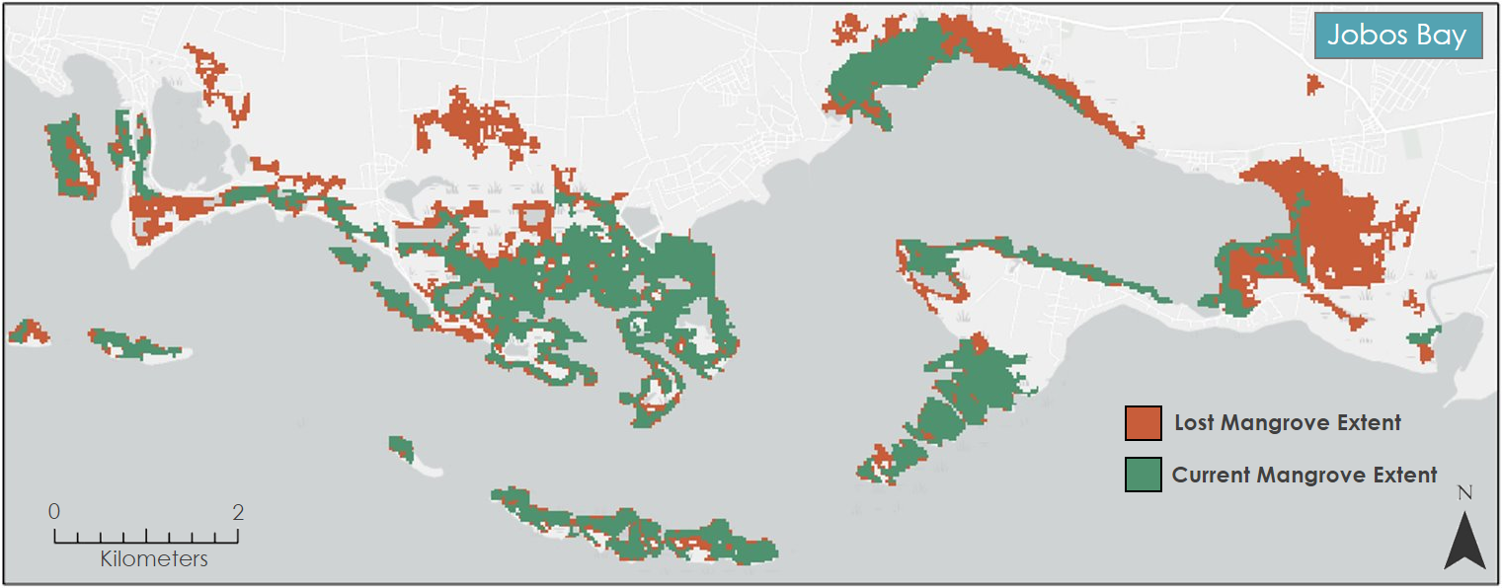
Figure 6. Jobos Bay Mangrove Extent (2010 Orange, 2020 Green).
4.1.4 LULC
We produced accurate, composite imagery of the study area to serve as a guideline for JBNERR and to conduct a comparative analysis of how land usage, and land cover has shifted over the last ten years. In general, we found that the majority of the Jobos Bay watershed is covered by forested land, agriculture, grasslands, and urban buildup with 11%, 10%, 8% and 7% of the land cover, respectively (Figure 7). The LULC part of this project serves to inform JBNERR and the surrounding communities of land usage and change with emphasis on a final composite image that accurately portrays the study region and its land coverage today (Figure 7).
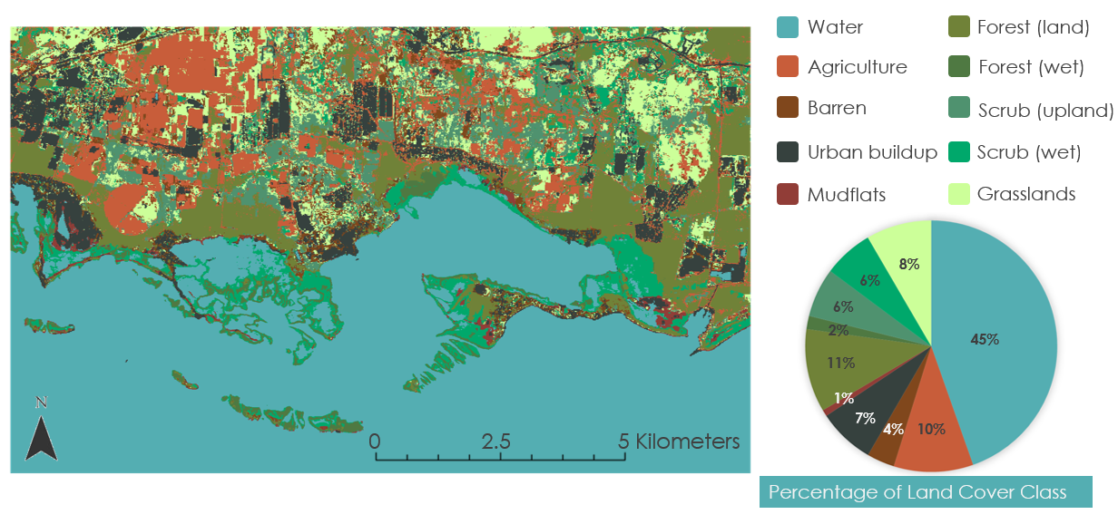
Figure 7. 10-meter resolution LULC map from 2020 for the Jobos Bay Watershed with 10 land cover classes.
In an effort to compare our work to pre-existing, authoritative land cover data, we created a comparison between our 2020 classification and a global land cover dataset created by Esri using Sentinel-2 imagery (Figure K1). From this, we concluded that our classification provides a more detailed classification that will provide more information to JBNERR scientists. Because Jobos Bay is a fairly small study area and the Esri dataset provided global coverage, it makes sense that our random forest classified output is more detailed. Additionally, we evaluated how each land cover type has shifted over the 10-year period by comparing the 2010 C-CAP product vs the 2020 DEVELOP product. In general, we see a decrease in forested wetlands and grasslands but an increase in scrub wetlands and forested uplands (Figure K3). ​

4.2 Future Work
While our work highlights important ecological and geologic trends in Jobos Bay, future work could build upon this project to better understand coastal change, water quality, mangrove extent, and LULC. To explore coastal change deeper, future work could involve delineating shoreline change over time and identifying erosion or accretion between time periods using historical imagery and NASA Earth observations. Our project shows overall coastal change and it would be beneficial to focus more on the shoreline itself through digitizing work. Historical imagery could allow an expansion of the study period, looking at shorelines prior to 1997. ​Additionally, analyzing water quality parameters near mangrove loss areas could increase understanding of mangrove loss drivers and benefit conservation efforts. Mangrove habitat identified as “in-decline” could be better understood with increased soil sampling and in-situ water sensors in the estuary as JBNERR monitors mangrove habitat in the future. With this, measurements of plant biomass could serve as a validation technique of the remote sensing measurements. A final route for deeper exploration could involve using a random forest classifier on Landsat 7 imagery to create a more in depth LULC change analysis rather than relying on ancillary datasets already available.
5. Conclusions
From our findings, the team found that Jobos Bay is prone to coastal change as it pertains to SLR, water quality, mangrove forest habitat, and LULC. Through extensive analysis producing a yearly and overall coastal change time series, we found that Jobos Bay has experienced a great deal of shifting from land to water coverage (17%), especially following hurricane events. This is important to understand in the face of climate change to best mitigate coastal erosion in the coming years. Alongside this finding, we also witnessed significant changes in water quality parameters in relation to large hurricane events, suggesting the same could be true with hurricanes in the future. While we were able to visualize turbidity and CDOM well utilizing remote sensing techniques, this was not the case with chlorophyll-a or sea surface temperature, which suggests limitations with relying solely on satellite imagery for this type of analysis in small study areas. Remote sensing can provide some insight, but using in-situ data in conjunction with these visualizations provides a better view of water quality in Jobos Bay. Another important finding from this project highlighted large loss in mangrove forest habitat over the last decade. Given the important role of mangrove forests in ecosystem functioning and coastal erosion protection, the loss of habitat highlights the importance of protecting and restoring mangrove forests. Lastly, our analysis of LULC uncovered the importance of high-resolution satellite imagery in classifying land use in smaller study areas.
6. Acknowledgments
Our team would like to thank our partners from JBNERR, especially to Milton Muñoz Hincapié, Aitza E. Pabón Valentín, and Angel Dieppa, for the opportunity to support their conservation work, as well as the datasets and feedback provided. In addition, our team is grateful for the advice and support that we received from our science advisors, Dr. Juan Torres Perez, Dr. Kenton Ross, and Lauren Childs-Gleason. We also appreciate the help that the NASA DEVELOP Senior Fellow, Hayley Pippen, provided us regarding the ORCAA tool. Additionally, we thank the LaRC Assistant Fellow, Egla Ochoa-Madrid, for assisting us in translating an ArcGIS StoryMap into Spanish for the partners to use in decision-making. Lastly, we would like to express our gratitude to our LaRC Fellow, Adriana Le Compte, for her continuous encouragement, leadership, and guidance throughout this project.
This material contains modified Copernicus Sentinel data (2017-2021), processed by ESA. Any opinions, findings, and conclusions or recommendations expressed in this material are those of the author(s) and do not necessarily reflect the views of the National Aeronautics and Space Administration (NASA). This material is based upon work supported by NASA through contract NNL16AA05C.

7. Glossary
CDOM (Colored Dissolved Organic Matter) - Optically measurable component of dissolved organic matter in water.
Chlorophyll-a - Measure of the amount of algae growing in a waterbody.
Earth observations - Satellites and sensors that collect information about the Earth’s physical, chemical, and biological systems over space and time
GCVI (Green Chlorophyll Vegetation Index) - Index used to measure leaf chlorophyll content in plants based on the near-infrared and green bands.
Google Earth Engine (GEE) - Platform for scientific analysis and visualization of geospatial datasets for academic, non-profit, business and government users. GEE hosts satellite imagery and stores it in a public data archive.
In-Situ Data - Data collected in the original place/position.
Landsat - USGS and NASA enterprise satellite system for moderate-resolution optical remote sensing for land, coastal areas, and shallow waters.
LiDAR (Light Detection and Ranging) - Remote sensing method to create digital 3-D representations of areas on the earth’s surface and ocean bottom.
LULC (Land Use/Land Cover) - Physical composition and characteristics of land elements on the Earth (e.g., forests, wetlands) or human related activities (e.g., residential, commercial, educational).
NASA ARSET - NASA Applied Remote Sensing Training Program
NDVI (Normalized Difference Vegetation Index) - Index to assess whether the target being observed contains vegetation.
NDWI (Normalized Difference Water Index) - Index used to differentiate water from land.
MNDWI (Modified Normalized Difference Water Index) - Index used to differentiate water from land.
ORCAA (Optical Reef and Coastal Area Assessment) - Tool in GEE to monitor and evaluate water quality changes and advise coastal management decisions
Sentinel-2 - Earth observation mission from the Copernicus Programme that acquires optical imagery at high spatial resolution over land and coastal waters.
Turbidity - Measure of the relative clarity of a liquid.

8. References
Barenblitt, A.; Fatoyinbo, T. (2020). Remote Sensing for Mangroves in Support of the UN Sustainable Development Goals. NASA Applied Remote Sensing Training Program (ARSET) https://appliedsciences.nasa.gov/join- mission/training

Costanza, R., D’Arge, R., De Groot, R., Farber, S., Grasso, M., Hannon, B., … Van Den Belt, M. (1997). The value of the world’s ecosystem services and natural capital. Nature, 387(6630), 253–260. https://doi.org/10.1038/387253a0

Goldberg, L., Lagomasino, D., Thomas, N., & Fatoyinbo, T. (2020). Global declines in human-driven mangrove loss. Global Change Biology, 26(10), 5844–5855. https://doi.org/10.1111/gcb.15275

Hamilton, S. E., & Casey, D. (2016). Creation of a high spatio-temporal resolution global database of continuous mangrove forest cover for the 21st century (CGMFC-21). Global Ecology and Biogeography, 25(6), 729–738. https://doi.org/10.1111/geb.12449

Jury, M. R. (2018). Puerto Rico sea level trend in regional context. Ocean and Coastal Management, 163, 478–484. https://doi.org/10.1016/j.ocecoaman.2018.08.006
Karra, K., Kontgis, C., Statman-Weil, Z., Mazzariello, J., Mathis, M., & Brumby, S. (2021). “Global land use/land cover with Sentinel-2 and deep learning.” IGARSS 2021-2021 IEEE International Geoscience and Remote Sensing Symposium.
Koch, M. S., Coronado, C., Miller, M. W., Rudnick, D. T., Stabenau, E., Halley, R. B., & Sklar, F. H. (2015). Climate Change Projected Effects on Coastal Foundation Communities of the Greater Everglades Using a 2060 Scenario: Need for a New Management Paradigm. Environmental Management, 55, 857–875. https://doi.org/10.1007/s00267-014-0375-y

Kuniansky, E. L., & Rodriguez, J. M. (2010). Effects of Changes in Irrigation Practices and Aquifer Development on Groundwater Discharge to the Jobos Bay National Estuarine Research Reserve near Salinas, Puerto Rico. In Scientific Investigations Report. https://doi.org/10.3133/SIR20105022

Martinuzzi, S., Gould, W. A., Lugo, A. E., & Medina, E. (2009). Conversion and recovery of Puerto Rican mangroves: 200 years of change. Forest Ecology and Management, 257(1), 75–84. https://doi.org/10.1016/J.FORECO.2008.08.037

Mitri, G., Nader, M., Abou Dagher, M., & Gebrael, K. (2020). Investigating the performance of Sentinel-2A and Landsat 8 imagery in mapping shoreline changes. Journal of Coastal Conservation, 24(3), 1–9. https://doi.org/10.1007/s11852-020-00758-4

NOAA National Estuarine Research Reserve System (NERRS). System-wide Monitoring Program. (n.d.). Water Quality Data for Jobos Bay. Retrieved July 1, 2021, from http://www.nerrsdata.org/

NOAA Office for Coastal Management (2017). 2010 C-CAP 30 Meter Land Cover of Puerto Rico.
Retrieved from https://coast.noaa.gov/digitalcoast/data/
Pippin, H, Olarte, A, Pilot, R, & Valenti, V. (2019) Developing a Google Earth Engine Dashboard for Assessing Coastal Water Quality in the Belize and Honduras Barrier Reefs to Identify Adequate Waste Control and Inform Coastal Resource Monitoring and Management.

Polidoro, B. A, Carpenter, K. E, Collins, L, Duke, N. C, Ellison, A. M, Ellison, J. C, … Yong, J.W.H (2010). The loss of species: Mangrove extinction risk and geographic areas of global concern. PLoS ONE, 5(4), 10095. https://doi.org/10.1371/journal.pone.0010095

Puerto Rico Water Resources Environmental Research Institute. (2013). Detailed Land Use and
Habitat Inventory, 2012 of the JBNERR watershed. Retrieved from
htpp://geodec.com/jbnerr2012/final_report_JBNERR2012.pdf

Sasmito, S. D., Murdiyarso, D., Friess, D. A., & Kurnianto, S. (2016). Can mangroves keep pace with contemporary sea level rise? A global data review. Wetlands Ecol Manage, 24, 263–278. https://doi.org/10.1007/s11273-015-9466-7

9. Appendices

Appendix A

Table A1. NASA ARSET mangrove forest indices and uses.
 | Indices | Bands | Use
NDVI | Normalized Difference Vegetation Index | Red and NIR | Quantifies Vegetation
NDMI | Normalized Difference Moisture Index | NIR and SWIR | Vegetation Water Content
MNDWI | Modified Normalized Difference Water Index | Green and SWIR | Water Information
SR | Simple Ratio | Red and NIR | Simple Vegetation Index
Ratio54 | Band Ratio 54 | SWIR and NIR | Maps Water Features
Ratio35 | Band Ratio 35 | Red and SWIR | Maps Water Features
GCVI | Green Chlorophyll Vegetation Index | NIR and Green | Green Leaf Biomass

Appendix B

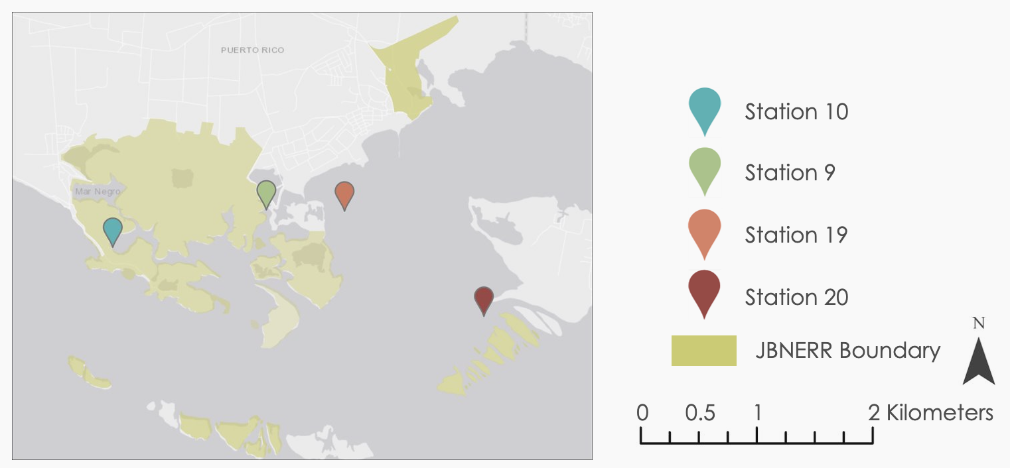
Figure B1. Map of Jobos Bay with the four currently active water quality stations color coded.

Appendix C

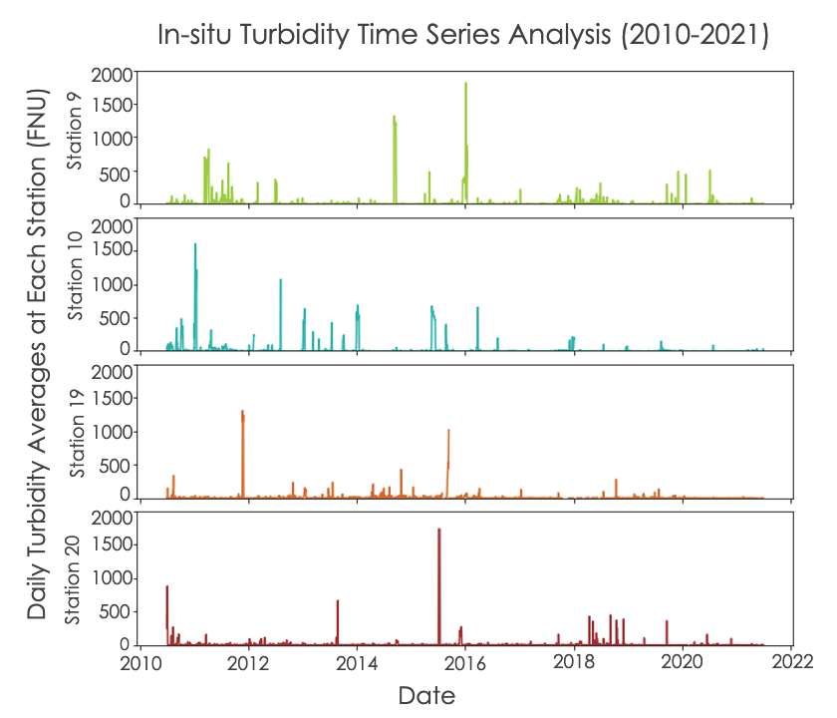
Figure C1. In-situ time series analyses for turbidity at Stations 9, 10, 19, and 20, from 2010 to 2021, averaged daily without outliers removed.
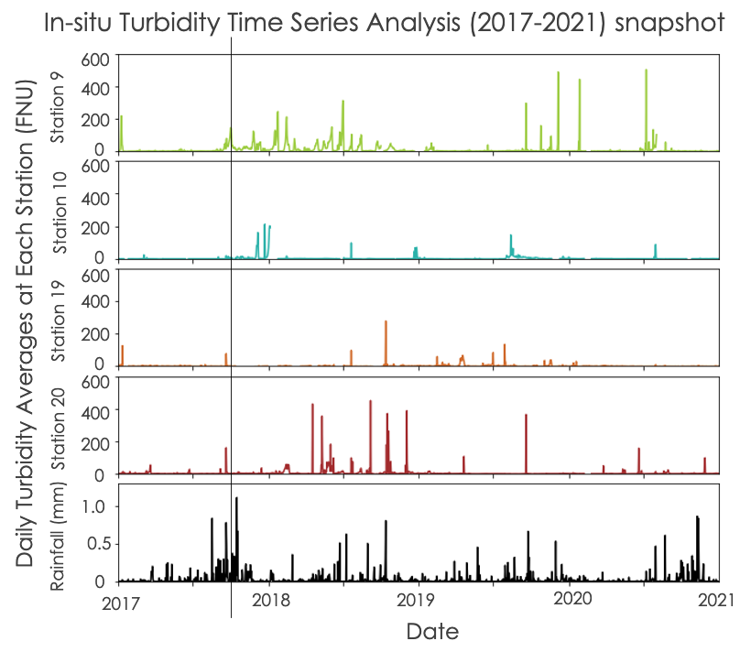
Figure C2. In-situ time series analyses for turbidity at Stations 9, 10, 19, and 20, from 2010 to 2021, averaged daily with outliers removed. Daily averaged in-situ rainfall data is included in this figure, with a vertical black line signifying the date Hurricane Maria hit Jobos Bay.

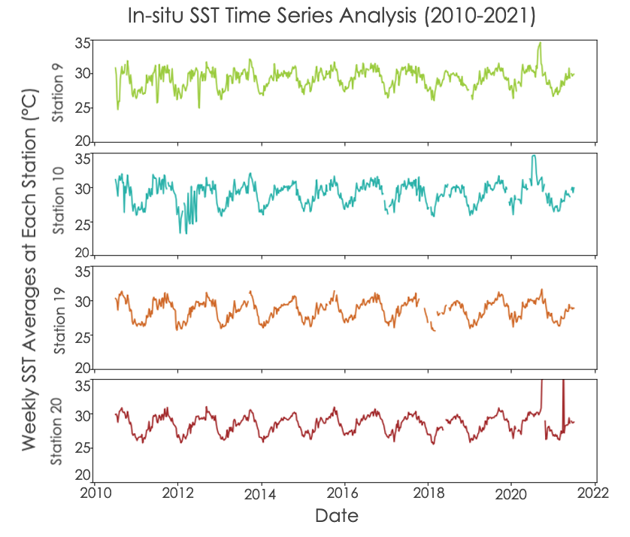
Figure C3. In-situ time series analyses for sea surface temperature at Stations 9, 10, 19, and 20, from 2010 to 2021, averaged weekly with outliers removed.
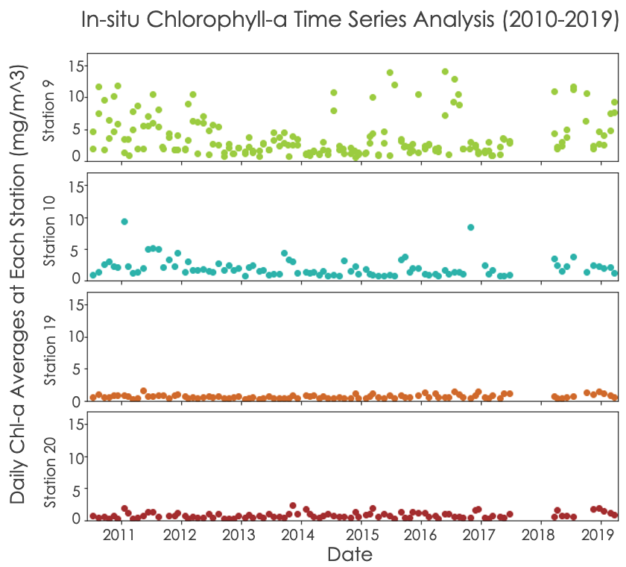
Figure C4. In-situ time series analyses for chlorophyll-a at Stations 9, 10, 19, and 20, from 2010 to 2021, averaged daily with outliers removed.

Appendix D

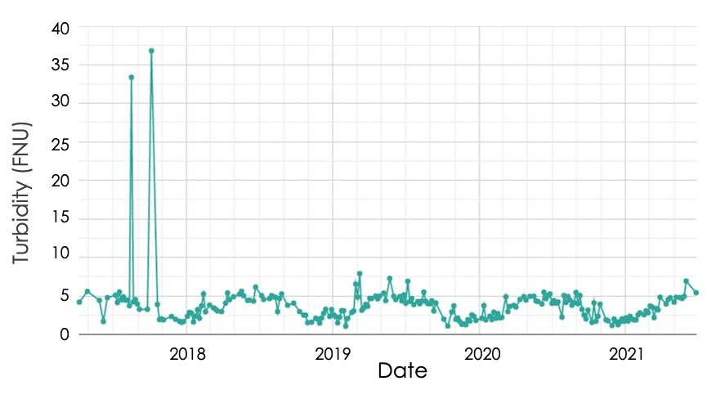
Figure D1. Turbidity time-series analysis generated in GEE by the ORCAA tool from April 1st, 2017, to July 1st, 2021, at Station 19.

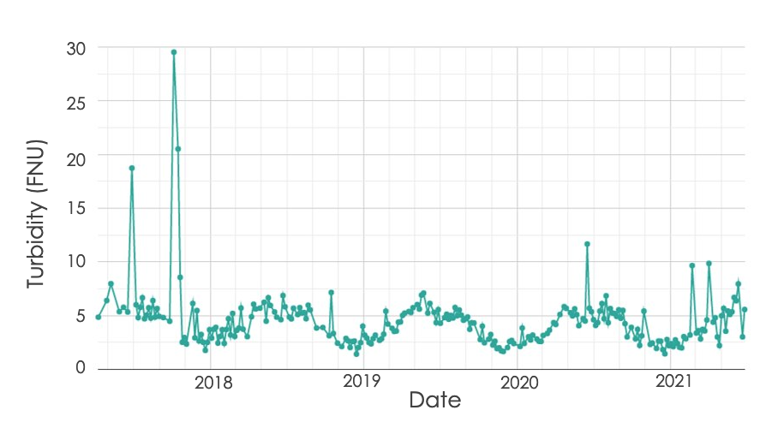
Figure D2. Turbidity time-series analysis generated in GEE by the ORCAA tool from April 1st, 2017, to July 1st, 2021, at Station 20.

Appendix E

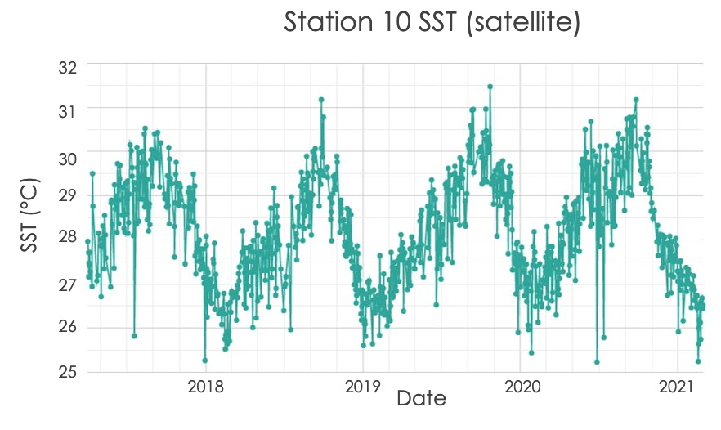
Figure E1. Sea surface temperature time-series analysis generated in GEE by the ORCAA tool from April 1st, 2017, to July 1st, 2021, at Station 10.

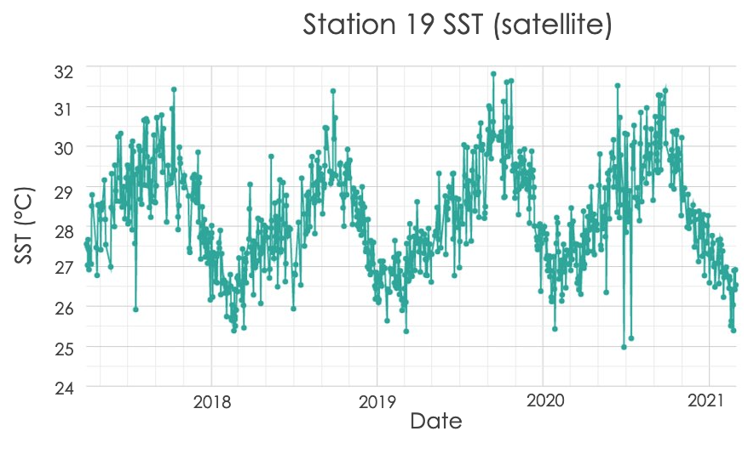
Figures E2. Sea surface temperature time-series analysis generated in GEE by the ORCAA tool from April 1st, 2017, to July 1st, 2021, at Station 19.

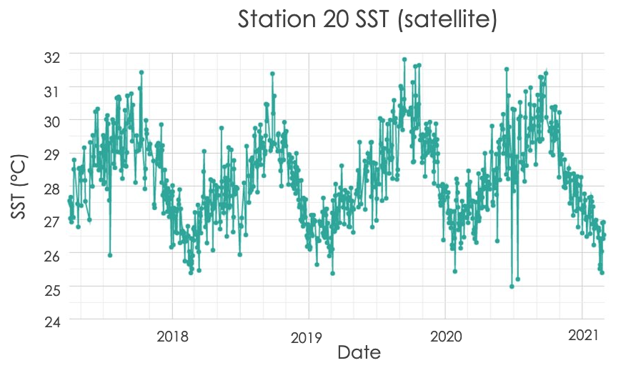
Figure E3. Sea surface temperature time-series analysis generated in GEE by the ORCAA tool from April 1st, 2017, to July 1st, 2021, at Station 20.

Appendix F

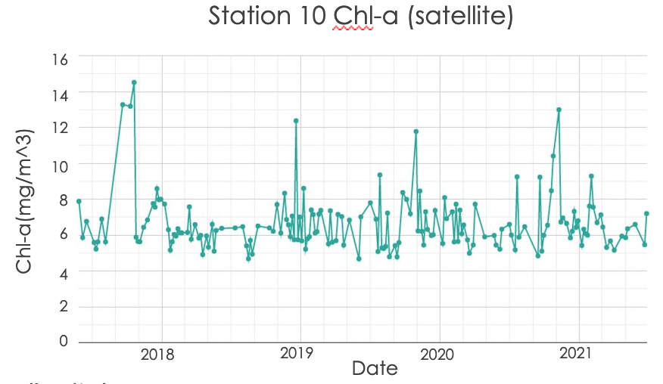
Figure F1. Chlorophyll-a time-series analysis generated in GEE by the ORCAA tool from April 1st, 2017, to July 1st, 2021, at Station 10.

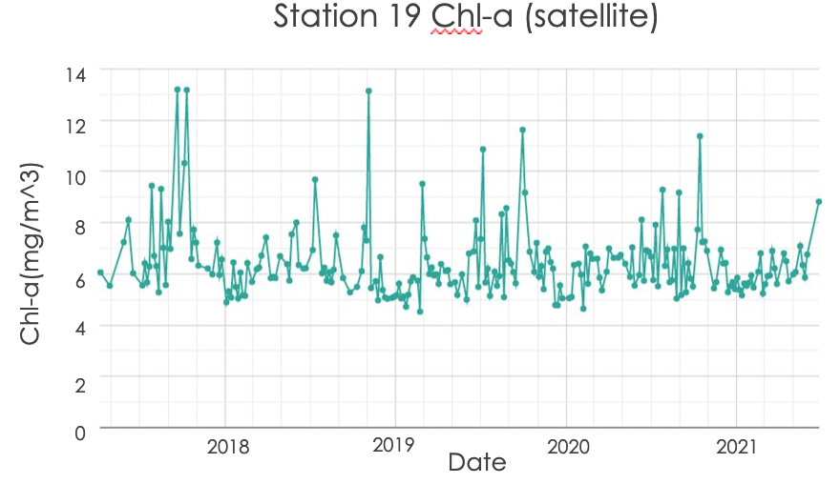
Figure F2. Chlorophyll-a time-series analysis generated in GEE by the ORCAA tool from April 1st, 2017, to July 1st, 2021, at Station 19.

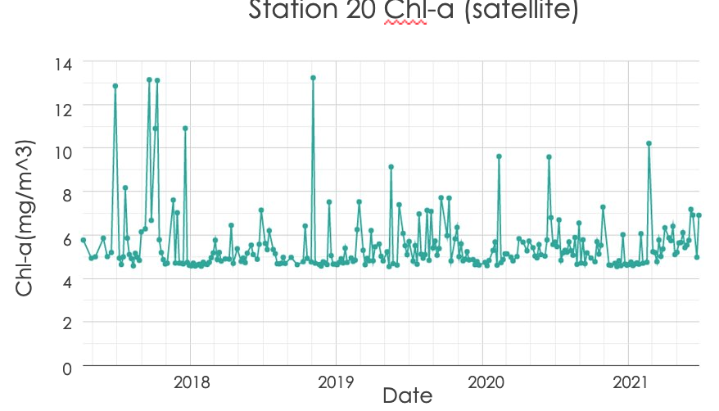
Figure F3. Chlorophyll-a time-series analysis generated in GEE by the ORCAA tool from April 1st, 2017, to July 1st, 2021, at Station 20.

Appendix G

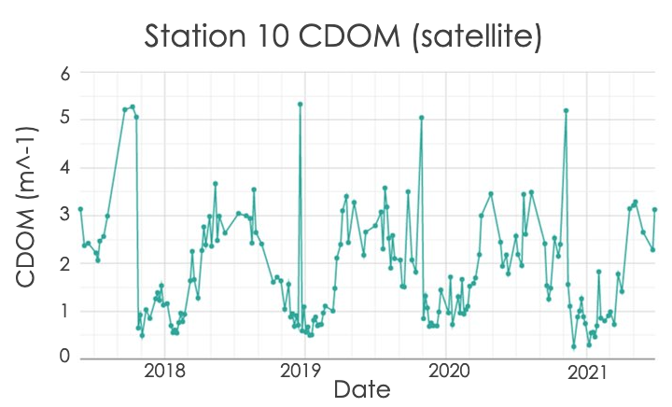
Figure G. Colored dissolved organic matter time-series analysis generated in GEE by the ORCAA tool from April 1st, 2017, to July 1st, 2021, at Station 10.

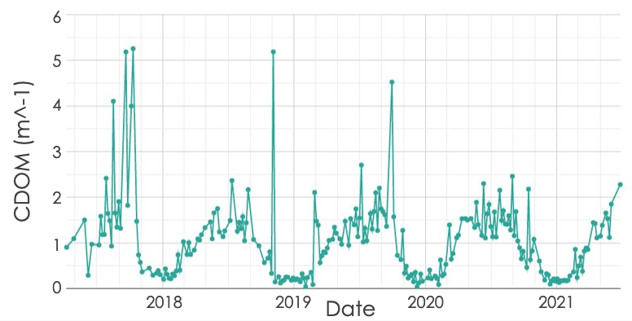
Figure G2. Colored dissolved organic matter time-series analysis generated in GEE by the ORCAA tool from April 1st, 2017, to July 1st, 2021, at Station 19.

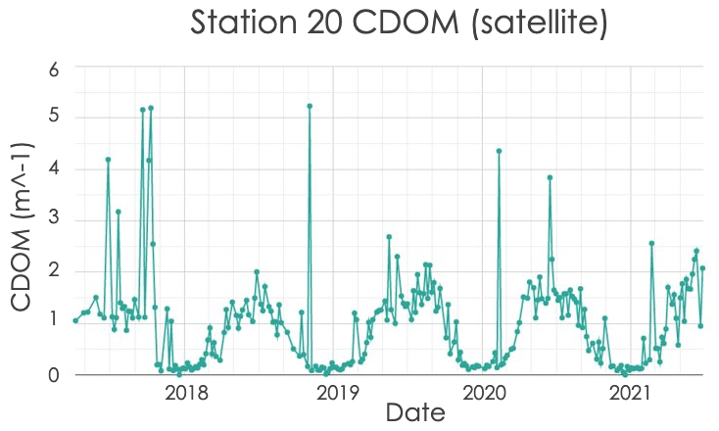
Figure G3. Colored dissolved organic matter time-series analysis generated in GEE by the ORCAA tool from April 1st, 2017, to July 1st, 2021, at Station 20.

Appendix H

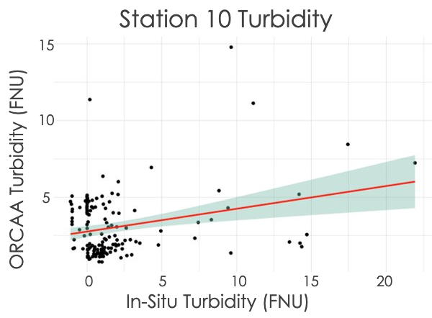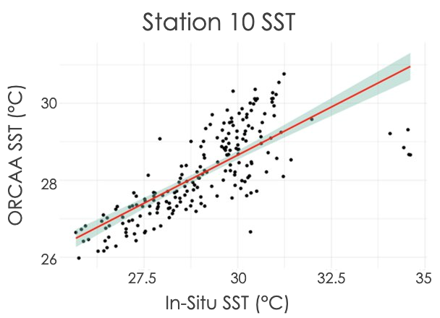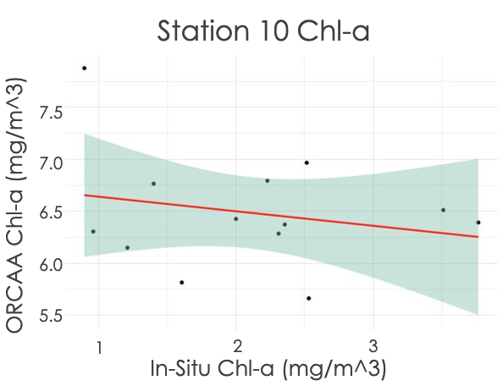
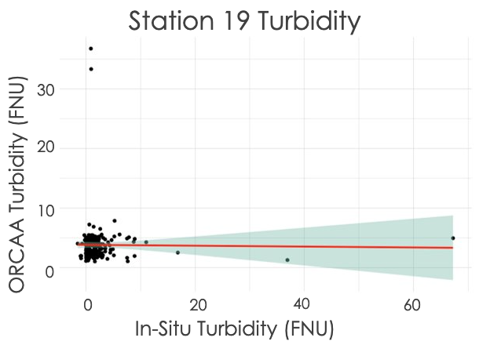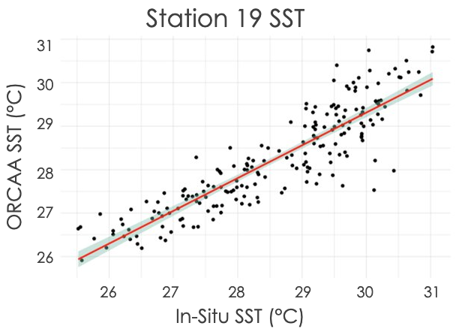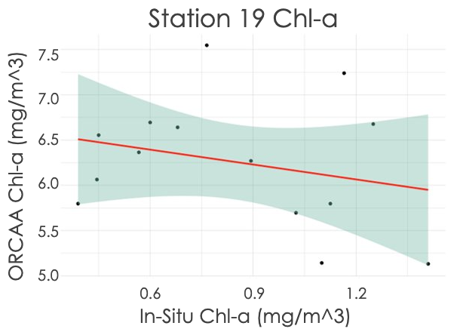
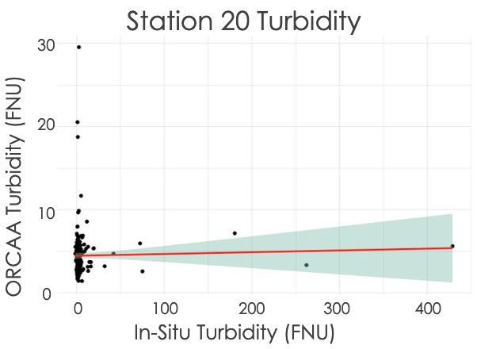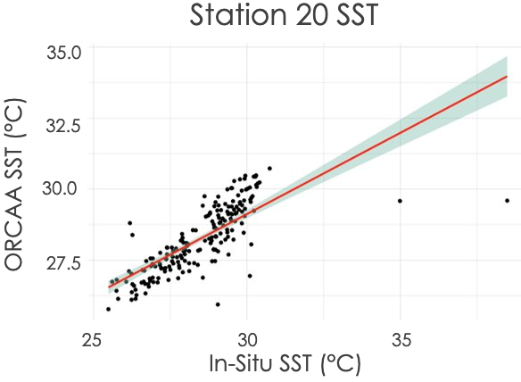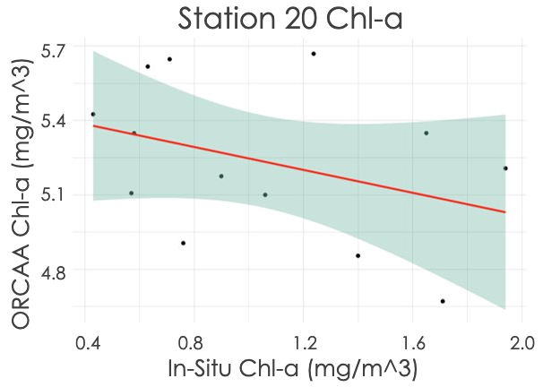
Figures H1-9. Linear regressions comparing in-situ water quality data to ORCAA generated data. Turbidity linear regressions for Station 10 (Figure H1), Station 19 (Figure H2), and Station 20 (Figure H3) had R values of 0.27, -0.012, and 0.028, respectively. Sea surface temperature linear regressions for Station 10 (Figure H4), Station 19 (Figure H5), and Station 20 (Figure H6) had R values of 0.75, 0.89, and 0.76, respectively. Chlorophyll-a linear regressions for Station 10 (Figure H7), Station 19 (Figure H8), and Station 20 (Figure H9) had R values of -0.23, -0.26, and -0.37, respectively.

Appendix I

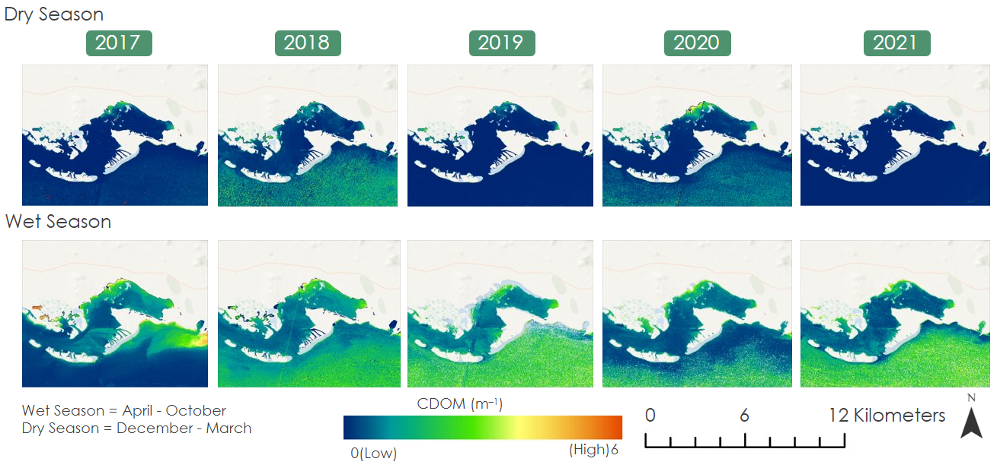
Figure I1. Colored Dissolved Organic Matter (CDOM) concentrations averaged by Wet & Dry seasons from 2017 – 2021.

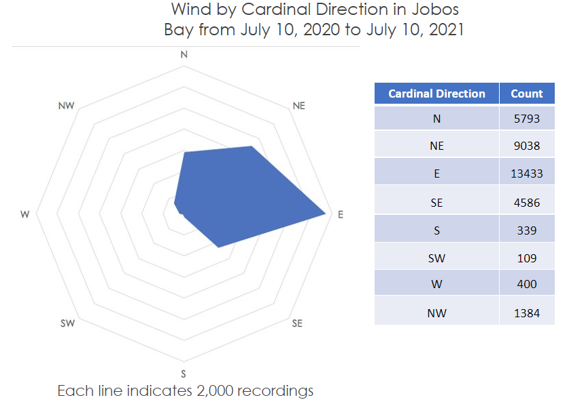
Figure I2. Wind By Cardinal Direction in Jobos Bay from July 10, 2020, to July 10, 2021.

Appendix J

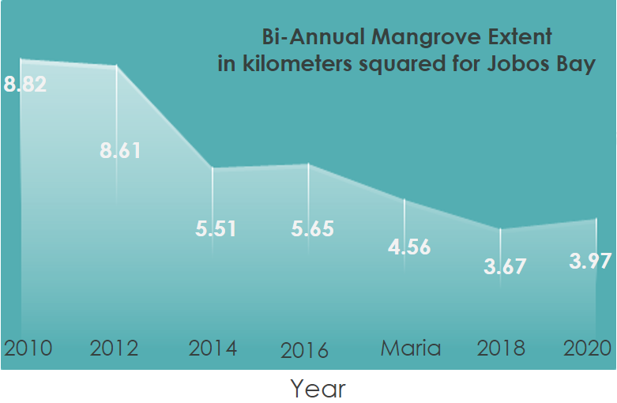
Figure J1. Mangrove extent 10-year timeline.

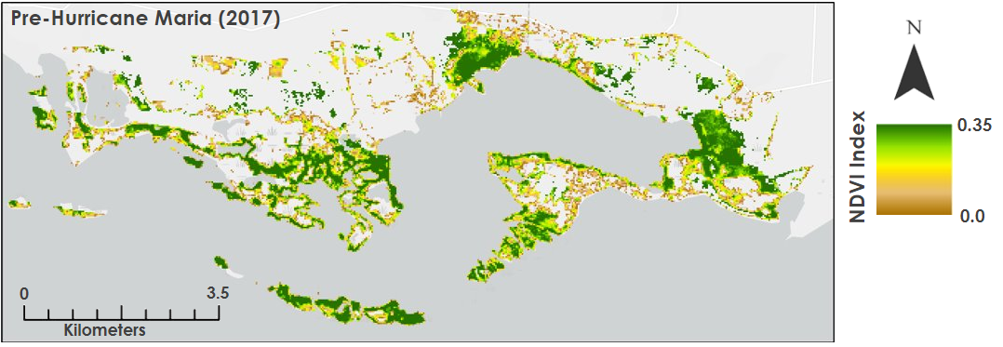
Figure J2. Pre-Hurricane Maria NDVI.

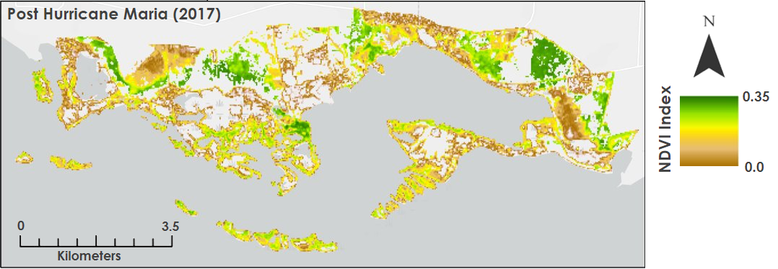
Figure J3. Post-Hurricane Maria NDVI.
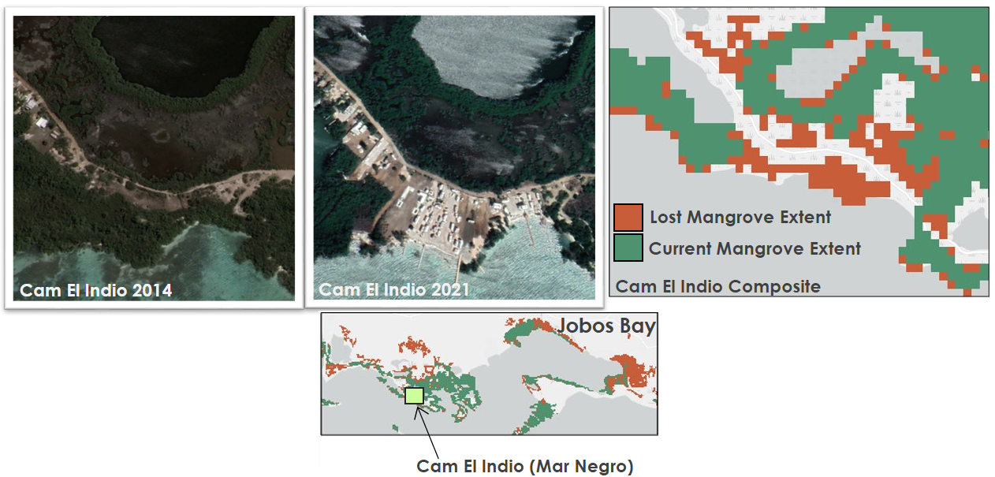
Figure J4. Changes in urbanization and mangrove extent in Camino El Indio located in the western part of Mar Negro.
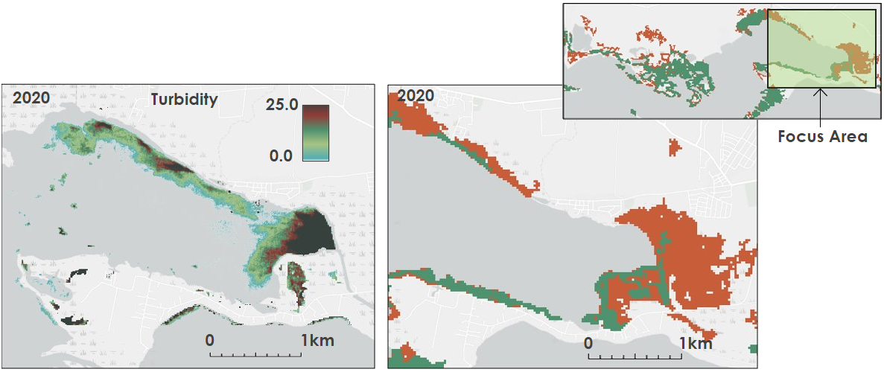
Figure J5. Comparison between turbidity concentrations (left) and mangrove loss (right).
Appendix K

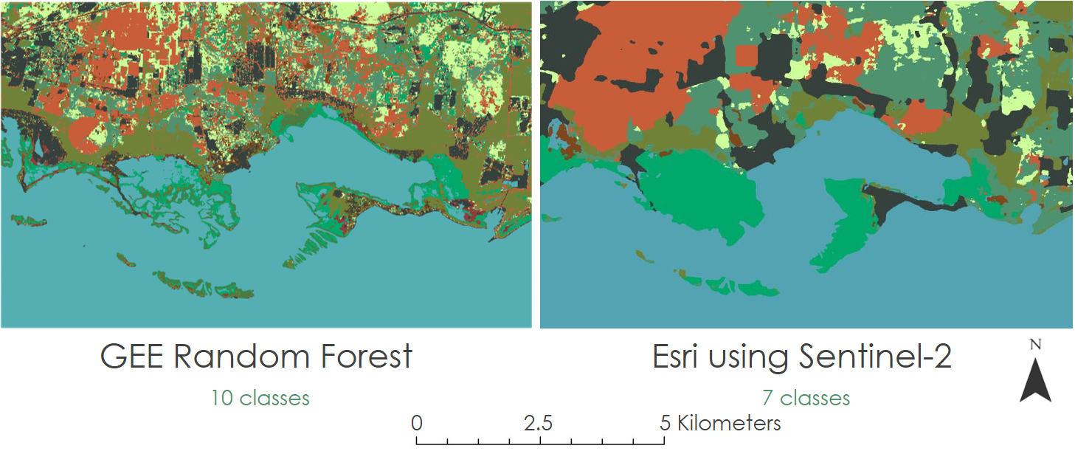
Figure K1. DEVELOP composite vs. Esri composite.

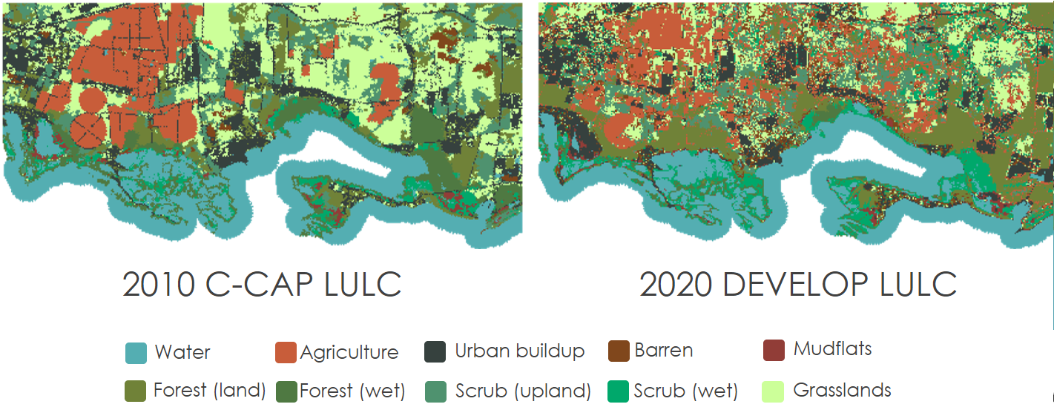
Figure K2. C-CAP composite vs. DEVELOP composite.

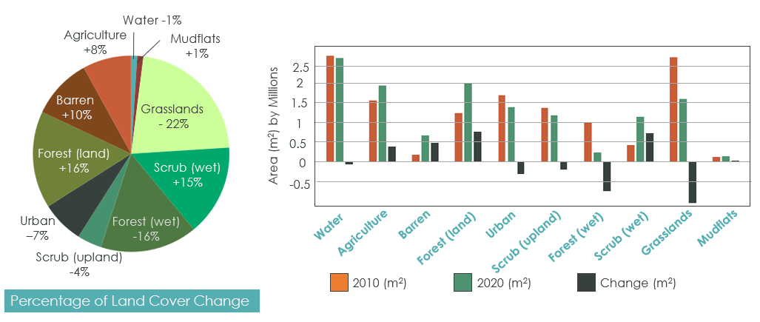
Figure K3. 10-year change for each land use/land cover class in Jobos Bay from 2010 to 2020.

Appendix L

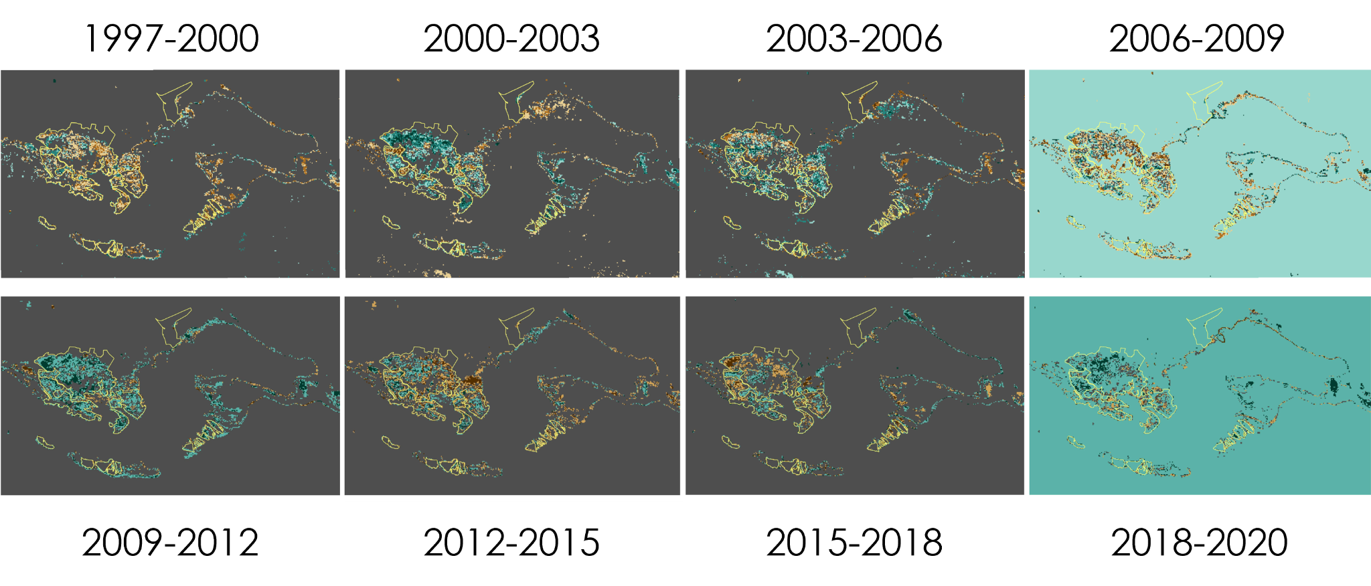
Figure L1. Three-year annual coastal changes in JBNERR from1997 to 2020.

