Missouri River Basin Disasters

Utilizing NASA Earth Observations and NOAA Climate Data Records to Produce Climate Indicators of Rangeland Health and Wildfire Risk

**Technical Report**

Final Draft – November 15th, 2018

Natalie Belew (Project Lead)

Tyler Hennessee

Nick Roberts

Michael Kruk, Earth Resources Technology, Inc.(Science Advisor)

Previous Contributors:

Kimberly Berry

Alec Courtright

Katherine Dooley

Ben House III

# 1. Abstract

The grasslands of the Great Plains that span the Dakotas and Nebraska are crucial for the region’s agriculture and livestock grazing. In the face of increased variability in regional climate, their susceptibility to drought conditions, wildfires, and extreme weather events are expected to increase. Building upon an existing fire risk indicator from a previous DEVELOP team, this project worked with the Bureau of Indian Affairs (BIA), the State Fire Meteorologist of South Dakota, the Central Region Climate Services Director of NOAA’s National Centers for Environmental Information (NCEI), and the National Integrated Drought Information System (NIDIS) to enhance the original product. The end product sends a daily map of wildfire risk across the Great Plains to partners. The map compiles Earth observations, including snow cover from NASA’s Moderate Resolution Imaging Spectroradiometer (MODIS) sensor aboard the Terra satellite, fuel moisture content derived from the Suomi National Polar-orbiting Partnership (NPP) Visible Infrared Imaging Radiometer Suite (VIIRS), and precipitation estimates from the Global Precipitation Measurement (GPM) Integrated Multi-satellite Retrievals for GPM (IMERG). Additional modeled datasets in the tool include wind speeds, daily average temperature, and dew point from NOAA’s Real-Time Mesoscale Analysis (RTMA), drought conditions from the US Drought Monitor, daily climatological temperature averages from 1981-2010 from Oregon State University’s Parameter-elevation Regressions on Independent Slopes Model (PRISM) Climate Group, and soil moisture measurements from the North American Land Data Assimilation System (NLDAS). This Fire Risk Estimation (FIRE) 2.0 tool creates a daily fire risk map for the fire management community in the Great Plains to monitor day-to-day changes in climate indicators and help them prepare for when and where the next major fire may strike.

**Keywords**

FIRE 2.0, Great Plains, wildfire, fuel moisture, precipitation, snow cover, soil moisture, Python, ArcMap

# 2. Introduction

* 1. ***Background Information***

In recent years as widely reported across US news outlets, wildfires have devastated societies and livelihoods across the United States. According to the National Interagency Fire Center, fires burned over 10 million acres throughout the country in 2017, costing the federal government almost $3 billion. In the Great Plains, wildfires are frequent occurrences that sustain the region’s ecological integrity and maintain ecosystem health by routinely burning away excess dead and decaying debris, thus allowing space for new growth (Ruokolainen & Salo, 2009). However, observations and fire statistical data suggest that wildfires have become larger and more frequent in recent years.

The Bureau of Indian Affairs (BIA) recognizes areas within the Great Plains are becoming increasingly subject to extreme variations in precipitation, increasing the region’s vulnerability to wildfires. At these higher occurrences, wildfires weaken the health of the environment and pose a direct threat to agricultural land and developed areas. Last year, fire managers in the states of Nebraska, South Dakota, and North Dakota observed 2,555 fires burning across almost 100,500 acres (National Interagency Fire Center). According to the BIA’s regional fire management team, since 2011, suppressing fires in reservations across these three states cost almost $50 million.

Throughout the years of combating these deadly natural disasters, fire experts have observed climatic and fuel conditions that intensify the risk of wildfires (Clabo, 2018). For example, large and frequent wildfires drive soil erosion and degradation, creating a landscape even more at risk of devastating floods and wildfires. For this reason, fire management requires in-depth monitoring of ecosystem vulnerabilities that increase the potential for massive, fast-moving wildfires to occur. This need led to the creation of the original Fire Risk Estimation (FIRE) Tool. In spring 2017, NASA DEVELOP’s Missouri River Climate II team assembled near-real-time climate and fuel conditions from NASA Earth observations and NOAA climate datasets to produce a daily wildfire risk map for the entire Missouri River Basin (MRB) (*Figure 1*).

*Figure 1.* Example daily wildfire risk map from the FIRE Tool of March 13, 2017.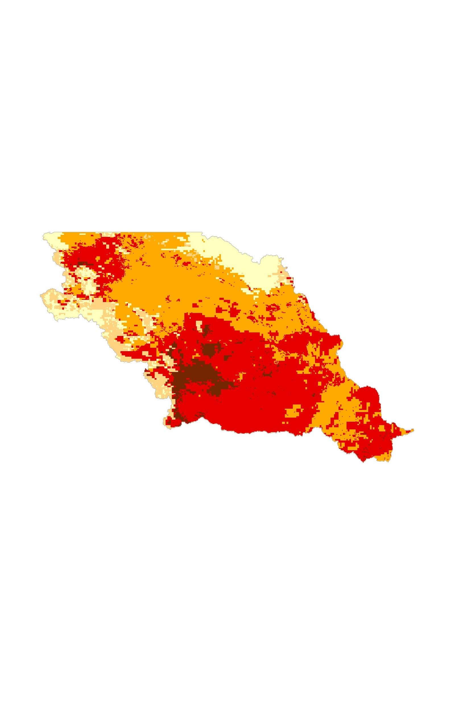

After utilizing the FIRE tool for the 2017 fire season, partners at the BIA and the South Dakota School of Mines & Technology (SD Mines) returned to NASA DEVELOP requesting some modifications and improvements to the original product. The fall 2018 Missouri River Basin Disasters team built on and enhanced the spring 2017 Missouri River Climate II’s FIRE tool and expanded the functionality of the original product as an operational near-real-time indicator of wildfire risk for on-the-ground fire managers in the Great Plains, specifically within the states of North Dakota, South Dakota, and Nebraska.

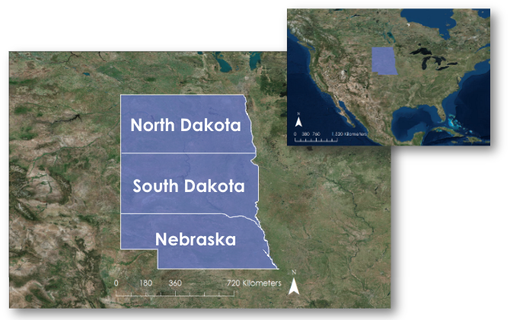

*Figure 2.*Image showing the study area of Nebraska, North Dakota, and South Dakota for the Missouri River Basin Disasters project.

Given the complex factors that lead to wildfires, the use of remote sensing allows for such weather data and fuel conditions to be calculated in a single matrix when in situ data are sparse (Clabo, 2018; Yebra et al., 2013). The original FIRE tool demonstrated the operational capability of such a product in the region. This project adapted the existing FIRE tool by updating satellites, such as incorporating Suomi National Polar-orbiting Partnership (NPP) Visible Infrared Imaging Radiometer Suite (VIIRS), adding new climate and fuel layers, like soil moisture from the North American Land Data Assimilation System (NLDAS), and modifying the area of interest from the entire MRB to the states of Nebraska, North Dakota, and South Dakota (*Figure 2*) to create an updated, functioning, and user-friendly interface for regional fire managers to assess potential fire risk.

* 1. ***Project Partners & Objectives***

During the process of modifying and improving the FIRE tool, the Missouri River Basin Disasters team coordinated with the BIA, the SD Mines, the NOAA NCEI Regional Climate Services Director of the Central Region, and the National Integrated Drought Information System (NIDIS). The goals of this project were to 1) transition the existing FIRE tool developed by the Missouri River Climate II team from Google Earth Engine (GEE) JavaScript to a Python-based ESRI ArcGIS platform while 2) updating data layers and modifying the study area from the entire MRB to the states of Nebraska, North Dakota, and South Dakota, and 3) to have the tool run automatically every day and distribute outputs to partners.

# 3. Methodology

***3.1 Data Acquisition***

The Missouri River Climate II project originally utilized GEE to acquire data and perform analysis to produce outputs for the original FIRE tool. Major issues regarding datasets not updating or not updating daily led to the decision to move the FIRE tool from GEE to an ESRI ArcGIS platform in order to directly download data from sources. This transition involved translating the original GEE JavaScript code to Python.

In order to calculate current fuel moisture using NDII, data were obtained from VIIRS. Bands M7 and M8 were used to assess the current status of fuel moisture conditions from 8-day composites that have a spatial resolution of 750 m. For 8-day composites of fuel moisture normals from 2001 to 2016, we used MODIS 8-Day Level 3 Surface Reflectance data from NASA’s Terra satellite at a spatial resolution of 1 km. We completed this assessment of fuel moisture using surface reflectance bands 2 and 6, which have similar band lengths and bandwidths to bands M7 and M8 from VIIRS. For precipitation, we brought in data from NASA’s GPM IMERG mission. This dataset includes daily precipitation displaying full data for 60°N-60°S with 11km resolution. Land surface temperature (LST), dew point temperature, and wind speed data were obtained from NOAA’s RTMA. This dataset includes hourly data for the continental United States with 2.5 km resolution and was downloaded from NOAA’s File Transfer Protocol (FTP) website as .grb2 files. To calculate the temperature anomaly layer, the PRISM Climate Group provided daily maximum temperature normals for the continental United States from the thirty-year climatic period of 1981 to 2010. The data have a fixed temporal resolution and a spatial resolution of 4 km. The US Drought Monitor produces drought data that the team downloaded in the form of a shapefile for the United States. This dataset from the University of Nebraska-Lincoln’s United States Drought Monitor website is updated weekly. Finally, for creating a soil moisture reference layer at the partners’ request, NLDAS data provide the daily .grb files with a four-day delay from NASA. Table 1 summarizes the data products used in this project.

Table 1

*Data products used and their sources with corresponding wildfire indicators*

|  |  |
| --- | --- |
| Data and Sources | Parameters |
| Global Precipitation Measurement v5 (GPM) Integrated Multi-satellite Retrievals for GPM (IMERG) | Precipitation |
| North American Land Data Assimilation System (NLDAS) | Soil Moisture |
| Parameter-elevation Regression on Independent Slopes Model (PRISM) | Temperature Normals |
| Real-Time Mesoscale Analysis (RTMA) | Temperature, Dew Point, Wind Speed |
| Terra Moderate Resolution Imaging Spectrometer (MODIS) | Normalized Difference Infrared Index (NDII) Normals, Snow Cover |
| US Drought Monitor (USDM) | Drought |
| Suomi National Polar-orbiting Partnership (NPP) Visible Infrared Imaging Radiometer Suite (VIIRS) | Fuel Moisture |

***3.2 Data Processing***

***3.2.1 General Overview of Data Processing***

Data were processed using ESRI ArcGIS to a consistent geospatial projection of GCS_WGS_1984 and clipped to the study region of North Dakota, South Dakota, and Nebraska. Each dataset needed to be processed in different ways in order to be able to apply the partner-identified thresholds and weights to each variable (Table 2). A greater than or equal sign designates the values that need to be equal or above the threshold listed, while a less than or equal sign indicates the values that need to be equal or below the threshold listed in order to contribute to wildfire risk.

Table 2

*Seasonal thresholds and values for variables provided by partners*

|  |  |  |  |  |
| --- | --- | --- | --- | --- |
|  | Spring | Summer | Fall | Winter |
| Drought (USDM) | ≥D1 | ≥D1 | ≥D1 | ≥D1 |
| Wind speed (m/s) | ≥9.00 | ≥9.00 | ≥9.00 | ≥9.00 |
| Rain-Soaking (mm) | ≤12.70 | ≤12.70 | ≤12.70 | ≤12.70 |
| Rain-Wetting (mm) | ≤2.54 | ≤2.54 | ≤2.54 | ≤2.54 |
| Relative Humidity (%) | ≤30.0 | ≤20.0 | ≤30.0 | ≤40.0 |
| Temperature Anomaly (°C) | ≥10.0 | ≥8.00 | ≥10.0 | ≥15.0 |
| Snow Cover (% Confidence) Interval) | ≥50.0 | ≥50.0 | ≥50.0 | ≥50.0 |

Throughout their experience of overseeing fire management strategies across the Great Plains, partners have observed patterns across eight climate and fuel parameters that have been present during large, dangerous fire outbreaks, which appear to significantly contribute to the volatility and speed of a given fire. Additionally, partners observed how these patterns varied throughout the year. With these observations, a series of seasonal thresholds for each climate indicator, as shown in Table 3, were identified. The creators of the original FIRE tool also collaborated with partners in creating thresholds, but the original matrix did not include variations across seasons. These seasonal thresholds were applied to each of the variable layers in the code to generate a binary layer to show which locations were above or below the applied threshold.

Table 3

*Seasonally-weighted, partner defined variables used to combine the thresholded data layers*

|  |  |  |  |  |
| --- | --- | --- | --- | --- |
|  | Spring | Summer | Fall | Winter |
| Drought (USDM) | 0.0625 | 0.0568182 | 0.0526316 | 0 |
| Wind speed (mph) | 0.1 | 0.1136364 | 0.1052632 | 0.1066667 |
| Rain-Soaking (mm) | 0.125 | 0.1363636 | 0.1578947 | 0.1333333 |
| Rain-Wetting (mm) | 0.125 | 0.1363636 | 0.1578947 | 0.1333333 |
| Relative Humidity (%) | 0.15 | 0.1590909 | 0.1578947 | 0.16 |
| Temperature Anomaly (°C) | 0.1875 | 0.1704545 | 0.1578947 | 0.2 |
| NDII Anomaly | 0.1875 | 0.1704545 | 0.1578947 | 0.2 |
| NDII Change | 0.0625 | 0.0568182 | 0.0526316 | 0.0666667 |

***3.2.2 PRISM Processing***

Long-term temperature and precipitation averages, climatically referred to as “normals,” are computed every 10-years by climate scientists at NOAA’s NCEI. Temperature normals in degrees Celsius for the continental United States were obtained as .csv files and were converted into a raster format to calculate temperature anomalies. Using another script, the daily .csv files were loaded into ArcMap and displayed as points using the “Make XY Event” layer tool. Then, these data were duplicated as an editable spatial data layer using the “Feature Class to Feature Class” conversion tool. The extent was then clipped to the study area to minimize processing time. Additionally, the data were projected to the GCS_WGS_1984 coordinate system. The point data were converted to rasters using the “Natural Neighbor” process, which interpolated areas of no data based on the closest data points. The output of this process added data outside of the study area, so the raster file was again clipped to the study area. The resulting files for all 365 days of the year were saved to reference for the temperature anomalies calculation.

***3.2.3 RTMA Processing***

After downloading the necessary RTMA data, wind speed in meters per second, temperature in degrees Kelvin, and dew point in degrees Kelvin were extracted from the RTMA files from 13Z of the previous calendar day to 12Z of the current day. These files were also projected to the GCS_WGS_1984 coordinate system and clipped to the study area. Using ArcGIS’s “Cell Statistics” tool, the resulting data layers for each hour for wind speed, temperature, and dew point were combined. This facilitated the calculation of the average daily dew point, average daily temperature, maximum daily temperature, and maximum daily wind speed for each pixel. Daily relative humidity (RH) values were computed using the August-Roche-Magnus Approximation (Equation 1), with the average temperature and the average dew point as input sources, which were converted from degrees Kelvin to degrees Celsius. After the conversion, the raster math tools were utilized to calculate each step of August-Roche-Magnus Approximation to get the percent RH.

$\text{RH} \text{=} \text{100 ×} \frac{{\text{e}}^{ ^{\frac{\text{17.625 × TD}}{\text{243.04 × TD}}}}}{{\text{e}}^{ ^{\frac{\text{17.625 × T}}{\text{243.04 × T}}}}}$ (1)

Depending on the season, the threshold values for RH change (Table 2), thus the written code references the appropriate threshold values based off of the current season. Values below the seasonal threshold value contributed to fire risk, while values above the threshold did not. Threshold values for wind speed do not change based on the season (Table 2), so values above 9 m/s contributed to fire risk, while wind speeds below 9 m/s did not.

Temperature anomalies were calculated using the maximum temperature normals from the PRISM data and the maximum daily temperature from the RTMA data. First, the temperature maximum data from RTMA had to be converted from degrees Kelvin to degrees Celsius. Using the raster math toolset, the raster file of the daily temperature average in degrees Celsius was subtracted from the day’s temperature normal in degrees Celsius. Threshold values were applied based on the season (Table 2), and as a result, values above threshold weights contributed to fire risk, while values below the threshold weights did not contribute to fire risk.

***3.2.4 USDM Processing***

Drought data were downloaded as a shapefile and converted into a raster file using the “Feature to Raster” tool. The drought data were projected to the GCS_WGS_1984 coordinate system and clipped to the study area. As the seasonal thresholds for drought do not change (Table 2), anything at or above a moderate drought (DM 1) was included as contributing to fire risk, while a DM value of 0 did not contribute to fire risk.

***3.2.5 GPM Processing***

GPM IMERG precipitation data from the past 15 days were downloaded and used to calculate wetting and soaking precipitation. Wetting precipitation refers to rainfall at or surpassing 2.54 millimeters in a given day while soaking precipitation refers to rainfall at or surpassing 12.70 millimeters in a given day. The sub-dataset ‘HQprecipitation’ was first extracted from the GPM hdf file, projected to the GCS_WGS_1984 coordinate system, and clipped to the study area. The raster files were then converted to numerical arrays using the “Raster to NumPyArray” tool. Precipitation values within a given array were reclassified twice using the partner defined wetting and soaking precipitation thresholds (Table 2). In these reclassifications, each value within the converted array was compared to a precipitation threshold. If the precipitation value fell below the threshold, it was given a value of 1 to indicate that due to the lack of precipitation, there was a contribution to fire risk. If the precipitation value was above the threshold, it was given a value of 0 to indicate that it did not contribute to fire risk. The code then went through all 15 reclassified precipitation files and summed their values, with a counter in place that reset the sum every time a 0, or area with recent significant precipitation, was encountered. This yielded the number of days since wetting precipitation and soaking precipitation has occurred.

***3.2.6 VIIRS Processing***

To estimate fuel moisture in the Great Plains, VIIRS data were imported into a separate script. The VIIRS data were divided into each category for fuel analysis. Cured fuels cannot be directly calculated from remotely-sensed data. A useful proxy for cured fuels is fuel moisture. NDII shows the moisture content of vegetation, as displayed in Equation 2 (Yebra et al., 2013).

$\text{NDII} \text{= }\frac{\text{NIR - SWIR}}{\text{NIR + SWIR}} \text{= }\frac{\text{Band 2 - Band 5}}{\text{Band 2 + Band 5}}$ (2)

The NDII layers were used in two parts of the threshold and weighting scheme: NDII anomaly and NDII weekly change. NDII anomalies show how much wetter or dryer the vegetation is from its historical norm while the NDII weekly change shows how the fuel moisture changed from the previous week. NDII anomaly was calculated by collecting the NDII measurement for each week from 2002-2011, with 46 images per year. Then the images were averaged by their date to find the average NDII value per pixel for each week. NDII 10-year weekly average images were stored in the Python script folder to be pulled as a data layer in the final map output. The NDII change was calculated by subtracting the most recent NDII VIIRS image from the corresponding weekly average NDII image stored in the assets folder. NDII weekly change was calculated by subtracting the previous NDII image from the most recent.

***3.2.7 MODIS Processing***

In order to detect snow cover that would nullify fire risk potential, a Terra MODIS Daily Snow Cover dataset was downloaded. The sub-dataset ‘Day_CMG_Snow_Cover’ was extracted from the hdf file, projected to the GCS_WGS_1984 coordinate system, and clipped to the study area. This snow cover variable was reclassified based on the partner provided snow cover threshold, where variables classified as 1 indicated the presence of snow and variables classified as 0 indicated the lack of snow. This was used to create a layer that was placed overtop the fire risk map in the final product.

***3.2.8 Final Processing***

Once the individual data layers were calculated, they were given weights to represent their influence in the overall fire risk and then added together. This was accomplished using the “Weighted Sum” tool from ArcGIS to apply the partner defined seasonal weights in Table 3. As the original FIRE tool’s weights did not add up to one, they had to be modified for the FIRE 2.0 tool to maintain the proportional weights the partners requested. Symbology was applied through layer files to the output map, and shapefiles of counties and reservations were overlaid on top of the risk map to produce the final fire risk map.

# 4. Results & Discussion

***4.1 Explanation of FIRE 2.0 Tool Outputs***

The resulting output of the FIRE 2.0 tool contains a risk map for the states of Nebraska, North Dakota, and South Dakota (*Figure 3*), a histogram of the day’s fire risk values (*Figure 4*), and a line graph showing the previous averages over the past 7 days (*Figure 5*).

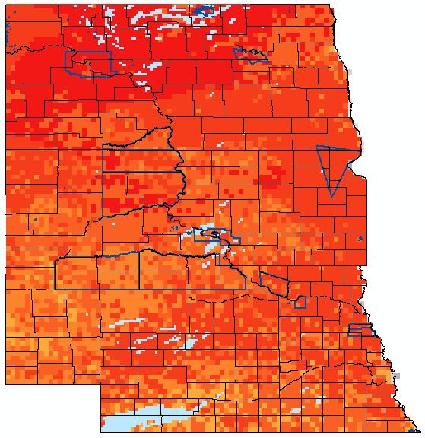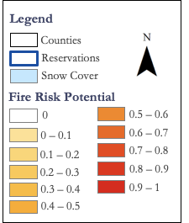



*Figure 3.* Output of the FIRE 2.0 tool for November 12, 2018.

The output of the FIRE 2.0 tool is displayed as a raster in the study area with a white to red color ramp showing varying degrees of the current fire risk (*Figure 3*). The yellow color displays areas of low risk, while red displays areas of high risk. Areas that have a fire risk of 0 are displayed on the map as white. Areas that also have a fire risk of 0 due to the presence of snow are displayed on the map as light blue over the fire risk values. This gives partners the ability to look underneath the snow cover data layer to see the underlying risk for the area if desired. Partners also wanted to view soil moisture data in addition to the fire risk, so NLDAS soil moisture data were added as a raster layer beneath the fire risk output layer. Additionally, the output showing the current day’s histogram of fire risk (*Figure 4*) displays the current day’s values in addition to the median fire risk for the study area. The FIRE 2.0 tool also outputs the overall trend in median fire risk for the previous seven days as a graph (*Figure 5*). These outputs are desired by partners in order to better visualize the fire risk for their areas of interest as well as to keep track of the overall fire risk in the study area.

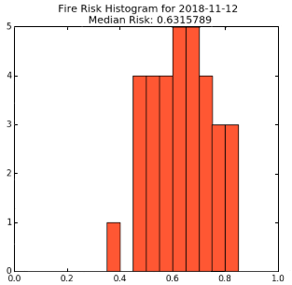

*Figure 4.* Histogram of the fire risk values for November 12, 2018.

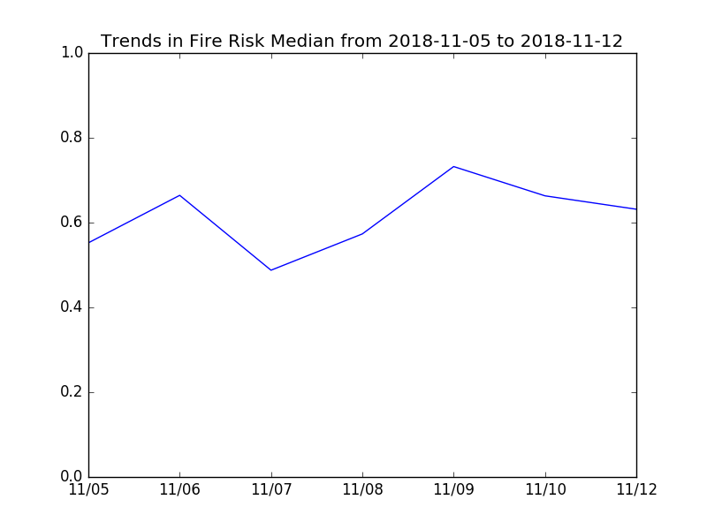

*Figure 5.* Line graph of the average fire risk for the dates of November 5-12, 2018.

***4.2 Errors & Uncertainties***

The FIRE 2.0 tool is not a predictive tool and does not guarantee that fires will occur at a given location at a given time. The tool displays the variables that contribute to fire risk as identified by partners, and the more variables that meet the threshold values, increased fire risk is displayed by the tool. Additionally, as new knowledge is discovered or observations are made as to how these variables contribute to fire risk, the thresholds and weights described in this paper may become outdated. While the FIRE 2.0 tool has the weights and thresholds identified at the top part of the code in order to be easily editable in this event, the tool may display an inaccurate output until these values are updated. The code also relies upon a certain naming scheme of files to download from the internet. If the naming structure of the web addresses or the file names change, the code will not be able to download the most recent data. Instead, it will utilize the most recent data it has access to in order to create the output map. This introduces error as the data the tool is utilizing is not the most recent data. While the previous FIRE tool underwent statistical verification, unfortunately, there was not enough time remaining at the end of the project to verify the outputs of the FIRE 2.0 tool against previous fires. However, the original FIRE tool was verified, and this project relied heavily upon the previous tool and partner input on updates based on their experience.

# 5. Conclusions

As highlighted in the spring 2017 Missouri River Climate II project, it is important for fire managers to understand which weather and fuel conditions are most likely to result in large, dangerous wildfires that could threaten the area. Knowledge of fire potential allows fire response teams to position firefighting equipment and personnel in regions of high fire risk and carefully monitor changing conditions in vulnerable regions.

The fall 2018 Missouri River Basin Disasters improved FIRE 2.0 tool automatically ingests near-real-time climate and fuel information across seven various NASA Earth observations, NOAA climate data, and other sources. From these seven sources, the tool produces a daily wildfire risk map comprised of eight different data layers, demonstrating the current state of climate and fuel indicators across the three states at a sub-county and reservation level. With the product automated to send a map following the processing of data, fire managers in the region can access this map every morning, including over weekends, to know when and where to prepare for the next potential fire.

While this tool does not guarantee that fires will occur in a given area, it can help decision makers direct appropriate resources and personnel to monitor areas at the greatest risk for fires. When discussing the application of this tool, partner Darren Clabo spoke to how this product could be utilized in the field. “This tool can really give our first responders an edge on the initial attack of suppressing those wildfires,” Clabo told the team during an interview for the project video. The FIRE 2.0 tool can provide that leg up on fire suppression in the Great Plains.

# 6. Acknowledgments

The Missouri River Basin Disasters team would like to acknowledge our project partners: David Martin of BIA, Darren Clabo of SD Mines, Doug Kluck of NOAA NCEI, and Britt Parker of NIDIS for their continuous involvement and communication throughout the term. Additionally, we are beyond grateful to NOAA NCEI for the continued support of the NOAA NASA Node. We would not have been able to do this work without the guidance and support of our science advisor, Michael Kruk, and our Center Lead, Aaron Mackey, as well as the support of individuals at NOAA NCEI who willingly shared their time and expertise throughout our ten weeks at NCEI. We also recognize the efforts of previous team members Kimberly Berry, Alec Courtright, Kathy Dooley, and Ben House III in creating the original FIRE tool.

Any opinions, findings, and conclusions or recommendations expressed in this material are those of the author(s) and do not necessarily reflect the views of the National Aeronautics and Space Administration.

This material is based upon work supported by NASA through contract NNL16AA05C.

# 7. Glossary

**BIA** – Bureau of Indian Affairs: a federal agency that provides services to American Indians and Alaska Natives

**FIRE tool** –Fire Risk Estimation tool: name of the existing product coined by the spring 2017 Missouri River Climate II team

**GEE** –Google Earth Engine: cloud-based geospatial processing platform

**MRB** – Missouri River Basin: a collection of watersheds in which precipitation, run-off, and other flows of water drains into the Missouri River; the MRB spreads across ten different states as well as Canada in the center of the United States

**NOAA NCEI** – National Oceanic and Atmospheric Administration’s National Centers for Environmental Information: the location of the DEVELOP node in Asheville, North Carolina

**NDII** – Normalized Difference Infrared Index: serves as a satellite-derived proxy for vegetation moisture

**NDSI** – Normalized Difference Snow Index: a satellite-derived measurement of snow cover

**NIDIS** – National Integrated Drought Information System: an interagency program NOAA oversees that promotes drought research through existing federal, tribal, state, and local partnerships in support of creating a national drought early warning information system

**RTMA** – The National Oceanographic and Atmospheric Association’s Real-Time Mesoscale Analysis: a high-spatial and temporal resolution analysis system for near-surface weather conditions derived from weather station and satellite data

**SD Mines** – South Dakota School of Mines & Technology: one of the MRB Disasters team’s partners

# 8. References

Clabo, D. R. (2018). Contemporary pyrogeography and wildfire-climate relationships of South Dakota, USA. *Atmosphere, 9*(6), 207. https://doi.org/10.3390/atmos9060207

Hall, D. K., & G. A. Riggs. (2016). MODIS/Terra Snow Cover Daily L3 Global 0.05Deg CMG, V006. Day_CMG_Snow_Cover. Boulder, Colorado USA, NASA National Snow and Ice Data Center Distributed Active Archive Center, accessed October 2018 to present. <https://doi.org/10.5067/MODIS/MOD10C1.006>

Huffman, G. (2016). GPM IMERG Early Precipitation L3 1 day 0.1 degree x 0.1 degree V05, edited by Andrey Savtchenko Greenbelt, MD, Goddard Earth Sciences Data and Information Services Center (GES DISC), accessed October 2018 to present. https://doi.org/10.5067/GPM/IMERGDE/DAY/05

National Aeronautics and Space Administration, NCEP, & National Oceanic and Atmospheric Administration. (2018). North American Land Data Assimilation System (NLDAS). Last accessed 13 November 2018. Retrieved from http://www.emc.ncep.noaa.gov/mmb/nldas/

National Drought Mitigation Center, US Department of Agriculture, National Oceanic and Atmospheric Administration, & University of Nebraska-Lincoln. (2018). United States Drought Monitor. Last accessed 6 November 2018. Retrieved from <https://droughtmonitor.unl.edu/Data/GISData.aspx>

National Interagency Fire Center. (2018). *Fire Information and Statistics.* Retrieved from https://www.nifc.gov/fireInfo/fireInfo_statistics.html

National Weather Service, NCEP Central Operations, & National Oceanic and Atmospheric Administration. (2018). Real-Time Mesoscale Analysis (RTMA) Products. Last Accessed 13 November 2018. Retrieved from http://www.nco.ncep.noaa.gov/pmb/products/rtma/#Top

PRISM Climate Group at Oregon State University. (2018). *PRISM Climate Data* [Data file]. Retrieved from http://prism.oregonstate.edu/

Ruokolainen, L., & Salo, K. (2009). The effect of fire intensity on vegetation succession on a sub-xeric heath during ten years after wildfire. *Annales Botanici Fennici, 46*(1), 30-42. https://doi.org/10.5735/085.046.0103

Vermote, E. (2015). MOD09A1 MODIS/Terra Surface Reflectance 8-Day L3 Global 500m SIN Grid V006 Surf_Refl_B002 & Surf_Refl_B006. NASA Land Processes Distributed Active Archive Center, accessed October 2018 to present. doi:10.5067/MODIS/MOD09A1.006

Vermote, E., Franch, B., & Claverie, M. (2016). VIIRS/NPP Surface Reflectance 8-Day L3 Global 1km SIN Grid V001 SurfReflect_M7_1 & SurfReflect_M8_1. NASA Land Processes Distributed Active Archive Center, accessed October 2018 to present. doi:10.5067/VIIRS/VNP09A1.001

Yebra, M., Dennison, P. E., Chuvieco, E., Riaño, D., Zylstra, P., Hunt, E. R., … Jurdao, S. (2013). A global review of remote sensing of live fuel moisture content for fire danger assessment: Moving towards operational products. *Remote Sensing of Environment, 136*, 455-468. https://doi.org/10.1016/j.rse.2013.05.029