Tempe Urban Development II

Establishing an Urban Heat Exposure Severity Score for Infrastructure Prioritization in Tempe, Arizona, Using NASA Earth Observations and LiDAR

 **Technical Report**

Final – November 19, 2020

Sydney Boogaard (Project Lead)

John Dialesandro

Blake Steiner

Yik Shun Anson Pang

***Advisor:***

Dr. David Hondula, Arizona State University (Science Advisor)

***Previous Contributors:***

Hannah Bonestroo

Roger Alvarez

Elizabeth Swanson

Taylor Quinn

# 1. Abstract

Located in the northern Sonoran Desert, Tempe, Arizona, features a semi-arid climate with summer daily maximum temperatures regularly exceeding 37.8° C (100.0° F). The area has experienced an increase in surface and air temperatures due to a steep expansion of impervious surfaces and rapid urban development. Urban heat is an increasingly pressing concern for Tempe with hundreds of heat-related deaths and thousands of heat-related hospitalizations over the past 15 years in Maricopa County. Furthermore, urban heat impacts residents’ quality of life and the economic vitality of the city. Recognizing the impacts of extreme urban heat, the City of Tempe collaborated with the Healthy Urban Environments initiative and the Fall 2020 Tempe Urban Development II NASA DEVELOP team to utilize NASA Earth observations (data from Aqua Moderate Resolution Imaging Spectroradiometer (MODIS), Landsat 8 Operational Land Imager (OLI), and Landsat 8 Thermal Infrared Sensor (TIRS) to investigate the drivers of heat exposure throughout the city. Social economic data from American Community Survey, and topographic LiDAR data were used to identify areas experiencing the worst heat effects that could be targeted for heat mitigation and adaptation. These areas included the Escalante neighborhood, Alegre Community, University Heights, and around Dwight Park. An example of the shading analysis we did showed the Gilliland and Escalante neighborhood walksheds do not meet the "good" shading threshold set at 30% by the Maricopa Association of Government.

**Key Terms**

Outdoor thermal comfort, heat vulnerability, Healthy Urban Environments, remote sensing, urban heat modeling, LST, LiDAR

# 2. Introduction

**2.1 Background Information**

Maricopa County encompasses the majority of the Phoenix metropolitan area and has grown to be the fourth-largest county in the United States with a population of 4.5 million. The City of Tempe is found within Maricopa County, has a population of just under 200,000 residents, and is home to an emerging technology hub, Arizona State University (ASU) with a dynamic student population exceeding 60,000, and has a population with just under 200,000 residents (*Figure 1*). Tempe features a semi-arid climate with summer daily maximum temperatures regularly exceeding 37.8° C (100.0° F). Tempe is also subject to the southwestern monsoon season in late summer, and the accompanying humidity exacerbates the high temperatures.

*Figure 1.* Project Study Area, Tempe, Arizona within the Phoenix Metropolitan Area

The rapid urbanization experienced throughout Maricopa County has increased impervious surfaces and driven substantial warming above that of the surrounding rural areas. This pattern, known as urban heat island (UHI), occurs because of greater absorption of downwelling solar irradiance compared to the surrounding desert landscape; this is also in combination with the complex three-dimensional geometry of the built environment and the release of waste heat from combustion engines, air conditioners, and other machines (Jenerette et al., 2016; Wang et al., 2018). Local climatic records have demonstrated that the Phoenix area has increased in temperature by almost 2° C (3.6° F) over the past fifty years. Furthermore, the summer of 2020 shattered the previous record of days exceeding 43.4° C (110.0° F) (NOAA, 2020). Increasing temperatures cause multiple concerns, such as higher energy and water costs, lower quality of life, and health consequences for residents. This is especially true for those with pre-existing conditions and marginalized demographic groups (Harlan et al., 2019).

Understanding the spatial variability of air temperature at the city scale is challenging for two reasons. First, the variability of air temperature in the city is high due to the distribution of the built environment and green spaces (Harlan et al., 2013). Second, the small spatial scale necessary to understand the variability and changes in heat exposure across the city eliminates the usefulness of coarse spatial scale gridded weather models. Moreover, there are no sufficient ground-based monitors to understand fine-scale variability in air temperature. Thus, using land surface temperature (LST) is a cost-effective proxy for heat hazard and is increasingly used in the absence of other options (Hondula et al., 2014). Other biophysical variables that have been used to assess urban heat exposure include normalized difference vegetation index (NDVI) (Hulley et al., 2019; Equere et al., 2020), normalized difference-built index (NDBI) (Equere et al., 2020), and normalized difference water index (NDWI) (Mushore et al., 2018), and albedo (Davis et al., 2016; Bosch et al., 2020).

A previous Arizona NASA DEVELOP team partnered with the City of Tempe to focus on the execution of the city's Urban Forestry Master Plan (UFMP). The 2018 team found a strong negative correlation between the NDVI and LST. NDVI is a remote sensing metric that measures greenness, commonly used as a proxy for vegetative abundance. LST is a remote sensing metric of how hot the surface of the Earth feels to the touch. The negative relationship was substantial with a unit increase in NDVI (0.1) associated with a 9.4° C (16.9° F) decrease in temperature. Impervious surface cover was found to be moderately correlated with LST with a correlation coefficient of 0.38. Surprisingly, tree canopy cover was only found to be weakly associated with cooler temperatures with a correlation coefficient of -0.13. Lastly, the 2018 team found that terrain of local parks could mitigate temperatures. For example, a 10% increase in tree coverage decreases LST by 0.19° C (0.34° F), while a 10% increase in road cover and building cover was found to drive an increase in temperature by 0.17° C (0.31° F) and 0.13° C (0.23° F), respectively.

**2.2 Project Partners & Objectives**

The fall 2020 Arizona NASA DEVELOP team partnered again with the City of Tempe to add a macro-level analysis to the city’s micro-level air temperature analysis in collaboration with the Healthy Urban Environments (HUE) initiative. The team used NASA Earth observations to aid the City of Tempe in identifying areas that experience the highest heat severity for mitigation initiatives. Variables calculated include remotely-sensed LST, NDVI, NDBI, NDWI, albedo, and a digital surface model (DSM) of urban morphology from the United States Geological Survey (USGS) light detection and ranging (LiDAR) data. These environmental factors were combined with sociodemographic data to produce heat priority maps with a principal component analysis (PCA), and a user-friendly geodatabase to enable the City of Tempe to make data-driven decisions. The team looked specifically at Tempe from April to October from 2014 through 2020. On a finer scale, a LiDAR shading analysis was performed on the Gililland and Escalante neighborhoods. These locations were suggested by the City of Tempe due to the concern for low tree canopy cover, low median income, and the overlap of various city programs in these areas.

# 3. Methodology

**3.1 Data Acquisition**

The team extracted 55 LANDSAT/LC08/C01/T1_SR USGS Landsat 8 Surface Reflectance Tier 1 images

in Google Earth Engine (GEE) from 2015-2020 (Table 1). Representative cloud-free images were selected for the months of the summer season, May to September, as well as the “shoulder” seasonal months of April and October. The shoulder seasonal months were selected to provide a more complete representation of when urban heat deaths and hospitalizations occur (Maricopa County Department of Public Health, 2019). Additionally, Aqua Moderate Resolution Imaging Spectroradiometer (MODIS) imagery was used to obtain nighttime LST data and an estimate of the plant health through the NDWI (Table 1). LiDAR data provided by the ASU Map and Geospatial Hub were used to provide detailed information on the urban morphology of Tempe and to support map shading (Table 2). Census tract (CT) level sociodemographic data for Tempe were retrieved from five-year datasets produced by the 2018 American Community Survey (ACS) using the Tidycensus package in RStudio (v. 4.0.3). A detailed overview of the datasets used in these analyses is shown in Table 1, 2, and A1.

Table 1:

*NASA Earth observation data used*

|  |  |  |  |
| --- | --- | --- | --- |
| **Platform & Sensor** | **Parameters** | **Use** | **Source** |
| **Aqua MODIS** | Nighttime LST, NDWI | Nighttime LST showed urban heat exposure at night. NDWI was used as a proxy for vegetation health and heat exposure. | NASA LP DAAC at the USGS EROS Center (Vermot & Wolfe, 2015) |
| **Landsat 8 Operational Land Imager (OLI)** | NDVI, albedo, NDBI | NDVI was used to map tree coverage in the study area. Albedo measured the amount of solar radiation the urban surfaces reflected. NDBI was used to map impervious surfaces. | USGS |
| **Landsat 8 Thermal Infrared Sensor (TIRS)** | LST | LST products were used as a proxy for urban heat measured at the city-wide scale of 100-meter and resampled to 30-meter resolution. | USGS |

Table 2:

*Ancillary data used*

|  |  |  |  |
| --- | --- | --- | --- |
| **Dataset** | **Data Type** | **Use** | **Source** |
| ACS 2014-2018 | Sociodemographic Variables | Supported the creation of heat vulnerability scores. | US Census Bureau |
| Open Street Map (OSM) | OSM Files | Compared streets to shade layers. | Open Streets Map |
| USGS Phoenix Metro LiDAR | LiDAR LASer (LAS) Files | Analyzed urban morphology and derive shading. | ASU Map and Geospatial Hub |
| Valley Metro Bus Stops View | Feature Layer | Analyzed infrastructure for prioritization. | Valley Metro Geo-Center |

**3.2 Data Processing**

*3.2.1 Study Area Shapefile Creation*

The team derived the study area shapefile of Tempe, Arizona from the city’s Open Data Portal and included the unincorporated areas known as county islands. The shapefile was set to WGS 1984 Datum UTM NAD 1983 Zone 12N projection.

*3.2.2 Biophysical Variables*

The team generated six biophysical variables. Daytime LST, NDVI, NDBI, and albedo were derived from the Landsat 8 OLI and TIRS imagery acquired from GEE. The team also collected Aqua MODIS (Vermot & Wolfe, 2015) images for NDWI and nighttime LST in Tempe at a spatial resolution of one kilometer. Cloud and cloud shadow masks were applied to obtain cloud-free imagery.

LiDAR point cloud data were used for mapping the urban morphology of Tempe. The processing included DSM creation and hill shading from LiDAR point clouds. The team looked at two neighborhoods, Gililland and Escalante for the focus of the shading analysis per the recommendation of the City of Tempe. We applied an 800-meter buffer around specific community centers, parks, and schools to establish a 15-minute walkshed to examine shade on these walkways.

*3.2.3 Social Variables*

The sociodemographic variables were collected using RStudio and the Tidycensus package. The variables were calculated as a percent population based on the total number of respondents per question for each tract. The eight variables are detailed in Table A1. The coefficient of variation (CV) and standard error (SE) were calculated for each social variable.

**3.3 Data Analysis**

*3.3.1 Biophysical Variable Calculations*

Daytime LST, NDVI, NDBI, NDWI, and albedo were calculated from thermal, near-infrared, and infrared wavelengths. LST is a function of brightness temperature (BT) (band 10 in the Landsat 8 Surface Reflectance product) and emissivity, a measurement of an object’s ability to emit infrared energy (Jin & Liang, 2006; Zhang, Wang, & Li, 2006) (Equation 1). LST can be described by Equation 1, where BT is in Kelvin and E is dimensionless emissivity (Kumar, Bhaskar, & Padmakumari, 2012).

(1)

$$\text{LST= }\frac{BT}{\text{(1 + (}\text{0.0000109 × (}\frac{\text{BT}}{\text{0.0}\text{1}\text{43}}\text{) × ln(E)))}}$$

Albedo is the fraction of incident radiation that is reflected by a surface (Equation 2). Blue, Green, Red, near-infrared (NIR), SWIR1, and SWIR2 are bands 2, 3, 4, 5, 6, and 7, respectively, in Landsat 8 Surface Reflectance images and the coefficients are empirically derived weighting coefficients (Olmedo et al., 2016).

(2)

$$\text{Albedo = 0.246 Blue + 0.146 Green + 0.191 Red + 0.304 NIR + 0.105 SWIR1 + 0.008 SWIR2}$$

NDVI is the normalized difference between NIR and red reflectance (Red) (Equation 3). Whereas NIR and Red correspond to band 5 and band 4 in the Landsat 8 surface reflectance product, respectively (Ke et al., 2015).

(3)

$$\text{NDVI = }\frac{\text{NIR - Red}}{\text{NIR + Red}}$$

NDBI is the normalized difference between shortwave infrared (SWIR) and near-infrared (NIR) which are stored in bands 6 and 5, respectively (Equation 4).

(4)

$$\text{NDBI = }\frac{\text{SWIR - NIR}}{\text{SWIR + NIR}}$$

NDWI is a measure of surface water content in plants and represents vegetation health when combined with NDVI (Equation 5). It is the normalized difference between the high plant reflectance wavelengths of 0.86-μm and 1.24-μm (Gao et al., 1996). In Aqua MODIS surface reflectance images these wavelengths are contained in the near-infrared band 2 and the short-wave infrared band 5.

(5)

$$\text{NDWI = }\frac{\text{NIR - SWIR}}{\text{NIR + SWIR}}$$

The imagery was then aggregated and exported as a csv file for statistical analysis as seen in subsection 3.3.2. These data were exported as a csv file for statistical analysis in R and as GeoTIFFs for ArcGIS Pro (v. 2.6.2). Aggregated imagery was used because the number of pixels available for most locations was too low to assume a normal distribution of the data and calculate a sample mean. Mean values were then calculated for each CT. Nighttime LST is available as an Aqua MODIS product. The NDVI, NDBI, NDWI, day and nighttime LST, and albedo variables were added to the image collection and exported from GEE as shapefiles. For each CT, the deviation from the city mean was calculated for LST, NDVI, NDBI, and NDWI.

*3.3.2 Heat Score Derivation*

For the heat score derivation, the team developed three scores: Heat Exposure Score (HES), Heat Vulnerability Score (HVS), and Heat Priority Score (HPS) using the PCA (Cutter et al., 2003; Hammer et al., 2020) across 37 CTs. PCA combines patterns across all variables into the main drivers of data variability. These new variables are called principal components (PC). As such, PCA was used to identify spatial clusters of key factors driving heat exposure, vulnerability, and priority.

To calculate HES, HVS, and HPS, the team performed PCAs on the corresponding input variables using R (Cutter et al., 2003; Conlon et al., 2020; Nisbet-Wilcox et al., 2020 DEVELOP). HES PCA was derived from the six biophysical variables, HVS PCA from the eight social variables, and HPS PCA from all variables. All variables for the three PCAs were aggregated from 2015 to 2020, April to October, by the mean for each CT (n = 42 for each CT). Before the PCA, input variables were transformed to z-scores (mean of 0, standard deviation of 1) to improve data comparability between variables with different data types, units, and ranges. PCA was done using the principal-function in base R with a varimax rotation. Only PCs that had eigenvalues greater than one were retained (Kaiser, 1960). Components were also required to explain approximately 80% of the data variance and have eigenvalues higher than those that would have been generated by random data sets with the same number of variables and observations (Horn’s method) using the paran-package in R (Glorfeld, 1995) There was an exception made on the 80% data variance test for HVS due to both eigenvalues and random data suggesting two components instead of three. Thus, two components for HVS explained approximately 65% of the variance.

Components were further assessed for their scientific consistency. The team evaluated whether the sign, positive or negative, of each component produced by the PCA represented the best current scientific understanding of the real-world relationship between that variable and heat exposure. For instance, the sign on the component related to LST was expected to be positive, since an increase in temperature would produce an increase in heat exposure. However, the PCA only detects patterns among input variables. The team, therefore, used scientific knowledge to determine whether the clustering of variables and sign on components identified by the PCA was plausible. The PCA scores were then calculated for each component and CT. These scores were calculated by weighing the z-score of each variable by the matrix product of the inverse correlation matrix of the data and loading results from the PCA. The factor scores, calculated by the number of CTs times the number of components, were summed to a single score. To communicate priority areas, these scores were then joined to a CT Tempe shapefile and ranked by quantile and classified as very low (1), low (2), medium (3), high (4), and very high (5) priority. These scored priorities will help the City of Tempe with its own priority score assessments to determine the location of future mitigation projects. Furthermore, the difference from the mean was calculated for all variables to detect CT anomalies.

**3.4 LiDAR Analysis**

*3.4.1 Sidewalk Analysis*

The team calculated the shading percentage in the Gililland (northwestern Tempe) and the Escalante (northeastern Tempe) neighborhoods with 2015 LiDAR point cloud data. A DSM was created to estimate the shade provided by extruded objects from the surface, such as buildings, trees, and signs. Four different shade layers were produced for each neighborhood with the *Hillshade* tool in ArcGIS Pro. Varying angle azimuths and altitudes were input to stimulate various time scenarios. Additionally, sidewalk data were retrieved from OSM and the data matched the sidewalks seen from satellite imagery in these neighborhoods. As the OSM layers obtained were street lines, the team used a 1-meter buffer to include the sidewalks. The buffered street layer and shading layer in polygon form were intersected to determine the percentage of roads that were shaded. This was calculated by dividing the length of the total shaded sidewalks by the total road lengths within the 15-minute walkshed. Our team also identified the streets with the most and least shade in the neighborhoods.

*3.4.1 Community Walkshed*

Buffers were created around important community features to produce walksheds for further analysis with the aforementioned shading layers. The walkshed encapsulates all sidewalks within these buffers and the 800-meter neighborhood buffer. In the areas where the buffers overlapped, a new polygon was created to include the new region. For the Escalante neighborhood, the City of Tempe recommended focusing on Escalante Park, Thew Elementary, and the Escalante Multi-Generational Center. For the Gililland neighborhood, the City of Tempe suggested the focus of Gililland Middle School, Mitchell Dog Park, Jaycee Park, and the Westside Multi-Generational Center. Similar to above the sidewalk shade analysis, the *Intersect* toolin ArcGIS Pro was used to compare the hill shade layers at different months and hours within these walksheds to assess which roads were least shaded.

**3.5 Infrastructure Analysis**

Bus stop point data for all of Maricopa County were obtained from the Valley Metro Geo-Center open data portal. The bus stop point data were masked to the boundary of Tempe using the *Extract by Mask* tool in ArcGIS Pro. The point data were then defined to bus stops without shelter. A 50-meter buffer was then applied. The *Zonal Statistics* tool in ArcGIS Pro and the *Join* tool were used to produce maps of mean aggregated LST from 2015-2020 at each bus stop without shelter. This analysis was performed at the city level and also at the neighborhood scale for both the Gililland and Escalante neighborhoods.

# 4. Results & Discussion

**4.1 Land Surface Temperature**

From 2015-2020, the hottest areas in Tempe experienced LST between 49.6° C (121.1° F) and 72.4° C (162.3° F) (*Figure 2*). These areas were associated with areas high in impervious surfaces. These included Arizona Mills Mall located just north of baseline and south of US Freeway 60 (Superstition Freeway) and Tempe Market Place located just south of US Freeway 202 (Red Mountain Freeway) (*Figure 2*). Additionally, industrial areas in southwestern Tempe registered high LST values. The industrial park area is between Southern and Broadway Avenue. This area includes a Safeway distribution center and the Tempe Southern Business Center (*Figure 2*). Some of the coolest areas with the lowest median LST aligned with areas of highest vegetation abundance, such as Kiwanis Park, the Ken McDonald Golf Course, and the heavily canopied University Park neighborhood just south of Apache Boulevard and ASU’s campus (*Figure 2*).

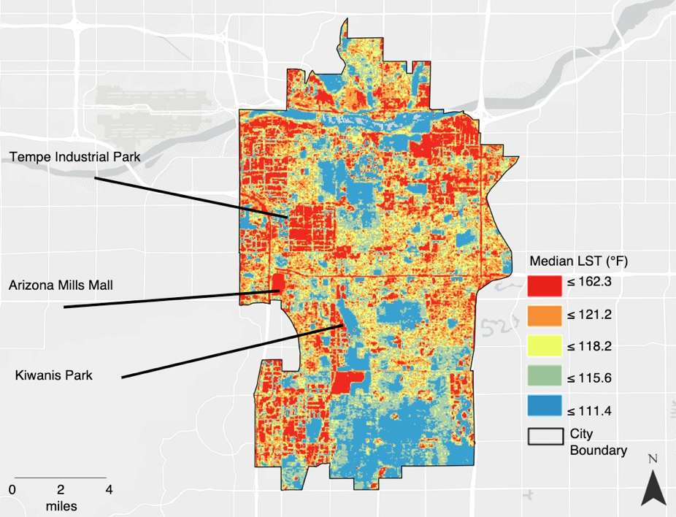

*Figure 2.* Median LST, for all warm season months 2015 to 2020

LST difference from the city mean from 2015-2020 LST ranged from 8.2° C (14.8° F) to -23.3° C (-9.9° F). Areas that have a negative difference from the city mean LST are generally located along the Salt River, the linear greenspace areas lining the Central Arizona Project canals, and other public parks in the southern region of Tempe. Areas that have the largest positive difference from city mean LST are located within the industrial areas, some undeveloped areas such as the natural desert landscape near Papago Park in the north, and residential areas in the dark red regions in northeastern Tempe such as Escalante, Alegre Community, and University Heights.

**4.2 Principal Component Analysis**

*4.2.1 Statistical Analysis*

The PCA run on the biophysical variables to derive the HES resulted in two PCs and showed that high daytime LST and impervious surfaces (via NDBI) are positively correlated, whereas NDVI is negatively correlated (Table A3). These three variables are important in the first PC as they explain most of the variation, 65% in the dataset, implying that these variables are important factors in urban heat. In contrast, albedo, NDWI, and nighttime LST in the second PC explained about 35% of the variation (*Figure A1*).

The sociodemographic PCA used to derive HVS resulted in two PCS and explained about 65% of the variation (Table A4). In PC1, percent poverty, percent minority, percent no high school diploma over the age of 25, and percent living alone were highly correlated together. Having a higher income and percentage of seniors were inversely related, and this is highlighted more in PC2. Both PCs explained the same amount of variation (*Figure A2*).

The HPS allowed for a more in-depth and separate examination of the relationships of variables included within the 14 sociodemographic and biophysical variables in this analysis. The combined PCA run on the datasets were clustered into four PCs, which together explained 74% of variances observed in this data (*Figure 3).* PC1 and PC2 explained 52% of the total variation. Of these two PCs NDVI, NDBI, percent poverty, and percent minority populations had high contributions and have strong loadings on daytime LST. In other words, CTs with low NDVI, high NDBI, percent poverty, and percent minority were likely to also be in CTs of high daytime LST. To a lesser extent, PC3 and PC4 proportionally explained 16 and 14%, respectively, of the remaining variance. The HPS PCA had a root mean square of the residuals of 0.07 and a fit of 0.96.

*Figure 3.* HPS Principal Component Analysis Correlation Map of all Variables

**4.2.2 Heat Score Maps**

All score maps were organized in quantiles, which enables policymakers to make more targeted and precise identifications into the most heat-risk CTs. Seven CTs were identified as very high heat risk areas as reflected by the calculated HPS with a score of ‘5’ and clustered around the northeastern corner of Tempe (*Figure 4*). The CT with the highest HPS was located in CT 319101 near the University Heights and Alegre Community areas. This area has the highest score due to a high percentage of the population having a low median income ($11,000), a high percent minority population (60%), a high level of the population living below the poverty line, a high daytime LST, a high nighttime LST, a low NDVI, a high NDBI, and a low NDWI (Table A2). This CT also had a high CV (greater than 40%) for percent population with no high school diploma, percent over 65 years, and percent over 65 years living alone. Two CTs that did not have any social variable with a CV greater than 40 percent were CT 319705, near the south of Tempe, and CT 319202, near the Escalante neighborhood. Other areas that scored within the top 20% of scores include Escalante, the northeastern portion of Dwight Park, and areas just south of Tempe Royal Estates along West Grove Road. Additionally, areas with a heat risk score of ‘4’ include Knoell Gardens, Peterson Park, Lindon Park, Baseline-Hardy, Superstition near the cross of South Rural Road and Freeway 60, the Hudson Manor and Shalimar neighborhoods in northeastern Tempe, and also the Discovery Business Campus and south Tempe Water Plant near Camelot Village area in southeastern Tempe.

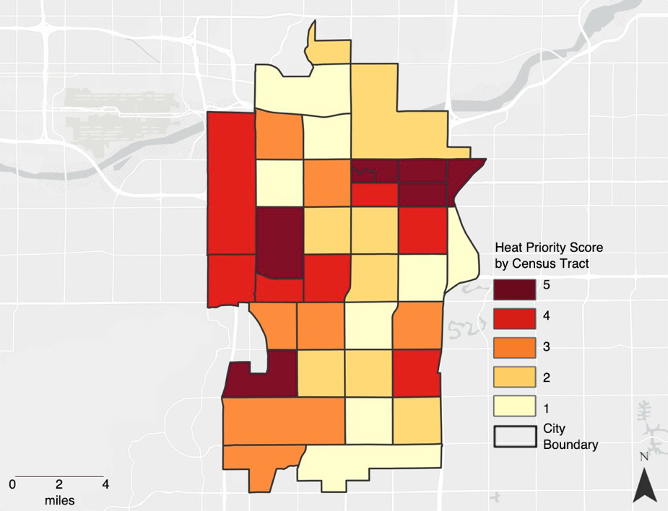

*Figure 4.* Heat Priority Map in Tempe, 2015 to 2020

The HES and HVS maps show similar spatial patterns as the HPS in that CTs with a high HES and HVS were in the northeastern CTs, to the east of ASU and along western Tempe, except for the technology park in southeastern Tempe (*Figure A3*; *Figure A4*). The number one CT for HES was 319705, which was the number two CT under the HPS (Figure A3). This CT had the highest HES because of a high daytime LST, low NDVI, and high NDBI (Table A3). For the HVS (*Figure A4*), the number one CT was 319202, which was the fourth-highest HPS (Table A2). This was due to high percent poverty, high percent minority, high percent of adults with no high school diploma, and a high percent of people living alone (Table A4). While the Escalante area scored high in all three combinations, Gililland did not. However, the LiDAR shade results for Gililland compared to Escalante suggest a different story.

**4.3 Shading Analysis with LiDAR data**

*4.3.1 Street Analysis at the Neighborhood-Level*

The LiDAR analysis results suggest that the Escalante neighborhood had greater overall shade than the Gililland neighborhood. For 4:00 pm on June 21, Escalante shade outperformed Gililland by 16% (27.3% vs. 11.3%). The highest amount of shade occurred in the April 1 scenario at 4:00 pm, while the lowest was at 12:00 pm on June 21. Overall, the mid-summer season (June 21) had far less shade than the early season (April 1). The highest shaded areas were still below the Maricopa Association of Governments (MAG) recommendations for ‘good’ shade of 30% (*Figure 5*), and far below MAG recommendations for ‘excellent’ shade at 60%.

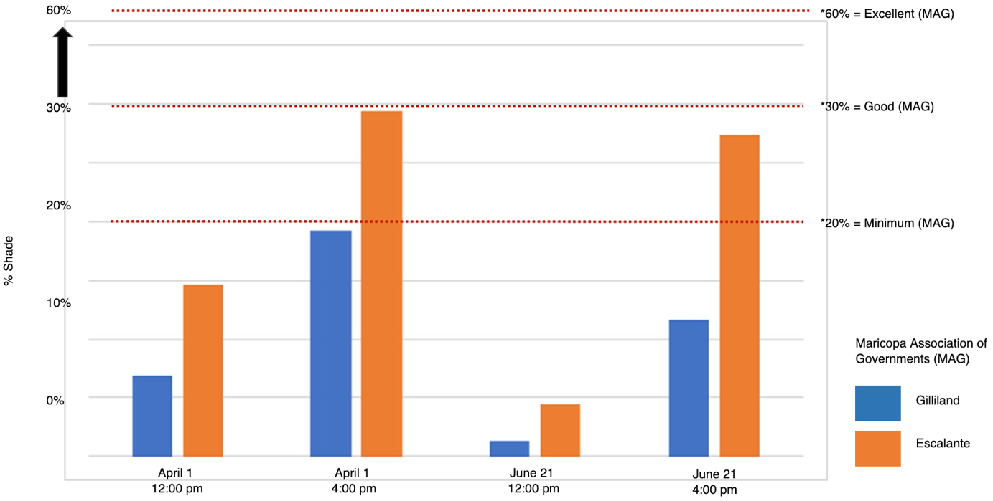

*Figure 5.* Shade Analysis in Gililland and Escalante, April 2015 & June 2015

*4.3.2 Community Walkshed*

For April 1, at 4:00 pm, three streets with the highest percent shade were in the Gililland neighborhood: Kyrene Avenue at 34.8% (which is near an industrial area), West Brown Street at 25.5%, and South Mitchell Drive at 20.8%. In the Escalante neighborhood, the street with the highest shade percent was South Torres Molino Circle at a high 92%. However, it should be noted that this is near a residential complex and is not a pedestrian route that many residents of Tempe would use. Other streets with high shade within the Escalante walkshed included East Sanos Drive and South Willow Creek Apartment Drive. Several streets were completely unshaded in both neighborhoods. These included East Lemon Street near Escalante Park in the Escalante neighborhood as well as West 12th Street in the Gililland neighborhood. Both of these streets could be considered for heat mitigation prioritization.

**4.4 Infrastructure Analysis**

There was a total of 493 bus stops in the Valley Metro Geo-Center database that were not sheltered throughout the city of Tempe (*Figure A6*). The bus stops in the hottest areas were found along various throughways including South McClintock Drive, South Mill Drive, and South Hardy Drive. The five bus stops with the highest LST each exceeded 52° C (125° F) and were located at the intersections of Mill and Southern Avenue, South McClintock Drive, and Apache Boulevard, Hardy and Fairmont Drive, Rio Salado and Parkard Drive, and South McClintock and McClintock Place. These hot and unsheltered public transit corridors could be targeted for mitigation efforts for pedestrians traveling along these routes.

The unsheltered bus stops were also examined at the Escalante (*Figure A7*) and Gililland (*Figure A8*) neighborhoods. The hottest stops in Escalante were University and Price Drive, Main Street, and Lebanon Lane. The hottest stops in Gililland were found along Apache Boulevard as well as the northern part of South Hardy Drive. While there were fewer unshaded bus stops in the Escalante neighborhood, unsheltered stops were located along University Boulevard.

**4.5 Error Analysis/Limitations**

This study did come with a few limitations. First, LST is a proxy for air temperature but it varies from air temperature and the physiologically perceived thermal experience. Second, the use of satellite imagery is limited by its spatial resolution. For example, the relatively low spatial resolution of Aqua MODIS data (1,000 m) may bring some errors in terms of nighttime LST and NDWI. Moreover, only two satellite images were taken per month and this small sample was used to estimate each of the biophysical variables. The images may not capture the days experiencing extreme heat events. Third, the vulnerability analysis used ACS data which is based on samples and has high statistical error for several variables in most CTs. Additionally, the team selected sociodemographic variables indicated in the literature on heat vulnerability within Maricopa County. However, there may be other factors that could have been considered in this analysis. Inherently, this could affect the results when examining the highest priority for heat mitigation efforts. Lastly, individuals are not stagnant and therefore an individual’s home or work is not a conclusive indication of where or how they experience heat.

**4.6 Future Work**

There are five main strategies to improve and expand the scope of this project. First, acquiring higher resolution satellite images would allow for a more detailed analysis of the thermal environment of Tempe. This would allow the quantification of LST near individual trees, buildings, and sidewalks which may better accompany the LiDAR shading analysis and expand statistical analyses. Furthermore, using Sentinel-2 MultiSpectral Instrument (MSI) data at 10 to 20-meter resolution and the normalized difference impervious surface index could be used to create impervious surface metrics that exceed the capabilities of Landsat 8 derived NDBI. Second, more recent LiDAR data could be used – this analysis relies on 2015 data and Tempe has experienced rapid urban expansion over the past five years. Third, this analysis could be completed at the block level by using Centers for Disease Controls (CDC) data and could provide a finer spatial resolution for this analysis. However, mapping the thermal footprint from the temporal resolution provided by Landsat 8 (every 16 days 2015-2020) cannot be improved with currently available satellite imagery. Fourth, surveys of the residents could help better understand and validate the social data and understand the covariations that may occur. In addition to CDC data, including location-based heat-related deaths and illnesses could enable the examination of “who” is most vulnerable to heat events. Fifth, obtaining ground measurements and comparing those to these indices could further validate this project’s findings.

# 5. Conclusions

This project demonstrated that NASA Earth observations can be used in investigating the thermal environment in Tempe and identify areas with high HPS scores that could be prioritized for heat mitigation. The City of Tempe is concerned about its vulnerable populations who are affected by heat-related illnesses and deaths. It is striving to include vulnerability and equity in many city plans, including initiatives like Cool Kids. Conclusions from this work can be used by the City of Tempe to enable a more data-driven approach to enhance its heat mitigation strategies. The PCA showed that NDBI, NDVI, and LST explained the most variation for the biophysical variables while percent poverty, percent population over 65, and percent minority explained the most variation in terms of social vulnerability. Based on the HPS, the areas that scored in the top 20% are near University Heights, the Alegre Community, Escalante, the northeastern portion of Dwight Park, and areas just south of Tempe Royal Estates along West Grove Road. The shading analysis found that the Escalante neighborhood is better shaded than the Gililland neighborhood at the time of 4:00 pm and 12:00 pm in April and June 2015. However, the walksheds in both neighborhoods do not meet MAG’s recommendations of ‘good’ shade at 30%. Lastly, the team also demonstrated how to analyze infrastructure for heat mitigation in Tempe by integrating bus stops without shelters into our analysis. Overall, these tools and workflow aim to inform the City of Tempe’s heat mitigation efforts and inspire further exploration of strategies to improve the resident's quality of life and health regarding urban heat.

# 6. Acknowledgments

A special thank you to Dr. David Hondula, Associate Professor for the School of Geographical Sciences and Urban Planning at Arizona State University, Ryan Hammock, Fellow for the Arizona – Tempe NASA DEVELOP node, and to everyone at the City of Tempe for taking the time to collaborate with us. The team is extremely grateful for the expertise, guidance, and collaboration provided to us.

Any opinions, findings, and conclusions or recommendations expressed in this material are those of the authors and do not necessarily reflect the views of the National Aeronautics and Space Administration.

This material is based upon work supported by NASA through contract NNL16AA05C.

# 7. Glossary

**ACS** –American Community Survey; it is conducted each year to provide up-to-date information about the socioeconomic community needs.

**Albedo** – the measure of reflected solar radiation by a surface; Latin for “whiteness”.

**Earth observations** – Satellites and sensors that collect information about the Earth’s physical, chemical, and biological systems over space and time.

**Google Earth Engine (GEE)** – A cloud-based platform for geospatial analysis.

**Healthy Urban Environments (HUE)** – Healthy Urban Environments is a collaborative initiative that combines the power of Arizona State University’s entrepreneurship, research and innovation infrastructure with partnership, support and collaboration from Maricopa County and its communities.

**Land surface temperature (LST)** – The radiative skin temperature of land surface derived from solar radiation.

**LiDAR** – Light Detection and Ranging, a remote sensing method that emits laser pulses and measures the reflections back to the sensor.

**MAG** –Maricopa Association of Governments, a Council of Governments that serves as the regional planning agency for the metropolitan Phoenix.

**Near-infrared (NIR)** –Light beyond the visible portion of the spectrum with longer wavelengths. Particularly sensitive to vegetative health.

**Normalized Difference Vegetation Index (NDVI)** – An index that quantifies the density of plant growth by using visible and near-infrared light reflection.

**Normalized Difference Built-Up Index (NDBI)** – The quantifiable presence of urban land cover measured by the difference between shortwave infrared and infrared reflectance.

**Normalized Difference Water Index (NDWI)** – An index estimating the surface water content of vegetation using near-infrared and shortwave infrared reflectance.

**Operational Land Imager (OLI)** – Imaging instrument aboard the Landsat 8 satellite. OLI can measure visible, near-infrared, and shortwave infrared wavelengths.

**R/RStudio** – R is a programming language and free software environment for statistical computing and graphics supported by the R Foundation for Statistical Computing. RStudio is an integrated development environment for R.

**Thermal Infrared Sensor (TIRS)** – Instrument aboard the Landsat 8 satellite. TIRS uses two thermal infrared wavelength bands in order to differentiate between the temperature of Earth’s surface and that of Earth’s atmosphere.

**Urban Forestry Master Plan (UFMP)** –A Master Plan developed by the City of Tempe with the consultation of arborists, city staff, community members, data analysts, and other experts in the urban forestry field in order to optimize the City’s urban forest tree canopy.

**Urban heat island (UHI)** – An urban area that is significantly warmer than surrounding rural regions due to anthropogenic activities and infrastructure.

**MODIS** – MODerate resolution Imaging Spectroradiometer imaging instrument aboard NASA’s Terra and Aqua satellites. MODIS has 36 spectral bands and views the entire Earth’s surface every one to two days.

# 8. References

Bosch, M., Locatelli, M., Hamel, P., Remme, R. P., Chenal, J., & Joost, S. (2020). A spatially-explicit approach to simulate urban heat islands in complex urban landscapes. *Geoscientific Model Development Discussions*, 1-22. https://doi.org/10.5194/gmd-2020-174.

City of Tempe (2020). City of Tempe Boundary. TempeData. Retrieved from https://data.tempe.gov/datasets/city-of-tempe-boundary.

Conlon, K. C., Mallen, E., Gronlund, C. J., Berrocal, V. J., Larsen, L., & O’neill, M. S. (2020). Mapping human vulnerability to extreme heat: a critical assessment of heat vulnerability indices created using principal components analysis. *Environmental Health Perspectives, 128*(9), 097001. https://doi.org/10.1289/EHP4030.

Cutter, S. L., Boruff, B. J., & Shirley, W. L. (2003). Social vulnerability to environmental hazards. *Social Science Quarterly, 84*(2), 242-261. https://doi.org/10.1111/1540-6237.8402002.

Davis, A. Y., Jung, J., Pijanowski, B. C., & Minor, E. S. (2016). Combined vegetation volume and “greenness” affect urban air temperature. *Applied Geography*, *71,* 106-114. <https://doi.org/10.1016/j.apgeog.2016.04.010>.

Equere, V., Mirzaei, P. A., & Riffat, S. (2020). Definition of a new morphological parameter to improve prediction of urban heat island. *Sustainable Cities and Society*, 56, 102021. https://doi.org/10.1016/j.scs.2020.102021.

Gao, B.C. (1996). NDWI – A normalized difference water index for remote sensing of vegetation liquid water from space. *Remote Sensing of Environment, 58*(3), 257-266. https://doi.org/10.1016/S0034-4257(96)00067-3.

Glorfeld, L. W. (1995). An improvement on Horn's parallel analysis methodology for selecting the correct

number of factors to retain. *Educational and Psychological Measurement, 55*(3), 377–393.

https://doi.org/10.1177/0013164495055003002.

Hammer, J., Ruggieri, D. G., Thomas, C., & Caum, J. (2020). Local extreme heat planning: An interactive tool to examine a heat vulnerability index for Philadelphia, Pennsylvania. *Journal of Urban Health: Bulletin of the New York Academy of Medicine, 97*(4), 519-528. doi:10.1007/s11524-020-00443-9.

Harlan, S. L., Declet-Barreto, J. H., Stefanov, W. L., & Petitti, D. B. (2013). Neighborhood effects on heat deaths: social and environmental predictors of vulnerability in Maricopa County, Arizona. *Environmental Health Perspectives*, *121*(2), 197-204. <https://doi.org/10.1289/ehp.1104625>.

Harlan, S. L., Chakalian, P., Declet-Barreto, J., Hondula, D. M., & Jenerette, G. D. (2019). Pathways to Climate Justice in a Desert Metropolis. In People and Climate Change: Vulnerability, Adaptation, and Social Justice. Oxford University Press. doi:10.1093/oso/9780190886455.001.0001.

Hondula, D. M., Davis, R. E., Saha, M. V., Wegner, C. R., & Veazey, L. M. (2014). Geographic dimensions of heat-related mortality in seven U.S. cities. *Environmental Research*, *138*, 439-452. https://doi.org/10.1016/j.envres.2015.02.033.

Hulley, G., Shivers, S., Wetherley, E., & Cudd, R. (2019). New ECOSTRESS and MODIS land surface temperature data reveal fine-scale heat vulnerability in cities: A case study for Los Angeles County, California. *Remote Sensing, 11*(18), 2136. https://doi.org/10.3390/rs11182136.

Jenerette, G. D., Harlan, S. L., Buyantuev, A., Stefanov, W. L., Declet-Barreto, J., Ruddell, B. L., Myint, S. W., Kaplan, S., & Li, X. (2016). Micro-scale urban surface temperatures are related to land-cover features and residential heat related health impacts in Phoenix, AZ USA. *Landscape Ecology*, *31*(4), 745-760. https://doi.org/10.1007/s10980-015-0284-3.

Jin, M., & Liang, S. (2006). An improved land surface parameter for land surface models using global remote sensing observations. *Journal of Climate*, *19*(12), 2867-2881. https://doi.org/10.1175/JCLI3720.1.

Kaiser, H. F. (1960). The application of electronic computers to factor analysis. *Educational and Psychological Measurement, 20*(1), 141-151. https://doi.org/10.1177/001316446002000116.

Ke, Y., Im, J., Lee, J., Gong, H., & Ryu, Y. (2015). Characteristics of Landsat 8 OLI-derived NDVI by comparison with multiple satellite sensors and in-situ observations. *Remote Sensing of Environment*, 164, 298-313. https://doi.org/10.1016/j.rse.2015.04.004.

Kumar, K. S., Bhaskar, P. U., & Padmakumari, K. (2012). Estimation of land surface temperature to study urban heat island effect using Landsat ETM+ image. *International Journal of Engineering Science and Technology, 4*(2), 771-778.

Maricopa County Health Department (2019). Heat Reports. Retrieved from https://www.maricopa.gov/1858/Heat-Surveillance.

Mushore, T. D., Mutanga, O., Odindi, J., & Dube, T. (2018). Determining extreme heat vulnerability of Harare Metropolitan City using multispectral remote sensing and socio-economic data*. Journal of Spatial Science, 63*(1), 173-191. https://doi.org/10.1080/14498596.2017.1290558.

NOAA (2020). *Summer 2020 ranked as one of the hottest on record for U.S. August was remarkably hot and destructive. Retrieved from* https://www.noaa.gov/news/summer-2020-ranked-as-one-of-hottest-on-record-for-us.

Nisbet-Wilcox, B., Meltzer, S., Nelson, S., Wagner, C., & Hondula, D. (2020). *Assessing Land Surface*

*Temperature, Vegetation Cover, and Compounding Vulnerability Factors to Identify High Priority*

*Areas for Cooling Initiatives in Philadelphia, Pennsylvania*. NASA DEVELOP.

http://www.devpedia.developexchange.com/dp/images/8/84/2020Spring_AZ_PhiladelphiaHealthAQ_TechPaper_FD-final.docx.

Olmedo, G. F., Ortega-Farías, S., de la Fuente-Sáiz, D., Fonseca-Luego, D. & Fuentes-Peñailillo, F. (2016)

Water: Tools and function to estimate actual evapotranspiration using land surface energy balance

models in R. *The R Journal*, *8*(2), 352-369. doi:10.32614/RJ-2016-051.

OpenStreetMap Contributors (2015). Multiline.osm file. Planet dump. Retrieved from https://planet.openstreetmap.org.

U.S. Census Bureau (2018). American Community Survey 5-Year Data, 2014-2018. Retrieved from https://www.census.gov/data/developers/data-sets/acs-5year.html.

U.S. Geological Survey (2018). LiDAR Dataset Phoenix Metropolitan, Arizona State University Map and Geospatial Hub. Retrieved from https://asu.maps.arcgis.com/apps/webappviewer/index.html?id=0372792855514dd3bf9654c20bbe10e6/.

U.S. Geological Survey Earth Resources Observation and Science Center. (2015-2020). Provisional Landsat OLI Surface Reflectance. Landsat 8 OLI and TIRS Level-1 Data Products. Courtesy of the U.S. Geological Survey. <https://doi.org/10.5066/F71835S6>.

Valley Metro GeoCenter (2020). Valley Metro Bus Stop View. Retrieved from https://geocenter-valleymetro.opendata.arcgis.com/datasets/valley-metro-bus-stops-view?geometry=-118.869%2C31.053%2C-104.806%2C34.289.

Vermote, E., Wolfe, R. (2015). MYD09GA MODIS/Aqua Surface Reflectance Daily L2G Global 1kmand 500m SIN Grid V006 [Data set]. NASA EOSDIS Land Processes DAAC. https://doi.org/10.5067/MODIS/MYD09GA.006.

Wang, C., Middel, A., Myint, S. W., Kaplan, S., Brazel, A. J., & Lukasczyk, J. (2018). Assessing local climate

zones in arid cities: The case of Phoenix, Arizona and Las Vegas, Nevada. *ISPRS Journal of*

*Photogrammetry and Remote Sensing*, 141, 59-71. https://doi.org/10.1016/j.isprsjprs.2018.04.009.

Zhang, J., Wang, Y., & Li, Y. (2006). A C++ program for retrieving land surface temperature from the data of Landsat TM/ETM+ band6. *Computers & Geosciences, 32*(10)*,* 1796-1805. https://doi.org/10.1016/j.cageo.2006.05.001.

# 9. Appendix A

Table A1:

*Overview of American Community Survey (ACS) sociodemographic data used, area division, date, source, and retrieval method.*

|  |  |  |  |  |
| --- | --- | --- | --- | --- |
| **Dataset** | **Area Division** | **Date/Time** | **Source** | **Retrieval** |
| Total Population  B01001_001 | Census tract | 2018, 5-year estimate (2014-2018) | ACS | Tidycensus package in R |
| Ethnic Minority  (Non-White)  B03002_001 | Census tract | 2018, 5-year estimate (2014-2018) | ACS | Tidycensus package in R |
| Below Poverty Line  B17021_002 | Census tract | 2018, 5-year estimate (2014-2018) | ACS | Tidycensus package in R |
| Median Income  B19013e1 | Census tract | 2018, 5-year estimate (2014-2018) | ACS | Tidycensus package in R |
| Without High School Diploma  B15003_002-016 | Census tract | 2018, 5-year estimate (2014-2018) | ACS | Tidycensus package in R |
| Total Median Income  B19326_001 | Census tract | 2018, 5-year estimate (2014-2018) | ACS | Tidycensus package in R |
| 65 Years and Older  B01001_020-25  B01001_044-49 | Census tract | 2018, 5-year estimate (2014-2018) | ACS | Tidycensus package in R |
| 65 Years and Older, Living Alone  B09020_015  B09020_018 | Census tract | 2018, 5-year estimate (2014-2018) | ACS | Tidycensus package in R |

Table A2:

*Heat Priority Score (HPS) table of top five scoring census tracts (CTs).*

|  |  |  |  |  |  |
| --- | --- | --- | --- | --- | --- |
| **GEOID** | | | | | |
| **Variables** | **319101** | **319705** | **319103** | **319202** | **319201** |
| Total Population | 3501 | 3829 | 5226 | 3357 | 6452 |
| Median Income ($) | 11630 | 28594 | 13106 | 22151 | 19247 |
| Minority  (%) | 61.81 | 55.05 | 66.90 | 47.36 | 60.23 |
| Poverty  (%) | 70.83 | 27.71 | 56.70 | 37.38 | 50.23 |
| No HS Diploma (%) | 6.09 | 16.69 | 14.10 | 12.75 | 25.87 |
| Over 65  (%) | 0.03 | 5.59 | 2.68 | 5.48 | 4.18 |
| Over 65 and Alone (%) | 0.03 | 3.26 | 0.50 | 2.77 | 0.76 |
| Alone (%) | 13.14 | 9.11 | 10.16 | 34.35 | 10.49 |
| dLST (° F) | 119.81 | 121.38 | 117.18 | 120.63 | 118.90 |
| nLST (° F) | 75.97 | 75.33 | 76.15 | 75.80 | 75.81 |
| NDVI | 0.12 | 0.12 | 0.18 | 0.14 | 0.17 |
| NDBI | -0.04 | -0.03 | -0.05 | -0.03 | -0.04 |
| NDWI | 0.02 | 0.02 | 0.02 | 0.02 | 0.01 |
| Albedo | 0.22 | 0.22 | 0.20 | 0.21 | 0.20 |
| Raw HPS Score | 4.79 | 4.67 | 3.02 | 3.02 | 3.02 |

Table A3:

*Heat Exposure Score (HES) table of top five scoring census tracts (CTs)*

|  |  |  |  |  |  |
| --- | --- | --- | --- | --- | --- |
| **GEOID** | | | | | |
| **Variables** | **319705** | **319101** | **319202** | **319906** | **81000** |
| dLST°C | 121.38 | 119.81 | 120.63 | 115.40 | 117.10 |
| nLST°C | 75.33 | 75.97 | 75.80 | 74.98 | 74.86 |
| NDVI | 0.12 | 0.12 | 0.14 | 0.18 | 0.17 |
| NDBI | -0.03 | -0.04 | -0.03 | -0.05 | -0.04 |
| NDWI | 0.02 | 0.02 | 0.02 | 0.02 | 0.00 |
| Albedo | 0.22 | 0.22 | 0.21 | 0.22 | 0.22 |
| Raw HES Score | 3.78 | 2.74 | 2.37 | 2.30 | 1.72 |

Table A4:

*Heat Vulnerability Score (HVS) table of top five scoring census tracts (CTs).*

|  |  |  |  |  |  |
| --- | --- | --- | --- | --- | --- |
| **GEOID** | | | | | |
| **Variables** | 319202 | 319703 | 319404 | 319300 | 318501 |
| Total Population | 3357 | 4302 | 3682 | 2833 | 3670 |
| Median Income($) | 22151 | 27211 | 37680 | 16664 | 23994 |
| Minority(%) | 47.36 | 45.51 | 23.06 | 52.03 | 38.86 |
| Poverty(%) | 37.38 | 14.95 | 9.28 | 35.30 | 20.54 |
| No HS Diploma (%) | 12.75 | 3.56 | 2.89 | 30.11 | 14.13 |
| Over 65 (%) | 5.48 | 21.87 | 30.34 | 13.45 | 13.49 |
| Over 65 and Alone (%) | 2.77 | 9.74 | 11.92 | 2.89 | 3.76 |
| Alone (%) | 34.35 | 21.48 | 17.19 | 10.84 | 17.22 |
| Raw HVS Score | 3.34 | 2.81 | 2.54 | 2.32 | 1.51 |

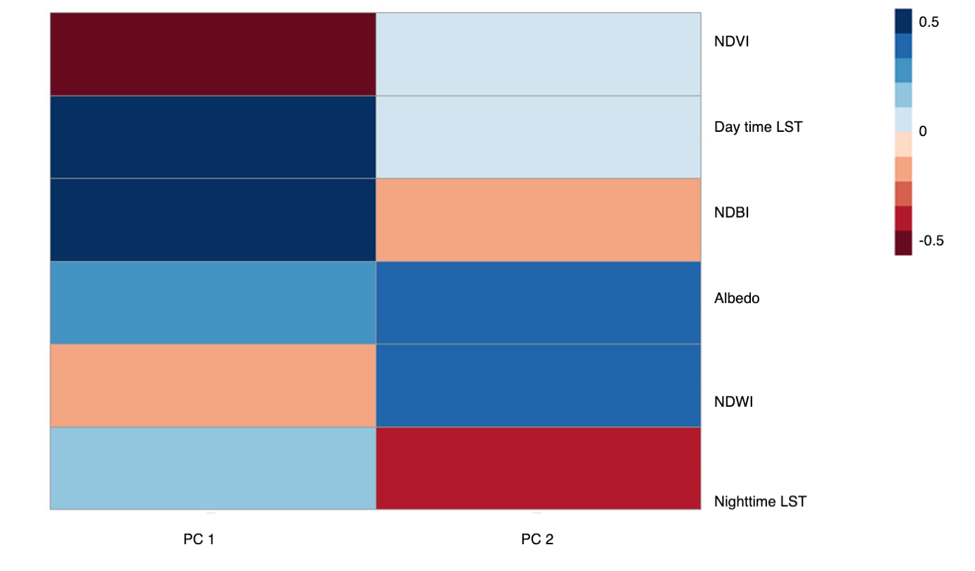

*Figure A1* Heat Exposure Score (HES) Principal Component Analysis (PCA) Correlation Map of Biophysical Variables

*Figure A2.* Heat Vulnerability Score (HVS) Principal Component Analysis (PCA) Correlation Map of Sociodemographic Variables

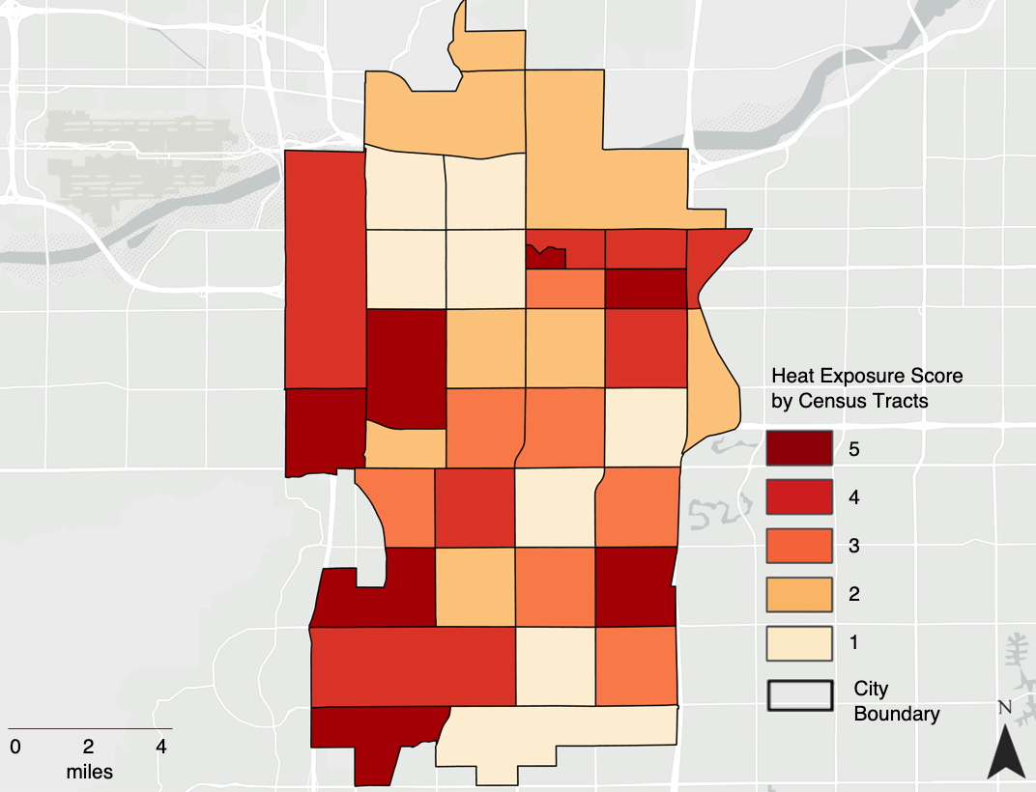

*Figure A3.* Heat Exposure Score (HES) Map in Tempe, 2015 to 2020

*Figure A4.* Heat Vulnerability Score (HVS) Map in Tempe, 2015 to 2020

*Figure A5.* Mean LST for City-wide Unsheltered Bus Stops, 2015 to 2020

*Figure A6.* Mean LST for Unsheltered Bus Stops in the Gililland Neighborhood, 2015 to 2020

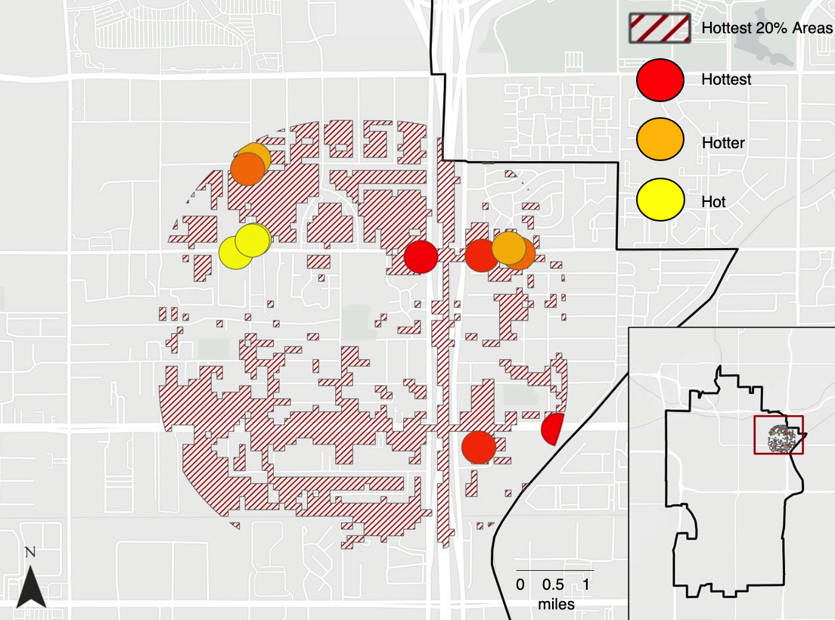

*Figure A7.* Mean LST for Unsheltered Bus Stops in the Escalante Neighborhood, 2015 to 2020