Southern Idaho Health & Air Quality

Monitoring Atmospheric Mixing Heights Post-Wildfire Through the Use of NASA Earth Observations

 **Technical Report**

Final – November 20th, 2020

Ella Griffith

Ashwini Badgujar

Sean Cusick

Patrick Giltz

***Advisors:***

Keith Weber, Idaho State University, GIS Training and Research Center

Dr. Kenton Ross, NASA Langley Research Center

Dr. Travis Toth, NASA Langley Research Center

# 1. Abstract

Wildfire smoke has long-lasting impacts on public and environmental health. Currently, agencies that monitor smoke base their decisions on an analysis of how fires burn, the direction the smoke moves from the fire source, and unverified estimates of mixing height. Mixing heights describe the maximum altitude to which a smoke plume rises. Satellite imagery provides more continuous and accurate coverage of mixing heights than current *in situ* methods. Thus, the team developed a software tool that processes and extracts mixing height observations from Cloud-Aerosol Lidar and Infrared Pathfinder Satellite Observations (CALIPSO) Vertical Feature Mask granules. The team partnered with the National Oceanic and Atmospheric Administration’s National Weather Service, the Bureau of Land Management’s National Interagency Fire Center, and the National Park Service’s Fire Management Program Center to analyze historic fire events in southern Idaho. To do so, they used Suomi National Polar-orbiting Partnership (Suomi NPP) Visible Infrared Imaging Radiometer Suite (VIIRS), and Terra and Aqua Moderate Resolution Imaging Spectroradiometer (MODIS) to verify where a CALIPSO pass intersects thermal anomalies and smoke plumes. The software extracts features of relevance from the hdf file of each CALIPSO transect to locate layers of continuous aerosols. The maximum altitude at which the aerosol ends is recorded as the mixing height, along with a matching latitude and longitude. The satellite-derived values can be used to validate past mixing height predictions and evaluate the accuracy and systematic bias of different estimation methods. These results may allow agencies to make better comparisons and subsequent smoke pollution management, prevention, and public health decisions if the spatial and temporal differences between predictions and observations can be resolved.

**Key Terms**

Air quality, wildfire smoke, smoke pollution, mixing height, CALIPSO, public health, aerosol dispersion

# 2. Introduction

***2.1 Background Information***

In recent decades, wildfire events in the western United States have increased in frequency due to changes in climate, severe droughts, invasive species, and consequences from historic fire management and fire repression. (Dennison et al., 2014). While the fires themselves may damage landscapes and infrastructure, smoke from these events is known to have adverse effects on human respiratory and cardiovascular health (Deflorio-Barker et al., 2019) and environmental productivity (Yue & Unger, 2018). Additionally, prescribed burns, which many ecosystems rely on to help reduce fuel loads and manage the size and severity of uncontrolled fires (Williamson et al., 2016), are often vetoed due to potential smoke hazards. For these reasons, the ability to accurately predict the dispersion of smoke from wildfires and prescribed burning is critical.

One of the key indices for smoke pollution forecasting is mixing height. Mixing height, synonymous with mixing layer, is defined as the maximum height that rapid vertical mixing takes place in the atmosphere and is expressed in an altitude measurement above ground or sea level (Figure 1). Mixing height estimation is critical to predict the movement and dispersal of wildfire smoke plumes. The National Weather Service Fire Weather Program has not determined a national standard for calculating mixing heights because there is little validation of the accuracy of different mixing height estimation models; this has resulted in inconsistencies in smoke forecasting between agencies and across state boundaries (Fearon et al., 2015). The four most common mixing height prediction[1] methodologies used by National Weather Service Forecast Offices (NWSFOs) are the Stull method, Holzworth method, turbulent kinetic energy (TKE) method, and Bulk Richardson number (RI) method, which are either based on meteorological soundings or models. All of these methods are estimations and are not based on observed mixing heights (Fearon et al., 2015).

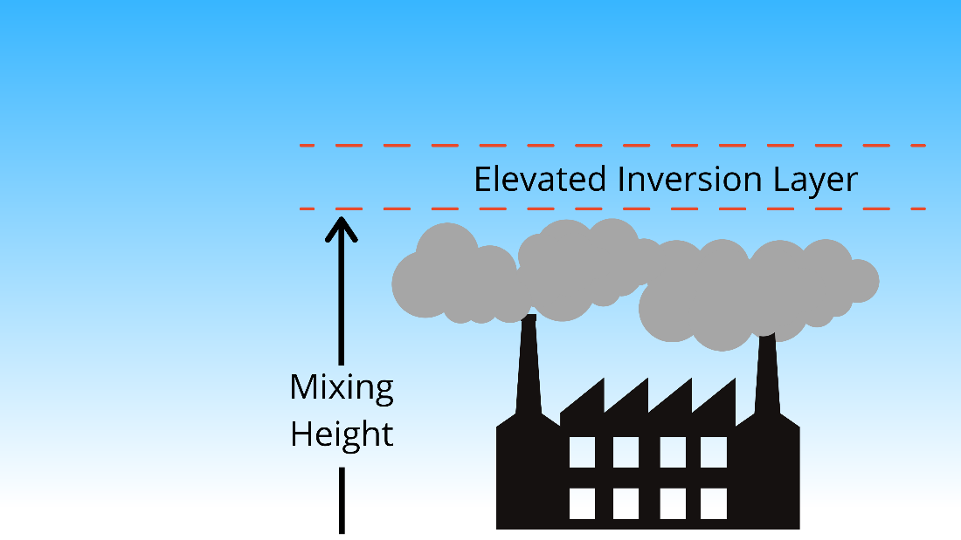

*Figure 1.* Mixing height illustrated by the altitude at which smoke is dispersed from aloft temperature inversion in the atmosphere.

Satellites, such as Cloud-Aerosol Lidar and Infrared Pathfinder Satellite Observations (CALIPSO), that measure atmospheric content can be used to calculate observed mixing height. Previous studies have used CALIPSO Level 2 LiDAR vertical feature mask (VFM) data to calculate observed mixing height because the CALIPSO VFM data product describes the vertical and horizontal distribution of cloud and aerosol layers and can detect many air quality feature types (NASA 2018). One of the feature types that is detected by the sensor is tropospheric aerosols; Smoke plumes that are contiguous relative to the earth’s surface are classified as tropospheric aerosols and the location and altitude at which these aerosols dissipate can be recorded as the mixing height (Fearon et al., 2015). The team wrote a script to automate the process of extracting features of interest and calculating mixing height from CALIPSO transects that coincided with smoke from a wildfire event.

This study focused on smoke pollution from historic fires in and around the southern Idaho region (Figure 2). As of 2019, Idaho was ranked in the top five most wildfire-prone states in the United States and ranked in the top three for average acreage burned from 2002-2018 (Jeffery et al., 2019). The semi-arid climate of southern Idaho, specifically around the Snake River Valley, results in dry vegetation shared by surrounding states to the west, south, and east. These conditions create a region prone to large wildfire events. The high volume of wildfires and stable dry climate regime made southern Idaho an ideal study area (National Climatic Data Center, 2019). In addition, the ecosystem is relatively uniform across the region, which allows for consistency in fuel type for wildfires as an additional variable control. The team acquired data from select wildfires that burned from 2013-2020.

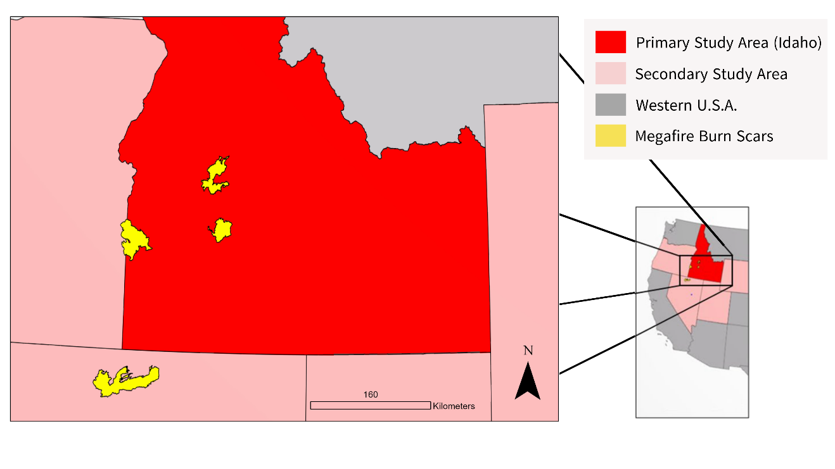

*Figure 2.* The Southern Idaho region of the western U.S. Burn-scars seen here in yellow are from the Pioneer Fire in 2016 (furthest north), the Elk Complex fire in 2013 (just below the Pioneer fire), the 2015 Soda fire along the Idaho/Oregon border, and the Martin fire which burned in northern Nevada in 2018. ​These four megafires were used as case studies for the team to refine their data acquisition and data processing methodology.

***2.2 Project Partners & Objectives***

The team partnered with the National Weather Service (NWS) Fire Weather Program (FWP), the National Park Service (NPS) Fire Management Program Center (FMPC), and the Bureau of Land Management (BLM) National Interagency Fire Center (NIFC) to improve verification methods to standardize the method used to estimate mixing heights. This is a challenge for the partners as the most commonly used method at the time of this study was the modified Stull method and is based on a single study. Since then, there has been no research into how accurate the Stull method is, leading to a non-uniform system in which each weather station implements its own preferred method. The FWP is therefore interested in a verification study that compares each method against observed mixing heights to create a national standard for mixing height predictions. The NIFC conducts prescribed burns in an effort to control wildfires and the decision to ignite a fire is based on mixing height estimations. The NIFC cannot burn if the estimated mixing height is too low due to possible downwind air quality hazards. A verification study will allow the NIFC to more accurately conduct prescribed burns. Lastly, the FMPC maintains national lands in regions of the United States that are subject to frequent wildfires. The FMPC is interested in a verification study of mixing height estimations so the agency can accurately forecast the mixing height of smoke in the area. This will aid the FMPC in determining if the air quality inside the park is safe to remain open to the public.

This project had three objectives. The first was to develop a Python script that uses CALIPSO data inputs and returns mixing height observations over given coordinates. The second goal was to compare the mixing height observation output from the software tool with back-calculated mixing height predictions and evaluate the accuracy of each estimation method. Finally, the third goal was to automate this process so that users and partners would be able to apply these methods to any area where there was a fire intersected by a CALIPSO pass.

# 3. Methodology

***3.1 Data Acquisition***

Due to the fact that smoke pollution is not stationary and that CALIPSO has a sparse temporal resolution --only making a pass once every sixteen days— this was a challenging study. To overcome the inconsistent sampling, the team began by exclusively investigating megafire events in which more than 100,000 acres were burned (Table 1). Given that these large fire events typically burn for extended periods of time, this approach was intended to increase the chance of a CALIPSO pass intersecting a smoke plume over the area of interest. Eventually, the team determined that a greater number of passes could be collected by looking through the primary months of wildfire season. Starting with the Elk Complex fire, the study period encompassed 2013-2019.

Table 1

*Vertical Feature Mask data acquired for wildfires of interest. These fires represent the four megafires that the team used as case studies to test the software tool. Twelve additional fires were identified and processed to find mixing height.*

|  |  |  |  |
| --- | --- | --- | --- |
| **Fire Name & Duration of Burn** | **VFM Granule** | **Date of CALIPSO Pass** | **Location** |
| Elk Complex Fire, August 6th-18th, 2013 | CAL_LID_L2_VFM-ValStage1-V4-20.2013-08-12T20-24-31ZD.hdf | August 13, 2013 | South-East of Boise, ID |
| SODA Fire, August 10th-20th, 2015 | CAL_LID_L2_VFM-Standard-V4-20.2015-08-16T09-57-00ZN.hdf | August 18, 2015 | West of Boise, along Idaho-Oregon border |
| Pioneer Fire, July 18th - September 6th, 2016 | CAL_LID_L2_VFM-Standard-V4-20.2016-07-28T20-19-04ZD.hdf | July 28, 2016 | North-West of Idaho City |
| Martin Fire, July 4th - August 2nd, 2018 | CAL_LID_L2_VFM-Standard-V4-20.2018-07-07T09-59-32ZN.hdf | July 7, 2018 | North of Paradise Valley, Humboldt County |

The team utilized multiple sensors (Table 2) and ancillary datasets (Table 3) to track aerosol content and movement throughout the atmosphere during historic wildfires in the southern Idaho region. We viewed 2D images of each wildfire in the NASA Worldview map with Suomi NPP VIIRS I Band 375 m Active Fire Product NRT and Terra and Aqua MODIS Atmospherically Corrected Surface Reflectance 5-Min L2 Swath 250m, 500m. The resulting map indicated the site of the active fire, and the direction and size of smoke plumes. Then, CALIPSO’s flight path was added, allowing the team to visualize when and where the optimal aerosol data could be extracted over the duration of the fires of interest (Figure 3). The team then used the NASA Worldview visual as a guide to download CALIPSO Vertical Feature Mask granules from NASA’s EOSDIS Earth Data website for vertical and horizontal distribution of cloud and aerosol layers.

Table 2

*Sensors utilized to view and track aerosol content and predict mixing height in the atmosphere.*

|  |  |  |  |
| --- | --- | --- | --- |
| **NASA Earth Observation Data** | | | |
| **Platform & Sensor** | **Description & Use** | **Years Acquired** | **Source** |
| CALIPSO CALIOP | CAL_LID_L2_VFM-Standard-V4 20, CALIPSO Lidar Level 2, 5km Vertical Feature Mask (VFM) V4-20 for vertical and horizontal distribution of cloud and aerosol layers | 2013, 2015, 2016, 2017, 2018 | NASA Earth Data |
| Terra MODIS | MOD09, MODIS/Terra Atmospherically Corrected Surface Reflectance 5-Min L2 Swath 250m, 500m, 1km for active fire boundary and smoke imagery | 2013, 2015, 2016, 2017, 2018 | NASA Earth Data, NASA Worldview |
| Aqua MODIS | MYD09, MODIS/Aqua Atmospherically Corrected Surface Reflectance 5-Min L2 Swath 250m, 500m, 1km for active fire boundary and smoke imagery | 2013, 2015, 2016, 2017, 2018 | NASA Earth Data, NASA Worldview |
| Suomi NPP VIIRS | VIIRS (S-NPP) I Band 375 m Active Fire Product NRT for historic fire approximation | 2013, 2015, 2016, 2017, 2018 | NASA Earth Data, NASA Worldview |

Table 3

*Ancillary Datasets.*

|  |  |  |
| --- | --- | --- |
| **Ancillary Dataset** | **Description and Use** | **Source** |
| Historic Fires Database (HFD) | GIS data for wildfires in the western U.S. from 1950 to 2019. Used to identify burn scars of wildfires in the study area. | Idaho State University GIS Training and Research Center. 2020. Historic Fires Database (HFD) version 3.0. Downloaded from http://giscenter.isu.edu/research/Techpg/HFD/ October 1, 2020 |
| Iowa State Bufkit Warehouse | Model sounding archive of the world from 1933 to 2020. Used to identify model-soundings in proximity to burn scars and CALIPSO passes. | Iowa State Department of Geological and Atmospheric Sciences, Bufkit Warehouse Jan 23, 2009 Accessed from https://meteor.geol.iastate.edu/~ckarsten/bufkit/bufkit.html  October 15, 2020 |

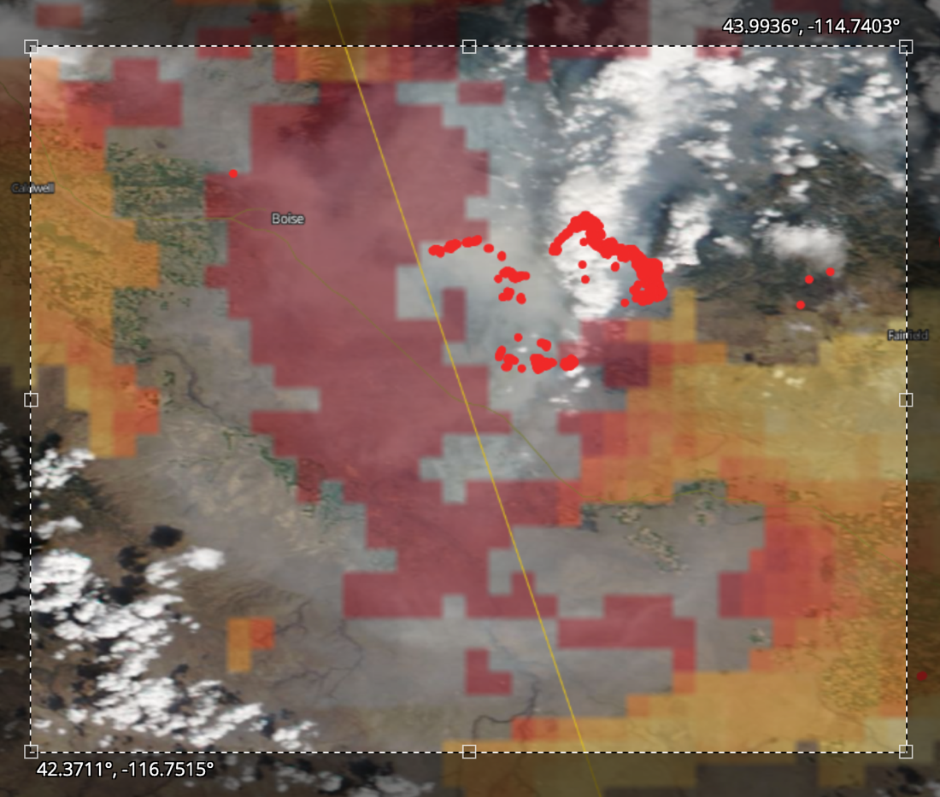

*Figure 3.* NASA Worldview Map of the Elk Complex Wildfire from August 12, 2013. The map includes MODIS Atmospherically Corrected Surface Reflectance 5-Min L2 Swath 250m, 500m for base map visualization of the smoke plumes, VIIRS (S-NPP) I Band 375 m Active Fire Product NRT for vector data of the current fire, and a thin yellow line representing CALIPSO’s flight path.

For soundings, the team found an online archive from the Iowa State Department of Geological and Atmospheric Sciences of model-based soundings calculated for specific locations. After speaking with the project partners, the team was given access to SHARPpy. The team used this software to access the archive and download the soundings as text files for the script to process, as described in Blumberg et al., 2017.

***3.2 Data Processing***

To calculate the mixing height from CALIPSO Vertical Feature Mask data, the team had to unpack each data block to determine atmospheric features. In each CALIPSO HDF data file, there is a set of feature classification flags from each layer detected in the CALIPSO backscatter data, one of which is the tropospheric aerosol feature type (NASA, 2018). The team created a python script that unpacks data within the desired latitude and longitude area and reassigns the values to find the mixing height based on aerosol profiles that are continuous from the surface up.

This script extracts and measures mixing heights using various packages and libraries. The packages in the script include matplotlib, numpy, os, scipy, pandas and sys. In addition to the calculation, the script also visualizes the plot of the air and aerosol content. In detail, the script inputs the CALIPSO file which consists of the hierarchical content values for aerosols, surface, and other features. Once the CALIPSO file is extracted, the features of the column of air are extracted as bits. The team then reassigned these features to a simplified integer value for easier access and processing. In particular, the features of interest to determine mixing height are surface, tropospheric aerosol, and attenuated data.

The output from the script includes a plot that displays the following features: clean air, surface, tropospheric aerosol, and attenuated data (Figure 4). Based on these values, the team calculated continuous aerosol profiles to measure mixing height and added the extracted mixing height values, as well as corresponding latitude and longitude, to a CSV. Each processed HDF file generates a unique plot and CSV with mixing height observations across the CALIPSO transect.

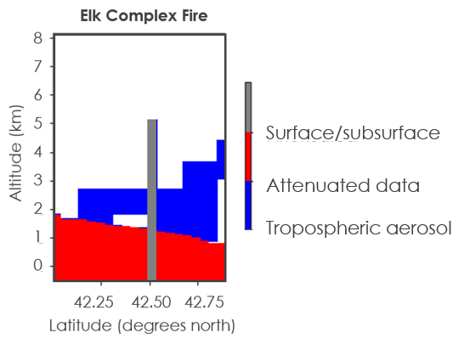

*Figure 4.* The representation plot of data taken from the CALIPSO file with extracted features for the 2013 Elk Complex fire in southern Idaho generated using CALIPSO data from August 12, 2013. The plot shows clean air (white), surface (red), tropospheric aerosol (blue), and attenuated data (grey). The figure indicates the mixing height altitude at 42.25 degrees North starts at ~2.9km, but increases to ~3.5km at 42.75 degrees North. A similar plot was generated for each CALIPSO HDF file corresponding to a wildfire event used in the study.

To estimate mixing height from model-based atmospheric soundings the team created another script separate from the main software tool that uploaded a .txt sounding file into a pandas dataframe. This script proceeded to break apart the data frame into smaller matrices of individual variables such as pressure and temperature. Using the initial values of dew point, temperature, and pressure, the script calculated the vapor pressure using the Clausius-Clapeyron equation. Next, the code calculated the mixing ratio at ground level using the vapor pressure and initial pressure. These values then calculated the virtual temperature and assigned it as the Stull initial temperature (Petty, 2008). Utilizing the MetPy module and the initial values, the code uses a MetPy function that calculated the temperature and pressure of the smoke as it is lifted through the atmosphere and places the output into matrices. The code finally plots the environmental temperature, dew point temperature, and smoke temperature (calculated using the Stull method and Holzworth method) onto a skew-t against pressure (Figure 5). This allowed the viewer to check the numeric mixing height pressure to the intersection of the temperature profiles from the Holzworth and Stull estimation methods.

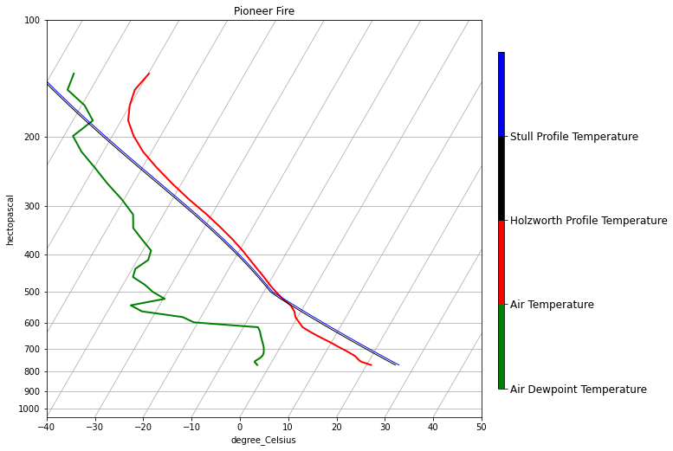

*Figure 5.* Skew-T plot showing the environment’s temperature, dew point temperature along with the Holzworth parcel temperature and Stull parcel temperature for the Pioneer Fire on July 27, 2016 at 18Z.

***3.3 Data Analysis***

The output of the processed CALIPSO data was a set of mixing height estimations with location coordinates. To verify the accuracy of the mixing height observations, the team mapped the mixing height layer in ArcGIS Pro and compared the result with the NASA Worldview image for each wildfire event. The team then attempted to compare the mixing height observations with mixing height predictions but faced difficulty in back-calculating mixing height using the four mathematical methods described in Fearon et al’s 2015 study. Instead, the team analyzed the temporal and spatial differences between model-based soundings (used to back-calculate mixing height), the mixing height observation layers, and the footprints of the wildfire that produced the smoke pollution.

# 4. Results & Discussion

***4.1 Results***

The team successfully developed a software tool, Automated Satellite Mixing height Observations and Known Remote Estimations (A-SMOKRE), which extracts features of interest from the VFM granule in order to calculate mixing height. This tool verifies the location of attenuated data, cloud interference, surface and continuous aerosols relative to the Earth’s surface. While the code automates the mixing height calculation process, it currently requires the user to manually enter index values for their desired latitude and name of the HDF file of interest. Additionally, the CALIPSO pass did not always indicate where there were continuous aerosols if the transect does not cross a smoke plume or if the LiDAR laser return was disrupted. In some instances, there were gaps in the return data that led to broken or incomplete mixing height layers, which is reflected in the atmospheric profile plots by the grey attenuated data (Figure 4). The team speculated that gaps in this data were due to the thick volume of smoke and aerosols in the air disrupting the CALIPSO LiDAR laser pulse. This may hinder future smoke pollution forecasting if the mixing height observations cannot be discerned over a wildfire or prescribed burn.

The team was not successful in being able to compare the observation results with historic mixing height calculations. The MetPy module assigned units that rendered the data incompatible with other modules. Because of this, the team was unable to find the pressure level at which the smoke’s temperature was equal to the environment’s temperature. If the equilibrium point had been found, the code would compute altitude using the initial pressure and the pressure of the smoke at the equilibrium point. Comparing the observed mixing heights to predicted mixing heights is the critical step that will allow researchers to identify systematic bias and errors in different mixing height estimation methodologies. The complications the team faced in back-calculating mixing height highlighted the necessity for further research to be done into mixing height prediction methods.

To provide insight on the feasibility of mixing height validation for future studies, the team explored comparing mixing height observation layers to model-based soundings from the Iowa State Department of Geological and Atmospheric Science, which was the sounding database the team utilized. When the mixing, height coordinates were displayed on a map, along with the burn scar of the corresponding megafire and the location of the modeled sounding, spatial differences were apparent (Figure 6). Distances between the CALIPSO transect lines and sounding locations ranged from 33 km for the Pioneer fire to nearly 170 km for the Soda fire. This spatial difference is significant because of the elevation change and environmental variance that can influence the mixing height. Additionally, temporal differences existed between the modeled soundings and CALIPSO measurements. The models occur daily at 12 PM MST, but satellite pass time depends on the area of interest, and CALIPSO data is available from daytime and nighttime passes. The full impact of these spatial and temporal differences is not yet known; however, future studies will have to consider and analyze the effect of these differences or consider an alternate sounding database that better lines up with CALIPSO’s flight path.

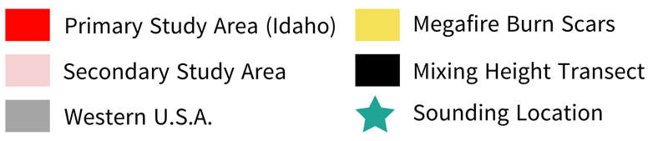

*Figure 6.* Four megafire burn scars plotted with CALIPSO mixing height calculations and modeled sounding locations. These figures highlight the spatial distance between the mixing height layer and modeled sounding site. The fires seen here are A) the Elk complex fire, which burned 129,565 acres in 2013 B) the Soda Fire, which burned 283,626 acres in 2015 C) the Pioneer fire which burned 180,000 acres in 2016 and D) the Martin fire that burned 439,230 acres in 2018.

This study has shown that data from CALIPSO can be used to calculate the observed the mixing height of aerosols in the atmosphere during a wildfire event. These results are important as a first step in helping our project partners to better understand smoke dispersal and validate different mixing height estimation methods. Although the tool could be used by anyone in its current state, the team would advise against such action, as validation testing has not yet taken place.

***4.4 Future Work***

For this project, the team chose fires within similar ecosystems to eliminate variations in the properties of the smoke such as smoke particle size. Fires burning different types of biomass produce smoke with varying compositions. Leaf litter and stems are prone to under-combustion (van der Werf et al., 2006) leading to larger-sized smoke aerosols (Reid et al., 2005b). In addition, fires from woodless regions, such as grasslands and savannahs, have smaller-sized smoke aerosols (Reid et al., 2005a). Another term should explore how smoke with varying smoke particle size changes its mixing height or mixing height detection. Along with smoke properties, more research is needed to determine how wet climate affects mixing height estimations and observations. The Stull method modifies the temperature based on the parcel’s water content (Fearon et al., 2015) but little is known on how much more water vapor will affect mixing heights and mixing height predictions. Pursuing this will further increase the accuracy of the NWS FWP mixing height calculations across the country. Lastly, the team hopes another term can finish the mixing height estimation code as well as fully automate A-SMOKRE. A completed mixing height estimation code will allow a validation study to assess the accuracy of various mixing height estimation methods. A-SMOKRE, in its current form, requires the user to specify the latitudes in which the swath should be taken within the code. Another term could automate this process for ease of data processing for the project partners.

# 

# 5. Conclusions

***5.1 Conclusions***

Understanding variance in mixing height during a wildfire is a critical element of smoke-pollution forecasting. A-SMOKRE, a software tool that the team developed, is successful in calculating mixing height from CALIPSO VFM data granules, but it requires improvements to the latitude index selection in order to be fully automated. While the team had hoped to infer which mixing height estimation methodology is the most accurate based on comparisons between observed and estimated mixing heights, mixing height estimations were difficult to analyze. To further complicate this comparison, the location of the CALIPSO transect and the location of the model soundings revealed that most observed mixing heights and model-based sounding locations were separated by many kilometers and several hours.

Air quality during wildfires is important because of the effects on human and environmental health. Furthermore, annual wildfire events are expected to increase globally; along with this comes an increased need for prescribed burns to reduce fire fuel loads and mitigate these disasters. Past studies that used CALIPSO data to validate mixing height prediction models determined mixing height layers from where there happened to be an intersecting CALIPSO pass with a sounding; these studies did not take into account the location of wildfires or smoke plumes (Fearon et al., 2015). CALIPSO follows the A-train satellite path; passes occur at the same time and in the same location every 16 days. While this sparse repetition can be limiting (in the southern Idaho region, there are four repeated passes that occur, which restricted the chance for intersection with both a smoke plume and model-based sounding) the consistency of the satellite pass also presents an opportunity to control the proximity of future soundings to along the transect. In order to achieve statistically significant validation of mixing height estimation during a wildfire, there must be a reconciliation of the spatial and temporal discrepancies between the observations and predictions or acceptable difference thresholds must be determined. Once these adjustments are made, mixing height observations calculated from CALIPSO can be used to validate the accuracy of mixing height models.

***5.2 Errors and Uncertainties***

Given the limited research in the field of mixing height estimation, this feasibility study provided insight into the possible errors that can occur when conducting a comparison between mixing height observations and mixing height estimations. First, the team used an older database of location-specific forecast model soundings. While our soundings did not match up, there are other balloon and model-based soundings that might. During this term, the team did not have access to the model software to generate soundings with the fires that had favorable CALIPSO passes. Second, while the limited study area was important in controlling smoke pollution variables, the team found it difficult to find enough fires that intersected with a CALIPSO pass to produce statistically significant results. Thus, expanding the study area will increase the number of wildfire events that are available and potential data points for comparison.

# 6. Acknowledgments

* Keith Weber (Idaho State University, GIS Training and Research Center)
* Dr. Kenton Ross (NASA Langley Research Center)
* Dr. Travis Toth (NASA Science Directorate)
* Robyn Heffernan (NOAA, National Weather Service)
* Heath Hockenberry (NOAA, National Weather Service)
* Larry Van Bussum (NOAA, National Weather Service)
* Mark Fitch (National Park Service, Fire Management Program Center)
* Dave Mueller (Bureau of Land Management, National Interagency Fire Center)
* Brandy Nisbet-Wilcox (Fellow, NASA DEVELOP)

Any opinions, findings, and conclusions or recommendations expressed in this material are those of the author(s) and do not necessarily reflect the views of the National Aeronautics and Space Administration.

This material is based upon work supported by NASA through contract NNL16AA05C.

# 7. Glossary

**AOD –** Aerosol Optical Depth, used to determine the density of aerosols

**ArcGIS Pro –** Application that provides geospatial data analysis and processing

**Attenuated data –** Due to scattering, phase changes or absorption not all of the radiation returns to CALIPSO and is interpreted as attenuated data

**BLM –** Bureau of Land Management

**Bulk Richardson** –The Bulk Richardson number is a ratio between buoyancy versus the wind shear and is used to determine if turbulent winds will result in upward vertical motion (Fearon et al., 2015). For mixing height calculations, once the air parcel’s Bulk Richardson number reaches the ratio of 0.505, it has reached its mixing height (Lee et al. 2008).

**CALIPSO** – Cloud-Aerosol Lidar and Infrared Pathfinder Satellite Observations; Houses CALIOP on board, the LiDAR sensor used to gather observed mixing heights

**Clausius-Clapeyron equation** – Using dewpoint temperature, this equation calculates water vapor partial pressure

**Earth observations** – Satellites and sensors that collect information about the Earth’s physical, chemical, and biological systems over space and time

**Holzworth:** The Holzworth method is a mixing height estimation. The method tracks an air parcel's path through the environment and calculates how much heat the parcel loses. Once the parcel has the same temperature as the environment, the altitude at which this occurs is the mixing height (Fearon et al., 2015).

**Matplotlib –** Python library that has functions related to graph and chart plotting.

**Megafires –** Fires that last for several months and cover area of more than 100,000 acres

**MetPy –** Ameteorological python module used to calculate air parcel paths and skew-ts

**Mixing Heights** – The height smoke rises due to buoyancy and wind

**Mixing Ratio** – The ratio between how much water vapor is in the air to how much water vapor the air could hold

**MODIS** – Moderate resolution Imaging Spectroradiometer

**NPS –** National Park Service

**NumPy –** Python library used for working with arrays

**NWS FWP –** National Weather Service Fire Weather Program. Responsible for monitoring fire susceptibility and forecast fire hazards

**OS –** Module that is used to work with file, folders and directories

**Pandas –** Python library used for working with dataframes

**SciPy –** A collection of mathematical algorithms and convenience functions built on the NumPy extension of Python

**SHARPpy** – NOAA storm prediction center sounding analysis program

**Sys –** Module used for working with constants, functions and methods of the Python interpreter

**Stull** –This method tracks an air parcel’s path through the environment and calculates how much heat the parcel loses. Once the parcel has the same temperature as the environment, the altitude at which this occurs is the mixing height. However, the starting temperature of the air parcel is not the environment but the parcel’s virtual temperature (Fearon et al., 2015).

**TKE** –Mixing height determination method. Turbulent Kinetic Energy (TKE) is a combined representation of buoyancy, wind shear, advection, and other gradients and perturbation terms that quantify the kinetic energy throughout the atmospheric column. TKE provides a combined measure of the static and dynamic stability (Fearon et al., 2015).

**Tropospheric aerosol** – An aerosol found in the lowest layer of the atmosphere

**VFM granule –** Vertical Feature Mask granule; A fragment of the data extracted from CALIPSO CALIOP.

**VIIRS –** Visible Infrared Imaging Radiometer Suite. Instrument that collects visible and infrared imagery and global observations of land, atmosphere, cryosphere, and oceans.

**Virtual Temperature** – The temperature the air would have if all the water vapor was condensed into liquid and the water vapor’s heat was added to the dry air

# 8. References

Blumberg, W. G., K. T. Halbert, T. A. Supinie, P. T. Marsh, R. L. Thompson, & J. A. Hart (2017). SHARPpy: An Open Source Sounding Analysis Toolkit for the Atmospheric Sciences. *Bulletin of the American Meteorological Society, 98*(8), 1625-1636. doi:10.1175/BAMS-D-15-00309.1.

DeFlorio-Barker, S., Crooks, J., Reyes, J., & Rappold, A. G. (2019). Cardiopulmonary Effects of Fine Particulate Matter Exposure among Older Adults, during Wildfire and Non-Wildfire Periods, in the United States 2008-2010. *Environmental Health Perspectives*, *127*(3), 37006. <https://doi-org.libpublic3.library.isu.edu/10.1289/EHP3860>

Dennison, P. E., Brewer, S. C., Arnold, J. D., & Moritz, M. A. (2014). Large wildfire trends in the western United States, 1984–2011. *Geophysical Research Letters*, *41*(8), 2928-2933. <https://doi.org/10.1002/2014GL059576>

Fearon, M. G., T. J. Brown, & G. M. Curcio (2015). Establishing a national standard method for operational mixing height determination. *Journal of Operational Meteorology*, *3*(15), 172-189. <http://dx.doi.org/10.15191/nwajom.2015.0315>.

Jeffery, T., Yerkes, S., Moore, D., Calgiano, F., & Turakhia, R. (2019) 2019 Wildfire Risk Report. *Core Logic Insurance Report*, 3-10 https://storymaps.arcgis.com/stories/cb987be2818a4013a66977b6b3900444

Lee, P., Tang, Y., Kang, D., McQueen, J., Tsidulko, M., Huang, H., Lu, S., Hart, M., Lin, H., Yu, S., DiMego, G., Stajner, I., & Davidson, P. (2008). Impact of consistent boundary layer mixing approaches between NAM and CMAQ. *Environmental Fluid Mechanics*, *9*, 23- 42. <https://link.springer.com/article/10.1007/s10652-008-9089-0>

National Climatic Data Center. (2019) Climate of Idaho. Prepared for the National Oceanic and Atmospheric Administration Climate Services Branch. <https://www.nrc.gov/docs/ML1018/ML101800249.pdf>

National Aeronautics and Space Administration. (2018). CALIPSO: Data User’s Guide - Data Product Descriptions - Lidar Level 2 5 km Vertical Feature Mask (VFM) Version 4.20 Product. https://www-calipso.larc.nasa.gov/resources/calipso_users_guide/data_summaries/vfm/index_v420.php#feature_classification_flags

Petty, G. W. (2008). *A first course in atmospheric thermodynamics*. Madison: Sundog Pub.

Reid, J. S., Koppmann, R., Eck, T. F., & Eleuterio, D. P. (2005a). A review of biomass burning emissions part II: Intensive physical properties of biomass burning particles. *Atmospheric Chemistry and Physics*, *5*, 799-825. <https://acp.copernicus.org/articles/5/799/2005/>

Reid, J. S., Eck. T. F., Christopher, S. A., Koppmann. R, Dubovik, O., Eleuterio, D.P., Holben, B.N., Reid, E.A., & Zhang, J. (2005b). A review of biomass burning emissions part III: Intensive optical properties of biomass burning particles. *Atmospheric Chemistry and Physics*, *5*, 827-849.

van der Werf, G.R., Randerson, J.T., Giglio, L., Collatz, G.J., Kasibhatla, P.S., & Arellano, A.F. Jr. (2006). Interannual variability in global biomass burning emissions from 1997 to 2004. *Atmospheric Chemistry and Physics, 6*, 3423–3441. <https://acp.copernicus.org/articles/6/3423/2006/acp-6-3423-2006.html>

Williamson, G. J., Bowman, D. M. S., Price, O. F., Henderson, S. B., & Johnston, F. H. (2016). A transdisciplinary approach to understanding the health effects of wildfire and prescribed fire smoke regimes. *Environmental Research Letters*, *11*(12), 125009. <https://iopscience.iop.org/article/10.1088/1748-9326/11/12/125009>

Yue, X., & Unger, N. (2018). Fire air pollution reduces global terrestrial productivity. *Nature Communications*, *9,* 5413. DOI: 10.1038/s41467-018-07921-4

1. Mixing height estimations and mixing height predictions are synonymous terms in this paper. Both refer to calculated mixing heights based on atmospheric balloon or model-based soundings.