**NASA DEVELOP National Program**



NASA Ames Research Center

*Summer 2017*

Chile Water Resources II

Applications of NASA Earth Observation Imagery in Google Earth Engine to Estimate Glacier Trends and Water Availability in Chile’s Aconcagua Watershed

**Technical Report**

Final Draft – August 10, 2017

Mariana Webb (Project Lead)

William Babis

Stuart DeLand

Dr. Juan Torres-Pérez, Bay Area Environmental Research Institute (Science Advisor)

Dr. Kenton Ross, NASA Langley Research Center (Science Advisor)

Dr. Eduardo Bendek, NASA Ames Research Center (Science Advisor)

Previous Contributors:

Garrett McGurk

# 1. Abstract

The Aconcagua basin in Central Chile, located just north of the capital city of Santiago, is a region dominated by the Andes Mountains and heavily dependent on glaciers and seasonal meltwater. Due to the orographic nature of precipitation on the basin, rain events occur sporadically in the late winter months of the year, accounting for 80% of total annual precipitation. Consequently, during the dry summer months, upwards of 67% of water is derived from glacial runoff. The Mediterranean-type climates of the lower-elevation fertile valleys support agricultural practices such as fruit and vegetable farming, which account for 70% of regional water consumption. Around the globe, weather intensification and the rising zero-degree isotherm are poised to threaten glacial retreat or complete wastage during the upcoming decades. The Aconcagua basin is especially vulnerable to these changes as a result of increasing water demands and reliance on sub-tropical glacier meltwater during the summer months. In response to concerns articulated by the Chilean Ministry of Agriculture, the research team created a suite of Google Earth Engine (GEE) tools that leverage NASA Earth observations to supplement the current Climate Data Library that informs the management of glacier-derived water resources. The first module of the tool was a near-real time classification tool that allows users to calculate glaciated area for a given year, allowing for near-real time monitoring of glacier health. Second, the team produced a module that conducts time series analysis of seasonal NDSI from 1988 to 2017, quantifying glacier accumulation and ablation using the Kendall’s Tau statistic. Finally, the team built a GEE module that combined NASA Earth observations with *in situ* discharge data to produce a comprehensive overview of regional factors affecting agriculture. The three modules provide an enhanced understanding of glacial water resources for agricultural irrigation and were designed to be adapted and built upon for future satellite-based analysis to support water resource management decision-making.

**Keywords**

Google Earth Engine, Glacial Extent, Trend Analysis, Snowmelt Runoff, Discharge

# 2. Introduction

* 1. ***Background Information***

Glaciers, or thickened masses of perennial surface land ice, are an integral part of the cryosphere and global ecosystems (Vaughan et al., 2013). Currently, glaciers occupy roughly 10% of Earth’s total land area (NSIDC, 2017). The Andes mountain range in South America is home to more than 99% of all tropical glacier regimes (Kaser, 1999), spanning from Venezuela to the southern areas of Chile and Argentina. Within the Andes lies the Aconcagua Basin of Central Chile, located between 32°7’S and 33°2’S (Figure 1), which relies heavily on glaciers and seasonal melt water for its water reserves (Pellicciotti and Burlando, 2007). The Aconcagua Basin has an area of roughly 7340 km2 and a maximum elevation of 5843 meters above mean sea level while the Mediterranean-type ecosystem extends from 32°S to 36°S dominates the region (Stehr and Mauricio, 2016, Bown, et al., 2008). Due to the orography of the basin, rain events occur sporadically in the late autumn and winter months of the year (Falvey and Garreaud, 2006). The presence of a rain shadow on the region, as well as precipitation regimes heavily affected by teleconnections such as the El Niño Southern Oscillation and the Pacific Decadal Oscillation, make annual estimates of rainfall challenging, however, observed precipitation is generally around 200 mm per year (Viale and Nuñez, 2011, Souvignet et al., 2012, and Armesto et al., 2007). On decadal time scales, glaciers of the region serve as a buffer against drought, storing water as snow and ice in cold and wet years, while providing additional runoff in warm and dry years (Huss et al., 2008).

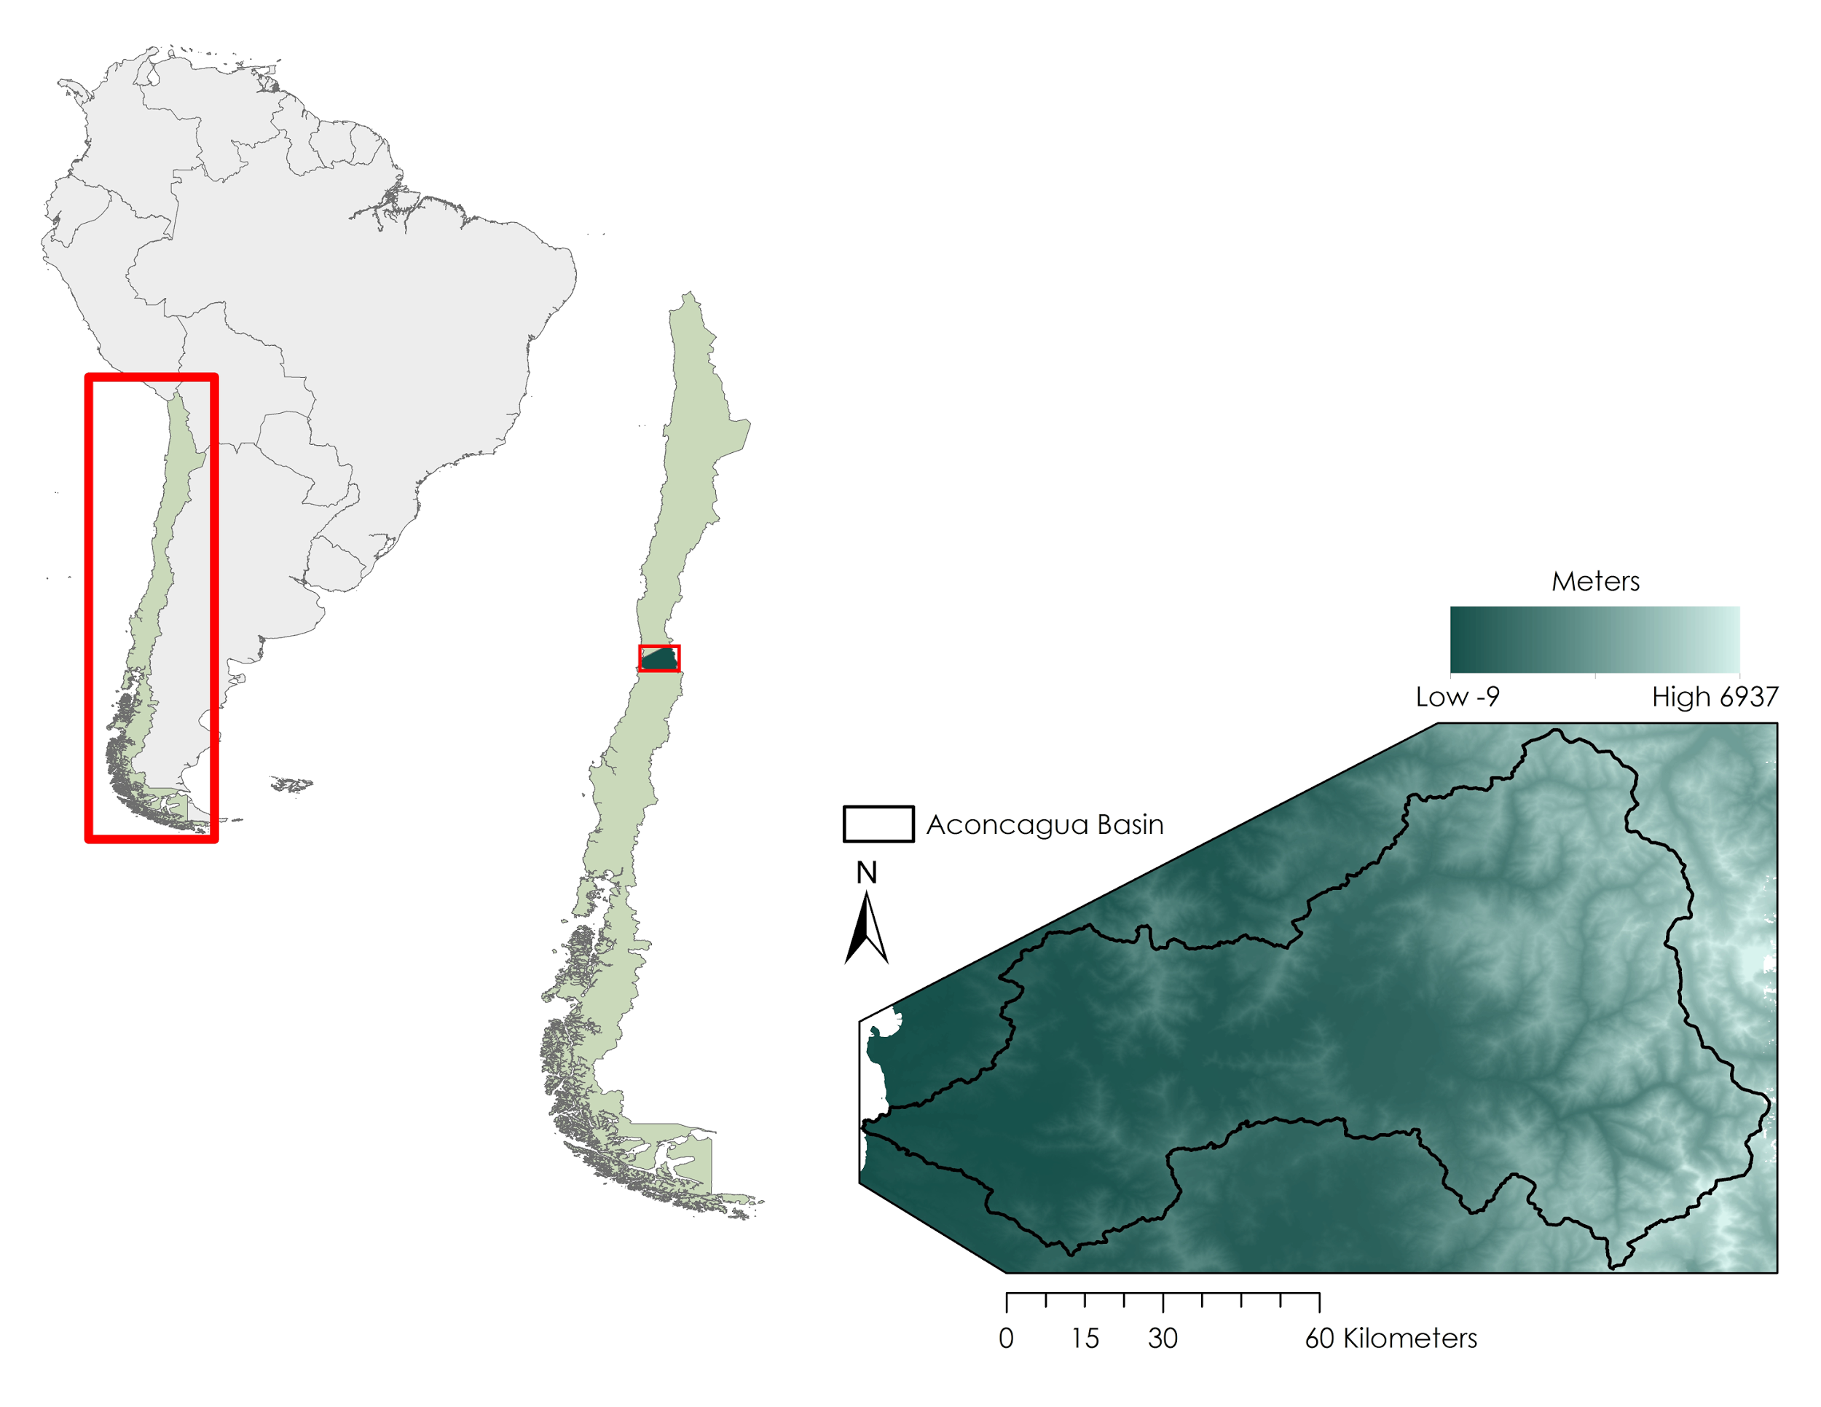  
  
*Figure 1.* The Aconcagua basin, located between 32°7’ S and 33°2’ in Chile, on the western coast of South America. Note the eastern sections of the region, the higher elevations are part of the Andes Range.

Around the globe, a warming climate is poised to induce drastic glacial retreat or complete wastage during the upcoming decades (Huss et al., 2008). Glaciers are sensitive to climatic variability as their size adjusts in response to changes in the climate such as temperature and precipitation (Vaughan et al., 2013). In the Aconcagua basin, glacial contribution to annual runoff is extremely important, especially in times of drought or dry summers, as up to 67% of total runoff may originate from glaciers (Peña and Nazarala, 1987 as cited in Bown et al., 2008). Chile relies on runoff to supply an extensive irrigation network for high yield agriculture (Souvignet et al., 2012). As such, the Aconcagua basin is in a precarious position due to its increasing water demands and heavy reliance on melt water during the summer (Pellicciotti et al., 2014).

* 1. ***Project Partners & Objectives***

The Chilean Ministry of Agriculture is tasked with managing the complex network of water resources that permit farmers to pursue agriculture in a country characterized by extremely variable climates. While agriculture accounts for 4% of Chile’s gross domestic product, agricultural practices in the Aconcagua watershed account for 70% of total regional water consumption (Central Intelligence Agency, 2016; Valdés-Pineda et al., 2014). The expansion of Chile’s agricultural economy, as well as anomalous climate dynamics, including extended periods of drought, place an increased strain on water management, threatening the stability and longevity of glacier-derived water resources in the region. Throughout Chile, water is primarily sourced from glacial meltwater runoff, but increasingly farmers are tapping into groundwater reserves. Currently, all of Chile’s publicly available drought-monitoring data are hosted on the Climate Data Library (CDL), and include information such as the Combined Drought Index (CDI), the Standardized Precipitation Index (SPI), as well as *in situ* precipitation and soil moisture measurements recorded at stations across the country.

As a result of increased strain on water resources, the Ministry of Agriculture is interested in expanding their current decision making tools. To that end, the objective of this project was to create a historic time series in GEE of seasonal glacial extents, in an attempt to quantify glacier dynamics and highlight statistically significant trends of accumulation or ablation. Additionally, the team built a supervised classifier for glacier identification in a user-friendly GEE module. Finally, NASA Earth observations including SMAP soil moisture, MODIS snow cover, MODIS surface temperature, AMSR-E, and AMSR2 snow water equivalent were correlated with *in situ* river discharge data to show how meltwater reserves may be influenced by certain environmental factors. These three modules of analysis in GEE provided decision makers in the Ministry of Agriculture with additional information on glacial water reserves and longevity under current conditions. As such, this project addressed NASA’s water resources, agriculture, and climate national application areas by applying NASA Earth observation imagery to water resource management and climate monitoring efforts by the Chilean Ministry of Agriculture.

# 3. Methodology

***3.1 Data Acquisition***

The GEE time series was composed of seasonal imagery from 1988 to 2017 using observations from the Landsat 5 TM and Landsat 8 OLI sensors. All Landsat imagery used for this section was openly available on the GEE repository and offered two products: top of atmosphere correction or surface reflectance. The seasonality of images was determined based on a literature-reviewed definition of the monthly range of austral seasons; as such, a minimum of four scenes per year was expected. Additionally, the Landsat satellites provide total coverage of the study area with two adjacent scenes, necessitating the acquisition of eight images to account for one year of seasonal observations. The classification module of the GEE tool incorporated Landsat 5 TM and Landsat 8 OLI imagery as well, however these data were imported from the GEE public data catalog. Similarly, three of the parameters used for the GEE correlation module were available in the GEE public data catalog; namely, the MOD10A1.006 Snow Cover Daily L3 Global 500m data set of MODIS Terra, the MOD11A1.006 Land Surface Temperature and Emissivity Daily L3 Global 1km Grid SIN dataset of MODIS Terra, and the TRMM Merged HQ and Infrared Precipitation datasets of TRMM. Conversely, other parameters in the GEE correlation module required manual uploading to private data repositories via Google Cloud. These included the SPL3SMP_E Enhanced L3 Radiometer Global Daily 9 km dataset of SMAP and the AE_MoSno Monthly L3 Global Snow Water Equivalent EASE-Grids V2 datasets of AMSR-E Aqua and AMSR2 GCOM-W1.

***3.2 Data Processing***

Within GEE, Landsat top of atmosphere (TOA) reflectance datasets, available and constantly updated on the GEE public data catalog, are preprocessed and readily imported. Landsat TOA was used in lieu of the otherwise preferable Landsat surface reflectances, as the publicly available GEE surface reflectance products did not include the panchromatic band of Landsat 8 which is powerful for glacier classifications; additionally, reflectance values of ice, clouds, and the roofs of houses exhibited values tens of times higher than the normal levels, skewing attempts at classification into unusable results. GEE TOA datasets are loaded with a “CLOUD_COVER” parameter that was utilized to filter for images with a cloud cover no greater than 30% for both the classification and time series products. A total of four images were used per year as a proxy for seasons; these four images were derived by taking the mean value for each pixel in a collection of cloud-free images from each season. The SMAP soil moisture and AMSR-E snow water equivalent datasets were level-3 and therefore had been pre-processed by the National Snow and Ice Data Center (NSIDC) Distributed Active Archive Center (DAAC) prior to being uploaded to the private GEE repository. The AMSR2 dataset was provided by the Global Hydrology Resource Center (GHRC) DAAC and processed using the AMSR-E algorithm. The TRMM precipitation, MODIS snow cover, and MODIS surface temperature were also level-3 datasets preprocessed by their distributors and GEE. Each of these datasets utilized in the correlation module were composited into monthly median images using GEE server-side functionality.

***3.3 Data Analysi******s***

The first GEE module was the glacial extent classifier. This module used a set of training points (Figure 2) to discern differences in spectral signatures between ice and non-ice features using the Classification and Regression Tree (CART) method. Training points from that classification were applied to both Landsat 5 and Landsat 8 imagery collected in February, which is late summer and therefore should isolate glaciers from seasonal snow cover. Results from the classification were verified through an error matrix. The GEE glacial classification tool automatically ingests near real-time Landsat 8 imagery and runs on the parallel server-side GEE infrastructure, providing the Chilean Ministry with an instant analysis of glaciated area for up-to-date monitoring of glacial health.

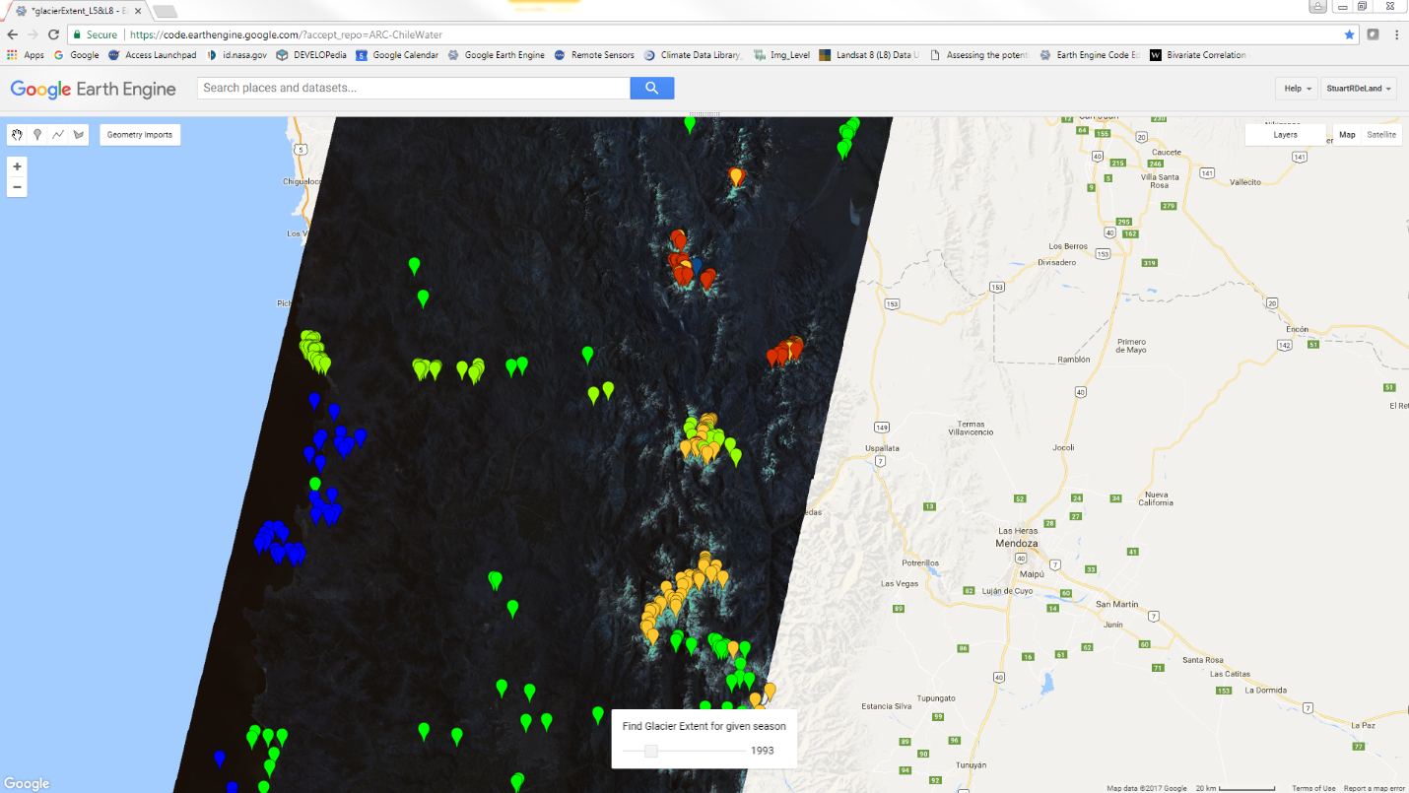

*Figure 2.* Training points of glaciated versus non glaciated areas.

For the GEE time series module, the Normalized Difference Snow Ice Index (NDSI = [Green – Near Infrared] / [Green + Near Infrared]) was calculated for all seasonal imagery to show changes in glacial patterns in the study area (Figure 3). NDSI is an index that allows areas of high visible reflectance and low infrared reflectance (e.g. snow) to stand out against the rest of a landscape (Riggs et al., 1994). NDSI time series were created in GEE to evaluate interannual seasonal trends of glacial extent in the Aconcagua Basin. The statistical method applied to each of the time series was the Kendall’s Tau b statistic (monotonic trend analysis). This calculation measures the degree to which a trend is consistently increasing or decreasing by evaluating all pairwise combinations of values at each pixel over time (Eastman, 2016). Kendall’s Tau b was chosen because it is resistant to outliers, and deals with shorter, non-normally distributed time series well (Souvignet et al., 2012). Thus, the NDSI scenes are the dependent variable while time is the independent variable. However, before running Kendall’s Tau b statistic, the data series was linearly detrended to avoid incorrect or over-represented correlations. Finally, a mask was applied to the scenes of the NDSI time series to limit calculations to the Aconcagua Basin itself. Additionally, GEE required the time series be run through a programmatic reducer. A reducer in GEE performs varying computations on a group of data, depending on the data format. For example, a reducer over a collection of images performs an operation (i.e. averaging or taking the median) to pixels within each image to output a single image. A reducer over a single image performs an operation on every band for each pixel and outputs an image with a single band. Thus, the Kendall’s Tau b reducer was applied to a collection of seasonal Landsat images for each pixel to derive the output.

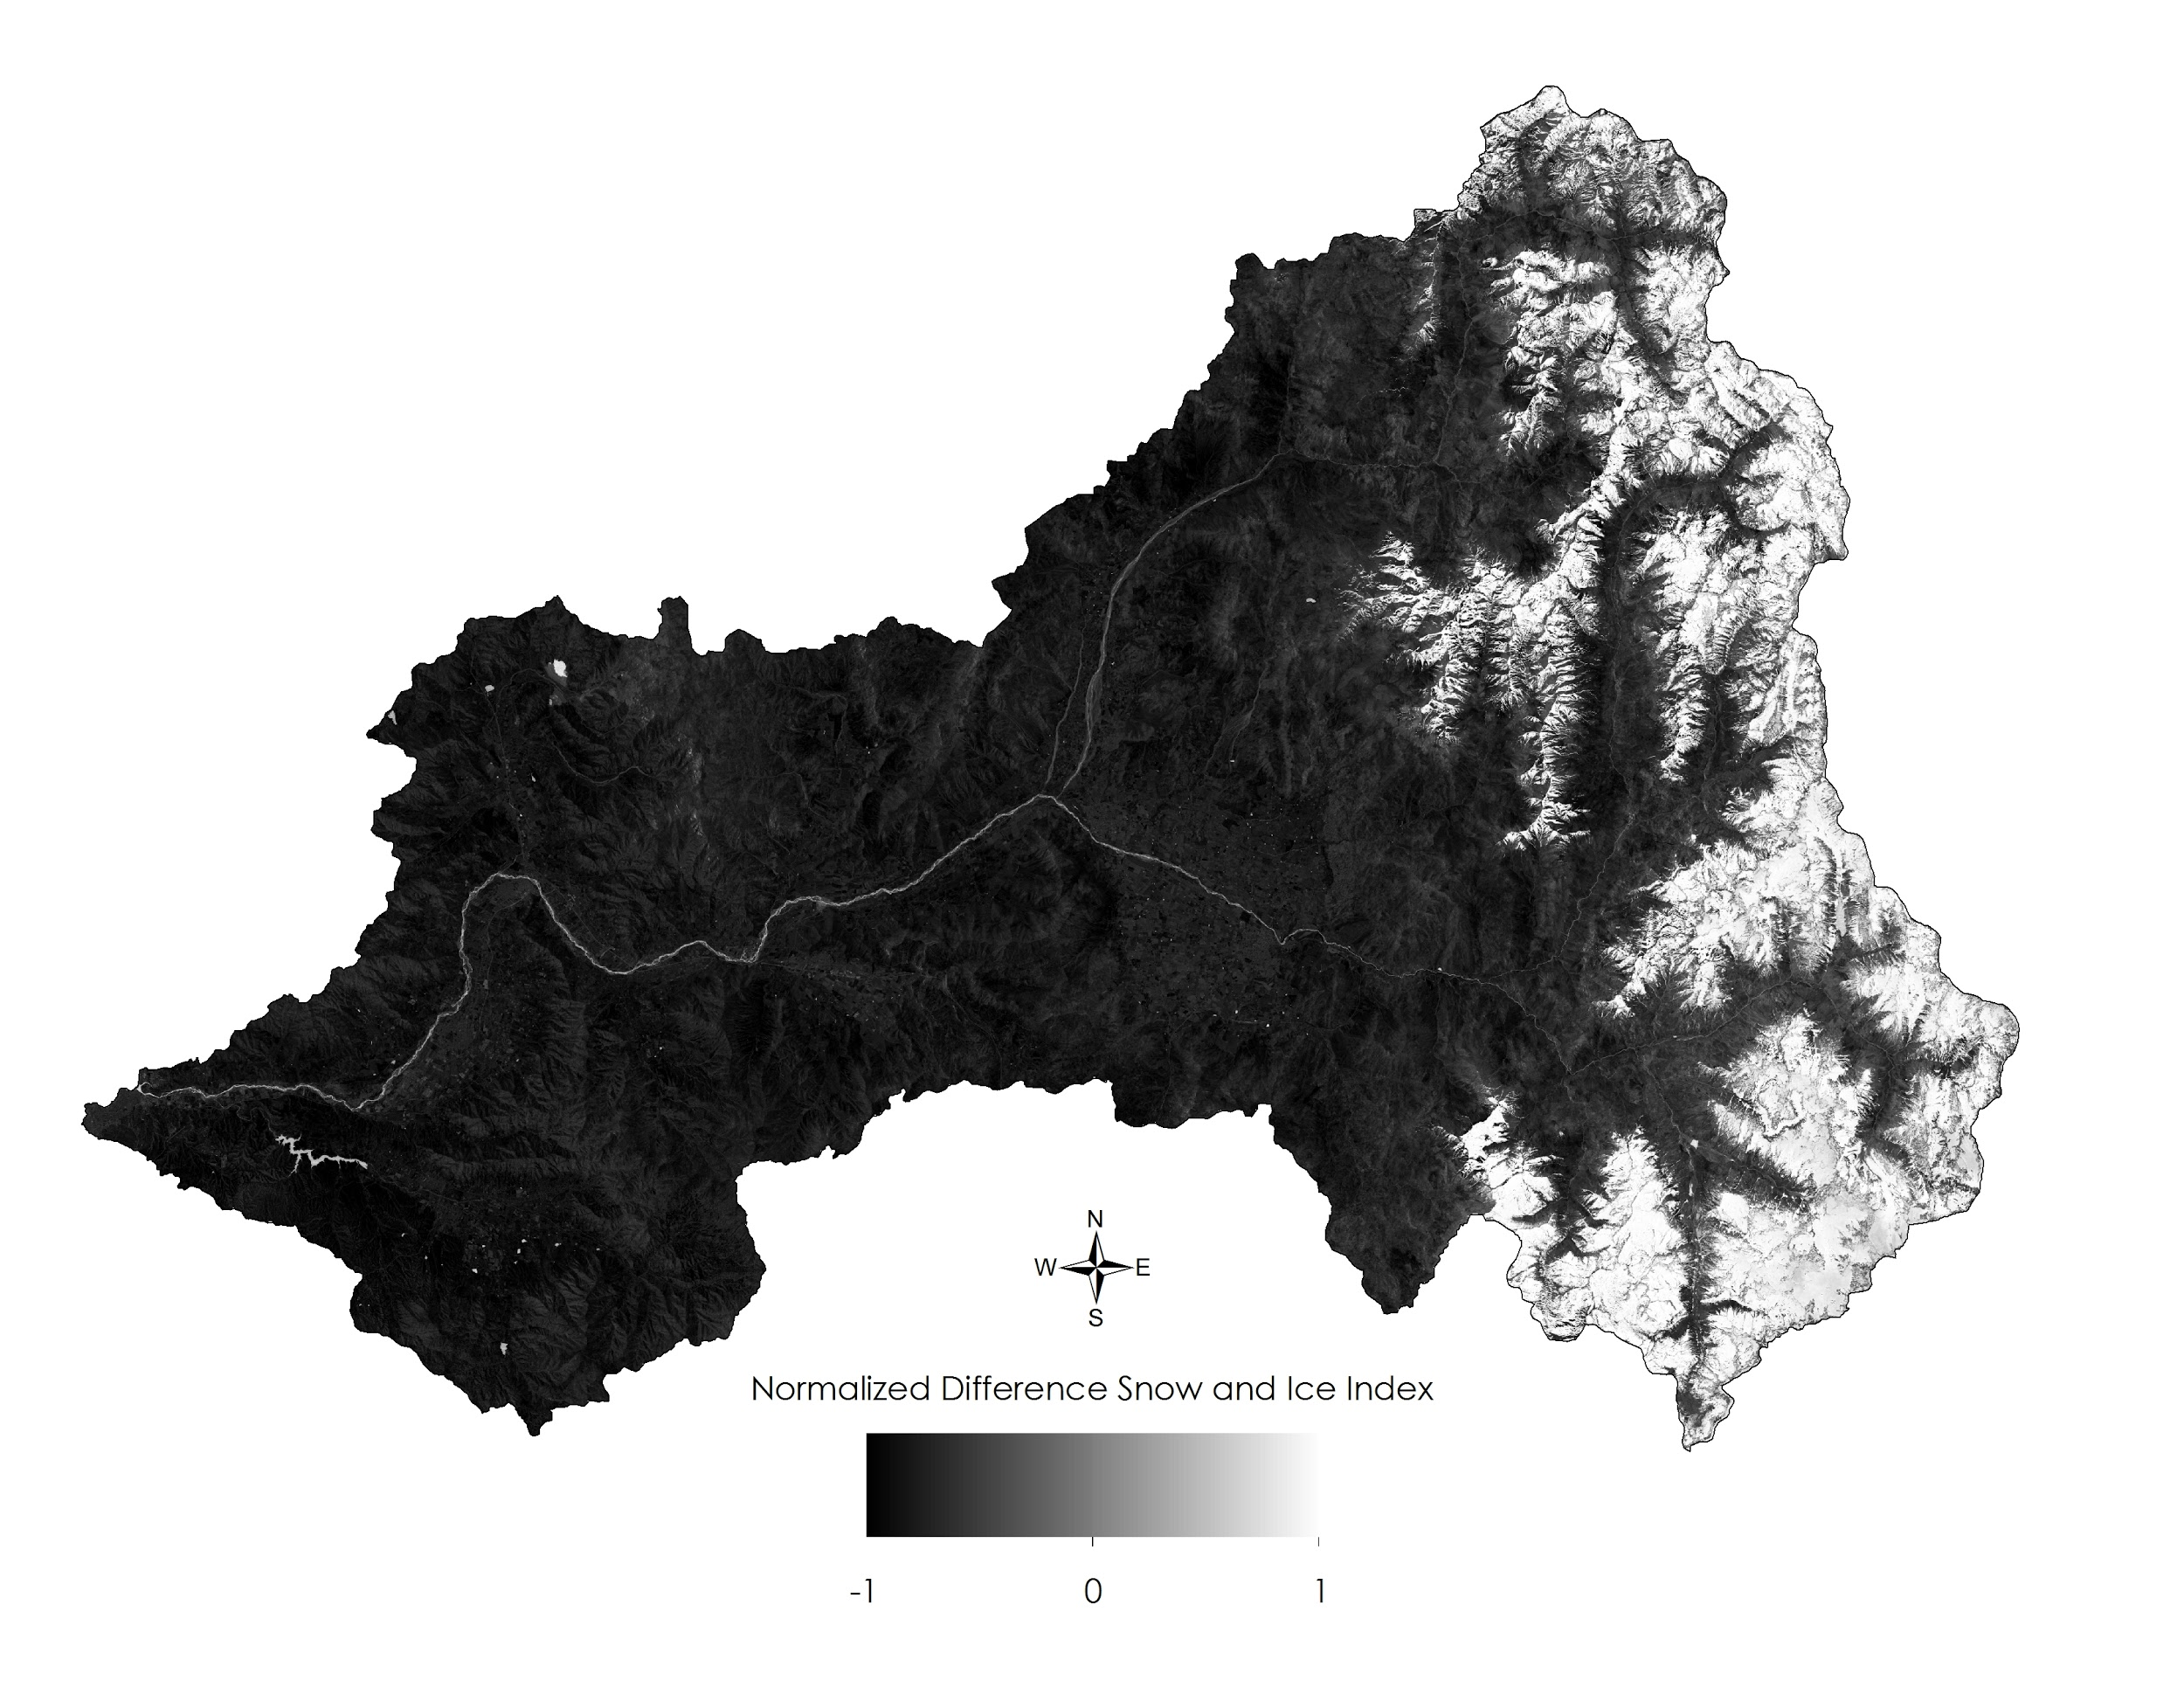  
*Figure 3.* Normalized Difference Snow and Ice Index for November 19, 2006. Note that this index not only highlights ice, but water as well, necessitating that we only interpret results in the areas of perennial glacier on the eastern third of the study area.

The final GEE module, the discharge correlation tool, compared *in-situ* monthly discharge values from three possible metering stations in the Aconcagua Basin with several NASA Earth observation hydrologic-indicator datasets. Pearson’s Product-Product Moment correlation was used to compare linear similarities between monthly discharge rates and transformations of monthly means for soil moisture, snow water equivalent, snow cover, surface temperature, and precipitation. Transformations varied per parameter (Table 1), and were necessary in order to compare singular discharge values per station per month with one value representing each of the environmental independent variables. After deriving two arrays containing the discharge values and parameter values for the selected month of each year, a predefined Pearson’s reducer was applied across this series to compute an r-coefficient and corresponding p-value. An r-coefficient value closer to 1 (maximum value) indicates high correlation while those approaching -1 correspond to a negative correlation; additionally, p-values of less than 0.05 indicate sufficient statistical significance.

|  |  |
| --- | --- |
| **Parameter** | **Transformation performed** |
| SM | Given a monthly mean image, find the mean of the pixel values across the study area. Multiply that average soil moisture value by 100 for feature scaling (100 mm). |
| SWE | Given an image representing the monthly mean, sum the snow water equivalent pixel values across the study area and multiply by two (m3/m3). |
| SC | Given a monthly median image where the value 25 and 200 correspond with values no-snow-cover and snow-cover respectively, count the number of pixels with value 200. To do this, mask pixels with value 25 and sum all pixels in the study area then divide by 200. Given the MODIS pixel resolution of 30m, divide that by 100 to get square kilometers (km2). |
| ST | Given an image representing the monthly mean, find the mean of the pixel values across the study area. Multiply that average ST value by 0.002 and subtract 273.15 to convert Kelvin to Celsius (degrees C). |
| Precipitation | Given an image representing the monthly mean, find the mean of the pixel values across the study area (mm/sec). |

*Table 1.* Transformations per environmental variable to be compared against *in situ* river discharge.

# 4. Results & Discussion

The supervised classification module created binary maps of glaciated versus non-glaciated regions within the study area for austral summer months (Figure 4). Selectable years within a range of dates from 1988 - 2017 produced ordinal outputs and reported square kilometers of glaciated area. The example year shown in Figure 4 displays the classification output for 1993, calculating the total glaciated area to be 167.99 km2. Glacial extent ranged from a maximum of 537.37 km2 in 1988 to a minimum of 6.46 km2 in 2006 (excluding years of no data due to Landsat gap years), with an average glacial extent of 104.04 km2 (Figure 5). Based on a linear regression trend, glacial extent values consistently decreased as the classification approached present day, with two exceptions of anomalous values in 1998 and 2016 (Figure 5). This tool, while adequately differentiating glaciers from surrounding geographic features, has not been validated by *in situ* observations or through accuracy assessment, thus outputs must be compared to other classification studies before exclusive future analysis is performed.

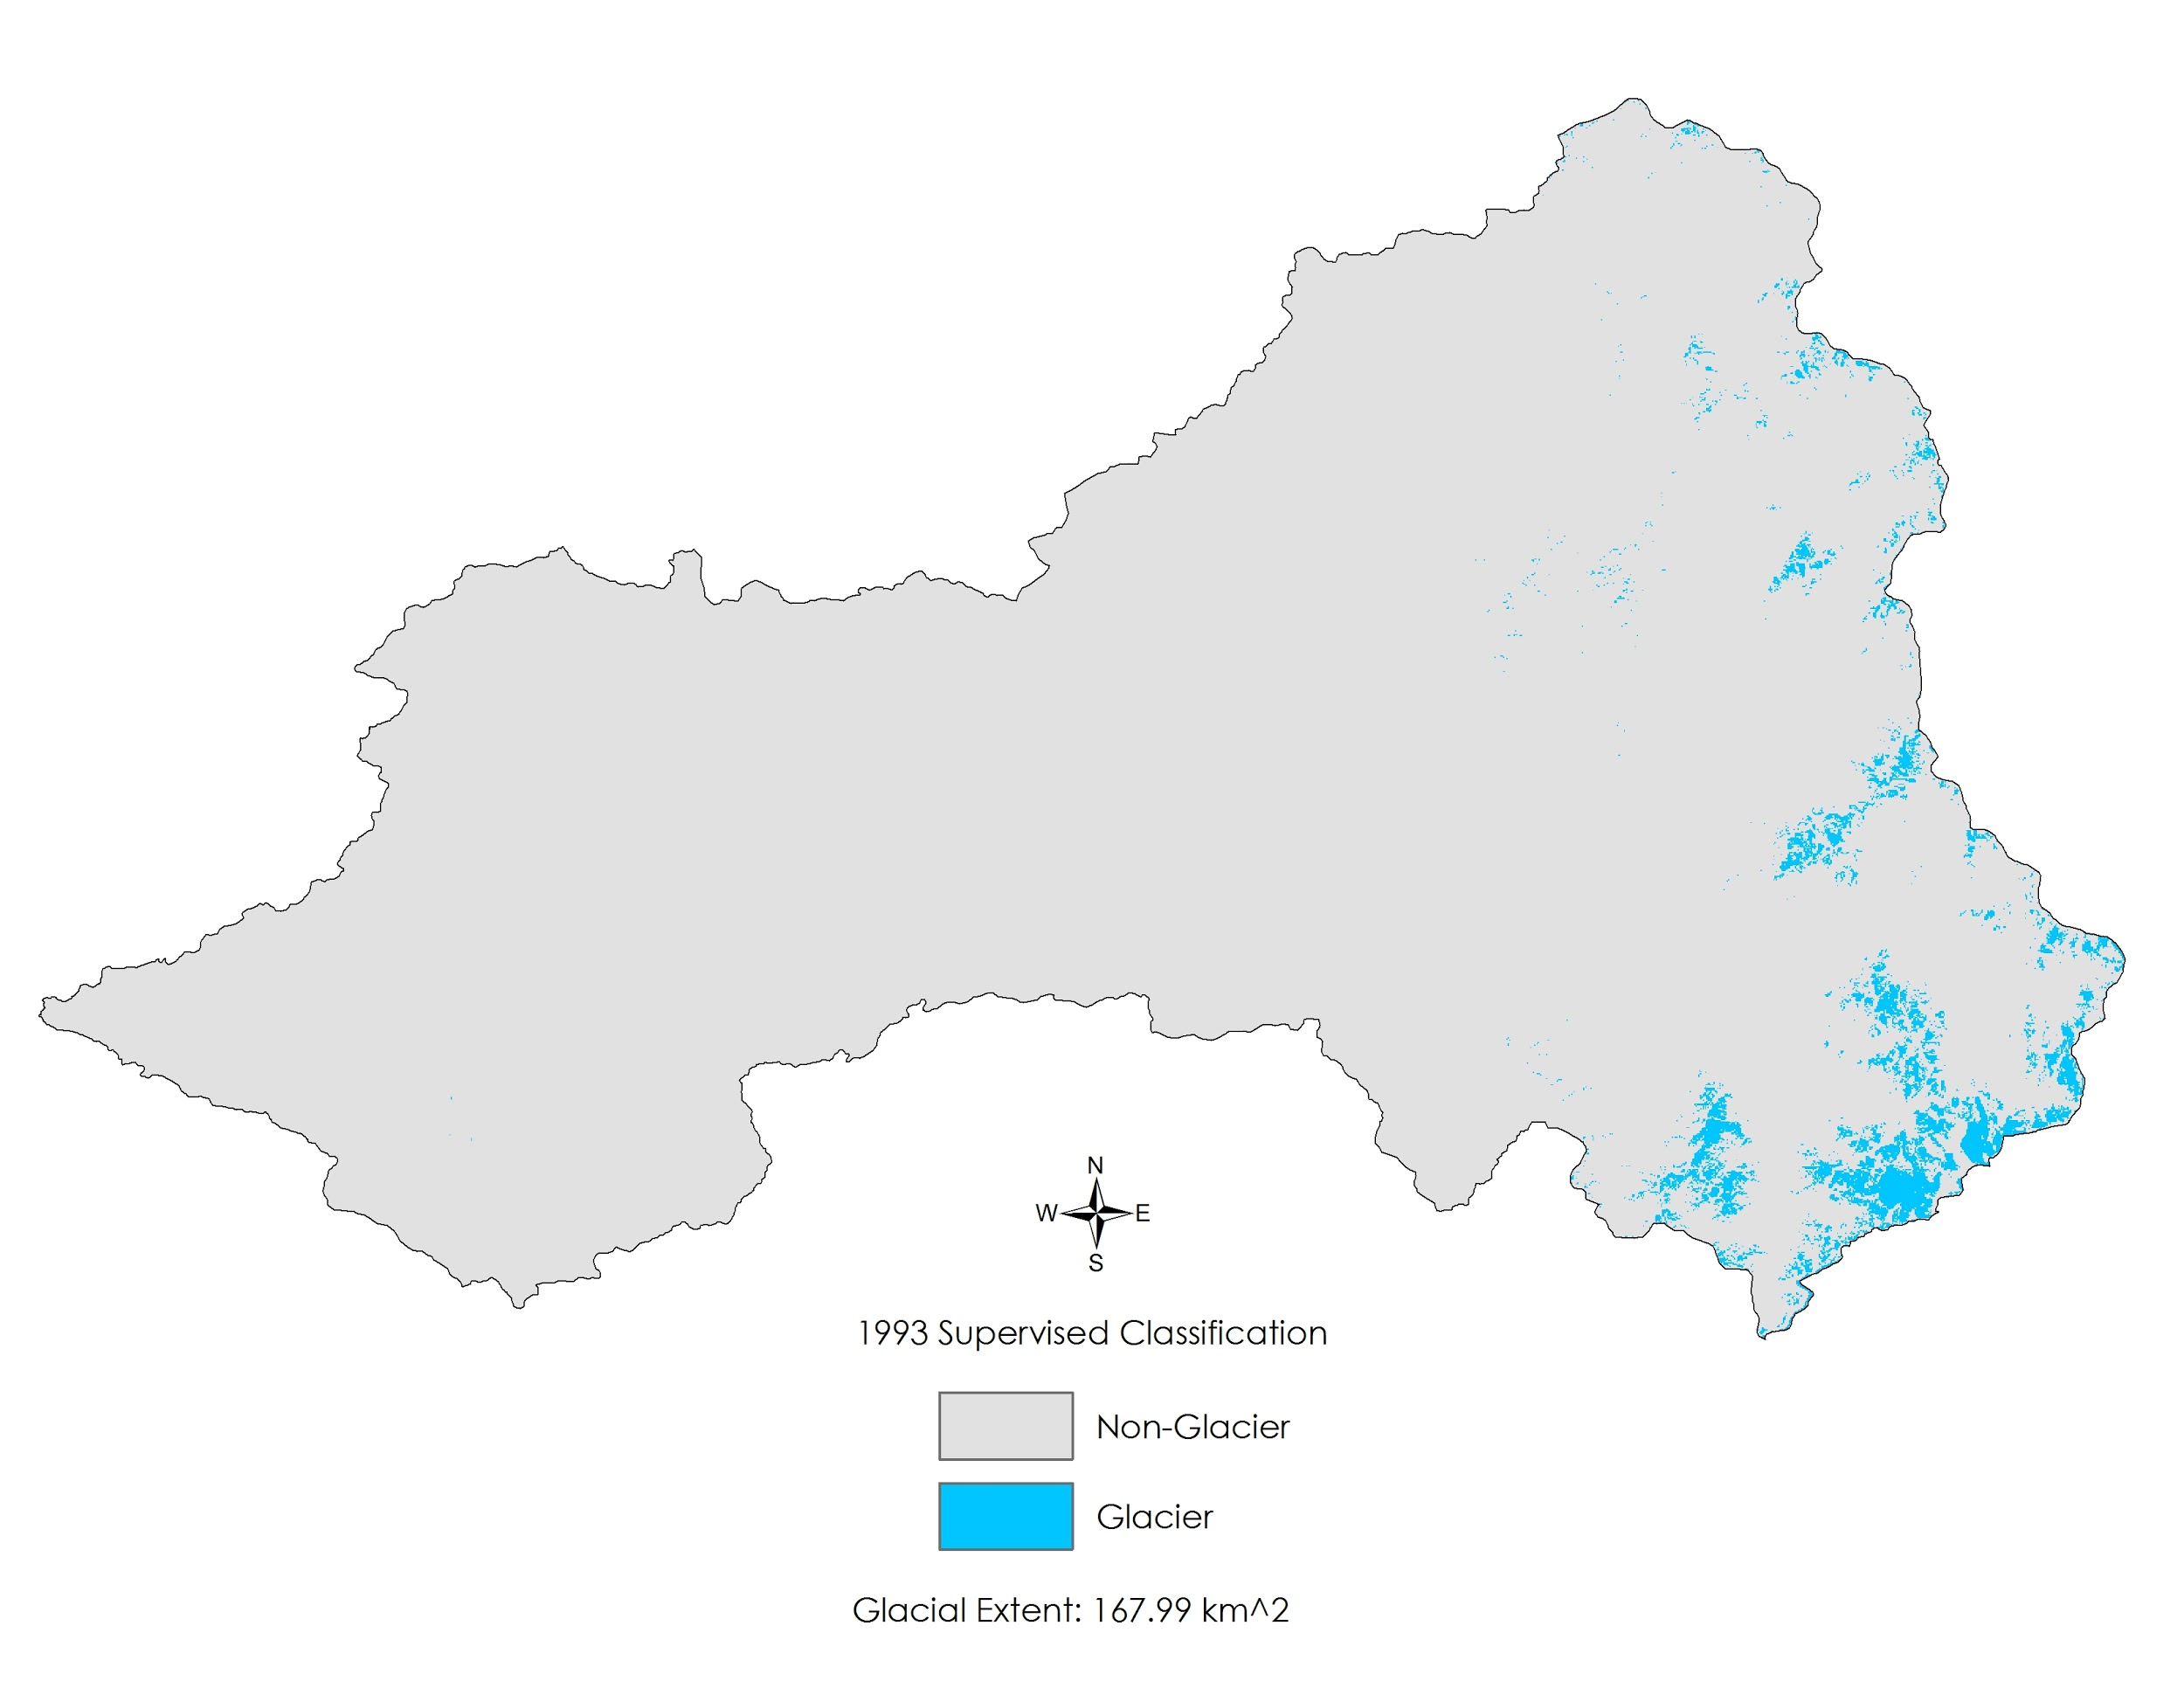  
*Figure 4.* Supervised Classification output of glacier versus non glacier area. Note the default season in which the classification is run is summer, hence the relatively minimal areas of glacial extent.

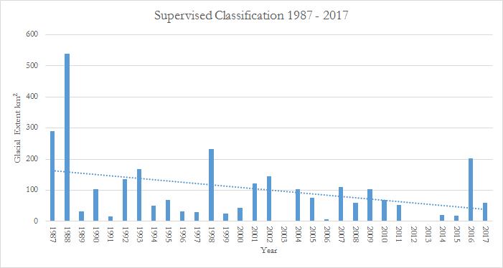  
*Figure 5.* Resultant glacial extent of supervised classification per year within maximum range of dates. Note the linear trend is steadily decreasing across time, despite several anomalously high years in the 2000’s.

Outputs of the 1988 – 2017 time series module can be seen in Figure 6; Kendall’s Tau b provided seasonal glacier trends based on the NDSI index. However, this statistical output comes with two caveats: one, only areas of perennial snow and ice (i.e. the Andes in the eastern region of the study area) can be considered when calculating pairwise neighbor correlations such as Kendall’s Tau. Second, GEE has yet to incorporate a functional p-value output alongside the Tau value, therefore the statistical significance of trends highlighted in this study cannot be proven until the algorithms used are updated. Upon exclusively examining areas of recurring glacial presence based on the supervised classification module (the ‘limited’ study area), the maximum Tau value was 0.81 while the minimum was -0.76 (Figure 6). The mean of the limited study area was 0.08 with a standard deviation of 0.19, thus 95% of the Tau values fell within the range of -0.3 to 0.46. Additionally, Tau values in the northeastern-most area of the Aconcagua Basin appear to be distorted as a result of one or multiple layers of Landsat data used; this zone is clearly different from the continuous trends surrounding it, so care must be taken in analyzing this sector.

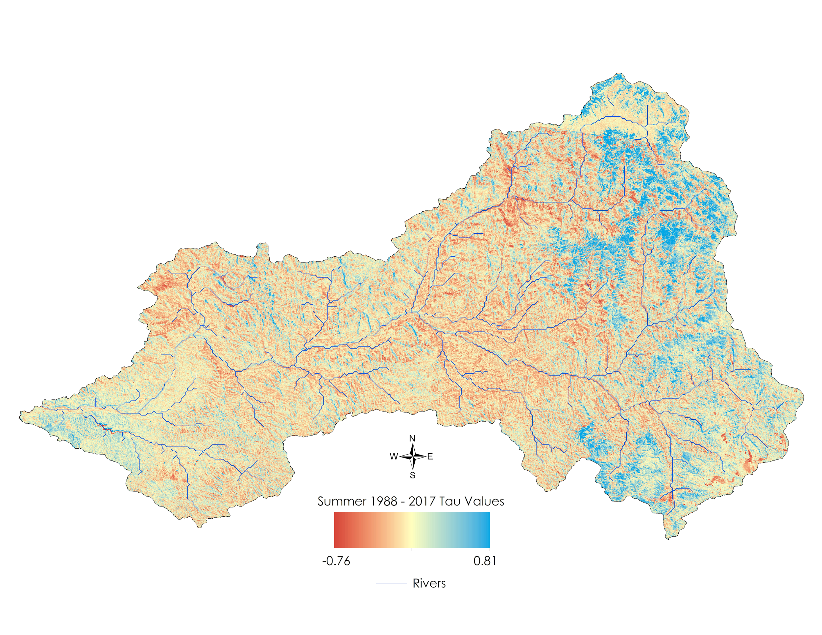  
*Figure 6.* GEE Kendall’s Tau correlation output for the summer season from 1988-2017. Note that input data consisted of NDSI-indexed images, therefore only areas of known ice and snow cover (i.e. the eastern regions) of the study area can be accurately considered in this analysis.

The correlations module of the GEE tool output Pearson’s R-values and p-values based on user-selected datasets, discharge station, month of year, and range of dates (Table 2). Two months representing the end of austral summer and end of austral winter (February and August) were included in this paper to quantify two extremes of the environmental spectrum. In austral summer, snow water equivalent consistently had the highest R-values and most significant p-values of any environmental variable. The summer R-values and p-values for snow water equivalent were 0.633 and 0.037 for the San Felipe station, 0.794 and 0.001 for the Chacabuquito station, and 0.717 and 0.02 for the Resguardo los Patos station, respectively (Table 2). In austral summer, surface temperature had the least correlated R-values and statistically insignificant p-value of any environmental variable. The summer R-values and p-values for surface temperature were -0.179 and 0.541 for the San Felipe station, 0.297 and -0.269 for the Chacabuquito station, and -0.303 and 0.338 for the Resguardo los Patos station, respectively. Austral winter R-values and p-values for all environmental variable exhibited little to no correlation with river discharge, and no p-value could be considered statistically significant. For comparison to austral summer, the austral winter R-values and p-values for snow water equivalent were 0.177 and 0.626 for the San Felipe station, 0.264 and 0.342 for the Chacabuqito station, and 0.297 and 0.405 for the Resguardos los Patos station, respectively (Table 3).

|  |  |  |  |
| --- | --- | --- | --- |
| **Variable (Month, Start Year – End Year)** | **R-value** | **p-value** | **Station** |
| Snow Cover (February, 2000 - 2017) | 0.561 | 0.037 | San Felipe |
| Snow Water Equivalent (February, 2002 - 2017) | 0.633 | 0.037 | San Felipe |
| Soil Moisture (February, 2015 - 2017 ) | -0.208 | 0.792 | San Felipe |
| Surface Temperature (February, 2000 - 2017 ) | -0.179 | 0.541 | San Felipe |
| Snow Cover (February, 2000 - 2017 ) | 0.026 | 0.536 | Chacabuquito |
| Snow Water Equivalent (February, 2002 - 2017) | 0.794 | 0.001 | Chacabuquito |
| Soil Moisture (February, 2015 - 2017 ) | -0.394 | 0.606 | Chacabuquito |
| Surface Temperature (February, 2000 - 2017 ) | 0.297 | -0.269 | Chacabuquito |
| Snow Cover (February, 2000 - 2017 ) | 0.042 | 0.594 | Resguardo los Patos |
| Snow Water Equivalent (February, 2002 - 2017) | 0.717 | 0.02 | Resguardo los Patos |
| Soil Moisture (February, 2015 - 2017 ) | 0.031 | 0.969 | Resguardo los Patos |
| Surface Temperature (February, 2000 - 2017 ) | -0.303 | 0.338 | Resguardo los Patos |

*Table 2.* Table of austral summer (February) correlations of *in situ* river discharge data to environmental variables via NASA Earth Observations.

|  |  |  |  |
| --- | --- | --- | --- |
| **Sensor (Month, Start Year – End Year)** | **R-value** | **p-value** | **Station** |
| Snow Cover (August, 2000 - 2016) | -0.169 | 0.6 | San Felipe |
| Snow Water Equivalent (August, 2002 - 2016 ) | 0.177 | 0.626 | San Felipe |
| Soil Moisture (August, 2015 - 2016) | 0.328 | 0.672 | San Felipe |
| Surface Temperature (August, 2000 - 2016) | -0.529 | 0.077 | San Felipe |
| Snow Cover (August, 2000 - 2016 ) | -0.074 | 0.788 | Chacabuquito |
| Snow Water Equivalent (August, 2002 - 2016) | 0.264 | 0.342 | Chacabuquito |
| Soil Moisture (August, 2015 - 2016) | 0.246 | 0.754 | Chacabuquito |
| Surface Temperature (August, 2000 - 2016) | -0.296 | 0.248 | Chacabuquito |
| Snow Cover (August, 2000 - 2016 ) | 0.174 | -0.42 | Resguardo los Patos |
| Snow Water Equivalent (August, 2002 - 2016) | 0.297 | 0.405 | Resguardo los Patos |
| Soil Moisture (August, 2015 - 2016) | 0.194 | 0.806 | Resguardo los Patos |
| Surface Temperature (August, 2000 - 2016) | 0.252 | -0.359 | Resguardo los Patos |

*Table 3.* Table of austral winter (August) correlations of *in situ* river discharge data to environmental variables via NASA Earth Observations.

***4.1 Analysis of Results***

The classification module of the GEE tool provides users an overview of seasonal glacial extent within the Aconcagua Basin. As the module outputs extents in square kilometers, user can gain a fundamental idea of how glaciers changed on a regional scale within the possible range of dates from 1987 - 2017. Figure 5 shows a consistent decrease in glacial extent values from 1987 - 2017, and a linear trendline confirms that extents calculated by the module are steadily decreasing, despite intermittent anomalies. These results coincide with findings from the others modules in the GEE tool as well as studies conducted by Bown et al., 2008 and Pellicciotti et al, 2007. This tool, while useful in locating glaciers, has not been validated by *in situ* classification data, nor parallel datasets or studies that classified the region in <1 meter resolution. Thus, users need to take care when interpreting the outputs, as this study cannot confirm that the classification of glaciers is accurate. Furthermore, the team chose to use TOA image correction with Landsat imagery in this module, foregoing the otherwise desirable surface reflectance GEE Landsat product as many of the high reflectance values were demonstrably incorrect. Thus, there is a margin of error in classifications associated with using top of atmosphere correction as opposed to the traditional dark-object subtraction method of producing surface reflectance.

Inspection of Kendall’s Tau b outputs reveal several trends of interest throughout the 29 year time series. Firstly, areas of pre-existing perennial glaciers, defined through the classification module of the GEE tool, are either increasing or remaining stable within the Andes Mountains. This result is important because it highlights that while river discharge rates have been decreasing, the source of this loss is not a cataclysmic melt of all glaciers present in the Aconcagua Basin. Additionally, while Kendall’s Tau b is resistant to outliers, the last two years of the time series, 2016 and 2017, are both anomalous years of high glacial extent when compared to their surrounding years. These occurrences, along with the shifting of the El Nino Southern Oscillation in the austral autumn of 2016, were important factors in the output of Kendall’s Tau b when considering the sustained range of glaciers in the study area. The second widely occurring result observed within the limited study area is the location of high negative trends. These highly negative areas, denoted by a dark red color (Figure 6) align with many of the headwaters of rivers feeding into the Aconcagua Basin. This is important for two reasons: the first is that river discharge values of recent years may be slightly higher than normal given the influx of additional meltwater from glaciers. Second, long term river discharge may decrease rapidly as glaciers retreat in the face of ablation and deposit their meltwater away from predefined river channels. These potential long term effects could result in further reduced water resources for farmers and reduced crop yields; the Chilean Ministry of Agriculture can use this module of the tool to determine which populations will be most encumbered by drought in the coming years, based on historic conditions. However, it must be restated that the Kendall’s Tau b requires a corollary output of p-values to draw conclusions about resultant statistical significance; while GEE is expected to implement this function into the Kendall’s Tau b reducer in the near future, current results can only be interpreted as potential historic trends as of now.

Measurements of snow water equivalent, taken by the AMSR-E and AMSR2 sensors, proved to be the highest correlated and statistically significant variables when compared to *in situ* river discharge in the austral summer. Pearson’s R-values taken from all discharge stations exhibit strong correlations to snow water equivalent. This is logical given environmental characteristics of the study area, where meltwater is known to be the driving sustenance of the rivers. Soil moisture and surface temperature proved to be the least correlated variables when compared to river discharge. These variables, while important on a geographically local scale to agriculture, do not greatly affect river discharge of a region so tightly controlled by high elevation glaciers, where surface temperature is a result of that elevation, as opposed to relatively uniform temperatures in the lowlands. Pearson’s r and p-values of significance for snow cover in the austral summer vary by discharge station: the Chacabuquito and Resguardo los Patos stations exhibit little correlation and are statistically insignificant while the San Felipe station has a moderately strong R-value of 0.561 and a statistically significant p-value of 0.037. This discrepancy between correlations indicates that the location of each discharge station is extremely important when comparing discharge values to environmental variables.

***4.2 Future Work***

As this is the final term of the Chile Water Resources project, NASA DEVELOP augmentation of this tool will not continue. However, the team has programed the GEE tool in a logical and highly mutable way. As such, the team expects the partners within the Chilean Ministry of Agriculture to take what was created and further customize it to suit their needs and future goals. Integration of additional NASA Earth Observation datasets such as CloudSat or Global Precipitation Measurement, are expected based on the methodologies and scripts provided. The Aconcagua Basin is not the only area of agriculture or hydrologic concern in Chile; not only can the partners add additional variables into the tool, they can refocus this tool on other watersheds within Chile.

# 5. Conclusions

GEE is a robust cloud-based programming platform that excels at geospatial analysis and visualization. Low cost and offering a wide array of statistical and geospatial capabilities, GEE is a tool that will be integral to a variety of remote sensing-based studies in the future. For this project, GEE allowed the team to create a user interface consisting of three geospatial modules: the first, a supervised classification algorithm that discerned glaciers from non-glaciers, the second, a time series analysis incorporating the Kendall’s Tau statistic to analyze glacial retreat or advance, and the third, a correlations function comparing *in situ* river discharge data to environmental variables via NASA Earth Observations. This three suite of tools was created for the Chilean Ministry of Agriculture so they might monitor glacial changes in the Aconcagua Basin in real time. The team expects the Ministry to expand upon this tool and apply it to other regions through the comprehensive and intuitive GEE code.

# 6. Acknowledgments

**Project Partners:**

Agricultural Office at the Chilean Embassy to the U.S.

Chile Ministry of Agriculture

**Advisors:**

Dr. Juan Torres-Perez, Bay Area Environmental Research Institute

Dr. Eduardo Bendek, NASA Ames Research Center

Jenna Williams, NASA Ames Research Center

Dr. Kenton Ross, NASA Langley Research Center

Nick Clinton, Google Earth Engine Developer Advocate

Brittany Zajic, Planet Labs

Any opinions, findings, and conclusions or recommendations expressed in this material are those of the author(s) and do not necessarily reflect the views of the National Aeronautics and Space Administration.

This material is based upon work supported by NASA through contract NNL16AA05C and cooperative agreement NNX14AB60A.

# 7. Glossary

**AMSR –** Advanced Microwave Scanning Radiometer

**CDL –** Climate Data Library

**CLI** - Command-Line Interface

**DAAC –** Distributed Active Archive Center

**DGA –** General Directorate of Water Resources

**GEE –** Google Earth Engine

**GHRC** - Global Hydrological Resource Center

**HAE** - Hydrological Anomaly Engine

**HAI** - Hydrological Anomaly Index

**JAXA –** Japanese Aerospace Exploration Agency

**MODIS** **–** MODerate resolution Imaging Spectroradiometer

**Moraine** – A mass of rocks and sediment carried down and deposited by a glacier, typically as ridges at its edges or extremity

**NRT** - Near Real-Time

**NSIDC –** National Snow and Ice Data Center Data

**SMAP –** Soil Moisture Active Passive

**SC –** Snow Cover

**SM –** Soil Moisture

**ST** - Surface Temperature

**SWE –** Snow water equivalent

# 8. References

"All About Glaciers." National Snow and Ice Data Center. Accessed 20 June 2017. [*https://nsidc.org/cryosphere/glaciers*](https://nsidc.org/cryosphere/glaciers)

Armesto, J.J., Arroyo, M.T.K., Hinojosa, L.F. (2007). The Mediterranean environment of central Chile. *Distributed on* [*http://repositorio.uchile.cl/handle/2250/120061*](http://repositorio.uchile.cl/handle/2250/120061)*,* 184-199.

Bown, F., Rivera, A., Acuna, C. (2008). Recent glacier variations at the Aconcagua basin, central Chilean Andes. *Annals of Glaciology, 48,* 43-48.

Central Intelligence Agency. (2017). Chile. *In The World Fact Book.* Retrieved from https://www.cia.gov/library/publications/the-world-factbook/geos/ci.html

Eastman, J.R. 2016. Terrset Geospatial Monitoring and Modeling System Manual. *Clark Labs,* 1-393.

European Space Agency. (2015). Sentinel-2 Data (Version 1.0) [Data set]. Geoscience Australia. https://doi.org/10.4225/25/566a407cd2e2b

Falvey, M., Garreaud, R. (2006). Wintertime Precipitation Episodes in Central Chile: Associated Meteorological Conditions and Orographic Influences. *Journal of Hydrometeorology, 8,* 171-193.

Huss, M., Farinotti, D., Bauder, A., Funk, M. (2008). Modelling runoff from highly glacerized alpine drainage basins in a changing climate. *Hydrological Processes, 22,* 3888-3902.

Kaser, G. (1999). A review of the modern fluctuations of tropical glaciers. *Global and Planetary Change, 22,* 93-103.

MODIS Land Science Team. (2015). MOD10_L2 MODIS/Terra Snow Cover 5-Min L2 Swath 500m. NASA LANCE MODIS at the MODAPS. https://doi.org/10.5067/modis/mod10_l2_nrt.006

Pellicciotti, F., Burlando, P., Vliet, K.V. (2007). Recent Trends in precipitation and streamflow in the Aconcagua River Basin, central Chile. *Glacier Mass Balance Changes and Meltwater Discharge (selected papers from sessions at the IAHS Aseembly), 318,* 1-22.

Pellicciotti, F., Ragettli, S., Carenzo, M., McPhee, J. (2014). Changes of glaciers in the Andes of Chile and priorities for future work. *Science of the Total Environment, 493,* 1197-1210.

Racoviteanu, A.E., Williams, M.W., Barry, R.G. (2008). Optical Remote Sensing of Glacier Characteristics: A Review with Focus on the Himalaya. *Sensors, 8,* 3356-3383.

Reichle, R. (2016). SMAP L4 Global 9 km Surface and Rootzone Soil Moisture Land Model Constants, Version 2. NASA National Snow and Ice Data Center DAAC. https://doi.org/10.5067/vbruc1afrq22

Riggs, G.A., Hall, D.K., Salomonson, V.V. (1994). A snow index for the Landsat Thematic Mapper and Moderate Resolution Imaging Spectroradiometer. *Geoscience and Remote Sensing Symposium,* 1942 – 1944*.*

Souvignet, M., Oyarzun, R., Verbist, K.M.J., Gaese, H., Heinrich, J. (2012). Hydro-meteorological trends in semi-arid north-central Chile (29-32°S): water resources implications for a fragile Andean region. *Hydrological Sciences Journal, 57(3),* 475-495.

Stehr, A., Mauricio, A. (2016). Snow cover dynamics in Andean watersheds of Chile (32.0-39.5°S) during the years 2000-2013. *Hydrology and Earth System Sciences Discussion,* 1-21.

Tedesco, M. (2004). AMSR-E/Aqua Daily L3 Global Snow Water Equivalent EASE-Grids Version 2 [Data set]. NASA DAAC at the National Snow and Ice Data Center. https://doi.org/10.5067/amsr-e/ae_dysno.002

U.S. Geological Survey Earth Resources Observation and Science Center. (2012). Provisional Landsat TM Surface Reflectance [Data set]. U.S. Geological Survey. <https://doi.org/10.5066/f7kd1vz9>

U.S. Geological Survey Earth Resources Observation and Science Center. (2014). Provisional Landsat OLI Surface Reflectance [Data set]. U.S. Geological Survey. <https://doi.org/10.5066/f78s4mzj>

Central Intelligence Agency. (2016). The World Fact Book [Data set]. Retrieved from: https://www.cia.gov/library/publications/the-world-factbook/fields/2012.html#ci.

Valdés-Pineda, R., Pizarro, R., García-Chevesich, P., Valdés, J. B., Olivares, C., Vera, M. & Abarza, A. (2014). *Water governance in Chile: Availability, management and climate change*. Journal of Hydrology, 519, 2538-2567.

Vaughan, D.G., J.C. Comiso, I. Allison, J. Carrasco, G. Kaser, R. Kwok, P. Mote, T. Murray, F. Paul, J. Ren, E. Rignot, O. Solomina, K. Steffen and T. Zhang, 2013: Observations: Cryosphere. In: Climate Change 2013: The Physical Science Basis. Contribution of Working Group I to the Fifth Assessment Report of the Intergovernmental Panel on Climate Change [Stocker, T.F., D. Qin, G.-K. Plattner, M. Tignor, S.K. Allen, J. Boschung, A. Nauels, Y. Xia, V. Bex and P.M. Midgley (eds.)]. Cambridge University Press, Cambridge, United Kingdom and New York, NY, USA

Viale, M., Nunez, M.N. (2010). Climatology of Winter Orographic Precipitation over the Subtropical Central Andes and Associated Synoptic and Regional Characteristics. *Journal of Hydrometeorology, 12,* 481-507.