**NASA DEVELOP National Program**

****NASA Goddard Space Flight Center

**Summer 2015**

**Short Title: Himalaya Disasters II**

**Subtitle:** Utilizing a Landslide Identification Product and a Hazard Assessment Model for Enhanced Landslide Detection

**VPS Title:** A SLIPpery Slope: Monitoring and Forecasting Rainfall Induced Landslides in the Wake of the Gorkha Earthquake

**Project Team & Partners**

**Project Team:**

Justin Roberts-Pierel (Project Lead), justin.roberts-pierel@nasa.gov

Aakash Ahamed

Jessica Fayne

Binu Maharajan

Kanti Sen Ojha

Ang Dawa Sherpa

Amanda Schochet

**Advisors & Mentors:**

Dr. Dalia B. Kirschbaum (NASA Goddard Space Flight Center)

Dr. John D. Bolten (NASA Goddard Space Flight Center)

Thomas A. Stanley (NASA Goddard Space Flight Center)

Sebastian Wesselman (ICIMOD)

**Past or Other Contributors:**

Amanda Rumsey

Jamie Shiplet

**Partner Organizations**

International Centre for Integrated Mountain Development (ICIMOD), Collaborator and End-User, POCs: Sebastian Wesselman and Deo Raj Gurung

**Project Details**

**Applied Sciences National Applications Addressed:** Disasters

**Study Area:** Nepal

**Study Period:** Feb 2000 - June 2015

**Earth Observations & Parameters**

Landsat 8 OLI - Landslide Identification

TRMM TMPA, GPM IMERG - Rainfall

SRTM, 1 Arc-Second Global - Topography

ASTER, Global DEM – TopographyAqua and Terra, MODIS - Land Cover, Permanent Water, and Leaf Area Index (LAI)

**Ancillary Datasets Utilized**

* Dr. Dalia Kirschbaum Central America Landslide Dataset 1998 – Landslide Locations
* ICIMOD Landslide Dataset 1992-2010 - Visually assessed manually digitized landslides
* ICIMOD Lithology Dataset - Geology
* USGS Landscan 2011 - Population
* USGS HydroSHEDS - Rivers
* OpenStreetMap - Roads
* ISRIC SoilGrids 1km - Soil properties
* Polar Geospatial Center and the Byrd Polar and Climate Research Center--Nepal SETSM 20 and 2 meter DEMs-- Topography

**Models Utilized**

* NASA Landslide Hazard Assessment Model
* NASA Susceptibility Model

**Software Utilized**

Python - Automation of Landslide Detection, Real-time Precipitation Monitoring

R - Statistical analysis of Landsat imagery and precipitation trends

ArcGIS - Raster Manipulation/Analysis, Image Enhancement & Map Creation

MATLAB - TRMM/GPM processing

**Project Overview**

**80-100 Word Objectives Overview**

The objective of this study was to better characterize landslide hazards within the Nepal and Himalaya region in the wake of the Gorkha earthquake, which occurred on April 25, 2015. This study sought to use high resolution remote sensing data and international landslide mapping efforts carried out following the Gorkha earthquake in order to develop a landslide identification product by using data analysis and evaluation techniques, as well as monitoring and reporting tools. The intended outcome of this work is to develop near real-time identification and precipitation monitoring products to help inform on the ground landslide risk management.

**Abstract**

Nepal and the Himalayan region are hotspots for landslide activity due to mountainous topography, complex terrain, and monsoon rains. This study combined NASA Earth Observation data from Landsat 8, Shuttle Radar Topography Mission (SRTM), Advanced Spaceborne Thermal Emission and Reflection Radiometer (ASTER), Tropical Rainfall Measuring Mission (TRMM) and the Global Precipitation Measurement Mission (GPM) with various ancillary datasets to create two products for use in the region: the Sudden Landslide Identification Product (SLIP), and Detecting Real-time Increased Precipitation (DRIP). SLIP will help identify landslides in near real-time using Landsat 8 and elevation products, as well as provide damage assessments by mapping landslides automatically after a disaster such as the Gorkha earthquake in May 2015. DRIP will monitor precipitation levels extracted from the GPM-IMERG 30-minute product to create alerts when current rainfall levels exceed calculated threshold values. SLIP and DRIP were also integrated to provide a more comprehensive landslide notification system for the region. The DRIP-SLIP model combination will be used by the International Centre for Integrated Mountain Development (ICIMOD) to: 1) protect and manage ecosystems and villages in Nepal, 2) prevent future loss of life and infrastructure due to landslides, and, 3) reduce poverty through integrated natural resource management and regional cooperation.

**Community Concerns**

* Landslides cause hundreds of fatalities and millions of dollars in losses in the Nepal and Himalaya region annually.
* In August 2014, over 150 people were killed in a single landslide in the Koshi region. The landslide also blocked the intersection of two rivers, causing extended concern for flooding.
* Landslides are a significant induced hazard arising from the M7.8 Gorkha earthquake, and increase in frequency and severity during the summer monsoon.
* Landslides are underestimated considerably at the global scale.

**Current Management Practices & Policies**

The International Centre for Integrated Mountain Development (ICIMOD) is an intergovernmental organization that serves eight regional entities located within the Hindu Kush Himalayan region, including Afghanistan, Bangladesh, Bhutan, China, India, Myanmar, Nepal, and Pakistan. Through partnerships with regional institutions, ICIMOD is able to serve as a regional knowledge hub that provides its end-users with insight on how climate change and globalization impacts the fragile mountainous ecosystems. ICIMOD oversees a variety of programs that were constructed to generate innovative forecasting products. While ICIMOD has a variety of resources and projects, few efforts have been made to use remotely sensed information to document precise landslide locations and estimate potential landslide conditions in the region. Many existing models rely on reporting which can reduce the spatial accuracy as well as introduce underreporting biases. The hazard model produced in this study will be used by ICIMOD to protect and manage the river basin ecosystem and to reduce poverty through integrated natural resources management and basin-wide cooperation.

**Decision Support Tools & Benefits**

|  |  |  |
| --- | --- | --- |
| **End-Product** | **Earth Observations Used** | **Benefit & Impact** |
| Sudden Landslide Identification Product (SLIP) | Landsat 8, | Detects areas that have potentially experienced landslides from one Landsat scene to the next. Events are catalogued and added to a landslide database for the Nepal and Himalaya region. |
| Detecting Real-time Increased Precipitation (DRIP) | GPM, TRMM | Highlights areas currently experiencing anomalously high precipitation accumulation and issues landslide warnings in near real-time. |

**Project Imagery**

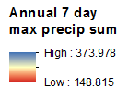

Figure 1: Annual 7 day maximum precipitation sums in Eastern Nepal. Image Credit: Himalaya Disasters II Team.

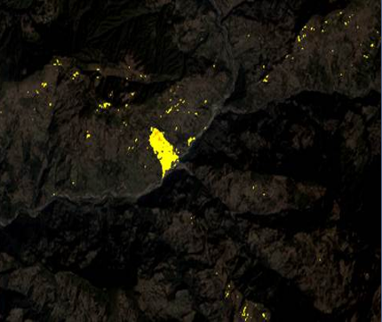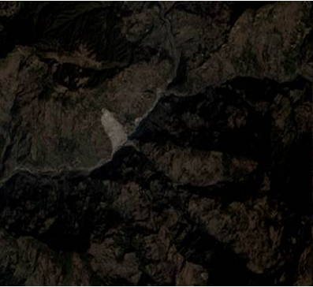

Figure 2: Demonstration of landslide detection using the Sudden Landslide Identification Product (SLIP). Image Credit: Himalaya Disasters II Team.