Paria River Ecological Conservation

Mapping Russian Olive and Tamarisk to Inform Invasive Species Management

Along the Paria River, Utah & Arizona

 **Technical Report**

August 11th, 2023

Max VanArnam (Project Lead)

Wesley Rancher

Annie Kowalski

Truman Anarella

***Advisors:***

Dr. Paul Evangelista, Colorado State University, Natural Resource Ecology Laboratory (Science Advisor)

Dr. Catherine Jarnevich, United States Geological Survey, Fort Collins Science Center (Science Advisor)

Dr. Anthony Vorster, Colorado State University, Natural Resource Ecology Laboratory (Science Advisor)

Nicholas Young, Colorado State University, Natural Resource Ecology Laboratory (Science Advisor)

Peder Engelstad, Colorado State University, Natural Resource Ecology Laboratory (Science Advisor)

Christopher Tsz Hin Choi, Colorado State University, Natural Resource Ecology Laboratory (Science Advisor)

***Fellow:***  
Sarah Hettema (Colorado – Fort Collins)

# 1. Abstract

Invasive species within desert riparian environments significantly affect ecosystem function by overtaking native species and altering the fluvial geomorphology. The Paria River, a sediment-heavy river and watershed, flows through the Grand Staircase-Escalante National Monument (GSENM) before its confluence with the Colorado River. Due to its heavy sediment load, it provides an important habitat for various species of native fish and amphibians. Grand Staircase Escalante Partners (GSEP) noticed an increased presence of invasive tamarisk (*Tamarix ramosissima*) and Russian olive (*Elaeagnus augustifolia*) plants along the Paria River watershed; however, the extent of both species is largely unknown. Using field survey data from the Grand Staircase Escalante Partners and remote sensing data from Landsat 8 Operational Land Imager (OLI), Landsat 9 OLI-2, Shuttle Radar Topography Mission (SRTM), and Light Detection and Ranging (LiDAR), we performed a Random Forest classification model to identify the presence of these invasive species. We used Tasseled Cap indices to create a time series phenology for 2022, which helped us identify our predictor variables for the random forest classification model. We found that the limited Russian olive cover reflected in the field survey data, and the low spectral and height differentiation from other species, resulted in a classification model not strong enough to make a reliable prediction map. The tamarisk data, however, was abundant enough to produce a marginally reliable prediction map of presence in the watershed. Our results and tamarisk prediction map will help our partners at GSEP make informed decisions about future funding and management efforts.

**Key Terms**

invasive species, Russian olive, tamarisk, remote sensing, Random Forest, Tasseled Cap

# 2. Introduction

***2.1 Background Information***

Riparian zones occur along the boundary of terrestrial and aquatic ecosystems. These areas provide water in arid regions, control sediment, and contain valuable habitats for both aquatic and terrestrial animals (Gregory et al., 1991). Productivity and species diversity is typically much higher in riparian areas when compared to surrounding areas that are water limited (Lesica & Miles, 2001). Invasive species within desert riparian environments significantly affect ecosystem function by altering fluvial geomorphology (Hood & Naiman, 2000). A combination of satellite imagery and in-situ field data allow researchers to train models that predict locations of invasive vegetation that were not originally sampled through field work. Recent literature provides information on predictor variables such as elevation or distance to streams. While higher spatial and/or spectral resolution imagery such as WorldView-2 or AVIRIS provides a more detailed view of exact vegetation differences at any given time (Bransky et al., 2021; Martin et al., 1998), higher temporal resolution imagery provides more comprehensive information on phenological differences (Aghababaei et al., 2021).

Originally from Eurasia, the United States introduced tamarisk to the Southwest for erosion and drought control in the early 1900s (Chew, 2009). Tamarisk is a perennial woody shrub with brown to reddish-brown bark, green scaly leaves and distinct pink and white flowers during the growing season (Spellenberg et al., 2014). It is estimated to be the second most common woody riparian species in the western United States (Friedman et al., 2005), and due to its excessive salt secretions, which increase the soil salinity, it can outcompete native vegetation for space along the riverbank (Nagler et al., 2018). Areas that have both tamarisk and native species may result in an overall unsuitable habitat for sensitive species (such as butterflies) that depend on one specific host plant (Nelson & Wydoski, 2013). Friedman et al. (2005) found that tamarisk plants can flower and disperse seeds in their first year, spreading rapidly over long distances through air and water.

Like tamarisk, Russian olive (*Elaeagnus augustifolia*) came to the United States in the early 1900s for erosion control and wind management in riparian areas (Lesica & Miles, 2001). This plant is a small deciduous tree that has reddish bark with some thorns and silvery-gray leaves (Katz & Shafroth, 2003). The species is drought tolerant, and spreads through an individual yellow seed (Nagler et al., 2011). Russian olive is more tolerant to environmental conditions such as flooding, drought, and shade, giving it the ability to live in varying environments (Nagler et al., 2011). Russian olive is the fourth most frequently occurring woody riparian plant and the fifth most abundant plant along rivers throughout the western United States based on canopy cover (Friedman et al., 2005).

The Grand Staircase-Escalante National Monument (GSENM), located in southern Utah, was established in 1996 (Waters et al., 2004). Within the monument are two main rivers, the Escalante River and the Paria River, both of which feed into the Colorado River (Simpson, 2019). The Paria River is in the western portion of GSENM and contributes a large amount of sediment to the Colorado River (Thieme et al., 2001). The Paria River’s riparian area is home to many species of trees, including native cottonwood and willow trees, as well as (invasive) tamarisk and Russian olive plants (Simpson, 2019). In partnership with the Grand Staircase Escalante Partners (GSEP), our team is aware of efforts made to identify, map, and remove invasive Russian olive plants along the Escalante River, as well as the minimal efforts made for invasive species management along the Paria River. As such, we limited our study area to just the Paria River (Figure 1).

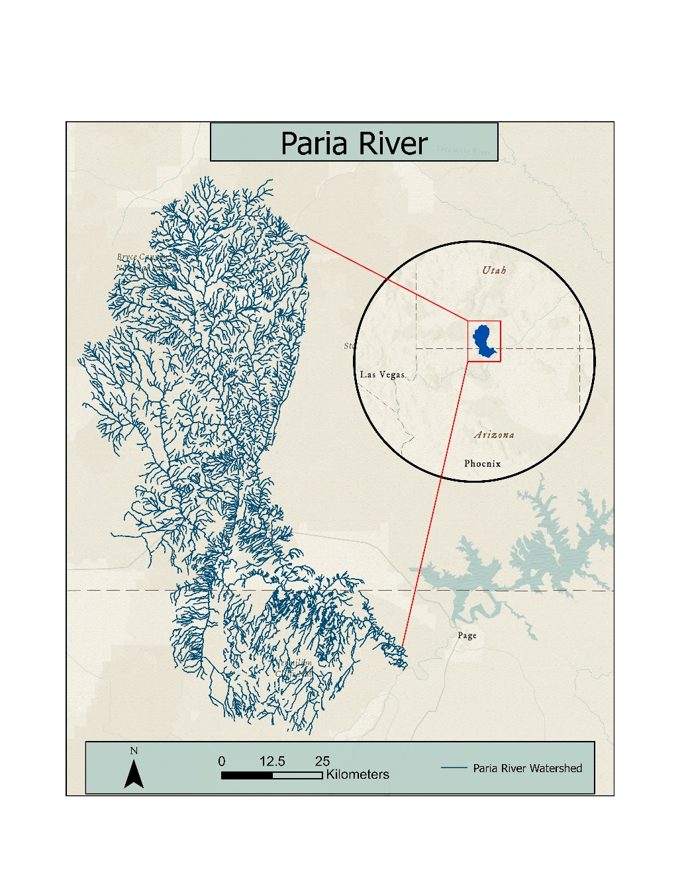

*Figure 1.* This map shows the Paria River Watershed in reference to the American Southwest region

***2.2 Project Partners & Objectives***

Established in 2004, the Grand Staircase Escalante Partners (GSEP) is a non-profit that aims to sustainably manage the monument through conservation, science, and education. We worked with GSEP to map invasive species in the Grand Staircase-Escalante National Monument along the Paria River watershed. Beginning in 2009, GSEP focused their efforts on eradicating invasive species of Russian olive and tamarisk in the Escalante River basin (GSEPartners, 2022). GSEP sought to conduct a wide scale eradication effort in the Paria River watershed, however there was little information available regarding the spatial extent and spatial cover of Russian olive and tamarisk. This project informed monitoring and management approaches along the Paria River. Additionally, the team generated species extent maps to help inform partners of where to focus for project budgeting and management efforts.

This study aimed to demonstrate the feasibility of using remotely sensed data to detect invasive plants along remote riparian zones. Using Landsat 8 and 9 and Sentinel 2A imagery, we implemented a variety of bands and spectral indices to quantify the percent cover of invasive (Russian olive and tamarisk) and native (cottonwood and willow) riparian plants within our study area through the production of species extent maps. Moreover, to complement our detection maps, we conducted time series analyses to monitor phenological differences between the species.

# 3. Methodology

***3.1 Data Acquisition***

To begin this study, GSEP and associated volunteers collected field data on vegetation and substrate cover throughout the Paria River watershed. The field data collected in May 2023 consists of 345 10-meter diameter plots that measure different types of biotic and abiotic cover, including percent Russian olive cover and percent tamarisk cover as well as categories for native vegetation and sediment cover. The data also includes latitude, longitude, tributary, and Paria River watershed reach (i.e., upper, middle, or lower).

GSEP approached NASA with this project and this data, and our team received the csv file of the field data, as well as a shapefile of the study area location (Table 1). We aggregated satellite imagery in Google Earth Engine (GEE) from Landsat 8 OLI tier 1 Top of Atmosphere (TOA), Landsat 9 OLI-2 tier 1 TOA, and SRTM digital elevation model (DEM) data (USGS, 2018a; USGS, 2018b; USGS, 2018c; Table 2). We also incorporated LiDAR data into our model, which was collected using the Leica CityMapper and Leica TerrainMapper. Moreover, we filtered our study area to the riparian corridor of the Paria River and surrounding tributaries using the Valley Bottom Extraction Tool (VBET), which delineates the valley bottom using slope and valley width data (Gilbert et al., 2016).

Table 1.

*Ancillary Data*

|  |  |  |  |  |
| --- | --- | --- | --- | --- |
| **Data Type** | **Source** | **Data Product** | **Extent** | **Collection Date** |
| Percent cover | In-situ data from Grand Staircase Escalante Partners | Percent cover data of various plant and soil types | 345 10m plots | May 2023 |
| Shapefile | Grand Staircase Escalante Partners | Paria River study area shapefile | Paria River watershed | May 2023 |

Table 2.

*Remote Sensing Data Sources*

|  |  |  |  |  |
| --- | --- | --- | --- | --- |
| **Sensor / Source** | **Data Products** | **Acquisition Method** | **Spatial Resolution** | **Dates Used** |
| Landsat 8 OLI Collection 2 Tier 1 TOA | Tasseled Cap Brightness, Tasseled Cap Greenness, Tasseled Cap Wetness | Google Earth Engine | 30m | 2022 | |
| Landsat 9 OLI-2 Collection 2 Tier 1 TOA | Tasseled Cap Brightness, Tasseled Cap Greenness, Tasseled Cap Wetness | Google Earth Engine | 30m | 2022 |
| LiDAR | Canopy height | Utah Geospatial Resource Center | 1m | 2019 |
| SRTM | Elevation, slope, aspect | Google Earth Engine | 30m | 2000 |

***3.2 Data Processing***

*3.2.1 Landsat Data*

Of the 345 in-situ field measurements that we received from our partners at GSEP, only 302 were usable due to data collection issues. We converted this CSV to a point-shapefile in ArcGIS Pro 3.1 and added it to Google Earth Engine. We imported Landsat 8 OLI and Landsat 9 OLI-2 2022 images and clipped them to cover the entire Paria River basin study area. The team created a function that masked out all cloudy, cloud shadowed, and snowy pixels in all images. Using the collection of 2022 images, we calculated the Tasseled Cap Index for each available date. The Tasseled Cap transformation is a weighted sum of six spectral Landsat bands that provides more information on vegetation characteristics (Baig et al., 2014). We implemented Tasseled Cap brightness, greenness, and wetness values into our random forest model as predictor variables (Table 3). We created a time series plot of brightness, greenness, and wetness for each species to provide insight into phenological differences between the invasive plants and native cottonwood and willow plants. Finally, our team extracted Tasseled Cap values as well as individual band values for blue, green, red, NIR, SWIR1, and SWIR2 wavelengths at all field data points for all Landsat scenes.

Table 3.

*Tasseled Cap Weighted Sum Equations*

|  |  |
| --- | --- |
| **Parameter** | **Equation** |
| Tasseled Cap Brightness | (0.2381)(B1)+(0.2576)(B2)+(0.2934)(B3)+(0.5599)(B4)+(0.508)(B5)+(0.1872)(B6) |
| Tasseled Cap Greenness | (-0.2941)(B1)+(-0.243)(B2)+(-0.5424)(B3)+(0.7276)(B4)+(0.0713)(B5)+(-0.1608)(B6) |
| Tasseled Cap Wetness | (0.1511)(B1)+(0.1973)(B2)+(0.3283)(B3)+(0.3407)(B4)+(-0.7117)(B5)+(-0.4559)(B6) |

*3.2.2 Geographic Data*

We obtained approximately 7000 first-return (DSM) and bare-earth (DEM) LiDAR tiles at 1m spatial resolution from the Utah Geospatial Resource Center (2019). The team mosaicked the 1000m2 tiles to the extent of the Paria Watershed using the Mosaic to New Raster tool in ArcGIS Pro. We calculated the difference between our first-return and bare-earth mosaics to derive canopy height at the initial 1m resolution and a resampled 10m resolution (Figure 2). As for data in 1m resolution, we needed to obtain the average canopy height value at our field data plots so we added a 10m buffer to the plots in ArcGIS Pro, and then calculated the average canopy height for the buffered plots using the zonal statistics tool. Finally, our team extracted 1m averaged and 10m canopy height values for our field data plots and exported these to a CSV format. As 20 of the remaining 302 plots were outside of the available LiDAR data bounds (and did not have high percentage cover of the target species), we completed the rest of our processing based on 282 plots.

Additionally, we incorporated SRTM data to create additional predictor variables. In GEE, we used the DEM raster to derive the slope and aspect of each plot. We also converted all aspect values from degrees to northness and eastness, where –1 equals due south and due west, and 1 equals due north and due east.

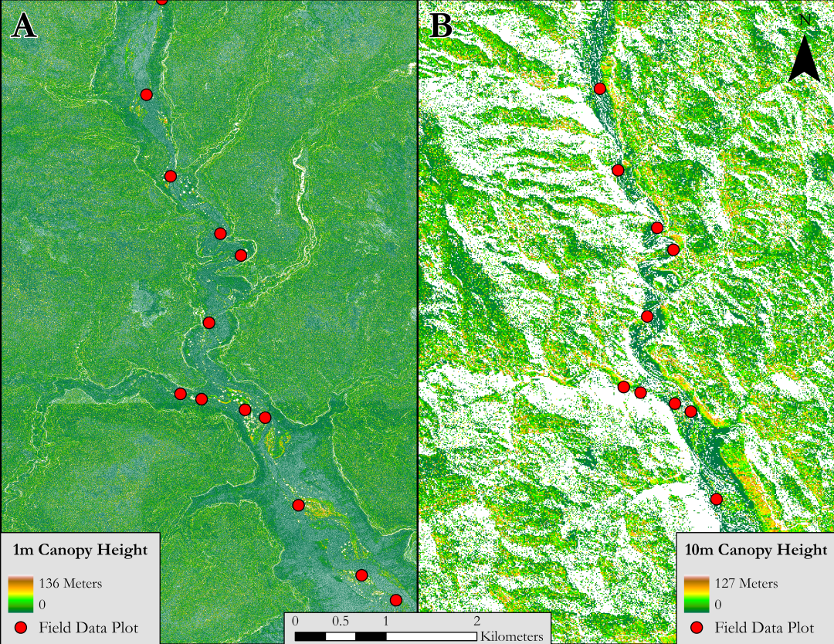

*Figure 2.* These are canopy height outputs at 1m (A) and 10m (B) resolution respectively with field data plots overlaid (red). The images are zoomed into the Paria River in a central region of the watershed. Areas with a large extent of white symbolized are representative of no data, as we sought to eliminate canopy height values below zero.

***3.3 Data Analysis***

*3.3.1 Predictor Variable Selection*

The first step of our data analysis required selecting the variables to use as predictors in our random forest model. To begin this step, we produced a time series graph of Tasseled Cap brightness, greenness, and wetness for the entirety of the available field data over the 2022 calendar year using combined Landsat 8 and Landsat 9 satellite data (Figure 3).

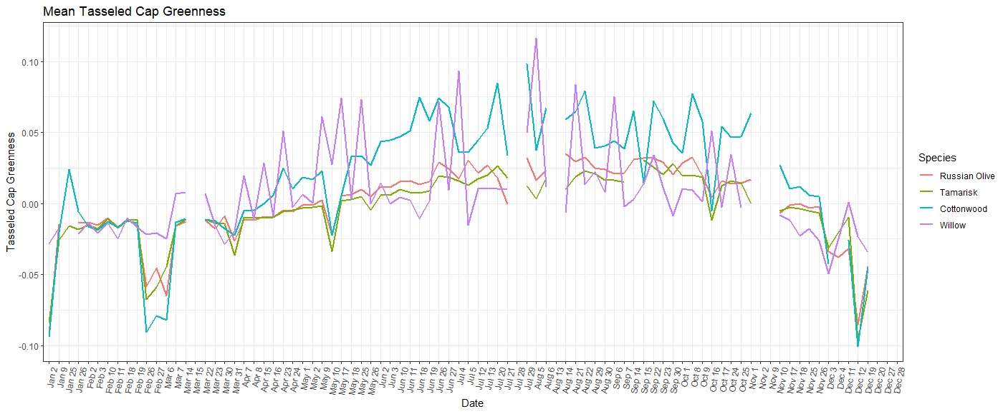

*Figure 3.* 2022 Tasseled Cap Greenness in the Paria River Watershed.

From these time series plots we sought to identify key dates of interest where Russian olive and tamarisk peaked relative to other species, allowing us to extract remotely sensed Tasseled Cap data that best represents the occurrence of Russian olive or tamarisk. To aid in this date identification process and identify significant predictor variables, we utilized the Variable Selection Using Random Forest (VSURF) algorithm in R to select the most important variables (Genuer, R., Pggi, J.-M., & Tuleau-Malot, C., 2015). This algorithm eliminates irrelevant variables, selects variables that relate to the response variables of Russian olive and tamarisk cover, and finally eliminates redundancy within those selected variables. We input every date in the Tasseled Cap time series, along with topographic variables, canopy height, and distance to stream variables. The output selected by VSURF is listed below in Table 4.

Table 4.

*Predictor Variables*

|  |  |
| --- | --- |
| **Response Variable** | **Predictor Variables** |
| % Russian Olive Cover | July 12th​ Tasseled Cap Wetness​, May 2nd​ Tasseled  Cap Wetness, July 12th Raw Band 2, April 8th Raw  Band 2 |
| % Tamarisk Cover | October 25th Tasseled Cap Wetness, May 2nd Raw Band 5, July 12th Raw Band 6, Elevation, Canopy Height |

*3.3.2 Random Forest Modeling*

With our predictor variables selected, we performed a random forest classification model using the randomForest (Liaw and Wiener, 2002) algorithm tool in R to predict the presence and absence of Russian olive and tamarisk, as well as rank the variables’ importance as predictors. To use the classification model, we converted the field data from percent cover to presence/absence data. To run the model, we imported raster data layers for each of the predictor variables as well as the vector shapefile containing data on the presence and absence of Russian olive and tamarisk response variables and set the model parameters to 5000 trees with 5 trees tried at each split. To assess model performance, we tested four minimum thresholds of 10%, 20%, 30% and 40% cover to classify a species as present/absent. We then plotted the predicted presence/absence values against actual presence/absence values and produced a confusion matrix to identify the model’s ability to identify presence and absence points. Once the random forest model was optimized, we created a predictive raster of tamarisk presence and absence across the entire Paria River Watershed (Figure 6).

# 4. Results & Discussion

***4.1 Analysis of Results***

*4.1.1 Russian Olive Random Forest Model Performance*

The highest performing Russian olive random forest model produced an out of bag (OOB) error of 19.15% and a true class error of 0.73. This model included all plots with 10 percent or higher cover of Russian olive and included the predictor variables from Table 4. We also ran the model multiple times, with each instance using a slightly different set of predictor variables and % cover thresholds (Table B2). The performance of this model was not strong enough to warrant the next step of producing an occurrence map of predicted Russian olive presence.

Table 5.

*Russian Olive Random Forest Model Confusion Matrix*

|  |  |  |  |
| --- | --- | --- | --- |
|  | False | True | Class Error |
| False | 209 | 13 | 0.059 |
| True | 44 | 16 | 0.733 |

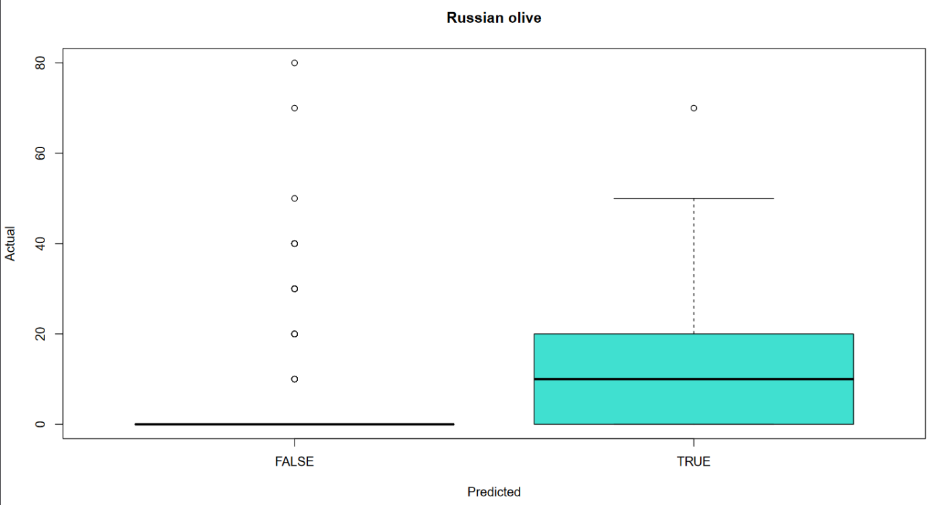

*Figure 4:* Russian olive predicted vs observed presence.

*4.1.2 Tamarisk Random Forest Model Performance*

The random forest model predicted tamarisk distribution with low accuracy across the study area. The best-performing tamarisk random forest model used the predictor variables in Table 4, with the number of trees (ntree) set to 5000, and the number of variables randomly sampled as candidates at each decision tree split (mtry) set to 5. This model also included field data plots that had 10% or higher canopy cover. This yielded an OOB of 24.82% and a true class error of 0.63, as seen in Table 6. This means that of the 79 plots with above 10% tamarisk, our model correctly identified 29 of them. We also ran the model with slightly different predictor variables and percentage cover thresholds (Table B1).

Table 6.

*Tamarisk Random Forest Model Confusion Matrix*

|  |  |  |  |
| --- | --- | --- | --- |
|  | False | True | Class Error |
| False | 177 | 26 | 0.128 |
| True | 50 | 29 | 0.633 |

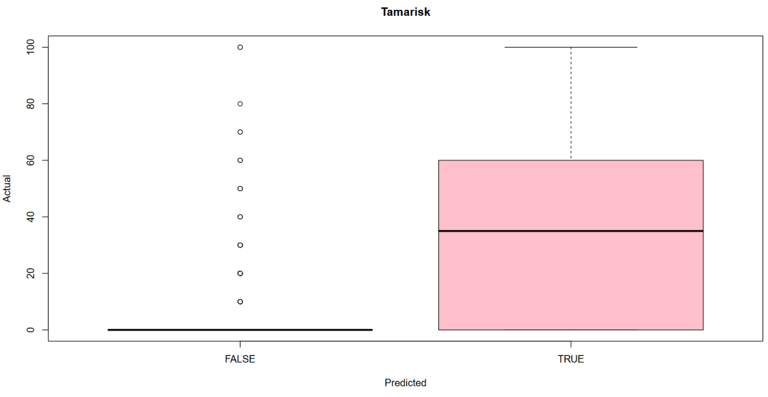

*Figure 5:* Tamarisk predicted vs observed presence.

*4.1.2 Random Forest Model Results*

In Figure 6 we see the predicted tamarisk occurrence map produced as a result of our random forest model. Note that there are regions of the watershed with limited LiDAR data coverage, and therefore the model was unable to predict tamarisk presence or absence in these regions. These areas can be seen as two gaps in predicted presence maps, located in the northern reach of the main stem of the Paria River as well as across the southern portion of the watershed that falls within Arizona. In the regions that the model was able to predict onto, the results indicate widespread distribution of tamarisk throughout each reach of the watershed. By examining the map, we see certain reaches of the river predicted to have high tamarisk abundance, as displayed in yellow below. In the zoomed-in inset map on the top right, we see the predicted occurrence area in yellow, demonstrating the maps capability to aid in classifying even the smallest reaches in the watershed by their tamarisk abundance.

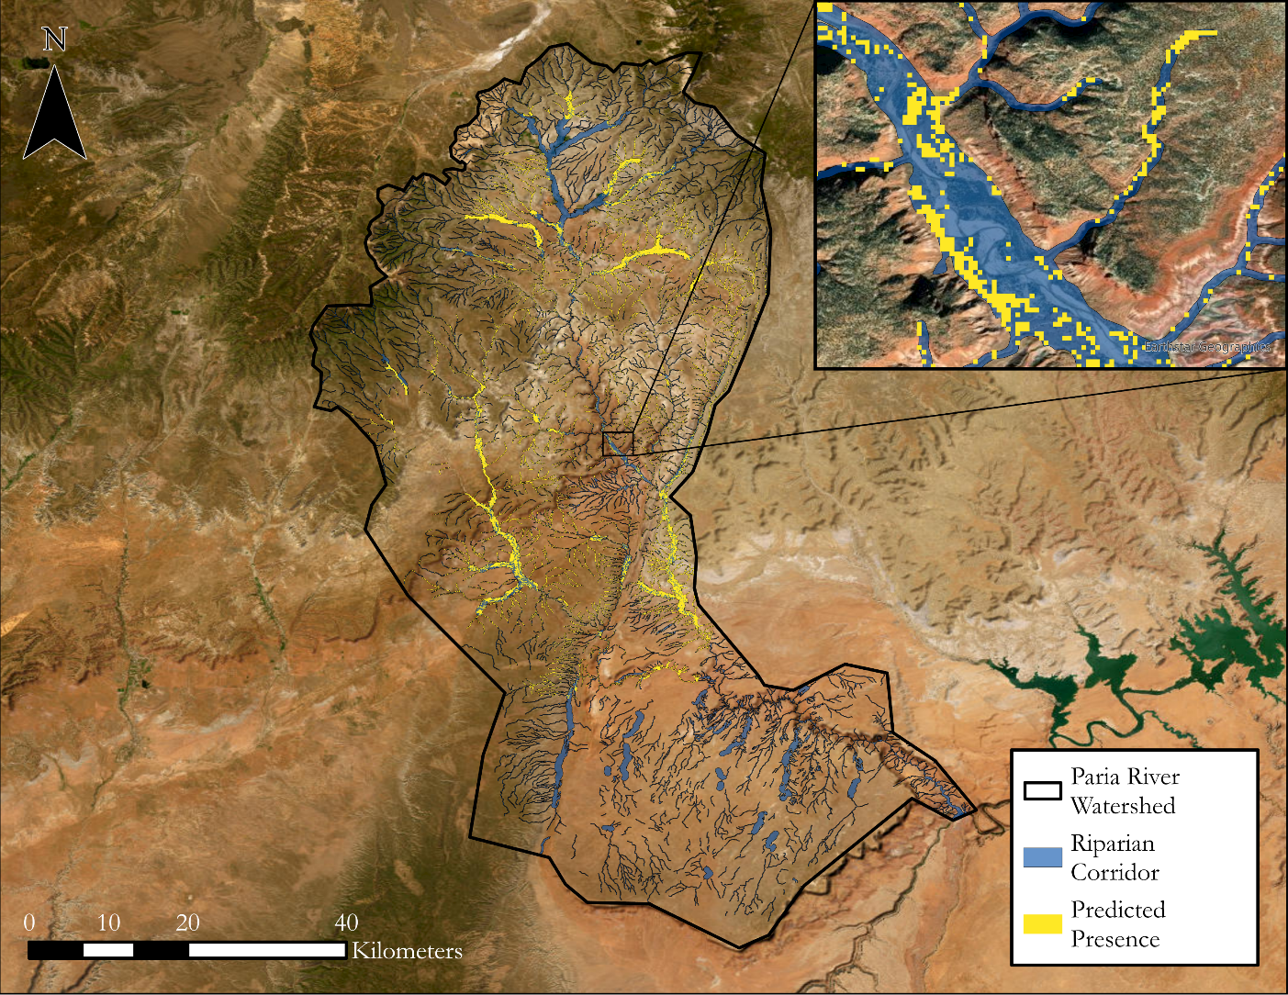

*Figure 6:* Paria River WatershedTamarisk Occurrence Prediction Map.

***4.2 Caveats and Uncertainties***

Our study was based on field observations which were insufficient in representing the phenology of the target species. For example, there were only six field data plots that had higher than 40% Russian olive cover, leaving us with very few viable training data points. This is congruent with information from our partner, who mentioned that Russian olive plants were not as abundant along the Paria River. In addition to this, using plots with 10% cover for training data may improve the model’s performance, but it also decreases our confidence in the results of our model. For example, our tamarisk model predicts tamarisk presence with 37% accuracy, but the model is predicting if there is anywhere from 10% to 100% tamarisk cover. In other words, in any given predicted pixel, we are 37% confident that there is at least 10% tamarisk cover for that pixel, leaving a lot of room for imprecision.

***4.3 Feasibility Assessment***

When conducting the time series portion of our project, we observed no significant spectral differences between the Russian olive, tamarisk, and native vegetation. This is because many of the plants display similar colors, such as the silvery colors of both Russian olive and sagebrush plants. The plants’ spectral similarities made it difficult to isolate, and therefore, predict individual plant species. There were no specific dates where tamarisk or Russian olive species had distinct differences from each other and local flora, which meant that their phenology was roughly identical in this watershed. While we did succeed in making a predictive map of tamarisk occurrence from the field data and subsequent remote sensing imagery, we do not have high confidence in its accuracy.

Our partner could potentially employ ocular sampling from higher spatial resolution imagery, such as National Agriculture Imagery Program (NAIP), to identify Russian olive and tamarisk species. They will also be able to view their in-situ field data on the maps that we created to view their collected field data, which will help them to better understand spatial distribution of the invasive and native species.

***4.4 Future Work***

Our methods can be translated and recreated in other riparian areas to inform future invasive species studies. Future studies will require abundant field data, but they could also incorporate ocular sampling of high-resolution imagery to create additional data points. This will give the random forest model more training points, and therefore, increase its accuracy and predictive capacity. Plotting percent species cover in 30-meter plots, as opposed to 10-meter plots, to better match the spatial resolution of Landsat imagery may assist the Landsat-derived variables’ predictive capacity in the random forest classification model.

Another way to improve our methods is by implementing alternative modeling processes. A two-step model would use our current model as the first step, and then manipulate the percent cover data for the second step because it is zero-inflated. A habitat suitability model would allow us to use similar predictor variables but also give specific weights to each variable. Adding in other metrics to measure vegetation health, such as the Normalized Difference Vegetation Index (NDVI) and the Normalized Difference Water Index (NDWI), may also improve the Random Forest Model, or could be utilized in the habitat suitability model.

# 5. Conclusions

Landsat 8 and 9’s combined high temporal resolution together with LiDAR’s high spatial resolution demonstrate promise for mapping invasive species, especially in the American Southwest region. The challenges that exist in this endeavor are rooted in the spectral and phenological similarities of the native and invasive species, as well as in the limited coverage of field survey data. By running two random forest classification models with varying abundance of field data coverage, one for Russian olive with less data and another for tamarisk with more, we observed that the model improves when provided with more field data. A low quantity of field data with high percentage cover of the target species would likely improve the model’s capabilities, and ocular sampling from a trained botanist using higher spatial resolution imagery (such as National Agriculture Imagery Program) would supplement the field data. This contributes to the conclusion that the outlook for mapping invasive species in this region is optimistic, despite the challenges faced in this study.

Due to tamarisk’s long roots and its elevated water consumption, we expected to find tamarisk present along the riparian corridor. The tamarisk model only predicted with limited accuracy, but it did predict tamarisk to be present throughout the entire watershed. The Grand Staircase Escalante Partners can use this study’s tamarisk prediction map to identify and prioritize treatment areas, as well as get an approximation of the acreage of tamarisk present along the Paria River. This data will also support any grant or funding applications for GSEP and facilitate coordination with other partners such as the Bureau of Land Management (BLM). While the purpose of the map is to predict the spatial extent of tamarisk occurrence, the model was much more accurate when predicting the absence of tamarisk. This information is still helpful to our partners, as it can be used to select areas with less invasive species and deprioritize them for management.

# 6. Acknowledgements

The Paria River Ecological Team would like to thank the Grand Staircase Escalante Partners for their collaboration and guidance on this project, as well as their initial field data collection. Thank you to our science advisors Dr. Paul Evangelista, Dr. Catherine Jarnevich, Dr. Anthony Vorster, Nicholas Young, Peder Engelstad, and Christopher Tsz Hin Choi, to our Node Fellow Sarah Hettema and our PC Fellow Olivia Landry, for their input and guidance on this project. The team would also like to thank the greater DEVELOP network and previous teams for the impact they had in the direction of our analyses.

Any opinions, findings, and conclusions or recommendations expressed in this material are those of the author(s) and do not necessarily reflect the views of the National Aeronautics and Space Administration.

This material is based upon work supported by NASA through contract NNL16AA05C.

# 

# 7. Glossary

**BLM –** Bureau of Land Management

**Canopy Height –** How tall local vegetation is when compared to the bare earth elevation. Derived from LiDAR data

**DEM –** Digital Elevation Model, the bare-earth topographic surface collected by LiDAR

**DSM –** Digital Surface Model, the first-return collected by the LiDAR sensor, which includes object height

**Earth observations –** Satellites and sensors that collect information about the Earth’s physical, chemical, and biological systems over space and time

**Fluvial Geomorphology –** The study of rivers, their shape, and how streams interact with sediment and their physical environment to create landforms

**GEE –** Google Earth Engine

**GSENM –** Grand Staircase-Escalante National Monument

**GSEP –** Grand Staircase Escalante Partners, our partner organization

**Invasive species –** A species not native to an ecosystem that can cause harm

**LiDAR** – Light detection and ranging. A remote sensing method used to inspect the surface of the Earth.

**NAIP –** National Agriculture Imagery Program

**NIR –** Near infrared radiation

**OLI** – Operational Land Imager (OLI for Landsat 8 and OLI-2 for Landsat 9).

**OOB –** Out-of-bag error, a composite measure of the predictive error of a Random Forest Model

**Phenology –** The study of a plant’s life cycle

**Random Forest Model** – A machine learning classification model that can predict vegetation presence using decision trees.

**Riparian –** Relating to the area on or near riverbanks.

**SRTM –** Shuttle Radar Topography Mission. Used to gather elevation and other spatial data.

**SWIR –** Short-wave infrared radiation

**Tasseled Cap Index –** A transformation of raw satellite data into vegetation brightness, greenness, and wetness indicators

**TOA –** Top of Atmosphere. A dataset type for Landsat satellite imagery

**UGRC –** Utah Geospatial Resource Center, a database used to download LiDAR data

**VBET –** Valley Bottom Extraction Tool, an ArcGIS package for delineating riparian corridor

**VSURF –** Variable Selection Using Random Forests, an R package for variable importance analysis

# 8. References

Aghababaei, M., Ebrahimi, A., Naghipour, A. A., Asadi, E., & Verrelst, J. (2021). Vegetation Types Mapping Using Multi-Temporal Landsat Images in the Google Earth Engine Platform. *Remote Sensing*, *13*(22), 4683. <https://doi.org/10.3390/rs13224683>

Baig, M. H. A., Zhang, L., Shuai, T., & Tong, Q. (2014). Derivation of a tasselled cap transformation based on Landsat 8 at-satellite reflectance. *Remote Sensing Letters*, *5*(5), 423-431. <https://doi.org/10.1080/2150704X.2014.915434>

Bransky, N., Sankey, T., Sankey, J., Johnson, M., & Jamison, L. (2021). Remote sensing Monitoring Tamarix Changes Using WorldView-2 Satellite Imagery in Grand Canyon National Park, Arizona. In *Remote Sensing* (Vol. 13). <https://doi.org/10.3390/rs13050958>

Chew, M. K. (2009). The Monstering of Tamarisk: How Scientists Made a Plant into a Problem. *Journal of the History of Biology*, *42*(2), 231–266.

Friedman, J. M., Auble, G. T., Shafroth, P. B., Scott, M. L., Merigliano, M. F., Freehling, M. D., & Griffin, E. R. (2005). Dominance of non-native riparian trees in western USA. *Biological Invasions*, *7*(4), 747–751. <https://doi.org/10.1007/s10530-004-5849-z>

Genuer, R., Pggi, J.-M., & Tuleau-Malot, C. (2015). VSURF: An R Package for Variable Selection Using Random Forests. *The R Jounral,* 7(2) 2073-4859. <https://journal.r-project.org/archive/2015-2/genuer-poggi-tuleaumalot.pdf>

Gilbert, J.T., Macfarlane, W.W., & Wheaton, J.M. (2016). The Valley Bottom Extraction Tool (V-BET): A GIS tool for delineating valley bottoms across entire drainage networks. *Computers & Geosciences*, 97,1-14. <https://doi.org/10.1016/j.cageo.2016.07.014>.

Gregory, S. V., Swanson, F. J., McKee, W. A., & Cummins, K. W. (1991). An Ecosystem Perspective of Riparian Zones. *BioScience*, *41*(8), 540–551. <https://doi.org/10.2307/1311607>

GSEPartners*.* (2023). Conservation. <https://gsenm.org/conservation-2/>.

Hood, W. G., & Naiman, R. J. (2000). Vulnerability of Riparian Zones to Invasion by Exotic Vascular Plants. *Plant Ecology*, *148*(1), 105–114.

Katz, G. L., & Shafroth, P. B. (2003). Biology, ecology and management of Elaeagnus angustifolia L. (Russian olive) in western North America. *Wetlands*, *23*(4), 763–777. [https://doi.org/10.1672/0277-5212(2003)023[0763:BEAMOE]2.0.CO;2](https://doi.org/10.1672/0277-5212(2003)023%5b0763:BEAMOE%5d2.0.CO;2)

Lesica, P., & Miles, S. (2001). Natural History and Invasion of Russian Olive Along Eastern Montana Rivers. *Western North American Naturalist*, *61*(1), 1–10.

Liaw, A., & Wiener, M. (2002). “Classification and Regression by randomForest.” *R News*, **2**(3), 18-22. [https://CRAN.R-project.org/doc/Rnews/](https://cran.r-project.org/doc/Rnews/).

Martin, M. E., Newman, S. D., Aber, J. D., & Congalton, R. G. (1998). Determining Forest Species Composition Using High Spectral Resolution Remote Sensing Data. *Remote Sensing of Environment*, *65*(3), 249–254. <https://doi.org/10.1016/S0034-4257(98)00035-2>

Nagler, P. L., Glenn, E. P., Jarnevich, C. S., & Shafroth, P. B. (2011). Distribution and Abundance of Saltcedar and Russian Olive in the Western United States. *Critical Reviews in Plant Sciences*, *30*(6), 508–523. <https://doi.org/10.1080/07352689.2011.615689>

Nagler, P. L., Nguyen, U., Bateman, H. L., Jarchow, C. J., Glenn, E. P., Waugh, W. J., & van Riper III, C. (2018). Northern tamarisk beetle (Diorhabda carinulata) and tamarisk (Tamarix spp.) interactions in the Colorado River basin. *Restoration Ecology*, *26*(2), 348–359. <https://doi.org/10.1111/rec.12575>

Nelson, S. M., & Wydoski, R. (2013). Butterfly Assemblages Associated with Invasive Tamarisk (*Tamarix* spp.) Sites: Comparisons with Tamarisk Control and Native Vegetation Reference Sites. *Journal of Insects*, *2013*, e561617. <https://doi.org/10.1155/2013/561617>

Simpson, L. (2019). *Grand Staircase-Escalante National Monument Visual Resource Inventory*. Department of the Interior.

Spellenberg, R., Earle, C. J., Nelson, G., & Hughes, A. K. (2014). Tamaricacae: Tamarisk Family. In Trees of Western North America (pp. 522–527). Princeton University Press. <https://search-ebscohost-com.du.idm.oclc.org/login.aspx?direct=true&db=e025xna&AN=759253&site=ehost-live&scope=site>

Thieme, M. L., M𝒸ivor, C. C., Brouder, M. J., & Hoffnagle, T. L. (2001). Effects of pool formation and flash flooding on relative abundance of young-of-year flannelmouth suckers in the Paria River, Arizona. *Regulated Rivers: Research & Management*, *17*(2), 145–156. <https://doi.org/10.1002/rrr.618>

# United States Geological Survey (USGS). (2018a). *Digital Elevation - Shuttle Radar Topography Mission (SRTM) Void Filled* [Data set]. USGS EROS Archive. <https://doi.org/10.5066/F7F76B1X>

United States Geologic Survey (USGS). (2018b). *Landsat 8 OLI/TIRS Level-2 Data Products – Top Of Atmosphere* [Data set]. USGS EROS Archive. <https://doi.org/10.5066/f78s4mzj>

United States Geologic Survey (USGS). (2018c). *Landsat 9 OLI-2/TIRS Level-2 Data Products – Top Of Atmosphere* [Data set]. USGS EROS Archive. <https://doi.org/10.5066/f78s4mzj>

Utah Geospatial Resource Center (UGRC). (2019). *Quality Level 2 LiDAR 2019 Bare Earth DTMs and First Return DSMs* [Data set]. UGRC 2019 Kane County Lidar Elevation Data. <https://gis.utah.gov/data/elevation-and-terrain/2019-lidar-kane-county/>

Waters, M. A., Stohlgren, T. J., Evangelista, P. H., Guenther, D. A., Alley, N. W., & Newman, G. J. (2004). *Landscape-scale Assessment of Grand Staircase-Escalante National Monument*. Natural Resource Ecology Laboratory.

# 9. Appendices

**Appendix A: Additional Time Series Plots**

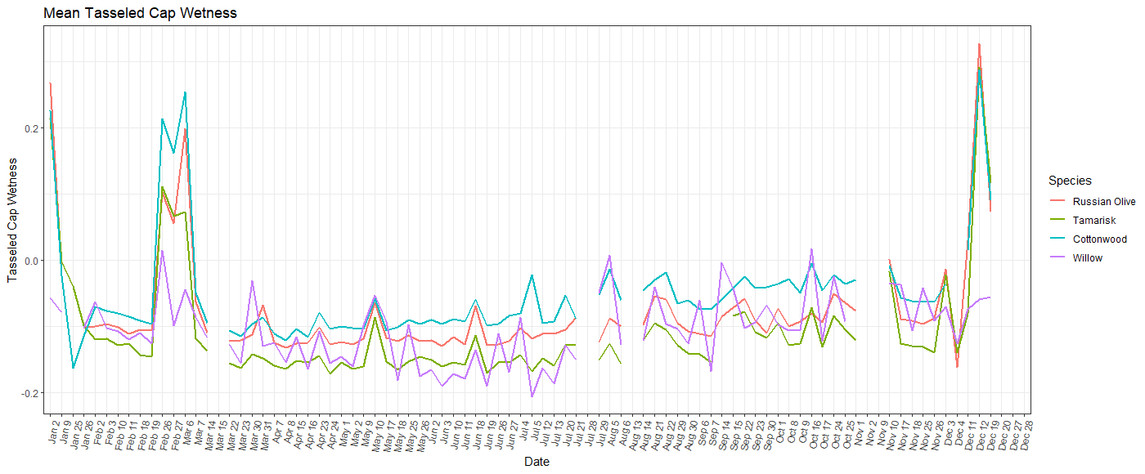

*Figure A1.* Tasseled Cap Wetness Time Series Plot

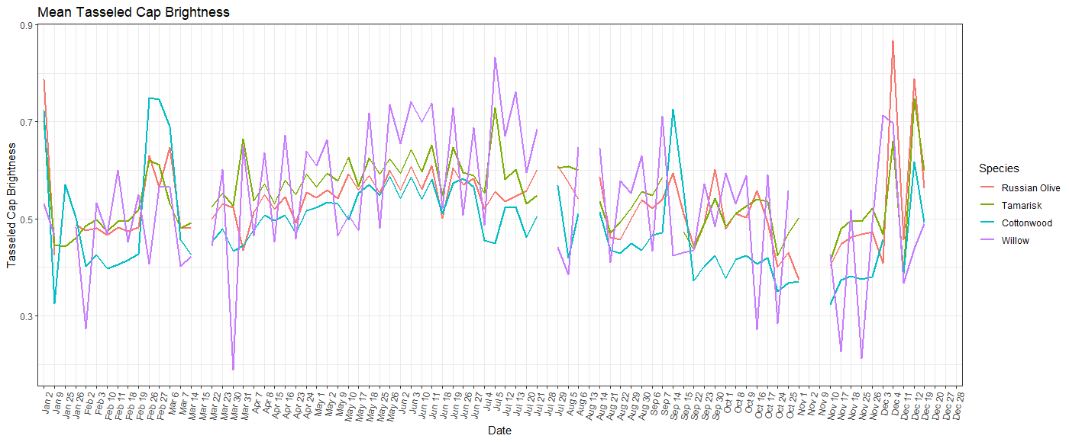

*Figure A2***.** Tasseled Cap Brightness Time Series Plot

**Appendix B: Model Performance Tracking**

Table B1.

*Tamarisk Random Forest Model Performance Tracking*

|  |  |  |  |  |
| --- | --- | --- | --- | --- |
| Description | Predictor Variables | % Cover Threshold | OOB Error | True Class Error |
| N/A | TCW_Oct.25, B5_May.2, B7_Jul.12, B6_Jul.12, Elevation, 1m_CanopyHeight | 40 | 10.28 | 0.72 |
| N/A | TCW_Oct.25, B5_May.2, B7_Jul.12, B6_Jul.12, Elevation, 1m_CanopyHeight | 30 | 12.18 | 0.70 |
| N/A | TCW_Oct.25, B5_May.2, B7_Jul.12, B6_Jul.12, Elevation, 1m_CanopyHeight | 20 | 22.34 | 0.65 |
| Same Predictor variables with 10% tamarisk cover | TCW_Oct.25, B5_May.2, B7_Jul.12, B6_Jul.12, Elevation, 1m_CanopyHeight | 10 | 24.82 | 0.58 |
| Split % cover into 3 categories | TCW_Oct.25, B5_May.2, B7_Jul.12, B6_Jul.12, Elevation, 1m_CanopyHeight | 0-30 = 0  40-60 = 1  70-100 = 2 | 12.41 | 0 = 0.02  1 = 1.00  2 = 0.92 |
| Included select differenced values | TCW_Oct.25, B5_May.2, B7_Jul.12, B6_Jul.12, Elevation, 1m_CanopyHeight, TCG Jul – Nov | 10 | 25.89 | 0.65 |

Table B2.

*Russian Olive Random Forest Model Performance Tracking*

|  |  |  |  |  |
| --- | --- | --- | --- | --- |
| **Description** | **Predictor Variables** | **% Cover Threshold** | **OOB Error** | **True Class Error** |
| **Includes many topographic variables** | TCW July 12, B2 April 8, Elevation, B2 July 12, TCW May 2, Canopy Height, aspect e and n, slope fill, dist to stream | class=10% and above | 21.28 | 0.87 |
| **Only includes elevation as topographic variable** | TCW July 12, B2 April 8, Elevation, B2 July 12, TCW May 2, Canopy Height, | class=10% and above | 21.28 | 0.76 |
| **Cover threshold is 40% and above** | TCW July 12, B2 April 8, Elevation, B2 July 12, TCW May 2, Canopy Height, | class=40% and above | 6.38 | 1.00 |
| **Cover threshold is 20% and above** | TCW July 12, B2 April 8, Elevation, B2 July 12, TCW May 2, Canopy Height, | class=20% and above | 17.73 | 0.84 |