Gila Water Resources

Using Earth Observations to Track Watershed Recovery After Wildfires in the Gila National Forest

**Technical Report**

Final Draft – November 20, 2019

Terra Edenhart-Pepe (Project Lead)

Abigail Barenblitt

Ariege Besson

Carli Merrick

Dr. Sebastian Martinuzzi, University of Wisconsin-Madison (Science Advisor)

Dr. John Bolten, NASA Goddard Space Flight Center (Science Advisor)

Dr. Raha Hakimdavar, USDA Forest Service (Mentor)

# 1. Abstract

The largest fire in New Mexico’s recorded history, the Whitewater-Baldy Complex Fire, occurred in 2012 in the Gila National Forest (Gila NF). Then, in 2013, the Silver Fire broke historic records for destruction of private property. These disturbances have become more frequent, more severe, and are powerful forces of landscape change. Fire disturbances prompt serious concern over associated impacts, such as post-fire flooding, erosion, debris flows, and the ability of the Gila NF to provide essential goods and services, including safe drinking water and timber. Understanding the impacts of interrelated disturbances on watershed recovery dynamics is increasingly important to ensure future health and function of watershed ecosystems. This project partnered with the US Department of Agriculture (USDA) US Forest Service’s (USFS) Gila National Forest and Region 3 to explore watershed recovery trends following wildfires. The purpose of this project was to generate data-supported knowledge to inform land management decisions and planning, including the prioritization of specific regions for restoration efforts. To evaluate the watershed recovery phenomena in the Gila NF, this project used a combination of local knowledge and Earth observations, including Landsat 5 Thematic Mapper (TM), Landsat 7 Enhanced Thematic Mapper Plus (ETM+), and Landsat 8 Operational Land Imager (OLI). Normalized Burn Ratio (NBR) was the index used to evaluate recovery trends over time. Additionally, the team used USGS stream gauge data to evaluate the relationship between wildfires and flood events observed in the years following fire disturbances. Finally, potentially significant physical and environmental parameters were collected in a spatial database for use in subsequent studies.

**Keywords**

wildfire, flood, watershed, LandTrendr, Landsat, restoration ecology

# 2. Introduction

* 1. ***Background Information***

New Mexico has a history of wildfire disturbances, which impact ecological functions and human health. Recent wildfires have had drastic impacts on both land use and water quality, particularly within the Gila National Forest (Gila NF) watershed in southwestern New Mexico. The 2012 Whitewater-Baldy Complex Fire was the largest fire recorded in New Mexico’s history, burning 274,784 acres (Gila National Forest, 2012). The 2013 Silver Fire burned a total of 138,698 acres and was highly destructive to human property, burning 788 acres of private land (Gila National Forest, 2013).

These fire disturbances prompt concern over associated impacts including flooding, erosion, and debris flows. The relationships between flood events and fire events are of particular interest to this project. Partners at the Gila NF observed a temporal relationship between wildfires and flash floods, with flooding and debris flows occurring a few years after wildfires in the area. A Forest Service Burned Area Emergency Response (BAER) Team, that examined the immediate impact of the Whitewater-Baldy Complex fire, predicted that post-fire flows from a 25-year precipitation event could increase 2-4 times in many of the drainage regions impacted by these fires (Gila National Forest 2012). Other recent studies provide evidence of a relationship between fire and heightened streamflows (Wine & Cadol, 2016; Hallema et al., 2018).

Fires also impact the ability of the Gila NF to provide essential ecosystem services, such as safe water supply for communities downstream (Soulard, Albano, Villarreal, & Walker, 2016; USDA-FS, 2011; Potyondy & Geier, 2010). Following the Whitewater-Baldy Complex Fire, a number of Outstanding National Resource Waters (ONRW), which are subject to higher than average water quality standards, were negatively impacted by these fires. As a result, users downstream of wilderness areas like West Fork and Whitewater Creek experienced reduced water quality (Gila National Forest, 2012). Similar impacts to the ecosystem and surrounding communities were detected following the Silver Fire a year later (Gila National Forest, 2013). For further discussion, see the Extended Background section in Appendix A.

Land managers respond quickly to wildfires by employing restoration practices like seeding. However, informed restoration efforts require an understanding of the interrelated processes acting on the landscape (Aqua, n.d.; Potyondy & Geier, 2010). Managing future risk of harmful watershed system impacts necessitates characterization of landscape changes at spatial and temporal scales that capture fire effects (Kennedy, Yang, Cohen, Pfaff, Braaten, & Nelson, 2011). Institutions like Oregon State University have demonstrated the ability to analyze post-fire vegetation recovery in temperate forest areas by operationalizing tools to recognize spectral change in Landsat time-series stacks (Bright, et al., 2019; Kennedy, et al., 2012; Kennedy, et al., 2010). Methods to understand the impact of wildfires on hydrological functions will also improve our understanding of recovery in the Gila across the watershed. In recent years, the frequency of flood following fire events have motivated hydrological studies (Sun, et al., 2018; Wine & Cadol, 2016; Hallema, et al., 2018) which reveal increased streamflow following fire events at the subwatershed scale. This project served as an exploratory study to identify appropriate data and methodologies to support future land management decision-making in the study area (Figure 1) through the examination of vegetation regrowth as a proxy for recovery and hydrological processes.

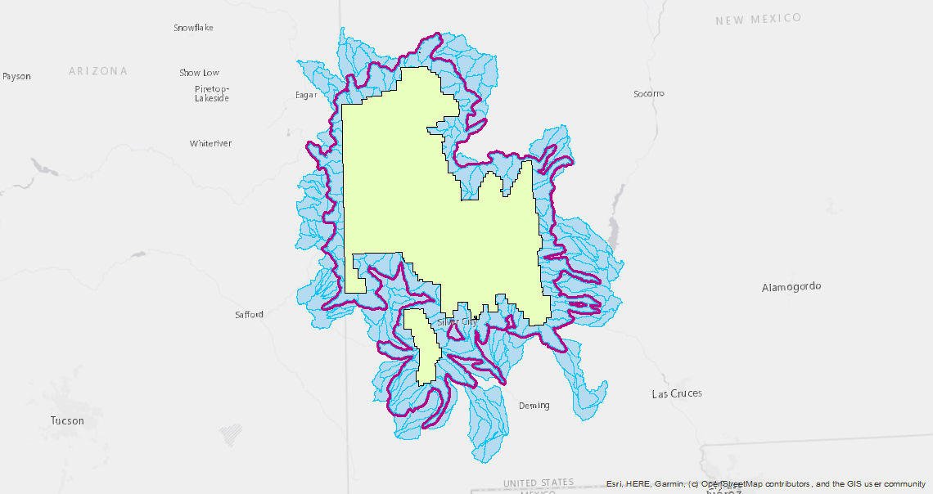

**N**

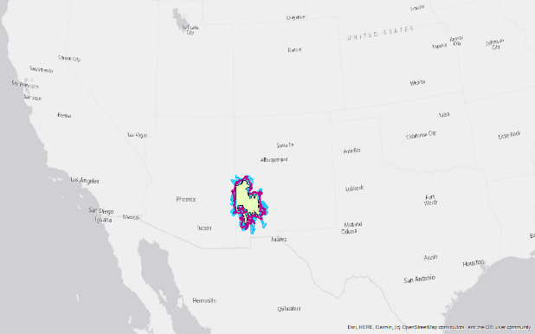

**N**

United States

New Mexico

Arizona

Watershed Boundary an NationsNafgNationalrFoForestForest

Gila National Forest NationsNafgNationalrFoForestForest

Project Study Area

*Figure 1.* The study area for this project (outlined in purple) includes all of the HUC-12 level watersheds intersecting with the Gila National Forest.

* 1. ***Project Partners & Objectives***

The end users of this project are the USFS Gila National Forest (USFS Gila NF) and USFS Region 3. The USFS Gila NF and Region 3 have actively managed and monitored regional disturbances with practices that include survey, inventory, and observation of environmental correlations. However, condition assessments and management decision practices currently rely on local knowledge, ground surveys, and some *in situ* restoration monitoring and data collection. This project seeks to improve USFS Gila NF’s ability to make medium-to-long term management decisions at the watershed scale. With the resulting products from this project, Gila NF managers can determine which areas would benefit from seeding, mulching, and other restoration efforts. Additionally, understanding which factors significantly impact watershed recovery will allow forest managers to proactively plan mitigation efforts.

Our team examined methodologies for utilizing satellite data to identify recovery across the Gila NF watershed. Medium and long-term recovery trends were represented by a vetted proxy for land cover condition, Normalized Burn Ratio (NBR). Additionally, we examined streamflow data from USGS stream gauges to provide preliminary analyses of the impact of the 2012 and 2013 wildfires on hydrological processes in the Gila NF. Finally, we laid the groundwork for a model-ready spatial database that can be used as a framework for understanding the correlations between various environmental features and watershed recovery. It is the first step in generating data-supported knowledge to inform present and future land management decisions.

# 3. Methodology

***3.1 Data Acquisition***

To assess landscape change, we extracted a combination of observational data and NASA EO’s including Landsat 5 Thematic Mapper (TM), Landsat 7 Enhanced Thematic Mapper Plus (ETM+), and Landsat 8 Operational Land Imager (OLI) atmospherically corrected surface reflectance (“USGS Landsat 5 Surface Reflectance Tier 1”, “USGS Landsat 7 Surface Reflectance Tier 1”, and “USGS Landsat 8 Surface Reflectance Tier 1”) (*Table 1*). The Landsat archive contained land cover change information at appropriate temporal and spatial scales (Kennedy et al., 2011). Additionally, we used Google Earth Engine (GEE) to access USGS HUC 12 Watershed Boundaries, USGS National Landcover Database (NLCD), USGS National Elevation Dataset, and Joint Research Center (JRC) Global Surface Water. USFS Gila NF provided ancillary datasets, including Riparian Vegetation Maps and Burn Severity (*Table 2*). We also included data describing a number of physical landscape characteristics (*Table 2; Appendix B)* to better understand how outside factors may impact recovery. Data acquisition, processing and analyses were performed within the GEE JavaScript Application Programming Interface (API). GEE is a powerful and freely available platform for processing GIS and remotely sensed data. This platform will also prove useful to future iterations of this project, which aim to create a Graphical User Interface (GUI) for the data products completed during this term.

Table 1

*NASA and ESA satellite data used in this project*

|  |  |  |
| --- | --- | --- |
| **Earth Observation Data** | | |
| **Platform** | **Level** | **Google Earth Engine ImageCollection IDs** |
| Landsat 5 TM | Tier 1 | LANDSAT/LT05/C01/T1_SR |
| Landsat 7 ETM+ | Tier 1 | LANDSAT/LE07/C01/T1_SR |
| Landsat 8 OLI | Tier 1 | LANDSAT/LC08/C01/T1_SR |
| SRTM | V3 | USGS/SRTMGL1_003 |

Table 2

*Ancillary data acquired and used in this project.*

|  |  |  |  |
| --- | --- | --- | --- |
| **Ancillary Data** | | | |
| **Parameter** | **Spatial Resolution** | **Provider** | **Source** |
| Burned Areas | 500 m | NASA LP DAAC at the USGS EROS Center | MODIS |
| Watershed Boundaries | Vector Data | United States Geological Survey | United States Geological Survey |
| Land Cover | 30 m | United States Geological Survey | National Land Cover Database |
| Water Classification History | 30 m | EC JRC / Google | Landsat 5, 7, 8 |
| Elevation | 0.33 arc seconds | United States Geological Survey | National Elevation Dataset |
| Land Cover | 30 m | United States Geological Survey | LANDFIRE |
| Hydrologically Conditioned DEM | 15 arc seconds | World Wildlife Fund | Shuttle Radar Topography Mission |
| Streamflow | na | USGS National Water Information System | USGS Gauges |
| Soil moisture | 25 km | Western Water Applications Office | Soil Moisture Active Passive |
| Soil moisture | 1 km | Western Water Applications Office | Western Land Data Assimilation System |

We experimented with the viability of using streamflow as a metric for assessing watershed recovery, assuming that a recovered watershed would return to a state of stasis to match flow dynamics prior to a given disturbance. We downloaded 20 years of data from four strategically selected gauges within the forest boundary: downstream of the Whitewater-Baldy Fire Complex (San Francisco River near Glenwood, NM), downstream of the Silver fire (Mimbres River at Mimbres, NM), downstream of both fires (Gila River near Gila, NM), and downstream of neither fire (Gila River near Redrock, NM). Tabular streamflow data was exported from the USGS website and cleaned. Although there was potential to acquire other data in addition to streamflow, such as sediment measurements, this data did not align with the time of interest.

***3.2 Data Processing***

To address the challenge of distilling essential features of landscape change, we used a tool known as LandTrendr. LandTrendr is a set of spectral-temporal segmentation algorithms, which can be used to detect change within a Landsat time series (Kennedy, Yang, & Cohen, 2010; Kennedy, et al., 2011). The algorithms use yearly composites to identify disturbance events and calculate recovery at the pixel level within an image based on indices like NBR. NBR uses Landsat’s near infrared (NIR) and shortwave infrared (SWIR) bands to identify burned areas and measure burn severity (Equation 1):

(1)

$NBR = \frac{NIR-SWIR}{NIR + SWIR}$

NBR was selected as the primary index as past studies suggest that it is ideal for assessing post-fire recovery. NBR is “most sensitive to the capture of disturbance events” (Kennedy et al., 2010) and is less prone to saturation than NDVI when considering post-fire vegetation recovery (Bright et al., 2019). Additionally, Soulard, et al. (2016) found that current disturbance products are inadequate for identifying disturbance events and studying their effects in areas such as mountain meadows, where the composition of the vegetation is either mixed or largely characterized by herbaceous vegetation. Examples like this point toward using an index such as Normalized Burn Ratio (NBR) in lieu of Normalized Difference Vegetation Index (NDVI) for obtaining information about post-fire recovery. Examining the magnitude of gain of NBR over time can provide insight into the recovery of a region after a fire. High values of change in NBR (660-1300) align with high severity burn regions, while low values of NBR change (100-269) align with low severity burn regions. High percent recovery of NBR should indicate that a region has recovered from a disturbance and demonstrates a spectral signature more indicative of a healthy landscape. LandTrendr algorithms were applied to NBR values in the study area, collected between the years 1998 and 2018. This study period captures mid and long-term time scales and overlaps recent wildfire events.

We performed LandTrendr analyses using GEE. LandTrendr algorithms harmonized bands from Landsat 8 OLI and Landsat 7 ETM+ to ensure cross comparison between satellites (Roy et al., 2016). We masked clouds, cloud shadow, and snow from Landsat imagery to yield the clearest image across all years of study, then merged the Landsat imagery into a single image per year by calculating the medoid for each pixel within the image. The medoids were then mosaiced to create a mosaic collection to feed into the LandTrendr algorithm. These methods follow guidelines for running the algorithm based on the process established by Kennedy et al (2011).

We explored the use of data from the Western Water Application Office (WWAO) to determine soil moisture at a 1 km resolution across the study area. However, we quickly determined that this data was not available in the format needed to conduct the project. The soil moisture data from WWAO’s Western Land Data Assimilation System (WLDAS) could provide important information about watershed recovery to future projects as this data becomes more accessible. While we explored the idea of using SMAP and the North American Land Data Assimilation System (NLDAS), the resolution of SMAP was too coarse for this project and NLDAS models do not take wildfires into account.

***3.3 Data Analysis***

Results from LandTrendr algorithms specifying percent recovery for each pixel were classified to yield an image layer to grade the extent of recovery across the Gila watershed. We classified pixels into groups based on percent recovery in comparison to pre-disturbance NBR. Percent recovery was calculated using information about NBR values before fire disturbance, immediately following disturbance, and at present (Equation 2). We used the results produced by the LandTrendr algorithm to evaluate the relationship between various environmental parameters and recovery. We used ArcMap’s Create Fishnet tool to extrapolate data describing physical landscape features across a grid and related that information to recovery within the watershed. Then, we used a linear regression model to calculate the relationships between each parameter and recovery.

(2)

$$Percent Recovery = \frac{Present NBR - Post-fire NBR}{Pre-fire NBR - Post-fire NBR}$$

For the hydrology portion of the project, our intention was to analyze streamflow from each of the four gauge stations during the twenty year study period which includes pre-fire and post-fire years. Metrics employed to summarize patterns of streamflow included mean annual streamflow, daily mean streamflow, and Q7 Max, a measure of the mean of the highest 7 consecutive days of streamflow per year. Each of these metrics were analyzed and plotted for the four gauge stations using R. The R package called Hydrostats was used to begin a streamflow separation analysis on the gauges selected. Streamflow separation is an analysis that calculates the baseflow and surface flow from stream gauge data. Baseflow is the portion of the total streamflow that is generally due to groundwater discharge to the stream and is sustained during times of no rain, or “fair weather.” Surface flow is representative of the portion of the total streamflow that is due to inputs from surface water, mostly runoff.

Lastly, in ArcGIS, ancillary data layers were combined into a single map document (MXD) and clipped to the project’s region of interest (ROI). A spatial sampling grid, or fishnet, of 1km cells was overlaid on the ROI. Vector and raster datasets were joined to the fishnet *(Appendix B).* The goal of the fishnet was to create a model-ready spatial database that can be used as a framework for modeling correlations between physical features and recovery across the ROI.

# 4. Results & Discussion

***4.1 Analysis of Results***

Results from the LandTrendr algorithm yielded 5 bands of information related to NBR and disturbance from fire. These bands included raster data describing the year of change detection indicating a disturbance, magnitude of gain of NBR, duration of change event, the spectral value of each pixel prior to gain in NBR, and rate of change. We used these bands to verify that the results from the LandTrendr algorithm yielded accurate information. We found that the band describing the year of disturbance determined through LandTrendr matched the years that the Gila experienced wildfires in the region. Additionally, regions with a high magnitude of gain in NBR overlapped with areas of high burn severity. Values of NBR gain ranged from 500 - 1,487 (*Figure 2*). We used these results to calculate the percent recovery using NBR as a proxy. Values of percent recovery ranged from 44.15% - 100% (*Figure 3)*. Areas of high percent recovery appeared to experience high overlap with regions where the Gila NF performed mulching, seeding, and other treatments.

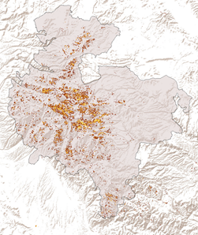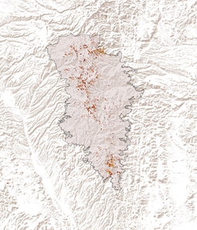

High

Moderate

Low

Burned Areas



*Figure 2.* Magnitude of Gain in NBR (Left: Whitewater-Baldy, Right: Silver)

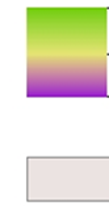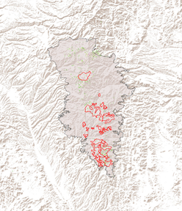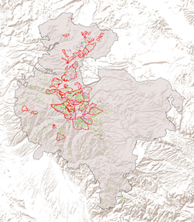

High

Moderate

Low

Burned Areas

Treatment Plots



*Figure 3.* Percent Recovery of NBR (Left: Whitewater-Baldy, Right: Silver)

Further, we examined values of NBR gain and percent recovery in relation to burn severity and land cover type (*Tables 3 and 4*). We chose to exclude areas previously treated by the USFS Gila NF from this analysis in order to reduce the bias created by included treated plots. Within the burned areas of the Whitewater-Baldy fire, the average gain of NBR was 610.5 (SD 102.2) in areas of low burn severity, 634.7 (SD 109.9) in areas of moderate burn severity, and 645.1 (SD 116.1) in areas of high burn severity. Within the burned areas of the Silver fire, the gain of NBR was 592.4 (SD 86.2) in areas of low burn severity, 585.4 (SD 76.6) in areas of moderate burn severity, and 598.2 (SD 83.2) in areas of high burn severity. The average NBR gain was 604.4 (SD 93.8) in forested areas, 643.3 (SD 119.8) in herbaceous area, and 651.8 (SD 128.5) in shrub and scrubland.

Within the burned areas of the Whitewater-Baldy fire, the average recovery was 90.8% (SD 0.09) in areas of low burn severity, 88.5% (SD 0.09) in areas of moderate burn severity, and 77.5% (SD 0.12) in areas of high burn severity. This shows a potential inverse relationship between percent recovery and burn severity within the Whitewater-Baldy fire area. Within the burned areas of the Silver fire, the average recovery was 85.0% (SD 0.10) in areas of low burn severity, 86.5% (SD 0.10) in areas of moderate burn severity, and 84.9% (SD 0.10) in areas of high burn severity. The average recovery was 92.3% (SD 0.07) in forested areas, 82.1% (SD 0.12) in herbaceous area, and 80.0% (SD 0.13) in shrub and scrubland. While we had expected to see a significant difference in percent recovery in regions with different burn severities and land cover types, the differences yielded in our results were not statistically significant. We did not expect the recovery by land cover type to be higher for forested areas than other types, but this result may be because there was more parent material left post-fire than for the other land cover types. This would allow the forest to regenerate more quickly than other land cover types, which may have been the case for vegetation such as shrubs.

Table 3

*Summary Statistics by Fire Severity*

|  |  |  |  |  |  |  |  |  |
| --- | --- | --- | --- | --- | --- | --- | --- | --- |
|  | **Whitewater- Baldy** | | | | **Silver** | | | |
| **Burn Severity** | **Mean NBR Gain** | **Standard Deviation NBR Gain** | **Mean % Recovery** | **Standard Deviation % Recovery** | **Mean NBR Gain** | **Standard Deviation NBR Gain** | **Mean % Recovery** | **Standard Deviation % Recovery** |
| Low | 319.8 | 107.9 | 90.8 % | 0.09 | 302.8 | 95.7 | 85.0% | 0.10 |
| Moderate | 420.7 | 160.5 | 88.5% | 0.09 | 348.9 | 118.9 | 86.5% | 0.10 |
| High | 670.5 | 196.6 | 77.5% | 0.12 | 455.9 | 148.2 | 84.9% | 0.10 |

Table 4

*Summary Statistics by Land Cover Classification*

|  |  |  |  |  |
| --- | --- | --- | --- | --- |
| **Land Cover Class** | **Mean NBR Gain** | **Standard Deviation NBR Gain** | **Mean % Recovery** | **Standard Deviation % Recovery** |
| Forest | 604.4 | 93.8 | 92.3% | 0.07 |
| Shrub/ scrub | 643.3 | 119.8 | 82.1% | 0.12 |
| Herbaceous | 651.8 | 128.5 | 80.0% | 0.13 |

The preliminary analysis using daily and annual mean streamflow and Q7 Max yielded a few insights. The gauge station downstream of the Silver fire (2013) has a gap in data for 2013 and 2014, which are years of significant interest for this study. The data gap prevented the inclusion of this gauge as a source of relevant data. However, the other three gauges were used in the analysis. The mean annual streamflow was calculated and plotted, as shown in Figure 4*.* The plots show an increase in annual mean in 2013 after the Whitewater-Baldy Complex Fire for all three gauges, although a statistically significant correlation has not yet been confirmed by this study. However, a 2016 study of three watersheds in New Mexico, including the Gila watershed, was able to confirm a correlation between significant burn events (one fifth or more of a large watershed burned) and significant increases in water yield (Wine & Cadol, 2016). In our study, the annual mean decreases from 2013 to 2014, but 2014 is not as low as the pre-fire value in any of the gauges, meaning that it may still be affected by a higher streamflow than normal. The y-axis scales for the individual plots do not match each other because the size of the stream affects the magnitude of the streamflow value. This means that any comparisons or assumptions cannot be made upon first glance at the mean annual streamflow plots relative to each other.

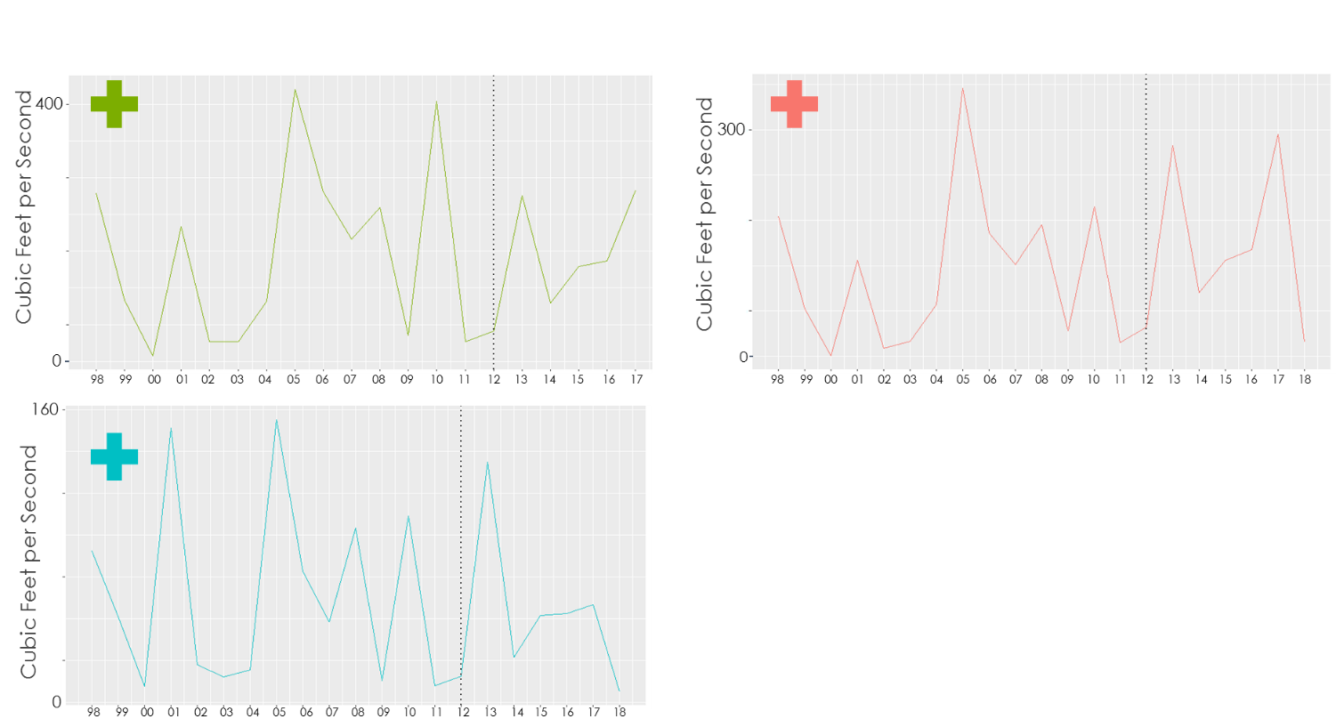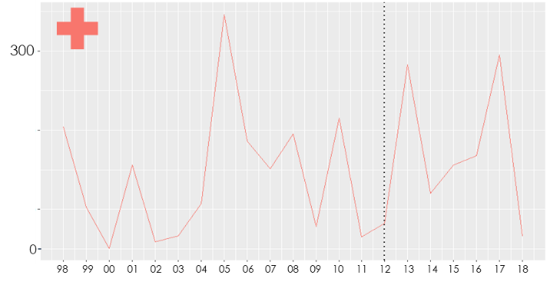

Cubic feet per second

Cubic feet per second

Cubic feet per second

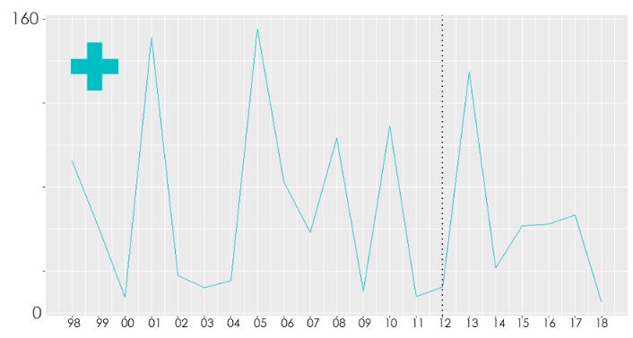

Year

Year

Upstream

Downstream (Both)

Downstream (Whitewater-Baldy)

Whitewater-Baldy Fire Year

Year

*Figure 4.* Mean Annual Streamflow

Upstream

The Q7 Max calculation that was completed in R yields results in two forms. The first is a .csv file, which shows 52 columns representing each week of the water year (October 1 - September 30), and the number of rows is equal to the number of water years for the study. The value within each cell of the .csv file represents the streamflow of that week in mm/day. The second output is a time series plot of the Q7 Max values. These plots, shown in Figure 5*,* tell a slightly different story than the annual mean. The value of Q7 Max increases from 2013 to 2014 instead of decreasing. This shows that the annual mean may not be the temporal resolution we are looking for with this study as it does not necessarily reflect flash flood events in the years post-fire. Annual mean is more susceptible to longer term hydrological impacts such as precipitation anomalies over the course of an entire year. The 2016 study mentioned above also confirmed a positive precipitation anomaly in 2013 following the Whitewater-Baldy Complex Fire, which is reflected in the annual mean plots our study produced (Wine & Cadol, 2016). The Q7 Max is more representative of shorter periods of very high streamflow.

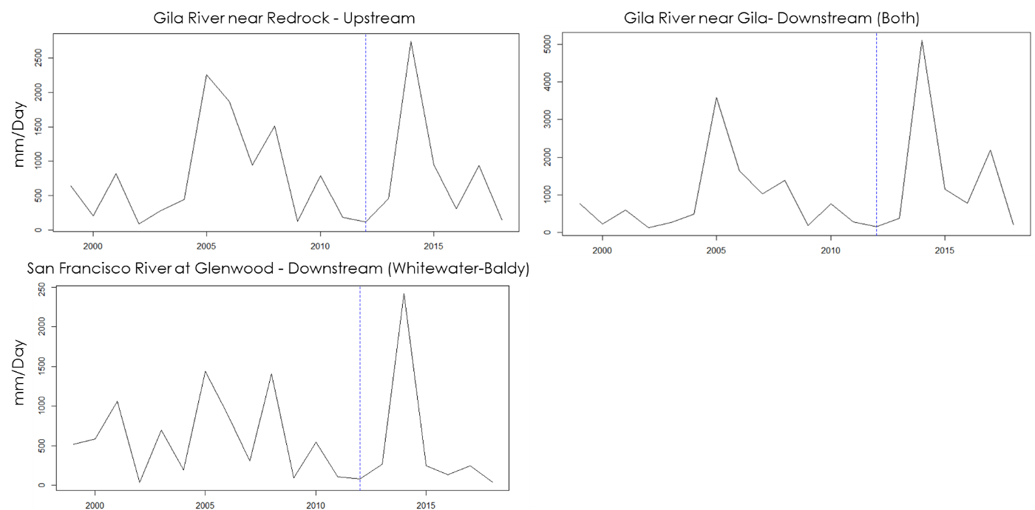

Gila River near Redrock - Upstream

mm/day

Gila River near Gila – Downstream (Both)



mm/day

Year

Year



San Francisco River at Glenwood – Downstream (Whitewater-Baldy)

mm/day

Whitewater-Baldy Fire Year

Year

*Figure 5.* Q7 Max Calculation Results

The current results of the streamflow separation only include the baseflow. The surface flow will need to be separately calculated in future work. The baseflow was calculated for the gauges in this study and plotted with the daily mean streamflow. An example of this result at the gauge downstream from both fires is shown in Figure 6*.* The plot shows that much of the streamflow increase is due to surface flow inputs or that the streams in this area are prone to flashfloods.

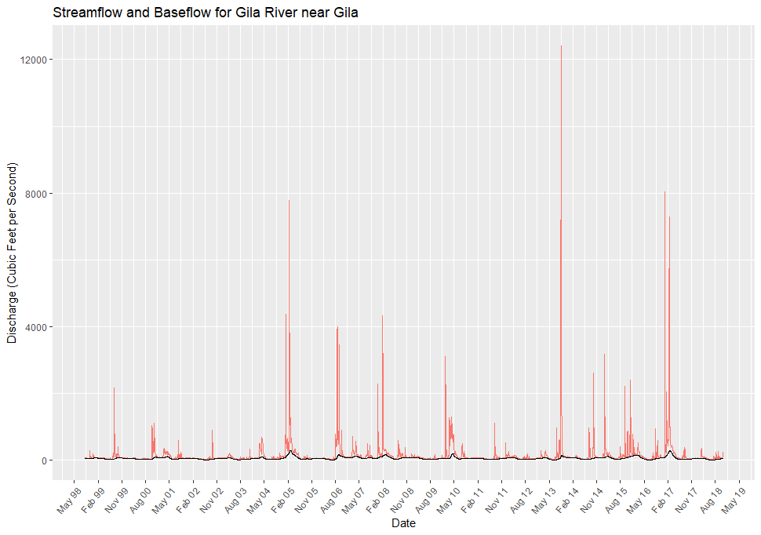

Cubic feet per second

Daily Streamflow

Baseflow

Month and Year

*Figure 6.* Baseflow Calculation and Daily Mean Streamflow

***4.2 Future Work***

While the results of this study yield useful information about appropriate data, data gaps, and methodologies for identifying watershed recovery, additional work is needed to provide a comprehensive recovery assessment and to predict future recovery. Additionally, future studies would help specify not just the spectral aspects of recovery, but also what types of vegetation (native, non-native, invasive) are growing back. Establishing a baseline for recovery to date sets the stage for predicting areas that would benefit the most from restoration efforts. Over the course of this term, we were unable to make conclusions explaining why we did not see significant differences in recovery at different burn severity levels and within different land cover types. Our results may indicate that examining magnitude of NBR Gain may be a better metric to examine recovery. Future work could focus on determining if there are better proxies to use as a metric for recovery in the Gila NF.

One of the limiting factors for analyzing post-fire flooding events and overall watershed recovery was the limited number of stream gauges available. Additional stream gauges within the study site would allow future work to better identify the connection between severe fire events and damaging floods within the watershed. Future work would also benefit from the creation of a hydrological model that includes parameters like precipitation and evapotranspiration. The Q7 Max calculation uses the daily streamflow data to calculate a weekly mean for each year and output the .csv file and Q7 Max plots. Because this calculation was found to better represent flash flood events, weekly mean may be useful in future work to analyze changes in the hydrological processes. A continuation of streamflow separation modeling will be important for future work, along with a deeper analysis of the flashiness of the streams in the Gila NF. These metrics and analyses will allow for further statistical analysis of the correlation between wildfire events and flooding events. From there, inferences can be made about how hydrology impacts recovery in our study area.

# 

# 5. Conclusions

Much of this project was exploratory, with the objective to identify what data and methods are appropriate to study watershed recovery. We determined that NBR is a useful metric for recovery within a watershed, due to the consistency between LandTrendr results and pre-established values of burn severity levels. Our metric for percent recovery would be improved through the use of a different calculation. The magnitude of gain in NBR appears to be a more accurate proxy for recovery. Our results lay the groundwork for further exploration of recovery at the watershed level. Additionally, our project demonstrates that streamflow Q7 Max or weekly mean data could be analyzed and used in the future as an additional metric for watershed recovery. Future work to incorporate environmental parameters, such as precipitation, into hydrological modeling will help provide focus to this metric. Finally, our results indicate the recovery may be higher in areas where managed restoration has already occurred and may be impacted by other environmental parameters. This project provides a foundation for understanding the processes impacting recovery. Work in subsequent terms will expand upon this understanding.

# 

# 6. Acknowledgments

* Dr. John Bolten, NASA Goddard Space Flight Center
* Dr. Sebastian Martinuzzi, University of Wisconsin-Madison
* Dr. Ibrahim Mohammed, Goddard Space Flight Center
* Dr. Raha Hakimdavar, USDA, US Forest Service
* Carolyn Koury, USDA, US Forest Service, Gila National Forest
* Mike Natharius, USDA, US Forest Service, Gila National Forest
* Nessa Natharius, USDA, US Forest Service, Gila National Forest
* Jack Triepke, USDA, US Forest Service, Region 3
* Bart Matthews, USDA, US Forest Service, Region 3
* Anna Jaramillo, USDA, US Forest Service, Region 3

Any opinions, findings, and conclusions or recommendations expressed in this material are those of the author(s) and do not necessarily reflect the views of the National Aeronautics and Space Administration.

This material is based upon work supported by NASA through contract NNL16AA05C

# 7. Glossary

**Disturbance –** A temporary change in environmental conditions that creates a drastic change to a region or ecosystem

**Earth observations** – Satellites and sensors that collect information about the Earth’s physical, chemical, and biological systems over space and time

**HUC 12 Watershed** – A 6th level, local sub-watershed level that captures tributary systems

**LandTrendr –** A set of spectral-temporal segmentation algorithms used to identify change in a time series using Landsat data

**MODIS** – MODerate resolution Imaging Spectroradiometer

**NBR –** Normalized Burn Ratio, A formula using Near Infrared and Shortwave-infrared wavelengths to estimate burn severity

**NDVI –** Normalized Difference Vegetation Index, A formula using Near Infrared and Red wavelengths to estimate vegetation

**Watershed –** A land area that channels precipitation to surface water systems and eventually to outflow points, such as the ocean

# 8. References

Aqua Terra Consultants. (2019). Watershed modeling to evaluate potential impacts of climate and land use change on the hydrology and water quality of major U.S. drainage basins. Retrieved from: https://drive.google.com/file/d/15b5YgxBgQYAESS3HkPm0_5oqVq88QZY1/view

Bond, Nick. (2019). Hydrostats: Hydrologic Indices for Daily Time Series Data. R package version 0.2.7.

<https://cran.r-project.org/web/packages/hydrostats/hydrostats.pdf>

Bright, B. C., Hudak, A. T., Kennedy, R. E., Braaten, J. D., & Khalyani, A. H. (2019). Examining post-fire

vegetation recovery with Landsat time series analysis in three western North American forest types.

*Fire Ecology*, *15*(1), 8. <https://doi.org/10.1186/s42408-018-0021-9>

Cohen, W. B., Yang, Z., & Kennedy, R. (2010). Detecting trends in forest disturbance and recovery using

yearly Landsat time series: 2. TimeSync—Tools for calibration and validation. *Remote Sensing of*

*Environment*, *114*(12), 2911-2924. <https://doi.org/10.1016/j.rse.2010.07.010>

Frazier, R., Coops, N., Wulder, M., Hermosilla, T., & White, J. (2018). Analyzing spatial and temporal variability in short-term rates of post-fire vegetation return from Landsat time series. *Remote Sensing of Environment*. *205*, 32-45. <https://doi.org/10.1016/j.rse.2017.11.007>

Gila National Forest. (2012). Whitewater Baldy Complex Burned Area Emergency Response (BAER) Team executive summary. Silver City, New Mexico. Retrieved from:https://www.fs.usda.gov/Internet/FSE_DOCUMENTS/stelprdb5375619.pdf

Gila National Forest. (2013). Silver Fire Burned Area Emergency Response (BAER) Team Executive Summary. Silver City, New Mexico. Retrieved from: <https://www.fs.usda.gov/detail/gila/landmanagement/resourcemanagement/?cid=stelprdb5374811>

Gitas, I., Mitri, G., Veraverbeke, S., & Polychronaki, A. (2012). Advances in remote sensing of post-fire

vegetation recovery monitoring—a review. *Remote Sensing of Biomass-Principles and Applications*, *1*, 334.

Hallema, D. W., Sun, G., Bladon, K. D., Norman, S. P., Caldwell, P. V., Liu, Y., & McNulty, S. G. (2017).

Regional patterns of postwildfire streamflow response in the Western United States: The importance

of scale‐specific connectivity. *Hydrological Processes*, *31*(14), 2582-2598. <https://doi.org/10.1002/hyp.11208>

Hallema, D. W., Sun, G., Caldwell, P. V., Norman, S. P., Cohen, E. C., Liu, Y., ... & McNulty, S. G. (2018).

Burned forests impact water supplies. *Nature communications*, *9*(1), 1307.

<https://doi.org/10.1038/s41467-018-03735-6>

Kennedy, R. E., Yang, Z., Cohen, W. B., Pfaff, E., Braaten, J., & Nelson, P. (2012). Spatial and temporal

patterns of forest disturbance and regrowth within the area of the Northwest Forest Plan. *Remote*

*Sensing of Environment*, *122*, 117-133. <https://doi.org/10.1016/j.rse.2011.09.024>

Kennedy, R.E., Yang, Z., Gorelick, N., Braaten, J., Cavalcante, L., Cohen, W.B., & Healey, S. (2018). Implementation of the LandTrendr Algorithm on Google Earth Engine. *Remote Sensing.* *10*, 691. <https://doi.org/10.3390/rs10050691>

Kim, S., J. Van Zyl, R. S. Dunbar, E. G. Njoku, J. T. Johnson, M. Moghaddam, & L. Tsang. (2016). SMAP L3 Radar Global Daily 3 km EASE-Grid Soil Moisture, Version 3. NASA National Snow and Ice Data Center Distributed Active Archive Center, Boulder, Colorado USA, accessed 1 Oct 2019. <https://doi.org/10.5067/IGQNPB6183ZX>

NASA Jet Propulsion Laboratory. (2014). SRTM Digital Elevation Data Version 4. Google Earth Engine, accessed July 2019. doi://10.1029/2005RG000183

Potyondy, J. P., & Geier, T. W. (2010). Watershed condition classification technical guide. Retrieved from: <https://www.fs.fed.us/biology/resources/pubs/watershed/maps/watershed_classification_guide2011FS978.pdf>

Roy, D.P., Kovalskyy, V., Zhgang, H.K., Vermote, E.F., Yan, L., Kumar, S.S, & Egorov, A. (2016). Characterization of Landsat-7 to Landsat-8 reflective wavelength and normalized difference vegetation index continuity. *Remote Sensing of Environment. 185*, 57-70. Retrieved from: http://dx.doi.org/10.1016/j.rse.2015.12.024

Soulard, C.E., Albano, C. M., Villarreal, M. L., & Walker, J. J. (2016). Continuous 1985–2012 Landsat monitoring to assess fire effects on meadows in Yosemite National Park, California. *Remote Sensing, 8*, 371. <https://doi.org/10.3390/rs8050371>

Triepke, F., Whalberg, M., Cress, D., & Benton, R. (2014). RMAP: Regional Riparian Mapping Project. *USDA Forest Service technical report*. Southwestern Region, Regional Office, Albuquerque, NM. Retrieved from:https://www.fs.fed.us/r3/gis/gisdata/rmap_project_report_SEPT_2013.pdf

USDA Forest Service. Watershed Condition Framework: A Framework for Assessing and Tracking Changes to Watershed Condition (Report FS-977). Retrieved from <https://www.fs.fed.us/sites/default/files/Watershed_Condition_Framework.pdf>

USDA Forest Service. (n.d.). White-Water Baldy Complex fire information. Retrieved from: https://www.fs.usda.gov/detail/gila/home/?cid=stelprdb5376537

U.S. Geological Survey Earth Resources Observation and Science Center. (2012). Provisional Landsat 5 TM Tier 1 Data Products – Surface Reflectance. Google Earth Engine, accessed 2 Oct 2019. <https://doi.org/10.5066/F7KD1VZ9>

US Geological Survey Earth Resources Observation and Science Center. (2019). Landsat 7 Tier 1 Data Products – Surface Reflectance. Google Earth Engine, accessed 2 Oct 2019. <https://doi.org/10.5066/F7Q52MNK>

US Geological Survey Earth Resources Observation and Science Center. (2019). Landsat 8 OLI/TIRS Tier 1 Data Products – Surface Reflectance. Google Earth Engine, accessed 3 Oct 2019. <https://doi.org/10.5066/F71835S6>

Wine, M. L., & Cadol, D. (2016). Hydrologic effects of large southwestern USA wildfires significantly increase regional water supply: fact or fiction? Environmental Research Letters, 11(8), 085006. <https://doi.org/10.1088/1748-9326/11/8/085006>

# 9. Appendices

***Appendix A: Extended Background***

New Mexico has a history of wildfire disturbances, which impact processes inherently related to ecological functions and human health. Recent wildfires have had drastic impacts on both land use and water quality, particularly within the Gila National Forest (Gila NF) watershed in western New Mexico. The 2012 Whitewater-Baldy Complex Fire was the largest fire recorded in New Mexico’s history, burning 274,784 acres (Gila National Forest, 2012). Another fire, the Silver Fire, occurred in a different region of the Gila NF in 2013. The Silver Fire, which burned a total of 138,698 acres, was highly destructive to private lands, burning 788 acres of private land (Gila National Forest, 2013).

Disturbances like wildfires have become more frequent and severe, and are major forces of land cover change, disrupting natural recovery processes. In turn, disturbances prompt concern over associated impacts, including post-fire flooding, erosion, and debris flow. The relationship between flooding events and fire events are of particular interest to this project and evidence of a relationship has been provided by other recent studies (Wine & Cadol, 2016; Hallema, Dennis, Ge Sun, Peter Caldwell, Steven Norman, Erika Cohen, Yongqiang Liu, Kevin Bladon, Steven McNulty, 2018). The Burned Area Emergency Response (BAER) Team that examined the immediate impact of the Whitewater-Baldy Complex fire predicted that post-fire flows from a 25 year precipitation event could increase 2-4 times in many of the drainage regions impacted by these fires (Gila National Forest 2012).

Fires also impact the ability of the Gila NF to provide essential ecosystem services, such as safe water supply for communities downstream, climate variability moderation, and timber (Soulard, Albano, Villarreal, & Walker, 2016; USDA-FS, 2011; Potyondy & Geier, 2010). Following the Whitewater-Baldy Complex Fire, a number of Outstanding National Resource Waters (ONRW), which are subject to higher than average water quality standards, were negatively impacted by these fires, which reduces water quality for users downstream of wilderness areas like West Fork and Whitewater Creek (Gila National Forest, 2012). Similar impacts to the ecosystem and surrounding communities were detected following the Silver Fire a year later (Gila National Forest, 2013).

Land managers respond quickly to wildfires by employing restoration practices like seeding. However, informed restoration efforts require an understanding of the interrelated processes acting on the landscape (Aqua, n.d.; Potyondy & Geier, 2010). Managing future risk of harmful watershed system impacts necessitates characterization of landscape changes at spatial and temporal scales that capture fire effects (Kennedy, Yang, Cohen, Pfaff, Braaten, & Nelson, 2011). Previous studies demonstrate that satellite data from NASA Earth observations (EO’s) and other sources have a large potential for helping land managers understand the impacts owildfires. For example, vegetation regrowth is often used as a proxy for overall recovery due to the drastic changes immediately visible post-fire (Bright, et al.., 2019; Gila National Forest, 2012; Gila National Forest, 2013). When using satellite imagery, various parameters measuring vegetation can be measured, including greening with Normalized Difference Vegetation Index (NDVI) or other vegetation indices, land cover classification, and fractional vegetation cover (Gitas, et al, 2012). These data can be used to generate a picture of recovery across a larger landscape than ground surveys alone.

Additionally, institutions like Oregon State University have demonstrated the ability to analyze post-fire vegetation recovery in temperate forest areas by operationalizing tools to recognize spectral change in Landsat time-series stacks (Bright, et al., 2019; Kennedy, et al., 2012; Kennedy, et al., 2010). In conjunction with the use of satellite imagery to understand changes in vegetation, methods to understand the impact of wildfires on hydrological functions will also improve our understanding of recovery in the Gila across the watershed. In recent years, the frequency of flood following fire events have motivated hydrological studies (Sun, et al., 2018; Wine & Cadol, 2016; Hallema, et al., 2018). While studies clearly reveal increased streamflow following fire events at the subwatershed scale, there is little research to support hydrological models as a metric for assessing watershed recovery at broader scales (Wine and Cadol, 2016).

This project served as an exploratory study to identify appropriate data and methodologies to support future land management decision-making in our study area (Figure 1) through the examination of vegetation regrowth as a proxy for recovery and hydrological processes. Our team examined methodologies for utilizing satellite data from Landsat 5 Thematic Mapper (TM), Landsat 7 Enhanced Thematic Mapper Plus (ETM+), and Landsat 8 Operational Land Imager (OLI) to identify recovery across the Gila NF watershed using NBR as a proxy for vegetation regrowth. Additionally, we examined stream data from USGS stream gauges to provide preliminary analyses of the impact of the 2012 and 2013 wildfires on hydrological processes in the Gila NF. Finally, we laid the groundwork for a model-ready spatial database that can be used as a framework for understanding the correlations between various environmental features and watershed recovery.

There are many ways to use satellite-based sensors to characterize landscape change (Kennedy et al., 2010). The primary research question is what methods are most appropriate for assessing landscape recovery, or restoration of watershed functioning prior to disturbance. The watershed recovery phenomena in Gila NF can be mapped using satellite-based sensors that excel at characterizing landscape change. Short and medium-term recovery trends were represented by a vetted proxy for land cover condition, Normalized Burn Ratio (NBR). We also explored streamflow to assess landscape change and a method for building a spatial database to relationships between landscape features and recovery.

Resultant recovery maps can be used to identify recovery trends at the forest or HUC12 subwatershed level (Figure 1). With these results, inferences may be made about which areas would benefit from seeding, mulching, and other restoration efforts. Additionally, understanding which factors significantly impact watershed recovery will allow managers to proactively plan mitigation efforts.

The end users of this project’s products are the USFS Gila National Forest (Gila NF) and USFS Region 3. The Gila NF and Region 3 have actively managed and monitored regional disturbances with practices that include survey, inventory, and observation of environmental correlations. One such observed correlation is a temporal relationship between wildfires and flash floods. Our partners at The Gila NF have made observations that one to two years after fire events, severe flooding and debris flows occur in the area.

While the United States Department of Agriculture- Forest Service (USDA-FS) Region 3 and Gila NF (*Figure 1)* have robust data representing wildfire events and innovative tools to monitor related impacts, such as flooding, researchers suggest that many of the methods for analyzing recovery often produce erratic results (Soulard et al., 2016). One explanation is that many current tools and methods have difficulty accurately analyzing fine temporal or spatial resolutions and greater difficulty scaling up to a watershed scale. Some researchers suggest that specific land cover types can make data acquisition, interpretation, and analysis more difficult (Soulard et al., 2016). The USDA-FS currently has a wealth of information about post-fire impacts through on-the-ground surveys. With the advent of the Monitoring Trends in Burn Severity (MTBS) program, mapping methods have evolved. There are many precedents for less costly and more time-effective ecosystem evaluation after fire events. Accessibility of high spatial and spectral resolution imagery and advanced image analysis techniques make satellite remote sensing essential for tracking landscape change (Gitas, Ioannis, Mitri, G., Veraverbeke, S., Polychronaki, A., 2012).

There are several programs to assess immediate hydrology and soil impacts following wildfires, such as Burned Area Emergency Response (BAER) and Rapid Assessment of Vegetation Condition after Wildfire (RAVG). Gila NF and Region 3 have used Landsat data and other datasets provided by United States Geological Survey (USGS) to assess hydrological impact. However, condition assessments and management decision practices currently rely on local knowledge, ground surveys, and some *in situ* restoration monitoring and data collection. Presently, few studies evaluate post-fire landscape recovery or impacts of recovery trends on other ecosystem processes in the Gila NF (Aqua, n.d.), and there are few operational tools in place to look at long-to-medium term (5 to 20 year increments) recovery of watershed processes. This project seeks to improve Gila NF’s ability to make long-to-medium term management decisions at the watershed scale via improved recovery maps and a model-ready-database to explore the relationships between physical environmental features and watershed recovery.

***Appendix B: Fishnet Schema***





