NASA DEVELOP National Program
NASA Marshall Space Flight Center
Summer 2016

Short Title: Chaco Canyon Cross-Cutting
Subtitle: Utilizing NASA Earth Observations to Identify Chacoan Community Signature Profiles throughout the Chaco Canyon to Assist Preservation and Protection Strategies
VPS Title: Can you Dig it?: Identifying and Protecting Ancient Chacoan Ruins

Project Team & Partners
Project Team:
Kelsey Herndon (Project Lead), kelseyeherndon@gmail.com
Dashiell Cruz
Sydney Neeley
Ryan Schick

Advisors & Mentors:
Dr. Jeffrey Luvall (NASA at National Space Science Technology Center)
Dr. Robert Griffin (University of Alabama in Huntsville)
Dr. Tom Sever (University of Alabama in Huntsville)

Partner Organizations:
Organization | POC (Name, Position/Title) | Partner Type | Boundary Org?
National Park Service, Intermountain Region Cultural Resources Department | Tom Lincoln, Intermountain Region Assistant Regional Director for Cultural Resources | End-User | No
Binghamton University | Dr. Ruth Van Dyke, Professor | End-User | No
University of Nebraska-Lincoln | Dr. Carrie Heitman, Assistant Professor | End-User | No
University of Colorado Boulder | Dr. Steve Lekson, Curator of Anthropology | End-User | No

Project Details
Applied Sciences National Application Addressed: Cross-Cutting
Study Area: San Juan Basin, NM and CO
Study Period: Jan 2014 - Jun 2016

Earth Observations & Parameters:
Landsat 8, Operational Land Imager (OLI) – surface reflectance
Shuttle Radar Topography Mission (SRTM) Version 2 – Digital Elevation Model (DEM)
Terra, Advanced Spaceborne Thermal Emission and Reflectance Radiometer (ASTER) – Global Emissivity Dataset (GED), Surface Radiance Thermal Infra-Red (TIR) dataset, and surface kinetic temperature dataset

Ancillary Datasets Utilized:
- University of Nebraska-Lincoln in situ data – known locations of Chaco roads and houses
- OpenStreetMap – global data set of roads
- Landscape Fire and Resource Management Planning Tools Program (LANDFIRE) land cover data – existing vegetation type and pre-European vegetation type
- NASA Socioeconomic Data and Applications Center (SEDAC) Gridded Population of the World (GPW) version 3 – population density
- San Juan County data – in situ locations of past and current oil and gas drills in New Mexico
- Colorado Department of Natural Resources data – in situ locations of past and current oil and gas drills
- USGS National Hydrography Dataset – location of water bodies and streams
- USDA National Agriculture Imagery Program (NAIP) – aerial imagery for visual identification of Chaco sites and roads
- Thermal Infrared Multispectral Scanner (TIMS) – identification of Chaco sites and roads
- Hyperspectral Thermal Emission Spectrometer (HyTES) – identification of Chaco sites and roads

Models Utilized:
- Princeton University Maximum Entropy (MaxEnt) Model

Software Utilized:
- ArcGIS 10.3 – Raster manipulation/analysis, image enhancement, and map creation of Landsat 8 OLI, Terra ASTER, and SRTM-v2 C-band
- ENVI 5.3 – Raster manipulation/analysis and image enhancement of Landsat 8 OLI and Terra ASTER data.
- Python 2.7 – Raster manipulation/analysis and image enhancement of Landsat 8 OLI, Terra ASTER, and SRTM-v2 C-band

Project Overview
80-100 Word Objectives Overview:
Monumental ruins, constructed by the Chacoan community between 850 and 1150 AD, are at risk from encroaching development in the San Juan Basin, which encompasses portions of New Mexico and Colorado. In an effort to prevent the looting and destruction of ancient Chacoan heritage, the Chaco Canyon Cross-Cutting Project partnered with the National Park Service (NPS), Binghamton University, the University of Nebraska-Lincoln, and the University of Colorado Boulder to identify highly probable locations of unknown Chacoan sites, to determine which areas are most vulnerable to infrastructure development, and to identify the spectral signatures of these ancient communities.

Abstract:
The Chacoan people flourished in northwest New Mexico between 850 and 1150 AD. Today, remnants of their monumental architecture draw over 40,000 visitors a year to Chaco Canyon National Park to experience the natural grandeur of the area and to learn about Native American history throughout the San Juan Basin. However, many Chacoan roads and communities are located outside the boundaries of the National Park. These unprotected sites are threatened by encroaching infrastructure associated with resource extraction, such as drill pads with requisite access roads and pipelines. Currently, the National Park Service (NPS), Binghamton University, the University of Nebraska-Lincoln, and the University of Colorado Boulder rely on expensive and time-consuming ground surveys, imagery from Google Earth, and the Landsat series to identify the extent of Chacoan roads and houses. This project utilized Landsat 8 Operational Land Imager (OLI) surface reflectance, Shuttle Radar Topography Mission Version 2 (SRTM-v2) digital elevation models (DEMs), Terra Advanced Spaceborne Thermal Emission and Reflectance Radiometer (ASTER) emissivity data, Thermal Infrared Multispectral Scanner (TIMS)data, Hyperspectral Thermal Emission Spectrometer (HyTES) data, Sentinel-1 Synthetic Aperture Radar (SAR) data, and Sentinel-2 MultiSpectral Instrument (MSI) data to identify highly probable locations of unknown Chacoan sites, to determine sites at risk from infrastructure development, and to identify the spectral signatures of these ancient communities. Documenting Chacoan community signature profiles and determining which areas are at risk of being affected by encroaching development will help the project partners to better understand the Chacoan landscape, as well as to better protect and preserve these ancient sites.

Keywords:
Satellite archaeology, San Juan Basin, Terra ASTER, Landsat 8 OLI, SRTM v2 C-band, MaxEnt, spectral signatures

Community Concerns:
- Dozens of Chacoan communities and roads exist outside of the Chaco Canyon National Park protected boundaries.
- Chaco Canyon archeological sites are threatened by encroaching development from population growth and oil and gas exploration.

Current Management Practices & Policies:
Currently, the National Park Service (NPS), Binghamton University, University of Nebraska-Lincoln, and University of Colorado Boulder mainly rely on expensive and time-consuming ground surveys to identify Chacoan roads and houses. The project partners also use imagery from Google Earth and the Landsat series to find Chacoan roads and communities.

Decision Support Tools & Benefits:
End-Product | Earth Observations Used | Benefit & Impact | Software  Release
Chacoan Sites Suitability Map | Landsat 8 OLI, SRTM-v2 C-band, Terra ASTER | This map shows which areas of the San Juan Basin have the highest probability of containing Chaco sites based on ecological modeling. Our project partners can use this map to direct exploration of new archaeological sites. | N/A
Chacoan Sites Risk Map | Landsat 8 OLI, SRTM-v2 C-band, Terra ASTER | This map shows areas within the San Juan Basin that are at risk of being affected by resource extraction and encroaching infrastructure. This will be used by the project partners to know where preservation efforts should be focused. | N/A

Project VPS/Booklet Imagery
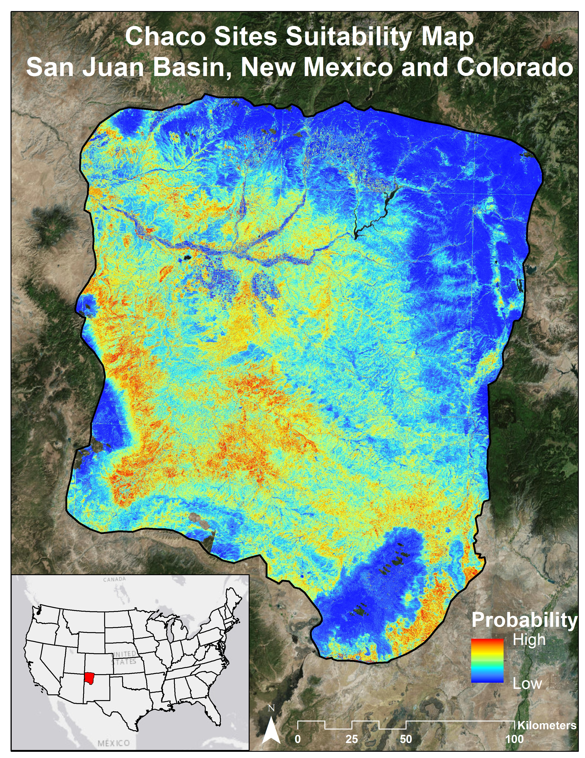
Caption: This map illustrates results from the Chaco sites habitat suitability model. Inputs included NDVI, slope, aspect, elevation, land cover, pre-European land cover, and Terra ASTER GED. Image Credit: Chaco Canyon Cross-Cutting Team.
Image: 2016Sum_MSFC_ChacoCanyonCross-Cutting_VPSimage.jpg

