**NASA DEVELOP National Program**

****NASA Langley Research Center

**Fall 2016**

**Short Title: Everglades Ecological Forecasting II**

**Subtitle:** Utilizing NASA Earth Observations to Enhance the Capabilities of Everglades National Park to Monitor and Predict Mangrove Extent to Aid Current Restoration Efforts

**VPS Title:** Fixing the Root of the Issue: Mangrove Mapping in the Florida Everglades

**Project Team & Partners**

**Project Team:**

Donnie Kirk (Project Lead), donnie.kirk@nasa.gov

Adama Ba

Amy Wolfe

Tyler Rhodes

**Advisors & Mentors:**

Dr. Kenton Ross (NASA Langley Research Center)

Dr. Marguerite Madden (University of Georgia)

Dr. Sergio Bernardes (University of Georgia)

**Past or Other Contributors:**

Caitlin Toner

Rachel Cabosky

Emily Gotschalk

Brad Gregory

Candace Kendall

**Partner Organizations:**

|  |  |  |  |
| --- | --- | --- | --- |
| **Organization** | **POC (Name, Position/Title)** | **Partner Type** | **Boundary Org?** |
| National Park Service, Everglades National Park (ENP) | Jed Redwine, Ecologist, South Florida Natural Resources Center | End-User | No |
| Group on Earth Observations (GEO), Blue Planet Initiative (BPI) | Dr. Hans-Peter Plag | End-User | Yes |
| Old Dominion University, Mitigation and Adaptation Research Institute (MARI) | Dr. Hans-Peter Plag | Collaborator | No |

**Project Details**

**Applied Sciences National Applications Addressed:** Ecological Forecasting

**Study Area:** Everglades National Park, FL

**Study Period:** 1995 to 2015 (Dry season, January 1 to May 30); Forecasting to 2030

**Earth Observations & Parameters:**

Landsat 5, Thematic Mapper (TM) – land cover

Landsat 7, Enhanced Thematic Mapper Plus (ETM+) – land cover

Landsat 8, Operational Land Imager (OLI) – land cover

Sentinel-2 MultiSpectral Instrument (MSI) – land cover

**Ancillary Datasets Utilized:**

* USGS National Land Cover Dataset (NLCD) – land cover
* NOAA Coastal Change Analysis Program (C-CAP) – regional land cover
* USGS National GAP Analysis Program (GAP) – land cover
* Detailed Vegetation Map from the National Park Service – ground reference

**Models Utilized**:

* TerrSet Land Change Modeler (LCM)

**Software Utilized:**

* Google Earth Engine API – land classification of Landsat imagery
* ESRI ArcGIS – creating sampling boundary shapefile

**Project Overview**

**80-100 Word Objectives Overview:**

This project conducted a spatial analysis using NASA Earth observations and Google Earth Engine API to create a replicable methodology that mapped mangrove forest extent in Everglades National Park. Successful completion of the cloud removal process for satellite images was enhanced to produce a more accurate classification process. The goal of this project was to map the rate of vegetation change on a five year interval scale from 1995 through 2015. This timeline produced a baseline to forecast changes in the mangrove extent to the year 2030. From this, targeted information could be determined to enhance sustainable mitigation practices of water resources throughout the park.

**Abstract:**

Mangroves act as a transition zone between fresh and salt water habitats by filtering and indicating salinity levels along the coast of the Florida Everglades. However, dredging and canals built in the early 1900s depleted the Everglades of much of its freshwater resources. In an attempt to assist in maintaining the health of threatened habitats, efforts have been made within Everglades National Park to rebalance the ecosystem and adhere to sustainably managing mangrove forests. The Everglades Ecological Forecasting II team utilized Google Earth Engine API and satellite imagery from Landsat 5, 7, and 8 to continuously create land-change maps over a 25 year period, and to allow park officials to continue producing maps in the future. In order to make the process replicable for project partners at Everglades National Park, the team was able to conduct a supervised classification approach to display mangrove regions in 1995, 2000, 2005, 2010 and 2015. As freshwater was depleted, mangroves encroached further inland and freshwater marshes declined The current extent map, along with transition maps helped create forecasting models that show mangrove encroachment further inland in the year 2030 as well. This project highlights the changes to the Everglade habitats in relation to a changing climate and hydrological changes throughout the park.

**Keywords:**

Remote Sensing, Google Earth Engine API, JavaScript, Landsat, Coastal Ecosystem, Mangroves

**Community Concerns:**

* Mangrove forests are one of the world’s most threatened ecosystems.
* Mangroves serve many niche functions that the region depends on, including the indication of salinity levels, providing habitat for diverse wildlife, and stabilizing shorelines.
* The health and extent of mangroves is declining due to a changing environment, pollution, and human impact on the land.
* Coastal areas have historically been difficult to monitor given their limited accessibility and likelihood for abrupt change when compared to their terrestrial counterparts.
* The National Park Service (NPS) would like updated maps to aid in regional decision making.

**Current Management Practices & Policies**:

The Comprehensive Everglades Restoration Plan (CERP) was enacted by Congress in 2000 in an attempt to restore the Everglades ecosystem. The project is expected to take 30 years to complete. This plan includes creating surface water storage reservoirs, improving water deliveries to estuaries, and removing levees and canals that block sheet flow. Many of the management practices and policies performed at Everglades National Park focus on variables that influence mangrove forests. Park personnel monitor how fires are concentrated due the effects of fire on the regrowth of mangrove forests. Researchers also obtain soil and water salinity field measurements throughout the park because the transition from saltwater to freshwater strongly influences both the density and size of mangrove forests. Everglades National Park has also re-routed water from reservoirs to regulate habitats within the park. As many areas within the park are inaccessible, the personnel at Everglades National Park utilize mangrove extent maps in their decision making for re-routing water. The mangrove extent map currently being used by park officials to make these decisions was last updated in 2000, but current projects are focusing on obtaining in-situ data for better vegetation mapping in the future.

**Decision Support Tools & Benefits:**

|  |  |  |  |
| --- | --- | --- | --- |
| **End-Product** | **Benefit & Impact** | **Earth Observations Used** | **Software**  **Release** |
| Current Mangrove Extent Map | The partner will use this to help better understand the extent of the mangroves and identify areas that require better monitoring practices | Landsat 5, 7, and 8 and Sentinel-2a will be used to create the maps | III |
| Mangrove Extent Change Maps | The partner will use this to help assess areas where mangrove forests have been declining | Dr. Madden’s Everglades Map (1999); Global maps of Mangrove (ESRI, 2011) and Current Mangrove Extent Map | N/A |
| Mangrove Forecasting Maps | The partner will use this to help plan mangrove protection policies | Dr. Madden’s Everglades Map (1999); Global maps of Mangrove (ESRI, 2011) and Current Mangrove Extent Map | N/A |
| Tutorial | The partner will use the methodologies developed during the project to apply to other study areas | Google Earth Engine API in conjunction with Landsat 5, 7, and 8 | N/A |

**Project VPS/Booklet Imagery**

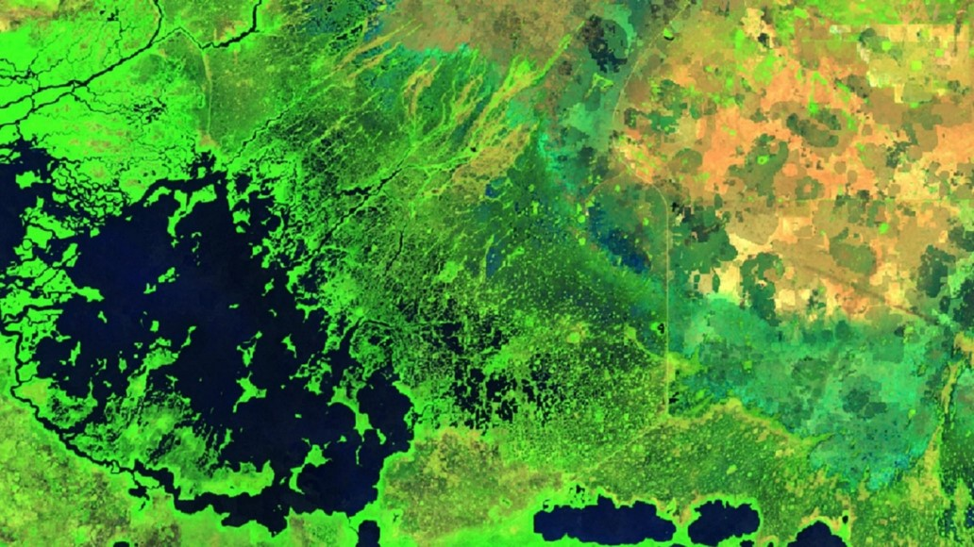

**Caption:** Landsat 8 OLI processed with a Cloud Removal Function of Mask algorithm with bands 6, 5, and 4 illustrating a false color composite for the year 2016. Image Credit: Everglades Ecological Forecasting II Team.

**Image:** 2016Fall_LaRC_EvergladesEcoII_VPSImage.jpg