California Agriculture
Using Earth Observations to Estimate the Age and Carbon Stock of Perennial Agriculture


Technical Report
Final – March 31st, 2022

Rachael Ross (Project Lead)
Alex Posen
Shreya Suri
Stefanie Mendoza

Advisors:
Juan Torres-Pérez, NASA Ames Research Center (Science Advisor)

1. Abstract
California seeks to become a carbon neutral state by 2045. To track progress toward this goal, it is important to quantify the amount of carbon stored by various landcover types across the state. Vineyards and orchards make up a large portion of California's agricultural landcover and store considerable amounts of carbon. For this project, NASA DEVELOP partnered with the California Air Resources Board to estimate the age and carbon stock of crop-specific agricultural regions across California between 1984 and 2021. The DEVELOP team created the Perennial Agriculture Age and Carbon Estimation Tool (PAACET), a Google Earth Engine tool that employs Earth observation from the Landsat 5 Thematic Mapper (TM), Landsat 7 Enhanced Thematic Mapper Plus (ETM+), and Landsat 8 Operational Land Imager (OLI) to estimate the age and carbon stock of vineyards and almond, walnut, pistachio, and orange orchards. The team used an ocular sampling accuracy assessment consisting of 53 sample vineyards and orchards and found that on average, PAACET estimated ages within ±4.3 years of their actual age. The tool estimated that vineyards and walnut orchards are the oldest woody croplands, and almond orchards store the largest total carbon.

Key Terms
remote sensing, Google Earth Engine, biomass, carbon stock, orchards, vineyards, Landsat

2. Introduction
2.1 Background Information
California’s natural and working lands represent most of the state’s land cover and provide a range of environmental, human health, social, and economic benefits. These areas—which include forests, grasslands, shrublands, woodlands, rangelands, farmlands, wetlands, and greenspaces within urban and constructed environments—also represent a key component of California’s climate mitigation strategy. Due to the complexity of organism interactions and various stressors amongst ecosystems, these lands often are the first to experience climate-induced disturbances. It is apparent that California’s natural and working lands have been deteriorating over time as a result of extreme events exacerbated by climate change such as wildfires and drought (CARB, 2019). The release of carbon from these events currently makes the natural and working lands a net source of greenhouse gas emissions (CARB, 2019).
To meet California’s 2045 carbon neutrality goal, efforts to convert these lands into resilient carbon sinks have been outlined in the state’s 2030 Natural and Working Lands Climate Change Implementation Plan. Within the plan, cropland is identified as a land category of interest for greater carbon storage. Specifically, perennial biomass in orchards and vineyards have the greatest carbon sequestration potential in the agricultural sector (CARB, 2018). Unlike herbaceous crops, these woody crops are not regularly harvested, and are thus capable of storing more carbon (CARB, 2018). However, current methods to estimate cropland biomass—and, consequently, carbon stock—are still lacking. Because age is strongly correlated with biophysical characteristics such as height, diameter, and root structure (Baddeley & Watson, 2005; Zhang et al., 2014), accurate estimation of tree crop age is necessary for accurate cropland carbon stock estimates. In situ sampling techniques are a prevalent approach for tree age estimation, but this approach can be time consuming, costly, and limited in sample size (Rozas, 2003). Empirical models are also utilized for tree age estimation, but this approach requires input data for age-related biophysical characteristics, which are also limited in sample size (Zhang et al., 2014).
Recent advances in remote sensing offer new approaches for estimating tree crop age that are spatially explicit, cost effective, and continuous. In this project, our team adapted the methodology proposed by Chen et al. (2019) for automatic mapping of tree planting year with Landsat time series stacks. Using Landsat 5 Thematic Mapper (TM), Landsat 7 Enhanced Thematic Mapper Plus (ETM+), and Landsat 8 Operational Land Imager (OLI) data from 1984 to 2021, our team estimated and mapped age and carbon stock for vineyards and almond, walnut, pistachio, and orange orchards across agricultural regions of California (Figure 1). These five woody crop types represent the most prevalent perennial crops in California, making up approximately 84% (2.6 million acres) of California’s perennial croplands (CARB, 2018). Grapes and almonds represent the most common perennial crops in California, each occupying approximately 30% of the state’s total perennial cropland area (CARB, 2018). Walnuts, pistachios, and oranges occupy 11%, 7%, and 6% of total perennial cropland area, respectively, while the remaining 16% consists of 44 other perennial crops (CARB, 2018).
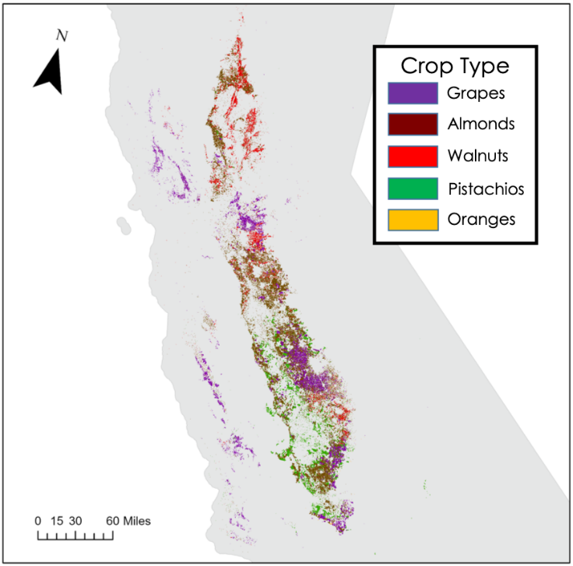
Basemap: Esri, DeLorme, HERE, MapmyIndia

Figure 1. Map of the study area including vineyards and almond, walnut, pistachio, and orange orchards across California according to the 2021 USDA-NASS 2 Cropland Data Layer.
2.2 Project Partners & Objectives
For this project, our DEVELOP team partnered with the California Air Resources Board (CARB). As California’s climate change planning agency, CARB sets emissions standards, ecosystem carbon targets, and desired sequestration rates to meet climate goals. To track progress towards California's 2045 carbon neutrality goal, CARB developed the Natural and Working Lands (NWL) Inventory, which quantitatively estimates the amount of carbon contained within the state’s land base. CARB is particularly interested in improving the carbon stock estimation workflow for orchards and vineyards in California. CARB developed the Diameter Estimated Method for Even-aged Trees Examined Remotely (DEMETER) tool to estimate orchard and vineyard age, tree height, tree density, and carbon stock, but this tool requires numerous data sources, relies on significant user input, and is not easily updated (CARB, 2018). In partnership with CARB, we built a software tool called Perennial Agriculture Age and Carbon Estimation Tool (PAACET) that incorporates annually updated data to estimate crop age and carbon stock for California’s orchards and vineyards on an ongoing basis.

3. Methodology
3.1 Data Acquisition
We used the Google Earth Engine (GEE) data catalog to access tier 1 surface reflectance data from the Landsat 5 TM, Landsat 7 ETM+, and Landsat 8 OLI, as well as National Agriculture Imagery Program (NAIP) imagery. Additionally, we utilized agricultural land use data from the Cropland Data Layer (CDL) published by the United States Department of Agriculture (USDA). The USDA National Agricultural Statistics Service (NASS) CDL is a raster format, geo-referenced, crop-specific land cover data layer with a ground resolution of 30 m (USDA-NASS, 2021). The CDL is produced using satellite imagery from the Landsat 8 OLI and Thermal Infrared Sensor (TIRS), the Indian Space Research Organization (ISRO) ResourceSat-2 Linear Imaging Self-Scanning Sensor-3 (LISS-3), and the European Space Agency Sentinel-2 MultiSpectral Instrument (MSI) collected during the agricultural growing season.

3.2 Data Processing
3.2.1 Satellite Data Processing
After gathering Landsat data, we performed cloud masking to remove individual pixels with cloud contamination and low image quality. The team calculated the Normalized Difference Vegetation Index (NDVI) for all Landsat images using Equation 1 (Lillesand et al., 2015). For each year from 1984 to 2021, we created a maximum NDVI composite image where each pixel is represented by its maximum NDVI value reported during that year. Maximum NDVI corresponds to peak plant heath during the growing season, when crops are in full bloom. The resulting 38 images were combined in an image collection.

$$\begin{aligned}\text{NDVI} \text{=} \frac{\text{NIR – Red}}{\text{NIR + Red}}\#1\end{aligned}$$

3.2.2 Cropland age estimation
To derive cropland age, we estimated planting year using a Z-score methodology to detect changes in annual NDVI values associated with orchard dynamics before and after planting events. This statistical approach analyzes the temporal changes in the maximum NDVI composites and detects lower NDVI values as large deviations from yearly mean NDVI values. Low NDVI values correspond to the occurrence of a planting year, when soil is bare (Chen et al., 2019).

We calculated the Z-score for each pixel in the annual maximum NDVI image collection using Equation 2, where z_{i} represents the Z score for any given year, x_{i} represents the max NDVI value for any given year, and µ and σ represent the mean and standard deviation, respectively, from the max NDVI image collection (Chen et al., 2019). Z-score values range from –3 standard deviations to +3 standard deviations from the mean. We identified pixels with maximum NDVI values that deviate two standard deviations from the yearly mean values. For each year, pixels with a Z-score less than or equal to –2 were designated as planted in that year, and pixels with undetected planting years were masked. In instances where a pixel was assigned several planting years, the most recent year was selected to remove false detections (Chen et al., 2019). The resulting raster contained the estimated planting year for each orchard and vineyard pixel. The team calculated cropland ages by subtracting the planting year estimates from the last year of the study period, 2021. We overlaid this age raster with the 2021 USDA-NASS CDL to identify ages of the five woody crop types in this study: grape vineyards and almond, walnut, pistachio, and orange orchards.

$$\begin{aligned}{\text{z}}_{\text{i}} \text{=} \frac{{\text{x}}_{\text{i} }\text{-μ}}{\text{σ}}\#2\end{aligned}$$

3.2.3 Carbon stock estimation
In GEE, we used the orchard pixel age estimates as inputs in the allometric equations developed by CARB (2017) to obtain carbon stock estimates for almond, walnut, pistachio, and orange orchards. The equations were developed using ground-based and aerial imagery techniques to estimate tree biomass using orchard age (CARB, 2017). The structure of CARB’s allometric equations is outlined in Equation 3 below, with coefficients for each crop-specific equation listed in Table 1. The biomass estimate in kilograms for a given tree age (${\hat{\text{B}}}_{\text{age}}$) can be calculated using the following input variables: y is the age of the tree, X_{age} is a random number from a normal distribution with a mean of 0 and a standard deviation of 1, and SE_{age} is the standard error of the age (CARB, 2017). Because CARB’s allometric equations have units of kg C/ha, we multiplied Equation 3 outputs by 0.09 to obtain carbon stock estimates per 30m x 30m pixel.

$$\begin{aligned}{\hat{\text{B}}}_{\text{age}} \text{=} {\text{b}}_{\text{0}}{\text{y}}^{{\text{b}}_{\text{1}}} \text{+} {\text{X}}_{\text{age}}\text{S}{\text{E}}_{\text{age}}\#3\end{aligned}$$

Table 1
The coefficients and standard error by orchard type for Equation 3.

Crop Type | b₀ | b₁ | SE_{age}
Almond | 13.72 | 1.38 | 0.048
Walnut | 12.56 | 1.49 | 0.058
Pistachio | 2.81 | 1.74 | 0.067
Orange | 2.52 | 1.37 | 0.046

We did not use an allometric equation for vineyards because there isn’t one suitable for relating carbon stock to age of this crop type (CARB, 2017). Instead, we used a non-age specific carbon density value of 10.0 Mg C/ha (Equation 4; Morandé et al., 2017). This meant that all 30m x 30m pixels of the USDA-NASS CDL vineyard layer were reclassified in ArcGIS Pro to have a carbon stock value of 900 kg.

$$\begin{aligned}\text{Vineyard} \text{carbon} \left(\text{kg}\right) \text{=} \left(\text{area}\right)\text{ × 1kg}\text{/}{\text{m}}^{\text{2}}\#4\end{aligned}$$

3.3 Data Analysis
3.3.1 Ocular Accuracy Assessment
To assess the accuracy of crop age estimates, we conducted ocular sampling to determine the actual planting year. Using high resolution NAIP images, we visually determined the year when each orchard polygon was planted (Figure 2). Although NAIP imagery is only available starting in 2003, it has a ground resolution of 1 m, allowing us to clearly distinguish the year when crops were first planted. We sampled 52 orchard and vineyard plot boundaries from the USDA-NASS CDL. Orchards and vineyards were selected only if there was NAIP imagery for every year starting in 2003. In GEE, we created nine polygons each for walnut, pistachio, grape, and orange orchards and 16 polygons for almond orchards. We sampled more almond orchards compared to the other crop types because there were more almond orchards with a complete collection of NAIP imagery. For each polygon, we used zonal statistics in ArcGIS Pro to calculate the mean PAACET-estimated age of all pixels within the polygon. We calculated the difference between the mean estimated age and the actual age we visually determined for each polygon. This difference represents the error that occurred in each polygon. To report total error, we took the mean of the error calculated for all 52 polygons.

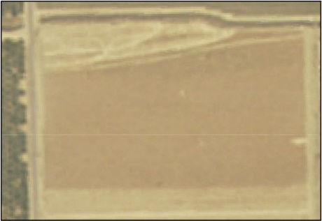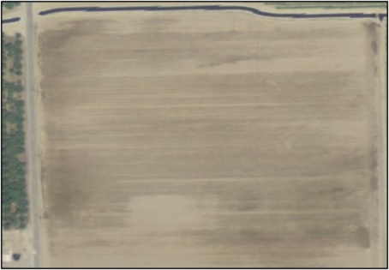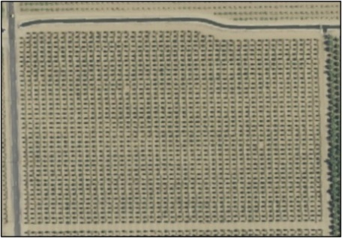
Figure 2. NAIP images from different years were used to visually determine the age of this almond orchard. From left to right, shown here are example images from 2003, 2013, and 2016. The planting year was determined to be 2016 after visually comparing the images for each year starting in 2003.

4. Results & Discussion
4.1 Analysis of Age and Carbon Stock Results
Our team estimated the age and carbon stock of vineyards and almond, walnut, pistachio, and orange orchards of California in 2021 at the pixel level. Figure 3 shows a detailed map of the five study crops across California. Areas of singular and mixed crop types can be seen in the regions near Modesto (top right) and Fresno (bottom right). Table 2 shows the total area by crop type calculated in ArcGIS Pro from the 2021 USDA-NASS CDL. Almonds make up the largest area of California cropland, comprising roughly 750,000 hectares. The total area covered by almond orchards makes up nearly the same amount of land as the other four crop types combined.

Despite homogenous regions in crop type, such as the almond orchards near Modesto and vineyards near Fresno, we were able to detect granular variations in ages. The map in Figure 4 shows the variation in ages, 37 years at the oldest, across the five crop types in California, and it depicts the mosaic of ages in regions of largely almond orchards and vineyards near Modesto (top right) and Fresno (bottom right). The age values at the pixel level were used to estimate the carbon stock of the five crop types across California (Figure 5). Carbon stock values for orchard and vineyard pixels range from 42.4 kg/m² to 13,812.3 kg/m². Comparing the maps in Figures 4 and 5, it is evident that older croplands store greater carbon. Despite variation in ages among vineyard pixels as seen in the bottom right image of Figure 4, all vineyard pixels were estimated to store 900 kg of carbon due to Equation 4 lacking an age input.

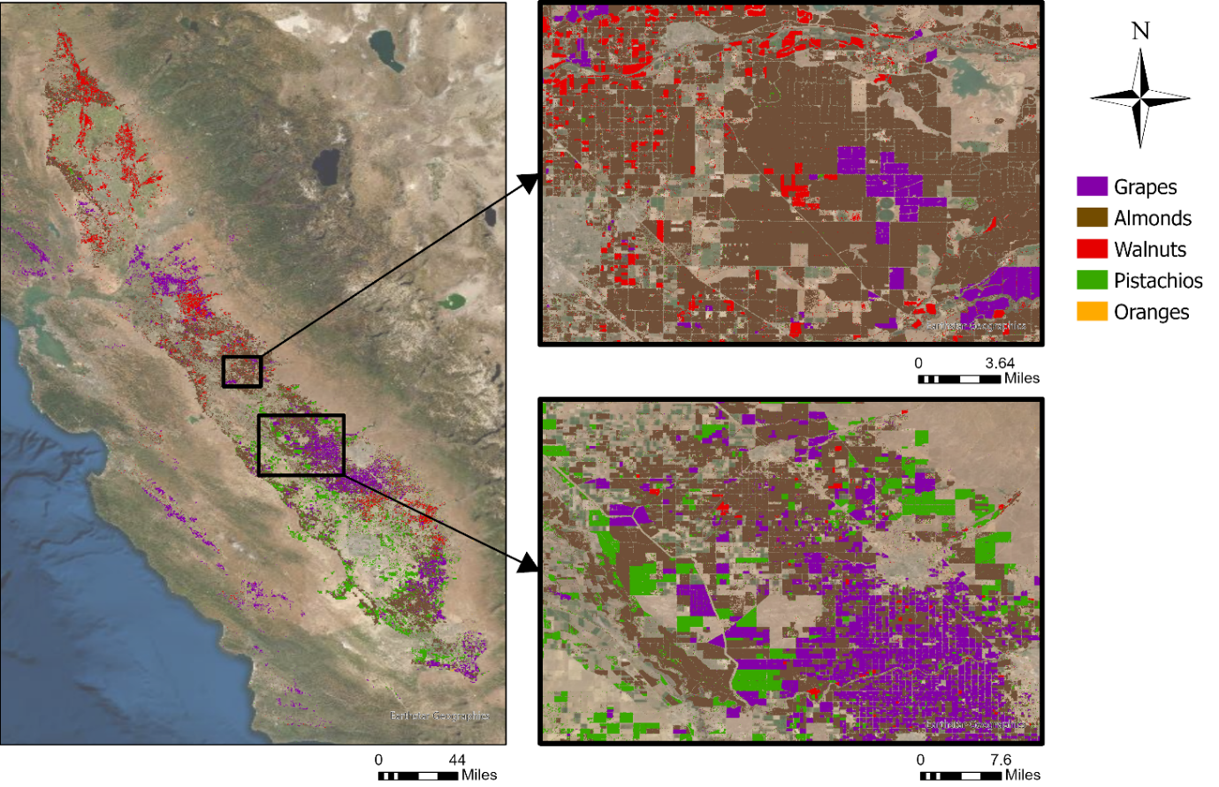
Figure 3. Map of five crop types across the study area with zoomed in regions near Modesto (upper right) and near Fresno, California (bottom right).

Table 2
The total area for each crop type in California in 2021.

Crop Type | Area (hectares)
Almond | 749,178.3
Walnut | 211,108.5
Pistachio | 245,658.0
Orange | 4,141.0
Grape | 345,872.6

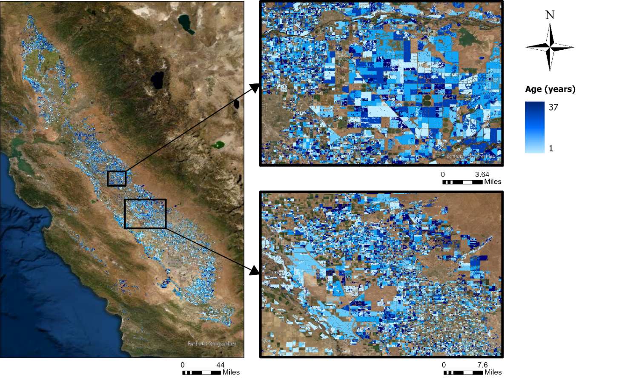
Figure 4. Map of perennial cropland age estimates across California in 2021, with zoomed in regions near Modesto (upper right) and near Fresno, California (bottom right).

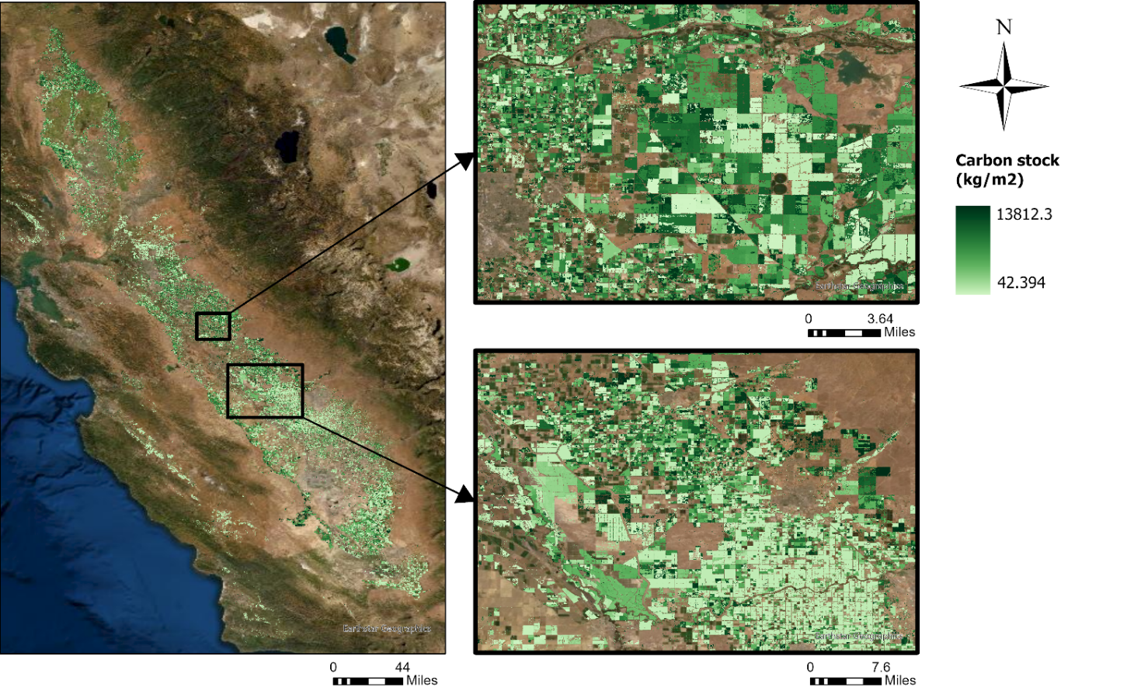
Figure 5. Map of perennial cropland age carbon stock estimates across California in 2021, with zoomed in regions near Modesto (upper right) and near Fresno (bottom right).
We plotted the distribution in crop type mean age across all orchard and vineyard pixels in the study region (Figure 6). The mean ages of orchards and vineyards range from 14.5 years to 19 years. Vineyards and walnut orchards tend to be older in age while pistachio and almond orchards tend to be younger. Vineyards have the highest mean age of 19 years and pistachio orchards have the lowest mean age of 14.5 years.

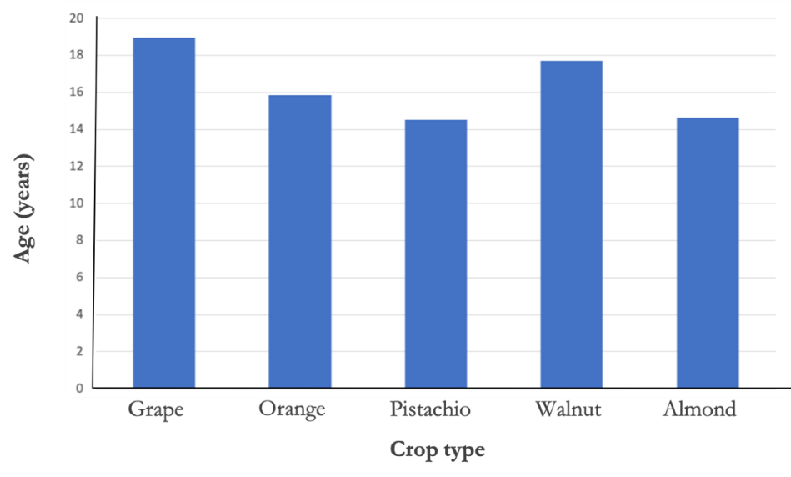
Figure 6. Distribution of mean age by crop type across California in 2021.

Figure 7 shows the 2021 total carbon stock by crop type for all pixels in the study area. Almond orchards store the most carbon, 46.32 Tg C, and make up 65.50% of the overall carbon stock among the five studied crop types. By comparison, orange orchards store only 0.06 Tg C, making up 0.08% of overall carbon stock across these five crop types in California.
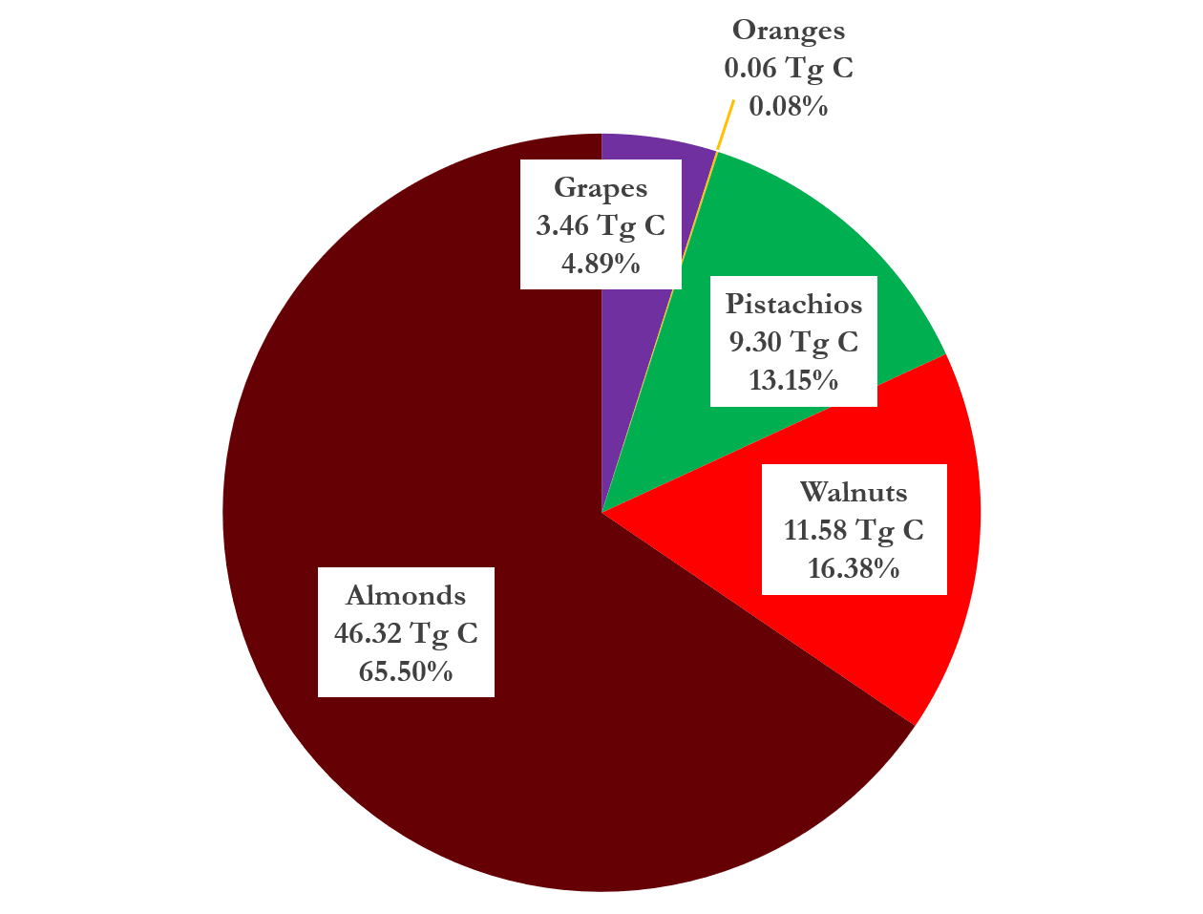
Figure 7. Distribution of carbon stock by crop type across California in 2021.

4.2 Ocular Accuracy Assessment Results
Our team created a total of 52 orchard and vineyard boundary polygons for ocular sampling and assessed error in cropland age estimates for each polygon. We visually determined the actual ages for each orchard and vineyard polygon and calculated the difference between the estimated and actual cropland ages. The mean error for the 52 polygons was ±4.3 years.

4.3 Limitations
Our accuracy in estimating age and carbon stock is dependent on the orchard and vineyard classification accuracy of the USDA-NASS CDL. USDA-NASS CDL data accuracy varies by crop type. While there is a high classification accuracy of over 80% for almond, walnut, and pistachio orchard pixels, USDA-NASS CDL reported 30% accuracy for classifying orange pixels (USDA-NASS, 2021). PAACET estimates the age and carbon stock for any misclassified pixels, therefore reporting values that may not be associated with the crop type. As USDA-NASS CDL accuracy improves over time, PAACET’s accuracy will also improve. Alternatively, orchard parcel boundary data would be significantly more accurate than CDL products. This would also allow the user to aggregate pixels to the orchard boundary level, which would improve accuracy compared to the pixel-based approach used in this analysis.

Another limitation of PAACET is that the tool was unable to estimate the age for approximately 25% of pixels within the study area. Pixels with undetected planting years may represent orchards or vineyards older than 37 years, as these pixels cannot be aged due to the limited extent of Landsat data starting in 1984. In other instances, the tool’s Z score threshold may not have been sensitive enough to detect a planting year. To address this issue, PAACET could be updated by iteratively decreasing the Z-score threshold for unaged pixels (Chen et al., 2019). This might allow the tool to estimate the age and carbon stock of additional orchard and vineyard pixels. Finally, the team’s ocular sampling accuracy assessment used a small sample size and was not representative of the entire study area.

4.4 Future Work
Although the primary focus of this work was to improve CARB’s natural and working lands carbon inventory estimates, future collaborations between DEVELOP and CARB may focus on improving soil organic carbon and fertilizer inventories using our annually updated GEE orchard mapping tool. Future work could include a more robust accuracy assessment with a larger sample size and the incorporation of ancillary ground truth data on orchard and vineyard ages and carbon stock. Future work might also incorporate light detection and ranging (LiDAR) data to relate tree height to biomass and updated parcel data for improved accuracy in carbon stock estimation. If there are no available orchard and vineyard parcel data, future research could aggregate pixels to the orchard boundary level to reduce noise and improve functionality. In addition, the methodologies utilized in this project may be applied to future works estimating agricultural biomass and carbon stock for other regions or states. Finally, future teams may apply this methodology to estimate the age and carbon stock of additional perennial agriculture crop types.

5. Conclusions
The California Agriculture team designed a Google Earth Engine tool called PAACET, which automatically estimates and maps the ages and carbon stock of perennial agriculture in California. Although the tool detects planting years for most orchards and vineyards, many cropland pixels were unaged. These unaged pixels may be the result of limited data availability, as PAACET is unable to estimate ages for orchards and vineyards planted before the study period of this project. It is also possible that the tool’s change detection algorithm was not sensitive enough to detect the planting year for certain pixels.

Our pixel-based approach indicates a moderately high level of accuracy, as an ocular sampling accuracy assessment consisting of 52 sample plots found that PAACET estimated croplands within an average of 4.3 years of their actual age. Because our accuracy assessment was limited, however, we advise our partners to perform a more extensive and representative accuracy analysis. Additionally, future improvements to the tool could involve aggregating pixels to orchard and vineyard boundaries, which we expect would reduce noise and the number of unaged pixels.

Overall, PAACET offers an improved workflow for estimating carbon stocks that minimizes user inputs and increases temporal resolution. By incorporating annually updated remotely sensed data, PAACET will both lower costs and enhance the accuracy of CARB’s natural and working lands carbon inventory estimates. This will improve CARB’s ability to monitor progress towards California’s 2045 carbon neutrality goal.

6. Acknowledgments
The team would like to thank our partners from the California Air Resources Board for their collaboration and input on this project. We would also like to thank our science advisors, Dr. Juan Torres-Peréz and Dr. Kenton Ross, and our fellows, Britnay Beaudry and Hayley Pippin, for their continued guidance and support throughout the project’s duration. A special thank you to Dr. Lee Johnson and Dr. Forrest Melton for providing additional feedback on orchard imagery analysis. Finally, thank you to the other Ames Research Center DEVELOP teams who provided us with valuable insights and feedback on our project throughout the term, and to previous teams within the greater DEVELOP network whose contributions made this project possible.

This material contains modified Copernicus Sentinel data (2021), processed by ESA.

Maps throughout this work were created using ArcGIS® software by Esri. ArcGIS® and ArcMap™ are the intellectual property of Esri and are used herein under license. All rights reserved.

Any opinions, findings, and conclusions or recommendations expressed in this material are those of the author(s) and do not necessarily reflect the views of the National Aeronautics and Space Administration.

This material is based upon work supported by NASA through contract NNL16AA05C.

7. Glossary
California Air Resources Board (CARB) – California’s central climate change planning agency
responsible for setting emissions standards, ecosystem carbon targets, and desired sequestration rates to meet climate goals
Cropland Data Layer (CDL) – a raster, geo-referenced, crop specific land cover data layer with a ground resolution of 30 m produced using satellite imagery from the Landsat 8 OLI and TIRS sensors, the ISRO ResourceSat-2 LISS-3, and the ESA Sentinel-2 MSI collected during the agricultural growing season
Diameter Estimated Method for Even-aged Trees Examined Remotely (DEMETER) – a software tool developed by CARB to estimate orchard carbon stocks
Earth observations – satellites and sensors that collect information about the Earth’s physical, chemical, and biological systems over space and time
Google Earth Engine (GEE) – cloud-based platform for geospatial analysis
National Agriculture Imagery Program (NAIP) – high resolution aerial imagery available between 2003–2018
National Agricultural Statistics Service (NASS) – USDA service that provides crop information for the entire United States through census and survey inventory programs
Normalized Difference Vegetation Index (NDVI) – standardized index for quantifying the health of vegetation by measuring the difference between reflected near-infrared and red light
Natural Working Lands (NWL) – include forests, grasslands, shrublands, woodlands, rangelands, farmlands, wetlands, and greenspaces within urban and constructed environments
Perennial Agriculture Age and Carbon Estimation Tool (PAACET) – software tool created by the California Agriculture DEVELOP team to estimate age and carbon stocks for orchards and vineyards
U.S. Department of Agriculture (USDA) – federal agency responsible for overseeing farming, ranching, and forestry industries

8. References

Baddeley, J. A., & Watson, C. A. (2005). Influences of root diameter, tree age, soil depth and season on fine root survivorship in Prunus avium. Plant and Soil, 276(1), 15–22. https://doi.org/10.1007/s11104-005-0263-6

California Air Resources Board. (2017). Technical Documentation for California's 2001-2010 Forest and Other Natural Lands Carbon and Emission Inventory. Sacramento: California Air Resources Board. https://www.arb.ca.gov/cc/inventory/pubs/ghg_inventory_folu_tsd.pdf

California Air Resources Board. (2018, December). Technical Support Document for the Natural & Working Lands Inventory. https://ww3.arb.ca.gov/cc/inventory/pubs/nwl_inventory_technical.pdf

California Air Resources Board. (2019, January). California 2030 Natural and Working Lands Climate Change Implementation Plan. https://ww2.arb.ca.gov/sites/default/files/2020-10/draft-nwl-ip-040419.pdf

Chen, B., Jin, Y., & Brown, P. (2019). Automatic mapping of planting year for tree crops with Landsat satellite time series stacks. ISPRS Journal of Photogrammetry and Remote Sensing, 151, 176–188. https://doi.org/10.1016/j.isprsjprs.2019.03.012

Lillesand, T. M., Kiefer, R. W., & Chipman, J. W. (2015). Remote Sensing and image interpretation. Wiley.

Morandé, J. A., Stockert, C. M., Liles, G. C., Williams, J. N., Smart, D. R., & Viers, J. H. (2017). From berries to blocks: Carbon stock quantification of a California vineyard. Carbon Balance Management, 12, Article 5 (2017). https://doi.org/10.1186/s13021-017-0071-3

Rozas, V. (2003). Tree age estimates in Fagus sylvatica and Quercus robur: Testing previous and improved methods. Plant Ecology, 167(2), 193–212. https://doi.org/10.1023/A:1023969822044

United States Department of Agriculture National Agricultural Statistics Service (USDA-NASS), 2021. Published crop-specific data layer. USDA National Agricultural Statistics Service Cropland Data Layer. Washington, DC.

United States Geological Survey (n.d.). Landsat 4-5 TM Surface Reflectance (Collection 1) [Data set]. United States Geological Survey. https://doi.org/10.5066/F7KD1VZ9

United States Geological Survey (n.d.). Landsat 7 ETM+ Surface Reflectance (Collection 1) [Data set]. United States Geological Survey. https://doi.org/10.5066/F7Q52MNK

United States Geological Survey (n.d.). Landsat 8 OLI/TIRS Surface Reflectance (Collection 1) [Data set]. United States Geological Survey. https://doi.org/10.5066/F78S4MZJ

Zhang, C., Ju, W., Chen, J. M., Li, D., Wang, X., Fan, W., Li, M., & Zan, M. (2014). Mapping forest stand age in China using remotely sensed forest height and observation data. Journal of Geophysical Research: Biogeosciences, 119(6), 1163–1179. https://doi.org/10.1002/2013JG002515

