**NASA DEVELOP National Program**

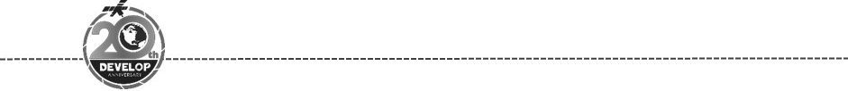Idaho - Pocatello

*Spring 2018*

Navajo National Monument Water Resources

Monitoring and Forecasting Precipitation Patterns and Erosion Potential to Enhance Archaeological Preservation and Decision Making

 **Technical Report**

Final Draft – March 29th, 2018

Dane Coats (Project Lead)

Theresa Condo  
Brandon Crawford  
Leah Kucera  
Zachary Sforzo

Keith Weber, Idaho State University GIS TReC (Science Advisor)

# 1. Abstract

Monsoonal precipitation severity in Navajo National Monument (NAVA) is exacerbating erosion and arroyo cutting, affecting culturally significant archaeological sites in the area. In order to better understand and mitigate erosional processes, land managers at the park would benefit from comprehensive rainfall data and maps of where erosion hazards are more likely to occur. The Idaho NASA DEVELOP team developed a virtual rain gauge system called Rainfall Intensity Graphs (RIG) and erosion hazard maps that utilize NASA Earth observations to provide a more complete picture of rainfall measurements at the monument. RIG was developed in Google Earth Engine API from Global Precipitation Measurement (GPM) Integrated Multi-satellitE Retrievals (IMERG) and Tropical Rainfall Measuring Mission (TRMM) Precipitation Radar (PR) satellite data. Rainfall data from TRMM and GPM (both gathered from RIG) were synthetically validated against one another as well as Parameter-elevation Relationships of Independent Slopes Model (PRISM) data, and were also compared to ground-based weather stations near the monument. The data displayed a weak statistical correlation between satellite derived data and ground-based weather stations for the study area. However, peaks within the data show temporal similarities suggesting that the differences within the data were representative of regional variability. In future work, rainfall data from RIG can be used as temporal and intensity parameters, which combined with Shuttle Radar Topography Mission (SRTM) derived hazard maps, can help target erosion mitigation.

**Keywords:** Google Earth Engine, virtual rain gauge, GPM, TRMM, IMERG, Navajo National Monument, alluvial erosion

# 2. Introduction

* 1. ***Background Information***

Located in northeastern Arizona, Navajo National Monument (NAVA) is comprised of three separate National Park Service (NPS) units containing three of the best-preserved Ancestral Puebloan archaeological sites (Figure 1). These sites include: (1) Betatakin Unit and (2) Keet Seel Unit, both of which are built into side canyons of the Tsegi Canyon system, and (3) Inscription House Unit, which lies in an arm of Nitsin Canyon (Graham, 2007). All three of the pueblo villages were constructed within alcoves in the Navajo Sandstone during the 13th Century CE. The lands and archeological sites of Navajo National Monument are important to the cultural identity of a number of Native tribes, including the Hopi, Navajo, San Juan Southern Paiute, and Zuni (NPS, 2003).

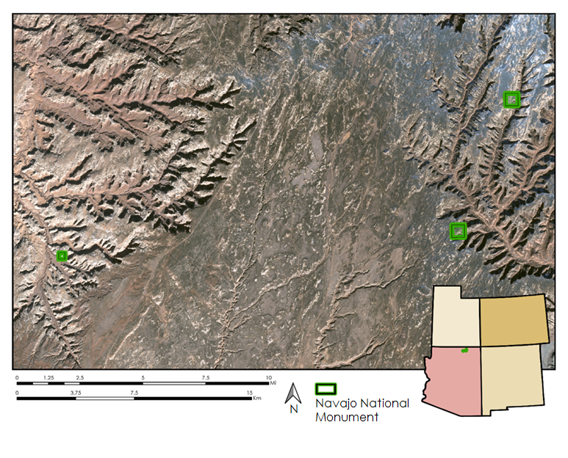

*Figure 1*. Map of Navajo National Monument, National Park Service boundaries located in northeastern AZ.

The region encompassing NAVA is primarily defined by uplift and erosion, resulting in deeply incised canyons cutting through the Triassic- and Jurassic-age sandstone rock formations of the Glen Canyon Group (Graham, 2007). The canyon floors and alluvial aprons of NAVA have been highly modified from downcutting (incision) and backfilling (deposition), creating arroyos, or deeply entrenched ephemeral streams (Bull, 1997; Waters & Haynes, 2001). Arroyo formation in the Southwest has been attributed to periods of low precipitation followed by high precipitation (Balling & Wells, 1990; Waters & Haynes, 2001; Hereford, 2002), erosional thresholds (Patton & Schümm, 1975), human land use (e.g. grazing and logging), and groundwater overdraft (Rich 1911, Baily 1935). Additionally, desert basin erosion is sensitive to fluctuating precipitation intensities throughout the year due to summer monsoonal cycling (Waters & Haynes, 2001).

Land managers at NAVA are tasked with maintaining the cultural heritage of the area through the preservation of the Ancestral Puebloan cave dwellings (NPS, 2003). These preservation efforts are threatened by exacerbated levels of erosion and arroyo cutting (Shaw, unpublished); indeed, large-scale erosion has already cut off access to the Inscription House archeological site. However, monitoring erosion events in the remote canyons of NAVA and surrounding areas is challenging because regional precipitation and groundwater flow is not well-studied or documented. The National Monument lacks a comprehensive network of *in situ* rain gauges that would aid in assessing erosional potential. Even if these data were available, rain gauges have drawbacks. For example, the amount of rainfall measured depends heavily on the elevation, aspect, and position of the gauge (Aleotti, 2004). In contrast, NASA satellite Earth observation data can remotely capture rainfall over a given area with high observation frequency and accuracy (Hong, Adler, & Huffman, 2007).

* 1. ***Project Partners & Objectives***

The National Park Service at NAVA has an ongoing research interest in understanding the geomorphologic processes associated with arroyo cutting and widening at the site. With sparse rainfall data for NAVA and the surrounding area, current erosional risk assessments rely on qualitative observations and aerial imagery (Shaw, unpublished). Ziadat & Taimeh (2013) demonstrate a strong link between precipitation intensity and soil erosion in the southwestern United States. The Navajo National Monument Water Resources team collaborated with NAVA to provide hydrological and topographical data derived from NASA Earth observations for NPS to incorporate into their monitoring and mitigation planning processes. The project team created two tools for archaeologists and land managers at NAVA: (1) Rainfall Intensity Graphs (RIG), a virtual rain gauge system enabling ongoing measurements of precipitation, and (2) hazard maps delineating flood-prone areas from low to high erosion potential.

# 3. Methodology

***3.1 Data Acquisition***

The team used two primary precipitation inputs for RIG. We pulled data from Tropical Rainfall Measuring Mission (TRMM) 34B2 product for the period from 1998 to 2017 which features a 3-hour temporal resolution and a 0.25° (~27 km) spatial resolution. We also used the Global Precipitation Measurement (GPM) Integrated Multi-satellitE Retrievals for Global Precipitation Measurement (IMERG) system from 2014 to present. GPM/IMERG precipitation data provides a combined microwave precipitation and microwave-calibrated infrared (IR) satellite estimator with a half-hour temporal resolution and a 0.1° (~11km) spatial resolution (Huffman et al., 2018; Huffman and Bolvin, 2017). All data were accessed and processed in Google Earth Engine API; these data are hosted on GEE’s public data catalog (2017).

For the erosion hazard maps, the team gathered data from several sources. Parameter-elevation Relationships of Independent Slopes Model (PRISM) data at 4 km spatial resolution was downloaded  from the PRISM Group at Oregon State University (2018). We used Hydrologic Soil Group (HSG) data from the United States Department of Agriculture (USDA) Natural Resources Conservation Service (NRCS) Web Soil Survey database (2018). We then obtained NAVA park boundaries created by the NPS Land and Resources Division (LRD) (2009). The team assembled National Oceanic and Atmospheric Administration (NOAA) National Centers for Environmental Information (NCEI) daily precipitation summaries of weather stations from the NOAA-NCEI climate data online database (2018). The team downloaded land surface elevation data products from the Shuttle Radar Topography Mission (SRTM) from the United States Geological Survey (USGS) EarthExplorer website (NASA JPL, 2013).

***3.2 Data Processing***

The team used Google Earth Engine (GEE) Application Programming Interface (API) to import NASA satellite datasets (GPM and TRMM) into the Integrated Development Environment (IDE) on the Google-hosted website known as the GEE Code Editor from the GEE cloud-based public data catalog. We selected specific combinations of precipitation bands and masked the imagery to area boundaries. RIG produces precipitation estimate values in a time-series chart format that can be generated for any user-defined point of interest. The calculated precipitation values were then compared with two regional NOAA - NCEI rain gauges located nearby (Betatakin and Beaver Springs). Applied supplemental GEE statistical calculations were used to create temporal aggregates of precipitation data (Google Developers, 2017). The precipitation data estimate for TRMM was calculated from a merged microwave and infrared (IR) band generating a precipitation rate expressed in mm/hr every three hours. For GPM, the precipitation estimates were computed from a merged IR band producing a rate in mm/hr every half hour (Huffman and Bolvin, 2017; Huffman et al., 2018).

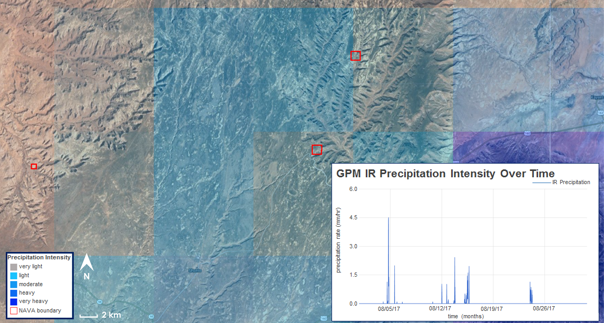RIG was developed to organize the selection of precipitation data into a helpful user interface. The user is able to type in their choice of start and end date. This user-selected time frame is activated when the user clicks the execute button. Charts displaying precipitation intensity over the user-defined time period appear for any selected pixel (Figure 2). In addition, RIG creates an average rainfall map for the user-defined time range after the “Make Map” button is clicked. This map shows a visualization of average rainfall data over the time range as a semi-transparent layer on top of the standard GEE satellite imagery that is centered on NAVA (Figure 2).

*Figure 2*. Example map and graph outputs from Rainfall Intensity Graphs (RIG). Developed on Google Earth Engine API, RIG is a virtual rain gauge tool that provides precipitation rate data from NASA’s Earth observing satellites, Tropical Rainfall Measuring Mission (TRMM) Precipitation Radar (PR) and Global Precipitation Measurement (GPM) Integrated Multi-satellitE Retrievals for Global Precipitation Measurement (IMERG), for a user defined time period. RIG was developed for Navajo National Monument; the park service boundaries appear in red on the map.

The team developed erosion hazard maps using SRTM elevation data from the method outlined in Papaioannou, Vasiliades, and Loukas (2015). The elevation data were processed into slope, flow accumulation, and horizontal and vertical overland flow distance. Wetness index was calculated from the natural log of the flow accumulation divided by the tangent of the slope at a given point. Curve number is a function of hydrologic soils group, land cover, and impervious areas. Curve number was calculated using the Soil Conservation Service method and the Army Corps of Engineers Hydrologic Modeling System. These parameters are calculated in ArcGIS, normalized to a 0-1 scale, and synthesized into a map using the weighted overlay tool (Table 1). The map output displays areas with high and low probabilities of flooding.

*Table 1. Relative weights of criteria used for weighted overlay to produce erosion hazard maps shown in figure 5.*

|  |  |  |  |  |  |  |  |
| --- | --- | --- | --- | --- | --- | --- | --- |
| **DEM** | **Slope** | **Aspect** | **Flow Acc** | **HOFD** | **VOFD** | **WI** | **CN** |
| 0.03 | 0.11 | 0.02 | 0.15 | 0.08 | 0.07 | 0.31 | 0.26 |

***3.3 Data Analysis***

|  |  |  |  |
| --- | --- | --- | --- |
| ***t*-test** | **TRMM** | **GPM** | **PRISM** |
| **Betatakin WS** | 0.70 | 0.86 | 0.91 |
| **Beaver Springs WS** | 0.01 | 0.60 | 0.63 |

The team synthetically validated rainfall data outputs from TRMM and GPM against one another as well as PRISM daily precipitation data (mm) from 2014 to 2017. In order to validate and calibrate RIG, 2000-2017 TRMM and 2014-2018 GPM precipitation values are compared with the NOAA-NCEI station precipitation data for the two data rich and closest stations to NAVA (Betatakin, Kayenta, AZ; Beaver Springs, Tsaile, AZ) (2018). RIG generated GPM and TRMM data were also compared to PRISM precipitation data. To do this, data were converted from precipitation intensity into values of mm/day to facilitate comparing mean, median and standard deviation of precipitation values for rainy days in excel. We compared our data sources using two methods: correlation coefficient and several *t*-tests (Table 2).

*Table 2. P-values from t-tests, which compare ground-based weather station (Betatakin and Beaver Springs weather stations) precipitation data to Tropical Rainfall Measuring Mission (TRMM) Precipitation Radar (PR, Global Precipitation Measurement (GPM) Microwave Imager (GMI), and Parameter-elevation Relationships of Independent Slopes Model (PRISM) precipitation data. P-values above a significance level of 0.05 indicate that the two data sources are not significantly different.*

The correlation coefficient quantifies the relationship between two data sources, and the *t*-test determines if two data sources are significantly different. If p-values from *t-*tests fall above 0.05 the two data sources being compared are not significantly different. The team visualized trends in the data using a 2 point moving average to compare RIG, PRISM, and the weather station (Figure 3).

The team created erosion hazard maps using SRTM elevation data showed flood prone areas using methods detailed by Papaioannou, Vasiliades, & Loukas (2015). The maps were created using Analytical Hierarchy Process (AHP), which breaks down complex questions into simple components that are easy to determine and then recombines those components in a  hierarchical structure. The processed and calculated parameters - slope, flow accumulation, horizontal and vertical overland flow distance, wetness index, and curve number - were calculated in ArcGIS, normalized to a 0-1 scale, and synthesized into a map using the weighted overlay tool. The map output displays areas with high and low probabilities of flooding.

# 4. Results & Discussion

*Figure 3.* Rainfall data for August of 2014 from a weather station located within the Betatakin unit at Navajo National Monument, Tropical Rainfall Measuring Mission (TRMM) Precipitation Radar (PR, Global Precipitation Measurement (GPM) Microwave Imager (GMI), and Parameter-elevation Relationships of Independent Slopes Model (PRISM) precipitation data.

***4.1 Analysis of Results***

This work focused on the synthetic and ground-based validation of RIG. Satellite-based rainfall data from RIG was weakly correlated to the Betatakin weather station (Table 2). Correlation values comparing RIG data to Betatakin ranged from 0.19 to 0.39, where values closer to 1.0 are considered highly correlated (Table 2). However, peaks within the precipitation data sources for 2014 showed temporal similarities, suggesting the differences within these data were representative of regional variability (Figure 3). Additionally, p-values from the *t*-tests were well above 0.05, which determines that TRMM and GPM data from RIG were not significantly different from ground-based data sources.

$\text{Correlation (X.Y)=}\frac{\sum{(x-\overline{x})(y-\overline{y})}}{\sqrt{\sum{{(x-\overline{x})}^{2}\sum{{(y-\overline{y})}^{2}}}}}$ (1)

*Table 3. Correlation values comparing various sources of rainfall data for the same area at Navajo National Monument. Values closer to 1.0 are more correlated.*

|  |  |  |  |  |
| --- | --- | --- | --- | --- |
| **Correlation** | **RIG (TRMM)** | **RIG (GPM)** | **PRISM** | **GPMHQ** |
| **Weather Station (2000 – 2017)** | 0.30 | 0.29 | 0.63 | 0.19 |
| **Weather Station (2014 – 2017)** | 0.39 | 0.29 | 0.63 | 0.19 |
| **RIG (GPM)** | 0.54 | 1.00 | 0.49 | 0.70 |
| **PRISM** | 0.73 | 0.49 | 1.00 | 0.70 |

Monthly precipitation averages also can shed light on the conditions preceding major arroyo cutting events. Figure 4 shows how RIG can be used to visualize rainfall and compare total precipitation for the monsoonal season along with average precipitation for every rainy day during the same month from 2000 to 2017. RIG can provide a base level for the rainfall intensities during specified periods. This provides the user with information about changing yearly trends in weather. RIG data can differentiate high intensity rainfall in months with few rainy days, or months that show many rainy days with numerous low intensity rainfall events.

*Figure 4.* Total precipitation (left) and mean rainy day precipitation (right) for the month of August from 2000-2017, covering an ~11 km pixel over Navajo National Monument’s southeastern unit. Data were acquired from Rainfall Intensity Graphs (RIG) which utilize precipitation data from NASA’s Earth observing satellites: Tropical Rainfall Measuring Mission (TRMM) and Global Precipitation Measurement (GPM).

RIG’s primary limitations are the low spatial resolution of its source data, 11-27 km pixel size, which may fail to identify isolated storms. Data from RIG are presented as a rainfall rate (mm/hr), making it difficult for direct comparison with ground-based rain gauges which measure daily rainfall accumulation. When comparing to a ground station it is possible to scale the intensities to match the weather stations, but this can cause complications in interpretation. For example, because RIG data is summed each day, a major storm event may be characterized as a number of lower intensity storms.

Erosion hazard maps show areas most at risk of flooding, and can be utilized to predict channel incision in NAVA (Figure 5). At the regional scale, the walls of Nitsin and Tsegi Canyons generally appear to be at a higher risk of erosion relative to the large flat central area. At the individual canyon scale, areas most at risk of flooding were generally higher in elevation and had flatter slopes. The high risk areas in the highlands are connected to the streams in the canyons which may show areas that have formed arroyos or are likely to be incised during intense rainfall events.

***4.2 Future Work***

The near real-time and historical precipitation information accessed from RIG has many applications including monitoring for resource management, improving water models, and understanding local hydrologic cycling.

RIG is designed to allow a user to address problems that relate to watershed scale precipitation intensity and rates. Further development of RIG could allow it to pull from both GPM and TRMM simultaneously and create a dataset selector. This feature would increase the accessibility of these separate datasets. The precipitation data, coupled with soil moisture and previous mass wasting events can help managers identify the factors affecting slope stability. Using this information, grazing allotments and canyon reseeding efforts could be targeted to protect regions with similar conditions to previous failures.

The NPS at NAVA designed a follow-up internship for the summer of 2018 that aims to implement the NASA DEVELOP Idaho team’s products for further research during the spring 2018 term. One objective of this internship is to use the products from this term to better understand the erosional processes at NAVA. The intern will work towards building a long-term NPS monitoring structure for erosion geared towards the management of monument resources. These concerns include preservation of the roads accessing the cliff dwelling ruins, wildlife habitat, and invasive species control. Remediation efforts following erosional events is crucial for maintaining access to the ancient Pueblos and for conserving other park resources (Golya, G. L., Lyons, K., Bilderback, E., personal communication, January/February, 2018).

Future work could incorporate satellite-derived precipitation measurements into surface and groundwater flow models for the region. RIG could also be applied to determine any correlations between intense rainfall events and documented mass movements. Additional field data collection may also be useful to quantify arroyo incision rates and other measurable sediment transport. Overall, future research could focus on issues related to vegetation health and multivariate factors contributing to erosion. RIG will provide the precipitation inputs for these investigations, allow future work to focus on other parts of the puzzle contributing to erosion.

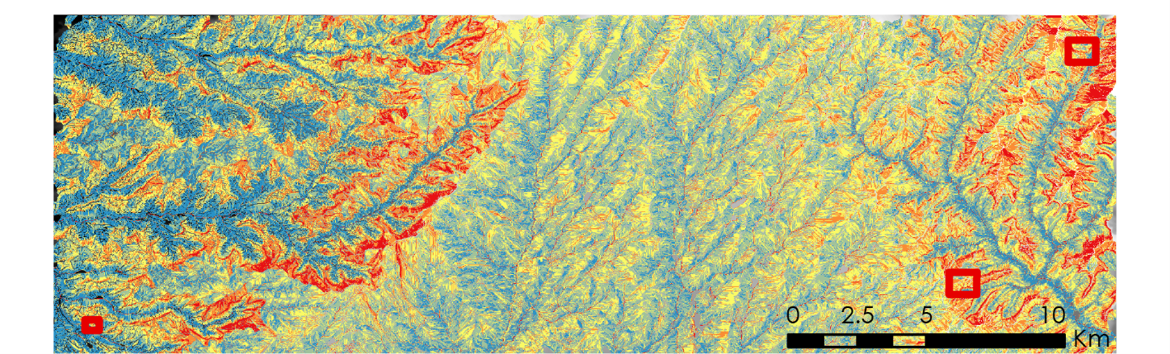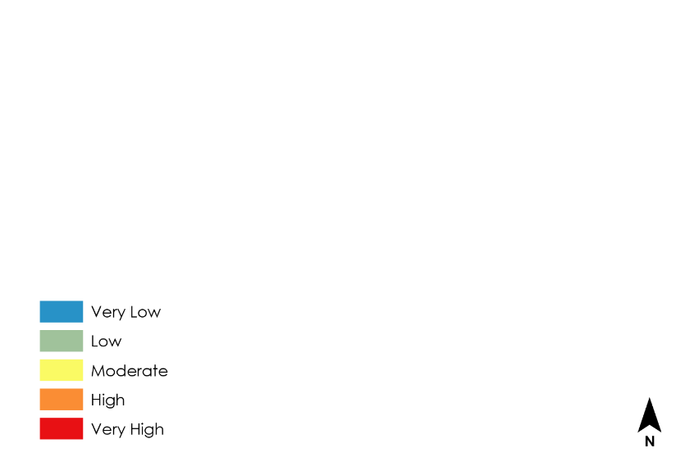

*Figure 5.* Erosion hazard map delineating areas most at risk of flooding at Navajo National Monument and the surrounding area.

# 5. Conclusions

This research developed two products: (1) RIG - a virtual rain gauge GEE application, and (2) erosion hazard maps created through ArcGIS Pro. RIG used NASA satellite Earth observations to expand the spatial and temporal extent of rainfall data coverage beyond what ground-based weather stations can cover. RIG provides near real-time and historical information on the timing and intensity of rainfall events for a user defined area and time period making it a useful tool. RIG was validated by comparing its precipitation values with ground-based weather stations as well as independent climate data (PRISM). The erosion hazard maps provide actionable information to our project partners at NAVA, delineating areas that are most likely to erode. These areas can be targeted for erosion mitigation efforts, preserving architectural artifacts, and allocating human resources within the NPS. In summary, these platforms facilitate access to NASA earth observations for the NPS at NAVA and will provide the framework for erosion monitoring and examining regional precipitation trends in the future.

# 6. Acknowledgments

The NASA DEVELOP Team would like to thank our advisors, partners, and contributors:

* Keith Weber, Idaho State University GIS TReC
* Dr. Gregory Luna Golya, National Park Service
* Dr Jeremy Shaw, Colorado State University
* Keith Lions, National Park Service
* Amy Schott, National Park Service

This material contains modified Copernicus Sentinel data (2016 and 2017), processed by ESA.

Any opinions, findings, and conclusions or recommendations expressed in this material are those of the author(s) and do not necessarily reflect the views of the National Aeronautics and Space Administration.

This material is based upon work supported by NASA through contract NNL16AA05C and cooperative agreement NNX14AB60A.

# 7. Glossary

**Arroyo** - Incised, ephemeral channels with steep sidewalls and rectangular in cross section

**Monsoon** -Late summer high precipitation period, generally from July through mid-September within the southwest United States

**GPM** - Global Precipitation Measurement

**GSFC** - Goddard Space Flight Center

**NACSE** - Northwest Alliance for Computational Science & Engineering

**NAVA –** Navajo National Monument

**NCEI** - NOAA’s National Centers for Environmental Information

**NOAA** - National Oceanic and Atmospheric Administration

**NRCS -** Natural Resource Conservation Service

**NWS** - National Weather Service

**TRMM** - Tropical Rainfall Measuring Mission

**PRISM -** Parameter-elevation Regressions on Independent Slopes Model; uses elevation to interpolate climate data derived from local weather stations

**USDA -** United States Department of Agriculture

# 8. References

Adams, D., & Comrie, A. (1997). The North American Monsoon. *Bulletin of the American Meteorological*

*Society, 78*(10), 2197–2213.

Aleotti, P. (2004). A warning system for rainfall-induced shallow failures. *Engineering Geology*, *73*(3-4), 247-265.

Bailey, R. (1935). Epicycles of Erosion in the valleys of the Colorado Plateau Province. *The Journal of Geology, 43*(4), 337–355.

Balling, R., & Wells, S. (1990). Historical rainfall patterns and arroyo activity within the Zuni River Drainage Basin, New Mexico. *Annals of the Association of American Geographers, 80*(4), 603–617.

Boughton, W. (1989). A review of the USDA SCS curve number method. *Soil Research*, *27*(3), 511-523.

Bull, W. (1997). Discontinuous ephemeral streams. *Geomorphology, 19*(3–4), 227–276.

Gires, A., Tchiguirinskaia, I., Schertzer, D., Schellart, A., Berne, A., & Lovejoy, S. (2014). Influence of small

scale rainfall variability on standard comparison tools between radar and rain gauge data. *Atmospheric Research*, *138*, 125-138.

Google. (2017). Explorer - Selections from the Data Catalog [Database]. Retrieved March, 2018, from https://explorer.earthengine.google.com/#index.

Google Developers (2017). Reducer Overview - Google Earth Engine API. Retrieved March 18, 2018, from https://developers.google.com/earth-engine/reducers_intro.

Graham, J. (2007). *Navajo National Monument Geologic Resource Evaluation Report. Natural Resource Report*

*NPS/NRPC/GRD/NRR - 2007/005*. National Park Service, Denver, Colorado.

Hereford, R. (2002). Valley-fill alleviation during the Little Ice Age (ca. A.D. 1400-1880), Paria River basin and southern Colorado Plateau, United States. *Bulletin of the Geological Society of America, 114(*12), 1550–1563.

Hong, Y., Adler, R. F., Negri, A., & Huffman, G. J. (2007). Flood and landslide applications of near real-time

satellite rainfall products. *Natural Hazards*, *43*(2), 285-294.

Huffman, G. (2017). GPM IMERG Final Precipitation L3 Half Hourly 0.1 degree x 0.1 degree V05. Greenbelt, MD, Goddard Earth Sciences Data and Information Services Center (GES DISC). Accessed [January/February/March 2018] 10.5067/GPM/IMERG/3B-HH/05.

Huffman, G. J., Bolvin, D. T. (2017). Real-Time TRMM Multi-Satellite Precipitation Analysis Data Set Documentation (Version 7, pp. 1-48). Greenbelt, MD: NASA/GSFC/SSAI. Retrieved from https://pmm.nasa.gov/sites/default/files/document_files/3B4XRT_doc_V7_4_19_17.pdf

Huffman, G. J., Bolvin, D. T., Braithwaite, D., Hsu, K., Joyce, R., Kidd, C., Nelkin, E. J., Sorooshian, S., Tan, J.,  Xie, P. (2018). NASA Global Precipitation Measurement (GPM) Integrated Multi-satellitE Retrievals for GPM (IMERG) - Algorithm Theoretical Basis Document (ATBD) (Version 5.2, pp. 1-35). Greenbelt, MD: NASA/GSFC. Retrieved from https://pmm.nasa.gov/sites/default/files/document_files/IMERG_ATBD_V5.2_0.pdf.

Jordan, S. (2009). Navajo National Monument Tract and Boundary Data [.zip]. Department of the Interior (DOI), National Park Service (NPS), Land Resources Division (LRD), Intermountain Land Resources Program Center. Retrieved from https://irma.nps.gov/DataStore/Reference/Profile/1048406.

NASA JPL (2013). NASA Shuttle Radar Topography Mission Global 1 arc second [Data set]. NASA EOSDIS Land Processes DAAC. Accessed [February/March 2018]. doi: 10.5067/MEaSUREs/SRTM/SRTMGL1.003.

National Park Service (NPS). (2003). *Navajo National Monument (N.M.), General Management Plan: Environmental*

*Impact Statement.* Navajo National Monument, Arizona.  
  
NOAA/NCEI. (2018, March 21). Climate Data Online - NCEI Station Details [Database], Retrieved February/March, 2018, from https://www.ncdc.noaa.gov/cdo-web/datasets/GHCND/stations/GHCND:USC00020750/detail.

Northwest Alliance for Computational Science & Engineering (NACSE). (2016). *Descriptions of PRISM Spatial Climate Datasets for the Conterminous United States* [Technical Document]. Corvallis, OR: NACSE. Retrieved from <http://www.prism.oregonstate.edu/documents/PRISM_datasets.pdf>.

Papaioannou, G., Vasiliades, L., & Loukas, A. (2015). Multi-criteria analysis framework for potential flood prone areas mapping. *Water resources management*, *29*(2), 399-418.

Patton, P. C., & Schümm, S. A. (1975). Gully erosion, Northwestern Colorado: a threshold phenomenon. *Geology, 3(2)*, 88–90.

PRISM Climate Group, Oregon State University (1981-2018). Corvallis, OR: NACSE. Retrieved from http://prism.oregonstate.edu.

Rich, J. L. (1911). Recent stream trenching in the semi-arid portion of southwestern New Mexico, a result of removal of vegetation cover. *The American Journal of Science, 32*(190), 237–245.

Tropical Rainfall Measuring Mission (TRMM)(2011). TRMM (TMPA) Rainfall Estimate L3 3 hour 0.25 degree x 0.25 degree V7. Greenbelt, MD, Goddard Earth Sciences Data and Information Services Center (GES DISC). Accessed [January/February/March 2018] https://disc.gsfc.nasa.gov/datacollection/TRMM_3B42_7.html.

Tucker, G. E. (2004). *Modeling the dynamics of gully and arroyo formation, Fort Carson and Pinyon Canyon maneuver site,*

*Colorado*. University of Colorado, Boulder, Colorado.

USDA Natural Resources Conservation Service (NRCS). (2018). Web Soil Survey [Database]. Retrieved March, 2018, from https://websoilsurvey.nrcs.usda.gov/app/.

Waters, M. R., & Haynes, C. V. (2001). Late Quaternary arroyo formation and climate change in the American Southwest. *Geology, 29(5),* 399–402.

Ziadat, F. M., & Taimeh, A. Y. (2013). Effect of rainfall intensity, slope, land use and antecedent soil moisture

on soil erosion in an arid environment. *Land Degradation & Development*, *24*(6), 582-590.