**DEVELOP Virtual Machine Guidebook**

Your virtual machine is a SMCE EC2 instance. Here’s a quick guide on getting it started and using some of its helpful features. Navigate to any of the sections directly by clicking on its name in the Table of Contents.

Table of Contents

I. Launch the EC2 1

II. Remote into Your VM 4

III. SMCE AWS Passwords 6

Check Password Expiration 6

Change Password 7

IV. Storing Files 8

V. Shutting Down Your EC2 9

**Troubleshooting Note:** If you are experiencing any difficulties with your VM, reach out to James (Jim) Davis via Microsoft Teams or email ([james.davis@ssaihq.com](mailto:james.davis@ssaihq.com)).

# I. Launch the EC2

1. Navigate to the Jenkins server login page: [**https://jenkins.developprogram.org/**](https://jenkins.developprogram.org/)

*Note: If you are logged into a NASA VPN, the page will not load. Disconnect from the VPN and reload the Jenkins server login page. Most participants will not have VPN access, so this mainly applies to Fellows.*

1. Sign in with the password provided to you by James (Jim) Davis. The username should look something like **firstname.lastname**, and the password will be pretty long!

*Note: Passwords are set to expire every 60 days. Refer to Section III on how to check and change your password*

1. Select **AWSDevelop**. This is where you will be able to view the job build history and start a new job.

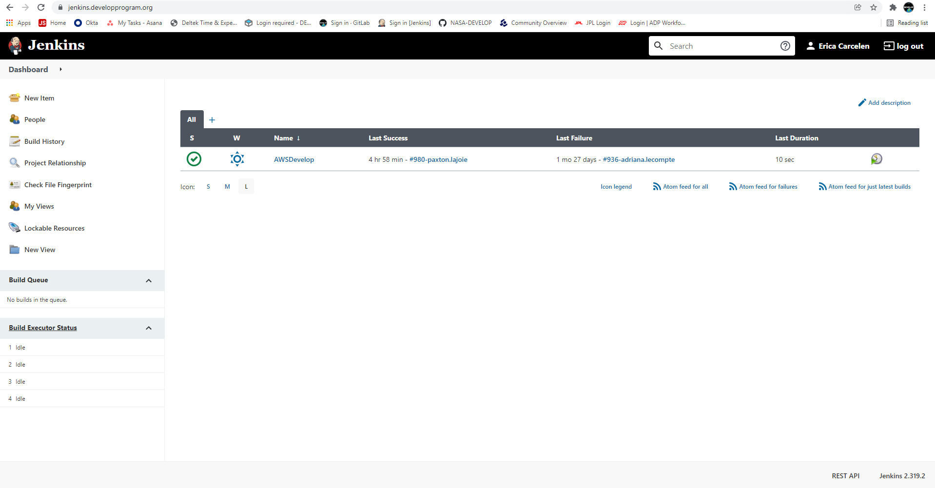

1. In the left-hand panel, select **Build with Parameters**. This is where you can select Start to launch your EC2 instance, Stop to stop your instance, Status to check the current state of your instance, or Reboot.

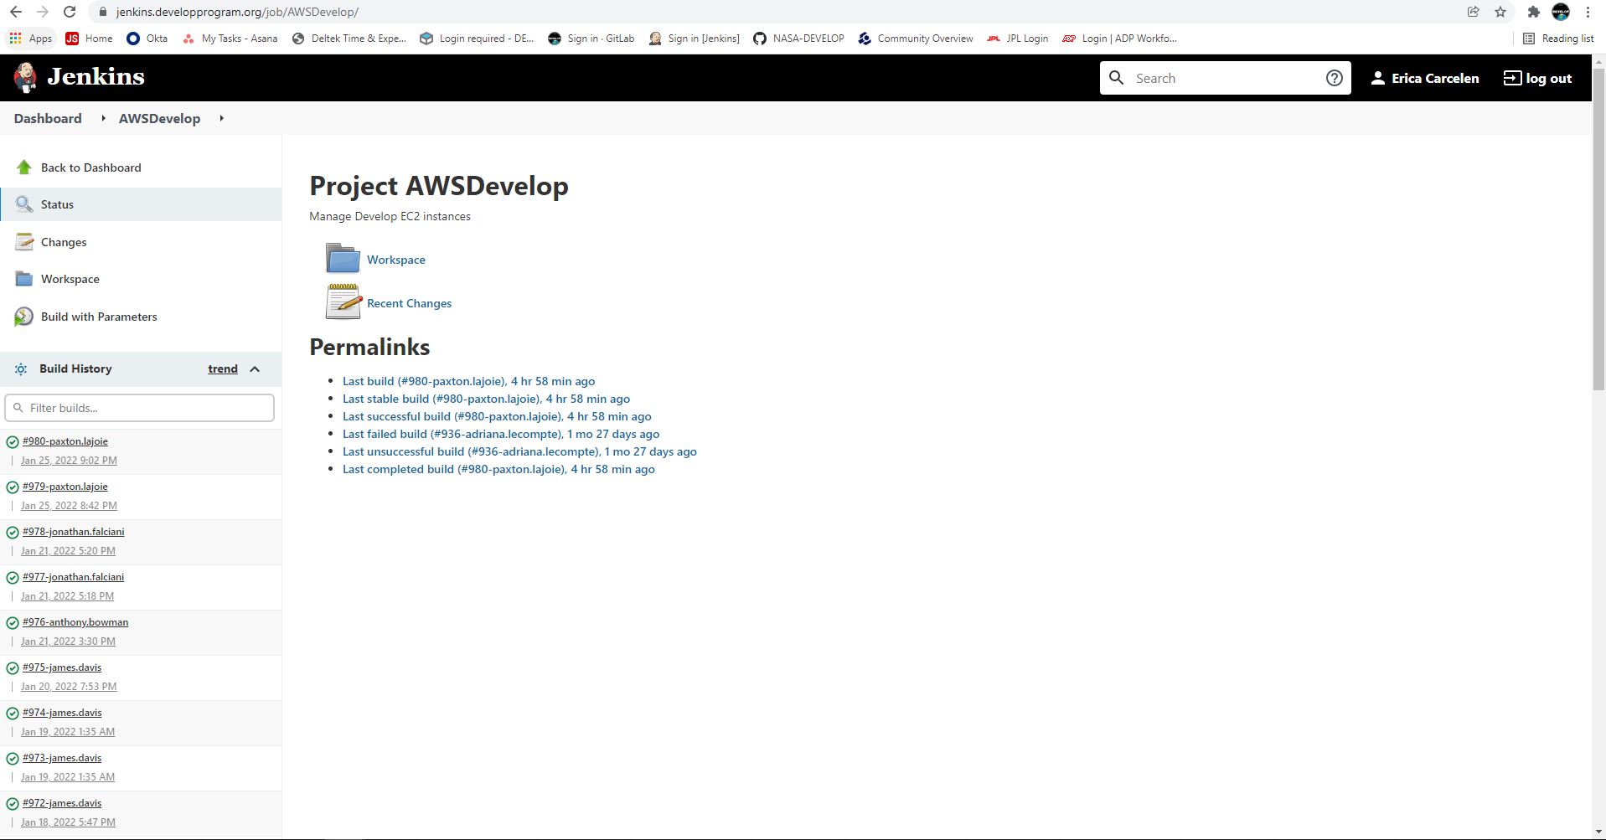

1. To start your EC2 Instance, you first need to select **Start** under the **Operation** dropdown menu, then click the blue **Build** button.

*IT will be monitoring your use and will auto-upgrade based on your needs until the cost exceeds $1.00. At that point, IT will let you know and you should work with your Fellow to submit a formal upgrade request.*

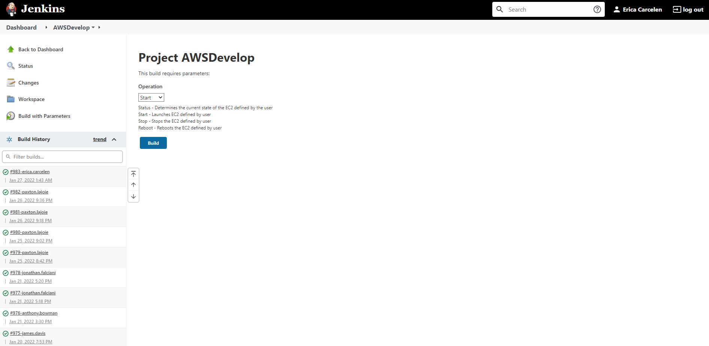

1. You can view the progress of your build under the **Build History** panel on the left-hand side.

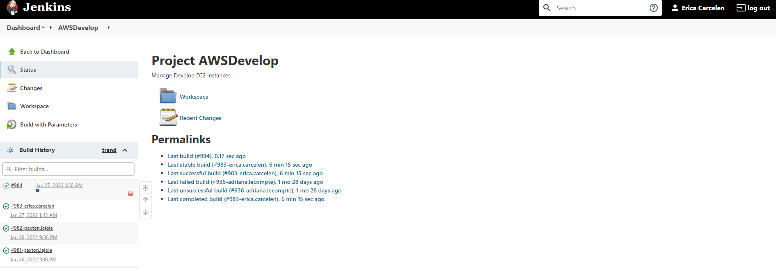

1. Wait until the progress bar shows the build is complete (it should have a closed green checkmark next to it in the **Build History** panel). It will always be the first one in the list. *The first time you Start your instance may take a while, so be patient and let it run until you get the green checkmark.*

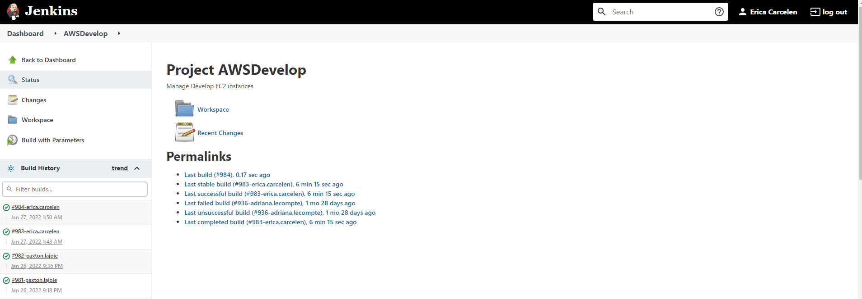

1. Once the build is complete, you can check the status by selecting **Build with Parameters** again and setting the Operation option to **Status** and hitting **Build**.
2. Once again, wait for build to complete, then select your completed build under **Build History** and select **Console Output** on the left-hand side.

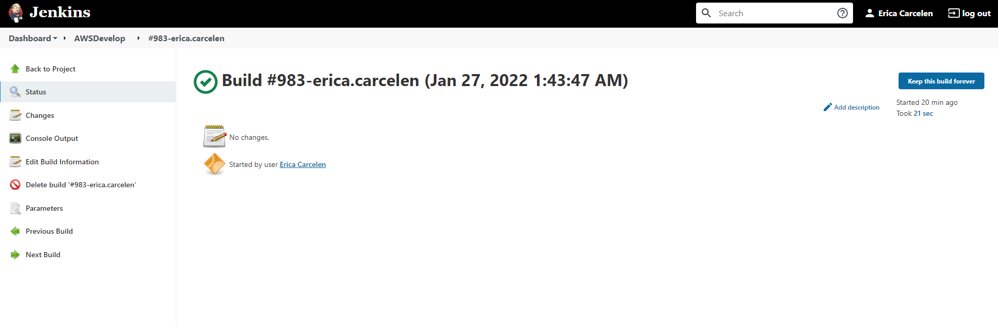

1. Scroll to the bottom of your console output and find your IP address. It will be towards the bottom half of the screen, in the last column of the table. The text may wrap on to the next line, see the example below to find where the IP address will be located.

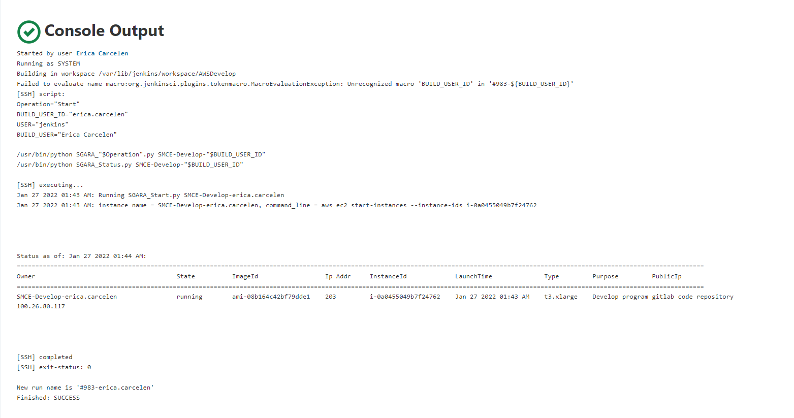

1. Highlight and copy the IP address and continue to Section II.

# II. Remote into Your VM

1. You will need a Microsoft Remote Desktop client. This client is provided as part of the Windows operating systems.
   1. Mac OS X users will need to download/install from the AppStore.
   2. On Windows, if you search for “remote,” the Remote Desktop client is usually the first applications offered.
2. Launch Microsoft Remote Desktop. Enter the IP address you located in Section I, Step 11 in the field labeled Computer (Windows) or PC name (Mac).

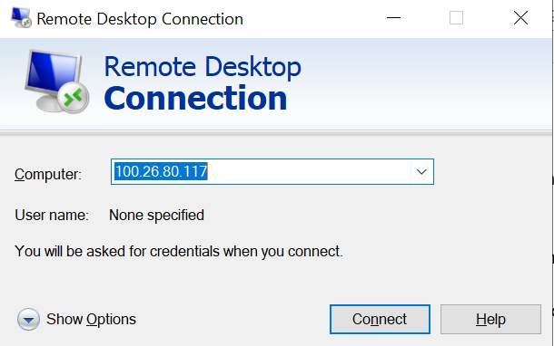

v

1. Click **Connect** (Windows) or **Add** (Mac) and double click the PC you just added in the Remote Desktop main page.
2. Enter your login information. Your username is **develop\firstname.lastname**, and the password is the same you used to get into the Jenkins server in Section I, Step 2. You may need to select **Use a different account** to login using the develop domain.

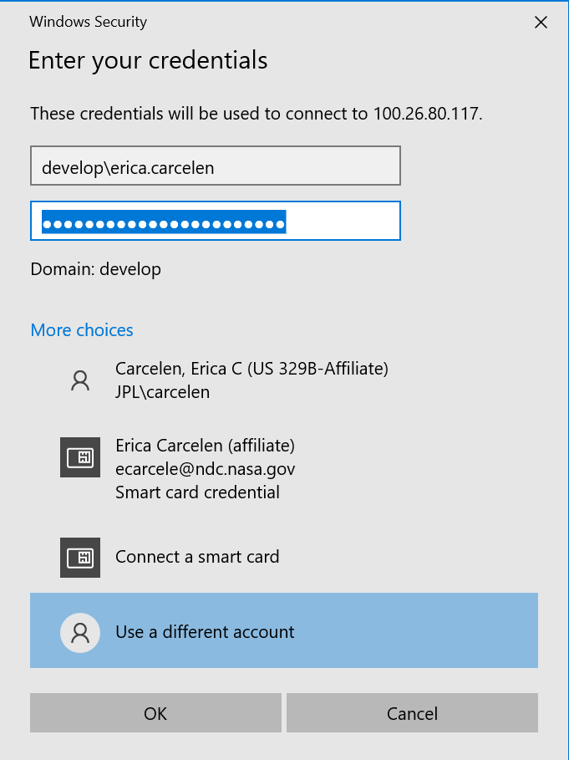

1. You may get a pop-up about validity of certificate similar to the example below. Click **Continue**, this is normal for Remote Desktop connections to EC2 instances.

1. After clicking **Continue**, you should be greeted with your EC2 instances’ desktop!

# III. SMCE AWS Passwords

For security reasons, your SMCE AWS account passwords expire every 60 days. Please keep track of when your password will expire and remember to change it beforehand!

## Check Password Expiration

1. When logged into your EC2, a window should pop up within 10 days of expiration with a warning that your password will expire soon. However, you can check the expiration date at any time.
2. Open the **Command Prompt** application in your EC2. In the Command Prompt application, type **net user <your login> /domain** replacing <your login> with your AWS username (typically firstname.lastname) and hit Enter. Make sure there is a space between your **<your login>** and **/domain**.

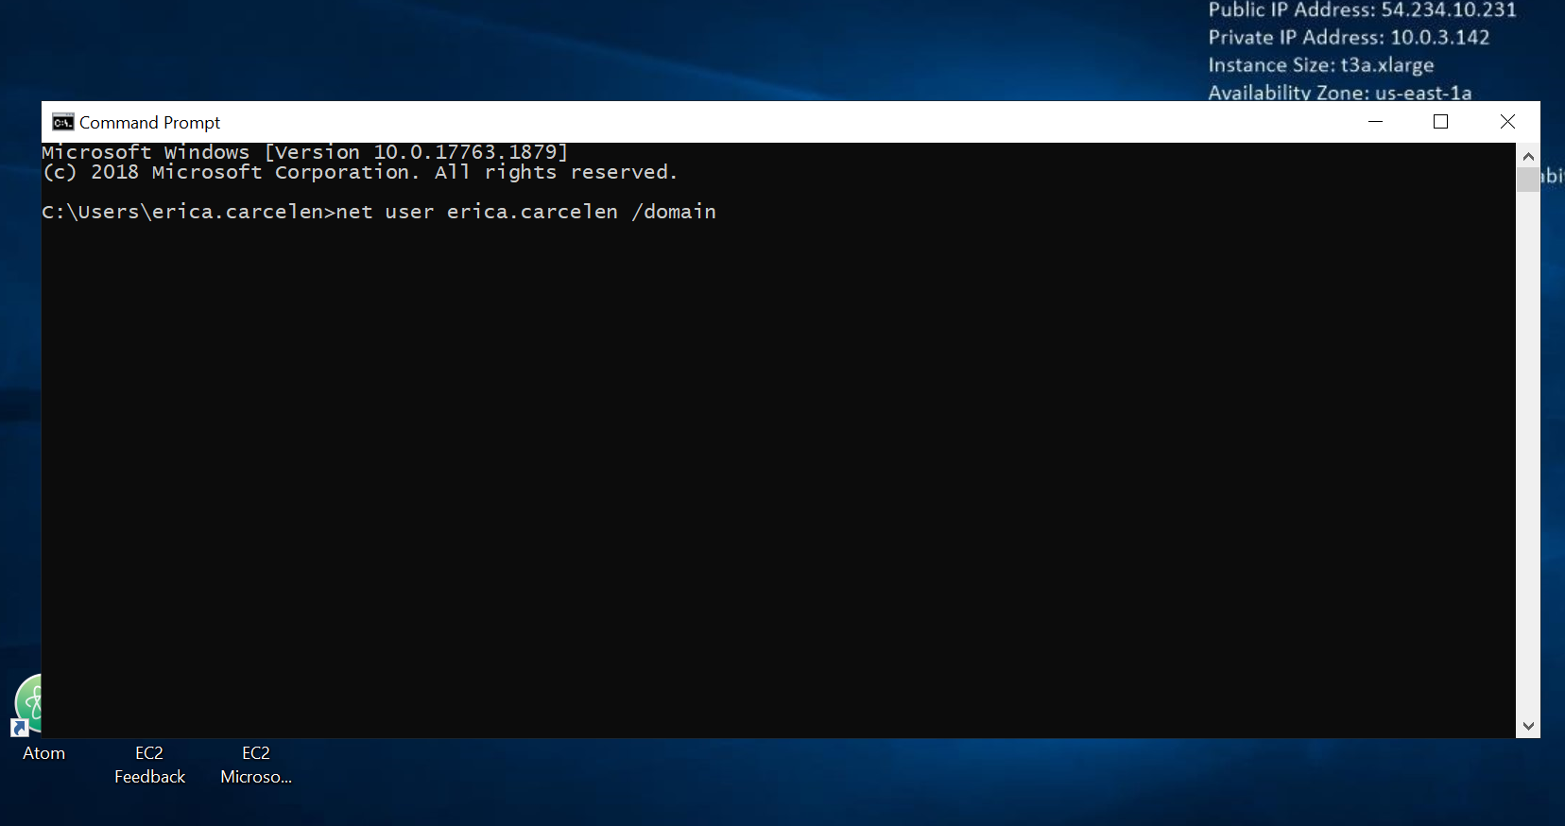

1. A report will then show up with information about your account. Refer to the passwords section for the exact day your current password is set to expire.

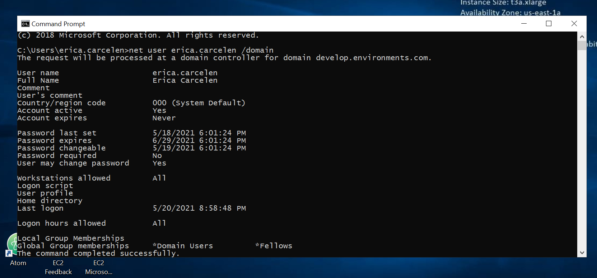

## Change Password

1. In the Command Prompt on your EC2, type **osk** and hit Enter.
2. A keyboard will pop up. On your machine’s keyboard **hold Ctrl-Alt** (these should turn blue on the screen keyboard) and **click Del** on the screen keyboard. *Make sure you* **click Delon the screen keyboard** *and do not hit Del on your machine’s keyboard.* If you hit instead of click, you may be changing the password on your local machine, not the EC2!

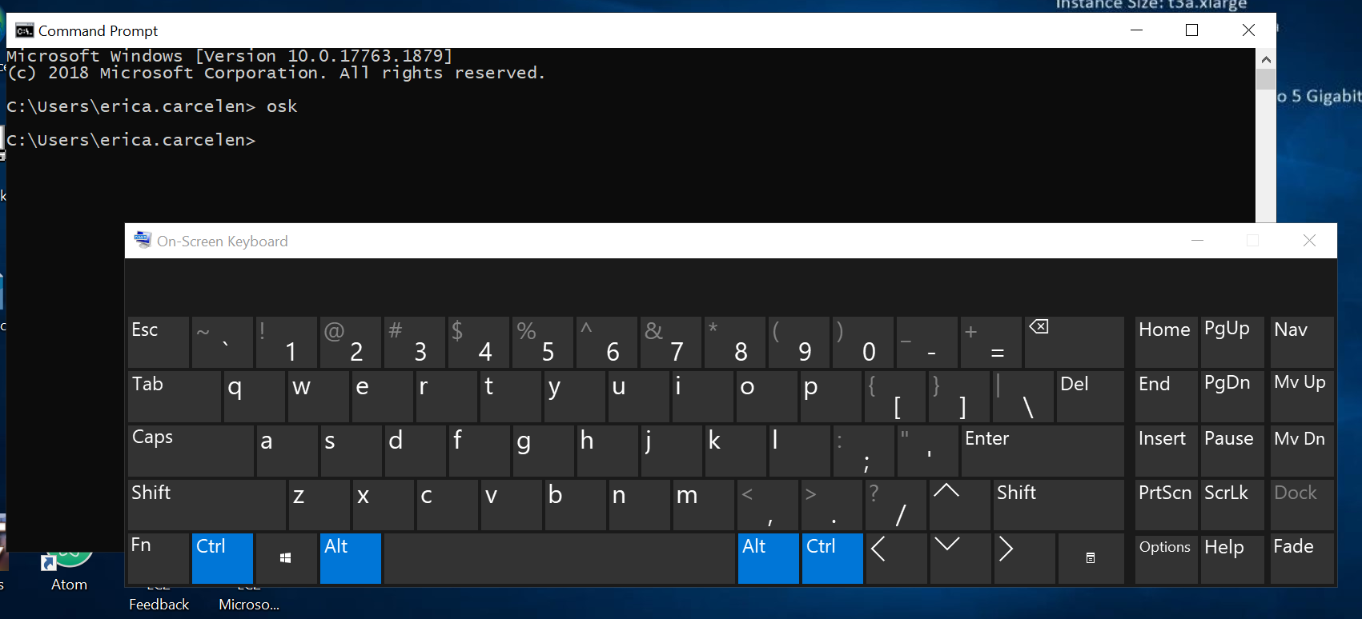

1. Select **Change a password** and fill out the sections accordingly. Now your password is set for the next 60 days!

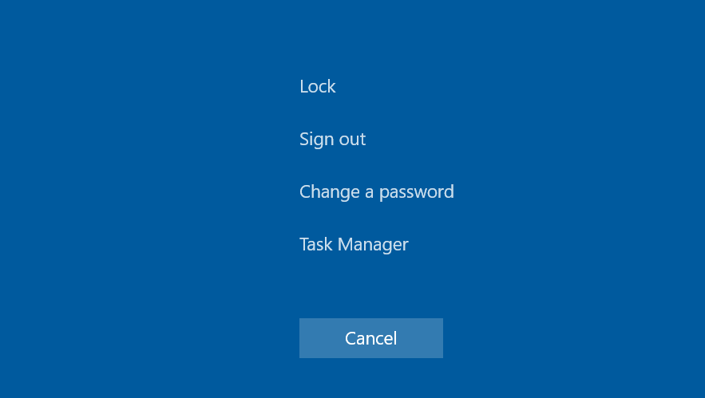 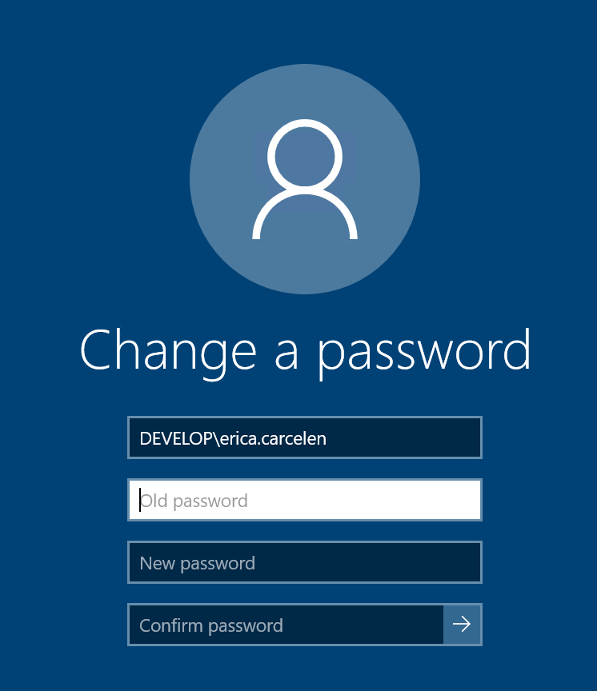

# IV. Storing Files

At DEVELOP there are several resources available to store your files, which are detailed below. Discuss these options with your Fellow, they may have preferences for the node or suggestions for what would work best for your team!

## Local Storage (C:)

The **C: drive** on your virtual machine is your local drive, meaning any files stored here are only accessible on your virtual machine. If you start running low on space in your C: drive, work with your Fellow to request an increase in space from IT. Files stored on your C: drive will be lost at the end of the term, so make sure you have sent files to your Fellow or uploaded them to the shared drive. These should only be files that cannot be re-downloaded or files that are being sent to your partners. Use a README to document your folder’s content and structure!

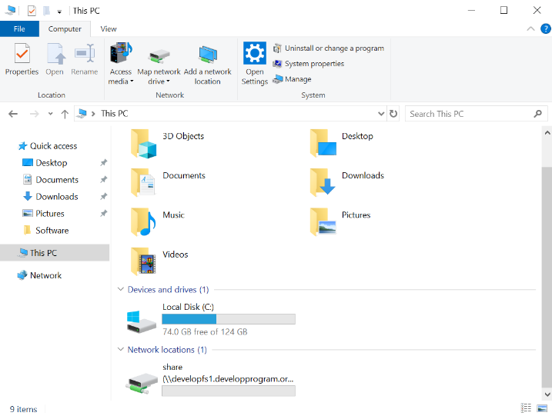

## Shared Drive (D:)

The program’s shared drive is accessible through the Virtual Machine and is already mapped to the **D: drive, no additional steps are needed to connect to it**. Because this folder is accessible by everyone in the program, you can use it to transfer files among your team members or back-up your work. Please keep your files organized in a team folder with the following naming format: YearTerm_Node_ProjectShortTitle. Remember that this is a shared space for the program, so be mindful of the amount of space you are using.

*If you have several large files that need to be shared with your team members, contact IT about options to set-up a server for easy transfer!*



## AWS WorkDocs

AWS WorkDocs is a cloud-based file sharing platform that can be accessed both inside and outside the Virtual Machine. It is a great option for teams that are not requesting Virtual Machines and need space to share files outside of Office 365.

Please access AWS WorkDocs through the browser ***only***, *do not download and install the app on your virtual machine*.

1. Navigate to the AWS WorkDocs page: [**https://developprogram.awsapps.com/workdocs/loginv2/index.html#/emailSelect?sitename=developprogram**](https://developprogram.awsapps.com/workdocs/loginv2/index.html#/emailSelect?sitename=developprogram)
2. Login with the username (firstname.lastname) and password Jim sent to you. The username should be formatted as **username@develop.environments.com.** It should be the same username and password used for Jenkins and Gitlab.

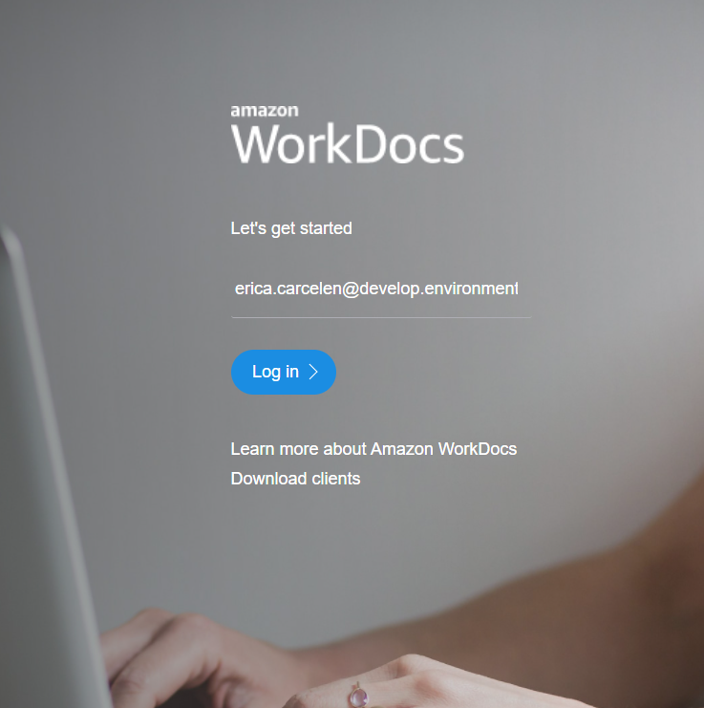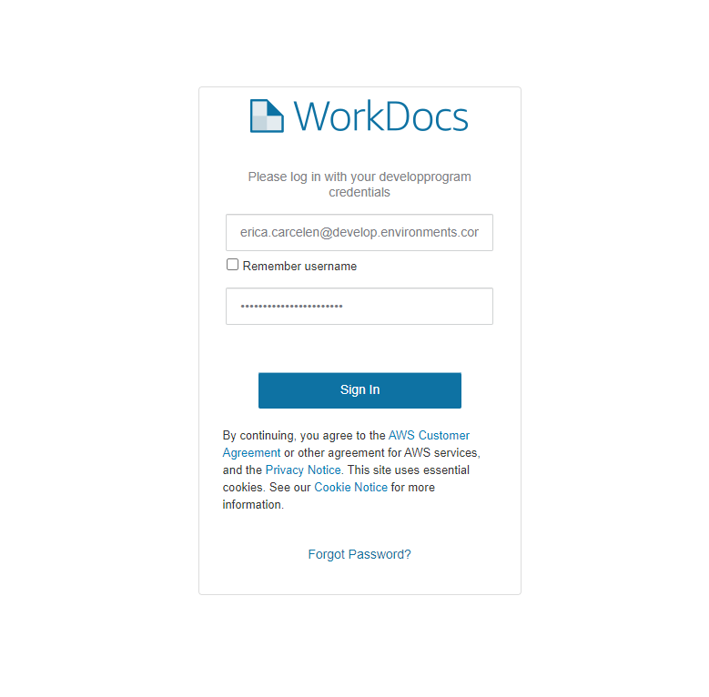

1. The home page defaults to **MyDocs**, which are the folders and files you have uploaded to AWS WorkDocs. If this is your first time logging in, there should be no files since you have not added any files yet! Navigate to **Collaborate** to see folders shared among other users in DEVELOP’s AWS WorkDocs and **Activity** to see recent actions taken in your files.

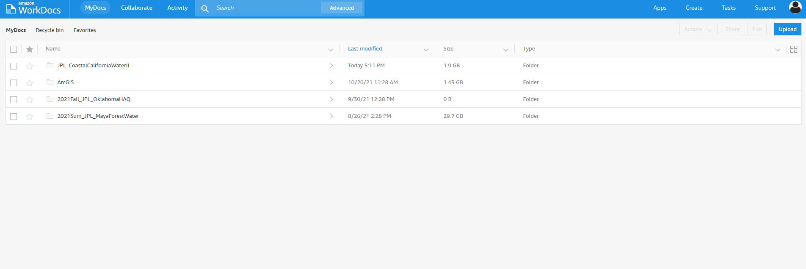

1. To create a new folder, use the **Create** button at the top right. Once you’re ready to upload files to your folder, navigate to the folder and use the blue **Upload** button to upload folders or individual files.



1. If you’d like to share the folder with your teammates via AWS WorkDocs, select the file or folder you’d like to share. Click the **Share** button that becomes available on the top right, near the blue Upload button.

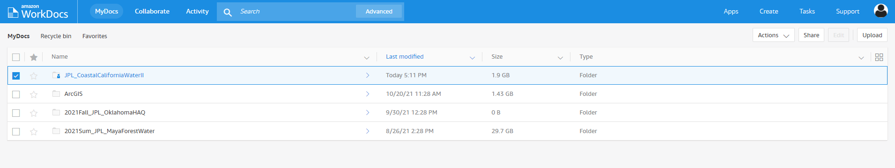

* 1. You can create a link by selecting the **Share a link** option and selecting the appropriate option.

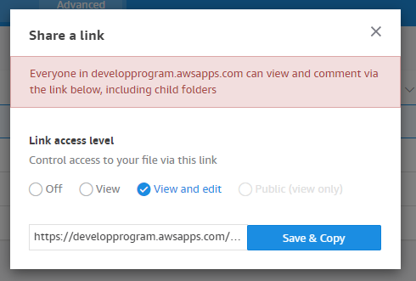

* 1. You can also add people to the folder by selecting **Invite people** and entering their emails (typically firstname.lastname@ssaihq.com). Any folders shared with you will show up in the **Collaborate** tab.

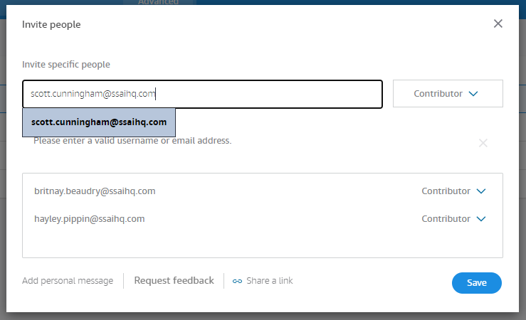

*Note: Only those with access to DEVELOP’s AWS WorkDocs can access these folders. If you need to share a folder or file externally, discuss any limitations and options with your Fellow and IT.*

1. When you select a file or folder, the **Actions** drop-down menu also becomes available. Use this drop-down to download, edit, or delete the item.



# V. Shutting Down Your EC2

You ***MUST*** shut down your EC2 every single time you are done using it! We don’t want to waste energy or money on an unused virtual machine.

* 1. If you are not currently logged in to Jenkins, you will need to log back into the Jenkins server: [**https://jenkins.developprogram.org/**](https://jenkins.developprogram.org/)

* 1. Click on **DevelopAWS** to navigate back to the DEVELOP AWS project page.
  2. Select **Build with Parameters** on the left-hand side panel.



* 1. In the **Operation** dropdown menu, select the option **Stop** and click the blue **Build** button.

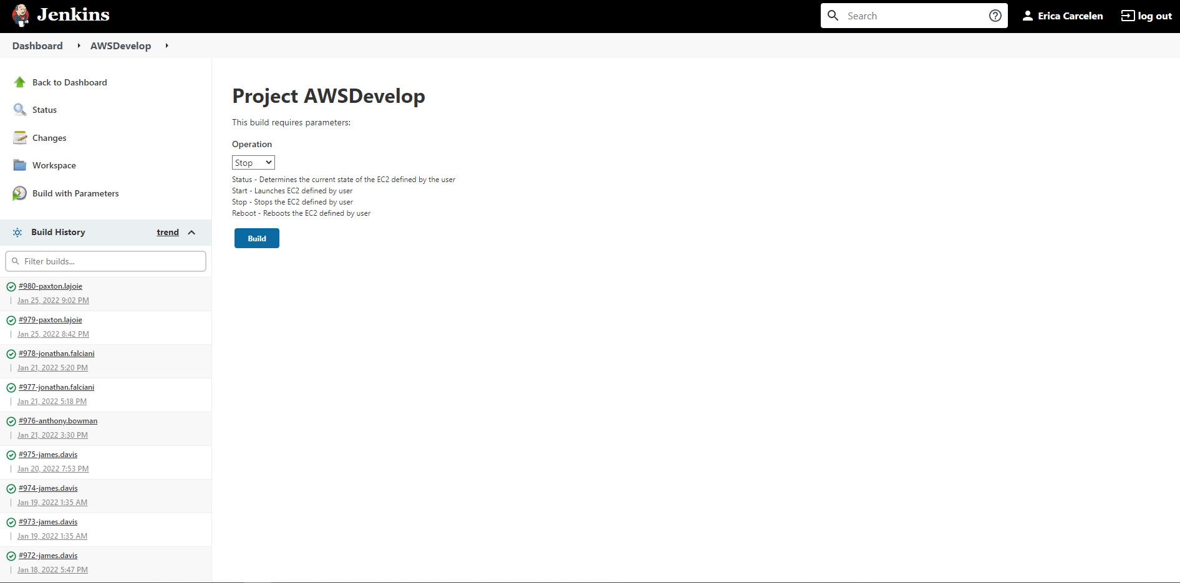

* 1. You can view the progress of your Stop job in the bottom left-hand panel under **Build History**. Your job will always be the first one listed.
  2. Once you see a green checkmark next to it, you know that your EC2 has shut down and you are good to log off for the night.

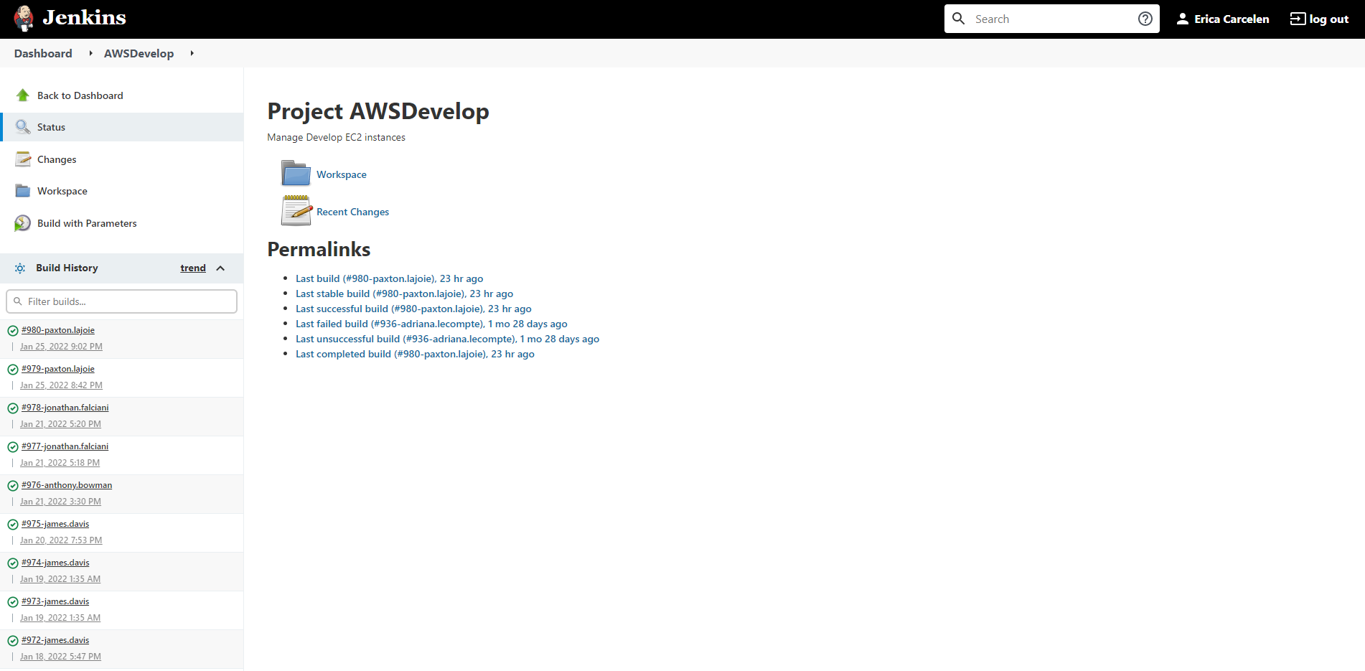

c