**NASA DEVELOP National Program**

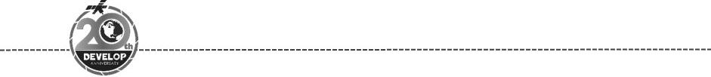Alabama – Marshall

*Spring 2018*

New Jersey Urban Development

Identifying Optimal Regions within New Jersey’s Pine Barren Forest for Urban Development Based on Wildfire Risk and the Wildland-Urban Interface Theory

**Technical Report**

Final Draft – March 29, 2018

Man Kumari Giri (Project Lead)

Mercedes Bartkovich

Olivia Buchanan

Nicholas McVey

Dr. Robert Griffin, University of Alabama in Huntsville (Science Advisor)

Dr. Jeffrey Luvall, NASA Marshall Space Flight Center (Science Advisor)  
Maggi Klug, University of Alabama in Huntsville (Mentor)  
Leigh Sinclair, University of Alabama in Huntsville/Information Technology and Systems Center (Mentor)

# 1. Abstract

As New Jersey’s population increases, more of this population is relocating to the wildland-urban interface (WUI) of the south-central Pinelands region. Due to this increase in human activity coupled with local environmental conditions, local authorities are concerned about an increased possibility of wildfires that could damage both the area’s infrastructure and ecosystem. To counteract this risk, it is necessary to develop methods for accurate wildfire assessment and mitigation efforts. This project partnered with the New Jersey Pinelands Commission (NJPC) to develop a Fire Risk Assessment Tool that identifies areas with high fire risk based on land cover characteristics. The team incorporated vegetation indices derived from Landsat 8 Operational Land Imager (OLI) and Sentinel-2 Multi-Spectral Instrument (MSI), land-use classification derived from LANDFIRE data and elevation into a Fuzzy Logic model to generate a 30 x 30 m Fire Risk Assessment Map. The map was used to analyze fire susceptibility in the Pinelands WUI and to identify optimal areas for urban expansion. Fifty-three percent of the total area within the Pinelands WUI was classified as having a moderate fire risk, while high and extremely-high fire risk accounted for 13%. An estimated 200,000 acres of land with a low to moderate risk of fire were identified as areas that would be suitable for development. The results and maps produced will be used by the New Jersey Pinelands Commission to guide urban development planning and decision making.

**Keywords**

Landsat 8 OLI, Sentinel-2 MSI, wildfire, Pinelands, fire risk assessment, urban development, Fuzzy Logic

# 2. Introduction

* 1. ***Background Information***

The region where human infrastructure and natural vegetation are adjacent or interspersed is known as wildland-urban interface (WUI) (Radeloff et al., 2005; Theobald & Romme, 2007; Stewart, Radeloff, & Hammer, 2007). The WUI areas are widely increasing across the United States (Stewart, Radeloff, Hammer & Hawbaker, 2003). New Jersey is one of the most densely populated state within the U.S., and in recent decades, migration to the state’s Pinelands region has increased due to the desire for privacy, natural beauty, more space, and recreational opportunities. With the expansion of the WUI, there is an increased risk of wildland fire and threat to life and property due to fire (Fox et al., 2015). As a result, the wildland fire policy is dedicated to fire prevention and preparedness projects primarily in the WUI region (USDA, 2002).

The Pinelands lie in the south-central portion of New Jersey, covering 22% of the state’s total land and 1.1 million acres in Ocean, Atlantic, Cape May, Camden, Gloucester, Burlington, and Cumberland counties (Forman, 1998; Clark, Skowronski, Gallagher, Renninger, & Schäfer, 2012). The gently sloping terrain has a vegetative cover consisting mainly of pine and oak stands, including “pygmy” stands, or trees at approximately 11 feet or less in height (New Jersey Pinelands Commission, 2015). The soil of the Pinelands region is sandy and porous allowing for rainwater to swiftly infiltrate and filter through the ground and leaving the surface relatively dry (Clark et al., 2012). This low water retention capacity results in increased susceptibility to wildfires (DeBano, 2000). In addition to high permeability, Pinelands soil is acidic so leaf litter on the forest floor does not readily decompose causing fuel load to accumulate (Ludlum, 1983). The Pinelands ecologically depend on natural occurrences of wildfire in order for seeds to germinate, thus wildfire is a naturally occurring phenomenon of the region. However, with the expansion of the WUI, there is increased concern about higher risk of forest fires due to the increase in human recreational activities and changes in vegetation (Cohen, 2000). Thus, thorough measures for wildfire mitigation and preparation are crucial for the community and the agencies overseeing the Pinelands region.

New Jersey experiences approximately 1,500 forest fires annually (State of New Jersey Department of Environmental Protection, 2017). Since 2008, the New Jersey Pinelands Commission (NJPC) has joined forces with the New Jersey Forest Fire Service to improve wildfire mitigation planning and execution. Much of this collaborative study targeted the high risk areas of Stafford and Barnegat municipalities in Ocean County. However, there is a need for updated and more widespread methods of risk analysis and wildfire mitigation throughout the region.

This project studied the Pinelands region using data from January to December of 2017 to create a fire risk assessment tool and map from fuzzy logic modeling. The variables used in the model include vegetation type, fuel load, soil moisture, topography, lightning density, and housing density of the WUI. Studies in spatial analysis of forests and human activity indicate that “areas with dense clusters of buildings surrounded by forestland have the highest density of fire ignition” (Chas-Amil, 2013). Certain vegetation types are more susceptible to wildfire requiring more thorough analysis of vegetation cover. Considering the effect of topography on vegetation distribution, a higher risk of ignition is associated with lower elevation areas which tend to have abundant vegetation (Calviño-Cancela, 2017).

* 1. ***Project Partners & Objectives***

The team partnered with the NJPC, which monitors fire suppression and prevention efforts within the New Jersey Pineland Reserve. A risk assessment map for the Pinelands area was developed in 1981, but with the influx of development that has occurred over the past 40 years, updated maps are necessary for proper management. In efforts to obtain updated information on fire risk potential, the NJPC performs expensive and time consuming field assessments of vegetative conditions. While government funding for wildfire suppression has increased, the cost of fire suppression due to changes in various climatic conditions and urban growth has increased as well, limiting the NJPC’s ability to consistently monitor wildfire risk within the area (USFS, 2007).

The objectives of this project were to identify optimal areas within the WUI for urban development and to locate areas where fire mitigation efforts should be allocated. The end products developed will allow NJPC to examine and update existing policies to better accommodate the changing environment in the Pinelands region as population growth continues to increase.

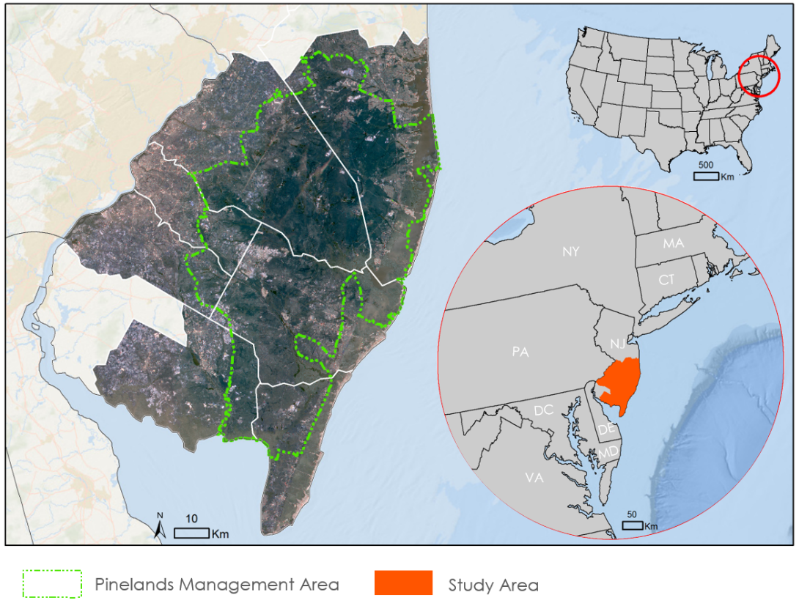

*Figure 1*. Map showing New Jersey and Pinelands Management Areas

# 3. Methodology

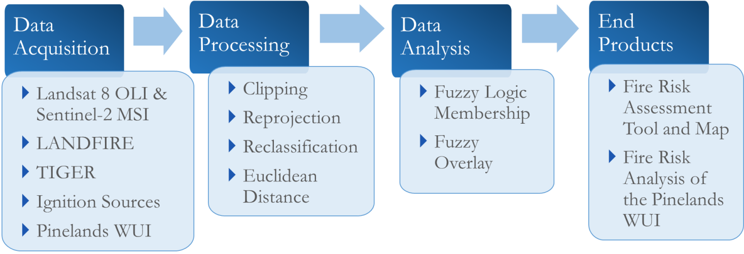

*Figure 2*. Flowchart showing the methodology for the project.

***3.1 Data Acquisition***

The team incorporated Sentinel-2 MultiSpectral Instrument (MSI) and Landsat 8 Operational Land Imager (OLI) into this project. Sentinel-2 MSI Level 1C cloud free data for the year 2017 (April - November) were acquired from the United States Geological Survey (USGS) GloVis data portal. This included four tiles, T18SWJ, T18SVJ, T18TVK, and T18TWK, of Copernicus Sentinel-2 data 2017 covering the study area. The data has a spatial resolution of 10 meters, a temporal resolution of 5 days, and a spectral resolution of 13 bands. The data were used to derive vegetation indices for each month. Cloud free Landsat 8 OLI data were also acquired for several months (Feb/Jun/Jul/Oct/Dec) throughout 2017 in order to provide a more complete understanding of the vegetation in the study area during the year. The data were collected from the GloVis data portal for Path 14/Rows 32 and 33, which corresponds to the study area of southern New Jersey. The data collected were used to derive vegetation and soil moisture indices for each month.

The team obtained the Digital Elevation Model (DEM) data derived from high quality light detection and ranging (LiDAR) for the study area from the USGS National Map-3D Elevation Program (3DEP) data portal. The elevation data had a high spatial resolution of 1/9 arc second (3.4 meters). The 72 tiles of elevation datasets covered the study area from 2006 to 2011.

Vegetation data were acquired from the USGS LANDFIRE (LF) data portal. These data identify 89 different vegetation types. Vegetation type classifications were primarily derived from NatureServe EcoLogical Systems classification, alliances of the U.S. National Vegetation Classification, the National Land Cover Database, and LF specific types.

The NJPC provided the team with zoning and management area shapefiles for the Pinelands. These data contained the Pinelands WUI extent. Similarly, the New Jersey Forest Service provided shapefiles of ignition sources and fire history for the Pinelands. These data included point locations of ignition sources for approximately 5,000 fires in the study area over a 10-year period from 2008 through 2017. The ignition source dataset detailed the location, acreage burned, and year of the fire. NJ Roadway Network shapefiles were obtained from the United States Census Bureau TIGER/Line Shapefiles data portal. This dataset depicted primary and secondary roads throughout the study area.

***3.2 Data Processing***

The USGS 3DEP data were mosaicked together to cover southern New Jersey. The mosaicked layer was then clipped to the study area boundary to obtain elevation for the area. This elevation layer was further processed using ArcGIS to derive other topographical variables such as slope and aspect.

The Euclidean distance tool was used to calculate the distance between roads to determine the location of primary and secondary roads across the study area. This tool measures how far away roads in the area are from each other. This is a vital step towards understanding how variables will impact the fire risk assessment model.

Each band from the four tiles of Sentinel-2 MSI data and the two tiles of Landsat 8 OLI data were mosaicked and processed to derive the Normalized Difference Vegetation Index (NDVI) and the Tasseled Cap Wetness (TCW) for the leaf-on (Apr/May/Jun/Jul/Aug) and leaf-off (Feb/Sep/Oct/Dec) periods. These two periods were used to account for variation in fuel load availability as deciduous forests lose their leaves during the winter months providing more fuel load to burn. During the summer, when deciduous forests regain their leaves, the increase in fuel load at both the surface and canopy leads to higher fire risk. The team chose to use NDVI to analyze vegetation because it reflects vegetation condition and health for the area, while TCW is associated with vegetation and soil moisture. Since vegetation cover, condition, and soil moisture play significant roles in wildfire occurrence, these variables had critical implications for the study. NDVI was calculated from the red (RED) and near infrared (NIR) bands using equation 1 in raster calculator (Rouse, Haas, Schell & Deering, 1974; Deering, 1975). Similarly, TCW was derived using equation 2 which incorporated the BLUE, GREEN, RED, NIR, and Shortwave Infrared (SWIR) bands (Baig, Zhang, Shuai & Tong, 2014).

$\text{NDVI=(NIR-RED)/(NIR+RED)}$ (1)

$\text{TCW = 0.1509}\left(\text{BLUE}\right)\text{+0.1973}\left(\text{GREEN}\right)\text{+0.3279}\left(\text{RED}\right)\text{+0.3406}\left(\text{NIR}\right)\text{-0.7112}\left(\text{SWIR1}\right)\text{-0.4572}\left(\text{SWIR2}\right)$ (2)

After the NDVI and TCW were calculated, the layers were clipped to the study area. Then NDVI and TCW values for the leaf-on and leaf-off period were averaged using respective months to obtain final NDVI and TCW layers for each period and for each Earth observation.

The LANDFIRE vegetation type data were reclassified from 89 specific land classes to 12 broader categories. These included open water, sparsely vegetated, developed, exotic herbaceous, exotic tree-shrub, grasslands, conifer-hardwood, riparian, agricultural land, hardwood, conifer, and conifer-hardwood. The classified vegetation types were aggregated and ranked from 1to 9 based on fire susceptibility and relation with ignition sources (Table 1). All input layers were re-projected in the North America Albers Equal Area Conic coordinate system for further analysis.

Table 1

*Land Use classifications from the LANDFIRE Vegetation Type dataset*

|  |  |
| --- | --- |
| Land Use Classification | Rank (In Order of Fire Susceptibility) |
| Conifer | 1 |
| Conifer-Hardwood | 2 |
| Hardwood | 3 |
| Grassland | 4 |
| Exotic Herbaceous/Exotic Tree-Shrub | 5 |
| Sparsely Vegetated/Agriculture | 6 |
| Riparian | 7 |
| Developed | 8 |
| Open Water/Quarries/Gravel Pits/ Roads/Barren | 9 |

***3.3 Data Analysis***

Fuzzy membership dictates how data impacts associated fire risk. To ensure proper fuzzy membership and midpoint assignments, the team examined the frequency of ignition sources occurring in several input variables, including NDVI, TCW, vegetation type and elevation. Specifically, all variable layers were overlain with ignition source point data, and respective variable values were extracted to each point. The team then identified the frequency of ignition sources occurring within a given range for each variable. Then the range with the highest number of ignition sources was determined to be the midpoint for the variable. The analysis of NDVI and ignition sources showed that a majority of ignition sources occurred at Sentinel-2 MSI’s leaf-on NDVI value of 0.47, Sentinel-2 MSI’s leaf-off NDVI value of 0.35, Landsat 8 OLI’s leaf-on NDVI value of 0.70, and Landsat 8 OLI’s leaf-off NDVI value of 0.58 (Figures A1-A4). These values were used as midpoints when assigning fuzzy membership. Similarly, the analysis of elevation and ignition sources showed that the majority of ignition sources occurred at 10 to 30 meters above sea level, with a sharp decline in ignition sources as maximum elevation exceeds 30 meters (Figure B1).

Table 2

*Variables, and their assigned Fuzzy Membership, that were incorporated into Fire Risk Assessment Map*

|  |  |  |  |  |  |
| --- | --- | --- | --- | --- | --- |
| Variable | Data Source | Spatial Resolution | Temporal Resolution | Date Published | Fuzzy Membership |
| Elevation | NLCD 3DEP | 3.4m | - | 2006-2011 | Near (29) |
| NDVI Leaf On | Landsat 8 OLI | 30m | 16 Days | 2017 | Near (0.7) |
| NDVI Leaf On | Sentinel-2 MSI | 10m | 5 Days | 2017 | Near (0.47) |
| NDVI Leaf Off | Landsat 8 OLI | 30m | 16 Days | 2017 | Near (0.58) |
| NDVI Leaf Off | Sentinel-2 MSI | 10m | 5 Days | 2017 | Near (0.35) |
| TCW Leaf On | Landsat 8 OLI | 30m | 16 Days | 2017 | Linear |
| TCW Leaf On | Sentinel-2 MSI | 10m | 5 Days | 2017 | Linear |
| TCW Leaf Off | Landsat 8 OLI | 30m | 16 Days | 2017 | Linear |
| TCW Leaf Off | Sentinel-2 MSI | 10m | 5 Days | 2017 | Linear |
| Vegetation Types | LANDFIRE | 30m | - | 2014 | Linear |
| Distance from Roads | TIGER | Line | - | 2017 | Linear |

Two fuzzy memberships, “Near” and “Linear”, were used for this study based on the correlation of variables with ignition sources, as well as the expert opinion of our partner. The NDVI and elevation variables were assigned “Near” memberships, while TCW, vegetation type and distance to road variables were assigned “Linear” memberships as their relationship with ignition sources were directly proportional (Table 2). The “Near” Membership demonstrated that NDVI and elevation have the highest risk of fire at the midpoint value, and the risk decreases as values deviated from the midpoint. Specifically, elevation values closest to 20-30 meters have a high fire risk, with a sharply decreasing fire risk for higher or lower elevations. For TCW, high fire risk was assigned to low TCW values that correspond to very dry areas, and low fire risk was assigned to high TCW values that correspond moisture rich areas. The “Linear” membership for vegetation types was assigned based on each vegetation type’s fire susceptibility. This included conifer forests as high fire risk area and open water/barren/roads as low fire risk area.

Understanding how roads affect wildfire risk was more challenging because roads have both positive and negative associations with fire risk. One of the most common ignition sources are cigarette butts tossed from primary and secondary roads that land in relatively dry shrubbery along road sides. This would lead to the assumption that closeness to roads increases fire risk, but these types of fires are generally not likely to spread due to ease of access and containment by fire services. On the contrary, an increase in distance from roads increases the difficulty for fire rescue workers to access and combat potential wildfires. Based on this, we assigned a “Linear” membership to distance from roads, where areas further from roads have a higher the fire risk than areas near roads.

Once all the datasets were assigned a fuzzy membership, a fuzzy overlay tool was made to incorporate each dataset into the model. The model weighed each variable based its importance and maintained separate memberships for each of the input variables. The gamma function was selected as it balances the sum and product functions incorporating all the predictor variables into the fuzzy overlay tool. A fire risk assessment map was generated for the study area. The methods were incorporated into Model Builder in ArcGIS environment to develop a Fire Risk Assessment Tool to allow NJPC to generate updated fire risk maps in the future.

The final map produced displayed fire risk using a scale of 0 to 1, with 0 being the lowest fire risk and 1 being the highest fire risk. The team classified the scale into five equal intervals: extremely low, low, moderate, high, and extremely high.

This Fire Risk Map was used to analyze fire risk in the Pinelands WUI. Based on our partner’s needs, four categories of the Pinelands Management Area were selected for this analysis based on the area’s ability to accommodate development. The Pinelands WUI includes regional growth areas, Pinelands villages, Pinelands towns, and rural development areas. The team masked the Fire Risk Map using Pinelands WUI to analyze the different fire risk classes within the area.

# 4. Results & Discussion

***4.1 Analysis of Results***

A 30 meter resolution Fire Risk Assessment Map for the year 2017 was generated using a fuzzy logic model (Figure 3). Thirteen percent of the study area was determined to be in high and extremely high fire risk areas, while 52% was in moderate fire risk areas, 20% in low fire risk areas, and 15% in extremely low fire risk areas. The extremely low fire risk areas includes open water, barren lands, mine gravel pits, roads and some of the developed regions. The extremely high fire risk includes the pine barren forest, which is mostly in the preservation area of the Pinelands.

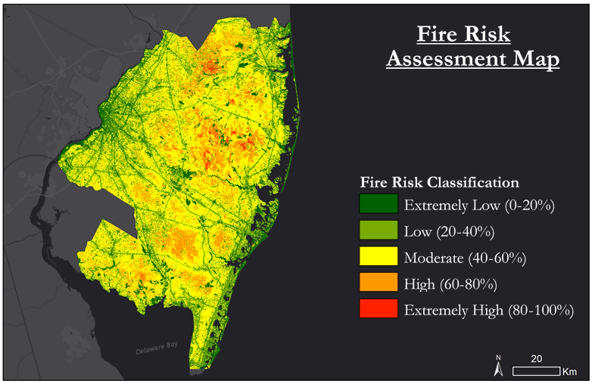

*Figure 3*. Fire Risk Assessment Map for southern New Jersey classified in five equal intervals from low to high.

The analysis of the Pineland WUI showed that the majority of all four regions is in low and moderate fire risk areas (Table 3; Appendix C). The extremely high fire risk areas in the Pinelands WUI account for less than 0.5% of the total area, while 13% of the region is in high fire risk areas and 53% of the region is in low and moderate fire risk areas.

Table 3

*Fire risk analysis of the Pinelands WUI*

|  |  |  |  |  |  |  |
| --- | --- | --- | --- | --- | --- | --- |
| Pinelands WUI | Total Area in acres | Fire risk Area within Pinelands WUI in acres | | | | |
| Extremely Low | Low | Moderate | High | Extremely High |
| Regional Growth Area | 126028.9 | 25197.3 | 29767.5 | 59672.8 | 11284.3 | 107.0 |
| Rural development area | 125245.9 | 10789.9 | 17679.5 | 78170.1 | 18499.2 | 107.2 |
| Pinelands villages | 26128.5 | 3069.5 | 4603.6 | 12295.1 | 6012.4 | 147.9 |
| Pinelands Town | 24524.3 | 5388.4 | 5707.1 | 10825.9 | 2579.8 | 23.1 |

***4.2 Future Work***

The team was unable to validate their results due to the lack of 2018 fire occurrence data and ground truth data. In the future, ignition source data from 2018 can be overlain on the Fire Risk Assessment Map to determine its accuracy. The WUI boundaries within the Pinelands were from 2014, so the current extent of the Pinelands WUI was unknown. A fire risk analysis of the Pinelands WUI should be conducted once current WUI boundaries are available. Higher resolution climate data and other edaphic or topographic variables could be incorporated into the analysis to more accurately assess wildfire risk in the Pinelands. As more updated data becomes available, the project partner can input it into the Fire Risk Assessment Tool and continue to generate updated fire risk assessment maps. Moreover, the NJPC can utilize the fire risk analysis of the Pinelands WUI to identify areas within the Pinelands to expand urban development.

# 5. Conclusions

A majority of the Pinelands WUI lie in low and moderate fire risk zones, which are considered to be suitable areas for development. The areas in the high and extremely high fire risk zones primarily lie in the Pinelands Preservation Area where development is not permitted.

The most recent fire risk analysis of the New Jersey Pinelands was conducted in 1981 by the NJPC. Given the 30-40 year time difference, differences in fire risk between the 1981 map and the newly generated 2017 map were discovered. This project’s 2017 map displays considerably more land lying in moderate fire risk areas than the fire risk map created in 1981. The fire risk map of 1981 shows the majority of the Pinelands in moderate to extreme fire hazard zones, with moderate zones outlining the northwestern region of the Pinelands. In the 2017 map, the majority of the study area lie in moderate risk zones, with high and extreme fire risk in isolated areas of the Pinelands.

As population in the region continues to grow, the boundaries of each fire risk area may change. The NJPC can use the end products produced by this project for planning the development of areas within the Pinelands WUI as the population continues to increase over time. The Fire Risk Assessment Map will help the NJPC to target areas for increased wildfire mitigation and to determine areas most suitable for urban development based on low fire risk. Moreover, the project partner will be able to produce updated fire risk assessments maps as new data becomes available using the Fire Risk Assessment Tool.

# 6. Acknowledgments

The team would like to thank the efforts of several instrumental people involved with this project from its inception to completion.

Dr. Jeffrey Luvall (NASA Marshall Space Flight Center)

Dr. Robert Griffin (University of Alabama in Huntsville)

Larry Liggett (New Jersey Pinelands Commission)

Gina Berg (New Jersey Pinelands Commission)

Williams Zipse (New Jersey State Forest Service)

Jeremy Webber (New Jersey State Forest Service)

Maggi Klug (University of Alabama in Huntsville)

Leigh Sinclair (University of Alabama in Huntsville/Information Technology and Systems Center)

Helen Baldwin (NASA DEVELOP MSFC)

This material contains modified Copernicus Sentinel data 2017, processed by ESA.

Any opinions, findings, and conclusions or recommendations expressed in this material are those of the author(s) and do not necessarily reflect the views of the National Aeronautics and Space Administration.

This material is based upon work supported by NASA through contract NNL16AA05C and cooperative agreement NNX14AB60A.

# 7. Glossary

**Earth observations** – Satellites and sensors that collect information about the Earth’s physical, chemical, and biological systems over space and time

**Fuzzy Logic** – A type of logic that separates answers from the discrete categories True or False, into a range of what is likely true and what is likely false

**Fuzzy Membership** – A tool in ArcMap that transforms an input raster to a 0 to 1 scale, indicating the strength of membership in a set based on a specified fuzzification algorithm; a value of 1 indicates full membership in the fuzzy set, while a value of 0, indicates the pixel is not a member of the fuzzy set

**Fuzzy Overlay** – The fuzzy overlay tool allows the analysis of the possibility of a phenomenon belonging to multiple sets in a multi-criteria overlay analysis.; not only does fuzzy overlay determine what sets the phenomenon is possibly a member of, it also analyzes the relationships between the membership of the multiple sets

**NDVI** – The Normalized Difference Vegetation Index is the ratio between NIR and red spectral bands that shows the presence of green vegetation in an area; NDVI values ranges from -1 to +1 indicates lower to higher vegetation cover

**Pinelands towns** – Areas of the Pinelands WUI where residential development is permitted at a density of two to four homes per acre with sewers; there are seven large Pinelands towns

**Pinelands villages** – Areas of the Pinelands WUI which are spatially discrete settlements that are appropriate for infilling with residential, commercial and industrial development compatible with their existing character; there are forty-seven small Pinelands villages

**Regional growth areas** – Parts of Pinelands WUI which are areas of existing growth and accommodate regional growth influences while protecting the essential character and environment of the Pinelands

**Rural development area** – Areas where limited low-density residential development and roadside retail are permitted in the Pinelands WUI; the transitional areas that balance environmental and developmental values between conservation and growth areas

**TCW** – Tasseled Cap Wetness; an index associated with soil and vegetation moisture that is less sensitive to topographic effects and more responsive to interaction between water content and canopy structure

**Wildland Urban Interface** –The line, area, or zone where structures and other human development meet or intermingle with undeveloped wildland or vegetative fuels

# 8. References

Baig, M. H. A., Zhang, L., Shuai, T., & Tong, Q. (2014). Derivation of a tasselled cap transformation base on Landsat 8 at-satellite reflectance. *Remote Sensing Letters*, *5*(5), 423-431.

Calviño-Cancela, M., Chas-Amil, M. L., García-Martínez, E. D., & Touza, J. (2017). Interacting effects of topography, vegetation, human activities and wildland-urban interfaces on wildfire ignition risk. *Forest Ecology and Management*, *397*, 10-17. doi:10.1016/j.foreco.2017.04.033

Chas-Amil, M. L., Touza, J., & García-Martínez, E. (2013). Forest fires in the wildland–urban interface: a spatial analysis of forest fragmentation and human impacts. *Applied Geography, 43*, 127-137.

Clark, K. L., Skowronski, N., Gallagher, M., Renninger, H., & Schäfer, K. (2012). Effects of invasive insects and fire on forest energy exchange and evapotranspiration in the New Jersey pinelands. *Agricultural and Forest Meteorology*, *166*, 50-61. Retrieved from <https://www.sciencedirect.com/science/article/pii/S0168192312002419>

DeBano, L. F. (2000). The role of fire and soil heating on water repellency in wildland environments: A review. *Journal of Hydrology*, *231*, 195-206. Retrieved from <https://www.sciencedirect.com/science/article/pii/S0022169400001943>

Deering, D. W. (1975). Measuring" forage production" of grazing units from Landsat MSS data. In *Proceedings of the Tenth International Symposium of Remote Sensing of the Environment*, 1169-1198.

European Space Agency. (2015). Sentinel-2 Data [Data set]. Geoscience Australia. Retrieved from <https://doi.org/10.4225/25/566a407cd2e2b>

Forman, R. T. (Ed.). (1998). *Pine Barrens: Ecosystem and Landscape*. New Burnswick, New Jersey: Rutgers University Press.

Fox, D. M., Martin, N., Carrega, P., Andrieu, J., Adnès, C., Emsellem, K., ... & Fox, E. A. (2015). Increases in fire risk due to warmer summer temperatures and wildland urban interface changes do not necessarily lead to more fires. *Applied Geography*, *56*, 1-12.

Ludlum, D. M. (1983). *The New Jersey weather book*. New Brunswick, NJ: Rutgers University Press. Retrieved from <https://climate.rutgers.edu/stateclim_v1/njclimoverview.html>.

Martinuzzi, S., Stewart, S. I., Helmers, D. P., Mockrin, M. H., Hammer, R. B., & Radeloff, V. C. (2015). *The 2010 wildland-urban interface of the conterminous United States. Research Map NRS-8*. Newtown Square, PA: US Department of Agriculture, Forest Service, Northern Research Station.

New Jersey Pinelands Commission (NJPC). (2015). *The Pinelands National Reserve*. Retrieved January 24, 2018, from <http://www.nj.gov/pinelands/reserve/>

New Jersey Department of Environmental Protection. (2017). *Wildfire Danger Levels & Restrictions*. Retrieved from <http://www.state.nj.us/dep/parksandforests/fire/firedanger-restrictions.htm>

Radeloff, V. C., Hammer, R. B., Stewart, S. I., Fried, J. S., Holcomb, S. S., & McKeefry, J. F. (2005). The wildland–urban interface in the United States. *Ecological Applications, 15*(3), 799-805. doi: 10.1890/04-1413

Rouse, J. W., Haas, R.H., Schell, J.A. and Deering, D.W. (1973). Monitoring vegetation systems in the Great Lakes with ERTS*.* In *Third ERTS Symposium,* *NASA SP-351 I*, 309-317.

Stewart, S.I., Radeloff, V.C., & Hammer, R.B. (2003). Characteristics and location of the wildland urban interface in the United States. In *Proceedings of the Second International Wildland Fire Ecology and Fire Management Workshop*, Orlando, FL, November 16–20. Retrieved from <https://www.researchgate.net/publication/237434606>

Stewart, S. I., Radeloff, V. C., Hammer, R. B., & Hawbaker, T. J. (2007). Defining the wildland-urban interface. *Journal of Forestry*, *105*(4), 201-207. Retrieved from <http://fpf.forestry.oregonstate.edu/system/files/Stewartetal_definingWUI.pdf>

Theobald, D. M., & Romme, W. H. (2007). Expansion of the US wildland-urban interface. *Landscape and Urban Planning*, *83*, 340-354. Retrieved from <http://dx.doi.org/10.1016/j.landurbplan.2007.06.002>

US Department of Agriculture, US Department of the Interior, National Association of State Foresters, And National Association of Counties. (2002). *National Fire Plan Memorandum of Understanding for the Development of a Collaborative Fuels Treatment Program*. Retrieved from [www.fireplan.gov](http://www.fireplan.gov)

US Forest Service. 2007. Fiscal Year 2007 Budget Justification. Retrieved from [www.fs.fed.us/publications/budget-2007/fy2007 - forest-service-budget-justification.pdf](http://www.fs.fed.us/publications/budget-2007/fy2007%20-%20forest-service-budget-justification.pdf)

U.S. Geological Survey Earth Resources Observation and Science Center. (2014). Provisional Landsat OLI Surface Reflectance [Data set]. Retrieved from <https://doi.org/10.5066/f78s4mzj>

# 9. Appendices

Appendix A. Relationship among Ignition Sources and Vegetation Indices Derived from Sentinel and Landsat Data.

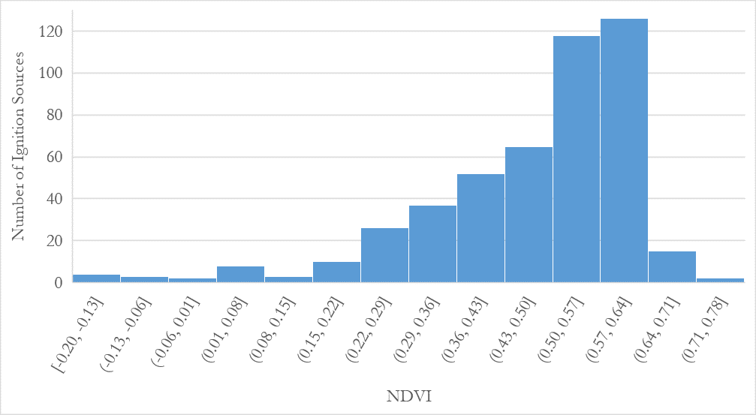

*Figure A1*. Histogram showing the NDVI values found at the point locations of ignition sources from the Sentinel-2 MSI data during the leaf on season.

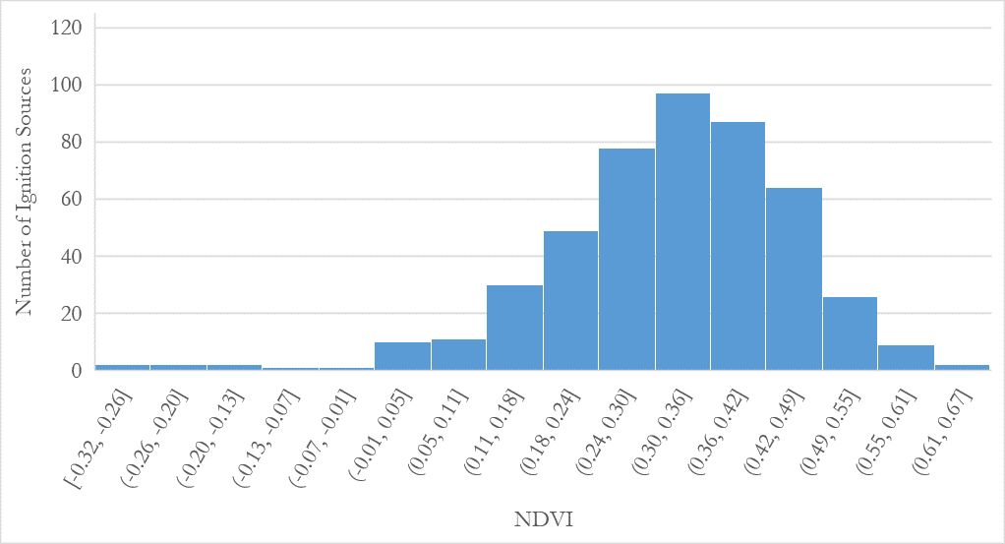

*Figure A2*. Histogram showing the NDVI values found at the point locations of ignition sources from the Sentinel-2 MSI data during the leaf off season.

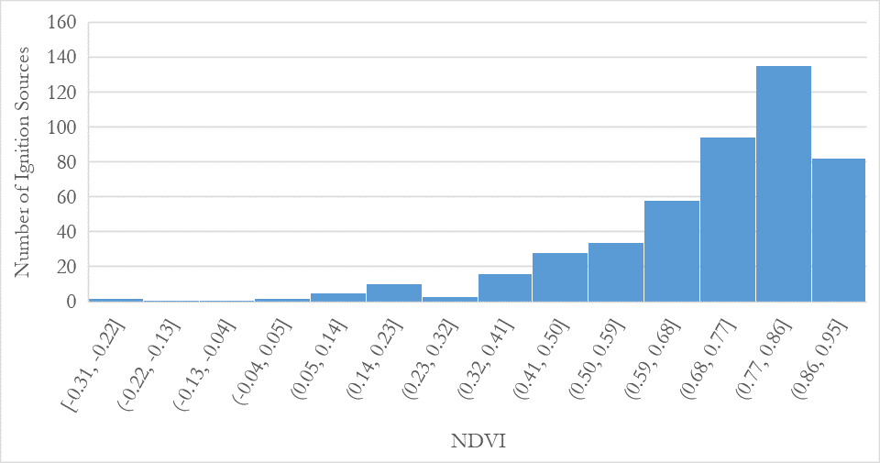

*Figure A3*. Histogram showing the NDVI values found at the point locations of ignition sources from the Landsat 8 OLI data during the leaf on season.

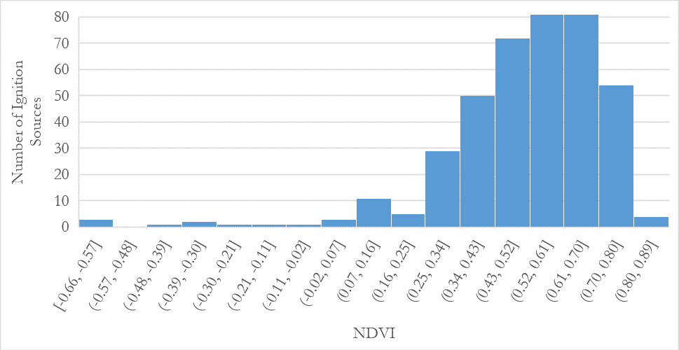

*Figure A4*. Histogram showing the NDVI values found at the point locations of ignition sources from the Landsat 8 OLI data during the leaf off season.

Appendix B. Relationships between Ignition Sources and Elevation

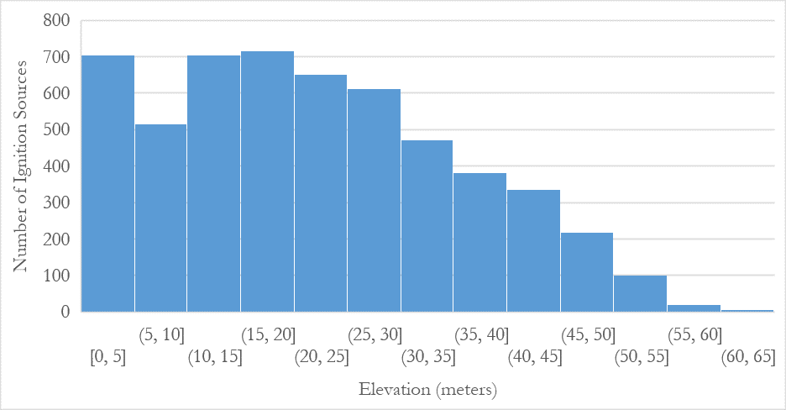*Figure B1*. Histogram showing the average elevation value calculated from 3DEP data found at the point locations of ignition sources throughout the study area.

Appendix C. Fire Risk Analysis of the Pinelands WUI

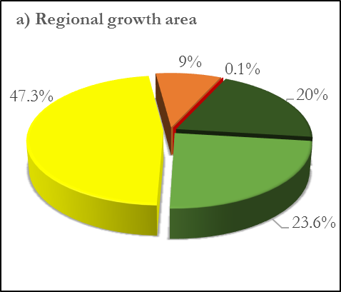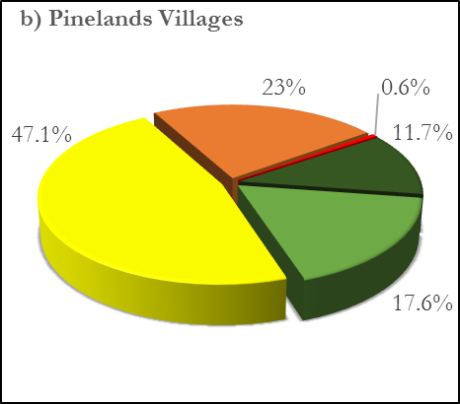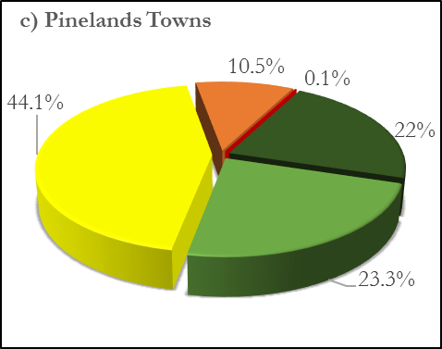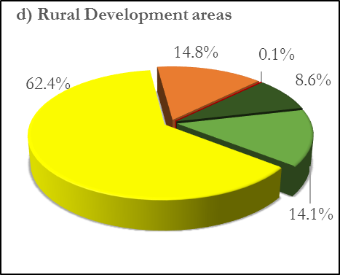

*Figure C1*. Fire risk analysis of the regional growth area (a), Pinelands villages (b), Pinelands towns (c), and rural development areas (d) within the pinelands management area. This shows that less areas are under higher fire risk and more areas in low and moderate fire risk.

.