**NASA DEVELOP National Program**

****NASA Jet Propulsion Laboratory

**Fall 2015**

**Short Title: New Mexico Water Resources II**

**Subtitle:** Delivering Automated Evapotranspiration Data to the New Mexico Office of the State Engineer for Enhanced Water Resource Decision Making

**VPS Title:** Automating the Not-So-Extraterrestrial ET

**Project Team & Partners**

**Project Team:**

Trevor McDonald (Project Lead), [tjmcdonald@ucla.edu](mailto:tjmcdonald@ucla.edu)

Gregory Halverson

**Advisors & Mentors:**

Joshua Fisher (NASA Jet Propulsion Laboratory)

Greg Moore (NASA Jet Propulsion Laboratory)

Munish Sikka (California Institute of Technology)

**Past or Other Contributors:**

Sol Kim

Agustin Muniz

**Partner Organizations:**

New Mexico Office of the State Engineer (End-User), POC: John Longworth

**Project Details**

**Applied Sciences National Applications Addressed:** Water Resources

**Study Area:** Eastern Plains Region of New Mexico (NM)

**Study Period:** March 2000 - Present (Ongoing daily products generated)

**Earth Observations & Parameters:**

Terra & Aqua, MODIS – Evapotranspiration

**Ancillary Datasets Utilized:**

* National Centers for Environmental Prediction (NCEP) Reanalysis II – 2 meter temperature, specific humidity, minimum temperature, U-wind

**Models Utilized:**

* NASA JPL Evapotranspiration (PT-JPL)

**Software Utilized:**

Python – To submit download requests for 14 datasets total – 6 MODIS land, 4 MODIS atmosphere, and 4 National Centers for Environmental Prediction datasets

Cron – To automatically run Python and Shell scripts on daily basis

HDF-EOS to GeoTIFF Conversion Tool (HEG) – Used for converting MODIS atmospheric swath data into sinusoidal tiles/stitching of various MODIS data/data subsampling

GDAL – Python library used to merge, project and calculate zonal statistics of evapotranspiration (ET) data

MATLAB – Calculations for ET products and conversion to GeoTiff data format

Apache – HTTP web server application housing web content

Apache Tomcat – Java Servlet container for Java code to run in, essential for GeoServer

GeoServer – Geospatial data server written in Java, serving raster and vector to web

Leaflet – JavaScript library to create interactive web map

Curl – To create interactivity between source files and GeoServer

**Project Overview**

**80-100 Word Objectives Overview:**

The goal of this project is to automate the acquisition, processing, and delivery of evapotranspiration data to the New Mexico Office of the State Engineer. Dr. Fisher’s PT-JPL Evapotranspiration model ingests the NCEP and MODIS Land and Atmosphere datasets we acquire to compute daily global evapotranspiration products. These products create valuable and timely data for any decision-maker in the ranching, water resources, drought assessment and fire-response communities. In particular, these communities, in the Eastern Plains Region of New Mexico, will have access to our daily ET products through an interactive web map application enabling them to improve management planning and assessment.

**Abstract:**

With the southwestern region of the United States experiencing unprecedented drought conditions, improving and deploying real time applications enable water resource managers to plan and manage more effectively. Dr. Fisher’s daily evapotranspiration (ET) product implemented through our pipeline provide an improved temporal and spatial resolution assessment of rangeland water resource conditions, consequently enhancing decisions related to cattle management, emergency response for rapid rangeland and farmland deterioration, fire management risk decisions, and determining drought severity. The current assessment methods that New Mexico land managers and decision-makers utilize include spatially limited *in situ* spot check as well as weekly Normalized Difference Vegetation Indices (NDVI) and ET products for New Mexico counties. The current methods are insufficient because of difficult accessibility, limited information, and lack of distribution. Our team’s automated and streamlined pipeline, in combination with Dr. Fisher’s daily ET product delivered to the New Mexico Office of the State Engineer will prove to be critical in enhancing water resource decision-making.

**Community Concerns:**

* Eastern New Mexico has suffered from consistent drought conditions throughout the last decade, negatively impacting agriculture, ranching, and the gas and oil industries.
* Prolonged and unprecedented drought conditions continue with the possibility of worsening in the future to due climatic changes.
* Decision makers need to be equipped with a superior temporal and spatial resolution assessment to guide water use and land use management plans.
* Decision makers need easier access to remotely sensed data, such as our ET data for improved management and distribution.

**Current Management Practices & Policies**:

Currently, New Mexico land managers and decision-makers utilize spatially limited *in situ* spot checks and NDVI products processed by the New Mexico Department of Agriculture from the USDA Forest Service. Neither of the current modes meets the spatial extent or temporal resolution necessary for improved water resource management. These current methods lack ease of access and are not widely distributed. Additionally, current ET products used by New Mexico land managers are problematic because they are either too coarse to be useful or are proprietary which restricts accessibility and distribution.

**Decision Support Tools & Benefits:**

|  |  |  |
| --- | --- | --- |
| **End-Product** | **Earth Observations Used** | **Benefit & Impact** |
| Automated & interactive web map, serving Dr. Fisher’s multi-temporal ET data for New Mexico land managers and decision makers | Suite of MODIS data from Terra & Aqua | Provide multi-temporal high-resolution remotely sensed ET data to guide & analyze water/land use practices in New Mexico |

**Project Imagery**

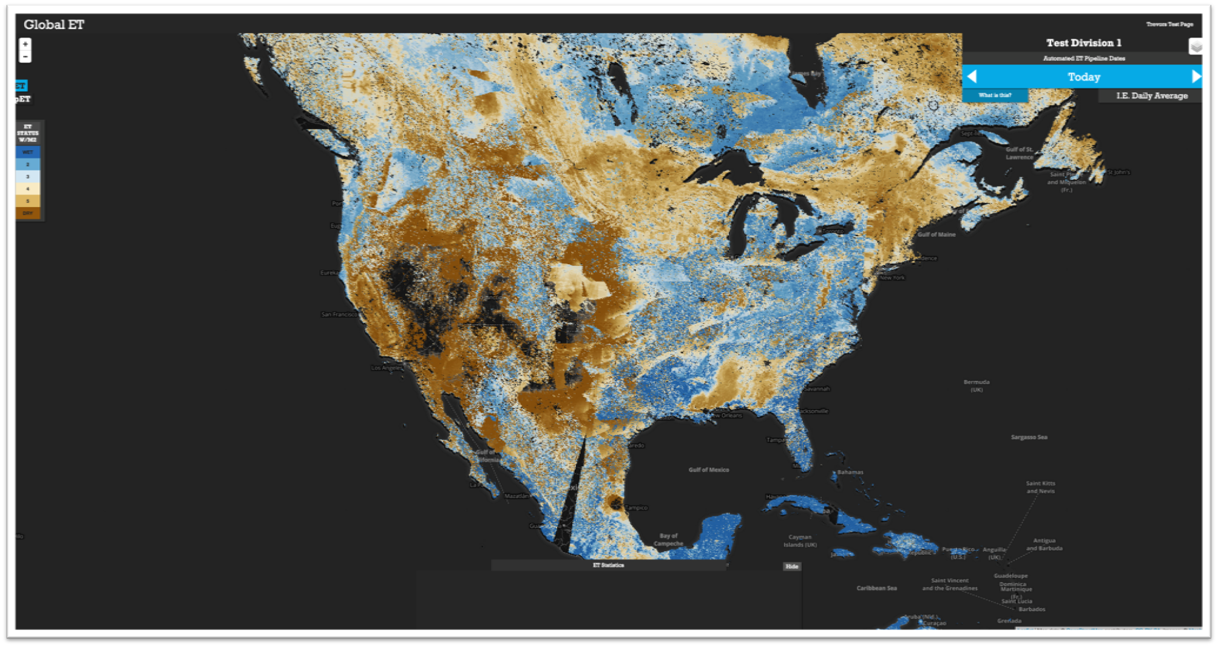

**Caption:** Prospective Web Interface

Image Credit: [New Mexico Water Resources & Agriculture Team.

**Image:** NMWaterF2015_WEB

**Software Release Requirements**

Category V