Maine Ecological Forecasting III

Utilizing Earth Observations to Monitor Federally Endangered Atlantic Salmon (*Salmo salar*) Habitat in Maine: An Interactive Workshop

 **Technical Report**

Final – August 11th, 2022

Jonathan Falciani (Project Lead)

Colin Hogan

Linda Mitchell

Makario Sarsozo

***Advisors:***

Sean McCartney, Science Systems and Applications, Inc., NASA Goddard Space Flight Center (Science Advisor)

Dr. Bridget Seegers, NASA Goddard Space Flight Center, Morgan State University (Science Advisor)

Joseph Spruce, Science Systems and Applications, Inc. (Science Advisor)

***Previous Contributors:***

Tony Bowman

Philip Casey

Michael Corley

Olivia Landry

Christopher Matechik

Lily Oliver

Kelsey Preslar

Brian Varley

# 1. Abstract

Shifting patterns in land use and land cover (LULC), temperature, and precipitation have exacerbated a rapid decline in Federally Endangered wild Atlantic salmon (*Salmo salar*) populations. The team at NASA DEVELOP partnered with the Maine Department of Marine Resources (DMR) and the Downeast Salmon Federation (DSF) to create a comprehensive workshop designed to demonstrate the applicability of Earth observations in examining these threats using the Penobscot, Union, and Machias Rivers as case studies. This entailed curating tutorials for acquiring and analyzing satellite data using Google Earth Engine, EarthExplorer, and Earthdata. The team demonstrated how to classify LULC in ArcGIS Pro from 1985 until 2021 using Landsat 5 Thematic Mapper (TM), Landsat 8 Operation Land Imager (OLI), Sentinel-2 MultiSpectral Instrument (MSI), and datasets from the United Stated Geological Survey (USGS) National Land Cover Database (NLCD), showing an overall transition from coniferous forests to other LULC classes. The team also demonstrated how to use historical data from Terra Moderate Resolution Imaging Spectroradiometer (MODIS) and Integrated Multi-satellite Retrievals for Global Precipitation Measurement (GPM IMERG) to generate 2021 land surface temperature (LST) and precipitation maps, respectively, showing that Maine was abnormally dry during the summer in an increasingly warm region. These workshop materials will aid the partners in integrating NASA Earth observations into their future salmon habitat restoration initiatives.

**Key Terms**

MODIS, Landsat, LULC, precipitation, land surface temperature, critical salmon habitat, data communication, environmental change

# 2. Introduction

***2.1 Background Information***

Once abundant throughout New England, Atlantic salmon (*Salmo salar*) populations have been completely extirpated from all but the freshwater habitat of Maine. This anadromous fish has historically supported fisheries throughout the state, but faced a precipitous population decline against a backdrop of overfishing, dam construction, landscape changes, and climate change over the past two centuries (Jonsson & Jonsson, 2009; Turunen et al., 2021). The Gulf of Maine Distinct Population Segment is now protected by the Endangered Species Act as the last remaining population of wild Atlantic salmon in the United States, centering the rivers and streams of Maine in Atlantic salmon recovery efforts (National Marine Fisheries Service, National Ocean & Atmospheric Administration & United State Fish & Wildlife Service, 2000).

Naturally, juvenile salmon are reared in cold freshwater streams for 1 to 3 years before smolting in the summer and migrating to the saltwater habitats of the North Atlantic Ocean. Once mature, Atlantic salmon return to freshwater streams to spawn (McCormick et al., 1998). However, Atlantic salmon’s anadromous life history has made the species particularly vulnerable to rapid changes of climate and landscape during each life stage. Dam construction and overfishing physically obstruct mature Atlantic salmon from returning to their spawning grounds (Saunders et al., 2006). Land use and land cover (LULC) changes exacerbate both polluting stressors from increased agricultural runoff and thermal stressors from reduced riparian shade cover by displaced vegetation (Moore et al., 2005; Tang et al., 2005). Warming streams due to climate change compounds Atlantic salmon’s thermal stress by reducing fecundity, shifting emergence times, limiting oxygen, and decreasing metabolic rates (McCullough, 1999; Jonsson & Jonsson, 2009). Moreover, increasing drought frequency can affect habitat connectivity and increase interspecies competition (Frumhoff et al., 2007).

Today, Downeast Maine (Figure 1) presents an interesting case study because of its history of dam removal and its array of landscapes that include evergreen forest, deciduous forest, cultivated land, and urban development like the riverside cities of Bangor, Ellsworth, and Machias (Saunders et al., 2006; Figure 1). Despite the historical presence of dams, the Penobscot River alone once boasted an annual yield of no less than 100,000 Atlantic salmon and still hosts the largest Atlantic salmon run left in the United States, establishing it as one of the most important rivers to the species (Saunders et al., 2006). The Machias and Union Rivers contrast each other; the former had its last dam removed in 1978 and features a large conservation easement protecting the state’s largest juvenile salmon habitat, while the latter is still obstructed by two dams with no such protection against riverside development. These ties to the community in Maine create an opportunity to engage with residents who are largely unaware of the rate of extirpation of Atlantic salmon and how it directly affects them.

To target Atlantic salmon restoration efforts, the prior two terms of this DEVELOP project leveraged remote sensing data and *in-situ* measurements to assess LULC changes, temperature shifts, and precipitation patterns throughout the state of Maine. These teams used Landsat 5 Thematic Mapper (TM), Landsat 8 Operational Land Imager (OLI), Sentinel-2 MultiSpectral Instrument (MSI), and the National Land Cover Database (NLCD) to create increasingly refined LULC maps in 1985, 2003, and 2021, showing that Maine has experienced a net loss of evergreen and mixed forest, but a net gain of deciduous forest, agricultural, and developed land. The second team also forecasted these projections to 2040 using the Land Change Modeler in Idrisi TerrSet. Climate analysis leveraged Terra Moderate Resolution Imaging Spectroradiometer (MODIS) land surface temperature (LST) datasets to create temperature maps for 2000 to 2020 and leveraged Global Precipitation Measurement (GPM) Integrated Multi-satellite Retrievals (IMERG) to create precipitation maps for 2000 to 2020. These analyses indicated that agricultural and developed land were the warmest land uses while forests were the coolest. These results allowed the Maine Ecological Forecasting III team to focus efforts on regional case studies that were emblematic of LULC and climatic patterns.

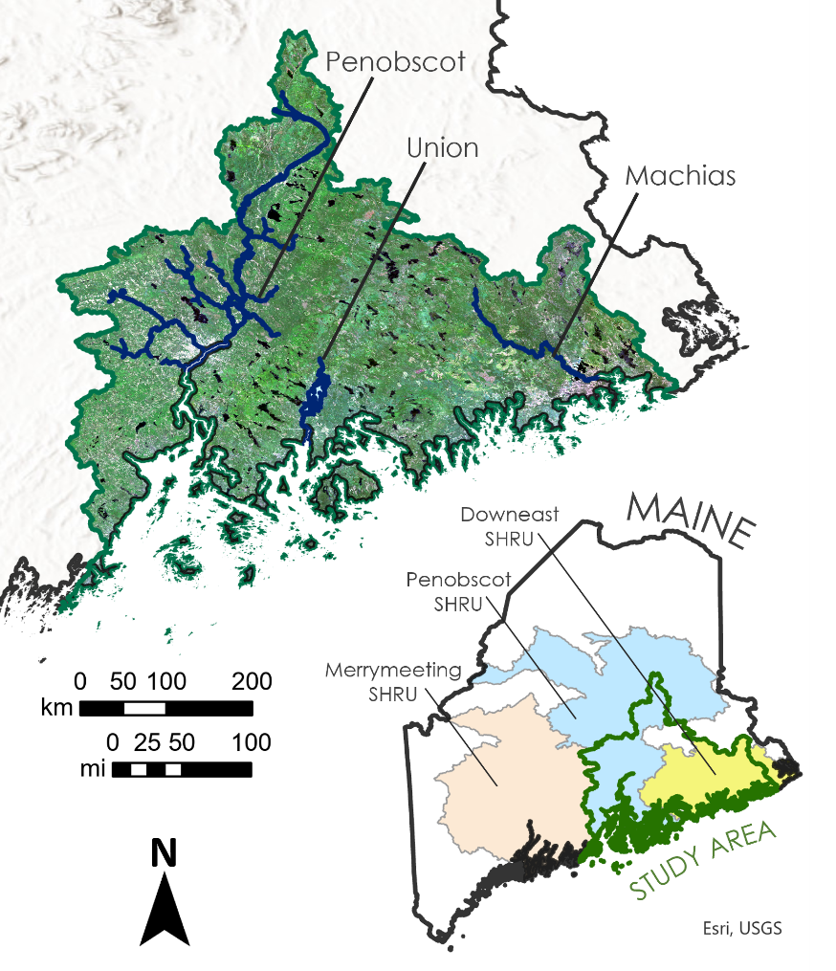

*Figure 1.* Study area within the state of Maine, henceforth referred to as Downeast Maine. Displayed inside the study area is an averaged summer 2021 Landsat 8 OLI true color composite image with the three case study rivers (the Penobscot River, the Union River, and the Machias River) labelled. The inset image of Maine shows the relationship of the study area with the three Salmon Habitat Recovery Unit (SHRU) delineations.

***2.2 Project Partners & Objectives***

The Maine Ecological Forecasting III team continued the partnership with the Department of Marine Resources (DMR) and the Downeast Salmon Federation (DSF) to transfer techniques, methodologies, and insights for accessing and using remote sensing data through detailed written tutorials and an interactive workshop. The DSF is a non-profit organization that focuses on conservation hatcheries, long-term land protection, and habitat restoration. The DMR is a state agency that works to advise local, state, and federal officials on the conservation of marine resources. Both organizations are interested in utilizing remote sensing data beyond their partnership with NASA DEVELOP to inform salmon habitat restoration decisions in the future.

To aid in this knowledge transfer, the team planned an interactive workshop with over 80 pages of accompanying written tutorials that focused on acquiring, processing, and analyzing remote sensing data to create LULC, LST, and precipitation maps of the Downeast region. The team placed special focus on the Penobscot, Union, and Machias Rivers identified in collaboration with results from the prior DEVELOP terms and partner insight. The written tutorials and the live workshop first detailed the satellite data each team used and several ways to acquire it. The team also detailed steps to produce LULC maps, highlighting features of interest. The final part of the demonstration showed how to map climatic variables to identify trends between LST, precipitation, LULC, and *in-situ* measurements.

# 3. Methodology

***3.1 Written Tutorials***

*3.1.1 Earth Observation Overview*

The Earth Observation Overview is a document that lists the satellites and sensors relevant to the Maine Ecological Forecasting III project and the partners’ conservation initiatives for future reference. This document includes reference photos and specifications like the bands, spatial resolution, and temporal resolution of each satellite and sensor. The Earth Observation Overview included the following satellites and sensors: Aqua MODIS, Terra MODIS, Landsat 5 TM, Landsat 8 OLI, Landsat 9 OLI-2, GPM IMERG, Sentinel-1 Synthetic Aperture Radar (SAR), Sentinel-2 MSI, and Suomi National Polar-Orbiting Partnership (NPP) Visible Infrared Imaging Radiometer Suite (VIIRS).

*3.1.2 Data Acquisition Tutorials*

The team created three data acquisition tutorials to provide the DMR and the DSF with step-by-step instructions on using EarthExplorer, Earthdata, and Google Earth Engine (GEE) to access Earth observations in the future. These tutorials provide detailed documentation on navigating each platform interface using Landsat 8 OLI imagery of Downeast Maine as an example. The EarthExplorer Tutorial shows users how to access Earth observation data hosted by the United States Geological Survey (USGS). Similarly, the Earthdata Tutorial provides detailed instructions on accessing Earth observations hosted on the NASA Global Imagery Browser Service. Both the EarthExplorer and Earthdata tutorials explain how to conduct a search, select datasets, visualize data, and download data. The Google Earth Engine Tutorial explains how to use the GEE code editor to access, process, and download Earth observations hosted on the Earth Engine Data Catalog using a sample of GEE’s scripting language.

*3.1.3 Land Use & Land Cover Tutorial*

The team also produced an LULC tutorial for the partners which describes how to create their own LULC map using 2021 imagery of Downeast Maine as an example. This tutorial adapts the methodology used by Maine Ecological Forecasting II using raw Landsat 8 OLI imagery clipped to the Downeast Maine study area. First, the tutorial details several ways to calculate indices in ArcGIS Pro. Using the 2020-2021 leaf-on and leaf-off Landsat 8 OLI data acquired last term, the tutorial provides instructions to calculate the year’s summer and winter Normalized Difference Vegetation Index (NDVI) using the Raster Functions pane in ArcGIS Pro (Equation 1; Sousa da Silva et al., 2020).

$$\begin{aligned}NDVI = \frac{NIR - Red}{NIR + Red}\#1\end{aligned}$$

The Modified Bare Index (MBI) is calculated using the custom Band Arithmetic function in ArcGIS Pro with data from the summer 2021 median Landsat imagery to assess cultivation (Equation 2; Nguyen et al., 2021).

$$\begin{aligned}MBI = \frac{SWIR1 - SWIR2 - NIR}{SWIR1 + SWIR2 + NIR}\#2\end{aligned}$$

The Normalized Difference Built-Up Index (NDBI) is also calculated using the Band Arithmetic function with summer 2021 median Landsat imagery to assess urbanization (Equation 3; Zha et al., 2003).

$$\begin{aligned}NDBI = \frac{SWIR1 - NIR}{SWIR1 + NIR}\#3\end{aligned}$$

The next part of the LULC tutorial details how to use the ArcGIS Pro Image Classification Wizard to classify LULC in Downeast Maine. The composite image used for the Image Classification wizard consists of raw Landsat imagery along with NDVI, MBI, and NDBI to remain consistent with Maine Ecological Forecasting II’s methodology. The tutorial shows how to perform an unsupervised pixel-based classification using this raster due to the unavailability of *in-situ* training data in the state. As an example, the tutorial classifies images into eight land cover categories: water, wetlands, deciduous forest, evergreen forest, planted/cultivated, barren, developed, and a snow/cloud mask. Evergreen forest is distinguished using the aforementioned winter NDVI calculation to determine where vegetation is present during winter months. After a section on determining accuracy, inaccuracies among classes are addressed through a step-by-step “cluster-busting” walkthrough in which the developed class is isolated and rerun separately through the Image Classification Wizard using the previous composite image and the Raster Calculator. By the end, users should have the tools to create LULC maps like those in Maine Ecological Forecasting I and II (Figure 2) to assess land change in any area and time period relevant to salmon conservation.

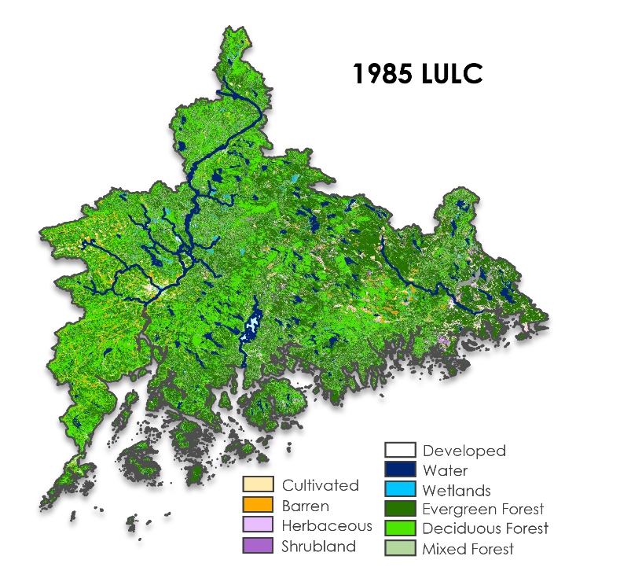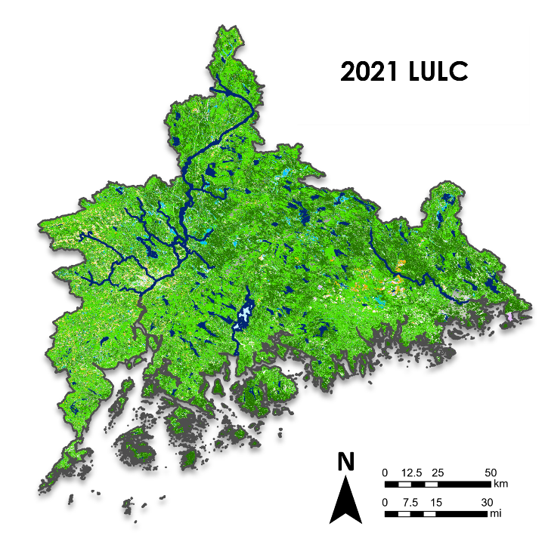

*Figure 2*. (Left) LULC from 1985 derived from Landsat 5 TM by Maine Ecological Forecasting II. (Right) LULC from 2021 derived from Landsat 8 OLI by Maine Ecological Forecasting II. The Penobscot, Union, and Machias Rivers are indicated.

*3.1.4 Climate Tutorial*

The final tutorial provides a walkthrough on accessing and processing climatic variables. This tutorial provides the partners with step-by-step instructions to map LST and precipitation data, produce a time series, create anomaly maps, and analyze relationships between climatic variables. The tutorial starts with comparing an *in-situ* stream temperature time series accessed via the Eco Spatial Hydro-Ecological Decision System (EcoSHEDS) Stream Temperature Database against a concurrent historical LST time series derived from Terra MODIS accessed via an adapted GEE script. The GEE script also shows how to access Terra MODIS LST data, process it, and map it (Figure 3, Left).

The climate tutorial introduces Downeast Maine’s drought trends using the U.S. Drought Monitor (USDM) in Climate Engine before pivoting to ArcGIS Pro to process spatial data against historical averages. To do so, the tutorial uses the Raster Calculator to produce absolute and relative difference maps between summer 2021 GPM IMERG precipitation data and a 20-year summer GPM IMERG precipitation baseline (Figure 3, Right). To demonstrate how this data can be used to identify areas of compounding stressors for Atlantic salmon, the tutorial shows how to use the Extract by Attributes and Clip by Properties tools to filter for areas over 20°C and under 80% of the historical summer precipitation. Lastly, the tutorial uses the 2021 LULC map to demonstrate the Zonal Statistics as Table tool to draw preliminary statistical relationships between LULC and LST. By the end, users should have the tools to continue investigating the climatological trends observed by Maine Ecological Forecasting I and II relating to freshwater salmon habitat.

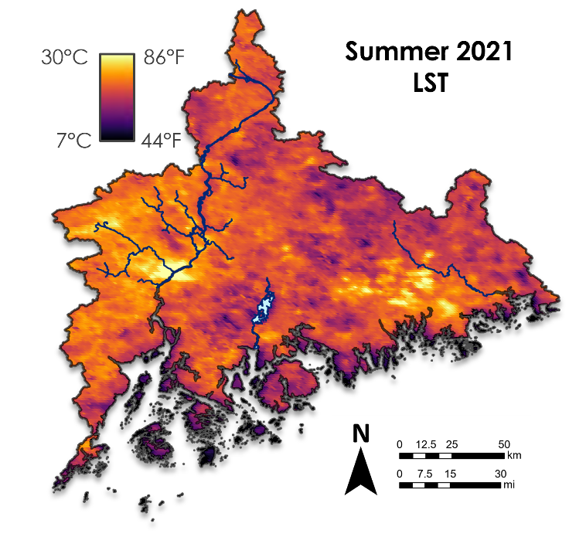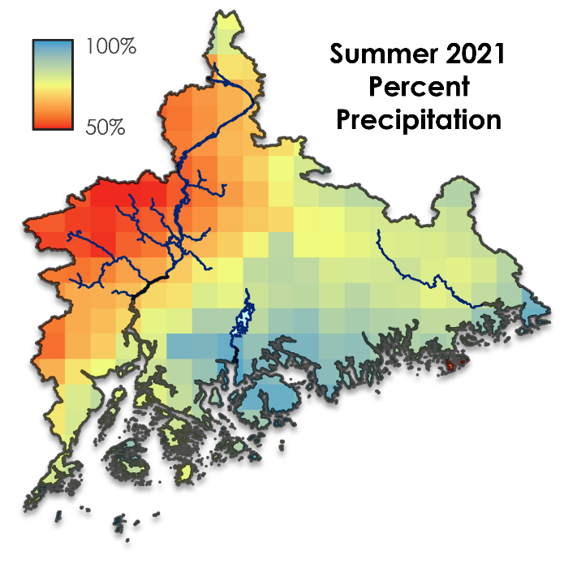

*Figure 3.* (Left) Summer 2021 LST in Downeast Maine. (Right) Summer 2021 percent precipitation in relation to the summer 2000-2020 average baseline. The Penobscot, Union, and Machias Rivers are indicated.

***3.2 Case Study Analysis***

In addition to providing the partners with written tutorials, the team also produced a case study to demonstrate how Earth observations can be applied to monitor riparian habitat over time. To do so, the team analyzed trends in the Downeast region along the Penobscot, Union, and Machias Rivers by leveraging maps produced by Maine Ecological Forecasting I and II (Figure 4). The study area was defined by merging the Lower Penobscot and Maine Coastal Hydrologic Unit Code 8 (HUC-8) subbasins. The river delineations were acquired from the National Hydrography Dataset (NHD) where the Union River was merged with Graham and Leonard Lakes. To capture trends within riparian habitat like the 1000-foot riverside easement along the Machias River, the team established a 2000-foot buffer along either side of each river to calculate associated trends.

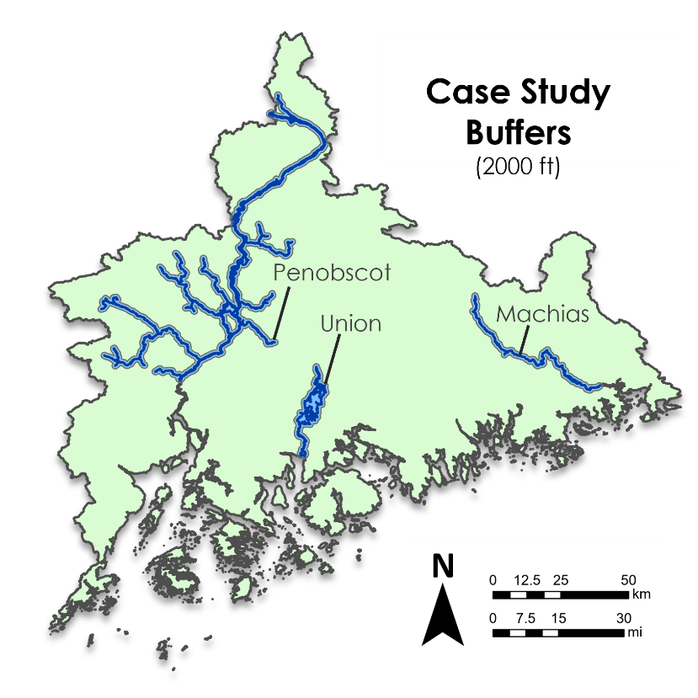

*Figure 4.* 2000-foot riparian buffers, indicated in light blue, used to elucidate LULC, LST, and precipitation trends from the aforementioned data sources for the Penobscot, Union, and Machias Rivers, indicated in dark blue. The Downeast study area is shown in green.

LULC trends were calculated using the 1985 and 2021 LULC maps produced by Maine Ecological Forecasting II. That team acquired median Landsat 5 TM and Landsat 8 OLI (Collection 2, Tier 1, Level 2) for leaf-off (winter, December 31 – March 8) and leaf-on (summer, May 1 – July 31) imagery for 1985 and 2021 respectively. The team composited winter NDVI, summer NDVI, summer MBI, and summer NDBI with the associated summer Landsat spectral bands which was input into the ArcGIS Image Classification Wizard. Confused classes underwent cluster-busting in which they were isolated and underwent an additional round of classification using all summer spectral bands, winter NIR and SWIR, winter NDVI, and summer NDVI. The Zonal Histogram tool totaled the percent area taken by each LULC class within the 2000-foot buffers for each river and the study area for 1985 and 2021.

Climate trends were calculated using data produced by Maine Ecological Forecasting I. In addition to monthly averages, that team calculated summer averages (May 1 – July 31) for Terra MODIS LST and GPM IMERG precipitation in GEE and Giovanni. In GEE, the Maine Ecological Forecasting III team produced a 20-year summer precipitation baseline using summer data between 2000 and 2020. The summer 2021 precipitation map was divided against the baseline to produce a summer 2021 percent precipitation map (Figure 3, Right). The Zonal Statistics as Table tool calculated the mean summer LST for each river from 2000 until 2021 and the mean percent precipitation for each river in 2021.

# 4. Results & Discussion

***4.1 Workshop***

In collaboration with the partners, the team prepared a three-hour live workshop to demonstrate how to access Earth observation data and how it can be used to monitor Atlantic salmon habitat. The live workshop consisted of interactive demonstrations that followed the written tutorials in which attendees were invited to follow along in real time (Figure 5). Attendees included members of conservation non-profits, like the DSF, and government agencies, like the National Oceanographic and Atmospheric Administration (NOAA), the U.S. Fish and Wildlife Service (USFWS), the Maine Department of Environmental Protection (DEP), and the Maine DMR. There were varying levels of technical ability, as some attendees had little to no experience with software such as ArcGIS Pro or GEE, while others used these programs daily. Given the difference in backgrounds and technical skills, having both interactive and demonstration elements ensured that attendees took something away from the workshop despite their varied backgrounds.

*Figure 5.* The order of the three-hour live workshop. Each section has its purpose labeled along the central horizontal line. Whether the product was delivered as a written tutorial, workshop demonstration, or both is indicated.

*4.1.1 Introduction and Earth Observation Overview*

Prior to the workshop, the team shared an invitation that included each of the written tutorials and instructions to sign up for EarthExplorer and GEE. To begin the workshop, the team provided background information regarding salmon declines in Maine, an overview of Maine Ecological Forecasting I and II, and an outline of what the workshop would entail. The Earth Observation Overview provided an opportunity to explain what satellites were used throughout all three terms of the project. The team provided a “cheat sheet,” an abbreviated version of the written document, that linked to the webpages for each satellite and sensor that attendees could reference throughout the workshop.

*4.1.2 Data Acquisition Demonstrations*

The workshop then shifted to live demonstration. The project used Terra MODIS to assess historical temperature data, but also offered VIIRS as an alternative upon learning it will be decommissioned in the future. The first demonstration taught attendees how to acquire publicly available data through the EarthExplorer platform. Attendees that created an account prior to the workshop could follow along. This demonstration included how to use the EarthExplorer interface, select datasets, set up search criteria, perform a search, and download datasets using Landsat 8 imagery of Downeast Maine as an example. The next section focused on data acquisition through GEE in which the team walked users through acquiring Landsat 8 imagery and applying it to a study area of their choosing using code from the written tutorial. Like the EarthExplorer demonstration, attendees that created a GEE account prior to the workshop were given the chance to follow along.

*4.1.3 LULC Demonstration*

The third demonstration of the workshop showed LULC classification in ArcGIS Pro. To avoid long processing times, this section was mostly prerecorded and edited with a live voiceover to pause and answer questions when necessary. This demonstration assumed attendees would not follow along step-by-step using their own software, instead opting to keep the live demonstration more conceptual than the written tutorial. This section went over how to create an LULC map from the Landsat 8 imagery acquired in the data acquisition demonstrations using the ArcGIS Image Classification Wizard. It also briefly covered concepts such as index calculation, compositing, accuracy assessment, and cluster-busting. The team allotted time for a Q&A session in which attendees were given the opportunity to examine Maine Ecological Forecasting II’s LULC maps in areas of their interest. For example, attendees were interested in seeing how forest cover around the Machias River has shifted from evergreen to deciduous.

*4.1.4 Climate Demonstration and Conclusion*

The last section of the workshop demonstrated how the use of climatological Earth observations data. This section combined both presentation and interactive elements in which the attendees could follow along with comparing *in-situ* stream temperature time series in EcoSHEDS against remotely sensed Terra MODIS LST time series in GEE if they were inclined, but it was not expected. After emphasizing the benefits and trade-offs of *in-situ* versus remotely sensed data, this demonstration proceeded into ArcGIS to compare GPM IMERG precipitation data to historical averages as in the written tutorial and the case study analysis. The demonstration ended with using the Zonal Statistics as Table tool to draw relationships between summer 2021 LST and 2021 LULC. The team closed the workshop by reminding attendees that they had access to over 80 pages of written tutorials that provided walkthroughs in even greater detail than each live demonstration in the workshop. The workshop ended with a discussion of the case study analysis.

***4.2 Case Study Analysis***

*4.2.1 LULC Results*

Using the maps generated from term II, the team analyzed trends from 1985-2021 in the Downeast region specifically. The team found a drastic transition from evergreen to deciduous forests in the Downeast region. In the 36-year span that the study period covered, Downeast Maine lost over 155,000 hectares of evergreen forest (representing a decrease of 10 percentage points of the region) while gaining 183,000 hectares of deciduous forest (representing an increase of 12 percentage points of the region). This is consistent with Maine Ecological Forecasting II’s results which found this transition statewide. This team also found that evergreen forests are slightly cooler than deciduous forests. This transition between forests could be responsible for decreasing riparian shade which could lead to warmer stream temperatures, increasing the risk of exceeding juvenile salmon’s thermal tolerance. Furthermore, the team found that developed areas, among the warmest LULC classes, increased by 45,000 hectares in the Downeast region which could compound thermal stress even more (Figure 6).

The team was also able to track shifts in the percentage of each LULC class within each 2000-foot river buffers (Figure 6). Again, the most notable changes were a gain of deciduous forest cover and a loss of evergreen forest cover. In 2021, the Machias River retained the greatest proportion of both total forest cover and evergreen forest cover. The Machias River also experienced the greatest increase in forest cover since 1985 which could be due to the conservation easement preventing riverside development and timber extraction. Even the Machias River, however, experienced a net transition between evergreen and deciduous forest. The Penobscot River presented the greatest share of neighboring land use with little forest. Its main classifications were urban, barren, and cultivated areas—all of which are very warm LULC classes.

|  |  |  |  |  |
| --- | --- | --- | --- | --- |
|  | **LULC Study Area** | **LULC Penobscot** | **LULC Union** | **LULC Machias** |
| **1985** |  |  |  |  |
| **2021** |  |  |  |  |

*Figure 6.* Proportion of LULC classes within the Downeast study area, the Penobscot River buffer, the Union River buffer, and the Machias River buffer in 1985 and 2021. The area including water was removed from the statistics calculated within the river buffers.

*4.2.2 Climate Results*

The team found that, on average, the Penobscot River is warmest, followed by the Machias River, and then the Union River (Figure 7). This could be due to several factors like the average distance to the coast and percent water coverage. The Union River in particular is, on average, much closer to the coast where LST is cooler. Moreover, this river features the greatest proportion of water cover because of Graham and Leonard Lakes. While the LST is lower along the Union which is healthier for salmon, it is still obstructed by dams. Additionally, the longer length associated with the Penobscot River could statistically obfuscate exceedingly warm urban areas like Bangor. There is no conclusive trend towards warming or cooling along any river which is consistent with the results of Maine Ecological Forecasting I and II. The previous terms found that while LST is increasing statewide, Downeast Maine is among the only places where the second decade of the 21st century is as cool or cooler than the first decade.

Precipitation throughout Maine in summer 2021 was abnormally low. Some areas in Maine experienced precipitation lower than 50% of the usual. In the Downeast area, there was an east-west precipitation gradient where it was lowest west of the Penobscot River. The rest of the area was only slightly dry (Figure 3, Right). Overall, the Penobscot River experienced 61% of its usual precipitation, while the Union River experienced 85% and the Machias experienced 79% (Figure 8).

*Figure 7.* Average historic Terra MODIS LST within the Penobscot River buffer (red), the Union River buffer (blue), and the Machias River buffer (yellow).

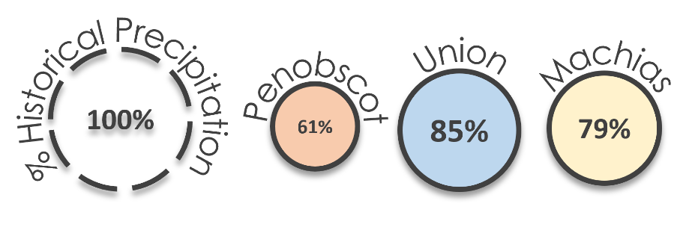

*Figure 8.* Summer 2021 average percent precipitation in relation to the summer 2000-2020 baseline for the Penobscot River, Union River, and the Machias River. The radius and color are scaled to the percent difference.

***4.3 Future Work***

Future work could include studying other salmon habitats within the state of Maine. The team provided a cursory case study analysis along three rivers within an area chosen because of its ease for the tutorials and the workshop. The partners expressed interest in other places such as the East Branch of the Penobscot River and the West Branch of the Union River. Work can also be done to statistically relate fish-presence datasets provided by the partners to trends in LULC, LST, and precipitation.

Perhaps the best focus of future work should consider warming oceanic temperatures in the Gulf of Maine. There is evidence to suggest declining salmon populations could be due to shifting ecosystem conditions in the Gulf of Maine relating to climate (Mills et al., 2013). In fact, the Gulf of Maine is warming faster than almost anywhere on Earth which has led to drastic declines of other fish species (Pershing et al., 2015). As ocean temperatures warm, solubility of oxygen in the water decreases and thus raises metabolic energy costs of salmon leading to harmful effects (Johnson & Johnson, 2009). Therefore, future studies could look at sea surface temperature, salinity, and biological conditions of the plankton community.

It will also become imperative to continue such work with newer satellites. As the MODIS constellation retires, it will become necessary to conduct future research using comparable satellites such as VIIRS. The launch of the Phytoplankton, Aerosol, Cloud, Ocean Ecosystem (PACE) satellite may also prove beneficial to determine the effects of harmful algal blooms (HABs) and shifting trophic patterns on wild Atlantic salmon.

# 5. Conclusions

The results of the case study analysis show that land use is changing along rivers in Downeast Maine, particularly among forest classes. However, suspected misclassification in Maine Ecological Forecasting II LULC maps could introduce uncertainty. Nonetheless, forest cover is greatest along the Machias River which experienced precipitation somewhat lower than average in 2021. The Union River is coolest and experienced the closest to normal precipitation in 2021, although it is obstructed by dams. The Penobscot River was among the driest in 2021 with the highest average LST. These all have implications on the habitability of Maine’s riparian habitat as patterns in riverside shade, temperature, and precipitation change, altering habitat health like the distribution of thermal refugia for cold-water fish like salmon. While the partners can use these results in their conservation efforts, they will be able to use the written tutorials and live demonstrations to bolster studies of their own. Earth observations will not only provide them with tools to study ecological impact but also a means to reach out to members of the public and policy makers through increasingly targeted conservation efforts and visuals for easier community outreach.

# 6. Acknowledgments

The Summer 2022 Maine Ecological Forecasting Team would like to thank the project partners, science advisors, and additional supporters: Dwayne Shaw, Downeast Salmon Federation; Ernie Atkinson, State of Maine Department of Marine Resources; Sean McCartney, Science Systems and Applications, Inc., NASA Goddard Space Flight Center; Dr. Bridget Noreen Seegers, NASA Goddard Space Flight Center, Morgan State University; Joseph Spruce, Science Systems and Applications, Inc.; Dr. Nicole Ramberg-Pihl, NASA DEVELOP, NASA Goddard Space Flight Center; and Dr. John Bolten, NASA Goddard Space Flight Center.

The Summer 2022 Maine Ecological Forecasting Team also acknowledges the stewardship of the Abenaki, Maliseet, Micmac, Passamaquoddy, and Penobscot peoples over Atlantic salmon in unceded land.

This material contains modified Copernicus Sentinel data (2020, 2021), processed by ESA.

Maps throughout this work were created using ArcGIS software by Esri.

Any opinions, findings, and conclusions or recommendations expressed in this material are those of the author(s) and do not necessarily reflect the views of the National Aeronautics and Space Administration.

This material is based upon work supported by NASA through contract NNL16AA05C.

# 

# 7. Glossary

**Anadromous** – Fish that migrate upstream from the sea for spawning

**Diadromous** – Fish that migrate between fresh and saltwater environments in different life stages

**Demonstration** – An instructional session given in the workshop

**DMR** – The State of Maine Department of Marine Resources

**DSF** – The Downeast Salmon Federation

**Earth observations** – Satellites and sensors that collect information about the Earth’s physical, chemical, and biological systems over space and time

**EcoSHEDS** – Eco Spatial Hydro-Ecological Decision System

**Extirpated** – Local extinction

**GEE** – Google Earth Engine

**GIS** – Geographic Information Systems

**GPM** – Global Precipitation Measurement

**IMERG** – Integrated Multi-satellite Retrievals for GPM

**Landsat** – Family of satellite missions in NASA’s Earth observing fleet in collaboration with USGS

**LST** – Land Surface Temperature

**LULC** – Land Use Land Cover

**MBI** – Modified Bare Index

**MODIS** – Moderate Resolution Imaging Spectroradiometer

**NLCD** – National Land Cover Database

**NDBI** – Normalized Difference Built-Up Index

**NDVI** – Normalized Difference Vegetation Index   
**OLI** – Operational Land Imager

**Smolt** – Life cycle stage wherein salmon first migrate to sea

**TM** –Thematic Mapper

**Tutorial** – An instructional document written prior to the workshop

# 8. References

Earthdata. (n.d.). Visible Infrared Imaging Radiometer Suite (VIIRS). NASA. Retrieved from <https://ladsweb.modaps.eosdis.nasa.gov/missions-and-measurements/viirs/>

ESA. (n.d.). Sentinel-1. European Space Agency. NASA. Retrieved from 

<https://sentinel.esa.int/web/sentinel/missions/sentinel-1>

Frumhoff, P. C., McCarthy, J. J., Melillo, J. M., Moser, S. C., & Wuebbles, D. J. (2007). Confronting Climate Change in the U.S. Northeast. Synthesis report of the Northeast Climate Impacts Assessment (NECIA). Cambridge, MA: Union of Concerned Scientists (UCS). 1–160. <https://www.ucsusa.org/sites/default/files/2019-09/confronting-climate-change-in-the-u-s-northeast.pdf>

Huffman, G. J., Bolvin, D. T., Braithwaite, D., Hsu, K., Joyce, R., & Xie, P. (2014). Integrated Multi-satellitE Retrievals for GPM (IMERG), version 4.4. NASA's Precipitation Processing Center

Jonsson, B., & Jonsson, N. (2009). A review of the likely effects of climate change on anadromous Atlantic salmon *Salmo salar* and brown trout *Salmo trutta*, with particular reference to water temperature and flow. *Journal of Fish Biology*, *75*(10),2381–2447. <https://doi.org/10.1111/j.1095-8649.2009.02380.x>

McCormick, S. D., Hansen, L. P., Quinn, T. P., & Saunders, R. L. (1998). Movement, migration, and smolting of Atlantic salmon (*Salmo salar*). *Canadian Journal of Fisheries and Aquatic Sciences*, *55*(S1), 77–92. <https://doi.org/10.1139/d98-011>

McCullough, D.A. (1999). A review and synthesis of effects of alteration to the water temperature regime on freshwater life stages of salmonids, with special reference to Chinook salmon. Accessed from <https://www.semanticscholar.org/paper/A-review-and-synthesis-of-effects-of-alteration-to-McCullough/be437b6535ca176af78ea9fa2a7431831fb9ec14>

Mills, K. E., A. J. Pershing, T. F. Sheehan, & D. Mountain (2013). Climate and ecosystem linkages explain widespread declinces in North American Atlantic salmon populations. *Global Change Biology, 19*(10). <https://doi.org/10.1111/gcb.12298>

Moore, R. D., Spittlehouse, D. L., & Story, A. (2005). Riparian microclimate and stream temperature response to forest harvesting: A review. *Journal of the American Water Resources Association*, *41*(4), 813–834. <https://doi.org/10.1111/j.1752-1688.2005.tb03772.x>

NASA. (n.d.). Landsat 9. NASA. Retrieved from <https://landsat.gsfc.nasa.gov/satellites/landsat-9/landsat-9-overview/>

NASA. (n.d.). MODIS Land Surface Temperature and Emissivity (MOD11). NASA. Retrieved from

<https://modis.gsfc.nasa.gov/data/dataprod/mod11.php>

National Marine Fisheries Service, National Oceanic and Atmospheric Administration, & United States Fish & Wildlife Service (2000). Endangered and Threatened Species; Final Status for a Distinct Population Segment of Atlantic Salmon (*Salmo salar*) in the Gulf of Maine, 65 Fed. Reg. 69459. Effective Date: 12/18/2000. <https://www.federalregister.gov/documents/2000/11/17/00-29423/endangered-and-threatened-species-final-endangered-status-for-a-distinct-population-segment-of>

Nguyen, C.T.; Chidthaisong, A., Kieu Diem, P., Huo, L.-Z. (2021). A modified bare soil index to identify bare land features during agricultural fallow-period in southeast Asia using Landsat 8. *Land*, *10*(3), Article 231. <https://doi.org/10.3390/land10030231>

NOAA & USFWS. (2019). Recovery Plan for the Gulf of Maine Distinct Population Segment of Atlantic Salmon (*Salmo salar)*. <https://media.fisheries.noaa.gov/dam-migration/final_recovery_plan2.pdf>

Pershing, A. J., M. A. Alexander, C. M. Hernandez, L. A. Kerr, A. Le Bris, K. E. Mills, J. A. Nye, N. R. Record, H. A. Scannell, J. D. Scott, G.D. Sherwood, & A. C. Thomas. (2015). Slow adaptation in the face of rapid warming leads to the collapse of the Gulf of Maine cod fishery. *Science*, *350*(6262). <https://doi.org/10.1126/science.aac9819>

Saunders, R., Hachey, M. A., & Fay, C. W. (2006). Maine’s diadromous fish community: Past, present, and implications for Atlantic salmon recovery. *Fisheries*, *31*(11), 537-547. <https://doi.org/10.1577/1548-8446>

Sousa da Silva, V., Salami, G., Da Silva, M. I. O., Silva, E. A., Monteiro Junior, J. J., & Alba, E. (2020). Methodological evaluation of vegetation indexes in land use and land cover (LULC) classification. *Geology, Ecology, and Landscapes*, *4*(2), 159–169, from

<https://doi.org/10.1080/24749508.2019.1608409>

Tang, Z., Engel, B. A., Pijanowski, B. C., & Lim, K. J. (2005). Forecasting land use change and its environmental impact at a watershed scale. *Journal of Environmental Management*, *76*(1), 35–45, from <https://doi.org/10.1016/j.jenvman.2005.01.006>

Turunen, J., Elbrecht, V., Steinke, D., & Aroviita, J. (2021)Riparian forests can mitigate warming and ecological degradation of agricultural headwater streams. *Freshwater Biology*, *66*(4), 785–789, from <https://doi.org/10.1111/fwb.13678>

USGS (2021) USGS EROS Archive – Sentinel Archives – Sentinel-2 MSI Level 2A Data Products [data]. Retrieved from <https://www.usgs.gov/centers/eros/science/usgs-eros-archive-sentinel-2?qt-science_center_objects=0#qt-science_center_objects>

MSI Level 2A Data Products [data]. Retrieved from <https://www.usgs.gov/centers/eros/science/usgs-eros-archive-sentinel-2?qt-science_center_objects=0#qt-science_center_objects>. Accessed June 24, 2022. https:/doi.org/10.5066/F76W992G

USGS (2021) USGS EROS Archive – Landsat Archives – Landsat 5 TM Level –2 Data Products [data]. Retrieved from <https://www.usgs.gov/core-science-systems/nli/landsat/landsat-collection-2-level-2-science-products>. Accessed June 24, 2022, from <https://doi.org/10.5066/P9IAXOVV>

USGS (2021) USGS EROS Archive – Landsat Archives – Landsat 8 OLI and TIRS Level –2 Data Products [data]. Retrieved from <https://www.usgs.gov/core-science-systems/nli/landsat/landsat-collection-2-level-2-science-products>. Accessed November 18, 2021, from <https://doi.org/10.5066/P9OGBGM6>

Wan, Z., Hook, S., & Hulley, G. (2015). *MOD11A1 MODIS/Terra Land Surface Temperature/Emissivity Daily L3 Global 1km SIN Grid V006* [Data set]. NASA EOSDIS Land Processes DAAC. Accessed June 24, 2022, from <https://doi.org/10.5067/MODIS/MOD11A1.006>

Zha, Y., Gao, J., & Ni, S. (2003). Use of normalized difference built-up index in automatically mapping urban areas from TM imagery. *International Journal of Remote Sensing*, *24*(3), 583–594, from <https://doi.org/10.1080/01431160304987>