**NASA DEVELOP National Program**



NASA Jet Propulsion Laboratory

*Summer 2016*

California Water Resources

Quantifying the Impacts of the 2015-2016 El Nino Event

On California’s Historic Drought to Improve Water Resource Management

 **Technical Report**

Final Draft – August 11, 2016

Justin Lawrence (Project Lead, jlawrence@gatech.edu)

Lauryn Gutowski

Brittany Zajic

Nick Rousseau

Dr. John T. Reager, NASA Jet Propulsion Laboratory (Science Advisor)

# 1. Abstract

2015 marked the arrival of the strongest El Niño ever recorded, surpassing the 1997-1998 event that brought significant precipitation to the southwestern United States. As sea surface temperatures in the Central Pacific increased, it was forecasted that the 2015 event may have similar effects and alleviate what the US Drought Monitor classified as “exceptional” drought across the majority of the state of California. However, the impacts of the drought, now in its fifth year, continue to strain California water supplies. This study utilized data from NASA’s Gravity Recovery and Climate Experiment (GRACE) Earth observation, meteorological ground observations from the National Oceanic and Atmospheric Administration (NOAA), reservoir levels from the California Department of Water Resources (DWR), and the Oceanic Niño Index (ONI) to better quantify impacts of the 2015-16 El Niño event in the state of California. Specifically, monthly measurements of terrestrial water storage (TWS) from GRACE allowed for a more complete estimate of drought recovery throughout the state over the course of the 2016 water year. TWS was correlated with NOAA precipitation data (nClimDiv) in order to quantify the total current water deficit across the state. During attempts to relate the ONI with TWS via likely precipitation scenarios, it was determined that the ONI has little predictive power with regard to precipitation when spatially averaged across the entire state. With drought in the Southwestern US projected to increase in general intensity, frequency, and duration, quantitative assessments of statewide water resources are becoming increasingly important. NASA GRACE TWS hydrological data presents a uniquely integrated measure to inform resource managers and decision makers.

**Keywords**

Drought, ENSO, Water, GRACE, TRMM, GPM, SMAP, TWS

# 2. Introduction

* 1. ***Background Information***

The state of California has endured record-breaking drought since 2012, brought on by five years of below-average precipitation (Taeb et al., 2015). On January 17, 2014 Governor Jerry Brown declared a state of emergency followed by an executive order to increase water conservation regulations on agencies and residents due to low groundwater and reservoir levels statewide (Department of Water Resources, 2015). In the midst of this drought, the National Oceanic and Atmospheric Administration’s (NOAA) Climate Prediction Center (CPC) forecasted an El Niño event during the winter of 2015-2016 that had the potential to provide above average precipitation and replenish the state’s water reserves (Hoell et al., 2016). However, according to the US Drought Monitor (USDM), the wet season did not provide enough precipitation to fully relieve drought conditions and the majority of the state remains in drought, particularly the central and southern regions where the drought is classified as exceptional, the highest level (Svoboda et al., 2002). This project quantitatively assesses current drought conditions in California in order to create a more robust measurement that will assist the National Weather Service (NWS) of NOAA as well as land managers to prepare for the projected new normal of drier conditions across the state (Department of Water Resources, 2015).

The El Niño Southern Oscillation (ENSO) is a cyclical departure from normal atmospheric conditions in the central Pacific, shifting approximately every two to seven years between conditions termed El Niño and La Niña. An El Niño state is typified by weakened, or even reversed, easterly trade winds that allow equatorial surface waters to flow back from the west and pool in the central Pacific while warming in excess of average temperatures. The opposite extreme, La Niña, occurs when the easterlies strengthen and blow the cold, deep waters upwelled off the western coast of South America across the Pacific resulting in cooler than normal surface waters. ENSO fluctuations initiate a cascade of atmospheric and meteorological effects with global consequences (Kiladis and Diaz, 1989). Based on historical events and commonly reported trends, should a La Niña follow last winter’s El Niño it could likely exacerbate current drought conditions (Rojas et al., 2014). We also look at the extent to which this holds true for California as a whole. This analysis will consider whether the ENSO condition does indeed correlate with precipitation on a statewide basis.

California agriculture supplies nearly half of all produce grown in the United States, grossing roughly $45 billion per year (Horwitt et al., 2014). The effects of drought, while clearly visible at the surface, are more difficult to quantify below the surface with regard to groundwater storage. With an increased reliance on groundwater, which is largely unregulated and unsustainably managed in the state, water tables across the Central Valley have dropped several hundred feet within a few decades, one hundred feet in the last five years alone (Famiglietti, 2014). As of 2014, the California Department of Food and Agriculture reported over $1.5 billion dollars in lost revenue due to limited surface reservoir allotments, forcing farmers to rely on groundwater (Horwitt et al., 2014). Overuse has many consequences, ranging from land subsidence and infrastructure damage to hindering the replenishment of groundwater aquifers in wet years due to soil compaction. Furthermore, climate models indicate that California is likely to experience a climatological decrease in overall precipitation, challenging the ability of the state’s water resources to support expanding agriculture and increasing population densities (Department of Water Resources, 2015).

* 1. ***Project Partners & Objectives***

This project is in collaboration with the NOAA, National Weather Service, Los Angeles/Oxnard Weather Forecast Office, which is responsible for providing forecasts and issuing warnings using weather, water, and climate data to protect life and property as well as maintain weather preparedness in the event of a natural disaster. As part of the collaboration for this project, team members established contact with Mark Jackson, the chief meteorologist at the National Weather Service in Oxnard, hydrologist Jayme Laber, and John Dumas, science and operations officer. Additionally, John Dumas and Jayme Laber both contribute to the USDM survey.

The objective of this research project is to analyze the 2015-2016 El Niño event and determine the extent of drought recovery over the course of the wet season. In order to gain more insight about current conditions, the project also seeks to further analyze historical precipitation and the ONI from the past 65 years to compare this El Niño event with past events to better understand the impact ENSO has on California’s water balance statewide. This project addresses the NASA Applied Science’s water resources application area.

Our project partner’s interest stems from the fact that NASA Earth observations may offer a more quantitative approach to understanding the impacts of both historic and present precipitation and storage trends. Due to the subjectivity of the USDM classifications, NASA’s Earth observations also offer enhanced drought monitoring. An Esri ArcGIS Online Story Map has also been created in collaboration with this office and is hosted on the NOAA/NWS Oxnard office’s website for the general public.

# 3. Methodology

***3.1 Data Acquisition***

To evaluate California’s historical water resources and perform a thorough analysis of current drought conditions in the greater context of ENSO fluctuations, a suite of NASA Earth observation data were combined with NOAA meteorological ground observations. For past precipitation and temperature trends, this project utilized NOAA’s National Centers for Environmental Information (NCEI) nClimDiv dataset, which is monthly data derived from the Global Historical Climatology Network-Daily (GHCN-D). The Oceanic Niño Index (ONI) was also acquired from NOAA in the form of a 3-month rolling average from 1950 to 2016. Reservoir level data, as a percent of total capacity, was acquired from California Department of Water Resources Data Exchange Center via data scraped by the USGS for an open source visualization project (www.cida.usgs.gov/ca_drought). This dataset was subset to the 60 largest reservoirs (> 10,000 AF capacity) within the state of California.

In conjunction with nClimDiv, NASA’s GRACE, SMAP, GPM, and TRMM Earth observations were utilized to provide more integrated coverage of California while improving understanding of parameters difficult to observe via ground observations. Launched in 2002, the GRACE mission observes changes in Earth’s gravity, which, after processing, can be attributed to changes in water storage reported as centimeters of equivalent water thickness (www.grace.jpl.nasa.gov). Particularly, this study utilized the terrestrial water storage variations (TWS) data parameter to quantify total vertically integrated water storage. The dataset runs from April 2002 – March 2016 with 3.0° x 3.0° spatial resolution and was provided by science advisor Dr. JT Reager, a surface hydrologist and member of the GRACE science team at NASA Jet Propulsion Laboratory (JPL). Dr. Reager first aligned the data to the 15th of every month, and subtracted the overall mean of the data set to determine deviation from normal conditions.

SMAP launched in January 2015 to measure global surface soil moisture and freeze-thaw state (www.smap.jpl.nasa.gov). Despite the radar failure that occurred in July 2015, the radiometer still offers 36 km spatial resolution of surface soil moisture up to five centimeters in depth. Level 3 radiometer global daily (SPL3SMAP) surface soil moisture data from April 2015 – March 2016 were used to give more robust soil moisture data during the 2015 – 2016 El Niño event.

TRMM launched in 1997 to study rainfall, specifically the rainfall associated with heat release that drives global atmospheric circulation (www.trmm.gsfc.nasa.gov). Level 3 (3B43 Multisatellite Precipitation) 0.25° x 0.25° spatial resolution data from January 1998 to March 2016 was accessed via the Goddard Earth Sciences Data and Information Services Center (GES DISC). GPM, launched in 2014 as a global successor to TRMM, was also accessed from the GES DISC. The GPM dataset collected was Level 3 at 0.1° x 0.1° spatial resolution from March 2014 to March 2016. For the purpose of this study, GPM-IMERG was used, which is monthly rainfall estimates from passive-microwave instruments, although smaller increments of time are available.

***3.2 Data Processing***

After data acquisition, Earth observations and ancillary datasets were read into one Python programming environment using Numpy and Pandas modules. Data were spatially averaged to the study area, set to the same date index, resampled on a monthly basis, and joined in a multivariate data frame dating from 1895 to 2016. While most of the data were already available on a state basis, in order to spatially subset GRACE from global coverage we applied a mask. A California shapefile was converted into a netCDF using GDAL, which was then rasterized and scaled using GDAL_rasterize. The netCDF was converted into a Numpy array, transformed into a 3D array, and used to mask GRACE data allowing us to generate an average storage anomaly in cm for each month of available data.

The second step involved several different processing methods to aid in visualization and analysis. Multiple iterations of the base dataset created above were generated via data smoothing and seasonal variability removal via 13 month rolling averages, normalization, and scaling. Climatological anomalies were calculated by subtracting the long-term monthly averages to determine monthly deviations. Additional derivative variables were also calculated, such as accumulated precipitation, TWS rate of change, and surplus or deficit water volumes derived from TWS quantities.

***3.3 Data Analysis***

After initial processing, the various dataset versions (original, smoothed, normalized, and climatological anomalies) were explored via time series, regression, and correlation plots. We began by comparing all precipitation data to look for differences between ground and remote observations (Fig. 1). Based on the high correlation coefficient (r = 0.97) between TRMM and nClimDiv precipitation, we selected nClimDiv as the base precipitation measurement for further analysis due to its longer base period. We then accumulated nClimDiv precipitation rate to convert it a quantity relatable to TWS. Regressed accumulated precipitation and TWS have a correlation coefficient of r = 0.88, demonstrating that TWS is driven by precipitation (Fig. 2). This relationship allowed estimation of storage levels based on a given precipitation amount. We used this to calculate GRACE TWS based on historical precipitation rates back to 1895, the beginning of the nClimDiv record (Fig. 3).

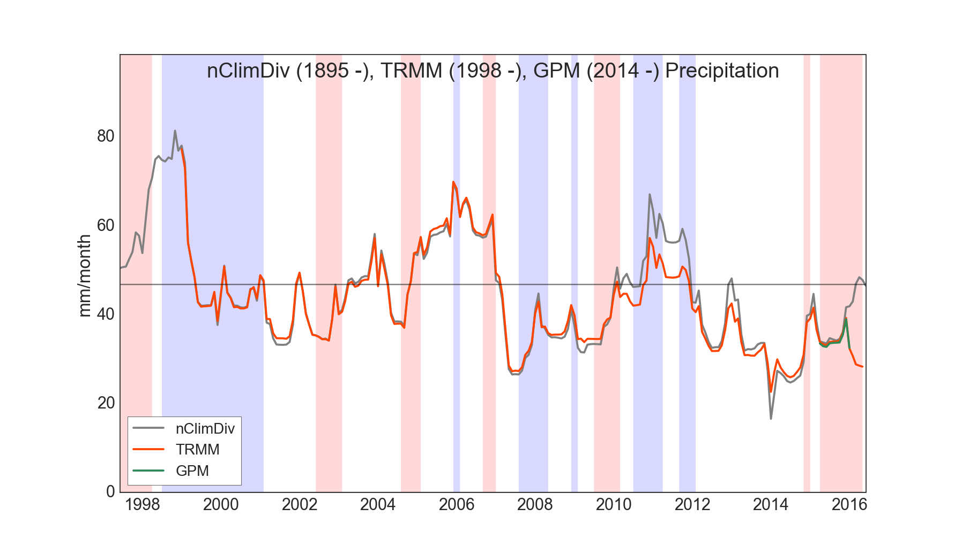

Figure 1. Comparison of TRMM, GPM, and nClimDiv precipitation records with ONI as background

(La Niña as blue, El Niño as red).

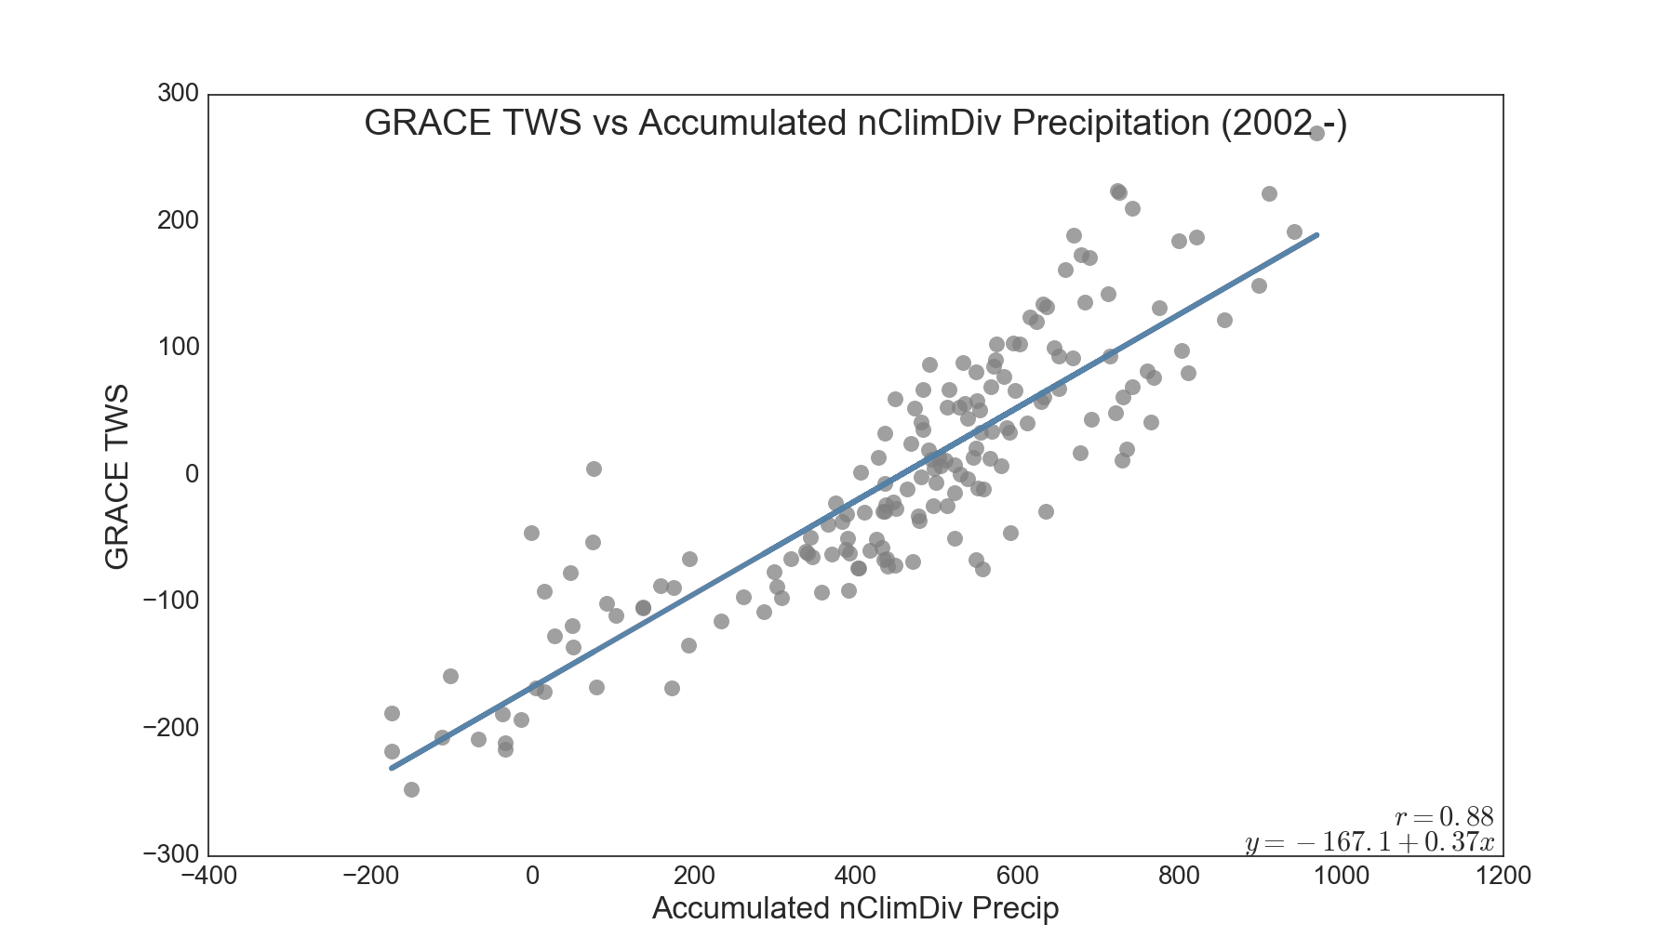

Figure 2. Relationship between TWS and accumulated precipitation.

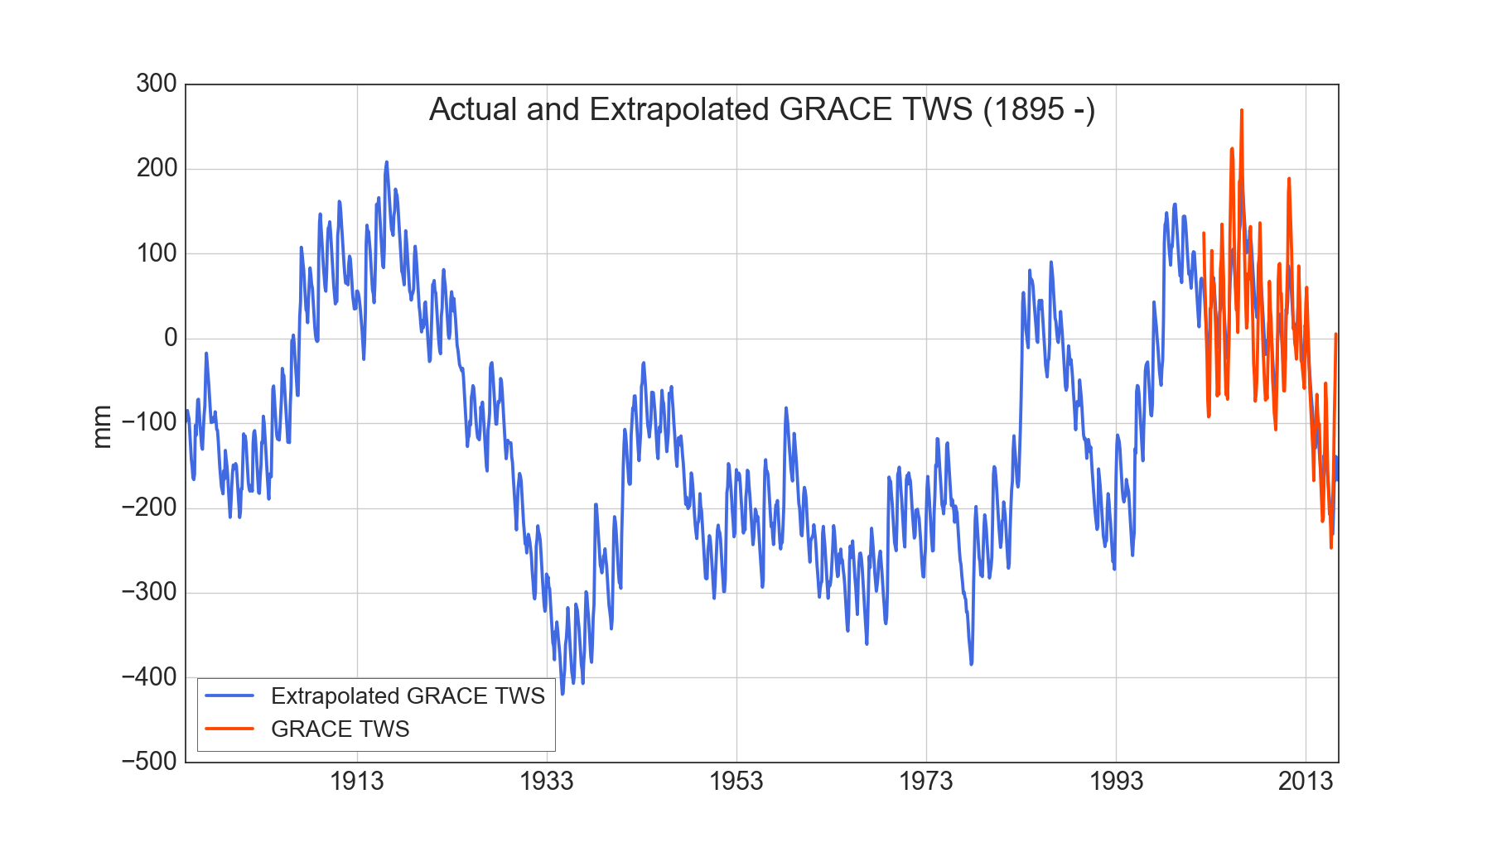

Figure 3. Extrapolated GRACE TWS since 1895.

We then looked to see if ENSO, via the ONI, had predictive power with regard to precipitation over all of California as this would allow us to project TWS based on forecasted ENSO events. We regressed the ONI with nClimDiv precipitation from 1950 (the beginning of the ONI dataset) to present and binned the results into three separate categories, La Niña (ONI < -0.5), Normal (ONI -0.5 to 0.5), and El Niño (ONI > 0.5) (Fig. 4). The correlation coefficient of < 0.1 demonstrates that the Oceanic Niño Index cannot predict precipitation on a statewide basis.

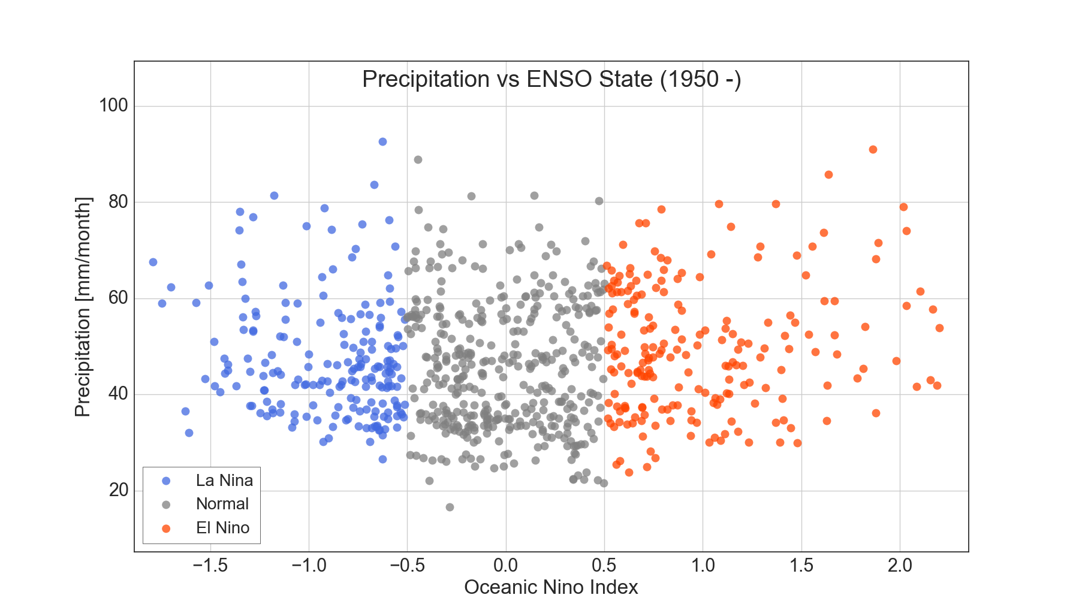

Figure 4. Relationship between precipitation spatially averaged over California and ENSO state

according to the ONI.

Additionally, we quantified some relevant rates and volumes based on TWS. We regressed TWS after calculating the rate of change with nClimDiv precipitation to assess, at a very high level, an equilibrium water storage average precipitation rate of 48 mm per month (54 cm or 22” annually). This is the rate at which TWS remains constant (with all other variables constant as well) (Fig. 5). Finally, to quantify any recovery over the past water year we compared the volumetric (TWS • area of CA ) difference between the 2015 and 2016 TWS peaks (-46.26 km3 and -33.15 km3 respectively) and determined that California’s overall water budget added 13.11 km3 of water since 2015, but remains depleted.

# ../CA%20Water%20Resources/plots/final%20presentation%20plots/precip%20vs%20tws%20dsdt.png

Figure 5. TWS ds/dt regressed with precipitation, indicating 48 mm as the average monthly precipitation required to maintain storage levels.

# 4. Results & Discussion

***4.1 Analysis of Results***

Our analysis highlights several interesting trends. For example, as seen below in the accumulated record, there is a long dry period from about 1915 to 1930, which appears to have been even drier than the present dry situation (Fig. 6). Looking closely at this figure, it appears that we have gone back to normal in amount of precipitation in 2016. The cyclical nature of precipitation trends in California is also apparent, making it difficult to define a climatological normal.

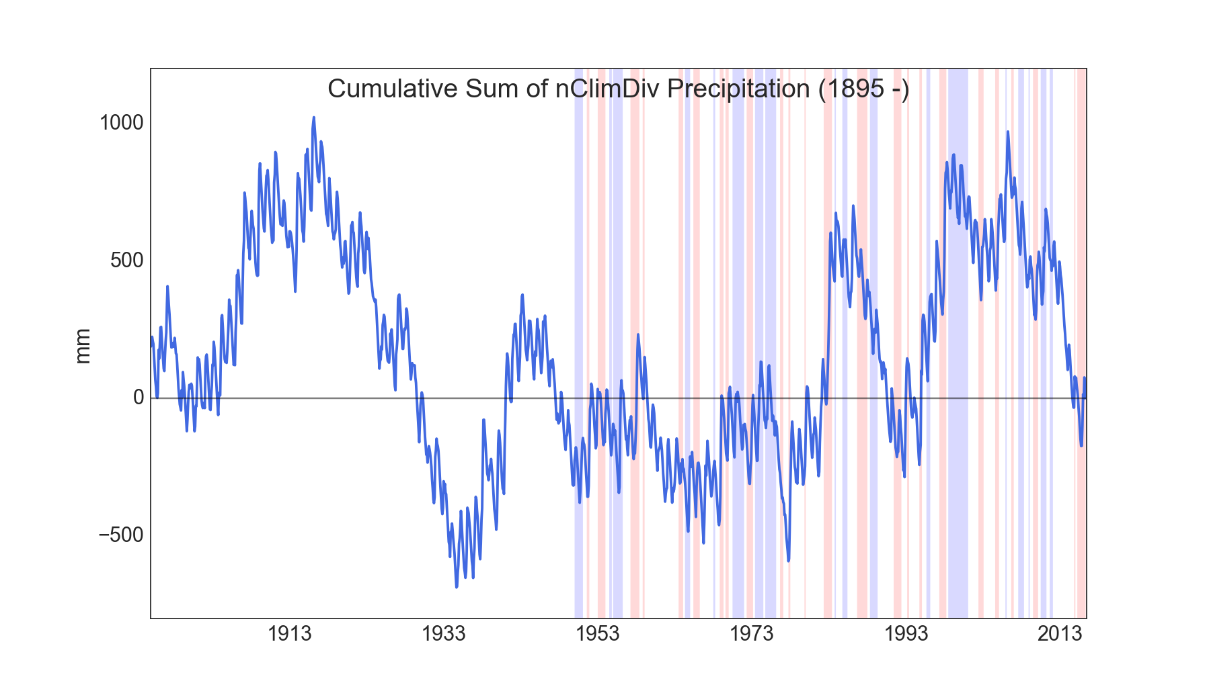

Figure 6. Accumulated nClimDiv precipitation with the ONI overlaid.

California’s reservoirs store water for both human and agriculture use, and the water is distributed throughout the state. California’s reservoir levels were compared to TWS based on the hypothesis that while most surface reservoirs appear to have recovered, this does not necessarily mean California is out of the drought. Normalized plots of both variables display similar trends with wet and dry periods coinciding, but more interesting is the most recent data. Recent reservoirs data shows nearly zero deviation from normal indicating recovery, while GRACE remains one deviation below the normal (Fig.  7). While TWS increased by 13 km3 over the past wet season during El Niño, overall TWS in California remains more than 8 trillion gallons below the average and the drought continues.

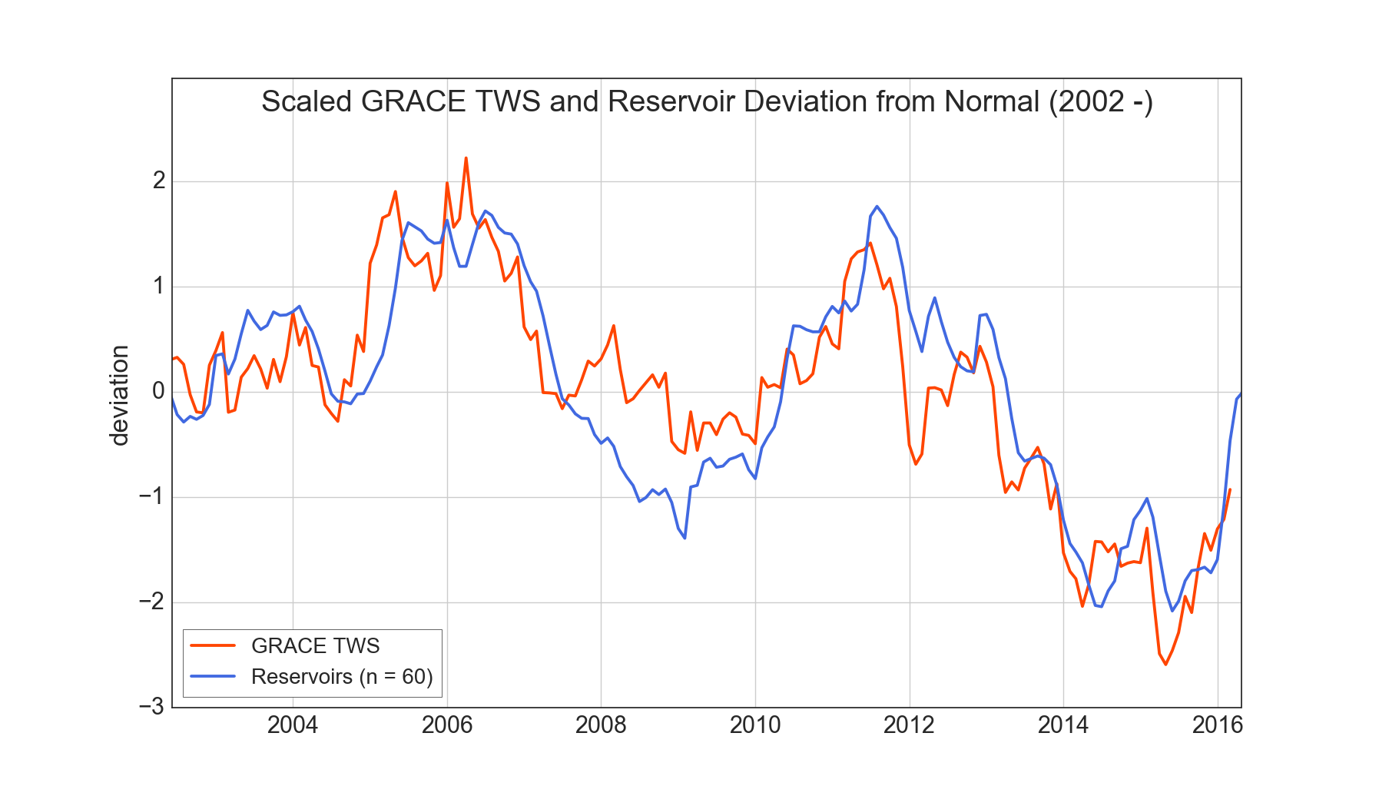

Figure 7. Scaled reservoir and TWS data.

Estimates for the total volume of water deficit were calculated by taking TWS deviation from normal multiplied by the spatial extent of the data, California. At the peak wetness of 2015, TWS is 46.26 km3 below the normal and the 2016 peak is still 33.15 km3 below normal. This shows that there was 13.11 km3 of recovery this wet season, but we are still below the 14-year climatology. This rough calculation allows us to quantify the drought conditions, similar to looking at reservoirs in volume of water stored, but in a more robust way using GRACE TWS.

An overarching question is how GRACE relates to precipitation. A regression plot of accumulated nClimDiv and GRACE TWS shows how TWS would respond to precipitation, thus allowing the estimation of storage levels (Fig.  2). The r value for the regression line was found to be 0.88, showing good correlation. Using the equation, a relationship between GRACE TWS and precipitation was established, and from this an extrapolation of ‘historical’ TWS. The extrapolated GRACE, or modeled GRACE, allowed us to predict storage as far back as our precipitation record, 1895. We hoped that extrapolated TWS would be more useful in generating longer term baseline climatologies, but determined that the model would need to account for other non-constant factors (e.g. temperature, population, agricultural production) since 1895 in order to be utilized more meaningfully. Future work could improve the model, and make a longer record of extrapolated TWS available for other investigations as well.

We know that we have predictive power given precipitation, but can we actually predict precipitation, given the ONI? Precipitation rolling averages were regressed with the ONI to find out. Due to the lack of a linear trend and the similarities in the average precipitation rates under each condition it was concluded that the ONI cannot predict precipitation on a statewide basis (Fig.  4). This came as a bit of a surprise as our team had hoped that, based on varying rates of precipitation under certain ENSO conditions, we could project TWS under different scenarios such as La Niña this coming winter. Unfortunately, due to no discernible difference on a statewide basis, this analysis was not possible.

We continued by relating the TWS as a rate of change (ds/dt) with precipitation rate. This comparison allowed us to calculate the ‘breakeven’ precipitation rate that needs to occur in order to maintain water storage levels statewide. A regression equation was found by plotting GRACE TWS ds/dt versus nClimDiv precipitation. The r value was 0.7, showing a good correlation. Using this graph, it was found that if precipitation rates in California fall below an average of ~48 mm per month of precipitation, water reserves are drawn down (Fig. 5).

***4.2 Future Work***

With the introduction of CMIP5 modeled climate data, the project will look to forecast California’s changing climate and what that means for state’s economy, increasing human populations, and continued water stress. We would also like to strengthen our historical GRACE TWS product to generate a longer-term climatology and look at the current drought in the context of not just GRACE’s 14-year record but for the entire 120 years that we have precipitation data. Additionally, there are several other ENSO tracking indices and the project would seek to investigate if a different metric held more power for predicting precipitation. This analysis could be done on a divisional basis within the state of California to look for correlations at smaller scales.

# 5. Conclusions

California is currently in its fifth year of severe drought, which is causing problems such as water quality degradation, surface and groundwater levels declining, land subsidence, and financial stress. California is also the most populous state in the US, and provides nearly half of all produce in the US (Department of Water Resources, 2015). The El Niño event that was predicted for the winter of 2015-2016, that had the potential to replenish water reserves, did not restore integrated water supplies back to the normal condition as defined by GRACE’s 14-year mission (Svoboda et al., 2002). In order to take a deeper look at the drought, this project used both *in situ* and satellite data to quantify drought recovery throughout California during the 2016 water year and to better understand ENSO’s relationship with precipitation and California’s water balance at a statewide level.

From the comparison of GRACE TWS and California’s reservoir data, it was concluded that GRACE provides a more complete metric for water storage and drought assessment. The GRACE TWS anomaly remains nearly a full deviation below the climatological mean, meaning California is still in a drought. The analysis shows also that precipitation in excess of 48 mm per month on an annual basis across the state is required for drought recovery. Although inferences can be made about past water storage using precipitation, precipitation cannot be reliably predicted statewide based on the ONI alone.

With quantitative assessments of statewide water resources becoming increasingly important, it was found that NASA GRACE TWS hydrological data presents a uniquely integrated measure to incorporate into water reports for resource managers, decision makers, and stakeholders. TWS serves as an important parameter when considering drought and/or water resources for the state of CA. Remotely sensed hydrological data has proven beneficial for current drought analysis for the state and will continue to provide a "more complete" picture than parameters currently offered in water reports and drought monitor classification. And with the given results stated in this paper, this remains an important parameter to consider when entering the La Niña weather event this coming water year.

# 6. Acknowledgments

We would like to our science advisor JT Reager at NASA Jet Propulsion Laboratory for his expertise and insight regarding this project. We would also like to thank Aaron Trefler and Jinny Lee for their time and insight.

Any opinions, findings, and conclusions or recommendations expressed in this material are those of the author(s) and do not necessarily reflect the views of the National Aeronautics and Space Administration.

This material is based upon work supported by NASA through contract NNL11AA00B and cooperative agreement NNX14AB60A.

# 7. References

Department of Water Resources (2015). California Significant Droughts, <http://www.water.ca.gov/waterconditions/docs/a9237_CalSignficantDroughts_v10_int.pdf>

Famiglietti, J. S. (2014). The global groundwater crisis. Nature Climate Change Nature Climate Change, 4(11), 945-948. doi:10.1038/nclimate2425

Griffin, D., & Anchukaitis, K. J. (2014). How unusual is the 2012-2014 California drought? Geophys. Res. Lett. Geophysical Research Letters, 41(24), 9017-9023. doi:10.1002/2014gl062433

Hoell, A., Hoerling, M., Eischeid, J., Wolter, K., Dole, R., Perlwitz, J., . . . Cheng, L. (2016). Does El Niño intensity matter for California precipitation? Geophys. Res. Lett. Geophysical Research Letters, 43(2), 819-825. doi:10.1002/2015gl067102

Howitt, R., Medell´ın-Azuara, J., MacEwan, D., Lund, J. & Sumner, D. (2014) Economic

analysis of the 2014 drought for California agriculture. Center for Watershed Sciences, University

of California, Davis

Kiladis, G.N., Diaz, H.F. (1989). Global Climatic Anomalies Associated with Extremes in the Southern

Oscillation, American Meteorological Society, pp. 1069-1090.

Larson, K.M., Nievinski, F.G. (2012). GPS snow sensing: results from EarthScope Plate boundary

Observatory, GPS Solut, 1-12. doi 10.1007/s10291-012-0259-7

Reager, J.T., Thomas, A.C., Sproles, E.A., Rodell, M., Beaudoing, H.K., Li, B., Famiglietti, J.S. (2015).

Assimilation of GRACE Terrestrial Water Storage Observation into a Land Surface Model for the Assessment of Regional Flood Potential, Remote Sensing, 1-17, 14663-14679; doi:10.3390/rs71114663.

Rojas, O., Li, Y., Cumani, R.(2014) Understanding the drought impact of El Nino on the global agricultural

areas: An assessment using FAO’s Agricultural Stress Index (ASI), Food and Agricultural Organization of the United States, Rome, p. 1-44.

Svoboda, M., et al. (2002), The drought monitor, Bull. Am. Meteorol. Soc., 83(8), 1181–1190

Taeb, A., Reager, J. T., Turmon, M., & Chandrasekaran, V. (2016, June 26). California Reservoir Drought Sensitivity and Exhaustion Risk using Statistical Graphical Models. Arxiv, 1(1606), 08098th ser.

Thomas, A.C., Reager, J.T., Famiglietti, J.S., Rodell, M. (2014). A GRACE-based water storage deficit

approach for hydrological drought characterization, Geophysical Research Letters, 1537- 1545.

# 8. Content Innovation

Please select three content innovation features to support your paper. For each item, please list the name of the feature, and include the tool itself if possible (e.g. glossary terms and definitions). If the tool does not work in Microsoft Word (e.g. Glossary Viewer), please list the file name and email the related file to the Lauren Gleason-Childs ([Lauren.M.Childs@nasa.gov](mailto:Lauren.M.Childs@nasa.gov)).