**NASA DEVELOP National Program**

****BLM at Idaho State University GIS Training and Research Center

**Summer 2016**

**Short Title: Eastern Idaho Disasters**

**Subtitle:** Utilizing NASA Earth Observations to Identify Wildlife Habitat Areas Threatened by Heightened Wildfire Susceptibility for Improved Conservation and Management Practices

**VPS Title:** Wildfire Destruction: A Changing Fire Regime Threatens Local Fauna

**Project Team & Partners**

**Project Team:**

Courtney Ohr, (Project Lead), ohrcou@gmail.com

Jenna Williams

Priscilla Addison

**Advisors & Mentors:**

Keith Weber (GIS Training and Research Center at Idaho State University)

Dr. John Schnase (NASA Goddard Space Flight Center)

Mark Carroll (NASA Goddard Space Flight Center)

**Partner Organizations:**

|  |  |  |  |
| --- | --- | --- | --- |
| **Organization** | **POC (Name, Position/Title)** | **Partner Type** | **Boundary Org?** |
| Bureau of Land Management (BLM), Pocatello Field Office | Mike Kuyper, Natural Resource Specialist | End-User | No |
| National Park Service (NPS), Craters of the Moon National Monument and Preserve | Todd Stefanic, Wildlife Biologist and Georgina Pearson, Vegetation Ecologist | End-User | No |
| Idaho Department of Fish and Game | Scott Bergen, Senior Wildlife Research Biologist | Collaborator | No |
| USDA Forest Service, Caribou-Targhee National Forest | Chris Colt, Wildlife Biologist | Collaborator | No |

**Project Details**

**Applied Sciences National Application Addressed:** Disasters

**Study Area:** Eastern Idaho (ID)

**Study Period:** June 2015 – July 2016

**Earth Observations & Parameters:**

Shuttle Radar Topography Mission (SRTM) – DEM

Sentinel-2 – Spectral vegetation indices

Landsat 8, Operational Land Imager (OLI) – land cover

**Ancillary Datasets Utilized:**

* NASA RECOVER data – Identify critical habitat areas of sage-grouse, Historic Fire polygons
* Utah State University Mule Deer Mapping Project – Identify Mule Deer habitats
* Western Association of Fish and Wildlife Agencies – Identify Mule Deer wintering range habitat
* USFS Caribou-Targhee NF Existing Vegetation Map – Remote Sensing Applications Center (RSAC)
* USGS National Land Cover Dataset – Multi-Resolution Land Characteristics Consortium (MRLC)
* NASA MERRA – Soil wetness and evaporation, leaf area index
* USGS National GAP Analysis Program (GAP) – Existing Vegetation map
* USDA National Agriculture Imagery Program (NAIP) – Point Classification
* AgriMet Weather data – Historical meteorological records used for perception data

**Models Utilized:**

* Fire Susceptibility Model which includes Clark Labs – GINI Classification Tree Analysis (IDRISI).

**Software Utilized:**

* ArcGIS – data prepping (i.e. reclassification), habitat suitability consideration, post-image processing
* IDRISI TerrSet – raster manipulation/analysis, image enhancement & map creation of Landsat ETM+, NPP VIIRS, Aqua/Terra MODIS, Fire Susceptibility

**Project Overview**

**80-100 Word Objectives Overview:**

Eastern Idaho Disasters project identified critical wildlife habitats with increased wildfire susceptibility, which may be the result of more biomass from noxious weeds and encroaching species such as cheatgrass (*Bromus tectorum*) and juniper (*Juniperus, spp*), respectively. The study incorporated habitats for both sage-grouse (*Centrocercus*) and mule deer (*Odocoileus hemionus*), and examined the intrinsic properties of the region to provide updated wildfire susceptibility maps which recognize increased susceptibility for current habitat data to identify habitats at risk if a wildfire were to occur.

**Abstract:**

Wildfires can be disastrous for declining, threatened, or endangered wildlife species. Encroachment of non-native annual grasses such as cheatgrass or woody-vegetation such as juniper have increased fuel loads, intensified wildfire severity, and altered fire regimes throughout the Great Basin and Intermountain West. This project partnered with Craters of the Moon National Monument and Preserve (CRMO) and the Bureau of Land Management (BLM) in Idaho to identify wildlife habitats with increased susceptibility to wildfires due to fuel loads. This project is unique in its inclusion of kipukas, islands of wildlife habitats found throughout lava formations. Wildlife habitats of the diminished Greater Sage-grouse (GRSG) (*Centrocercus uraphasignus*) and declining mule deer (*Odocoileus hemionus*) were included in the study. Two primary non-anthropogenic threats to GRSG sustainability are wildfires and invasive annual grasses dominating low- to mid-elevation sagebrush. This project leveraged Landsat 8 Operational Land Imagery (OLI) data from June 2015, Sentinel-2 data from June 2016, fuel loads measured in tons per acre, and topographic variables to produce an at-risk habitat wildfire susceptibility model. Weightings from expert opinion and industry standards were applied to model variables to discern fire behavior and habitat vulnerability. Methods developed provided decision makers with new and effective ways to monitor remote areas and threatened habitats.

**Keywords:**

Mule Deer, Greater Sage-grouse, Sentinel 2, Threatened Habitats, encroaching species

**Community Concerns:**

* Wildfire regimes are changing as a result of altered vegetation dynamics which increase threats to wildlife habitats.
* Mule deer, an indicator species, are an integral component in the food web as they are the primary food resources for both black bears, cougars, and wolves.
* Sage-grouse are an umbrella species exclusive to the sagebrush-steppe ecosystem and their loss might likely effect the lives of other species.
* Some of Craters’ kipukas, islands of wildlife habitat that exist throughout the lava flows, encompass the last pristine to semi-pristine endemic sagebrush-grass ecosystems and need to be incorporated into broader management plans.
* Executive Order 3336 was issued on January 6th 2015 by the Secretary of Interior, which calls for a science-based strategy to address the increase in frequency and intensity of wildfires in the Great Basin Region.

**Current Management Practices & Policies**:

Currently, staff at the Craters of the Moon National Monument and Preserve (CRMO) rely on various sources of habitat layers and expert knowledge to identify habitats and vegetation types. Many of these sources stop at the lavas’ edges and do not incorporate the park in their analyses. They fail to account for the kipukas found throughout the lava formations which are known to burn up to five times a year. Developing this wildfire susceptibility model will inform proactive management in reducing influences of habitat destruction. Leveraging Earth observations also provides a way to monitor remote areas that currently require long distance foot travel over difficult terrain.

The BLM works with other agencies like the U.S. Forest Service to identify and protect areas that threaten the Greater Sage-grouse and other sagebrush dependent species. A large part of their decision making relies on field studies where they gather geospatial data using transects, GPS, and on-screen digitizing. These data are used in planning for conservation efforts as well as future land management practices.

**Decision Support Tools & Benefits:**

|  |  |  |  |
| --- | --- | --- | --- |
| **End-Product** | **Earth Observations Used** | **Benefit & Impact** | **Software**  **Release** |
| Fire Susceptibility Model | Landsat 8 OLI  Sentinel 2  STRM | This model will improve our partners’ understanding of where wildfire susceptible habitats are located and aid in their decision making processes for habitat conservation and restoration. | 1 |
| At-Risk Wildlife Habitats Map | Landsat 8 OLI  Sentinel 2  STRM | Critical habitat datasets overlaid with fire susceptibly results will be used in combination with habitat suitability modeling to identify habitats that are threatened by wildfire | 1 |

**Project VPS/Booklet Imagery**

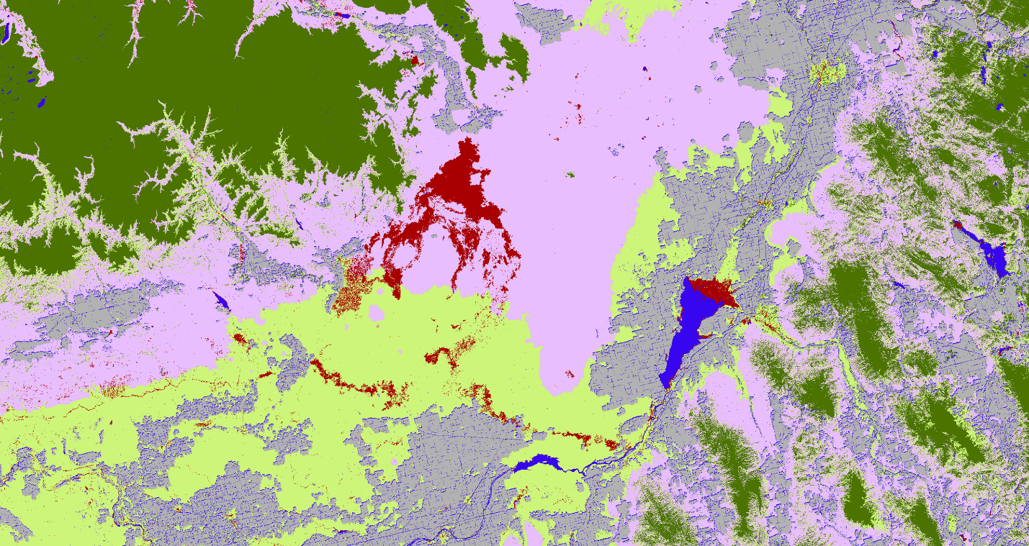

**Caption:** Initial Classification Tree result. Rock (red), water (blue), Grass (lime green), Forest/Slash (dark green), shrub (purple), masked/no data (gray). Classes are weighted in tons/acre. Image Credit: Eastern Idaho Disasters Team.

**Image Credit:** Eastern Idaho Team

**Image:** 2016Sum_ID_EasternIdahoDisasters_VPSimage.jpeg