Plum Island Estuary Water Resources II
Employing Remote Sensing Techniques to Quantify Sediment Supply and Evaluate Salt Marsh Vulnerability in the Plum Island Estuary


Technical Report
August 10th, 2018

Henrik Westerkam (Project Lead)
Ruizhe Guo
Sydney Neugebauer
Linnea Smith

Cedric Fichot, Boston University (Science Advisor)
Sergio Fagherazzi, Boston University (Science Advisor)

Previous Contributors:
Kimberly Johnson
Zachary Bengtsson
Bogumila Backiel

1. Abstract
The Plum Island Estuary (PIE) in Massachusetts is New England’s largest salt marsh. This dynamic ecosystem plays an important role in the surrounding communities by providing ecosystem services and acting as a center for education, research, and recreation. However, marshes around the world are threatened by sea level rise. As the equilibrium between sediment supply, erosion rates, and vegetation growth is unbalanced by rising waters, marshes are liable to recede. Because sediment is so crucial, researchers use sediment budgets as a metric to assess PIE’s vulnerability to rising seas; however, established data collection methods are limited in scope. The project employed five years of imagery from Landsat 8 Operational Land Imager and three years of imagery from Sentinel-2 Multispectral Instrument, in conjunction with in situ data, to generate and refine a local algorithm that derives suspended sediment concentration from remote sensing reflectance. This information was used to generate a time series analysis, and a hydrodynamic model was used to analyze transport patterns and possible sediment sources, particularly the Merrimack River via coastal connectivity. Results of these analyses demonstrated that sediment in the estuary comes primarily from riparian rather than oceanic sources, making it unlikely that the Merrimack is a major sediment source. The use of remote sensing techniques will provide our partners at the US Geological Survey, US Fish and Wildlife Service, and Long Term Ecological Research Network, Plum Island Ecosystems LTER with higher spatial and temporal resolution data, which will allow for the development of more effective management practices.

Keywords
Remote sensing, Landsat 8 OLI, Sentinel-2 MSI, salt marsh, suspended sediment concentration, sediment flux, remote sensing reflectance, sea level rise, bottom reflectance, turbidity

2. Introduction
  - Background Information
Salt marsh ecosystems are highly productive coastal ecosystems characterized by regular tidal flooding (Weston, 2013). They provide habitat for a variety of fish, bird, and shellfish species, which sustains nearby fisheries and protects the region’s biodiversity (Barbier et al., 2011). Salt marshes are also important to coastal communities, providing an array of ecosystem services such as water purification, carbon sequestration, erosion control, and protection from storms, as well as opportunities for both education and recreation (Barbier et al., 2011). However, salt marshes are threatened by sea level rise (SLR) (Kirwan & Megonigal, 2013; Weston, 2013; Ganju & Schoellhamer, 2009; Morris et al., 2002).

Salt marshes are sustained by the sediment available to them; when there is adequate sediment supply, sediment accretes, resulting in elevation gain (Kirwan & Megonigal, 2013; Weston, 2013; Morris et al., 2002). For a marsh to persist, sediment must accumulate at a rate equal to or faster than the rate of SLR (Kirwan & Megonigal, 2013; Weston, 2013). In undisturbed marshes, feedbacks between water level, vegetation, and sediment accretion are able to compensate for rising sea levels, at least to an extent (Kirwan & Megonigal, 2013). However, in places where sediment delivery has been disrupted by anthropogenic activity such as land use change or dam building, marshes are vulnerable to changes in sea level and begin to subside (Kirwan & Megonigal, 2013). Suspended sediment concentration (SSC) in marshes, and the rivers that feed them, is therefore an important metric for evaluating marsh susceptibility to SLR (Ganju et al., 2015).

The Plum Island Estuary (PIE) in northern Massachusetts is the largest salt marsh in New England and is fed by the Ipswich, Rowley, and Parker Rivers (Figure 1). All of these rivers have one or more dams along their length, which can limit sediment transport from the rivers to the estuary. The estuary is bordered on the north by the Merrimack River, which has some direct connectivity with PIE at high tide. Sediment may also be transported out of the mouth of the Merrimack, down the coast, and into the mouth of the estuary.
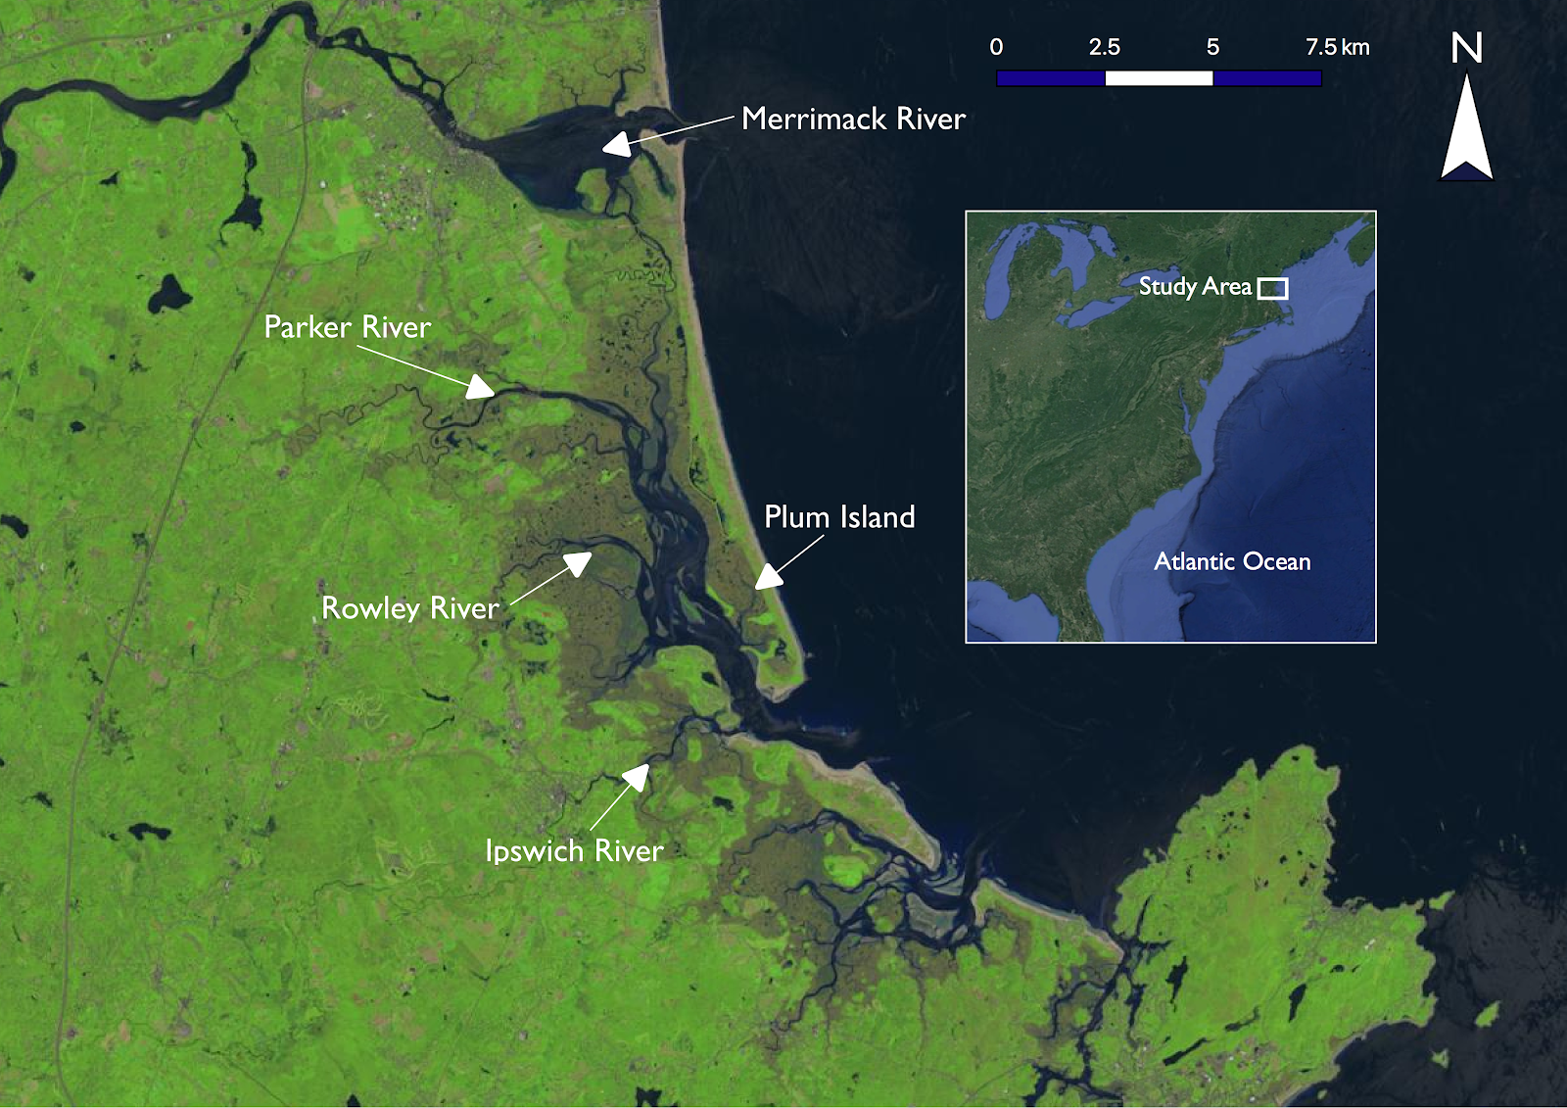
Figure 1. The Plum Island Estuary study area. Image source: Landsat 8 OLI from June 17th, 2018. Inset source: Google, Landsat/Copernicus.

PIE is studied by the Long Term Ecological Research Network, Plum Island Ecosystems LTER (PIE LTER). PIE LTER conducts a robust body of research on the estuary, trains undergraduate and graduate students as well as post-doctoral scientists, and runs an active education and outreach program for students in kindergarten through high school. Because of these efforts, PIE not only provides the traditional ecosystem services and recreational opportunities afforded by salt marshes worldwide but also serves as a valuable social resource for nearby communities.

The study period of this project was April 2013 to July 2018. In situ data from November 2017 and May to July 2018 were used. Remote sensing data spanned the entire length of the study period.

In the previous term of this project, the team used Landsat 8 Operational Land Imager (OLI) and Sentinel-2 Multispectral Imager (MSI) data coupled with in situ data to create an empirical algorithm for deriving SSC from remote sensing reflectance (Rrs). However, the in situ data set contained only six points from within the estuary and the team did not perform validation or analysis on the resulting imagery. This term’s project will address these issues.

  - Project Partners & Objectives
The end user for this project is the United States Geological Survey (USGS) Woods Hole Coastal and Marine Science Center. Other collaborators are PIE LTER and the United States Fish and Wildlife Service (USFWS) Parker River National Wildlife Refuge. Our partners use SSC as a metric in vulnerability assessments of the area. When conducting vulnerability assessments, researchers at USGS classify different areas of the marsh based on the Unvegetated-Vegetated Marsh Ratio (UVVR). UVVR is a relative measure of marsh deterioration that compares the ratio of open-water areas to vegetated areas in the marsh. The ratio is strongly correlated with the marsh’s sediment budget, and subsequently, SSC (Ganju et al., 2017). Currently, the USGS uses point measurements and some aerial photography in their vulnerability assessments (Figure 2). This method is limited by the frequency with which measurements can be taken and the area of the marsh that can be studied, and frequently only captures vertical stability (Ganju et al., 2017). Deriving SSC from Rrs offers much higher spatial and temporal resolution, which will allow our partners to judiciously allocate resources based on more comprehensive information than was previously available. The results of these vulnerability studies inform decisions about how to allocate limited conservation resources. In the future, our end-user hopes to use a similar methodology to study other factors that relate to marsh vulnerability and expand the study area to include coastal systems across the US, including the Chesapeake Bay and the Gulf of Mexico.
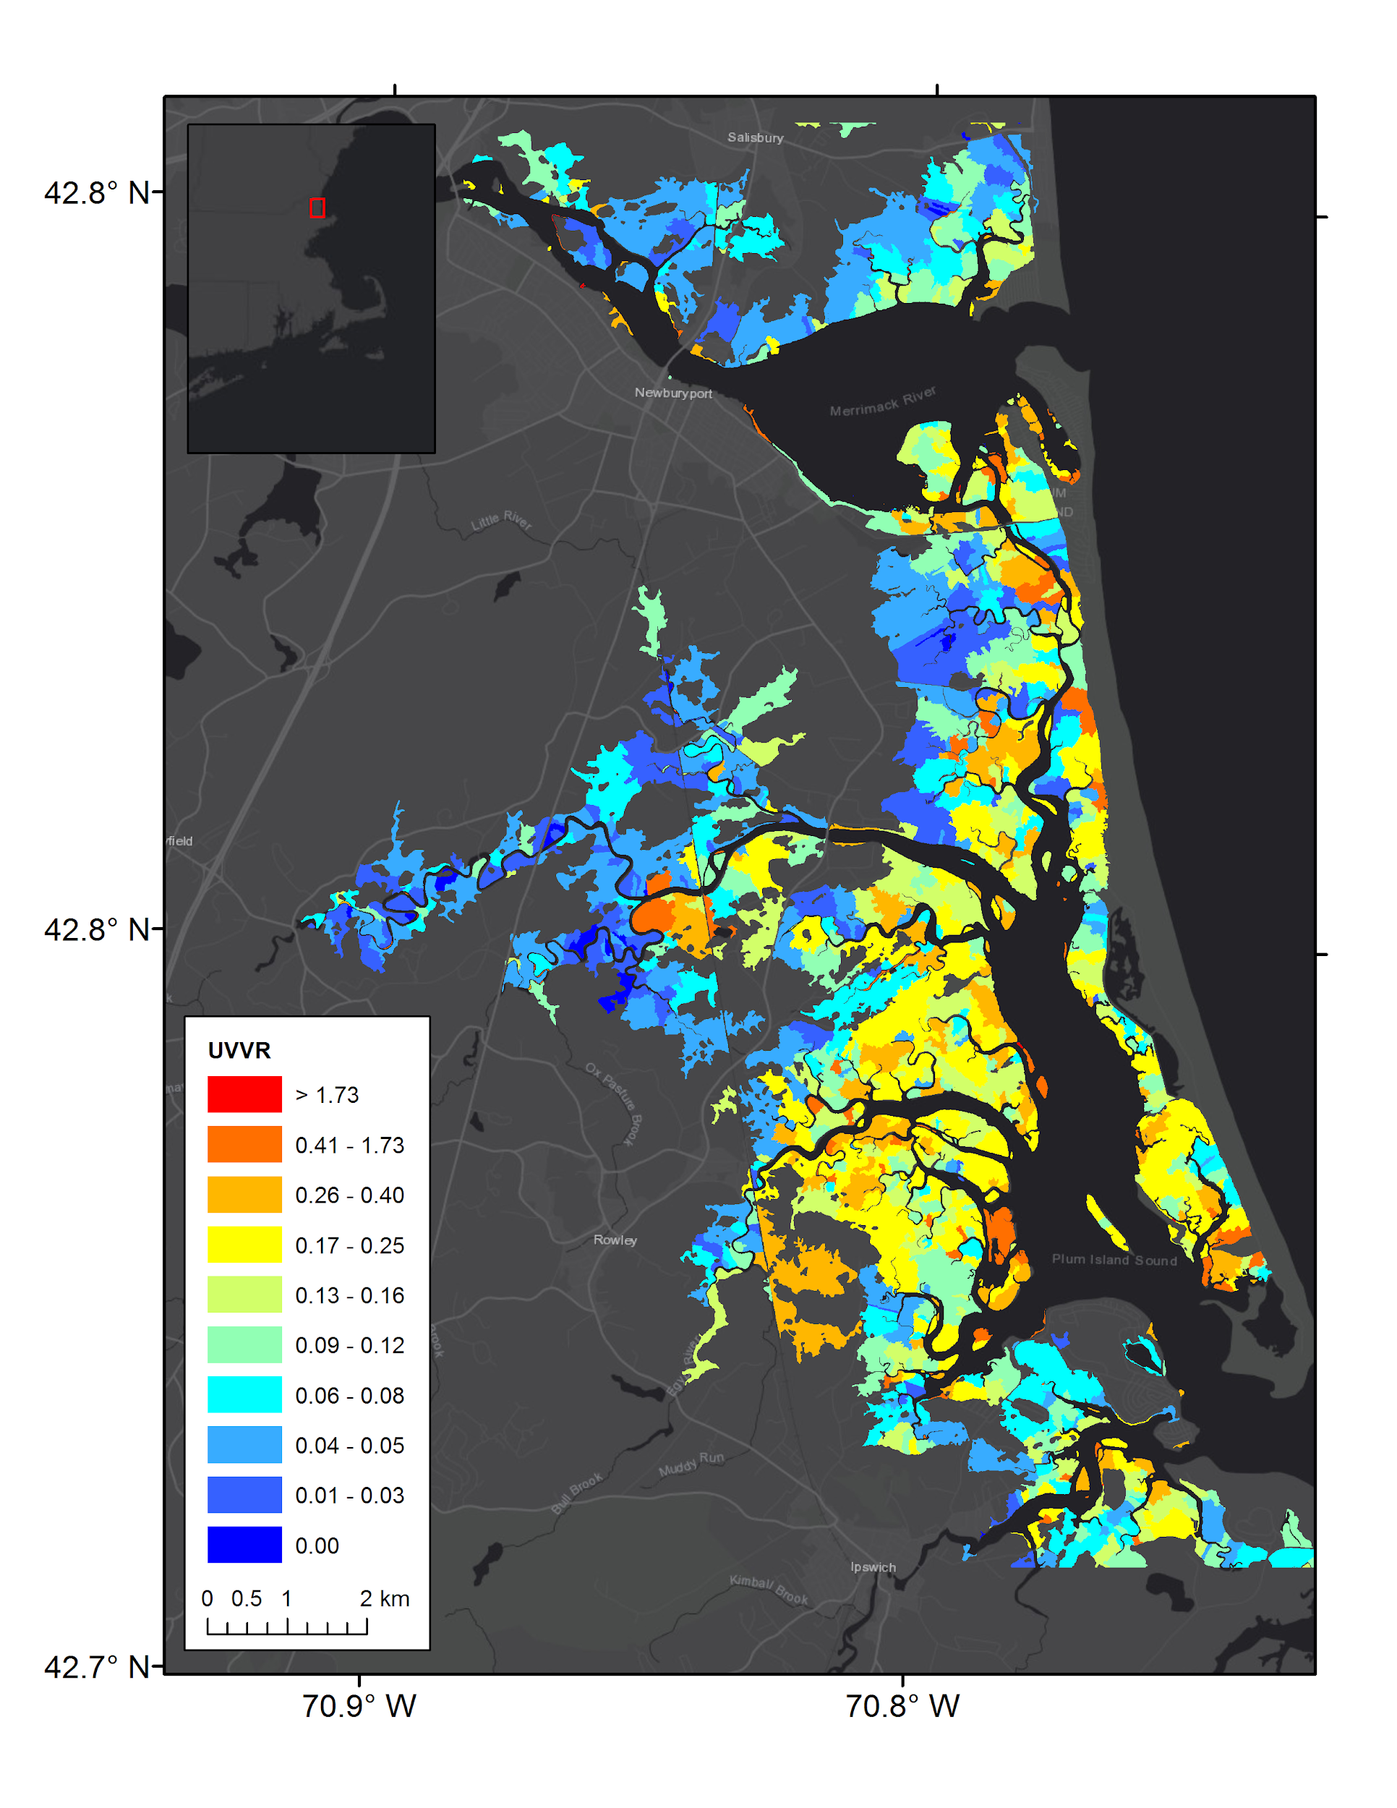
Figure 2. Map of UVVR, a relative measure of marsh deterioration, in the study area. Image source: USGS Woods Hole Coastal and Marine Science Center.
This project sought to improve the atmospheric correction process and ameliorate the algorithm developed in the previous term with an increased number of in situ data points. This term built on prior work by mapping SSC throughout the estuary and creating a time series to show how SSC changes in the estuary with varying environmental conditions, such as tidal level, discharge rate, wind speed, and change in water level. The team also correlated turbidity with SSC and compared the local model with an established turbidity model. Finally, the team used the derived SSC information as an input to a hydrodynamic model of the estuary (Delft3D) to map sediment flux into and out of the estuary, and investigated potential sources of sediment, such as the Merrimack River.

3. Methodology
3.1 Data Acquisition
The high spectral and spatial resolution of both Landsat 8 OLI and Sentinel-2 MSI (Table 1) made these sensors the most appropriate choice for this study. The team downloaded Landsat 8 level 1 images from USGS Global Visualization Viewer (GloVis), and Sentinel-2 level 1C images from ESA Sentinel Open Access Hub. Images with large amounts of obstructing cloud cover were omitted. Cloudless images from Landsat 8 extend from April 2013 to July 2018, and Sentinel-2 images range from March 2017 to May 2018. In total, the team processed 46 images (24 from Landsat 8 and 22 from Sentinel-2) for analysis.

Table 1: Resolutions of sensors used to determine SSC
Sensor | Spatial Resolution | Temporal Resolution | Radiometric Resolution
Landsat 8 OLI | 30 m | 16 days | 9 spectral bands from 435 nm - 1384 nm
Sentinel-2 MSI | 10-20 m | 10 days | 13 spectral bands from 496 nm - 2200 nm

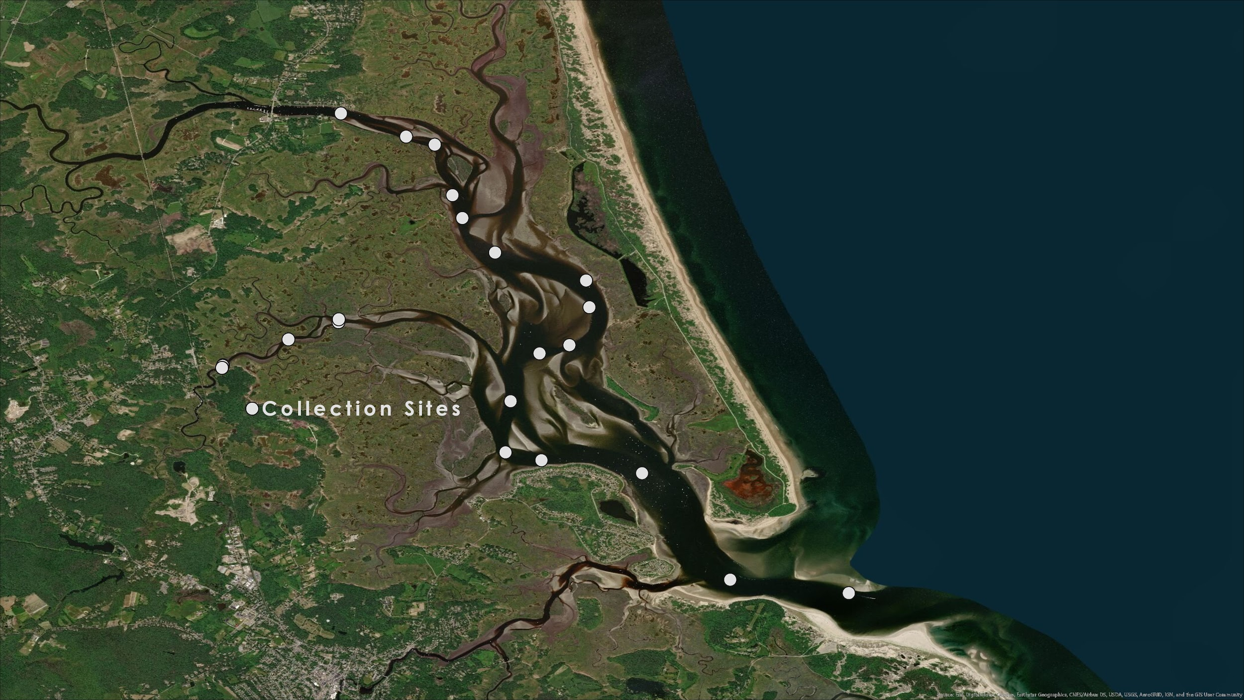
The team’s physical proximity to the study area allowed participants to gather in situ data on multiple dates from May to July 2018. Because the algorithm relates Rrs to SSC, its development requires concurrent in situ SSC and surface reflectance data. To obtain these paired values, the team simultaneously collected water samples from the site using a Van Dorn sampler and measured reflectance using a profiling spectroradiometer (Biospherical Instrument’s Compact Optical Profiling System, or C-OPS) or a handheld VNIR radiometer (ASD Fieldspec HandHeld 2 Pro). The team also used a water quality probe (YSI ProDSS with ODO/CT extension) to collect turbidity data at each collection site. These measurements were collected at a variety of sites within the estuary, as shown in Figure 3, and in the Merrimack River.

Figure 3. Map of in situ data collection sites in the estuary. Image source: Esri, DigitalGlobe, GeoEye, i-cubed, USDA FSA, USGS, AEX, Getmapping, Aerogrid, IGN, IGP, swisstopo, and the GIS User Community.

Some areas of the estuary are too shallow for Rrs to be informative. In these shallow areas, observed Rrs is reflected by the estuary bed rather than by material suspended in the water, and is termed “bottom reflectance.” The team masked areas of the estuary where bottom reflectance dominated observations. This was completed using a 2016 NOAA chart of the estuary with a combination of true color images from Google Earth Pro and Landsat 8 OLI. Using the depth measurements from the NOAA chart, a preliminary mask was created to exclude all areas shallower than six feet in depth. The preliminary mask was then overlaid on the high-resolution true color imagery from 2016 in Google Earth Pro to compare how well the mask matched with the visible channels. Based on the high-resolution imagery, the mask was tweaked to better capture the main channel and remove areas that were not consistently deep. This mask was then imported into ArcGIS Pro and compared with the atmospherically-corrected Landsat 8 OLI true color imagery. The mask was adjusted to remove mixed pixels along the shoreline of the Landsat 8 OLI imagery to ensure that the mask was only capturing pixels that were deep water.

The team also collected data on the water level, wind speed and direction, and river discharge at the time of each satellite image. Information on water level and wind speed and direction were collected from the OTT radar level sensor and the wind sensor, respectively, for the Ipswich Bay Yacht Club pier. These datasets are available on the PIE LTER Website (Giblin, 2013-2017). River discharge data for the Ipswich River were obtained from USGS Station 0110200, and data for the Parker River were from USGS Station 0110100.

3.2 Data Processing
After downloading all of the remotely sensed imagery, the team performed atmospheric correction using SeaDAS. Due to the significant effect of atmospheric signal in aquatic remote sensing, the team performed customized atmospheric corrections calibrated to local conditions in order to obtain the most accurate products. The team applied near-infrared/short-wave infrared aerosol corrections based on the moderate turbidity of the waters in PIE. To correct for Rayleigh scattering, the team used the preset operations in SeaDAS, but input the atmospheric pressure at the date and time of each image to obtain more accurate results. In addition to atmospheric correction, the team used SeaDAS to apply gains to the images. This process is known as vicarious calibration and is applied to correct for minute errors in sensor calibration after launch. Minor differences in calibration can lead to sizable errors in retrieved values, so the application of gains can greatly improve the quality of remote sensing products. The team used the default Landsat 8 gains in SeaDAS and applied preliminary gains from Pahlevan et al. (2017) to Sentinel-2 images. After running atmospheric corrections and applying gains, the team used SeaDAS to derive Rrs from the data.
Water samples collected from PIE were filtered in the lab using a vacuum filtration system. The team used Whatman grade GF/F glass microfiber filters with a pore size of 0.7 µm, meaning anything larger than 0.7 µm was retained on the filter. This included algal matter as well as inorganic materials such as sediment. To separate the sediment from the algal material residing on the filter, the filters were placed in a furnace at 75°C overnight. This process eliminated all organic material, leaving only sediment. The mass of suspended sediment was then found using the weighing by difference method, subtracting the weight of the empty filter from the weight of the filter and materials. SSC was found by dividing this mass by the total volume of water sampled (Equation 1). In total, the team collected thirty in situ data points that could be added to the original six points used in the previous term, as well as six new points from the Merrimack River.

$SSC=\frac{Final filter weight \left(mg\right)-Initial filter weight (mg)}{Volume of sample filtered (L)}$ (1)

In order to finalize the mask creation in ArcGIS Pro, the atmospherically corrected Landsat 8 OLI imagery was exported from SeaDAS using the Reproject Operator. The Reprojection Parameters used a Predefined CRS of “EPSG:32619 - WGS 84 / UTM zone 19N” and were saved in the BEAM-DIMAP format. These files were then imported into ArcGIS Pro and a true color composite was created using the Composite Bands tool.

Using the in situ data, the team generated an empirical algorithm to derive SSC from Rrs. The team studied the possibility of generating a semi-analytical algorithm based on a bio-optical model. The relationship generated by a semi-analytical algorithm is process-based and yields more informed estimates of SSC. However, attempting to implement the proposed semi-analytical algorithm from Han et al., 2016 was not successful, and the team opted to generate a new empirical algorithm. After testing a variety of possible algorithms, the best algorithm was an exponential regression based on Rrs at 655 nm for Landsat 8 and 665 nm for Sentinel-2. The team applied these algorithms to all of the images and generated maps of SSC throughout the estuary’s main channel in ArcGIS Pro, as shown in Figure 4. The team also drew a transect line through the center of the channel, in order to more easily analyze how SSC changes from the top to the mouth of the estuary (Figure 4).

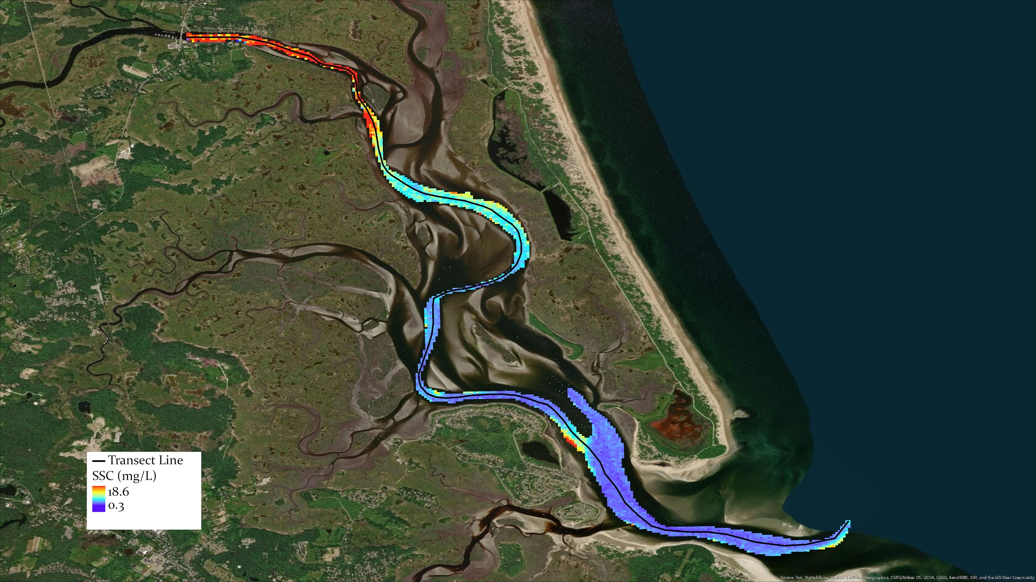
Figure 4. Map of SSC in the estuary’s main channel from Landsat 8 OLI on February 6, 2017 generated using empirical algorithm in ArcGIS Pro. The black line through the center of the channel is the transect line. Image source: Esri, DigitalGlobe, GeoEye, i-cubed, USDA FSA, USGS, AEX, Getmapping, Aerogrid, IGN, IGP, swisstopo, and the GIS User Community

The team also processed the images in ACOLITE to retrieve turbidity estimates from the algorithm generated by Dogliotti et al. (2015), which derives turbidity from Rrs. Since turbidity is an optical property, it is inherently related to Rrs, and can be used as a proxy for SSC. The in situ data suggested that there was a robust relationship between turbidity and SSC in the study area, so the team generated two additional algorithms that derive turbidity from Rrs and SSC, respectively. The team compared the outputs of these algorithms to the turbidity estimates generated by the semi-analytical algorithm from Dogliotti et al. (2015).

3.3 Data Analysis
The team collected in situ data at the same time as a Landsat 8 overpass, and these data were used for algorithm validation. The team compared a trace of in situ turbidity measurements in PIE to turbidity retrieved from our Landsat 8 algorithm for July 3, 2018, and found that RMSE was .9375 mg/L and bias was .8347. A similar comparison in the Merrimack of a turbidity trace from July 19, 2018 and turbidity derived from Rrs in the Merrimack proved much less successful, with RMSE of 2.131 mg/L and bias of 2.048. Only 6 in situ data points were collected throughout the term in the Merrimack, which was not enough to establish a unique relationship, so the team applied the same algorithm calibrated for PIE. The poor bias and RMSE achieved when applying the PIE turbidity algorithm to the Merrimack suggests that the relationship between Rrs and SSC differs in this area, likely due to the type of particles found in the Merrimack. A unique algorithm for this area would be preferable, but the amount of in situ data available was not sufficient to further explore this relationship.

The team also conducted a sensitivity analysis on the algorithm to analyze how SSC changes in response to a change in Rrs. Sensitivity, or the amount the output of the algorithm changes based on a change in the input, is found by taking the derivative of each algorithm (Dietze, 2017). Local sensitivity was found at the mean Rrs value by plugging the mean value of Rrs into each algorithm (Table 2). Finally, the team computed the local elasticity, a standardized, unitless measure of how output changes based on input, by multiplying the local sensitivity by the ratio of mean Rrs to mean SSC (Dietze, 2017). The local elasticities calculated here show that if Rrs changes by 100%, calculated SSC would change by about 98% for both algorithms (Table 2). These statistics imply that the relationship generated between these two variables is plausible.

Table 2. Algorithms used to obtain SSC from Rrs and their derivatives and sensitivities.
 | Landsat 8 OLI | Sentinel-2 MSI
Algorithm | $$SSC=e^{(526.6598*Rrs_655-0.3902)}$$ | $$SSC=e^{(598.4910*Rrs_665-0.3967)}$$
First derivative | $$\frac{dSSC}{dRrs}=526.6598e^{(526.6598*Rrs_{655}-0.3902)}$$ | $$\frac{dSSC}{dRrs}=598.4910e^{(598.4910*Rrs_665-0.3967)}$$
Local Sensitivity | 1833.1 mg L⁻¹ / sr⁻¹ | 2083.1 mg L⁻¹ / sr⁻¹
Local Elasticity | 0.981 | 0.985

In the main channel, the team compared SSC derived from the Dogliotti et al. (2015) turbidity algorithm with SSC data derived from the algorithm generated in this project. The team compared the results of the Dogliotti turbidity algorithm with the results of the new algorithm and found that the Dogliotti algorithm tended to overestimate SSC compared to the locally-derived algorithm for estimating SSC from Rrs. The Dogliotti algorithm also tended to overestimate turbidity compared to the turbidity algorithm the team generated for PIE.

To assess what factors affect SSC, the team first collected wind, water level, and river discharge data for each image. Water level data were used to calculate dh/dt, or the change in water level in a given period of time, using Equation 2, where W_{i} is the water at t_{i}, t₁ is 3:15 GMT on the date the image was taken, and t₂ is 3:30 GMT. The team also calculated the median SSC along the transect for each image. Finally, the team performed a simple linear regression between SSC and each possible explanatory variable in turn, and then fit a multiple linear regression.

$\frac{dh}{dt}=\frac{W_{2}-W_{1}}{t_{2}-t_{1}}$ (2)

The estuary looks very different at high and low tide, so the team decided to sort the images into two groups based on whether they were taken at high tide or low tide. Because dh/dt is the rate of change in water level, it is close to zero at peak high tide and peak low tide, when there is little water movement. Mid-tide, or the point between high and low tide, is therefore defined by the maximum absolute value of dh/dt. Using the water level at the maximum dh/dt as a baseline, the team defined any water level above the baseline as high tide and any water level below as low tide. To assess the seasonal and overarching trends in sediment concentration, the team also performed two analyses of variance (ANOVA): one to determine whether there were significant differences in sediment between years, without regard for season, and one to determine if there were significant differences in sediment between seasons, without regard for year.

To produce a time-series of SSC in the main channel, the team first applied the empirical SSC algorithm to all 46 images in MATLAB, and then used R to reproject all Sentinel-2 images to have the same spatial resolution as the Landsat 8 images. The team removed all SSC values greater than 30 mg/L, as experience with in situ data indicates that values greater than this are due to bottom reflectance rather than true sediment concentration. The team generated two times series, one with 24 images of high tide from 2013 to 2018, and one with 22 images of low tide from 2013 to 2018. The team used these time series to calculate the mean, standard deviation, median, minimum, and maximum of each pixel along the estuary channel for high tide and low tide (Appendix A).

The team also generated a visual representation of SSC along the transect, which was created by graphing date on the x-axis, distance along the transect on the y-axis, and using a color scale to represent SSC along the distance for each date (Figure 5; Appendix B). The distance is measured from the top of the estuary and runs along the transect, where 0 km is the top of the estuary and 15 km is the mouth of the estuary. These charts were paired with graphs of water depth to contextualize the SSC estimates displayed. Additionally, the team generated traditional SSC versus distance plots along the transect for each of the images (Figure 6; Appendix C). These plots clearly show where peaks in SSC occur along the transect, which can be useful when determining the source of the sediment.

To evaluate sediment flux throughout the estuary, the team provided SSC data produced by the algorithm for one image as an input to the Deltf3D hydrodynamic model. The model calculated the water flux through each pixel at the moment the image was taken based on the dh/dt calculated for 15 minutes around the time of the image capture. The water flux through a pixel was then multiplied by the SSC in that pixel to obtain the sediment flux through the pixel. The team obtained one preliminary scene from this analysis (Figure 8). This map provides a snapshot of how sediment is moving in the estuary at the specific moment the satellite image was captured.

4. Results & Discussion
4.1 Analysis of Results
The transect graphs indicate that in general, SSC decreases from the top of the estuary towards the estuary’s mouth (Figure 5; Figure 6; Appendix B; Appendix C). Peaks in the data tend to correlate with the mouth of the Parker River. The relatively small amount of sediment at the mouth of the estuary indicates that rivers and creeks, rather than the ocean, are likely the major sources of sediment to the estuary. The high concentration of sediment at the top of the estuary and at the mouths of the Parker and Ipswich Rivers support this theory. Although there is a small, recurring peak in SSC at the mouth of the estuary, it appears that very little sediment enters the estuary via the mouth, and sediment transported down the coast from the mouth of the Merrimack is likely not a major source. Further analysis of SSC at the mouth of the estuary during flood tide could help support this hypothesis.
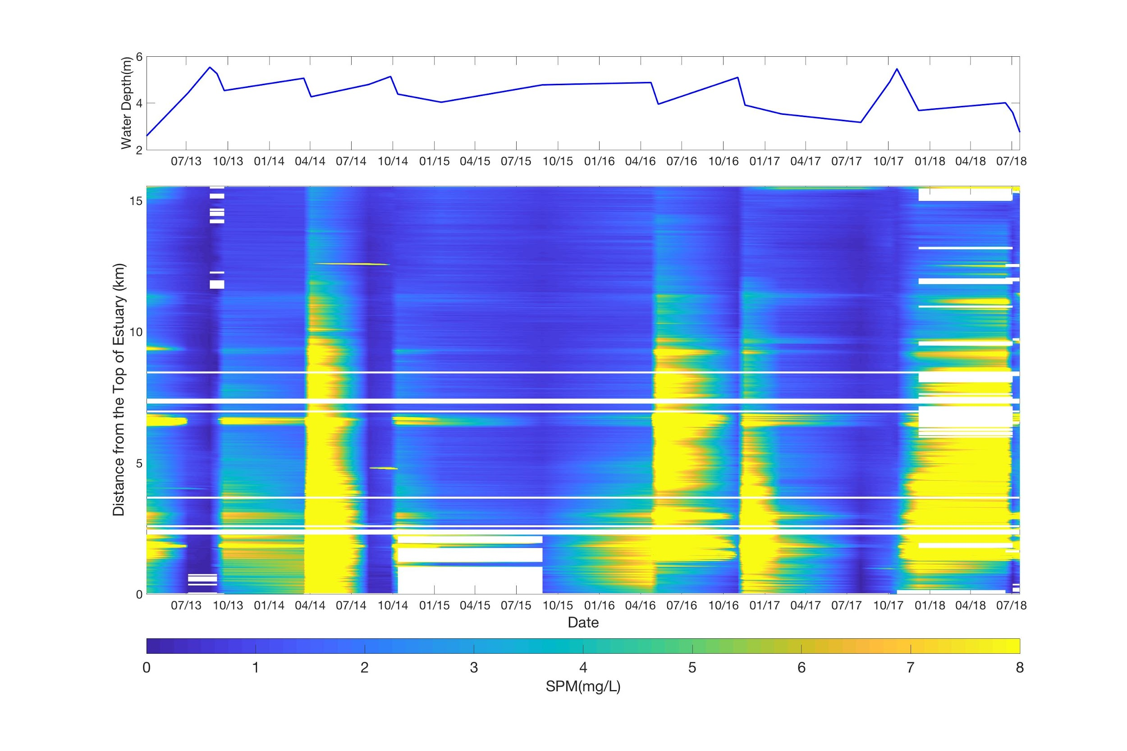
Figure 5. Graph of SSC along the transect for each date with the corresponding water depth. Landsat 8 OLI.

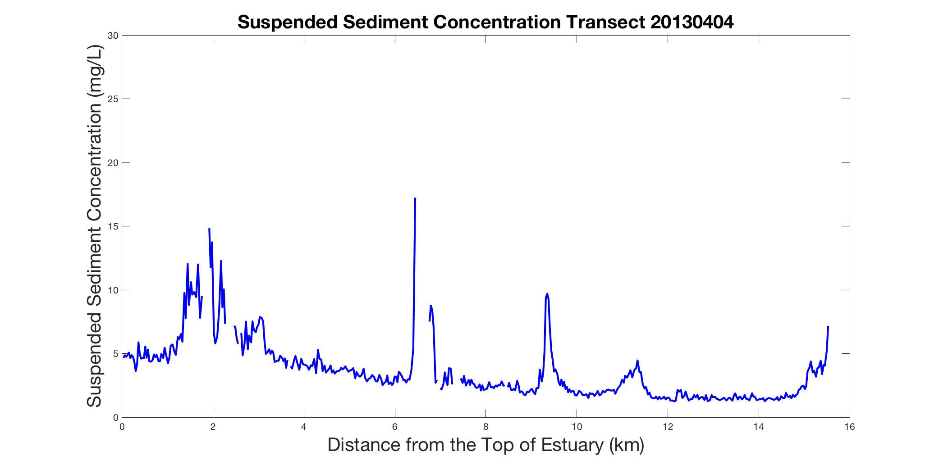
Figure 6. Plot of SSC along the transect vs distance. Image source: Landsat 8 OLI on April 4, 2013.

The maps of mean SSC showed that SSC was consistently lower throughout the channel at high tide than at low tide (Appendix A). At low tide, the mean SSC retrieved by the algorithm ranged from roughly 0 - 15 mg/L, while at high tide, the mean SSC ranged from 0 - 5 mg/L (Appendix A). The maps of standard deviation indicate that SSC is most variable toward the top of the estuary, although areas of high variability appear to exist along the edge of the mask in both high and low tide images (Appendix A). This seemingly high variability could be due to shifting bathymetry over the span of five years or to increased discharge from the nearby rivers during storm events. The time series also confirmed that the mask successfully excluded topography from the results. If the mask had not been successful, persistently high SSC would appear in the same area across multiple images, which would indicate that the signal is due to bottom reflectance rather than true SSC. Within the mask, very few pixels show consistently high SSC across all dates.

The team used individual linear regression to study how different environmental factors influenced SSC. Of the factors examined, discharge from the Ipswich and Parker Rivers, dh/dt, and water level all had a significant effect on median SSC (Figure 7). The team then fit a multiple linear regression to generate a multivariate model that explained variation in SSC (Equation 3). Ipswich River discharge had a p-value of less than 0.001, dh/dt had a p-value less than 0.005, and water level had a p-value of less than 0.02. This model had an R² of 0.47, indicating that 47% of the variation in SSC is due to variation in these factors. Parker River discharge was not included in the model because it had a high covariance with Ipswich River discharge.

$Median SSC∼Ipswich Discharge +\frac{dh}{dt}+Water Level$ (3)

In addition, the two ANOVAs showed that there are no overarching trends in sediment from 2013 to 2018 (p = 0.124). However, there was a significant difference in sediment concentration between spring and the other seasons (Tukey HSD test; p < 0.05 for all combinations of spring and another season). SSC tends to be higher in spring than in the other seasons, which is likely the result of increased river discharge and runoff caused by snowmelt (Figure 7).

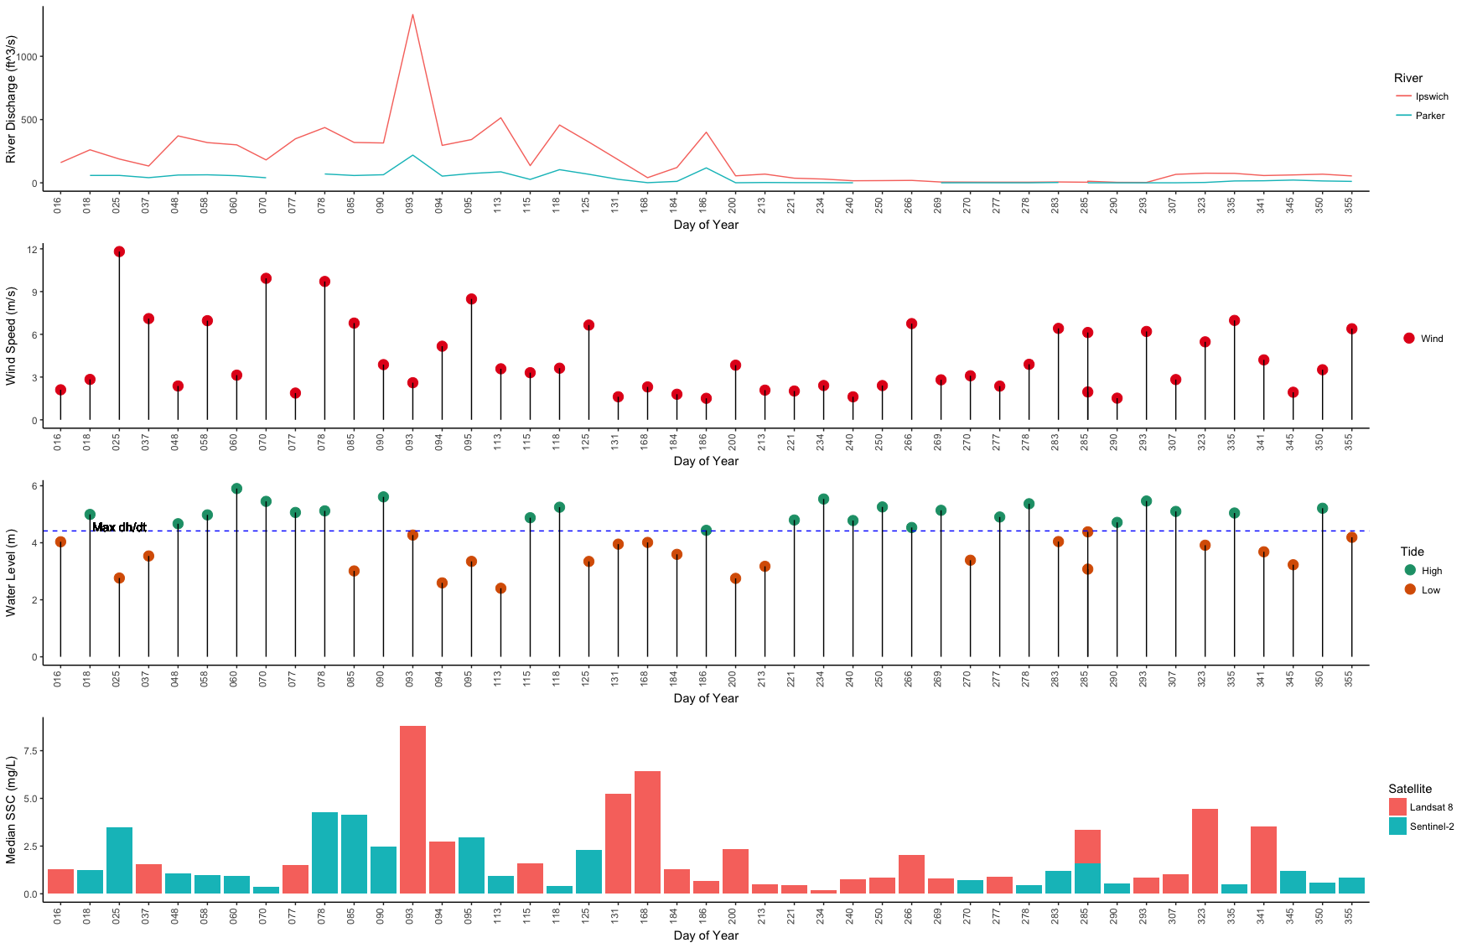
Figure 7. Plots of river discharge for the Ipswich and Parker rivers, wind speed, water level, and median SSC versus day of the year for all images.

This multivariate model supports the hypothesis that the rivers are the primary source of sediment for the estuary. High river discharge corresponding to high sediment concentration in the estuary means that when a river is transporting large amounts of water into the estuary, the estuary also receives large amounts of sediment, implying that the sediment is coming from a river. Lower SSC at high tide, when water transport into the estuary is dominated by oceanic rather than riparian sources, implies that the influx of ocean water dilutes, rather than enriches, the sediment concentration in the estuary. We can conclude that the primary sediment source must be the rivers, rather than the ocean. This also implies that coastal transport of sediment from the mouth of the Merrimack River to the estuary’s mouth is not a significant source. The relationship between SSC and dh/dt shows that SSC is consistently low at peak high or peak low tide, when there is slack, non-moving water. As dh/dt increases or decreases from zero, SSC can increase. One possible explanation for this observation is that water movement influences whether or not sediment is suspended; when water is slack, sediment can start to settle out.

Although flux modeling analysis was somewhat limited, the team found that sediment flux increases from the mouth to the top of the estuary (Figure 8). The image analyzed with flux modeling was taken during flood tide, when the water level is low enough to be classified as low tide. However, during a flood tide water is entering the estuary from the ocean and consequently water level increases. Despite the incoming water from the ocean, there is little sediment flux at the mouth of the estuary. This supports the hypothesis that the ocean is not a major source of sediment to the estuary when compared to the rivers and streams that feed it.
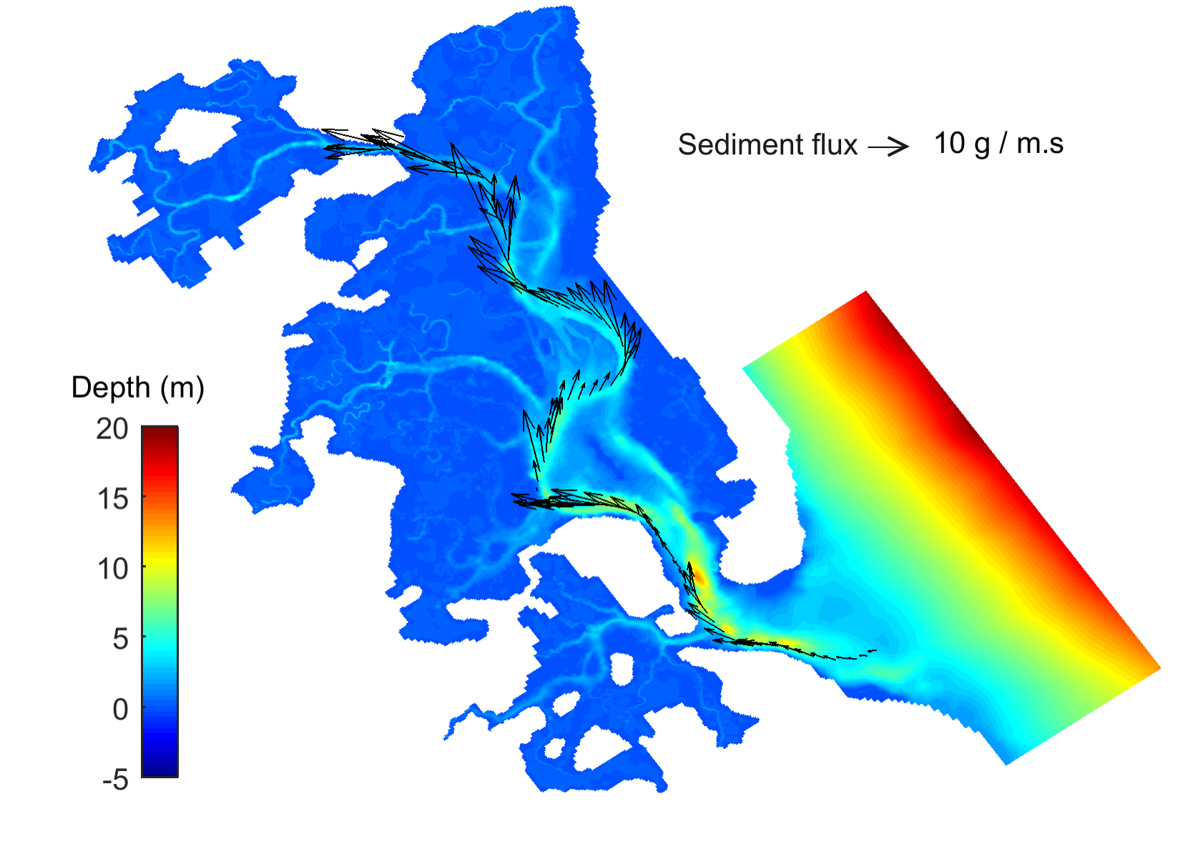

Figure 8. Flux map for November 8th, 2016 produced by Deltares Delft3D hydrodynamic model. Water level is at low tide during the flood stage of the tidal cycle; in other words, water level is low but increasing. Image source: Landsat 8 OLI.

4.2 Future Work
Because high spatial resolution data are not available prior to 2013, the effect of the dams on SSC in PIE could not be investigated. However, the town of Ipswich is looking into removing the Ipswich Mills Dam on the Ipswich River. Dams are known to reduce SSC transport to estuaries, so it would be interesting to investigate the effect of dam removal on sediment transport.

In order to create a more consistent model that relates SSC to Rrs from any sensor at any time, data could be fused via data integration. This would allow the user to utilize only one model that accounts for both algorithms generated in this research. Using data fusion could lead to the generation of an all-in-one tool for estimating SSC from Rrs with data from any sensor.

A long term goal for this area is to develop a comprehensive set of look-up tables for the entire estuary. These look-up tables could be used to retrieve pre-computed Rrs values through a radiative transfer model and correlate measured Rrs values with a specific set of inherent optical properties, including SSC. Researchers could then begin to develop local algorithms for properties such as SSC, chromophoric dissolved organic matter, chlorophyll-a concentration, and many other key properties. Once hyperspectral remote sensing data becomes available for this area, which is likely to happen in the next few decades, researchers will be prepared with a toolkit of robust, local algorithms that can expedite the remote study of this area.

5. Conclusions
Deriving SSC from remote sensing imagery is a feasible method for obtaining SSC data at high spatial and temporal resolution. A higher number of in situ data points, a more refined mask, and improved atmospheric correction methods allowed for reliable retrieval of SSC in areas of the estuary not influenced by bottom reflectance. The team found that applying a local empirical algorithm is a useful method that can be used to create sediment budgets and observe sediment dynamics, information which will help our partners extend their vulnerability assessments of PIE. By studying the relationships between Rrs, turbidity, and SSC, the team also found that locally calibrated algorithms were more successful at retrieving SSC than a semi-analytical model established for use in any estuarine system. This finding demonstrates the advantage of local algorithm development and suggests that future studies using remote sensing to study estuarine environments may benefit from developing their own algorithms specific to their study site, rather than relying on previously established, non-local algorithms.
Analysis of the time series and environmental variables strongly indicated a dominant riverine source of sediment. Such knowledge about sources of sediment to PIE will help our partners understand the overarching sediment dynamics of PIE, which will guide a more nuanced approach to large-scale vulnerability assessments. Additionally, the time series created in this project defines a baseline for the current state of sediment dynamics in PIE. Our partners will be able to continue to use the methods established in this study to observe sediment in the estuary moving forward, and compare these future observations to those from this project to track long-term change in the estuary. By collecting preliminary in situ data from the Merrimack River, it was determined that the relationship between Rrs and SSC is unique and would require further data collection in order to be analyzed using these methods. In the long term, more frequent, comprehensive vulnerability assessments will help our partners prioritize future research and advise stakeholders on effective management practices not only in PIE, but in coastal systems across the nation.

6. Acknowledgments
We would like to thank the following individuals for their contributions to this project:

Dr. Neil Ganju, United States Geological Survey, Woods Hole Coastal and Marine Science Center
Dr. Anne Giblin, Long Term Ecological Research Network, Plum Island Ecosystems LTER
Nancy Pau, United States Fish and Wildlife Service, Parker River National Wildlife Refuge
John Macone, Merrimack River Watershed Council
Robert Russell, Merrimack River Watershed Council
Dr. Cedric Fichot, Boston University Department of Earth and Environment
Dr. Sergio Fagherazzi, Boston University Department of Earth and Environment
Carly Baracco, Boston University Undergraduate Research Opportunities Program
Xiaohe Zhang, Boston University Department of Earth and Environment
Dr. Michael Dietze, Boston University Department of Earth and Environment

This material contains modified Copernicus Sentinel data (2017-2018), processed by ESA.

Any opinions, findings, and conclusions or recommendations expressed in this material are those of the author(s) and do not necessarily reflect the views of the National Aeronautics and Space Administration.

This material is based upon work supported by NASA through contract NNL16AA05C and cooperative agreement NNX14AB60A.

7. Glossary
Bottom reflectance – Light reflected by the bottom of a water body, rather than by the water and its constituents
Landsat 8 OLI – The Operational Land Imager (OLI) is one of two sensors onboard Landsat 8, launched in 2013, and includes 9 spectral bands and a 16-day revisit time.
PIE LTER – Plum Island Ecosystems Long Term Ecological Research Network.
Remote sensing – The science of obtaining information about objects or areas from a distance, typically from aircraft or satellites.
Remote sensing reflectance (Rrs) – Apparent optical property that is the ratio of water leaving irradiance to total incident solar radiation on a flat surface; also known as ocean (or water) color.
Salt marsh – Highly productive, coastal ecosystems characterized by regular tidal flooding.
Sea level rise (SLR) – Increase in ocean water levels due to ice melt and thermal expansion.
Sentinel-2 MSI – The Multispectral Instrument (MSI) aboard Sentinel-2 measures reflected radiance in 13 spectral bands, with a revisit time of 10 days.
Suspended sediment concentration (SSC) – The ratio of the mass of dry sediment in a water-sediment mixture to the volume of the water-sediment mixture, typically measured in mg/L.
Sediment flux – The amount of sediment that passes through a given point in a given period of time.
Turbidity – A measure of the relative clarity of a water body. An optical characteristic of the water body that expresses the amount of light scattered at a given angle by suspended material in the water, measured in FNU (Formazin Nephelometric Units) in this study.

8. References
Barbier, E., Hacker, S., Kennedy, C., Koch, E., Stier, A., & Silliman, B. (2011). The value of estuarine and coastal ecosystem services. Ecological Monographs, 81(2), 169-193.

Dietze, M. C. (2017). Ecological forecasting. Princeton University Press.

Dogliotti, A. I., Ruddick, K. G., Nechad, B., Doxaran, D., & Knaeps, E. (2015). A single algorithm to retrieve turbidity from remotely-sensed data in all coastal and estuarine waters. Remote Sensing of Environment, 156, 157-168.

European Space Agency. (2013-2017). Sentinel-2 Data. Processed by ESA

Ganju, N., Kirwan, M., Dickhudt, P., Guntenspergen, G., Cahoon, D., & Kroeger, K. (2015). Sediment transport-based metrics of wetland stability. Geophysical Research Letters, 42, 7992-8000.

Ganju, N., & Schoellhamer, D. (2009). Decadal-Timescale Estuarine Geomorphic Change Under Future Scenarios of Climate and Sediment Supply. Estuaries and Coasts, 33, 15-29.

Ganju, N., Defne, Z., Kirwan, M. L., Fagherazzi, S., D’Alpaos, A., & Carniello, L. (2017). Spatially integrative metrics reveal hidden vulnerability of microtidal salt marshes. Nature Communications, 8, 14156.

Giblin, Anne (2013-2017): Wind sensor data, 15 minute intervals, from the Ipswich Bay Yacht Club pier located in Ipswich, MA. Plum Island Ecosystems LTER, Long Term Ecological Research Network.

Kirwan, M. L., & Megonigal, J. P. (2013). Tidal wetland stability in the face of human impacts and sea-level rise. Nature, 504(7478), 53.

Morris, J., Sundareshwar, P. V., Nietch, C., Kjerfve, B., & Cahoon, D. R. (2002). Responses of coastal wetlands to rising sea level. Ecology, 83(10), 2869-2877.

Tide Predictions – NOAA Tides & Currents. (n.d.). Retrieved July 17, 2018, from https://tidesandcurrents.noaa.gov/tide_predictions.html

Pahlevan, N., Sarkar, S., Franz, B.A., Balasubramanian, S.V., & He, J. (2017). Sentinel-2 MultiSpectral Instrument (MSI) data processing for aquatic science applications: Demonstrations and validations. Remote Sensing of Environment, 201, 47-56.

U.S. Geological Survey, 2018, USGS Surface-Water Daily Data for Massachusetts. https://nwis.waterdata.usgs.gov/ma/nwis/dv? (Accessed July 17, 2018)

U.S. Geological Survey Earth Resources Observation and Science Center (2013-2018). Provisional Landsat 8 OLI Surface Reflectance [Data set]. U.S. Geological Survey. https://dx.doi.org/10.5066/F78S4MZJ

Weston, N. (2013). Declining Sediments and Rising Seas: an Unfortunate Convergence for Tidal Wetlands. Estuaries and Coasts, 37, 1-23.

9. Appendices

Appendix A: Time Series Products
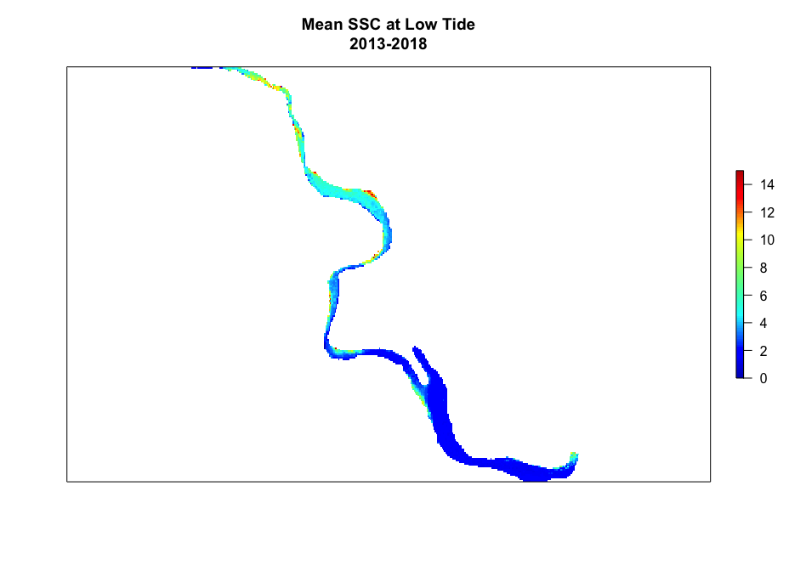
Figure A1. Mean SSC from 2013 - 2018 at low tide; n = 22.

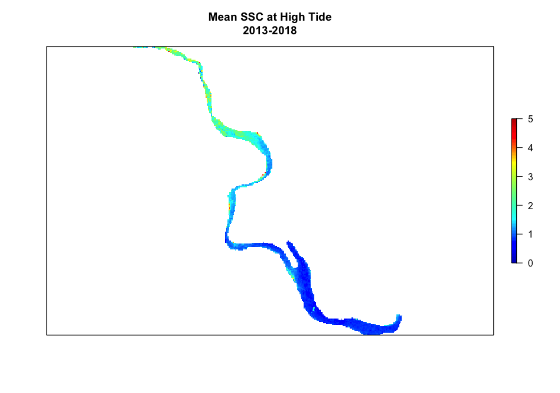
Figure A2. Mean SSC from 2013 - 2018 at high tide; n = 24.

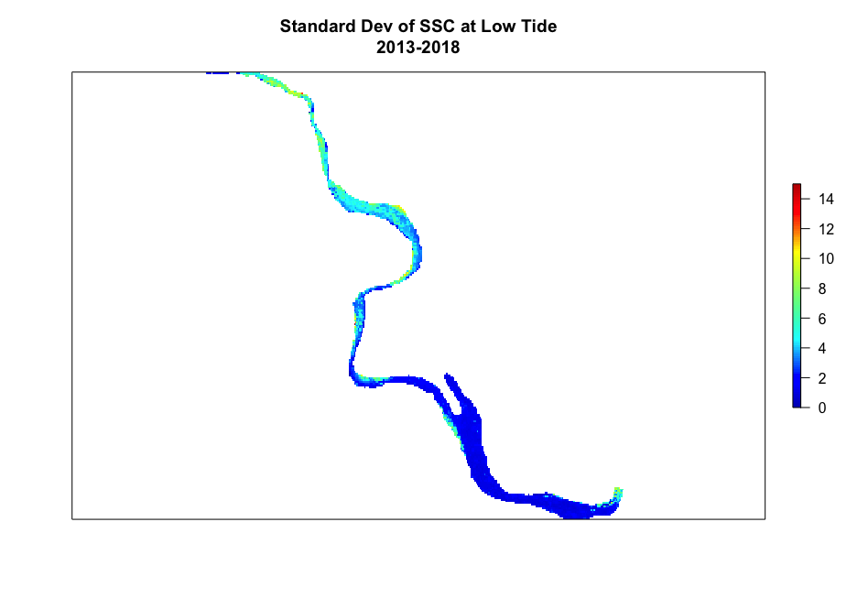
Figure A3. Standard deviation of SSC from 2013 - 2018 at low tide; n = 22.

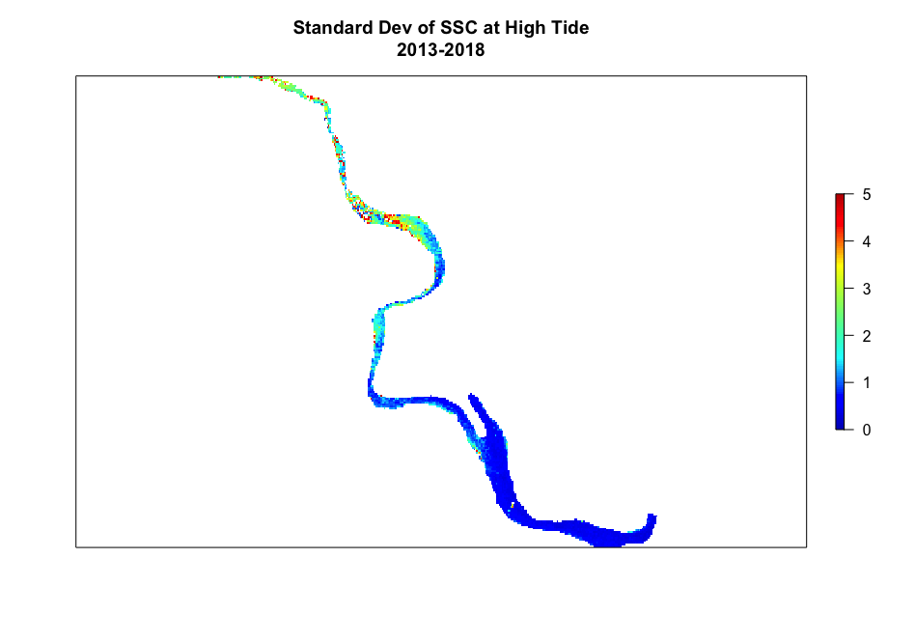
Figure A4. Standard deviation of SSC from 2013 - 2018 at high tide; n = 24.
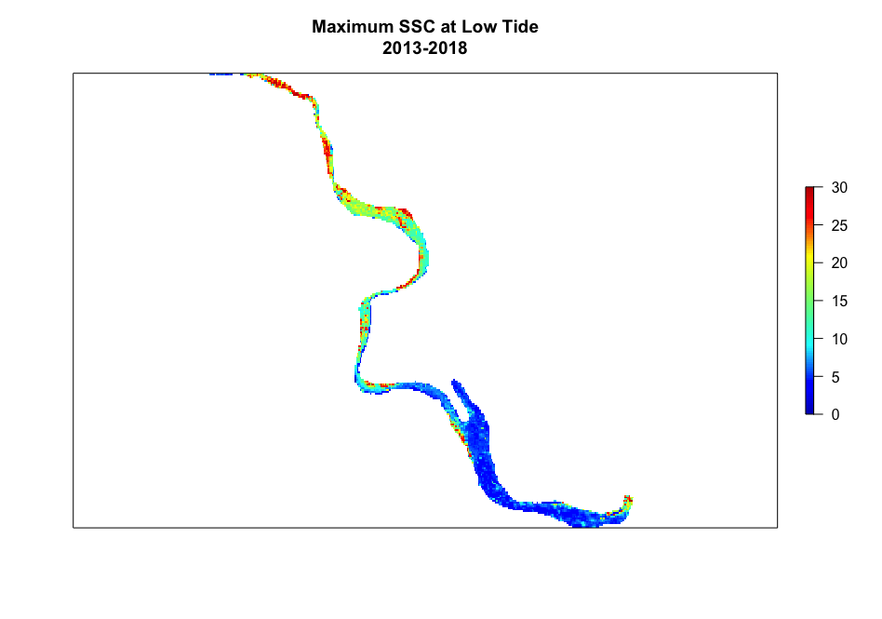
Figure A5. Maximum SSC from 2013 - 2018 at low tide; n = 22.

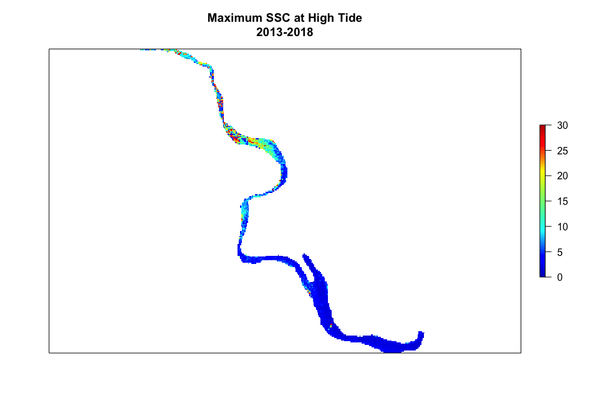Figure A6. Maximum SSC from 2013 - 2018 at high tide; n = 24.

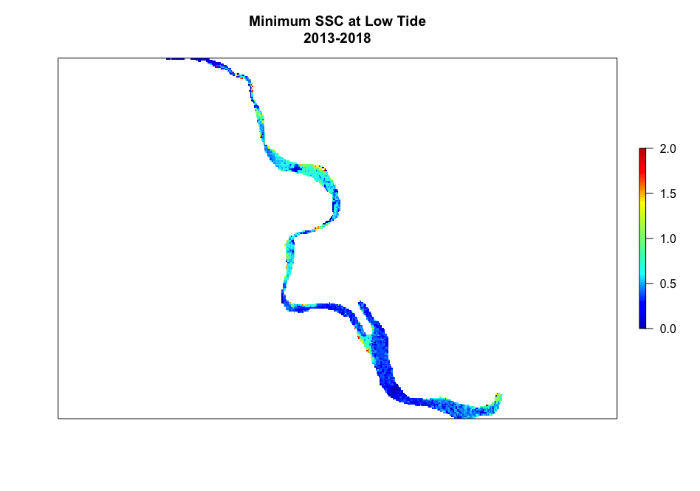
Figure A7. Minimum SSC from 2013 - 2018 at low tide; n = 22.

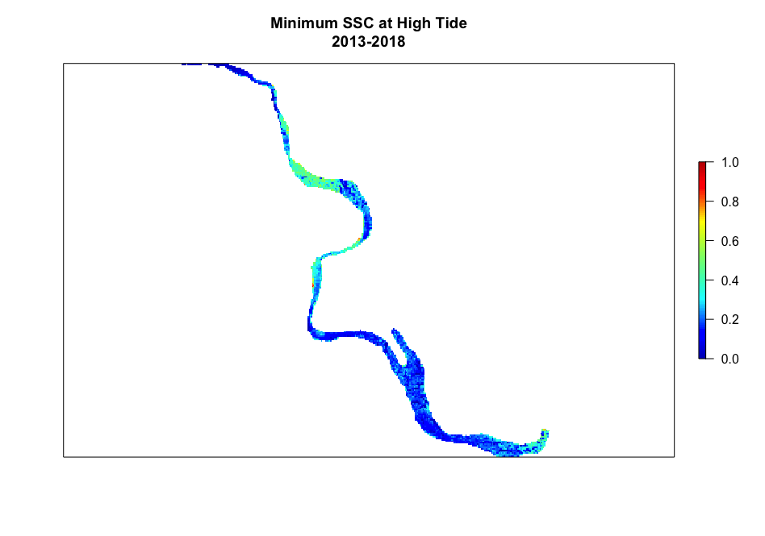
Figure A8. Minimum SSC from 2013 - 2018 at high tide; n = 24.
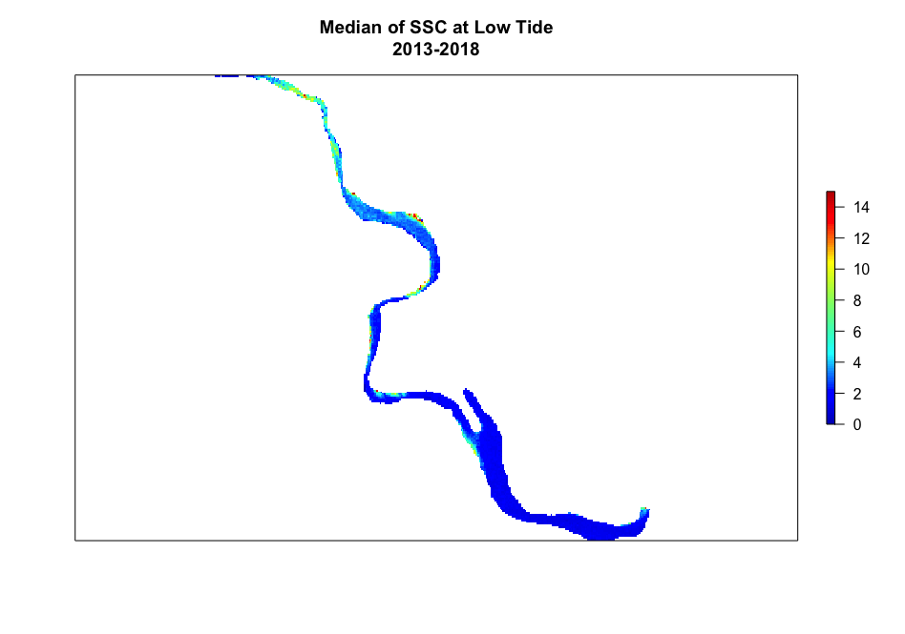
Figure A9. Median SSC from 2013 - 2018 at low tide; n = 22.

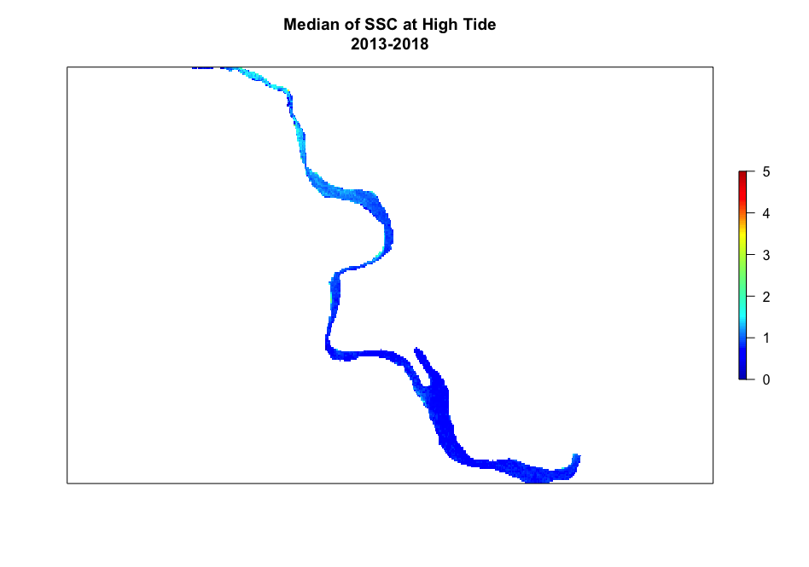
Figure A10. Median SSC from 2013 to 2018 at high tide; n = 24.

Appendix B: Graph of SSC along the transect for each day
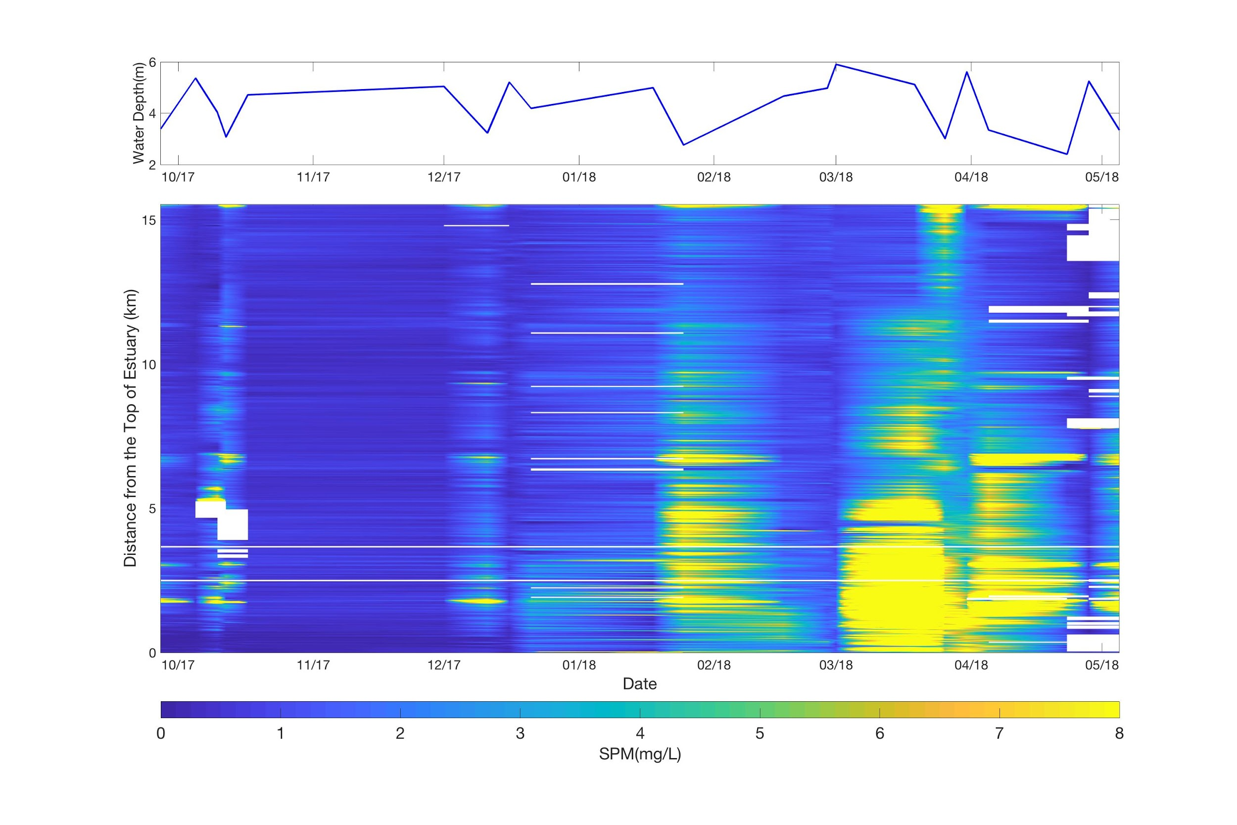
Figure B1. Graph of SSC along the transect for each date with the corresponding water depth. Sentinel-2 MSI.

Appendix C: Plot of SSC along the transect for single day
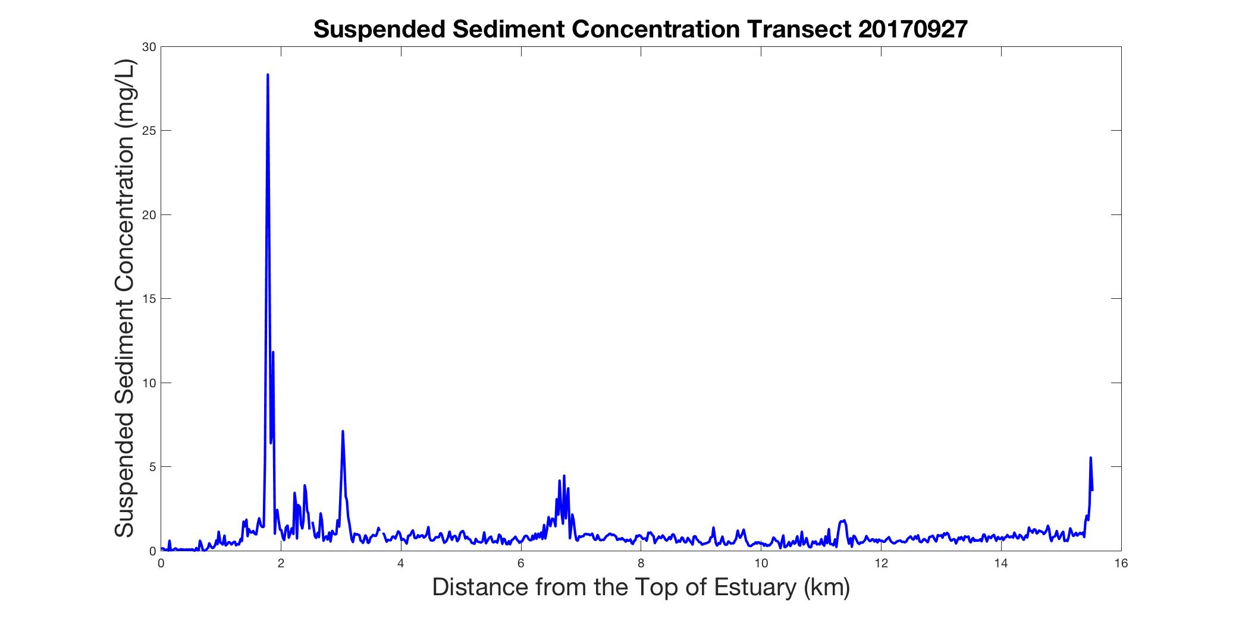
Figure C1. Plot of SSC along the transect vs distance. Image source: Sentinel-2 MSI on September 27, 2013.

