NASA DEVELOP National Program
NASA Langley Research Center
Fall 2015

North Carolina Ecological Forecasting II
Update of NOAA C-CAP Wetland Delineation and Further Disaggregation of Land Use Classes using Remote Sensing


Technical Report
Final Draft – November 13, 2015

Ben Roberts-Pierel (Project Lead)
Brett Buzzanga
Michelle Pasco
Jake Patrick
Benjamin Charlem
Taylor Sage

Emily Adams, NASA DEVELOP (Advisor)
Dr. Kenton Ross, NASA DEVELOP (Science Advisor)

Previous Contributors:
Zand Bakhtiari
Stephen Zimmerman
Kayla Patel
Brad Gregory

I. Abstract
This project focused on ecological forecasting for wetlands in the Albemarle-Pamlico watershed in Northeastern North Carolina and Southeastern Virginia. The Albemarle-Pamlico watershed encompasses the second largest estuary system in the United States. Understanding land cover types and uses is incredibly important in managing the myriad of uses for, and stressors on, this valuable resource. In partnership with the Albemarle-Pamlico National Estuary Partnership (APNEP), this project aimed to provide an updated version of NOAA’s Coastal Change Analysis Program (C-CAP) land-use classification, with a specific focus on delineation of wetland types within this watershed. The project also further disaggregated land cover types such as crop varieties and the invasive species, Phragmites australis. The team utilized a supervised land classification methodology and cross-referenced Landsat 8 imagery with ground truth, LiDAR or Digital Elevation Models (DEM), the National Hydrological Dataset (NHD) and soil datasets to create inputs for the R classifying model. The end goal of the project was to produce maps and a methodology by which APNEP can continually update wetland types and to establish if there is a correlation between wetland type and wetland health within the watershed. This was all with the aim of helping APNEP to make informed policy and management decisions.

Keywords
Albemarle, Pamlico, Landsat 8, Satellite, Supervised Classification, Spatial Analysis, Estuary

II. Introduction
Background Information: The Albemarle-Pamlico region is the ‘largest lagoonal estuarine system in the United States (EPA, 2007). It consists of six river basins (Fig 1) as well as the Albemarle and Pamlico Sounds. Wetlands specifically, as do water bodies in general, provide enormous value to the Southeastern United States through numerous ecosystem services. Wetlands absorb storm surges and strong winds; they minimize eutrophication by retaining and filtering agricultural and urban runoff; and they provide protection for developing fish and amphibian species, thereby continuing the existence and proliferation of terrestrial and oceanic biodiversity (APNEP, 2012).
However, the complex and dynamic nature of the Albemarle-Pamlico estuary network makes it a delicate system. Climate change induced sea level rise and land use change, secondary to population growth, are two significant threats to the Albemarle - Pamlico region (Carpenter 2012). Sea level is currently rising at a faster rate than wetland vegetation can keep pace with, which leads to inundation and erosion at about -3.3 feet/year (ibid). In the twenty years between 1990 and 2010, the Albermarle - Pamlico region’s population grew by 36%, from 2,762,409 to 3,756,019 (APNEP, 2012). This population increase necessitates land change in the form of urban development and agricultural expansion. Even when wetlands are not specifically drained and converted to these purposes, mismanagement of natural resources, waste production, and nutrient runoff have reduced the water quality and human health in the Albemarle-Pamlico watershed (Carpenter 2012).
In order to protect this region, the dynamics and characteristics of the estuary system must be better understood. A previous stage of this investigation, utilizing remote sensing data and indices that measured the extent and health of wetlands, concluded that wetland health has been deteriorating over time. However, to fully grasp the implications of this deterioration we must have clear delineations on the types of wetlands that currently exist, which types are deteriorating, and how this will affect the region as a whole.
Project Objectives: The Albemarle-Pamlico National Estuary Partnership (APNEP) currently relies on land use and land cover (LULC) data from NOAA’s Coastal Change Analysis Program (C-CAP) to understand land use designations and wetland types. This information helps to inform their management decisions by enabling them to decide where to allocate resources and to understand temporal trends. However, C-CAP is only updated every five years and is designed for regional coastline classifications. The team aimed to produce an updated classification that was tailored to the Albemarle-Pamlico estuary by providing additional land classification types. Building on the previous portion of this study, the team looked for a correlation between wetland deterioration and type. The objective was not only to provide APNEP with an updated set of images based on most recent available Landsat 8 imagery, but also to create a method of replicability so it would be possible for APNEP to update these classifications on a more regular basis than what C-CAP offers.
Study Area: The Albemarle-Pamlico region is located on the coast of Northeastern North Carolina and Southeastern Virginia. The basin consists of 31,000 square miles of land and water, including two major Sounds, Albermarle and Pamlico, and seven major river basins (Fig 1), six of which APNEP monitors. Three major land cover classes—forests (40.1%), croplands (25.3%), and wetlands (15.8%)—account for most of the LULC in the basin (APNEP, 2012; Carpenter, 2012).
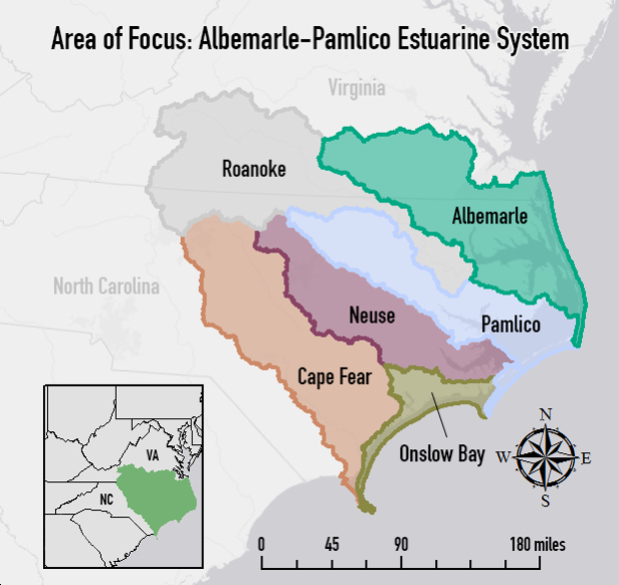
Study Period: The Develop collaboration with APNEP began in the spring of 2015 and will end with this project in the fall of 2015.
Figure : Map of the Albemarle-Pamlico study area: river basins and major sounds.
National Application Area: This project focuses on and contributes to the NASA Applied Sciences Application Area of Ecological Forecasting through the delineation of current wetland extent using remote sensing data, and software such as ArcGIS an ERDAS IMAGINE. Although use of Landsat data for LULC is fairly common, this study provided the partner organization with a useful tool for the specific region of focus and ideally a methodology that will be useful not just to APNEP but potentially other areas of the Applied Sciences program at NASA or to the public. The integration of other data from USGS and NOAA, as well as comparisons with the results from the previous portion of the project, represent other processes, which could lay groundwork for future projects. This methodology could contribute to the Application Area by increasing uptake and utilization amongst groups outside NASA by showcasing datasets, their uses, and the accessibility of the data NASA produces.
Project Partner: Partnership with APNEP started in the spring of 2015. The primary goal of APNEP is to manage, conserve and protect the resources of the Albemarle-Pamlico estuary system. In order to do this, they require a better understanding of how the discrete components of the ecosystem function together as a whole and what stressors are adversely impacting this resource. They are focused on analyzing both short and long term trends and utilizing citizen’s groups, researchers and federal agencies, as well as governments from the local to federal level to accomplish their objectives (APNEP, 2012).

III. Methodology
This study conducted a supervised land classification by using elevation, hydrography, soil, and crop data to select calibration points for a Random Forest Land Classification Model (Norning & Wegman 2013). The model runs in the open-source statistical analysis program, R, and converts spectral radiance values as recorded in Landsat 8 images to user - specified land cover types (ibid). The data used is summarized in Table 1 below.

Dataset | Source | Type/Specific Item
Landsat 8 Operational Land Imager (OLI) | NASA EOS/USGS | Path 14, Row 35  Path 14, Row 36
Landsat 8 Climate Data Record (CDR) | NASA EOS/USGS | Path 14, Row 35  Path 14, Row 36
National Hydrography Dataset (NHD) | USGS | Waterbodies
Coastal Change and Analysis Program (C-CAP) | NOAA | 2010 iteration
Soil Survey and Geographic Database (SSURGO) | USDA
Digital Elevation Models (DEMs) | USGS | 1/3 arc-second and 1 arc second
LiDAR | NOAA | 2001 NC Phase I
Cropscape Annual Crop Data | USDA | 2010-2014 growing seasons for area constrained by the Landsat scenes
Table 1: This provides a brief overview of the data utlized in the completion of this project. Federal agency titles have been abbreviated for the purposes of space. Please consult Appendix I for a list of acronyms.
Some of these data required preprocessing. Landsat 8 OLI scenes were preprocessed by the USGS to correct for surface reflectance as well as atmospheric interference in the Provisional Landsat 8 Surface Reflectance data product, part of the Landsat 8 Climate Data Record (CDR) dataset (USGS, 2015). Images from path 14 row 35 and three images for path 14 row 36 were obtained for three dates, (June 23, 2015, July 25, 2015, August 10, 2015) for a total of five Landsat scenes. The scenes were chosen due to the relatively high quality of the images: little cloud cover and most recent peak vegetation.
Processing and analysis proceeded by aggregation of these datasets in ESRI’s ArcGIS software. Eight 1/3 arc-second DEMs were mosaicked to create one representative raster of the area covered by the Landsat scenes. The ‘swamp/marsh’ type of the NHD Waterbody feature class was clipped to the study area. The “Ecological Site” and “Hydric Rating” SSURGO attributes were similarly merged for analysis within ArcGIS. The former attribute described an area’s characteristic soils, hydrology, and vegetation; the latter demarcated the percentage of an area’s soil that qualifies as hydric, defined as:
“Soil that is formed under conditions of saturation, flooding or ponding long enough during the growing season to develop anaerobic conditions in the upper part” (USDA, n.d.).
These datasets were contrasted in order to select polygons, the training sites, which would best serve as calibration points for the Random Forest Model. Using ArcGIS and ESRI Imagine, training sites were chosen that clearly delineated a specific landcover type. The C-CAP classifications (Appendix II) guided the choices in land cover types, but some regionally inappropriate classes were ignored (such as tundra), while others of local concern such as crop types and invasive species were added (Appendix III).
The training sites encapsulated a minimum of 30-40 pixels to allow for a margin-of-pixel-overlap in the Landsat images (30 m² resolution). 30-50 training sites were selected for each land cover classification type (Appendix IV). The sites and chosen land use classes were then input to the Random Forest Model which extrapolated the classification of the training sites to the entire spectral area (2 Landsat scenes), generating an image of land classification for the whole study area. The classifications produced by the model were compared against the specific case study areas utilized in the previous North Carolina Ecological Forecasting project to determine if there was a correlation between wetland type and health.
Accuracy Assessment: asdfsd

IV. Results & Discussion
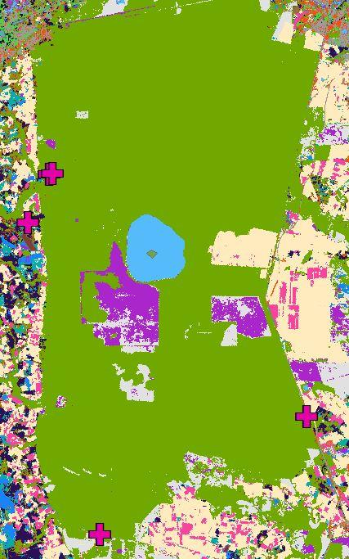
Results: The principal result of the project was the LULC map produced from the training sites assembled in ArcGIS. This particular classification was produced in Google Earth Engine (GEE) using a composite of seven bands from Landsat 8 and a slope layer derived from 1/3 arc second DEMs. Samples of the results depicting the Great Dismal Swamp in Northern North Carolina are pictured below:
Figure SEQ Figure \* ARABIC 2: Series of samples from project classifications including the original CCAP (left), results from Google Earth Engine (Center) and results from ArcGIS (right).
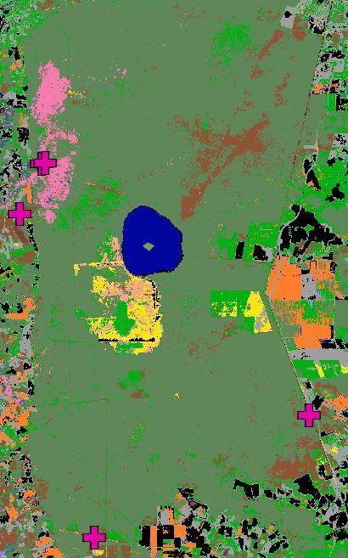
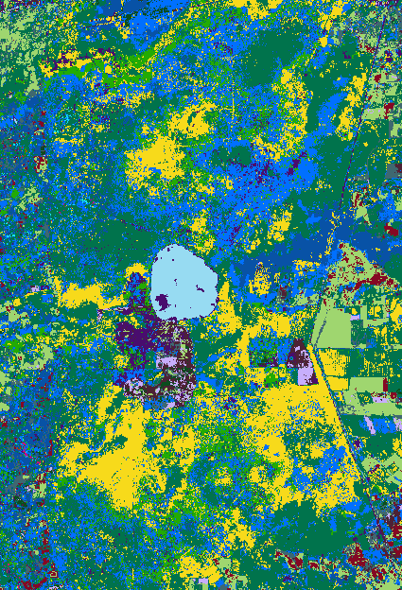
The raw output from GEE includes some ‘noise’, random single pixels and small groups of pixels which are likely misclassified based on their surrounding classes. To address this issue and make the results more user-friendly a series of tools including the Majority Filter, Boundary Clean, Region Group, Extract by Attributes and the Nibble tool were used in ArcGIS to smooth and clean up the image.
(Image Coming Soon)

Discussion: One of the principle uses of these results was to compare with the C-CAP product to highlight areas where our classifications differ from C-CAP, particularly in the wetland classes. Examples of some of these areas are in Figure 3 below. The most prevalent differences found were in the classification of palustrine scrub/shrub wetlands by C-CAP when in reality much of this area should likely be defined as palustrine forested wetlands. Furthermore, there are large areas defined by C-CAP as grass or pasture which have been developed into urban or agricultural land.
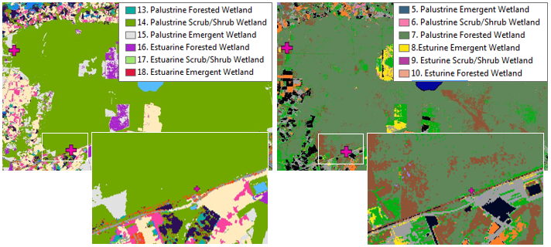
Figure 3: left image is from CCAP and depicts an area in the Great Dismal Swamp where CCAP classifies Palustrine Scrub/Shrub Wetland when in reality it is Palustrine Forested Wetland as depicted in our classification (right).
One of the other goals of this project, as stated above, was to highlight certain areas that the team from last term identified as experiencing declines in wetland health. In order to show these areas a sample of our classification as well as the C-CAP was simply compared with their study focus areas to determine which types of wetland are identified as having declining wetland health.
Image Coming Soon
There are a few potential sources of error in this project. The first and likely most influential is human error. The team developed a methodology for identifying wetland class types to attempt to standardize the process, however, selection of training sites remains largely subjective to the analyst. The process leveraged a wide range of data to cross reference and any error in these layers could also present a compounding factor. There is also a high level of potential error in the classification mechanism when trying to identify classes which have such a similar spectral signature (e.g. forest and forested wetland). In a similar realm, influences of factors such as clouds have an impact on the classification and how the algorithm is able to identify classes on the ground.

V. Conclusions
The team was able to complete a series of classifications and identify areas where C-CAP can be improved, as well as identify some areas where the health of specific wetland types is in decline. This was accomplished through the use of a variety of NASA, USDA and USGS-derived datasets. Google earth was also used for ground-truthing specific training sites used in the classification tool. However, it would have been greatly improved by additional input from partners. In order to make this portion of the assessment more statistically valid, a much wider ranging study would need to be conducted. The scope of this work was sufficient for highlighting specific areas of focus but the work involved in creating a representative model over the entirety of the study area would need to be much more in depth.
Based on the statistics obtained from the accuracy assessment, improvement in the selection of training sites or the methodology used could certainly be improved. Going forward, it would be advisable to incorporate more ground truth data into an accuracy assessment or even classification stage. This kind of data would be very useful in having a broader conceptual idea of what different types of wetlands look like and where one might expect to find them. Although we were able to collect a very small number of points, they were not enough to present anything statistically significant.
Looking forward, it would be helpful to expand the scope of this project in the data collected and the robustness of the methods used. This could involve some of the network of citizens, scientists, policymakers or industry which APNEP levies for some of their other work. There is no doubt that parts of the Albemarle-Pamlico basin are being threatened by stressors from land use changes and human activity and knowing more about where this is happening and which specific wetland types are most threatened should be of use in ameliorating these issues.

VI. Acknowledgments
Dr. Kenton Ross – National Science Advisor, NASA DEVELOP National Program
Emily Adams – Center Lead LaRC, NASA DEVELOP National Program
Rebekke Muench – Assistant Center Lead LaRC, NASA DEVELOP National Program
Bill Crowell – Ablemarle-Pamlico National Estuary Partnership

Any opinions, findings, and conclusions or recommendations expressed in this material are those of the author(s) and do not necessarily reflect the views of the National Aeronautics and Space Administration.

This material is based upon work supported by NASA through contract NNL11AA00B and cooperative agreement NNX14AB60A.

VII. References
Albemarle-Pamlico National Estuary Partnership, 2012. Comprehensive Conservation and Management Plan 2012-2022. APNEP. Available at: http://portal.ncdenr.org/c/document_library/get_file?uuid=e6600731-daed-4c5f-9136-253f23c9bbcf&groupId=61563 [Accessed October 7, 2015].
Carpenter, D., 2012. Albemarle-Pamlico Ecosystem Assessment 2012, Raleigh.
Environmental Protection Agency, 2007. National Estuary Program Coastal Condition Report. EPA. Available at: http://water.epa.gov/type/oceb/nep/upload/2007_05_09_oceans_nepccr_pdf_nepccr_nepccr_se_partb.pdf [Accessed October 7, 2015].
Norning, N. & Wegman, M., 2013. Script for Classification of Satellite data [in R].
United States Department of Agriculture, Hydric Soils - Introduction. USDA. Available at: http://www.nrcs.usda.gov/wps/portal/nrcs/detail/soils/use/hydric/?cid=nrcs142p2_053961 [Accessed October 7, 2015].
United States Geographical Survey, 2015. Product Guide: Provisional Landsat 8 Surface Reflectance Product. USGS. Available at: http://landsat.usgs.gov/documents/provisional_l8sr_product_guide.pdf [Accessed October 8, 2015].

VIII. Content Innovation
- R Land Classification Updater (In development)
- Albemarle-Pamlico Interactive KML (In development)

IV. Appendices
Appendix I
TOA | Operational Land Imager
APNEP | Top of Atmosphere
SWIR | Albemarle-Pamlico National Estuary Partnership
NPO | Short-Wave Infrared
C-CAP | National Project Office
NOAA | Coastal Change Analysis Program/ describes an amino acid in a particular position within a protein or polypeptide
DEM | National Oceanic and Atmospheric Administration
NHD | Digital Elevation Model
USGS | National Hydrological Dataset
USDA | United States Geological Survey
NOAA | United States Department of Agriculture
LULC | National Oceanic and Atmospheric Administration
SSURGO | Soil Survey and Geographic Database

Appendix II
C-Cap Attributes:
0 Background,
1 Unclassified (Cloud, Shadow, etc),
2 High Intensity Developed,
3 Medium Intensity Developed,
4 Low Intensity Developed,
5 Developed Open Space,
6 Cultivated Land,
7 Pasture/Hay,
8 Grassland,
9 Deciduous Forest,
10 Evergreen Forest,
11 Mixed Forest,
12 Scrub/Shrub,
13 Palustrine Forested Wetland,
14 Palustrine Scrub/Shrub Wetland,
15 Palustrine Emergent Wetland,
16 Estuarine Forested Wetland,
17 Estuarine Scrub/Shrub Wetland,
18 Estuarine Emergent Wetland,
19 Unconsolidated Shore,
20 Bare Land,
21 Open Water,
22 Palustrine Aquatic Bed,
23 Estuarine Aquatic Bed,
24 Tundra,
25 Snow/Ice,

Appendix III
[Forthcoming]
Appendix IV
[Forthcoming]

