Illinois Disasters

Utilizing NASA Earth Observations to Enhance Drought

Monitoring in Illinois

 **Technical Report**

Final – August 12th, 2021

Joshua Green (Project Lead)

Julia Marturano

Emma Myrick

Kyle Pecsok

Victor Schultz

Dr. Ronald Leeper, NOAA National Centers for Environmental Information,

North Carolina Institute for Climate Studies (Science Advisor)

Dr. Bjorn Brooks, NOAA National Centers for Environmental Information,

North Carolina Institute for Climate Studies (Science Advisor)

Dr. Robert Griffin, University of Alabama Huntsville (Science Advisor)

Dr. Jeffery Luvall, NASA Marshall Space Flight Center (Science Advisor)

Dr. Chris Hain, NASA Short-term Prediction Research and Transition Center (Support Advisor)

Dr. Chris Schultz, NASA Short-term Prediction Research and Transition Center (Support Advisor)

Jonathan Case, NASA Short-term Prediction Research and Transition Center (Support Advisor)

1. **Abstract**

Drought and flooding in Illinois have severe impacts on the communities and ecosystems of the state. Soil moisture is a valuable indicator of drought and flood vulnerability but can be difficult to measure since in situ monitoring is limited to discrete stations throughout the state. The team created a framework to compare in situ, modeled, and NASA satellite soil moisture measurements to increase the spatial coverage of soil moisture monitoring. The team partnered with the Illinois State Weather Survey, USDA Midwest Climate Hub, NOAA Regional Climate Services of the Central Region, NOAA National Integrated Drought Information System’s Midwest Drought Early Warning System, and the NOAA North Central River Forecast Center. The team standardized and compared soil moisture data from NASA’s Soil Moisture Active Passive (SMAP) mission, modeled soil moisture outputs from NASA’s SPoRT Land Information System (SPoRT-LIS), and in situ measurements from the Illinois State Weather Survey’s Water and Atmospheric Resources Monitoring (WARM) program. Compared to the WARM data, the satellite and modeled data showed seasonally variable differences and bias. The difference was highest in the winter months and lowest in the late summer and early fall months for the SMAP and SPoRT-LIS data products. SPoRT-LIS produced lower seasonal variability and SMAP demonstrated higher correlation values and lower differences. These analyses suggest that both SMAP and SPoRT-LIS products offer unique strengths and limitations when used for soil moisture monitoring.

**Key Terms**

*In-situ* validation, SMAP L-band, SPoRT-LiS, soil moisture, anomalies, climatologies, percentiles

# 2. Introduction

***2.1 Background Information***

Agriculture is the dominant driver of economic production in Illinois, comprising over 70% of the state by area (Illinois Department of Agriculture, n.d.). The state’s economic success and the availability of resources to the globe are highly influenced by the productivity of the agricultural industry (Illinois Department of Agriculture, n.d.). Climate variability in future decades is expected to cause severe drought conditions, threatening water resources necessary to sustain crop yields (Li et al., 2009; Cook et al., 2018)**.** Stakeholders in Illinois seek to implement an effective drought assessment to prepare for the potential economic and environmental damage invoked by drought. Soil moisture can be used as a drought indicator (Ford & Quiring, 2019). Previous studies have evaluated the extent to which these measurements can be used to assess drought (Babaeian et al., 2019, Ford & Quiring, 2019, Sadri et al., 2018, Sheffield et al. 2018, and Tavakol et al., 2019).

Ground stations, or *in-situ* measurements, provide the most reliable and direct method to obtain soil moisture information (Babaeian et al., 2019). Although accurate, *in-situ* climate networks (e.g. those shown in Figure 1) are costly and spatially limited. Satellite and modeled soil moisture data products can offer full geographical coverage (Tavakol et al., 2019), however, remotely-sensed products have limited subsurface penetration, temporal coverage, and require *in-situ* calibration (Tavakol et al., 2019). A multifaceted approach integrating *in-situ* and remote sensing data methods is necessary to create a complete assessment of soil moisture. Research conducted by Ford and Quiring (2019) demonstrates a spatially and temporally comprehensive drought assessment through integrating *in-situ* and remotely sensed soil moisture measurements in the United States. This type of assessment applying similar methods to drought monitoring in Illinois has not yet been completed.

***2.2 Community Concerns***

Drought can cause immense agricultural and ecological damage resulting in high mitigation and compensation costs. In 2012, a rapidly developing drought struck Illinois amid its growing season resulting in $3.5 billion in crop insurance payouts (Knapp et al., 2017). Extreme drought events are expected to intensify throughout the 21st century (Tomasek et al., 2019; Wang et al., 2011). Investing in soil moisture research and providing a comprehensive drought assessment will help ensure water, food, and economic security for local and regional communities. This research seeks to incorporate NASA Earth observations with existing drought monitoring infrastructure to enhance environmental forecasting and decision-making surrounding water resources and agricultural practices.

***2.3 Project Partners & Objectives***

Partners for this project include: i) the Illinois State Water Survey; ii) the USDA Midwest Climate Hub; iii) the NOAA Regional Climate Services Central Region; iv) the NOAA National Integrated Drought Information System (NIDIS) Midwest Drought Early Warning System; and v) the NOAA North Central River Forecasting Center (Table 1). The Illinois State Water Survey (ISWS) and other partners collect and distribute climate and weather information to Illinois farmers, government agencies, policymakers, local stakeholders, and even the general public to ensure the safety and welfare of people affected by this region’s disasters. To help the partners enhance their ability to monitor drought, the team came up with two objectives. The first objective was to conduct statistical analyses quantifying how Short-term Prediction Research and Transition-Land Information System (SPoRT-LiS), Soil Moisture Active Passive (SMAP), and in-situ measurements align to achieve a comprehensive assessment of soil moisture data. ​The second objective was to combine NASA Earth observations with existing infrastructure to enhance environmental forecasting and decision-making surrounding water resources and agricultural practices.

***2.4 Study Area & Period***

Illinois is a relevant study area (Figure 1) for both drought and flooding due to its economy, geography, and population. Drought and flooding can render agricultural land nonreproductive due to their harmful effects on crop yields. Illinois has a diverse set of stakeholder interests, ranging from urban flooding to reservoir management. The need for this work in the state is highlighted by the involvement and interest of the project partners (Table 1).

Table 1

*Overview of partner organizations, points of contact, and partner roles.*

|  |  |  |
| --- | --- | --- |
| **Partner Organization** | **Point of Contact** | **Partner Role** |
| Illinois State Water Survey | Dr. Trent Ford, Illinois State Climatologist;  Jennie Atkins, Water, and Atmospheric Resources Monitoring Program Manager | End-User |
| USDA Midwest Climate Hub | Dr. Dennis Todey, Director | End-User |
| NOAA, Regional Climate Services, Central Region | Doug Kluck, Regional Climate Services Director | Collaborator |
| NOAA, National Integrated Drought Information System, Midwest Drought Early Warning System | Molly Woloszyn, Regional Drought Information Coordinator | Collaborator |
| NOAA, North Central River Forecasting Center | Mike Welvaert, Senior Hydrologist;  Steve Buan, Hydrologist | Collaborator |

The period for this study is January 1, 2003 to May 31, 2021. This period provides adequate data for the creation of climatologies for statistical analysis of *in-situ* and modeled data. Furthermore, several significant flooding and drought events are captured in this time frame (e.g. the severe droughts of 2005 and 2012). While the temporal range of the project spans from 2003-2021, it is important to note that a critical data product in this study, SMAP data from Crop Condition and Soil Moisture Analytics (Crop-CASMA), is not available until 2015. Analysis before this date will be limited to SPoRT-LiS and *in-situ* measurements.

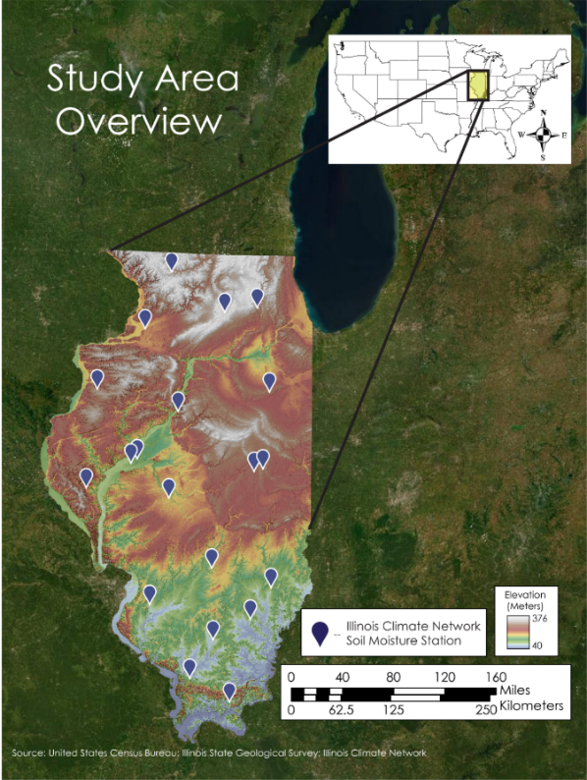

*Figure 1.* The distribution of the Illinois Climate Network (ICN) soil moisture data collection stations is shown within the state of Illinois, the full study area. These stations collect hourly volumetric soil content readings up to a depth of 50 cm and are used to inform drought monitoring efforts by the Illinois State Water Survey.

# 3. Methodology

***3.1 Data Acquisition***

The team obtained an ancillary dataset of volumetric soil moisture, defined as the volume of water per volume of total soil content, from *in-situ* and modeled data sources. The Illinois State Water Survey’sWater and Atmospheric Resources Monitoring Program (WARM) provided *in-situ* data from 19 stations throughout the state of Illinois in text file format (Table 2). Fourteen stations started collecting data in 1989 (Water and Atmospheric Resources Monitoring Program, 2015). The most recent addition to the network, Snicarte (SNI), began collecting data in 2016. The end period of record covered by all datasets is May 30, 2021; however, WARM network stations continue to collect data. At each of the stations, a Stevens hydraprobe sensor gathers soil moisture every hour with an accuracy of +/- 0.03 water fraction by volume (wfv) at 2, 4, 8, 20, 39, and 59 inches below ground (Hollinger et al., 1994). In order to maintain consistent units across datasets, these measurements were converted to centimeter (cm) values. Due to depth limitations of remotely sensed data products, i*n-situ* measurements greater than 50 cm were not included in the data analysis. Further, this data is organized in tabular spreadsheets as comma-separated value ‘.csv’ files and consists of hourly measurements at 5cm, 10cm, 20cm, and 50cm. Hourly data values were not fully available throughout each dataset, and there were cases of flagged data. Reasons for flagged data include time consistency checks, duplicate or missing record checks, reasonable comparison checks, and extreme value checks (Hollinger et al., 1994).

The team additionally accessed modeled volumetric soil moisture data from Crop Condition and Soil Moisture Analytics (Crop-CASMA) SMAP (Table 2) and an ancillary dataset from NASA SPoRT-LiS (Table 3). The SPoRT-LiS datasets were obtained as in Gridded Binary (GRIB) format as monthly archives from 2003 to 2021 from Jonathan Case, a research meteorologist on the NASA SPoRT team. We obtained 00:00 UTC daily 10 cm soil moisture of the continental United States from the SPoRT-LiS dataset. Model inputs into the 3 km resolution SPoRT-LiS model include the National Centers for Environmental Prediction (NCEP) Environmental Monitoring Center’s (ECM) North American Land Data Assimilation System-phase 2 (NLDAS-2) and Stage IV precipitation, along with near real-time MODIS-derived vegetation.

The project utilized 9 km resolution daily and instantaneous volumetric soil moisture from the Crop-CASMA’s SMAP Surface dataset. The daily product consists of values from the top 15 cm of the surface soil that was averaged daily from April 2015 to May 2021 (Reichle et al., 2018). The instantaneous product is collected at 0130 UTC each day from April 215 to May 2021. This product is a derivative of the NASA SMAP Level 4; a model output made from SMAP Level 1, 2, 3 observations integrated with land surface observations (Reichle et al., 2018). Being a modeled product, SMAP Level 4 has the benefit of daily global spatial coverage, which is not the case for lower-level SMAP products.

Table 2

*Satellite datasets used in this project*

|  |  |  |  |
| --- | --- | --- | --- |
| **Platform or Sensor** | **Data Product** | **Dates** | **Acquisition Method** |
| SMAP L-band | Surface and Rootzone Soil Moisture, a Level 4 modeled product derived from SMAP observations | 2015 - 2021 | [CROP-CASMA](https://nassgeo.csiss.gmu.edu/CropCASMA/) |

Table 3

*Ancillary datasets used in this project*

|  |  |  |  |
| --- | --- | --- | --- |
| **System or Network** | **Data Product** | **Dates** | **Acquisition Method** |
| [Illinois Climate Network](https://www.isws.illinois.edu/warm/climnet/abouticn.asp) | Soil Moisture (*in-situ*) | 2003 - 2021 | Tabular data was provided by Jennie Atkins, the WARM program manager from the Illinois State Water Survey. |
| [SPoRT-LiS](https://www.drought.gov/data-maps-tools/nasa-sport-lis-soil-moisture-products) | Soil Moisture | 2003 - 2021 | GRIB data was provided by Jonathan Case, a research meteorologist on the NASA SPoRT team. |

***3.2 Data Processing***

The team first converted the WARM i*n-situ* soil moisture data from a text file to ‘.csv’ format. This dataset required temporal resampling and filtering before comparison with Crop-CASMA SMAP and SPoRT-LiS datasets. Data flagged as outliers were first removed for quality control. The group filtered out daily soil moisture values at 7 p.m. Central Standard Time (CST) from the dataset to match the time scale of the SPoRT-LiS data to prepare for data analysis. Daily averages were calculated from the complete dataset to match the time scale of Crop-CASMA data. Days with less than 18 hours of data (i.e., missing more than 6 observations) were omitted from the daily average data.

NASA SPoRT sent SPoRT-LiS datasets in GRIB format as monthly tar archives. Utilizing a python script, the team converted the files to Tagged Image Format (TIF). The SPoRT-LiS raster data were then resampled to ensure that the datasets shared the same spatial resolution and coordinate reference system as the SMAP data from Crop-CASMA. The World Geodetic System WGS 1984 (EPSG: 4326) geographic coordinate system and UTM Zone 16N (EPSG: 32616) projected coordinate systems were used to maintain pixel dimensions and allow for spatial overlay analysis. The team resampled the 3 km resolution SPoRT-LiS product to 9 km resolution and ensured that the extent of the x,y raster cells were equal to each other. The data were then cropped to the same extent as the Crop-CASMA TIF files.

Similarly, volumetric soil moisture was pulled from Crop-CASMA in the form of TIF files. The data was reprojected from the NAD 83, Conus Albers projection (ESPG: 5070) to UTM Zone 16 (ESPG: 32616) to correspond with the SPoRT- LiS data. The team confirmed the data had a 9 km resolution and that the extent of the data was consistent for each snapshot in time. After these preprocessing steps, a daily time series for the temporal extent of each product was created for SMAP and SPoRT-LiS at each Illinois Climate Network station. The time series produced were in ‘.csv’ format.

***3.3 Data Analysis***

To make use of standard packages for observed vs model results, the team treated the WARM results as the proxy observations, and the SMAP and SPoRT-Lis as modeled results. The team compared percentiles and anomalies between processed and standardized WARM, SMAP, and SPoRT-LiS data products. For each gridded cell, a 31-day rolling average defined climatologies for the datasets which produced anomalies and percentiles. The team selected specific time frames during periods of drought and flooding and areas of interest to investigate the relationship among these products. The team quantified the performance and relationship between each of the data products using statistical indices including Root Mean Squared Error (RMSE), Mean Absolute Error (MAE), correlation coefficient (R), percent bias (PBIAS), and slope of the linear regression line. The group completed this analysis for certain spatial regions including weather station sites, as well as for spring, summer, fall, and winter seasons.

The team visualized the statistical results via observed vs modeled scatterplots, spatial comparison maps, and summary tables. The scatterplots showed overestimation and underestimation of modeled data compared to the WARM i*n-situ* data. The team applied this technique to specific years with wet and dry conditions to evaluate the performance of the models. Additionally, the group created maps of seasonal correlation, error, percent bias, and slope of the linear regression line to provide a spatial representation of dataset performance at different times of the year. The spatial comparison maps allowed for an analysis of geographical patterns in the statistical values for the WARM stations. Summary tables provided a way to assess differences among WARM stations using graduated colors.

# 4. Results & Discussion

***4.1 Analysis of Results***

Soil moisture dynamics are complex due to spatial and temporal variations in soil properties and meteorological factors (Babaeian et al., 2019). Therefore, multi-scale analyses that incorporate both *in-situ* and remote sensing data can improve drought monitoring and preparation strategies in Illinois. Some sources of heterogeneity have been corrected for in this study. For example, the SMAP L-band radiometer is not affected by cloud cover or vegetation. However, other sources of variability such as frozen soils or soil texture are not corrected for in this study. While this variability is important to consider, the team found consistent patterns in the volumetric water content, anomaly, and percentile data.

***4.2 Station Averaged Statistical Analysis***

The results of this study show a pronounced seasonal signal for both SMAP and SPoRT products. As seen in Figure 2, the strength in the relationship between WARM and SMAP data, as indicated by the Pearson’s r correlation coefficient, increases throughout the spring and summer, reaching an annual peak during the fall. In the winter, the correlation between SMAP values and the *in-situ* observations substantially drops. This unimodal seasonal change in the correlation of soil moisture datasets is also observed between WARM and SPoRT data.

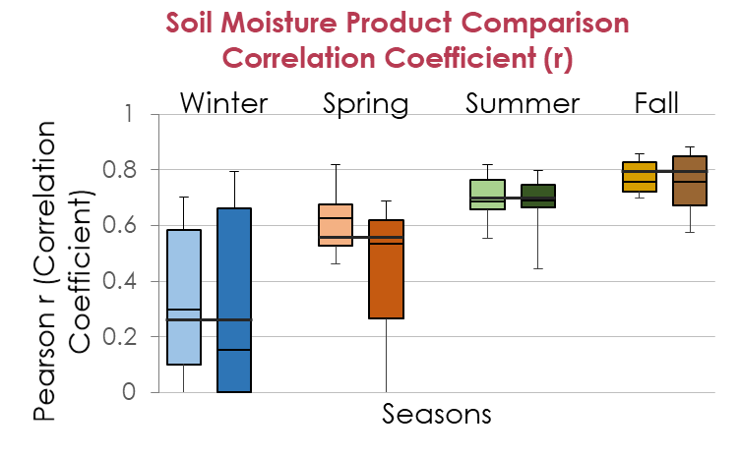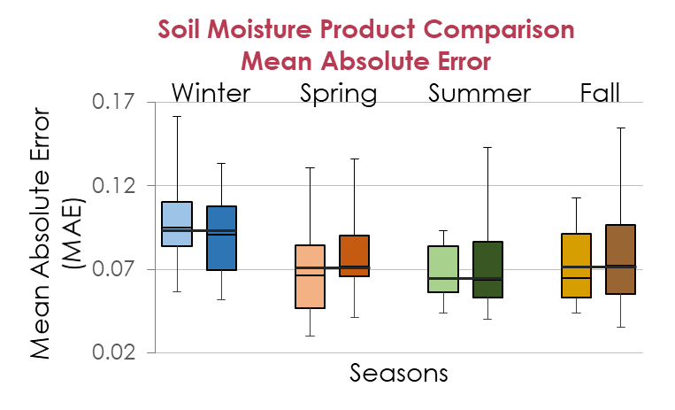

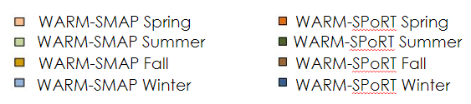

Figure 2. Seasonal average correlation coefficient and mean absolute error values calculated using raw soil moisture values. WARM-SPoRT and WARM-SMAP comparisons reflect data collected in 2003 to 2021 and 2015 to 2021, respectively.

The winter months show the lowest correlation coefficients and greatest mean absolute errors. This is consistent with our expectations, as frozen soils provide a source of variability poorly captured in satellite and modeled products. The fall and summer months show the highest correlation coefficients and lowest mean absolute errors. This suggests that both datasets produce predictions closest to the *in-situ* data during the growing season, an encouraging sign for drought monitoring. However, it is important to note that during the early growing season in late April and May, this trend is not observed. This category shows surprisingly low correlation and high errors compared to summer and fall. This could indicate that extremes in precipitation early in the growing season are more likely to be misrepresented by SMAP and SPoRT.

Averaging across all stations, the correlation coefficients between WARM-SMAP are slightly greater than those of WARM-SPoRT. Similarly, the WARM-SMAP relationship displayed smaller mean absolute error values than those calculated for WARM-SPoRT (Tables A2-A3). In terms of variability of statistics, SPoRT showed a larger range in correlation coefficient measures than SMAP (Table A1). SPoRT also exhibited greater variance in mean absolute error than SMAP, albeit to a lesser magnitude.

***4.3 Station Specific Statistical Analysis***

The average statistics help to show broad trends in the data. However, the team found several notable exceptions and station-specific observations that complement those trends. The below analysis will refer to each station by its three-letter code; the locations for each code can be referenced in Table 4. First, there are stations such as FRM and FAI that reported high error values for WARM-SMAP, but not for WARM-SPoRT (Tables A2 and A3). Second, others such as DEK, FRE, and RND fit with the station-averaged finding that SMAP-WARM had lower errors than SPoRT-WARM (Tables A2 and A3). This station variability highlights the importance of local environmental variables. In these cases, one of the datasets provided a relatively low-error relationship for drought monitoring.

Table 4

*WARM in-situ station codes and their respective locations.*

|  |  |  |  |
| --- | --- | --- | --- |
| **Station ID** | **Station Location** | **Station ID** | **Station Location** |
| BRW | Brownstown | ICC | Peoria |
| BVL | Bondville | LLC | Springfield |
| CMI | Champaign | MON | Monmouth |
| DEK | DeKalb | OLN | Olney |
| DXS | Dixon Springs | ORR | Perry |
| FAI | Fairfield | RND | Rend Lake |
| FRE | Freeport | SIU | Carbondale |
| FRM | Belleville | STC | St Charles |
| STE | Stelle |

In two cases, neither SMAP nor SPoRT produced a low-error relationship with the WARM *in-situ* observations. The stations of FAI and ORR showed much larger RMSE and MAE relative to the other stations for both WARM-SMAP and WARM-SPoRT (Tables A2 andA3). These stations reveal an area for potential future investigation; the variables producing high error are not being modeled by SPoRT or observed by SMAP. A handful of stations produced low error relationships for both WARM-SMAP and WARM-SPoRT. These stations could be good starting points for implementing the use of these satellite and modeled soil moisture products for drought monitoring. The stations BVL, CMI, LLC, MON, and OLN all had notably lower RMSE and MAE values (Tables A2 andA3). These station-specific observations can be used as a basis for future studies investigating why these differences exist. For example, the soil type, surrounding land use, or proximity to surface water could be analyzed.

***4.4 Spatial Comparison***

The team created seasonal maps of various statistical values for SMAP vs WARM and SPoRT vs WARM (Figures A1 andA2). The statistics in these maps include: the correlation coefficient (r), root mean square error, percent bias, and the slope of the linear regression line. SMAP vs WARM maps show that the correlation coefficient is largest in the fall across the entirety of the state. Winter has the smallest correlation coefficients. In winter the values are smallest in the North and increase southward. This North-South trend is only visible in winter and may be due to freezing of the soil with cold temperatures (Figures A1, A2). Regarding root mean square error, there does not appear to be a specific pattern in which the error follows. Summer shows the least amount of error across the state. Next, the percent bias shows a similar spatial pattern for winter, summer, and spring. Positive percent bias, or values where the satellite measures higher soil moisture values compared to the *in-situ* data, is present in the same four stations. This pattern changes slightly in the fall where most of the stations tend to collect drier measurements. The slope of the linear regression for SMAP vs WARM reveals that the measurements are closest to each other during the fall and farthest away during the winter. There does not appear to be a spatial pattern across seasons.

SPoRT vs WARM has the greatest correlation coefficients in the fall and summer and the smallest in the spring and winter. In the colder times of the year, there is a North-South trend in the r values. Like SMAP and WARM, the correlation increases as the stations are located more southward. Root mean square error is the least in the summer and highest in the winter. Positive percent bias stays consistent between the same stations in the summer, fall, and winter seasons, but was different in spring. This finding is different than the SMAP-WARM relationship where fall is unique. Slope in the winter shows inverse relationships for multiple northern stations and there were two stations with slopes greater than one. A slope greater than one indicates that the change in SPoRT data is greater than the change of *in-situ* data. There is no clear spatial pattern in terms of slope.

***4.5 Anomaly & Percentile Timeseries***

*4.5.1 Case Study - St. Charles*

To thoroughly understand the relationships among SPoRT, SMAP, and WARM in a specific location, the team analyzed the town of St. Charles in Northern Illinois. Anomaly and percentile plots for 2012, 2020, and 2021 show the relationships among the three data products under different drying and wetting scenarios (Figures C2, D3). Years 2012 and 2021 exemplify periods of drought beginning in the late spring, and 2020 demonstrates a period of wet conditions.

In 2012, the St. Charles WARM observations show a steep decline in anomaly and percentile calculations beginning in the early spring and bottoming out in late July. This event shows an interesting feature of the SPoRT modeled data. Although the anomalies for SPoRT show very little variation in the months of drought, the percentiles for SPoRT track well with WARM for the duration of the summer months (Figure D3).The team observed a low range of predicted values in the SPoRT dataset. This observation explains the amplitude variations between anomaly and percentile values.

2020 data values were compared with respect to all three datasets. In this plot, we observe the same muted signal in SPoRT anomalies, but the pattern does follow WARM with little offset at the beginning of the year. SPoRT’s percentiles show considerable variance that matches well with WARM percentiles during key periods (e.g. from June to August). In the first months of 2021, SPoRT matches well with WARM both showing high anomaly and percentile values following a particularly wet year (Figures C2, D3). However, SMAP has a neutral to reverse signal relative to WARM during the beginning of the year. This difference in signal could potentially be due to the vegetative cover modeling that occurs in SPoRT but not SMAP. Later into the spring, both SMAP and SPoRT catch up with WARM moving into the 2021 drought. This is shown by the steep drop in anomalies and percentiles from March to May (Figures C2, D3).

***4.5.2 All Stations***

Analyzing all station plots of anomaly and percentile timeseries, significant differences are clearly visible across stations. Despite this variation, there are a few common patterns shared among all stations; these patterns can provide insight into the strengths and weaknesses of the SMAP and SPoRT measurements. When comparing anomaly timeseries, there is a clear difference in amplitude between SMAP and SPoRT vs the WARM *in-situ* anomalies. Both products match WARM in direction but not magnitude of change in many cases, such as the period of 2018 to 2019 at station CMI (Figure C1). This suggests that the satellite and modeled data tend to underpredict higher anomalies and overpredict lower anomalies. This tendency will be discussed in more detail in the next section in reference to volumetric water content. Between SMAP and SPoRT, SPoRT is more affected by this limitation in the anomaly range. This could indicate a difference in parameters or limits on modeled soil moisture present in SPoRT. The lower range observed for both data products causes a reverse effect in percentile space. SMAP and SPoRT have adequate variability in percentiles since small changes in volumetric water content produce relatively large differences in rank. This causes a pattern of either nearly exactly matching WARM or producing extreme errors in percentile timeseries for both data products. The amplitude in most cases matches WARM, so when the direction is a good match the datasets show extremely high agreement. For example, see the period of 2016 to 2018 at station DXS (Figure D1). The corresponding dramatic differences between SMAP and SPoRT vs WARM are also common within the percentile figures, for instance, 2016 to 2018 at station FRE (Figure D2).

***4.6. Correlation & Error Scatterplots***

*4.6.1 Case Study - St. Charles*

In the case of St. Charles, SPoRT has limited variability, as illustrated by the near horizontal WARM-SPoRT scatterplots (Figures B1, B2). WARM *in-situ* observations range from 0.1 and 0.5 volumetric soil moisture, while modeled SPoRT values primarily lie between 0.3 and 0.5. During the year of extreme drought in 2012, SPoRT measurements tend to overestimate in the Summer and Fall relative to WARM observation. In the 2020 wet year, SMAP underestimates relative to the WARM for all seasons of the year (Figure B1). This is evidence that SMAP has a dry bias during wet conditions. SPoRT underestimates in the Spring and Winter and overestimates during Summer and Fall. This carries over into the beginning of 2021, where SPoRT continues to overestimate throughout late winter and early spring, before leading into the period of drought (Figure B2).

***4.6.2 All Stations***

Clustering of scatterplot data points at different locations relative to the 1:1 line indicates changes in the seasonal performance of SMAP and SPoRT products. Satellite and modeled measurements tend to be wetter when in-situ is dry, and dryer when in-situ is wet. The fitted regression line for all stations over the period of 2015-2021 is remarkably similar for SPoRT-WARM and SMAP-WARM (Figure 3). For both data products, the fitted line of modeled or satellite data shows a tendency for overprediction when WARM observations are less than 0.25 volumetric water content (cm3/cm3). When WARM observations are greater than 0.30 volumetric, both products have a tendency for underprediction. As shown in Figure 3, most data points fall in the underprediction space below the 1:1 line. Despite this similarity in fitted regression line, SPoRT and SMAP show very different distributions of point density. SPoRT stations with a low dynamic range stand out by causing a nearly horizontal high-density pattern between 0.30 and 0.35 volumetric water content. However, this SPoRT characteristic does not apply to all stations. These findings reveal that SPoRT and SMAP each possess their own strength in measuring soil water content depending on the season and wetting and drying conditions.

Figure 3. All station density plots for SMAP vs WARM and SPoRT vs WARM.

***4.7 Limitations & Future Work***

The results of this study were limited by spatial and temporal differences across datasets and the inherent limitations of these data products. For example, daily averages were available for Crop-CASMA SMAP data, while SPoRT-LiS data were limited to instantaneous daily outputs. Additionally, not all data products were available for the full temporal range of the study. SMAP data does not exist prior to March 2015, reducing the available data compared to the *in-situ* and SPoRT-LiS datasets ranging from 2003 to 2021. *In-situ* data were incomplete for some days; all days missing more than 25% of hourly measurements were not used. Other limitations are based on the instruments used for data collection. In other words, sources of variability such as frozen soils or soil texture could are not corrected for in this study. Additionally, factors such as seasonally variable crop cover were not accounted for in processing SMAP data.

Despite these limitations, this study establishes the groundwork for important future studies. These methods and analyses can be applied to other soil moisture datasets such as NASA’s Gravity Recovery and Climate Experiment (GRACE), the Airborne Microwave Observatory of Subcanopy and Subsurface (AirMOSS), the Advanced Microwave Scanning Radiometer 2 (AMSR-2), Soil Moisture and Ocean Salinity (SMOS), the Modern-Era Retrospective analysis for Research and Applications, Version 2 (MERRA-2), and the Advanced Scatterometer (ASCAT). The comparisons made in this analysis can be used as a starting point to create a tool to quantify the uncertainty of soil moisture datasets under varying conditions. This tool will progress soil moisture data analyses towards a fully representative model of climatic conditions.

# 5. Conclusions

Drought is one of the most damaging and financially harmful natural disasters to agricultural production (Ford & Quiring, 2019). Climate variability in future decades is expected to cause severe drought conditions (Kang et al., 2009; Cook et al., 2018).These climate variations pose a threat to water resources everywhere, which requires careful water supply planning (Winstanley et al., 2006). Previous research has explored soil moisture as an environmental indicator of drought. Ford & Quiring (2019) assert that soil moisture can signal moisture stress and, thus, improve drought forecasting. A similar framework was applied to this analysis to assess the suitability of NASA Earth observations data to enhance soil moisture analysis in the state of Illinois. Three datasets were analyzed including two remotely sensed datasets and an *in-situ* dataset provided by NASA Earth observations and the State of Illinois, respectively. Statistical and spatial analysis performed on these data provided an opportunity to compare remotely sensed, modeled, and *in-situ* data products.

The results outlined in this research emphasize the advantages and limitations of each ancillary and modeled data product. More specifically, results suggest that SPoRT-LiS calculations produce little offset from WARM values in wet conditions compared to SMAP comparisons. Conversely, SMAP comparisons were most closely correlated to WARM measurements when analyzing the full temporal and spatial range. These differences can be utilized to inform decision-making surrounding data selection for soil moisture analysis. In other words, considering the performance of these remotely sensed products in various climatic conditions is important to data product selection in future research.

NASA Earth observations data products provide a unique opportunity to expand the spatiotemporal range of soil moisture analysis. Incorporating these remotely sensed products with existing climate data infrastructure in a multi-faceted analysis will contribute to a fully representative drought forecast model. These reproducible methods can be applied in a variety of scenarios to enhance drought analysis in Illinois.

# 6. Acknowledgments

We thank everyone at the North Carolina - NCEI and Alabama - MSFC DEVELOP nodes for their support and guidance during this term and for providing the Earth observation data required for this project. This includes our node fellows Kathleen Lange and Rochelle Williams (NASA DEVELOP National Program, Leads/Fellows); our science advisors Dr. Ronald Leeper (NOAA National Centers for Environmental Information, North Carolina Institute for Climate Studies) and Dr. Bjorn Brooks (NOAA National Centers for Environmental Information, North Carolina Institute for Climate Studies). Our additional advisors include: Dr. Robert Griffin (University of Alabama Huntsville), Dr. Jeffery Luvall (NASA Marshall Space Flight Center), Dr. Chris Hain (NASA Short-term Prediction Research and Transition Center), Dr. Chris Schultz (NASA Short-term Prediction Research and Transition Center), and Jonathan Case (NASA Short-term Prediction Research and Transition Center)

Another special thank you to our project partners who provided us with areas of interest, *in-situ* data, and their expertise throughout this project: Dr. Trent Ford (Illinois State Water Survey), Jennie Atkins (Illinois State Water Survey), Dr. Dennis Todey (USDA Midwest Climate Hub), Doug Kluck (NOAA, Regional Climate Services, Central Region), Molly Woloszyn (NOAA, National Integrated Drought Information System, Midwest Drought Early Warning System), Mike Welvaert (NOAA, North Central River Forecasting Center), and Steve Buan (NOAA, North Central River Forecasting Center).

Any opinions, findings, and conclusions or recommendations expressed in this material are those of the author(s) and do not necessarily reflect the views of the National Aeronautics and Space Administration.

This material is based upon work supported by NASA through contract NNL16AA05C.

# 

# 7. Glossary

**Anomalies** – Difference between the observed and expected value that can be measured in a variety of ways such as the difference between the two values, percent difference, or standard deviation

**Climatologies** – Long-term average of a climate variable calculated through various time ranges

**DEWS** – Drought Early Warning System

**Drought** – Prolonged shortages of precipitation, surface water, or groundwater

**Drought monitoring** – Using indices and indicators that search for differing hydrological cycles in various regions

**Drought forecasting** – Collection of historical, real-time, and forecasted data to predict the probability of a drought

**Earth observations** – Satellites and sensors that collect information about the Earth’s physical, chemical, and biological systems over space and time

**Evaporation** – Process of turning a liquid on the surface into its gas phase

**Evapotranspiration** – The combination of evaporation and transpiration

**Field capacity** – The moisture content after the gravitational water has drained and capillary water movement has substantially decreased; capillary capacity

***In-situ*** – Reference data collected on-site

**ISWS** – Illinois State Water Survey

**NIDIS** – National Integrated Drought Information System

**Percentiles** – a score that reveals what percent of observations contain a lower value than the observation being examined

**SMAP** – Soil Moisture Active Passive

**Soil** – Upper layer of Earth that supports plant growth and consists of a mixture of organic matter, clay, and rock particles

**Soil profile** – Diagram illustrating the vertical succession of soil horizons

**Soil structure** – Arrangement of soil of various shape, size, stability, and degree of adhesion

**Soil moisture** – (1) gravitational moisture, (2) capillary moisture, (3) hygroscopic moisture, and (4) moisture vapor

**SPoRT-LiS** – Short-term Prediction Research and Transition Center - Land Information System

**Tensiometer** – Instrument used to measure soil moisture by monitoring the water tension within the soil

**Transpiration** – Loss of water from plants through evaporation

**WARM** - Illinois State Water Survey’s Water and Atmospheric Resources Monitoring Program

# 8. References

Agha Kouchak, A., (2014). A baseline probabilistic drought forecasting framework using standardized soil moisture index: application to the 2012 United States drought. *Hydrology and Earth Systems Science.*, *18*, 2485–2492, <https://doi.org/10.5194/hess-18-2485-2014>.

Babaeian, E., Sadeghi, M., Jones, S. B., Montzka, C., Vereecken, H., & Tuller, M. (2019). Ground, proximal, and satellite remote sensing of soil moisture. *Reviews of Geophysics*, *57*, 530– 616. <https://doi.org/10.1029/2018RG000618>

Cook, B. I., Mankin, J. S., & Anchukaitis, K. J. (2018). Climate Change and Drought: From Past to Future. *Current Climate Change Reports*, *4(2*), 164–179. <https://doi.org/10.1007/s40641-018-0093-2>

Entekhabi, D., Yueh, S., O’Neill, P., Kellogg, K., Allen, A., Bindlish, R., ... & Crow, W. T. (2014). SMAP Handbook, JPL Publication JPL 400-1567. *Jet Propulsion Laboratory,*  *Pasadena, California*, *182*.

Ford, T. W., & Quiring, S. M. (2019). Comparison of contemporary in situ, model, and satellite remote sensing soil moisture with a focus on drought monitoring. *Water Resources Research*, *55*, 1565– 1582. <https://doi.org/10.1029/2018WR024039>

Hollinger, S. E., Reineke, B. C., & Peppler, R. A. (1994). Illinois climate network: site descriptions, instrumentation, and data management. *Circular no. 178*.

Illinois Department of Agriculture. (n.d.). *Facts About Illinois Agriculture*.

Illinois.gov. [https://www2.illinois.gov/sites/agr/About/Pages/Facts-About-Illinois-A](https://www2.illinois.gov/sites/agr/About/Pages/Facts-About-Illinois-Agriculture.aspx) griculture.aspx.

Knapp, H. V., Angel, J. R., Atkins, J. R., Bard, L., Getahun, E., Hlinka, K. J., Keefer, L. L., Kelly, W. R., & Roadcap, G. S. (2017). *The 2012 Drought in Illinois*. (ISWS Report of Investigation 123). Illinois State Water Survey., <https://www.isws.illinois.edu/pubdoc/RI/ISWSRI-123.pdf>

Li, Y., Ye, W., Wang, M., & Yan, X. (2009). Climate change and drought: a risk assessment of crop-yield impacts. *Climate Research*, *39*, 31–46. <https://doi.org/10.3354/cr00797>

Reichle, R. H., Ardizzone, J. V., Kim, G. K., Lucchesi, R. A., Smith, E. B., & Weiss, B. H. (2018). Soil Moisture Active Passive (SMAP) mission level 4 surface and root zone soil moisture (L4_SM) product specification document. NASA Goddard Space Flight Center.

Reichle, R., G. De Lannoy, R. D. Koster, W. T. Crow, and J. S. Kimball. 2017. *SMAP L4 9 km EASE-Grid* *Surface and Root Zone Soil Moisture Geophysical Data, Version 3*. Boulder, Colorado USA. NASA National Snow and Ice Data Center Distributed Active Archive Center. <https://doi.org/10.5067/B59DT1D5UMB4>. [06 July 2021].

Sadri, S., Wood, E. F., & Pan, M. (2018). A SMAP-Based Drought Monitoring Index for the United States. *Hydrology and Earth System Science Discussions*, *182*, 1-19. <https://doi.org/10.5194/HESS-2018-182>

Sheffield, J., Wood, E. F., Pan, M., Beck, H., Coccia, G., Serrat‐Capdevila, A., & Verbist, K. (2018). Satellite remote sensing for water resources management: Potential for supporting sustainable development in data‐poor regions. *Water Resources Research*, *54*(12), 9724-9758.

SPoRT. (2015, July 14). *LIS Soil Moisture Quick Guide by NASA/SPoRT*. Drought.gov. [https://nasasporttraining.files.wordpress.com/2015/12/lis-soil-moisture-quick-guide-by-nasa-](https://nasasporttraining.files.wordpress.com/2015/12/lis-soil-moisture-quick-guide-by-nasa-sport1.pdf) sport1.pdf

Tavakol, A., Rahmani, V., Quiring, S.M., & Kumar, S.V., (2019). Evaluation analysis of NASA SMAP L3 and L4 and SPoRT-LIS soil moisture data in the United States. *Remote Sensing of Environment, 229*, 234 – 236. <https://doi.org/10.1016/j.rse.2019.05.006>

Tomasek BJ, Williams MM, II, Davis AS (2017) Changes in field workability and drought risk from projected climate change drive spatially variable risks in Illinois cropping systems. *PLoS ONE 12*(2): e0172301. <https://doi.org/10.1371/journal.pone.0172301>

Water and Atmospheric Resources Monitoring Program. Illinois Climate Network. (2015). Illinois State Water Survey, 2204 Griffith Drive, Champaign, IL 61820- 7495.

<https://dx.doi.org/10.13012/J8MW2F2Q>.

Winstanley, D., Angel, J.A., Changnon, S.A., Knapp, V., Kunkel, K.E., Palecki, M.A., Scott, R.W.,

Wehrmann, A.H., (2006). The Water Cycle and Water Budgets in Illinois: A Framework for Drought and Water-Supply Planning. *Illinois State Water Survey; Illinois Department of Natural Resources; University of*  *Illinois at Urbana/Champaign.* [*https://www.ideals.illinois.edu/bitstream/handle/2142/8918/ISWSIEM2006-*](https://www.ideals.illinois.edu/bitstream/handle/2142/8918/ISWSIEM2006-02.pdf?sequence=2)*02.pdf?sequence=2*

9. Appendices

**Appendix A**

**Tables and Figures**

|  |  |  |  |  |  |  |  |  |  |  |  |  |  |  |  |  |  |  |
| --- | --- | --- | --- | --- | --- | --- | --- | --- | --- | --- | --- | --- | --- | --- | --- | --- | --- | --- |
| Data Products | Season | BRW | BVL | CMI | DEK | DXS | FAI | FRE | FRM | ICC | LLC | MON | OLN | ORR | RND | SIU | STC | STE |
| WARM-SMAP | Spring | 0.507 | 0.684 | 0.731 | 0.531 | 0.626 | 0.777 | 0.538 | 0.662 | 0.524 | 0.626 | 0.517 | 0.817 | 0.668 | 0.462 | 0.596 | 0.560 | 0.667 |
| WARM-SMAP | Summer | 0.628 | 0.664 | 0.792 | 0.753 | 0.650 | 0.700 | 0.625 | 0.670 | 0.710 | 0.820 | 0.555 | 0.778 | 0.707 | 0.664 | 0.758 | 0.687 | 0.773 |
| WARM-SMAP | Fall | 0.752 | 0.719 | 0.760 | 0.842 | 0.846 | 0.792 | 0.722 | 0.723 | 0.848 | 0.711 | 0.806 | 0.698 | 0.742 | 0.798 | 0.857 | 0.810 | 0.794 |
| WARM-SMAP | Winter | 0.558 | 0.262 | 0.119 | 0.013 | 0.598 | 0.599 | 0.241 | 0.655 | 0.034 | 0.334 | -0.055 | 0.571 | 0.488 | 0.299 | 0.702 | 0.084 | 0.262 |
| WARM-SPoRT | Spring | 0.564 | 0.623 | 0.505 | -0.165 | 0.688 | 0.617 | 0.164 | 0.663 | 0.319 | 0.464 | 0.209 | 0.637 | 0.555 | 0.330 | 0.539 | 0.155 | 0.497 |
| WARM-SPoRT | Summer | 0.694 | 0.658 | 0.683 | 0.700 | 0.778 | 0.735 | 0.676 | 0.657 | 0.523 | 0.707 | 0.669 | 0.798 | 0.758 | 0.445 | 0.699 | 0.741 | 0.750 |
| WARM-SPoRT | Fall | 0.842 | 0.683 | 0.612 | 0.882 | 0.833 | 0.856 | 0.661 | 0.802 | 0.575 | 0.715 | 0.828 | 0.789 | 0.706 | 0.822 | 0.859 | 0.607 | 0.865 |
| WARM-SPoRT | Winter | 0.689 | 0.180 | -0.024 | -0.288 | 0.667 | 0.481 | -0.071 | 0.749 | 0.063 | 0.100 | -0.254 | 0.476 | 0.628 | 0.213 | 0.780 | -0.005 | 0.246 |
| SMAP-SPoRT | Spring | 0.738 | 0.695 | 0.511 | 0.511 | 0.687 | 0.802 | 0.502 | 0.721 | 0.572 | 0.624 | 0.676 | 0.820 | 0.751 | 0.779 | 0.747 | 0.457 | 0.642 |
| SMAP-SPoRT | Summer | 0.865 | 0.782 | 0.717 | 0.767 | 0.855 | 0.824 | 0.885 | 0.797 | 0.754 | 0.731 | 0.857 | 0.851 | 0.864 | 0.856 | 0.825 | 0.788 | 0.801 |
| SMAP-SPoRT | Fall | 0.858 | 0.874 | 0.651 | 0.833 | 0.890 | 0.815 | 0.860 | 0.877 | 0.665 | 0.670 | 0.881 | 0.902 | 0.807 | 0.908 | 0.917 | 0.683 | 0.859 |
| SMAP-SPoRT | Winter | 0.757 | 0.444 | 0.098 | 0.728 | 0.701 | 0.736 | 0.699 | 0.814 | 0.230 | 0.423 | 0.655 | 0.698 | 0.684 | 0.854 | 0.856 | 0.367 | 0.402 |

**Table A1:** Thedistribution of seasonal Pearson’s r (correlation coefficient) values at each of the 17 ICN stations analyzed in Illinois averaged from 2015 to 2021

|  |  |  |  |  |  |  |  |  |  |  |  |  |  |  |  |  |  |  |
| --- | --- | --- | --- | --- | --- | --- | --- | --- | --- | --- | --- | --- | --- | --- | --- | --- | --- | --- |
| Data Products | Season | BRW | BVL | CMI | DEK | DXS | FAI | FRE | FRM | ICC | LLC | MON | OLN | ORR | RND | SIU | STC | STE |
| WARM-SMAP | Spring | 0.093 | 0.083 | 0.055 | 0.069 | 0.079 | 0.141 | 0.077 | 0.139 | 0.086 | 0.080 | 0.062 | 0.040 | 0.099 | 0.091 | 0.139 | 0.078 | 0.063 |
| WARM-SMAP | Summer | 0.105 | 0.095 | 0.055 | 0.081 | 0.079 | 0.109 | 0.062 | 0.113 | 0.073 | 0.055 | 0.073 | 0.075 | 0.105 | 0.075 | 0.084 | 0.069 | 0.097 |
| WARM-SMAP | Fall | 0.124 | 0.070 | 0.076 | 0.064 | 0.103 | 0.122 | 0.065 | 0.124 | 0.103 | 0.063 | 0.065 | 0.080 | 0.121 | 0.080 | 0.109 | 0.094 | 0.076 |
| WARM-SMAP | Winter | 0.099 | 0.087 | 0.114 | 0.122 | 0.118 | 0.169 | 0.113 | 0.162 | 0.119 | 0.110 | 0.121 | 0.072 | 0.119 | 0.098 | 0.166 | 0.096 | 0.121 |
| WARM-SPoRT | Spring | 0.095 | 0.078 | 0.053 | 0.111 | 0.082 | 0.093 | 0.090 | 0.085 | 0.086 | 0.078 | 0.083 | 0.059 | 0.142 | 0.117 | 0.073 | 0.072 | 0.072 |
| WARM-SPoRT | Summer | 0.109 | 0.060 | 0.100 | 0.071 | 0.064 | 0.075 | 0.081 | 0.075 | 0.102 | 0.067 | 0.066 | 0.049 | 0.155 | 0.126 | 0.065 | 0.103 | 0.048 |
| WARM-SPoRT | Fall | 0.132 | 0.061 | 0.083 | 0.101 | 0.071 | 0.103 | 0.101 | 0.105 | 0.083 | 0.062 | 0.087 | 0.078 | 0.162 | 0.136 | 0.087 | 0.071 | 0.043 |
| WARM-SPoRT | Winter | 0.107 | 0.089 | 0.072 | 0.115 | 0.111 | 0.119 | 0.102 | 0.096 | 0.088 | 0.079 | 0.132 | 0.072 | 0.144 | 0.136 | 0.107 | 0.090 | 0.074 |
| SMAP-SPoRT | Spring | 0.065 | 0.074 | 0.060 | 0.087 | 0.024 | 0.053 | 0.098 | 0.054 | 0.032 | 0.042 | 0.082 | 0.058 | 0.038 | 0.033 | 0.038 | 0.051 | 0.090 |
| SMAP-SPoRT | Summer | 0.052 | 0.057 | 0.047 | 0.062 | 0.048 | 0.054 | 0.066 | 0.057 | 0.080 | 0.078 | 0.073 | 0.054 | 0.050 | 0.041 | 0.035 | 0.113 | 0.060 |
| SMAP-SPoRT | Fall | 0.051 | 0.064 | 0.067 | 0.074 | 0.073 | 0.055 | 0.060 | 0.057 | 0.081 | 0.092 | 0.072 | 0.055 | 0.058 | 0.043 | 0.026 | 0.101 | 0.063 |
| SMAP-SPoRT | Winter | 0.068 | 0.073 | 0.059 | 0.072 | 0.032 | 0.051 | 0.074 | 0.058 | 0.061 | 0.048 | 0.077 | 0.053 | 0.059 | 0.039 | 0.028 | 0.076 | 0.082 |

**Table A2:** Thedistribution of seasonal Root Mean Square Error (RMSE) values at each of the 17 ICN stations analyzed in Illinois averaged from 2015 to 2021

|  |  |  |  |  |  |  |  |  |  |  |  |  |  |  |  |  |  |  |
| --- | --- | --- | --- | --- | --- | --- | --- | --- | --- | --- | --- | --- | --- | --- | --- | --- | --- | --- |
| Data Products | Season | BRW | BVL | CMI | DEK | DXS | FAI | FRE | FRM | ICC | LLC | MON | OLN | ORR | RND | SIU | STC | STE |
| WARM-SMAP | Spring | 0.077 | 0.061 | 0.043 | 0.049 | 0.066 | 0.130 | 0.064 | 0.107 | 0.074 | 0.064 | 0.042 | 0.030 | 0.091 | 0.077 | 0.131 | 0.070 | 0.044 |
| WARM-SMAP | Summer | 0.086 | 0.078 | 0.044 | 0.065 | 0.065 | 0.087 | 0.051 | 0.083 | 0.057 | 0.045 | 0.058 | 0.058 | 0.093 | 0.057 | 0.070 | 0.055 | 0.084 |
| WARM-SMAP | Fall | 0.105 | 0.055 | 0.063 | 0.051 | 0.085 | 0.105 | 0.048 | 0.093 | 0.090 | 0.050 | 0.055 | 0.044 | 0.113 | 0.062 | 0.089 | 0.084 | 0.065 |
| WARM-SMAP | Winter | 0.086 | 0.057 | 0.097 | 0.095 | 0.109 | 0.160 | 0.082 | 0.130 | 0.108 | 0.089 | 0.096 | 0.057 | 0.111 | 0.082 | 0.162 | 0.090 | 0.088 |
| WARM-SPoRT | Spring | 0.092 | 0.068 | 0.041 | 0.101 | 0.073 | 0.088 | 0.082 | 0.081 | 0.072 | 0.072 | 0.070 | 0.055 | 0.136 | 0.108 | 0.067 | 0.057 | 0.064 |
| WARM-SPoRT | Summer | 0.100 | 0.049 | 0.081 | 0.059 | 0.053 | 0.067 | 0.071 | 0.064 | 0.087 | 0.058 | 0.054 | 0.042 | 0.143 | 0.108 | 0.054 | 0.086 | 0.040 |
| WARM-SPoRT | Fall | 0.126 | 0.049 | 0.061 | 0.096 | 0.059 | 0.093 | 0.093 | 0.096 | 0.067 | 0.051 | 0.079 | 0.070 | 0.155 | 0.125 | 0.072 | 0.051 | 0.035 |
| WARM-SPoRT | Winter | 0.102 | 0.076 | 0.052 | 0.103 | 0.103 | 0.114 | 0.089 | 0.091 | 0.071 | 0.070 | 0.111 | 0.067 | 0.134 | 0.124 | 0.104 | 0.069 | 0.063 |
| SMAP-SPoRT | Spring | 0.060 | 0.066 | 0.053 | 0.079 | 0.019 | 0.049 | 0.092 | 0.048 | 0.026 | 0.034 | 0.077 | 0.055 | 0.031 | 0.027 | 0.032 | 0.037 | 0.084 |
| SMAP-SPoRT | Summer | 0.044 | 0.050 | 0.039 | 0.055 | 0.041 | 0.044 | 0.062 | 0.048 | 0.071 | 0.065 | 0.066 | 0.046 | 0.040 | 0.032 | 0.028 | 0.101 | 0.049 |
| SMAP-SPoRT | Fall | 0.043 | 0.058 | 0.052 | 0.067 | 0.070 | 0.046 | 0.055 | 0.051 | 0.071 | 0.074 | 0.068 | 0.050 | 0.051 | 0.037 | 0.021 | 0.092 | 0.058 |
| SMAP-SPoRT | Winter | 0.062 | 0.067 | 0.048 | 0.066 | 0.026 | 0.045 | 0.066 | 0.053 | 0.046 | 0.040 | 0.071 | 0.047 | 0.049 | 0.034 | 0.024 | 0.060 | 0.075 |

**Table A3:** Thedistribution of seasonal Mean Absolute Error (MAE)values at each of the 17 ICN stations analyzed in Illinois averaged from 2015 to 2021

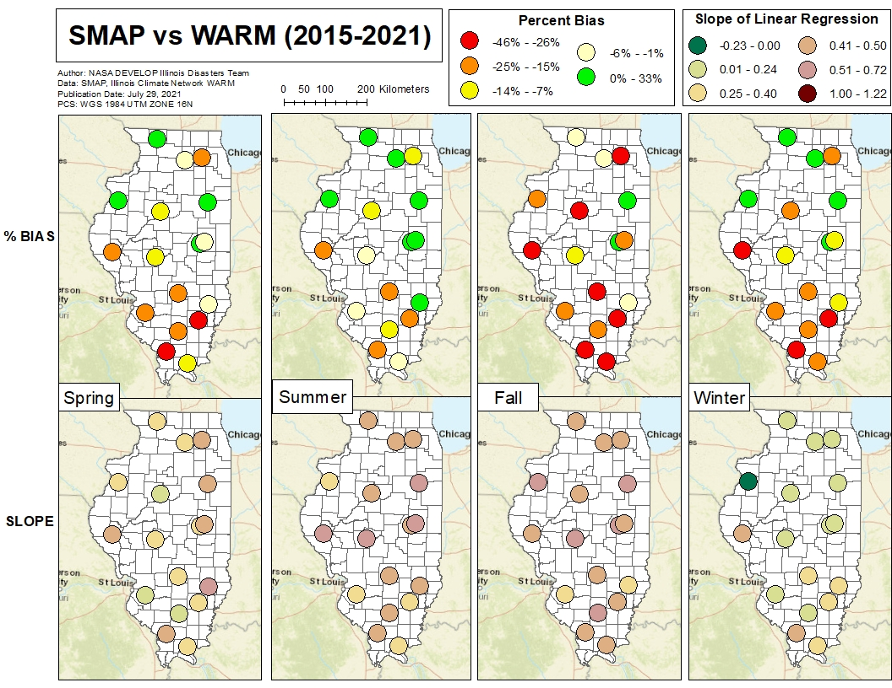

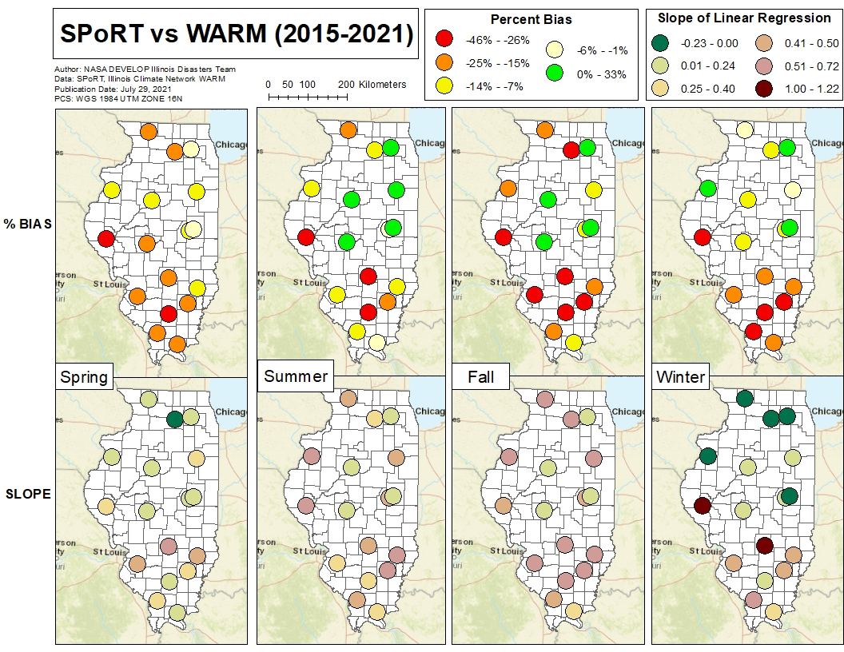

**Figure A1:** Thedistribution of the 17 ICN stations analyzed in Illinois with information on each station’s percent bias and slope of the least linear squares line when comparing SMAP vs. WARM and SPoRT vs. WARM from 2015 to 2021.

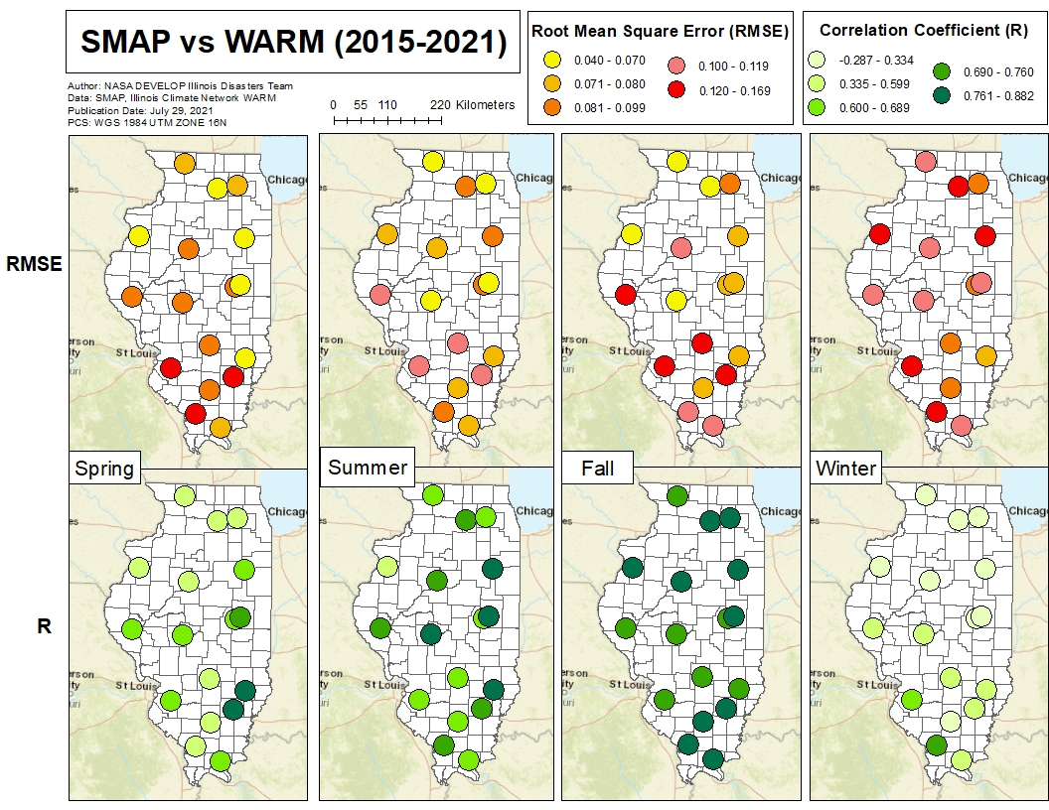

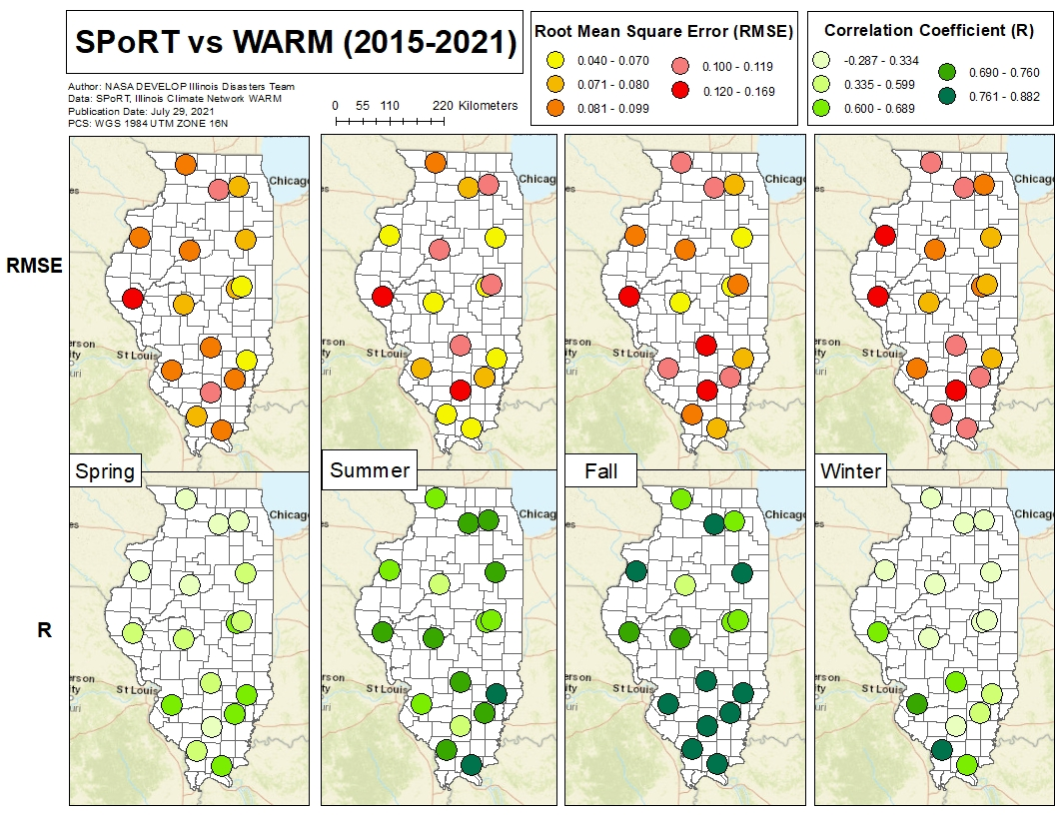

**Figure A2:** Thedistribution of the 17 ICN stations analyzed in Illinois with information on each station’s root mean square error (RMSE) and Pearson’s r (correlation coefficient) value when comparing SMAP vs. WARM and SPoRT vs. WARM from 2015 to 2021.

**Appendix B – SMAP vs WARM & SPoRT vs WARM Scatterplots**

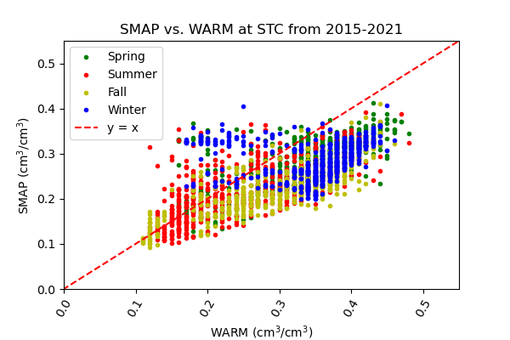

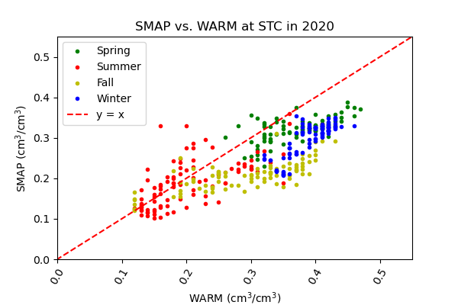

**Figure B1:** Scatterplots of the relationships between SMAP vs WARM at the St. Charles (STC) station.

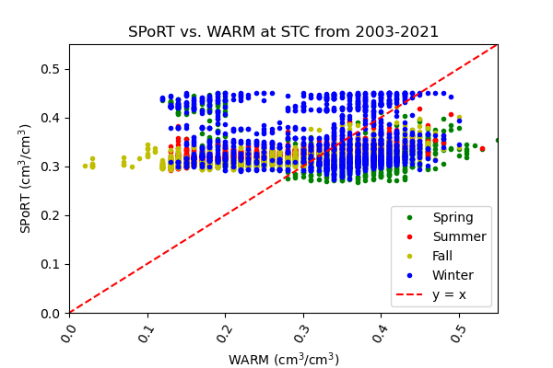

**Figure B2:** Scatterplots of the relationships between SPoRT vs WARM at the St. Charles (STC) station

**Appendix C – Anomaly Timeseries**

**Figure C1:** Soil Moisture Anomaly Timeseries at the Champaign (CMI) station with instantaneous values at the top and bottom charts, and daily averages at the middle chart.

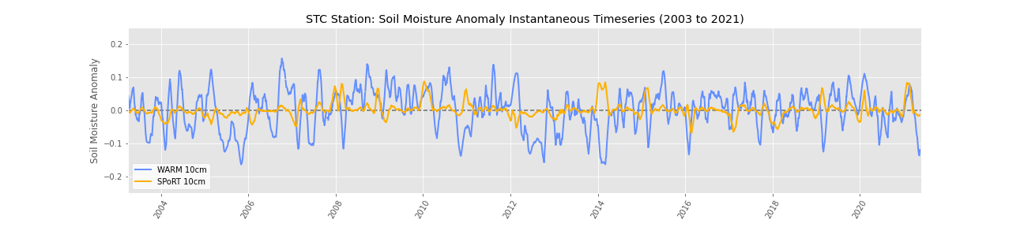

**Figure C2:** Soil Moisture Anomaly Timeseries at the St. Charles (FAI) station with instantaneous values at the top and bottom charts, and daily averages at the middle chart.

**Appendix D – Percentile Timeseries**

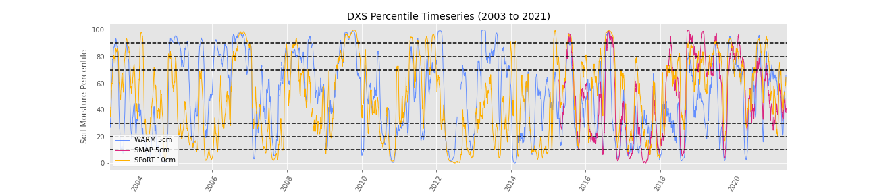

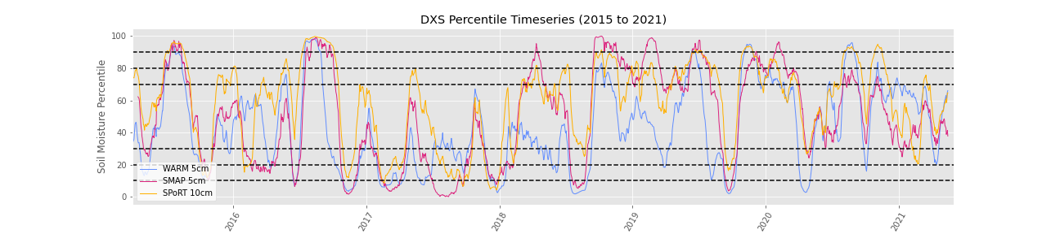

**Figure D1:** Percentile Timeseries at the Dixon Springs (DXS) station from 2003 to 2021 and 2015 to 2021.

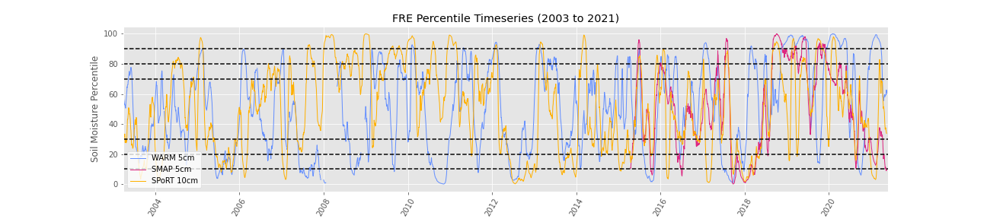

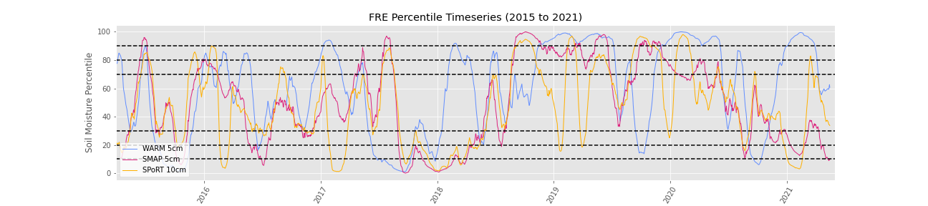

**Figure D2:** Percentile Timeseries at the Freeport (FRE) station from 2003 to 2021 and 2015 to 2021.

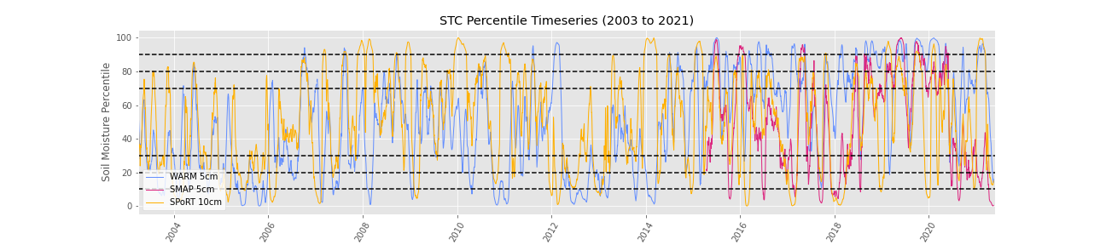

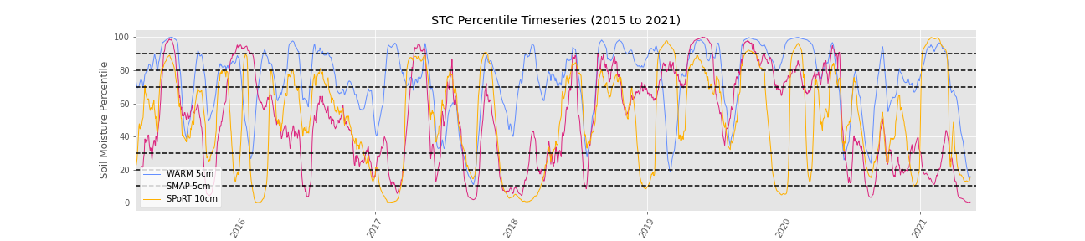

**Figure D3:** Percentile Timeseries at the St. Charles (STC) station from 2003 to 2021 and 2015 to 2021.