Kansas City Disasters II
Analyzing Precipitation and Land Cover Data to Refine the Assessment of Urban Flood Vulnerability

 Technical Report
Final – November 17th, 2022

Nora Carmody (Project Lead)
Dain Kim
Kameron Lloyd
Ruby Nagelberg

Advisor
Dr. Kent Ross, NASA Langley Research Center

Previous Contributors:
M. René Castillo
Hadwynne Gross
Eric Sjöstedt
Raychell Velez

Fellow:
Tyler Pantle (Massachusetts – Boston)

1. Abstract
In pluvial flood events, stormwater runoff can pollute ground and surface water, posing a threat long after rain has ceased. In Wyandotte County, Kansas, this contamination is compounded in historically disinvested neighborhoods by high levels of impervious surface cover, a combined sewer system, and socioeconomic vulnerability. The DEVELOP Kansas City Disasters I team conducted water quantity analyses to assess flood vulnerability in Wyandotte County, and to complement their research, we, the Kansas City Disasters II team, addressed water quality concerns related to stormwater retention and combined sewer system overflows (CSOs). We acquired precipitation data from NASA’s Global Precipitation Measurement (GPM IMERG) from January 2000 to December 2020 and ancillary data, such as land cover classifications from the USGS’s National Land Cover Database, as inputs into the Natural Capital Project’s Integrated Valuation of Ecosystem Services and Tradeoffs (InVEST) Stormwater Retention Model. We utilized this model to produce stormwater retention ratios across Wyandotte County to identify areas where land is not retaining stormwater and its associated pollutants, exposing surrounding regions to waterway contamination. We then used U.S. Census data to create a social vulnerability index, which was compared to the model’s retention outputs. The results suggested that the most vulnerable block groups were located in Northeast Wyandotte County, where populations are burdened by poor stormwater retention and intersectional social vulnerabilities. The end products provided insights into the distribution of stormwater retention and purification in Wyandotte County and an identification of points of intervention for Groundwork NRG’s future green infrastructure projects.

Key Terms
Kansas City, urban stormwater, water quality, InVEST, combined sewer system overflow (CSO), remote sensing, retention, avoided pollution

2. Introduction
2.1 Background Information
Frequent pluvial flooding and high concentrations of impervious surface cover in Wyandotte County, Kansas pose a serious threat to local groundwater and surface water quality as high levels of stormwater runoff carry pollutants to nearby waterways. Urbanization and increased impervious land cover inhibit two essential ecosystem services for stormwater management: stormwater purification and stormwater retention. Stormwater purification occurs when water infiltrates into the ground and soil filters contaminants out of the stormwater, keeping pollutants from reaching surface and groundwater. Stormwater retention is the process in which soil stores water during storm events, decreasing runoff volume (Skaalsveen, 2019). When high levels of impervious surfaces disrupt the hydrological cycle and hinder these essential ecosystem services, more stormwaters become runoff, which transports a range of pollutants including suspended solids, nitrogen, and phosphorous to surface and groundwater, all of which can pose a threat to aquatic ecosystems as well as human health (Aryal, 2010).

As a consequence of failing infrastructure and an overall lack of investment due to the historic practice of racial redlining (Wilson, B., 2020), marginalized communities in Northeast Wyandotte are disproportionately exposed to these environmental hazards. Beyond pollutants carried to waterways in runoff, Northeast Wyandotte is further burdened by a combined sewer system that collects rainwater runoff, sewage, and industrial wastewater into one pipe. During heavy precipitation events, the volume of wastewater can exceed the sewer system’s capacity and lead to untreated stormwater and wastewater discharging into nearby water bodies in what is known as combined sewer overflows (CSO; Petrie, 2021).

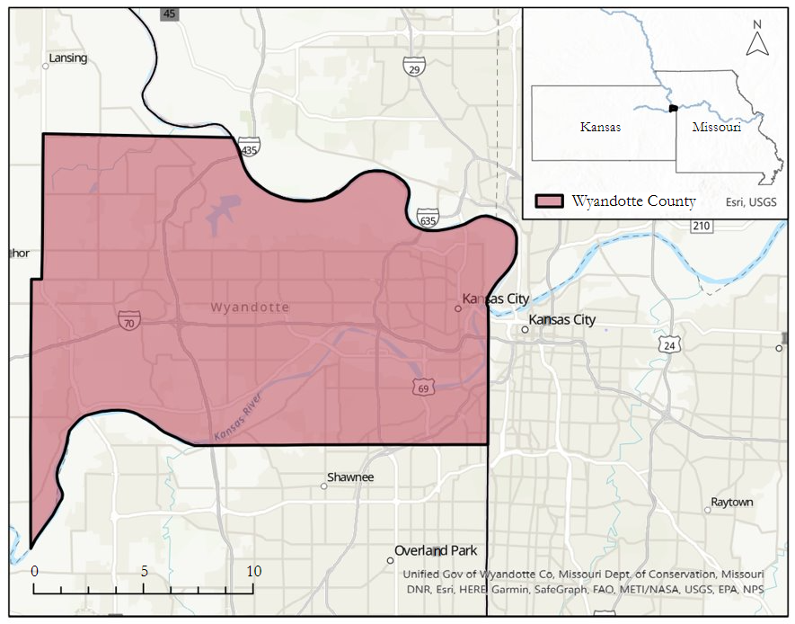
Figure 1. The Wyandotte County study region, located at the junction of the Kansas and Missouri Rivers
In 2013, the Unified Government of Wyandotte Co. and Kansas City, Kansas (UG)’s management of the sewer system was found to be in violation of the Clean Water Act as well as the city’s National Pollution Discharge Elimination System permit. The Environmental Protection Agency (EPA) charged the UG with unauthorized discharge of sewage from the sanitary sewer system, dry weather overflows, and failure to properly maintain the sewer system in accordance with the terms outlined in their city permits. The settlement requires the UG to implement a $600 million-dollar Integrated Overflow Control Plan, as well as an improved Stormwater Management Plan (U.S. Environmental Protection Agency, 2020).
While this sewer shed update plan is in progress, there have been efforts to identify regions of the county where mitigation is still needed. In the summer 2022 DEVELOP project, Assessing Environmental and Socioeconomic Factors of Urban Flood Vulnerability in Kansas City, Kansas, the Kansas City Disasters I team used Earth observations from the Global Precipitation Measurement satellite to investigate flood events from June 2010 to June 2021. Utilizing Natural Capital Project’s Integrated Valuation of Ecosystem Services and Tradeoffs (InVEST) Urban Flood Risk Mitigation model and a cloudburst blue spot model, they identified neighborhoods that were most impacted by severe storm events and estimated potential economic damage. Considering socioeconomic factors, as well as runoff accumulation values, their analyses demonstrated high flood vulnerability in the Northeast region of Wyandotte County.
Building upon the previous term’s focus on identifying the impact of severe storm events on socially vulnerable communities, we investigated longer term retention ratios using annual precipitation measures from January 2000 to December 2020 to examine water quality concerns associated with runoff. As urban stormwater pollution continues to threaten already vulnerable populations, there is a growing need for more accurate stormwater pollution models to inform management practices, land use change impact assessments, and green infrastructure siting (Obropta, 2017). More specifically, there is a need for user-friendly comprehensive models accessible to decision-makers and community leaders like those in Wyandotte County. The Integrated Valuation of Ecosystem Services and Tradeoffs (InVEST) Urban Stormwater Retention Model (USRM), while not a direct assessment of water quality, produces evaluations of the ecosystem services referred to as stormwater purification and stormwater retention (Hamel, 2021) through retention and avoided pollutant outputs. These model results provide insight into where the land is failing to provide natural stormwater management services and identify points of intervention for green infrastructure projects to improve water quality in these neighborhoods.
2.2 Project Partners & Objectives
Groundwork USA is a network of local organizations advocating for environmental justice by calling attention to and alleviating the environmental burden placed on marginalized communities. In partnership with Groundwork USA and Groundwork Northeast Revitalization Group (Groundwork NRG), this project aimed to identify areas with low levels of stormwater purification and retention, as well as high levels of runoff contributing to frequent CSO’s during flood events. This project supported the partners’ Climate Safe Neighborhoods initiatives, building capacity to integrate remote sensing with community input to examine inequitable distribution of ecosystem services affecting water quality. These analyses will also allow the partners spatial insights into the implications of land cover variances in neighborhoods of different demographics due to historical racist housing practices and inform appropriate points of intervention for green infrastructure projects.

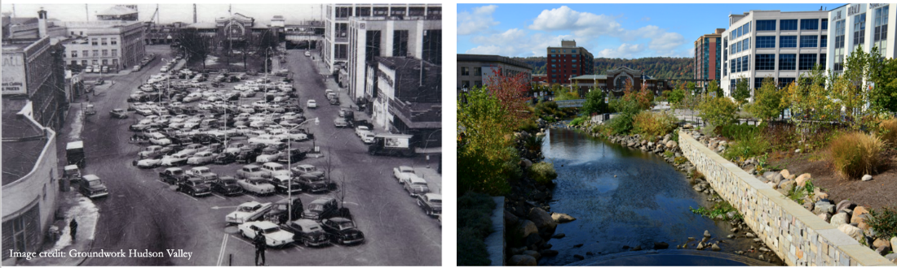
Figure 2. The Saw Mill River in Yonkers, NY before and after 'daylighting' as championed by Groundwork Hudson Valley.

3. Methodology
3.1 Model Description
The InVEST USRM calculates annual stormwater retention ratios and volume, as well as associated water quality benefits, such as the avoided transport of pollutants to ground and surface water. Stormwater retention ratio is defined here as the percent of stormwater that is retained in the soil compared to the percent that percolates or becomes runoff. Stormwater retention volume is a direct measure of the amount of stormwater retained within the soil.

The model requires an annual precipitation raster layer, a land cover classification raster, a soil group classification raster layer, and values of annual runoff coefficients (RC) and event mean concentration (EMC) values for each land cover classification in a biophysical table. For each land cover class x, the stormwater retention ratio (SRR_{x}) is calculated using Equation 1 (Stanford Natural Capital Project, 2022b). Based on the land cover and soil group classifications, the model assigns a stormwater retention ratio to each pixel, i. The model then computes the retained volume (RV_{i}) in cubic meters/year for each pixel using Equation 2 (Stanford Natural Capital Project, 2022b). Finally, the avoided pollutant load (APL_{i}) for each pixel is calculated as a product of the retained volume (RV) and the event mean concentration (EMC) value of a given pollutant using Equation 3 (Stanford Natural Capital Project, 2022b).

Equation 1:
$$SRR_{x} = 1 – RC_{x}$$

Equation 2:
$$RV_{i} = 0.001 * Annual Precipitationi * SRR_{i} * pixel area$$

Equation 3:
$$APL_{i} = 0.001 * RV_{i} * EMC$$

The InVEST USRM calculates retention ratios by subtracting the annual runoff coefficient of each land cover classification from 1. Annual runoff coefficients are defined as the ratio between annual surface runoff and annual precipitation, where pervious land cover types have lower runoff ratios. Land cover classifications are also used to calculate the avoided pollutant load outputs since avoided pollutant load is the product of retention volume and the EMC values of a given pollutant. EMCs are assigned to each land cover class, so the land cover classifications were limited to the classes that we found EMC data for.

3.2 Data Acquisition
The datasets used as inputs into the InVEST USRM are listed in Table 1. The datasets used to analyze the stormwater retention outputs as part of our social vulnerability analysis are listed in Table 2.
Table 1
Summary of data used as inputs into the InVEST Urban Stormwater Retention Model
Dataset Used | Parameter | Dates | Use |  | Model Parameter | Acquisition Location
GPM IMERG | Precipitation | Jan 2000 – December 2020 | Used to calculate annual precipitation sums for Wyandotte County from 2000 – 2020 | Annual precipitation raster input |  | GEE
National Landcover Database (NLCD) | Land cover | 2001, 2011, 2019 | Used to classify land cover types in Wyandotte County | Land cover raster input |  | United States Geological Survey (USGS)
Gridded Soil Survey Geographic Database | Soil group classification | 2019 | Used to classify soil types in Wyandotte County | Soil type raster input |  | United States Department of Agriculture (USDA)
National Stormwater Quality Database (NSQD) | Event Mean Concentration (EMC) values | 2015 | Used to estimate the EMC values of total Suspended Solids, Nitrogen, and Phosphorous for impervious land cover classes in Wyandotte County | Part of the biophysical table input |  | International Stormwater BMP Database
Stormwater chemistry and water quality | Event Mean Concentration (EMC) values | 1998 | Used to estimate the EMC values of total Suspended Solids, Nitrogen, and Phosphorous for pervious land cover classes in Wyandotte County | Part of the biophysical table input |  | Environmental Research and Design, Inc.  (Harper, H. H., 1998)
Pollutant export from various land uses in the Upper Neuse River Basin | Event Mean Concentration (EMC) values | 2002 | Used to estimate the EMC values of total Suspended Solids, Nitrogen, and Phosphorous for pervious land cover classes in Wyandotte County | Part of the biophysical table input |  | (Line, D. E. et al., 2002)
Run-off coefficients by land use class and permeability class | Run-off coefficients | 2007 | Used to identify the run-off coefficients of different land use classes in Wyandotte County | Part of the biophysical table input |  | (Puccinelli, C. et al., 2012)

Table 2
Summary of data used in our social vulnerability analysis
Dataset Used | Parameter(s) | Dates | Use
U.S. Census Bureau Block Group Shapefile | Census block groups, median household income, race, high school diploma | 2020 | Used to assess the social demographics of Wyandotte County
Unified Government of Wyandotte County parcel data | Vacant parcels | 2008 | Used to identify vacant land parcels in vulnerable census blocks

3.3 Data Processing
3.3.1 Precipitation data
From the GPM Monthly precipitation dataset, we computed annual precipitation sums for the years 2000 – 2020 to use as inputs into the InVEST USRM. The sums were calculated in Google Earth Engine and exported into ArcGIS Pro, where the projection was corrected to ensure that all the input raster layers were in the identical coordinate system, WGS 1984 Web Mercator. Finally, all precipitation layers were clipped to the Wyandotte County study region.

To assess the impacts of the precipitation levels on retention ratios and volume, we created three annual precipitation scenarios: low, medium, and high. We identified 2012 as being the year with the lowest annual precipitation, 2019 as the year with the highest annual precipitation, and 2016 as being the closest to the 20-year average precipitation sum from 2000-2020. These were then used as inputs into the InVEST USRM.

3.3.2 Land cover data
The InVEST USRM requires that the EMC and RC inputs are consistent with the land cover classifications. While the United States Geological Survey (USGS) National Landcover Database (NLCD) included 15 land cover classes for Wyandotte County, the National Stormwater Quality Database (NSQD) and supporting literature only had Event Mean Concentration (EMC) values for 11 land cover classes. To ensure that the land cover classification raster matched the biophysical table, we uploaded the USGS National Landcover Database layers to ArcGIS Pro, clipped them to our Wyandotte County study region, and reclassified the 18 land cover classes into the 11 classes that we had biophysical table data for. Appendix A highlights this reclassification. To assess the impacts of land cover change on retention ratios and volume we downloaded, clipped, and reclassified land cover data for 2001, 2011, and 2019 to use as inputs into the InVEST model.

3.3.3 Biophysical table data
We acquired Runoff Coefficients for each land cover type from Cecchi et al., 2007. We acquired EMC values for avoided nitrogen, phosphorus, and total suspended solids from the NSQD. We isolated runoff monitoring sites and records located in Johnson County, Kansas, as they were the sites nearest Wyandotte County. Then we further isolated entries containing data for total phosphorus, total suspended solids, and total Kjeldahl nitrogen plus nitrate as a proxy for total nitrogen. We then calculated the mean value of each pollutant by land cover type to find a single value to input into the biophysical table. The NSQD included EMC data for all of the developed land cover classes, and for the EMC values for land cover types not included in the NSQD, we acquired parsed supplemental data from Central and South Florida (Harper, H. H., 1998) and the Upper Neuse River Basin in North Carolina (Line, D. E. et al., 2002), and connected the most similar land cover types to the NLCD of Wyandotte County. Appendix B highlights all the data used as inputs into the biophysical table.
3.4 Data Analysis
3.4.1 Avoided pollutant outputs
To quantify the differing levels of water purification across the county, we used the zonal statistics tool in ArcGIS Pro and calculated the sum of avoided total suspended solids, nitrogen, and phosphorus in Wyandotte County and in Groundwork KCK’s service area in Northeast Wyandotte. We then divided these sums by the respective areas of each region to produce an avoided pollutant/m² in the broader county and service area. These values were then compared to determine the extent to which Groundwork’s service area in Northeast Wyandotte is lacking water purification services compared to the county as a whole.

3.4.2. The effects of precipitation level on stormwater retention volume and ratio
To assess the effect of precipitation level on stormwater volume and ratios, we ran the model for the high, medium, and low precipitation scenarios that we identified from the 20-year range of annual precipitation data. During these runs, we kept the land cover and soil group classification rasters constant. This attempted to simulate how Wyandotte County would react to a varying magnitude of annual rainfalls.

3.4.3. The effects of land cover on stormwater retention volume and ratio
To assess the effects of land cover change on stormwater retention volume and ratios, we input land cover layers from 2001, 2011, and 2019, respectively, into the InVEST Urban Stormwater Retention Model. We kept the precipitation constant, by using the mean 20-year average precipitation. The stormwater ratio layers then provided information on how retention capability would have changed in the last 20 years with Wyandotte County’s changing land cover. These model outputs also revealed which land cover types are most effective and ineffective in retaining stormwater.

3.4.4 Social justice and green infrastructure analysis
Based on the stormwater retention ratio results from the model and the socioeconomic data from the Census Bureau, we examined the correlation between the retention capabilities and socioeconomic vulnerability per each census block. We first created a social vulnerability index by running principal component analysis on three socioeconomic factors: median household income, percent non-white population, and percent of population with no high school diploma. We chose these variables based on socioeconomic factors considered in other GI infrastructure analyses in the area (Evans, 2021), as well as the Kansas City Disasters I team’s environmental justice analysis. We then selected the first component of the Principal Component Analysis (PCA), PC1, to represent our social vulnerability index.

4. Results & Discussion
4.1 Analysis of Results
4.1.1 Most recent distribution of stormwater retention and purification in Wyandotte County
To understand the current distribution of stormwater retention and purification, we examined model outputs with the most recent data available - 2020 average annual precipitation data and 2019 land cover data. The InVEST model produced outputs as seen in Figure 3. The Eastern areas of Wyandotte are shown to have lower retention ratios, symbolized in yellow and light orange on the map on the left, and higher runoff ratios, symbolized in dark blue on the map on the right, than the Western region of the county. These higher runoff ratios are notably found within the region with the combined sewer system, making the higher proportion of stormwater runoff especially problematic due to the threat of CSOs.
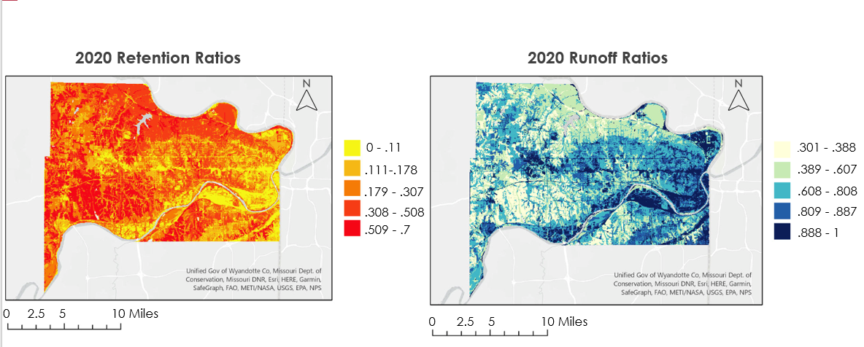
Figure 3. Outputs from 2020 precipitation and 2019 land cover data. The left map shows retention ratios, while the right one shows runoff ratios.

The InVEST model further produced outputs of avoided pollutant loads, as shown in figure 4, that we utilized to examine the stormwater purification capability of the land. Using the zonal statistics tool in ArcGIS Pro, we calculated the amount of avoided pollutant/m2 for the county as a whole, as well as Groundwork’s KCK service area in Northeast Wyandotte for each of the three avoided pollutant outputs
produced. From these values, we concluded that the KCK service area retained 2.5 times less total suspended solids, 1.9 times less nitrogen, and 1.4 times less phosphorus compared to the county as a whole. These lower avoided pollutant values, symbolized as light purple and white on the map, suggest poor stormwater purification services and higher water quality concerns in this Northeast region. These pollutants are more likely to end up in nearby waterways, which can pose a number of adverse human health and environmental effects.
0 - .11
.111-.178
.179 - .307
.308 - .508
.509 - .7
0 2.5 5 10 Miles
2020 Retention Ratios

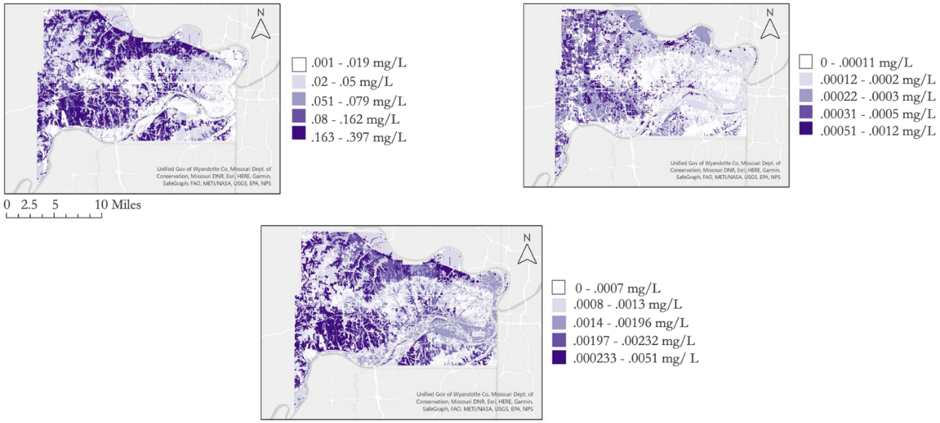
Figure 4. Avoided pollutant loads in Wyandotte County. 4.1 demonstrates avoided total suspended solids (left). 4.2 demonstrates avoided nitrogen (middle). 4.3 represents avoided phosphorus (right).

4.1.2 The effects of precipitation on stormwater retention
The model outputs with varying precipitation levels showed that changes in annual precipitation are not reflected in the retention ratio outputs produced by the InVEST model. The model is most sensitive to land cover, and we kept the land cover consistent throughout the three model runs. A linear increase in retention volume was found as precipitation level increased proportional to the amount of precipitation. This result does not fully reflect the changes in retention capabilities and does not consider additional hydrologic processes that may happen in our study region.

4.1.3 The effects of land cover change on stormwater retention
The model retention outputs with varying land covers from 2001, 2011, and 2019 showed that retention ratios and volumes decreased from 2001 to 2019. Analyzing the change in land cover across 20 years in Wyandotte County, we calculated a 3% increase in impervious landcover, suggesting a negative correlation between impervious surface cover and retention. While Groundwork’s service area in Kansas City had a notably lower retention ratio than the remainder of Wyandotte County during all three land cover scenarios, we were able to identify the region shown in figure 5 that had the largest decrease in stormwater retention within the service area and could be used as a possible focus for future Groundwork projects.
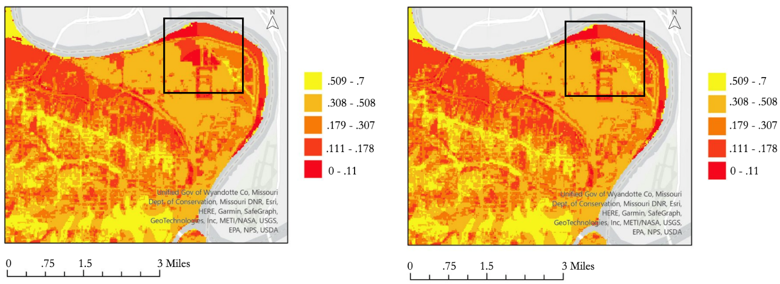
Figure 5
Groundwork KCK service area. 5.1 shows retention ratios produced from 2001 land cover (left). 5.2 shows retention ratios produced from 2019 land cover (right).

4.1.4 Social justice and green infrastructure analysis
By comparing our PC1-inferred social vulnerability index with the retention ratio from the model in Wyandotte County, we found that there is a negative correlation between the retention ratio and the social vulnerability index. From the scatter plot shown in figure 6, a decreasing trend is found in retention ratio as the vulnerability index becomes higher. The adjusted r-squared of .19 illustrates the complex nature of our social analysis. By ranking the census blocks by our PC-1 inferred social vulnerability index, we identified 10 census blocks that could benefit most from Groundwork NRG’s green infrastructure initiatives, as highlighted in yellow in Figure 7.
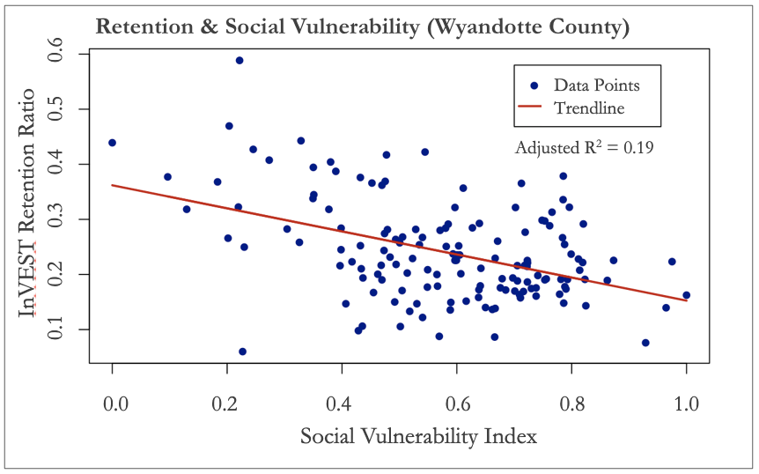
Figure 6. Scatter plot of social vulnerability index and retention ratio outputs.

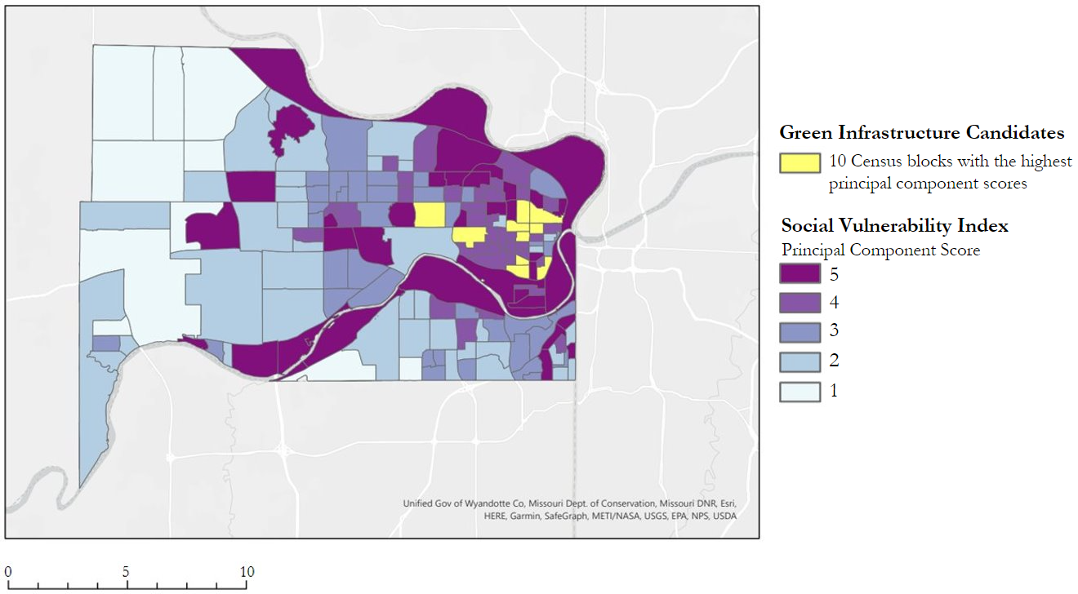
Figure 7. Green infrastructure candidates (highlighted in yellow) and the social vulnerability index by census block.

As shown in Appendix C, we also identified vacant land parcels within these 10 census blocks, as well as census blocks with the highest vulnerability score, to provide partners with vacant land potentially suitable for these green infrastructure projects. Groundwork USA’s mission is to bring about the sustained regeneration, improvement, and management of the physical environment, and their primary agent of change is landscape improvement projects that reintroduce permeable surfaces to historically disinvested neighborhoods. Providing partners with vacant land in vulnerable block groups in Wyandotte County will allow them to find effective locations for these landscape improvement projects and uplift communities that are lacking natural stormwater management services.

4.1.4 Model limitations
While we were able to examine the effects of precipitation and land cover on stormwater retention in Wyandotte County, the analysis was limited by model uncertainties, data uncertainties, and limitations within the model itself. To start, the model is highly simplified and only considers seven land cover classifications and four soil groups. This simplifies the spatial variability that exists in Wyandotte County. Additionally, the precipitation data that was used as a model input was rather coarse, and the data used in the biophysical table was found in literature. This limits the quality of our data analysis. Finally, the model itself is limited in what it can tell us about water quality since it models stormwater retention as an ecosystem service rather than measuring how much pollutant ends up in nearby waterways.

4.2 Future Work
Further research is required to directly quantify the amount of pollutant discharged into surface and groundwater, taking into account the retention volumes produced in this analysis. A model like the EPA’s Stormwater Management Model (SWMM) could work in tandem with Groundwork’s citizen science projects collecting water quality measurements in local waterways. This would allow insight into the extent to which poor stormwater management and the resulting high levels of runoff and CSO’s are contributing to degraded water quality. Utilizing a more comprehensive model like SWMM, taking into account both built and natural stormwater infrastructure, would also allow for analysis of the reduction of runoff produced from green infrastructure in order to more accurately identify sites of highest potential impact.

Another direction for future research could combine Kansas City Disasters I team’s flood vulnerability maps based on pooling of runoff with other environmental hazard assessments like the low retention volumes found in this study. Urban heat disparities, air pollution measurements, as well as socioeconomic factors could be used in addition to this data to create an environmental vulnerability index. This would show the cumulative impact of the environmental health hazards that burden disinvested neighborhoods.

Both projects would require community input to ensure lived experiences are reflected by the work. Remote sensing imagery can help produce powerful maps and analyses to empower those most affected by environmental hazards. However, integrating marginalized communities' perspectives is essential to a comprehensive understanding of environmental justice issues.

5. Conclusions
This project examined the implications of land cover change and precipitation on the distribution of natural stormwater management ecosystem services: stormwater purification and retention. With the retention volume, retention ratio, and avoided pollutant outputs from the InVEST Urban Stormwater Retention Model, we analyzed the distribution of these services in conjunction with socioeconomic data from the Census Bureau. We identified areas in the Wyandotte County study region with existing socioeconomic vulnerabilities, as well as low levels of retention and avoided pollutant loads. Examining the median household income of each census block, the percent non-white population, and the percent of each census block without a high school diploma, we observed that all of the census blocks in Northeast Wyandotte County experienced intersecting social vulnerabilities. Our analysis additionally suggested that Northeast Wyandotte is prone to higher levels of polluted stormwater runoff compounded by the contamination caused by CSO’s in this region. We identified the census blocks most eligible for green infrastructure projects according to our principal component analysis, as well as vacant land parcels within these blocks. These end products will provide Groundwork with priority areas for intervention for brownfield reclamation or general green infrastructure work. They will also provide objective evidence of failing stormwater management in already vulnerable neighborhoods that can be used to advocate for more equitable integrated overflow control, as well as stormwater management plans.

6. Acknowledgments
The Kansas City Disasters II team thanks our project partners at Groundwork USA and Groundwork NRG for their valuable input and collaboration on this project: Jalisa Gilmore, Lawrence Hoffman, and Reverend Adri Showalter-Matlock. We thank Dr. Kent Ross for his technical advisory and scientific guidance throughout the term and Tyler Pantle for overseeing the project and being our main point of support. Finally, we thank the Kansas City Disasters I team for the important work they contributed to the project: M. René Castillo, Hadwynne Gross, Eric Sjöstedt, Raychell Velez. This project would not be possible without the support of all the individuals listed above.

Any opinions, findings, and conclusions or recommendations expressed in this material are those of the author(s) and do not necessarily reflect the views of the National Aeronautics and Space Administration.

This material is based upon work supported by NASA through contract NNL16AA05C.

7. Glossary
CSO – Combined Sewer Overflow: when, during heavy rainfall events, a combined sewer system becomes overwhelmed and discharges untreated stormwater and sewage into nearby waterbodies
Combined sewer system – a sewer system in which stormwater and sewage are collected in the same pipes
Earth observations – satellites and sensors that collect information about the Earth’s physical, chemical, and biological systems over space and time
GPM – Global Precipitation Measurement: an international satellite mission that measures both active precipitation and atmospheric conditions
InVEST – Integrated Valuation of Ecosystem Services and Tradeoffs: a suite of models used to map and evaluate the changes in ecosystems influencing natural goods and services that sustain human life
LULC – Land Use Land Cover: Land Use Land Cover: The classification of human-related activities and land elements on the Earth’s surface
UG – Unified Government of Wyandotte County and Kansas City, Kansas: the consolidated city and county government responsible for sewer and stormwater management

8. References
Aryal, R., Vigneswaran, S., Kandasamy, J., & Naidu, R. (2010). Urban stormwater quality and treatment. Korean Journal of Chemical Engineering, 27, 1343–1359. https://doi.org/https://doi.org/10.1007/s11814-010-0387-0
Balstrøm, T., & Crawford, D. (2018). Arc-Malstrøm: A 1D hydrologic screening method for stormwater assessments based on geometric. Computers & Geosciences, 111, 64-73. https://doi.org/10.1016/j.cageo.2018.04.010
Evans, K. (2021). Green Infrastructure Site Suitability Analysis for Wyandotte County and Kansas City, Kansas. https://doi.org/10.17615/nw3f-3y81
Hamel, P., Guerry, A. D., Polasky, S., Han, B., Douglass, J. A., Hamann, M., Janke, B., Kuiper, J. J., Levrel, H., Liu, H., Lonsdorf, E., McDonald, R. I., Nootenboom, C., Ouyang, Z., Remme, R. P., Sharp, R. P., Tardieu, L., Viguié, V., Xu, D., … Daily, G. C. (2021). Mapping the benefits of nature in cities with the invest software. Npj Urban Sustainability, 1, Article 25. https://doi.org/10.1038/s42949-021-00027-9
Harper, H. H. (1998). Stormwater chemistry and water quality. Environmental Research & Design, Inc.: Orlando, FL, USA.
Huffman, G.J., E.F. Stocker, D.T. Bolvin, E.J. Nelkin, Jackson Tan (2019), GPM IMERG Final Precipitation L3 1 month 0.1 degree x 0.1 degree V06, Greenbelt, MD, Goddard Earth Sciences Data and Information Services Center (GES DISC), Accessed: [October 18, 2022], https://doi.org/10.5067/GPM/IMERG/3B-MONTH/06
Line, D. E., White, N. M., Osmond, D. L., Jennings, G. D., & Mojonnier, C. B. (2002). Pollutant export from various land uses in the Upper Neuse River Basin. Water Environment Research, 74(1), 100-108. https://doi.org/10.2175/106143002X139794
Obropta, C., & Kardos, J. (2017). Review of Urban Stormwater Quality Models: Deterministic, Stochastic, and Hybrid Approaches. Journal of the American Water Resources Association, 43(6), 1508–1523. https://doi.org/https://doi.org/10.1111/j.1752-1688.2007.00124.x
Petrie, B. (2021). A review of combined sewer overflows as a source of wastewater-derived emerging contaminants in the environment and their management. Environmental Science and Pollution Research, 28, 32095–32110. https://doi.org/https://doi.org/10.1007/s11356-021-14103-1
Puccinelli, C., Marcheggiani, S., Munafò, M., Andreani, P., & Mancini, L. (2012). Evaluation of Aquatic Ecosystem Health Using the Potential Non Point Pollution Index (PNPI) Tool. In (Ed.), Diversity of Ecosystems. IntechOpen. https://doi.org/10.5772/36330
Skaalsveen, K., Ingram, J., & Clarke, L. (2019). The effect of no-till farming on the soil functions of water purification and retention in north-western Europe: A literature review. Soil and Tillage Research, 189, 98–109. https://doi.org/https://doi.org/10.1016/j.still.2019.01.004
Stanford Natural Capital Project. (2022). InVEST. Natural Capital Project. https://naturalcapitalproject.stanford.edu/software/invest
Stanford Natural Capital Project. (2022). InVEST Documentation: Urban Stormwater Retention model. Natural Capital Project. https://storage.googleapis.com/releases.naturalcapitalproject.org/invest-userguide/latest/stormwater.html
United States Environmental Protection Agency. (2020). “Unified Government of Wyandotte County and Kansas City, Kansas.” EPA, United States Environmental Protection Agency. https://www.epa.gov/enforcement/unified-government-wyandotte-county-and-kansas-city-kansas#over.
Wilson, B. (2020). Urban heat management and the legacy of redlining. Journal of the American Planning Association, 86(4), 443-457. https://doi.org/10.1080/01944363.2020.1759127

9. Appendices
Appendix A: Table summarizing land cover reclassification
Original Classification | Reclassification
Open water | Open water
Developed, open space | Developed, open space
Developed, low intensity | Developed, low intensity
Developed, medium intensity | Developed, medium intensity
Developed, high intensity | Developed, high intensity
Barren land (Rock/Sand/Clay) | Barren land (Rock/Sand/Clay)
Deciduous Forest | Wooded
Evergreen Forest | Wooded
Mixed Forest | Wooded
Shrub | Wooded
Grassland | Grassland
Pasture | Pasture
Cultivated Crops | Cultivated Crops
Woody Wetlands | Wetlands
Emergent Herbaceous Wetlands | Wetlands

Appendix B: Summary of biophysical table
Land Cover Code | Description | Connected | RC_A | RC_B | RC_C | RC_D | EMC_[TSS] mg/L | EMC_[N] mg/L | EMC_[Ph] mg/L
11 | Open water | 0 | 1 | 1 | 1 | 1 | 3.1 | 1.25 | 0.11
21 | Developed open area | 1 | 0.39 | 0.61 | 0.74 | 0.8 | 151 | 3.95* | 0.4
22 | Developed low intensity | 1 | 0.57 | 0.72 | 0.81 | 0.86 | 107 | 3.02* | 0.31
23 | Developed med intensity | 1 | 0.77 | 0.85 | 0.9 | 0.92 | 54.885 | 1.56* | 0.215
24 | Developed high intensity | 1 | 0.89 | 0.9 | 0.94 | 0.94 | 117.36 | 12.75* | 1
31 | Barren land | 0 | 0.77 | 0.86 | 0.91 | 0.94 | 11.1 | 1.25 | 0.053
41 | Wooded | 0 | 0.36 | 0.6 | 0.73 | 0.79 | 487 | 4.58* | 0.35
71 | Grassland | 0 | 0.49 | 0.69 | 0.79 | 0.84 | 202 | 7.87* | 1.07
81 | Pasture | 0 | 0.3 | .058 | 0.71 | 0.78 | 122.65 | 3.69** | 1.308
82 | Cultivated crops | 0 | 0.58 | 0.73 | 0.82 | 0.87 | 55.3 | 2.5 | 0.453
95 | Wetlands | 0 | 1 | 1 | 1 | 1 | 10.2 | 1.6 | 0.19
*value calculated by adding total Kjeldahl nitrogen and nitrates (TKN + NO3) because total nitrogen (TN = TKN + NO3 + NO2) values were unavailable.
**value calculated by averaging land class nitrogen values from two different studies, one of which used TKN + NO3 in place of TN.
Appendix C: Vacant land parcels

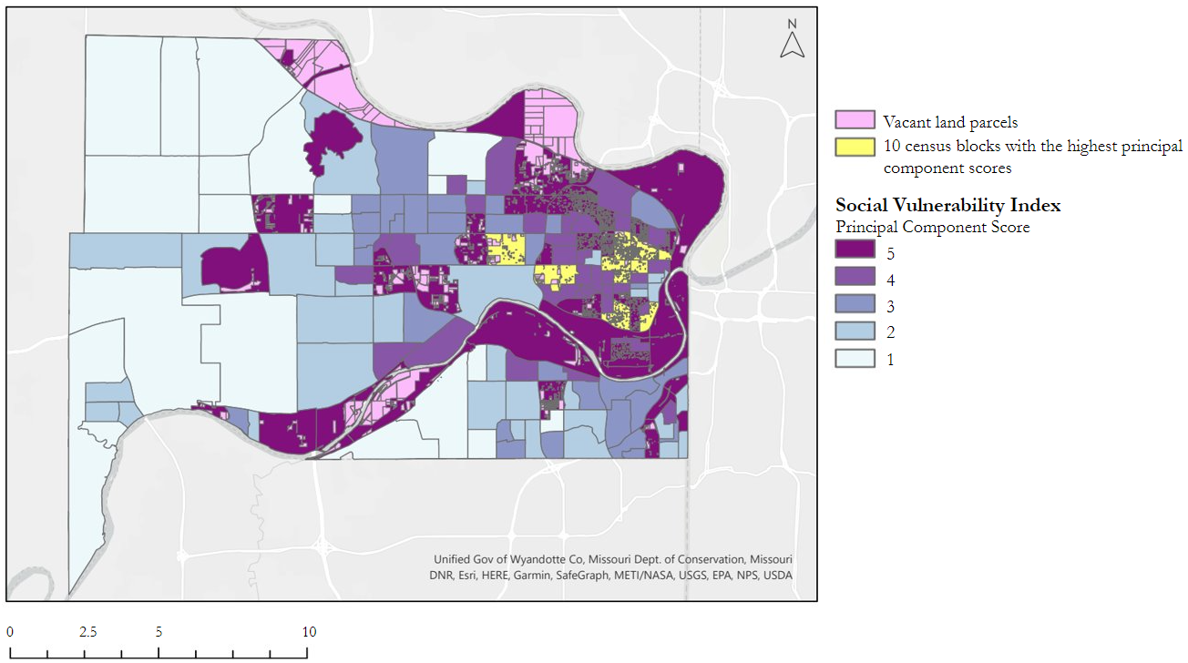
Figure C1
Map of Social Vulnerability Index in Wyandotte County overlayed with land parcel data

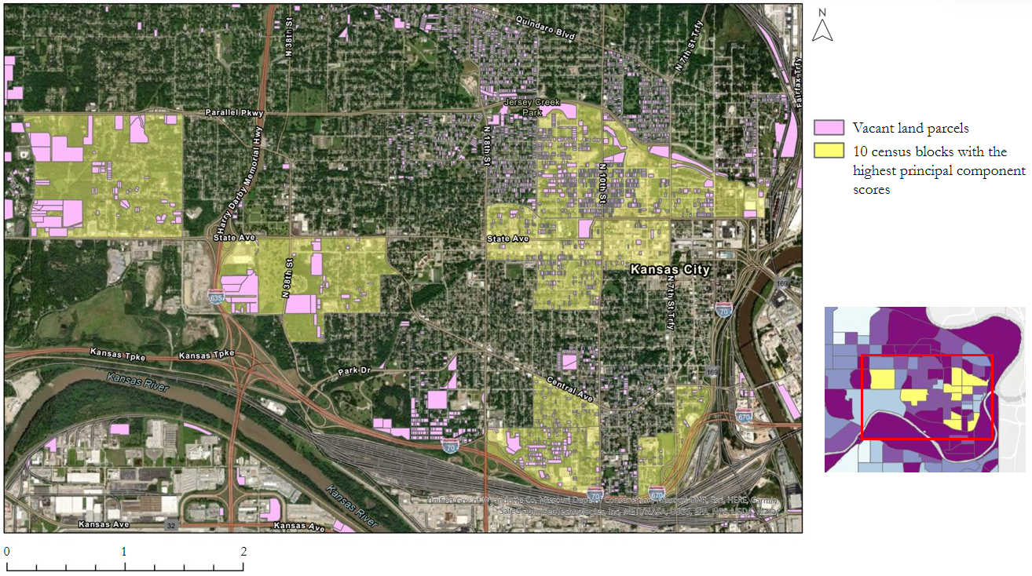
Figure C2
High resolution image overlayed with vacant land parcels in all 10 vulnerable census blocks

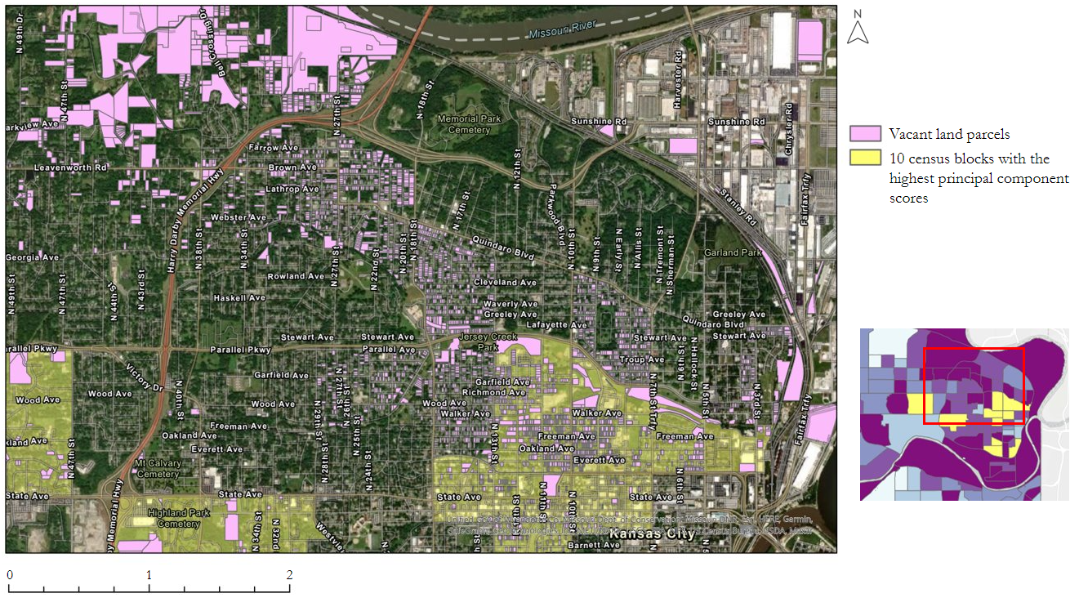
Figure C3
High resolution image of Zone 1 (as indicated on the right) overlayed with vacant land parcels in vulnerable census blocks

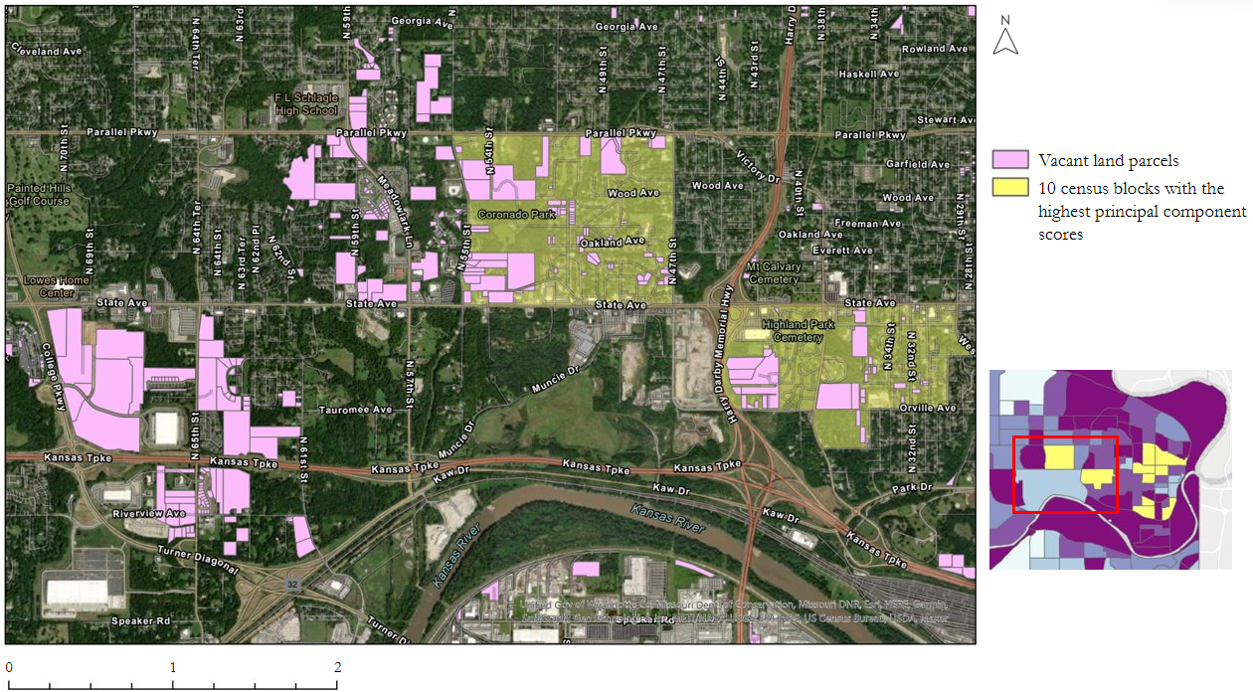
Figure C4
High resolution image of Zone 2 (as indicated on the right) overlayed with vacant land parcels in vulnerable census blocks

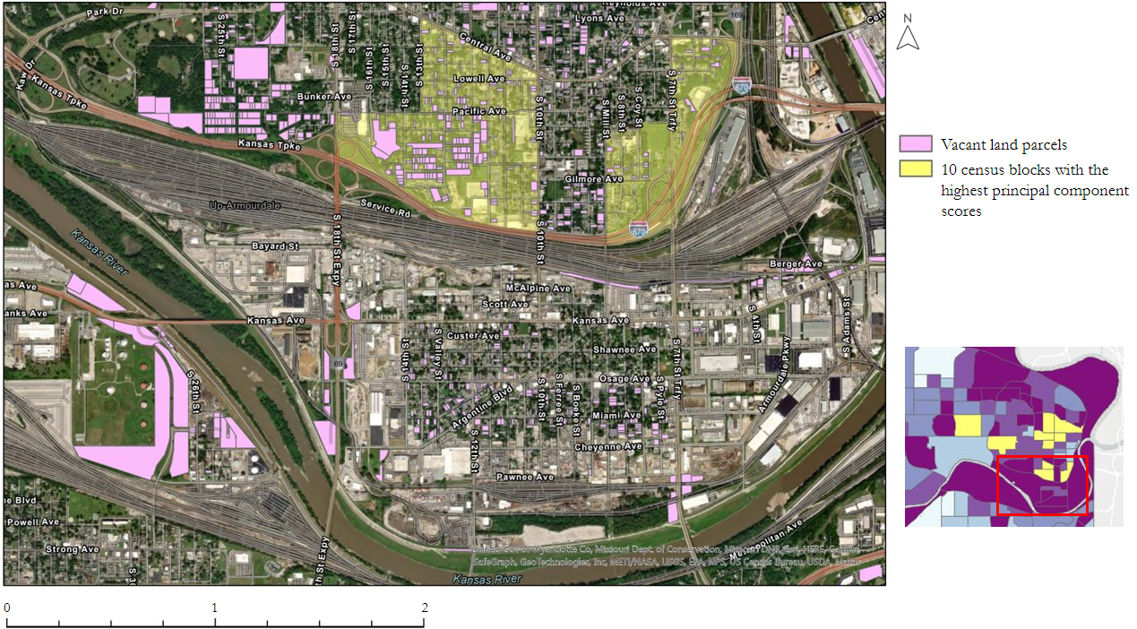
Figure C5
High resolution image of Zone 3 (as indicated on the right) overlayed with vacant land parcels in vulnerable census blocks

