Delaware Urban Development

Utilizing NASA Earth Observations to Assess Coastline Replenishment Initiatives and Shoreline Risk Along Delaware's Coasts

**Technical Report**

Final Draft – November 22nd, 2019

Rachel Tessier (Project Lead)

Ani Matevosian

Greta Paris

Nicholas Gagliano

Dr. Jeffrey Luvall, NASA Marshall Space Flight Center (Science Advisor)

Dr. Robert Griffin, University of Alabama in Huntsville (Science Advisor)

# 1. Abstract

Delaware’s coastline is a vibrant tourist destination and unique habitat for many vulnerable species. Yet, with the lowest mean elevation of any state, this indispensable stretch of land is threatened by numerous geological and climatic forces, including coastal erosion, sea level rise, storm surge, and subsidence. The state’s Department of Natural Resources and Environmental Control (DNREC) has, therefore, served as a diligent combatant of coastal land loss since the 1950s. In partnership with the DNREC, this team utilized Landsat 8 Operational Land Imager (OLI), Landsat 7 Enhanced Thematic Mapper Plus (ETM+), Landsat 5 Thematic Mapper (TM), and the Terra Advanced Spaceborne Thermal Emission and Reflection Radiometer (ASTER) in combination with ancillary datasets to create a suite of time-series maps that identified shoreline extent changes in response to management projects and to generate a coastal land loss susceptibility map. Analyses of coastline change across time were performed using quantifiable measures derived from the time-series maps. The team found that there was a statistically significant, dampening shift of land to water between 1988 and 2018. Bombay Wildlife Refuge, Prime Hook Wildlife Refuge, Rehoboth Beach, Slaughter Beach, and Assawoman Bay are the most susceptible areas to land loss along Delaware’s coast. Areas that experienced the greatest land loss within the thirty-one-year range were the Prime Hook and Bombay Hook Wildlife Refuges. Conversely, Cape Henlopen exhibited a notable accretion of land. These maps and analyses can be used by the DNREC to support the development of future coastal protection and replenishment strategies through the evaluation of restoration technique effectiveness and identification of at-risk areas. Finally, these products were implemented into a story map that demonstrated the unique geological circumstances that put Delaware at risk and showcased the impacts of the state’s efforts to protect it.

**Keywords**

Delaware, coastline management, erosion, sea level rise, storm surge, subsidence, Landsat, Terra ASTER

# 2. Introduction

***2.1 Background Information***

Delaware’s economically and ecologically vibrant coastline is currently threatened by various climatic and geological forces, including subsidence, coastal erosion, sea level rise, and storm surge. As a popular tourist destination, the coastline fuels the state’s economy and it hosts productive fishing, crabbing, and oyster industries (DNREC Public Affairs, 2012). Delaware’s coast is also ecologically valuable, as it serves as an important transition zone and migration stopping point for flora and fauna, alike. (DNREC, 2015). For these reasons, the state’s government is interested in protecting and restoring the coastline to prevent habitat-loss and property damage.

The state of Delaware lies on the Coastal Plain unit and has the lowest mean elevation of any state. The Coastal Plain is comprised of unconsolidated soils that are easily erodible (Coastal Hazards in Delaware, n.d.). Research of this region indicates that sea level rise and decreases in sediment supply are the main drivers of shoreline recession (Zhang, Douglas, & Leatherman, 2002). The state also experiences subsidence due to tectonic movement and anthropogenic extraction of subsurface resources, further exacerbating the concurrent drivers of coastal land loss (DNREC, n.d.). Although long-term erosion accounts for the majority of Delaware’s coastal land loss (Jesse Hayden, personal communication, September 25, 2019), the state is also impacted by extreme weather events, such as Nor’easters and hurricanes. This is especially true for marshes and wetlands, where average wave conditions, rather than episodic storms, are the dominant cause of marsh boundary loss (Leonardi, Ganju, & Fagherazzi, 2015). An exception to this trend is the break in the natural barrier of Prime Hook Wildlife Refuge that Hurricane Sandy caused in 2012.

Delaware’s Department of Natural Resources and Environmental Control (DNREC) has implemented major shoreline management programs to combat land loss in partnership with the United States Army Corps of Engineers (USACE). These programs are generally comprised of beach nourishment and hard structure installation projects and may be funded by the state or federal government (DNREC, n.d.). Research on the effectiveness of beach nourishment in New Jersey during Hurricane Sandy found a slight reduction in damage to beaches that had been nourished since 2000, validating the continuation of these projects (Griffith, Coburn, Peek, & Young, 2015). The most notable restoration project in the area is that of the Prime Hook Wildlife Refuge, following Hurricane Sandy. This monumental state and federal effort received the 2019 Climate Adaptation Leadership Award for Natural Resources to recognize its innovation and success (Eisenhauer, 2019).

Previous studies demonstrate remote sensing’s ability to monitor wetland and coastline changes and restoration efforts (Arcuri, Ortiz, & Edmonds, 2016; Guo, Sheng, Xu, & Wu, 2017; Klemas 2014, Mars & Houseknecht, 2007). For instance, Arcuri et al. (2016) used Landsat imagery of the Mississippi River Delta Plain to identify wind-driven wave edge erosion as a critical driver of the land loss that they quantified. Mars and Houseknecht (2007) also used Landsat imagery to detect a doubling in the erosion rate of a segment of Alaska’s coast. A new approach to quantify and map shoreline and coastal wetland water extent is through the use of the Coastal Annual Land Cover Change (CALCC) tool. Created by the Fall 2018 Hampton Roads Urban Development DEVELOP team and modified by the Spring 2019 Niagara Falls Disasters team, this tool generates synthetic rasters of land and water yearly averages of pixel values.

This project focused on the coastal wetlands and shorelines of Delaware (*Figure 1*) from 1988 to 2018. While Atlantic coastal research is covered by the USGS, the Delaware Bay is left to the state, which has therefore received less research due to budget limitations (Jesse Hayden, personal communication, Oct 1, 2019). Remote sensing data from Landsat 5 Thematic Mapper (TM), Landsat 7 Enhanced Thematic Mapper Plus (ETM+), and Landsat 8 Operational Land Imager (OLI) cover the thirty-one-year period, allowing for an analysis of Delaware’s coastline over time via the CALCC tool.

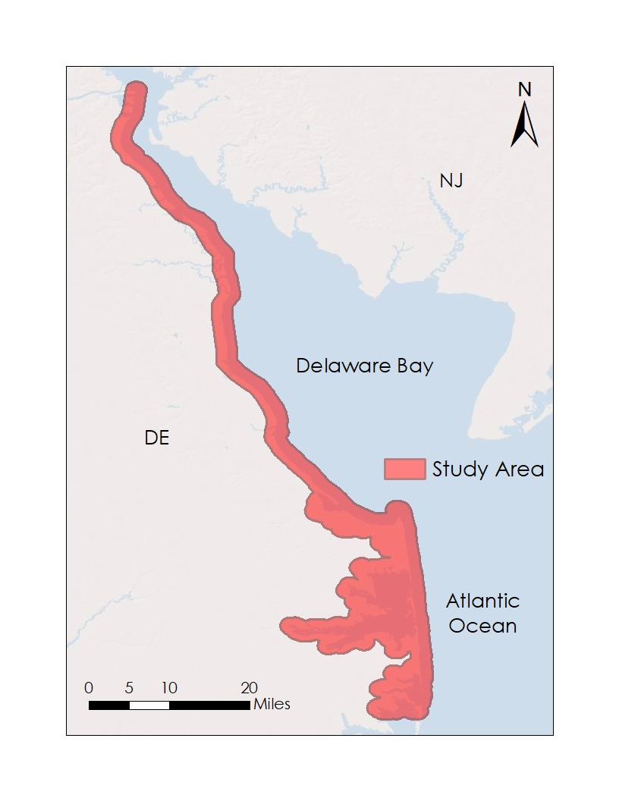

*Figure 1.* Our study area included a half-mile buffer from Delaware’s coastline.

***2.2 Project Partners & Objectives***

The DNREC has implemented coastal management strategies to tackle the threat of land loss. Our partners currently do not utilize NASA Earth observations (EOs). The end products developed by the team will enable partners to identify and address coastal areas most in need of intervention to better protect habitats and infrastructure.

This project aimed to support the DNREC in decision-making processes by employing NASA EOs, which has been achieved by exemplifying historical coastline changes in comparison to coastal management programs via a number of time-series maps and GIFs. Then, the team generated a susceptibility map to highlight areas at-risk to coastal land loss. To quantify possible changes to the coastline, we performed a series of regressions on the relationships between time and coastal change. The team also created an ArcGIS StoryMap to showcase the unique risks threatening Delaware’s coastline, management efforts by the DNREC, and the team’s products and results.

# 3. Methodology

***3.1 Data Acquisition for Susceptibility Maps***

The final susceptibility map is comprised of numerous factors that influence coastal land loss, as shown in *Table 1.* The team chose these factors based on literature review and the availability of relevant data for use in ArcMap 10.5.1. The team derived elevation data from a Terra Advanced Spaceborne Thermal Emission and Reflection Radiometer (ASTER) digital elevation model (DEM) and calculated slope from the DEM. We acquired land cover, soil hydrology, and relative sea level rise data from the most relevant, recently available datasets. The team also obtained wind speed and wave height data from the DNREC. Using these data, the team created the coastal land loss susceptibility map.

Table 1

*Data Sources for Susceptibility Factors*

|  |  |
| --- | --- |
| **Susceptibility Factors** | **Data Sources** |
| Elevation | Terra ASTER Digital Elevation Model via NASA Earthdata |
| Slope | Terra ASTER Digital Elevation Model via NASA Earthdata |
| Land Cover | NOAA Coastal Change Analysis Program (C-CAP) |
| Soil Hydrology | USDA/NRCS Gridded Soil Survey Geographic Database (gSSURGO) |
| Relative Sea Level Rise | NOAA Tides & Currents |
| Wind Speed | Delaware Environmental Observing System (DEOS) |
| Wave Height | CB&I Coastal Planning & Engineering, Inc. via DNREC |

***3.2 Data Acquisition for Time-Series Maps & Analyses***

To complete the time-series map, the team utilized 5,830 images using three Landsat sensors (*Table 2* and *Figure 2*). Using the CALCC tool, we acquired and processed the data within the Google Earth Engine (GEE) JavaScript Application Programming Interface (API) to create time-series maps of coastline changes between 1988-2018 within ArcGIS Pro. One of the time-series maps also showcases the DNREC’s historical coastline management projects alongside the coastline changes. Our partners at the DNREC provided us with the historical coastal management project database.

Table 2

*Data Sources for Time-Series Maps and Analyses*

|  |  |  |  |  |
| --- | --- | --- | --- | --- |
| **Platform/Sensor** | **Processing Level** | **Dataset Type** | **Number of Images** | **Dates** |
| Landsat 5 Thematic Mapper (TM) | Collection 1, Tier 1 | Surface reflectance | 1,699 | February 1988 - December 2011 |
| Landsat 7 Enhanced Thematic Mapper Plus (ETM+) | Collection 1, Tier 1 | Surface reflectance | 1,564 | July 1999 - September 2018 |
| Landsat 8 Operational Land Imager (OLI) | Collection 1, Tier 1 | Surface reflectance | 578 | March 2013 - September 2018 |

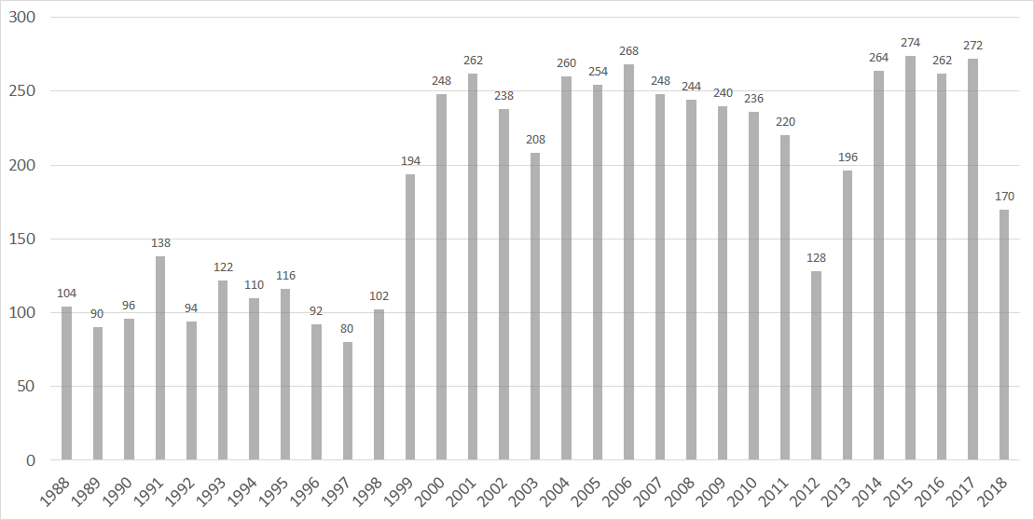

*Figure 2.* Number of satellite images used per year.

***3.3 Data Processing for Susceptibility Maps***

*3.3.1 Elevation*

The team classified elevation based on natural breaks in the data. Areas five feet or below are at the greatest risk to erosion, while areas between five and ten feet are at moderate risk. Areas between ten and sixteen feet are at low risk. Finally, areas over sixteen feet are at the least risk.

*3.3.2 Slope*

The team calculated slope percentage from the Terra ASTER DEM using the Slope (Spatial Analyst) tool in ArcMap, then classified the data based on natural breaks. Because Delaware lies in the Atlantic Coastal Plain, slope percentage remained consistently low. Areas with approximately 6% slope or higher are at the greatest risk of erosion, between 3.4% and 6% are at moderate risk, between 1.7% and 3.4% are at low risk, and areas with 1.7% or below are at the least risk.

*3.3.3 Land Cover*

We acquired land cover data from NOAA’s C-CAP Land Cover Atlas (Dobson, 1995). Highly developed land, moderately developed land, cultivated cropland, estuarine wetland, unconsolidated shore, and bare land received the classification of the most susceptibility to erosion (National Association of Counties Research Foundation, 1970; Kerris & Iivari, 2006; Titus, 1998). The team classified palustrine wetlands as moderately susceptible (Titus, 1998); lightly developed land, developed open space, and pasture as less susceptible (National Association of Counties Research Foundation, 1970; Kika de la Garza Plant Materials Center, n.d.); and grasslands, deciduous forest, evergreen forest, mixed forest, and scrub/shrub as least susceptible (Kika de la Garza Plant Materials Center, n.d.).

*3.3.4 Soil Hydrology*

The team acquired the USA Soils Hydrologic Group map layer from ArcGIS Online, with pre-classified soils based on the USDA’s Soil Hydrologic Groups A-D. These classifications are characterized by infiltration and runoff rates. Group A has the highest infiltration rate and lowest runoff rate, thus making it the least susceptible to erosion. Group B has a moderately low runoff potential. Group C has a moderately high runoff potential. Group D has the lowest infiltration rate and highest runoff rate, thus making it the most susceptible to erosion (Mockus & Hoeft, 2007).

*3.3.5**Relative Sea Level Rise*

The team obtained relative sea-level rise (RSLR) data from the NOAA Tides & Currents Database. RSLR includes both sea-level rise and local subsidence rates. The team created Thiessen Polygons within ArcMap to assign RSLR proximity values to the entire coast based on the three measuring stations: Reedy Point, Lewes, and Ocean City (Esri, n.d.).

*3.3.6 Wind Speed*

The team collected wind speed data from the Delaware Environmental Observing System (DEOS) at six measuring stations along Delaware’s coast. The data collected contained a three-year average wind speed for each station. We then reclassified the six measured wind speeds into four groups of susceptibility: very low (4.12-4.38 mph), low (4.38-4.75 mph), moderate (4.75-5.39 mph), and high (5.39-9.46 mph). Lastly, we created Thiessen Polygons in ArcMap to assign wind speed proximity values to the entire coast of Delaware (Esri, n.d.).

*3.3.7**Wave Height*

We collected wave height data from CB&I Coastal Planning & Engineering, a contractor hired by the Delaware Department of Natural Resources and Environmental Control. The team stimulated maximum significant wave height (feet) at five measuring stations based on the Simulating Waves Nearshore Model. Then, the team reclassified the five measured wave heights into four groups of susceptibility: very low (3.6 feet), low (3.7 feet), moderate (3.8 feet), and high (greater than 3.8 feet). Lastly, we created Thiessen Polygons in ArcMap to assign wave height proximity values to the entire coast of Delaware (Esri, n.d.).

***3.4 Data Processing for Time-series Maps & Analyses***

The team used the CALCC tool to process all rasters used in the time-series maps and analyses. This tool masked clouds using the methods of Gorelick et al. (2017), which reassigns cloud-affected pixel to “no data”. We omitted interpolation techniques to avoid uncertainty (Lenth, 2001). To convert the raster imagery to a format that distinguishes between land and water, the CALCC tool uses the Normalized Difference Water Index (NDWI; *Equation 1*) and the Modified Normalized Difference Water Index (MNDWI; *Equation 2*; Jiang et al., 2014). Pixels with a value of zero are classified as land and values of one as water. The pixel values of all rasters for each year are averaged, resulting in a single synthetic raster for each year between 1988 and 2018 in a Georeferenced Tagged Image File Format (GeoTIFF). Pixels with values between one and zero represent locations that changed for that year. The raster calculator within ArcGIS Pro enabled the quantification of year-to-year change, by using *Equation 3*.

$NDWI =\frac{GREEN - NIR}{GREEN + NIR}$

$MNDWI =\frac{GREEN - MIR}{GREEN + MIR}$

$Change = {Year}_{Final}-{Year}_{Initial}$

***3.5 Data Analysis for Susceptibility Maps***

The team performed a weighted sum of slope, land cover, and soil hydrology to create the susceptibility to erosion map (Esri, n.d.), with a weight of 1.00 being given to each factor. The team then reclassified the susceptibility to erosion map into four classes based on equal intervals. A spectrum of red to green represents areas from most to least susceptibility, respectively.

The team performed a second weighted sum of elevation, susceptibility to erosion, wind speed, wave height, and relative sea-level rise to create the overall coastal land loss susceptibility map (Esri, n.d.). We assigned a weight of 1.00 to elevation and susceptibility to erosion, a weight of 0.50 to wind speed and wave height, and a weight of 0.75 to relative sea-level rise. We then reclassified this map into four classes based on natural breaks, again with a spectrum of red to green that indicates high to low susceptibility.

***3.5 Data Analysis for Time-Series Maps & Analyses***  
Using the GEE Javascript API, the CALCC tool yielded a classification of land and water pixels within our study area. This allowed for the analysis and quantification of land loss and accretion over the thirty-one-year period, as well as the rate of that change, which was calculated with the Raster Calculator (Spatial Analyst) Tool within ArcGIS Pro (Esri, n.d.; *Equation 3*). Within Microsoft Excel, we regressed both the annual averages and year-to-year changes to detect potential trends in land change and land change rates through time. More specifically, we performed linear and quadratic regressions, with alpha values below 0.05 being deemed significant. The team then created three GIFs within Adobe Premiere Pro for qualitative analyses, including the coastline changes for the entire study area through time with the beach management projects, shoreline changes for the Prime Hook Wildlife Refuge and Cape Henlopen area, and the Bombay Hook Wildlife Refuge.

# 4. Results & Discussion

***4.1 Susceptibility Maps***

The coastal land loss susceptibility map (*Figure 3*) encompasses the entire coast of Delaware and all susceptibility factors. The team obtained the datasets for each susceptibility factor from government sources, such as NOAA, USDA, and DNREC, some of which are dated. Additionally, wind speed and wave height data do not extend into the tidal wetlands found on Delaware’s Atlantic coast. With dates and areas differing for each dataset, the team found it difficult to sum the factors with mathematical precision (see section 3.3). A map displaying susceptibility to erosion, exclusively, is comprised of the slope, land cover, and soil hydrology factors. This susceptibility to erosion map, along with the maps of every susceptibility factor, can be found in the Appendix.

Areas of high susceptibility to land loss tended to be have vulnerable land cover and soil hydrology. These areas include Bombay Hook Wildlife Refuge, Prime Hook Wildlife Refuge, Slaughter Beach, Rehoboth Beach, and Assawoman Bay. Assawoman Bay is particularly susceptible due primarily to high rates of relative sea level rise. Areas of low susceptibility showed characteristics of having adequate land cover and soil hydrology. Furthermore, these areas were the least affected by relative sea level rise, wind speed, and wave height and were comprised of the western portion of Rehoboth Bay and most of the coastline north of Bombay Hook.

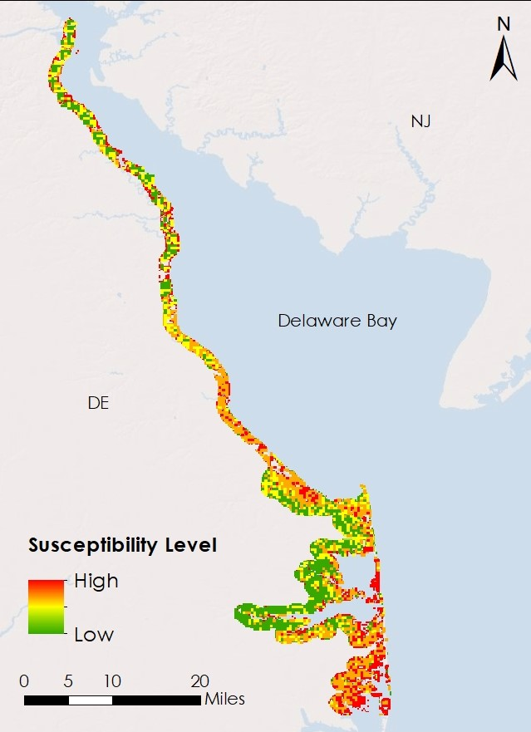

*Figure 3.* Coastal land loss susceptibility of Delaware’s coast.

***4.1 Time-series Maps & Analyses***

The time-series map of the entire study area and historical management projects is quantitatively uninformative due to a lack of project-specific information. However, the team detected trends in overall land loss, both qualitatively and quantitatively. *Figure 4* encompasses the coastal change for the entire study area as well as the changes for two areas of interest. As can be seen, Bombay Hook Wildlife Refuge experienced considerable land loss over the thirty-one-year period due primarily to chronic erosion. Little Creek Wildlife Area experienced coastal loss, but also exhibited land accretion within its inland portions. Kitts Hummock exhibited coastal and inland land loss. Prime Hook Wildlife Refuge exhibited the most dramatic changes. Up to 2012, the loss and accretion of this area appeared to be largely cyclical. The break in the natural barrier of this refuge by Hurricane Sandy in 2012 is evident within our time-series maps, as well as the extensive restoration efforts of state and federal entities. An important temporal landmark can also be found within these maps. In 1995, the construction of the Wolfe Neck Wastewater Treatment Facility occurred and is visible within these maps. The representation of its ponds serves as assurance of the validity of the CALCC tool.

Another notable implication of the land change map of *Figure 4* is that of the Bombay Hook Wildlife Refuge. Apart from the fact that the area has experienced considerable land loss, it is clear via our partner-provided beach management project dataset that this area has never received land loss intervention projects by state or federal entities. The loss of this area must be primarily due to chronic erosion, as the visual rate of loss evident in the GIFs is gradual. Chronic erosion is the geologic force of land loss that our partners are most interested in, and it is likely that they will find this information invaluable moving forward in their decision-making processes.

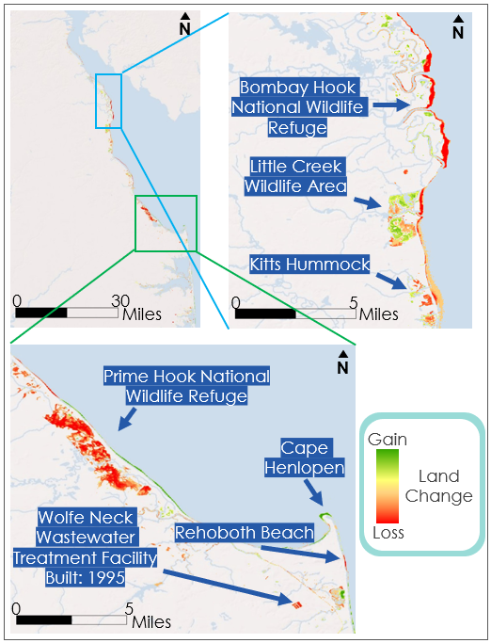

A

B

C

*Figure 4.* Maps of coastal land loss between 1988 and 2018 (see Equation 3). Map A showcases the change of the entire study area. Map B encompasses an area of interest, from Bombay Hook Wildlife Refuge south to Kitts Hummock. Map C encompasses a second area of interest that includes Prime Hook National Wildlife Refuge, Cape Henlopen, Rehoboth Beach, and the Wolfe Neck Wastewater Treatment Facility.

The changes in percent water through the years is plotted in *Figure 5*, and the rates of those changes are exhibited in *Figure 6*. Notable events are reflected within the respective years of these plots. For instance, Hurricane Sandy and the subsequent inundation of Prime Hook Wildlife Refuge is reflected in the considerable increase in water between 2012 and 2013. And the marsh restoration projects that began in 2015 can also be seen in these plots by the decrease in water, or increased rate of land accretion.

A quadratic regression had a better fit for both plots than linear regressions (quadratic fit for Figure 5: R2 = 0.7611; linear fit for Figure 5: R² = 0.7534; quadratic fit for Figure 6: R² = 0.0061; linear fit for Figure 6: R² = 0.0041). The negative quadratic and a significantly positive linear trends (p-value= 2.55699E-10) for *Figure 5* suggest a thirty-one-year trend of coastal land loss, rather than accretion. The regressions for *Figure 6* are largely uninformative.

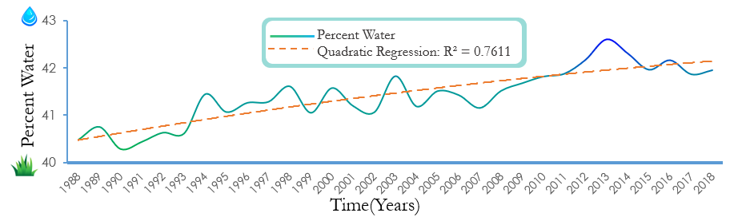

*Figure 5.* Coastal land change of Delaware’s coast from 1988 to 2018.

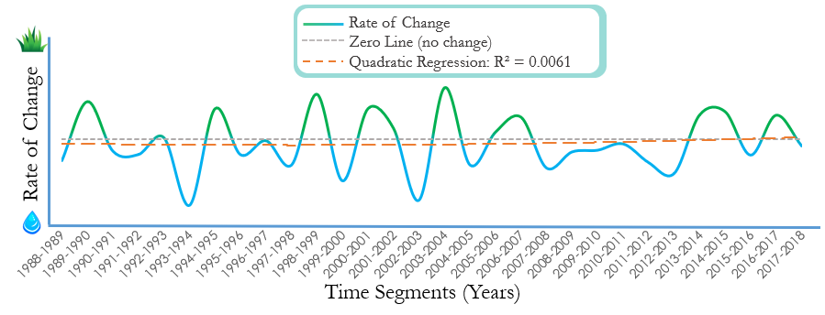

*Figure 6.* Rate of Delaware’s coastal land change from 1988 to 2018.

***4.2 Future Work***

# There are three key areas that should be addressed moving forward. Little research has been done regarding Delaware’s vulnerability to subsidence-caused land loss, and the inclusion of subsidence via relative sea level rise is what makes our susceptibility map novel. The additional use of the Sentinel-1 interferometric synthetic aperture radar (InSAR) instrument can provide our partners with an even more informative time-series map of the state’s vertical mobility, namely subsidence, as well as higher quality mapping overall, particularly for the factors of elevation and slope (ESA, 2019). The socioeconomic distinction between the two stretches of Delaware’s coastline are quantifiable, as residents near the Bay’s coastline are socially more vulnerable to environmental threats according to the CDC (2018), but NOAA’s social vulnerability index (2017) suggests that the entirety of Delaware’s coast has medium to high social vulnerability. It would be interesting and informative to incorporate all of the social vulnerability factors of these two federal entities with the susceptibility information that our team has developed to discern which communities are truly the most vulnerable. And finally, our results are not validated, which is a limitation that can be remedied through the use of our partner’s substantial reserves of *in situ* datasets.

# 5. Conclusions

As demonstrated within this project, the DNREC and organizations like it can utilize NASA’s EOs to explore historical, current, and potential spatial phenomena. The team has shown both qualitatively and quantifiably that Delaware’s coast has experienced land loss since 1988 but found no detected trend in the rate of land change. Prime Hook and Bombay Hook National Wildlife Refuges, Slaughter Beach, Rehoboth Beach, and Assawoman Bay are the most susceptible areas to land loss along Delaware’s coast. And the Prime Hook and Bombay Hook National Wildlife Refuges have experienced the greatest amount of land loss from 1988-2018. Three interesting occurrences detected by the Landsat satellites exhibited the break in the natural barrier of the Prime Hook Wildlife National Refuge by Hurricane Sandy, the subsequent marsh restoration, the chronic erosion of Bombay Hook National Wildlife Refuge, and the construction of a wastewater treatment facility. Although limitations existed within the coastal management projects information, supporting evidence showed that the area that has experienced the most extreme chronic erosion, Bombay Hook Wildlife Refuge, has never received federal or state intervention. This illuminating notion is just one example of an instance in which these products can help the DNREC in their decision-making processes moving forward.

# 6. Acknowledgments

The DEVELOP Fall 2019 Delaware Urban Development team would like to thank our partners at the Delaware DNREC, Jesse Hayden, Ashley Norton, Joe Faries, and Sierra Davis. Thank you, also, for the support from our science advisors, Dr. Jeffrey Luvall and Dr. Robert Griffin. And of course, we are grateful for all the guidance from our mentors and colleagues, Danielle Ruffe, Maggi Klug, Helen Baldwin, Christine Evans, and Madison Murphy.

Any opinions, findings, and conclusions or recommendations expressed in this material are those of the author(s) and do not necessarily reflect the views of the National Aeronautics and Space Administration.

This material is based upon work supported by NASA through contract NNL16AA05C.

# 7. Glossary

**API** – Application Programming Interface

**ASTER** – Advanced Spaceborne Thermal Emission and Reflection Radiometer

**CALCC** – Coastal Area Land Cover Change

**C-CAP** – Coastal Change Analysis Program

**DEM** – Digital Elevation Model

**DEOS** – Delaware Environmental Observing System

**DNREC** – Delaware Department of Natural Resources and Environmental Control

**EO** – Earth observations; satellites and sensors that collect information about the Earth’s physical, chemical, and biological systems over space and time

**ETM+ –** Enhanced Thematic Mapper Plus from Landsat 7

**GEE –** Google Earth Engine

**GIS** – Geographic Information System

**InSAR** – Interferometric Synthetic Aperture Radar

**LiDAR** – Light Detection and Ranging

**MNDWI –** Modified Normalized Difference Water Index

**NASA** – National Aeronautics and Space Administration

**NDWI** – Normalized Difference Water Index uses Near-Infrared (NIR) and Short Wave Infrared (SWIR). **NOAA** – National Oceanic and Atmospheric Administration

**OLI** – Operational Land Imager

**RSLR** – Relative Sea Level Rise

**Subsidence** – the gradual caving in or sinking of an area of land

**TM** – Thematic Mapper from Landsat 5

**USACE –** United State Army Corps of Engineers

**USDA** – United States Department of Agriculture

**USGS** – United States Geological Survey

# 8. References

Arcuri, J. L., Ortiz, A. C., & Edmonds, D. A. (2016). Remote Sensing Analysis of Land Loss Processes in the   
Mississippi River Deltaic Plain. Geological Society of America Abstracts with Programs, 48(7). doi:   
10.1130/abs/2016AM-286113

CB&I Coastal Planning & Engineering, Inc. (2015). State of Delaware Bay Beach Design Verification Report.

State of Delaware Bay Beach Design Verification Report (pp. 1–125).

CDC's Social Vulnerability Index (SVI). (n.d.). Retrieved November 19, 2019, from <https://svi.cdc.gov/map.html>

CERES Science Team. (2015). CERES Level 3 SYN1DEGDAYTerra+Aqua netCDF file, Edition 3A.

NASA Atmospheric Science Data Center, accessed 11 February 2016. doi://10.5067/Terra+Aqua/CERES/SYN1degDAY_L3.003A

Copernicus Sentinel-1 Supports Detection of Shoreline Positions. (2019, May). Retrieved from   
https://sentinel.esa.int/web/sentinel/news/-/article/copernicus-sentinel-1-supports-detection-of-shoreline-positions

Delaware Department of Natural Resources and Environmental Control. (n.d.). A Line in the Sand: Beach

Preservation. Retrieved from<https://perspectives.dnrec.delaware.gov/stories/s/A-Line-in-the-Sand-Beach-Preservation/3aqi-49z2/>

Delaware Department of Natural Resources and Environmental Control. (2015). Chapter 2: Delaware’s

Wildlife Habitats. 2015 Delaware Wildlife Action Plan. Retrieved from<http://www.dnrec.delaware.gov/fw/dwap/Pages/default.aspx>

Delaware Environmental Observing System. (2019). Retrieved from http://www.deos.udel.edu/

DNREC (n.d.). Coastal Hazards in Delaware. [PowerPoint slides]. Retrieved from:

<http://www.dnrec.delaware.gov/swc/Shoreline/Documents/Coastal%20Resiliency/coastal_hazards_overview.pdf>

DNREC Public Affairs (29 May 2012). Delaware Bayshore Initiative Launched to Spur Conservation,

Recreation, and Eco-Tourism in State’s Coastal Communities. [Press release]. Retrieved October 7, 2019, from [http://www.dnrec.delaware.gov/News/Pages/Delaware-Bayshore-Initiative-given-](http://www.dnrec.delaware.gov/News/Pages/Delaware-Bayshore-Initiative-given-national-launch-to-spur-conservation,-recreation-and-eco-tourism-within-state.aspx)

[national-launch-to-spur-conservation,-recreation-and-eco-tourism-within-state.aspx](http://www.dnrec.delaware.gov/News/Pages/Delaware-Bayshore-Initiative-given-national-launch-to-spur-conservation,-recreation-and-eco-tourism-within-state.aspx)

DNREC (n.d.). Sea Level Rise and Delaware’s Wetlands. Retrieved from

<http://www.dnrec.delaware.gov/Admin/DelawareWetlands/Pages/Sea-Level-Rise.aspx>

DNREC (n.d.). Topic: Wetlands. Retrieved from<https://dnrec.alpha.delaware.gov/wetlands/>

Dobson, J. (1995, April). NOAA Coastal Change Analysis Program: Guidance for Regional

         Implementation. Retrieved October 16, 2019, from

         https://coast.noaa.gov/digitalcoast/training/ccap-land-cover-classifications.html

Eisenhauer, D. (2019, September 23). Prime Hook National Wildlife Refuge marsh restoration effort recognized as a national model for climate adaptation leadership. Retrieved November 19, 2019, from <https://www.fws.gov/news/ShowNews.cfm>?ref=prime-hook-national-wildlife-refuge-

marsh-restoration-effort--recognized-&_ID=36464

Esri. (n.d.). Create Thiessen Polygons. Retrieved November 5, 2019, from

         https://pro.arcgis.com/en/pro-app/tool-reference/analysis/create-thiessen-polygons.htm

Esri. (n.d.). Weighted Sum. Retrieved October 17, 2019, from

         http://desktop.arcgis.com/en/arcmap/10.5/tools/spatial-analyst-toolbox

Gorelick, N., Hancher, M., Dixon, M., Ilyushchenko, S., Thau, D., & Moore, R. (2017). Google Earth Engine:   
Planetary-scale geospatial analysis for everyone. Remote Sensing of Environment.

Griffith, D. A., Coburn, S. A., Peek, K.M.,  & Young, R. (2014). Hurricane Sandy: Did Beach Nourishment

Save New Jersey? Learning from the Impacts of Superstorm Sandy (pp. 57-67). Academic Press.

Guo, M., Li, J., Sheng, C., Xu, J., & Wu, L. (2017, April 5). A Review of Wetland Remote Sensing. Retrieved   
from https://www.ncbi.nlm.nih.gov/pmc/articles/PMC5422050/

Houseknecht, D. W., & Mars, J. C. (2007, July 1). Quantitative remote sensing study indicates doubling of

coastal erosion rate in past 50 yr along a segment of the Arctic coast of Alaska. Retrieved from https://pubs.geoscienceworld.org/gsa/geology/article-abstract/35/7/583/129876

Interferometry. (n.d.). Retrieved from   
https://sentinel.esa.int/web/sentinel/user-guides/sentinel-1-sar/product-overview/interferometry

Jiang, H., Feng, M., Zhu, Y., Lu, N., Huang, J., & Xiao, T. (2014). An automated method for extracting rivers   
and lakes from Landsat imagery. Journal of Remote Sensing, 6, 5067-5089; doi: 10.3390/es6065067

Kerris, C. A., & Iivari, T. A. (2006, April 2). Soil Erosion on Cropland in the United States:

         Status and Trends for 1982-2003. Retrieved October 30, 2019, from

https://pdfs.semanticscholar.org/9b26/6deec84089b01e201057b7f6fbf73feedcff.pdf

Kika de La Garza Plant Materials Center. (n.d.). Vegetative Barriers for Erosion Control.

         Retrieved October 30, 2019, from https://www.nrcs.usda.gov

[Klemas](https://bioone.org/search?author=Victor_Klemas), V. "Remote Sensing of Riparian and Wetland Buffers: An Overview," Journal of Coastal Research

30(5), 869-880, (1 September 2014).<https://doi.org/10.2112/JCOASTRES-D-14-00013.1>

Landsat Level 3 Dynamic Surface Water Extent (DSWE) Science Products courtesy of the U.S. Geological

Survey.

Lenth, R. (2001). Some practical guidelines for effective sample size determination. The American Statistician,

55(3), 187-193. Retrieved from http://www.jstor.org/stable/2685797

Leonardi, N., Ganju, N. K., & Fagherazzi, S. (2016). A linear relationship between wave power and erosion

determines salt-marsh resilience to violent storms and hurricanes. Proceedings of the National Academy of Sciences, 113(1), 64–68.<https://doi.org/10.1073/pnas.1510095112>

Mockus, V., & Hoeft, C. C. (2007, May). Hydrologic Soil Groups. Retrieved October 8, 2019,

         from https://directives.sc.egov.usda.gov/OpenNonWebContent.aspx?content=17757.wba

NASA/METI/AIST/Japan Spacesystems, and U.S./Japan ASTER Science Team (2019). ASTER Global Digital Elevation Model V003 [Data set]. NASA EOSDIS Land Processes DAAC. Accessed 2019-11-19 from <https://doi.org/10.5067/ASTER/ASTGTM.003>

National Association of Counties Research Foundation. (1970, May). Urban Soil Erosion

         and Sediment Control. Retrieved October 30, 2019, from <https://nepis.epa.gov>

NOAA Sea Level Rise Viewer. (2019, July). Retrieved from   
<https://coast.noaa.gov/slr/#/layer/vul-soc/0/-8412188.727325013/4737691.101190568/9/satellite/none/0.8/2050/interHigh/midAccretion>

Sea Level Trends. (2018). Retrieved from <https://tidesandcurrents.noaa.gov/sltrends/sltrends.html>

Shoreline and Waterway Management Section. (n.d.). Retrieved September 27, 2019, from   
http://www.dnrec.delaware.gov/swc/Shoreline/Pages/Shoreline.aspx

Titus, J. G. (1998). Rising Seas, Coastal Erosion, and the Takings Clause: How to Save

Wetlands and Beaches Without Hurting Property Owners. Retrieved October 31,

2019, from http://digitalcommons.law.umaryland.edu

The Delaware Geological Survey. (n.d.). Retrieved from

https://www.dgs.udel.edu/delaware-geology/summary-geologic-history-delaware

USA Soils Hydrologic Group. (2019, June). Retrieved from https://landscape11.arcgis.com/arcgis/rest/services/USA_Soils_Hydrologic_Group/ImageServe

U.S. Census Bureau (n.d.). Small Area Income and Poverty Estimates (SAIPE). Retrieved October 7, 2019,

from [https://www.census.gov/data-tools/demo/saipe/#/expandedMap?map_geoSelector=](https://www.census.gov/data-tools/demo/saipe/#/expandedMap?map_geoSelector=mhi_c&s_measures=mhi_snc&s_year=2017&s_state=10)

[mhi_c&s_measures=mhi_snc&s_year=2017&s_state=10](https://www.census.gov/data-tools/demo/saipe/#/expandedMap?map_geoSelector=mhi_c&s_measures=mhi_snc&s_year=2017&s_state=10)

U.S. Department of Commerce, N. N. C. for E. I. (n.d.) NOAA Marine Environmental Buoy Database.

Retrieved September 30, 2019, from https://www.nodc.noaa.gov/BUOY/

U.S. Geological Survey Earth Resources Observations and Science Center. (2018). Landsat ETM+ Level-1 Surface Reflectance (SR). Science Product. U.S. Geological Survey. https://doi.org/[10.5066/F7WH2P8G](https://doi.org/10.5066/F7WH2P8G)

U.S. Geological Survey Earth Resources Observation and Science Center. (2012). Landsat TM Level-2 Surface Reflectance (SR) Science Product. U.S. Geological Survey.  <https://doi.org/10.5066/f7kd1vz9>

U.S. Geological Survey Earth Resources Observations and Science Center. (2018). Landsat OLI  Level-1 Surface Reflectance (SR). Science Product. U.S. Geological Survey. https://doi.org/10.5066/F71835S6

Zhang, K., Douglas, B., & Leatherman, S. (2002). Do Storms Cause Long‐Term Beach Erosion along the U.S. East Barrier Coast? The Journal of Geology, 110(4), 493–502.<https://doi.org/10.1086/340633>

# 9. Appendices

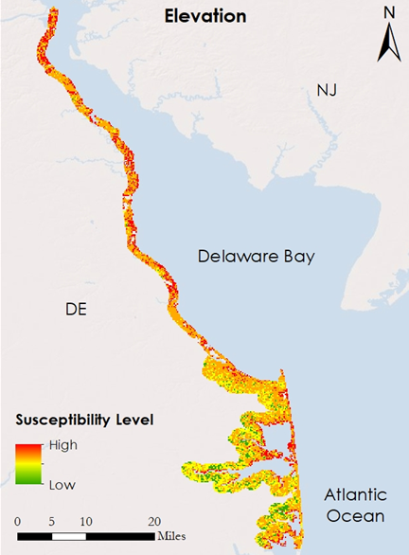

*Figure A1.* Land loss susceptibility of Delaware’s coast based on elevation. Low susceptibility is shown in green, while high susceptibility is shown in red.

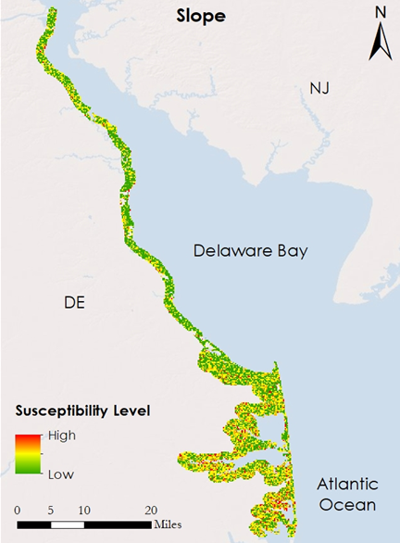

*Figure A2.* Land loss susceptibility of Delaware’s coast based on slope. Low susceptibility is shown in green, while high susceptibility is shown in red.

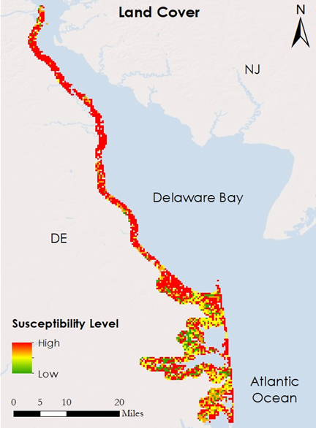

*Figure A3.* Land loss susceptibility of Delaware’s coast based on land cover. Low susceptibility is shown in green, while high susceptibility is shown in red.

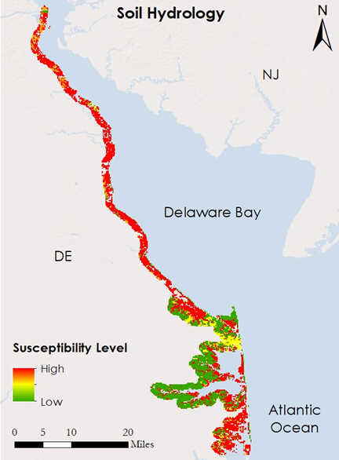

*Figure A4.* Land loss susceptibility of Delaware’s coast based on soil hydrology. Low susceptibility is shown in green, while high susceptibility is shown in red.

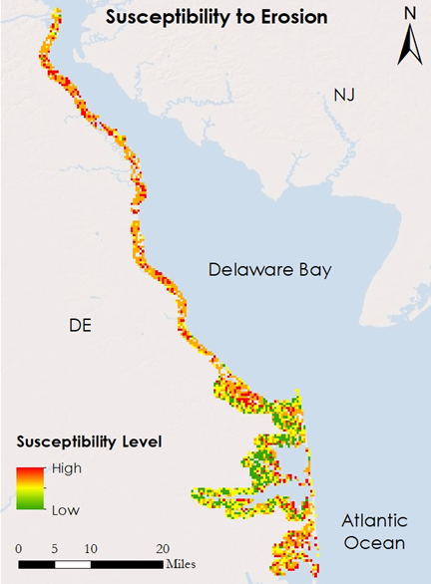

*Figure A5.* Land loss susceptibility of Delaware’s coast based on slope, land cover, and soil hydrology. Low susceptibility is shown in green, while high susceptibility is shown in red.

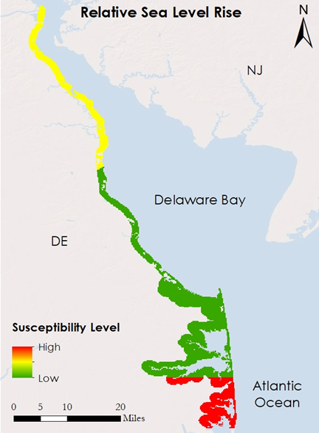

*Figure A6.* Land loss susceptibility of Delaware’s coast based on relative sea level rise. Low susceptibility is shown in green, while high susceptibility is shown in red.

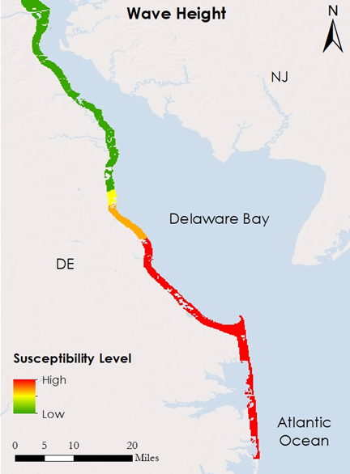

*Figure A7.* Land loss susceptibility of Delaware’s coast based on wave height. Low susceptibility is shown in green, while high susceptibility is shown in red.

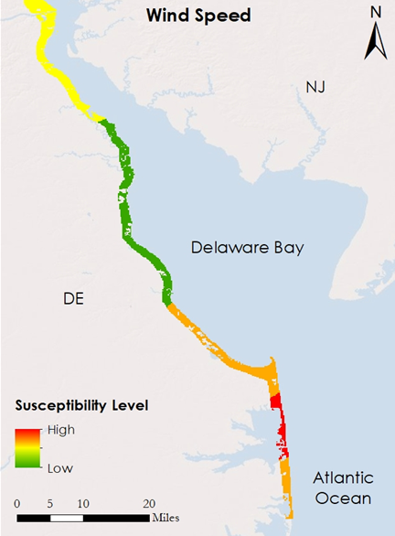

*Figure A8.* Land loss susceptibility of Delaware’s coast based on wind speed. Low susceptibility is shown in green, while high susceptibility is shown in red.