Guatemala and Panama Urban Development

Evaluating the Effects of Urban Expansion on Social and Environmental Vulnerability in Guatemala and Panama

 **Technical Report**

Final – November 17th, 2022

Jennifer Ruiz (Project Lead)

Viviana Lademan

Aaron Whittemore

Coral del Mar Valle Rodríguez

***Advisors:***

Betsy Hernández (NASA SERVIR)

Dr. Emil Cherrington (NASA SERVIR)

Lauren Carey (NASA SERVIR)

Ricardo Quiroga (NASA Applied Science Disasters Program)

Eric Anderson (NASA SERVIR)

Ronan Lucey (NASA Earth Applied Science Disasters Program)

Dr. Robert Griffin (University of Alabama Huntsville)

Dr. Jeffrey Luvall (NASA Marshall Space Flight Center)

***Fellow:***  
Brianne Kendall (Marshall Space Flight Center)

# 1. Abstract

Central America is experiencing rapid and unregulated urban expansion, which is contributing to an increase in socioeconomic and environmental risks including inequities in infrastructure and housing accessibility, biodiversity loss, vulnerability to natural disasters, and negative health outcomes. NASA DEVELOP, in partnership with NASA SERVIR, Sistema de la Integración Centroamericana (SICA), Secretariat of Central American Social Integration (SISCA), Deutsche Gesellschaft für Internationale Zusammenarbeit (GIZ), and Centro de Coordinación para la Prevención de los Desastres en América Central y República Dominicana (CEPRENEDAC), examined changes in urban extent, characterized roofing material type, and analyzed vulnerability within urban areas in two Central American cities, Guatemala City and Panama City. The team used land cover imagery from Landsat 5 Thematic Mapper (TM), Landsat 7 Enhanced Thematic Mapper Plus (ETM+), Landsat 8 Operational Land Imager (OLI), and Landsat 9 OLI-2 to map urban extent, and surface reflectance data from Maxar Worldview to identify roofing material types. Socioeconomic and environmental data were used to assess vulnerability. Results depict how the two cities have expanded from 2000 to present day and highlight areas of greatest vulnerability within each urban area. The supervised classification of roofing materials performed well but could be improved with a few enhancements. Findings can help partner organizations improve monitoring of urbanization and inform their planning and decision-making while prioritizing disaster prevention, public health, and environmental integrity. Additionally, these case studies can be used to inform future, similar work elsewhere in Central America to aid in understanding urbanization and its associated challenges.

**Key Terms**

Urban development, NDVI, Landsat, Roofing material, Central America, Google Earth Engine

# 2. Introduction

***2.1 Background Information***

Urban expansion in Central America is increasing at unprecedented rates (Price, 2014). Currently, 59% of Central Americans live in cities, and this number is expected to increase to 70% by the year 2050 (Maria et al., 2017). This growth poses many socioeconomic challenges but also creates opportunities for sustainability and inclusivity in Central American cities (Toledo-Silva, 2007). Rapid urban expansion is resulting in inequities in urban infrastructure, accumulated deficit in construction, the inefficient expansion of public services such as transportation and electricity, and financial crises (Sánchez Rodríguez, 2007). Currently, Central American infrastructure is also highly vulnerable to natural disasters such as landslides, flooding, and earthquakes (World Bank, 2016). This issue is exacerbated by rapid urbanization when greater demand for urban environments leads to informal and unregulated urban development. To combat this, environmental groups have focused on identifying, assessing, and forecasting the rates of urbanization and its implications (CEPREDENAC, 2007). This includes efforts by the Centro de Coordinación para la Prevención de los Desastres en América Central y República Dominicana (CEPREDENAC) and their division, Política Centroamericana de Gestión Integral de Riesgo de Desastres (PCGIR), whose focus is to reduce the risk of natural disasters, promote sustainable production in the public and private sector, and manage territories, disasters, and rehabilitation (CEPREDENAC, 2007).

Similar to CEPRENEDAC’s work, the NASA DEVELOP team analyzed and characterized urban expansion in two Central American cities: Guatemala City, Guatemala and Panama City, Panama (Figure 1). These cities are rapidly developing and feature a diverse set of characteristics that make them of interest to project partners. Additionally, the cities were ideal study areas due to both a lack of current urban development research in these areas and the fact that project partners are actively leading urban resiliency efforts in each city.

Satellite imagery is widely used for the identification of urban areas at large scales (Bai et al., 2008). For this study, the team utilized various earth observations to map the rate of urban expansion (Phan et al., 2020), analyze roofing materials, and evaluate the intersection of urbanization and vulnerability within the two study areas. The team created urban extent maps for the time period 2002 – 2022 and conducted social and environmental risk assessments for the time period 2018 – 2022. The data and methodology of the study will inform policy in rapidly developing Central American cities and serve as a framework for future urbanization assessments.

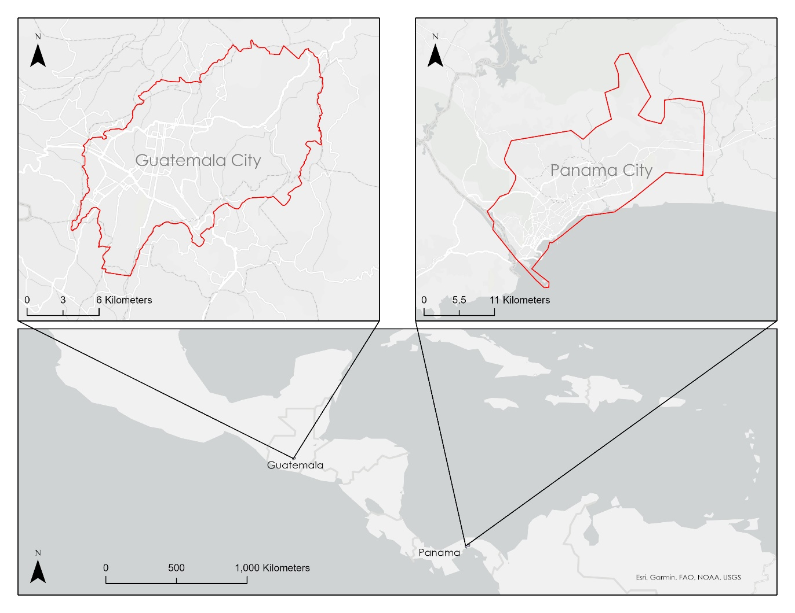

***Figure 1.*** *Map depicting study area, composed of Guatemala City, Guatemala and Panama City, Panama.*

***2.2 Project Partners & Objectives***

The team partnered with NASA SERVIR, Sistema de la Integración Centroamericana (SICA), Secretariat of Central American Social Integration (SISCA), Deutsche Gesellschaft für Internationale Zusammenarbeit (GIZ), and CEPRENEDAC. These five organizations collaborate in Central America to create urban environments that are resilient to the changing hazards posed by climate change and equitably support urban expansion. This is done by developing tools to monitor changes in space, hosting informative forums and high-level meetings, and consulting with regional and international organizations. Specifically, SISCA aims to increase resilience in communities by focusing on poverty, employment, and urban development by improving the resilience of vulnerable neighborhoods.

Overall, the project had four main objectives. The first was to analyze and map the rate of urban expansion in Guatemala City and Panama City. The second was to develop a methodology to analyze infrastructure vulnerability by identifying roofing materials. The third was to evaluate the connection between urbanization and social, economic, and ecological vulnerabilities using Earth observations and remote sensing data sets. Finally, the last objective was to assess trends in urbanization and community vulnerabilities in the two Central American cities with the goal of improving local policy makers’ decision-making.

The results of this project will enable better monitoring of urban expansion and inform city planning and decision-making by prioritizing disaster prevention, public health, and environmental integrity. The end-user organizations make decisions that affect disaster risk management and urbanization. Findings and methodologies will provide supplemental information on how urban regions are changing and which urban regions are most vulnerable to disasters. This will allow partners to better focus their efforts in allocating disaster response resources to areas identified as highly vulnerable.

# 3. Methodology

***3.1 Data Acquisition***

Table 1 outlines the various Earth observations and datasets used to conduct the study. To assess urban expansion in Guatemala City and Panama City, the team processed data from Landsat 5 Thematic Mapper (TM), Landsat 7 Enhanced Thematic Mapper Plus (ETM+), Landsat 8 Operational Land Imager (OLI), and Landsat 9 OLI-2 in LandTrendr using Google Earth Engine (GEE). The resulting analyses allowed the team to identify how the urban landscape has changed over the last two decades. In addition to Landsat imagery, Open Street Mapper (OSM) Road Network Data and WorldPop Population Density Grids (100m) were used to further characterize urbanization.

The acquisition process for these datasets was fairly streamlined. First, the team used data from Maxar Worldview-2 and Worldview-3 to identify roofing materials. Imagery from Maxar was acquired by an order request on Maxar Archive Search and Discovery. The team obtained Shuttle Radar Topography Mission (SRTM) 1 Arc-Second Global data (which is the highest resolution product for Central America) from the United States Geological Survey (USGS) Earth Explorer application. Lastly, the team acquired various socioeconomic datasets, such as Visible Infrared Imager Radiometer Suite (VIIRS) Lights-at-Night Grids from Earth Observation Group (EOG), various population density datasets from the Humanitarian Data Exchange (HDX), and landslide disaster risk data from the project partners at SICA. The specific population density datasets used in the vulnerability analysis were total population density, elderly population density, and children under five population density.

Table 1

*Earth observations and datasets used to complete project objectives.*

|  |  |  |  |
| --- | --- | --- | --- |
| **Sensor/Dataset** | **Dates** | **Acquisition Method** | **Product ID** |
| Landsat 5 TM | 01/1999-05/2013 | GEE | LANDSAT/LT05/C02/T1_TOA |
| Landsat 7 ETM+ | 01/1999-11/2022 | GEE | LANDSAT/LE07/C02/T1_TOA |
| Landsat 8 OLI | 01/2013-11/2022 | GEE | LANDSAT/LC08/C02/T1_TOA |
| Landsat 9 OLI-2 | 01/2021-11/2022 | GEE | LANDSAT/LC09/C02/T1_TOA |
| WorldView-2 | 01/2021 - 02/2022 | Maxar | N/A |
| WorldView-3 | 03/2018 - 02/2022 | Maxar | N/A |
| SRTM | 02/2000 | USGS Earth Explorer | 1 Arc-Second Global |
| HDX Population Density | 10/2018 - 10/2020 | HDX | N/A |
| VIIRS Lights-at-Night Grids | 01/2022 - 10/2022 | EOG | V2.1 |

***3.2 Data Processing***

The team used GEE to analyze urban extent through the creation of four different visualizations. The team used LandTrendr to process Landsat imagery for Guatemala City, Guatemala and Panama City, Panama. The team imported the code “LT-GEE-Vis-DownLoad-App_WB_v1.0” from openmrv.org to create a time series and 3-band image (Red Green Blue). We changed several parameters to achieve desired results for the time series and RGB map. We included the years 1999 to 2020 and assigned the red year to 2000, green year to 2010, and blue year to 2020. We also set the extent to our study area before running the too. The code “LandTrendr Greatest Disturbance Mapping” was imported from eMapR Lab to create a greatest disturbance map. The code was slightly altered in order to export data only within the area of interest. The team used the EE-TS-GIF and Snazzy-EE-TS-GIF apps to create a Graphic Interchange Format (GIF) file.

The team used Maxar Worldview-2 and Worldview-3 to assess roofing material types in each city. For each city, the team requested four images to provide coverage across the entire study area. The team chose these images based on their low cloud cover values (<9%), low nadir values (<15°), and for being as close to present day (Oct 2022) as possible. Due to delays in receiving the imagery, roofing material classification was only performed for one image, which covered the northwestern corner of Guatemala City and extended outside the study area. Other images either did not arrive in time or were less desirable for analysis due to either a lack of urban areas within the image or lack of full multispectral band coverage. The chosen image contained all eight bands that are within Worldview imagery and covered an area that featured both formal and informal settlements. The image was then imported into GEE for the roofing material classification. First, the team performed a visual inspection of the imagery to create classification categories. It became apparent there were three main types of roofing materials within the image, which were split into three categories based on visual differences: tile roofs, metal roofs, and slate roofs. The team also created four other categories (roads, dirt roads, vegetation, and barren land) for purposes of differentiating roof materials from other features in the imagery. For each of the seven classification categories, the team created 100 training points using GEE’s point geometry by placing markers on 100 pixels that represented that category. Similarly, the team created 100 validation points to be used for post-classification validation. The team tried out several different classification schemes including a CART classification and random forest classifications with various numbers of decision nodes. Each classification output was checked for accuracy using a confusion matrix accuracy test and the best performing result (a random forest classifier with 200 decision nodes that sampled all eight bands of the image) was chosen for the final classification.

The vulnerability analysis included five variables for Panama and six variables for Guatemala. The team used SRTM Digital Evaluation Model (DEM) data to calculate the slope of the terrain in each city. First, the DEMs were opened in ArcGIS Pro. Panama City needed two unique DEM tiles to cover the entire study area. These two tiles were merged together to produce a single tile. The resulting two tiles were clipped to their respective study areas. For each city, the team used the clipped DEM raster as input into the Slope tool within ArcGIS Pro to calculate the slope for each cell in the raster. The team imported VIIRS Lights-at-Night Grids, total population density, elderly population density, and children under 5 population density into ArcGIS pro and clipped each dataset to their respective study areas. The landslide disaster risk data for Guatemala City was also imported in ArcGIS Pro and converted into raster data to use it alongside the other variables. At this point, all six variables were ready to undergo further analyses of vulnerability.

***3.3 Data Analysis***

The team used GEE’s Landtrendr algorithm to map changes in urban extent from 2000 to 2022. The multispectral imagery from Landsat provided a visual assessment of land cover in Guatemala City and Panama City. Specifically, it portrayed when and where urban expansion and ecological disturbances had occurred.

The team used the visually inferred validation data to assess the accuracy of the roofing material classification via a confusion matrix accuracy test, which provided an overall accuracy percentage (Equation 1) and showed the number of times a category was correctly or incorrectly classified. For example, metal roofs were classified correctly 97 times out of 100 and incorrectly as slate roofs three times out of 100. The team also obtained the percentage of roofs classified as each roof category. In ArcGIS Pro, the team performed a count of all pixels for each roof type and divided that number by the total number of roof pixels (e.g., Equation 2, where $n_{1}$, $n_{2}$, and $n_{3}$ are the number of tile roof pixels, metal roof pixels, and slate roof pixels, respectively). Finally, the team performed a visual inspection of results in ArcGIS Pro to compare classification output to the Worldview image to better understand classification performance and issues.

$Overall Accuracy =\frac{correctly classified values}{total numer of values} × 100$ (1)

$Roof Category Percentage = \frac{n_{i}}{n_{1} + n_{2} + n_{3}}×100$ (2)

To assess vulnerability across the two cities, the team performed a weighted cumulative analysis of risk by assigning rankings to several variables and spatially combining the results to yield an overall ranking. The team used steepness of slope, presence of electricity, total population density, elderly population density, and children under five population density as variables for Panama City. The same five variables were used for Guatemala City, in addition to the landslide disaster risk variable. Before the datasets were analyzed, a 1km-by-1km fishnet grid was created in ArcGIS Pro using the Create a Fishnet tool for each city. For all six variables, the fishnet grid was overlayed onto the study area, and the Zonal Statistics tool was used to median reduce the slope data, mean reduce the electricity and all three population datasets, and lastly, to find the majority value for the landslide risk data. At this point, all six variables were reclassified using the Reclassify tool to assign the ranks one to four, with four representing greater vulnerability and one representing lesser vulnerability within each cell. Once all vulnerability variables had been individually ranked, the values from each of the five layers for Panama City and six layers for Guatemala City were summed using the Raster Calculator tool. This allowed for a spatial understanding of vulnerability across the two study areas.

# 4. Results & Discussion

***4.1.1 Urban Extent Mapping***

The urban extent mapping portion of the project allowed for the detection of urbanization trends in Guatemala City and Panama City. In order to observe these trends, changes in urbanization based on years of disturbance, RGB change imagery, time series imagery, and a GIF using LANDSAT imagery were created. For Guatemala City (Figure 2), the year of disturbance map demonstrated a noticeable vegetation disturbance during the 2000-2004 period (shown in blue). In subsequent periods, the disturbance is scattered and noticeably less than the initial disturbance. For Panama City (Appendix Figure B1), there is a large initial disturbance from the 2000-2004 period shown in blue. In subsequent years the disturbance primarily occurred along or close to the initial disturbance area, however, its behavior was more scattered. In the period from 2010 - 2014, there was another large increase in disturbance, similar in extent to the first period. In the second and fourth period, 2005-2009 and 2015-2020, respectively, the behavior was scattered but smaller in size compared to the first and third disturbance.

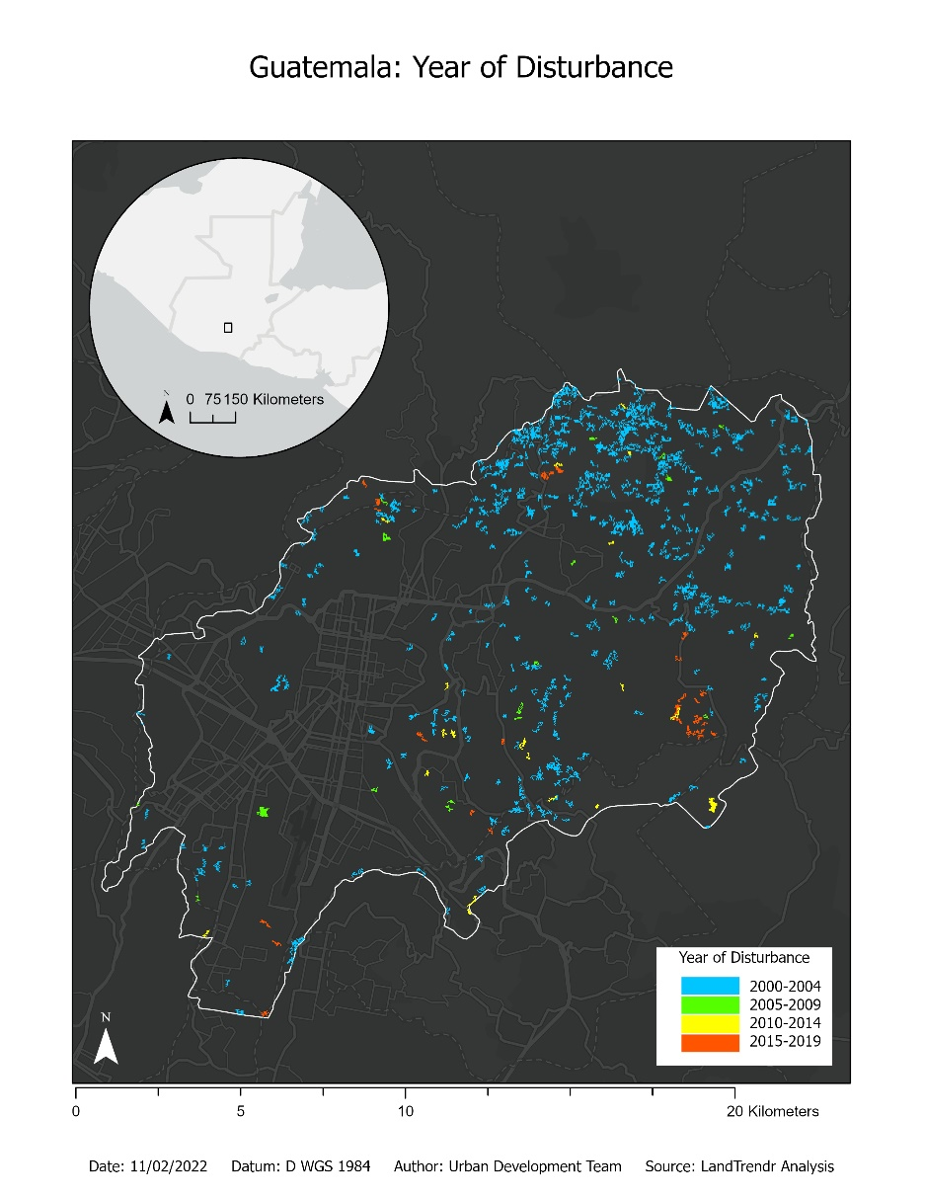

***Figure 2.*** *Map of urbanization changes in Guatemala City.*

For Guatemala (Appendix Figure C2), the RGB change map shows a dense urban area towards the southwest of the city, whilst the east and northeast were mostly rural. Additionally, vegetation disturbances took place during most of the time period between 2000-2020. Finally, Guatemala’s vegetation decreased in urban areas while primarily vegetated areas largely remained the same. In Panama City (Appendix Figure C1), the mostly urban areas are primarily in the northwest, and there is an urban to rural gradient towards the east of the city. These figures demonstrate that Guatemala’s urban extent is higher than Panama City, and resultingly, there is a larger decrease in vegetation in Guatemala than Panama.

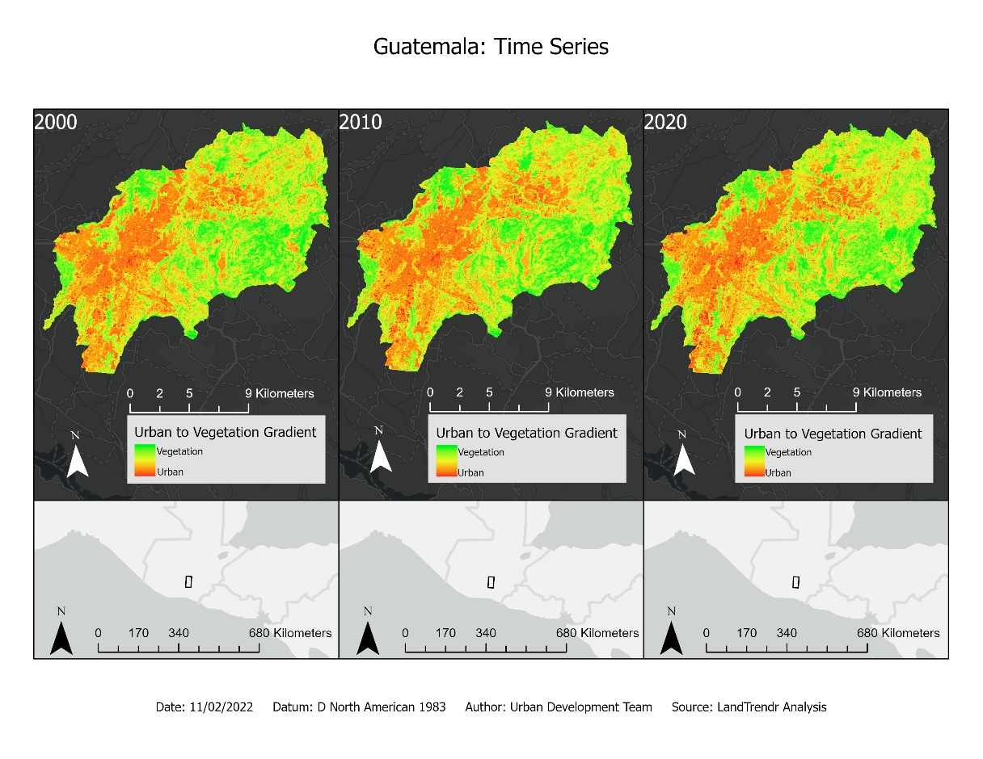

***Figure 3.*** *Time series map for Guatemala City.*

Based on the Time Series Imagery for Guatemala (Figure 3) and Panama (Appendix Figure D1), there was an increase in already urban areas. The urban areas became denser as time progressed, and there was a simultaneous decrease in vegetation. For Guatemala specifically (Figure 3), the increase in urbanization was towards the southeast and north areas of the city. In Panama City (Appendix Figure D1), there was no creation of new urban areas and the urbanization growth was mostly towards the north of the city.

The urban extent maps and the LANDSAT GIF (Appendix Figure A1), show that for Guatemala City there was evidence of an outward expansion of the urban areas. In addition, the already urbanized areas became denser with time. In Panama City, there was an outward expansion of urban area but not at the same rate as Guatemala City. Finally, both cities were found to expand in a northward direction.

***4.1.2 Roof Classification***

The roofing material classification performed well, with an overall classification accuracy of over 94%. Appendix Figure E1 shows roof type classification output overlaid on basemap satellite imagery. Pixels classified as any other category (roads, dirt roads, vegetation, barren land) were removed from the image. Output viewed at this extent shows that the classification successfully limited roof types primarily to the urban environment, but closer inspection of the classification reveals a few limitations of the approach.

The confusion matrix table (Table 2) shows how classification results ranged across different categories. Row values correspond to the actual value of a validation pixel and column values correspond to how that category was classified. Green cells show the number of times (out of 100) that classification for that category was successful. Other cells show when a category was misclassified. For example, tile roof pixels were correctly classified 99 times and incorrectly classified as dirt roads once. Metal roofs were correctly classified 97 times and incorrectly classified as slate roofs three times, and so on. The confusion matrix shows that classification for the roof types across the validation pixels performed well with accuracies of 99, 97, and 97 percent for tile, metal, and slate roofs, respectively. Classification did not perform as well for the dirt roads and roads categories with accuracies of 93 and 95 percent, respectively. Barren land had the lowest classification accuracy of only 80%, though 15 of the incorrect classifications were dirt roads, which are visually (and spectrally) quite similar. The decision to create two categories for these types of land cover was due to dirt roads typically presenting as a lighter color than barren land. Four barren land validation pixels and three dirt road validation pixels were classified as tile roofs, meaning the classification algorithm sometimes struggled to differentiate these land cover types from tile roofs. Metal roofs were incorrectly classified as slate roofs three times across the validation pixels. However, when inspecting the classification (Figure 4) it became apparent that the classification struggled to differentiate slate and metal roofs likely due to the aspect ratio as it commonly split pixels from the same roof between the categories. This suggests that the chosen validation pixels may not have been representative of the entire image and underscores the need for ground truth data to improve performance in future iterations. Finally, the vegetation category had a 100% accuracy across validation pixels, the highest of any category. This suggests that land cover classification, especially in differentiating vegetation from other land cover types, could be highly accurate with Worldview imagery or other high-resolution imagery.

***Table 2.***

*Confusion matrix for the roof classification.*

|  |  |  |  |  |  |  |  |
| --- | --- | --- | --- | --- | --- | --- | --- |
|  | Tile Roofs | Metal Roofs | Slate Roofs | Vegetation | Barren Land | Dirt Roads | Roads |
| Tile Roofs | 99 | 0 | 0 | 0 | 0 | 1 | 0 |
| Metal Roofs | 0 | 97 | 3 | 0 | 0 | 0 | 0 |
| Slate Roofs | 0 | 0 | 97 | 0 | 0 | 1 | 2 |
| Vegetation | 0 | 0 | 0 | 100 | 0 | 0 | 0 |
| Barren Land | 4 | 0 | 0 | 0 | 80 | 15 | 1 |
| Dirt Roads | 3 | 0 | 0 | 0 | 3 | 93 | 1 |
| Roads | 0 | 0 | 0 | 0 | 4 | 1 | 95 |

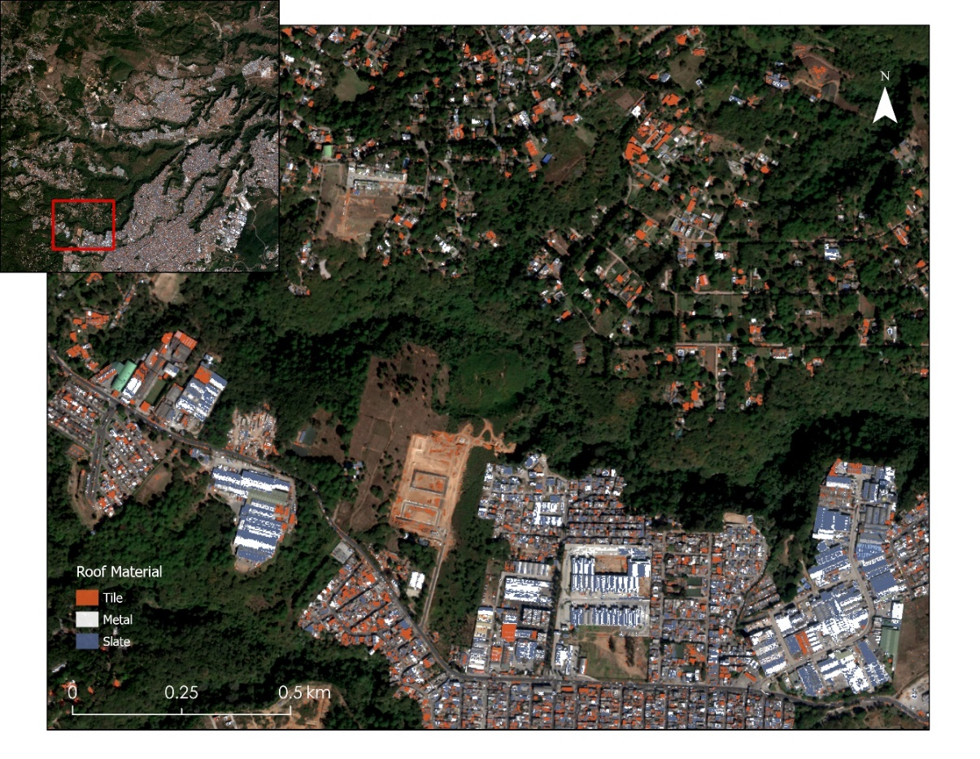

***Figure 4.*** *Zoomed in roof material classification over Basemap Satellite imagery of Guatemala City. Basemap: Esri, Maxar*

While the roof classification generally performed well, there are some caveats and improvements that could be made. To eliminate issues with other types of land cover being classified as roof types, the classification could be limited to the urban environment or to building footprints by clipping the imagery to another data set. This was not possible in this analysis because the image used for roof classification was partially outside of the study area and thus outside the area in which the team classified urban areas. The team also did not have time to find and work with a building footprints data set. There are also methods that can be used to extract building footprints solely from satellite imagery (Trevisiol et al., 2022), but that was beyond the scope of this project. The classification and the validation of roofing materials could also both be improved through use of ground truth data. As roofing material types were inferred from a visual inspection of the imagery, their categorization may not be accurate and there could be more categories that were not easily discerned from visual differences. Further, as the validation pixels were chosen in the same manner as the training pixels, there is likely some inherent bias toward better results.

***4.1.3 Vulnerability Analysis***

The team found that, from a socioeconomic and environmental perspective, the greatest vulnerability was found in the northern part of Guatemala City (Figure 5) and the northwestern part of Panama City (Appendix Figure F1). The usefulness of these results lies largely in the overall methodology developed by the team that will allow partners to adjust aspects of the analysis and apply them to other rapidly developing Central American cities. Being able to identify areas of high social and environmental vulnerability could also help partners pinpoint areas filled with informal settlements.

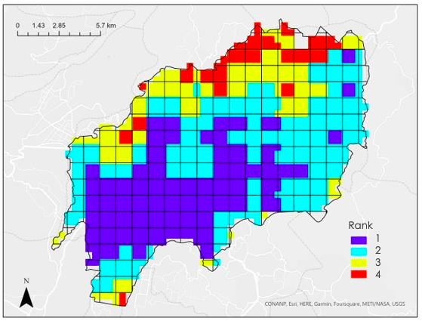

***Figure 5.*** *Vulnerability assessment for Guatemala City.*

Two things that could improve the vulnerability assessment would be to use quantitative thresholds instead of the arbitrary thresholds for the ranks, and to uniquely assign weight to the variables to better reflect their significance in the overall analysis. These are two tasks that could be relatively easy for our partners to accomplish as they are more familiar with the communities and would be able to assign the thresholds and weights with greater certainty. Additionally, these edits can be made easily in ArcGIS Pro. The team did intend to include the roof materials classifications into the vulnerability assessment, but due to time constraints were unable to do so. Similarly, the team intended to include disaster risk data unique to Panama City, such as flooding, but were unable to find a suitable dataset within the DEVELOP term.

***4.2 Future Work***

This project could be further expanded across other Central American cities that are of interest to the partners. SICA, SISCA, and CEPRENEDAC, have expressed specific interest in conducting urbanization analyses in major cities in Honduras and El Salvador. Additionally, it would be useful to partners if DEVELOP could more precisely identify the spatial relationship between impoverished communities and areas vulnerable to natural disasters. This kind of analysis could utilize more socioeconomic data acquired from the community such as the level of highest education in the household or household income. Other potential analyses include expanding the study periods or conducting seasonal analyses of disaster vulnerability. Partners were also interested in types of analysis that were beyond the scope of this project, such as the identification of formal and informal settlements by using satellite imagery to analyze street width. While methods for differentiating such settlements were not used in our project, there is literature (e.g., Graesser et al., 2012) on how this may be accomplished using similar types of imagery and tools that the team used in the analysis. Lastly, the urban expansion maps and analyses could be improved using higher spatial resolution imagery.

# 

# 5. Conclusions

The LandTrendr analysis allowed for the visualization and interpretation of urbanization in Guatemala City and Panama City. The results can be used by our partners to understand the rates of urban expansion and historical changes. This can be used to understand the general trend to inform future urbanization projections. However, these analyses could be improved in the future with higher quality images. Similarly, the roofing material classification performed well, with a visually estimated overall classification accuracy of 94%, but improvements could be made by using ground truth data for classification and validation in future efforts, and by limiting the classification to an urban extent or building footprints layer. Still, this step of the project showed that a classification of roofing materials is possible using Worldview imagery and our methods could be applied elsewhere to extract information about roofing materials in other areas. In combination with the vulnerability assessment, the urban expansion analysis and the roof classification can provide substantial insight into spatially identifying informal settlement and vulnerable communities. The vulnerability assessment for Guatemala City and Panama City showed that the greatest socioeconomic and environmental vulnerability was in the northern and northwestern parts of the study areas, respectively. There are improvements that could be made by partners using their expertise on the communities, but overall, the analysis proved to be very informative. For example, in Guatemala City the region where there is the highest vulnerability is called Zona 6, a low-income community that is experiencing great pressure from unplanned urban sprawl. The team’s assessment accurately identifying a vulnerable community is a significant achievement, and with refinement by the project partners could be an extremely useful tool.

# 

# 6. Acknowledgments

The team would like to express our gratitude to everyone for their contributions to making this project possible. First, the team would like to give thanks to the MSFC node fellow, Brianne Kendall, for all her kindness, wisdom, and patience throughout the term. The team also expresses their gratitude to the project’s advisors and partners for their support and guidance: Betsy Hernández, Dr. Emil Cherrington, Lauren Care, and Eric Anderson with NASA SERVIR, Ricardo Quiroga (NASA ASDP), Ronan Lucey (NASA ESASDP), Dr. Robert Griffin (University of Alabama-Huntsville), and Dr. Jeffrey Luvall (NASA-Marshall SFC). Additionally, the team would like to honorably mention fellow DEVELOPer Aaron Carr, for providing guidance through MAXAR troubleshooting. Lastly, the team would like to give a shout out to the SSAI and human resources specialist, Jolona Davis, for all her help with the schematics behind NASA DEVELOP.

DigitalGlobe/Maxar data were provided by NASA’s Commercial Archive Data for NASA investigators (cad4nasa.gsfc.nasa.gov) under the National Geospatial-Intelligence Agency’s NextView license agreement

Any opinions, findings, and conclusions or recommendations expressed in this material are those of the author(s) and do not necessarily reflect the views of the National Aeronautics and Space Administration.

This material is based upon work supported by NASA through contract NNL16AA05C.

# 7. Glossary

**Earth observations** – Satellites and sensors that collect information about the Earth’s physical, chemical, and biological systems over space and time

**MODIS** – Moderate Resolution Imaging Spectroradiometer

**Maxar**- refers to deliverables from Maxar Technologies, which supplies earth observations

**LandTrendr**- Refers to LANDSAT-based detection of trends in disturbance and recovery, is an algorithm-based program that captures, labels, and map changes in satellite imagery.

**GEE**- Refers to Google Earth Engine, an interactive server on the geospatial processing powered by google.

**ETM+** - Refers to the Enhanced Thematic Mapper Plus instrument, is a scanning radiometer which provides high resolution imagery information

**Mesoamerica**- is the historical region extending from southern North America across Central America, known for its highly rich pre-colonial cultural societies.

**Central America**- Composed of countries extending from southern North America to the boundary of South America. It is composed of seven countries: Belize, Costa Rica, Guatemala, El Salvador, Honduras, Nicaragua, and Panama.

# 8. References

Cutter, S. L., Boruff, B. J., & Shirley, W. L. (2012). Social vulnerability to environmental hazards. *In Hazards vulnerability and environmental justice* (pp. 143-160). Routledge

Elvidge, C.D., Zhizhin, M., Ghosh, T., Hsu, F.C., & Taneja J. (2021). Annual time series of global VIIRS nighttime lights derived from monthly averages: 2012 to 2019. *Remote Sensing 2021, 13*(5), p.922, <https://doi.org/10.3390/rs13050922>

Graesser, J., Cheriyadat, A., Vatsavai, R. R., Chandola, V., Long, J., & Bright, E. (2012). Image Based Characterization of Formal and Informal Neighborhoods in an Urban Landscape. IEEE Journal of Selected Topics in Applied Earth Observations and Remote Sensing, 5(4), 1164–1176. <https://doi.org/10.1109/JSTARS.2012.2190383>

Maria, A., Acero, J.L., Aguilera, A.I., Garcia Lozano, M. (2017). *Central America Urbanization Review: Making Cities Work for Central America. Directions in Development--Countries and Regions*. Washington, DC: World Bank. © World Bank. <https://openknowledge.worldbank.org/handle/10986/2627>

Maxar. (2021). Worldview 03 Multispectral Imagery. Image ID: 1040010062588D00

.

Phan, T. N., Kuch, V., & Lehnert, L. W. (2020). Land cover classification using Google Earth engine and random forest classifier—the role of image composition. *Remote Sensing*, 12(15), 2411 <https://doi.org/10.3390/rs12152411>

Price, M. A. (2014). The State of the Upper Bay of Panama Wetlands: Ecological Significance, Environmental Policy, Urbanization, and Social Justice

Sánchez Rodríguez, R., & Bonilla, A. (2007). Urbanization, Infrastructure and Socio-Environmental Justice. In R. Sanchez-Rodriguez (Ed.), *Urbanization, Global Environmental Change, and Sustainable Development in Latin Americ*a (pp. 8-30). essay, Inter American Institute for Global Change Research – IAI

Shuttle Radar Topography Mission 1 Arc-Second Global (Digital Object Identifier (DOI) number: <https://doi.org/10.5066/F7PR7TFT>

Toledo-Silva, R., & Bonilla, A. (2007). Urbanization, Infrastructure and Socio-Environmental Justice. In R. Sanchez-Rodriguez (Ed.), *Urbanization, Global Environmental Change, and Sustainable Development in Latin Americ*a (pp. 127–160). essay, Inter American Institute for Global Change Research – IAI

Trevisiol, F., Lambertini, A., Franci, F., & Mandanici, E. (2022). An Object-Oriented Approach to the Classification of Roofing Materials Using Very High-Resolution Satellite Stereo-Pairs. Remote Sensing, 14(4), Article 4. <https://doi.org/10.3390/rs14040849>

US Geological Survey (USGS). (1999). Landsat 7 Enhanced Thematic Mapper Plus (ETM+) Level 1, Collection 2, Tier 1 Top of Atmosphere Reflectance [Dataset]. Earth Engine Data Catalog/USGS. Retrieved June 2022, from Digital Object Identifier (DOI) number: <https://doi.org/10.5066/P9TU80IG>

US Geological Survey (USGS). (2013). Landsat 8 Operational Land Imager (OLI) Level 1, Collection 2, Tier 1 Top of Atmosphere Reflectance [Dataset]. Earth Engine Data Catalog/USGS. Retrieved June 2022, from Digital Object Identifier (DOI) number: <https://doi.org/10.5066/P975CC9B>

US Geological Survey (USGS). (2021). Landsat 9 Operational Land Imager (OLI)-2 Level 1, Collection 2, Tier 1 Top of Atmosphere Reflectance [Dataset]. Earth Engine Data Catalog/USGS. Retrieved June 2022, from Digital Object Identifier (DOI) number: <https://doi.org/10.5066/P975CC9B>

# 9. Appendices

**Appendix A**

***Figure A1.*** *Landsat imagery GIF of gradient between vegetation and urbanization across the study period.*

GIF for Panama City <https://drive.google.com/file/d/1Q4Nw5oRorkyqLaqX3F-jdx7ZXP6YOeyf/view?usp=share_link>. GIF for Guatemala City: <https://drive.google.com/drive/folders/1FUBliqOiA3L3pdVwSPpDuo0i2AUQnZlj?usp=sharing>

**Appendix B**

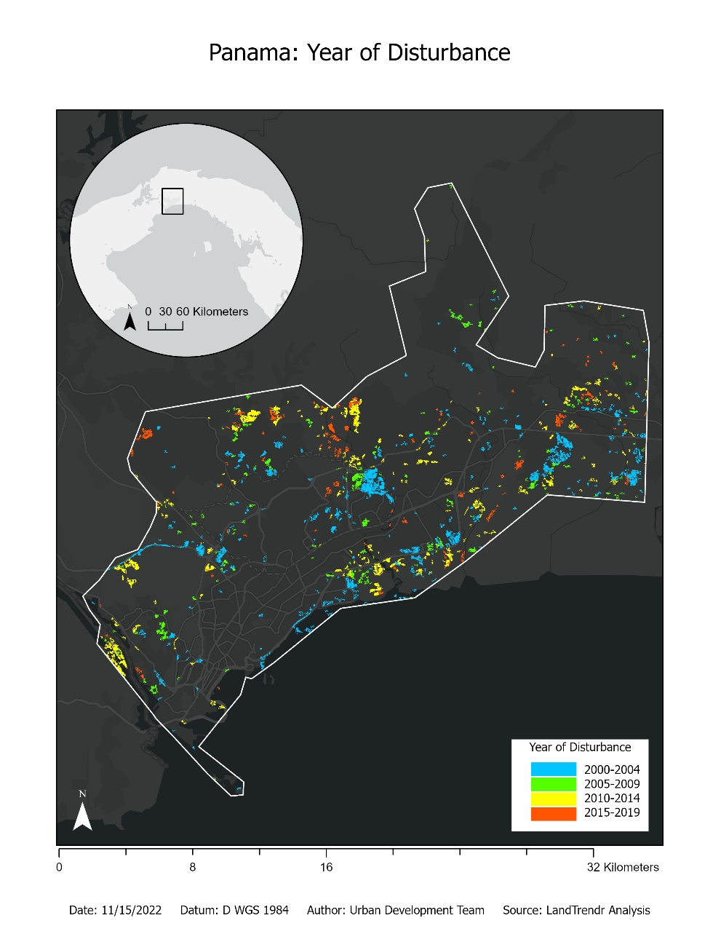

***Figure B1.*** *Map of urbanization changes in Panama City.*

**Appendix C**

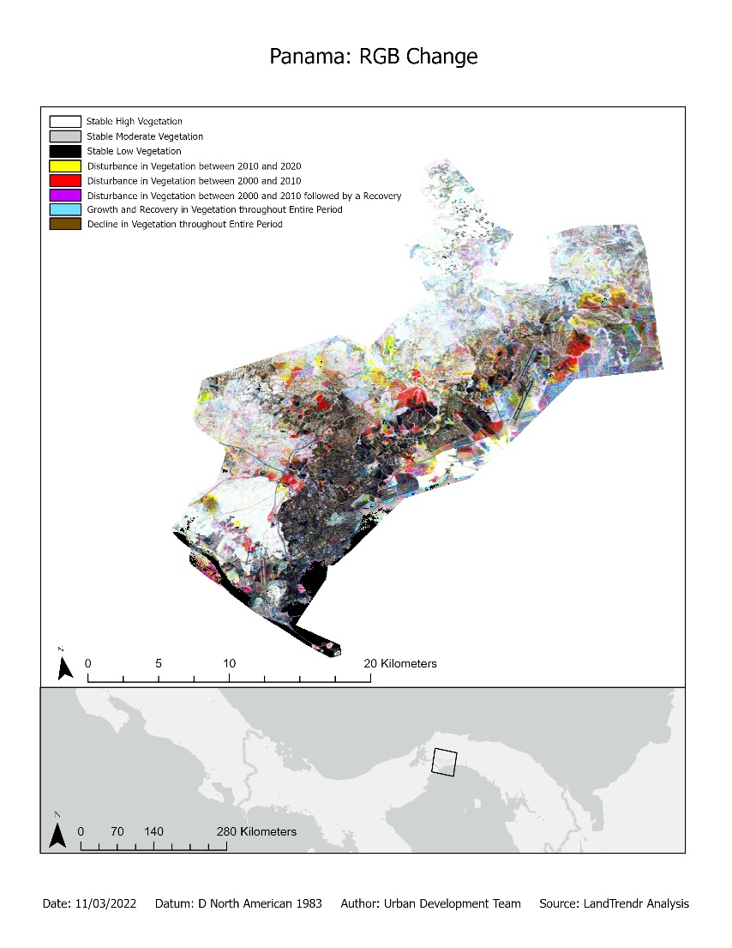

***Figure C1.*** *Map of land cover changes in Panama City.*

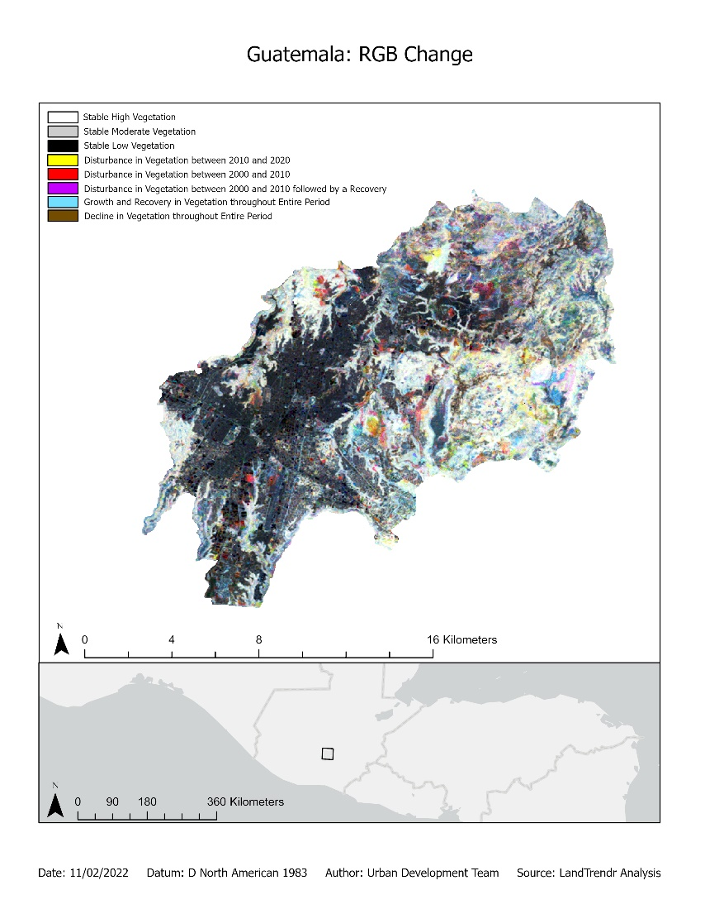

***Figure C2.*** *Map of land cover changes in Guatemala City.*

**Appendix D**

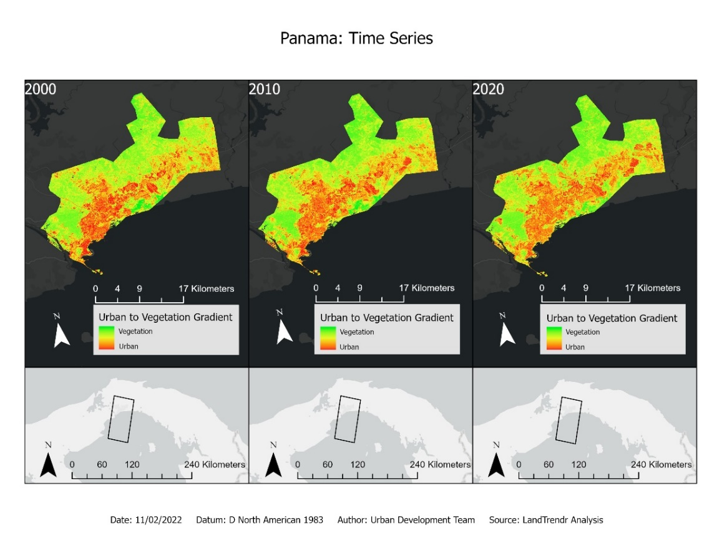

***Figure D1.*** *Time Series Map of Panama City.*

**Appendix E**

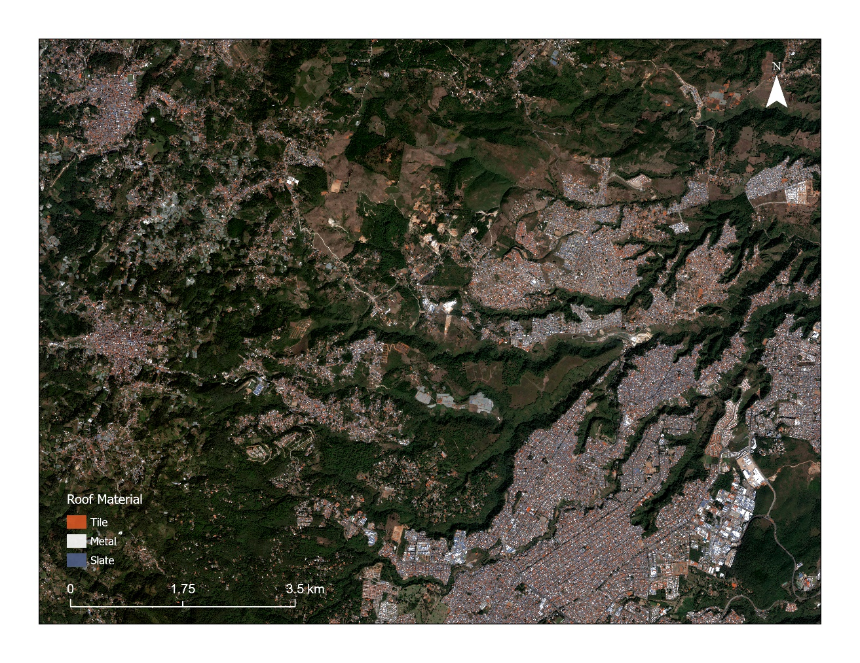

***Appendix Figure E1.*** *Basemap satellite imagery with roof classification overlay. Basemap: Esri, Maxar.*

**Appendix F**

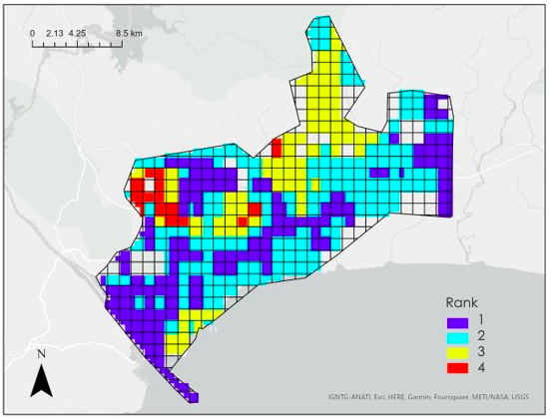

***Figure F1.*** *Vulnerability assessment for Panama City.*