**NASA DEVELOP National Program**

****NASA John C. Stennis Space Center

**Summer 2015**

**Short Title: Southern California Disasters II**

**Subtitle:** Assessing the Effectiveness of Simulated HyspIRI Data for Use in USDA Forest Service Post-Fire Vegetation Assessment and Decision Support.

**VPS Title:** Coming soon in 2022! Hyperspectral Wildfire Burn Analysis by HyspIRI

**Project Team & Partners**

**Project Team:**

Heather Nicholson (Project Lead), [hnichols5500@gmail.com](mailto:hnichols5500@gmail.com)

Amber Todoroff

Madeline LeBoeuf

**Advisors & Mentors:**

Joseph Spruce (NASA John C. Stennis Space Center)

James “Doc” Smoot (NASA John C. Stennis Space Center)

Dr. Kenton Ross (NASA Langley Research Center)

**Past or Other Contributors:**

Timothy Sutherlin

Eric Mack

Caitlin Ruby

Luke Wylie

**Partner Organizations**

USDA Forest Service Remote Sensing Applications Center (RSAC), End-User, POC: TBD

USDA Forest Service Eastern Forest Environmental Threat Assessment Center (EFETAC), End-User, POC: Steve Norman

USDA Forest Service Rocky Mountain Research Station, Missoula Fire Sciences Laboratory, Collaborator and Boundary Organization, POC: Robert Keane

HyspIRI Science Team, JPL, Collaborator, POC: Robert Green

**Project Details**

**Applied Sciences National Applications Addressed:** Disasters, Ecological Forecasting

**Study Area:** Southern California (CA) fires including: the Aspen Fire, the French Fire, and the King Fire.

**Study Period:** June 2013 – November 2014

**Earth Observations & Parameters**

ER-2 Aircraft, AVIRIS – Simulated HyspIRI Data: Burn Severity and Vegetation Condition

ER-2 Aircraft, MASTER – Simulated HyspIRI Data Burn Severity and Vegetation Condition

Landsat 8, OLI – Vegetation Condition (Pre/Post Fire), Land Use/Cover, and Burn Severity

Landsat 5, TM – Vegetation Condition (Pre/Post Fire), Land Use/Cover, and Burn Severity

**Ancillary Datasets Utilized**

* USDA Forest Service BAER, RAVG, and MTBS program products such as BARC, NBR, dNBR, RdNBR
* GIS shapefile delineating geographic coverage of Forest Service RAVG products
* Historic fire perimeter, burn scar, and MODIS Normalized Difference Vegetation Index (NDVI) data from the Forest Service *ForWarn* Forest Change Assessment Viewer
* California Department of Forestry and Fire Protection (CAL FIRE) Fire and Resource Assessment Program (FRAP) historic fire perimeter GIS shapefiles
* USDA Forest Service CALVEG vegetation classification GIS vector data layers
* Existing vegetation type and fire regime data products from LANDFIRE (Landscape Fire and Resource Management Planning Tools Program operated by U.S. Department of the Interior and the USDA Forest Service)
* USDA Farm Service Agency National Agricultural Imagery Program (NAIP) aerial photos from the Natural Resources Conservation Service (NRCS) Data Gateway

**Models Utilized**

* TerrSet Geospatial Monitoring and Modeling Software

**Software Utilized**

ERDAS Imagine – computing vegetation indices from Landsat data as well as performing other general image processing operations on simulated HyspIRI data products (e.g. projection, stacking, area of interest calculations, contrast enhancement, raster attribute editing)

ArcGIS – performing GIS analyses, such as raster calculation on simulated HyspIRI data and Landsat data, and generating cartographic products in user-friendly formats

ENVI – stacking and processing of hyperspectral AVIRIS and MASTER imagery (e.g. vegetation/burn severity indices, contrast enhancement, change detection)

TerrSet Geospatial Monitoring and Modeling Software – statistical analysis of HyspIRI products and Landsat Products.

HDF to GeoTiff Conversion (HEG) Tool – reformatting and re-projecting MODIS products into GEOTIFF format, if needed

IDL – manipulation and processing of HDF data files to extract data fields of interest, if needed

**Project Overview**

**80-100 Word Objectives Overview**

This research project utilized and assessed simulated HyspIRI data (produced from co-located AVIRIS and MASTER imagery) as a means to produce wildfire burn severity and vegetation monitoring products, such as dNBR and RdNBR, that are needed for aiding wildfire mitigation and wildland restoration. These products were quantitatively compared to Landsat-based products from the USDA Forest Service. This allowed for HyspIRI’s potentially improved capabilities for burn severity detection to be analytically compared to the Landsat-derived products in order to determine how HyspIRI can be used to improve on current monitoring capabilities.

**Abstract**

The USDA Forest Service has multiple programs in place which monitor post-fire burn severity. These programs primarily utilize Landsat imagery to produce burn severity indices which provide widely-used wildfire damage assessment tools to decision makers. When the Hyperspectral Infrared Imager (HyspIRI) is launched, its hyperspectral resolution will support new methods for assessing natural disaster impacts on ecosystems, including wildfire damage to forests. Since it is critical to evaluate and understand the capabilities and limitations of this satellite prior to its proposed launch date in 2022, NASA conducted an airborne campaign to simulate HyspIRI data starting in 2013 and continuing into 2015. HyspIRI data were simulated from co-located Airborne Visible/ Infrared Imaging Spectrometer and Master/ Aster Simulator (MASTER) sensors onboard a NASA ER-2 aircraft. A NASA DEVELOP project completed in the summer of 2014 qualitatively compared burn indices calculated using simulated HyspIRI data to those produced using Landsat. This project expanded upon those efforts using simulated HyspIRI data to study three southern California fires from 2013 and 2014: Aspen, French, and King. Burn severity indices were calculated from the data and the results were quantitatively compared to the USFS products currently in use. The final results from this project indicate how HyspIRI data may be used in the future to enhance assessment of fire-damaged areas and provide additional monitoring tools for decision support to agencies such as the USDA Forest Service.

**Community Concerns**

* Over the past four decades, California wildfires have become both larger and more frequent. In 2014, there were over 5,000 fires that burned an approximate 90,606 acres in California.
* Increase in wildfires can lead to soil erosion, loss of life, and expansion of invasive plant species.
* It is necessary to evaluate the simulated HyspIRI products before the mission is launched to maximize the benefits of HyspIRI’s capabilities in the future

**Current Management Practices & Policies**

Currently, the Forest Service operates the Burned Area Emergency Response (BAER) Mapping Support, Rapid Assessment of Vegetation Condition after Wildfire (RAVG), and Monitoring Trends in Burn Severity (MTBS) programs. All three initiatives make use of Landsat imagery (and occasionally other multispectral sensors such as SPOT) to generate geospatial products that are used to aid decision making regarding post-fire vegetation management. Additionally, the USFS RSAC also produces fire burn detection “hot spot” products derived from MODIS data. Although a few Forest Serve studies have examined the potential use of hyperspectral data to evaluate post-fire soil properties, the Forest Service does not use hyperspectral remote sensor data to generate BAER, RAVG, or MTBS standard products.

**Decision Support Tools & Benefits**

|  |  |  |
| --- | --- | --- |
| **End-Product** | **Earth Observations Used** | **Benefit & Impact** |
| Normalized Burn Ratio (NBR) map | Simulated HyspIRI and Landsat 8 | Estimating vegetation condition and burn severity; Allocation of post fire response resources |
| Differenced Normalized Burn Ratio (dNBR) map | Simulated HyspIRI and Landsat 8 | Estimating vegetation condition and burn severity; Allocation of post fire response resources |
| Relative Differenced Normalized Burn Ratio (RdNBR) map | Simulated HyspIRI and Landsat 8 | Estimating vegetation condition and burn severity; Allocation of post fire response resources |
| Quantitative Product Comparison | Simulated HyspIRI and USFS Landsat Computed Products | Feasibility of utilizing HyspIRI imagery in the BAER, RAVG, or MTBS programs |

**Project Imagery**

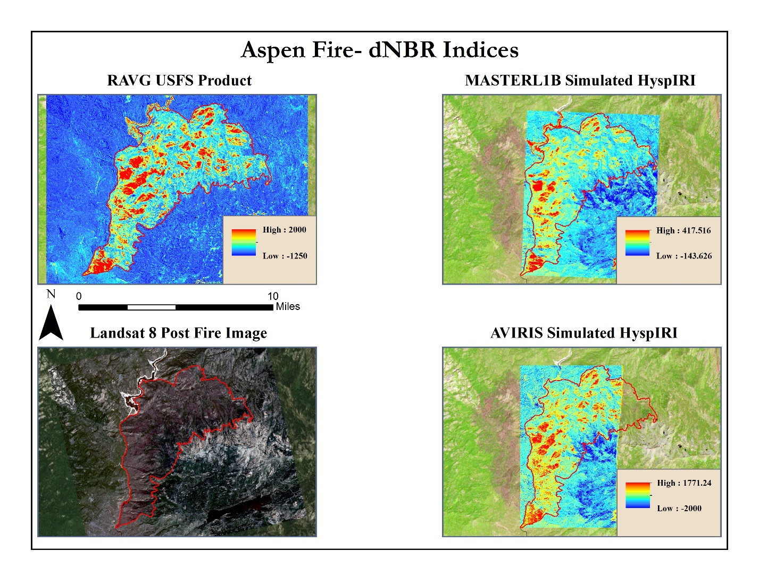

**Caption:** A visual comparison between dNBR’s that were computed using AVRIS, MASTER, and Landsat data. Also shown is a true color Landsat image after the fire.

Image Credit: SSC Southern California Disasters 11 Team.

**Image:** 2015Sum_SSC_SoCalDisastersII_ProjectSummary_FD.jpeg