**NASA DEVELOP National Program**



NASA Marshall Space Flight Center

Wise County Clerk of Court’s Office

*Summer 2015*

Thailand Agriculture

Monitoring Food Crop Health and Stress Due to Changing Climate for Enriched Agricultural Land Management

 **Technical Report**

Final Draft – August 6, 2015

Timothy Klug (Project Lead)

Arom Boekfah

Chayanit Choomwattana

Komsan Rattanakijsuntorn

Watanyoo Suksa­-ngiam

Atipat Wattanuntachai

Dr. Jeffrey Luvall (NASA at National Space Science and Technology Center)

Dr. Robert Griffin (University of Alabama in Huntsville)

# I. Abstract

Monitoring climate change is crucial for the Thailand agricultural industry. Climate change results in shifting rainfall patterns which in turn affect the management of crop production. Northeastern Thailand grows the majority of the country’s rice, but the rice yield per hectare is relatively low. One primary factor is uncertainty surrounding the ability to monitor and assess climate change. This project aims to assess changing climate patterns to improve the understanding of environmental variables, such as precipitation and temperature, to determine relationships between environmental variables and production areas of rice crop. This study used satellite imagery from Landsat 5 Thematic Mapper (TM), Landsat 7 Enhanced Thematic Mapper Plus (ETM+), and Landsat 8 Operational Land Imager (OLI) and Thermal Infrared Sensor (TIRS) and precipitation data from Tropical Rainfall Measuring Mission (TRMM) and Global Precipitation Measurement (GPM), and land surface temperature data from Moderate Resolution Imaging Spectroradiometer (MODIS). The images were analyzed by using land cover classifications, Normalized Difference Vegetation Index (NDVI), Scaled Drought Condition Index (SDCI), and precipitation data. Understanding the changing climate patterns assisted the end-users in initiating the best policies to tackle the challenges of climate change. While statistical rice yield is primarily related to the classified rice area and NDVI, the statistical rice yield per area is significantly dependent on the classified rice area, NDVI and precipitation. The results of the study can be used for facilitating effective land management strategies to enhance rice production in the future.

**Keywords**

Thailand, Agriculture, Rice, Climate, Precipitation, Remote Sensing, Land Cover Classification

# II. Introduction

**Background Information**

Thailand is well-known not only as one of the world’s largest rice exporters, but also as a producer of high quality rice. Rice can be grown in almost every region of Thailand, especially in the central and northeastern regions. Northeastern Thailand, or Isan, is famous for its agricultural industry, particularly its rice crops. Rice yield per hectare is low in this region due to several factors, such as a lack of irrigation, soil erosion, drought, and undulating topography (Ricepedia, 2015). Tung Kula Rong Hai is a sub-region in Northeastern Thailand where Thai jasmine rice, is grown most. Tung Kula Rong Hai partially covers five provinces including Surin, Maha Sarakham, Buri Ram, Si Sa Ket, and Roi Et for total area of 3,200 km² (Childs, 2015).

On 12 February 2013, European Commission has officially granted the protection of the “Thai Khao Hom Mali Thung Kula Rong-Hai” as a registered European Union’s Protected Geographical Indication or PGI. Set for better protection within 27 European Union Member States, this is the first-ever South East Asian PGI being recognized and the second by the European Union. The selling price of Thai Khao Hom Mali Rice is currently more than twice of an average selling price of normal white rice (USDA, 2015).

Roi Et has the largest land portion in Tung Kula Rong Hai covering almost 50% of the region. Moreover, rice is the most important agricultural product in Roi Et, especially Thai Khao Hom Mali Thung Kula Rong-Hai. However, most of the rice grown in Isan including Roi Et is rain-fed, which climate variability has a significant impact on rice yield. Roi Et was chosen as the study area where the researchers monitored and recorded data determining precipitation and land surface temperature. Policy makers and researchers are able to understand the impact of climate variability on the rice production, especially in the Roi Et province.

**Project Objectives**

In this project, NASA Earth observations were used to monitor rice agriculture in Thailand. Agricultural health and stress can be monitored using remote sensing data products, such as land cover classifications, land surface temperature, precipitation, and vegetation indices. When these products were analyzed over time, correlations between the products and total rice yield became apparent. These products were compiled into linear regression models and the results were compared to government reports of rice yield in order to estimate total seasonal rice output for a given year.

**Study Area**

This project focused on paddy fields in the northeastern region of Thailand. These rice fields are vulnerable to climate variability due to rain-fed water dependence. Roi Et province was chosen to be the focused study area due to its large paddy fields, and those areas are suitable for growing jasmine rice, which is a premium rice product that plays a significant role in Thai economy.

Roi Et is located in the middle of northeastern region covering 8,300km² of land. Most of its land cover consists of plains with 120-160m height above mean sea level. It borders the Phuphan mountain range in the north. Central Roi Et is undulating plain while the Southern region is comprised of low lands which locates Thung Kula Rong-Hai.

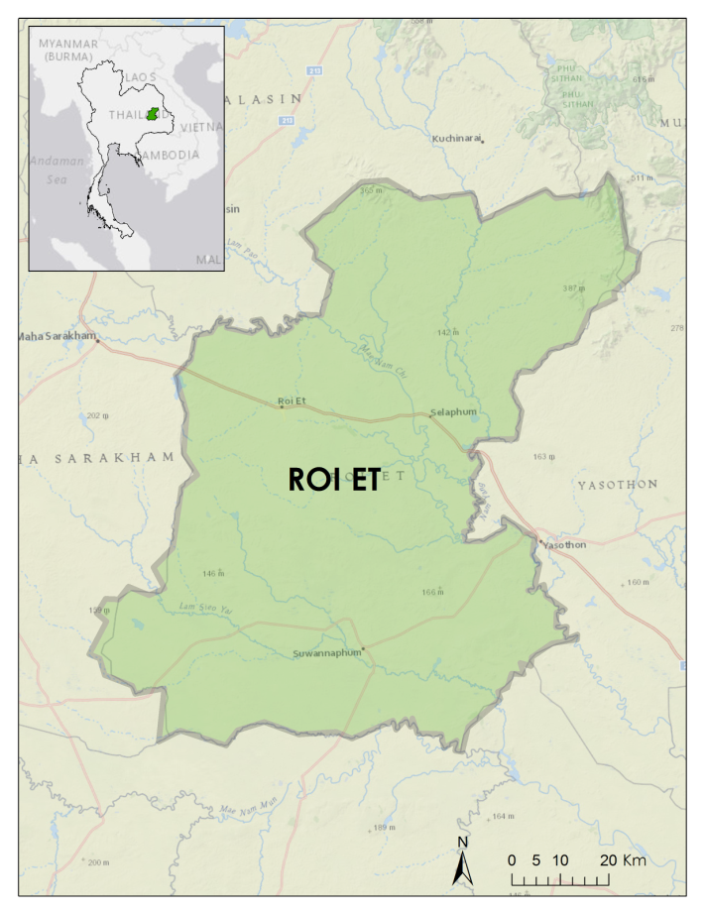

Figure 1: Study area map displaying Roi Et province

**Study Period**

To evaluate how climate variables such as precipitation and temperature can impact rice crops in Roi Et, Aqua and Terra Moderate Resolution Imaging Spectroradiometer (MODIS), Landsat 5 Thematic Mapper (TM), Landsat 7 Enhanced Thematic Mapper Plus (ETM+), Landsat 8 Operational Land Imager (OLI), Global Precipitation Measurement (GPM), and Tropical Rainfall Measuring Mission (TRMM) data were downloaded from 2000 to 2015.

**National Applications Addressed**

The NASA national application area addressed in this project was agriculture. This project used NASA Earth observations to monitor precipitation and temperature in Roi Et, Thailand. This study assisted decision makers to understand the relationship between the effects of climate change and rice production by identifying trends of rice yields in recent years. This project used NASA Earth observations and statistics from Thai government bodies.

**Project Partners**

# This project’s partners were the Royal Thai Embassy located in Washington D.C. and the SERVIR Mekong regional hub. The tools and models created by this project were designed to assist these organizations in decision-making and to improve understanding of the relationship between agricultural yield and environmental factors such as climate variability and water availability. This project highlights the utility of NASA’s Earth observations as tools for monitoring agriculture and encourages their use in land management strategies.

# III. Methodology

**Data Acquisition**

Three main classes of NASA’s Earth observations were used for this project. 30m imagery taken from Landsat 5 TM, Landsat 7 ETM+, and Landsat 8 OLI were downloaded from USGS’s GLOVIS website in order to provide high-resolution land cover classifications (LCCs) of the study area. NASA’s TRMM and GPM satellites provided products downloaded from Giovanni containing monthly precipitation accumulation averages in mm. Finally, MODIS products from the Aqua and Terra satellites were downloaded from USGS’s GLOVIS and used to produce land surface temperature (LST) and vegetation indices.

**Data Processing**

All Landsat images were preprocessed using the dnppy top-of-atmosphere digital number to reflectance conversion script. Additional python scripts were written to automate the reflectance conversion, remove negative reflectance values, and create composite band rasters of each Landsat scene. Once the images were preprocessed, training samples were drawn within the study area in order to perform a Maximum Likelihood Estimate (MLE) land cover classification. Three classes of training samples were drawn: rice, non-rice, and cloud cover. Pixels in the rice crop land cover classification were estimated using zonal statistics and converted into km²for further comparisons. This method was validated by rice searching algorithm (see Appendix D.) In addition, the NDVI was calculated over the classified rice area to be a predictor in our prediction models.

Due to the climate characteristics of the study area, farmers usually grow rice only during the wet season (May to October). In this project, monthly rainfall data were accumulated into 6-month seasonal rainfall. Monthly SDCI data were averaged into 6-month average SDCI during the wet season. In order to calculate all the data from 2000 to 2015, a Python script was created using ArcPy for batch processing.

The Scaled Drought Condition Index (SDCI) was provided by Thailand Disaster team from 2000 to 2015. The SDCI product was in one month temporal period. The SDCI was calculated by using formula found in (Rhee et al., 2010).

**Data Analysis**

This research was quantitative research. The multiple regression analysis was employed to make two prediction equations.

Generalized regression equation:

$y=b_{0}+b_{1}x_{1}+b_{2}x_{2}+e$

Where,

# $y$ = dependent variable $b_{0}$ = constant of the equation $b_{1}$ = change in $y$ relative to change in $x_{1}$ $b_{2}$ = change in $y$ relative to change in $x_{2}$ $x_{1}$ = predictor one $x_{2}$ = predictor two $e$ = residual (prediction error)

# Multiple regression was useful to develop prediction models. Multiple regression predicted the value of dependent variable based on the values of predictors or independent variables.

# The unit of analysis or sample in this study was the 20 districts of Roi Et in 6 years. Hence, the total number of units of analysis is 120 units. The multiple regression analysis required at least 30 units together to consider one dependent variable per more than five samples. Hence, the total number of samples was quite large.

# IV. Results & Discussion

**Analysis of Results**

Table 1 shows the correlation Matrix. Pearson’s correlation was used to measure linear the relationship between pairs of variables. In this table, Pearson’s correlation coefficient is equal to one suggests that the two variables on the row and column are the same variable. The correlation values in table were calculated by using Microsoft’s Excel while the p-values were calculated by using R.   
Based on the available satellite data and Pearson’s correlation, six significant relationships were found. Classified rice area from land cover classification had a positive correlation with the predicted rice yield. The predicted rice yield per area had a negative correlation with classified rice area. The predicted rice yield per area had a positive correlation with NDVI. The predicted rice yield per area had a negative correlation with precipitation. SDCI had a positive correlation with classified rice area and precipitation (RAIN), but had a negative correlation with NDVI.

Table 1: Pearson’s Correlation



Subsequently, linear multiple-regression analysis was conducted to predict rice yield (ton). However, two independent variables provided significant coefficients for the linear regression equation. These variables were the classified rice area (AREA) from the land cover classification method and NDVI. Hence, the result in the equation (1) shows the prediction equation. The predicted rice yield model is depicted in the following equation:

${\hat{Y}}_{1}=-116,342+187.91(AREA)+213,952(NDVI)$ (1)

Where

${\hat{Y}}_{1}$ = predicted rice yield (ton)

AREA = classified rice area (km2)

NDVI = Normalized Difference Vegetation Index

Table 2 shows that both variables can provide adjusted R squared as much as 0.576; in other words, 57.6 % of the variance of predicted rice yield can be explained by both Classified Rice Area and NDVI.

The F ratio is also significant, suggesting that the variance explained by the regression model is significantly larger than the unexplained variance. Hence, this predicting model can be accepted.

The coefficients of the intercept, classified rice area, and NDVI are all significant; the p-values are less than 0.05.

Table 2: Regression results of model one



In terms of the second prediction model, the number of ton per km² was used as the dependent variable. The equation (2) shows regression results for predicting rice yield per area when the classified rice area, NDVI, and precipitation are used as predictors.

${\hat{Y}}_{2}=121.05-0.07\left(AREA\right)+491.03\left(NDVI\right)-0.08(RAIN)$ (2)

Where

${\hat{Y}}_{2}$ = predicted rice yield per area (ton/ km2)

AREA = classified rice area (km2)

NDVI = Normalized Difference Vegetation Index

RAIN = precipitation (mm/wet season)

According to Table 3, three variables can be used to predict yield per area (ton per km²). These variables are classified rice areas (AREA), NDVI, and precipitation. However, the number of adjusted R square is equal to 0.18, which is quite small. 18% of the variance of the predicted number of ton per km² can be explained by classified rice area, NDVI, and precipitation.

Table 3: Regression results of predicted rice yield per area



The F ratio is also significant, suggesting that the variance explained by the regression model is significantly larger than the unexplained variance. Hence, this predicting model can be accepted. The coefficients of classified rice area, NDVI, and precipitation are all significant; the p-values are less than 0.05. However, classified rice area and precipitation have a negative relationship with the yield per area.

**Errors & Uncertainty**

The main sources of error in this project were assumptions made during the land cover classification step. Because of the rain-fed nature of agriculture in Northeastern Thailand, the availability of cloud-free imagery during the growing seasons was minimal. The few wet season Landsat images containing only partial cloud cover were classified anyway with the clouds and cloud shadows masked out. Percentages of total rice area of production were compared to images between seasons, which introduced potential errors depending on the land features covered by the mask as shown in Figure 2.

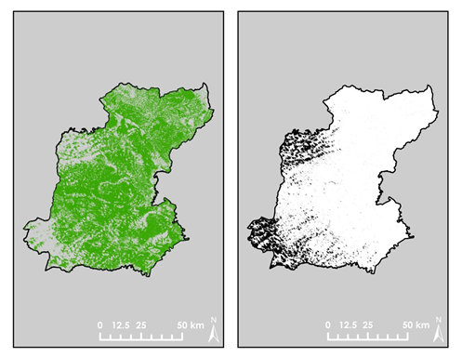

Rice Classification

Cloud Mask



Figure 2: Cloud mask compared to land cover classification

In addition, it became necessary to divide classification of the geographically large study area between two participants. The division of labor improved the project’s efficiency, but added an extra level of variability to our classifications.

**Future Work**

For the predictive analysis, the future work should be considered the use of critical factors determining rice yields. These factors can be, for example, soil quality, fertilizer used, and crop species together with such economics data as demand and competition. Recent literature indicates that fertilizers are crucial factors determining productivity of rice paddies in Thailand. Furthermore, farmers in Thailand cultivate different crop species. Ideally, different types of rice crops would be considered in the prediction models.

To improve the accuracy of the prediction, the use of Geographically Weighted Regression (GWR) in addition to a linear regression can be helpful because GWR accounts for spatial characteristics of data. The local R squared coefficients, and residuals of each district of Roi Et are able to be found.

In order to validate usefulness of the prediction models, applying the prediction models in other provinces is recommended. Testing the models in other circumstances is useful because it would enhance the applicability of the models.

In order to mitigate land classification errors, working with ground researchers and farmers is strongly recommended because it can provide high accuracy of training samples and it is the most rigorous research validation. To solve temporal problems, using constellation of satellites is recommended because Landsat suit has very few images per year and some images are not usable due to cloud. To solve cloud errors, using active remote sensing is recommended since it has an ability to penetrate the cloud because during the wet season Thailand is mostly covered by clouds.

Expanding the collaboration with other partners is also a good strategy. For example, Geo-Informatics and Space Technology Development Agency (GISTDA), an organization in Thailand, can provide images from SPOT, RARARSAT, ALOS and Thaichote. Cooperating with such an organization will increase an opportunity to obtain more images which in turn mitigate temporal and cloud cover problems.

# V. Conclusions

This project studied the effect of the classified rice area, NDVI, precipitation, and SDCI on the statistical rice yield and on statistical rice yield per area. Our results show that statistical rice yield is dependent on the classified rice area and NDVI. Statistical rice yield per area is dependent on classified rice area, NDVI, and precipitation. The results of the study can be used for facilitating effective land management strategies to enhance rice production in the future.

# VI. Acknowledgments

Dr. Jeffrey Luvall (NASA at National Space Science and Technology Center)

Dr. Robert Griffin (University of Alabama in Huntsville)

Dr. Kenton Ross (NASA Langley Research Center)

Dr. Bill Crosson (SERVIR Mekong)

Dr. Peter Cutter (SERVIR Mekong)

Bunyakiat Raksaphaeng (Royal Thai Embassy)

NASA DEVELOP Thailand Disasters Team

This material is based upon work supported by NASA through contract NNL11AA00B and cooperative agreement NNX14AB60A.

# VII. References

Broadband Greenness (Using ENVI) - Exelis VIS Docs Center. (2015). Retrieved June 30, 2015, from http://www.exelisvis.com/docs/broadbandgreenness.html

# Childs, N. (2015, May 14). USDA Rice Outlook. Retrieved June 12, 2015, from http://www.ers.usda.gov/publications/rcs-rice-outlook/rcs-15e.aspx

# Rhee, J., Im, J., & Carbone, G. (2010). Monitoring agricultural drought for arid and humid regions using multi-sensor remote sensing data. Remote Sensing of Environment, 2875-2887.

# Rhee, J., Im, J., & Carbone, G. (2010). Monitoring agricultural drought for arid and humid regions using multi-sensor remote sensing data. *Remote Sensing of Environment,* 2875-2887.

# Thailand - Ricepedia. (2015). Retrieved June 19, 2015, from http://ricepedia.org/thailand

# The National Statistical Office of Thailand. (2012). Statistical non-glutinous rice yield and harvested area. Retrieved June 20, 2015, from http://roiet.old.nso.go.th/nso/project/search/index.jsp?province_id=72&fid=3

# VIII. Content Innovation

**Interactive Map Viewer**

* 2015Sum_MSFC_ThailandAgriculture_TechPaper_InteractiveMapViewer_rice2004.kmz
* 2015Sum_MSFC_ThailandAgriculture_TechPaper_InteractiveMapViewer_rice2005.kmz
* 2015Sum_MSFC_ThailandAgriculture_TechPaper_InteractiveMapViewer_rice2006.kmz
* 2015Sum_MSFC_ThailandAgriculture_TechPaper_InteractiveMapViewer_rice2007.kmz
* 2015Sum_MSFC_ThailandAgriculture_TechPaper_InteractiveMapViewer_rice2009.kmz
* 2015Sum_MSFC_ThailandAgriculture_TechPaper_InteractiveMapViewer_rice2010.kmz
* 2015Sum_MSFC_ThailandAgriculture_TechPaper_InteractiveMapViewer_rice2012.kmz
* 2015Sum_MSFC_ThailandAgriculture_TechPaper_InteractiveMapViewer_rice2013.kmz
* 2015Sum_MSFC_ThailandAgriculture_TechPaper_InteractiveMapViewer_rice2014.kmz

**Featured Multimedia for this Article**  
2015Sum_MSFC_ThailandAgriculture_VPS_Video_Revised.mp4  
  
Video available through Developedia or through: https://www.youtube.com/watch?v=CiTiWjsIVVE

# Appendix A

Minimum cloud cover (%) from Landsat imagery (Path/Row: 127/049) which covers Roi Et, Thailand is shown in the table below. The acceptable percentage was set to be approximately 10% during wet season (May – Oct) for 2000-2015.



Source: http://glovis.usgs.gov/

According to the cloud cover problem, Landsat data: 10/2004, 10/2005, 10/2006, 10/2007, 10/2009, 10/2010, 10/2012, 10/2013, and 10/2014 were analyzed.

Rice data for twenty districts of Roi Et from National Statistical Office of Thailand are available for 2001, 2002, 2003, 2004, 2005, 2006, 2009, 2010, 2011, and 2012.

For our regression analysis, both statistical rice yield and classified rice area are available for 2004, 2005, 2006, 2009, 2010, and 2012.

# Appendix B

Rice fields in Roi Et, Thailand, were classified from Landsat images during wet season months. Classified Landsat imagery shows percent of rice fields in sub-province scale during wet season months are provided together with Julian date for each image.



Classified Rice Field (Year 2014) 10/14 (LC81270492014275LGN00)

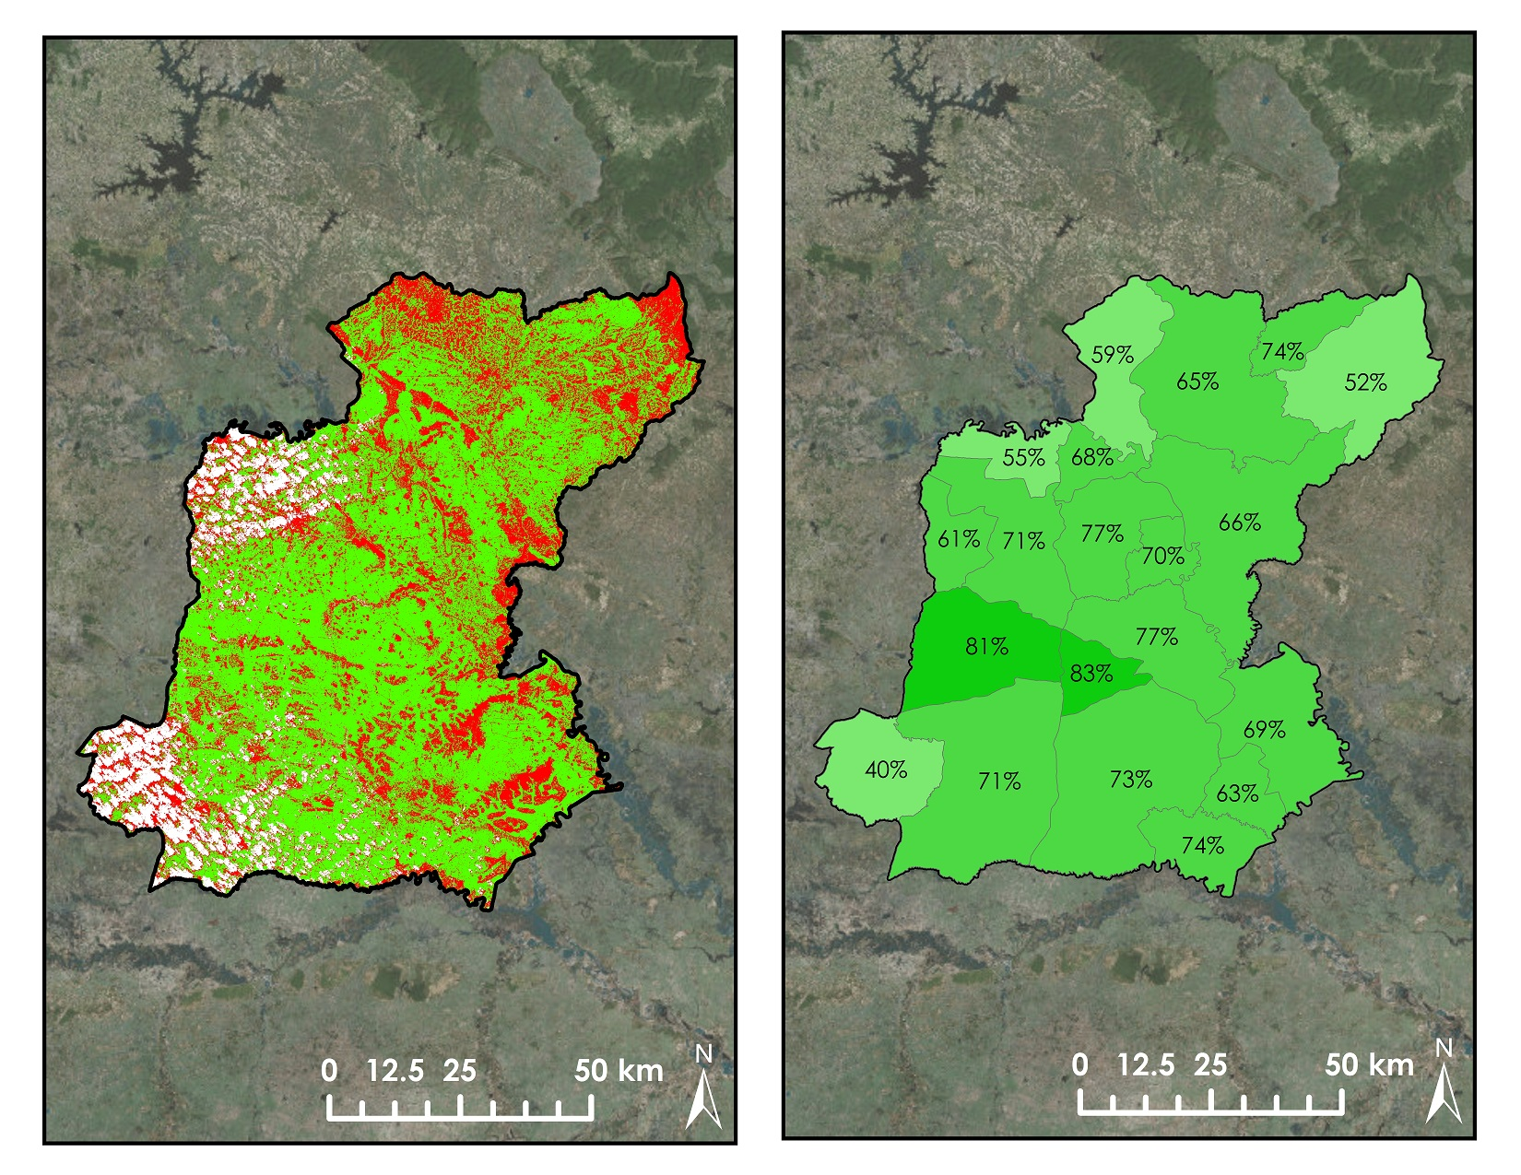

The calculation for the percentage of the rice area:

$$\% Rice area= \frac{Classified rice area}{Total area-Error area}×100$$

Where, the error area is cloud area or Landsat 7 gap area in kilometer (km2).

For example, in Pathum Rat, the percentage of the classified rice area for 10/2012 can be found by

$Rice area= \frac{178}{350-119}×100=77.1\%$.

District name Total area (km2)

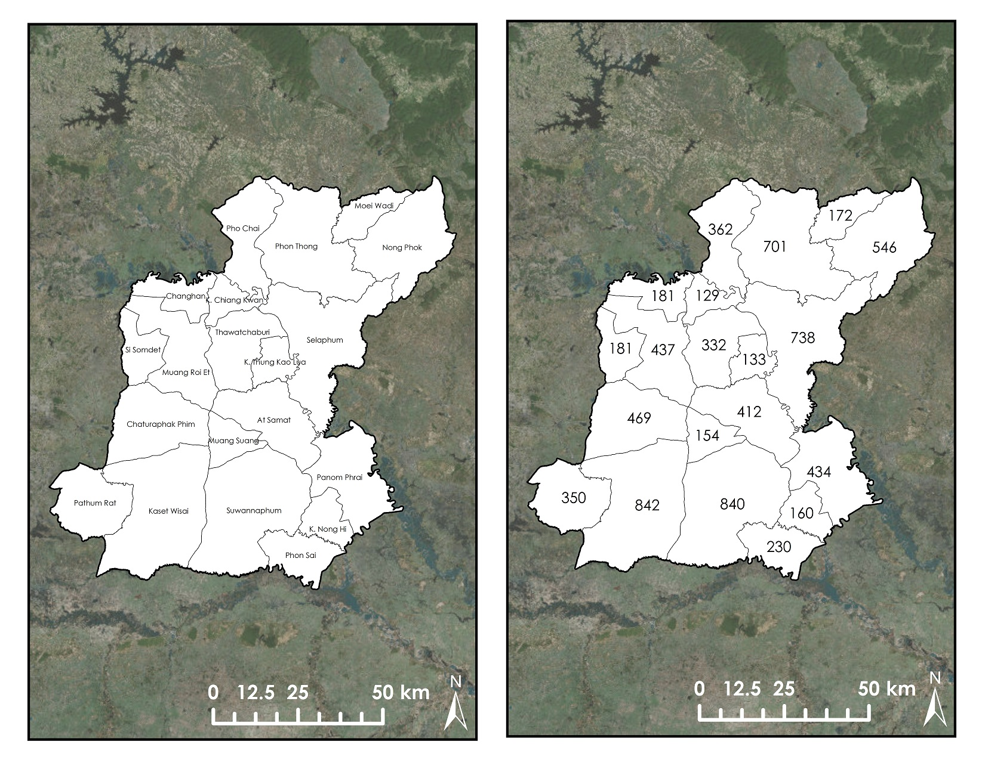

Classified Rice Area (km2) Landsat 7 Gap Area (km2)

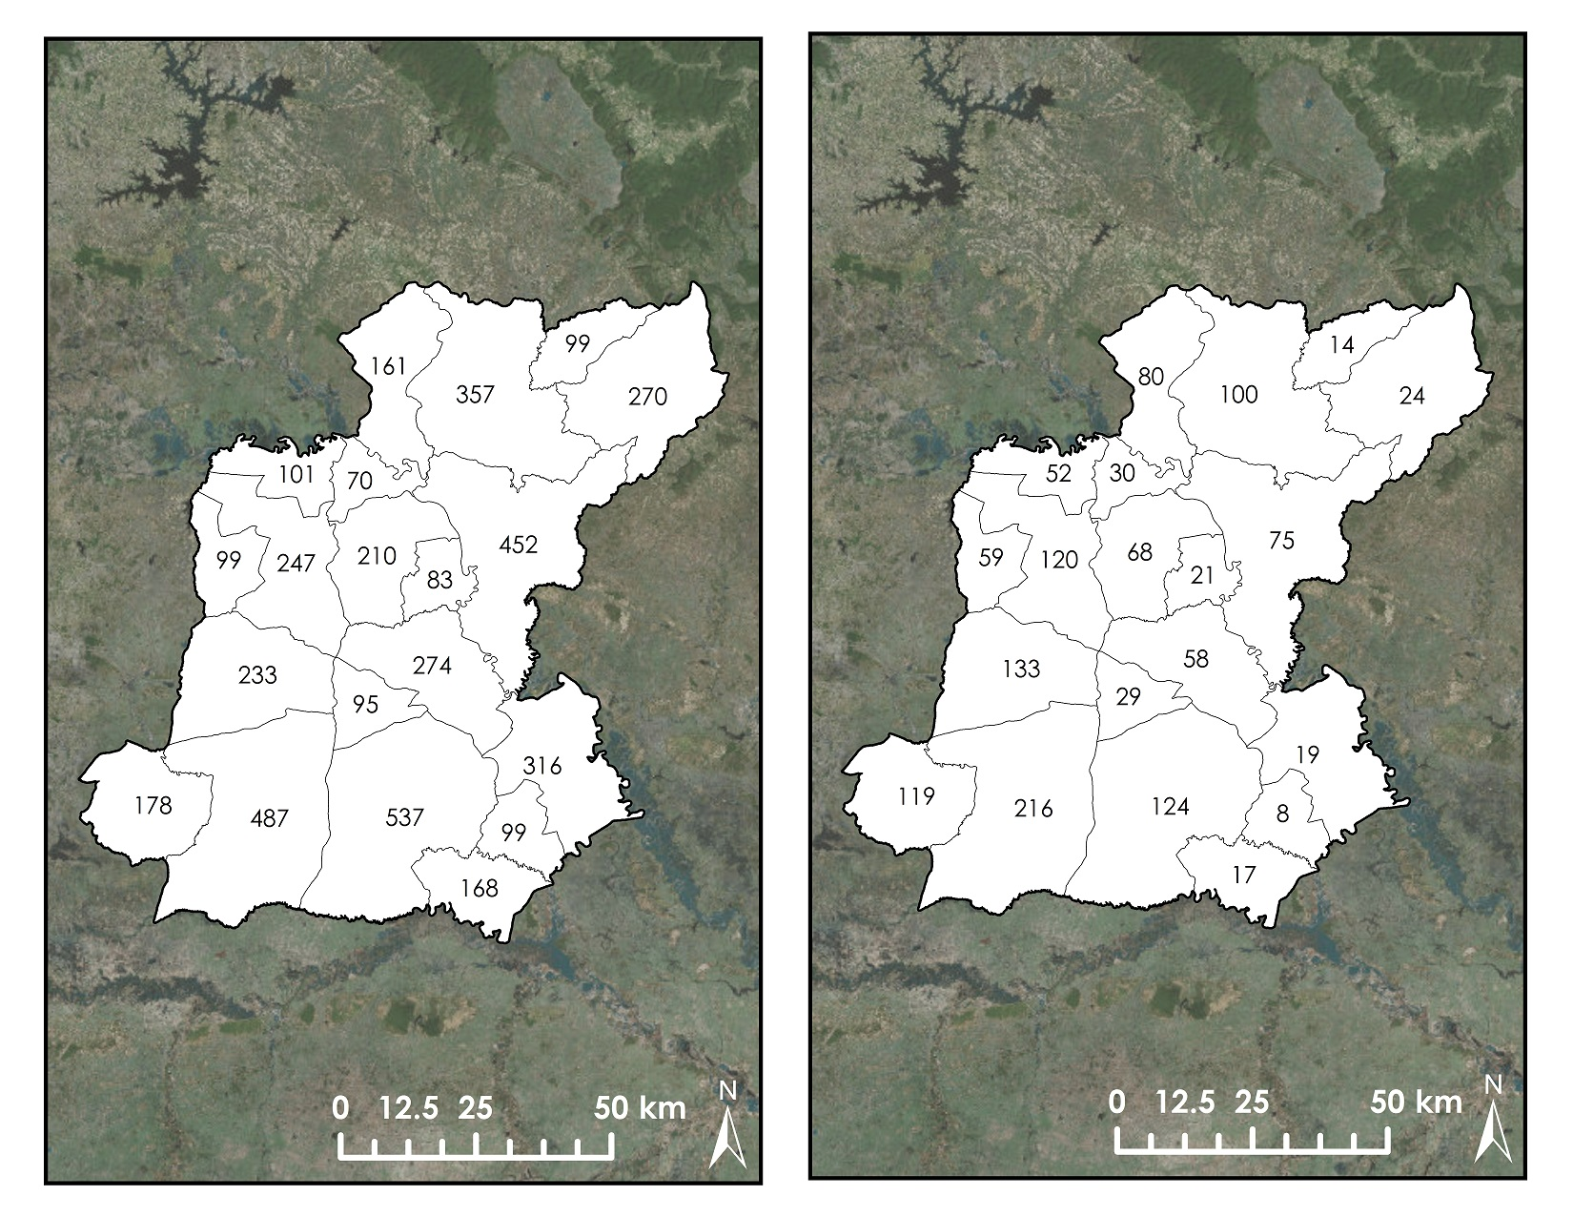

10/12 (LE71270492012294EDC00) 10/13 (LC81270492013304LGN00)

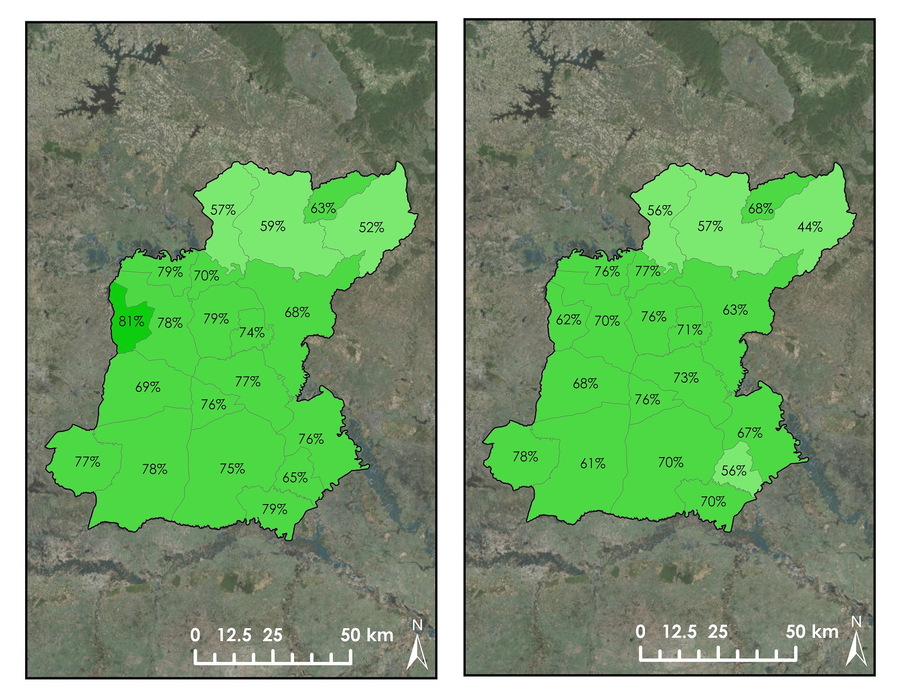

10/09 (LE71270492009301EDC00) 10/10 (LT51270492010296BKT00)

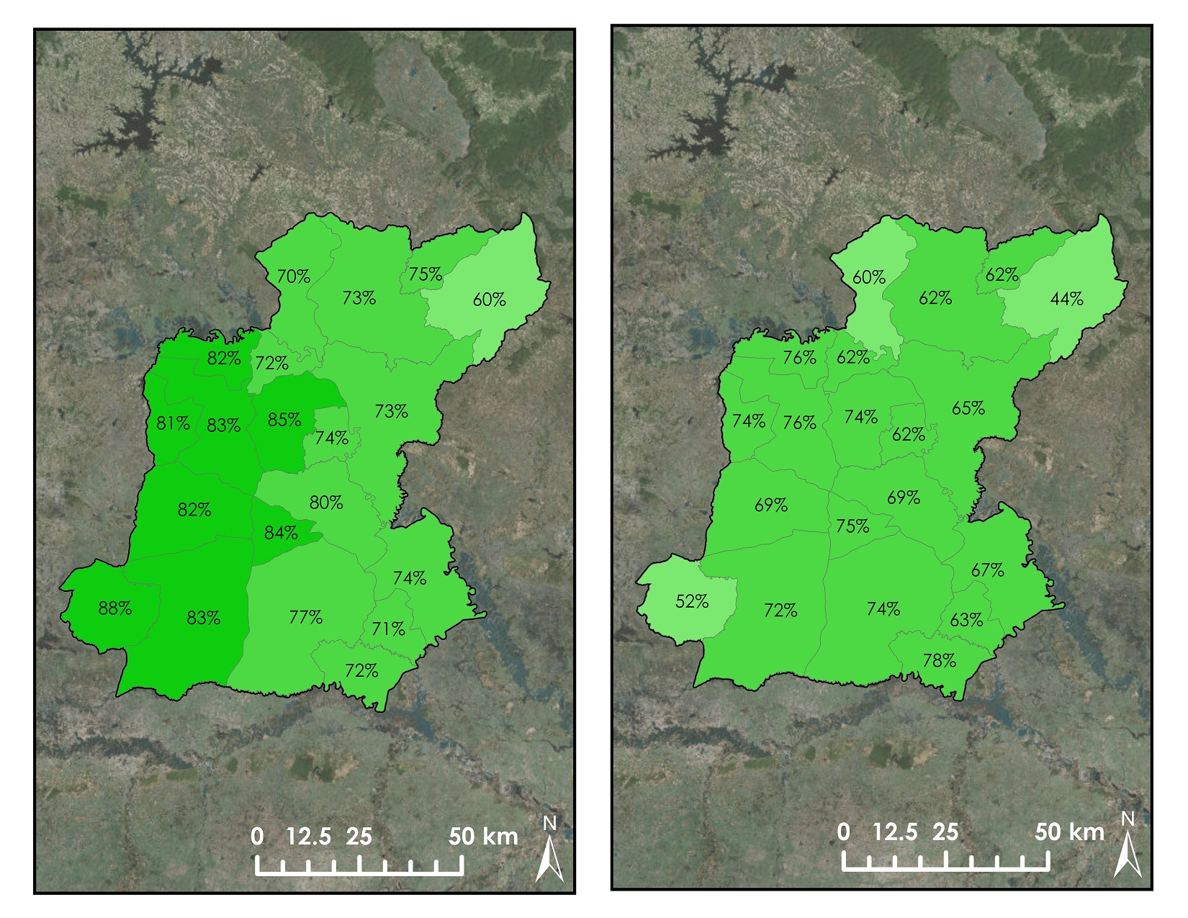

10/06 (LE71270492006293PFS00) 09/07 (LE71270492007264PFS00)

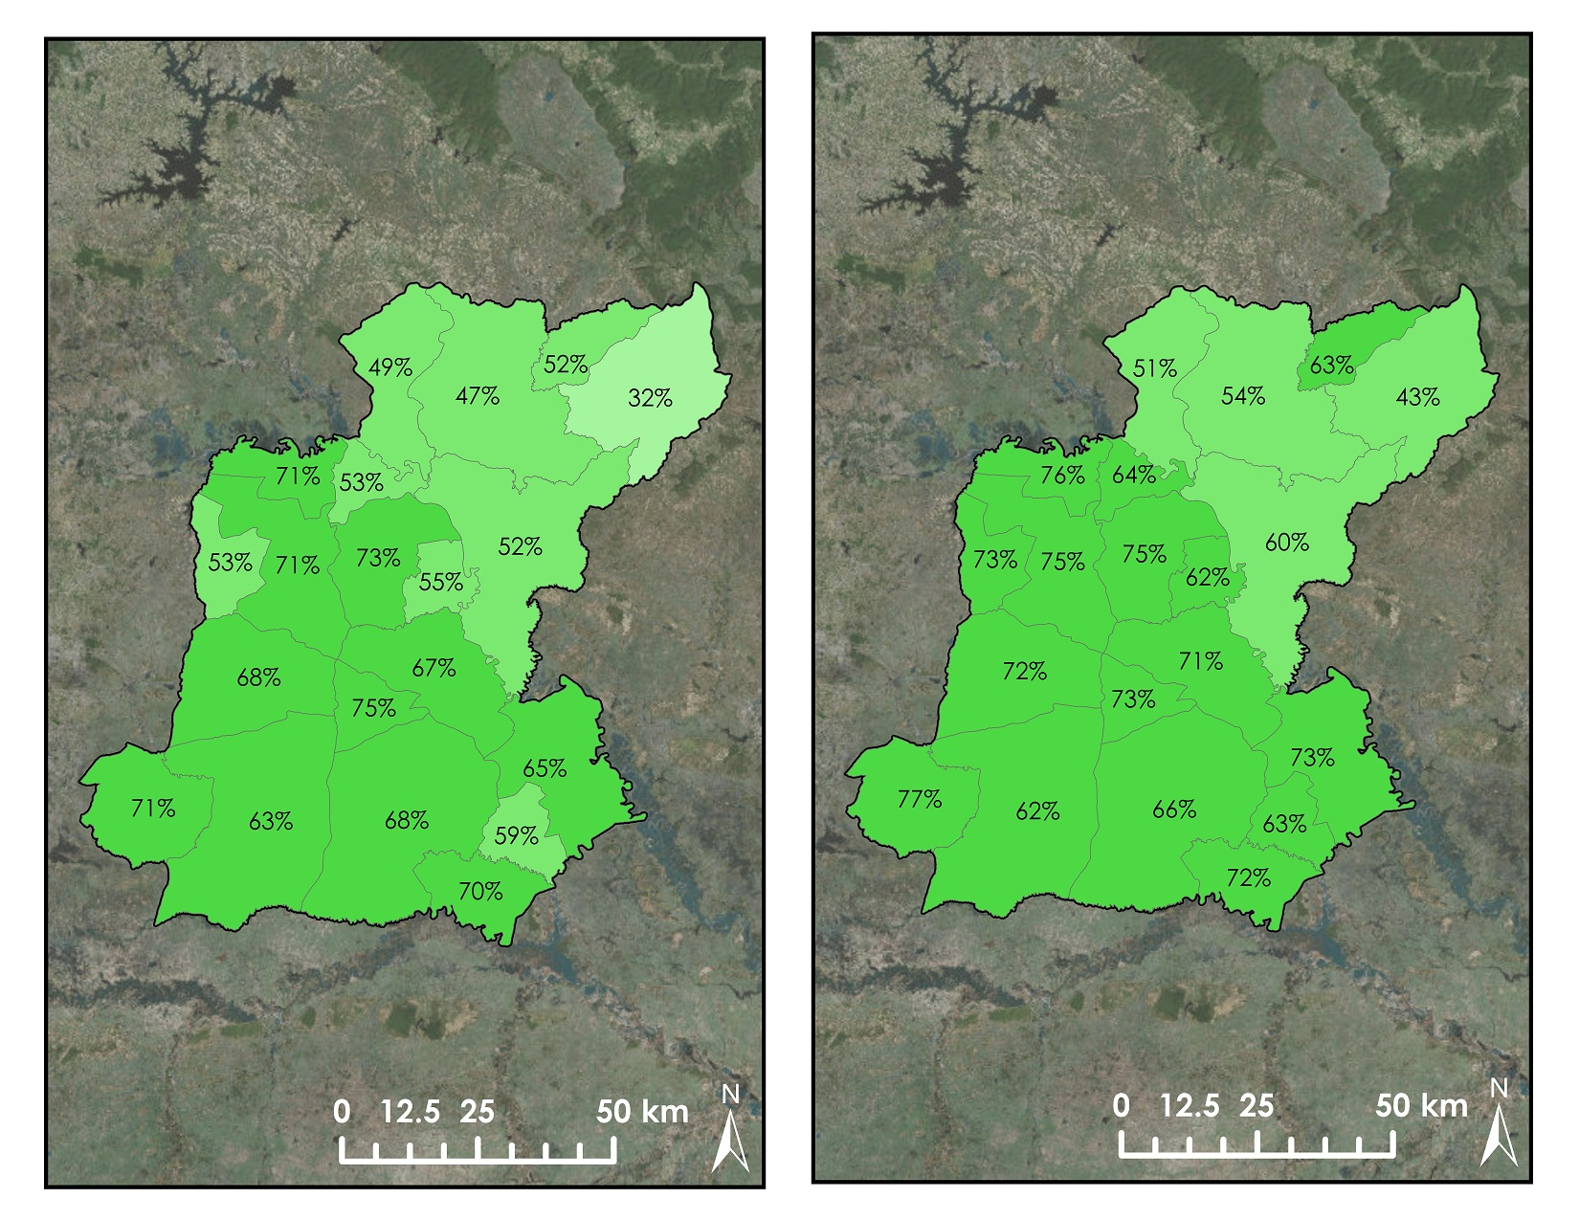

10/04 (LT51270492004280BKT00) 10/05 (LE71270492005290PFS01)

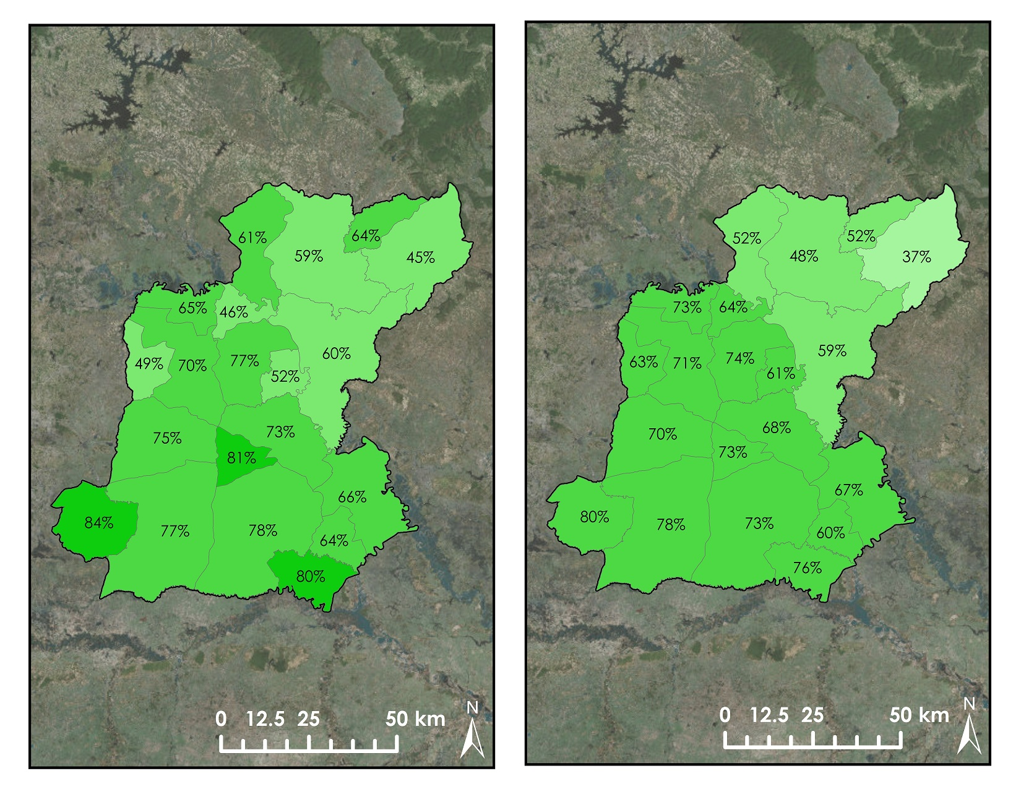

# Appendix C

Table of statistical data and satellite data in Roi Et, Thailand



Statistical non glutinous rice yield and harvested area are obtained from the National Statistical Office of Thailand (website: http://roiet.nso.go.th/index.php)

Table of statistical data and satellite data in Roi Et, Thailand (continued)



Statistical non glutinous rice yield and harvested area are obtained from the National Statistical Office of Thailand (website: http://roiet.nso.go.th/index.php)

# Appendix D

The Rice Searching Algorithm

A rice-searching algorithm has been developed to detect rice by using four different wave ranges: blue, green, red, and near infrared. Blue, red, and near infrared are used to calculate Modified Simple Ratio (MSR) and Enhanced Vegetation Index (EVI). The algorithm detects the properties of rice paddies in terms of green wave, MSR, EVI, and red wave together. The properties of green, MSR, EVI, and red in each pixel are converted into the z-score. The formulas of MSR and EVI are taken from exelisvis.com (2015)

$$MSR=\frac{\left( \frac{NIR}{Red} \right)}{\left(\sqrt{\frac{NIR}{Red}}\right)+1}$$

Where

MSR = the Modified Simple Ratio

NIR = the near infrared wave range

Red = the red wave range

$$EVI=2.5*\frac{(NIR-Red)}{(NIR+6*Red-7.5*Blue+1)}$$

Where

EVI = Enhanced Vegetation Index

Blue = the blue wave range

NIR = the near infrared wave range

Red = the red wave range

$$Z= \frac{(x- μ)}{σ}$$

where

z = the z score

x = the value of the variable

μ = the mean of the population

σ = the standard deviation of the population

Then areas that have a z-score between -2 and +2 are selected for further calculation. We select this range because it includes areas that belong to the 95 percent of the normal distribution. Then the areas selected by the range between -2 and +2 of the z score was selected to do the intersection of the set theory by using the ESRI’s combine tool.

Z-Green Map ∩ Z-MSR Map ∩ Z-EVI Map ∩ Z-Red Map

Where

Z-Green Map = the map showing the z score of the green wave range  
Z-MSR Map = the map showing the z score of the MSR  
Z-EVI Map = the map showing the z score of the EVI  
Z-Red Map = the map showing the z score of the red wave range

The intersected map was calculated from the zonal statistics providing the area of potential rice crops. The result of this algorithm had a very high relationship with the classified rice area by using supervised land cover classification. The supervised land classification and rice searching algorithm confirm that both methods provide a Pearson’s correlation coefficient (r) as much as 0.986. The Pearson’s coefficient can be turned into the r square. Both methods can explain each other as much as 0.973 (the r square) or 97.3 % with the p-value less than 0.001.

Table D1: The relationship between rice searching algorithm and classified rice area

|  |  |  |
| --- | --- | --- |
|  | Searching Algorithm | Classified Rice Area |
| Searching Algorithm | 1 |  |
| Classified Rice Area | 0.987 | 1 |

The complete rice searching algorithm model:

