**NASA DEVELOP National Program**



Mobile County Health Department

*Summer 2015*

Coastal Texas Water Resources

Utilizing NASA Earth Observations to Assess Estuary Health and Enhance Management of Water Resources in Coastal Texas through Land Cover and Precipitation Mapping

**Technical Report** 

Final Draft – August 4, 2015

Elaina Gonsoroski (Project co-Lead)

Tyler Lynn (Project co-Lead)

Georgina Crepps

Rodrigo Pereira da Silva

Ryan Schick

Bernard Eichold, M.D., Dr. PH, Mobile County Health Department (Mentor)

Joe Spruce, NASA Stennis Space Center (Science Advisor)

James “Doc” Smoot, NASA Stennis Space Center (Science Advisor)

# I. Abstract

This project partnered with the National Park Service (NPS) to help analyze the correlation between mesquite trees and the salinity of the Laguna Madre of the Padre Island National Seashore. The project was performed to help the NPS in conducting needed assessments for this area’s coastal water resource management. The lagoon is currently a hypersaline estuary; however, there is historical evidence that this was not always the case. It is hypothesized that the increased frequency of honey mesquite trees (*Prosopis glandulosa var. glandulosa*) in the area has effectively increased the Laguna Madre’s salinity by decreasing the groundwater inflow to the lagoon. These mesquite trees have long taproots capable of extracting significant amounts of groundwater. This project utilized Earth observation data, specifically Landsat 5, 7, and 8, to compute needed land cover maps to analyze the change in the occurrence of mesquite trees in the study area over time. Thermal maps of the lagoon were also generated using Landsat 5, 7, and 8 data to understand changes in groundwater inflow. In addition, TRMM precipitation data and GRACE derived changes in root zone soil moisture content data were compared over the study period. By assessing the relationships between mesquite tree distributions and the salinity of the Laguna Madre, the NPS can use resulting information to help plan and improve future land management practices affecting the estuary.

**Keywords**

Hypersalinity, Remote Sensing, Land Cover, Estuary, Mesquite trees, Groundwater

# II. Introduction

**Background**

As part of the Padre Island National Seashore, the Laguna Madre falls under federal land management. The Laguna Madre is a hypersaline estuary, but historical evidence suggests that it has not always been. It is hypothesized that the increased salinity is in part due to an increase in the number of honey mesquite trees (*Prosopis glandulosa var. glandulosa)* in the surrounding area, which has reduced groundwater inflow to the lagoon. Currently, the water quality and nutrient levels of the Laguna Madre are monitored with *in situ* data collection in limited locations by the National Park Service (NPS). However, the relationship between mesquite trees, groundwater and the salinity of the lagoon has not been systematically studied. As much of the area surrounding the lagoon is privately owned, remote sensing data is ideal to map and assess the increase in mesquite trees.

**Objectives**

The objective of this project was to explore the suspected correlation between the increasing salinity in the Laguna Madre and the increasing number of mesquite trees in the surrounding area. Mesquite tree expansion was analyzed through a Land Use/Land Cover (LULC) and a Normalized Difference Infrared Index (NDII) time series. Precipitation trends were analyzed to understand how these trends correlated with changes in root zone soil moisture content (RZSMC), and the increase in mesquite trees. A thermal map time series was created to identify changes in groundwater flow into the lagoon. These analyses are a valuable management tool for the NPS to address the suspected correlation between the increasing salinity of the lagoon and the increasing number of mesquite trees in the area.

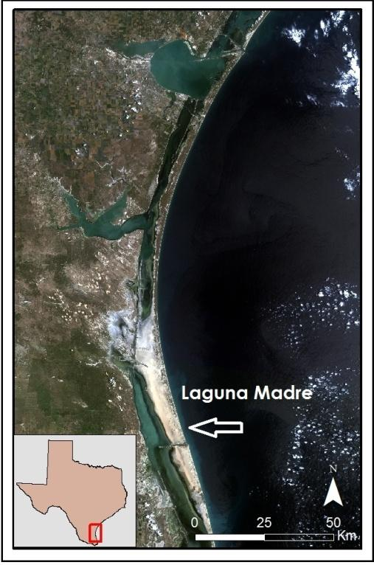

**Study Area**

The project study area was the Laguna Madre of the Padre Island National Seashore located in southern Texas along the Gulf of Mexico (Figure 1). The latitude lines 27.6 N and 26.2 N were used for the northern and southern boundaries of the study area, respectively. The western boundary stretched past US Highway 77 while the eastern boundary extended into the Gulf of Mexico.

**Study Period**

The study period for the project was from 2000 to 2015. Landsat data collected in late fall were obtained incrementally for 2000 to 2015 for land cover classifications and NDII calculations. Additional Landsat data for January and February were also downloaded incrementally for thermal mapping of the lagoon. These months offered the greatest difference in temperature between the warmer groundwater and the cooler lagoon in order to identify thermal anomalies of groundwater inflow. GRACE-derived data products were obtained for 2003 to 2014 in order to identify root zone soil moisture content changes. TRMM monthly accumulated precipitation data were obtained for 2000 to 2014.

Figure . Study area showing the Laguna Madre of Padre Island National Seashore.

**Figure SEQ Figure \* ARABIC 1: Study area with the Laguna Madre and surrounding land.**

**National Application Addressed**

The application area addressed in this project was Water Resources, which focuses on remote sensing applications that address water availability, forecasting, and quality concerns. By examining various environmental variables, this project’s analyses provided insight into the relationship between land cover, precipitation, root zone soil moisture content and the health of the Laguna Madre. This work helped to aid in the NPS's decision making process for estuary management.

**Project Partner**

This project partnered with the NPS Padre Island National Seashore to investigate spatio-temporal changes in the salinity of the Laguna Madre. Historical evidence suggests the salinity was once lower. The increasing salinity can have harmful effects on the ecosystem, as the Laguna Madre is home to a variety of endangered and threatened species including seagrasses, and it is also a productive fishery (Tunnel 2001). The project was conducted under the hypothesis that the mesquite trees’ long taproots are linked to the increasing salinity of the lagoon because they are able to reach groundwater and thus reduce the freshwater flowing into the lagoon. However, it is unclear how different environmental factors are affecting the lagoon’s salinity. With the creation of multiple map time series and the help of different analyses focusing on changes in vegetation, water and surface temperature, the partner will be provided with information necessary to make more informed land management decisions in the future.

# III. Methodology

**Data Acquisition**

Landsat 5, 7, and 8 data from the same path and row were downloaded for the Land Use/Land Cover classification. The data were downloaded from the USGS LandsatLook Viewer. Landsat 7 Enhanced Thematic Mapper Plus, Scan Line Corrector-on (ETM+ SLC-on) data was acquired for November 22, 2002. Landsat 5 TM data was acquired for December 27, 2006 and November 4, 2010. Landsat 8 OLI and TIR data were acquired for October 14, 2014. To create maps of the NDII the same Landsat 5, 7 and 8 data, were used.

TRMM 3B43 monthly accumulated rainfall data were downloaded for each month between January 2000 and December 2014 from the Goddard Earth Sciences Data and Information Center (GES DISC) in the NetCDF format. 3B43 data are a level 3 gridded product with input from multiple sensors with a 0.25 degree resolution.

Monthly assimilated GRACE data of root zone soil moisture content (RZSMC) from January 2003 through December 2014 were also downloaded. These data were created by integrating observational data of terrestrial water storage from GRACE Release-05 into the Catchment Land Surface Model (CLSM) along with data from the Global Land Assimilation System (GLDAS) (Houborg et al. 2012; Zaitchik et al. 2008). These data were provided by Dr. Matthew Rodell of NASA’s Goddard Space Flight Center.[1] The derived data have a resolution of 0.25 degrees, higher than raw GRACE data resolution at 0.5 degrees.

To conduct thermal mapping of the lagoon, Landsat 5 Thematic Mapper (TM), Landsat Enhanced Thematic Mapper Plus Scan Line Corrector-on (ETM+ SLC-on), and Landsat 8 Operational Land Imager (OLI) and Thermal Infrared Sensor (TIRS) data were downloaded from the USGS LandsatLook Viewer as Level 1 GeoTIFF files for January or February from the years 2000, 2002, 2003, 2005, 2007, 2011, 2014, and 2015. For these dates, Landsat path 26, rows 41 and 42 were downloaded.

**Data Processing**

For the LULC, Landsat 5 TM, Landsat 7 ETM+ SLC-on and Landsat 8 OLI data were processed through dnppy, ArcGIS 10.3.1 and ERDAS Imagine 2014. The dnppy TOA script was used to remove atmospheric interferences on the data quality. ArcGIS was used to stack the bands to create a false infrared image, clip the data to the study area, and mosaic different scenes. ERDAS Imagine was used to create the LULC maps.

Once the Landsat data were converted to TOA reflectance, bands 4 and 7 from Landsat 5 TM and Landsat 7 ETM+ and bands 5 and 7 from Landsat 8 OLI (the near infrared (NIR) and shortwave infrared (SWIR) bands) were used to calculate the Normalized Difference Infrared Index (NDII) for each year. These data were clipped to the study area and the different scenes were mosaiced. A water mask was applied using the Conditional tool in ArcGIS so only the NDII values for land were included in the analysis.

TRMM data were converted from NetCDFs to rasters using the make NetCDF raster layer tool in ArcGIS. All layers were projected in the WGS 1894 UTM Zone 14 coordinate system to match the coordinate system of the other data used in this analysis. Monthly binary files of the assimilated GRACE data were converted to GeoTIFF files from binary files using a Python script. Once these files were converted to GeoTIFFs, the data were projected in ArcGIS 10.2.2 into the coordinate system WGS 1984 UTM Zone 14. Then the rasters were clipped to the approximate size of the study area (due to resolution) by running the rasters through the clip to shape function from the DEVELOP National Program Python Package (dnppy). Although the same resolution, these data pixels did not align with the TRMM data pixels. To line up the pixels, the unprojected, unclipped raster data of monthly anomalies and averages for the GRACE derived and TRMM data were first oversampled by a factor of 50. Then, these data were projected into the coordinate system WGS 1984 UTM Zone 14. Next the data were clipped in ArcGIS using a shapefile which excluded the pixels covering water in the Gulf because there was no RZSMC data for these areas. Finally, the data were resampled back to the original pixel size. The mean values for these raster data were exported to a text file using a Python script and then imported into Excel. A comma separated values (CSV) file was created from the Excel file for additional analysis in R.

The thermal maps of the study area were processed by first applying a cloud mask to the raw data using the dnppy cloud mask script. Next, the data was clipped to the study area and mosaiced together. A land mask was then applied to the study area. A shapefile of the Laguna Madre was used to then extract the lagoon from the Gulf of Mexico in the land-masked data to better identify anomalies of groundwater inflow in the lagoon by excluding the thermal values of the Gulf. To the convert the data from digital numbers to radiance, the Spectral Radiance Scaling Method was used for Landsat 5 data, the ENVI Radiance Calibration tool for Landsat 7 (Yale 2010), and the methods outline in the literature for Landsat 8 band 10 (Sameen and Al Kubaisy 2014: 14). Atmospheric corrections were then applied to the Landsat 5 and Landsat 7 data. The Landsat 5, 7, and 8 data were then converted to Kelvin and lastly Celsius.

**Data Analysis**

To create the LULC maps, an unsupervised classification was conducted to apply a water mask and to create 70 unsupervised classes. To improve the accuracy, the supervised classification was then run. Polygons were created to distinguish different classes containing pixels with similar spectral signatures. Two accuracy assessments were completed for each of the four LULCs. The first created 200 equally distributed samples, covering all eight classes. As mesquite tree classification was the primary focus of the LULCs, the second accuracy assessment was done creating 50 random sample points within only the mesquite class, with an additional 50 samples created for the other seven classes combined.

The NDII values were calculated using the raster calculator in ArcGIS. The NDII is ratio of foliar water content and defined as:

$NDII=\frac{NIR-SWIR}{NIR+SWIR}$ (1)

where NIR is the near infrared reflectance and SWIR is the short wave infrared reflectance (Hoshino, *et al*. 2011). As Landsat 8 data have two SWIR bands, the SWIR band with the most similar spectral range as Landsat 5 and 7’s SWIR bands was chosen (band 7) (Appendix I, Table 3). The foliar water content shown by the NDII indicates the water stress level of vegetation. The locations of mesquite trees shown by the NDII maps were compared to the locations of the mesquite trees shown by the LULC maps.

To analyze the TRMM precipitation and the GRACE derived RZSMC data, monthly and yearly averages and monthly anomalies were calculated. Average precipitation by month and year were calculated using the raster calculator tool in ArcGIS. The monthly and yearly averages in RZSMC were calculated using a python script. The monthly anomalies were calculated for both datasets using the same python script that took the values for each month during the 12 year period for precipitation and RZSMC and subtracting the monthly averages previously calculated for each to identify any anomalies.

The GRACE derived RZSMC and the TRMM precipitation data from 2003 through 2014 were compared in Excel and in R. The monthly anomalies for each month of each year were graphed. Additionally, periods of drought, as identified by the United States Drought Monitor, were added to the anomaly graph.

To better analyze the thermal data, a common scale was created to identify any possible anomalies of warm, fresh groundwater inflow into the cool, salty lagoon. The scale ranged from 6 degrees Celsius to 24 degrees Celsius and at increments of three degrees.

# IV. Results & Discussion

**Analysis of Results**

The accuracy assessment of the four LULC maps presented substantial agreement and almost perfect agreement for overall kappa statistics and for mesquite tree kappa statistics. The first accuracy assessment was done by creating 200 equalized random samples (Table 1). The second accuracy assessment was done by creating 100 samples, with 50 samples within the mesquite tree class alone. The other 50 samples were equally distributed for the other classes (Table 2).

Table 1. Land Use/Land Cover Classification - Accuracy Totals - 200 Samples Equalized Random.

|  |  |  |  |  |  |
| --- | --- | --- | --- | --- | --- |
|  | **All Classes (175 Samples - Equalized)** | | **Mesquite tree Class (25 Samples)** | | |
|  | **Overall Classification Accuracy** | **Overall Kappa Statistics** | **Mesquite Tree Producers' Accuracy** | **Mesquite tree Users' Accuracy** | **Mesquite Tree Kappa Statistics** |
| **2002** | 82.0% | 0.79 | 71.9% | 88.5% | 0.86 |
| **2006** | 86.0% | 0.84 | 85.7% | 96.0% | 0.95 |
| **2010** | 89.0% | 0.87 | 80.7% | 100.0% | 1.00 |
| **2014** | 85.0% | 0.83 | 88.5% | 92.0% | 0.91 |

Table 2. Land Use/Land Cover Classification - Accuracy Totals - 100 Samples (50 samples for mesquite class).

|  |  |  |  |  |  |
| --- | --- | --- | --- | --- | --- |
|  | **All Classes (50 Samples - Equalized)** | | **Mesquite tree Class (50 points)** | | |
|  | **Overall Classification Accuracy** | **Overall Kappa Statistics** | **Mesquite Tree Producers’ Accuracy** | **Mesquite tree Users' Accuracy** | **Mesquite Tree Kappa Statistics** |
| **2002** | 85.0% | 0.79 | 92.0% | 92.0% | 0.84 |
| **2006** | 91.0% | 0.88 | 95.8% | 92.0% | 0.85 |
| **2010** | 94.0% | 0.92 | 97.9% | 92.00% | 0.85 |
| **2014** | 85.0% | 0.79 | 95.7% | 90.0% | 0.81 |

The agreement for categorical data was interpreted according to Landis and Koch-Kappa’s Benchmark Scale from 1977 (Appendix II, Table 4). The overall Kappa statistic and the mesquite tree class Kappa statistic for both accuracy assessments fell within the substantial agreement and almost perfect agreement categories. Our analysis showed that the number of mesquite trees increased over the study period (Figure 2).

Figure 2. Increase in the area covered by mesquite trees over the study period.

High values of NDII indicate vegetation has high water content and therefore is less stressed (Hoshino, *et al*. 2011). The locations of vegetation with higher water content as shown by the NDII maps roughly aligned with the locations of mesquite trees identified by the LULC maps (Figure 3). The NDII maps showed that the mesquite trees presented higher values than the surrounding vegetation. This suggests that the mesquite trees are getting water that other nearby plants are not. As the literature on mesquite trees state that their long taproots can reach groundwater (Phillips 1963; Shackleton *et al*. 2014; Fisher et al. 1973), and there was an increase in the number of mesquite trees over the study period, the hypothesis of the relationship between the mesquite trees and the salinity of the lagoon was fortified. Additional LULC and NDII maps are located in the appendix (Appendix IV, Figure 9). This research project yielded results that will be further assessed and expanded in the continuation of this project.

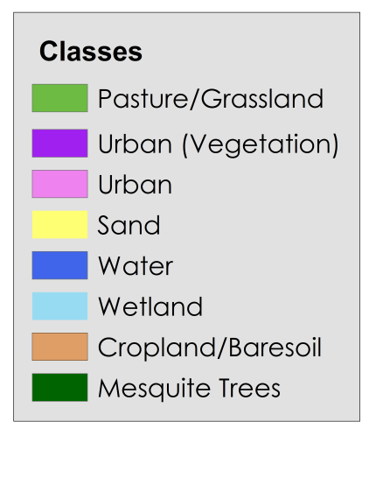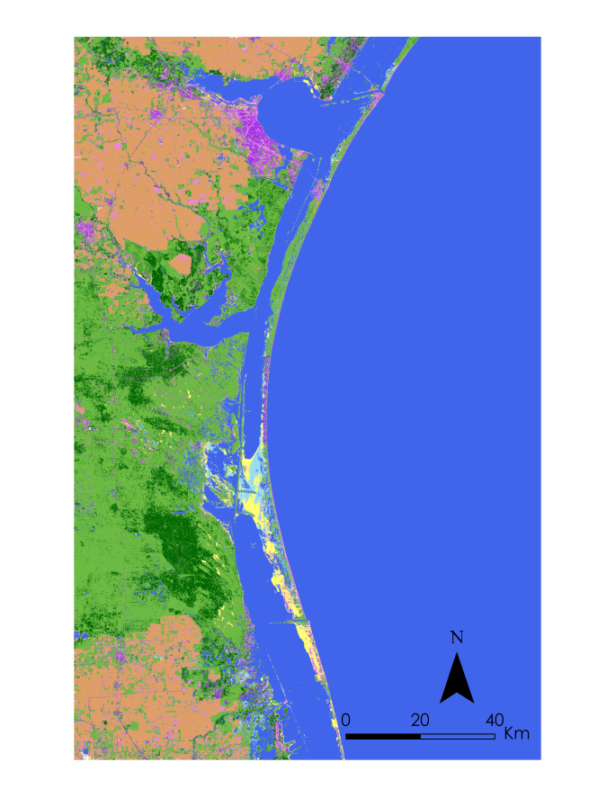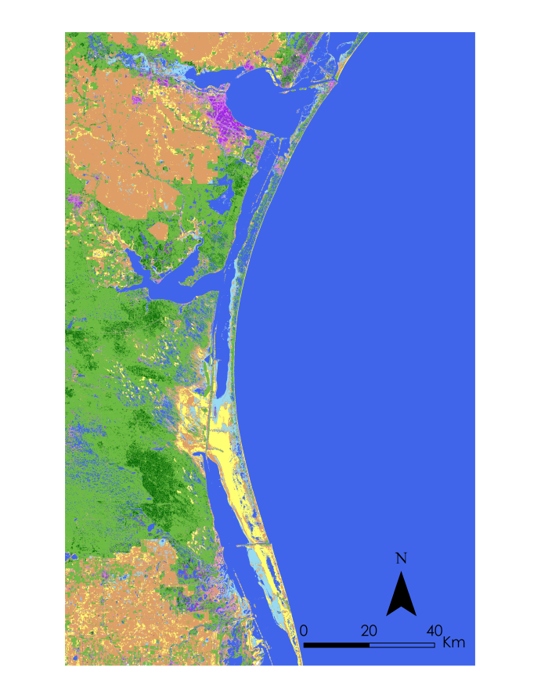

**2014**

**2002**

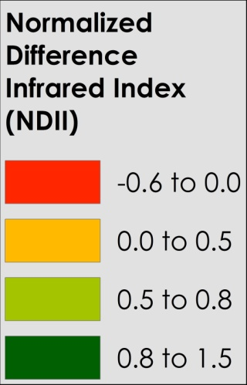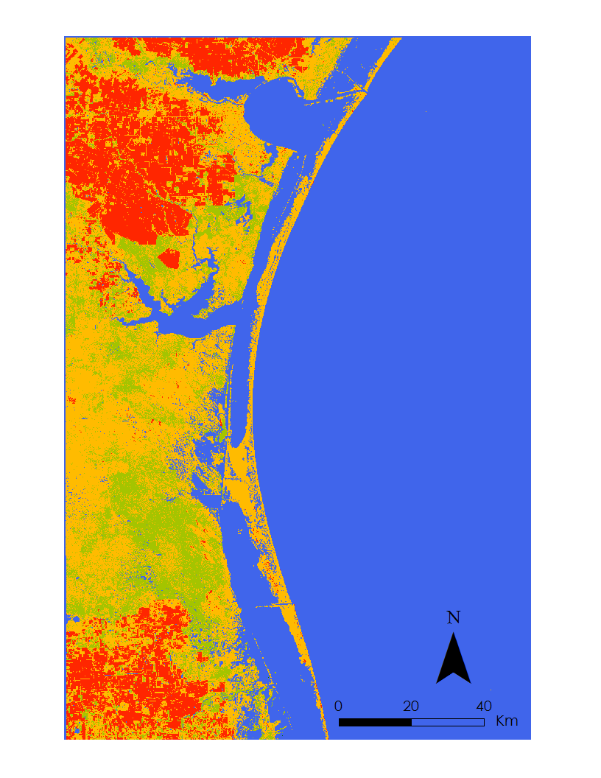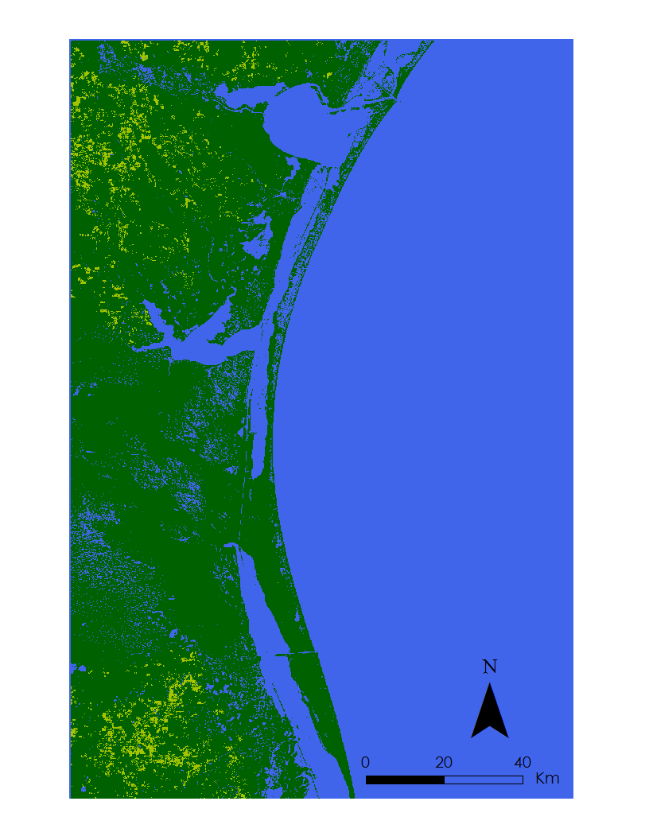

**2014**

**2002**

Figure 3. LULC (top) and NDII (bottom) maps for 2002 (left) and 2014 (right).

The monthly anomalies of RZSMC derived from GRACE and precipitation from TRMM were tabulated and graphed (Figure 4). Pearson’s correlation coefficient between the monthly anomalies was moderately strong with a value 0.60 (p-value<0.001). This indicates that precipitation does have influence on the moisture content of the soil. Periods of low precipitation are linearly correlated with low root zone soil moisture content, which in turn may influence from where vegetation is able to draw water.

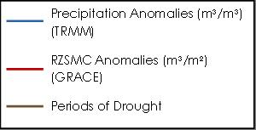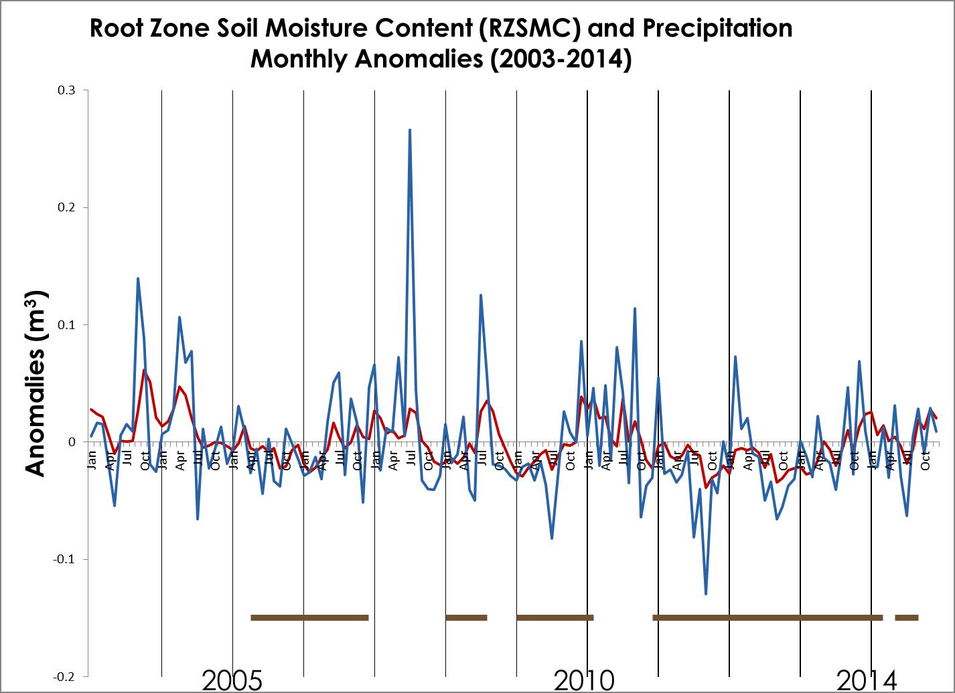

Figure 4. Graph of monthly anomalies in precipitation and RZSMC along with drought data.

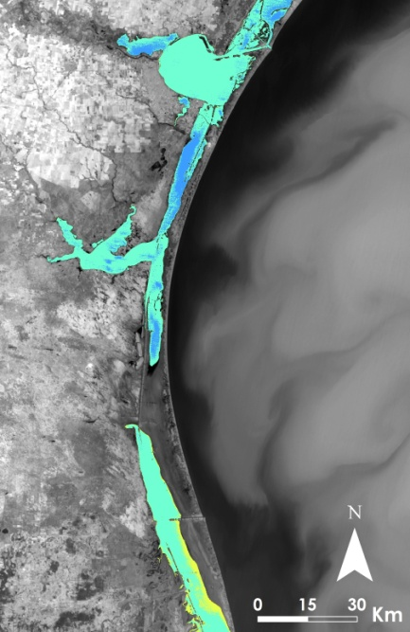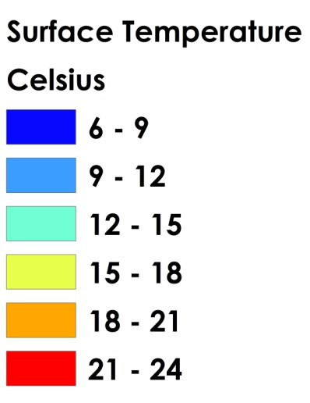Analysis of the thermal data revealed no clear anomalies of groundwater inflow. Although changes in the temperature of the Laguna Madre were seen, no clearly identifiable areas of groundwater inflow were evident in the thermal data (Figures 5 and 6). Additional thermal maps can be seen in Appendix III, Figures 7 and 8).

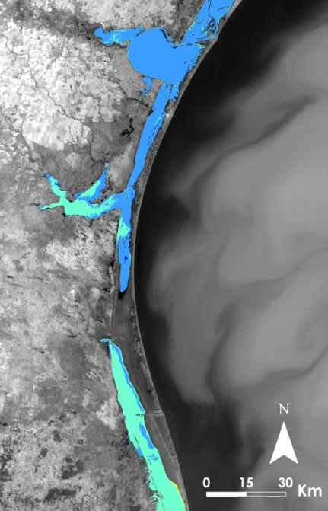

Figure 6: Surface temperature of the Laguna Madre for January 15, 2014.

Figure 5: Surface temperature of the Laguna Madre for February 10, 2003.

**Errors and Uncertainty**

Challenges occurred during the land classification due to the resolution of the Landsat satellites. The Landsat imagery has a resolution of 30 meters, which created some errors when mapping the location of mesquite trees. As each pixel may only classified as one particular class, even if the area was partially covered by mesquite on the ground, it may not have been classified as such in the imagery.

There was additional uncertainty in the GRACE derived and TRMM analyses due to satellite resolution as well. Both of these datasets had a resolution of 0.25 degrees. Due to the size of the study area, the total number of pixels used for the water analysis was only 21. This limited the amount of data for the study area in both of these datasets.

Uncertainty in identifying anomalies in the thermal data resulted from two areas: the resolution of the thermal bands and the extent of the study period. While all the thermal data downloaded from LandsatLook Viewer were already resampled to 30 meters, the original resolution of the thermal bands ranged from 120 meters, 60 meters, and 100 meters for Landsat 5, 7, and 8, respectively. As potential thermal anomalies may be considerably smaller, the imagery resolution may not be fine enough to pick them up. In addition, changes in groundwater inflow may have occurred prior to this project’s study period. Extending the study period would allow for a change in the groundwater inflow over time to be better identified.

**Future Work**

Future work will extend the time period analyzed to identify long term trends. Continuing to investigate the change in mesquite trees over a longer time period will improve understanding about how the environment surrounding the Laguna Madre has changed. Additional data containing precipitation accumulation as well as precipitation data from different sources to compare information.

Further analysis of land cover changes with precipitation amounts will be useful in estimating evapotranspiration rates. Evapotranspiration rates in the study area can be estimated by using the tree coverage indicated by the LULC map and the evapotranspiration rates of mesquite trees identified from the literature. The total amount of rainfall for the study area can also be estimated. Calculating the difference between the amount of precipitation in the study area and the evapotranspiration rate will provide an estimate of how much groundwater is available to recharge the lagoon.

# V. Conclusions

The salinity of the Laguna Madre is influenced by a number of different environmental factors. The LULC maps created for the project showed mesquite tree coverage increased during the study period of 2000-2014. The areas of mesquite tree coverage indicated by the LULC maps approximately corresponded to the areas of moister vegetation shown by the NDII maps. This supports the notion that mesquite trees are able to obtain water when other vegetation is not. Analysis also showed precipitation and RZSMC were moderately correlated. Analyzing precipitation trends with changes in RZSMC can provide more information about the water availability to plants in the study area. While the observed thermal anomalies were inconclusive, the project introduced some of the challenges associated with creating thermal maps for a small study area and comparing these results for different years. More work is needed to further assess the potential of thermal data for identifying groundwater contribution to the estuary. In all, these analyses provided the team’s partner with more information about the environmental changes surrounding the Laguna Madre and are available to the NPS to help inform their land resource management decisions for the Padre Island National Seashore.

# VI. Acknowledgments

The team would like to thank the following people for their help in the completion of this project: the team’s mentor Bernard Eichold, M.D., Dr. PH (Mobile County Health Department), the team’s science advisors Joe Spruce (NASA Stennis Space Center) and James “Doc” Smoot (NASA Stennis Space Center), the DEVELOP program’s national science advisor Dr. Kenton Ross (NASA Langley Research Center), and the team’s partner Joe Meiman (National Park Service).

This material is based upon work supported by NASA through contract NNL11AA00B and cooperative agreement NNX14AB60A.

# VII. References

Fisher, C. E.; Hoffman, G. O.; Scifres, C. J. 1973. The mesquite problem. In: Mesquite: Growth and development, management, economics, control, uses. Research Monograph 1. College Station, TX: Texas A&M University, The Texas Agricultural Experiment Station: 5-9. [4680]

Hoshino, Buho, Maino Yonemori, Karina Manayeva, Abdelaziz Karamalla, Kiyotsugu Yoda, Mahgoub Suliman, Mohamed Elgamri, Hiroshi Nawata, Yusuke Mori, Shunsuke Yabuki and Shigeto Aida. 2011. “Remote Sensing Methods for the Evaluation of the Mesquite Tree (*Prosopis juliflora)* Environmental Adaptation to Semi-Arid Africa. *Geoscience and Remote Sensing Symposium (IGARSS), 2011 IEEE International.* doi: 10.1109/IGARSS.2011.6049498.

Houborg, R., M. Rodell, B. Li, R. Reichle, and B.F. Zaitchik. 2012. “Drought Indicators Based on Model-Assimilated Gravity Recovery and Climate Experiment (GRACE) Terrestrial Water Storage Observations.” *Water Resources Research*. 48 (7). doi: 10.1029/2011WR011291 (June 24, 2015).

Landis, J. R, and Koch G.G. 1977. “The measurement of observer agreement for categorical data”. Biometrics, 33(1): 159-174.

Phillips, Walter. 1963. “Depth of Roots in Soil.” *Ecology,* 44(2). (August 4, 2015).

Sameen, Maher Ibrahim, and Mohammed Ahmed Al Kubaisy. 2014. “Automatic Surface Temperature Mapping in ArcGIS using Landsat - 8 TIRS and ENVI Tools, Case Study: Al Habbaniyah Lake.” *Journal of Environment and Earth Science*. 4(12): 12-17.

Shackleton, Ross T., David C. Le Maitre, Nick M. Pasiecznik, and David M. Richardson. 2014. “Prosopis: A Global Assessment of the Biogeography, Benefits, Impacts and Management of one of the World’s Worst Woody Invasive Plant Taxa.” AOB Plants 6. doi:10.1093/aobpla/plu027. (August 8, 2015).

Tunnel, John. 2001. “Protect the Laguna Madre.” *Corpus Christi Caller Times*. http://www.nps.gov/pais/learn/nature/laguna.htm. (June 25, 2015).

United States Geological Survey. 2014. EarthExplorer. http://earthexplorer.usgs.gov/ (June 25, 2015).

United States Geological Survey. 2014. LandsatLook Viewer. http://landsatlook.usgs.gov/ (June 25, 2015).

Yale Center for Earth Observation. 2010. “Converting Landsat TM and ETM+ thermal bands to temperature.” Yale Center for Earth Observation. http://www.yale.edu/ceo/Documentation/Landsat_DN_to_Kelvin.pdf (July 28, 2015).

Zaitchik, B.F., M. Rodell, and R. Reichle. 2008. “Assimilation of GRACE Terrestrial Water Storage Data into a Land Surface Model: Results for the Mississippi River Basin.” *Journal of Hydrometeorology*. 9(3). doi:10.1175/2007JHM951.1 (June 24, 2015).

# VIII. Content Innovation

AudioSlides

Featured Multimedia for this Article (VPS)

Interactive Map Viewer

# IV. Appendices

# Appendix I: NIR and SWIR Bands

Table 3. The bands for NIR and SWIR reflectance used to calculate the NDII for each Landsat satellite.

|  |  |  |
| --- | --- | --- |
| Satellite | NIR | SWIR |
| Landsat 5 | Band 4 (0.76-0.90 µm) | Band 7 (2.08-2.35 µm) |
| Landsat 7 | Band 4 (0.77-0.90 µm) | Band 7 (2.09-2.35 µm) |
| Landsat 8 | Band 5 (0.85-0.88 µm) | Band 7 (2.11-2.29 µm) |

# Appendix II: Landis and Koch-Kappa’s Benchmark Scale

Table 4. Landis and Koch-Kappa’s Benchmark Scale (Landis J.R., and Koch G.G. 1977)

|  |  |
| --- | --- |
| Kappa Statistics | Strength of Agreement |
| < 0.00 | Poor |
| 0.00-0.20 | Slight |
| 0.21-0.40 | Fair |
| 0.41-0.60 | Moderate |
| 0.61-0.80 | Substantial |
| 0.81-1.00 | Almost perfect |

# Appendix III: Additional Thermal Maps of the Laguna Madre

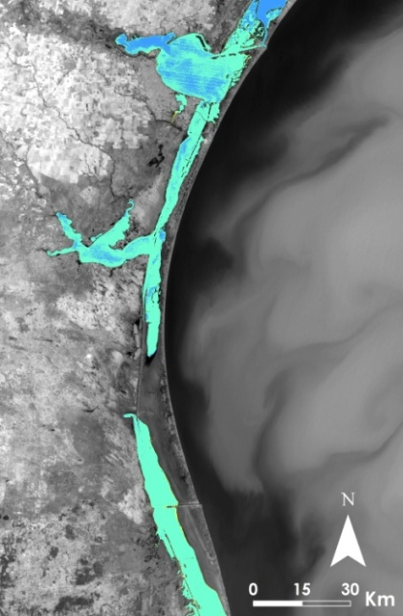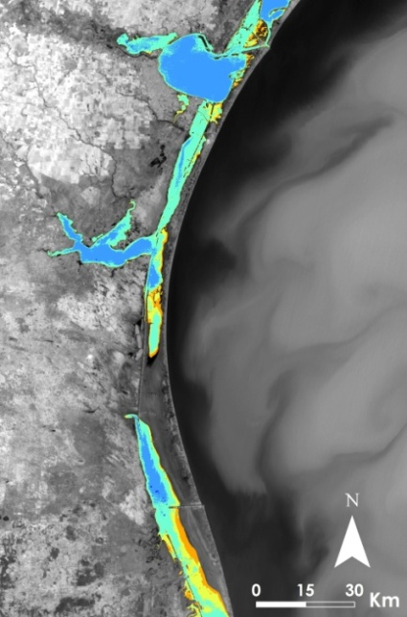

Figure 8. Surface temperature of the Laguna Madre for February 8, 2011.

Figure 7. Surface temperature of the Laguna Madre for January 6, 2002.

**Appendix IV: Additional LULC and NDII Maps**

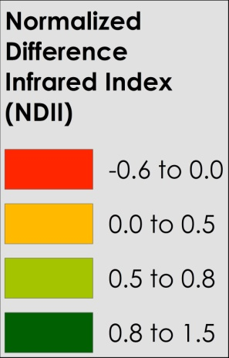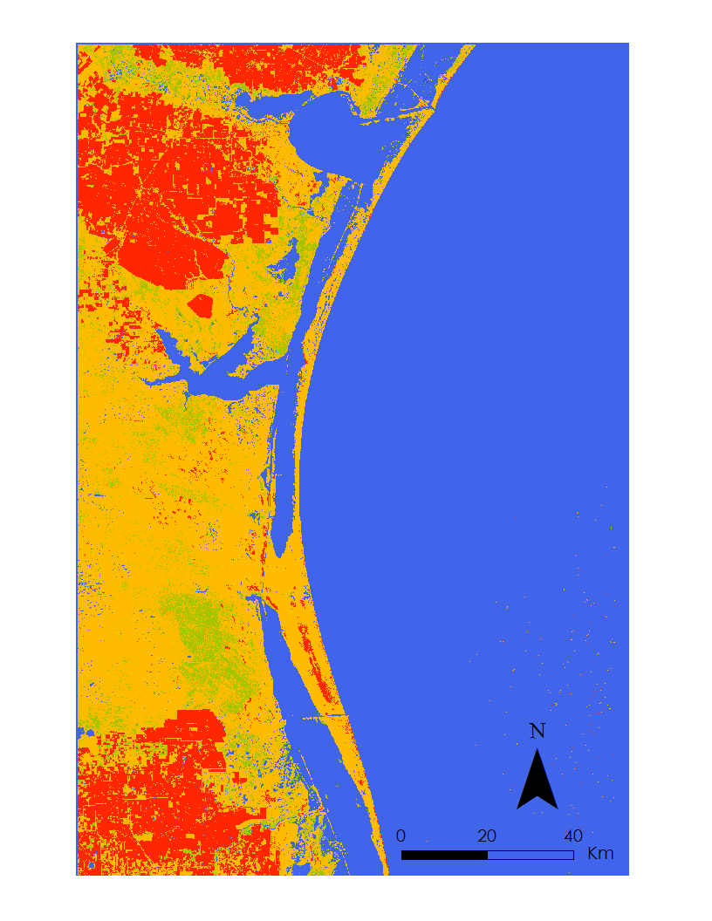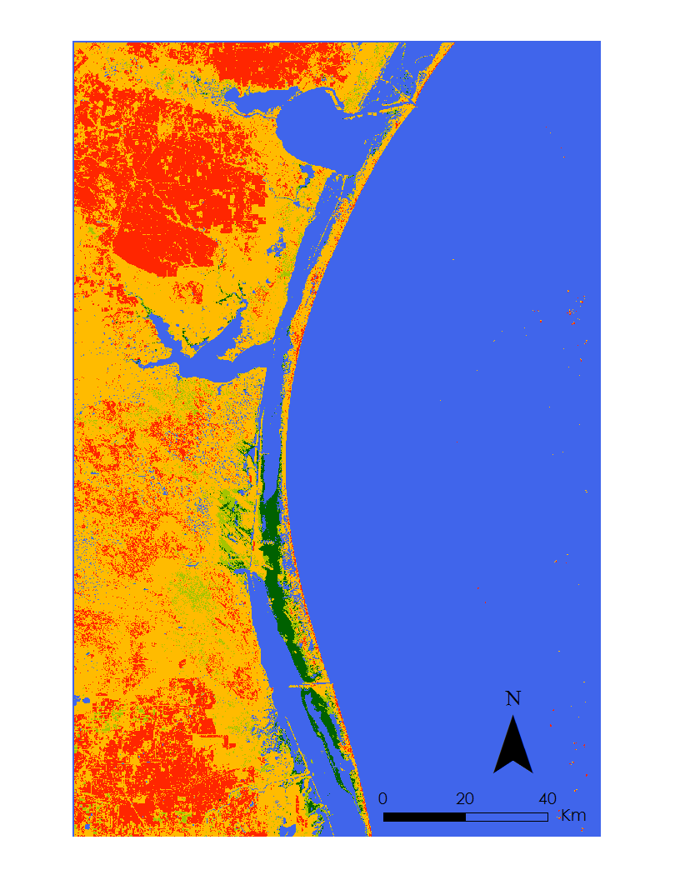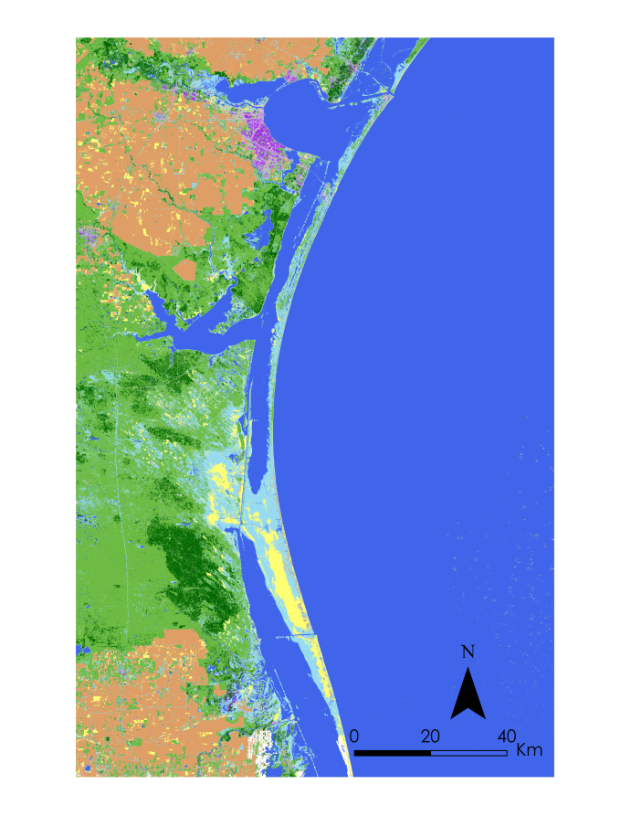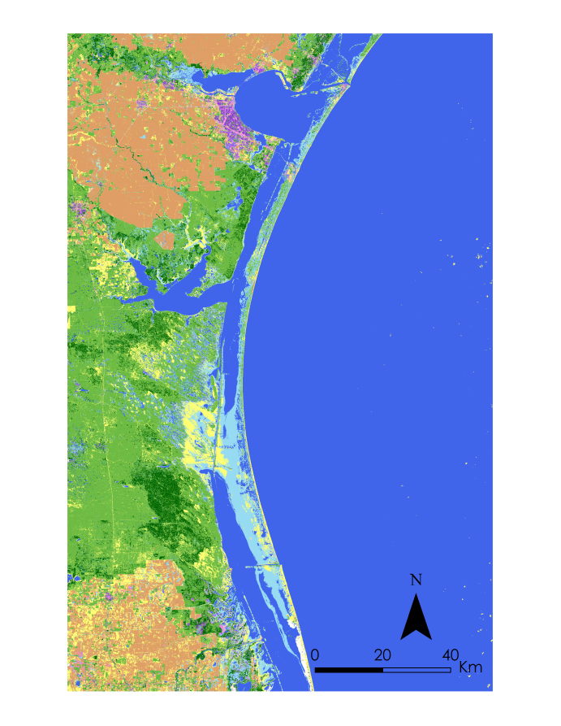

Figure 9. LULC (top) and NDII (bottom) maps for 2006 (left) and 2010 (right).

**2006**

**2010**

**2006**

**2010**

1. Assimilated GRACE data was retrieved from: ftp://gs6143shinano.gsfc.nasa.gov/pub/DM/GRACE_Assim_RL05/