**NASA DEVELOP National Program**



BLM at Idaho State University GIS TReC

**Summer 2015**

**Short Title: Idaho Disasters III**

**Subtitle:** Using Landsat 8 Earth Observations to Identify Increased Fire Susceptibility Due to Invasion of Cheatgrass (*Bromus tectorum*)

**VPS Title:** A Burnin’ Range of Fire: Wildfire susceptibility and Fuel in Idaho

**Project Team & Partners**

**Project Team:**

Jeff May (Project Lead), [mayja02@gmail.com](mailto:mayja02@gmail.com)

Jenna Williams

Zachary Simpson

**Advisors & Mentors:**

Keith Weber (Idaho State University)

Mark Carroll (NASA Goddard Space Flight Center)

John Schnase (NASA Goddard Space Flight Center)

**Past or Other Contributors:**

Kiersten Newtoff

Kyle Sowder

Andrea Bodenberg

Kathryn Bradford

Eric Smith

**Partner Organizations**

Bureau of Land Management, Idaho State Office and cooperating District Offices, End-User, POCs: Steve Jirik & Mike Kuyper

Idaho Department of Lands, Boise Field Office, End-User, POCs: Dixie Booker-lair & Robin Dunn

NASA RECOVER, Boundary Organization, POCs: Keith Weber, John Schnase, & Mark Carroll

USGS, Collaborator, POC: Collin Homer

**Project Details**

**Applied Sciences National Applications Addressed:** Disasters

**Study Area:** Southeast Idaho, United States

**Study Period:** April - September, 2013 & 2014; April - June, 2015

**Earth Observations & Parameters**

Landsat 8, OLI - Spectral bands to calculate vegetation and soil indices

**Ancillary Datasets Utilized**

* USGS National Land Cover Dataset 2011(NLCD) - Land cover
* USGS Biodiversity Information Serving Our Nation (BISON) - Plant species occurrence data
* USGS Earth Resources Observation and Science – 2014 annual grass percent cover estimate for the Twin Falls BLM District
* BLM 2013 cover plots that used a 100 foot transect on Chinese Peak in Pocatello, Idaho
* Center for Invasive Species & Ecosystem Health, University of Georgia - Cheatgrass distribution point data
* GIS Training & Research Center, Idaho State University Field Samples - Dominant land cover and cheatgrass point features
* USGS Cheatgras Percent Cover 2014

**Models Utilized**

* Clark Labs – GINI Classification Tree Analysis (IDRISI)

**Software Utilized**

ArcGIS 10.3 - Image enhancement, map creation of Landsat 8 OLI, post-image processing

IDRISI TerrSet - Image processing, Classification Tree Analysis, Atmospheric correction, and image classification

Hawth’s Analysis Tools - Random selection of class subsets for training and validation sites

Python – Software integration and batch processing

Pheno-Calc (GIS TReC) - Match calculations to more strategically select remotely sensed imagery for analysis

**Project Overview**

**80-100 Word Objectives Overview**

The Idaho Disasters III project explored the distribution of various vegetation types in SE Idaho and the affect this distribution has on wildfire regimes in the region. The objectives of this study were to map cheatgrass (*Bromus tectorum*) as this species is largely responsible for increased fire frequency since being introduced to the Western U.S. at the end of the nineteenth century. Classification analysis produced a vegetation map for the study region that was used to create a fire susceptibility model that identifies cheatgrass populations. These results benefit the broad fire community by identifying areas with greater fire susceptibility due to cheatgrass invasion.

**Abstract**

Wildfires, coupled with the presence of invasive plant species, are primary drivers of change in semi-arid savanna ecosystems. These wildfires disrupt ecosystems, human localities, critical habitats of the endangered Greater Sage Grouse (*Centrocercus urophasianus*), and create opportunities for invasive species to expand their populations. Wildland fire regimes have changed dramatically due to cheatgrass (*Bromus tectorum*), an invasive annual grass, which has effectively lengthened the wildfire season and increased fire frequency. Cheatgrass*es* ability to quickly establish in disturbed areas creates a positive feedback cycle with wildland fire, resulting in landscapes that burn more frequently and become increasingly dominated by this invasive plant. This creates a need for more advanced landscape and wildfire monitoring tools that can identify the prominence of invasive plants in order to provide better information regarding fire susceptibility. Currently, there are no active cheatgrass management plans in Idaho due to the overwhelming capabilities of the plant to dominate landscapes. However, effective management of this species requires knowledge of its distribution in order to evaluate wildfire regimes and prevent cheatgrass expansion in recently disturbed landscapes. This study used spring and summer 2013, 2014, and 2015 imagery from Landsat 8 Operational Land Imagery (OLI) and decision-tree-based classification to create a vegetation distribution map of SE Idaho that identified cheatgrass and was subsequently used to create a fire susceptibility map for the study area. These results enhance the decision making processes of the Bureau of Land Management and Idaho Department of Land with respect to resource allocations and supports post-fire rehabilitation planning and fuel reduction programs.

**Community Concerns**

* Climate change and invasive species have created a positive feedback environment leading to increased frequency and duration of wildfire regimes in Idaho.
* In 2012, Idaho spent $211 million dollars combating fires that burned 1.75 million acres resulting in the destruction of 96 structures and loss of life.
* Cheatgrass invasion decreases overall rangeland health and affects grazing allotments and critical habitats of endangered rangeland species.
* Disturbed rangeland are frequently re-inhabited by cheatgrass.

**Current Management Practices & Policies**

Project end-users currently rely on vegetation moisture measurements to support decisions regarding allocation of helicopters, dozers, and other fire suppression equipment across fire management zones throughout Idaho. These moisture measurement are collected at two week intervals in discrete locations across the state from March to October by various national, state, local and independent agencies and are input into the national Fuel Moisture Database. Presently, there is no active cheatgrass management program in Idaho, but its effect on rangeland ecology and wildfire regimes is well understood as a problem for Idaho and the Great Basin region.

**Decision Support Tools & Benefits**

|  |  |  |
| --- | --- | --- |
| **End-Product** | **Earth Observations Used** | **Benefit & Impact** |
| Vegetation Distribution Map | Landsat 8 OLI | Provide end-users valuable information regarding fuel distribution in Idaho rangelands to support resource allocation and fuel load reduction programs |
| Fire Susceptibility Map | Landsat 8 OLI derived vegetation map | Deliver mapped information regarding fire susceptibility to end-users based on vegetation distribution and topographic factors. This product will help identify areas where fire risk exists. |

**Project Imagery**

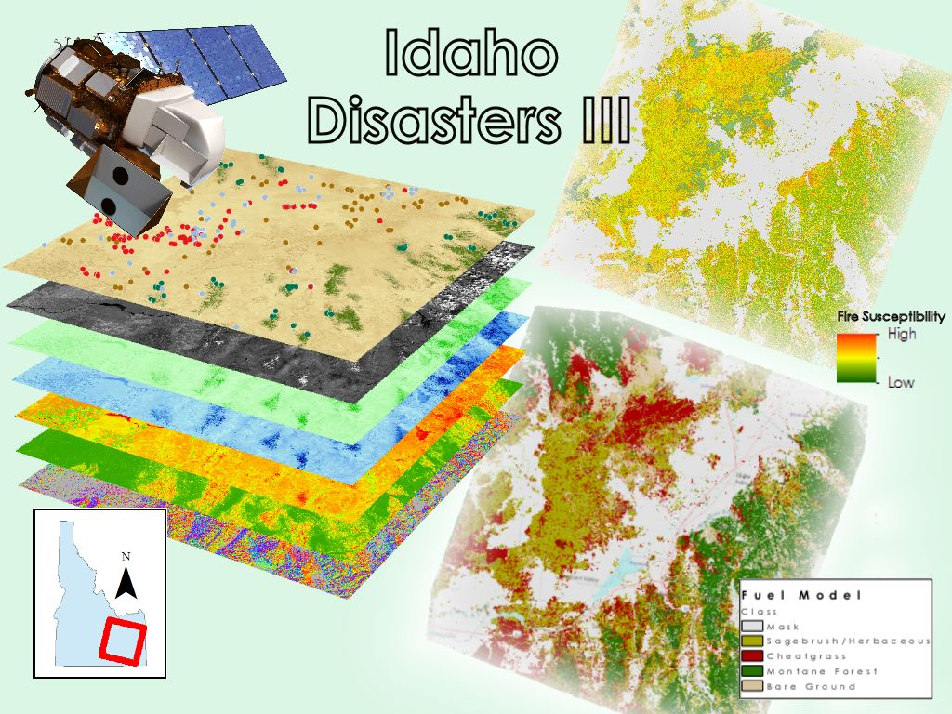

**Caption:** Image Credit: Idaho Disasters III Team

**Image:** IdahoDisastersIII_Imagery.jpg