**NASA DEVELOP National Program**

****NASA Jet Propulsion Laboratory

**Spring 2016**

**Short Title: Los Angeles Oceans II**

**Subtitle:** Validating Satellite Observations of Wastewater Plume Biological Impacts in Santa Monica Bay, California

**VPS Title:** Validating Satellite Observations of Wastewater Plume Biological Impacts in Santa Monica Bay, California

**Project Team & Partners**

**Project Team:**

Rebecca Trinh (Project Lead), Rebecca.Trinh@jpl.nasa.gov

Lindsay Almaleh

**Advisors & Mentors:**

Benjamin Holt (Oceans-Ice Group, NASA Jet Propulsion Laboratory)

Michelle Gierach (Oceans-Ice Group, NASA Jet Propulsion Laboratory)

**Past or Other Contributors:**

Christine Rains

Jack Pan

Mark Barker

**Partner Organizations:**

City of Los Angeles Hyperion Water Reclamation Plant (HWRP) (End-User), POC: Curtis Cash, Ashley Booth, and Mas Dojiri

**Project Details**

**Applied Sciences National Applications Addressed:** Oceans

**Study Area:** Santa Monica Bay, CA

**Study Period:** August 26 – November 30, 2015

**Earth Observations & Parameters:**

Aqua, MODIS – sea surface temperature, chlorophyll-a, remote sensing reflectance

Landsat 8, TIRS – sea surface temperature, chlorophyll-a, remote sensing reflectance

Terra, ASTER – sea surface temperature

Suomi NPP, VIIRS- chlorophyll-a, remote sensing reflectance

**Ancillary Datasets Utilized:**

* Hyperion Water Reclamation Plant- *in situ* temperature, salinity, dissolved oxygen, pH, conductivity, chlorophyll-a fluorescence
* NASA/JPL, Hyperpro™- *in situ* atmospheric aerosols, CDOM, turbidity
* NASA/JPL, Microtops- *in situ* atmospheric aerosol optical thickness
* University of Southern California- identify phytoplankton species and harmful algal blooms
* University of California Santa Barbra- HF radar for surface currents, and GPS-equipped drogue surface drifters

**Software Utilized:**

ArcGIS – Raster manipulation/analysis, image enhancement & map creation of MODIS, ASTER, VIIRS, and Landsat-8

SeaDAS - Data processing and manipulation of MODIS, VIIRs, and Landzat-8 data

ENVI – ASTER and Landsat-8 data processing

ACOLITE- Landsat-8 data processing

Matlab – Data processing and analysis, validating satellite image data with *in situ* data

**Project Overview**

**80-100 Word Objectives Overview:**

Sewage treatment plants must periodically undergo facility maintenance or upgrades to their current infrastructure of outfall pipes that routinely carry treated effluent into deep, offshore coastal waters. During this maintenance, the outflow is typically diverted to a shorter outfall pipe, releasing effluent into shallow coastal waters. By combining NASA Earth observations and *in situ* readings taken during the outflow event at the Hyperion Water Reclamation Plant (HWRP) in the City of Los Angeles, we can determine whether the effluent is negatively impacting the marine ecosystem and washing ashore, potentially harming beachgoers and marine biota.

**Abstract:**

The Hyperion Water Reclamation Plant is one of the largest wastewater treatment plants in the western United States. Treated sewage is generally released at depths of approximately 60 m through 8.05 km outfall pipes into a deep marine canyon in the Santa Monica Bay. In times of repair and maintenance, services on the main outfall pipe are temporarily suspended and require the plant to divert treated sewage to a shorter 1.6 km pipe that extends into shallow coastal zones. These shallow zones make it possible for the buoyant freshwater plumes to reach the surface, potentially contaminating the local environment. A six-week diversion event occurred at HWRP from September 21 to November 2, 2015. This project plans to integrate previously obtained NASA satellite images and ancillary data collected by other scientists. By combining remotely-sensed observations with GPS-equipped drogue surface drifters and *in situ* readings of temperature, salinity, atmospheric aerosols, colored dissolved organic matter (CDOM), and chlorophyll-a florescence, an accurate assessment of the full impact and extent at which these effluent plumes affected the Los Angeles Basin is possible. The outcome of this study can aid in developing proper methods to avoid harmful outcomes during similar diversion events in the future.

**Community Concerns:**

* Treated wastewater is diverted to shorter outfall pipes that extend into shallow coastal zones, where buoyant, freshwater plumes, containing possible containments, may reach the surface and potentially the coastline.
* Contaminants and bacteria can be harmful to humans who come in contact with the wastewater.
* Excessive nutrients near the surface may also stimulate harmful algal blooms (HABs) that are not only toxic to many marine organisms but also cause health problems to humans.

**Current Management Practices & Policies**:

The overriding concern of HWRP during required diversion events is to identify the wastewater plume, the extent of the plume, and how the plume might impact water quality and public health related to potential nutrient enrichment and beach bacterial contamination, respectively. The City of Los Angeles Hyperion Water Reclamation Plant conducts their own internal research operations, both within the plant and in the coastal waters in which they discharge the treated effluent. Extensive *in situ* sampling programs were undertaken on a daily basis during the 2015 diversion to determine water quality, concentration and spread of effluent-indicator components (e.g. fecal indicator bacteria and nutrients), and environmental ocean conditions. However, conducting *in situ* operations are very costly, and Hyperion officials typically partner with outside sources to bolster their near real-time observations. A project website has been set up for all science institutions working on this project, to allow for easy and fast data exchange. Satellite data provided through this web portal served as a synoptic capability for plume detection, which we used for guiding adaptive *in situ* sampling strategies. The City of Los Angeles is required to submit a final technical report on the diversion event by Spring 2016.

**Decision Support Tools & Benefits:**

|  |  |  |
| --- | --- | --- |
| **End-Product** | **Earth Observations Used** | **Benefit & Impact** |
| Maps of Thermal Plume Signature | Landsat 8, TIRS  Terra, ASTER  Aqua, MODIS | The effluent plume has distinct cold temperature signature that can be detected via satellite. This makes it easier for HWRP to track where the plume is. |
| Maps of Ocean Color Changes | Landsat 8, TIRS  Aqua, MODIS Suomi NPP,VIIRS | The effluent plume carries high nutrient loads and suspended solids that can be detected via satellite. The biological response in terms of phytoplankton bloom can also be monitored via satellite. This makes it easier for HWRP to track where the plume is. |
| Charts and Maps Comparing *In Situ* Data to Satellite Images | Landsat 8, TIRS  Aqua, MODIS  Terra, ASTER  Suomi NPP, VIIRS | Water quality and biological responses from the *in situ* measurements made before, during, and after the diversion event will be used in conjunction with the satellite images to validate both space borne and i*n situ* measurements for all parties involved. |

**Project Imagery**

**IMAGE**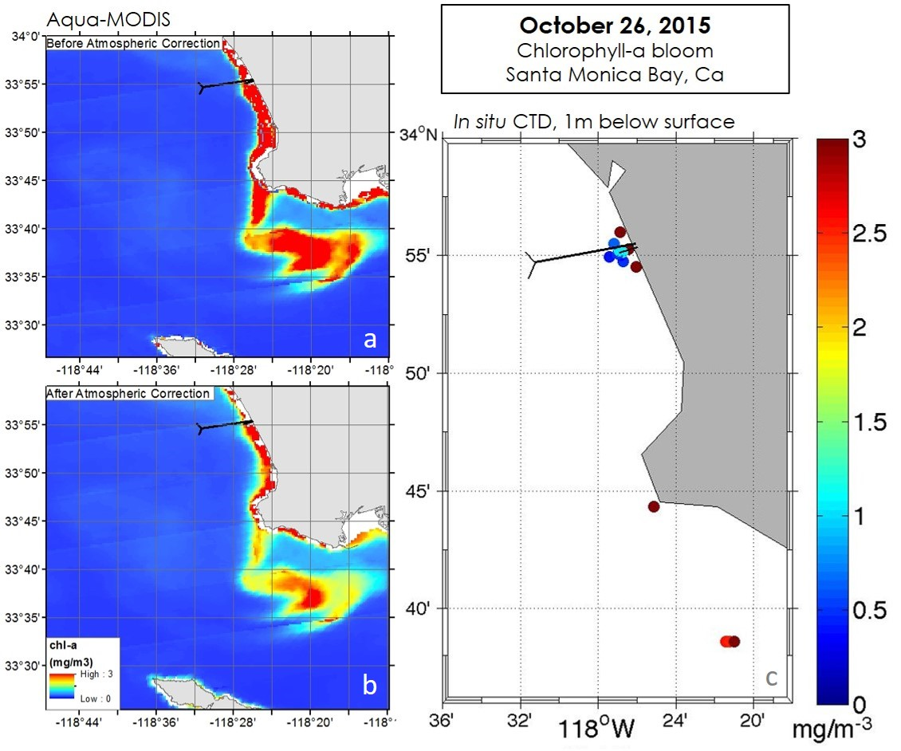

**Caption:** This project compares satellite observations with *in situ* readings in Santa Monica Bay, Ca during the Hyperion Water Reclamation Plant’s (HWRP) effluent diversion. The data acquired from NASA satellite Aqua-MODIS has been atmospherically corrected using aerosol optical thickness values (τ) obtained in the field on the same day as the satellite overpass (a and b). On October 26, 2015 an anomalous phytoplankton bloom was observed, using satellite imagery, curving downward and around Palos Verdes Peninsula. This bloom pattern is validated through *in situ* chlorophyll-a (chl-a) measurements taken on the same day using a CTD equipped with a fluorometer (c). This bloom is likely due to the increased level of nutrients released in the effluent at HWRP’s 1-mile outfall. Image credit: Los Angeles Oceans II Team.

**Image:** 2016Spring_JPL_LosAngelesOceansII_VPS_Image.jpeg

**Software Release Requirements**

What category do the tools your project is creating fall within?

Category I