**NASA DEVELOP National Program**



Wise County Clerk of Court’s Office

*Spring 2016*

African Great Lakes Weather II

Utilizing NASA Earth Observations to Identify Indicators to Help Predict Deadly Storms over the African Great Lakes

**Technical Report** 

Final Draft – Mar 31, 2016

Annabel White (Project Lead)

Jakub Blach

Michael Brooke

Megan Buzanowicz

Katherine Dooley

Rajkishan Rajappan

Ryan Umberger

Dr. Kenton Ross, NASA DEVELOP National Program (Science Advisor)

Kristopher Bedka, NASA Applied Sciences Climate Science Branch (Science Advisor)

Dr. DeWayne Cecil, Global Science & Technology National Centers for Environmental Information (Science Advisor)

Robert VanGundy, University of Virginia’s College at Wise (Science Advisor)

Previous Contributors:

William Wilson

Grant Bloomer

Juan Antonio Chacón Castro

# I. Abstract

The African Great Lakes lie along the East African Rift Valley and play an important role in the economy and culture of the millions of people in the region. Intense storms can develop around the lakes with little warning and create life-threatening hazards to fishermen. This project aims to find correlations between weather indicators and the onset of storms. The results will help the Kenya Meteorological Department to improve the forecasting accuracy of local and regional authorities. For the years 2005 to 2013, the NASA DEVELOP team compared potential storm indicators on days of heightened and average overshooting top (OT) detections. OTs are dome-like protrusions that form above the anvil of storms. Persistent OT detections are associated with storm events and therefore served as an indicator for hazardous storms over the study area. The Hazardous Storm Event Database (HSED), derived from the Spinning Enhanced Visible and Infrared Imager (SEVIRI) sensors present on Meteosat 8 & 9 satellites, contained the OT detection information used in this project. Aqua Atmospheric Infrared Sounder (AIRS) sensors, along with various Modern-Era Retrospective Analysis for Research and Applications (MERRA) products, provided meteorological data for statistical and spatial comparisons.

**Keywords**

Lake Victoria, weather, hazardous storms, natural disasters, MERRA, Aqua, Hazardous Storm Event Database, early storm warning

# II. Introduction

The African Great Lakes region spans Eastern Africa’s Great Rift Valley, including parts of Kenya, Tanzania, Uganda, Burundi, Rwanda, and the Democratic Republic of the Congo. These lakes significantly influence the regional climate (Thiery, 2015). Lake Victoria, one of the Great Lakes, is the second largest freshwater lake in the world in terms of surface area, and it serves a vital economic role for the 30 million people living along its coastline (Thiery, 2015). Nearly a third of the regional food supply is sourced from the lake by more than 200,000 fishermen (Song, 2004; Thiery, 2015). However, without an effective early warning system for dangerous weather, these fishermen are often caught in deadly storms resulting in loss of life every year (Thiery, 2015).

While meteorologists have a solid understanding of how these large lakes regulate long-term climate and contribute to the diurnal cycles of lake/land breezes and the thermal gradient surrounding the lake, less is known about short-term weather patterns over the lakes. This is, in part, due to the tropical climate, where hazardous storms with strong winds suddenly erupt and are not always accompanied by larger, more comprehensive storm movements.

This project aims to better understand storm meteorology over Lake Victoria by analyzing atmospheric conditions that were present during some of the most hazardous weather days over the study period from 2005-2013. Storm events that feature convective phenomena known as overshooting tops (OTs) typically yield more hazardous conditions at the ground level. Therefore, events of heightened OT activity were selected to represent hazardous storm occurrences. The Hazardous Storm Event Database (HSED) contains a directory of pixels identified as OTs by a detection algorithm developed by the National Aeronautics and Space Administration (NASA) Applied Sciences Program (ASP) and the Geostationary Operational Environmental Satellite R-Series (GOES-R) Aviation Algorithm Working Group. Employing infrared brightness temperatures from the Spinning Enhanced Visible and Infrared Imager (SEVIRI) sensor on-board the European Organization for the Exploitation of Meteorological Satellites (EUMETSAT) Meteosat 8 and 9 satellites, this algorithm analyzed 15-minute geostationary images during the aforementioned time period (Bedka et al., 2010; Bedka, 2011).

Uganda

**Lake**

**Victoria**

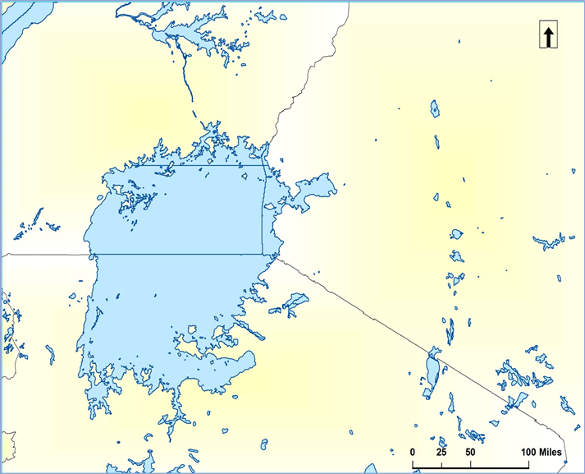

**Tanzania**

**Lake Victoria**

**Uganda**

**Kenya**

Figure 1: The study area, extending from 31°E to 38°E and 3°S to 2°N, includes the full extent of Lake Victoria and sections of Uganda, Kenya, and Tanzania.

The partner for this project was the Kenya Meteorological Department (KMD), whose mission is “to facilitate accessible meteorological information and services and infusion of scientific knowledge to spur socio-economic growth and development” (KMD, 2015). In the past, KMD partnered with NASA SERVIR to help incorporate satellite data into their weather forecasting model. In response, SERVIR trained KMD personnel to integrate NASA Earth observations into their models (Improving Kenya, n.d.).

This project contributes to the NASA ASP Application Areas of Weather and Disasters, as the findings from this project will assist KMD by providing them with information regarding weather variables that commonly precede the development of hazardous storms. Improved weather forecasting can mitigate damage and loss of life.

# III. Methodology

During the fall 2015 NASA DEVELOP term, MATLAB r2015a was used to compile data from the HSED into hourly detections over the study area. The hourly data was summarized into daily activity; then, the days were separated into percentiles based on the total number of OT pixel detections per day. Each percentile contained 30 days, and this analysis used each day that fell within the 50th and 99th percentiles, which represented average weather and the most hazardous weather during our study period, respectively. The weather variables present on these days were used to compare conditions between the two percentiles. The list of study dates are listed in Table 1, Appendix A.

Compiling the OT data from both percentile yields the following graph showing the OT pixel distributions with respect to time of day.

Figure 2: OT pixel counts vs time of day

Both OT distributions have bimodal peaks (Figure 2). Because overshooting tops are an indicator of storms, the peaks in Figure 2 represent times of increased storm activity. This project chose to examine the meteorological conditions at 0 and 12 UTC across the selected days, which provided a standardized way to compare conditions around periods of increased weather activity.

Modern Era Retrospective Analysis for Research and Applications (MERRA) data accessed from the Global Modeling and Assimilation Office at Goddard Space Flight Center provided 2-D atmospheric single-level and 3-D atmospheric assimilated state variable diagnostic data for each study date. Specific diagnostics were extracted at 0 and 12 UTC for the 2-D (Table 1) and 3-D (Table 2) diagnostics using both MATLAB r2015a and ArcGIS 10.1.

|  |  |  |
| --- | --- | --- |
| **Table 1: MERRA IAU 2-D Single-Level Diagnostics Used** | | |
| **Variable Name** | **Description** | **Unit** |
| U850 | Eastward wind at 850 mb | m/s |
| U500 | Eastward wind at 500 mb | m/s |
| V850 | Northward wind at 850 mb | m/s |
| V500 | Northward wind at 500 mb | m/s |
| T850 | Temperature at 850 mb | K |
| T500 | Temperature at 500 mb | K |
| Q850 | Specific humidity at 850 mb | kg/kg |
| Q500 | Specific humidity at 500 mb | kg/kg |
| H500 | Geopotential height at 500 mb | m |
| OMEGA500 | Vertical pressure velocity at 500 mb | Pa/s |
| TS | Surface skin temperature | K |
| U2M | Eastward wind at 2 m above the displacement height | m/s |
| V2M | Northward wind at 2 m above the displacement height | m/s |
| TQL | Total column cloud liquid water | kg/m2 |
| n/a* | Wind speed at 850 mb | m/s |
| n/a* | Wind speed at 500 mb | m/s |
| n/a* | Wind speed at at 2 m above the displacement height | m/s |
| n/a** | Temperature difference between surface and 500 mb | K |

*Wind speed was derived from eastward (U) and northward (V) wind velocity data using the formula: $\sqrt{U^{2}+V^{2}}$

**Temperature difference was derived from TS and T500 using the formula: TS – T500

|  |  |  |
| --- | --- | --- |
| **Table 2: MERRA IAU 3-D Assimilated State Variable Diagnostics Used** | | |
| **Variable Name** | **Description** | **Unit** |
| U700 | Eastward wind at 700 mb | m/s |
| V700 | Northward wind at 700 mb | m/s |
| T700 | Temperature at 700 mb | K |
| Q700 | Specific humidity at 700 mb | kg/kg |
| H700 | Geopotential height at 700 mb | m |
| OMEGA700 | Vertical pressure velocity at 700 mb | Pa/s |
| n/a* | Wind speed at 700 mb | m/s |

These variables were chosen because they represent typical levels analyzed by forecasters when they are predicting regions favorable for hazardous thunderstorm formation. For standard atmosphere, the 500 mb pressure level occurs at approximately 5.5 km altitude where circulation, wind, and temperature have a strong impact on thunderstorm development and severity; the 700 mb pressure level occurs at approximately 3 km; and the 850 pressure level is close to the surface where warm temperatures and high moisture content are typically present to produce thunderstorms. Both 500, 700, and 850 mb are standard pressure surfaces used in global meteorological models.

Thirty day average weather maps, corresponding to the 50th and 99th percentiles of each weather variable at 0 and 12 UTC, were produced and compared to one another. In addition, Atmospheric Infrared Sounder (AIRS) sensor data from the Aqua satellite were used to create skew-T plots at approximately 0 and 12 UTC for each study day. Archived AIRS data were uploaded to the AIRS Project Skew-T LogP Web Application by Steve Licata, a senior software engineer on the AIRS project. The Skew-T plots were then generated using the aforementioned AIRS Project Skew-T LogP Web Application available online via the AIRS Jet Propulsion Laboratory website.

# IV. Results & Discussion

Data from the HSED confirmed that OTs, suggestive of hazardous storms, typically formed over the land during the day and over Lake Victoria at night (Figure 3).

**Overshooting Tops on 23 March 2010 at 00 UTC**

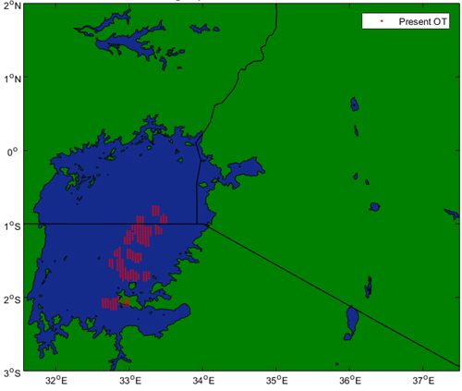

Latitude (degrees)

Longitude (degrees)

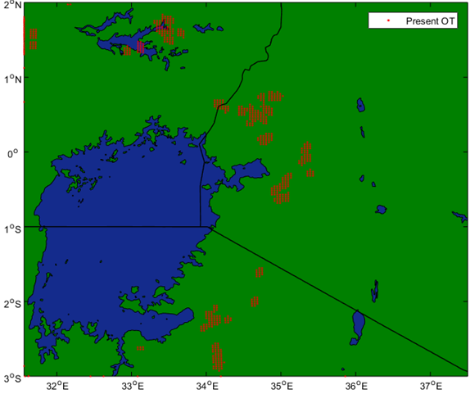

**Overshooting Tops on 23 March 2010 at 12 UTC**

Latitude (degrees)

Longitude (degrees)

Figure 3: March 23, 2010 (99th percentile day) overshooting top locations at 0 (left) and 12 UTC (right)

Although the locations of the OTs varied slightly from one day to the next, the separation of the OTs developing primarily over land during the day but over the lake at night represents the typical nature of these storms across the study period. Assuming that sunrise and sunset remain relatively constant at 04:00 UTC and 16:00 UTC over Lake Victoria, of the OTs within the 99th percentile that formed over the lake, Figure 4 depicts that 72% occurred at night while only 28% occurred during the day.

Figure 4: OTs over Lake Victoria by Time of Day

Skew-T plots from AIRS data shown in Figure 5 suggest that atmospheric instability indicated by high Convective Available Potential Energy (CAPE) measurements is the primary cause for hazardous storms over the land around Lake Victoria during the daytime.

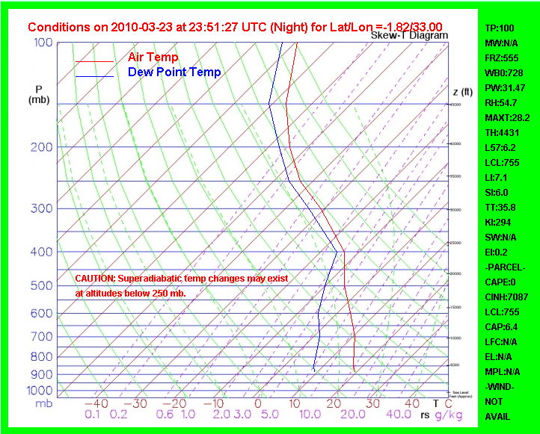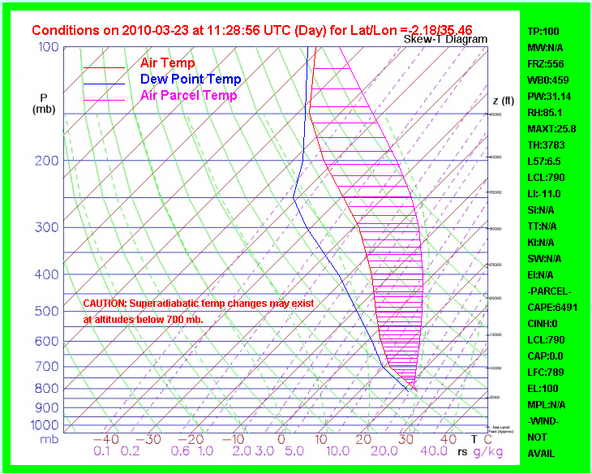

**No CAPE**

**High CAPE**

Figure 5: March 23, 2010 (99th percentile day) skew-T plots at approximately 0 (left) and 12 UTC (right)

Figure 5 is representative across the study period, in that high CAPE is generally detected over the land during the day relative to the general absence of CAPE over Lake Victoria at night. Negligible CAPE measurements suggest atypical factors cause the storms at night over the lake. Because the storms over the lake are of primary concern for fishermen, the analysis hereon will turn to comparing the differences in MERRA weather variables at 0 UTC between the 99th percentile, hazardous weather days and the 50th percentile, average weather days.

The 30-day average MERRA maps identified some parameters supporting storm development, while others showed no discernable trends. Specifically, 700 mb specific humidity was on average greater for the 99th percentile than the 50th percentile as displayed in Figure 6.

**99th Percentile Avg Specific**

**Humidity at 700 mb, 00 UTC**

**50th Percentile Avg Specific**

**Humidity at 700 mb, 00 UTC**

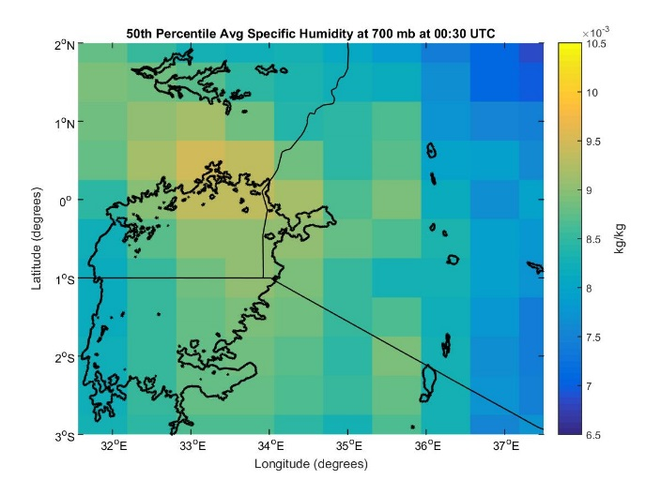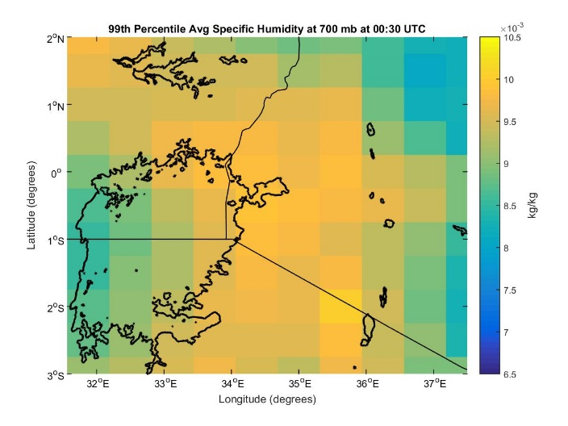

Latitude (degrees)

Longitude (degrees)

Longitude (degrees)

Latitude (degrees)

Figure 6: 700 mb specific humidity at 0 UTC for the 50th (left) and 99th (right) percentiles

Decreased geopotential height at the 700 mb level for the 99th percentile days implies low pressure over the region. This lower pressure provides a lifting mechanism, which coupled with the instability created by increased humidity at the 700 mb pressure level, (Figure 7) can indicate favorable conditions to drive the storm events.

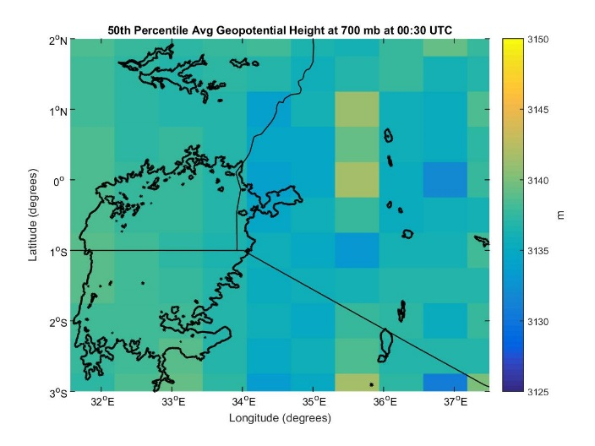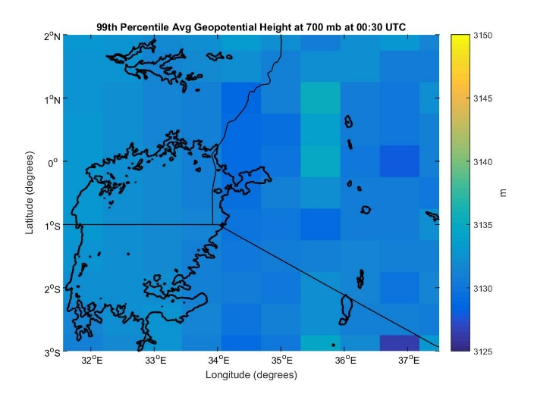

**99th Percentile Avg Geopotential**

**Height at 700 mb, 00 UTC**

**50th Percentile Avg Geopotential**

**Height at 700 mb, 00 UTC**

Longitude (degrees)

Longitude (degrees)

Latitude (degrees)

Latitude (degrees)

Figure 7: 700 mb geopotential height at 0 UTC for the 50th (left) and 99th (right) percentiles

700 mb vertical pressure velocity also indicated expected trends. Figure 8 reveals widespread negative vertical pressure velocity measurements across the lake for both percentiles, corresponding to rising air over the lake.

**99th Percentile Avg Vertical Pressure Velocity at 700 mb, 00 UTC**

**50th Percentile Avg Vertical**

**Pressure Velocity at 700 mb, 00 UTC**

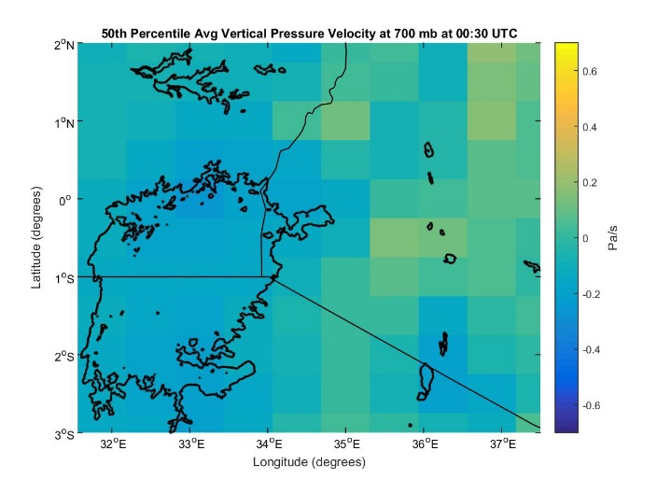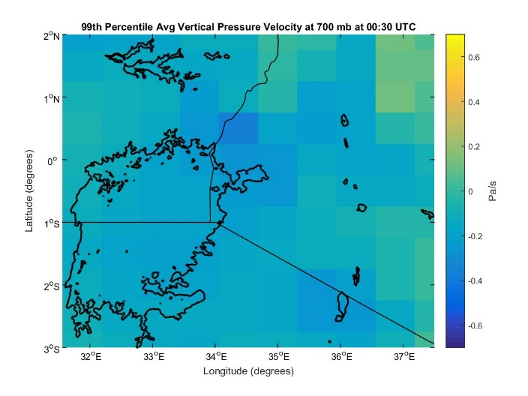

Longitude (degrees)

Longitude (degrees)

Latitude (degrees)

Latitude (degrees)

Figure 8: 700 mb vertical pressure velocity at 0 UTC for the 50th (left) and 99th (right) percentiles

During the night, the lake is warmer than the land around it causing the air over the lake to rise, which is needed for storm formation. The average vertical pressure velocity in a pixel off the northeast corner of the lake’s coast is 0.1 Pa/s higher for the 99th percentile than the 50th percentile. This difference may be due to the initial formulation of the storms generally occurring over the mountains northeast of the lake. 500 mb vertical pressure velocity showed similar trends.

The wind speed measurements at the 700 mb pressure level proved inconclusive. Contrary to expectation, the data indicated weaker wind speeds for the hazardous weather days relative to the average weather days, as displayed in Figure 9.

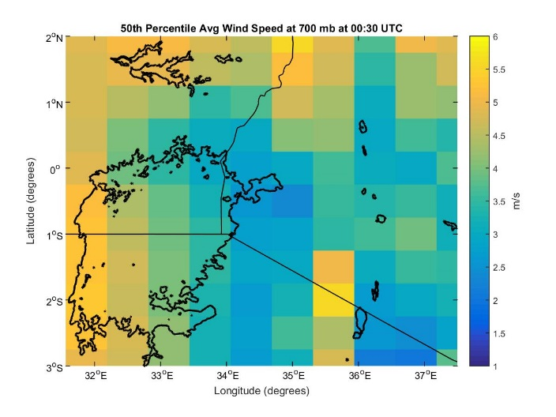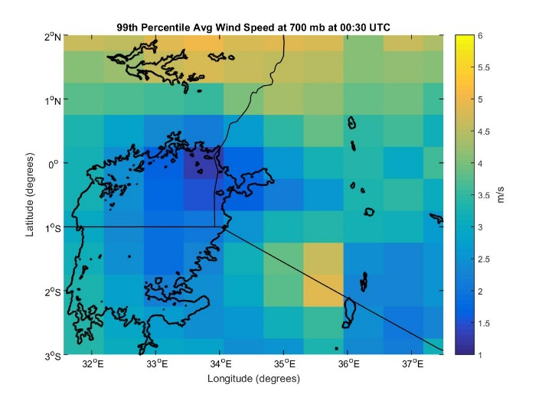

**50th Percentile Avg Wind Speed at 700 mb, 00 UTC**

**99th Percentile Avg Wind Speed at 700 mb, 00 UTC**

Longitude (degrees)

Longitude (degrees)

Latitude (degrees)

Latitude (degrees)

Figure 9: 700 mb wind speed at 0 UTC for the 50th (left) and 99th (right) percentiles

Strong winds that produce high wave heights are likely the leading cause of deaths among the fishermen on Lake Victoria; yet, Figure 9 presents weaker winds on the hazardous weather days.

All other weather variables not discussed showed negligible differences between the 50th and 99th percentile days at 0 UTC.

Effect size statistical tests were performed for six variables: TQL, vertical pressure velocity, TS, T850, T500, and temperature difference between the surface and 500 mb (TS-T500). The measurements of these six variables were extracted from the location of every overshooting top that occurred between 0 and 5 UTC across our 99thpercentile study dates. These data were compared against every measurement taken across the study period during this timeframe.

|  |  |
| --- | --- |
| **Weather Variable** | **Cohen’s d** |
| TS | 1.201736 |
| T850 | 0.541386 |
| T500 | 0.182381 |
| TS-T500 | 1.166731 |
| Vertical Pressure Velocity | 0.034428 |
| TQL | 0.217732 |

Table 3: Cohen’s d test of the difference between weather variable values at OT locations versus all measurements in the study area

Due to the large sample size, normal statistic tests evaluating significance could not be used to determine whether the difference between these datasets were practically notable; any small difference in the means would result in significant results due to the large sample size. Instead, Cohen’s d effect size was computed for the six variables. Although there is not a standard cutoff that indicates a large difference, generally a value of 0.2 indicates there is a small difference, 0.5 medium, and 0.8 large. Vertical pressure velocity was found to have no distinct difference between values at OT locations versus overall measurements in the study area, TQL yielded a small difference, and TS-T500 displayed a large difference (Table 3). Therefore, TS-T500 may be an important indicator of storm activity.  Also, as expected, temperature increased in importance as it neared the earth’s surface: TS, T850, and T500 yielded large, medium, and small importance respectively. Statistical summaries of these six variables can be found in Tables 5-10, Appendix A.

# V. Limitations and Future Research

MERRA’s resolution is 56x74 km, while a typical thunderstorm is approximately 24 km in diameter. MERRA, therefore, is simply unable to provide data at the necessary resolution to detect localized factors leading to these hazardous storms over the lake. This may explain some of the unexpected results such as the weaker winds on the hazardous weather days and other variables with negligible differences between the 50th and 99th percentiles.

This project also made the assumption that overshooting tops are synonymous with hazardous storm events. This assumption was based on research that demonstrated 47% of hazardous storms reported in Europe had a corresponding OT detection (Bedka, 2013). However, further research is needed to verify the inverse of this relationship: what percentage of detected OTs resulted in a hazardous storm. Adding more study dates in the analysis would also strengthen the validity of observed trends and statistical analyses.

Future work in this project would benefit from analyzing data on an hourly time step over 24 hours in addition to the current 0 and 12 UTC times. A correlation between OT detections and lightning data over the study area would further validate the OT-hazardous weather assumption. Finally, including additional statistical analyses to back up the trends observed in the weather maps would provide numerical evidence that these variables correlate with hazardous weather.

# VI. Conclusions

The weather maps produced from MERRA data products highlighted distinct differences in humidity, vertical pressure velocity, and geopotential height at the 700 mb pressure level between the average and hazardous weather days, therefore identifying these atmospheric conditions as potential storm indicators. However, the coarse resolution of the MERRA data limited the analysis of some variables, such as wind speed. The skew-T plots produced from AIRS data illustrated the absence of high CAPE values over the lake during storm events, indicating atypical drivers produce these storms. Future work can build upon the efforts of this project by including additional MERRA weather variables to provide a more complete picture of atmospheric conditions leading up to these storm events and identifying the driving factors in storm formation.

The suddenness with which hazardous storms occur over Lake Victoria and the African Great Lakes, in general, is a major factor in limiting the forecasting efforts of local meteorological agencies. The results from this project will provide our project partner, the Kenya Meteorological Department, with which atmospheric conditions can serve as potential storm indicators. By closely monitoring changes in these atmospheric conditions, more targeted and timely forecasts can be produced to reduce the loss of life and infrastructure associated with storm events over Lake Victoria.

# VII. Acknowledgments

The African Great Lakes Weather II Team would like to acknowledge the following people for their support:

* Dr. Kenton Ross – NASA DEVELOP National Program
* Kristopher Bedka – Climate Science Branch at NASA Langley’s Science Directorate
* Steve Licata - Jet Propulsion Laboratory, Atmospheric Infrared Sounder Project
* Dr. DeWayne Cecil – Global Science and Technology, Inc.
* Robert VanGundy – University of Virginia’s College at Wise
* April Huff – NASA DEVELOP/Wise County Clerk of Court’s Office
* Mike Bender – NASA DEVELOP National Program

Any opinions, findings, and conclusions or recommendations expressed in this material are those of the author(s) and do not necessarily reflect the views of the National Aeronautics and Space Administration.

This material is based upon work supported by NASA through contract NNL11AA00B and cooperative agreement NNX14AB60A.

# VIII. References

Bedka, K. (2011). Overshooting cloud top detections using MSG SEVIRI infrared brightness temperatures and their relationship to severe weather over Europe. Atmospheric Research, 175-189.

Bedka, K., Brunner, J., Dworak, R., Feltz, W., Otkin, J., & Greenwald, T. (2010). Objective satellite-based detection of overshooting tops using infrared window channel brightness temperature gradients. J. Appl. Meteor. Climatol. Journal of Applied Meteorology and Climatology, 181-202.

Improving Kenya Meteorological Department Numerical Weather Prediction. (n.d.). Retrieved October 7, 2015 from http://catalogue.servirglobal.net/Product?product_id=15.

Mission and functions of the Kenya Meteorological Department. (2015). Retrieved Feb 16, 2016 from http://www.meteo.go.ke/index.php?q=about.

Song, Y., Semazzi, F., Xie, L., & Ogallo, L. (2004). A coupled regional climate model for the Lake Victoria basin of East Africa. International Journal of Climatology, 24, 57-75.

Thiery, W., Davin, E., Panitz, H.-J., Demuzere, M., Lhermitte, S., & Van Lipzig, N. (2015). The impact of the African Great Lakes on the regional climate. Journal of Climate, 28, 4061-4085.

# IX. Content Innovation

MATLAB Plots: Inline Supplementary Material

Skew-T Plots: Inline Supplementary Material

# X. Appendix A

|  |  |
| --- | --- |
| **Table 4: Study Dates** | |
| **99th Percentile** | **50th Percentile** |
| 03/08/2006 | 03/06/2005 |
| 11/19/2006 | 03/20/2006 |
| 11/21/2006 | 03/27/2006 |
| 11/22/2006 | 04/02/2006 |
| 04/13/2007 | 09/28/2006 |
| 11/07/2008 | 06/03/2007 |
| 02/04/2009 | 08/21/2007 |
| 04/06/2009 | 10/04/2007 |
| 04/07/2009 | 02/27/2008 |
| 04/11/2009 | 08/15/2008 |
| 05/11/2009 | 11/19/2008 |
| 02/25/2010 | 06/01/2009 |
| 03/23/2010 | 06/05/2009 |
| 03/24/2010 | 12/03/2009 |
| 03/27/2010 | 12/07/2010 |
| 10/18/2011 | 03/16/2011 |
| 10/27/2011 | 06/09/2011 |
| 11/06/2011 | 09/22/2011 |
| 11/07/2011 | 10/15/2011 |
| 11/24/2011 | 10/31/2011 |
| 04/18/2012 | 01/12/2012 |
| 04/24/2012 | 03/19/2012 |
| 03/27/2013 | 04/02/2012 |
| 03/28/2013 | 07/14/2012 |
| 03/30/2013 | 10/18/2012 |
| 03/31/2013 | 11/04/2012 |
| 04/06/2013 | 12/29/2012 |
| 04/10/2013 | 09/06/2013 |
| 04/11/2013 | 10/20/2013 |
| 04/12/2013 | 11/02/2013 |

|  |  |  |
| --- | --- | --- |
| **Table 5: TS Statistics** | | |
|  | **Population** | **OT** |
| **Mean** | 292.7222 | 296.7442 |
| **Standard Deviation** | 3.877531 | 2.714261 |
| **Sample Size** | 21780 | 34890 |
| **Cohen’s d** | (296.7442 - 292.7222) / 3.346824 | 1.201736 |
| **Gate’s delta** | (296.7442 - 292.7222) / 3.877531 | 1.037258 |
| **Hedge’s g** | (296.7442 - 292.7222) / 3.211579 | 1.252343 |

|  |  |  |
| --- | --- | --- |
| **Table 6: T850 Statistics** | | |
|  | **Population** | **OT** |
| **Mean** | 292.2486 | 292.8465 |
| **Standard Deviation** | 1.200779 | 0.998737 |
| **Sample Size** | 18004 | 34633 |
| **Cohen’s d** | (292.8465 - 292.2486) / 1.104388 | 0.541386 |
| **Gate’s delta** | (292.8465 - 292.2486) / 1.200779 | 0.497927 |
| **Hedge’s g** | (292.8465 - 292.2486) / 1.072135 | 0.557672 |

|  |  |  |
| --- | --- | --- |
| **Table 7: T500 Statistics** | | |
|  | **Population** | **OT** |
| **Mean** | 267.7711 | 267.8944 |
| **Standard Deviation** | 0.682618 | 0.669432 |
| **Sample Size** | 21780 | 34650 |
| **Cohen’s d** | (267.8944 - 267.7711) / 0.676057 | 0.182381 |
| **Gate’s delta** | (267.8944 - 267.7711) / 0.682618 | 0.1860628 |
| **Hedge’s g** | (267.8944 - 267.7711) / 0.674552 | 0.182788 |

|  |  |  |
| --- | --- | --- |
| **Table 8: TS-T500 Statistics** | | |
|  | **Population** | **OT** |
| **Mean** | 24.951013 | 28.869881 |
| **Standard Deviation** | 3.894376 | 2.719838 |
| **Sample Size** | 21780 | 34302 |
| **Cohen’s d** | (28.869881 - 24.951013) / 3.358845 | 1.166731 |
| **Gate’s delta** | (28.869881 - 24.951013) / 3.894376 | 1.00629 |
| **Hedges’ g** | (28.869881 - 24.951013) / 3.358845 | 1.166731 |

|  |  |  |
| --- | --- | --- |
| **Table 9: TQL Statistics** | | |
|  | **Population** | **OT** |
| **Mean** | 0.103629 | 0.120521 |
| **Standard Deviation** | 0.083523 | 0.071146 |
| **Sample Size** | 21780 | 36436 |
| **Cohen’s d** | (0.120521 - 0.103629) / 0.077582 | 0.217732 |
| **Gate’s delta** | (0.120521 - 0.103629) / 0.083523 | 0.202244 |
| **Hedges’ g** | (0.120521 - 0.103629) / 0.076013 | 0.222226 |

|  |  |  |
| --- | --- | --- |
| **Table 10: Vertical Pressure Velocity Statistics** | | |
|  | **Population** | **OT** |
| **Mean** | -0.125708 | -0.137821 |
| **Standard Deviation** | 0.382338 | 0.318425 |
| **Sample Size** | 21538 | 44015 |
| **Cohen’s d** | (-0.137821 - -0.125708) / 0.351836 | 0.034428 |
| **Gate’s delta** | (-0.137821 - -0.125708) / 0.382338 | 0.031681 |
| **Hedges’ g** | (-0.137821 - -0.125708) / 0.340749 | 0.035548 |