**NASA DEVELOP National Program**



NASA Langley Research Center and NASA Jet Propulsion Laboratory

*Spring 2017*

Mississippi Sound Water Resources

Synthesizing Trends in Water Quality Parameters that Affect Oyster Reef Health in the Mississippi Sound Using NASA Earth Observations

 **Technical Report**

Final Draft – March 30, 2017

Emily Gotschalk (Project Co-Lead)

Brigitte Moneymaker (Project Co-Lead)

Katherine Cavanaugh

Jessica Gregory

Erika Higa

Catherine Stolfi

Dr. Kenton Ross, NASA Langley Research Center (Science Advisor)

Ben Holt, NASA Jet Propulsion Laboratory (Science Advisor)

Dr. Severine Fournier, NASA Jet Propulsion Laboratory (Science Advisor)

# 1. Abstract

Commercially-harvested oysters are a significant ecological and economic driver in multiple coastal regions throughout the world. In the last decade, the Mississippi Sound has seen a rapid decline in oyster reef production, especially in the years following large ecological disturbances such as Hurricane Katrina in 2005 and the flooding of the Mississippi River in 2011. In partnership with the Mississippi Department of Marine Resources, the NASA DEVELOP team utilized remotely-sensed products in order to create a climatology and time series of specific water quality parameters that can have impact on oyster reef productivity. These parameters included salinity, sea surface temperature, chlorophyll-a, absorption due to gelbstoff and detrital material (aDG), total suspended matter, and turbidity. The project utilized data from several Earth observing satellites including Aqua MODIS, SMAP, Landsat 5 TM, Landsat 7 ETM+, Landsat 8 OLI and TIRS, and MUR, as well as data from ESA’s Sentinel-2 MSI and SMOS. The results from this project could potentially assist the Mississippi Department of Marine Resources by providing products for additional mapping and assessment of future oyster reef health in the Mississippi Sound. These products will also allow the project partners to improve future management practices for species recovery and the creation of additional oyster reefs.

**Keywords**

Mississippi Sound, water resources, water quality, oyster reefs, remote sensing, SMAP, MODIS, MUR, Landsat, SMOS, Sentinel-2, Aqua

# 2. Introduction

* 1. ***Background Information***

The Mississippi Sound spans roughly 90 miles along the southern coasts of Mississippi and Alabama. The Sound is bordered by Lake Borgne on the west, Mobile Bay to the east, and runs adjacent to the Gulf Coast Barrier Islands to the south. As an ecologically diverse system that receives vital freshwater inflows from several rivers and tidal bayous, the Sound remains a brackish-water environment due to its proximity to the Gulf of Mexico (Eleuterius, 1977). The area is also home to several commercially-significant oyster reefs, which contain select brackish-water shellfish species such as the Eastern Oyster (*Crassostrea virginica*). In addition to their economic importance, these reefs provide a vital habitat for fish and other aquatic species, and improve water quality through filter feeding on phytoplankton that could potentially lead to harmful algal blooms (Newell and Jordan 1983; Zimmerman et al., 1989).

According to the Mississippi Department of Marine Resources (MDMR), 97% of the state’s commercial oysters are harvested from the western part of the Sound (Appendix A1). Over the last two decades, the reefs in this area have experienced a 90% decrease in oyster production, which was exacerbated by the landfall of Hurricane Katrina in 2005 (Impact Assessment Inc., 2007). In addition to large ecological disturbances, oyster reef populations can also be negatively affected by regional water quality changes, such as a decrease in salinity or an increase in temperature (Power et al., 1995; Rybovich et al., 2016). Reports have shown that large influxes of freshwater, such as the Bonnet Carré Spillway opening due to Mississippi River flooding, can cause higher oyster mortality (Eleuterius, 1977). Additionally, the Louisiana marshland located west of the Mississippi Sound, which is an important source of filtration for freshwater flows into the reef, has been subjected to rapid degradation over the last decade. This combination of reduced marshland and increased freshwater flow into the Mississippi Sound has likely contributed to the decline of oyster reef production, according to the MDMR. The deliverables produced from this project will provide MDMR with additional resources to monitor these changes, and allow for supplementary mapping and assessment of future oyster reef health in the Mississippi Sound.

* 1. ***Project Partners & Objectives***

The Mississippi Department of Marine Resources (MDMR) is devoted to maintaining all marine habitats in the Mississippi Sound. Since 2015, the MDMR has been working with the established Oyster Restoration and Resiliency Council in order to slow and reverse the decline of oyster populations in the Sound. The Mississippi Sound Water Resources NASA DEVELOP team partnered with the MDMR to develop short term climatology maps and time series of water quality parameters, intended to show how oyster reef production has been affected in the area from 2002 to 2016. The project area for this study includes the entire Mississippi Sound, in addition to Louisiana's Lake Borgne and Chandeleur Islands.

The project partners will use the water quality climatology maps and time series to provide additional insight to both the spatial and temporal scale of oyster reef decline in the Sound. This project addresses the NASA Applied Sciences’ Water Resources National Application Area by supporting the use of Earth observations for water resources management.

# 3. Methodology

***3.1 Data Acquisition***

USGS EarthExplorer provided 30 m resolution images from Landsat 5 Thematic Mapper, Landsat 7 Enhanced Thematic Mapper Plus, and Landsat 8 Operational Land Imager (Appendix B1). We excluded the images with cloud cover greater than 90%, and masked any remaining cloud cover and associated shadows within ACOLITE. USGS EarthExplorer also provided Level-1C 20 m resolution images from Sentinel-2 (Appendix B3) We excluded the images with cloud cover greater than 90%, and masked any remaining cloud cover and associated shadows within ACOLITE.

NASA Ocean Color provided Level 3 4km monthly Aqua MODIS chlorophyll-a, aDG, and Sea Surface Temperature (SST) data, which the team downloaded using the browser extension tool DownThemAll! 3.0.8. Dr. Chuanmin Hu also provided the team with daily chlorophyll-a 1 km resolution data for 2003-2014, which was processed according to Le et al., (2014). Dr. Chuanmin Hu and his colleagues developed a hybrid algorithm for estimating chlorophyll-a with near-concurrent MODIS data which were calibrated and validated using field observations in the Louisiana coast.

The Land Processes Distributed Active Archive Center (LP.DAAC) provided surface reflectance from Aqua MODIS using the Application for Extracting and Exploring Analysis Ready Samples (AppEEARS) area sample tool, courtesy of the NASA EOSDIS LP DAAC USGS/Earth Resources Observation and Science (EROS) Center. The 8-day Level 3 product contains the best possible observations as selected on the basis of high observation coverage, low-view angle, the absence of clouds or cloud shadow, and aerosol loading. The data obtained spans from July 2002 to December 2016.

The Soil Moisture Active Passive (SMAP) platform provided a sea surface salinity (SSS) data product that is based on a retrieval algorithm combining both the SSS and wind speed (WSPD) retrieval method. The L3 V2 monthly data is already filtered for quality at the map aggregation stage, gridded at 0.25° resolution, excludes land cover, and is provided in NetCDF4 format. The data is pre-processed and distributed by JPL, and the team accessed imagery from April 2015 to December 2016 through the JPL Physical Oceanography Distributed Active Archive Center (PO.DAAC) using a Python code that batch downloaded all the files by file transfer protocol (FTP).

Centre Aval de Traitement des Données SMOS (CATDS) provided SSS products from the Soil Moisture and Ocean Salinity (SMOS) satellite. The L3 V2 monthly composite, 0.25° resolution SMOS SSS data were obtained from the Ocean Salinity Expertise Center (CECOS) of the CNES-IFREMER CATDS. The product is land masked and is provided in NetCDF4 format. The team batch downloaded this dataset from May 2010 to December 2014 using a FileZilla server that connected to the CATDS FTP site.

The PO.DAAC also provided analyzed sea surface temperature from the Multi-scale Ultra-high Resolution (MUR) sea surface temperature dataset. The dataset is produced by the Group for High Resolution Sea Surface Temperature (GHRSST), and includes NetCDF4 files of global analyzed SST data every day at roughly 1 km intervals. The L4 analysis is based on input from several NASA sensors, including AMSR-E, MODIS, AVHRR-3, and WindSat. The team batch downloaded daily SST from June 2002 to January 2017 from PO.DAAC using Python to bind the coordinates to the Mississippi Sound.

The team also acquired *in situ* discharge, water temperature, and salinity data from the USGS Current Water Data for the Nation (Appendix B4). These specific stations were chosen based on proximity and relation to the western portion of the study area.

***3.2 Data Processing***

To create the zonal time series, a shapefile was created within ArcMap using four separate zones,

All chosen based on their proximity to the Sound and river outputs (Appendix A2). Each time series utilized these shapefiles in order to maintain consistent processing boundaries. The only exception was sea surface salinity due to the data availability near the coast from both SMAP and SMOS. The zone used for the sea surface salinity time series was much larger, which encompassed as much data near the Mississippi Sound as possible (Appendix A3). Since very few SSS pixels were included in the five zonal areas, it was best to create a larger zone to analyze SSS in the study area. An R script was used to derive the mean of the pixels that were within each box of interest for each month.

***Landsat and Sentinel-2: chlorophyll-a and Turbidity***

The team derived chlorophyll-a concentration and turbidity from Landsat 5, 7, 8, and Sentinel-2 data using the OC2 algorithm and the semi-empirical single band turbidity retrieval algorithm, respectively, provided within the ACOLITE processing software (Appendix B5 and B6). Each variable within the OC2 algorithm represents a different numeric constant for both sensors (Appendix B7). Within the semi-empirical single band turbidity retrieval algorithm, AλT and Cλ are calibration coefficients that are dependent on wavelength and ρw is water reflectance (Nechadi et al., 2009). ACOLITE derived turbidity from both sensors using the 645/859 nm setting used within Dogliotti et al. (2015). For Landsat 8 OLI imagery, the 655/865 nm bands were used, and for Sentinel-2, the 664/865 nm bands were used (Vanhellemont, 2017).

The resulting images were converted from NetCDF to GeoTIFF format, and geolocated using Geospatial Data Abstraction Library (GDAL). The resulting desired values were extracted from both the Landsat 5, 7, 8, and Sentinel-2 images, and used to create a time series for each parameter.

***Aqua MODIS: chlorophyll-a, Total Suspended Matter, and aDG***

The chlorophyll-a data from Dr. Chuanmin Hu was converted to GeoTIFFs using a Python code that incorporated gdal_translate. ModelBuilder was used to batch convert all the pixel values that were above 100 and below 0 as No Data values. A monthly mean of the data was then created using ArcMap’s Cell Statistics on the daily data, which were used to create time series for the appended study period of 2003 to 2014.

Total suspended matter (TSM) was derived from the MODIS Aqua 8-day Surface Reflectance product using band 1 (red portion) 250 m data. Utilizing provided Quality Assurance (QA) data files, the clouds in each 8-day file were masked and extraneous values were removed. The reflectance value range was converted to % Reflectance applying the scale factor provided with the MODIS product [Reflectance Value (0.001)]. An equation, outlined by Miller and McKee (2004), was applied to the % Reflectance value for conversion to the TSM mg/L unit (Appendix B8). The 8-day products were then separated into roughly 1 month aggregates for easier comparison (Appendix C1). ArcMap Cell Statistics was used to create monthly averages, and the rasters were clipped within ArcMap ModelBuilder to speed up processing time. Zonal averages for each time series was created using an R script in RStudio, and graphed using Microsoft Excel. Level-3 4km Aqua MODIS chlorophyll-a and aDG products were converted from NetCDF files to GeoTIFF rasters using ModelBuilder in ArcMap. GeoTIFFs were then processed using an R script to determine zonal averages for each time series, and graphed in Microsoft Excel (Appendix C2).

***SMAP and SMOS: Sea Surface Salinity***

SSS from SMAP and SMOS were converted to GeoTIFF files from NetCDF files using Python, and then reprojected to ArcMap’s World Geodetic System 1984 projection using Python and GDAL. The SSS data were also batch clipped to a smaller study area. Zonal averages for the modified processing boundary were calculated using R.

***MUR: Sea Surface Temperature***

The MUR products were converted from NetCDF files to GeoTIFF files using a python script. These files were then processed in ArcMap using Cell Statistics and ModelBuilder to create climatology maps. The zonal averages for the time series were processed using an R script in RStudio, and the resulting time series were graphed in Microsoft Excel.

***USGS: in situ Discharge, Salinity, and Temperature***

The *in situ* data from the USGS was downloaded into Microsoft Excel, and aggregated into monthly and daily averages using R.

***3.3 Data Analysis***

Each parameter was analyzed on a monthly basis using cell statistics to determine the climatology of the areas around the oyster reefs, and corresponding zonal statistics to create time series for several predetermined zones (Appendix D1).

USGS *in situ* sea surface salinity and temperature data were converted to a time series, and used to fill in any coastal data gaps that occurred within coarser resolution imagery.

# 4. Results and Discussion

***4.1 Analysis of Results***

***Chlorophyll-a and aDG***

Large spikes of chlorophyll-a concentrations tend to occur one to two weeks after periods of large rainfall when river discharge levels are high, as the incoming water contains an abundance of terrestrial nutrients that increases optimal conditions for algal photosynthesis (Bennett et al., 1986; Julta et al., 2011). As a result chlorophyll-a was chosen as a way to analyze the amount of freshwater flowing into the sound from the surrounding lakes and rivers. The Mississippi Sound chlorophyll-a time series from each sensor exhibited similar patterns, yet values for each trend contained slightly different magnitudes (Appendix E1). The 4km MODIS was able to capture the entire time period of the study, while data from Le et al.’s MODIS is unavailable after 2014, Landsat 8 data is unavailable before May 2013, and Sentinel-2 data is unavailable before December 2015. Landsat 5 and 7 were excluded from further analysis after ACOLITE processing determined that both sensors provided data that was too unreliable for both chlorophyll-a and turbidity.  Furthermore, Landsat 8 and Sentinel-2 were unsuccessful at capturing an accurate depiction of chlorophyll-a concentration within the study area during the summer months, as extensive cloud cover from May to August caused data gaps and unreliable values in the trend (Appendix E4).

Spatially, Landsat 8 and Sentinel-2 were able to capture patterns in specific locations of both high and low chlorophyll-a concentrations, as each satellite has a fine spatial resolution (Appendices E2, E3). The data from Le et al.’s MODIS was able to capture better spatial patterns than the 4km MODIS, which has an extremely coarse spatial resolution, especially in coastal regions (Appendices E5, E6). The data from Le et al.’s  MODIS, however, should be analyzed with caution since the algorithm is fine tuned for mapping chlorophyll-a along the Louisiana coast. Chlorophyll-a values along the Mississippi coast may not be representative of true chlorophyll-a conditions, or may be over-quantified. Furthermore, MODIS image inputs to Le et al.’s data were limited for February 2012 and July 2013, and these values may be outliers in the trend.

For the 4km MODIS chlorophyll-a products, each of the five study areas from Landsat 8 and Sentinel-2 contained similar chlorophyll-a concentration values throughout the time series, and none of the trends were consistently higher or lower than the rest (Appendix E6). Lake Borgne showed the highest chlorophyll-a concentration with an average of 25.08 mg/m3 for the entire study period, while the average concentration of chlorophyll-a for the Mississippi Sound was 12.33 mg/m3. The influx of freshwater flowing into Lake Borgne is most likely responsible for the higher concentrations of chlorophyll-a in this region. The chlorophyll-a concentration from the 4km MODIS had similar spatial trends with Lake Borgne exhibiting a consistently higher reading than the other study area in the first half of the study period (2003-2009), but the second half (2009-2016) shows similar seasonal trends among all five study areas, with noticeable spikes in mid-2011 and early 2016. For the Landsat derived from Landsat 8, the highest value occurred in the Western Sound in May of 2014 with a value of 8.08 mg/m3. For Sentinel-2, the highest value occurred in the Chandeleur Gulf in December of 2016 with a value of 65.44 mg/m3.

Additionally, the overall chlorophyll-a concentration from 4km MODIS was higher than Sentinel-2 and Landsat, but lower than the Le et al.’s MODIS method (Appendix E1). The 4km MODIS average chlorophyll-a concentration for Lake Borgne was 11.42 mg/m3 for the entire study period, with a maximum value of 26.60 mg/m3 in May 2011. Additionally, there was a spike in chlorophyll-a concentration shown by the Le et al.’s MODIS in mid-2013 for the Western Sound and the Chandeleur Gulf that does not register with 4km MODIS (Appendix E5). This could be due to the coarser resolution of the 4km MODIS chlorophyll-a product, which failed to pick up data near the coastline, whereas the Le et al. (2014) method was designed to be more fine-tuned to the blooms near the coast, and was able to detect a higher concentration of chlorophyll-a.

Absorption due to gelbstoff and detrital matter (aDG) is a measure of the amount of colored dissolved organic matter (CDOM) present in the water (measured in aDG coefficient/m). CDOM is much higher in freshwater environments and estuaries, where it originates from terrestrial discharge (Hoge et al., 1995). Similar to chlorophyll-a, aDG DG was used as an additional parameter to monitor freshwater input into the Mississippi Sound. 4km Aqua MODIS also suffered from a large amount of data loss in our project area, especially in Lake Borgne (Appendix E7). With the data available for Lake Borgne, it was clear in the time series that it had the highest amount of aDG, followed by the Western Sound. The average aDG for Lake Borgne during the entire study period was 1.175 m-1 with a high of 1.81 m-1 in August 2009. The average aDG for the Western Sound during the entire study period was 0.77 m-1, with a high of 1.81m-1 in December 2015. The high aDG levels in Lake Borgne and the Western Sound are consistent with the amount of freshwater input into the sound in that area, including the Pearl River into Lake Borgne, and then Lake Borgne flowing into the Western Sound.

***Total Suspended Matter and Turbidity***

Turbidity and total suspended matter (TSM) are parameters that can also be used as an indicator of increased freshwater flow into a system. Although they are very similar, turbidity and TSM measure two slightly different things. Turbidity refers to the light scattering properties of water, and particulates of light passage interference can include suspended inorganic material, organic material, and algae (Water Research Watershed Center, 2014). TSM, on the other hand, is a quantitative measurement of the suspended particles present within water that will not settle with gravity (Water Research Watershed Center, 2014).

The Mississippi Sound time series for TSM and turbidity from each sensor exhibited different patterns (Appendix E8). The 250m MODIS product was able to capture the entire time period of the study, while Landsat 8 data is unavailable before May 2013, and Sentinel-2 data is unavailable before December 2015. Furthermore, Landsat 8 and Sentinel-2 suffered from the same cloud contamination issues present within the chlorophyll-a analysis.

For the 250m MODIS TSM, Lake Borgne exhibited the highest signal during the entire study period reaching a maximum of 56.86 mg/L in April of 2013. The overall average for the entire study period for Lake Borgne was 34.92 mg/L. After 2007, the overall average for the entire study period for Lake Borgne increases to 39.62 mg/L. In contrast, the monthly average TSM for the entire Mississippi Sound area is just 15.77 mg/L (Appendix E10). This is another indicator of the high amount of freshwater coming into the Lake from the surrounding rivers. There is also a clear seasonal trend that can be seen with the 250m MODIS time series that shows TSM exhibiting more of a consistent seasonal pattern after 2007. For the Sentinel-2 derived chlorophyll-a, the highest value was 25.21 mg/m3 in May 2016, which corresponds with a recent algal bloom witnessed by the MDMR during the past season (Appendix E9)  For the turbidity derived from Landsat 8, the highest value occurred in May of 2013 with a value of 63.97 FNU.  For the turbidity derived from Sentinel-2, the highest value occurred in November of 2016 with a value of 128 FNU (Appendix E11).

Utilizing the 250m MODIS band 1 data for mapping suspended sediment concentration is a common method and appropriate for smaller coastal environments, such as the area near the coast of the Mississippi Sound, given the red band high sensitivity, 250 m spatial resolution, and the near-daily temporal coverage of Aqua (Miller and McKee, 2004). The approach for deriving total suspended matter from 250m MODIS Surface Reflectance data utilizing the Miller and McKee (2004) equation is additionally robust since the resulting regression line used for creating the equation was created from TSM concentration measurements sampled from the Mississippi Sound coastal region. It is important to note, however, that Miller and McKee (2004) were using MODIS Terra daily data and it was atmospherically corrected. Spatially, Landsat 8 and Sentinel-2 were able to capture patterns in specific locations of both high and low turbidity. Where data were present, these two satellites were able to capture better spatial patterns than 250m MODIS, which has an extremely coarse spatial resolution. Furthermore, the 250m MODIS data had many gaps in the Lake Borgne and Louisiana coastline regions.

***Sea Surface Salinity***

The overall average of the remotely sensed SSS in the Mississippi Sound region was 33.79 psu. The reproductive and metabolic capabilities of oysters are often reduced in low salinity conditions and these patterns can be noticed each year during the summer in the SMOS and SMAP data (Appendix E12).The Mississippi Sound receives an influx of fresh water from two major rivers (Pearl and Pascagoula), four minor rivers (Tchouticabouffa, Biloxi, Jourdan, and Wolf), as well as from surface runoff. Salinities are usually lower at the western end of the Sound due to the discharge from Pearl River and Lake Borgne, and the average salinity conditions that Mississippi Sound oysters grow in is above 33 psu (Kilgen and Dugas, 1989). The salinity levels may be lower during the summer due to the influx of freshwater during the winter and spring months. Oyster mortalities are also higher when there is both high temperature waters and high salinity (Kilgen and Dugas, 1989). More research needs to be done to see if there are correlations between *in situ* temperature and salinity data along with remotely sensed temperature and salinity data. The SMOS SSS data should be observed with caution since the sensor does not to a good job measuring SSS near the coasts due to land contamination and since most of the data has noise.

The *in situ* derived salinity from the Rigolets River displayed an extremely seasonal trend, with no drastic outliers that would indicate a large change in the salinity regime (Appendix E13). There are very few stations with consistent salinity reading near the oyster reefs in the Mississippi sound, but the Rigolets River provided salinity for the entire study period.

***Sea Surface Temperature***

Sea Surface Temperature is primarily used for more climate-based analysis, in addition to monitoring ocean currents and marine life. Since the product provided by the MUR dataset measures the temperature of the ocean to a depth of 5 meters, and the Mississippi Sound has a maximum depth of about 6 meters, MUR was used as another parameter to indicate the presence of a freshwater flow into the Sound. The L4 product is the result of input from several NASA infrared and microwave sensors, and in situ data, to create a blended product with higher resolution and coverage than using one sensor alone.

The time series graphs produced from MUR data showed an extremely strong seasonal trend, with higher SST in the summer months, with the entire Sound reaching a high of 30.02° C for the July 2003-2016 monthly average (Appendix E14). The warmest year for the entire time period was 2010, with all five study areas reaching sea surface temperatures of over 31.2° C (Appendix E15). This is expected due to higher air temperatures in the summer months, and the increased mixing of the sound from seasonal rain and inflows. Due to the blended nature of the MUR SST product, these seasonal change were easily visualized in the climatology maps, but individual events could not be picked up on the smaller scale of our project area.

The *in situ* derived temperature from the Rigolets River also showed a consistent seasonal trend, with no drastic outliers than would indicate an extreme change in the temperature regime. There are very few stations with consistent temperature reading near the oyster reefs in the Mississippi sound, but the Rigolets River provided temperature for the entire study period (Appendix E16).

***Discharge***

The data retrieved from the USGS stations provided discharge from the Natalbany and Tchefuncte rivers, both of which feed into Lake Borgne and the Western Sound. The discharge data were available for the entire study period, from 2002 to 2016 (Appendix E17). The data reflects a consistent seasonal trend, with higher readings during the rainy spring and summer months, but there are large discrepancies in huge discharge spikes occurring towards the end of the study period. One particular spike occurs in March 2016, with average discharge reaching a maximum of 938.36 ft3/s, which corresponds to a large flooding event observed by the National Water Service on March 8-11 2016 (NOAA, 2016). This spike also corresponded with a high level of chlorophyll-a concentration picked up by 4 km MODIS, with a reading of 34.90 mg/m3

(Appendix E6). This mutually-observed event is further evidence at the accuracy of the 4km MODIS chlorophyll-a product. Alternatively, another large discharge event in January 2013 was picked up as a spike in chlorophyll-a concentrations from the Le et al. MODIS, but none of the other sensors. These discrepancies in chlorophyll-a readings show how differences in resolution and coverage from sensor to sensor can affect their ability to accurately detect large events. The *in situ* discharge data is a valuable resource to validate if the various data products match up with ground truth data.

***4.2 Future Work***

Future work on this project will include further analysis of *in situ* discharge data from specific USGS stations in the western Mississippi Sound, including correlation and regression analyses for each parameter. Additionally, the introduction of new sensors, such as Sentinel-2B, and a longer time series for SMAP will allow better data acquisition for the study area. A second term for this project would include the continued analysis of water quality parameters, which will allow for greater interpretation of factors affecting future oyster reef production in the Sound. Additionally, further analysis of specific key events would also assist in understanding how hurricanes or flooding in the Mississippi River flooding could be affecting Oyster Reef health on a longer scale.

# 5. Conclusions

The results of this project showed that there are several limitations in remotely sensed data near coastal areas, including large differences in data quality at smaller geographic scales. Remotely sensed water quality parameters provide valuable data at larger spatial and temporal scales that are nearly impossible to measure with shipboard or moored monitoring instruments (Bailey and Werdell, 2006). Despite this large availability of data, the quality and accurate validation of remotely-sensed products can vary due to issues such as cloud and land contamination. The project area for this study was located in a very specific location near the coast of Mississippi, including several small barrier islands and inland lakes that were difficult to pick up with the various sensors. Despite these limitations, the higher resolution data from Aqua MODIS, Landsat 8, and Sentinel-2 were more likely to pick up unique trends in water quality parameters in the Mississippi Sound than SMOS, SMAP, or MUR. Several sensors were also successful in sensing more local changes in water quality in Lake Borgne and the Western Sound, where input from the Pearl River would provide a source of freshwater inflow into the area. Aqua MODIS using Le et al.’s method and Sentinel-2 were able to provide the highest resolution data with the most coverage for our project area, despite cloud contamination issues. SMAP was also able to provide a much better SSS product that SMOS, but the lack of data near the coast limited our use of monitoring the salinity regime directly. SMAP is still a relatively new satellite, so upgrades to the radar equipment or a longer availability of data could improve its use in the future. Additionally, a new ESA satellite launched in 2017, Sentinel-2B, has the potential to provide supplementary data products with coverage every five days. The MUR SST dataset was the most successful overall in terms of coverage for the entire study period and study area, but its blended characteristics masked out any changes in water quality at the smaller scale required by the project objectives. Previous studies in this area have shown that seasonal salinity and temperature were critical to oyster growth and mortality, which was inextricably linked to freshwater discharge (La Peyre, 2016). Additional studies of SST and SSS in this area would be more robust by utilizing all available *in situ* data, even though parameters and testing vary from station to station. Additionally, any further studies of chlorophyll-a, turbidity, TSM, and SSS would be elevated by completing several correlation and regression analyses, including the incorporation of additional *in situ* discharge data in several locations near the Mississippi Sound.

This project lays the framework for monitoring long term trends in water quality in the Mississippi Sound from 2002 to present. Future studies can build upon this framework, and develop more detailed analyses of oyster response to specific climatic events, specifically validation with all available *in situ* data for the area. Many water quality factors within the Western Mississippi Sound have changed since 2002, and monitoring and detecting these changes using remote sensing methods can provide detailed information that is beneficial to the conservation and management of oysters. By comparing different water quality variables against historical oyster productivity, optimal water conditions can be determined. Furthermore, by studying the reaction of oysters to different water quality variable fluctuations post-hurricane and post-flooding, when one of these climatic events arises, the Mississippi Department of Marine Resources will know where to dedicate their time, resources, and effort.

# 6. Acknowledgments

The Mississippi Sound Water Resources team would like to thank the partners, advisors, and mentors who made this project possible: from the Mississippi Department of Marine Resources - Scott Gordon, Charlie Robertson, Karen Clark, Robert Gruba, and Amber Jones; Dr. Kenton Ross, NASA Langley Research Center, Ben Holt, NASA Jet Propulsion Laboratory, and Dr. Severine Fournier, NASA Jet Propulsion Laboratory.

Thank you to Dr. Chaunmin Le for providing the Aqua MODIS chlorophyll-a data for our project.

Any opinions, findings, and conclusions or recommendations expressed in this material are those of the author(s) and do not necessarily reflect the views of the National Aeronautics and Space Administration.

This material is based upon work supported by NASA through contract NNL16AA05C and cooperative agreement NNX14AB60A.

# 7. Glossary

**aDG** - absorption coefficient due to gelbstoff and detrital material - water quality parameter

**ETM+** - Enhanced Thematic Mapper Plus - Landsat 7 Earth satellite sensor

**MDMR** -Mississippi Department of Marine Resources - a state agency of Mississippi dedicated to enhancing, protecting and conserving the marine interests of Mississippi for present and future generations

**MODIS** – MODerate resolution Imaging Spectroradiometer - Aqua Earth satellite sensor

**MUR** - Multi-scale Ultra-high Resolution Sea Surface Temperature

**OLI** - Operational Land Imager - Landsat 8 Earth satellite sensor

**SMAP** - Soil Moisture Active-Passive - Earth satellite mission that measures and maps Earth's soil moisture and freeze/thaw state

**SMOS** - Soil Moisture and Ocean Salinity - Earth satellite from the European Space Agency that measures soil moisture and ocean salinity

**SSS** - Sea Surface Salinity - water quality parameter in practical salinity unit (psu)

**SST -** Sea Surface Temperature - water quality parameter

**TSM** - Total Suspended Matter - a mg/l unit water quality parameter

**TSS** - Total Suspended Solids - water quality parameter

# 8. References

Bailey, S.B., Werdell, P.J. (2006). A multi-sensor approach for the on-orbit validation of ocean color satellite data products. *Remote Sensing of Environment*, *102*(1-2), 12-23. DOI: 10.1016/j.rse.2006.01.015

Bennett, J.P., Woodward, J.W., & Shultz, D.J. (1986). Effect of discharge on chlorophyll-a distribution in the tidally-influenced Potomac River. *Estuaries*, *9*(4), 250-260. DOI: 10.2307/1352097.

Centre Aval de Traitement des Données SMOS (CATDS) Expertise Center Ocean Salinity (CECOS). (2012). CATDS/CEC-OS SMOS Level 3 SSS research products. Plouzane, France. Dataset accessed 22 February 2017 at <ftp://ext-catds-cecos-ifremer@ftp.ifremer.fr/Ocean_products/sss_smos_l3_V02/>.

Dogliotti, A., Ruddick, K., Nechad, B., Doxaran, D., & Knaeps, E. (2015). A single algorithm to retrieve turbidity from remotely-sensed data in all coastal and estuarine waters. *Remote Sensing of Environment,* *156*, 157–168.

Eleuterius, C. K. (1977). Location of the Mississippi Sound oyster reefs as related to salinity of bottom waters during 1973-1975. *Gulf Research Reports,* *6*(1): 17-23. Retrieved from <http://aquila.usm.edu/gcr/vol6/iss1/3>.

E. Vermote. (2015). MYD09Q1 MODIS/Aqua Surface Reflectance 8-Day L3 Global 250m SIN Grid V006. NASA EOSDIS Land Processes DAAC. <https://DOI.org/10.5067/MODIS/MYD09Q1.006>.

European Space Agency. Copernicus Sentinel data (2003-2016). Accessed from <https://earth.esa.int/web/sentinel/user-guides/sentinel-2-msi/product-types>.

Gons, H.J. (1999). Optical teledetection of chlorophyll a in turbid inland waters. *Environmental Science and Technology,* *33*, 1127–1132.

Gons, H.J., Rijkeboer, M., & Ruddick, K.G. (2005). Effect of a waveband shift on chlorophyll retrieval from MERIS imagery of inland and coastal waters. *Journal of Plankton Research,* *27*, 125–127.

Hoge, FE., Vodacek, A., Swift, RN., Yungel, JK., and Blough, NV (October 1995). Inherent optical properties of the ocean: retrieval of the absorption coefficient of chromophoric dissolved organic matter from airborne laser spectral fluorescence measurements. *Applied Optics*, *34*(30), 7032–8. DOI:10.1364/ao.34.007032.

Impact Assessment, Inc. (2007). Preliminary assessment of the impacts of Hurricane Katrina on Gulf of Mexico coastal fishing communities. *Final technical Report submitted to Southeast Regional Office,* NMFS, NOAA. 7.

Julta, S.A., Akanda, A.S., Griffiths, J.K., Colwell, R., & Islam S. (2011). Warming Oceans, Phytoplankton, and River Discharge: Implications for Cholera Outbreaks. *The American Journal of Tropical Medicine and Hygiene*, *85*(2), 303-308. DOI: 10.4269/ajtmh.2011.11-0181.

JPL MUR MEaSUREs Project. (2015). GHRSST Level 4 MUR Global Foundation Sea Surface Temperature Analysis (v4.1). Ver. 4.1. PO.DAAC, CA, USA. Dataset accessed 08 February 2017. DOI[://dx.DOI.org/10.5067/GHGMR-4FJ04](http://dx.doi.org/10.5067/GHGMR-4FJ04).

Kilgen, R. H. & Dugas, R. J. (1989). The ecology of oyster reefs of the northern Gulf of Mexico: an open file report. *National Wetlands Research Center*, U.S. Fish and Wildlife Service, Slidell, LA. NWRC Open File Rep. 89-02. p113.

Landsat data distributed by the Land Processes Distributed Active Archive Center (LP DAAC), located at USGS/EROS, Sioux Falls, SD. Accessed at <http://lpdaac.usgs.gov>.

La Peyre, M.K., Geaghan, J., Decossas, G., and La Peyre, J.F. (2016) Analysis of Environmental Factors Influencing Salinity Patterns, Oyster Growth, and Mortality in Lower Breton Sound Estuary, Louisiana, Using 20 Years of Data. *Journal of Coastal Research*, *32*(3), 519-530. DOI: http://dx.DOI.org/10.2112/JCOASTRES-D-15-00146.1

Le, C., Lehrter, J.C., Hu, C., Murrell, M.C., Qi, L. (2014). Spatiotemporal chlorophyll-a dynamics on the Louisiana continental shelf derived from a dual satellite imagery algorithm. *Journal of Geophysical Research: Oceans,* *119*(11), 7449-7462. 10.1002/2014JC010084.

Miller, R. L., and McKee. (2004), Using MODIS Terra 250 m imagery to map concentrations of suspended matter in coastal waters, *Remote Sensing of Environment, 93,* 259-266.

Mississippi Department of Marine Resources. (2013). Oystermen’s Guide to Mississippi Gulf Coast Oyster Reefs. Retrieved from http://www.dmr.state.ms.us/joomla16/images/publications/2013 oystermens-guide.pdf

NASA Goddard Space Flight Center, Ocean Ecology Laboratory, Ocean Biology Processing Group. (2014). Moderate-resolution Imaging Spectroradiometer (MODIS) Aqua Level-3 Chlorophyll Monthly 4km Data; 2014 Reprocessing. NASA OB.DAAC, Greenbelt, MD, USA. DOI: 10.5067/AQUA/MODIS/L3M/CHL/2014. Accessed on 27 January 2017.

NASA Goddard Space Flight Center, Ocean Ecology Laboratory, Ocean Biology Processing Group. Moderate-resolution Imaging Spectroradiometer (MODIS) Aqua Ocean Color Data; 2014 Reprocessing. NASA OB.DAAC, Greenbelt, MD, USA. DOI: 10.5067/AQUA/MODIS_OC.2014.0. Accessed on 27 January 2017.

NASA Jet Propulsion Laboratory, Climate Oceans and Solid Earth group. (2017). JPL SMAP Level 3 CAP Sea Surface Salinity Standard Mapped Image Monthly V3.0 Validated Dataset. Ver. 3.0. PO.DAAC, CA, USA. Dataset accessed 27 January 2017 at [http://dx.DOI.org/10.5067/SMP30-3TMCS](http://dx.doi.org/10.5067/SMP30-3TMCS).

Nechad, B., Ruddick, K., & Neukermans, G. (2009). Calibration and validation of a generic multisensor algorithm for mapping of turbidity in coastal waters. In: SPIE Europe Remote Sensing. p. 74730H–74730H.

Nechad, B., Ruddick, K., & Park, Y. (2010). Calibration and validation of a generic multisensor algorithm for mapping of total suspended matter in turbid waters. *Remote Sensing of Environment*, *114*, 854–866.

Newell, R.I.E., & S.J. Jordan. (1983). Preferential ingestion of organic material by the American oyster Crassostrea virginica. *Marine Ecology Progress Series*, *13(*1), 47-53.

National Oceanic and Atmospheric Administration. (2016). National Weather Service.  March 8-11 Heavy Rain and Flooding. Accessed 30 March 2017 <https://www.weather.gov/shv/event_2016-03-09_flooding>.

Oram, B. (2014). Stream water quality - importance of total suspended solids/turbidity. Water Research Center, Environmental Consultants Inc.

Power, M.E., Sun, A., Parker, G., Dietrich, W.E., & Wootton, J.T. (1995). Hydraulic food-chain models. *BioScience*, *45*(3), 159-16.

Rybovich, M., Peyre, M. K. L., Hall, S. G., & Peyre, J. F. L. (2016). Increased Temperatures Combined with Lowered Salinities Differentially Impact Oyster Size Class Growth and Mortality. *Journal of Shellfish Research*, *35*(1), 101-113.

U.S. Geological Survey. (2016). National water information system data available on the world wide web *Water Data for the Nation.* <http://waterdata.usgs.gov/nwis>.

Zimmerman R.J., T.J. Minello, T. Baumer, & M. Castiglione. (1989). Oyster reef as habitat for estuarine macrofauna. Technical Memorandum NMFS-SEFC-249, NOAA, Galveston, TX.

# 9. Appendices

**Appendix A: Reference Maps**

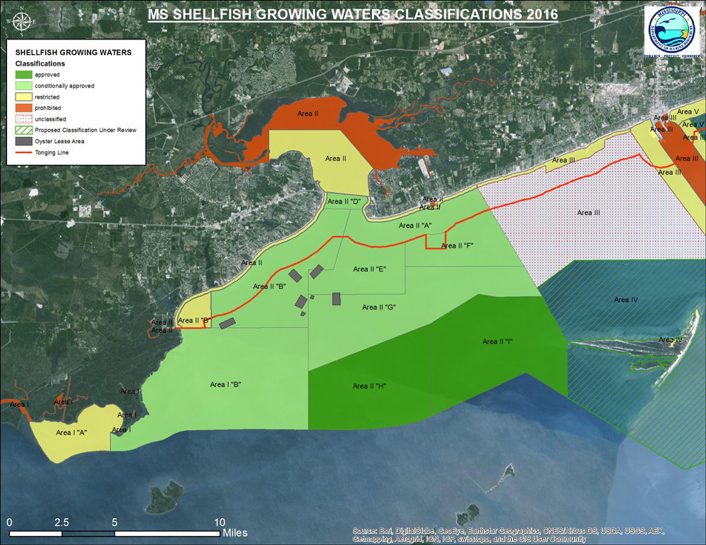

*Figure A1. Shellfish Growing Areas in the Western Mississippi Sound (MDMR, 2016).*

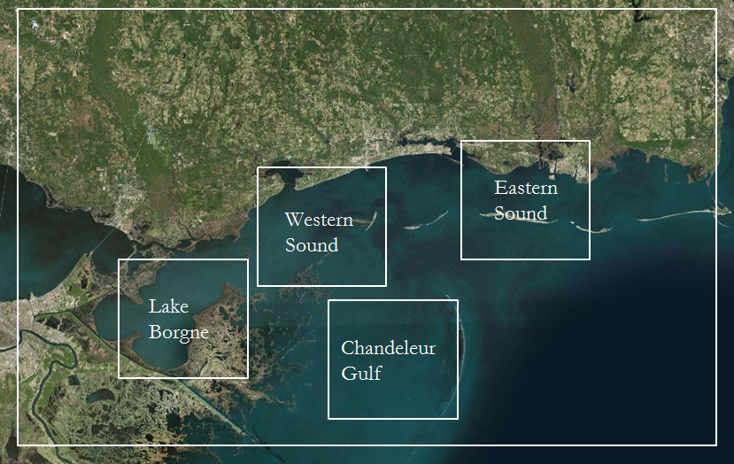

*Figure A2: Processing boundaries for TSM, SST, chlorophyll-a,* aDG*, and turbidity zonal averages (ESRI, 2016).*

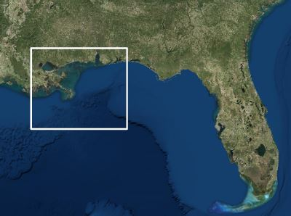

*Figure A3. Processing boundaries for Sea Surface Salinity (ESRI, 2016).*

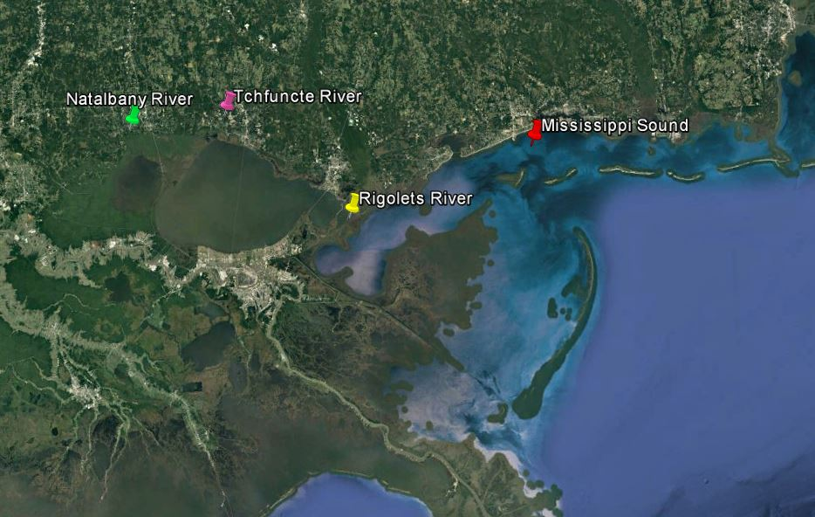

*Figure A4: USGS stations for discharge, salinity and temperature in situ data.*

**Appendix B: Data Acquisition**

*Table B1. NASA and ESA Sensors, including products utilized and parameters produced.*

|  |  |  |
| --- | --- | --- |
| **Sensor** | **Parameter** | **Products** |
| Aqua MODIS | Surface Reflectance | MYD09Q1 MODIS/Aqua Surface Reflectance 8-Day L3 Global 250m SIN Grid V006 |
| chlorophyll-a | MODIS-Aqua Level 3 Mapped chlorophyll-a Data Version 2014 |
| aDG | MODIS-Aqua Level 2 Ocean Color Data Version 2014 |
| MUR | Sea Surface Temperature | GHRSST Level 4 MUR Global Foundation Sea Surface Temperature Analysis (v4.1) |
|
| Sentinel-2 | chlorophyll-a Concentration | Level-1C Top of atmosphere reflectances in cartographic geometry |
|
|
| Suspended Sediment Concentration | Level-1C Top of atmosphere reflectances in cartographic geometry |
| Turbidity | Level-1C Top of atmosphere reflectances in cartographic geometry |
| Landsat 5, 7, 8 | chlorophyll-a Concentration | Landsat 5 TM C1 Level-1 |
|
|
| Suspended Sediment Concentration | Landsat 7 ETM+ C1 Level-1 |
| Turbidity | Landsat 8 OLI/TIRS C1 Level-1 |
| SMAP | Sea Surface Salinity | JPL SMAP Level 3 CAP Sea Surface Salinity Standard Mapped Image Monthly V3.0 Validated Dataset |
| SMOS | Sea Surface Salinity | CATDS/CEC-OS SMOS Level 3 SSS |

*Table B2. Landsat dates and path-rows.*

|  |  |  |
| --- | --- | --- |
| **Sensor** | **Dates** | **Path-row** |
| Landsat 5 TM | January 2002 - November 2011 | 21-39 |
| Landsat 7 ETM+ | November 2011 - March 2013 | 21-39 |
| Landsat 8 OLI | April 2013 - December 2016 | 21-39 |

*Table B3. Sentinel-2 dates and tiles.*

|  |  |  |
| --- | --- | --- |
| **Sensor** | **Dates** | **Tiles** |
| Sentinel-2 | July 2015 to December 2016. | T16RCU |
| Sentinel-2 | July 2015 to December 2016. | T16RBU |

*Table B4. In situ data parameters and station locations supplied by the USGS Current Water Data for the Nation.*

|  |  |  |
| --- | --- | --- |
| **Parameter** | **Station Locations** | **Station Numbers** |
| Discharge | Natalbany River  Tchefuncte River | 07376500  07375000 |
| Salinity | Rigolets | 301001089442600 |
| Water Temperature | Rigolets | 301001089442600 |

*Table B5.  The algorithms used by ACOLITE to derive chlorophyll-a concentration, suspended sediment concentration, and turbidity from Landsat 5, 7, and 8 imagery.*

|  |  |  |
| --- | --- | --- |
| **Parameter** | **Algorithm Name** | **Algorithm Equation** |
| chlorophyll-a Concentration | OC2 (NASA Ocean Biology Processing Group) | https://lh6.googleusercontent.com/q2Glym3SfL2iDFe-s6Z3wX5wvvqsC99ua109HKuyHajkOFLFf9dXSYb7iXUpkH6DN94rO2RYbwgsHtgwSBV7Y5FkrzQym3Bi9SQANLPYmM-4lqTQSFAg0eVwoq0x0wEFqVwBuxgQ |
| Turbidity | Semi-empirical single band turbidity retrieval algorithm (Nechad et al. 2009, Dogliotti et al.2015) | https://lh4.googleusercontent.com/FM37lsx038xcLRAiGnkAoTvIJ_t7HNdGfBeoMdl-uLgAWoA0TaNfSRE96ythzqB7l6WD3fSMUd-w5gbtVaPos8zFKK4HF6DR3Ytz5IiKq7SQ9e5omuOx1UATfM_hfie05ghGJ2kB |

*Table B6. The algorithms used by ACOLITE to derive chlorophyll-a concentration, suspended sediment concentration, and turbidity from Sentinel-2 imagery.*

|  |  |  |
| --- | --- | --- |
| **Parameter** | **Algorithm Name** | **Algorithm Equation** |
| chlorophyll-a Concentration | OC2 algorithm (NASA Ocean Biology Processing Group) | https://lh5.googleusercontent.com/_7N9_fddn05rDZJ-uZ7Nkbwr22KTqNyWu4an8Dcr8_hz-3t4BwFeJ44w_U0_k35ImmqPbAw5BRuLP51fVZfAgjkYNwLGXq7tCzjI3_bVohZe-y4Ytm9RC1_KIuWCYXpFgaQKDNPb |
| Turbidity | Semi-empirical single band turbidity retrieval algorithm (Nechad et al. 2009, Dogliotti et al.2015) | https://lh4.googleusercontent.com/FM37lsx038xcLRAiGnkAoTvIJ_t7HNdGfBeoMdl-uLgAWoA0TaNfSRE96ythzqB7l6WD3fSMUd-w5gbtVaPos8zFKK4HF6DR3Ytz5IiKq7SQ9e5omuOx1UATfM_hfie05ghGJ2kB |

*Table B7. Constants and associated values used within the OC2 algorithm for Landsat 8 and Sentinel-2.*

|  |  |  |
| --- | --- | --- |
| **Constant** | **Landsat Value** | **Sentinel-2 Value** |
| a0 | 0.1977 | 0.2389 |
| a1 | -1.8117 | -1.9369 |
| a2 | 1.9743 | 1.7627 |
| a3 | -2.5635 | -3.0777 |
| a4 | -0.7218 | -0.1054 |
| λblue | 482 nm | 490 nm |
| λgreen | 561 nm | 560 nm |

*Table B8. The equation used to derive total suspended matter (TSM) from % reflectance*

|  |  |  |
| --- | --- | --- |
| **Parameter** | **Reference** | **Equation** |
| Total Suspended Matter | Miller and McKee (2004) | TSM = 1140.25(MODIS Band 1) -1.91  % Reflectance = MODIS Band 1 |

Appendix C: Data Processing

*Table C1: 8-day MODIS Aqua surface reflectance monthly separation*

|  |  |  |  |
| --- | --- | --- | --- |
| **Month** | **8-day File #** | **8-day Julian Filename** | **Monthly Range** |
| 1 | 4 | 1, 9, 17, 25 | January 1st - February 1st |
| 2 | 4 | 33, 41, 49, 57 | February 2nd - March 5th |
| 3 | 4 | 65, 73, 81, 89 | March 6th - April 6th |
| 4 | 3 | 97, 105, 113 | April 7th – April 30th |
| 5 | 4 | 121, 129, 137, 145 | May 1st – June 1st |
| 6 | 4 | 153, 161, 169, 177 | June 2nd – July 3rd |
| 7 | 4 | 185, 193, 201, 209 | July 4th – August 4th |
| 8 | 4 | 217, 225, 233, 241 | August 5th – September 5th |
| 9 | 3 | 249, 257, 265 | September 6th – September 29th |
| 10 | 4 | 273, 281, 289, 297 | September 30th – October 31st |
| 11 | 4 | 305, 313, 321, 329 | November 1st – December 2nd |
| 12 | 4 | 337, 345, 353, 361 | December 3rd – December 31st |

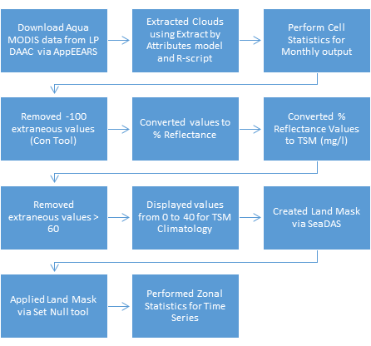

*Figure C2: 250m Aqua MODIS processing workflow*

Appendix D: Data Analysis

*Table D1. Explanation of data analysis for each sensor-derived parameter*

|  |  |  |  |
| --- | --- | --- | --- |
| **Data** | **Processing** | | **Analysis** |
| Total Suspended Matter | Cell Statistics | Zonal Averages | Climatology |
| Sea Surface Temperature |
| chlorophyll-a |
| Turbidity | Time Series |
| Sea Surface Salinity |
| aDG |

Appendix E: Results Graphs

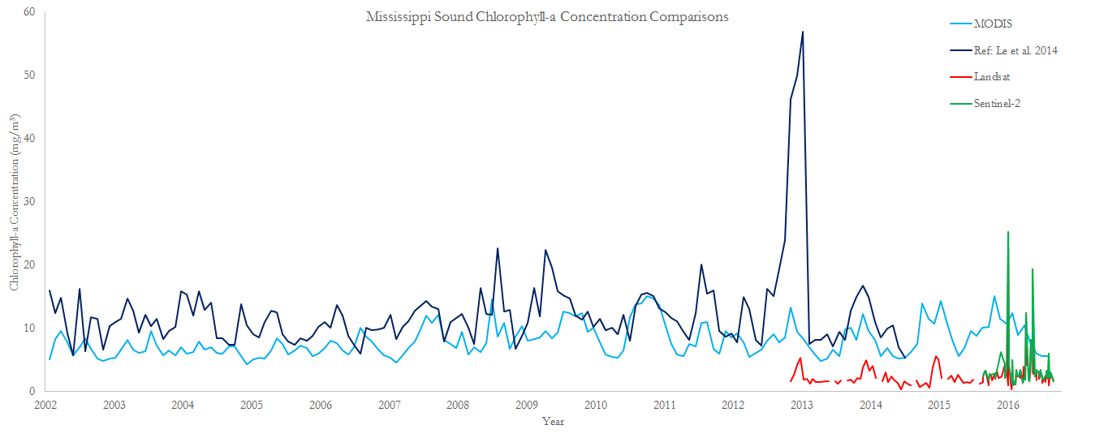

*Figure E1. Temporal comparison of MODIS, Le et al. (2014), Landsat 8, and Sentinel-2 chlorophyll-a concentration data for the Mississippi Sound.*

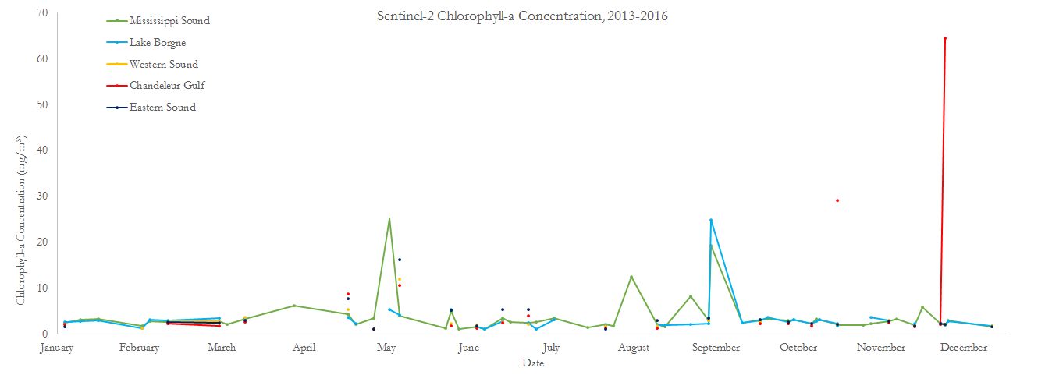

*Figure E2. Sentinel-2 chlorophyll-a concentration data for each study area 2013-2016.*

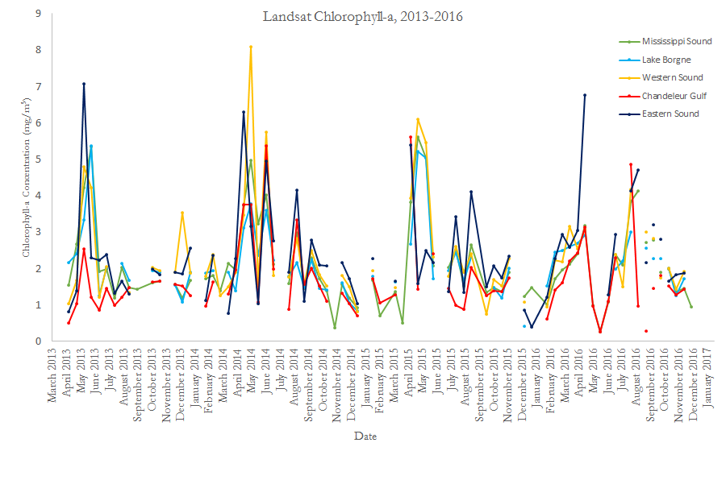

*Figure E3. Landsat 8 chlorophyll-a concentration data for each study area 2003-2016.*

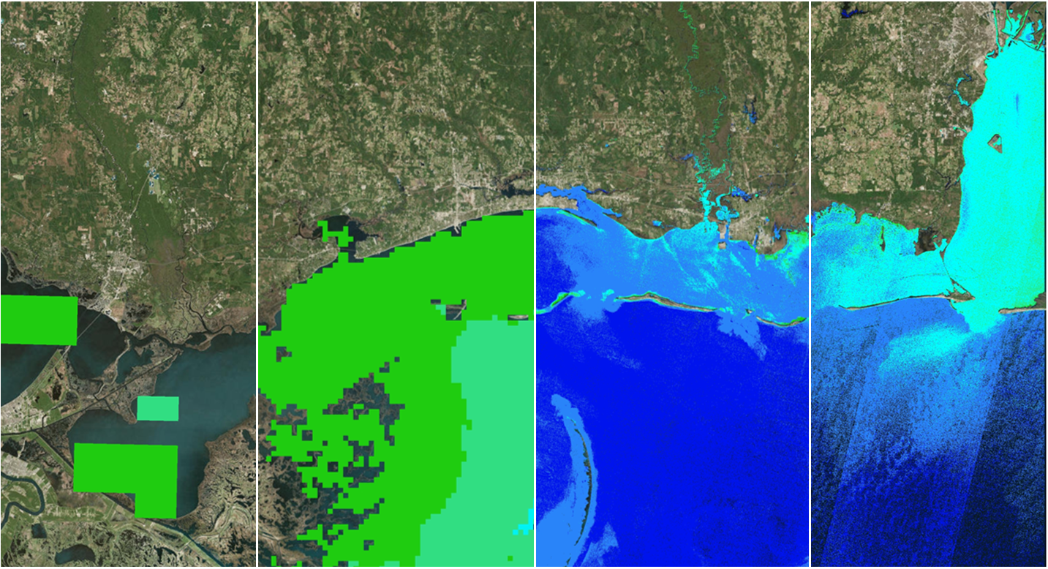

Landsat 8

Le et al. 2014 MODIS

Sentinel-2

4km MODIS

< 5 mg/m3

5-10 mg/m3

10-15 mg/m3

15-20 mg/m3

>20 mg/m3

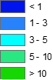

*Figure E4. Spatial comparison of 4km MODIS, Le et al. (2014) MODIS, Landsat 8, and Sentinel-2 chlorophyll-a concentration data across the Mississippi Sound.*

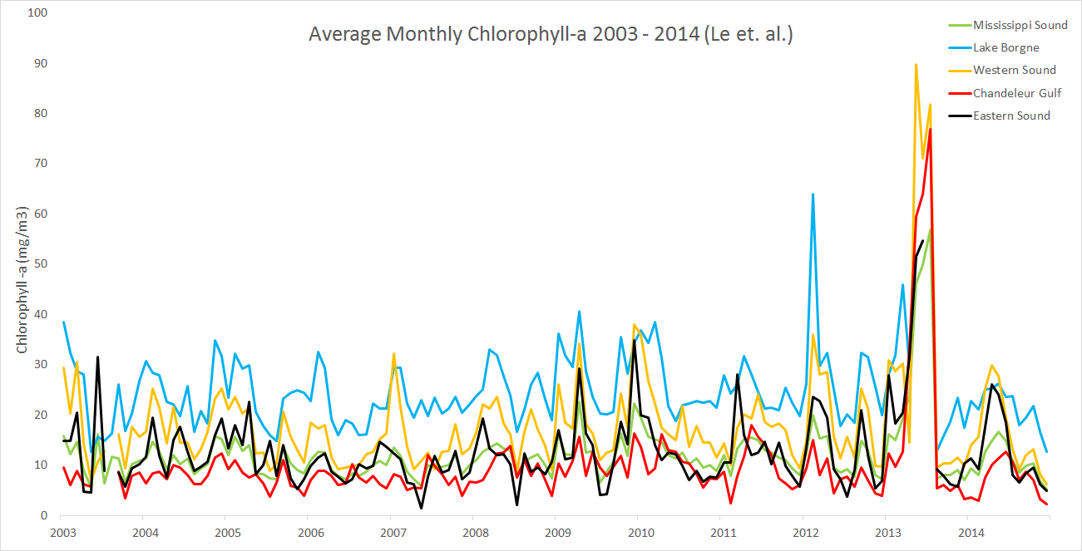

*Figure E5. Monthly average chlorophyll-a from Aqua MODIS derived from Le et al.’s (2014) algorithm for the entire study period, from January 2003 to December 2014.*

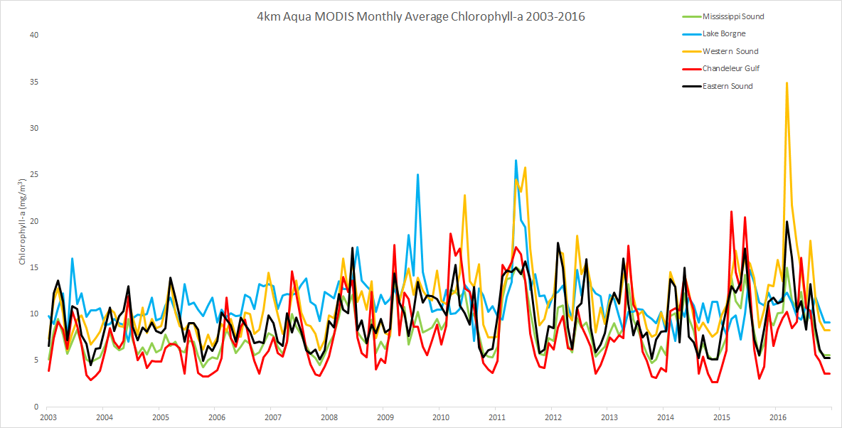

*Figure E6. Monthly average chlorophyll-a from the 4km Aqua MODIS product for the entire study area January 2003-December 2016.*

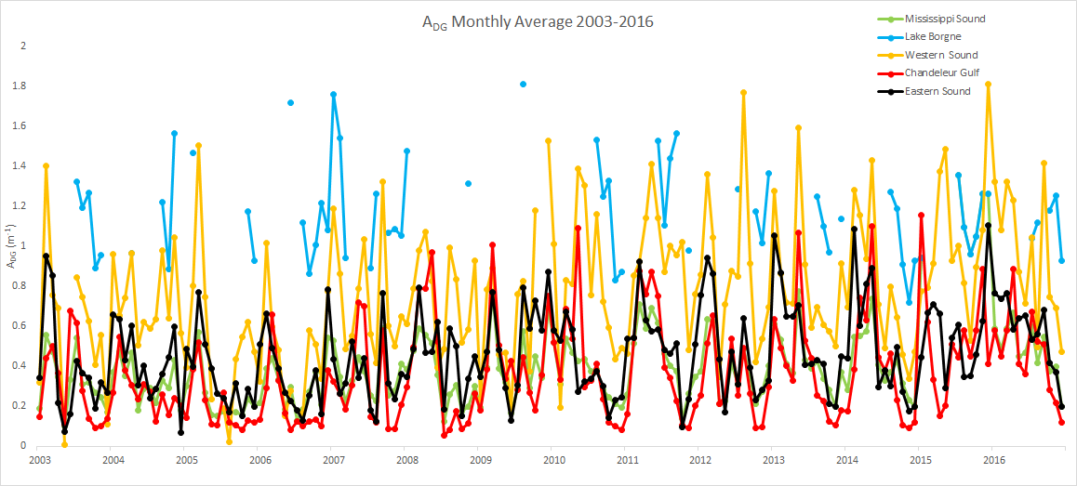

*Figure E7. Monthly average* aDG *for the entire study area 2003-2016.*

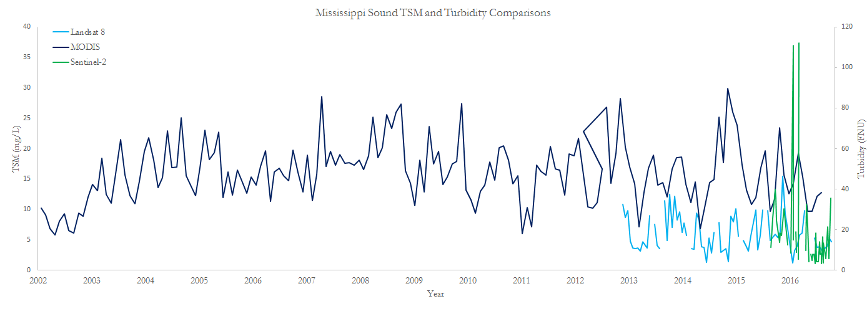

*Figure E8. Temporal comparison of Landsat 8, MODIS, and Sentinel-2 TSM and turbidity data for the Mississippi Sound.*

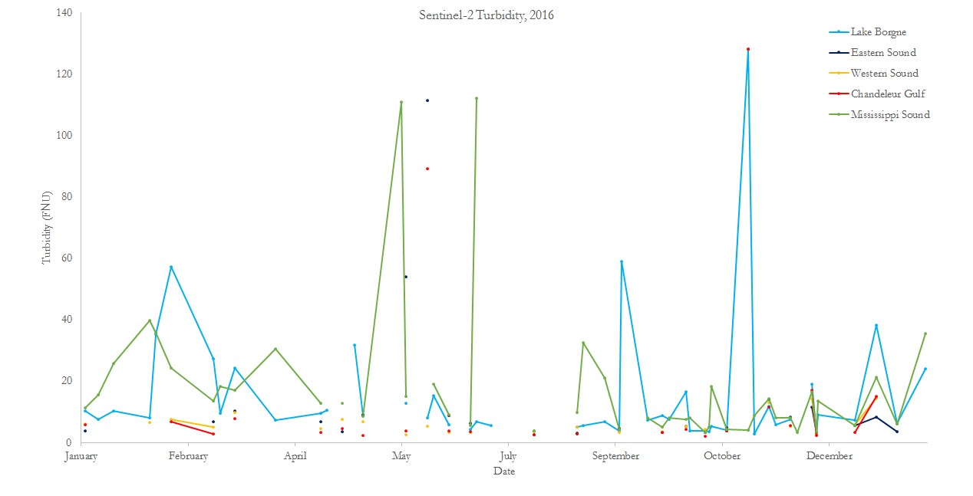

*Figure E9. Monthly Average Sentinel-2 Turbidity for the entire study area for 2016.*

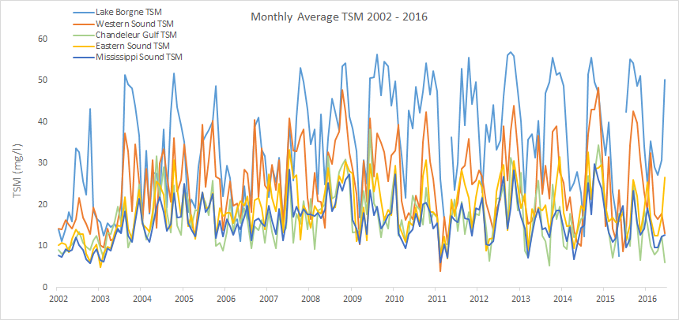

*Figure E10. 250m MODIS Monthly Average TSM for the entire study area, July 2002 to December 2016*

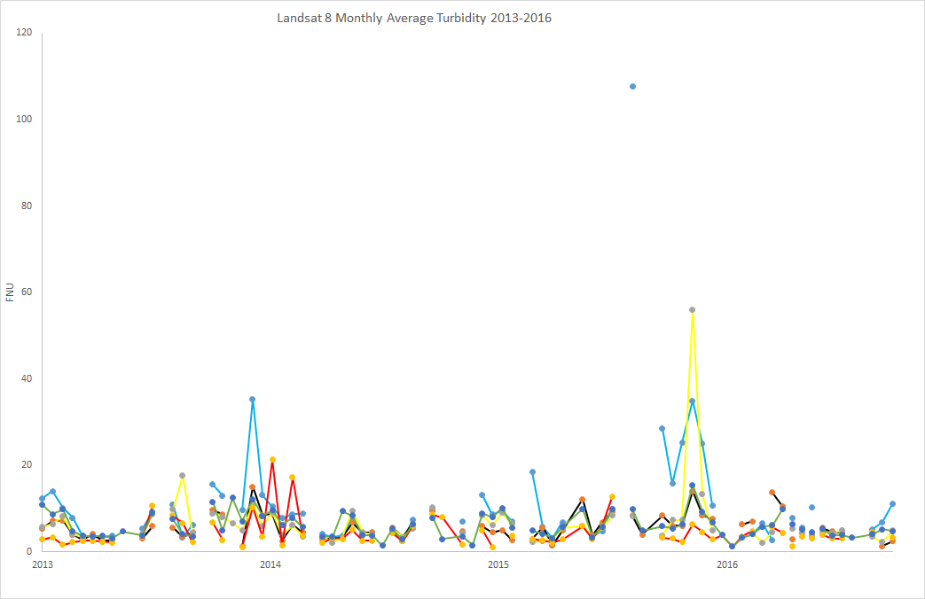

*Figure E11. Monthly Average TSM for the entire study area, July 2002 to December 2016*

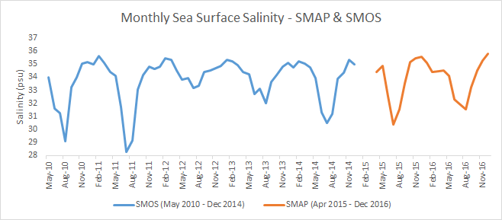

*Figure E12. Monthly Average SSS from SMAP and SMOS for May 2010-December 2016.*

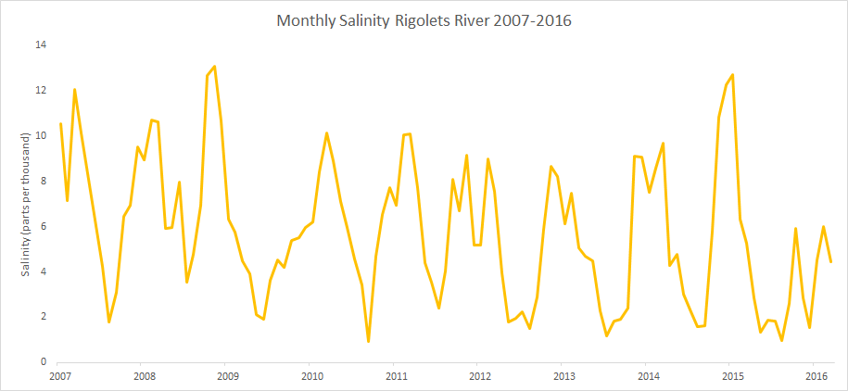

*Figure E13. USGS in situ salinity data for the Rigolets River 2007-2016.*

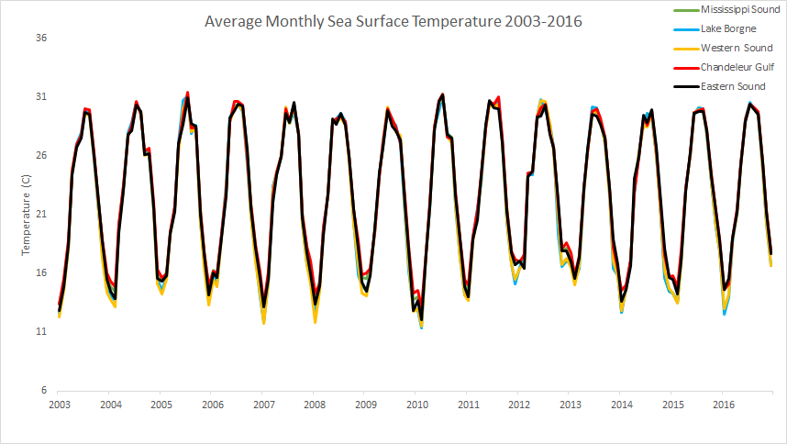

*Figure E14. Average MUR Monthly SST for the entire project area, 2003-2016.*

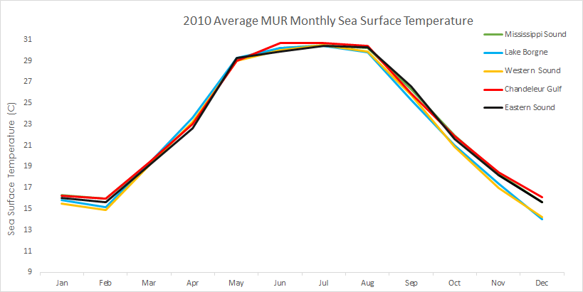

*Figure E15. Average 2010 monthly MUR SST for the entire project area.*

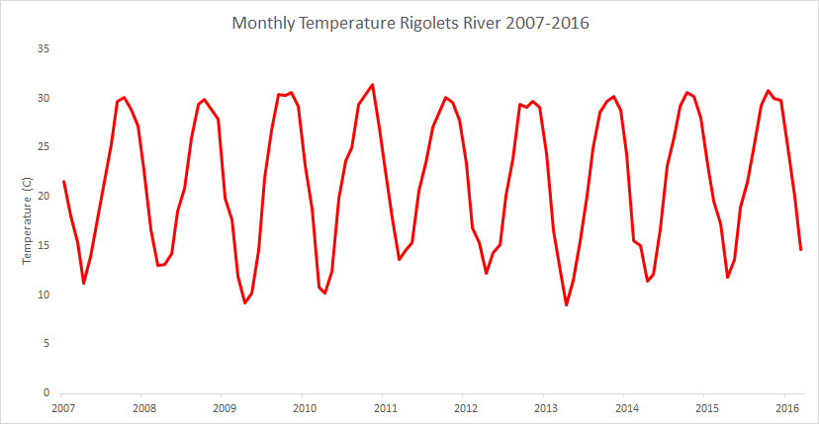

*Figure E16. USGS in situ temperature data for the Rigolets River 2007-2016.*

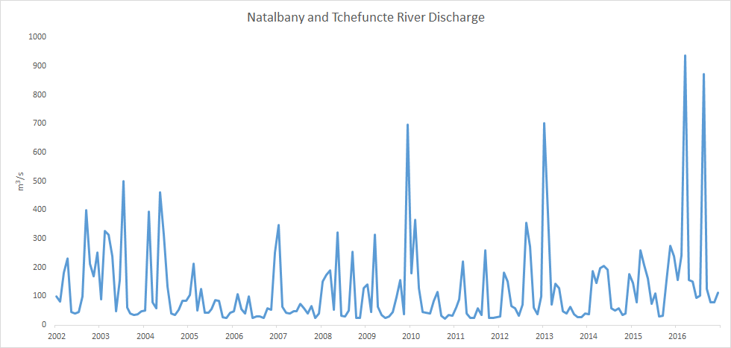

*Figure E17. USGS in situ discharge data for the Natalbany and Tchefuncte Rivers.*

**Appendix F: Google Drive folder of results imagery**

<https://drive.google.com/drive/folders/0B6k54ZrfyOpRanh3ckExTWtJUFU?usp=sharing>