**NASA DEVELOP National Program**



University of Georgia

*Summer 2015*

Southeast U.S. Ecological Forecasting

Utilizing NASA Earth Observations and Proximal Remote Sensing to Map the Spatio-temporal Distribution of *Hydrilla verticillata*

**Technical Report** 

Rough Draft – June 25, 2015

Shuvankar Ghosh (Project Lead)

Peter Hawman (Co-Project Lead)

Wuyang Cai

Elizabeth Dyer

Pradeep Kumar Ragu Chanthar

Dr. Deepak Mishra, University of Georgia (Science Advisor)

Dr. Susan Wilde, University of Georgia (Science Advisor)

# I. Abstract

[Placeholder - do not put anything here until the final draft submission. The abstract in the project summary is where the working draft of the abstract should “live”]

**Keywords**

Remote Sensing, Landsat 8 OLI, Hydrilla, Macrophyte, Aquatic Plants, Invasive Species

# II. Introduction

Background Information

*Hydrilla verticillata*, known commonly as hydrilla, is an invasive aquatic plant that can negatively impact native vegetation and water quality. It outcompetes native plants by growing rapidly and forming a surface canopy that blocks light passing through the water column. It intensifies stratification, creates anoxic conditions in deeper areas, and changes the amounts of many other important nutrients. This submersed aquatic plant is on the state and federal noxious weed lists and has been nicknamed ‘‘the perfect aquatic weed’’ due to its aggressive growth habit and adaptive morphological characteristics (Langeland 1996). Hydrilla has become one of the most serious aquatic weed problems for the southeastern United States. It affects the food chain, as aquatic wildlife can die from consuming hydrilla with associated toxic epiphytic cyanobacteria (Wilde et al., 2005). Hydrilla is also a concern for the recreation industry, clogging boat motors and becoming a swimming hazard. It can be economically costly as it obstructs water withdrawal for drinking, irrigation or power generation.

The native range of *Hydrilla verticillata* is believed to be Asia, Australia and possibly Africa (Cook & Luond 1982). The freshwater aquarium trade introduced hydrilla to Florida in the 1950s, and hydrilla spread throughout the southeast in the subsequent years (McCann et al., 1996). Today, according to the USDA’s Plants Database, Royle waterthyme or hydrilla spans the southern United States, up the east coast into New England and west into California and Washington State (USDA Plants Database, 2015).

Study Area

This study focused on five reservoirs located in Georgia and bordering Alabama, Florida, and South Carolina (Fig. 1). Located in the southwest corner of Georgia along its border with Florida, Lake Seminole is a United States Army Corps of Engineers (USACE) reservoir where there have been attempts to control hydrilla for almost 50 years using a combination of chemical, physical and biological controls. Hydrilla in Lake Seminole has interfered with navigation, degraded water quality, fish and wildlife habitat, diminished recreation area use, increased mosquito populations, blocked hydropower intakes, and decreased adjacent property values. Another lake run by the USACE, Lake Strom Thurmond is a large reservoir (288 Km2) on the border between Georgia and South Carolina just north of Augusta, GA. This reservoir is the third of three reservoirs along the Savannah River. The USACE struggles to produce rapid accurate estimates of invasive plant density to determine which techniques provide the most cost-effective control throughout these reservoirs.

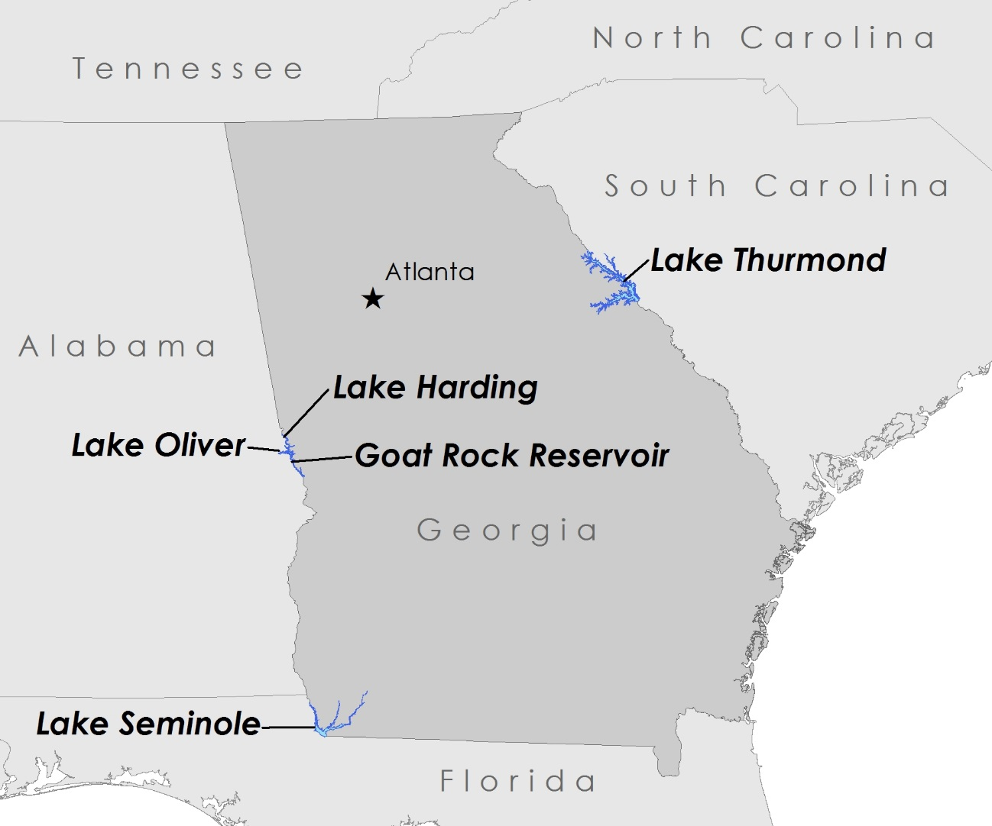

Figure 1**:** The five reservoirs studied: Lake Thurmond, Lake Harding, Lake Oliver, Goat Rock Reservoir, and Lake Seminole.

In 2013, Georgia Power experienced a rapid hydrilla invasion throughout two large reservoirs on the Chattahoochee River: Lake Harding (24 Km2) and Lake Oliver (9 Km2). During the fall of 2014, Georgia Power discovered hydrilla expanding into the next reservoir down in the series, Goat Rock Reservoir. They have received countless complaints from their stakeholder user groups, including dock owners who are overrun with hydrilla and fisherman who can’t motor through the thick mats.

Study Period

This project focused on mapping hydrilla distribution in the southeast for the years 2013 through 2015. These years were chosen because the project focused on utilizing NASA’s Landsat 8 satellite, which began collecting data in 2013. The Landsat 8 mission provides timely, high quality, visible and infrared images of all landmass and near-coastal areas on the Earth, which was necessary for the project goal of determining the distribution pattern of hydrilla in the study area.

National Application Areas

This project addressed two NASA Applied Science national application areas: Ecological Forecasting and Water Resources. This project focused on the formation of a benthic model allowing the forecasting of areas susceptible to hydrilla infestation. Because hydrilla impacts nutrient and oxygen levels in lakes and reservoirs, this project also addressed water quality issues and the results will aid lake managers in focusing mitigation efforts to control hydrilla expansion.

Project Partners

This project partnered with the Joseph W. Jones Ecological Research Center, the Georgia Power Company, and Henry County Water Authority.

The Joseph W. Jones Ecological Research Center is a research facility located in southern Georgia outside the town of Newton along the Flint River. The research facility is located just north of Lake Seminole. Dr. Stephen W. Golladay, Associate

Scientist, is a lead investigator on Lake Seminole Studies. For 10 years he and his team have been conducting studies on water quality in the lower Flint River and Lake Seminole, focusing on invasive species such as *Hydrilla verticillata*. Dr. Golladay and his colleagues are very interested in incorporating remote sensing to better understand phenological characteristics and seasonal distributions of hydrilla.

The Georgia Power Company is responsible for protecting and restoring 17 reservoirs in Georgia. As the owner and steward of these reservoir resources, the Georgia Power Company is concerned with the spread of *Hydrilla verticillata* and the negative impacts this species has on the health of Georgia reservoirs. Georgia Power requires a comprehensive assessment of hydrilla expansion to optimize their chemical control efforts. The production of accurate, timely biomass maps will allow for adaptive plant management.

University of Georgia science advisors have been assisting the Henry County Water Authority since 2010 when a hydrilla infestation was discovered in two of their newly constructed drinking water reservoirs. Hydrilla is creating recreation concerns for fisherman and waterfowl hunters. Bird deaths from Avian Vacuolar Myelinopathy, an emerging wildlife neurological disease linked to hydrilla have been documented at both two Henry County reservoirs.

# III. Methodology

# Data Acquisition

# i. Landsat 8 OLI: The team used NASA's Landsat 8 Operational Land Imager (OLI) data to estimate hydrilla density and distribution in the four selected sites. Four scenes were needed to cover the five reservoirs. Lakes Harding, Oliver, and Goat Rock were covered by one scene (path 19 row 37). Lake Thurmond spanned two scenes for full coverage (path 18 row 36 and path 18 row 37). Lake Seminole was covered by one scene (path 19 row 39). All scenes were acquired from the data portal USGS Global Visualization Viewer as Level 1 GeoTIFF Data products. Images were selected based on cloud-free conditions in the vicinity of the study sites through visual interpretation. Images were collected from 2013 to present.

ii. Reservoir Digital Boundaries: Lake boundaries were acquired from several sources including the National Hydrographic Dataset and the Georgia GIS Clearinghouse. Individual lake boundary shapefiles from these two sources were compared and adjusted to reflect changes in shorelines based on the Landsat data and Google Earth imagery.

# iii. Field Data

The team collected extensive field data from the aforementioned reservoirs in Georgia. Multiple sites across these reservoirs were sampled for hydrilla presence, distribution and density. Observations were recorded for each of the parameters listed below:

1. *In situ* images of Hydrilla distribution using DJI Phantom 2 Vision +, an unmanned aerial system.
2. *In situ* images of Hydrilla using Hyperspectral digital camera Basler acA1300, for estimation of vegetation fraction and other spectral analysis.
3. *In situ* spectral data for Hydrilla using OceanOptics non-imaging hyperspectral radiometer, for estimation of remote sensing reflectance (Rrs).
4. Hydrilla biomass using invasive sampling techniques; biomass samples were collected over 1 square foot area, oven dried and dry weight was estimated.
5. In-situ measurements of plant height, using metric ruler.

# Data Processing

Prior to quantitative analysis and/or estimation of biophysical parameters, it was imperative to reduce the atmospheric effect on the surface reflectance values and increase the signal to noise ratio. Two atmospheric correction methods were compared, ACOLITE (Vanhellemont & Ruddick 2014) and the atmospheric correction suggested by Dash et al. (2012). The method created by Vanhellemont & Ruddick (2012) incorporates values of solar radiance, water absorption, Rayleigh optical thickness and ozone optical thickness into an intuitive graphic user interface for processing Landsat specific data. The results of each method were compared based on spectral signatures and field measurements.

Atmospherically corrected scenes were mosaicked if required, and reservoir subsets were created using the digital lake boundaries. These subsets were used for model development, and creation of hydrilla distribution and density maps.

Data Analysis

Hydrilla biomass, height and vegetation fraction were calibrated using both Landsat-derived as well as *in-situ-*derived vegetation indices. The model was validated using Visible Atmospherically Resistant Index (VARI) (Gitelson et al., 2002) and Green NDVI (Gitelson et al., 1996) values calculated from field data, as shown in the equations (1) and (2) below.

VARI = (RGreen - RRed)/(RGreen + Rred) (1)

Green NDVI = (RNIR - RGreen)/(RNIR + RGreen) (2)

The relative performances of the models were statistically analyzed, and the best model was selected using the performances in terms of coefficient of determination, percent root mean square error, residual trends etc. The best fit model was then used to generate hydrilla time-series distribution and density maps. The maps were then analyzed for the spatio-temporal trends in hydrilla distribution over successive growing seasons.

# IV. Results & Discussion

Insert images, graphs, maps, charts, etc. here. Choose the most important results to highlight here. No word cap, but two to six pages is a good range.

Things to discuss:

* Analysis of Results: What can you tell from your graphs, images, etc? What does this mean for your project?
* Errors & Uncertainty: What factors could you not account for, what things didn’t work out like you expected they would, etc.
* Future Work: If this project was to be selected for another term, what would be the focus? What other areas would be of interest?

# V. Conclusions

Final conclusions. Word count: 200-600 (~a page).

# VI. Acknowledgments

The NASA DEVELOP Southeast U.S. Ecological Forecasting team would like to thank the project partners, the Joseph W. Jones Ecological Research Center, the Georgia Power Company, and the Henry County Water Authority. Their support through field data and access to study sites was necessary for the success of this project. We would also like to thank our science advisors, Dr. Deepak Mishra and Dr. Susan Wilde. Their expertise and guidance helped drive this project and their continued support for the DEVELOP program has benefited the University of Georgia node greatly. Finally, a special thanks to the DEVELOP National Program Office for their support of this project.

This material is based upon work supported by NASA through contract NNL11AA00B and cooperative agreement NNX14AB60A.

# VII. References

Cook, C.D.K. and Luond, R. (1982). A revision of the genus Hydrilla (Hydrocharitaceae). Aquatic Botany 13:485-504.

Dash, P., Walker, N., Mishra, D., D’Sa, E., & Ladner, S. (2012). Atmospheric Correction and Vicarious Calibration of Oceansat-1 Ocean Color Monitor (OCM) Data in Coastal Case 2 Waters. Remote Sensing, 4(6): 1716-1740.

Gitelson, A. A., Kaufman, Y., & Merzlyak, M. N. (1996). Use of green channel in remote sensing of global vegetation from EOS-MODIS, Remote Sensing of Environment, 58: 289 – 298.

Gitelson, A. A., Stark, R., Grits, U., Rundquist, D., Kaufman, Y., & Derry, D. (2002). Vegetation and soil lines in visible spectral space: a concept and technique for remote estimation of vegetation fraction, International Journal of Remote Sensing, 23(13): 2537−2562

“Hydrilla verticillata (L. f.) Royle waterthyme.” USDA Natural Resource Conservation

Service: Plants Database. n.p. Web. 18 June 2015

Langeland, K. A. (1996). Hydrilla verticillata (LF) Royle (Hydrocharitaceae)," The Perfect Aquatic Weed". Castanea, 293-304.

Vanhellemont, Q., & Ruddick, K. (2014). Turbid wakes associated with offshore wind turbines observed with Landsat 8. Remote Sensing of Environment 145: 105-115.

Wilde, S. B., Murphy, T. M., Hope, C. P., Habrun, S. K., Kempton, J., Birrenkott, A., Wiley, F., Bowerman, W. W., Lewitus, A. J. (2005). Avian Vacuolar Myelinopathy Linked to Exotic Aquatic Plants and a Novel Cyanobacterial Species. Environmental Toxicology, 20(3), 348-353.

McCann, A.J., Arkin, L.N., Williams, J.D. (1996). Nonindigenous Aquatic and Selected Terrestrial Species of Florida. Southeastern Biological Science Center, 256 p.

# VIII. Content Innovation

In preparation for DEVELOP’s coming microjournal, please select two content innovation features to support your paper. For each item, please list the name of the feature, and include the tool itself if possible (eg. glossary terms and definitions). If the tool does not work in Microsoft Word (eg. Interactive MATLAB Figure Viewer), please list the file name and upload the related file to the microjournal folder on the DEVELOP Exchange. If you choose to use Inline Supplementary Material, please also include where the material should appear in the text.

**Some options include:**

AudioSlides

Database Linking Tool

Data Profile

Executable Papers

Featured Author Videos

Featured Multimedia for this Article (video and podcast options)

Glossary Viewer

Inline Supplementary Material (figures, tables, computer code)

Interactive Map Viewer

Interactive MATLAB Figure Viewer

Interactive Plot Viewer

Nomenclature Viewer

# IV. Appendices

Insert here