Maine Ecological Forecasting

Using NASA Earth Observations to Assess Federally Endangered Atlantic Salmon Habitat in Maine

**Technical Report**

Final – November 18th, 2021

Michael Corley (Project Lead)

Philip Casey

Olivia Landry

Lily Oliver

Brian Varley

***Advisors:***

Dr. John Bolten, NASA Goddard Space Flight Center (Science Advisor)

Dr. Bridget Seegers, NASA Goddard Space Flight Center (Science Advisor)

Joseph Spruce, Consultant, Science Systems and Applications, Inc. (Science Advisor)

# 1. Abstract

Atlantic salmon (*Salmo salar*) is a species of anadromous fish that was historically prevalent throughout the New England region. Overfishing and habitat loss caused a severe decline in the salmon population, restricting North America’s remaining wild Atlantic salmon to rivers in Maine. Land use and land cover (LULC) change and factors associated with temperature and precipitation are important for understanding the suitability of freshwater habitat for juvenile salmon. In collaboration with the Maine Department of Marine Resources and the Downeast Salmon Federation, the team utilized NASA Earth observations to aid partners in understanding how these factors change in relation to critical salmon habitat. Landsat 5 Thematic Mapper (TM) and Landsat 8 Operational Land Imager (OLI) imagery were analyzed to assess changes in LULC between 1985 and 2021. Terra Moderate Resolution Imaging Spectroradiometer (MODIS) and Integrated Multi-satellite Retrievals for Global Precipitation Measurement (GPM IMERG) data were used to determine land surface temperature and precipitation, respectively, between 2000 and 2020. Lastly, temperature and precipitation anomaly maps visualized deviation from the 20-year climatic average for each pixel. LULC analysis for 1985 to 2020 showed a loss of forest cover throughout critical salmon habitat although gains in forested area were also observed. Assessment of mean summer land surface temperature revealed an increase in temperature from 2000 to 2020 and anomaly maps highlighted areas experiencing abnormally high or low summer precipitation and temperature. These results and the underlying data were packaged for the partner organizations to inform future conservation efforts.

**Key Terms**

satellite remote sensing, salmonid fisheries management, land use land cover change, land surface temperature, forecasting, critical salmon habitat

# 2. Introduction

***2.1 Background Information***

Atlantic salmon (*Salmo salar*) are an anadromous fish species native to New England (Figure 1). Juvenile salmon spend about 2 years in freshwater streams before smolting and migrating to the ocean. After several years in the marine environment, Atlantic salmon return to streams and rivers to spawn (Saunders et al., 2006). These migrations facilitate nutrient cycling and can be major carbon fluxes and food sources for terrestrial and piscivorous animals (Hilderbrand et al., 2004).

Atlantic salmon historically sustained commercial, subsistence, and recreational fisheries in Maine (National Research Council, 2004; Saunders et al., 2006). However, their populations have significantly declined due to dam construction, overfishing, pollution, and logging practices (Buchsbaum et al., 2005; Saunders et al., 2006). The Gulf of Maine Distinct Population Segment is home to the only remaining population of wild Atlantic salmon in the United States, which is protected as a Federally Endangered Species (Endangered and Threatened Species, 2000). Recovery of this Atlantic salmon population is important to ensure the continuation of the ecosystem services they provide and protect opportunities for restoring Maine’s fisheries.

The state of Maine (Figure 2) is temperate and heavily forested, with mild summers and cold winters (Runkle et al., 2017). The effects of current climate change in Maine include increased average temperatures and winter precipitation, greater storm intensity, and increased frequency of droughts (Frumhoff et al., 2007). These factors may impact critical salmon habitat and influence the survival and distribution of the Gulf of Maine Distinct Population Segment of Atlantic salmon (Jonsson & Jonsson, 2009).

Habitat recovery is crucial to restoring the stability of Atlantic salmon populations, particularly with respect to river temperature and streamflow (NOAA & USFWS, 2019; Piou & Prévost, 2013). Warming temperatures stress the thermal limits for survival, growth, and performance of Atlantic salmon (Jonsson & Jonsson, 2009). Additionally, reduced precipitation levels have the ability to alter streamflow, impacting habitat connectivity and water temperature during lower water levels. Changes in temperature and streamflow may be facilitated by land use and land cover change near salmon habitat. Practices such as logging, agriculture, and development may result in loss of riparian vegetation, which can impact the intensity of streamflow and warm stream temperatures due to the reduction of shade cover (Moore et al., 2005; Tang et al., 2005).

Satellite remote sensing has been used to understand climate and watershed variables relating to conservation and management of freshwater fisheries (Dauwalter et al. 2017). The team used NASA Earth observation products to explore how land surface temperature (LST), precipitation, and land use land cover (LULC) are changing throughout Maine. Data from Terra MODIS were used to create a historical record of land surface temperature and temperature anomaly maps from 2000 to 2020. Historical precipitation and anomaly data from 2000 to 2014 were obtained from GPM IMERG. The team also derived historical (1985 to 2021) land use land cover change information from Landsat 5 TM and Landsat 8 OLI imagery.

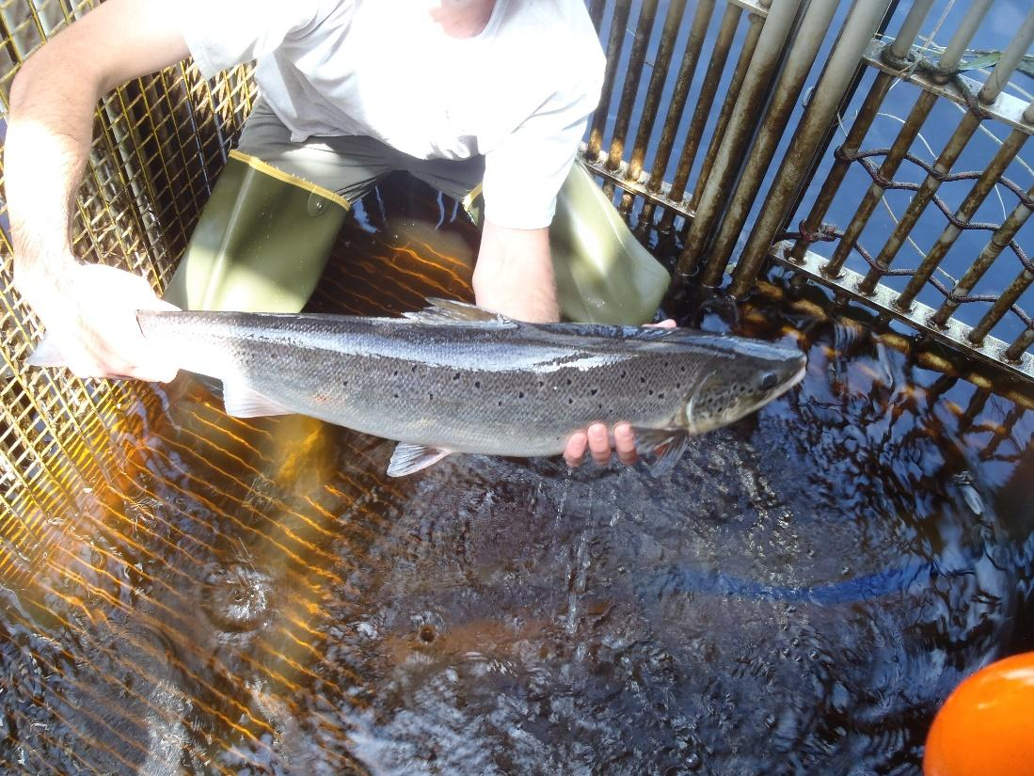

*Figure 1*. Image of an Atlantic salmon handled in the field (provided by the State of Maine Department of Marine Resources)

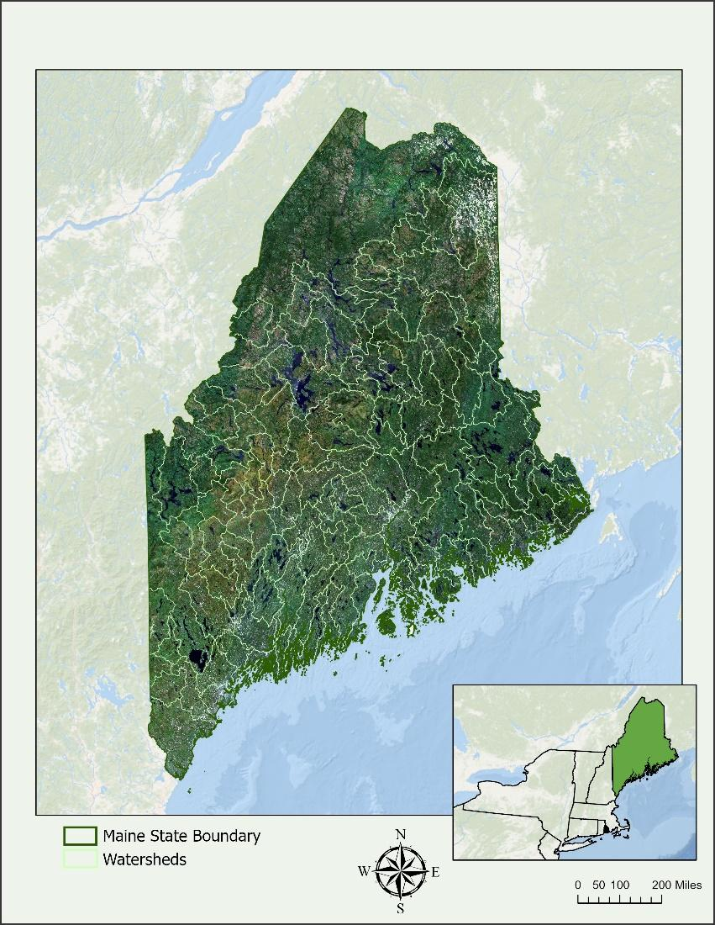

*Figure 2.* State of Maine overlaid with watersheds containing salmon habitat (from Landsat 8 OLI, 2021).

***2.2 Project Partners & Objectives***

The Maine Ecological Forecasting team partnered with the Downeast Salmon Federation (DSF) and the Department of Marine Resources (DMR) to investigate changes in precipitation, temperature, and land use land cover over time within the state of Maine. The DSF works on conservation and restoration of Atlantic salmon habitats and river resources with specific focus on the rivers in Downeast Maine. Some of their programs include in-stream restoration, salmon stocking, conservation hatcheries, and dam removal. The DMR is interested in rebuilding Atlantic salmon populations through stream and habitat restoration work. As the mortality rate of Atlantic salmon migrating to the ocean is high, ranging from 8 to 71% (Thorstad et al., 2012), the goal of the Atlantic salmon restoration community is to have a larger population of salmon spawning in rivers, and therefore, a greater number of salmon making it to the ocean.

The Maine Ecological Forecasting team used NASA Earth observations and Terra MODIS to obtain historical precipitation and temperature data in hopes to provide context to historical and current salmon declines. The team created summer temperature and precipitation anomaly maps for the state of Maine from 2000 to 2020 along with LULC maps for the years 1985, 2003, 2021. The data provided by the team will allow for partners to more thoroughly investigate climate trends in areas that they are invested in.

# 3. Methodology

***3.1 Data Acquisition***

The Maine Ecological Forecasting team acquired NASA Earth observations spanning from 1985 to 2021. The team used Google Earth Engine (GEE) to obtain land surface temperature data as well as imagery for LULC maps (Table 1). The team also used Giovanni, an online data system developed and maintained by the NASA GES DISC, to obtain precipitation data from GPM IMERG. Furthermore, the team used the USGS National Land Cover Database (NLCD) to inform the classification scheme drafting process. The DMR provided Salmon Survey Data that contained known Atlantic salmon locations at various sample sites in Maine’s Downeast region streams and rivers. This dataset provided the team with historical records of Young of the Year (YoY) and juvenile salmon presence and absence in rivers. The Salmon Survey Data provided by the partners also included the Wright Habitat Suitability Model with flow line delineations for Atlantic salmon habitat.

Table 1

*List of Sensor and Data Products utilized for this project*

|  |  |  |  |
| --- | --- | --- | --- |
| **Platform and Sensor** | **Data Product** | **Dates** | **Variable** |
| Landsat 5 TM | 10.5066/P9IAXOVV | May – July 1985 May – July 2003 | LULC |
| Landsat 8 OLI | 10.5066/F78S4MZJ | May – July 2020 | LULC |
| Terra MODIS | MOD11A1  Land Surface Temperature and Emissivity Daily Global 1km | March 2000 to September 2021 | Land Surface Temperature |
| GPM IMERG | GPM_3IMERGHHL  Global Precipitation Measurement (GPM) v6 | 2000 – 2020 | Precipitation |

***3.2 Data Processing***

*3.2.1 Climate Variables*

The team processed Terra MODIS satellite imagery in GEE. Daily readings from Terra MODIS were compiled into monthly median image collections from 2000 to 2020 in order to reduce outliers and faulty LST readings. The team converted the MODIS LST values from Kelvin to Celsius at the 1-kilometer scale before creating a mean image composite from the monthly image collection. During initial attempts to obtain LST values for the state of Maine, the team attempted to calculate the mean LST value for each HUC-12 sub-watershed in the state of Maine. However, this proved to be too large of a request for GEE to process. To circumvent this limitation, the team exported the mean LST image composite from GEE and imported the data into ArcGIS Pro. After importing into ArcGIS Pro, the team used the Zonal Statistics as Table tool to calculate monthly mean LST for each HUC-12 sub-watershed hydrologic management unit in Maine from 2000 to 2020. The output was in a format that could be used to create files that were readable in RStudio. The team used Giovanni to generate monthly total precipitation averages for the whole state from GPM IMERG daily data and download into a CSV file for analysis in RStudio. Average monthly rasters for summer months were also downloaded directly from the Giovanni platform. These monthly average precipitation rasters were then pulled into ArcGIS Pro for analysis.

*3.2.2 Land Use Land Cover*

The team used Landsat 5 TM and Landsat 8 OLI imagery to create historical LULC maps of land and inland water areas in Maine. Collection 2, Tier 1, Level 2 imagery was acquired in GEE, with Landsat 5 TM data used for 1985 and 2003 scenes while Landsat 8 OLI was used for 2021 scenes. The time range of May 1 to July 31 was selected based on leaf-on dates provided by the partners. The team cloud masked images in this time period and composited the images from each year using the greenest pixel method. The composites were exported from GEE to ArcGIS Pro for classification.

The composites from 1985 and 2003 had sections with visibly discernable clouded or sub-optimal imagery, which may have impacted classification and interpretation. The team drew polygons covering these areas and erased them from the composite. These areas were then filled using the same polygons clipped to composites from 1986 and 2002. The 1986 and 2002 composites were acquired using the same method as the 1985 and 2003 composites.

Once the three composites were imported in ArcGIS Pro, the team applied an Iso-Unsupervised Classification method within the ArcGIS Pro Image Classification Wizard. The RGB combination used for classification of imagery included SWIR1, NIR, and Red wavelengths. In that order, the corresponding band combinations were 5, 4, and 3 of Landsat 5 TM and 6, 5, and 4 of Landsat 8 OLI. The classification scheme was drafted by the team with input from the partners, and the NLCD was also used as a reference. The team finalized a foundational land classification scheme with the land cover types listed in Table 2.

Table 2

*Classification Scheme used in LULC Mapping*

|  |  |  |
| --- | --- | --- |
| Value | Land Cover Type | Description |
| 1 | water and wetlands | Freshwater streams, lakes, and rivers that include salmon habitat |
| 2 | bare soil or sparsely vegetated | Areas not covered by vegetation, or covered by sparse vegetation, that promote runoff of pollutants into water system |
| 3 | forest | Mixed (coniferous and deciduous) forests |
| 4 | shrubs and agriculture | Prevalent historical land use, including crops, pastures, and blueberry fields similar to other woody shrubs in the region |
| 5 | urban developed | Built-up developed areas often with high impervious cover that promotes surface runoff of water and pollutants |

***3.3 Data Analysis***

*3.3.1 Climate Variables*

In RStudio, the monthly mean LST and total precipitation readings for each HUC-12 were compiled into a CSV file and used to create a historical time series of climate data variables. These data were then visualized with line graphs. June through September were designated as summer months to assess historical variations in Maine's summer precipitation and temperature. In ArcGIS Pro, the team also created summer anomaly maps of temperature and precipitation for the years 2000, 2005, 2010, 2015, and 2020. In order to do so, the team calculated the mean summer LST and precipitation value for each pixel in the state of Maine via Cell Statistics from 2000 to 2020. Each of the output rasters from Cell Statistics included consistent No Data values of -2147483648. The team set these No Data values to null.

Then the team averaged each output raster from Raster Calculator into two 20-year climatic mean variable rasters: one for LST and one for precipitation. The team then used Diff, an Image Analyst tool in ArcGIS Pro, to subtract the pixel value for each indexed year from the newly created 20-year climatic mean 2000–2020 summer LST and precipitation rasters to create the Temperature and Precipitation Anomaly Maps. These anomaly maps visualize how each indexed year’s summer temperature and precipitation differs from Maine’s 2000–2020 mean summer temperature and precipitation.

*3.3.2 Land Use Land Cover Classifications*

To assess the accuracy of unsupervised classifications of 2003 and 2021 land cover, the team used stratified random sampling to generate points across all land cover types. The team then exported these points to Google Earth Pro and used Landsat RGB composites from each year to cross reference the results of the unsupervised classifications and assess the accuracy of the results. Next, the team compiled the results of the accuracy assessments into error matrixes. The team also made a preliminary assessment of how land cover has changed over time. The focus was on discerning areas that transitioned from forest in 1985 to either bare soil, urban developed, or shrubs and agriculture in 2021. This decision was made since land cover classes can influence water runoff, erosion, nutrient-loading, and shade near freshwater ecosystems.

# 4. Results & Discussion

***4.1 Analysis of Results***

*4.1.1 Climate Variables*

The team analyzed trends in summer precipitation and temperature from 2000 to 2020. From the plot depicted in Figure 3a, there is a visible trend of increasing summer temperatures for the entire state of Maine. However, Figure 3b does not suggest a directional change in Maine’s summer precipitation. These results are comparable to the results found in the NOAA National Centers for Environmental Information State Climate Summaries (Runkle et. al 2017). The Maine State Climate Summary found that mean summer temperatures have increased by about 1 degree Celsius from the five-year period of 2005-09 to 2010-14. There has been a general trend of increasing precipitation over the state; however, most of the precipitation increases have been during the winter and spring seasons.

a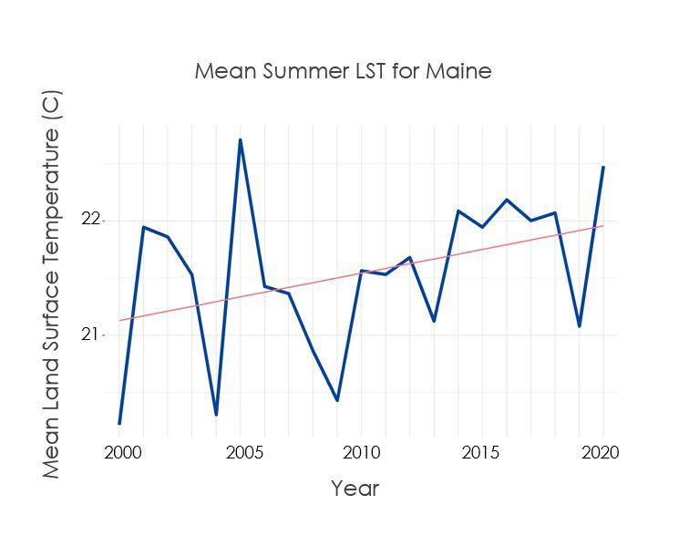b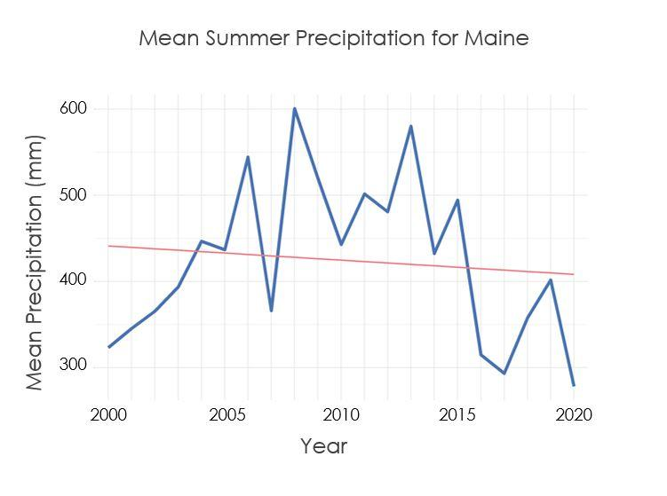

*Figure 3.* Time series of (a) mean summer temperature and (b) mean summer precipitation between 2000 and 2020.

The temperature and precipitation anomaly maps in Figure 4 indicate that the spatial variation of climatic variables is highly irregular across the landscape of Maine. That being said, using finer resolution satellite sensors would further refine anomaly maps to more accurately show the spatial variation across critical salmon watersheds. The anomaly maps for 2020 show that the majority of areas in Maine are around the mean or warmer than the mean summer temperature of 73 degrees. Meanwhile, large portions of Maine demonstrated below average precipitation levels ranging from 0 to 40mm below average. In the latter years of the study, the general trend was that of average annual summer temperatures nearing or surpassing the 20-year mean. The annual anomaly maps of temperature can be found in Appendix A (Figures A1 - A5) and of precipitation in Appendix B (Figures B1 - B5). Clear patterns in Maine’s precipitation regimes were not detected. The years 2000 and 2020 were the most anomalously dry, while 2005, 2010, and 2015 experienced above average precipitation.

a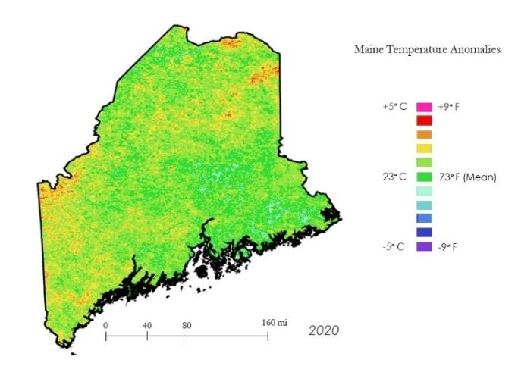b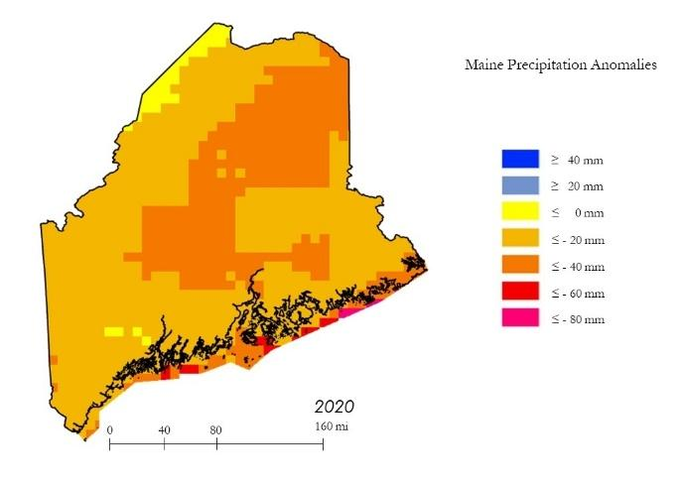

*Figure 4.* Maine summer 2020 (a) temperature anomalies, in degrees Celsius and Fahrenheit, and (b) precipitation anomalies, in millimeters.

*4.1.2 Land Use Land Cover Classifications*

The team created three classified rasters for the entire state of Maine for the years 1985, 2003, and 2021 (Figure 5). The initial observations derived from the classified maps indicate a trend of ongoing afforestation in Maine as evident in the maps for 1985 and 2021. However, the classified maps also indicate an increase in urban developed areas.

One feature of note is the appearance of urban developed land cover in the northeast of Maine in 2003 (Figure 5). The urban area does not appear as starkly in 1985 or 2021. During validation for 2003, the team noticed agricultural plots being misclassified as urban areas which could be responsible for the northeastern hot spot observed in 2003. However, it could also be a result of irregularity in data quality, such as cloud presence, rather than an indication of change in land cover.

a 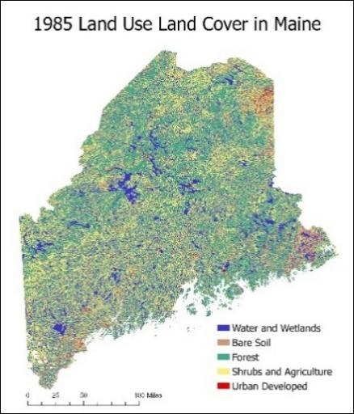 b 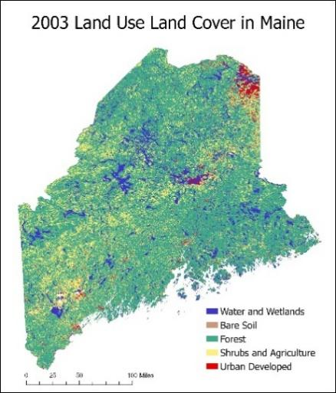 c 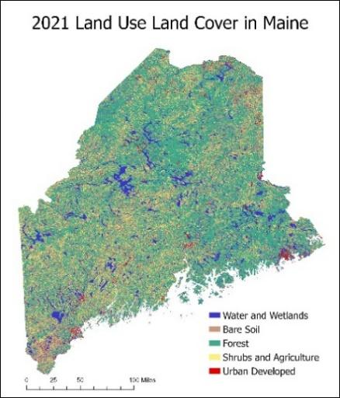

*Figure 5*. Land use and land cover of Maine in (a) 1985, (b) 2003, and (c) 2021.

In order for future work to build off of the LULC maps created in this term, the team validated the output classifications for the years 2003 and 2021. The team encountered technical difficulties during validation of the 1985 map and was unable to complete the task during the term. The results from the completed accuracy assessments indicate that 2003 had the highest accuracy of 82.28% while the accuracy of the 2021 classification was 80.38%.

The team also created a LULC change map as an introductory investigation and quantification of forest cover change in Maine. As visualized in Figure 6 below, the team calculated the total area of each land cover type for all three years. The team focused on areas in Maine where forest habitat in 1985 transitioned to either urban developed, bare soil, or shrubs and agriculture in 2021. The choice to focus on these transitions was made for a few reasons. Firstly, forest habitat provides shade and prevents erosion, which influences stream temperature and aquatic ecosystem nutrient loading, respectively. Secondly, urban areas increase impervious cover, facilitating flooding and contamination of water runoff. Thirdly, agricultural areas practice “tile drainage,” in which excess water runoff is cycled to a nearby drainage or water system. Given that Atlantic salmon productivity is highly susceptible to habitat quality changes, land cover changes facilitating water runoff in watersheds containing critical salmon could increase the likelihood of salmon habitat degradation. The results from the team’s preliminary assessment into how land cover has changed over time indicates that 361,025 hectares of forest transitioned to urban developed, 508,661 hectares transitioned to shrubs and agriculture, and 588,688 hectares were degraded to bare soil. Though these are not net changes, the results indicate that in total, 1,458,374 acres of forest transitioned to some land cover type or another that facilitates water runoff and nutrient loading. However, it is important to note again that an accuracy assessment was not completed for the 1985 LULC map. Therefore, confidence in these results could be increased by including validation from an accuracy assessment.

The results from the areal calculations of land cover types indicate little change in the urban and water classes. However, there seems to be considerable forest and shrubs and agriculture loss between 2003 and 2021. The loss observed in these classes coincides with a considerable increase in bare land cover. The large increase in bare soil could be caused by misclassification of land cover type; future work should seek to address this misclassification in the year 2021. However, forest and shrubland conversion is not unusual for Maine considering the state’s active forestry practice and the development of formerly rural areas.

Google Earth Pro imagery was used to validate land cover classification categories to maintain consistency in methods between years. However, for the earlier years of the study period, 1985 and 2003, image options were limited and in cases Google Earth Pro imagery was not available for the entire state. Additionally, some locations only had winter imagery available in 1985, which made it difficult to discern forest areas when trees had shed their leaves. Furthermore, the resolution and quality of pre-2003 Google Earth Pro images made it difficult to discern between forest and wetland land cover types. This introduced some uncertainty into the LULC results.

Some implicit sources of error when using Landsat data were present in this project. Residual cloud contamination could contribute to errors in classification. In most instances where this risk was present, the clouds were classified as the same category consistent with “urban developed” areas by the classification wizard. Some areas in water bodies were also misclassified as “urban developed.” Furthermore, during validation the team noticed that farmlands would commonly be misclassified as “urban developed” or “bare soil.” Other interesting observations included highways misclassified as water and difficulty differentiating between forest and wetland areas.

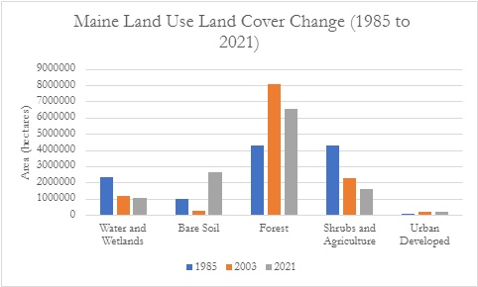

*Figure 6*. Maine land use land cover areal changes for 1985, 2003, and 2021.

***4.2 Future Work***

Further work should include validating the 1985 classification map, refining LULC maps created in this DEVELOP term, and forecasting LULC to 2040. Additional work could distinguish between coniferous and deciduous forests, as well as woody and non-woody wetlands, to account for differences in shade provided to streams, which can influence temperature. Ultimately, classifying more specific land cover categories and investigating net LULC changes would further inform the partners’ work in the field. During validation, the team discovered numerous locations in Maine that could be useful for training a supervised classification scheme. For instance, the airport near Bangor could be used for training the classifier to identify Urban Developed areas, and the farmlands west of Waterville or in northeastern Maine could be used to train a potential “farm” class. Future efforts should investigate using NLCD land cover maps for validation.

Future work could also look for correlation between partner-provided fish presence datasets and observed temperature, precipitation, and LULC at sample sites. Project team members could work with partners to determine critical temperature and precipitation thresholds to create stratified risk categories to geospatially visualize the relationship between LST, precipitation, and salmon performance. Project partners may also find use in curated indices displaying days above temperatures of interest.

# 5. Conclusions

The preliminary forest change results suggest that an estimated 1,458,374 hectares of forest land cover in Maine transitioned to urban, shrubs and agriculture, and bare soil over the study period. However, interpretation of this result should not fail to consider that the LULC classification for 1985 has not been validated, and the 30-m pixel resolution of Landsat is a limitation. Nonetheless, the loss of carbon sequestration-capable areas due to deforestation is a known driver of climate change. The temperature and precipitation anomaly maps indicate that these parameters are highly variable across the landscape. The temperature anomaly maps show larger surface areas nearing or surpassing Maine’s 20-year mean summer temperature towards the end of the study period. The precipitation anomaly maps do not indicate increasingly wet or dry summers. Furthermore, the summer mean temperature time series plot indicates a general trend in warming temperatures. It is interesting to note that our mean summer precipitation time series plot did not support strong evidence for decreasing summer precipitation. Considering the high spatial variability of rain and temperature across the landscape, finer spatial resolution data and smaller study areas would be necessary to discern definitive trends in precipitation and temperature within salmon habitat. The climatic anomaly maps and time series data allows for partners to investigate smaller critical study areas like the Machias, Narraguagus, and Union watersheds via the unique HUC-12 ID delineations. Historical Earth observation data provides context to the documented history of Atlantic salmon decline in the state of Maine. Future research should attempt to correlate partner-provided fish presence data in Maine to land surface temperature and precipitation trends in an effort to assess the relationship between climate and salmon decline.

The LULC maps serve as example applications and methods to investigate historical and ongoing LULC change near critical salmon habitat. The LULC maps for 2003 and 2021 were more than 80% accurate and quantified areal changes of habitat across Maine. These LULC maps provide preliminary results for our partners to investigate LULC change within the critical salmon habitat that they work to restore. Future work can further refine the classification scheme to discern between deciduous and evergreen forest types while working to better inform the classifier and improve accuracies. Despite being preliminary results, the LULC maps identified key objects of interest to salmon conservation. One such object of interest is the dam at the Androscoggin River reservoir; further investigation here could help partners to understand the impacts of dam building and resulting LULC changes along key Atlantic salmon rivers over time. With LULC mapped statewide, partners can clip the data to shapefiles of watersheds that include Atlantic salmon migratory rivers.

The complex life cycle of Atlantic salmon makes them extremely susceptible to habitat change and challenging to monitor. The introduction of remote sensing-based temperature, precipitation, and land use land cover monitoring in Maine provides additional context for assessing the impact these habitat variables have on Atlantic salmon populations and management strategies. NASA Earth observations can be used alongside *in situ* observations to obtain historical and baseline datasets that can inform conservation and policy-making efforts.

# 6. Acknowledgments

The Fall 2021 Maine Ecological Forecasting Team would like to thank the following project partners, science advisors, and NASA DEVELOP Fellow for their considerable contributions and support during this project:

* The State of Maine Department of Marine Resources
  + Ernie Atkinson, Marine Resources Scientist
* The Downeast Salmon Federation
  + Dwayne Shaw, Executive Director
* Science Advisors
  + Dr. John Bolten, NASA Goddard Space Flight Center
  + Dr. Bridget Noreen Seegers, NASA Goddard Space Flight Center
  + Joseph Spruce, Science Systems and Applications, Inc
* NASA DEVELOP National Program Fellow
  + Dr. Nicole Ramberg-Pihl, NASA Goddard Space Flight Center

Any opinions, findings, and conclusions or recommendations expressed in this material are those of the author(s) and do not necessarily reflect the views of the National Aeronautics and Space Administration.

This material is based upon work supported by NASA through contract NNL16AA05C.

# 

# 7. Glossary

**Anadromous** – Pertaining to fish, i.e., salmon, that migrate upstream from the sea for spawning

**DMR** – The State of Maine Department of Marine Resources

**DSF** – The Downeast Salmon Federation

**Earth observations** – Satellites and sensors that collect information about the Earth’s physical, chemical, and biological systems over space and time

**GEE** – Google Earth Engine

**GPM IMERG** – The Integrated Multi-satellitE Retrievals for Global Precipitation Measurement

**HUC-12** – Sub-watershed hydrologic management unit used by the National Hydrology Dataset

**Landsat** – Family of satellite missions in NASA’s earth observing fleet

**Land Surface Reflectance** – Values from the reflectance of the electromagnetic spectrum off surface cover

**LST** – Land Surface Temperature

**LULC** – Land Use Land Cover

**MODIS** – Moderate resolution Imaging Spectroradiometer

**NLCD** – National Land Cover Database  
**OLI** –Operational Land Imager

**Parr** – Pre-smolt young salmon

**Smolt** – Life cycle stage wherein salmon first migrate to sea

**TM** –Thematic Mapper

**YOY** – Young of the Year, fish born in the current year

# 8. References

Buchsbaum, R., Pederson, J., Robinson, W. E. (2005). The decline of fisheries in New England: Evaluating the impact of overfishing, contamination, and habitat degradation. Page MIT Sea Grant College Program Publication. 1–191. http://www.gulfofmaine.org/kb/files/8966/Moring,%20J.%20

2005%20Decline%20of%20Fisheries%20Resources%20book%20copy.pdf

Dauwalter, D. C., Fesenmyer, K. A., Bjork, R., Leasure, D. R., & Wenger, S. J. (2017). Satellite and Airborne Remote Sensing Applications for Freshwater Fisheries. *Fisheries*, *42*(10),526–537. https://doi.org/10.1080/03632415.2017.1357911

Endangered and Threatened Species; Final Status for a Distinct Population Segment of Atlantic Salmon (*Salmo salar*) in the Gulf of Maine, 65 Fed. Reg. 69459 (Nov 17, 2000). Effective Date: 12/18/2000. https://www.federalregister.gov/documents/2000/11/17/00-29423/endangered-and-threatened-species-final-endangered-status-for-a-distinct-population-segment-of

Frumhoff, P. C., McCarthy, J. J., Melillo, J. M., Moser, S. C., & Wuebbles, D. J. (2007). Confronting Climate Change in the U.S. Northeast. Synthesis report of the Northeast Climate Impacts Assessment (NECIA). Cambridge, MA: Union of Concerned Scientists (UCS). 1–160. <https://www.ucsusa.org/sites/default/files/2019-09/confronting-climate-change-in-the-u-s-northeast.pdf>

Hilderbrand, G. V., Farley, S. D., Schwartz, C. C., & Robbins, C. T. (2004). Importance of salmon to wildlife: Implications for integrated management. *Ursus*, *15*(1), 1–9. https://doi.org/10.2192/1537-6176(2004)015<0001:IOSTWI>2.0.CO;2

Huffman, G. J., Bolvin, D. T., Braithwaite, D., Hsu, K., Joyce, R., & Xie, P. (2014). Integrated Multi-satellitE Retrievals for GPM (IMERG), version 4.4. NASA's Precipitation Processing Center

Jonsson, B., & Jonsson, N. (2009). A review of the likely effects of climate change on anadromous Atlantic salmon *Salmo salar* and brown trout *Salmo trutta*, with particular reference to water temperature and flow. *Journal of Fish Biology*, *75*(10),2381–2447. https://doi.org/10.1111/j.1095-8649.2009.02380.x

Moore, R. D., Spittlehouse, D. L., & Story, A. (2005). Riparian microclimate and stream temperature response to forest harvesting: A review. *Journal of the American Water Resources Association*, *41*(4), 813–834. https://doi.org/10.1111/j.1752-1688.2005.tb03772.x

National Research Council. (2004). *Atlantic Salmon in Maine*. The National Academies Press. https://doi.org/10.17226/10892

NOAA & USFWS. (2019). Recovery Plan for the Gulf of Maine Distinct Population Segment of Atlantic Salmon (*Salmo salar)*. https://media.fisheries.noaa.gov/dam-migration/final_recovery_plan2.pdf

Piou, C., & Prévost, E. (2013). Contrasting effects of climate change in continental vs. oceanic environments on population persistence and microevolution of Atlantic salmon. *Global Change Biology*, *19*(3), 711–723. https://doi.org/10.1111/gcb.12085

Runkle, J., Kunkel, K., Champion, S., Frankson, R., Stewart, B., & DeGaetan, A. (2017). Maine State Climate Summary*. NOAA Technical Report NESDIS 149-ME*. Accessed 7 October 2021. <https://statesummaries.ncics.org/chapter/me/>

Saunders, R., Hackey, M. A., Fay, C. W. (2006). Maine’s diadromous fish community: Past, present, and implications for Atlantic salmon recovery. *Fisheries*, *31*(11), 537–547. https://doi.org/10.1577/1548-8446(2006)31[537:MDFC]2.0.CO;2

State of Maine Department of Marine Resources. (2021). *NG Trap* [Photograph (JPG)]. Personal Communication.

Tang, Z., Engel, B. A., Pijanowski, B. C., & Lim, K. J. (2005). Forecasting land use change and its environmental impact at a watershed scale. *Journal of Environmental Management*, *76*(1), 35–45. https://doi.org/10.1016/j.jenvman.2005.01.006

Thorstad, E. B., Whoriskey, F., Uglem, I., Moore, A., Rikardsen, A. H., & Finstad, B. (2012). A critical life stage of the Atlantic salmon *Salmo salar*: Behaviour and survival during the smolt and initial post-smolt migration. *Journal of Fish Biology*, *81*(2), 500–542. https://doi.org/10.1111/j.1095-8649.2012.03370.x

USGS (2021) USGS EROS Archive – Landsat Archives – Landsat 5 TM Level –2 Data Products [data]. Retrieved from https://www.usgs.gov/core-science-systems/nli/landsat/landsat-collection-2-level-2-science-products Accessed November 18, 2021. https://doi.org/10.5066/P9IAXOVV

USGS (2021) USGS EROS Archive – Landsat Archives – Landsat 8 OLI and TIRS Level –2 Data Products [data]. Retrieved from https://www.usgs.gov/core-science-systems/nli/landsat/landsat-collection-2-level-2-science-products Accessed November 18, 2021. https://doi.org/10.5066/P9OGBGM6

Wan, Z., Hook, S., & Hulley, G. (2015). *MOD11A1 MODIS/Terra Land Surface Temperature/Emissivity Daily L3 Global 1km SIN Grid V006* [Data set]. NASA EOSDIS Land Processes DAAC. Accessed 2021-11-19 from https://doi.org/10.5067/MODIS/MOD11A1.006

# 9. Appendices

**Appendix A**

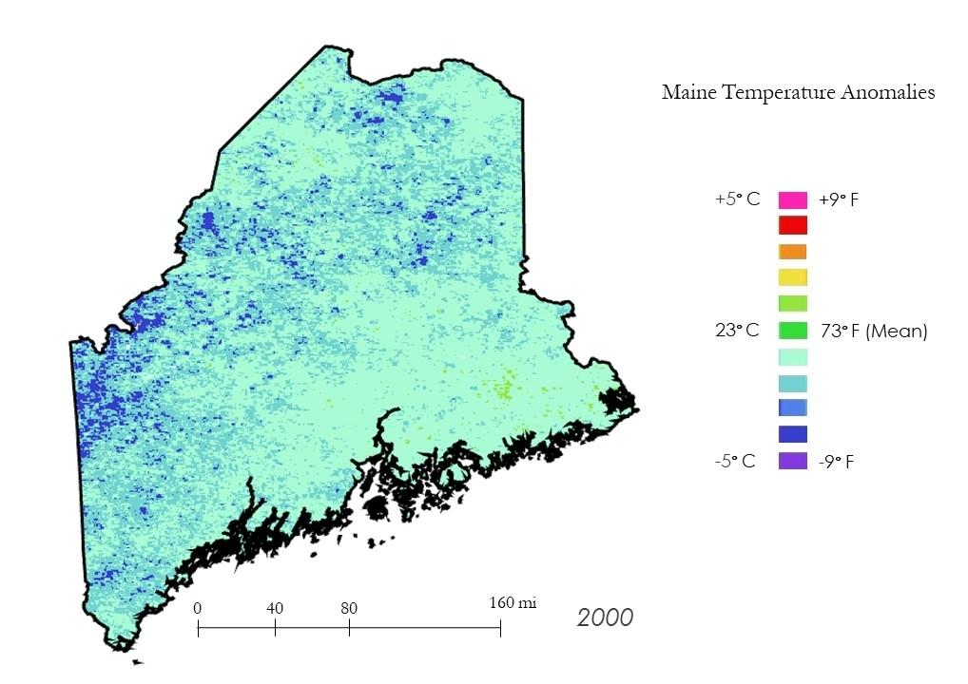

Figure A1. Temperature Anomaly Map for Maine (2000)

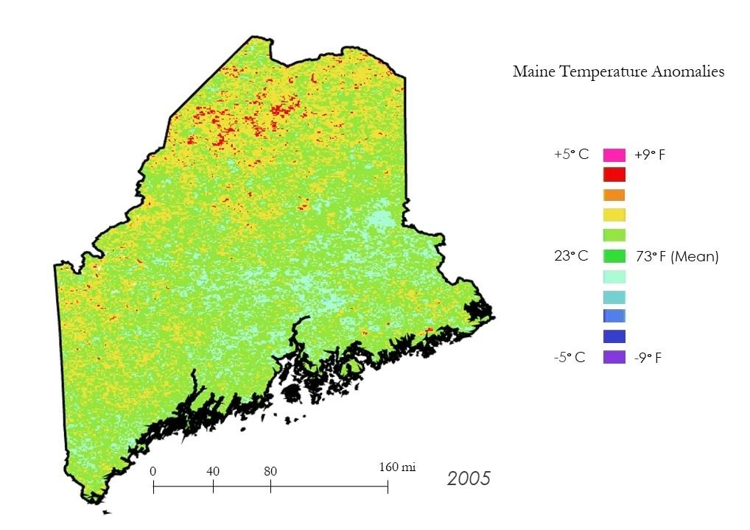

Figure A2. Temperature Anomaly Map for Maine (2005)

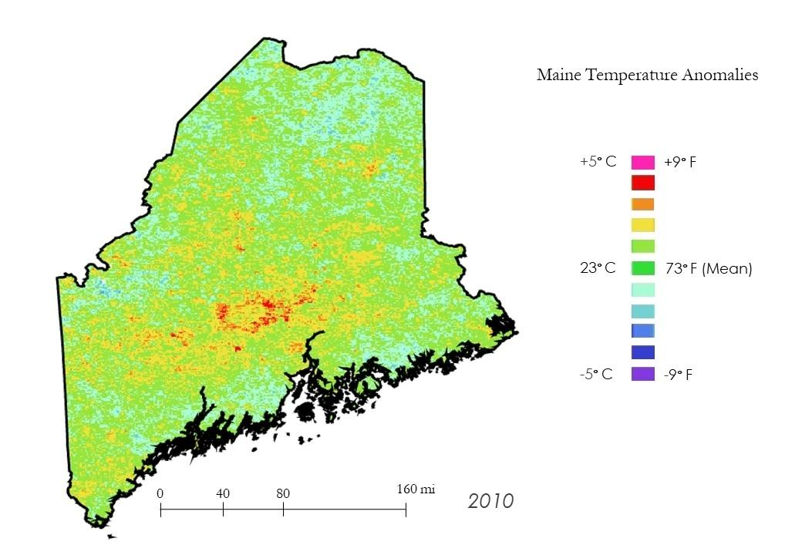

Figure A3. Temperature Anomaly Map for Maine (2010)

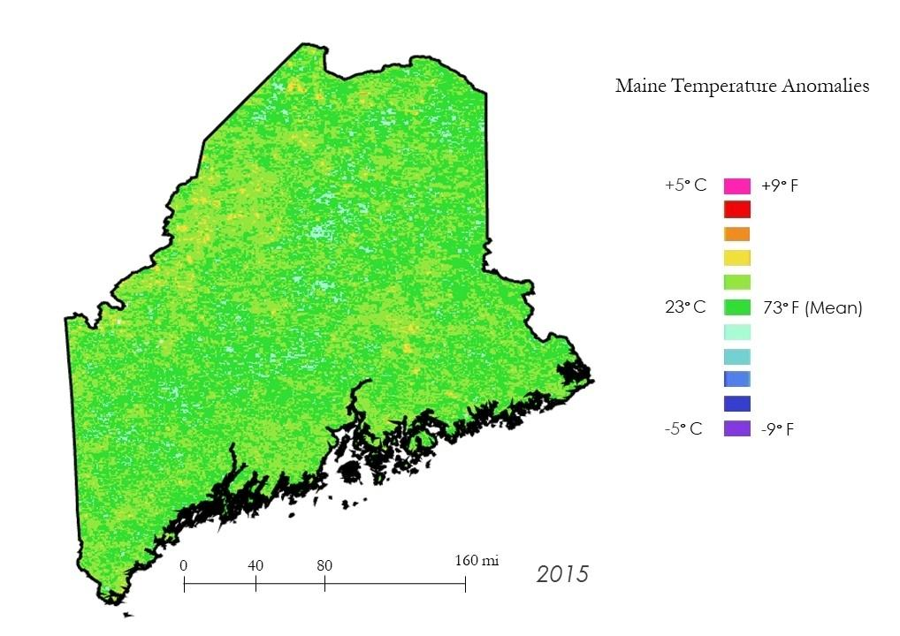

Figure A4. Temperature Anomaly Map for Maine (2015)

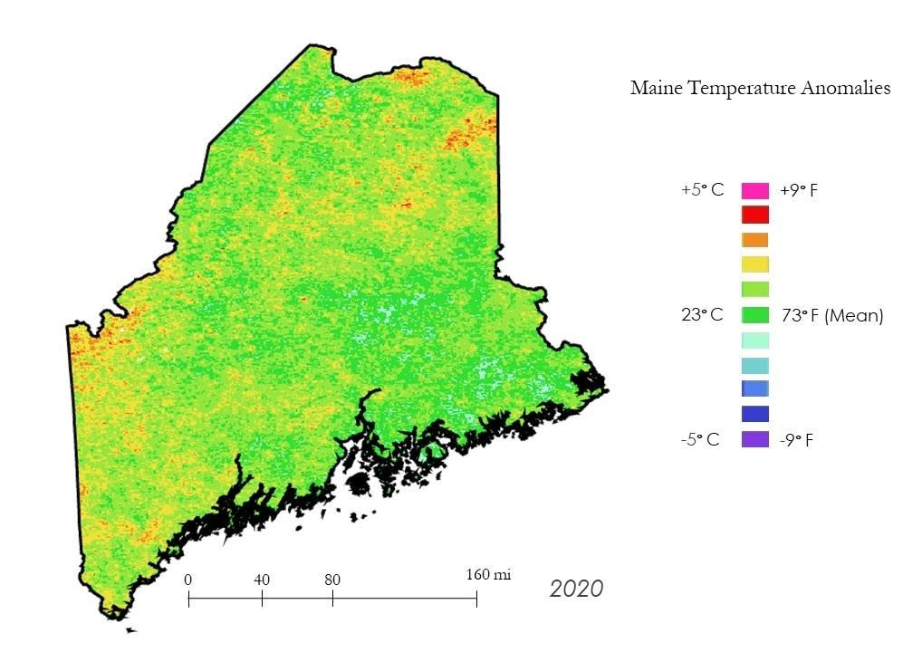

Figure A5. Temperature Anomaly Map for Maine (2020)

**Appendix B**

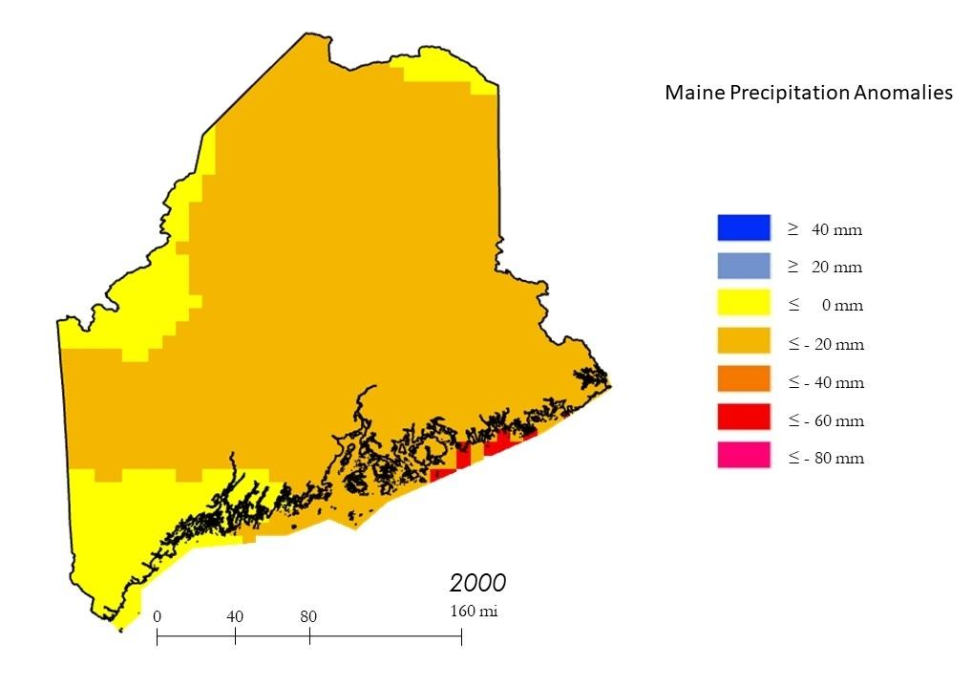

Figure B1. Precipitation Anomaly Map for Maine (2000)

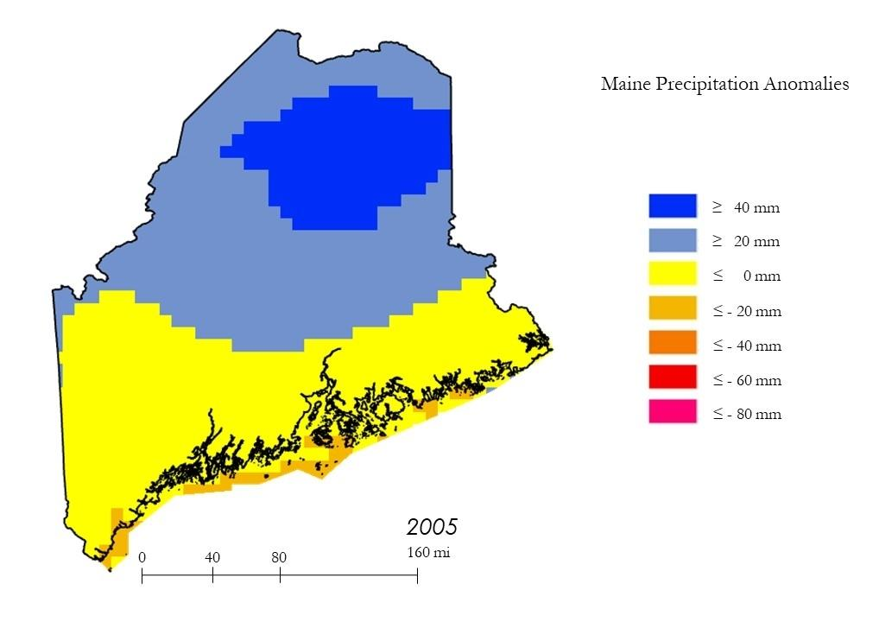

Figure B2. Precipitation Anomaly Map for Maine (2005)

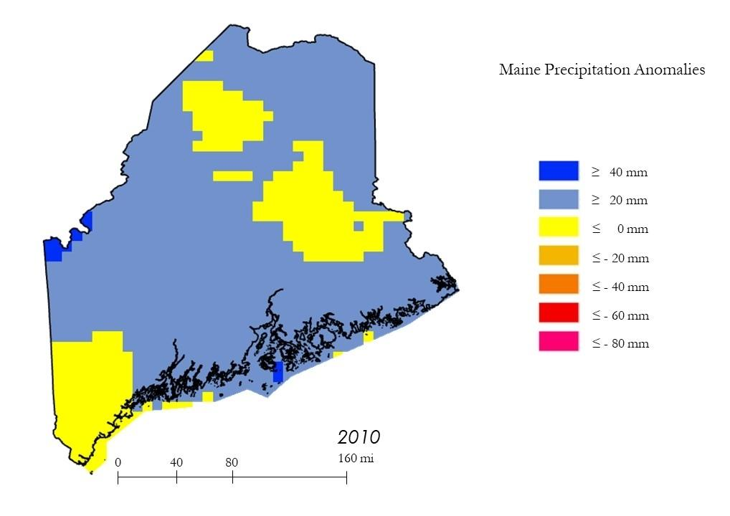

Figure B3. Precipitation Anomaly Map for Maine (2010)

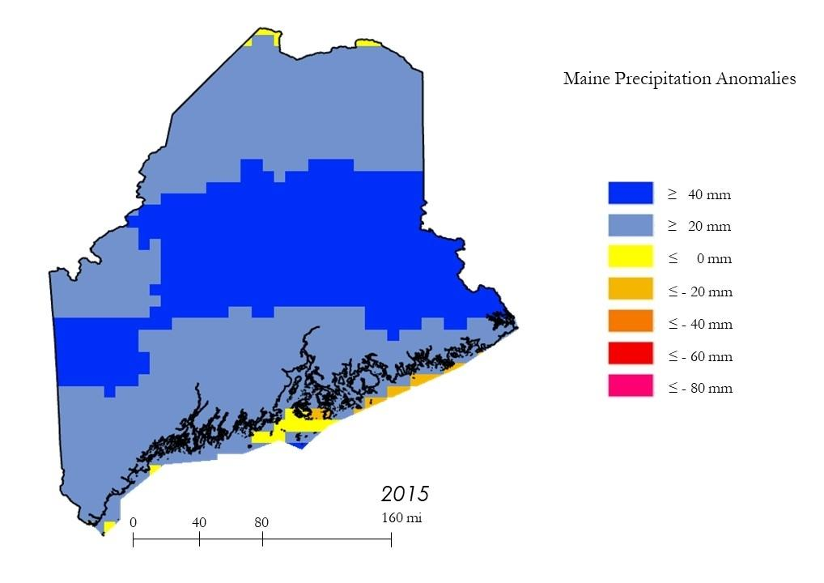

Figure B4. Precipitation Anomaly Map for Maine (2015)

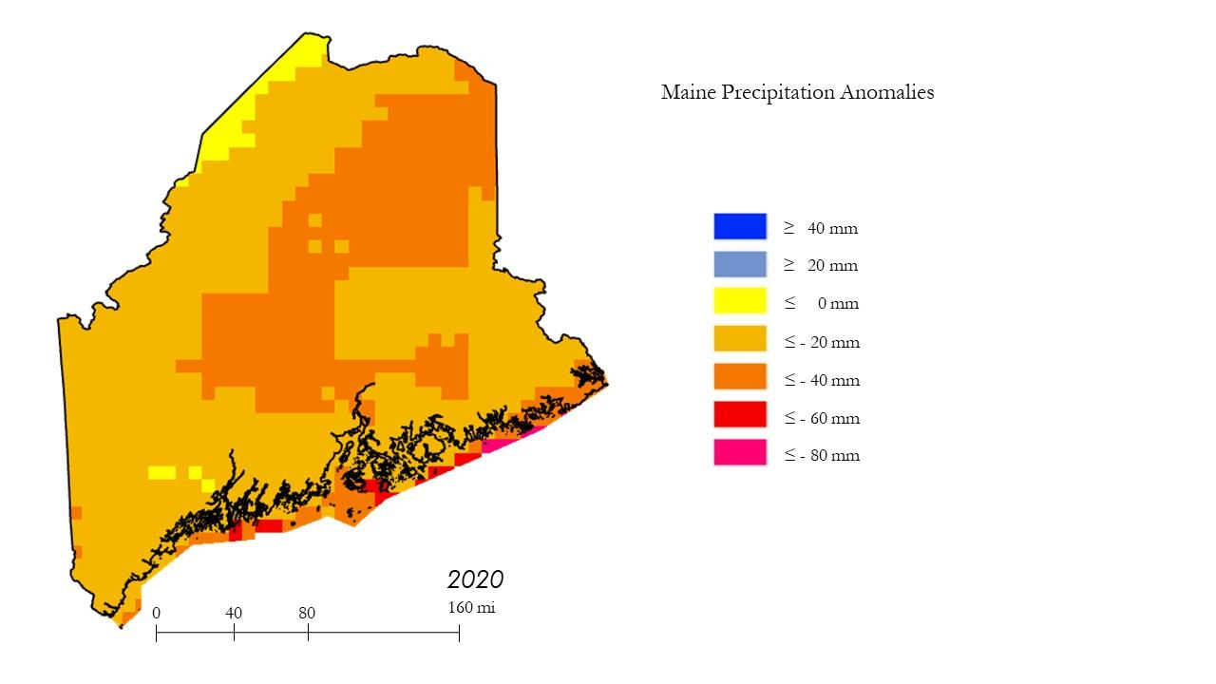

Figure B5. Precipitation Anomaly Map for Maine (2020)