Lake Michigan Water Resources

Utilizing NASA Earth Observations and Community Science to Detect and Map the Displacement of *Cladophora* along the Milwaukee County Shoreline

 **Technical Report**

Final Draft – August 9th, 2018

Jerrold Acdan (Project Lead)

Steven Chao

Lawrence Fujiwara

Ella Golovey

Dr. Juan Torres-Pérez, Bay Area Environmental Research Institute, NASA Ames Research Center (Science Advisor)

# 1. Abstract

Although *Cladophora* is naturally occurring and nontoxic, the accumulation and decay of this green macroalgae creates salient socioeconomic issues for communities situated along the shoreline of Lake Michigan. When *Cladophora* washes ashore and decays, it creates unaesthetic and unpleasant smelling beaches, potentially endangering public health and threatening the local tourism economy. Furthermore, decaying *Cladophora* promotes the growth of toxic bacteria, which can impact organisms that come into contact with it. In collaboration with Groundwork Milwaukee, the 2018 NASA DEVELOP Lake Michigan Water Resources team created *Cladophora* Habitat Suitability and Washup Predictive Maps to identify areas where the algaegrows and predict where it will most likely come ashore. These maps were created using Landsat 8 Operational Land Imager (OLI) and Aqua Moderate Resolution Imaging Spectroradiometer (MODIS) imagery of Lake Michigan near Milwaukee, WI, from June to September for the years 2016 and 2017. The results of this project will be validated during the fall 2018 DEVELOP term using *in situ* data of *Cladophora* sightings collected by Groundwork Milwaukee using an ArcGIS Collector App. To encourage community involvement, the team developed a project story map and provided Groundwork Milwaukee with content for their community science social media campaign that highlights the significance of this project while informing members of the general public about how they can contribute to cleanup efforts. These products will allow local organizations such as Groundwork Milwaukee to identify, monitor, and predict the movement of *Cladophora* and allocate cleanup resources more efficiently along the shores of Lake Michigan.

**Keywords**

*Cladophora,* Aqua MODIS, Landsat, Lake Michigan, Groundwork Milwaukee, community science, submerged aquatic vegetation, floating algae index

# 2. Introduction

* 1. ***Background Information***

*Cladophora* is a filamentous green macroalgae (Chlorophyta) found naturally in the Great Lakes (Harrington, 2014) that develops in April, with the peak growing season between June and September (Verhougstraete, Byappanahalli, Rose, & Whitman, 2010). It grows substantially underwater up to depths of 10 meters, attaching itself to hard substrates (Bootsma, Young, & Berges, 2006; Harrington, 2014; U.S. Geological Survey & U.S. Department of the Interior, 2009). When uprooted by wind and water currents, mats of *Cladophora* float to the surface and are often deposited on the shore, producing a powerful and pungent smell due to its subsequent decay (Harrington, 2014). Over the past century, *Cladophora* has been a nuisance in the Great Lakes. After a period of reduced growth in the 1980s and 1990s, the area today is once again experiencing a resurgence (Riley, Tucker, Adams, Fogarty, & Lafrancois, 2015).

*2.1.1 Factors Influencing* Cladophora *Growth and Deposition*

The factors influencing *Cladophora* growth are well understood and include: water depth, water temperature, increasing water clarity due to invasive mussels, and phosphorus inputs. However, the factors influencing the movement of dead floating algae remain poorly understood (Bootsma et al., 2006; Harrington, 2014; Riley et al., 2015; Shuchman, Sayers, & Brooks, 2013; University of Wisconsin-Milwaukee & Wisconsin Department of Natural Resources, n.d). Although storm activity, wave heights, wind speed and direction, currents, and water level likely affect the deposition of *Cladophora*, Riley et al. (2015) suggest that nearshore structures (number of structures within 500 m of the beach) and shoreline curvature could be the main drivers of algae deposition along the beaches of Lake Michigan.

*2.1.2 Impacts of* Cladophora *Deposition*

The decay of washed up *Cladophora* impacts local communities in many ways. Although *Cladophora* itself is not a health risk, the algal mats provide a habitat for bacteria such as *E. coli*, which come from manure, sewage, and runoff (Harrington, 2014; Verhougstraete et al., 2010). Waves and wind action can dislodge bacteria into the water, affecting those who come in contact with contaminated water. Washed up algal mats also create unsightly and foul-smelling scenes (Verhougstraete et al., 2010; US Geological Survey & US Department of Interior, 2009) that often decrease property values and discourage people from visiting the beaches (Harrington, 2014). In addition, the presence of algal mats has frequently forced the closure of beaches for public safety concerns. It is estimated that closing a beach in Lake Michigan deprives the economy of $37,030 per day (Devine, 2014). In addition to human impacts, algal mats can affect the biodiversity of the water. Decaying algae create an oxygen-poor environment, which promotes the growth of toxin-producing bacteria. The ingestion of this bacteria can reverberate up the food chain and cause avian botulism (Brooks, Grimm, Shuchman, Sayers, & Jessee 2015; Harrington, 2014; Verhougstraete et al., 2010; US Geological Survey & US Department of Interior, 2009).

* 1. ***Project Partners***

Our team partnered with Groundwork Milwaukee (GWMKE) to address the challenges regarding *Cladophora*. GWMKE is a non-profit organization dedicated to environmental restoration through community-based campaigns and youth programs (“Groundwork Milwaukee,” n.d.). Every year, organizations from Milwaukee, WI, seek to earn the city’s contract to clean *Cladophora* washup from Milwaukee County beaches so that residents and visitors can enjoy Lake Michigan’s water resources. The current disposal process involves transporting the algae to a local landfill. However, GWMKE seeks to implement a more sustainable disposal method through composting, which can only be accomplished if they acquire the contract (D. Powell & L. Hoffman, personal communication, June 13, 2018).

* 1. ***Project Objectives, Study Area, & Study Period***

To support GWMKE’s efforts, we established three objectives for this project: 1) create *Cladophora* Habitat Suitability and Washup Predictive Maps to identify factors influencing growth, displacement, and deposition of algae mats; 2) utilize Collector for ArcGIS via a mobile phone application to gather *in situ* data of *Cladophora* washup locations; and 3) produce a project story map and social media campaign content to inform the public about how they can help address issues regarding *Cladophora* nuisances in their own communities. The end products produced by this project can help GWMKE better manage *Cladophora* that comes ashore if they earn the city’s contract. The study area was confined to Milwaukee County, with an emphasis on seven beaches identified by GWMKE as areas of interest (Figure 1). The study period was June through September for the years 2016 and 2017 to capture the most recent *Cladophora* growing seasons.

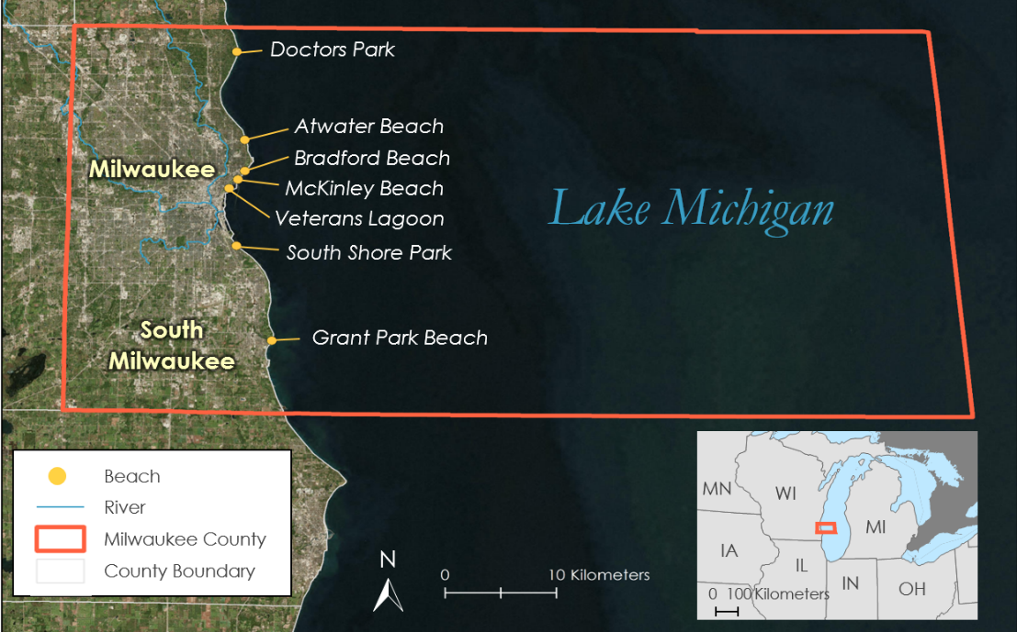

Figure 1. This is a map of the study area encompassing the Milwaukee County portion of Lake Michigan. (Source: Lake Michigan Water Resources Team, Esri, DigitalGlobe, GeoEye, Earthstar, Wisconsin Department of Natural Resources, US Census Bureau)

* 1. ***Previous Methodologies***

Researchers have applied various methodologies to quantify and track *Cladophora* in Lake Michigan and other freshwater bodies. One method to detect dead floating algae is calculating the Floating Algae Index (FAI), which Hu (2009) found to be better than NDVI as it corrects for various environmental and observing conditions. Shuchman et al. (2013) developed the Submerged Aquatic Vegetation Mapping Algorithm (SAVMA) to quantify the extent of submerged aquatic vegetation, which is mostly comprised of *Cladophora* in the Great Lakes. Research performed by Cox, Philippoff, Baumgartner, and Smith (2012) validated the effectiveness of scientific data collected by the general public. Our project adopted the use of FAI, SAVMA, and community science *in situ* data collection for its methodologies.

# 3. Methodology

The team created *Cladophora* Habitat Suitability and Submerged Aquatic Vegetation (SAV) maps to identify where in the study area *Cladophora* is likely to grow and where it currently exists. Additionally, a *Cladophora* Washup Predictive and Floating Algae Index (FAI) map was produced to highlight locations where the algae mats are most likely to come ashore. While the suitability and predictive maps were derived from multi-criteria evaluations (MCE) of various factors as determined from previous scholarly works, SAV was classified using a mapping algorithm and FAI was derived from index calculations. The GWMKE GIS team utilized Collectorfor ArcGIS, to collect *in situ* data that will be used to assess the accuracy of our map products in a continuation term. A chart displaying the methodology workflow is found below (Figure 2).

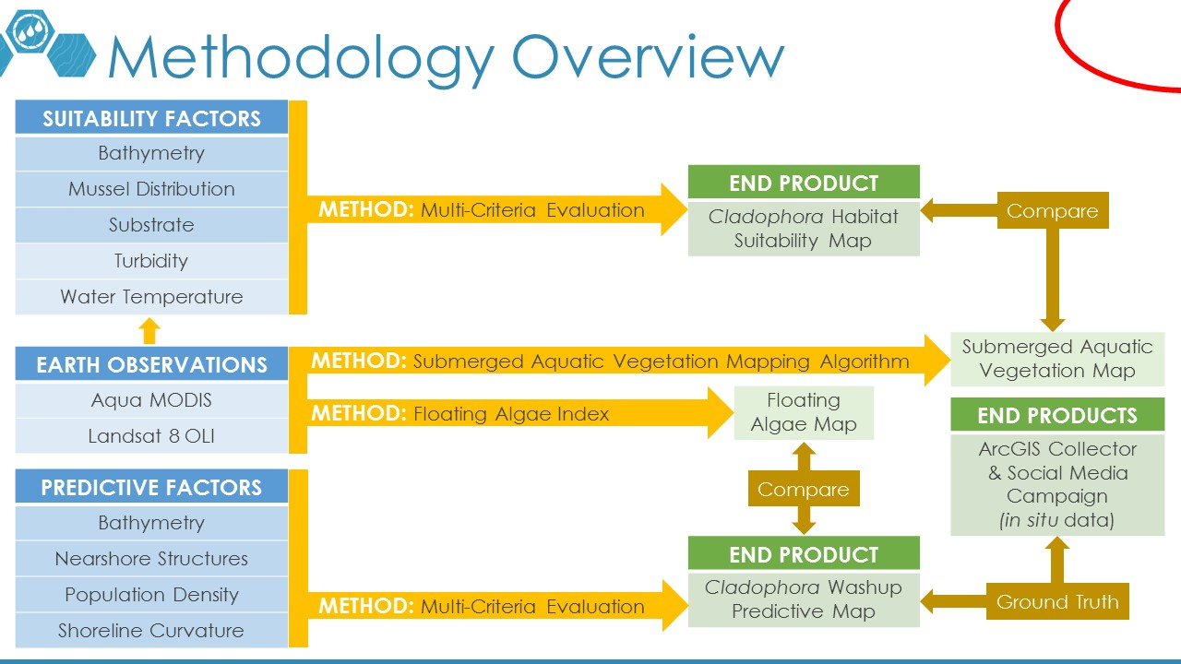

Figure 2. This flowchart details the methodology followed in this project.

(Source: Lake Michigan Water Resources Team)

***3.1 Data Acquisition***

We acquired the following satellite imagery and other ancillary data detailed below in Tables 1 and 2:

Table 1

*NASA Data acquired for this project. Citations for these data are found in the References section.*

|  |  |  |  |
| --- | --- | --- | --- |
| **NASA Data** | | | |
| **Product Title** | **Specifications** | **Image Dates** | **Source** |
| Landsat 8 Operational Land Imager (OLI) Top of Atmosphere (TOA) reflectance Level-1, Tier 1 | Path 23, Row 30  Little/no cloud cover | June 24, 2016  July 26, 2016  September 12, 2016  September 15, 2017 | [EarthExplorer - USGS](https://earthexplorer.usgs.gov/) |
| Aqua MODIS Sea Surface Temperature 8 Day composites | GeoTIFF raster with spatial resolution of 0.1 by 0.1 degrees | June 17 - 24, 2016  July 19 - 26, 2016  September 5 - 12, 2016  September 14 - 21, 2017 | [NASA Earth Observations](https://neo.sci.gsfc.nasa.gov/) |

Table 2

*Ancillary Data acquired for this project. Citations for these datasets are found in the References section.*

|  |  |  |
| --- | --- | --- |
| **Ancillary Data** | | |
| **Data Type** | **Specifications** | **Source** |
| US population per county subdivision | Shapefile | [US Census Bureau](http://www2.census.gov/geo/tiger/TIGER2010DP1/CouSub_2010Census_DP1.zip) |
| Lake Michigan bathymetry | GeoTIFF raster | [NOAA National Centers for Environmental Information](https://www.ngdc.noaa.gov/mgg/greatlakes/michigan.html) |
| Great Lakes Substrate | GeoTIFF raster | [Great Lakes Aquatic Habitat Framework](https://www.glahf.org/blog/2016/01/04/geomorphology/) |
| Quagga mussel distribution | Point data | [NOAA Great Lakes Environmental Research Laboratory](https://doi.org/10.1111/fwb.12653) |
| Great Lakes surface water current direction | Point data | [Great Lakes Observing System](http://data.glos.us/glcfs/) |
| 2012 Great Lakes Submerged Aquatic Vegetation (SAV) maps | GeoTIFF raster | [Michigan Tech Research Institute](http://geodjango.mtri.org/static/sav/) |
| Milwaukee County Boundary, Milwaukee County Shoreline data, and Lake Michigan Shapefiles | Shapefiles | [US Census Bureau TIGER/LINE (R)](https://www.census.gov/cgi-bin/geo/shapefiles/index.php)  [NOAA CUSP](https://shoreline.noaa.gov/data/datasheets/cusp.html) |

***3.2 Data Processing & Analysis***

*3.2.1 Cladophora Habitat Suitability Maps*

To create *Cladophora* Habitat Suitability Maps, we considered bathymetry, quagga mussel distribution, substrate, turbidity, and water temperature. We used quagga mussel distribution data as a proxy for phosphorus levels (the limiting nutrient for *Cladophora* growth) because no phosphorus data were available for Lake Michigan. These data layers were processed using ArcMap 10.6 and QGIS in the following steps:

First, we acquired turbidity data from Landsat imagery using the t_nechad2016 algorithm on ACOLITE.

Next, we re-projected all layers to the WGS_1984_UTM_Zone_16N coordinate system for consistency across all processing. Then, the bathymetry, substrate, and water temperature layers were resampled to 30-by-30 m to match the spatial resolution of the turbidity layer. Mussel distribution data, originally a vector layer, were converted to a raster through Kriging interpolation and resampled to 30-by-30 m in the process. Then, we clipped all data layers to a shapefile of Milwaukee County and to the 20-m bathymetry contour since *Cladophora* does not grow deeper than that according to the literature. To standardize data, we rescaled the bathymetry and turbidity values to be between 1 and 0 because shallower depths and less turbid waters lead to more favorable habitat suitability. Oppositely, mussel distribution and water temperature values were rescaled to be between 0 and 1 because higher phosphorus levels and warmer temperatures are better for *Cladophora* growth. Finally, in the substrate layer, we assigned “hard” pixels a value of one (since *Cladophora* grows best on hard substrates), “sand” pixels a value of 0.75 (less suitable for growth, but still possible), and the rest a value of zero.

To avoid issues associated with multicollinearity, we ran correlation tests on our variables. The results for September 12, 2016 data can be seen in Table 3 (See Tables A1-A3 in Appendix A for the other correlation test results). The fact that the correlation values were within the -0.8 and 0.8 range suggested that multicollinearity should not be a concern for the multi-criteria evaluation of our factors (McGrew, Lembo, & Monroe, 2014, p. 270; S. Palacios, personal communication, July 11, 2018). Therefore, all of these factors were added together using equation (1) to create a *Cladophora* habitat suitability layer (Figure 3). This process was repeated for all Landsat scenes.

Table 3

*Correlation Matrix for September 12, 2016 Data Layers.*

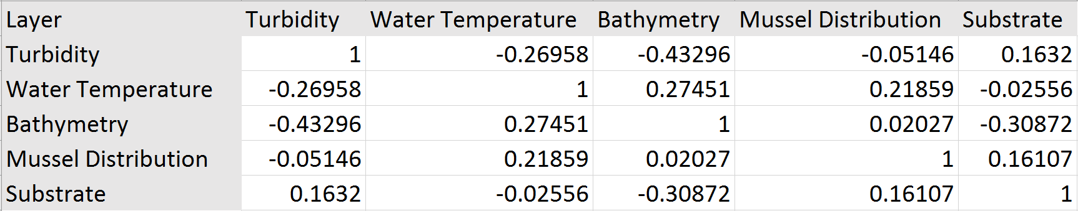

Habitat Suitability = (rank $\text{×}$ Bath) + (rank $\text{×}$ Sub) + (rank $\text{×}$ WT) + (rank $\text{×}$ MslDist) + (rank $\text{×}$ Turb) (1)

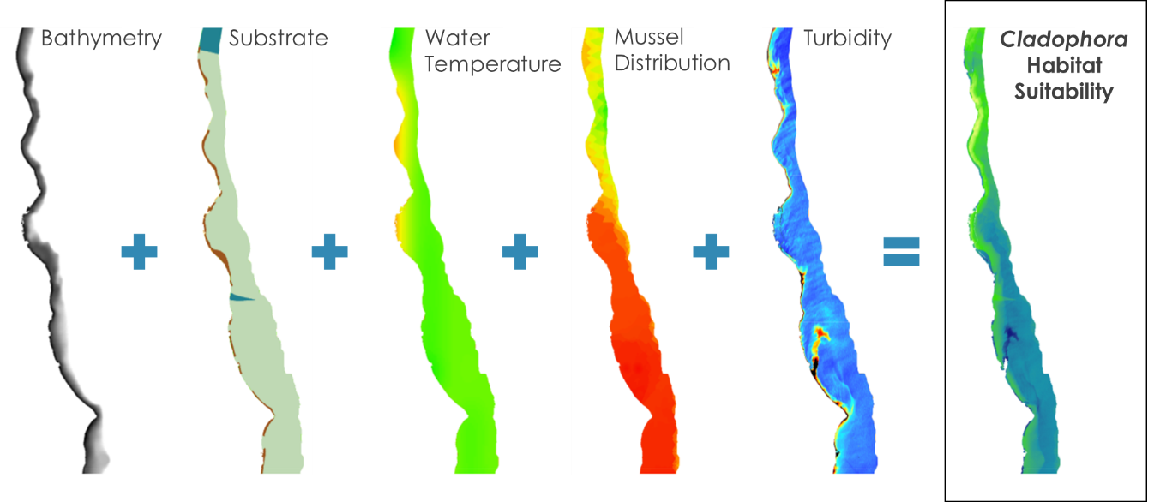

Figure 3. Factors used to calculate Cladophora habitat suitability.

(Source: Lake Michigan Water Resources Team)

The initial habitat suitability maps we produced assigned a ranking coefficient of one to all factors, but in reality, some factors have different impacts on habitat suitability. In order to gain a better understanding of the impacts different factors have on habitat suitability, we produced maps from the September 12, 2016 Landsat image where bathymetry is weighted less than the other factors and where water temperature is weighted more than the other factors (equations 2 and 3). We ran these calculations because bathymetry is already considered when we clipped the study area to only include areas no deeper than 20 meters. We also know that water temperature has a significant impact on *Cladophora* growth, so we ran a calculation to see how the habitat suitability map would change if water temperature was weighted more. Additionally, we ran a calculation to consider both of these differently weighted factors (equation 4).

Habitat Suitability = (0.8 $\text{×}$ Bath) + (Sub) + (WT) + (MslDist) + (Turb) (2)

Habitat Suitability = (Bath) + (Sub) + (1.2 $\text{×}$ WT) + (MslDist) + (Turb) (3)

Habitat Suitability = (0.8 $\text{×}$ Bath) + (Sub) + (1.2 $\text{×}$ WT) + (MslDist) + (Turb) (4)

*3.2.2 SAV Maps*

We used Raster Calculator in ArcMap 10.6 to calculate the density of submerged aquatic vegetation from our satellite imagery using the SAVMA equation and methodology (equations 5 through 8) created by Shuchman et al. (2013) and Brooks et al. (2015):

${\text{depth invariant index}}_{\text{ij} }\text{=} {\text{X}}_{\text{i}}\text{-}\left( \text{K} \text{×} {\text{X}}_{\text{j}}\right)$ (5)

*where,*

${\text{X}}_{\text{i}} \text{=}\text{ln}\left( {\text{L}}_{\text{i} }\text{-} {\text{L}}_{\text{si} }\right)$ (6)

*and,*

$${\text{L}}_{\text{i}} \text{=} \text{radiance for band }\text{i}$$

$${\text{L}}_{\text{si} }\text{=} \text{average radiance over deep water for band }\text{i}$$

$${\text{X}}_{\text{i} }\text{=} \text{depth corrected radiance for band }\text{i}$$

*and where,*

$\text{K} \text{=} \text{a} \text{+} {\text{(} {\text{a}}^{\text{2}} \text{+} \text{1} \text{)}}^{\text{1/2}}$ (7)

*where,*

$\text{a} \text{=} {\text{(} \text{σ}}_{\text{ii} }\text{-} {\text{σ}}_{\text{jj} }\text{)} \text{/} \text{(} \text{2}{\text{σ}}_{\text{ij} }\text{)}$ (8)

*and,*

$${\text{σ}}_{\text{ii} }\text{=} \text{variance of }{\text{X}}_{\text{i}} \\ {\text{σ}}_{\text{ij}} \text{=} \text{covariance of }{\text{X}}_{\text{i}}\text{ and }{\text{X}}_{\text{j}}$$

With guidance from Shuchman et al.’s (2013) team, we inputted the green, blue, and coastal bands from Landsat 8 at-sensor radiance imagery into the algorithm to produce three index images: green and blue, green and coastal blue, and blue and coastal blue (Shuchman’s team was recreating their SAVMA maps and determined that the coastal blue band was better than the red band for Landsat 8) (K. Bosse, personal communication, July 19, 2018). We calculated ${\text{L}}_{\text{si} }$ using the reflectance pixels in the imagery beyond the 30 m contour line found in the bathymetry contour data.

We used a simple threshold to reclassify the index images into sand, light SAV, and dense SAV (K. Bosse, personal communication, July 19, 2018). By comparing the 2012 SAV rasters with our index images (due to a lack of *in situ* data from the dates the satellite images were taken), we calculated the average y-values from our index images for each class. Based on these averages, we generated thresholds (the median between the average y-values) to sort the index image pixels into the three classes. We then reclassified these classes, giving sand a value of 0; light SAV, 1; and dense SAV, 2. We added the 3 reclassified index rasters together using Raster Calculator to produce a new raster. We again reclassified this new raster based on the aggregated pixel value (0 and 1 were sand; 2 and 3, light SAV; and 4, 5, 6, dense SAV). Our reasoning was that if two index images labeled a certain pixel as dense SAV and one index image labeled it as light SAV (which, based on our methods, would create an aggregated value of 5), there was a likely chance the pixel was actually dense SAV. These steps were repeated for each Landsat image.

*3.2.3* Cladophora *Washup Predictive Map & Floating Algae Index Maps*

We created the *Cladophora* Washup Predictive Map based on factors identified as important for deposition by Riley et al. (2015). Using ArcMap 10.6, we used the resampled bathymetry data to generate curvature data using the Curvature tool. We then used the Focal Statistics tool to create an average curvature index image by calculating the average curvature value of the pixels within 5-mile circular radius of each pixel and assigning that pixel the averaged value. This output was then clipped to a 500 m buffer around each beach that extends only into the Lake Michigan side of each beach. To obtain the number of near structures, we used the aerial maps of our study area and the attribute table from NOAA’s CUSP to count the number of manmade structures (break walls, jetties, and piers) that fell within the clipped 500-meter buffer. The number of nearshore structures was appended to the attribute table of the 500 m buffer shapefile surrounding the Milwaukee beaches. We then converted this shapefile to a raster with a 30 m by 30 m resolution using a cubic convolution.

The shoreline curvature data and rasterized near shore structure data were assigned equal weights due to the lack of *in situ* data to calibrate coefficients. We then added the layers together to create a map that predicts beaches in the study area most likely to experience washup (equation 9). Subsequently, population density and water current direction layers were layered on top of the map. To assess relative accuracy of the map, we sought to compare it to FAI maps, which we created using the FAI algorithm in ACOLITE.

Predictive Value = (A $×$ Number of Nearshore Structures) + (B $×$ Shoreline Curvature) (9)

(note, for this project: A = B = 1)

*3.2.4 ArcGIS Collector Cladophora Monitoring Tool*

In order to utilize the Collector for ArcGIS mobile phone application, we created a geodatabase and a point feature class ArcGIS Desktop 10.6. In the geodatabase, we modified 4 domains to allow the user to have “drop down menu” options on their mobile devices. We then gave the point feature class 17 attributes, as seen in Figure 4, to record information of *Cladophora* washup. All the attributes were made editable so that they can be recorded while in the field collecting data or back in the office after data collection. The new geodatabase and the new point feature class were then published onto the ArcGIS online platform where the basemap was inputted, map extent was set and the symbology of the point feature class was created. The ArcGIS online map created using data from ArcGIS Desktop 10.6 was then shared to be used in the ArcGIS Collector mobile application.

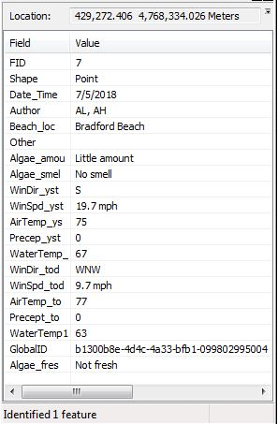

Figure 4. List of attributes of the “Cladophora washup location” point feature class.

(Source: Lake Michigan Water Resources Team)

# 4. Results & Discussion

***4.1 Analysis of Results***

*4.1.1 Cladophora* *Habitat Suitability Maps*

Below are maps of habitat suitability where all the input factors were weighted equally for the September 12, 2016 and September 15, 2017 Landsat images (Figure 5*).* In both images, there is a general trend where habitat suitability decreased from North to South in the study area. One interesting thing we noticed was the area enclosed by a red circle that shows very low habitat suitability in 2016 but not in 2017. It turns out that there is a power plant located in this area that uses water from Lake Michigan in their cooling system. When the water is returned back to the lake, it creates a very turbid environment that is not favorable for *Cladophora* growth. However, when the power plant is not returning water to the lake, the habitat appears more favorable.

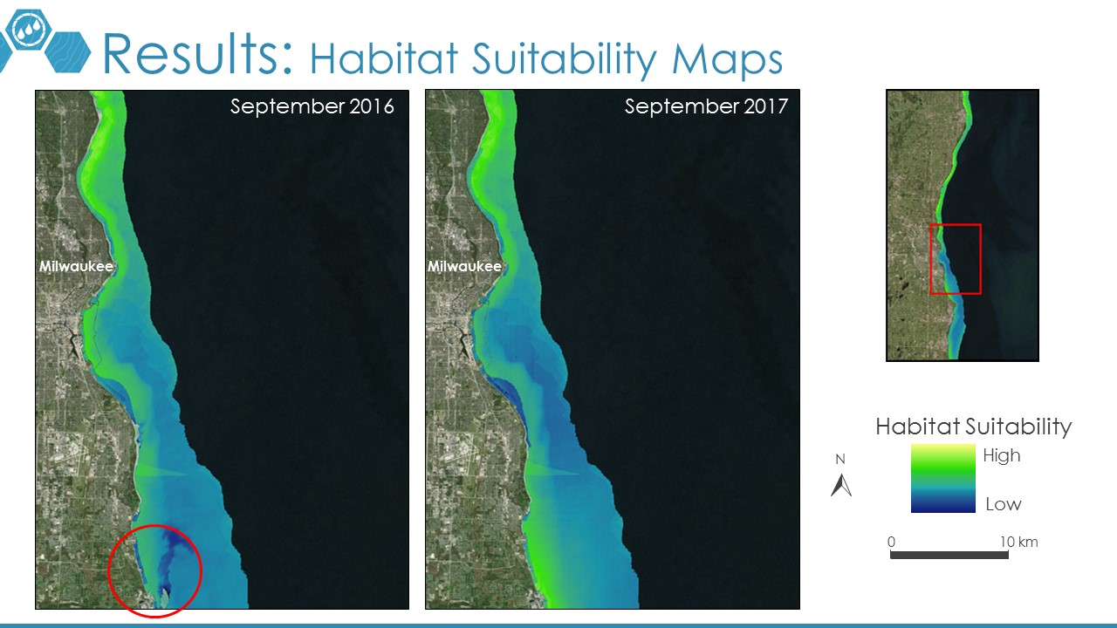

*Figure 5*. Habitat Suitability Maps for September 12, 2016 and September 15, 2017.

(Source: Lake Michigan Water Resources Team)

The results of applying equations 1 through 4 on the September 12, 2016 Landsat image can be found in Appendix A as Figure A1. Despite weighing factors with different weights, all the maps appeared almost exactly the same. This could be a result of two reasons: 1) all the factors we considered impact habitat suitability equally or 2) there is a huge uncertainty in the values we chose as coefficients, especially since they were arbitrarily selected. The second reason is more likely; *in situ* data is needed to calibrate the coefficients in a scientifically accurate manner.

*4.1.2 SAV Maps*

The maps produced by the SAVMA equation are shown in Figure 6. They were clipped to the 10-meter bathymetry contour line since *Cladophora* generally does not grow below 10 meters. All maps show a substantial amount of Cladophora growth along the shorelines, with 92.98% of pixels classified as SAV in the June 2016 image, 95.05% in the July 2016 image, 80.57% in the September 2016 image, and 59.39% in the September 2017 image.

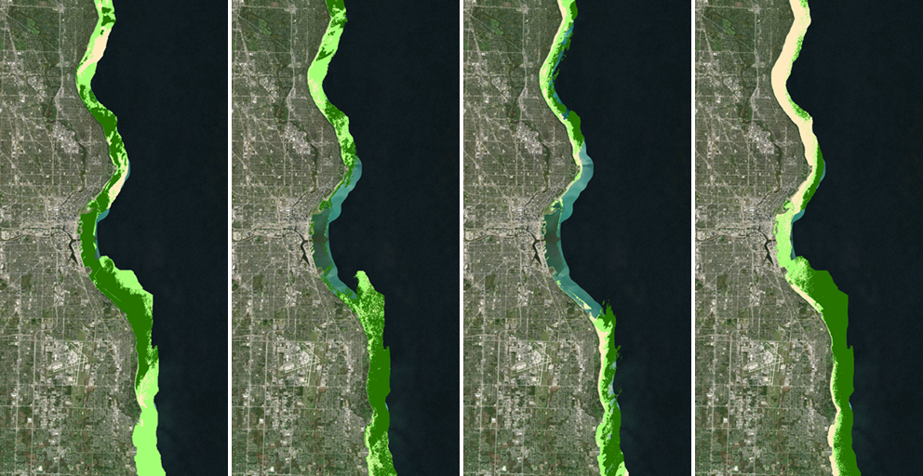

**Milwaukee**

**Milwaukee**

**Milwaukee**

**Milwaukee**

***Milwaukee Bay***

***Milwaukee Bay***

***Milwaukee Bay***

***Milwaukee Bay***

**(d)**

**(c)**

**(b)**

**(a)**



Dense SAV

Less Dense SAV

Sand

*Figure 6.* Maps depicting submerged aquatic vegetation using the Submerged Aquatic Vegetation Mapping Algorithm for (a) June 2016, (b) July 2016, (c) September 2016, and (d) September 2017.

(Source: Lake Michigan Water Resources Team)

The higher SAVMA values on the satellite imagery should correspond with high probability areas as determined by our suitability map. Consequently, we overlaid the SAVMA map on the suitability map.

While the *Cladophora* Habitat Suitability Map shows more suitable *Cladophora* locations in the north of the study area, some of the SAV maps, particularly the September maps, visually suggest more *Cladophora* growth closer to the 10 m bathymetry contour line than to the shoreline. This suggests that the trend of deeper water being less conducive of *Cladophora* growth, as determined from the literature, may be a generalized trend. When looking at a smaller scale, as in this case, there are variations in the trend. Consequently, the *Cladophora* Habitat Suitability Map equation, particularly the bathymetry parameter, may need to be modified.

Furthermore, in the July 2016 and September 2016 SAV maps, Milwaukee Bay (the center of the image) does not have any data, meaning that SAVMA removed those pixels because it considered them as deep water (the pixel values in that location were less than ${\text{L}}_{\text{si} }$). Visually examining aerial imagery reveals that the water in the bay is darker than the rest of the water in the study area; however, according to bathymetry data, it is clearly shallow water. There are two possible explanations for this phenomenon. First, Shuchman et al. (2013) note that extremely dense SAV may make water appear as deep water in terms of pixel values. Second, the Milwaukee River flows into Lake Michigan at that point. Since nearby municipalities empty wastewater into the river, the dark pixels in that area could be a result of nutrient-rich water. This phenomenon may be a combination of both factors, especially because the *Cladophora* Habitat Suitability Maps show the location is suitable for *Cladophora* growth (suggesting that there may be extremely dense SAV) and because the June 2016 and September 2017 SAV maps have data for those locations (suggesting that changing nutrient levels from Milwaukee River may be influencing the pixel values).

*4.1.3 Cladophora Washup Predictive Map*

The *Cladophora* Washup Predictive Map shown in Figure 7 has five inset maps showing six beaches. Veterans Beach is not shown because it is a freshwater lagoon with no near shore structures. This map reveals that *Cladophora* washup will generally occur more in the southern beaches rather than in the northern beaches. Of all the beaches analyzed, South Shore Park beach had the highest predictive value, as shown in Table 4. One important thing to note is that while water current direction data were overlaid as a map layer, they were not factored into the predictive values. The nearshore currents seasonally shift from flowing north to south in June and July to flowing south to north in August and September. Although Riley et al (2015) suggest that water currents do not play as big a role in *Cladophora* deposition on Milwaukee beaches as other factors, future studies should investigate this claim further.

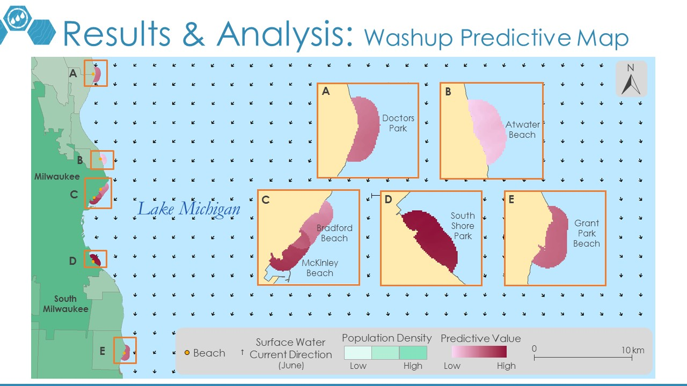

Figure 7. Cladophora Washup Predictive Map.

(Source: Lake Michigan Water Resources Team)

Table 4.

Relative predictive values listed for each beach location.

|  |  |
| --- | --- |
| **Beach Location Name** | **Predictive Value** |
| South Shore Park | Very High |
| McKinley Beach | High |
| Grant Park Beach | Medium High |
| Doctors Park | Medium |
| Bradford Beach | Medium Low |
| Atwater Beach | Low |

*4.1.4 Floating Algae Index Maps*

FAI Maps for September 2017, September 2016, July 2016, and June 2016 all had an approximate average value of zero (Find FAI maps for all four Landsat images in Appendix B as Figure B1). When zoomed into the shorelines of the September 2016 FAI map, very few pixels had medium floating algae index values (Figure 8). We believe this approximate average value of zero occurred in all our maps because either: 1) spatial resolution of Landsat 8 OLI is not high enough to detect floating *Cladophora* mats (which are probably not large at all), or 2) there were no *Cladophora* mats floating in our study area at the time the images were acquired. As a result, FAI maps cannot be compared to the predictive map.

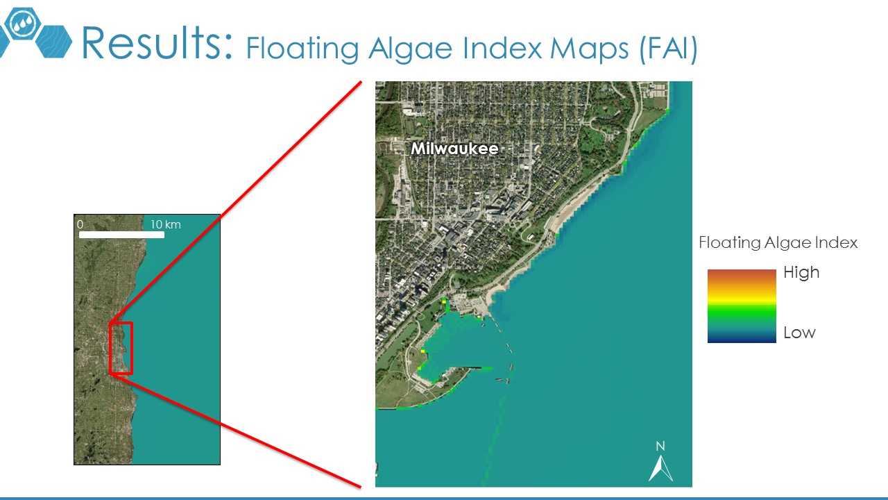

Figure 8. September 2016 FAI map zoomed into Bradford and McKinley Beaches.

(Source: Lake Michigan Water Resources Team)

***4.2 Future Work***

A continuation of this project is proposed for the NASA DEVELOP fall 2018 term. The continuation project team will strive to expand the study area beyond Milwaukee County to find other areas of *Cladophora* growth and more robustly incorporate surface water currents in future washup location predictive analyses. The use of community science will also be incorporated by launching a social media campaign on Twitter and Instagram, where images can be georeferenced and used to identify specific locations on beaches with algae accumulations. By having *in situ* data from both the Collector for ArcGIS *Cladophora* Monitoring Tool and the community science campaign, the fall 2018 team will ultimately be able to calibrate and modify the maps and models built during this term.

# 5. Conclusions

Utilizing NASA Earth observations to detect and map the displacement of *Cladophora* along the Milwaukee County shoreline is difficult due to a lack of data and research in our study area and an inability to detect *Cladophora* washup from satellite imagery due to small beaches and low image resolution. Creating *Cladophora* Habitat Suitability Maps was challenging due to discontinuous data that didn’t reach the shoreline and uncertainty in assigning ranks to factors that influence *Cladophora* growth. Nonetheless, the Habitat Suitability Maps show that more suitable habitat is found in the northern portions of Lake Michigan, and subsequent algae washup on Milwaukee County beaches is due to the direction of water currents. The SAV Map shows a substantial amount of *Cladophora* within the 10 m bathymetry contour, and the Predictive Washup map suggests that the southern beaches will generally experience more washup. Floating Algae Index Maps had an approximate average value of zero, making the FAI methodology not useful for this project. The accuracy of these maps and models will be assessed next term with *in situ* data collected by GWMKE using the Collector application in ArcGIS. Despite running into challenges regarding lack of available and relevant data, this project was still able to identify areas most susceptible to *Cladophora* growth and predicted where it will likely wash up in Milwaukee County. These results will enhance our project partners’ decision-making processes related to *Cladophora* washup management and hopefully help them conserve resources during cleanup efforts.

# 6. Acknowledgments

Our team would like to thank the leadership and mentors at the NASA DEVELOP Ames Node for their expert advice and unwavering support:

* Jenna Williams, NASA DEVELOP Center Lead
* John Dilger, NASA DEVELOP Geoinformatics Fellow
* Dr. Juan Torres-Pérez, Science Advisor (Bay Area Environmental Research Institute, NASA Ames Research Center)
* Dr. Sherry Palacios, Mentor (Bay Area Environmental Research Institute, NASA Ames Research Center)

We also appreciate the cooperation and help from the team at Groundwork Milwaukee:

* Deneine Christa Powell, Executive Director
* Lawrence Hoffman, GIS Program Manager
* Alex Halloway and Alex Litscher, GIS Interns

Any opinions, findings, and conclusions or recommendations expressed in this material are those of the author(s) and do not necessarily reflect the views of the National Aeronautics and Space Administration.

This material is based upon work supported by NASA through contract NNL16AA05C and cooperative agreement NNX14AB60A.

# 7. Glossary

**Aqua MODIS** – (MODerate Resolution Imaging Spectroradiometer) An instrument on the Aqua satellite launched in 2002

***Cladophora*** –Genus of filamentous green algae found naturally in the Great Lakes

**Classification** – Grouping of objects that share distinct characteristics and shared qualities

**Community science** – The collection of data relating to the natural world by members of the general public. Also known as *citizen science* but referred to as *community science* to include all members of society.

**Earth observations** – Satellites and sensors that collect information about the Earth’s physical, chemical, and biological systems over space and time

**FAI** – (Floating Algae Index) An index that quantifies the density of floating algae

**GWMKE** – Groundwork Milwaukee, a nonprofit organization that works with the local community to create positive socioeconomic and environmental change

***In situ*** – Latin word that describes an object in its original place

**Landsat 8 OLI** – (Operational Land Imager) An instrument on Landsat 8 launched in 2013

**MCE** – (Multi-Criteria Evaluation) A type of analysis that uses decision-making rules and weights to combine various user-specified criteria into a single map

**Multicollinearity** – A problem in multiple regression analysis where two explanatory variables correlate with each other, which can compromise the overall outcome of the analysis

**CUSP** – (Continually Updated Shoreline Product) A dataset created by NOAA’s National Geodetic Survey that uses imagery and other sources to generate up-to-date national natural and manmade shoreline

**NDVI** – (Normalized Difference Vegetation Index) Quantifies vegetation by measuring the difference between near-infrared and red light

**Radiance** – Amount of light emitted by an object or feature

**Reflectance** – proportion of light or other radiation reflected off a surface relative to what hit the surface

**SAV** – (Submerged Aquatic Vegetation) Aquatic plants that are found under water

**SAVMA** – (Submerged Aquatic Vegetation Mapping Algorithm) A method that quantifies the density of submerged aquatic vegetation

**TOA reflectance** – (Top Of Atmosphere) Refers to the rescaling done to Landsat Level-1 data to account for the scattering effects of the atmosphere

# 8. References

Bootsma, H. A., Young, E. B., & Berges, J. A. (2006, February 17). Cladophora abundance and physical / chemical conditions in the Milwaukee region of Lake Michigan (Tech. No. 2005-02). Retrieved June 25, 2018, from Milwaukee Metropolitan Sewerage District website: https://www.mmsd.com/application/files/3914/8192/3960/cladophora_report.pdf

Brooks, C., Grimm, A., Shuchman, R., Sayers, M., & Jessee, N. (2015). A satellite-based multi-temporal assessment of the extent of nuisance *Cladophora* and related submerged aquatic vegetation for the Laurentian Great Lakes. *Remote Sensing of Environment*, *157*, 58-71. doi:10.1016/j.rse.2014.04.032

Cox, T. E., Philippoff, J., Baumgartner, E., & Smith, C. M. (2012). Expert variability provides perspective on the strengths and weaknesses of citizen-driven intertidal monitoring program. *Ecological Applications, 22*(4), 1201-1212. doi:10.1890/11-1614.1

Devine, J. (2014). *The impacts of beach pollution* (Rep.). Retrieved June 25, 2018, from Natural Resources Defense Council website: https://www.nrdc.org/sites/default/files/ttw2014_Impacts_of_Beach_Pollution.pdf

Feldman, G., & Kuring, N. (2018). MOD28 Sea Surface Temperature 8-Day Aqua/MODIS [Dataset]. Ocean Biology Distributed Active Archive Center, accessed June 28, 2018.

Graham, D. (2018). NOAA Continually Updated Shoreline Product [Dataset]. Accessed July 2, 2018 from

https://shoreline.noaa.gov/data/datasheets/cusp.html.

Great Lakes Observing System. (2018). Lake Michigan water surface currents [Dataset]. Accessed July 25,

2018 from http://data.glos.us/glcfs/.

Groundwork Milwaukee. (n.d.). Retrieved June 26, 2018, from http://www.groundworkmke.org/

Harrington, M. (2014). *Nuisance algae on Lake Michigan shores* (Issue brief No. WISCU-G-14-009). Retrieved June 25, 2018, from University of Wisconsin Sea Grant Institute website: https://publications.aqua.wisc.edu/download/nuisancealgaelakemichigan-pdf/

Hu, C. (2009). A novel ocean color index to detect floating algae in the global oceans. *Remote Sensing of Environment, 113*(10), 2118-2129. doi:10.1016/j.rse.2009.05.012

Kautz, S. (2018). Landsat 8 OLI (Operational Land Imager) and TIRS (Thermal Infrared Sensor) [Dataset]. U.S. Geological Survey, accessed June 28, 2018. https://doi.org/10.5066/f71835s6

McGrew, J. C., Lembo, A. J., & Monroe, C. B. (2014). *An introduction to statistical problem solving in geography.* Long Grove, IL: Waveland Press.

National Geophysical Data Center. (1996). Bathymetry of Lake Michigan [Dataset]. National Geophysical Data Center, NOAA, accessed July 2, 2018. doi:10.7289/V5B85627

Rowe, M. D., Obenour, D. R., Nalepa, T. F., Vanderploeg, H. A., Yousef, F., & Kerfoot, W. C. (2015). Mapping the spatial distribution of the biomass and filter-feeding effect of invasive dreissenid mussels on the winter-spring phytoplankton bloom in Lake Michigan [Dataset]. *Freshwater Biology, 60*(11), 2270-2285. doi:10.1111/fwb.12653

Riley, S. C., Tucker, T. R., Adams, J. V., Fogarty, L. R., & Lafrancois, B. M. (2015). Factors associated with the deposition of *Cladophora* on Lake Michigan beaches in 2012. *Journal of Great Lakes Research, 41*(4), 1094-1105. doi:10.1016/j.jglr.2015.09.008

Shuchman, R. A., Sayers, M. J., & Brooks, C. N. (2013). Mapping and monitoring the extent of submerged aquatic vegetation in the Laurentian Great Lakes with multi-scale satellite remote sensing. *Journal of Great Lakes Research, 39*, 78-89. doi:10.1016/j.jglr.2013.05.006

University of Wisconsin-Milwaukee & Wisconsin Department of Natural Resources. (n.d.).Cladophora *in Lake Michigan* [Brochure]. Author. Retrieved June 25, 2018, from https://dnr.wi.gov/topic/greatlakes/documents/CladophoraFactsheet.pdf

U.S. Army Corps of Engineers. (2012). Substrate for the bottom of the Great Lakes [Dataset]. Retrieved July 2, 2018 from https://www.glahf.org/blog/2016/01/04/geomorphology/

U.S. Census Bureau. (2010). Population per county subdivision TIGER/Line ® shapefile [Dataset]. Retrieved July 2, 2018 from http://www2.census.gov/geo/tiger/TIGER2010DP1/CouSub_2010Census_DP1.zip

U.S. Census Bureau. (2017). Coastline TIGER/Line ® shapefile [Dataset]. Retrieved July 2, 2018 from https://www.census.gov/cgi-bin/geo/shapefiles/index.php.

U.S. Census Bureau. (2017). Counties (and equivalent) TIGER/Line ® shapefile [Dataset]. Retrieved July 2, 2018 from https://www.census.gov/cgi-bin/geo/shapefiles/index.php.

U.S. Geological Survey & U.S. Department of the Interior. (2009). *Algal (*Cladophora*) mats harbor high concentrations of indicator bacteria and pathogens* (United States, U.S. Geological Survey, Great Lakes Science Center). Retrieved June 25, 2018, from https://archive.usgs.gov/archive/sites/greatlakesbeaches.usgs.gov/publications/2009-1 Cladophora.pdf

Verhougstraete, M. P., Byappanahalli, M. N., Rose, J. B., & Whitman, R. L. (2010). *Cladophora* in the Great Lakes: Impacts on beach water quality and human health. *Water Science & Technology, 62*(1), 68-76. doi:10.2166/wst.2010.230

# 9. Appendices

**Appendix A: Habitat Suitability Data and Images**

Table A1:

Covariance test for factors included in the June 2016 Habitat Suitability Map.



Table A2:

Covariance test for factors included in the July 2016 Habitat Suitability Map.



Table A3:

Covariance test for factors included in the September 2017 Habitat Suitability Map.



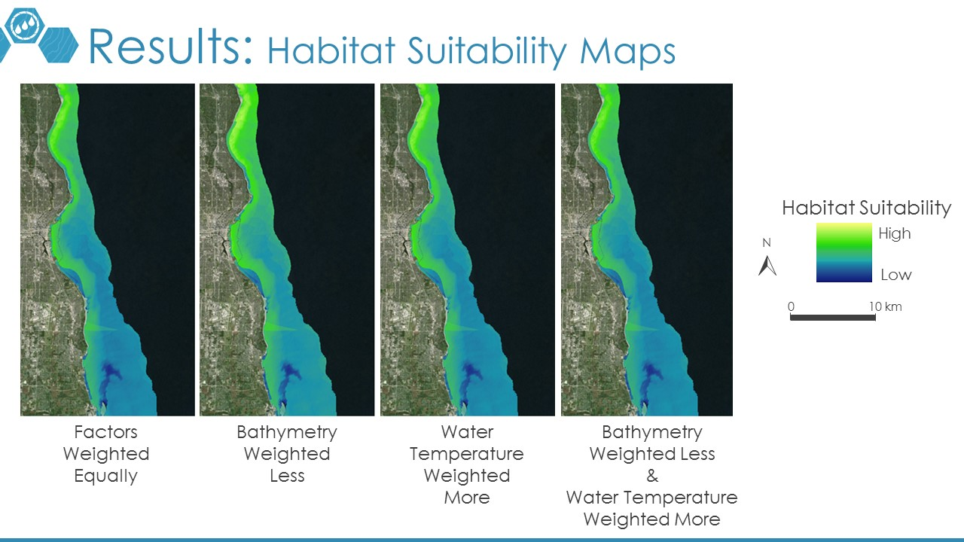

*Figure A1*. Results of calculating habitat suitability using equations 1 through 4 (left to right) on the September 12, 2016 Landsat image. *(Source: Lake Michigan Water Resources Team)*

**Appendix B: Floating Algae Index Maps**

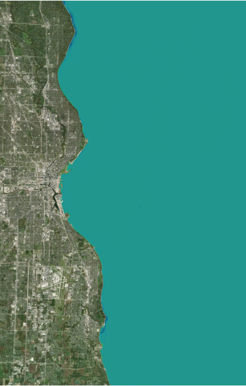 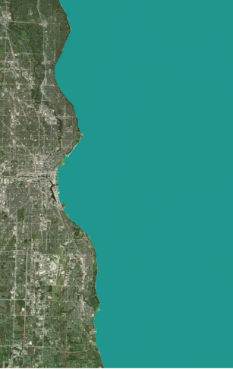 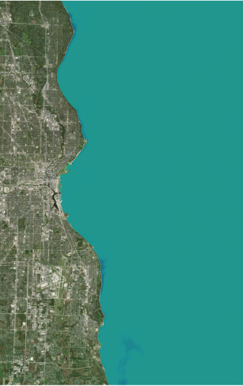 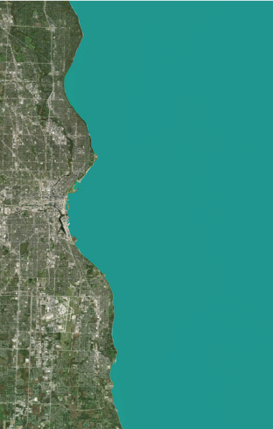

1. (b) (c) (d)

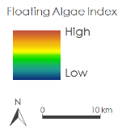

*Figure B1.* FAI Maps for (a) June 24, 2016; (b) July 26, 2016; (c) September 12, 2016; and (d) September 15, 2017

(Source: Lake Michigan Water Resources Team)