**NASA DEVELOP National Program**

****NASA Langley Research Center

**Fall 2015**

**Short Title: Perú Climate**

**Subtitle:** Monitoring and Forecasting Shifting Climate and Land Use Change Impacts in Peru’s Parque de la Papa for Enhanced Agricultural Management

**VPS Title:** Peruvian Potatoes in Peril: The Impacts of a Changing Climate

**Project Team & Partners**

**Project Team:**

Rebekke Muench (Project Lead), rebekke.e.muench@nasa.gov

Kayla McDonald

Ryan Murphy

Michael Sclater

Richard Rose

Dajon Begin

**Advisors & Mentors:**

Dr. Kenton Ross (NASA DEVELOP National Program Science Advisor)

Noel Baker (NASA Post-Doc Program)

**Partner Organizations:**

International Potato Center (CIP) (End-User), POC: Dr. Noelle Barker and Dr. David Ellis

Asociación para la Naturaleza y el Desarrollo Sostenible (ANDES) (End-User)

**Project Details**

**Applied Sciences National Applications Addressed:** Climate, Agriculture, Ecological Forecasting, Water Resources

**Study Area:** Parque de la Papa, Perú

**Study Period:** 1980 – June 2015

**Earth Observations & Parameters:**

TRMM - rainfall measurements

Aqua, MODIS - land surface temperature

Landsat 8, OLI - land cover

SRTM - elevation/ topography

SMOS - soil moisture

**Ancillary Datasets Utilized:**

* CIP Weather Station - precipitation and temperatures
* CIP HOBO Transportable Weather Stations - temperature, relative humidity, dew point

**Models Utilized:**

* NASA Land Data Assimilation Systems (LDAS)
* Clemson University Chill Hours Calculation Regression Model

**Software Utilized:**

TerrSet - land classification of Landsat imagery

ArcGIS - raster manipulation/analysis, image enhancement & map creation

Google Earth Engine - downloading and processing MODIS DATA

DIVA GIS - raster manipulation/analysis, image enhancement & map creation

**Project Overview**

**80-100 Word Objectives Overview:**

Shifting climates are causing farmers to relocate potato crops in the Parque de la Papa, Peru to higher elevations. These spatial changes are creating novel problems for the inhabitants of the park. The objective of the project was to create different factor maps such as growing degree days, chill hours, precipitation, pest suitability, and elevation, which will be incorporated into a potato crop suitability map for current and future climatic conditions in the Parque de la Papa.

**Abstract:**

Changing climates are affecting agricultural production around the world. This impact will be particularly severe in tropical highland regions like the Peruvian Andes, where shifts in climate have caused changes in suitable areas for endemic crops. In the Parque de la Papa (Peruvian Potato Park), evidence suggests that potato cultivation has shifted to higher altitudes in response to increasing temperatures and pest populations. The primary concern is the current suitable lands within Parque de la Papa will eventually become unsuitable for traditional potato production. In addition, the impact of shifting climates threaten both agrobiodiversity and community livelihoods within the park and surrounding region. The objective of this project was to develop an increased understanding of changes in climate and their influence on potato cultivation in the park using NASA Earth observations. Land surface temperature data from the Aqua and Terra Moderate Resolution Imaging Spectroradiometer (MODIS) were used to derive growing degree days for the region. Historical and current precipitation was assessed using Tropical Rainfall Measuring Mission (TRMM) and Global Precipitation Measurement (GPM) data. Current and historical potato cultivation areas were estimated using Landsat 4, 5, 7, and 8, sensors. A digital elevation model (DEM) and a slope map were created from the Shuttle Radar Topography Mission (SRTM) data. These factors were incorporated into suitability maps for weevils, a pest in the park. Finally, current and future potato suitability maps were developed using growing degree days, precipitation, elevation, weevil suitability, and slope.

**Community Concerns:**

* In response to changing growing seasons, irregular precipitation, and increased pest issues, local farmers have moved their potato crops to higher elevations, thereby decreasing the amount of available cropland.
* Indigenous farmers work to maintain traditional farming practices and conserve thousands of native potato varieties. However, variable growing conditions have threatened the conservation of potato diversity within the park.

**Current Management Practices & Policies**:

Farmers in Parque de la Papa use traditional agricultural practices to control pests and maintain yields. For example, in response to increased crop damage by weevils, farmers plant a barrier of root and tuber crops that contain an anti-weevil compound as a form of integrated pest management (IPM). In addition, “improved” potato varieties are available and used in lower lands by CIP; however, CIP’s primary concern is to ensure that communities within the park are able to maintain potato biodiversity and continue to use traditional practices in order to conserve indigenous traditions and culture. Additionally, CIP purchased commercial aerial images in 2007 to map locations of potatoes and other crops. The CIP has limited their remote sensing practices to land cover classifications and have not used any climatology data to assess potato suitability.

**Decision Support Tools & Benefits:**

|  |  |  |
| --- | --- | --- |
| **End-Product** | **Earth Observations Used** | **Benefit & Impact** |
| Growing Degrees Day Map | MODIS Aqua | An accurate representation of historical and current growing degree days in the region will aid park decision makers in explaining the impact of climate change and planning for potential shifts in potato suitability |
| Chill Hours Map | Aqua and Terra MODIS | An accurate representation of historical and current chill hours in the region will aid park decision makers in explaining the impact of climate change and planning for potential shifts in potato suitability |
| Precipitation Map | TRMM | Precipitation maps will improve understanding of both historical trends and current conditions. |
| Elevation Map | SRTM | Accurate elevation maps will be a necessary input in the creation of current potato suitability maps as well as forecasting future changes. |

**Project Imagery**

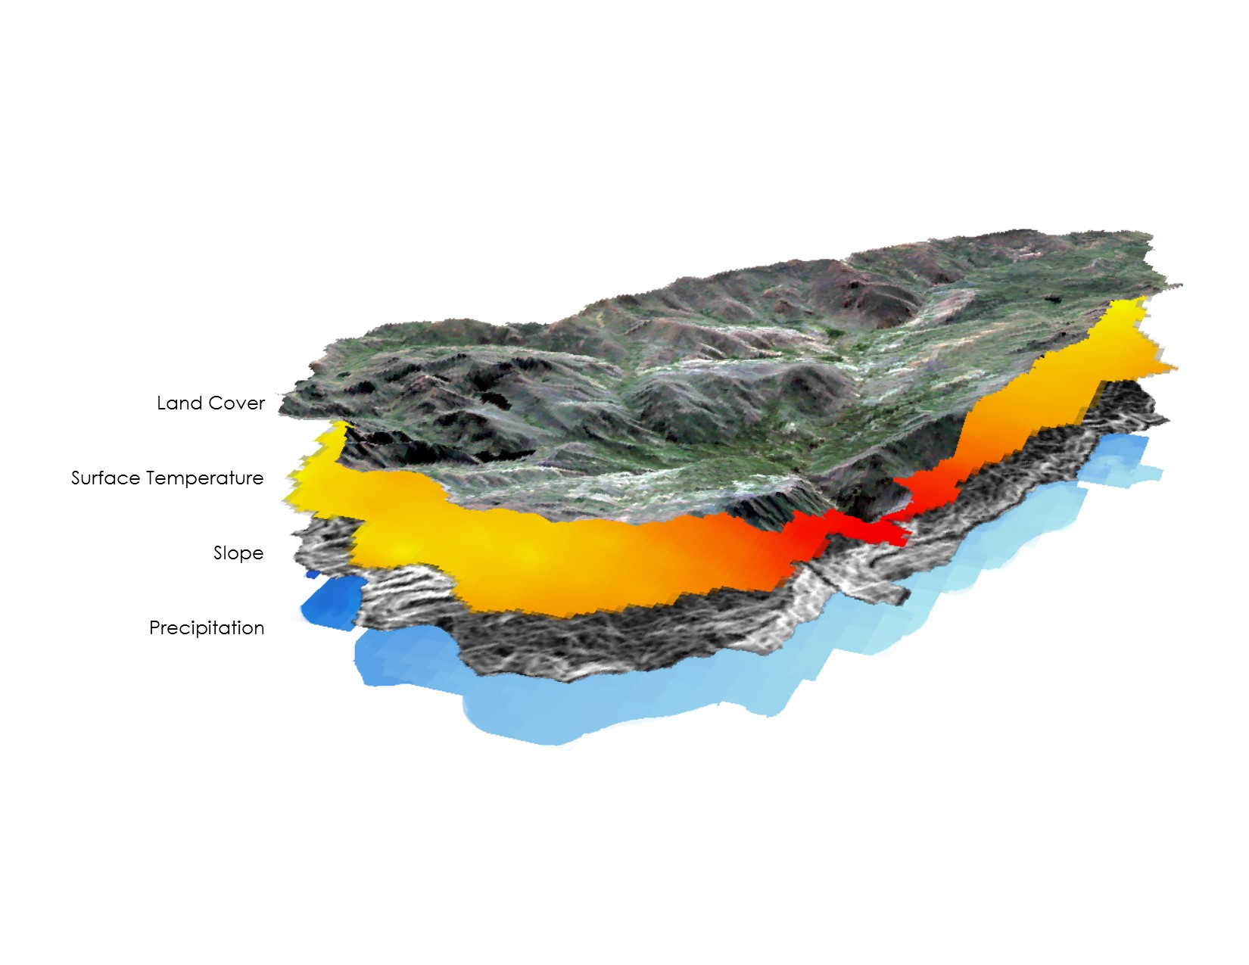

**Caption:** Multi-layer overlay of potato suitability factors for the Parque de la Papa in Peru. Image Credit: Peru Climate Team.

**Image:** Fall2015_LaRC_VPSImage_PeruClimate.jpeg

**Software Release Requirements**

Category II