**NASA DEVELOP National Program**



Arizona State University

*Summer 2016*

Maricopa County Health & Air Quality

Monitoring PM10 Concentrations with MODIS Aerosol Optical Depth Measurements for Enhanced Public Health and Air Quality Decision Making and Epidemiology

 **Technical Report**

Jason Hodgson

Leslie Araujo

Tamara Dunbarr

Lance Watkins, Center Lead

David Hondula, Science Advisor

# 1. Abstract

One of the most prevalent issues with air quality monitoring is the lack of distribution of sampling sites that gather data regarding particulate matter (PM) concentrations in the surrounding environment. By utilizing data from the Moderate Resolution Imaging Spectroradiometer (MODIS) sensor on the Aqua and Terra satellites, we constructed a mixed model to provide a significantly high correlation between aerosol optical depth (AOD) and PM10 concentrations. Due to the mixed model’s use of additional periodic variables such as meteorological and environmental factors, the model is applicable in conjunction with satellite data in the absence of ground-based monitors to present a better picture of the air quality in Maricopa County, Arizona.

**Keywords**

Remote Sensing, Pollution, Aqua, Terra, Maricopa County, AOD, dust storm,

# 2. Introduction

* 1. ***Background Information***

Airborne particulate matter less than 10 microns in aerodynamic diameter (PM10) is a human respiratory health hazard and a large contributor to air pollution in urbanized areas. Particulate matter (also commonly referred to as aerosols) includes any atmospheric particles derived from various anthropogenic and natural sources (Kaufman et al., 2002). Traffic, industrial activity, and biomass burning (i.e., home heating and cooking) are prime examples of non-natural sources of PM10 (Han, 2006). Natural sources of the pollutant include volcanic ash, suspended dust from concentrated agricultural activity, and dust storms in arid and semi-arid areas, as in Maricopa County, Arizona.

Excessive human exposure to PM10 has been largely demonstrated to have negative consequences on the human respiratory system and overall health through various studies in relatively recent years. Many of these have successfully established an association between elevated and concentrated PM10 levels to respiratory, cardiovascular, and mutagenic diseases (Schwartz, 1993). The microscopic size of the particles allows them to penetrate deeper into the respiratory system causing a more profound level of exposure to the long-term effects of the particulate matter, including hospitalizations for asthma and chronic respiratory disease.

Currently, across the United States, air quality and health departments use ground-based monitoring to sample small, “representative” areas of the environment in order to help reduce PM10 emissions and subsequent epidemiological problems associated with PM10 inhalation. However, this leaves large swaths of land without PM10 monitoring, potentially exposing thousands or millions of people to environmental hazard (Prud’homme, 2013).

Many current methods used to estimate PM10 concentrations using ground-monitor point data involve interpolation (such as kriging) and land-use regression models. These methods, although useful to an extent, do not provide the level of spatial and temporal granularity that the immersion of satellite aerosol-optical depth data allows. Satellite aerosol optical depth data is not always employed in these studies given its complex nature and required higher level of understanding, still there are some studies that use satellite data, though they typically involve large regional study areas (Kloog, 2011) (Nordio, et al., 2013). Kriging is a favored interpolation method for *in situ* particulate matter point observations, however this does not give enough information to identify local sources of PM10 (and other pollutants), especially in smaller, county-level study areas (Pope et al., 2014).

Utilizing methodology outlined by Kloog (2011) and Nordio (2013), this study uses monthly satellite mosaic raster images in a 3 km resolution along with ground-based sensor data, meteorological data, open space/land cover data, transportation data, and elevation data to create a model of predicted PM10 concentrations for areas without the benefit of ground-based sensors. The study observes PM10 in these counties from 2006 to 2015, focusing on Maricopa and Pinal counties of Arizona. This area is unique climactically because it is a semi-arid desert area situated at approximately 33 degrees in latitude, in the midst of a subtropical high pressure band. This high pressure area of the planet is characterized by stagnant air flow and little cloud cover. The surrounding mountains further restrict air circulation, creating a settling effect. This effect prevents air pollution from circulating out of the metropolitan area.

* 1. ***Project Partners & Objectives***

The objective of this project was to assist the Maricopa County Department of Public Health and the Maricopa County Air Quality Department with decision-making related to PM10 both with regard to federal regulations and epidemiological concerns and inhalation risk. The Maricopa County Department of Public Health (MCDPH) is interested in cross-referencing areas of high PM10 concentrations with other factors, such as epidemiological reports. Additionally, the data will be cross-referenced with other studies by the Maricopa County Department of Public Health, such as studies of areas high on the social vulnerability index as determined by county scientists. The Maricopa County Air Quality Department (MCAQD) will be using the data to assess areas of greater concern that are not being covered by ground-based PM10 monitors in order to address potential hotspots for pollution activity, both spatially and temporally (Figure 1). National Ambient Air Quality Standards dictate that PM10 concentrations are measured and reported every 24 hours. Only one exceedance per year is allowable under the Clean Air Act provisions (NAAQS, 2016).

Our primary objective is to produce the PM10 MODIS-enhanced mixed effect model and archive of modeled PM10 concentrations from 2006-2015 at a relatively high spatial and temporal resolution for the Maricopa County study area. This timeframe was chosen because it represents the best long-term intersection of both satellite and ground-based monitoring systems. Secondary objectives include a Social Vulnerability- PM10 Concentration Analysis and Time-Series Hot Spot Analysis. The objectives and goals outlined above encourage the use of Earth observations in: assessing exposure of health-related hazards, the implementation of air quality monitoring, and public health outreach and intervention. As such this project falls within NASA’s National Application Area of Health & Air Quality.

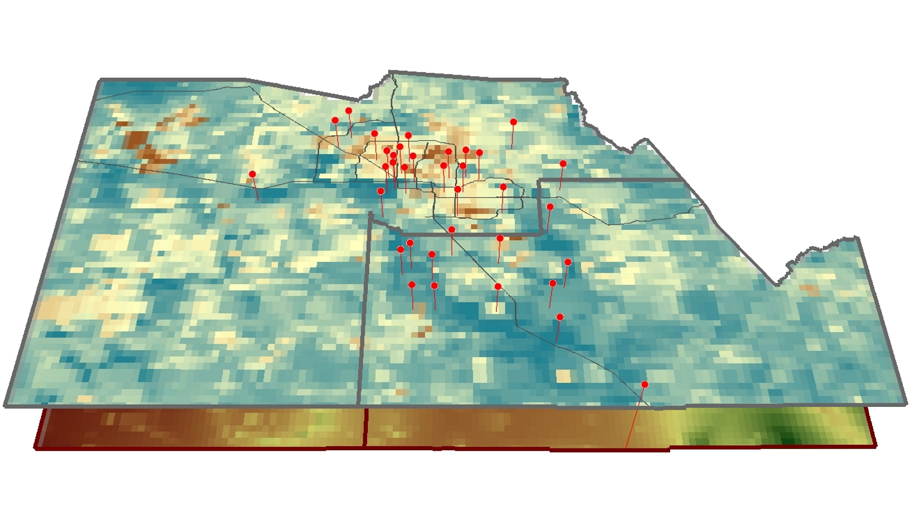

Figure 1. Location of all PM10 monitors (red vertical markers) in

Maricopa County and Pinal County, Arizona overlaid on an AOD raster surface.

# 3. Methodology

The MODerate Resolution Imaging Spectroradiometer (MODIS) is an instrument aboard the Terra and Aqua satellites. For this study, MODIS data was compared to other aerosol optical depth sensors such as the Multi-angle Imaging SpectroRadiometer (MISR) and Cloud Aerosol Lidar Pathfinder Satellite Observations (CALIPSO), and it was deemed the best suited to analyze the Maricopa County study area given its higher spatial resolution of 3 km (MISR offers Level 2 AOD products at 17.6 km spatial resolution and CALIPSO offers Level 2 AOD products at a 5 km spatial resolution). All of the mentioned sensors, including MODIS, are satellites which are part of the “A-train”—a string of NASA earth-observing satellites closely following one another in a polar orbit.

Multiple potential predictors were examined for the required spatial resolution of a 3 km x 3 km grid: areas of open spaces, elevation, length of roads, and meteorological data. To be able to create the model, the location of all the included sites were laid over the the 3-km layers.

***3.1 Data Acquisition***

*Satellite Data (AOD)*

Aerial Optical Depth (AOD) data was queried using Level 1 and Atmosphere Archive and Distribution System (LAADS Web), using Terra MODIS Level 2 Aerosol Product at 3km resolution (MOD04_3K) and Aqua Level 2 Aerosol Product at 3km resolution (MYD04_3K) from Collection 6 Aerosol Data from the Corrected_Optical_Depth_Land parameter. Data were obtained for the 2006-2015 period.

*County line data*

County border shapefiles were obtained from the TIGER/Line repository.

*Meteorological data*

Meteorological data were obtained from the National Centers for Environmental Information (NCEI). Data utilized included only stations with daily readings throughout the study period. From those stations, minimum and maximum temperature was calculated into daily average temperature in degrees Celsius, daily total precipitation was gathered in millimeters, and wind speed was acquired in meters per second.

*Elevation*

Elevation data were obtained from the USGS National Elevation Dataset.

*Open space*

Land cover data were obtained from the United States Geological Survey (USGS) 2011 National Land Cover Database (NLCD) which was then clipped to the Maricopa and Pinal Counties. Land use data were acquired from the Maricopa Association of Governments’ 2012 Maricopa General Plan. These datasets were combined to determine the percentage of open space within the study area.

*Transportation*

Transportation data were obtained from the TIGER/Line repository and Maricopa County Air Quality Department’s repository.

***3.2 Data Processing***

The Aerosol Optical Depth (AOD) variable came directly from the satellite data and is a measure of the aerosol concentration in any given area. It assisted in calculating an accurate prediction of ground level PM amounts. County border shapefiles were constrained to Maricopa and Pinal counties and all other layers were clipped to the extents of this layer for aesthetics regarding the area of interest (Figure 2).

MODIS data was geographically constrained to 34.5 N, 32 S, -110 E, and -114 W, temporally constrained month-to-month, and only daytime files were used to increase accuracy because MODIS uses all of its available 36 sensors for daytime observations as opposed to 16 during nighttime observations, thereby increasing the accuracy of its AOD measurements (Toller, 2002/2009). The files were processed into a geographic projection and output as a GeoTIFF raster with nearest neighbor processing via the LAADS post-processing system. The resulting files were then mosaicked into a single raster showing the monthly max value for each raster cell.

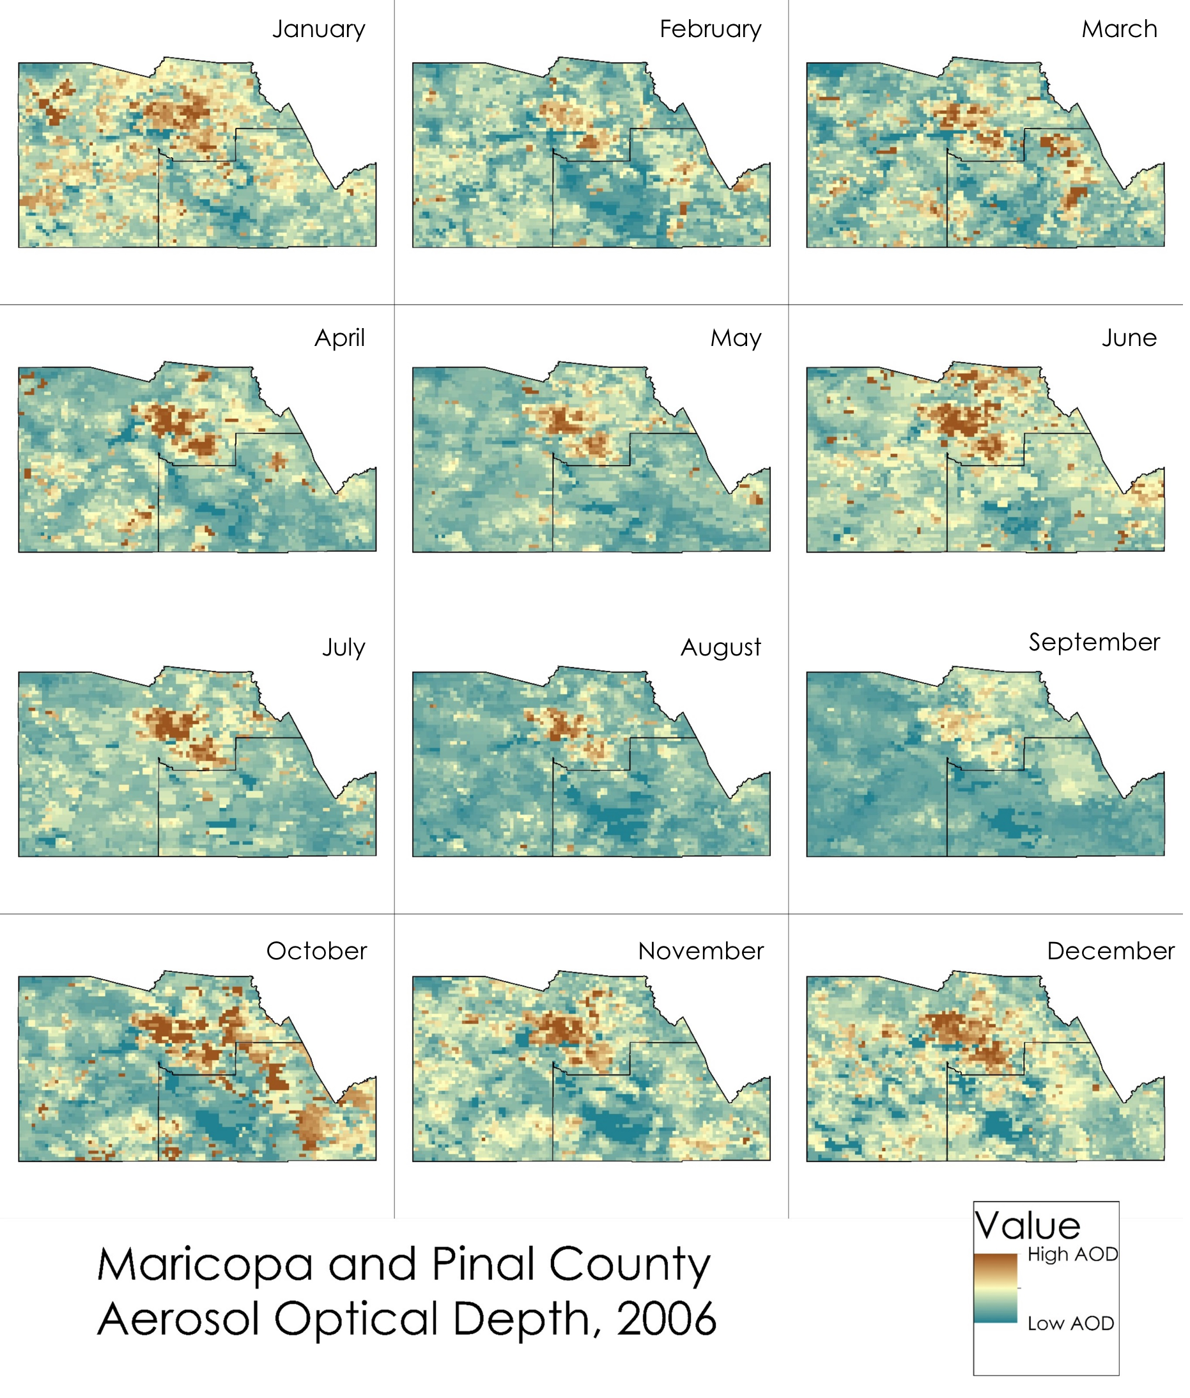

Figure 2. A compilation of all processed AOD maximum value monthly raster surfaces

from MODIS Level 2 data for 2006.

The meteorological variable used in the finalized model was ambient air temperature, however wind speed was also obtained and processed for future analysis. Daily averages of PM10, temperature, and wind datasets were computed from hourly data and then calculated into monthly averages. This condensed the table down from 87,000 individual rows of data to only 120 rows. All dates were formatted into the following convention: yyyymm (Ex: 200605).

Elevation data were obtained from the USGS’s National Elevation Dataset. It was aggregated via bilinear interpolation to a 3 km cell grid and used as the primary reference for all other layers (the snap raster). This ensured that all 3 km raster cells were aligned properly for comparison.

Percent of open space was derived from the United States Geological Survey (USGS) 2011 National Land Cover Database as a raster. Any area that was classified as non-open space within the context of PM10 (such as developed, urban area) was assigned a value of ‘0’, while all other open areas (such as shrub land, agricultural areas) were assigned a value of ‘1’. After reclassification, this raster dataset was aggregated and snapped to a 3km grid to match the elevation dataset. Each raster cell value indicated the percent of open space within that cell’s area (this value was obtained by calculating the 0/1 value average during aggregation). This process allowed for quick identification and a calculation that simplified the NLCD data into open-space and non-open space (Figure 3).

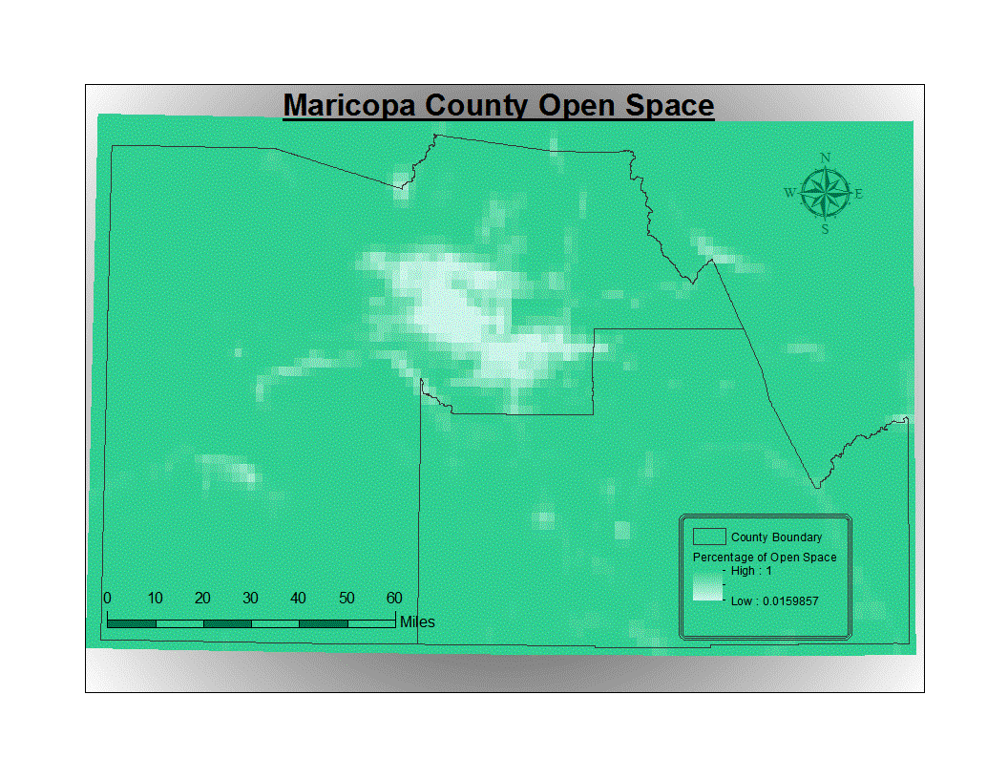

Figure 3. Percent of open space raster surface for Maricopa County and Pinal County derived from reclassification and aggregation of the USGS’ 2011 NLCD and snapped to a 3-km grid.

Transportation data were obtained from the Maricopa Department of Air Quality repository. These data were used to determine road densities for each 3 km grid square. The roads layer was clipped to the Maricopa and Pinal County boundary lines and then a 3 km fishnet was created and overlaid the roads layer. A geo-processing intersect was performed on the roads with the fishnet as the feature which allowed the road segments to be sectioned off at the fishnet boundaries (Figure 4). Each 3 km fishnet cell was assigned an objectID and the sum of the road lengths were calculated for each unique cell. This allowed values to be assigned to each cell, which provides a numerical value to input into the model.

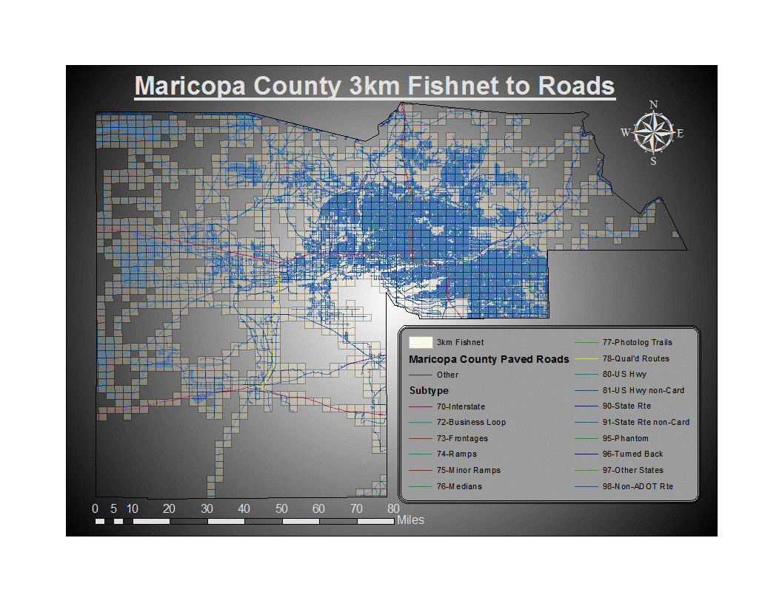

Figure 4. Map depicting the dataset used to produce

a road density rasterized surface via a 3 km fishnet grid.

All of the aforementioned datasets were organized at a monthly scale (except for elevation, road density, and open space, as they remain relatively consistent throughout), thus totaling in 120 individual months being represented by the data for the total 10-year study period. The monthly was an effect of the limited temporal resolution of the MODIS sensors; to be able to get the most complete image over the Maricopa County (and Pinal County) study area, we had to resort to values that represented every month in the dataset (monthly average and monthly maximum).

***3.3 Data Analysis***

One of the key points to keep in consideration while analyzing these datasets in an effort to come up with a model to predict PM10 is that the raw monthly correlations between AOD and PM10 is not very strong. This is due to the fact that AOD observes and reports any particulates and pollutants in the air, so it is essentially a measure of how “dirty” the air is over a certain area. There are plenty of other effects that contribute the AOD levels, and PM10 is only one of those many particulates and pollutants. By incorporating other variables associated specifically with PM10 into the mixed effect model, we were able to distinguish that specific relationship and help improve the predictability of PM10 concentrations in areas currently unrepresented by PM10 monitors.

To set up the data in a format ready for model development, we first obtained all the PM10 monitoring station location information (latitude and longitude) and listed it on a table. Each monitoring station had its respective monthly maximum and average observations listed, and the monthly average temperature designated to each monitoring station was also included. To incorporate the raster datasets, the value of the pixel corresponding to each monitoring station location was identified and then added to the table. This was done for AOD, elevation, percent of open space, and transportation raster datasets. Therefore, for every monitoring station listed in the table, there was a corresponding monthly maximum PM10, average PM10, average temperature, the percent of open space, elevation value, and road density.

Before being imported into R, a refined dataset was also created to be compared to the complete dataset for model performance. The refined dataset included only Maricopa County monitoring sites that had complete data for all the corresponding variables. Ultimately, the entire statistical modeling process was carried out on both datasets to determine which dataset resulted in a better-performing model for predicting PM10.

Once imported into R, the lme4 package was used to create the mixed effect model. Given that the values for each of the variables vary greatly, all of the variables were also scaled beforehand to allow the model to run efficiently. Two base models relating AOD to PM10 average and PM10 max values were created as a starting point. More variables were added one by one, and AOD and temperature were added as random effects with respect to month and monitoring site.

Once all variables were included, the Akaike Information Criterion (AIC) was used as the main indicator for model performance, and the varying models were compared to one another based on their AIC score. The models were adjusted to optimize performance and PM10 predictability, and once those refined models were obtained, their corresponding R2 value was calculated.

# 4. Results & Discussion

The monthly boxplot comparisons of max AOD and max PM10 readings for the 10-year timespan from 2006-2015 reveal a similar monthly trend (Figure 5). A major increase for AOD begins around May/June, and a steadier increase begins for PM10 around June/July -- which is especially evidenced by the latter 25% of the observations and the outliers in the boxplots for PM10. Overall, these comparisons provide a good foundation for understanding how AOD and PM10 relate to each other, especially with the statistical modeling process in mind.

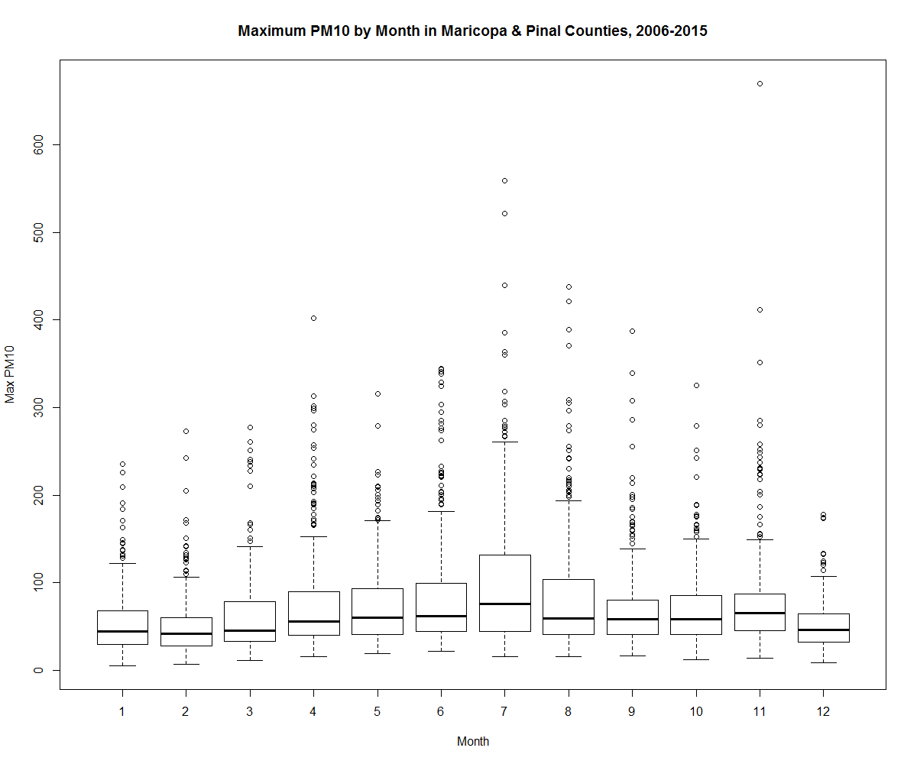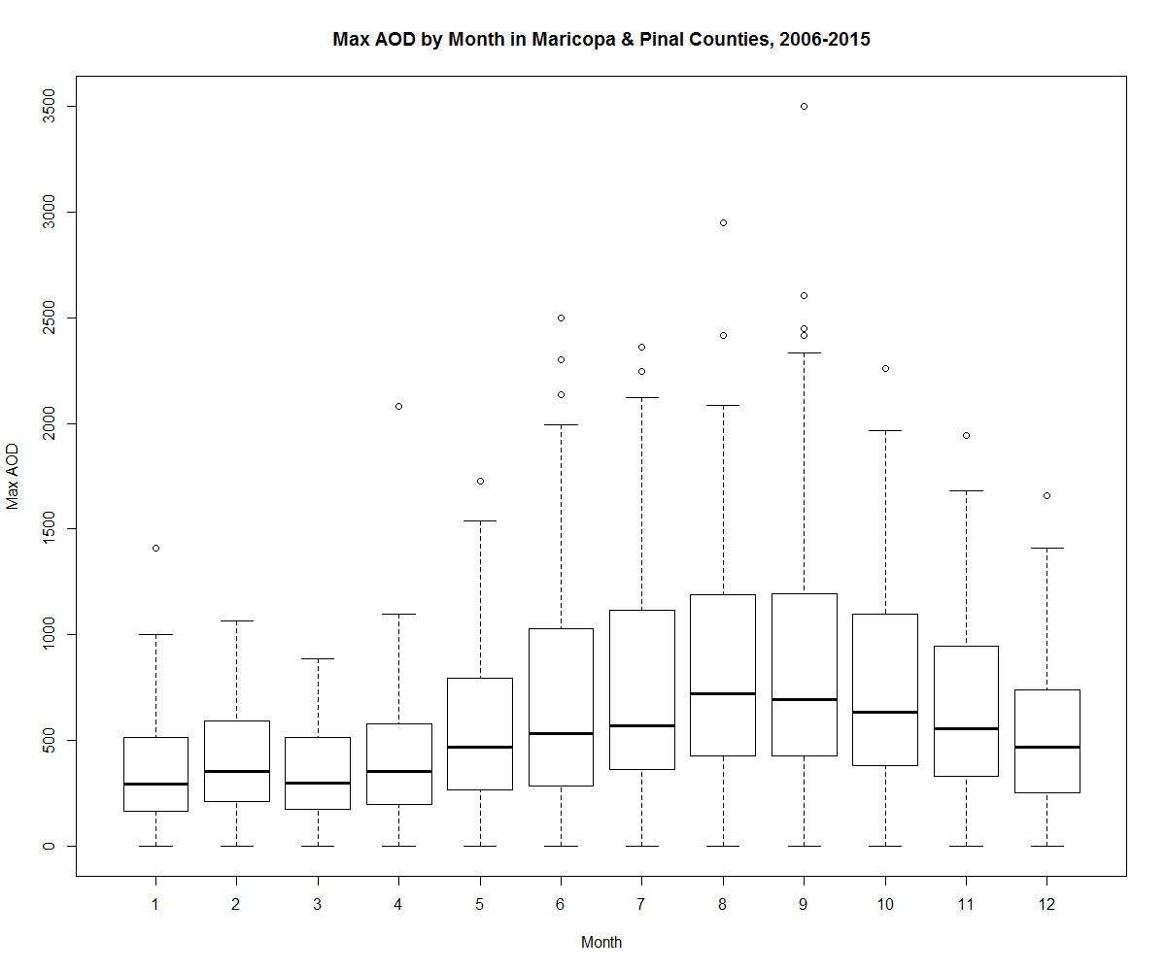

Figure 5. Boxplot comparisons of monthly distributions of maximum AOD and PM10 values for 2006-2015.

***4.1 Analysis of Results***

The modeling process for PM10 and AOD was primarily carried out in R Statistical Programming. We decided to predict both PM10 max and PM10 average to be able to provide better flexibility in creating final PM10 concentration surfaces and improving model performance.

We used a mixed model to predict PM10, which includes both random and fixed effects to distinguish a relationship between all incorporated variables. The variables included, in order to predict PM10, were AOD, temperature, elevation, road density, and percent of open space. AOD max values have a monthly trend (see Figure 5 above), therefore we incorporated AOD as a random effect as well based on its monthly trend. This ultimately helps the model perform better in predicting PM10.

To be able to statistically determine whether or not incorporating more variables into the model is useful, we first computed a correlation of PM10 with AOD (not including all effects). The main indicator in question here was the AIC. The complete dataset yielded some problems providing results given its incorporation of all sites even if they have missing data. However, the base models for the refined dataset resulted in the following: for the PM10 max to AOD model, there was an AIC of 3782.4 and for PM10 average to AOD, the AIC was 3781.3. A lower AIC indicates a better model, therefore in this case, the PM10 average to AOD performed a bit better.

**Models without all effects (in R):**

pm10**max**~aodmax.+(1|month)

pm10**avg**~aodmax+(1|month)

When all random and fixed effects were added to the model, we were also able to see successful drops in the AIC values from the base models (for the refined dataset). For PM10 max to AOD and all other effects, the AIC was 3558.9, and for PM10 average to AOD and all other effects, the AIC was 3418.8 – the lowest of all models for the refined dataset.

**Mixed Effect Model (in R):**

pm10**max** ~ aodmax + TempMthAvg + Elev + Roads+ prctOpen + (1+aodmax|month)

pm10**avg** ~ aodmax + TempMthAvg + Elev + Roads+ prctOpen + (1+aodmax|month)

The complete dataset yielded surprising results once all random and fixed effects were added to the model. It did not perform very well for PM10 max to AOD and all other effects (AIC score of 4647.1). However, the AIC of PM10 average to AOD and all other effects was 2046.7 – the lowest AIC thus far.

Overall, the models seem to be consistent in that they perform better when PM10 average (rather than PM10 max) is on the predicted side of the model. Also, considering the reduction in AIC values when more variables are added into the model, we can see that the model’s correlation becomes stronger and the model performs better when more variables associated with PM10 are included. If this trend continues, then adding more variables will only increase the R2 resulting in better PM10 concentration predictability.

|  |  |
| --- | --- |
| **Model (Complete Dataset):** | **R2** |
| Base Model (PM10 Max) | .07244138 |
| Base Model (PM10 Avg) | .1038027 |
| Full Model (PM10 Max) | .1997006 |
| Full Model (PM10 Avg) | .2978223 |

Table 1. Table reporting the R2 values obtained via different models for the complete dataset, including all sites and their associated data. The Base Model relates PM10 only to AOD (without all other effects), and the full model includes all random effects.

|  |  |
| --- | --- |
| **Model (Refined Dataset):** | **R2** |
| Base Model (PM10 Max) | .09530829 |
| Base Model (PM10 Avg) | .1001109 |
| Full Model (PM10 Max) | .1964938 |
| Full Model (PM10 Avg) | .2825578 |

Table 2. Table reporting the R2 values obtained via different models for the refined dataset that included only Maricopa County monitoring sites that had almost no missing data. The Base Model relates PM10 only to AOD (without all other effects), and the full model includes all random effects.

***4.2 Future Work***

The focus for extended research would include solely analyzing PM2.5 for Maricopa County and the neighboring Pinal county study areas in order to allow the further study of the permeation of finer particles in the atmosphere. Additional study may be provided on the epidemiological effects of both PM10 and PM2.5 by analyzing the pollution data in the context of epidemiological reports and social vulnerability indices. Further, analyzation of trends for both particulate matter types allows the Maricopa County Department of Public Health and the Maricopa County Air Quality Department to analyze environmental justice concerns.

Considering the steady decrease of the Akaike Information Criterion (AIC) value and the increase in R2 as the number of variables increases, the model will continue to produce more accurate predictions. A few of the factors to take into account, but not to be limited to are; soil moisture, humidity, point emissions, visibility, and unpaved road networks.

Since social vulnerability is described as the social, economic, demographic, and housing characteristics that impact a community’s ability to respond to, cope with and recover from an environmental hazard.One major variable is socioeconomic status (Income, Political Power, and Prestige). This affects the individual, household, or community’s ability to absorb losses and be resilient to the PM hazard impacts. People who are totally dependent on social services for survival are already economically and socially marginalized and may require additional support in the post-event period, and development of this project will help that cause. By applying this model in a more polished form, the impacts of PM concentrations on the social vulnerability aspect will help to mitigate the negative repercussions these events would have on individuals and communities.

# 5. Conclusions

We can see, based on the correlations, that the base models relating PM10 to AOD without all fixed and random effects had weaker correlations, about 0.1. For the models that related PM10 to AOD and included all variables, we observed an increase in the correlations to about 0.2 for the model predicting maximum PM10 and 0.3 for the model predicting average PM10.

Although these correlations are not as great as we would have liked them to be, we see something very promising: as more variables associated with PM10 are incorporated in the model, such as percent of open space, temperature, etc., we see our models become stronger. The AIC scores also demonstrate this phenomenon. Therefore, adding more variables relevant to the PM10 (or any other pollutant or item of interest) would be ideal in creating a successful mixed effect model for concentration prediction, as it would ultimately improve the R2.

These low correlation values were also not necessarily surprising, as this type of analysis and modeling over arid or semi-arid areas (such as the Maricopa County area) are not as common given that they result in weaker correlations due to many factors associated with the interaction between satellite sensors and the brightness and high albedo of these desert regions. We conclude, then, that fine-tuning AOD products (and satellite sensor products in general) to perform better when remotely sensing these regions would be highly beneficial for this topic of study and many others. Ultimately, the work performed via this product provides a great foundation for expansion and fine tuning once more data becomes available of better quality or quantity. Once the model and datasets are refined to a point where they yield a high R2, many epidemiological and public health studies as well as air quality research endeavors will benefit greatly from it.

# 6. Acknowledgments

The authors would like to thank Dr. Itai Kloog, Geography and Environmental Development Department, Ben-Gurion University of the Negev, Be'er Sheva, Israel.

Any opinions, findings, and conclusions or recommendations expressed in this material are those of the author(s) and do not necessarily reflect the views of the National Aeronautics and Space Administration.

This material is based upon work supported by NASA through contract NNL11AA00B and cooperative agreement NNX14AB60A.

# 7. References

Han, X., and L. P. Naeher. "A Review of Traffic-related Air Pollution Exposure Assessment Studies in the Developing World." Environment International 32.1 (2006): 106-20. doi: 10.1016/j.envint.2005.05.020

Hoek, G., R. Beelen, K. de Hoogh, D. Vienneau, J. Gulliver, P. Fischer, and D. Briggs. “A Review of Land- Use Regression Models to Assess Spatial Variation of Outdoor Air Pollution.” Atmospheric Environment 42, no. 33 (October 2008): 7561–78. doi:10.1016/j.atmosenv.2008.05.057

Kaufman, Y. J., D. Tanré, and O. Boucher. "A Satellite View of Aerosols in the Climate System." Nature 419.6903 (2002): 215-23. doi: 10.1038/nature01091

Kloog, I., Koutrakis, P., Coull, B. A., Lee, H. J., & Schwartz, J. (2011, August 29). Assessing temporally and

spatially resolved PM2.5 exposures for epidemiological studies using satellite aerosol optical depth

measurements. Atmospheric Environment, 45(35), 6267-6275. doi:10.1016/j.atmosenv.2011.08.066

NAAQS Table. (2016, March 29). Retrieved June 30, 2016, from https://www.epa.gov/criteria-air-

pollutants/naaqs-table

Nordio, F., Kloog, I., Coull, B. A., Chudnovsky, A., Grillo, P., Bertazzi, P. A., . . . Schwartz, J. (2013, March

21). Estimating spatio-temporal resolved PM10 aerosol mass concentrations using MODIS satellite

data and land use regression over Lombardy, Italy. Atmospheric Environment, 74, 227-236.

doi:10.1016/j.atmosenv.2013.03.043

Pope, R., & Wu, J. (2014). Characterizing air pollution patterns on multiple time scales in urban areas: A landscape ecological approach. Urban Ecosystems Urban Ecosyst, 17(3), 855-874. doi:10.1007/s11252-014-0357-0

Prud'homme, G., Dobbin, N. A., Sun, L., Burnett, R. T., Martin, R. V., Davidson, A., . . . Johnson, M. (2013,

December). Comparison of remote sensing and fixed-site monitoring approaches for examining air

pollution and health in a national study population. Atmospheric Environment, 80, 161-171.

doi:10.1016/j.atmosenv.2013.07.020

Ryan, P. H., & Lemasters, G. K. (2007). A Review of Land-use Regression Models for Characterizing

Intraurban Air Pollution Exposure. Inhalation Toxicology, 19(Sup1), 127-133.

doi:10.1080/08958370701495998

Schwartz, J., Slater, D., Larson, T. V., Pierson, W. E., & Koenig, J. Q. (1993). Particulate Air Pollution and

Hospital Emergency Room Visits for Asthma in Seattle. *Am Rev Respir Dis American Review of*

*Respiratory Disease, 147*(4), 826-831. doi:10.1164/ajrccm/147.4.826

Toller, G. N. "MODIS Level1B Product User's Guide." *NASA/Goddard Space Flight Center* (2002): 28. Web.

June 2016.

# 8. Content Innovation

**Content Innovation #1**

VPS

Emailed to [Lauren.M.Childs@nasa.gov](mailto:Lauren.M.Childs@nasa.gov) with filename AZVPS.mp4

**Content Innovation #2**

Glossary Viewer

* Aerosol Optical Depth (AOD) **-** The measure of aerosols in the atmosphere measured from the MODIS instrument on board the Terra and Aqua satellites. This measurement is not the same as a PM10 count, but with statistical modeling it can be highly correlated to PM10 in order to accurately predict PM10 concentrations over an area.
* AIC Score - The Akaike Information Criterion (AIC) is a measure of the relative quality of statistical models for a given set of data.
* Cloud-Aerosol Lidar and Infrared Pathfinder Satellite Observations (CALIPSO) - CALIPSO is a joint NASA (USA) and CNES (France) environmental satellite, built in the Cannes Mandelieu Space Center, which was launched atop a Delta II rocket on April 28, 2006.
* Digital Elevation Model (DEM) - A Digital Elevation Model (DEM) is a digital cartographic/geographic dataset of elevations in xyz coordinates.
* Epidemiology - the branch of medicine that deals with the incidence, distribution, and possible control of diseases and other factors relating to health.
* In Situ - In *situ* is a Latin phrase that translates literally to "on site" or "in position".
* Kriging - In statistics, originally in geostatistics, Kriging or Gaussian process regression is a method of interpolation for which the interpolated values are modeled by a Gaussian process governed by prior covariance’s, as opposed to a piecewise-polynomial spline chosen to optimize smoothness of the fitted values.
* NASA Earth Observing System (EOS) - A program of NASA comprising a series of artificial satellite missions and scientific instruments in Earth orbit designed for long-term global observations of the land surface, biosphere, atmosphere, and oceans of the Earth.
* GeoTIFF - GeoTIFF is a public domain metadata standard which allows georeferencing information to be embedded within a TIFF file.
* Maricopa County Department of Air Quality (MCDAQ) - The Maricopa County Air Quality Department is a regulatory agency whose goal is to ensure federal clean air standards are achieved and maintained for the residents and visitors of Maricopa County, Arizona.
* Maricopa Department of Public Health (MCDPH) – The Maricopa County Department of Public Health is a regulatory agency whose goal is to protect and promote the health and well-being of all of our residents and visitors in Maricopa County, Arizona.
* Multi-angle Imaging SpectroRadiometer (MISR) - MISR is a scientific instrument on the Terra satellite launched by NASA on December 18, 1999. This device is designed to measure the intensity of solar radiation reflected by the Earth system (planetary surface and atmosphere) in various directions and spectral bands.
* MODerate-resolution Imaging Spectroradiometer (MODIS) - MODIS is a payload scientific instrument built by Santa Barbara Remote Sensing that was launched into Earth orbit by NASA in 1999 on board the Terra Satellite, and in 2002 on board the Aqua satellite.
* National Ambient Air Quality Standards (NAAQS) - The National Ambient Air Quality Standards (NAAQS) are standards established by the United States Environmental Protection Agency under authority of the Clean Air Act (42 U.S.C. 7401 et seq.) that apply for outdoor air throughout the country.
* National Centers for environmental Information (NCEI) - NOAA’s National Centers for Environmental Information (NCEI) are responsible for hosting and providing access to one of the most significant archives on earth, with comprehensive oceanic, atmospheric, and geophysical data.
* National Land Cover Database (NLCD) - NLCD 2006 is designed to provide the user both updated land cover data and additional information that can be used to identify the pattern, nature, and magnitude of changes occurring between 2001 and 2006 for the conterminous United States at medium spatial resolution.
* PM10 **–** Can either refer to a piece of particulate matter less than 10 microns in size, or the measure of PM10 concentration in the atmosphere. High levels of PM10 are of epidemiological concern because they are inhalable at that size.
* R - *R* is a language and environment for statistical computing and graphics.
* RStudio - RStudio is a free and open-source integrated development environment (IDE) for R, a programming language for statistical computing and graphics.
* United States Geologic Survey (USGS) - The United States Geological Survey is a scientific agency of the United States government. The scientists of the USGS study the landscape of the United States, its natural resources, and the natural hazards that threaten it.

**Content Innovation #3**

Inline Supplementary Material

* Figure 1
* Figure 2
* Figure 3
* Figure 4
* Figure 5
* Table 1
* Table 2