**NASA DEVELOP National Program**

****NASA Jet Propulsion Laboratory

**Summer 2015**

**U.S. Disasters II**

**Subtitle:** Using GRACE-Derived Water and Moisture Products as a Predictive Tool for Fire Response in the Contiguous United States

**VPS Title:** Blazing Models: Creating a Predictive Tool for Wildfires

**Project Team & Partners**

**Project Team:**

Brittany Zajic (Project Lead), Brittany.N.Zajic@JPL.NASA.gov

Daniel Jensen

Nick Rousseau

**Advisors & Mentors:**

Dr. John T. Reager (NASA Jet Propulsion Laboratory)

**Past or Other Contributors:**

Max Baldridge

**Partner Organizations**

USDA Forest Service Remote Sensing Applications Center (RSAC), End-User, POC: Brad

Quayle, Everett Hinkley

NASA Terrestrial Hydrology Program at Goddard Space Flight Center, Collaborator,

POC: Dr. Matt Rodell

**Project Details**

**Applied Sciences National Applications Addressed:**

Disasters, Climate

**Study Area:** Contiguous United States

**Study Period:** January 2003 – December 2013

**Earth Observations & Parameters**

GRACE – Surface soil moisture content, root zone moisture content, terrestrial water storage

Terra, MODIS – Enhanced Vegetation Index

**Ancillary Datasets Utilized**

* USDA Forest Service, Fire Program Analysis Fire-Occurrence Database (FPA FOD) – Wildfire data
* USGS, National Land Cover Dataset (NLCD) - land cover

**Software Utilized**

Python – Numpy array datasets for processing and analysis

ArcGIS – 2011 NLCD Land Cover Data Product and Fire Program Analysis Fire-Occurrence Database Raster Data sets to perform land cover analysis and result visualization

**Project Overview**

**80-100 Word Objectives Overview**

Understanding the relationships between fire and regional climate conditions has previously faced great limitations in terms of the development of remote sensing applications. GRACE-derived terrestrial water data presents unique capabilities in terms of remote sensing applications in reference to fire. To that end, this project developed a programmatic methodology and algorithm using Python to analyze the relationships between fire, water content, vegetation index, and land cover datasets. This enabled the assessment of fire risk in the contiguous United States, which in turn provides a useful product for directing ground-response efforts during fire seasons.

**Abstract**

Understanding the relationship between wildfire activity and soil moisture in the United States has been difficult to assess, with limited ability to determine areas that are at high risk. This limitation is largely due to complex environmental factors at play, especially as they relate to alternating periods of wet and dry conditions, and the lack of remotely-sensed products. Recent drought conditions and accompanying low Fuel Moisture Content (FMC) have led to wildfire outbreaks causing economic loss, property damage, and environmental degradation. Thus, developing a programmed toolset to assess the relationship between soil moisture, which contributes greatly to FMC and fire severity, can establish the framework for determining overall wildfire risk. To evaluate these parameters, we used data assimilated from the Gravity Recovery and Climate Experiment (GRACE) and data from the Fire Program Analysis Fire-Occurrence database (FPA FOD) to determine the extent soil moisture affects fire activity. Through these datasets, we produced correlation and regression maps at a coarse resolution of 0.25 degrees for the contiguous United States. These fire-risk products and toolsets proved the viability of this methodology, allowing for the future incorporation of more GRACE-derived water parameters, MODIS vegetation indices, and other environmental datasets to refine the algorithm for fire risk. Additionally, they will allow the Tactical Fire Remote Sensing Advisory Committee (TFRSAC) and the USDA Forest Service Remote Sensing Applications Center (RSAC) to assess national-scale fire management and provide responders with a predictive tool to better employ early decision-support to high risk areas during regions’ respective fire season(s).

**Community Concerns**

* One of the biggest contributing factors to fire danger is fuel moisture content (FMC). Low FMC means higher the risk, as well as a higher potential for fire severity.
* There is a lack of remote sensing applications concerning FMC, and GRACE-assimilated terrestrial water products offers promising results in filling that gap.
* Studies show that fuel accumulation occurs in wet years, so together both wet and dry years are needed in sequence for increased fire risk and increased potential fire severity.

**Current Management Practices & Policies**

Currently, the USDA Forest Service Remote Sensing Applications Center (RSAC) uses MODIS, Visible Infrared Imaging Radiometer Suite (VIIRS), and Advanced Very High Resolution Radiometer (AVHRR) data to monitor active fires in the conterminous United States. Through remote sensing, the USDA Forest Service RSAC also creates post-fire severity maps used to predict erosion and post-fire effects. RSAC GIS specialist Brad Quayle also works with the National Interagency Coordination Center to provide fire predictive services such as Fuels and Fire Behavior Advisories based on modeling and *in situ* measurements. However, there is currently no accurate remotely-sensed fuel moisture content product in use, so an FMC product would improve predictive risk-assessment capabilities.

**Decision Support Tools & Benefits**

|  |  |  |
| --- | --- | --- |
| **End-Product** | **Earth Observations Used** | **Benefit & Impact** |
| Consolidated, modeled data inputted into an already created algorithm | GRACE, Terra MODIS | An assessment of 11 years of fire, water, and climate data to model fire risk and direct on-the-ground mitigation and response efforts |

**Project Imagery**

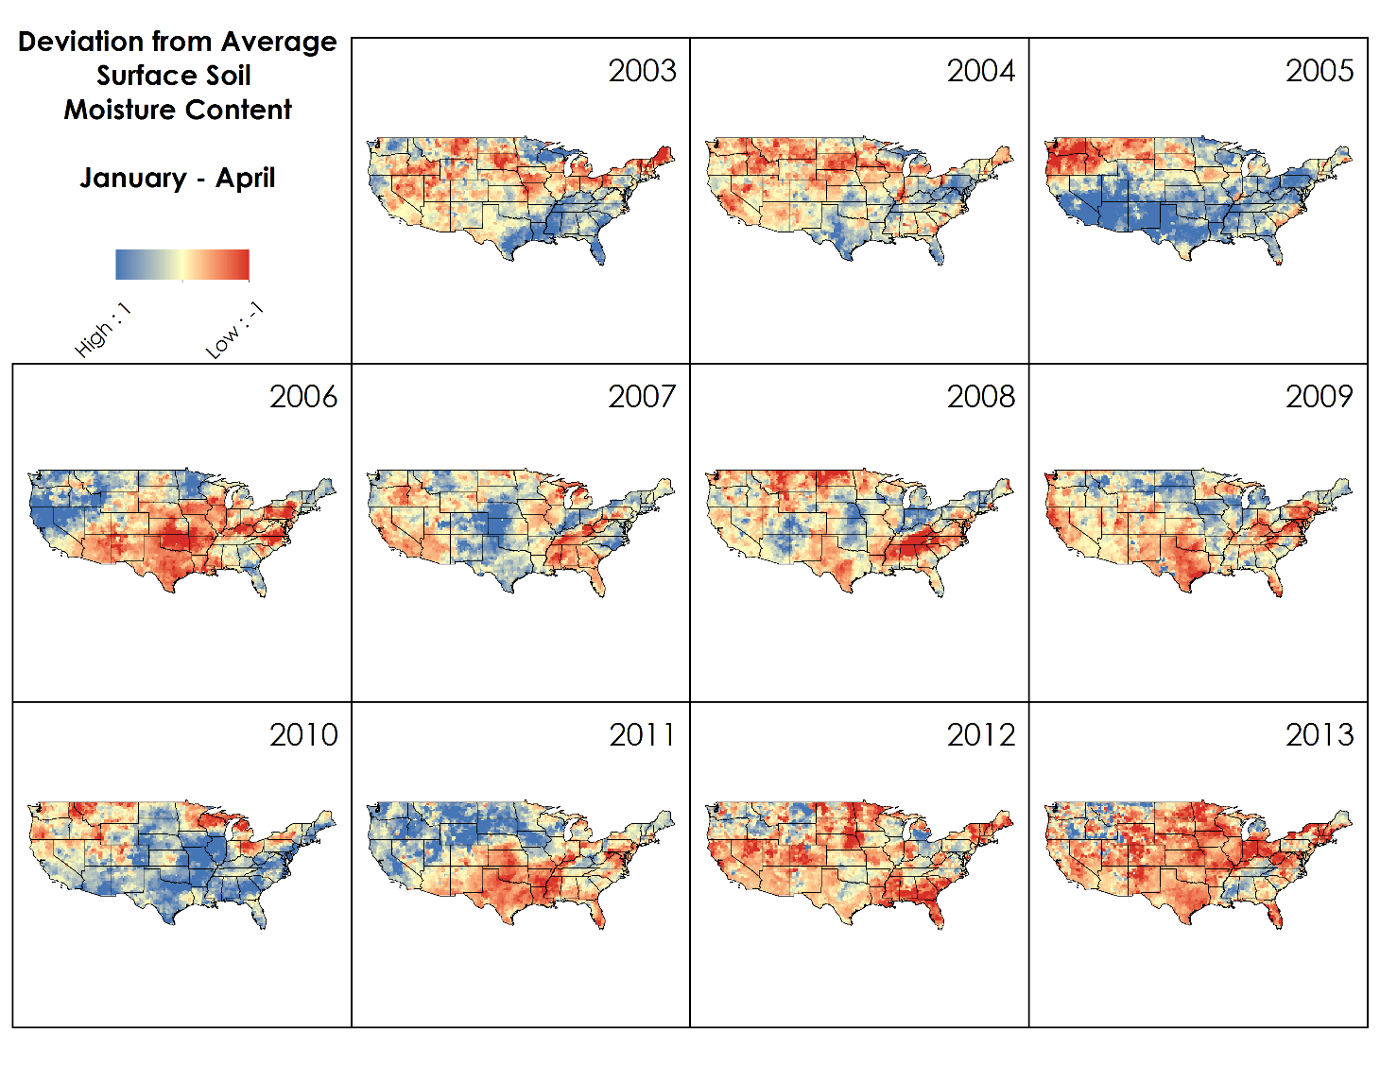

**Caption:** Deviation from average surface soil moisture content for January through April derived from GRACE assimilated data. Blue represents wetter than the average, while red represents drier than the average. Image Credit: U.S. Disasters II Team.

**Image:** Deviations_Norm.jpg