Southeast U.S. Agriculture

Evaluating the Spatial and Temporal Distribution of Flash Droughts within Agricultural Areas and Regional Crop Calendars in the Southeast using Earth Observations

 **Technical Report**

Final – March 30th, 2023

Kindrea Gibbons (Team Lead)

Michaela Gooch

Casey Mills

Quinton Deppert

***Advisors:***

Dr. Robert Griffin, University of Alabama Huntsville

Dr. Jeffery Luvall, NASA Marshall Space Flight Center

***Fellow:***  
Brianne Kendall

# 1. Abstract

A flash drought refers to the rapid onset or intensification of drought-like conditions. Within the Southeastern United States, flash droughts are made worse by the presence of consumptive vegetation and poor water-holding soils. According to the United States Drought Monitor, a 2016 flash drought occurred with roughly 92% of Georgia, Alabama, Mississippi, and Tennessee experiencing “severe drought” or worse in the fall of that year. The event resulted in widespread wildfires, reservoir shortages that led to interstate disputes over water rights, significant deterioration of pasture and rangeland, and crop sale losses. The occurrence of a flash drought similar to that listed above can cost the Southeast hundreds of millions of dollars, with effects lasting for several years. For this reason, the development of flash drought monitoring, forecasting, and communication tools is needed to alert both states and their practitioners of possible flash drought events, offsetting the potential loss caused by a flash drought event. This research employed NASA's Short-Term Prediction and Transition Center-Land Information System, Landsat 7 Enhanced Thematic Mapper Plus, and Landsat 8 Operational Land Imager and other datasets to determine climatological trends during peak growing season from 2000-2022. These products can help partners at the Alabama Office of the State Climatologist, National Integrated Drought Information System, and National Coordinated Soil Moisture Monitoring Network better manage agricultural lands inside drought-prone zones and monitor crop sensitivity during different growing seasons.

**Key Terms**

NDVI, Landsat, time series, SPoRT-LIS, root zone soil moisture, drought, agriculture, Southeast

# 2. Introduction

***2.1 Background Information***

Flash drought refers to the rapid onset or intensification of drought-like conditions. Flash droughts are caused by extended periods of low precipitation, unusually high temperatures, strong winds, or incoming radiation, which causes exceptionally high evapotranspiration (ET) rates. It is believed that ET and soil moisture can be early indicators of flash drought, with exceptionally high ET rates being the primary mechanism involved in the rapid onset and intensification of drought conditions (NOAA-NIDIS, 2021).

Flash droughts can happen in a matter of weeks or months and can happen so quickly that most go unperceived. Flash droughts can even occur in areas that recently did not have favorable drought conditions (Otkin et al., 2018). Unlike conventional droughts, the rapid development of flash droughts makes it harder to prepare for an impact, leading to more severe effects on agriculture and society than slower-moving droughts (Qing et al., 2022).

It is essential to consider that the overall agricultural impact of flash droughts is not attributed solely to the intensity or duration of the event, but also to the timing in which it occurs. The relationship between the meteorological anomalies that instigate a flash drought, and the percentage of crop yield loss varies significantly across the Southeastern United States (SEUS) depending on the timing of the climatic extremes and the crop type (Eck et al., 2020). This is because crops respond uniquely to water-related stress depending on their stage of development. A flash drought that occurs during a crop's water-sensitive growing stage severely impacts yield and quality. For this reason, the prediction of and preparation for flash droughts is vital.

At a conference assembled by the National Oceanic Atmospheric Association (NOAA), participants agreed that flash drought "indicators should be focused on leading impacts" (NOAA-NIDIS, 2021). The leading impact is primarily vegetative stress since it is often the first expression of flash drought. Concurrently, soil moisture decreases with rapidity and intensity (NOAA-NIDIS, 2021). NASA's Short-Term Prediction and Transition Center-Land Information System (SPoRT-LIS) has tracked root zone soil moisture (RZSM) from the year 2000 to 2022 at 0-40cm (Case, 2023). These data can be used to calculate the soil moisture percentile drop (SMPD), or how often soil moisture deviates below the 40th percentile in a climatology time series analysis (Osman et al., 2021).

A comparison study conducted between the NASA dataset Soil Moisture Active Passive (SMAP) and Short-Term Prediction and Transition Center – Land Information Center (SPoRT-LIS) found that SPoRT-LIS performs best in the summer and areas with lower vegetation density (Tavakol, 2019). These competitive functionalities make SPoRT-LIS an ideal tool for analyzing flash drought. Flash drought impacts on vegetative health can be analyzed using the Normalized Difference Vegetation Index (NDVI) derived from Landsat 7 Enhanced Thematic Mapper Plus (ETM+) and Landsat 8 Operational Land Imager (OLI) imagery. According to NOAA, these datasets can indicate the amount of stress the vegetation may be under, which is an emerging concern among those affected by flash droughts (NOAA-NIDIS, 2021).

The study area for this project consists of Alabama, Georgia, Florida, Tennessee, North Carolina, South Carolina, and Virginia from 1982 to 2022. In 2021, the Southeast contributed roughly $47 million in agricultural commodities. This makes up almost 11% of the total cash receipts reported for all United States agricultural production (USDA Economic Research Service, 2021). The development of non-elusive, region-specific flash drought monitoring, forecasting, and communication tools is needed to alert both states and their practitioners of possible flash drought events, offsetting the potential loss caused by a flash drought event.

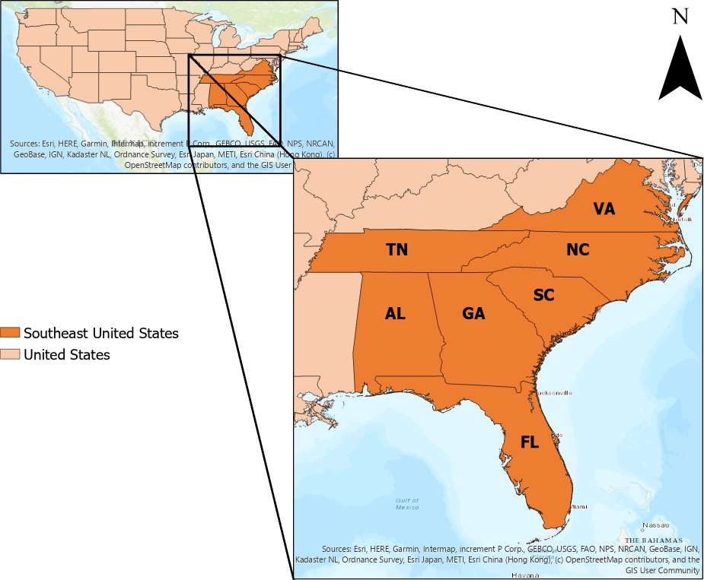

Figure 1*.* Study area of the SEUS including the states Tennessee, Alabama, Georgia, Florida, South Carolina, North Carolina, and Virginia.

***2.2 Project Partners & Objectives***

The team partnered with the Alabama Office of the State Climatologist (AOSC), NOAA’s National Integrated Drought Information System (NIDIS), and the National Coordinated Soil Moisture Monitoring Network (NCSMMN). The AOSC provides weekly reports to the U.S. Drought Monitor and disseminates products to state climatologists throughout the Southeast. It uses remote sensing-based technology, such as the Atmosphere-Land Exchange Inverse (ALEXI) model, ground-based Doppler radar, and SMAP products, to monitor drought and climatic trends occurring in the SEUS. NIDIS is part of the NOAA Climate Program Office, proactively monitoring drought and distributing drought information between federal, state, tribal, and local organizations. NCSMMN is a multi-agency and multi-institutional effort that consolidates soil moisture monitoring efforts across the United States. Both NIDIS and NCSMMN use Earth observations and in-situ data to monitor drought.

The partners are concerned about the effects of flash drought on crops during water-sensitive growing periods. In partnership with NIDIS, AOSC, and the NCSMMN, the project's overall goal was to create materials for members of the public interested in the relationship between flash droughts and crops. The objectives were to: (1) generate a climatology time series assessing soil moisture and precipitation of the SEUS using NASA SPoRT-LIS data, (2) analyze Landsat data from 1982 to 2022 to assess NDVI, (3) create flash drought susceptibility maps, and (4) create science communication materials describing the effects that flash droughts have on crops at water-sensitive growing stages.

# 3. Methodology

***3.1 Data Acquisition***

The team used Google Earth Engine (GEE) to acquire and process Surface Reflectance Tier 1 Landsat 7 ETM+ (1999-2022) and Landsat 8 OLI (2013-2022) data from January 2000 to November 2022 (Table 1). The team used the data to calculate NDVI.

Table 1:

*NASA Earth observations and source information*

|  |  |  |  |
| --- | --- | --- | --- |
| **Earth Observations** | | | |
| **Sensor** | **Processing Level** | **Data Provider** | **GEE Image Collection** |
| Landsat 7 ETM+ | Surface Reflectance Collection 2, Level 2, Tier 1 | USGS Earth Explorer | LANDSAT/LE07/C02/T1_L2 |
| Landsat 8 OLI | Surface Reflectance Collection 2, Level 2, Tier 1 | USGS Earth Explorer | LANDSAT/LC08/C02/T1_L2 |

John Case, a product manager for NASA’s SPoRT-LIS, provided high-resolution (about 3 km) gridded root zone soil moisture products from 2000 to 2022 from SPoRT-LIS. These data were used to make a climatological time series analysis. The team also used Parameter-elevation Regressions on Independent Slopes Model (PRISM) data from Oregon State University to create spatial climate datasets indicating short- and long-term precipitation trends, from March 2000 to August 2022. Finally, the team also clipped Landsat, SPoRT-LIS, and PRISM datasets to the USDA Cropland Data Layer, with the data layer acquired from the USDA website. The USDA Cropland Data layer allowed the team to narrow the scope of analysis to cropland areas. For the PRISM and SPoRT-LIS datasets, data file names and web addresses were generated via Microsoft Excel’s concatenation function for May to November. The team downloaded the data from servers using the Wget library in Python. The servers are hosted by Oregon State for PRISM and NASA SPoRT for SPoRT-LIS.

***3.2 Data Processing***

SPoRT-LIS, Landsat 7, Landsat 8, and PRISM datasets were clipped to a shape file of the SEUS states. Then, the datasets were clipped to the USDA Cropland Data Layer using the extract-by-mask tool.

Landsat 7 and Landsat 8 data were preprocessed to mask out cloud cover in GEE. Landsat datasets were analyzed in GEE using NDVI to assess vegetation productivity in the SEUS. The team assessed a NDVI on a monthly basis, focusing on months during the North American agricultural growing season from March to November. NDVI is a ratio between the red and near-infrared bands that serve as a proxy for vegetation presence and health (Equation 1).

$\text{NDVI=} \frac{\left(\text{NIR-R}\right)}{\left(\text{NIR+R}\right)}$ (1)

After computing NDVI in GEE, the images were exported to ArcGIS Pro and processed to reflect NDVI results as a color map, where each color corresponded to a certain NDVI value. Areas that received a value between –1 and 0 are less productive, and values between 0 and 1 indicate a productive area (Landsat Missions, n.d.). The team used the Geospatial Data Abstraction Library in Python to clip SPoRT-LIS and PRISM datasets from the continental US to a shapefile of the SEUS in a Python command line. In the process of clipping, SPoRT-LIS data were converted to GeoTIFFs from GRIB files, and the PRISM data were converted to GeoTIFFs from BIL format.

***3.3 Data Analysis***

The team created 20 climatology time series using the multiple datasets. The climatology time series was used to analyze soil moisture percentiles and precipitation anomaly data. If the weekly soil moisture percentiles provided by SPoRT-LIS appeared to have dropped below the 40th percentile for a period less than or equal to three weeks, that event was defined as a flash drought by SMPD (Osman et al., 2021). The team then analyzed PRISM daily precipitation data to find instances of precipitation anomaly. For every two weeks within the study period, the difference in precipitation was found between the actual and the two-week rolling average. These values were used to construct a climatological time series analysis of precipitation anomalies or precipitation deficit flash drought (Mo & Lettermaier, 2016). A positive value indicated an anomaly of above-average precipitation, and a negative value indicated an anomaly of below-average precipitation. Then, NDVI data were also compiled into a geodatabase for cross-validation with SMPD and precipitation anomaly datasets.

The team cross-referenced SPoRT-LIS, Landsat 7 and 8, USDA Cropland Data Layer, and PRISM data in ArcGIS Pro to identify instances of agricultural flash drought that were known to have occurred across the SEUS. Cross-referencing these datasets identified climate variables that were associated with the Alabama flash drought that occurred in the summer of 2016 (Osman et. al., 2021). Cross-referenced datasets allowed the team to examine trends over time, validating flash drought across multiple drought indicators. While each drought indicator can detect flash drought via soil moisture, vegetative stress, or precipitation, validation makes it possible to spatially and temporally identify where and when all three indicators can detect flash drought.

The following figures are time series analyses of 5 common crops in the SEUS: corn, cotton, pastureland, soybeans, and peanuts. These time series analyses were created by finding the coordinates of crop types as designated by the USDA Cropland Data Layer. Using an algorithm derived from Python’s PANDAS library, the rolling average for 1-week and 3-week periods are compared for soil moisture percentiles. Red bars highlight where the algorithm found flash droughts, as defined by SMPD. A similar algorithm was used to calculate precipitation anomaly, but it focused on 2-week rolling averages. Instances of two weeks where the difference line is below the zero bar are indicative of a flash drought via precipitation anomaly indicators.

# 4. Results & Discussion

***4.1 Analysis of Results***

Figures 2-6 are the time series analyses that effectively demonstrate the feasibility of measuring flash drought via precipitation and soil moisture indicators. These graphs show that precipitation-anomaly-induced flash-droughts roughly correlate temporally and spatially to SMPD induced flash droughts. Dips in soil moisture tend to have a corresponding dip in precipitation. When comparing 2015 to 2016, the RZSM percentiles are overall much lower in the 2016 flash drought than in 2015 when conditions were normal. Flash droughts tended to occur when conditions were already drier than usual. Only a few minor flash droughts were detected for Southern Georgia peanuts in 2015, whereas at least 3 flash droughts were found to have occurred for every other crop in 2016.

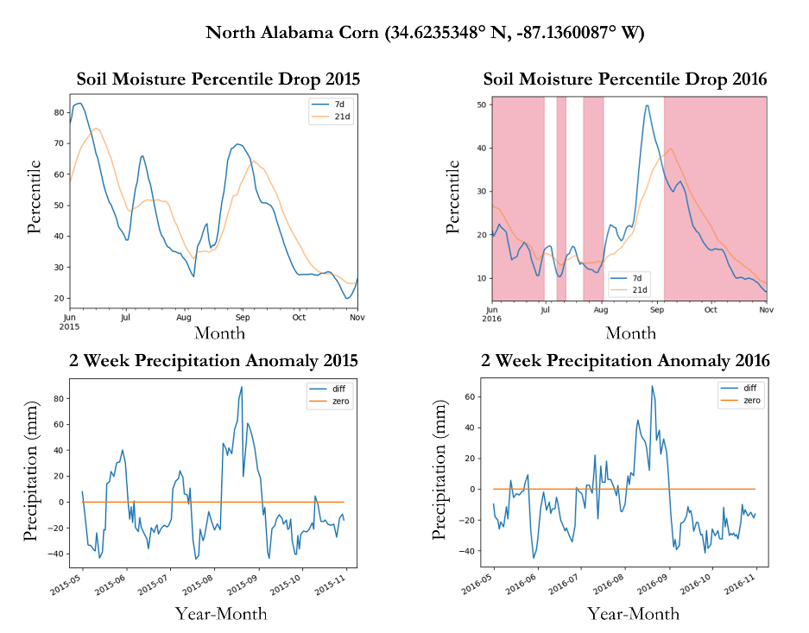

Figure 2*.* Comparison of Soil Moisture Percentile Drop and 2 Week Precipitation Anomalies in 2015 and 2016 in an area of corn cropland in North Alabama. Crop areas were identified by the USDA Cropland Data Layer (USDA NASS, 2023).

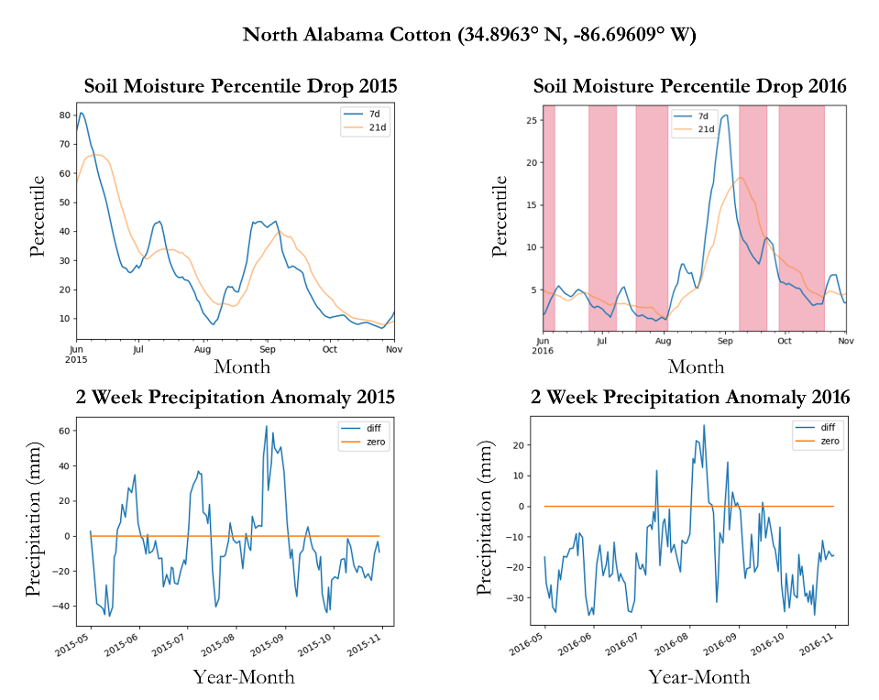

Figure 3*.* Comparison of Soil Moisture Percentile Drop and 2 Week Precipitation Anomalies in 2015 and 2016 in an area of cotton cropland in North Alabama. Crop areas were identified by the USDA Cropland Data Layer (USDA NASS, 2023).

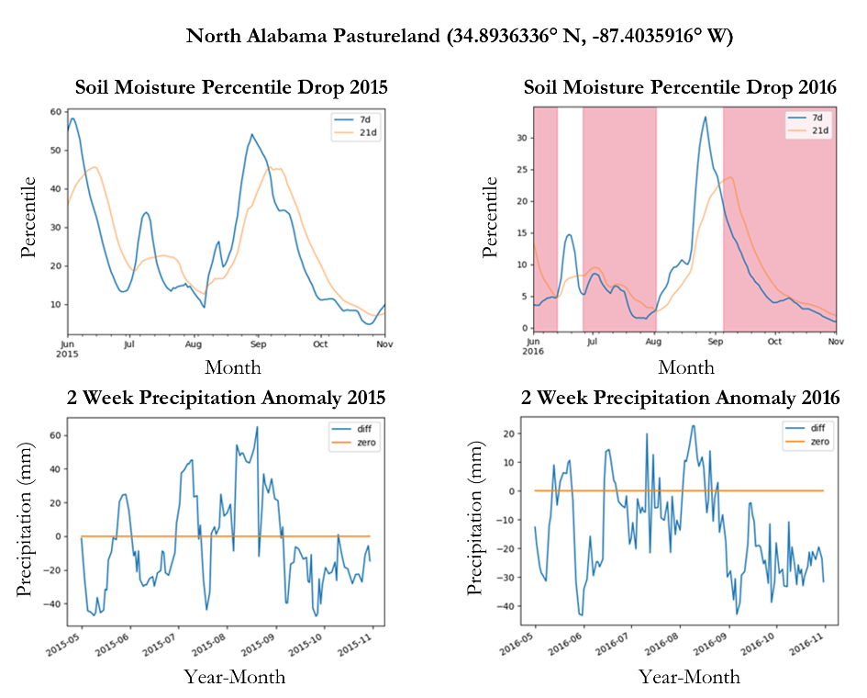

Figure 4. Comparison of Soil Moisture Percentile Drop and 2 Week Precipitation Anomalies in 2015 and 2016 in an area of pastureland in North Alabama. Crop areas were identified by the USDA Cropland Data Layer (USDA NASS, 2023).

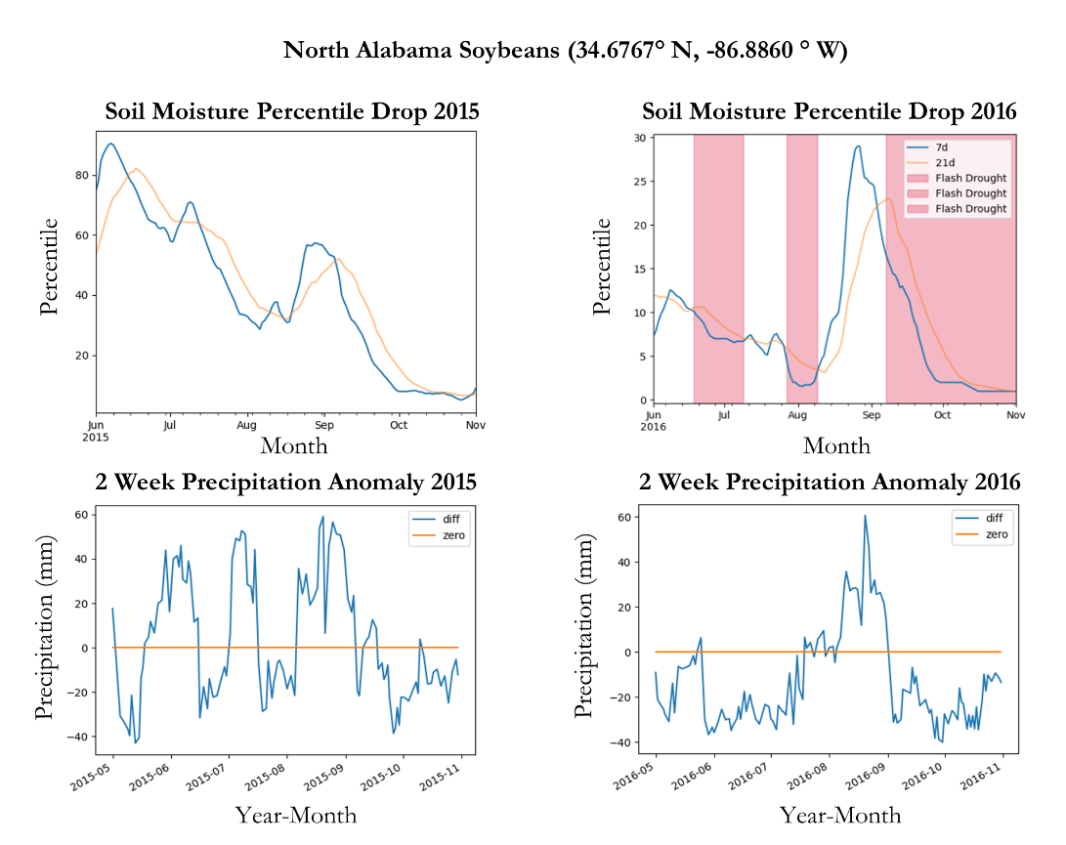

Figure 5. Comparison of Soil Moisture Percentile Drop and 2 Week Precipitation Anomalies in 2015 and 2016 in an area of soybean cropland in North Alabama. Crop areas were identified by the USDA Cropland Data Layer (USDA NASS, 2023).

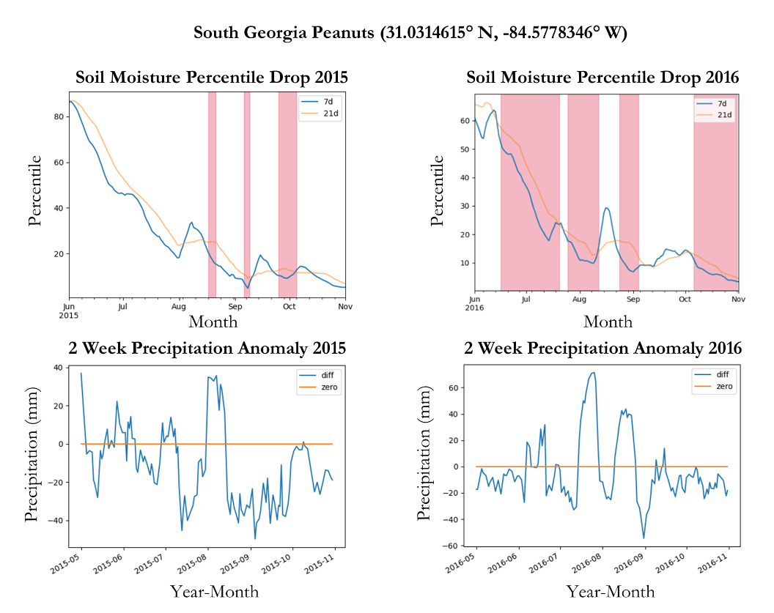

Figure 6*.* Comparison of Soil Moisture Percentile Drop and 2 Week Precipitation Anomalies in 2015 and 2016 in an area of peanut cropland in South Georgia. Crop areas were identified by the USDA Cropland Data Layer (USDA NASS, 2023).

The team identified multiple issues with the methodology. First, NDVI was assessed monthly from March to November, and Landsat satellites orbit the Earth every 16 days, passing over the same area twice a month. The satellite may not capture images of the exact locations in its second orbit. After filtering the images to remove cloud cover, NDVI pixels may not be present in the same area across the different months. Due to these restraints, the team could not calculate NDVI across the entire SEUS for each month. Instead, the team conducted similar research on smaller agricultural sites containing overlapping images. Future projects assessing flash drought should examine using harmonized Landsat-Sentinel optical satellite products, because it provides imagery captured every eight days, allowing more consistent imagery over a large study area like the SEUS.

The second issue was that the team did not have time within the ten-week term to ground truth the NDVI analysis and determine the accuracy of productive and nonproductive vegetation. The team failed to validate the climatology time series because there are instances of historical flash droughts that are unknown to modern science. A third significant factor the team could not account for is the study period. The project’s intended study period covered 40 years, from 1982 to 2022. Instead, the study focuses on 22 years because the NASA SPoRT-LIS dataset only extends back to 2000. The team prioritized analyzing the precipitation and soil moisture indicators via climatology time series.

***4.2 Future Work***

If given more time to work on this project, the team would evaluate and explore other possible flash drought indicators, such as evapotranspiration, land surface temperature, and groundwater. The team would complete a time series analysis that covers the entire study period, as well as complete susceptibility maps for the SEUS. Work should be done on the time series analysis algorithm to maintain consistent ranges along the y-axis, as well as clarify the algorithm to suggest possible times of “trouble” following the end of flash drought events. This team faced a problem when specific Landsat satellites failed to observe data with spatial and temporal relevance to this project data, due to cloud interference and the satellite orbit. Future projects should cross-reference imagery across multiple Landsat satellites, or they try to utilize NASA IMPACT's Harmonized Landsat Sentinel-2 data, which can pick up “higher resolution observations every 2-4 days" than Landsat alone (IMPACT, 2022).

Future teams could study background information for flash drought events. For example, teams could examine whether the precipitation and soil moisture for that year was higher or lower than average. Teams could also study the climatic events in the months prior to flash drought occurrences. The difference between flash drought and drought should also be further defined for the context of a time series analysis to further solidify the occurrence of a flash drought event.

# 

# 5. Conclusions

Flash droughts were detected at various locations throughout the SEUS in 2016 via three drought indicators: soil moisture, precipitation, and vegetative health. In 2016, areas growing the five crops of interest were all impacted by soil moisture-driven flash droughts and precipitation anomalies. Flash drought detected via the time series analyses seem to occur in succession. As indicated by the above RZSM percentiles, the 2016 flash drought occurred in what appeared to be a drier year compared to 2015 and as compared to the rest of the study period. In terms of forecasting when a rapid onset/intensification of a lack of precipitation or loss of soil moisture results in a flash drought, perhaps the best indicator is that the year was drier than usual. The findings of the climatology time series can help drought managers to better understand the indicators of flash drought and to better manage agricultural lands in drought-prone areas.

There is a lot of power in naming a phenomenon. Many farmers in SEUS have already experienced flash drought. Whether they had heard of the term flash drought or not, they are likely able to recall the impacts of the 2016 flash drought. What will be important is communicating to these farmers that the rapid onset/intensification of drought-like conditions has a name: flash drought. Using susceptibility maps, crop calendars, and time series analyses based on the team’s results, the spatial and temporal dimensions of historical flash droughts can be related to real-world farmers by NOAA-NIDIS, NCSMMN, and the AOSC. In the future, the farmers may be able to recognize the impacts of a flash drought sooner. They can then report the conditions they recognize as flash drought to drought monitors, ultimately improving the monitors ability to forecast flash drought. Improved reporting could ultimately lead drought investigators to a definitive understanding of the preconditions that lead to flash droughts.

# 6. Acknowledgments

The Southeast Agriculture Team would like to thank their science advisors Dr. Robert Griffin (University of Alabama in Huntsville) and Dr. Jeffrey Luvall (NASA, MSFC). We are grateful to our partners Dr. Lee Ellenberg (Alabama Office of the State Climatologist), Dr. Meredith Muth (NOAA NIDIS), and Marina Skumanich (National Soil Moisture Monitoring Network) for their time and assistance, our fellow Brianne Kendall (NASA DEVELOP MSFC Fellow) for her consistent support, and a special thanks to John Case (NASA SPoRT) and John Mandel (NASA IMPACT) for providing help data and information along the way.

Any opinions, findings, and conclusions or recommendations expressed in this material are those of the author(s) and do not necessarily reflect the views of the National Aeronautics and Space Administration.

This material is based upon work supported by NASA through contract NNL16AA05C.

# 

# 7. Glossary

**ALEXI** – Atmosphere-Land Exchange Inverse

**AOSC** – Alabama Office of the State Climatologist

**ET** –Evapotranspiration

**Earth observations** – Satellites and sensors that collect information about the Earth’s physical, chemical, and biological systems over space and time

**GEE** – Google Earth Engine

**NCSMMN** – National Coordinate Soil Moisture Monitoring Network

**NDVI** – Normalized Difference Vegetation Index

**NIDIS** – National Integrated Drought Information System

**NOAA** – National Oceanic Atmospheric Association

**PRISM** – Parameter-Elevation Regressions on Independent Slopes Model

**RZSM** – Root Zone Soil Moisture

**SEUS** – Southeast United States

**SMAP** – Soil Moisture Active Passive

**SMPD** – Soil Moisture Percentile Drop

**SPoRT-LIS** – Short-Term Prediction and Transition Center – Land Information Center

**USDA** – United States Department of Agriculture

# 8. References

Case, J. (2023) Short-Term Prediction & Transition Center, 2000-2022 <https://geo.nsstc.nasa.gov/SPoRT/outgoing/jlc/LIS/forDEVELOP/>

Eck, M. A., Murray, A. R., Ward, A. R., & Konrad, C. E. (2020). Influence of growing season temperature and precipitation anomalies on crop yield in the southeastern United States. *Agricultural and Forest Meteorology*, *291*, 108053. https://doi.org/10.1016/j.agrformet.2020.108053v

“Harmonized Landsat Sentinel-2 Generating Global Land Surface Reflectance Data Every 2 to 3 Days at 30 Meter Resolution.” IMPACT | HLS, NASA, 17 Oct. 2022, <https://impact.earthdata.nasa.gov/project/hls.html>.

Landsat Missions. (n.d.). *Landsat normalized difference vegetation index*. Landsat Normalized Difference Vegetation Index | U.S. Geological Survey. Retrieved March 2, 2023, from <https://www.usgs.gov/landsat-missions/landsat-normalized-difference-vegetation-index>

Mo, K. C., & Lettenmaier, D. P. (2016). Precipitation deficit flash droughts over the United States. *Journal of Hydrometeorology, 17*(4), 1169-1184. <https://doi.org/10.1175/JHM-D-15-0158.1>

NOAA-NIDIS. (2021, February 2). *What is flash drought*. Drought.gov. Retrieved from <https://www.drought.gov/what-is-drought/flash-drought#:~:text=What%20Is%20Flash%20Drought%3F,rapidly%20alter%20the%20local%20climate>

Oregon State University. (2023). *Prism Climate Data.* PRISM Climate Group. Retrieved February 22, 2023, from <https://ftp.prism.oregonstate.edu/daily/ppt/>.

Osman, M., Zaitchik, B. F., Badr, H. S., Christian, J. I., Tadesse, T., Otkin, J. A., Anderson, M. C. (2021). Flash drought onset over the contiguous United States: Sensitivity of inventories and trends to quantitative definitions. *Hydrology and Earth System Sciences*, *25*(2), 565-581. <https://doi.org/10.5194/hess-25-565-2021>

Otkin, J. A., Svoboda, M., Hunt, E. D., Ford, T. W., Anderson, M. C., Hain, C., & Basara, J. B. (2018). Flash droughts: A review and assessment of the challenges imposed by rapid-onset droughts in the United States. *Bulletin of the American Meteorological Society, 99*(5), 911–919. <https://doi.org/10.1175/bams-d-17-0149.1>

Qing, Y., Wang, S., Ancell, B. C., & Yang, Z. (2022). Accelerating flash droughts induced by the joint influence of soil moisture depletion and atmospheric aridity. *Nature Communications, 13*(1). <https://doi.org/10.1038/s41467-022-28752-4>

Tavakol, A., Rahmani, V., Quiring, S. M., & Kumar, S. V. (2019). Evaluation analysis of NASA SMAP L3 and L4 and SPoRT-LIS soil moisture data in the United States. *Remote Sensing of Environmen*t*, 229*, 234–246. https://doi.org/10.1016/j.rse.2019.05.006

USDA Economic Research Service. (2021). *Cash receipts by commodity State ranking* [Data set]. <https://data.ers.usda.gov/reports.aspx?ID=17844>

USDA National Agricultural Statistics Service. (2023). *USDA National Agricultural Statistics Service Cropland Data Layer*. [Online Data Map]. Retrieved March 23, 2022, from <https://nassgeodata.gmu.edu/CropScape/>

US Geological Survey (USGS). (1999). Landsat 7 Operational Land Imager (OLI) Level 2, Collection 2, Tier 1 Top of Atmosphere Reflectance [Data set]. Earth Engine Data Catalog / USGS. https://doi.org/10.5066/P9C7I13B

US Geological Survey (USGS). (2013). Landsat 8 Operational Land Imager (OLI) Level 2, Collection 2, Tier 1 Top of Atmosphere Reflectance [Data set]. Earth Engine Data Catalog / USGS. <https://doi.org/10.5066/P90GBGM6>