**NASA DEVELOP National Program**



BLM at Idaho State University GIS TReC

*Spring 2017*

Intermountain West Ecological Forecasting

Using NASA Earth Observations to Identify Current Habitat Areas and Forecast Habitat Suitability for the Yellow-Billed Cuckoo in Semiarid Environments

 **Technical Report**

Final Draft – March 30, 2017

Arina Mardoukhi (Project Lead)

Paul Bushman

Caitlin Toner

Courtney Ohr

Keith Weber, GIS Training and Research Center at Idaho State University (Science Advisor)

Charles Peterson, Idaho State University, Biology Department (Science Advisor)

Mark Carroll, NASA Goddard Space Flight Center (Science Advisor)

**1. Abstract**

Observations of the threatened western yellow-billed cuckoo (YBC) are rare in Idaho, Wyoming, and Utah. This species can act as an indicator for the overall health of an ecosystem, therefore understanding their habitat is critical to planning and improving land management and ecosystem conservation practices. These secretive birds spend only a few months of the year in breeding locations throughout the intermountain west from May to August. Partner organizations tasked with monitoring this species, such as the US Fish and Wildlife Service (USFWS) and the Idaho Department of Fish and Game (IDFG) find that observations can be difficult even through solicited survey methods. The team utilized NASA Earth observations Landsat 8 OLI to create current habitat suitability maps in order to help prioritize surveys in areas that are more likely to contain YBC. In addition, the team sought to understand the cause of the decline of the YBC areas across the Intermountain West in order to allow partner organizations to better plan for future monitoring and conservation efforts.

**Keywords**

Landsat, NDVI, remote sensing, conservation, habitat, yellow-billed cuckoo, forecasting

# **2. Introduction**

***2.1*** ***Background Information***

Over the past few decades, the western yellow-billed cuckoo (YBC) population has been declining (Dettling et al., 2015). In response, YBC was listed as threatened under the Endangered Species Act of 1973 in October, 2014 (Dettling et al., 2015). Surveys in Idaho between 2005 and 2011 indicate a breeding population of only 10-20 pairs, Wyoming estimates less than 5 breeding pairs, and Utah estimates approximately 10 breeding pairs (Hughes, 2015). The western YBC population is dependent on healthy cottonwood-willow riparian habitat and therefore their decline may show the need for monitoring other species with similar habitat requirements (Dettling et al., 2015). Field surveys and behavior monitoring for the YBC are difficult as they are an elusive and secretive species. Recorded observations of the bird are limited and are statistically insignificant to create solid management decisions (Villarreal et al., 2014). Previous studies have focused on locating the YBC in Arizona (McClure et al., 2015; Villarreal et al., 2014) and throughout the Sacramento Valley in California (Dettling et al, 2015). Current methods for detecting and monitoring this species have proven to be time consuming and costly in large areas of land, leading state and federal agencies to look for more effective solutions (Halterman et al., 2016).

The NASA DEVELOP Intermountain West Ecological Forecasting team reviewed and synthesized literature pertaining to the YBC and identified habitat variables that might indicate the presence of the species. The team focused on vegetation type, land cover, wildfire, slope and elevation to define the habitat of the YBC (Wallace, 2013). Moreover, YBC habitat has not been modeled before in the study areas selected for this project. Therefore, this study is one of the first YBC habitat modelling effort in the Intermountain West.

***2.2*** ***Study Area and Periods***

The main objective of this project is to a create model that will produce habitat suitability maps in Idaho, Utah, Wyoming (Figure 1). These products will help project partners in their decision making regarding monitoring in the upcoming months of May-August 2017. The YBC typically arrive in Idaho, Utah, and Wyoming in mid-May and begin nesting, which lasts until the end of August (McClure et al., 2015). For this reason, the team analyzed remotely sensed data for May-August of 2016 and then attempted to determine habitat change by looking at similar hydrologic water years which was 2003 for Idaho and Utah, and 2005 for Wyoming. Change maps were produced by excluding model components that could not be completed within the term guidelines. Originally the team planned to produce a 2030 ecological forecasting map by studying habitat changes between 2003 and 2016, however, due to the high level of uncertainty discovered in this study, the ecological forecasting maps were not produced.

***2.3*** ***Project Partners & Objectives***

Our partners for this study include Idaho Department of Fish and Game (IDFG) Southeast Regional Office, the US Fish and Wildlife Service (USFWS) Eastern Idaho Field Office, and USFWS Ecological Services Field Offices in Wyoming and Utah, and the NASA Rehabilitation Capability Convergence for Ecosystem Recovery (RECOVER) Science Team at Idaho State University’s GIS Training and Research Center (ISU GIS TReC). These organizations desired geospatial data maps and maps to more effectively manage the land for YBC. Currently these organizations are relying on field surveys to document the locations of YBC nesting areas but field work can be expensive, time consuming, and needs expert knowledge. IDFG is familiar with GIS software and has utilized satellite remote sensing data in the past, while the USFWS Southeast Regional Office and the Field Offices in Wyoming and Utah currently do not utilize NASA Earth observations in any capacity for monitoring and conservation decision support.

Figure 1. Areas in red indicate the study areas for Idaho, Wyoming, and Utah

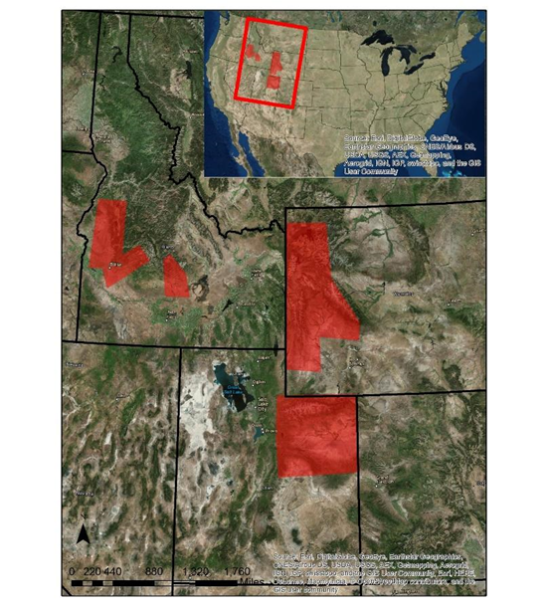

The team’s partner organizations will be able to use these suitability maps in the field to record YBC observations, and will be able to better identify locations with the highest likelihood of YBC presence for future monitoring efforts. Having this information allows the organizations to be more time and cost effective, which in turn will allow them to focus on other important wildlife management decisions.

**3. Methodology**

***3.1 Data Acquisition***

The data required for this project included vector and raster data; vector data included wildfire perimeters and road data while raster data included multispectral imagery, topography, and land cover data. The team collected 2016 imagery from Landsat 8 Operational Land Imager (OLI) for the study areas in Idaho, Utah, and Wyoming. The Landsat 8 satellite has a 16-day repeat cycle and each scene covers approximately 170 km north-south by 183 km east-west of the Earth’s surface. The OLI sensor collects multi-spectral bands at 30 meter resolution. Landsat 8 data were acquired for dates in late May to early June 2016 and consisted of scenes with less than ten percent cloud cover. Elevation data were collected from the USGS National Elevation Dataset (NED) 10 meter resolution for each of the study areas (U.S. Geological Survey, 1999). Wildfire perimeter data was provided by NASA RECOVER. Road data for Utah was retrieved from the AGRC database, the road data for Wyoming were retrieved from Wyoming Geospatial Hub and Teton County GIS File Archives. Idaho road data were retrieved from INSIDE Idaho website. The National Land Cover Database (NLCD) for 2001, 2006, and 2011, is a land cover classification database at 30 meter spatial resolution for the entire United States and was retrieved from the Multi-Resolution Land Characteristics Consortium.

***3.2 Data Processing and Analysis***

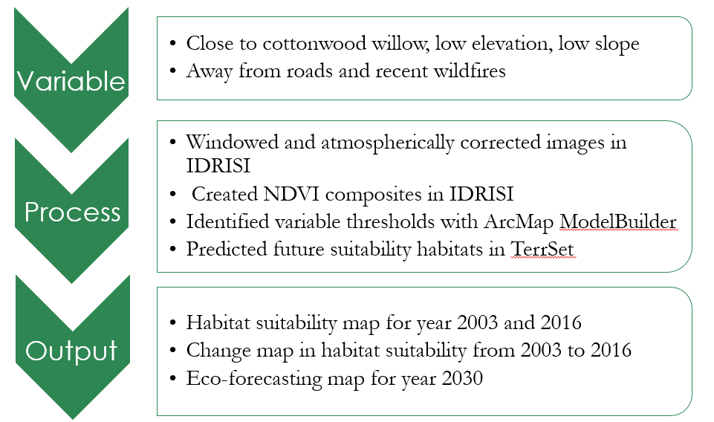

Figure 2: Image of model that applies threshold to YBC habitat variables

The team developed a model with the ModelBuilder application in Esri’s ArcMap 10.4 (Figure 2). This model included the Landsat 8 imagery, NLCD, roads, elevation, slope and fire history layers. Thresholds were created for vegetation types, proximity to roads, and elevation using existing literature and expert knowledge to help identify optimal habitat suitability areas for the YBC. The Landsat 8 OLI imagery were atmospherically corrected using the TerrSet IDRISI GIS analysis program. A normalized difference vegetation index (NDVI) mean composite was calculated for the 2016 growing season. NDVI is a way to estimate the photosynthetic activity of vegetation within each pixel. Using the visible red band 4 (B4) and the near infrared band 5 (B5) collected by Landsat 8 OLI, NDVI is calculated by a simple band ratio technique (equation 1).

|  |  |
| --- | --- |
| $\text{NDVI= ((ρ(_NIR^)- }\text{ρ_Red}\text{ ))/ρ( }\text{〖}\text{_NIR^ }\text{〗}\text{+ }\text{ρ_Red}\text{ ) }$ | (1) |

Since vegetation has low reflectance in the red band (B4) due to absorption by chlorophyll for photosynthesis, and strong reflectance in the near infrared band due to the cell structure of plants, NDVI can act as a spectral measure of the amount of active photosynthesis on the ground. Higher values are representative of more photosynthetic activity, lower values are representative of little to no vegetation, and negative values represent areas with barren rock, sand, water and snow (Wallace et al., 2013). An NDVI threshold was set to values between 0.65 and 0.75 which indicate cottonwood-willow vegetation (Glenn et al., 2008), a land cover type that is ideal for YBC nesting habitat. An NDVI composite was created because the growing peaks can occur throughout the growing season and the modeled NDVI threshold was derived from a study that included average sample of the trees.

The YBC nests in flat riparian habitats that have low to moderate elevation levels (Wallace, 2013). The team created a threshold to identify regions with low elevation and gentle slope. Because of this, the team looked at riparian areas that are below 1900m (~6234 ft.) for the study areas in Idaho and Utah, and then below 2100 m (6890 ft.) for the study area in Wyoming. Road noise has also been indicated as an important factor as noise can interfere with the vocalizations of the YBC and prevent them from occupying sites near busy roads (Goodwin & Shriver, 2011), therefore a road buffer of 800 m (0.5 mi) was set to exclude these areas from optimal habitat. This buffer is a stipulation of Utah surveying efforts created by Amy Defreese from the US Fish and Wildlife Service. In addition, because major wildfires can destroy YBC suitable habitat during drought conditions, the team masked out fire areas in 2016.

Finally, suitable nesting habitat was further limited by excluding all other land cover types beside those that provide suitable canopy. The NLCD is a widely used dataset that provides descriptive data to identify different land classes such as agricultural, urban, grassland or deciduous forest. Suitable land cover for YBC habitat was classified from the NLCD to include deciduous forest, mixed forest, and woody wetlands.

After running the datasets through the ModelBuilder, the tool identified all locations within in the study areas that matches the five habitat parameters. The resulting habitat maps were given a range between 0 and 11,111; where 0 did not meet any of the model parameters, 11,111 met all of the suitable requirements, 10,111 meant that the results did not meet the wildfire requirement, and so forth. Table 1 explains the variable key values. The ModelBuilder results were overlaid with survey data provided by Idaho Fish and Game and Utah Fish and Wildlife Service to validate the accuracy of our model. This accuracy assessment can help future researchers to adjust variables thresholds and improve the tool.

Table . Suitable Habitat Parameters with Assigned Values

|  |  |
| --- | --- |
| **Parameter** | **Value** |
| Met NLCD Classes & NDVI Threshold | 10,000 |
| No Recent Wildfires | 1,000 |
| Outside of Road Buffer | 100 |
| Met Elevation Threshold | 10 |
| Met Slope Threshold | 1 |

Change maps were produced from model results that did not include an NDVI component. It was originally planned to include Landsat 5 in order to see how suitability has changed in the last 10-15 years (2003-2016 for Utah and Idaho, 2006-2016 for Wyoming). These years were chosen for their similar precipitation with 2016, making them appropriate to compare growing seasons. After examining initial results, the team discovered that Landsat 5 NDVI values did not correlate with Landsat 8 values. The team only reviewed literature that showed the cottonwood-willow NDVI values for Landsat 8 and could not find similar studies for Landsat 5. Due to time restriction, the team did not have more time to find literature that suggested an appropriate Landsat 5 NDVI threshold for cottonwood-willow. Instead, the change maps are shown without using the NDVI criteria which means the only temporal data used to show change are wildfires (2003 for Utah and Idaho, and 2006 for Wyoming) and changes in land cover types (2001 NLCD for Utah and Idaho, and 2006 NLCD for Wyoming).

Since appropriate change maps could not be created, the ecological forecasting project component could also not be completed. Instead the team initiated another version of the YBC that eliminated the roads parameter and added a parameter for waterbodies. For the this new component, the model created a 800 m (0.5 mi) buffer around flowlines designated as rivers or streams found in the National Hydrography Dataset (NHD). The rest of the variables stayed the same (Table 1).

Table . Suitable habitat parameters with assigned values including water bodies and excluding roads

|  |  |
| --- | --- |
| **Parameter** | **Value** |
| Met NLCD Classes & NDVI Threshold | 10,000 |
| No Recent Wildfires | 1,000 |
| Inside a River or Waterbody Buffer | 100 |
| Met Elevation Threshold | 10 |
| Met Slope Threshold | 1 |

# **4. Results & Discussion**

***4.1*** ***Suitable Habitat for Yellow Billed Cuckoo***

The suitable habitat results show that optimal habitat is a very small portion in each study area. In the Idaho and Wyoming study area, suitable habitat cannot be seen unless there is a zoomed-in image. Utah shows more medium-high suitability, but still has very small regions that display the highest suitability. In each study area, the majority of the regions fall into the following four classes: low suitability, 1,101, 1,110, and 1,111. The last three classes were colored in yellow and orange. These three classes are similar in that none of them satisfy the criteria for vegetation but satisfy being away from fire locations and roads. These results made the team further investigate the importance of vegetation for suitable habitat and if the model was effectively identifying areas of vegetation.

This section discusses what major classes were seen in each study area both at the full extent and zoomed-in level. For Idaho, major cities such as Boise and Twin Falls have low suitable habitat areas. In Wyoming, suitable habitat locations are sometimes very close to urban development and may continue to diminish if not monitored. Utah had the most habitat suitability within its study area but much of it was at high elevation or steep slope. After running validation points and comparing the results with what the model produced, the team further looked at several variables such as vegetation, roads, and rivers. Examining the results allowed the team have a better understanding of the locations for habitat suitability and the effectiveness of the model.

Figure 3. Utah study area. Suitable area found in western part.

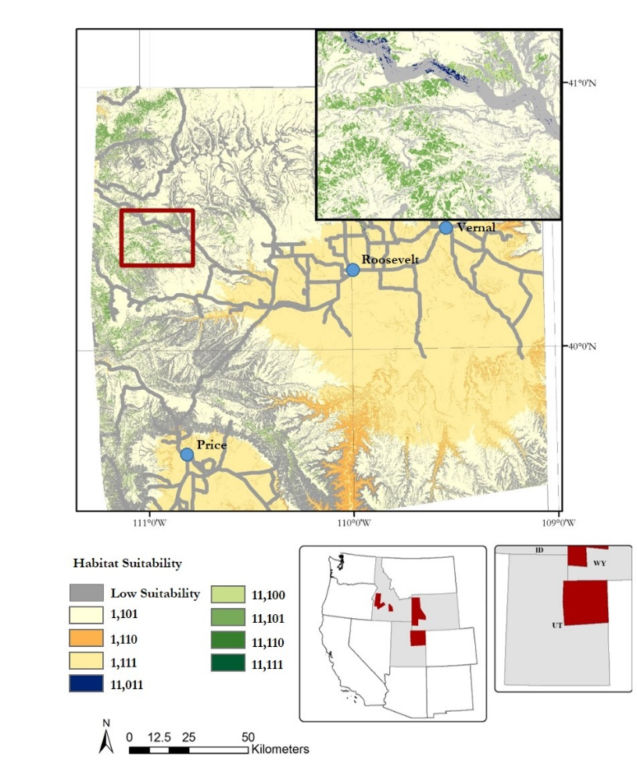

Figures 3 through 6 show YBC suitable habitat as predicted by the model. Many of these low suitability areas were very small and therefore cannot be seen on the map. The Utah study area contained the largest area of highly suitable habitat (3 mi2 or 7km2).

A large portion of the Utah study area (Figure 3) satisfies all the criteria except the desired vegetation/land cover type. These results suggest that project partners may wish to determine whether or not they can increase the presence of cottonwood-willow and restore canopy cover, which will likely increase the possibility of habitat suitability. Urbanization may be a cause of vegetation degradation in some areas. Looking at the Figure 4, the most suitable habitat (11,111) often exists near low suitability areas which is frequently due to existing roads. It is likely that urban development is diminishing cottonwood-willow.

In the Idaho study area (Figure 5), high suitability (11,111) cannot be seen at this scale level. At full extent, one can see a dense area of gray in the western part of the study area. This area is the Boise metro area, and the urban development does not support the bird’s need for suitable habitat. In the southeast corner there are also grid lines in gray. This is near Twin Falls, another developed area not ideal for YBC. Part of the Sawtooth Mountain range rests in the north-eastern part of the study area. The mountain range’s high elevation and steep slope makes the region a poor place for yellow-billed cuckoo suitability. The large portions of urban areas and the mountain range means suitable habitat for the yellow-billed cuckoo will most likely be found in fragmented-smaller patch size. In Figure 3, medium-high suitable areas (11,011) are speckled within the roads and satisfy all criteria for suitability except for being half a mile away from a road. The roads in Idaho follow riparian areas and therefore it would be reasonable to limit road buffer size in the future. Outside of the non-suitable habitat area we see medium suitable habitat regions (1,110 – 1,111). These areas meet the criteria for good elevation, are away from roads and fires, but lack desirable vegetation. The high suitable areas meet the vegetation requirement and therefore would be expected to host breeding habitats for yellow-billed cuckoo.

Figure 4. Idaho Suitable Habitat

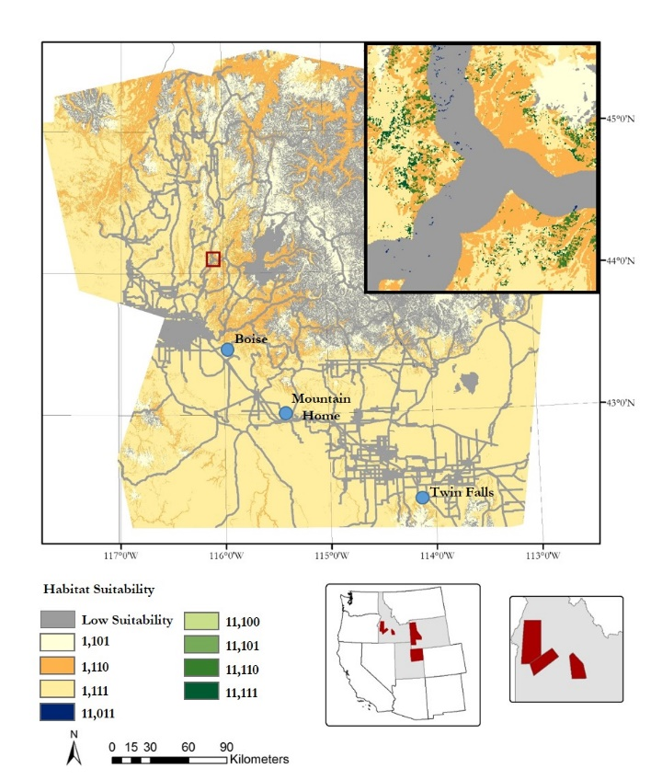

Figure 5 shows habitat suitability in Wyoming, the results from this area more clearly follow riparian habitats. This area has more available water and therefore should be able to support more available cottonwood-willow habitat. The medium-high (11,111) suitability class is very prevalent in this study area and is not considered highly suitable because the area can be found within the roads buffer. Because much of the Wyoming, Utah, and Idaho study areas have highly suitable habitats fragmented by medium-high (11,011) areas, there may be the need to decrease the road buffer, especially since many of these areas have roads that follow rivers. The areas that are considered to have medium suitability (1,101 – 1,111) are recommended recovery areas. These areas don’t meet the vegetation requirement and two of the classes don’t meet either the slope or elevation requirement which is not a clearly defined number within literature. When this suitability rating is found fragmenting highly suitable (11,100 - 11,111) habitats, and the fragmentation is due to decreased vegetation, it would be ideal locations for reseeding efforts or developing protection measure for the still highly suitable habitat.

Figure 5. Wyoming study area. The higher elevation makes it more difficult to identify suitable habitat

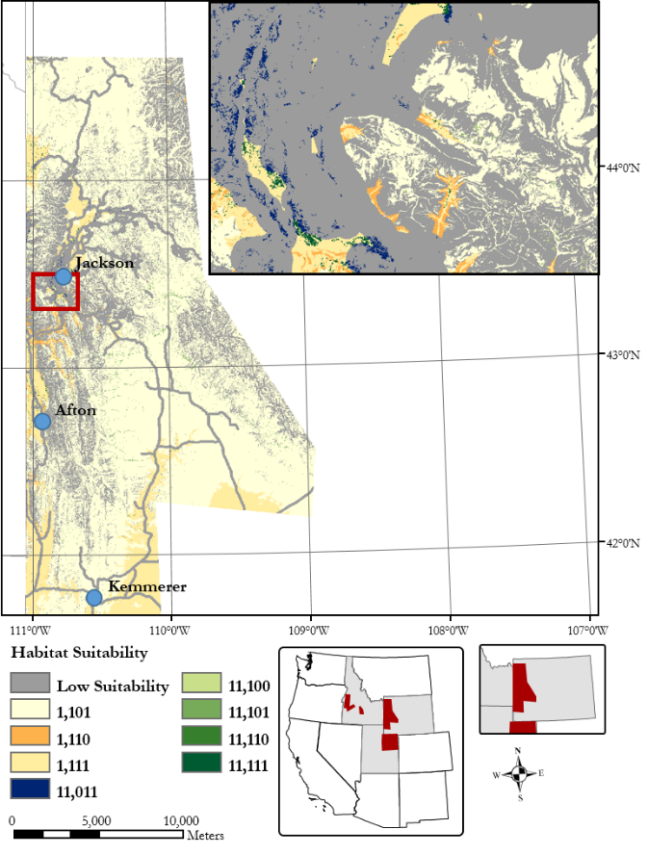

***4.2 Validation***

Observation points provided by IDFG and Utah USFWS (Wyoming was not tested) were used to determine if observations correlated with model outputs for suitable habitat. Both the Idaho and Utah study areas had 50 YBC observations each. The 50 observation points provided by IDFG included a large number of incidental sightings that frequently occurred outside suitable nesting habitat. Utah USFWS’s observation points mainly come from personnel that participated in organized field surveys. Both of these datasets were overlaid on our suitable habitat maps in their respective study area.

For Utah, 45 of the 50 points fell upon pixels with the value of 1,111. This means that sightings of YBC were in locations that met four out of the five habitat criteria used in this study, specifically away from previous fire sites, away from roads, in low elevation/gentle slope. The only habitat variable missing was good vegetation for cottonwood-willow. This variable however was considered a high priority for indicating suitable habitat.

In the Idaho study area, 31 of the 50 points matched locations with a pixel value of 1,011 which means it satisfied everything except cottonwood-willow vegetation and being away from roads. The Idaho study area has more urban areas than the Utah or Wyoming study areas, and may be the reason why observations did not match the suitability map. Many of the YBC observations in Idaho were incidental cases which may further explain this difference (e.g., people driving and seeing a bird fly nearby the road).

Both Idaho and Utah validation points seldom fell within pixels with the value of 10,000 or higher. This means that many of these validation points did not fall in locations that were considered to have the NDVI and NLCD criteria to identify optimal vegetation for YBC. The team assumed this variable was the most important criteria in identifying suitable habitat. To further understand the absence of this variable among observation points, the team compared the points with the NLCD to look at land cover types. For Idaho, observation points were found in the following land cover types: developed, evergreen canopy, grassland, pasture, corn and soybeans, and woody wetlands. Utah had much less variety with 90% of the points found in woody wetlands and the remaining ten percent found in pasture, shrubland, and developed (low intensity) land cover types. This may indicate NLCD is not produced at a fine enough granularity to identify nesting habitat, or it could also mean that the YBC forages in and was observed in these other cover types that were not considered in the model.

***4.3 Suitable habitat for Yellow Billed Cuckoo when considering waterbodies***

The alteration of the YBC model to include a water component is ideal because NDVI may not be accurate enough to fully rely upon. NDVI may not always account for changes in temperature caused by topography which has been shown to change NDVI by ± 5 (Verbyla, 2015). Because the the NDVI threshold was applied to a seasonal composite much of this variation should be smoothed, however the work by Glenn et al. (2008) did not specifically sample in differing topographies or temperatures and therefore the threshold may still not catch all of the necessary signatures. In addition to differing toporgaphies or temperatures, the NDVI threshold used for this model may not catch all of the suitable cottonwood-willow habitat. There are some overlaps on NDVI with other tree species, such as aspen. In general aspen’s stands minimum NDVI value in May starts at 0.55 and increases to 0.8 when their leaves emerge and expand (Barr et al. 2004). This is not a large concern because after the initial growth spike the NDVI falls back to 0.60 in early June. Once again the composite should take care of these problems, but there may be other unforseen issues when relying solely on NDVI measurements may misinterpret aspen as cottonwood-willow. While some types of aspen are found riparian habitats, other types of aspen are found at high elevation in non-sutiable YBC habitats, and thus creates a concern that the model may accidentally identify these areas as sutiable. In the future, leaf area indices and evapotransopiration can be introduced as another way to rely upon a specific species identification method. These matrices were not introduced in this model because YBC habitat does prefer mutli-storied canopies and evapotranspiration rates can be skewed.

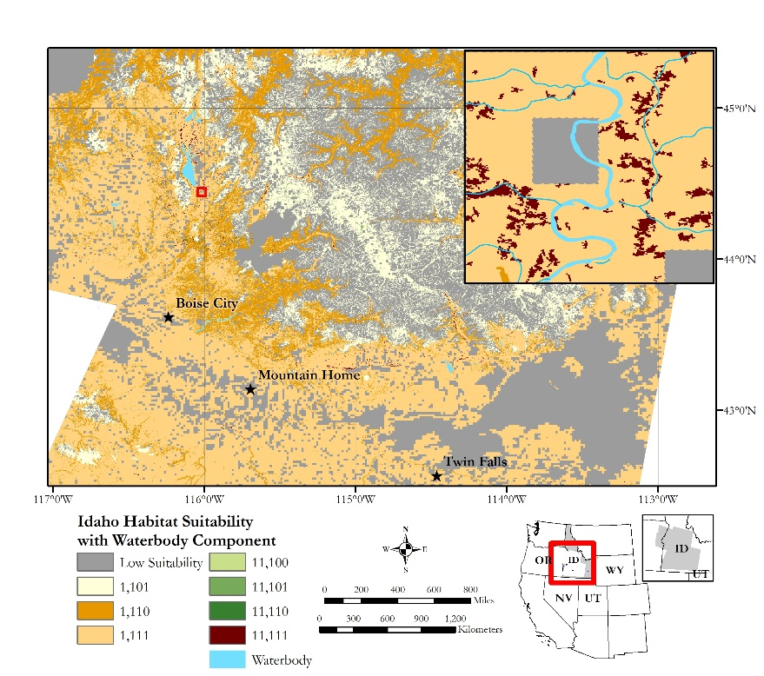

Figure 6. Idaho suitable habitat excluding roads criteria and including water bodies

The National Hydrography Dataset was an ideal contribution to the model because it increased the likelihood of finding highly suitable areas in the correct locations. While, the roads layer was dropped due to a large portion of urban areas following natural boundaries. For instance, the highways that go through the Sawtooth mountains follow cottonwood-willow galleries and river, while urban areas also follow streams. In Figure 6, highly sutiable habitat is found following a river, however there is also a road that follows the same river. If we were were to create a half a mile buffer none of this area would be considered suitable habitat. In addition the difference between these two models increased highly suitable habitat area by 209 km2 in Idaho (Table 3). This increase created more informative habitat data and suggests the 800 meter (0.5 mile) buffer is too great for the Idaho study area. Research supported exclusion thresholds for YBC noise tolerance are unknown and therefore expert opinion should be used to determine exclusion of this habitat instead of model outputs. The exclusion of the roads layer is more ideal for the Idaho study area because of the close relationship of urban-wildland boundaries. These boundaries are found in most of the suitable habitat and the birds may be more adaptable to urban intrusion, especially when it is low development. The elimination of the roads buffer and the additon of a water buffer may not hold be the best method for identifying sutiable habitat in Utah (Figure 7) and Wyoming (Figure 8). These study areas do not have these urban-wildland boundaries widely spread in their territories. Additonally, these two states have many disturbances that may be accounted for within road limitiations. A roads buffer may be more adaptable for silencing industry activities. For instance, Utah (Figure 7) has mining and oil activities that occur throughout the study region and the only way to exclude these areas from likely habitat is through the NDVI, canopy cover, and road buffering criteria. The NLCD data used in the model is from 2011 and may not reflect current mining activities. Therefore, an NDVI layer would be key in identifying suitable canopy.

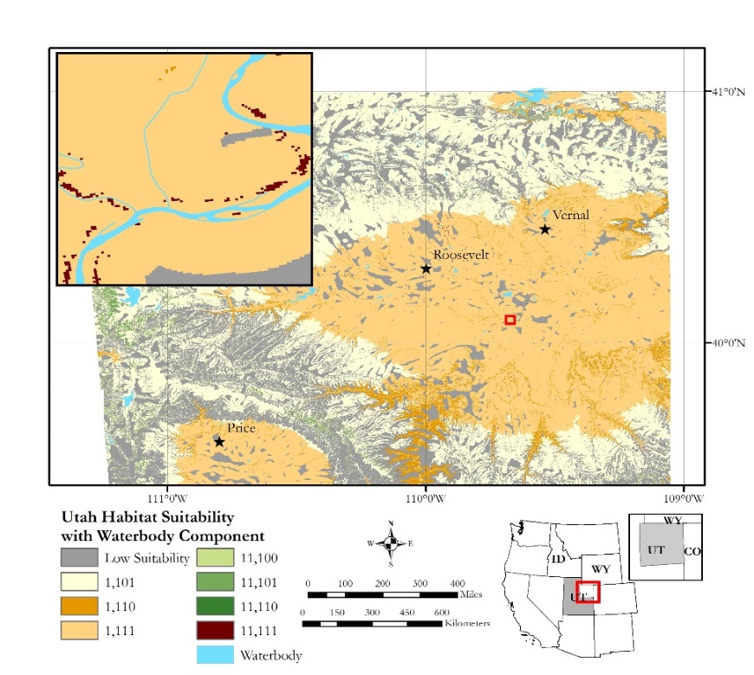

Figure 7. Utah suitable habitat excluding roads criteria and including water bodies

Considering that a roads buffer may be useful for Utah and Wyoming, the team compared the orignal model with the new water compnenet model to see if there was significant change. The difference between excluding the roads buffer and adding a waterbody component is only an increase of 2 km2 for Utah, suggesting roads do not follow riverbodies in this area. The team suggests that the Utah study area uses a combination of input waterbodies and road exclusions . This may help exclude intense industry while ensuring habitat is found along current waterbeds.

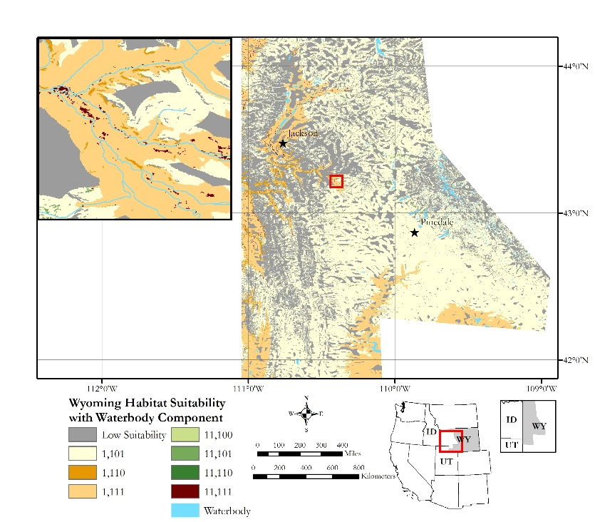

Figure 8. Wyoming suitable habitat excluding roads criteria and including water bodies

Wyoming is not a state that hosts intense development, but does have a thriving tourist season overlapping the YBC breading season. Tourist season can see millions of out-of-state visitors using the public roads system to gain access to Yellowstone National Park. This can easily lead loud traffic noises within proximity of YBC breeding habitat. Unlike Idaho, the bird has the choice to nest away from the road systems and therefore a road exclusion layer that includes heavy traffic would still be suggested. For Wyoming, the removal of the road criteria and the introduciton of the waterbodies layer increased highly suitable habitat by 26 km2. The Wyoming study area contains more extensive canopy coverage than Idaho or even Utah. This suggests that the waterbody criteria would be needed to limit the canopy cover to those that not only meet NDVI standards but also meet the waterbody criteria.

Table . Comparison of roads vs. waterbodies modeling results of Idaho habitat suitability results

|  |  |  |
| --- | --- | --- |
| **Highly Suitable Habitat (11,111)** | **Suitability with Roads in km2 (miles2)** | **Suitability with Waterbodies in km2 (miles2)** |
| Idaho | 33 (13) | 242 (94) |
| Utah | 7 (3) | 9 (4) |
| Wyoming | 35 (14) | 61 (24) |

***4.4 Change maps with exclusion of NDVI***

When using NDVI to produce change maps from the early-2000’s to 2016, there was an increase in suitable habitat from 2003 to 2016 for both Utah and Idaho. This would be a strange conclusion since urban development has increased in the same areas that showed an increase in habitat. The criteria used in this model specifically excluded any development and therefore should show a decrease in areas that had an increase in development. This is when the team researched NDVI readings between Landsat platforms and decided that the change maps would exclude NDVI. Excluding the NDVI criteria means that the only temporal data are changes in wildfires and changes in land cover types. Because these are the only criteria shown the change maps are not a true reflection of habitat change, but instead show how wildfires and land cover change may affect habitat. In general, Wyoming and Utah may have lost 2.3 km2 and 11.6 km2, respectively, of likely suitable habitat for foraging or nesting (see appendix for figures). While Idaho may have gained 43.4 km2 of likely suitable habitat for foraging or nesting (Figure 9). This gain correlates with sagebrush-steppe land cover being converted to crop lands that may provide foraging habitat. This change in habitat also, shows the importance of including NDVI or waterbodies to limit probable habitat.

Figure 9. Likely suitable habitat changes from 2003 to 2016

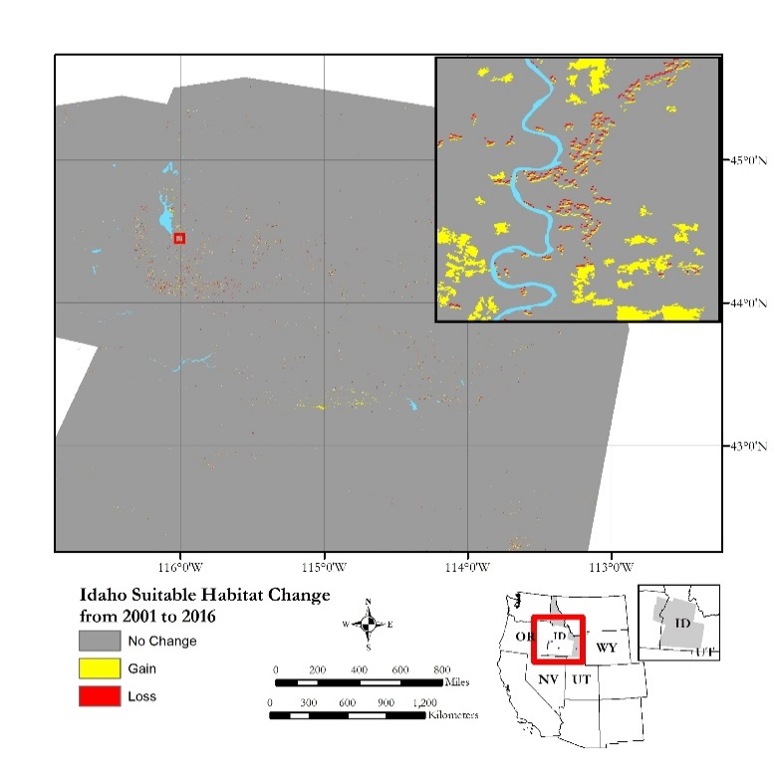

2003

**2003**

***4.5 Future Work***

Future work should determine whether or not NDVI is useful for identifying suitable habitat. One of the variables in the model was finding areas that had an NDVI threshold between 0.65 and 0.75 because this is the NDVI value for the cottonwood-willow land cover type reported in the literature. Many observation-validation were located in regions that did not meet the NDVI criteria, and may indicate NDVI is useful to identify suitable habitat for the YBC. While cottonwood-willow is a common plant found in YBC habitat, there may be better ways to identify this plant (e.g., NLCD or land fire data). .

A compilation of other tools and datasets may also help increase the accuracy of identifying suitable habitat. The use of LiDAR data may help determine canopy height of vegetation in riparian habitats and the presence of a multi-storied canopy. Field samples of cottonwood-willow can help understand where the plant actually exists. Due to the high vegetation density of YBC suitable habitat, the use of high precision surveying with an unmanned aircraft system (UAS) may detect the desired vegetation types. The high resolution of a UAS may even identify YBC in the survey field rather than having personnel tread through these habitat areas and potentially disturb the bird. The combination of knowing tree canopy height and the actual location of cottonwood forests can provide better understanding of the YBC habitat, and therefore help the team add additional criteria and thresholds for the model.

A setback with using NDVI was that the NDVI values for Landsat 5 are different than Landsat 8 even for the same area under similar growing seasons. If the team wished to continue using NDVI, future work should utilize Landsat 8 only. Under this scenario, the team can create change maps more reliably. These data would give partners a better indication of where YBC habitat is increasing or decreasing. The creation of these change maps would then allow the team to use TerrSet’s eco forecasting model. With this model, the team could forecast the future of YBC habitat within the next thirteen years. This prediction could help partners prepare for and monitor the YBC habitat.

Further refinement of this model could be enhanced using improved observational data to identify an improved set of YBC preferences. Current data provided by partners only have fifty observations for each study area. More sightings could help increase accuracy. In addition to an increase in the quantity of the observation points, an increase in the quality of the points could improve model accuracy as well. Many of the sightings from IDFG were provided by volunteers. There is little information on how well trained the volunteers were in identifying YBC, and what method they used to find the bird. Many may have just seen them while on the road rather than trying to go to locations off the road where YBC are more likely to be found. This can skew the data and show more sightings near roads when the bird is actually more commonly found away from roads.

# **5. Conclusions**

Current suitable habitat maps were created in ArcMap 10.4. The model was comprised of Landsat 8 OLI imagery, NDVI, past fire, road, hydrology, and topography data. The model was combined with land cover data from the National Land Cover Database 2011 and maps of each study area were created that indicate areas of suitable YBC habitat. Habitat change maps could not be created due to the lack of NDVI threshold values for the older Landsat 5 imagery. As a result, the team could not use the TerrSet Change Modeler to create an ecological forecasting map to the year 2030. Regardless of not having the change maps or eco forecasting maps, partners can still make use the 2016 suitability maps to better understand where the bird may be and direct this summer’s field observation campaign. In addition, these data will allow our partner organizations to determine key areas where habitat may need to be more closely monitored and remediated.

# **6. Acknowledgments**

A special thank you to our contributors for their time and assistance with this project

* Advisors: Keith Weber, Lead Science Advisor (GIS Training and Research Center at Idaho State University); Charles Peterson (Idaho State University, Biology Department); Mark Carroll (NASA Goddard Space Flight Center)
* Project Partners: Evan Ohr, US Fish and Wildlife Service- Eastern Idaho Field Office, Patricia Sweanor, US Fish and Wildlife Service - Ecological Services Wyoming Field Office, Amy Defreese, US Fish and Wildlife Service - Utah Ecological Services Field Office, and Scott Bergen and Becky Abel, Idaho Department of Fish and Game (IDFG)- Southeast Regional Office.

Any opinions, findings, and conclusions or recommendations expressed in this material are those of the author(s) and do not necessarily reflect the views of the National Aeronautics and Space Administration.

This material is based upon work supported by NASA through contract NNL16AA05C and cooperative agreement NNX14AB60A.

# **7. Glossary**

**YBC** – Yellow-billed Cuckoo, an avian species that consists of two distinct species, a thriving eastern population and a threated western population

**NDVI** – Normalized Differentiation Vegetation Index, a product of satellite imagery that can quantify the density or health of vegetation

**SRTM** – Shuttle Radar Topography Mission, an international research effort that obtained digital elevation models on a near-global scale, to generate the most complete high-resolution digital topographic database of Earth

**DEM** – Digital Elevation Model, a 3D surface model that represents the terrain’s surface

**NED** – National Elevation Dataset, the primary elevation product hosted by the USGS

**USGS** – United States Geological Survey

**NLCD** – National Land Cover Database, a US classification of land cover using Landsat TM.

**OLI** – Operational Land Imager, an instrument on board the Landsat 8 Satellite launched in February of 2013

**USFWS** –US Fish and Wildlife Service, the federal agency under the US Department of Interior that is dedicated to the management of fish, wildlife, and natural habitats

**IDFG** –Idaho Department of Fish and Game, the Idaho state agency responsible for protecting, preserving, and managing Idaho’s wildlife resources

**Hydrologic water year**- the total measure precipitation within a time period of 12 months starting October 1st.

# **8. References**

Barr, A. G., Black, T. A., Hogg, E. H., Kljun, N., Morgenstern, K., Nesic, Z. (2004) Inter-annual variability in the leaf area index of a boreal aspen-hazelnut forest in relation to net ecosystem production. *Agricultural and Forest Meteorology,* *126:* 237–255. doi: 10.1016/j.agrformet.2004.06.011

Dettling, M. D., Seavy, N. E., Howell, C. A., & Gardali, T. (2015). Current status of western Yellow-billed Cuckoo along the Sacramento and Feather Rivers, California. *PLoS ONE*, *10*(4), 1–17. doi: 10.1371/journal.pone.0125198

Glenn, E. P., Huete, A. R., Nagler, P. L., & Nelson, S. G. (2008). Relationship between remotely-sensed vegetation indices, canopy attributes and plant physiological processes: What vegetation indices can and cannot tell us about the landscape. *Sensors*, *8*(4), 2136–2160. doi: 3390/s8042136

Goodwin, S. E., & Shriver, W. G. (2011). Effects of Traffic Noise on Occupancy Patterns of Forest Birds. *Conservation Biology*, *25*(2), 406–411. doi: 10.1111/j.1523-1739.2010.01602.x

Halterman, M. D., Johnson, M. J., Holmes, J. A., & Laymon, S. A. (2016). *A Natural History Summary and Survey Protocol for the Western Distinct Population Segment of the Yellow-billed Cuckoo: DRAFT May 2016*.

Hughes, J.M. 2015. Yellow-billed cuckoo (Coccyzus americanus), The Birds of North America Online (A. Poole, Ed.). Ithaca: Cornell Lab of Ornithology; Revised May 7, 2015. Retrieved from the Birds of North America Online: https://birdsna.org/Species-Account/bna/species/yebcuc (last accessed March 14, 2017).

McClure, C. J. W., Johnson, E. A., Unnasch, R., & Sound Science, L. (2015). *Western Yellow-billed Cuckoo ( Coccyzus americanus occidentalis ) ( YBCU ) Basic Conceptual Ecological Model for the Lower Colorado River*.

U.S. Geological Survey (1999): *National Elevation Dataset.* U.S. Geological Survey; Long Term Ecological Research Network. doi:10.6073/pasta/67000748d3ae684936a51b9936588f78

Verbyla, d., (2015). Remote sensing of interannual boreal forest NDVI in relation to climatic condition in interior Alaska. *Environmental Research Letters, 10*, 1-11. doi:10.1088/1748-9326/10/12/125016

Villarreal, M. L., van Riper, C., & Petrakis, R. E. (2014). Conflation and aggregation of spatial data improve predictive models for species with limited habitats: A case of the threatened yellow-billed cuckoo in Arizona, USA. *Applied Geography*, *47*, 57–69. doi: 10.1016/j.apgeog.2013.12.003

Wallace, C. S. A., Villarreal, M. L., & van Riper, C. (2013). Influence of monsoon-related riparian phenology on yellow-billed cuckoo habitat selection in Arizona. *Journal of Biogeography*, *40*(11), 2094–2107. doi: 10.1111/jbi.12167

# **9. Appendices**

