**NASA DEVELOP National Program**



Patrick Henry Building

*Summer 2015*

Virginia Water Resources

*Utilizing NASA Earth Observations to Monitor the Extent of Harmful Algal Blooms in Chesapeake Bay Watershed*



**Technical Report**

Rough Draft – June 25, 2015

Cassandra Morgan (Project Lead)

Sara Lubkin

Dr. Kenton Ross, NASA DEVELOP National Program (Science Advisor)

Advisor 2, Affiliation (Science Advisor)

Previous Contributors:

Contributor 1

Contributor 2

# I. Abstract

[Placeholder - do not put anything here until the final draft submission. The abstract in the project summary is where the working draft of the abstract should “live”]

**Keywords**

Harmful Algal Bloom, Remote Sensing, Virginia, James River, York River, Chlorophyll A, Landsat 8 OLI, Water Quality Parameters, Lower Chesapeake Bay

# II. Introduction

Including the items listed below; write a synopsis of the following information. Be concise. Word count should be between 200-1000.

**Background:**

Relevant information to inform the reader of current status, issues, previous studies, etc

A Harmful Algal Bloom (HAB)is a high concentration of microscopic algae in a river, lake or other aqueous system that has a harmful effect on life and the environment. In the Chesapeake Bay Watershed, HABs affect water quality by disrupting water chemistry, reducing oxygen level in the water, and blocking the passage of sunlight through the water column. The species *Cochlodinium polykrikoides and Alexandrium monilatum* are of particular concern because these species also produce toxins that kill fish, cause deformities in shellfish, and are associated with human illness. HABs have a negative economic impact on Virginia fisheries and on the tourist industry.

Current monitoring of HABs in the Chesapeake Bay watershed occurs as a collaboration of the Virginia Department of Health (VDH), Virginia Institute of Marine Science (VIMS), Virginia Department of Environmental Quality (DEQ), and Old Dominion University (ODU). In the state of Virginia, HAB monitoring relies heavily on public reporting from the public - the DEQ responds to reported events and collects sample organisms. Additional monitoring is provided by ODU and VIMS.

ODU uses a boat on a fixed track to constantly sample chlorophyll levels in the Lower James River; water samples are collected when chlorophyll is above 15 mg/L. ODU also collects weekly water samples from seven fixed stations on the James River. VIMS collects water sample data from the western Chesapeake Bay as well as from fixed stations in the York River **[James River monitoring???]** . However, data from samples collected by VIMs and ODU are not available until the end of the season. Real time monitoring of algal blooms is not currently readily available as it requires a complex arrangement of DNA tests to identify specific algal species from a massive amount of benign microorganisms within the water. This limits the ability to predict HAB occurrence and document associated environmental and water quality conditions.

Currently, the Virginia Pollutant Discharge Elimination System (VPDES) Permit limits industrial discharge of nitrogen and phosphorus into the Chesapeake Bay watershed in Virginia. The permits were modified in 2012 to require a four year reduction of industrial discharge in order to reduce HABs and improve water quality in the James River and York River. The tools we create will allow the Virginia Harmful Algal Bloom Task to monitor the effect of the permit modifications and will influence decision-making regarding immediate and long-term response to harmful algal blooms in the Chesapeake Bay watershed.

**Project Objectives:**

These should be short decisive action items.

* Use Modis Aqua, Landsat 8 OLI/TIRS, and Landsat 7 ETM+ to generate an algorithm that will allow chlorophyll estimates to be calculated for the lower Chesapeake Bay.
* Create HAB event maps (Landsat 8 OLI/TIRS, Landsat 7 ETM+, MODIS Aqua) with the algorithm in order to provide insight to historical bloom patterns.
* Create tools that will allow partners to easily process Landsat 8 OLI/TIRS data to show chlorophyll estimates at 30 meter resolution.
  + This will improve current tracking and monitoring techniques by allowing methods to be reproduced and data to be available in a quicker timeframe.
  + Support VIMS and ODU efforts to characterize the environmental conditions that favor bloom development.
* Introduce partners to historical map products (MODIS Aqua, daily and weekly) available from NOAA CoastWatch which can be used to show the extent, magnitude and frequency of HAB events.
* Map in-situ data collected by Old Dominion University from 2011 to 2014 with satellite data.

**Study Area:**

Describe the geographic location of the study

Virginia (James River, York River, Elizabeth River, Mobjack Bay, Lower Chesapeake Bay)

**Study Period:**

Explain the time period of data you are looking at (years and dates of data)

May - October; 2011 - 2015

**National Application(s) Addressed:**

Explain which NASA national application areas this project addresses and how it contributes to them

Water Resources - The study addresses water quality issues related to harmful algal blooms.

**Project Partners:** Explain who the project partners are, why they are interested in this project, how they will use it, what decision making they have to do and is being addressed with this research and methodologies, etc. How will they benefit from this project and methodology?

The Virginia Water Resources project partners are the members of the Virginia Harmful Algal Bloom Task Force which includes the Virginia Institute of Marine Science (VIMS), the Virginia Department of Environmental Quality (DEQ), and Old Dominion University (ODU).

VIMS, which is located in Gloucester Point, Virginia, is an interdisciplinary research center that provides advisory services to policy makers. Dr. Kim Reece, chair of the Marine Science Department is our point of contact at VIMS. Her research focuses on the toxicity of Harmful Algal Blooms (HABs) species through laboratory and field experiments.

Monitoring of HABs on the York River is completed by using 7 fixed sample stations and a fixed path sample boat. Samples from the James River are collected from the Hampton Roads Sanitation District during routine water quality activities. Current methods limit the geographic and temporal scope of monitoring and reporting. Remote sensing data will allow VIMS and ODU scientists to assess the timing, magnitude, duration and frequency of HABs in the lower Chesapeake watershed and to better predict the environmental and water quality conditions that favor bloom development.

# III. Methodology

This should be concise, yet explanatory, and highlight the NASA Earth observations utilized and its/their capabilities. Include a paragraph or more for each of the following items. No word cap, but be thoughtful.

Data Acquisition: What data did you get, what level products are they, for what dates did you get images, where did you get the images from, etc.

Landsat Surface Reflectance products from Landsat 8 and Landsat 7 were downloaded using the United States Geological Survey’s Earth Explorer System. Data sets were obtained for May - October, 2011 - 2014 showing the James, York and Elizabeth rivers; the Mobjack Bay (Mathews, Va); and the Chesapeake Bay. In the Earth Explorer interface, Path 14 - Row 34 was used as the search criteria and “Landsat CDR” (Landsat Surface Reflectance) was selected as the preferred dataset. Only images with less than 30 percent cloud cover were selected.

Aqua Moderate Resolution Imaging Spectroradiometer (MODIS) Level 2 data for the Chesapeake Bay Watershed were obtained from NOAA CoastWatch’s East Coast Node. NOAA’s Chesapeake Bay Chlorophyll-a product was generated using the NOAA OC3 algorithm combined with the NIR-SWIR atmospheric correction and the regionally tuned NASA OC3 NIR algorithm. Daily chlorophyll-a estimates were downloaded as .hdf files and imported into ArcGIS.

In situ water sampling data was provided by Todd Egerton from the Department of Biological Sciences Old Dominion University. Samples were obtained from the lower James for years 2011 - 2014 and included measures such as annual corrected Chlorophyll -a ((µg/L) and biomass (µgC/L) by algae division.

Data Processing: What did you do to the data? Were there conversions needed to be able to analyze it? Did you have to mosaic images? Did you have to normalize anything to fit other datasets? Did you run an NDVI, change detection, etc?

**Data Processing**

Landsat imagery was processed with ArcGIS. A tool was created in Model Builder to process images in preparation for later spectral reflectance models.

First, pixel values were divided by 10,000 in order to rescale the integer values to floating point numbers between 0 and 1 (Figure 1).

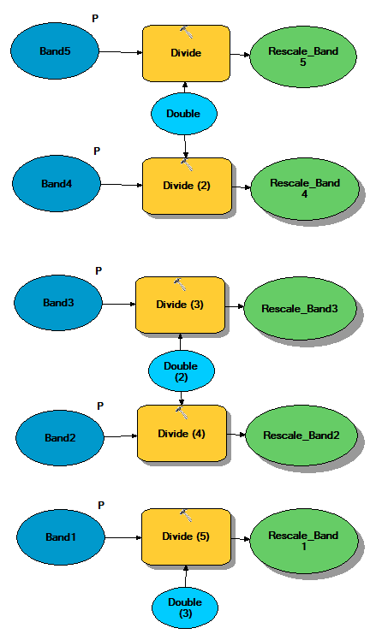

Next, the Normalized Difference Vegetation Index was calculated in order to determine the density of plant growth (Figure 2).

$\frac{Band 5 - Band 4}{Band 5 + Band 4}$ = $Normalized Difference Vegetation Index$

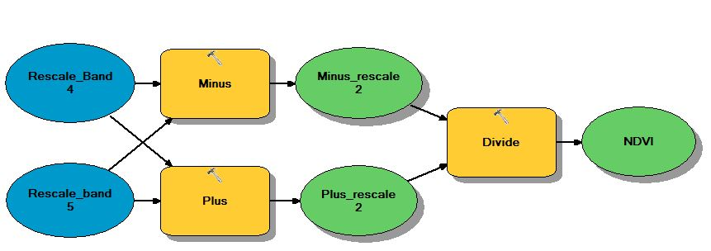

*Figure 2.*

After the NDVI was calculated, the conditional evaluation tool(con, spatial analyst) was used to create a water mask that could be used to remove land pixels and uniquely identify water. The input condition to the conditional evaluation tool was NDVI, expression <=0, input true raster or constant value = 1 (Figure 3).

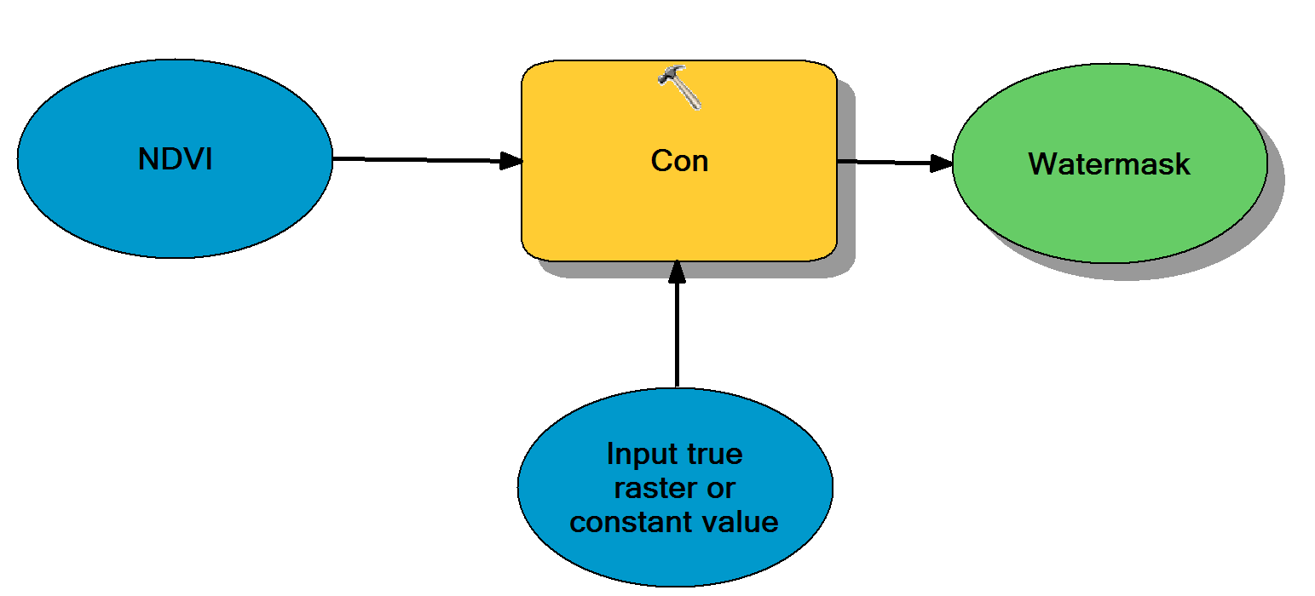

*Figure 3.*

Extract by mask was used to create a new layer from the extracted water values. The input raster was the rescaled band and the input raster or feature mask data was the watermask layer created in the previous step (Figure 4).

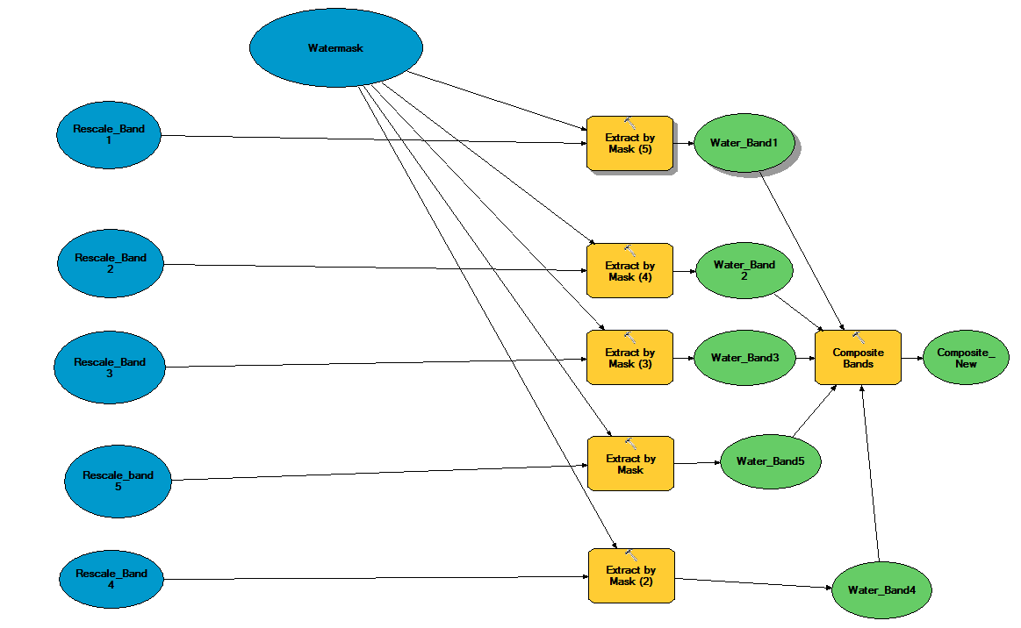

*Figure 4*

After a water layer was extracted for each band, a new composite image was created of the five extracted bands (Figure 4). The composite image was opened in ArcGIS. The red band was set to Band 4, the green band to Band 3, and the blue band to Band 2. Images were stretched using percent clip with min = 10 and max = 10.

In order to create a chlorophyll estimation tool, we had to cross calibrate the Landsat data from May through October 2013 with CoastWatch MODIS chlorophyll-a estimations for the corresponding dates. We used the ArcGIS focal statistics tool to obtain the find the mean pixel value of each 47 pixel by 47 pixel moving window; null values were removed to prevent underestimation. The result was a smoothed masked Landsat spectral reflectance raster for each band.

Daily CoastWatch MODIS chlorophyll-a estimates were imported into ArcGIS 10.3. The.hdf rasters were converted to point data using the “raster to point” tool. This vector file was imported into to the Landsat map for the appropriate date.

For each date, the MODIS chlorophyll-a value vector files were used to extract the values of each smoothed masked Landsat spectral reflectance raster band (ArcGIS extract values by points) and create a table of MODIS chlorophyll-a values and corresponding Landsat Spectral reflectance values for each band. This provided the information we needed for our regression equations. Equations were calculated using linear regression of data in R.

The resulting regression equations were used to produce rough estimates of chlorophyll and suspended sediment. Tools for each model were constructed in ArcGIS model builder.

Suspended sediment (samples)

* + *SS1 = 11.80 - (50.608 * Band2) + (14.58 * Band5) - (4.764 * (Band5/Band3))*
  + *SS2=10.763 - (7.308 * Band2) + (16.334 * Band3) + (4.92*Band4) + (44.61 * Band5)*
  + *SS3=10.69 - (10.792 * Band2) + (24.51 * B3) -4 (3.995 * Band5)*

Chlorophyll A

* + *Chla1 = 63.434 + (153.778 * Band2) - (803.31 * Band3)+ (239.639 * Band4)*
  + *Chla2 = 49.057 + (63.832 * Band2) - (Band3 - 110.046) * Band5*
  + *Chla3 = 49.428 - (183.033 * Band3) - (103.798 * Band5)*
  + *Chla4 = 51.922 - (366.287 * Band3) + (184.622 * Band4) - (116.926 * Band5)*
  + *Chla5 = 54.658 + (520.451 * Band2) - (1221.89 * Band3) + (611.115 * Band4) - (198.199 * Band5)*

**Data Analysis:**

How did you analyze the data? What methods did you use?

* We will be utilizing R statistical software to create a custom regression model based upon the Coastwatch’s MODIS data.
* Methods based on Lim,J & Choi, M (2015) - Multiple regression models of spectral reflectance and water quality parameters

# IV. Results & Discussion

Insert images, graphs, maps, charts, etc. here. Choose the most important results to highlight here. Things to discuss:

* Analysis of Results: What can you tell from your graphs, images, etc? What does this mean for your project?
* Errors & Uncertainty: What factors could you not account for, what things didn’t work out like you expected they would, etc
* Future Work: If this project was to be selected for another term, what would be the focus? What other areas would be of interest?

**Analysis of Results:** Coming soon

**Errors and Uncertainty:** Results of r-squared test

**Future Work:** This is a two term project. during the current term, our focus is the calculation and testing of the equations needed to estimate Chlorophyll A from Landsat products. During the second term, the equations will be used to create easy-to-use ArcGIS and Python tools that will allow our partners to create chlorophyll maps on their own.

In the future, the project methods could be modified to produce chlorophyll-a estimation tools geographically calibrated for tracking HABs in other bodies of water, including the upper Chesapeake Bay and Delaware Bay.

# V. Conclusions

Final conclusions. Word count: 200-600.

We used MODIS chlorophyll-a value to calculate regression equations that allowed us to create tools that would calculate chlorophyll-A on Landsat images for our partners. Our partners used the resulting maps to indicate probable locations of harmful algal blooms (HABs) in Virginia rivers (James, York, Elizabeth), the Mobjack Bay (Mathews, Va), and the Chesapeake Bay.

The combination of historical in-situ data collected by VIMS and ODU with Landsat satellite chlorophyll-a data ring and immediate tracking of in the Chesapeake Bay watershed.

# VI. Acknowledgments

Dr. Kenton Ross - National Program Science Advisor

This material is based upon work supported by NASA through contract NNL11AA00B and cooperative agreement NNX14AB60A.

# VII. References

Insert here. Use whatever style you want - here are some options:

Lim,J & Choi, M (2015) - Multiple regression models of spectral reflectance and water quality parameters. Environmental Monitoring Assessment 187: 384.

# VIII. Appendices

Insert here