Okefenokee Water Resources
Using Earth Observations to Assess Hydrologic Changes and Wildfire Risk in the Okefenokee Swamp


Technical Report
March 31, 2022

Brianne Kendall (Project Lead)
Kyle Steen
Hailey Schmidt
Laramie Plott

Advisors:
Dr. Robert Griffin, The University of Alabama Huntsville (Science Advisor)
Dr. Jeffrey Luvall, NASA Marshall Space Flight Center (Science Advisor)

1. Abstract
The Okefenokee Swamp is a vital ecosystem known for its protection of biodiversity, peatland carbon sinks, and recreational and economic opportunities for local residents. The swamp has experienced several wildfires since the 1990s, and new development along the borders of Okefenokee National Wildlife Refuge (ONWR) threatens to alter hydrologic activity and increase fire frequency. NASA DEVELOP partnered with staff at the ONWR to determine the feasibility of using satellite imagery to assess wildfire risk and map changes in vegetation cover. Using data from NASA satellites Landsat 7 Enhanced Thematic Mapper Plus (ETM+) and Landsat 8 Operational Land Imager (OLI), Soil Moisture Active Passive (SMAP) data from the USDA’s Crop Condition and Soil Moisture Analytics Tool (Crop-CASMA), European Space Agency (ESA) Sentinel-1 C-Band Synthetic Aperture Radar (C-SAR), and Sentinel-2 Multispectral Instrument (MSI), the DEVELOP team assessed the relationship between hydrologic change, vegetation cover, and wildfire risk in the swamp. Results showed that the southern portion of ONWR has been burned the most since 1990 and has greater water stability than other areas of the refuge. The team also found that the largest pockets of mature forests remain in the northernmost regions. Soil moisture anomaly readings may serve as an indicator of fire conditions. The team used these results to create a vegetation map, a swamp water visibility time series map, a historical wildfire correlation analysis, and a methodology tutorial. These products will assist the ONWR in making informed management decisions about the future of the Okefenokee Swamp.

Key Terms
wildfire analysis, vegetation mapping, peat deposits, remote sensing, wetland conservation

2. Introduction
2.1 Background Information
The Okefenokee National Wildlife Refuge (ONWR), pictured in Figure 1, is located in Folkston, Georgia and protects more than 400,000 acres of pristine wetlands (Patton et al., 2012). Its unique ecosystems store carbon in its deep peatlands, protect biodiversity, and offer various recreational and economic opportunities for local residents. Before it was protected as a National Wildlife Refuge in 1937 and later as a National Wilderness Area in 1974, the Okefenokee Swamp was abused for its vast water and timber resources (Trowell, 2020). Although the refuge is now federally protected from industrial use, it continues to suffer from natural disasters like wildfires.
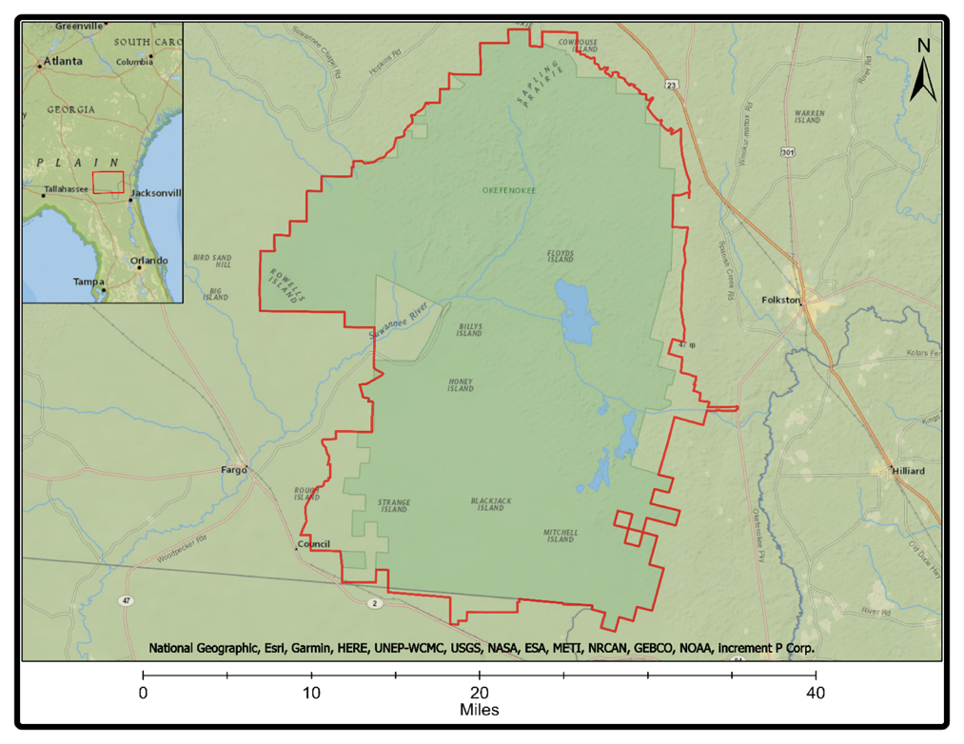
Figure 1. This map depicts the borders of ONWR in reference to the greater Georgia and Florida area.

Wildfires, although notoriously destructive, are beneficial to wetland habitats that are adapted to frequent, low-intensity burns. Healthy fires affect ecosystems by shifting vegetation cover from woody to herbaceous, thereby increasing plant diversity and creating suitable habitat for fire-adapted wildlife species. However, in the Okefenokee Swamp, fire plays a uniquely dangerous role due to its interactions with underground stores of peat, a precursor to coal. These peat reserves are highly combustible and can burn underground for days if ignited by a surface fire, turning a beneficial burn into an uncontrollable disaster. These peat deposits are also vital carbon sinks on the refuge, and extensive damage from wildfire releases large quantities of carbon into the atmosphere and water systems (US Fish and Wildlife Service [USFWS], 2006).

Swamp water levels are also an important contributing factor to how dangerous these wildfires are. The right conditions must be present for the fire to even start, let alone burn subsurface peat. As the water levels in the swamp naturally change over time, different portions of the swamp become more, or less, susceptible to drought and wildfire. The water level must be exceedingly low for a wildfire to break out, and even lower for peat to burn. Therefore, combined wildfire and peat destruction risk can be determined by monitoring the rise and fall of water levels. This level can be accomplished by analyzing backscattering returns from Synthetic Aperture Radar (SAR) as SAR highlights visible water levels well (Kim, 2017).
The staff at the Okefenokee Swamp are interested in applying a deeper understanding of hydrologic change and wildfire risk to the management of this pristine wetland, because their decisions affect not only the species and habitats that are vulnerable to change but also the more than 600,000 individuals who visit the swamp every year. Any wildfires that damage the natural integrity of the swamp also pose a threat to nearby property and local air quality (USFWS, 2006). To understand geologic processes within the swamp the ONWR historically utilized research conducted by Dr. Art Cohen, whose field-based observations included many theories about the necessity of peat in the swamp, and Dr. Cynthia Loftin, who created vegetation maps for the swamp in 1991, 2001, 2008, and 2012 (Loftin et al., 2018). This project furthers the research already conducted at the Okefenokee Swamp by using Earth observations to identify landcover change, wildfire risk, and swamp water levels from January 1st, 1999 to January 1st, 2022.

2.2 Project Partners & Objectives
This project worked in partnership with the Okefenokee Swamp Park and the United States Fish and Wildlife Service: Okefenokee National Wildlife Refuge. The ONWR partners with federal, state, and local organizations to fund projects and encourage community engagement at Okefenokee. They have historically relied on Geographic Information Systems (GIS) and field work to conduct their analyses and do not currently use Earth observations in their decision-making process. Both partners are currently working towards the achievement of various conservation goals outlined in their 2006 “Okefenokee National Wildlife Refuge Comprehensive Conservation Plan” (USFWS, 2006). This project will help the ONWR optimize ecosystem management through a greater understanding of current hydrologic trends, landcover change, and wildfire vulnerability across the refuge to meet their conservation goals.

To help partners accomplish their goals, this project addressed the following three objectives. First, create a burn severity map visualizing the extent of burn damages from the most recent large-scale fire—the 2017 West Mims Fire. Second, update historic vegetation maps to visualize current landcover after the 2017 fire and to identify areas of regrowth and recovery. Lastly, create a swamp water visibility timeseries and run a statistical correlation between surface level water, soil moisture levels, and wildfire risk across the refuge. These objectives helped the partners identify areas of greatest concern in terms of wildfire activity and hydrologic trends.

3. Methodology
3.1 Data Acquisition
The team acquired all datasets through the Google Earth Engine (GEE) data catalog, a cloud-based platform that processes Earth observation data from satellite imagery. The team utilized data from Landsat 7 Enhanced Thematic Mapper Plus (ETM+), Landsat 8 Operational Land Imager (OLI), Sentinel-1 Synthetic Aperture Radar (SAR), Sentinel-2 Multispectral Instrument (MSI), and Soil Moisture Active Passive (SMAP) datasets. The necessary parameters and source material for each dataset are outlined in Table 1.

Table 1
Description of Earth observations used in data processing
Platform/Sensor | Parameters | Purpose | Source
Landsat 7 ETM+ Surface Reflectance Collection 2 Tier 1 | Atmospherically corrected surface reflectance data (2 Bands: Near Infrared and Shortwave Infrared 2) | Calculate Normalized Burn Ratio (NBR) and Difference Normalized Burn Ratio (dNBR) for 1999–2013. The team used NBR and dNBR to analyze burn scarring and burn severity from known wildfires within the refuge. | GEE
Landsat 8 OLI Surface Reflectance Collection 2 Tier 1 | Atmospherically corrected surface reflectance data (2 Bands: Near Infrared and Shortwave Infrared 2) | Calculate NBR and dNBR for 2013–2021. The team used NBR and dNBR to analyze burn scarring and burn severity from known wildfires within the refuge. | GEE
Sentinel-1 SAR C-Band Backscatter | Ground Range Detected (GRD) imagery (1 Band: Dual Vertical-Vertical [VV] & Vertical-Horizontal [VH] polarization) | Show varying levels of reflected C-Band. The C-Band levels correspond to differing water levels. Comparing them determines where water area is expanding and shrinking. | GEE
Sentinel-2 MSI  Level-2A Bottom Of Atmosphere (BOA) reflectance images | True Color & False Color Visualizations | TCI_R, TCI_G, and TCI_B bands were used to create an unsupervised classification at a 10m resolution from 2021. | GEE
SMAP | Reflected L-Band Radio Waves (2 Bands: Surface Soil Moisture Anomaly [SSMA] and Soil Moisture Profile [SMP]) | Show moisture levels in topsoil. | GEE

3.2 Data Processing
3.2.1 Wildfire Severity
The team uploaded Landsat 7 ETM+, and Landsat 8 OLI surface reflectance images from January 1999–January 2022 from GEE, and then clipped them to the study area. Next, the team applied a cloud cover mask to filter out images with greater than 3% cloud cover. Because the Okefenokee is a wetland, it was imperative to mask out pixels that indicated cloud cover which would have otherwise been incorrectly interpreted as water data. Once the Landsat images were selected, the team filtered the data by dates in which known wildfires occurred, focusing on the three largest fires in 2007, 2011, and 2017. The team calculated the Normalized Burn Ratio (NBR) for the three months before each fire occurred and the three months after the fire occurred. NBR compared the Near Infrared (NIR) and Short-Wave Infrared 2 (SWIR 2) bands in each image to highlight areas that had been burnt (Equation 1). NBR only highlighted burn scarring, and published research indicates that NBR does not effectively determine burn severity (Park, 2008). To indicate burn severity, the team subtracted the post-fire NBR from the pre-fire NBR to find the Difference Normalized Burn Ratio (dNBR) index (Equation 2). The resulting images had pixels ranging from –1,300 to +1,300. To most accurately evaluate the severity levels, the team would have had to conduct field surveys when the fires had occurred and create distinct severity classifications based on the field samples and the corresponding values. Instead, the team utilized a generic dNBR classification scheme authorized by the United States Geological Survey (United Nations, n.d.). The classification scheme was as follows: pixel values less than 269 indicated low severity, between 270 and 439 indicated moderately low severity, between 440 and 659 indicated moderately high severity, and greater 660 indicated highest severity. After the images for each fire were finalized, the team exported the annual image rasters as GeoTIFFs and uploaded them into ArcGIS Pro for further analysis.

$$\begin{aligned}NBR=\frac{NIR-SWIR2}{NIR+SWIR2 } \#(1)\end{aligned}$$

$$\begin{aligned}dNBR = \left(Pre-Fire NBR\right)- \left(Post-Fire NBR\right) \#(2)\end{aligned}$$

3.2.2 Vegetation Map
Within GEE, the team acquired surface reflectance images from the Sentinel-2 MSI Level-2A product (Sánchez-Espinosa, 2019). The image collections were clipped to the study area, and the team applied a cloud cover mask to filter out images with greater than 3% cloud cover. The team inspected the available images, and chose the image of May 28th, 2021, to be the date for the updated vegetation map since it had the least amount of cloud cover. Gamma values were given a 100% stretch type, and the TCI_R, TCI_G, TCI_B bands were used to visualize the true color image of the ONWR within GEE to confirm the image was suitable for the basis of the vegetation map. Upon confirming the suitability of the image, the team exported the raster datasets as GeoTIFFs and uploaded them into ArcGIS Pro for further processing.

3.2.3 Swamp Water Level Timeseries
The team imported C-Band data from Sentinel-1 into GEE and filtered the data collection to images from January 01, 2015 to December 31, 2021. Once the image collection was filtered by date, the team clipped the images to the study area. The team selected data from the Interferometric Wide (IW) swath mode (as this mode is the best for landcover) and refined the dataset to only show pixels from the dual polarized VV & VH Band as is standard for the IW mode (European Space Agency, n.d.). Then data were categorized by year and from each year, one Median Image was composed. The team accomplish this by using the Median Function which took the measure of the reflected C-Band backscatter for each pixel for the entire year, ordered them, and selected the median pixel value of each year. The function then took all the median pixels and made a composite ‘year’ image out of them. The resulting image collection contained 6 images, one from each year between 2015–2021. The team exported these annual image rasters as GeoTIFFs and uploaded them into ArcGIS Pro for further analysis.

3.2.4 Soil Moisture Correlation
The team imported all available NASA-USDA Enhanced SMAP Global Soil Moisture Data from Apr. 2015 – Feb. 2022 into GEE. This data was then clipped to the study area. Within the 10 km X 10 km resolution, there were 23 pixels that made up the area of the Okefenokee Refuge. The available data for each pixel was located on 2 bands: Soil Moisture Profile (SMP) and Surface Soil Moisture Anomaly (SSMA). All data were downloaded to Microsoft Excel for analysis.

3.3 Data Analysis
3.3.1 Wildfire Severity
The raw Tiff files were in black and white, and the severity levels were hard to distinguish. After uploading the dNBR GeoTIFFs into ArcGIS Pro, the team created a custom color scheme to better analyze the images. The following colors were used: yellow for low severity, orange for moderate-low severity, red for moderate-high severity, and purple for high severity. The team also completed a basic statistical analysis for the 2017 dNBR map to see what percentage of the burnt areas experienced low severity and high severity and found that the 2017 fire was the most recent large-scale fire to affect the refuge. To perform this analysis, the team created a percentage column in the 2017 map’s attribute table and used the count tool to divide the number of pixels in each severity level by the total number of pixels in the dNBR map. These quantities were multiplied by 100, and then the team added the low and moderate-low severity levels together, as well as the moderate-high and high severity levels together (Equation 3). The resulting two numbers indicated what percentage of the refuge burned by the 2017 fire experienced low severity and what percentage experienced high severity. The team compared the dNBR maps with both NASA aerial images of the fires and the corresponding burn scars in the Okefenokee Swamp and the partners' shared wildfire shapefiles. This allowed the team to validate the GEE compiled burn scars to real time burn images of the West-Mims Fire.
$$\begin{aligned} \% Area Burned=\left(\frac{ \# Pixels in Severity Level}{Total Pixels in dNBR Map }\right)x 100 \#\left(3\right)\end{aligned}$$

3.3.2 Vegetation Map
The team imported the May 28th, 2021 raster dataset into ArcGIS Pro for further analysis. To create a classification scheme, the team used the Classification Wizard tool and conducted an unsupervised, object-based classification. The following parameters were implemented: ‘Spectral detail’ was 20, the ‘Spatial detail’ was 19, the ‘Minimum segment size in pixels’ was 20, and the ‘Show Segment Boundaries Only’ option was left unchecked. The team also used an ISO Cluster Classifier method with 30 as the ‘Maximum Number of Classes' and then left the rest of the training parameters as default. For the ‘Classify’ pane, the team created 8 distinct classes including: ‘Mature Forest’, ‘Diffuse Hardwood / Cypress / Pine’, ‘Pine / Sparse Pine’, ‘Shrubs’, ‘Shrubs / Herbaceous with Sparse Trees’, ‘Mixed Aquatic / Herbaceous Prairie’, ‘Bare Ground’, and ‘Open Water’. To assign these classifications, the team compared true and false color composites, identified distinct shapes which align with the historic 2012 map, and analyzed the maps with regard to partner input. After aggregating all the segments into the 8 distinct classifications, two areas located in the central portion of the map and near the northern boundary of the Suwannee River needed to undergo reclassification. This is because the Classification Wizard tool could not distinguish between the subtle differences of these areas. To accurately display the landcover types the team manually reclassified the areas into ‘Diffuse Hardwood / Cypress / Pine’ polygons which appear more homogenous in composition than the surrounding polygons after the reclassification process.

3.3.3 Swamp Water Visibility Timeseries
The team imported the 6 SAR images into ArcGIS Pro and utilized the Change Detection Wizard to conduct a change detection for each consecutive year and for the total timeframe from 2015–2021. Next, the team used the ‘INT’ function to assign the datasets to an integer type and remove unnecessary pixels that contained no data and applied a stretch symbology with a standard deviation stretch type to each dataset. Afterwards, they created a custom green-to-blue color scheme to visually assess the difference between forested areas versus aqueous areas. Green indicated a decrease in water levels over the given year, and blue indicated an increase in water levels. The team then used the ‘Majority Filter’ tool to smooth and aggregate the data values and selected the option ‘Eight’ for the ‘Numbers of neighbors to use’ parameter and the ‘Half’ option for the ‘Replacement Threshold’ parameter. After the team applied the proper thresholds, they used the ‘Compute Change Raster’ tool to calculate the pixel changes over time. The team input ‘Difference’ option for the ‘Compute Change Method’ parameter and ‘All Pixels’ option for the ‘Filter Method’ parameter. The resulting images detected either an increase or decrease in water over time. Next, the team created a Weighted Overlay from 2015 to 2021 using the ‘Weighted Overlay’ function with each year having an equivalent weight for the output raster. This overlay showed sections of the refuge that consistently had large changes year to year.

3.3.4 Soil Moisture Correlation
In Excel, the team averaged together the 23 pixels that make up the refuge area to get a refuge-wide average for each entry of the biweekly data. This step also helped to ‘declutter’ the data by reducing the 23 datasets to one large dataset that gave a good indicator of how wet or dry the entire refuge was at any given time. The team did this for both bands (SSMA and SMP). Then the team averaged each month of refuge-wide data to a monthly average. From this, the team created a chronological line graph for the SSMA band. The team did an in-depth analysis of SSMA data from 2015–2017 because there was one distinct wildfire for each year. This analysis overlaid the start date of the wildfires with the SSMA monthly line graph. The team also created a histogram based on the monthly SMP data to determine the distribution of the monthly moisture percentages.

4. Results & Discussion
4.1 Analysis of Results
4.1.1 Wildfire Severity
The last major fire to hit the Okefenokee Swamp was the West Mims Fire in 2017. The fire was started by a lightning strike on April 6 and burned over 152,000 acres of Georgia and Florida by the time it was extinguished in June. Interestingly, the area that was burned by the 2017 fire was also the most repeatedly burned area of the refuge, suffering damage from three major wildfires in 2007, 2011, and 2017. It was imperative to understand the severity of the 2017 West Mims Fire specifically, because the partners had not been able to update their vegetation maps since this large-scale fire. Figure 1 shows the severity levels for 2017 fire based off the dNBR values. Yellow indicates low severity and purple indicates high severity. Severity is an indicator of how much the landscape has changed since the fire, representing how badly the land was scarred. The team’s analyses indicate that 57% of the area burned in the 2017 fire experienced high severity and 43% experienced low severity. When compared to the amount of acreage burned in total, over 86,500 acres sustained major ecological damage and over 65,000 acres sustained minimal damage. Almost the entirety of the West Mims Fire occurred in the Southern region of the Okefenokee Swamp; however, the fire also expanded into the central portions of the refuge and even reached as far north as the upper boundary of the preserve. The team compared this severity map to aerial images and burn path maps from the National Weather Service (NWS). According to the NWS, the West Mims Fire remained in the southern portion of the swamp from April 6th to April 22nd but was eventually pushed towards the eastern and northern edges on May 2nd by a southwesterly wind system (NWS, 2017). This validation matched the pattern of the team’s 2017 West Mims Fire dNBR map. The team also created severity maps for the 2007 and 2011 wildfires (Appendix A) as well as overlay maps that show the surface level scarring of known peat reserves (Appendix B). It was not feasible for the team to conduct in-depth analysis on the peat reserves; however, these surface level scarring maps offer a starting point for future DEVELOP projects.
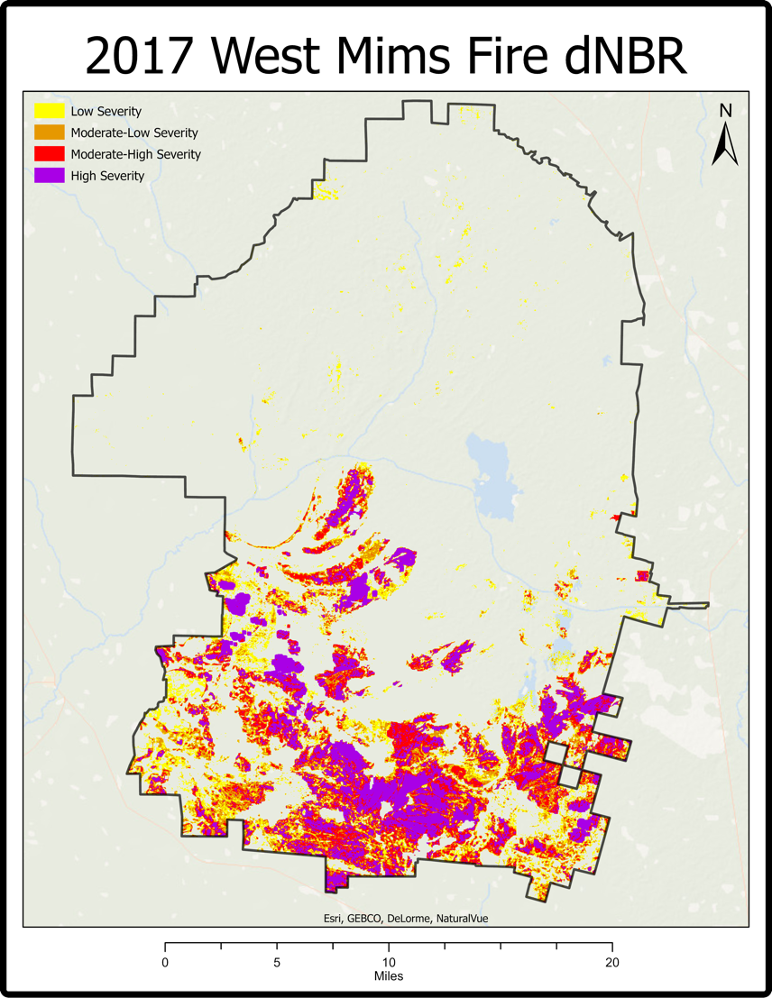
Figure 1. This map depicts the damage severity inflicted on the Okefenokee Swamp by the West Mims Fire.

4.1.2 Vegetation Map
As seen in Figure 2, the refuge has experienced regrowth across all areas of the refuge since the 2017 West Mims Fire. The most obvious similarity between the 2012 vegetation map (Loftin et al., 2018) and the updated vegetation map below is that the Mature Forest in the northwest of the refuge still has its distinct shape. The most significant difference between the two maps is that the 2021 map displays a dramatic increase in the ‘Mixed Aquatic / Herbaceous Prairie’. The southern portion of the refuge is dominated by the ‘Shrubs’ and ‘Shrubs/ Herbaceous with Sparse Trees’ classes and contains scattered areas of ‘Mixed Aquatic / Herbaceous Prairie’, ‘Open Water’, and pockets of ‘Pine / Sparse Pine’ typically around the islands. The northern portion of the refuge is substantially more diverse with every class prominently displayed. Overall, the Okefenokee exhibits a variety of classes common for a healthy, diverse wetland.
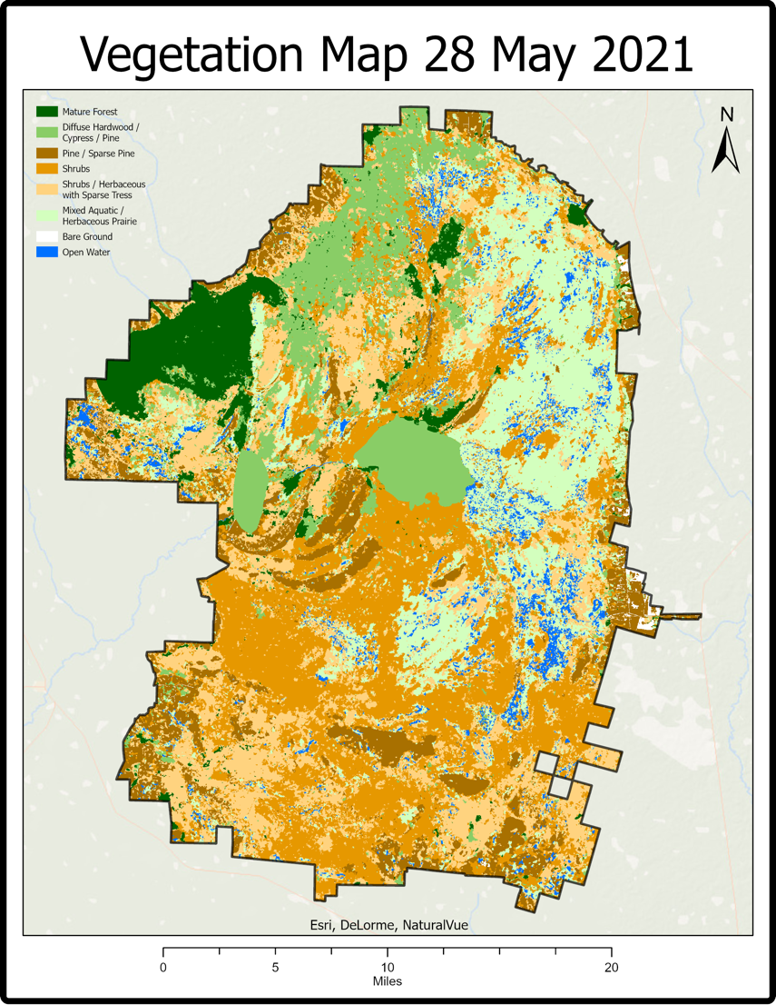
Figure 2. This map illustrates the vegetation classifications of the different portions of the Okefenokee.

4.1.3 Water Visibility Time Series
The water visibility time series maps portrayed a range of year-to-year changes. The most drastic changes occurred from 2016 to 2017 (Appendix C, Figure C1) when the entire swamp experienced a severe water decrease. This observation aligns with the occurrence of West Mims Fire in 2017, suggesting that the drastic drop of water levels may have created an ideal environment for such wildfire intensity. The SMAP data corroborated this by showing a similar trend. Figure 3 shows the overall hydrologic trends from 2015–2021. The northern portion of the swamp generally had more drastic changes than the southern portion. Areas just north of the Suwanee River had the most drastic decrease in water between 2015–2021. Most of these big changes occur near waterways: rivers, ponds, creeks, and prairies. This also corresponds with the locations shown in the weighted overlay map, which indicates areas of the refuge that saw the most extreme annual variation (Appendix C, Figure C2). Appendix C displays the entire six-year water visibility time series.
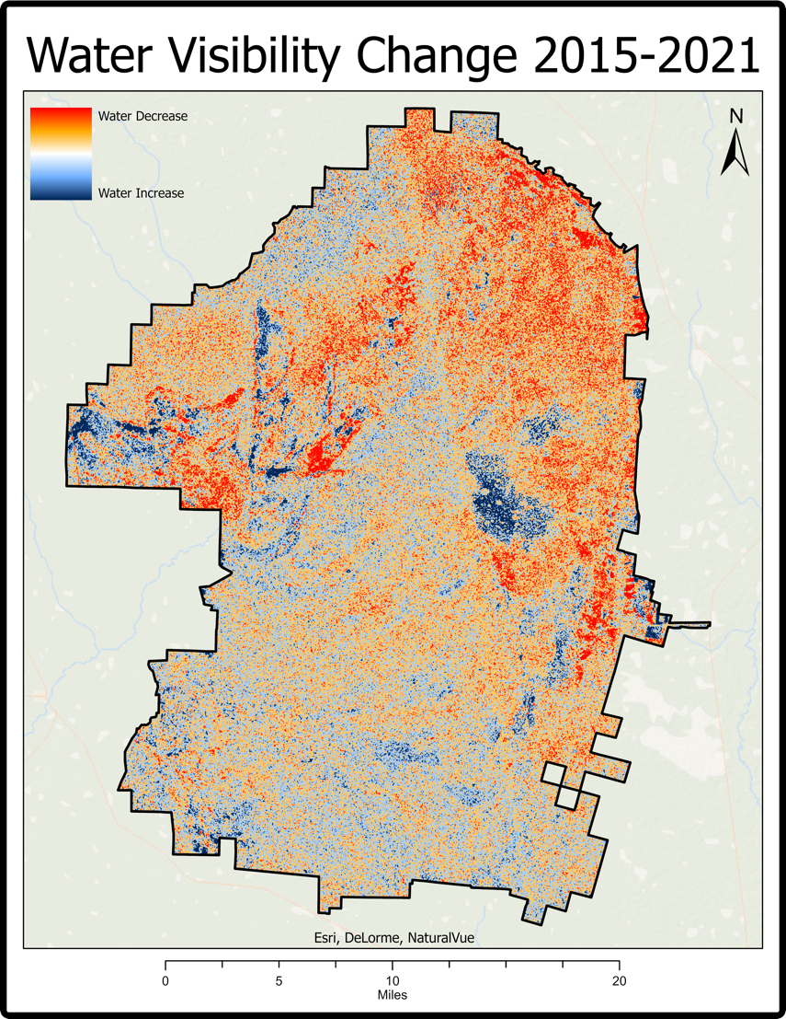
Figure 3. This map showcases the Change in Water Visibility from 2015 to 2021.

4.1.4 Soil Moisture Correlation
The SSMA-Fire analysis in Figure 4 identified that all three observed fires began when the SSMA value was right around -1. Prior to each fire, the SSMA value was continuously in the negative range for multiple months. This shows that each of these wildfires occurred at a lengthy, dryer-than-normal period. The West Mims Fire was the largest of these and had the longest range of preceding negative SSMA values—14 months. This doesn’t mean that fires occur anytime that the SSMA value is negative. Rather, this shows that the SSMA value is a good indicator for the outlook of fire-inducing conditions.

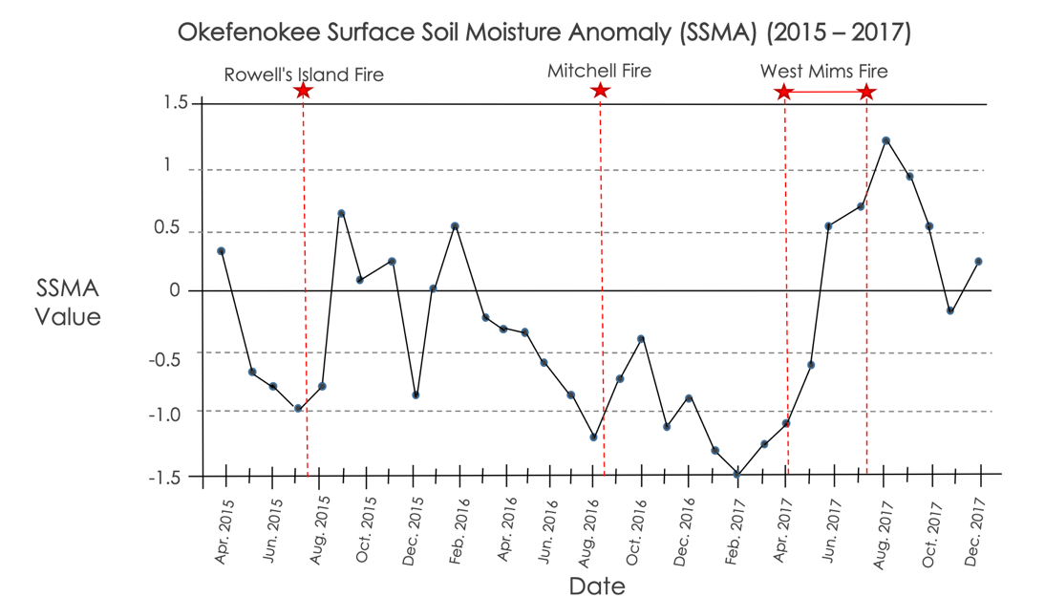
Figure 4. This chart shows SSMA values in relation to know wildfire events from 2015 to 2017.

The SMP monthly histogram (Figure 5) showed a mean value of 47%. Soil becomes water stressed at <40% (AgRISTARS, 1981). The distribution was approximately normal with a slight right skew. This indicates that over the observed time from April 2015 to February 2022 the refuge was dryer than is standard but not dry to the point of being water-stressed.

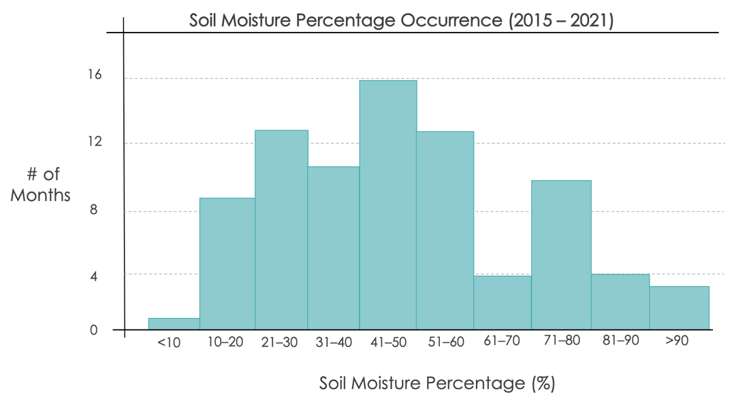
Figure 5. This chart shows the monthly distribution of SMP values from 2015 – 2021.

4.2 Future Work
There are three ways to continue the work from this project. First, there is currently a proposed rare-earth element mine near the southeastern border of the refuge. Future work could look at the impact of mining on blackwater swamps to better prepare refuge staff for conservation planning if this rare-earth mine goes forward. Next, Refuge staff expressed a desire to map the coordinate locations of old growth cypress trees. As these trees tend to be taller than the surrounding forest canopy, any remote sensing platforms that map vertical canopy height could be utilized. GEDI’s Level 2 products show canopy height at 82 ft diametric resolution and could be a useful tool. Lastly, all peat correlations done in this project utilized a location map provided by the partners. This location map is interpolated from a small amount of core samples taken by Dr. Arthur Cohen’s research in the 1980s. A future project could update this map using remote sensing. Proxy factors would need to be utilized to showcase both peat and peat depth. One of these could include nighttime ground temperatures as peat has a different temperature than the topsoil. The new map could then be verified with Dr. Cohen’s core samples.

5. Conclusions
The southern portion of the refuge seems to have taken the brunt of the damage, being burned by all three of the swamp's recent major fires and sustaining major ecological changes from the 2017 West Mims Fire. Despite this, the team found that the southern portion of the refuge that was destroyed in the West Mims Fire has been able to recover to the extent of shrubs and herbaceous areas with sparse trees. Little to no mature forests were found in this specific area, likely due to consistent burning over the years. There were, however, strong pockets of pine trees, especially along the southern islands within the refuge. Pine trees are known to be serotinous, which means they rely on wildfires to open their cones and release seeds. This was an interesting discovery since there have been many known fires in the regions where pine forests were found. The southern portions of the refuge also experienced more stable water levels throughout the study period. In contrast, the most drastic hydrologic change occurred along the Suwanee River on the western side of the refuge and amongst the eastern prairies. The soil moisture analysis concluded that soil moisture anomaly data may serve as an indicator of fire-inducing conditions, but not fire occurrence. All of this shows that while the concerns of wildfire continue to pose a threat to the refuge and peat deposits, the recent fires have been within historical norms, and the refuge has recovered well each time. While some areas of the refuge show decreasing water levels that should be monitored, the overall refuge water levels are still generally acceptable as there is not a consistent amount of water stress occurring. These findings, along with the soil moisture anomaly values, will serve as fire condition indicators for the staff at Okefenokee. The refuge can use these tools to assess wildfire risk and implement management plans that correspond to various risk factors. This will not only preserve the natural integrity and cultural heritage of the Okefenokee Swamp but also protect the local communities that are directly affected by the health of the refuge.

6. Acknowledgments
The Okefenokee Water Resources team would like to thank our partners from the Okefenokee National Wildlife Refuge for their constant support and collaboration on this project. We would also like to thank our science advisors, Dr. Jeffrey Luvall and Dr. Robert Griffin, and our fellow Paxton LaJoie for their technical guidance and leadership throughout the project. Lastly, the team thanks the DEVELOP leadership for their invaluable contribution and direction this term.

This material contains modified Copernicus Sentinel data (2015 – 2021), processed by ESA.

Any opinions, findings, and conclusions or recommendations expressed in this material are those of the author(s) and do not necessarily reflect the views of the National Aeronautics and Space Administration.

This material is based upon work supported by NASA through contract NNL16AA05C.

7. Glossary
Difference Normalized Burn Ratio (dNBR) – Index that measures fire severity by calculating the difference between Near Infrared and Short-Wave Infrared 2 bands from pre- and post-fire conditions
Earth observations (EO) – Satellites and sensors that collect information about the physical, chemical, and biological processes occurring on Earth
Enhanced Thematic Mapper Plus (ETM+) – Main instrument aboard the Landsat 7 NASA satellite launched in 1999
Geographic Information Systems (GIS) – Software that stores and offers tools to manipulate geographic data
Google Earth Engine (GEE) – Cloud-based platform to perform geospatial processing
Normalized Difference Burn Index (NBR) – Index that highlights burned areas by comparing Near Infrared and Short-Wave Infrared 2 bands
Operational Land Imager (OLI) – Main instrument aboard the Landsat 8 NASA satellite launched in 2013
Soil Moisture Active Passive (SMAP) – NASA satellite launched in 2015 to monitor the amount of water and soil on Earth
Soil Moisture Profile (SMP) – Measures the percent of Water Holding Capacity of the ground by Available Water
Surface Soil Moisture Anomaly (SSMA) – A unitless measure from –4 to +4 to show how dry or wet the soil is based on historical averages
Synthetic Aperture Radar (SAR) – Radar that creates two- and three-dimensional representations of landscapes
Vertical-Horizontal (VH) Band – C-Band waves that travel to Earth oscillating perpendicular to Earth’s surface and return to the sensor oscillating parallel to Earth’s surface
Vertical-Vertical (VV) Band – C-Band waves that travel to Earth oscillating perpendicular to Earth’s surface and return to the sensor oscillating perpendicular to Earth’s surface

8. References
AgRISTARS-Agriculture and Resources Inventory Surveys through Aerospace Remote Sensing. (1981). Fiscal Year 1980 Annual Report. National Aeronautics and Space Administration. http://www.nass.usda.gov/Education_and_Outreach/Reports,_Presentations_and_Conferen ces/GIS_Reports/AgRISTARS%20Annual%20Report%20%28FY%201980%29.pdf
European Space Agency (ESA). (2014). Sentinel 1 - SAR GRD: C-band Synthetic Aperture Radar Ground Range Detected, log scaling [Dataset]. Earth Engine Data Catalog/European Union/ESA/Copernicus. Retrieved February 14, 2022, from https://developers.google.com/earth-engine/datasets/catalog/COPERNICUS_S1_GRD
European Space Agency (ESA). (2017). Sentinel 2 - MSI: Multispectral Instrument, Level 2-A [Dataset]. Earth Engine Data Catalog/European Union/ESA/Copernicus. Retrieved February 14, 2022, from https://developers.google.com/earth-engine/datasets/catalog/COPERNICUS_S2_SR
European Space Agency. (n.d.). Acquisition Modes. Sentinel Online. https://sentinel.esa.int/web/sentinel/user-guides/sentinel-1-sar/acquisition-modes
Kim, J. W., Lu, Z., Gutenberg, L., & Zhu, Z. (2017). Characterizing hydrologic changes of the Great Dismal Swamp using SAR/InSAR. Remote Sensing of Environment, 198, 187–202. https://doi.org/10.1016/j.rse.2017.06.009
Loftin, C. S., Guyette, M. Q., & Wetzel, P. R. (2018). Evaluation of vegetation-fire dynamics in the Okefenokee National Wildlife Refuge, Georgia, USA, with Bayesian belief networks. Wetlands, 38(4), 819–834. https://doi.org/10.1007/s13157-018-1033-6
National Weather Service (NWS). (2017). West Mims Fire 2017. https://www.weather.gov/jax/WestMimsFire_Apr_thru_Jul_2017

Park, B.A., & Office, F.A. (2008). Assessing the difference Normalized Burn Ratio’s ability to map burn severity in the boreal forest and tundra ecosystems of Alaska’s national parks. Semantic Scholar: Environmental Science. https://www.semanticscholar.org/paper/Assessing-the-differenced-Normalized-Burn-Ratio-%E2%80%99-s-Park-Office/d1e4d2d5fed8ad4ccfdc9af8c738a9e699ad80f2
Patton, D., Bergstrom, J., Covich, A., & Moore, R. (2012). National Wildlife Refuge wetland ecosystem service valuation model, phase 1 report. National Wildlife Refuge. https://www.fws.gov/economics/Discussion%20Papers/USFWS_Ecosystem%20Services_Phase%20I%20Report_04-25-2012.pdf
Sánchez-Espinosa, A., & Schröder, C. (2019). Land use and land cover mapping in wetlands one step closer to the ground: Sentinel-2 versus Landsat 8. Journal of Environmental Management, 247, 484–498. https://doi.org/10.1016/j.jenvman.2019.06.084
Trowell, C. T. (2020, August 14). Human History of the Okefenokee Swamp. New Georgia Encyclopedia. https://www.georgiaencyclopedia.org/articles/geography-environment/human-history-of-the-okefenokee-swamp/
United Nations. (n.d.) Normalized Burn Ratio. Office for Outer Space Affairs UN-SPIDER Knowledge Portal. https://un-spider.org/advisory-support/recommended-practices/recommended-practice-burn-severity/in-detail/normalized-burn-ratio
US Department of Agriculture (USDA). (2015). NASA-USDA Enhanced SMAP Global Soil Moisture Data [Dataset]. Earth Engine Data Catalog/NASA GSFC. Retrieved February 14, 2022, from https://developers.google.com/earth-engine/datasets/catalog/NASA_USDA_HSL_SMAP10KM_soil_moisture?hl=en#bands
US Fish and Wildlife Service. (2006). Okefenokee National Wildlife Refuge comprehensive conservation plan. Atlanta, Georgia: Southeast Region. https://www.fws.gov/southeast/planning/PDFdocuments/OkefenokeeFinalCCP/Okefenokee%20Final%20CCP%20edited%20.pdf
US Geological Survey (USGS). (1999). Landsat 7 Enhanced Thematic Mapper Plus (ETM+) Level 2, Collection 2, Tier 2 [Dataset]. Earth Engine Data Catalog/USGS. Retrieved February 14, 2022, from https://developers.google.com/earth-engine/datasets/catalog/LANDSAT_LE07_C02_T1_L2
US Geological Survey (USGS). (2013). Landsat 8 Operational Land Imager (OLI) Level 2, Collection 2, Tier 1 [Dataset]. Earth Engine Data Catalog/USGS. Retrieved February 14, 2022, from https://developers.google.com/earth-engine/datasets/catalog/LANDSAT_LC08_C02_T1_L2

9. Appendices
Appendix A
(a) (b)
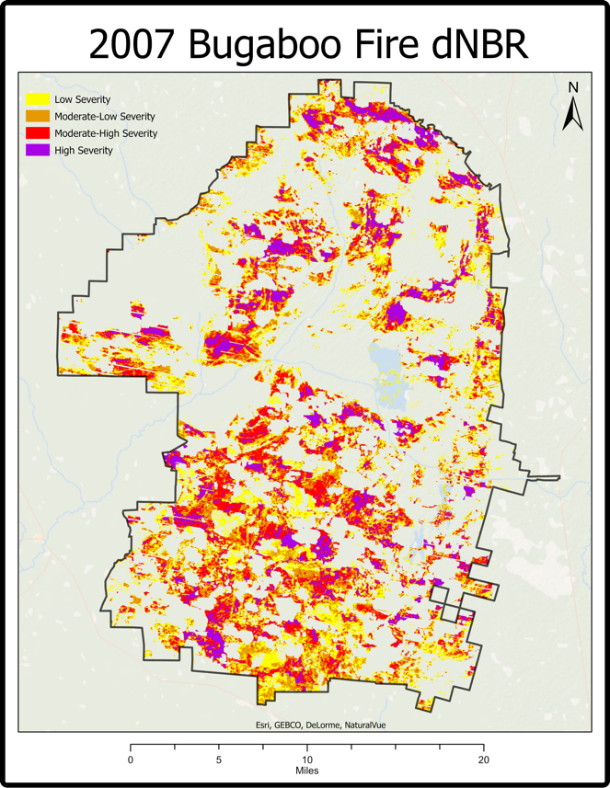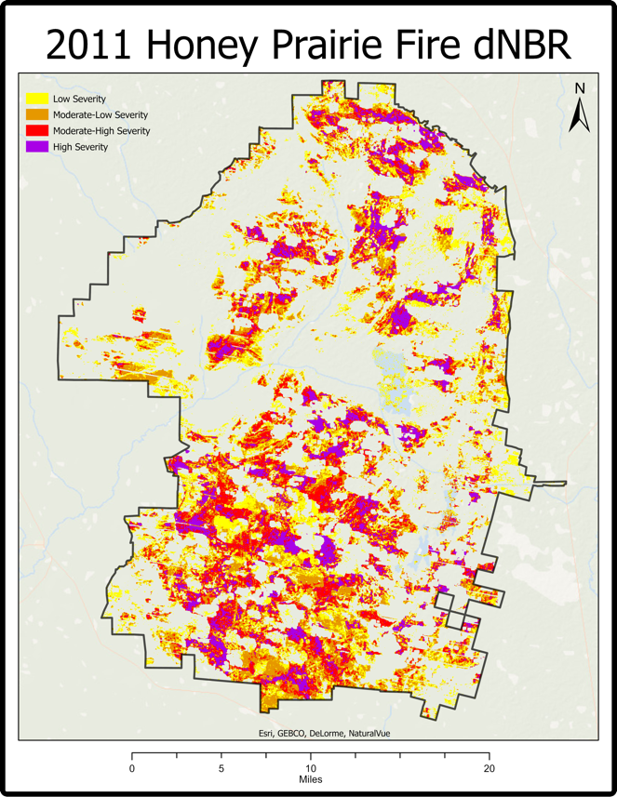
Figure A1. These maps show the fire severity levels of the (a) 2007 Bugaboo Fire (left image) and (b) 2011 Honey Prairie Fire (right image).

Appendix B
(a) (b)
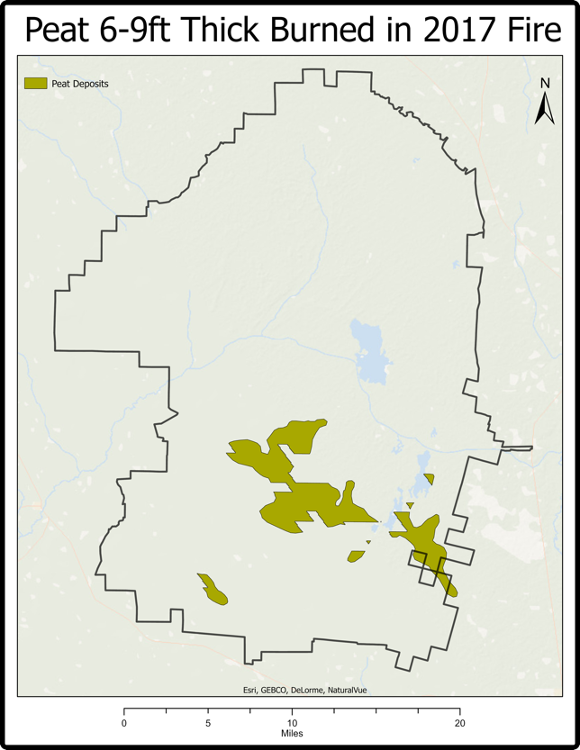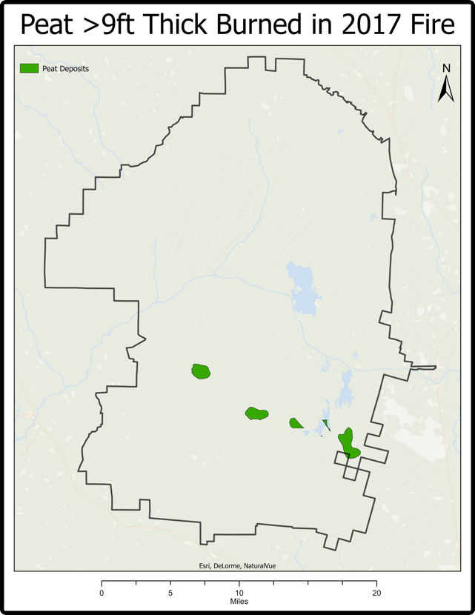
Figure B1. These maps show the locations of peat reserves (a) that are 6-9 feet deep (left image) and (b) greater than 9 feet deep (right image) that experienced surface scarring from the 2017 fire.

Appendix C
- (b)
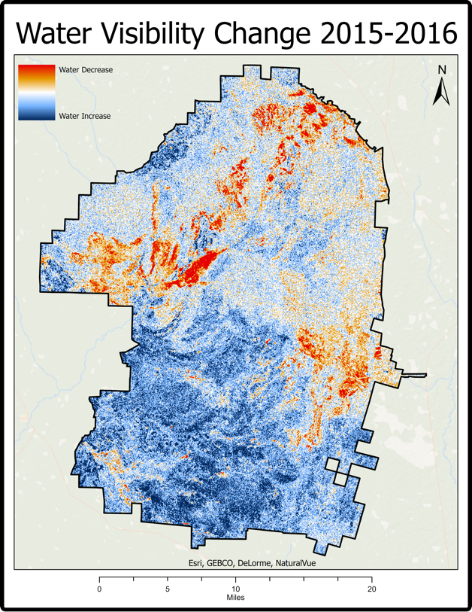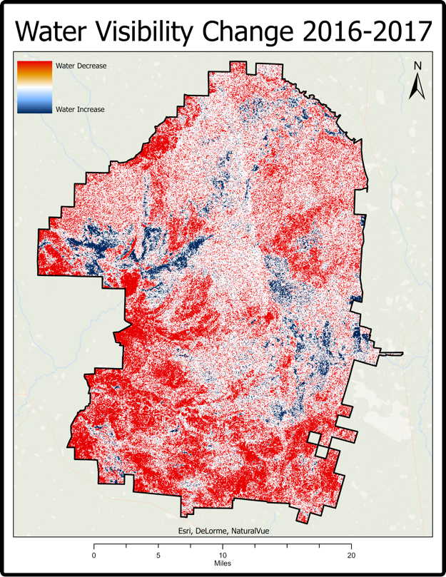
- (d)
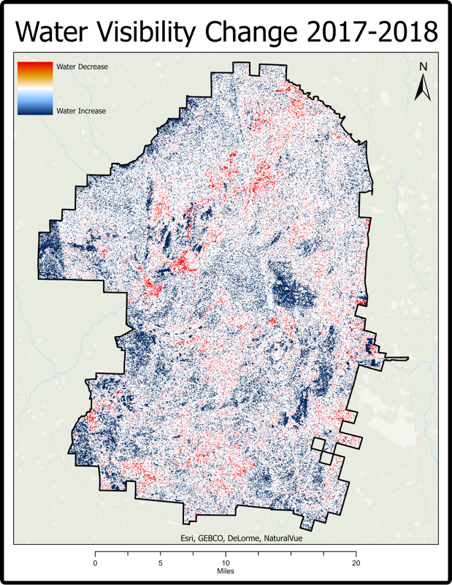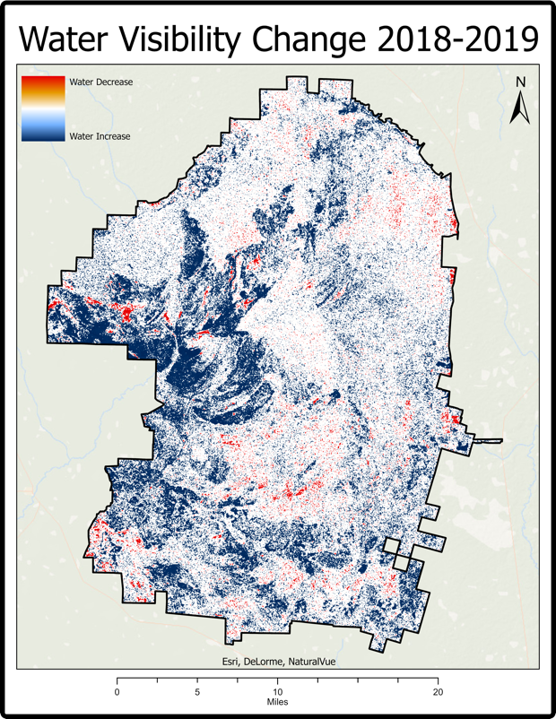

(e) (f)
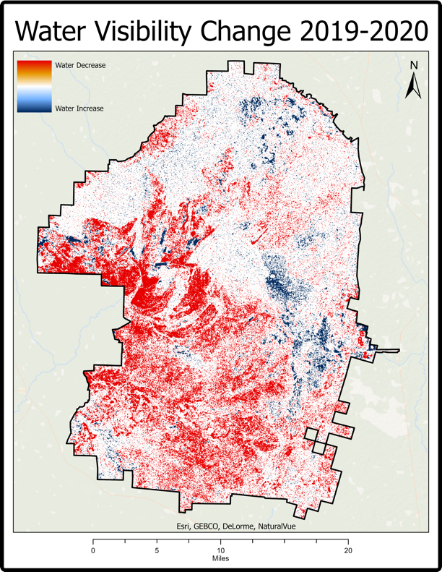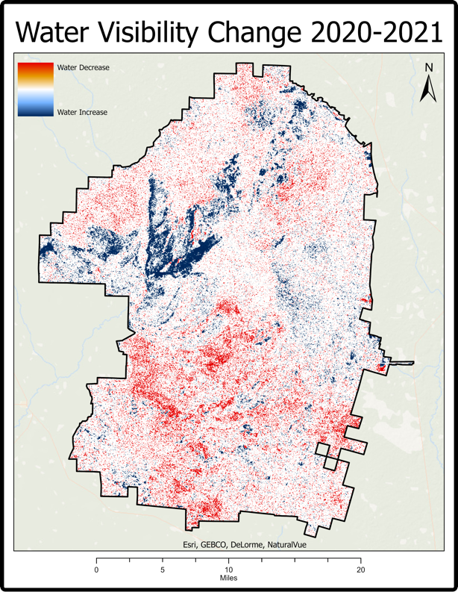
Figure C1. These maps show water visibility change from (a) 2015-2016, (b) 2016-2017, (c) 2017-2018, (d) 2018-2019, (e) 2019-2020, and (f) 2020-2021.

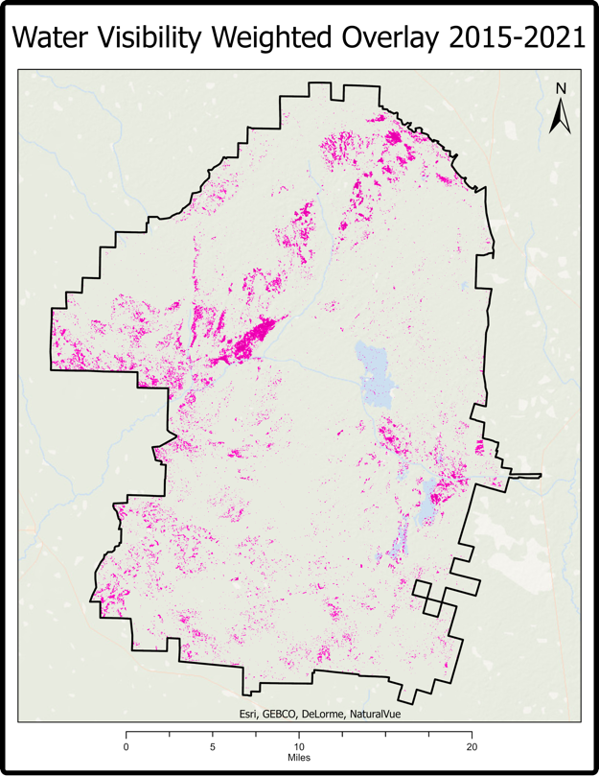
Figure C2. This map indicates which areas of the refuge experienced the most visible hydrologic changes from year to year.

