Kansas Agriculture & Food Security

Modeling Soil Drydown Parameters for Drought Mitigation in Cropland and Rangeland of Kansas Using NASA Earth Observations

**Technical Report**

Final Draft – August 8th, 2019

Danika Mosher (Project Lead)  
Max Dunsker

Krishna Tiwari

Jessica Blunden, NOAA National Centers for Environmental Information (Science Advisor)

# 1. Abstract

Kansas is a leading state in agricultural production, however, during recent droughts, farmers experienced decreased yields that negatively impacted the state and national economies. The exponential decay of soil moisture content is a major consequence of drought, stymieing plant growth. This study examined the rate of soil moisture drydown to understand and mitigate the damage caused by soil water shortage. Soil Moisture Active Passive (SMAP) L-band Radiometer rootzone soil moisture imagery from March 2015 to the present was used to understand the minimum and maximum soil moisture capacity. The variables selected from SMAP and parameters derived from *in situ*data were input into an exponential model. The model forecasted, for a given length of time, the rootzone soil moisture assuming no precipitation. Another model was used to identify areas in Kansas currently below a given percentage of their relative soil moisture saturation, measured as a function of minimum, maximum, and current soil moisture, and forecasted the number of days until the other pixels would reach that level. The data were observed at a spatial resolution of 9 km × 9 km. These outputs were compared to Evaporative Drought Demand Index (EDDI) data to understand the relationship between agricultural and meteorological drought for our partners at Kansas State University and the Desert Research Institute. Additionally, the project assisted the Kansas Water Office and Kansas Office of the State Climatologist at Kansas State University in creating statewide drought mitigation plans and disseminating comprehensive information to farmers.

**Keywords*:***soil moisture, SMAP, EDDI, exponential decay, forecasting, evaporative demand, relative saturation

# 2. Introduction

* 1. ***Background Information***

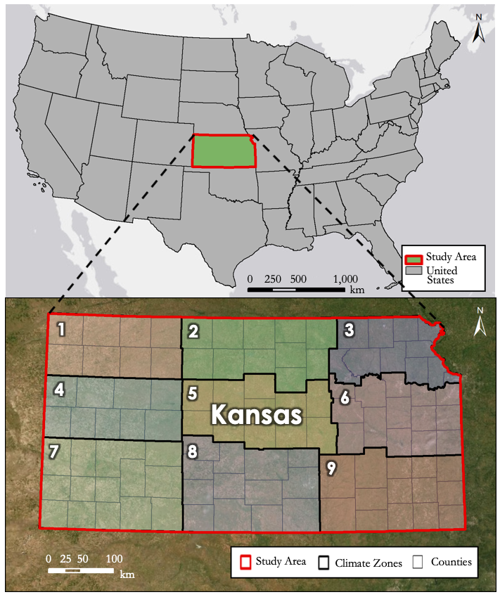Kansas is one of the leading states in agricultural production, exporting more than $18 billion in agricultural goods for local, national, and international consumption in 2018. Currently, there are 778 farming operations spread across Kansas, producing corn, soybeans, wheat, cattle, sorghum, in addition to other staple crops and livestock (United States Department of Agriculture National Agricultural Statistics Service [USDA NASS], 2019a). The acreage of grain harvested in June of 2019 is estimated to be 6.6 million acres (USDA NASS, 2019b). However, this agricultural productivity is threatened by the drought-prone climate of the Great Plains. Historic droughts, such as the Dust Bowl from 1932 to 1938, and recent droughts, such as the drought of 2011 and 2012, have disrupted the agricultural output of Kansas.

Kansas is located in the central United States (*Figure 1*), home to the geographic center of the contiguous 48 states. Its climate is temperate, with large seasonal variations in temperature and rainfall. These features result in a primary growing season in the spring and summer.

a.)

*Figure 1*. (a) Study area of Kansas within the United States of America. (b) Kansas’ 105 counties sectioned into 9 agroclimatic zones delineated by the National Oceanic and Atmospheric Administration’s National   
Climatic Data Center (Vose et al., 2014).

b.)

Crop areas account for 56 percent, or 29 million acres, while rangelands account for 37 percent, or 19 million acres, of the total land area in the state. Of the 52 million acres in Kansas, 25 million of them are designated as “prime farmland” by the United States Department of Agriculture (O’Brien, n.d.).

The future of Kansas agriculture may be even more precarious as its climate varies: regional climate models predict drier summers within the next 100 years, with precipitation unable to balance high evapotranspiration rates (Keables & Mehta, 2010). With this lack of precipitation, plants must rely on soil moisture to provide additional water for their growth. Reasons for drought include regional variability in the global water cycle as well as patterns in local weather and climatic circulation that cause temperature and rainfall anomalies. Drought can be categorized into four typologies: meteorological, agricultural, hydrological, and socioeconomic. One type often precipitates another, with the ramifications of low rainfall resulting in soil drydown, water scarcity, and economic decline (Aghakouchak et al., 2015). Soil drydown is the exponential decay of soil moisture content that takes place over time. Soil drydown is exacerbated in drought conditions due to the lack of precipitation and high evaporative demand. The Evaporative Drought Demand Index (EDDI), which measures the anomaly in daily evaporative demand over a specific time frame and location, provides atmospheric conditions in relation to soil moisture throughout Kansas.

Since the World Meteorological Organization named soil moisture an Essential Climate Variable in 2009 (Global Climate Observing System, 2010), there have been significant efforts to more accurately observe its dynamism. Soil Moisture and Ocean Salinity Mission (SMOS), launched in the fall of 2009 by the European Space Agency (ESA), and Soil Moisture Active Passive (SMAP), launched at the start of 2015 by NASA, are both satellites that use microwave remote sensing to gauge soil moisture (Kolassa et al., 2018).

The SMAP sensor began collecting data on March 31, 2015 and went into safe mode on June 19, 2019. The study period was further limited by the availability of Mesonet data (*Figure 2*) being that *in situ* root zone soil moisture (RZSM) was not measured until 2017.

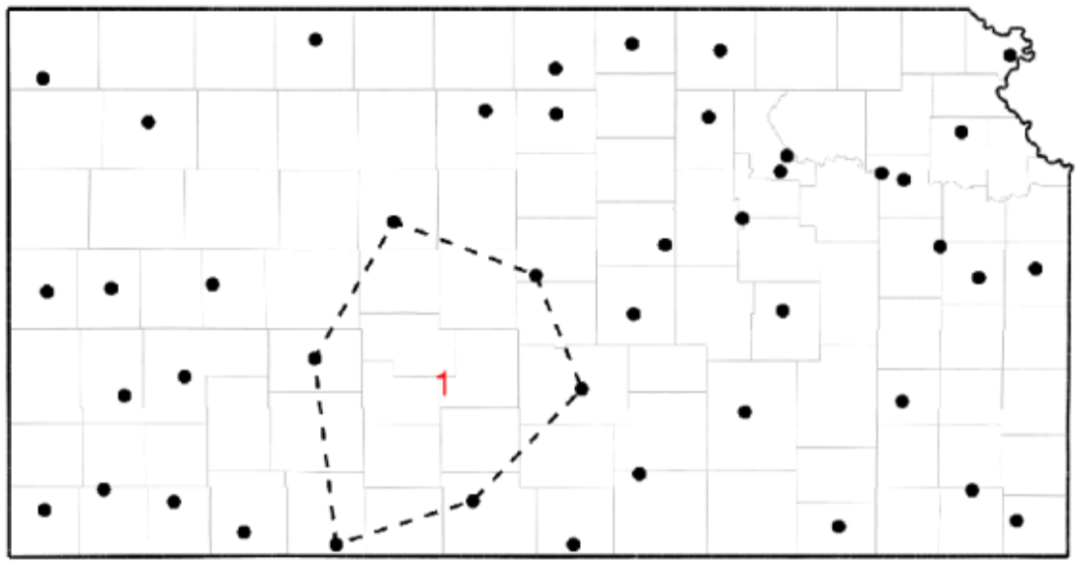*Figure 2*. Locations of the 41 Kansas Mesonet stations that measure soil drydown. The area notated with the red one indicates the largest polygon of no mesonet station. The encompassed counties include Pawnee, Barton, Stafford, Pratt, Kiowa, and Edwards (Redmond, n.d.).

* 1. ***Project Partners & Objectives***

There were four partner organizations for this project: the Kansas Office of the State Climatologist at Kansas State University, the Kansas Water Office, the Kansas State University Department of Agronomy, and the Desert Research Institute at Western Regional Climate Center. The Office of the State Climatologist disseminates climate and weather information to state action teams, including the Governor’s Drought Response Team and agricultural producers, such as farmers and cooperatives. The Office of the State Climatologist recognizes the spatially incomplete nature of the current *in situ* system and seeks to use remote sensing to develop a more comprehensive understanding of soil moisture drydown throughout Kansas to make more informed decisions in response to drought conditions. The Kansas Water Office relies on data from the Office of the State Climatologist; with the map atlas from the modeled outputs produced by this study, the Kansas Water Office will have spatially comprehensive, county-level data on soil drydown rates under various drought scenarios and up-to-date soil moisture and surface conditions. This information assists to identify counties with cropland and rangeland expected to have the fastest rates of soil drydown and at what time scale soil moisture will reach critical desiccation, increasing the ability to make effective drought mitigation plans.

This project characterized the process of soil drydown in cropland and rangeland areas by using an existing exponential decay model from Shellito et al. (2016). Further objectives included obtaining root zone soil moisture data for the model through SMAP imagery and producing a statewide map atlas of soil moisture capacity conditions.

Working with the Desert Research Institute, we analyzed the relationship between SMAP rootzone soil moisture and the EDDI. The soil moisture data served as a proxy for agricultural drought while the evaporative demand data represented atmospheric drought. By comparing these two values, a relationship between the occurrence of evaporative demand anomalies and soil moisture was discovered.

# 3. Methodology

***3.1 Data Acquisition***

The SMAP sensor was deployed to take measurements of soil moisture around the globe, including areas with frozen soils. Its purpose was to help collect data to better understand the connections between different Earth cycles, such as the water, energy, and carbon cycles, to inform hazard models. SMAP Level 4 (SM_L4) data products were generated with a land surface model that assimilated SMAP measurements, which produced data at a 9 km x 9 km resolution with a temporal scale of three hours. SMAP L4 Global 3-hourly 9 km Equal-Area Scalable Earth (EASE) Grid Surface and Root Zone Soil Moisture Analysis Update, Version 4 (SPL4SMAU) data were obtained through the National Snow and Ice Data Center (NSIDC) and extracted for the period March 31, 2015, to July 19, 2019 (Table 1).

The Kansas Mesonet Soil Moisture *in situ* stations are a part of the K-State Research & Extension (KSRE) from Kansas State University (KSU) (Table 1). The Mesonet was established in 1986 and currently has 41 stations that collect soil moisture data, primarily in grassland vegetation areas, and 88 stations overall. The majority of these stations are co-located within the National Weather Service Cooperative Observing Stations and have adequate exposure to weather to get near accurate measurements, such as wind and precipitation, as outlined by the World Meteorological Organization. The stations collect solar radiation data, air temperature, relative humidity, wind speed and direction, precipitation, barometric pressure, soil temperature, and soil moisture. Root zone soil moisture data were obtained from the Mesonet website as comma separated value (CSV) files.

EDDI data were obtained through the Earthlab Github (Table 1). EDDI is an index of anomalies in evaporative demand, a measure of the degree to which the air attempts to evaporate water, which coincides with the drought conditions of the US Drought Monitor. Data were obtained for the period March 31, 2015, to July 19, 2019, in order to visualize the severity and longevity of drought in Kansas over time under regimes of insufficient precipitation and normal conditions.

Table 1

*Selected Earth observations and ancillary datasets, data sources, and selected data products*

|  |  |  |
| --- | --- | --- |
| **Sensors and Ancillary Datasets** | **Source** | **Data Product** |
| Soil Moisture Active Passive (SMAP) L-band Radiometer | NSIDC | Satellite-derived Soil Moisture |
| Kansas Mesonet Soil Moisture | KSU | *In Situ* Soil Moisture |
| Evaporative Demand Drought Index | National Oceanic and Atmospheric Administration (NOAA) Earth System Research Laboratory | Evaporative Demand Anomalies |

***3.2 Data Processing***

SMAP L4 data (SPL4SMAU) were downloaded through RStudio as a GeoTIFF and processed in Python. The rasters for the term of the study period were compiled into a three-dimensional array. Using minimum soil moisture, as well as a current SMAP image, we executed the model from Shellito et al., 2016 (Equation 1). The exponential model outputs a forecasted level of soil moisture for a specified forecast length from the initial observation (*t*, days) based on the rate of soil drying calculated from Mesonet data (𝜏), initial soil water content (A, cm3cm-3) measured from SMAP, and the minimum soil water content measured from SMAP (𝜃𝑓 , cm3cm-3). Prior to running the model, 𝜏 and 𝜃𝑓 were calculated.

(*t*) = A × *e* (-*t* τ-1) + 𝜃𝑓 (1)

The calculation for 𝜏 is based on the day of the year (DOY) as a cosine function illustrating how drying rates vary throughout the year. The equation was derived from *in situ* Kansas Mesonet measurements where median 𝜏 values for each day were used to fit the model (Equation 2) based on 237 periods of drydown. This model assumes the worst-case scenario of no precipitation and normal evaporative demand for each day of the year in the calculation of 𝜏.

𝜏 = 55 + 44 cos[2𝜋(DOY-16)/365] (2)

The residual soil water content, 𝜃𝑓, was derived from the three-dimensional soil moisture array where the lowest value for the entire growing season was selected to identify the lower bound. This value is to make sure the model adequately reflects the soil moisture, not predicting a value lower than 𝜃𝑓.

Days until *x* percent relative saturation = $\text{τ}\text{(log(}{\text{2}}^{\frac{\text{-log(}\frac{\text{x}}{\text{100}}\text{)}}{\text{log(2)}}}\text{))-τ(-log(}\frac{{\text{RZSM}}_{\text{0}}\text{ - }{\text{RZSM}}_{\text{min}}}{{\text{RZSM}}_{\text{max}}\text{ - }{\text{RZSM}}_{\text{min}}}\text{))}$ (3)

Equation 3 provides the ability to see which areas have already reached relative saturation or will reach it. This is based on a designated percent threshold (*x*) as an integer and the rootzone soil moisture for the day selected (*RZSM0*). The equation accounts for the difference between relative saturation for the specified day and the designated threshold of relative saturation. If the value is positive, it represents days until those pixels will reach the designated threshold, whereas negative values reflect areas that have already fallen below the threshold.

***3.3 Data Analysis***

Soil moisture was characterized by looking at the root zone soil moisture values for each pixel of SMAP during the study period. The lowest values for each pixel are the minimum soil moisture content and the highest are maximum soil moisture content. The overall soil water storage capacity is found by subtracting the minimum from the maximum to measure the amount of water each pixel can hold during a rainfall event. These parameters served as inputs for equations 1 and 3; additionally, they are presented in a map atlas at the county scale to provide a spatially comprehensive knowledge of these soil characteristics.

The projected root zone soil moisture (*RZSMP*) at the end of a forecasted period was compared to actual SMAP values (*RZSMA*) at that date to produce a percent difference map (Equation 4). This is beneficial for looking at periods in Kansas that received minimal rainfall. Positive values indicate overprediction and negative values indicate underprediction of the true SMAP values.

Percentage Difference = $\text{(}\frac{{\text{RZSM}}_{\text{A}}\text{-}{\text{RZSM}}_{\text{P}}}{\text{RZSM}}\text{)100 }$ (4)

The percent difference map is compared to a one-week time scale EDDI values during the forecast period to observe model performance. Positive EDDI values indicate areas of high evaporative demand anomalies whereas negative are low evaporative demand anomalies.

To find a relationship between different types of drought, SMAP rootzone soil moisture was used as a proxy for agricultural drought and the EDDI was used as a proxy for atmospheric drought. The 88 Mesonet stations were chosen as a sample with which to compare SMAP and EDDI. First, the SMAP and EDDI observations for every day in the study period were gathered. These values were extracted to the Mesonet locations. SMAP raw values were then converted into their percentile rank for easier comparison with the anomaly values of EDDI. The values for all stations were compared in trendlines and a linear model was fit to the data.

# 4. Results & Discussion

***4.1 Analysis of Results***

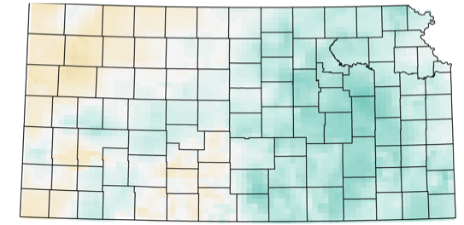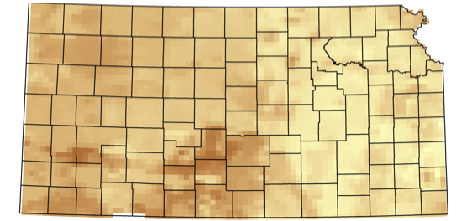



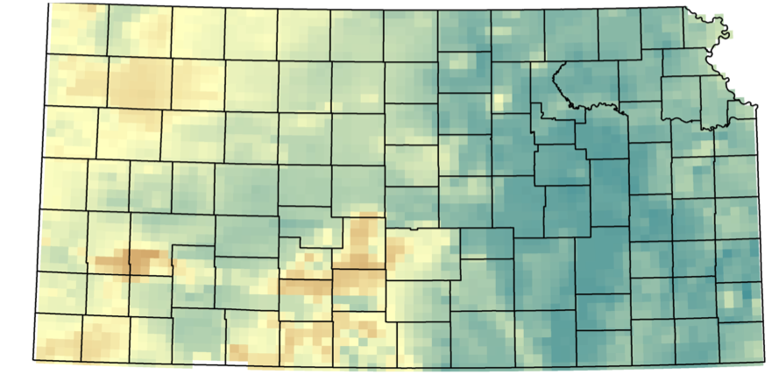

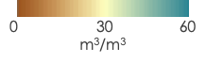

*Figure 4*. Soil characteristics of Kansas derived   
from SMAP values within the study period. Overall soil water storage capacity (a), minimum soil moisture (b), and maximum soil moisture (c) helped inform the models.

The overall trend for Kansas’s soil water storage capacity is a gradient of driest soils to the west and wettest soils to the east (*Figure 4*). Within central southern Kansas, these characteristics adequately reflect the high sand content around Great Bend and Garden City. The rest of the soil types are silt loam and deep, fertile soils, particularly around the Mesonet Stations. This analysis is able to provide sub-county variations of soil water storage capacity for all of Kansas.

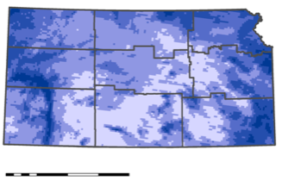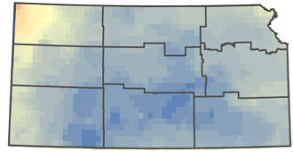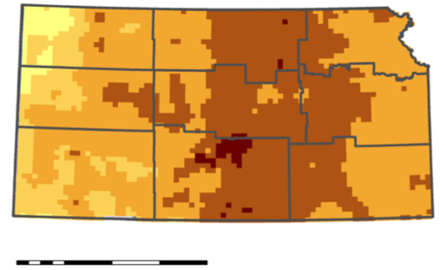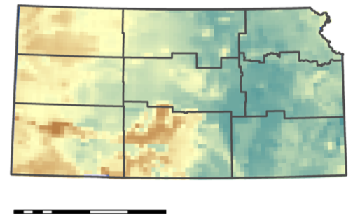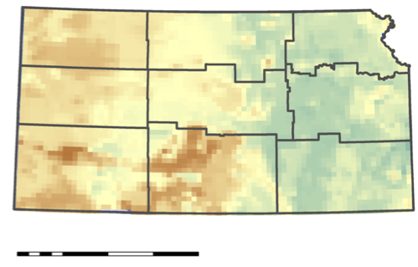

c.)

a.)

b.)

EDDI Anomalies

Rainfall

Soil Moisture

0 50 m3m-3

0 30 %

-2 2

0.1 4 in

Percent Difference

0 75 150 300 km

0 75 150 300 km

0 75 150 300 km

0 75 150 300 km

0 75 150 300 km

e.)

d.)

*Figure 5.* Example of the forecasted rootzone soil moisture model for July 19th, 2019 (b). It was compared to SMAP values (a) to generate a percent difference map (c). This date was informed by the cumulative rainfall (d) between July 15th and the 22nd. EDDI was used to observe the degree of thirst to inform model performance (e).

To observe the performance of the model, a recent sample date when the majority of Kansas experienced little rainfall was selected. Cumulative rainfall for Kansas between July 8th and July 22nd show central southern Kansas experiencing less than 0.1 inches (*Figure 5d*). When the modeled soil moisture values (*Figure 5b*) were compared to actual SMAP values (*Figure 5a*) through percent difference (*Figure 5c*), the model over performed for all of Kansas. The EDDI values for July 7th through the 13th show that there were abnormally low evaporative demand values for the majority of Kansas, aside from the northwestern corner where the model performed close to observed SMAP values (*Figure 5e*). The highest percent difference between the model and SMAP values were experienced in the eighth climatological zone of central southern Kansas.

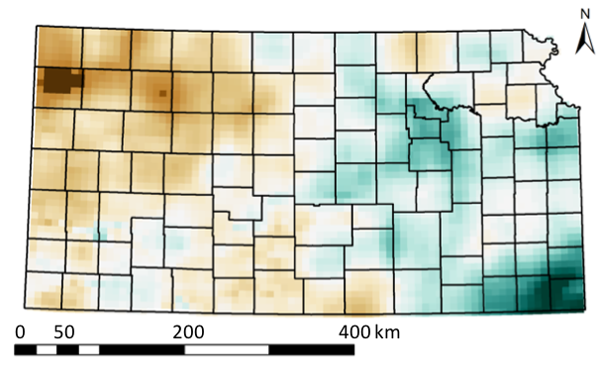

*Figure 6*. Sample of the relative saturation model with a threshold of 25% starting on July 1st, 2019. The map looks at areas that have experienced this defined threshold 30 days prior and after the date.

-30 30 days

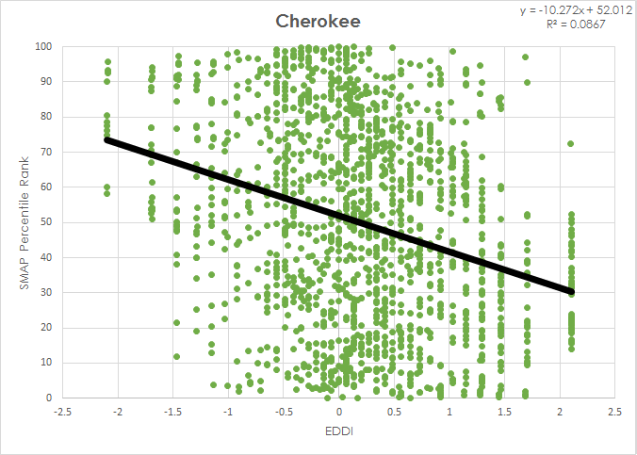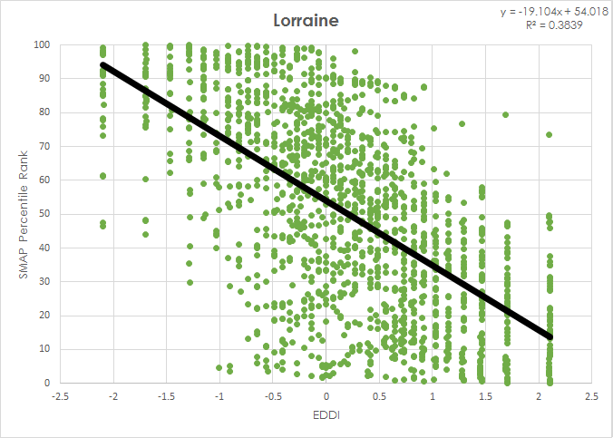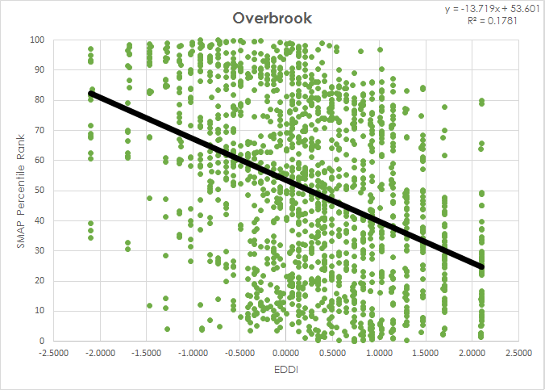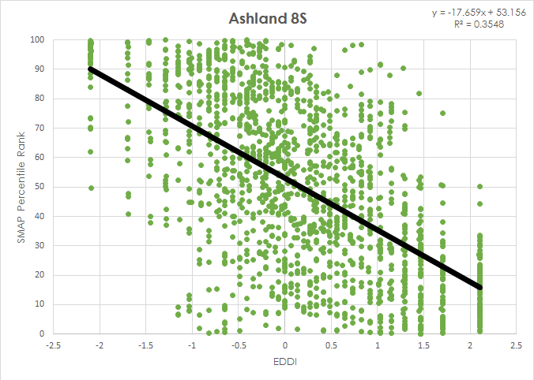

*Figure 7.* Sample of EDDI values throughout the year compared to SMAP percentile ranking by attaching a trend line to the values. The sample shows four of the 88 Kansas Mesonet stations analyzed.

The relative saturation model was observed with inputs of 25 percent relative saturation threshold and July 1st for the start date (*Figure 6*). Based on these drought parameters, Kansas experienced a gradient where the west already reached 25 percent relative saturation and eastern Kansas will experience it after July 1st. Labette and Cherokee Counties have areas that experienced the threshold 30 days out or more from the start date. Most of Sherman County had areas that reached the threshold 30 or more days prior. Preliminary analysis of SMAP percentile show an overall negative trend as seen from sample stations (*Figure 7*).

***4.2 Future Work***

There is a demand for more advanced sensors that remedy the issues presented by using SMAP, principally the spatial resolution of 9 km by 9 km. This low spatial resolution does not account for the heterogeneities of the soil attributes such as soil type, soil texture/roughness, and vegetation water content, as well as sensor albedo, which affects observed brightness temperature, backscatter, and retrieved soil moisture (Mohanty, Cosh, Lakshmi, & Montzka, 2017). Some models attempt to increase the spatial resolution by scaling the SMAP data using products with a higher resolution, such as Sentinel-1; this is an effective way to capture observed brightness temperature with more detail. However, this process has a longer revisit time to the point where the temporal resolution causes enhanced data to be unfit for daily or weekly observation (Mohanty et al., 2017). Other products yet to launch, such as the NASA-ISRO Synthetic Aperture Radar (NISAR), a sensor co-developed by NASA and the Indian Space Research Organization, and Tandem-L, developed by Germany, may also be used in the future for soil moisture observations and root zone soil moisture estimations (Mohanty et al., 2017). A daily product with a faster temporal or better spatial resolution could lead to major advances in soil moisture remote sensing.

Additionally, more tools to estimate the root zone soil moisture (RZSM) are being created to understand the dynamics of soil drydown below the 5 cm depth limit of microwave sensors. The one used in this study, the Level 4 SMAP product, uses the SMAP L1C_TB Brightness Temperature observations with a Catchment Land Model that includes the CPC Unified Precipitation Observations and GEOS-5 Surface Meteorology, creating an ensemble Kalman filter (EnKF) Assimilation. This L4_SM product can measure soil moisture at a 1 m depth, with a 9 km spatial resolution and 3-hour temporal resolution. While validating the surface soil moisture and RZSM products, it was found that the RZSM product better reflected the *in situ* measurements; the L4_SM product also outperformed the Nature Run v4 model (Reichle et al., 2017). The Soil Moisture Analytic Relationship (SMAR) model also relates observations of surface soil moisture into an estimate of RZSM. By introducing a non-linear soil water loss function to SMAR, Faridani introduced the modified SMAR model (MSMAR) model, which outperforms SMAR in finer textured soil, as a linear soil water loss function underestimates water loss in those soils (Faridani, Farid, Ansari, & Manfreda, 2017). SMAP data, instead of being assimilated into a Radiative Transfer Model (RTM) as in the L4_SM, can be coupled with a neural network algorithm to estimate soil moisture: RTM models suffer when physical characteristics such as land surface temperature (LST) and Normalized Difference Vegetation Index (NDVI) are not available, however, neural network algorithms can model the global statistical relationship between remote sensing observations and soil moisture. This neural network is trained using the GEOS-5 model, which is used by L4_SM as well. Though the neural network algorithm provides a globally unbiased output, it suffers in agricultural regions, such as the Great Plains, as a remotely sensed product can capture the results on agronomic practices such as irrigation, tilling, and harvesting, while they are not reflected in the model (Kolassa et al., 2018). Therefore, the L4_SM product is more helpful in understanding the soil moisture of Kansas, as its assimilation of SMAP data into the Land Catchment Model GEOS-5 allows it to model soil moisture with remote sensing observations, though the neural network algorithm may be helpful in future work. Future work for Kansas specific soil moisture measurements needs to validate SMAP values based on the Mesonet stations. Additional analysis of evaporative demand through the use of EDDI can create a more accurate model rather than using a proxy from DOY.

# 5. Conclusions

Remote sensing was able to mitigate gaps of rootzone soil moisture measurements from the Kansas Mesonet stations to generate soil characteristics. The map atlas will be used by the Kansas Office of the State Climatologist, empowering decision-making regarding drought mitigation plans by providing more robust, comprehensive knowledge of soil moisture conditions throughout the state. Additionally, the ability to predict soil drydown based on different rainfall scenarios will support the Kansas Water Office in its water management practices, allowing for the proactive dedication of water resources depending upon forecasted precipitation. The atlas of Kansas county soil drydown will serve as a reference for the partner organizations moving forward.

The noise experienced within the EDDI and SMAP percentile ranking analysis was due to observing EDDI values throughout the year where July anomalies can be the same values as January values despite evaporative demand values being different. The negative trendlines for all of the stations indicate that low evaporative demand values correlate with high soil moisture.

The combination of remotely sensed data through SMAP and the 41 *in situ* stations was able to inform a model that observed the worst-case scenario of no rainfall as a user-driven tool. The partners are able to define the degree of worst-case scenario and select a start date to generate a product that can inform drought mitigation planning. Despite having large percent different values within central Kansas when comparing the model’s performance, it shows that the worst-case scenario has been adequately incorporated into its parameters. This model is novel due to its ability to shorten the timescale on which flash drought can be identified from several months to less than two weeks.

# 6. Acknowledgments

We would like to thank our partner organizations in Kansas: Kansas State University, Kansas office of the State Climatologist, and the Kansas Water office for their support. We would also like to thank our Center Lead Andrew Shannon, and our science advisor Jessica Blunden, for their contributions towards the project.

Any opinions, findings, and conclusions or recommendations expressed in this material are those of the author(s) and do not necessarily reflect the views of the National Aeronautics and Space Administration.

This material is based upon work supported by NASA through contract NNL16AA05C.

# 7. Glossary

**DOY** - Day of the year

**Cropland** - Areas used for growing and harvesting of various crops

**Earth observations** - Satellites and sensors that collect information about the Earth’s physical, chemical, and biological systems over space and time  
**EASE** - Equal-Area Scalable Earth; various formats for global-scale gridded data

**EDDI** - Evaporative Demand Drought Index; EDDI is a drought index based on the “thirst” of the atmosphere, showing the anomaly in daily evaporative demand aggregated over a specific window at a given location

**ESSMI** - Empirical Standardized Soil Moisture Index

**Evaporative demand** - The evapotranspiration that would occur given an unlimited surface moisture supply, the thirst of the atmosphere

**Exponential Model** - A model which uses an exponential equation to determine output values based on input values

**GeoTIFF** - Standard format that allows georeferenced information to be imbedded as a TIFF file

***In situ*** *-* Ground-based measurements taken on-site at a specific location

**KSRE** - Kansas State Research & Extension; department of Kansas State University that oversees Kansas Mesonet Stations

**KSU** - Kansas State University

**Mesonet** - network of environmental monitoring stations designed to observe one or more parameters

**MODIS** - Moderate Resolution Imaging Spectroradiometer; MODIS is a sensor circulating the globe as part of NASA Earth observation satellites

**NSIDC** - National Snow and Ice Data Center; center that provides satellite data regarding soil moisture, snow, ice, and other parameters

**Python** - Statistical coding program used for data acquisition and visualization

**R** - Statistical coding program used for data acquisition and visualization

**Rangeland** - Wide areas used for grazing of cattle and livestock

**Relative Saturation** - Percentage ratio of the partial pressure of vapor to the vapor pressure of the liquid at the existing temperature

**RZSM** - Root Zone Soil Moisture; soil moisture content below the surface and within the root zone section of soil

**Safe Mode** - Satellite setting in which case the satellite is no longer collecting data

**Silt Loam** - Type of soil that is common to the state of Kansas, and ideal for agricultural production

**Soil Moisture** - Water content of soil that interacts with land and atmospheric conditions

**Soil Drydown** - Soil drydown is the exponential decay of soil moisture content that takes place over time   
**SMAP** - Soil Moisture Active Passive; one of NASA’s Earth observation satellites that measures soil moisture

**SPL4SMAU** - SMAP L4 Soil Moisture Analysis Update; product containing level 4 data on soil moisture

**Soil Drydown** – The phenomenon of exponentially decreasing soil moisture content

# 8. References

Aghakouchak, A., Farahmand, A., Melton, F. S., Teixeira, J., Anderson, M. C., Wardlow, B. D., & Hain, C. R.

(2015). Remote sensing of drought: Progress, challenges and opportunities. *Reviews of Geophysics, 53*(2), 452-480. doi:10.1002/2014rg000456

Faridani, F., Farid, A., Ansari, H., & Manfreda, S. (2017). A modified version of the SMAR model for

estimating root-zone soil moisture from time-series of surface soil moisture. *Water SA*, *43*(3), 492.

doi:10.4314/wsa.v43i3.14

Global Climate Observing System. (2010). *Implementation plan for the Global Observing System*

*for Climate in support of the UNFCCC* (2010 update) (World Meteorological Organization: [WMO/TD](https://library.wmo.int/index.php?lvl=coll_see&id=14)- No. 1523; [GCOS](https://library.wmo.int/index.php?lvl=serie_see&id=28)- No. 138). Geneva, Switzerland: World Meteorological Organization. Retrieved from https://library.wmo.int/doc_num.php?explnum_id=3851

Keables, M. J., & Mehta, S. (2010). A soil water climatology for Kansas. *Great Plains Research, 20*(2), 229-248. Retrieved from <https://pdfs.semanticscholar.org/a904/b5e248e4a5a7da3f64907b5c6a587fbc913e.pdf>

Kolassa, J., Reichle, R., Liu, Q., Alemohammad, S., Gentine, P., Aida, K., . . . Walker, J. (2018). Estimating surface soil moisture from SMAP observations using a Neural Network technique. *Remote Sensing of Environment*, *204*, 43-59. doi:10.1016/j.rse.2017.10.045

Mohanty, B. P., Cosh, M. H., Lakshmi, V., & Montzka, C. (2017). Soil moisture remote sensing:

State-of-the-Science. *Vadose Zone Journal*, *16*(1). doi:10.2136/vzj2016.10.0105

O'Brien, P. J. (n.d.). Natural Resources Conservation Service. Retrieved August 5, 2019, from <https://www.nrcs.usda.gov/wps/portal/nrcs/detail/ks/soils/?cid=nrcs142p2_033163>

Redmond, C. (n.d.). Kansas Mesonet [Digital image]. Retrieved August 6, 2019, from   
 https://www.dropbox.com/s/b1rpt2obqti8fsv/christopher_redmond.pdf?dl=0

Reichle, R. H., De Lannoy, G. J., Liu, Q., Ardizzone, J. V., Colliander, A., Conaty, A., . . . Zeng, Y. (2017). Assessment of the SMAP Level-4 Surface and Root-Zone Soil Moisture Product using in situ measurements*. Journal of Hydrometeorology*, *18*, 2621-2645. doi:10.1175/JHM-D-17-0063.1

Shellito, P. J., Small, E. E., Colliander, A., Bindlish, R., Cosh, M. H., Berg, A. A., . . . Walker, J. P. (2016). SMAP soil moisture drying more rapid than observed in situ following rainfall events. *Geophysical Research Letters*, *43*(15), 8068-8075. doi:10.1002/2016gl069946

SMAP data 2015 (NASA). Dataset: SMAP L4 km EASE-Grid Surface and Root Zone Soil Moisture   
 Analysis Update (SPL4SMAU), Version 3. Retrieved from NSIDC DAAC 26 June 2019. doi:   
 http://dx.doi.org/10.5067/20ULJH6EZKFJ

United States Department of Agriculture National Agricultural Statistics Service (USDA NASS). (2019a). *2018 state agriculture overview*. Retrieved June 25, 2019, from https://www.nass.usda.gov/Quick_Stats/Ag_Overview/stateOverview .php?state=KANSAS

United States Department of Agriculture National Agricultural Statistics Service (USDA NASS). (2019b). *Kansas crop production report*. Retrieved from https://www.nass.usda.gov/Statistics_by_State/

Kansas/Publications/Crops_Releases/Crop_Production/2019/index.php

Vose, R. S., Applequist, S., Squires, M., Durre, I., Menne, M. J., Williams Jr, C. N., … Arndt, D. (2014). NOAA's Gridded Climate Divisional Dataset (CLIMDIV). Kansas Climatological Divisions. NOAA National Climatic Data Center. Accessed June 2, 2019. doi:10.7289/V5M32STR