**NASA DEVELOP National Program**

****The University of Georgia

**Summer 2016**

**Short Title: Atlanta Water Resources II**

**Subtitle:** Identifying Key Urban Areas to Reduce Stormwater Runoff and Maximize Conservation Efforts in Metropolitan Atlanta

**VPS Title:** When It Rains, It Pours: Assessing Stormwater Runoff in Atlanta

**Project Team & Partners**

**Project Team:**

Christopher Cameron (Project Lead), cscameron89@gmail.com

Ike Astuti

Mark Beatty

Natalia Bhattacharjee (née Shim)

Manasi Parkhi

Alex Smith

**Advisors & Mentors:**

Dr. Rosanna Rivero (University of Georgia, College of Environment & Design)

Dr. Marguerite Madden (University of Georgia, Center for Geospatial Research)

**Past or Other Contributors:**

Beatriz Avila

Veronica Fay

Jason Reynolds

Jacob Spaulding

Wenjing Xu

**Partner Organizations:**

|  |  |  |  |
| --- | --- | --- | --- |
| **Organization** | **POC (Name, Position/Title)** | **Partner Type** | **Boundary Org?** |
| The Nature Conservancy | Sara Gottlieb, Conservation Planner | End-User | Yes |

**Project Details**

**Applied Sciences National Applications Addressed:** Water Resources, Ecological Forecasting

**Study Area:** Atlanta, GA

**Study Period:** Jan 2001 - Oct 2015

**Earth Observations & Parameters:**

Landsat 8, Operational Land Imager (OLI) - land cover

Terra, Advanced Spaceborne Thermal Emission and Reflection Radiometer (ASTER) - elevation

**Ancillary Datasets Utilized:**

* Atlanta Regional Commission (ARC) Developments of Regional Impact - locations of significant urban development centers
* Georgia Environmental Protection Division (GA EPD) data - 305b and 303d lists
* NCEP Climate Forecast System Reanalysis (CFSR) - precipitation, wind, relative humidity, and solar radiation data
* USDA Gridded Soil Survey - soil type and attribute data
* US Environmental Protection Agency Toxic Release Inventory - location of toxic release sites
* USGS National Hydrography Dataset - stream and flow lines
* US Census Bureau 2010 Georgia Census of Population and Housing - population
* USGS National Land Cover Dataset (NLCD) - land cover
* USGS stream gauge data - daily water levels

**Models Utilized:**

* Land Use Conflict Identification Model (LUCIS plus model)
* Soil and Water Assessment Tool (SWAT) model
* Soil and Water Assessment Tool - Calibration and Uncertainty Procedures (SWAT - CUP)

**Software Utilized:**

* ArcGIS - ancillary data processing, map creation, and LUCIS and SWAT model operation
* ENVI - atmospheric correction, image classification, and raster manipulation/analysis

**Project Overview**

**80-100 Word Objectives Overview:**

Rapid development in Atlanta and its suburbs is expanding areas of impervious surface that will continue to exacerbate stormwater management problems. The goal of this project is to assist The Nature Conservancy in identifying locations within metro Atlanta to focus reforestation of degraded areas and forested land protection efforts, which will reduce sediment and nutrient-laden stormwater runoff into local watersheds. This was accomplished by combining Landsat 8 and Terra ASTER data in the LUCIS and SWAT models to determine priority reforestation targets and locations negatively impacting water quality.

**Abstract:**

Residents of metro Atlanta pay the highest rates in the nation for municipal water and sewer, in part due to massive recent investments in infrastructure to manage stormwater runoff. As development continues at a rapid pace in Atlanta and its suburbs, expanding areas of impervious surface will continue to exacerbate this problem. Forested land is known to slow runoff during storms, allowing water to infiltrate, and the soil to absorb particles and contaminants before entering the surface water. Enabling the protection of existing green infrastructure, or strategically planting more trees to intercept stormwater runoff, will help reduce sediment and nutrient-laden stormwater runoff in local watersheds in addition to limiting the needs of future city infrastructure. The DEVELOP team at the University of Georgia partnered with The Nature Conservancy to identify conservation targets in the Atlanta region to improve existing green infrastructure and locate additional areas suitable for expansion of reforestation efforts using NASA data from Landsat 8 and Terra satellites. This was accomplished through a combined, watershed-scale assessment of metro Atlanta using the Land-Use Conflict Identification Strategy (LUCIS) and Soil and Water Assessment Tool (SWAT) models. The LUCIS model was employed in this project to identify areas of land use prioritization as it relates to existing and future conservation areas in Atlanta. The SWAT model produced an analysis of streamflow and runoff within the study area. Together, these model results provided project partners with an integrated understanding of water resource issues in metro Atlanta that emphasized land use scenarios.

**Keywords:**

LUCIS, SWAT, Green Infrastructure, Reforestation, Landsat 8, ASTER

**Community Concerns:**

* Costs of municipal water management in the metro Atlanta area are rising due to an increased demand of infrastructure required to handle stormwater runoff.
* Rapid, continued development in the city of Atlanta and its suburbs will expand areas of impervious surface cover, exacerbating stormwater management problems.

**Current Management Practices & Policies**:

The Nature Conservancy uses a standard framework for decision-making and planning for conservation projects referred to as Conservation By Design. The framework takes into account science-based information about the current status of conservation “targets” which are assessed through on-the- ground surveys, remote sensing (most often from freely-available sources such as NAIP imagery), or expert opinion. Stakeholder values are also assessed and considered in the development of project goals and strategies to be implemented. Project investments are monitored by senior managers and volunteer Board members to ensure sound financial practices and adequate monitoring of project outputs and outcomes. By working closely with TNC, the Atlanta Regional Commission is assessing impacts of the long-range transportation plans on air quality, working with local and state partners on strategies that protect watersheds and conserve resources. It is also developing a comprehensive regional greenspace plan with local governments. Additionally, TNC has an active collaboration with Trees Atlanta to protect and improve Atlanta’s urban forest by planting, conserving, and educating. The Nature Conservancy is pursuing similar missions and work with each of their collaborators and many other organizations that address this project’s community concerns.

**Decision Support Tools & Benefits:**

|  |  |  |  |
| --- | --- | --- | --- |
| **End-Product** | **Earth Observations Used** | **Benefit & Impact** | **Software**  **Release** |
| LUCIS & SWAT-based Suitability Analysis of Currently Forested Watersheds | Landsat 8, OLI  Terra, ASTER | Identify where The Nature Conservancy may invest or advise partners in forested land protection | N/A |
| LUCIS & SWAT-based Suitability Analysis of Potential Reforestation Areas | Landsat 8, OLI  Terra, ASTER | Locate where The Nature Conservancy may invest or advise partners in reforestation | N/A |

**Project VPS/Booklet Imagery**

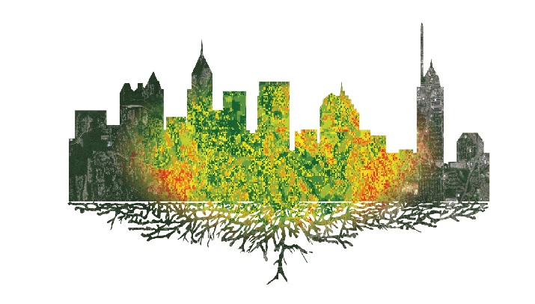

**Caption:** Landsat 8- and ASTER-based greenspace suitability analysis within metro Atlanta, Georgia. Image Credit: Atlanta Water Resources II Team.

**Image:** 2016Sum_UGA_AtlantaWaterII_VPSImage.jpg