**NASA DEVELOP National Program**

****USGS at Colorado State University

**Summer 2016**

**Short Title: Rocky Mountain Agriculture**

**Subtitle:** Utilizing NASA Earth Observations to Reconstruct and Identify Historical Forest Disturbances in the Southern Rocky Mountains for Enhanced Forest Management

**VPS Title:** Out of the Woods: Delineating Disturbances in the Southern Rockies

**Project Team & Partners**

**Project Team:**

Peder Engelstad (Project Lead), peder.engelstad@gmail.com

Christopher Beddow

Stephanie Krail

Amandeep Vashisht

**Advisors & Mentors:**

Dr. Paul Evangelista (Colorado State University, Natural Resources Ecology Lab)   
Tony Vorster (Bioenergy Alliance Network of the Rockies Feedstock Supply Team)

**Partner Organizations:**

|  |  |  |  |
| --- | --- | --- | --- |
| **Organization** | **POC (Name, Position/Title)** | **Partner Type** | **Boundary Org?** |
| National Park Service Rocky Mountain National Park (RMNP) | Hanem Abouelezz, Landscape Ecologist | End-User | No |
| Colorado Forest Restoration Institute | Dr. Tony Cheng, Director | End-User | Yes |
| Bioenergy Alliance Network of the Rockies, Feedstock Supply Team | Ryan Anderson, Research Associate | End-User | No |

**Project Details**

**Applied Sciences National Application Addressed:** Agriculture

**Study Area:** CO, WY

**Study Period:** July 1986 – August 2015

**Earth Observations & Parameters:**

Landsat 4 & 5, Thematic Mapper (TM) – Land cover

Landsat 8, Operational Land Imager (OLI) – Land cover

Shuttle Radar Topography Mission (SRTM) – Elevation, Compound Topographic Index (CTI), aspect, and slope

**Ancillary Datasets Utilized:**

* Colorado View – Colorado state boundary
* USDA Forest Service Administrative Boundaries – Map of USDA Forest Service roads
* National Park Service (NPS) shapefiles – Rocky Mountain National Park (RMNP) administrative boundary
* LANDFIRE Reference Database (LFRDM) – Forest management data
* Monitoring Trends in Burn Severity (MTBS) Project – Records of previous fires
* Bioenergy Alliance Network of The Rockies *in situ* data – Forestry field measurements, forest harvest history
* USDA National Agricultural Imagery Program (NAIP) – Classification of forest disturbances
* USDA Forest Service Aerial Surveys – Insect outbreak data; classification of disturbances

**Models Utilized:**

* Boosted Regression Trees (BRT) Classification Model
* Maximum Entropy (MaxEnt) Classification Model
* Random Forest (RF) Classification Model
* Generalized Linear Models (GLM) Classification Model
* Multivariate Adaptive Regression Splines (MARS) Classification Model

**Software Utilized:**

* ESRI ArcGIS – Raster manipulation/analysis, image processing, and map creation
* ENVI/IDL – Raster manipulation/analysis, image processing
* ERDAS IMAGINE – Classification of Landsat imagery
* LandsatLinkr – Preprocessing of Landsat imagery
* LandTrendr – Disturbance detection on a temporal scale
* PostGIS – Data table manipulation and analysis of forest disturbance classifications
* Software for Assisted Habitat Modeling (SAHM) Package – Fitting all models
* R Studio – Statistical modeling and analyses
* Google Earth Pro – Visual interpretation and qualitative assessment of historical imagery

**Project Overview**

**80-100 Word Objectives Overview:**

The project objective is to map and identify historical forest disturbance events occurring in the northern Colorado and southern Wyoming Rocky Mountains between 1986 and 2015. This project provided more complete forest disturbance records for our partners by modeling historical disturbances using Landsat imagery. Project outputs allowed partners to conduct similar analyses in the future and supported land management policy decisions. In addition, this methodology was expanded upon to analyze subtler disturbance events in National Park Service Rocky Mountain National Park (RMNP).

**Abstract:**

In recent decades, the Rocky Mountains of northern Colorado and southern Wyoming have experienced extremely high levels of forest disturbance. Methodologies for mapping and labeling disturbance and classifying historical harvest and thinning events on the landscape level have not been readily available in the past. However, recent literature has paved the way for refined approaches, such as change detection software and predictive classification models. This project provided a more complete dataset for the National Park Service Rocky Mountain National Park (RMNP), the Colorado Forest Restoration Institute (CFRI), and the Bioenergy Alliance Network of the Rockies (BANR) Feedstock Supply Team. Landsat 4 and 5 Thematic Mapper (TM) and Landsat 8 Operational Land Imager (OLI) imagery were integrated into the LandTrendr algorithm to detect magnitude, duration, and extent of past forest disturbances. A suite of classification algorithms, including the Boosted Regression Trees (BRT) and the Random Forests (RF) classification models, were used to conduct analyses at the landscape level across a temporal scale of 30 years. A labeled disturbance history, including harvest and thinning events, were provided to project partners, which filled gaps in their past records and led to enhanced decision-making in the future.

**Keywords:**

Forest Management, Timber Harvest, Thinning, Landsat, Supervised Classification, Software for Assisted Habitat Modeling, LandTrendr, Remote Sensing

**Community Concerns:**

* The Rocky Mountains of northern Colorado and southern Wyoming are experiencing extremely high levels of forest disturbance that threaten forest health.
* Partner organizations do not have a complete record of historical forest disturbances in the study area.
* Insect outbreaks of Douglas-fir beetle, mountain pine beetle, and spruce beetle have resulted in millions of acres of conifer mortality.
* The study area has experienced extensive wildfires, some with levels of fire severity high enough to limit conifer regeneration, potentially resulting in long-term cover type conversion.
* Our partners and fellow land managers are concerned with the interaction of fire, insect outbreaks, and timber harvest. Having access to more detailed disturbance history maps will further inform land management decisions.

**Current Management Practices & Policies**:

Rocky Mountain National Park (RMNP) staff currently track forest management practices in a Geographic Information System (GIS), but records going back to the year 1986 are incomplete and were not consistently collected over the past decades. RMNP has not evaluated forest treatment effectiveness within park boundaries recently. In addition, the Colorado Forest Restoration Institute (CFRI) currently relies on USDA Forest Service aerial survey data, but seeks to use additional historical data on fire and beetle outbreaks to better prepare landowners and managers for future disturbances. Finally, the Bioenergy Alliance Network of the Rockies (BANR) Feedstock Supply Team quantifies and locates live and dead forest biomass to develop short-term predictions of bark beetle outbreaks. BANR has used NASA Earth observations in past research, as well as USDA Forest Service and Colorado State Forest Service aerial detection survey data and reports. Each of these organizations lacks the finances, time, and human resource capacity to carry out an extensive study that reconstructs forest disturbance history on the landscape scale.

**Decision Support Tools & Benefits:**

|  |  |  |  |
| --- | --- | --- | --- |
| **End-Product** | **Earth Observations Used** | **Benefit & Impact** | **Software**  **Release** |
| 30-Year Categorized Disturbance History for the Study Area | Landsat 4 and 5 TM, Landsat 8 OLI | Inform partners on disturbance types and historical changes within the study area. Product will support future decision-making concerning forest management practice | 1 |
| 30-Year Categorized Disturbance History for RMNP | Landsat 4 and 5 TM, Landsat 8 OLI | Provide an informational and educational overview of specific forest disturbance types within the national park boundaries, demonstrating the capability of the models used | 1 |

**Project VPS/Booklet Imagery**

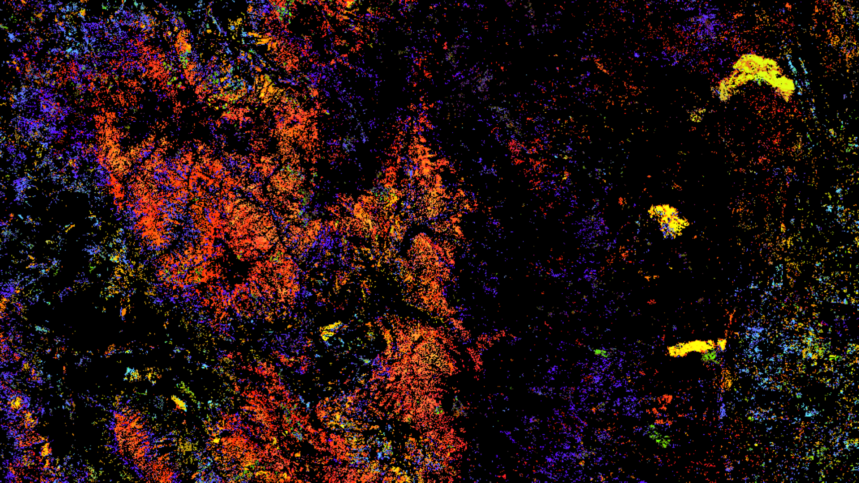

**Caption:** Imagery from Landsat 4, 5, and 8 were analyzed with LandTrendr software to create a map of disturbance events and assist in future management decisions. Image Credit: Rocky Mountains Agriculture Team.

**Image:** 2016Sum_FC_RockyMountainAg_VPSimage.jpeg