NASA DEVELOP National Program

NASA Langley Research Center
Spring 2015

North Carolina Water Resources
Utilizing NASA Earth Observations to Monitor Harmful Algal Blooms in the Albemarle Sound of North Carolina



Technical Report
Final Draft – April 2, 2015

Chad Smith (Project Lead)
Jelly Riedel
Keith Benjamin
Daniel Wozniak
Matthew Carter

Dr. Michelle Moorman & Sharon Fitzgerald, Biologist, U.S. Geological Survey
North Carolina Water Science Center

Dr. Bill Crowell, Dean Carpenter, & Jim Hawhee, Albemarle-Pamlico
National Estuary Partnership

Dr. Kenton Ross, NASA DEVELOP National Program (Science Advisor)

I. Abstract

Harmful algal blooms (HABs) cause significant ecological damage to aquatic systems by disrupting water chemistry, producing toxins, and blocking sunlight to submerged vegetation and other organisms. In the Albemarle and Pamlico Sounds, the USGS North Carolina Water Science Center monitors HABs by taking point samples throughout the region, but they lack a method to monitor the spatial extent of HABs throughout the entire sound during the year. For this project, Aqua Moderate Resolution Imaging Spectroradiometer (MODIS) Level 2 OC3M-derived chlorophyll data was downloaded from NASA Goddard Space Flight Center’s Ocean Color Website via a Linux operating system. The OC3M algorithm used multispectral reflectance bands available from Aqua MODIS to calculate the concentration of chlorophyll-a, which is used as a proxy for the presence of algae. Chlorophyll concentration values from these layers were then extracted from days with spatially and temporally corresponding in situ water samples for comparison. Then, images of monthly chlorophyll means were processed into a time-series video representation of algae extent throughout the sounds. End-users were able to use the ten year time series to supplement their in situ data to assess HAB behavior throughout the region.

Keywords
North Carolina, Remote Sensing, Harmful Algal Blooms (HAB), Albemarle Sound, Pamlico Sound, bio-toxins, submerged aquatic vegetation (SAV), Earth Observations

II. Introduction

The objective of this project was to monitor the extent of harmful algal blooms (HAB) in the Albemarle and Pamlico Sounds in North Carolina using NASA Earth observation imagery and ancillary data gathered between 2004 and 2014, and to address the Water Resources application area by giving end-users a tool to assess water quality as it related to HAB extent on a large scale.

The Albemarle and Pamlico Sounds are part of the Albemarle-Pamlico Estuarine Complex, the largest lagoonal estuarine system in the United States. This system receives drainage from approximately 30,000 square miles of watershed including discharge from the Chowan, Roanoke, Pasquotank, Neuse, and Tar-Pamlico Rivers (EPA, 2007). As the nation’s second largest estuary, the Albemarle-Pamlico system supports a diverse sea grass and submerged aquatic vegetation (SAV) population as well as rich fishery characterized by a mix of estuarine and pelagic species (Mallin et al., 2008). SAV plays a vital role in the sound by providing habitats for fish and aquatic invertebrates (Paerl, H.W. and T.G. Otten, 2013). The biodiversity and overall health of the estuary has become compromised over recent decades due to increased urbanization and industrialization in response to rapid population growth along the North Carolina coast. In addition, shifting agricultural interest during the 1980s led to a decline in tobacco farming which was promptly succeeded by an expansion of commercial swine production (Mallin et al., 2008). Together, these activities have increased the introduction of chemical and physical stressors from urban and agricultural runoff into the delicate estuarine ecosystem (EPA, 2007). Excessive eutrophication from anthropogenic sources have altered natural relationships between primary producers and have created an optimal environment for Harmful Algal Bloom (HAB) activity (Paerl, H.W. and T.G. Otten, 2013; Fu et al., 2012).

Harmful phytoplankton are capable of producing neurotoxins and hepatotoxins in concentrations lethal to wildlife and domestic animals (Lopez et al., 2008; Mallin et al., 2008). They can also manufacture endotoxins and dermatotoxins, causing serious irritation and various sublethal effects (Clercin, 2012). Humans who inhale toxins that HABs release into the air, drink water contaminated by HABs, or eat affected fish or shellfish may manifest gastrointestinal, neurological, dermal, or respiratory symptoms varying in severity from mild to fatal depending on the amount and type of HABs present (Seltenrich, 2014; Trevino-Garrison, 2015). While only certain species of phytoplankton produce deadly chemicals, all HABs deplete dissolved oxygen, alter water chemistry, and prevent sunlight from reaching the bottom of the sound (Paerl, H.W. and T.G. Otten, 2013).

Between 2004-2014, the state of North Carolina performed limited monitoring of HABs in the Chowan and Pasquotank rivers, and routinely monitored Chlorophyll-a on a monthly basis at stations in the Albemarle Sound. Nearly a quarter of water samples conducted by North Carolina’s Water Science Center during the summer of 2012 contained dangerous, toxin-producing phytoplankton. Several species of Anabaena, Anabaenopsis, Aphanizomenon, Aphanocapsa, Microcystis, Pseudanabaena, and the particularly aggressive Cylindrospermopsis raciborskii were detected. The synergistic effect of nutrient pollution and reduced light availability in the water column has caused damage to previously healthy areas of SAV throughout the Albemarle and Pamlico Sounds (Mallin et al., 2008).
The USGS North Carolina Water Science Center and the Albemarle-Pamlico National Estuary Partnership are interested in a 10-year history of algal bloom activity throughout the estuary system for the identification of patterns in HAB extent as it related to seasonal and climatic fluctuations. They will use the results of this project to expand their current knowledge of HABs and later predict HAB extent with through statistical modeling.

III. Methodology

Data Acquisition:

This project used Aqua Moderate Resolution Imaging Spectroradiometer (MODIS) ocean color products to represent algae extent throughout the Albemarle-Pamlico Estuary. Aqua MODIS Level 2 daily swath data was downloaded from NASA Goddard Space Flight Center’s Ocean Color Website using a Linux operating system.

In situ water quality data was provided by Michelle Moorman from the USGS North Carolina Water Science Center. Additional water quality data was downloaded from the National Water Quality Monitoring Council website along with water sampling station coordinates.

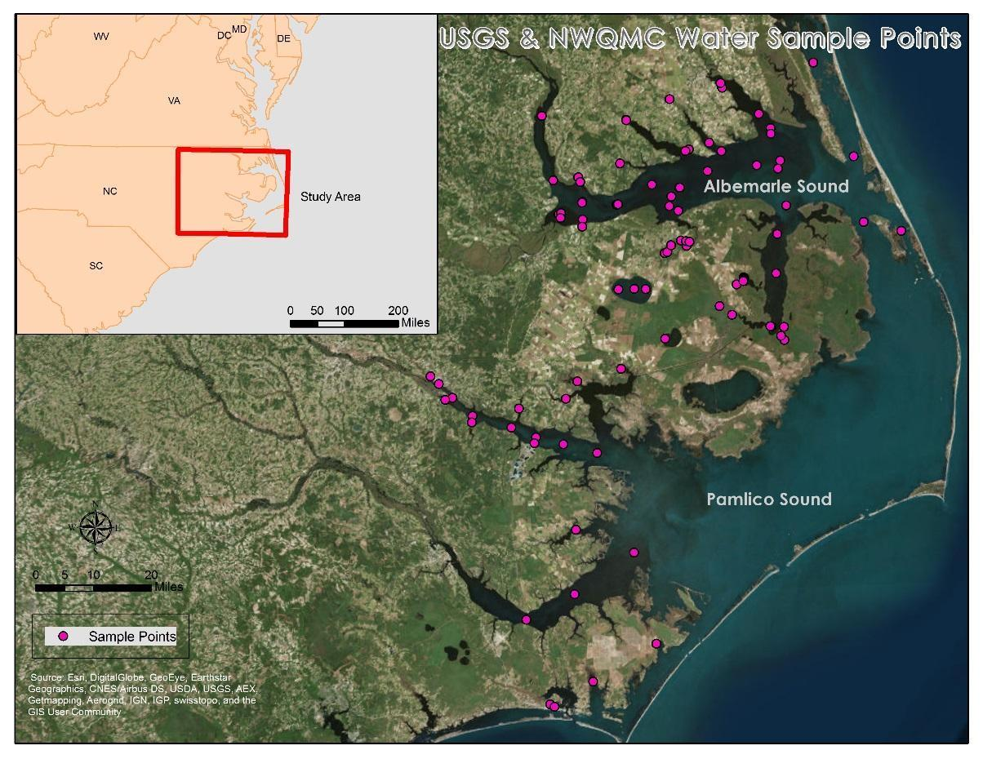
Figure 1: Location of sampling sites in the Albemarle-Pamlico Sound
Data Processing:

Originally, level 2 swath daily ocean color data were downloaded from NASA Goddard Space Flight Center’s Ocean Color Website from January 2004 to December 2014. These data layers were reduced to a study area bounding box with the geographic extent: -36.4 N, -34.9 S, -77.1 E, and -75.4 W. Any image that did not at least capture the entire bounding box was rejected to prevent inclusion of partial images.

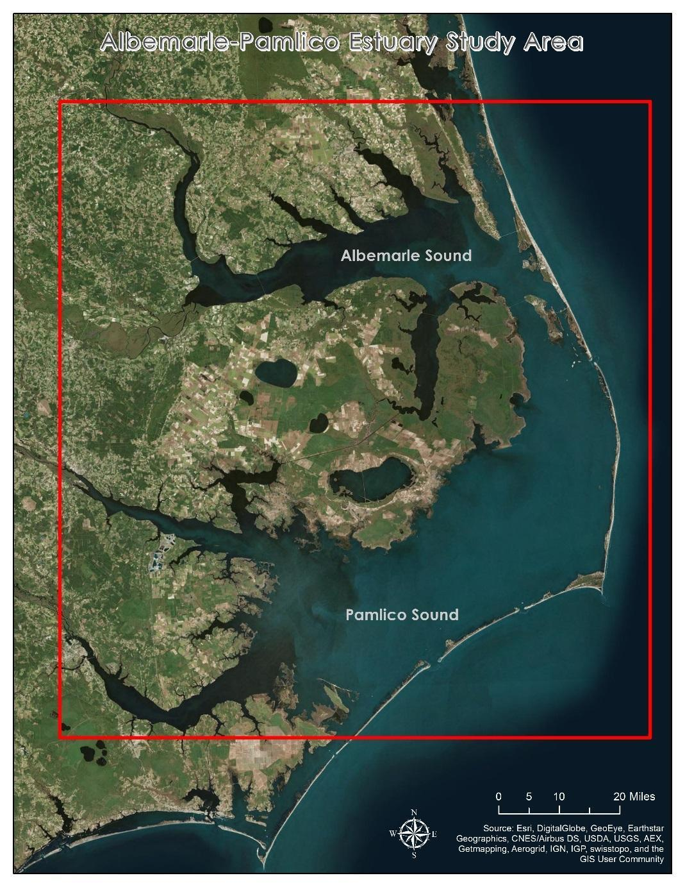
Figure 2: Study Area: the Albemarle and Pamlico Sound

Then, all layers were reprojected using SeaDAS from their original sinusoidal form to the projected coordinate system, NAD 1983 State Plane North Carolina FIPS 3200. In SeaDAS, the standard OC3M algorithm was applied to produce a chlorophyll result layer for each of the day in the data set. The OC3M algorithm, shown in Figure 3, uses reflectance values from MODIS band wavelengths 443, 489, and 547. The blue wavelength is represented by the greater R_{rs} value from the 443 or 489 bands, and the green wavelength is represented by R_{rs} from the 547 band. The results were saved as GeoTIFF files and exported for use in ESRI ArcGIS software.

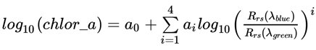
Figure 3: The standard OC3M algorithm

Using ESRI ArcMap, the OC3M calculated chlorophyll layer was separated from each daily multispectral composite file and copied to a new single layer raster file. These rasters were further processed using a Python script to automate the clip, resample, and rectify tool in ArcMap to ensure uniform image extent and pixel size.

A single composite table was created using Excel to list all in situ sample dates, latitude coordinates, longitude coordinates, and chlorophyll-a concentrations for use in SeaDAS to extract MODIS chlorophyll pixel values for comparison. MODIS Chlorophyll values were extracted at station locations from images acquired within one day of in situ sample date.

Daily chlorophyll levels can vary greatly from day-to-day. Therefore, in order to visualize long-term chlorophyll trends over the ten year study period, monthly mean chlorophyll concentrations were calculated using a Python script. This was done by taking a mathematical average of collocated pixel values for a one month period while filtering out images with ‘no data’ pixel values.

A detailed tutorial containing instructions on how to install and operate the SeaDAS system in a Linux environment is included in the Appendices section of this paper.
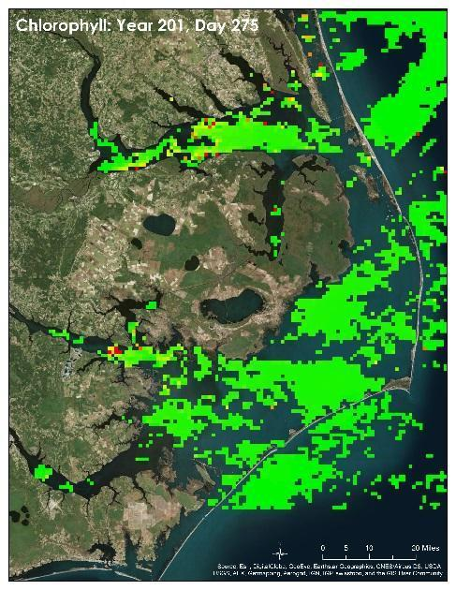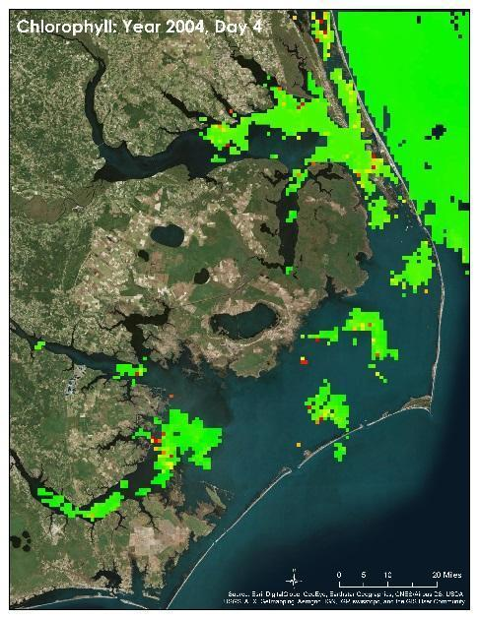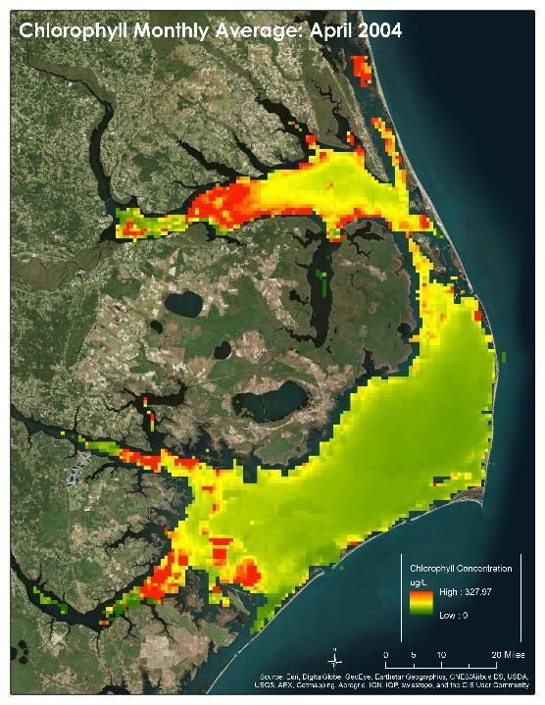
Figure 4: Top: Two daily images, shown here to illustrate day-to-day chlorophyll data variation.
Bottom: April 2004’s monthly chlorophyll average.
Data Analysis:

There were a total of 4,405 daily MODIS image files relevant to the study timeframe and location. Many in situ sample points occurred on a date and/or location that was not coincident with a MODIS image pixel; therefore, the values from these samples were not considered in analysis. Of 3,135 total in situ chlorophyll sample points taken during the study period within the bounding box, only 628 sample values were compared to MODIS-derived chlorophyll concentrations. This was simply the total number of in situ samples in the area that satisfied the conditions of being performed within a day of MODIS image acquisition, and having occurred at a location represented by a MODIS image pixel containing a valid chlorophyll concentration value. To measure how well MODIS-derived chlorophyll concentrations fit the in situ measurements, the Pearson’s correlation coefficient was calculated using Excel’s CORREL function. This value was then squared to find the coefficient of determination, or R² value. Additionally, the mean squared error was calculated to measure error between the chlorophyll values.

IV. Results & Discussion

Analysis of Results:

From this project’s analysis, it is determined that Aqua MODIS satellite imagery does not provide an accurate way of determining chlorophyll concentrations in the complex coastal waters of the Albemarle and Pamlico Sounds. A high mean squared error of 79.7844, and a low R² value of 0.0196 percent revealed no correlation between the two sets of chlorophyll concentrations. A plot of in situ data versus MODIS data shows the poor relationship visually.
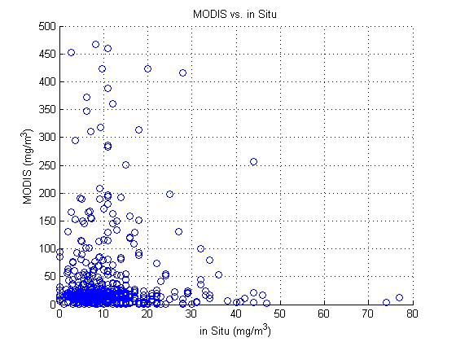
Figure 5: Scatterplot of Chlorophyll Values

Errors & Uncertainty:

Chlorophyll has been widely used with success to track the spatial extent of algae in many parts of the world. While chlorophyll levels are associated with all types of phytoplankton and algae, chlorophyll is not a direct indicator of a HAB (Siswanto, 2012). Since the OC3M algorithm used to calculate chlorophyll was developed from global in situ data from various coastal regions and oceans, it may not be the optimal algorithm for calculating chlorophyll concentrations in the Albemarle-Pamlico Estuary. Recent research has revealed that the accuracy of chlorophyll analysis in optically complex waters is greatly dependent upon the availability of specific algorithms developed in the region or water body of interest (Cannizzaro, J. P. and K. L. Carder, 2006). Other research has found that the MODIS sensor is not able to accurately detect algae or cyanobacteria. MODIS does not have spectral bands covering 620-650 nm or around 700 nm, which are the best for detecting phycocyanin and chlorophyll in eutrophic waters, respectively. Detecting ocean color in these wavelengths may only happen when chlorophyll concentrations are very high (Reinart, A. and T. Kutser, 2006). Additionally, the presence of total suspended matter (TSM), common in optically complex coastal waters, can be associated with reduced blue-green reflectance ratios which result in artificially inflated chlorophyll levels for those areas (Siswanto, 2012).

The OC3M algorithm is used for calculating near-surface chlorophyll (O’Reilly, J. et al., 2000). Water samples conducted by USGS and occurred at varying depths beneath the water surface. The water sample data downloaded from the National Water Quality Monitoring Council website did not contain information regarding sampling depth. Since the vast majority of all in situ data did not include sample depth information, all sample points were considered in the analysis. This sampling difference may contribute to the poor correlation between the two sets chlorophyll concentrations. Furthermore, there are inherent problems associated with collecting in situ water sample data that may have further contributed to the lack of correlation between the MODIS chlorophyll concentrations and water sample data. The act of water sampling from research vessels, whether performed with flow-through systems or surface grabs, can disturb the natural distribution of algae and cyanobacteria. This means that some in situ results may not represent real water conditions (Kutser, T. et al., 2006).

V. Conclusions

Future Work:

Although corollary confidence is low, further analysis can be done using the data collected from this project to produce a more refined analysis of algae extent throughout the study area. The possibility remains for the application of alternative algorithms or estuary-specific algorithms based on other available reflectance bands from MODIS or other sensors to give an accurate representation of the HAB events plaguing the Albemarle-Pamlico Estuary system. Future work could incorporate established processes to detect the cyanobacterial pigment, phycocyanin, as a way to monitor HABs (Vincent, R. et al., 2004). Bio-optical modelling of selected species of algae and cyanobacteria in differing types of water show great variance in their reflectance properties. For example, the cyanobacteria Aphanizomenon and Anabena along with algae species such as Scenedesmus and Chroomonas show greatest reflectance percentage in coastal waters around the 675 nm range. In open water, these species showed a reflectance peak closer to 550 nm (Kutser, T. et al., 2006). Knowledge of the dominant taxa present throughout the Albemarle-Pamlico Estuary and their reflectance characteristics in optically complex coastal waters will be vital to determining which sensors and algorithms are most useful to detect HABs in the area.

VI. Acknowledgments
- Dr. Kenton Ross - National Program Science Advisor
- Jeffrey Ely - Geoinformatics Scientist
- Nathan Owen - Center Lead

This material is based upon work supported by NASA through contract NNL11AA00B and cooperative agreement NNX14AB60A.

VII. References

(2007). National Estuary Program Coastal Condition Report, Chapter 4: Southeast National Estuary Program Coastal Condition, Albemarle-Pamlico National Estuary Program, Environmental Protection Agency: 202-211.

Cannizzaro, J. P. and K. L. Carder (2006). "Estimating chlorophyll a concentrations from remote-sensing reflectance in optically shallow waters." Remote Sensing of Environment 101: 13-24.

Clercin, N. (2012). Cyanobacteria and their Toxins: Real Concern or Just Green Water? Indiana Watersheds Webinar Series: Sharing experiences and ideas to strengthen watershed management, Purdue University College of Engineering.

Fu, F. X., et al. (2012). "Global change and the future of harmful algal blooms in the ocean." Marine Ecology Press Series 470: 207-233.

Kutser, T. et al. (2006). “Monitoring Cyanobacterial Blooms by Satellite Remote Sensing.” Estuarine Coastal and Shelf Science 67: 303-312.

Lopez, C. B., et al. (2008). Scientific Assessment of Freshwater Harmful Algal Blooms. Washington, DC., Interagency Working Group on Harmful Algal Blooms, Hypoxia, and Human Health of the Joint Subcommittee on Ocean Science and Technology.

Mallin, M., et al. (2000). "North and South Carolina Coasts." Marine Pollution Bulletin 41(1-6): 56-75.

O'Reilly, J.E., et al. (2000) “SeaWiFS Postlaunch Calibration and Validation Analyses, Part 3.” NASA Tech. Memo. 2000-206892, Vol. 11, S.B. Hooker and E.R. Firestone, Eds., NASA Goddard Space Flight Center, 49 pp.

Paerl, H. W. and T. G. Otten (2013). "Harmful Cyanobacterial Blooms: Causes, Consequences, and Controls." Environmental Microbiology 65: 995-1010.

Reinart, A. and T. Kutser (2006). “Comparison of different satellite sensors in detecting cyanobacterial bloom events in the Baltic Sea.” Remote Sensing of the Environment 102: 74-85.

Seltenrich, N. (2014). "Keeping tabs on HABs: New Tools for Detecting, Monitoring, and Preventing Harmful Algal Blooms." Environmental Health Perspectives 122(8): A206-A213.

Siswanto, E., et al. (2013). “Detection of harmful algal blooms of Karenia mikimotoi using MODIS measurements: A case study of Seto-Inland Sea, Japan.” Remote Sensing of the Environment 129: 185-196.

Trevino-Garrison, I., et al. (2015). "Human Illnesses and Animal Deaths Associated with Freshwater Harmful Algal Blooms—Kansas." Toxins 2015 7: 353-366.

Vincent, R. et al. (2004). “Phycocyanin detection from LANDSAT TM data for mapping
cyanobacterial blooms in Lake Erie.” Remote Sensing of the Environment 89: 381-392.

VIII. Appendices

DATA PROCESSING TUTORIAL
Tested with version 14.04.2LTS

- Install Linux

  - http://www.ubuntu.com/download/desktop/

    - USB
http://www.ubuntu.com/download/desktop/create-a-usb-stick-on-windows

    - Local
      - Boot from USB
      - Install to local disk

    - Portable HDD
      - Boot from USB
      - Connect portable HDD
      - Install to HDD
      - Track booting options
NOTE: Pay attention to your computer’s startup sequence. It may not be set to automatically boot from an external drive and may require an escape sequence during startup, such as pressing F12 or DEL.

- System Setup
NOTE: The process below should be helpful in setting up a new system new Linux system to run SeaDAS. Placing the URLs for Java, SeaDAS and the install-ocssw.py tool into a text file and running the installation script should automate the process.

  - Java – tested with version 8.31
    - https://java.com/en/download/
    - Ubuntu requires the non-RPM file
      - http://javadl.sun.com/webapps/download/AutoDL?BundleId=104760
    - Install Java
NOTE: The Linux system is case-sensitive all files and commands must be issued as demonstrated in this tutorial to be effective

      - Open xterm
      - Click on the Search Your Computer and Online Resources button. Enter xterm in the search box and select xterm
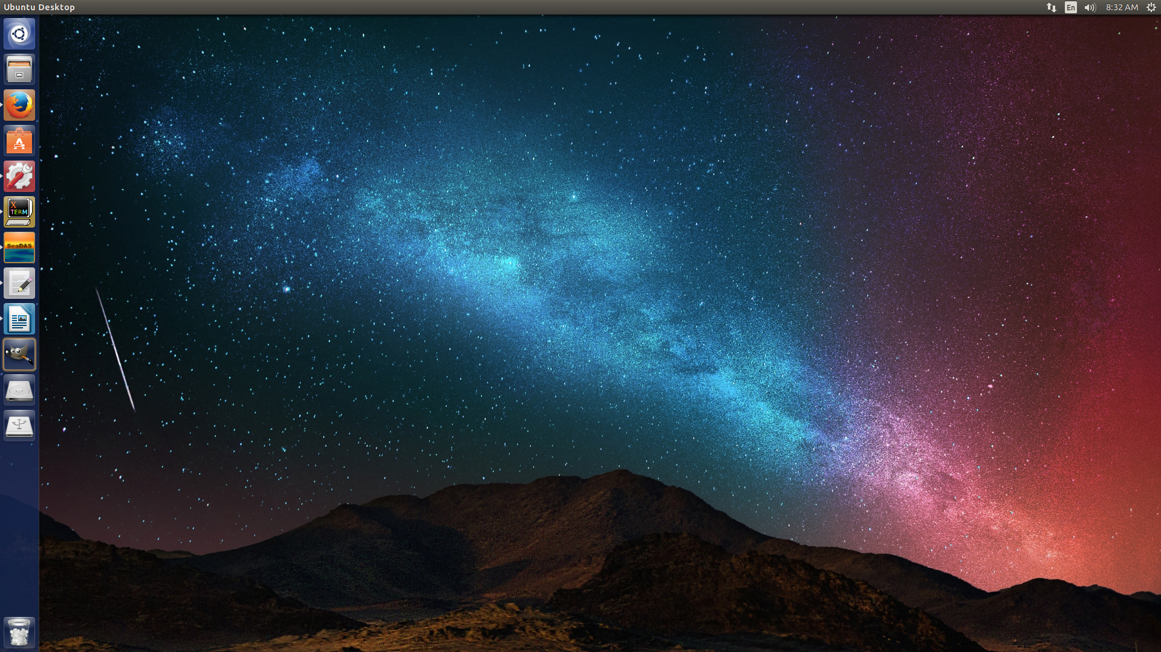
      - Type the following commands into the command line (run script as an alternate)
        - sudo apt-get install g++ -y
        - sudo apt-get install gfortran –y
        - sudo apt-get install git –y
        - sudo apt-get install curl –y
        - mkdir /usr/java
        - cd /usr/java/
        - move file to /usr/java
        - tar zxvf javaFile.tar.gz
        - rm javaFile.tar.gz

  - SeaDAS – Tested with seadas_7.1_linux64_installer.sh
    - http://seadas.gsfc.nasa.gov/
http://oceandata.sci.gsfc.nasa.gov/SeaDAS/installer/7.1/seadas_7.1_linux64_installer.sh
http://oceandata.sci.gsfc.nasa.gov/ocssw/install_ocssw.py
    - Back in xterm
      - sudo sh ./seadas_7.1_linux64_installer.sh
      - sudo export PATH=/usr/local/seadas-7.1/bin:$PATH

  - Start SeaDAS
    - Install processors
      - Click DataProcessing > Update OC Processors
      - Verify install directory
        - should be /usr/local/seadas-7.1/ocssw

      - Select “Processors” (i.e. Mission Data)
        - aqua in this case
        - “Clean Install” will remove all previous installations of selected processors. Source code, evaluation data files, and clean install are not required on initial installation

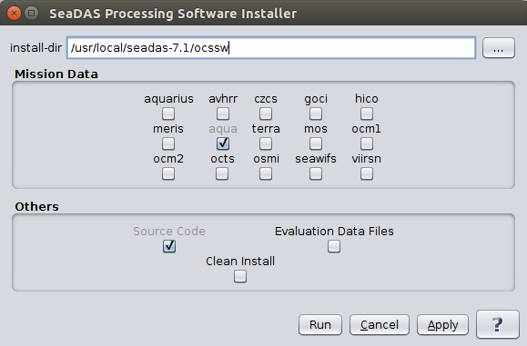

  - Acquire Datasets
    - http://oceancolor.gsfc.nasa.gov/cms/
    - Click “Data Access”
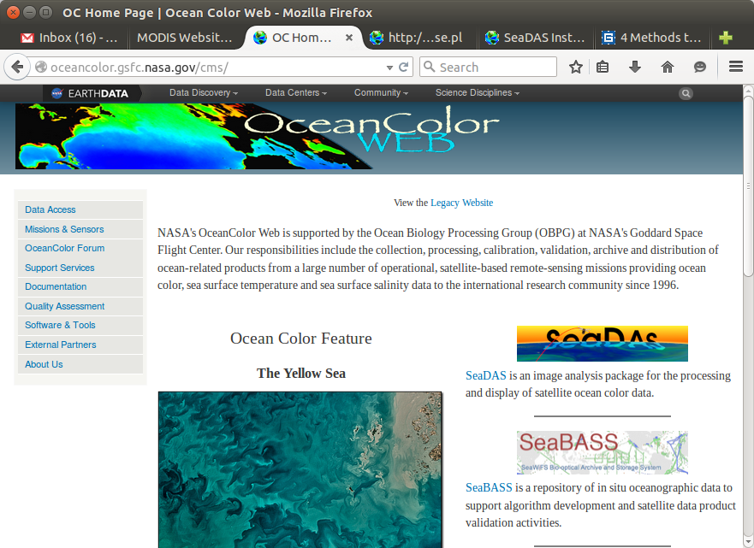

    - Click “Level 1&2 Browser”
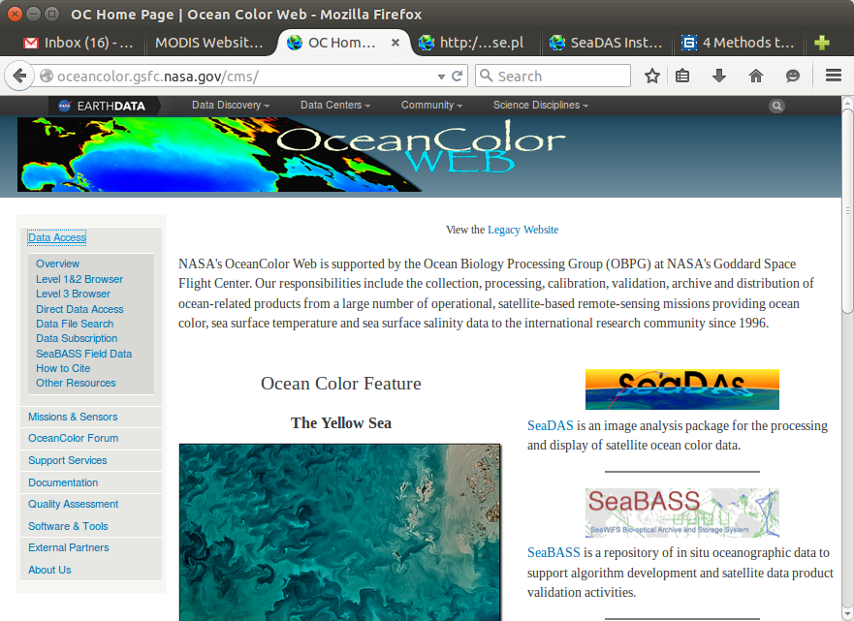

    - Select Sensor, Input Coordinates, Timeframe, and Swath Extent
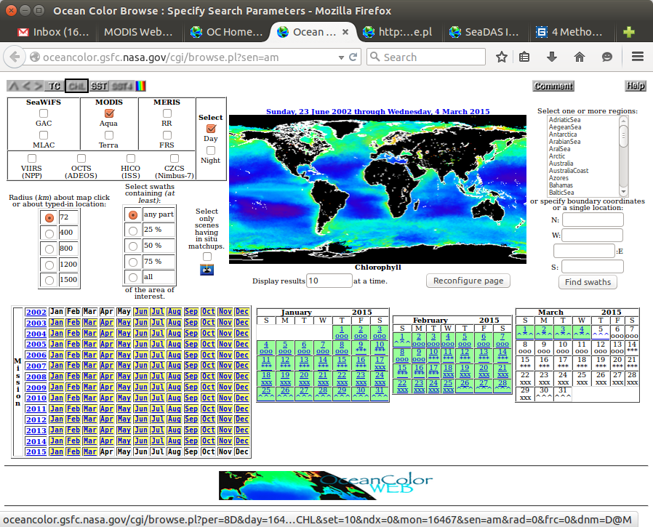

    - Click “Order Data”
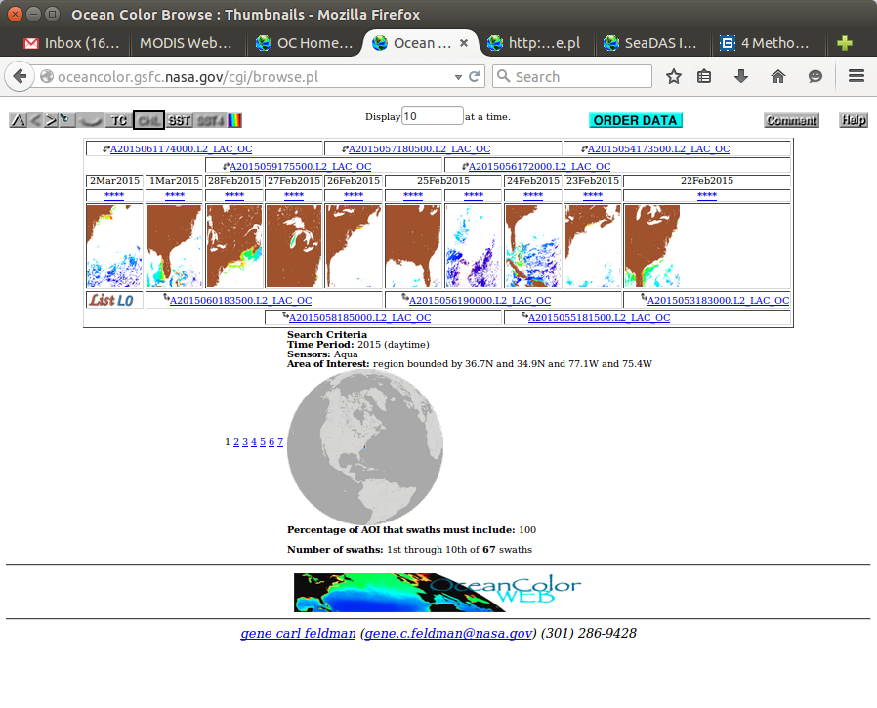

    - Enter email, do (not) extract, Level desired (level 2 OC for this example), click “Review Order”
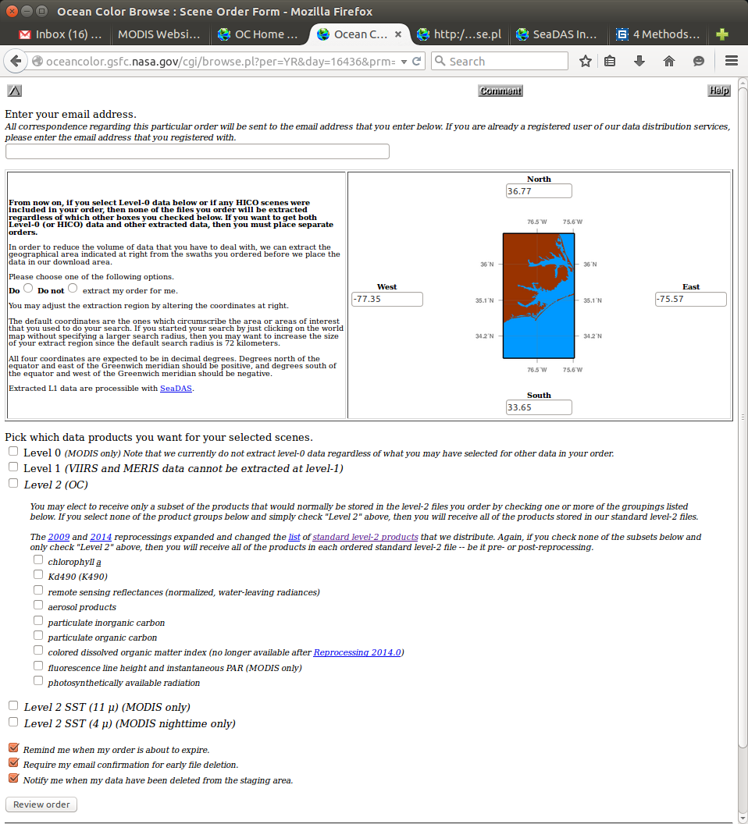

    - Review and Click “Submit Order”
NOTE: The Level 1/2 Browser does not always process very large data sets very well. If an order submission returns an error page, perform multiple file searches and combine all file lists into one file for processing. Alternatively, this web on which the Submit Button is located can be processed for the downloading file list using the processSubmissionPage script.

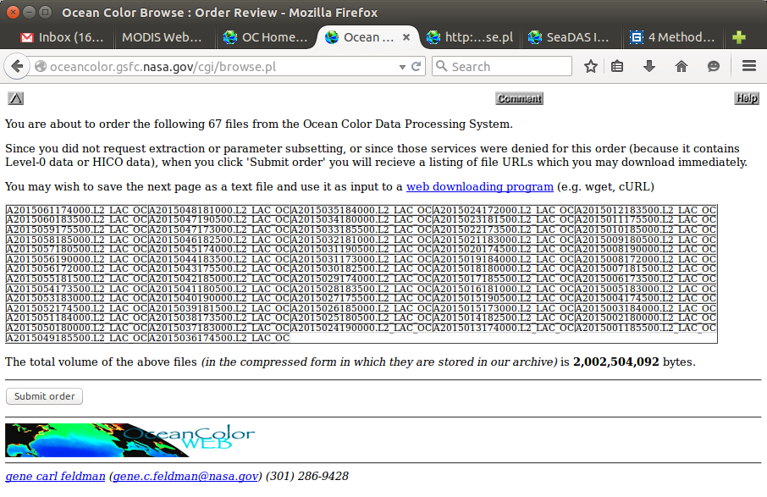

    - Select All (Ctrl+A) the file list in the web page and Copy (Ctrl+C)
    - Open the File Browser

    - Navigate to Downloads
    - Right Click in the open space > New Document > Empty Document
    - Give the document the names “dlFiles.” (The filename can be anything but is specified here for the purposes of this tutorial.)

    - Copy the runParams.xml and process.bash files into the Downloads directory
Note: The process.bash, runParams.xml, and dlFiles file can be placed in any user directory. The only requirement is that the process.bash file is run from a Linux directory as running executable files from a mounted drive is not always possible. Relative file descriptors are allowed on all files unless located in different directories. It is always safest to use absolute paths.

Relative Path:
“./” denotes the current working directory

“../” denotes the one directory higher in the files structure

“~/” refers to a users home directory. Can typically be used as a base reference.

Absolute Path:
Begins with “/” and denotes a reference location beginning with the root directory.

    - Return to xterm.
    - Navigate to Downloads
      - cd ~/Downloads
      - chmod 777 ./process.bash
      - ./process.bash ./dlFiles ./runParams.xml GeoTIFF ~/Downloads/processedFiles
process.bash downloads the files listed in ./dlfiles, processes them with gpt.sh using the parameters specified in ./runParams.xml, outputs the files in GeoTIFF format, and places all the processed files in the ~/Downloads/processedFiles directory. NOTE: the script will create the processedFiles directory if it does not already exist.
3. gpt.sh
gpt.sh is the command line interface for most of the standard SeaDAS processing tools. As such, scripts can be written to batch process large quantities of data without having to use the SeaDAS GUI which does not always provide a streamlined way to process multiple files. The list of available gpt functions is available through out the command line interface by issuing “gpt.sh”. Furthermore, information on the options available for individual tools is available by issuing “gpt.sh {toolName} -h”. For example, “gpt.sh Write -h” will display not only all of the command line options for the Write function, but also the xml script options available for that module.

If the linux/SeaDAS system installation script ran properly, the gpt.sh script can be called from any directory. If, however, the environment variables did not properly update then you must either navigate to the “/usr/local/seadas*/bin” directory or call the file using “/usr/local/seadas*/bin/gpt.sh”.

gpt.sh XML Run Parameters:

The gpt.sh shell script allows the user to string together multiple modules for streamlined image processing. The SeaDAS GUI and gpt.sh shell program provide the same features, however, only certain modules in the GUI are capable of batch processing multiple files. By using the XML scripting language, users can accomplish this batch process functionality for all processing modules in addition to multi-module processing. This is accomplished by passing the source file into the script using -Ssource={filename} at the command and <source>${source}</source> line in the first module of the XML parameters file. Stringing processing modules is accomplished by pointing subsequent “source” sections to the previous module name. An example is provided in the runParams.xml section below.

NOTE: Reprojection must occur before sub setting. Reversing these modules can cause output but that output will not be processed properly.

TIP: Several processors in SeaDAS provide the XML parameters in an easy to copy fashion. For instance, the Reprojection processor in the SeaDAS GUI allows you to easily input your desired input/output parameters; then selecting Help>Display Parameters will display function XML code for you that can be copied and pasted directly into your XML script for command line processing with little to no adjustments. This is particularly helpful when inputting standard CRS parameters for reprojecting to a different coordinate system or when learning the system in general.

#!/bin/bash
# ============================================================================ #
#
# DO NOT EDIT THE #!/bin/bash LINE WITHOUT PURPOSEFULLLY CHANGING THE SHELL
# #!/bin/bash MUST REMAIN IN LINE 1
#
# File: install.bash
# Created on: 12 March 2015
# Last Updated: 31 March 2015
#
# Author: Keith Benjamin
# Commissioner: SSAI Inc. for NASA DEVELOP
#
# Description: This script will install Java, SeaDAS, and the MODIS Aqua data
# processors on an Ubuntu Linux distribution.
#
# Command Line Arguments:
# 1:Download Links file - use for Java, SeaDAS, and Install-OCSSW
#
# REQUIREMENTS: This script requires superuser privileges to run. If you do
# not have superuser access seek guidance from a system
# administrator. If this is a new installation of Linux, the
# "sudo -i" command should give you the required access. On
# a fresh Ubuntu installation the password should be blank
# unless one was created during installation.
#
# WARNING: Operating as the system superuser is considered dangerous and
# can cause system corruption. This script has, however, been
# tested under these conditions and works appropriately at
# the time of its creation.
#
# Specifics: This installation script is designed to work on the Ubuntu
# Linux distribution. It can be updated to fit other
# distributions since it runs in the bash shell but will require
# changing/removing the apt-get and /etc/environment lines/blocks
# as these programs and environment variables are distribution
# dependent and not guaranteed across all platforms.
#
# The program will read URLs from an input file, download the
# links and install the files. The only programs expected are
# java, seadas, and install-ocssw. The java download section
# expects a file beginning with "Auto" as that was Sun Microsystems
# naming convention at the time this script was generated.
# Similarly, the SeaDAS section expects a file beginning with
# seadas. The wildcard(*) in the filenames throughout this script
# are meant to handle newer versions of released software from
# Sun Microsystems and SeaDAS. DO NOT change the download filenames
# to include wildcards.
#
# Other Information:
# The program specifications have been made as general as
# possible but script operability is expected to degrade with
# time.
# ============================================================================ #

if test -z $1
then echo "No Command Line Arguments"
exit
fi

#sudo -i
#su

# Installing Needed System Components #
apt-get install g++ -y
apt-get install gfortran -y
apt-get install git -y
apt-get install curl -y

cd /tmp

# Downloading Links #
while read -r m; do
wget -v $m
done < $1

# Installing Java #
mkdir /usr/java # Create a directory for Java
cd /usr/java # Move to the Java directory
tar zxvf /tmp/Auto* # Extract Java
rm /tmp/Auto* # Remove Java installation file
cd /usr/java/jre*/bin # Move to Java's bin directory
pwd > /tmp/environment # Push Java path to environment temporary

# Installing SeaDAS #
sh /tmp/seadas* # Run SeaDAS installation script
rm /tmp/seadas* # Remove SeaDAS installation file
cd /usr/local/seadas*/bin # Move to SeaDAS's bin directory
pwd >> /tmp/environment # Push SeaDas path to environment temporary

# Exporting environment temporary to PATH #
# This block finds the java/bin and seadas/bin paths and exports them
# to the environment startup file. This will make Java and SeaDAS
# available for access from any location on the command line. It should
# not require augmentation
while read -r m; do
export PATH=$PATH:$m
done < /tmp/environment

cd /usr/local/seadas*/
pwd > /tmp/environment
while read -r m; do
export SEADAS=$m
done < /tmp/environment

# Writing PATH to global environment - makes PATH persistent through reboots #
echo "PATH=\""$PATH\" > /etc/environment

# Installing SeaDAS processor #
# Processor installation options are available at:
# http://seadas.gsfc.nasa.gov/installers/
# Alternatively, OC processors can be installed from within the SeaDAS
# environment by selecting DataProcessing>Update OC Processors
chmod 111 /tmp/install_ocssw.py
/tmp/install_ocssw.py --install-dir=$SEADAS/ocssw --aqua
rm /tmp/install*

#!/bin/bash
# ============================================================================ #
#
# DO NOT EDIT THE #!/bin/bash LINE WITHOUT PURPOSEFULLLY CHANGING THE SHELL
# #!/bin/bash MUST REMAIN IN LINE 1
#
# File: process.bash
# Created on: 12 March 2015
# Last Updated: 31 March 2015
#
# Author: Keith Benjamin
# Commissioner: SSAI Inc. for NASA DEVELOP
#
# Description: Downloads a URL listing, decompresses the files, and
# processes the according to the gpt.sh parameters supplied
#
# Command Line Arguments:
# 1: Download File
# 2: XML Parameters File
# 3: Output File Format
# GeoTIFF and HDF5 are the most common
# 4: Output Directory
# Use absolute path (Not required?)
#
# Specifics: This script uses commonly available Linux tools (wget and bzip2)
# in conjunction with the SeaDAS command line tool gpt.sh to
# process satellite data for use in other software packages.
#
# Other Information:
# | Known as a 'pipe'. Takes the output from the left-hand-side of the
# pipe and 'pipes' it to the input for the right-hand-side.
#
# > Known as a 'redirection' operator. Redirects the output designated
# for the standard output (monitor) from the left-hand-side and
# sends it to the right-hand-side. Typically this will be a file.
# NOTE: The redirection operator will overwrite the output file.
#
# >> Known as the 'append redirection' operator. It performs the same
# function as '>' but appends instead of overwriting
#
# NOTES:
# Absolute path specification is the safest way to process this script
# file. If problems occur, it is recommended to create a new directory
# native to the Linux filesystem (i.e. not located on a mounted drive),
# copy all required file (process.bash, dlFiles, and runParams.xml) into
# that directory and run from there.
#
# gpt.sh is located in the seadas/bin directory. This script will not
# run correctly if that path is not listed in /etc/environment.
#
# ============================================================================ #

# Creates the directory specified by $4 and changes to that location
mkdir $4
cd $4

# wget downloads all URLs specified
# -v Generates verbose output
# -i {file} Uses {file} as the input download list
wget -v -i $1
echo "<------------------------------------>"
echo "<------- Downloading Complete ------->"
echo "<------------------------------------>"
# Uncommenting the next line will pause the program after download completion
#read x < /dev/tty

# find lists all files in the hierarchical path
# -L tells find to follow symbolic links if present
#
# grep {arg} will extract every line from the output piped by find which
# has {arg} in
find -L | grep .bz2 > /tmp/bzipFiles

# The following code block will read an input file (in this case /tmp/bzipFiles)
# line by line and pass that line to bzip2 for decompression via the $m variable
# bzip2 is a (de)compression tool
# -d Tells bzip2 to decompress
# -v Generates verbose output
while read -r m; do
echo ""
echo "<------------------------------------------------------------>"
echo "<------- Decompressing "$m" ------->"
echo "<------------------------------------------------------------>"
bzip2 -d -v $m
done < /tmp/bzipFiles
echo "<-------------------------------------->"
echo "<------- Decompression Complete ------->"
echo "<-------------------------------------->"
#Uncommenting the next line will pause the program after decompression completion
#read x < /dev/tty
rm /tmp/bzipFiles

find -L | grep L2_LAC > /tmp/OCFiles

# The following code block will process all decompressed files with the SeaDAS
# XML parameter script.
while read -r m; do
echo ""
echo "<------------------------------------------------------>"
echo "<------- Processing "$m" -------->"
echo "<------------------------------------------------------>"
echo ""
gpt.sh $2 -Ssource=$m -PoutFile=$m -PoutFormat=$3
rm $m
done < /tmp/OCFiles
echo "<----------------------------------->"
echo "<------- Processing Complete ------->"
echo "<----------------------------------->"
#Uncommenting the next line will pause the program after processing completion
#read x < /dev/tty
rm /tmp/OCFiles

<!--
# ============================================================================ #
#
# File: runParams.xml
# Created on: 12 March 2015
# Last Updated: 31 March 2015
#
# Author: Keith Benjamin
# Commissioner: SSAI Inc. for NASA DEVELOP
#
# Description: Contains the runtime parameters required by the gpt.sh SeaDAS
# extension for processing satellite imagery
#
# Specifics:
# Other Information:
#
# NOTES:
# Reprojection must occur before subsetting
#
# ============================================================================ #
-->
<graph id="someGraph">
<version>1.0</version>

<!--===========================================-->
<!-- REPROJECTION MUST OCCUR BEFORE SUBSETTING -->
<!--===========================================-->
<node id="reprojectNode">
<operator>Reproject</operator>
<sources>
<source>${source}</source>
</sources>
<!—-
parameters can be obtained from SeaDAS by selecting
Processing>Reproject>Reprojection Parameters>Predefined CRS>Select
The WKT information can then be copied and pasted directly into this script
file by overwriting the information between the <crs></crs> tags.
-->
<parameters>
<crs>PROJCS["NAD83 / North Carolina",
GEOGCS["NAD83",
DATUM["North American Datum 1983",
SPHEROID["GRS 1980", 6378137.0, 298.257222101, AUTHORITY["EPSG","7019"]],
TOWGS84[0.0, 0.0, 0.0, 0.0, 0.0, 0.0, 0.0],
AUTHORITY["EPSG","6269"]],
PRIMEM["Greenwich", 0.0, AUTHORITY["EPSG","8901"]],
UNIT["degree", 0.017453292519943295],
AXIS["Geodetic longitude", EAST],
AXIS["Geodetic latitude", NORTH],
AUTHORITY["EPSG","4269"]],
PROJECTION["Lambert_Conformal_Conic_2SP", AUTHORITY["EPSG","9802"]],
PARAMETER["central_meridian", -79.0],
PARAMETER["latitude_of_origin", 33.75],
PARAMETER["standard_parallel_1", 36.166666666666664],
PARAMETER["false_easting", 609601.22],
PARAMETER["false_northing", 0.0],
PARAMETER["scale_factor", 1.0],
PARAMETER["standard_parallel_2", 34.333333333333336],
UNIT["m", 1.0],
AXIS["Easting", EAST],
AXIS["Northing", NORTH],
AUTHORITY["EPSG","32119"]]
</crs>
<resampling>Nearest</resampling>
<orthorectify>false</orthorectify>
<noDataValue>NaN</noDataValue>
<includeTiePointGrids>true</includeTiePointGrids>
<addDeltaBands>false</addDeltaBands>
</parameters>
</node>

<node id="subsetNode">
<operator>Subset</operator>
<sources>
<source>reprojectNode</source>
</sources>
<parameters>
<geoRegion>
<!--
RECTANGLE could have also been used. The only requirement
is that the boundary begins and ends at the same location.
POLYGON allows more complex shapes than does RECTANGLE.
Nodes must be comma delimited and long/lat must be space delimited
-->
POLYGON(( -77.1 36.4, <!-- NW Corner -->
-77.1 34.9, <!-- SW Corner -->
-75.4 34.9, <!-- SE Corner -->
-75.4 36.4, <!-- NE Corner -->
-77.1 36.4 <!-- NW Corner --> ))
</geoRegion>
<!—
DO NOT place bandNames on separate lines as was done with POLYGON above
All layers designated for extraction must be comma delimited without
spaces and the name must match that which is in the file metadata and are
case sensitive. BandNames listed as they appear in the SeaDAS file manager
should be acceptable.
-->
<bandNames>chlor_a,Rrs_412,Rrs_443,Rrs_469,Rrs_488,Rrs_531,Rrs_547,
Rrs_555,Rrs_645,Rrs_667,Rrs_678,longitude,latitude</bandNames>
<copyMetadata>true</copyMetadata>
</parameters>
</node>

<node id="writeNode">
<operator>Write</operator>
<sources>
<source>subsetNode</source>
</sources>
<parameters>
<file>${outFile}</file>
<formatName>${outFormat}</formatName>
<deleteOutputOnFailure>true</deleteOutputOnFailure>
<writeEntireTileRows>true</writeEntireTileRows>
<clearCacheAfterRowWrite>true</clearCacheAfterRowWrite>
</parameters>
</node>
</graph>

