Grand Canyon Water Resources
Employing Landsat to Model Availability of Ephemeral Water Sources and Vegetation Change in Support of a USGS Feasibility Assessment and Management Strategy of Bison


Technical Report
Final Draft – August 9th, 2018

Jillian LaRoe (Project Lead)
Tim Mayer
Shaunie Rasmussen
Mikhail Schee
Griffin Shelor

Dr. Paul Evangelista, Colorado State University, Natural Resource Ecology Laboratory (Science Advisor)
Nicholas Young, Colorado State University, Natural Resource Ecology Laboratory (Science Advisor)
Tony Vorster, Colorado State University, Natural Resource Ecology Laboratory (Science Advisor)
Brian Woodward, Colorado State University, Natural Resource Ecology Laboratory (Science Advisor)

1. Abstract
The United States Geological Survey (USGS) and National Park Service (NPS) are concerned by the increasing Kaibab Plateau bison population on the North Rim of Grand Canyon National Park (GRCA). Currently, within the park’s boundaries, the bison have no predators and hunting is prohibited, resulting in an increasing bison population. This growing population has led to significant impacts on resources such as vegetation, water resources, soils, and archaeological sites from extensive grazing, trampling, and wallowing behavior. Wallowing, or the act of bathing in dust or loose soil to deter insects, is one of the chief concerns of the NPS because continuous wallowing slows the recovery of vegetation in arid environments. The NPS is tasked with sustaining the health of the park for future generations, but there is limited information available to quantify the impacts of bison. This study utilized NASA Earth observation data from Landsat 5 Thematic Mapper (TM), Landsat 7 Enhanced Thematic Mapper (ETM+), Landsat 8 Operational Land Imager (OLI), and the European Space Agency’s Sentinel-2 MultiSpectral Instrument (MSI) to analyze the changes in vegetation and water resources before and after intensive bison activity. Shuttle Radar Topography Mission (SRTM) version 3 data were paired with additional spectral information to model impacted resources for comparison with potential bison distribution. Final maps of water availability, vegetation change, and potential bison movement corridors will be used by the USGS and NPS to inform herd population management efforts and site level restoration.

Keywords
Remote sensing, time series analysis, Random Forest, Kaibab Plateau, Grand Canyon

2. Introduction
  - Background Information
The North Rim of the Grand Canyon is home to a free roaming herd of bison (Bison bison). They attract many visitors to the park and their recent resurgence embodies the enduring spirit of the west. Currently, the herd has an estimated 400 to 600 members, which is several hundred more than estimated 20 years ago when they began entering the park (Schoenecker, 2017). The increased population has left visible impacts on the landscape, particularly in the form of wallows and barren depressions. Found primarily in open meadows, these types of disturbances are created when large mammals dust-bathe in loose soil. Under many circumstances, soil disturbance from wallowing can promote plant diversity in an ecosystem (Coppedge & Shaw, 2000). However, the overconcentration of bison has led to prolonged usage of wallows, therefore preventing new vegetative growth on the fragile landscape (K. Schoenecker, personal communication, June 18, 2018). Reimondo (2012) concluded that bison have also had significant negative impacts on riparian areas, causing reduced vegetative cover and increased exposure of bare soil. An increase in bare soil can lead to erosion by wind and precipitation, altered soil chemistry, and decreased infiltration capacity (Reimondo, 2012). The National Park Service (NPS) is also concerned the growing herd may trample fragile archaeological sites as the plateau becomes more crowded (Minard, 2003).
The region of interest for this study encompasses the Kaibab Plateau, and includes three primary areas where bison are located: the Kaibab National Forest (KNF), the House Rock Valley Wildlife Area (HRVWA), and the North Rim of Grand Canyon National Park (GRCA) (Figure 1). The KNF and HRVWA are both managed by the United States Forest Service (USFS), while GRCA is managed by the NPS (National Park Service & Grand Canyon National Park, 2017). The North Rim is at an elevation of approximately 1,800 m – 2,600 m and is bounded by steep cliffs on three sides (Rasmussen, 1941); additionally, the division between NPS and USFS serves as an artificial hunting boundary on the fourth side. This keeps the bison encapsulated in this remote area. The predominant vegetation classes are coniferous forest and herbaceous meadows comprised of shrubs, herbs, and other grasses, making the area a beneficial setting for roaming bison (Rasmussen, 1941).

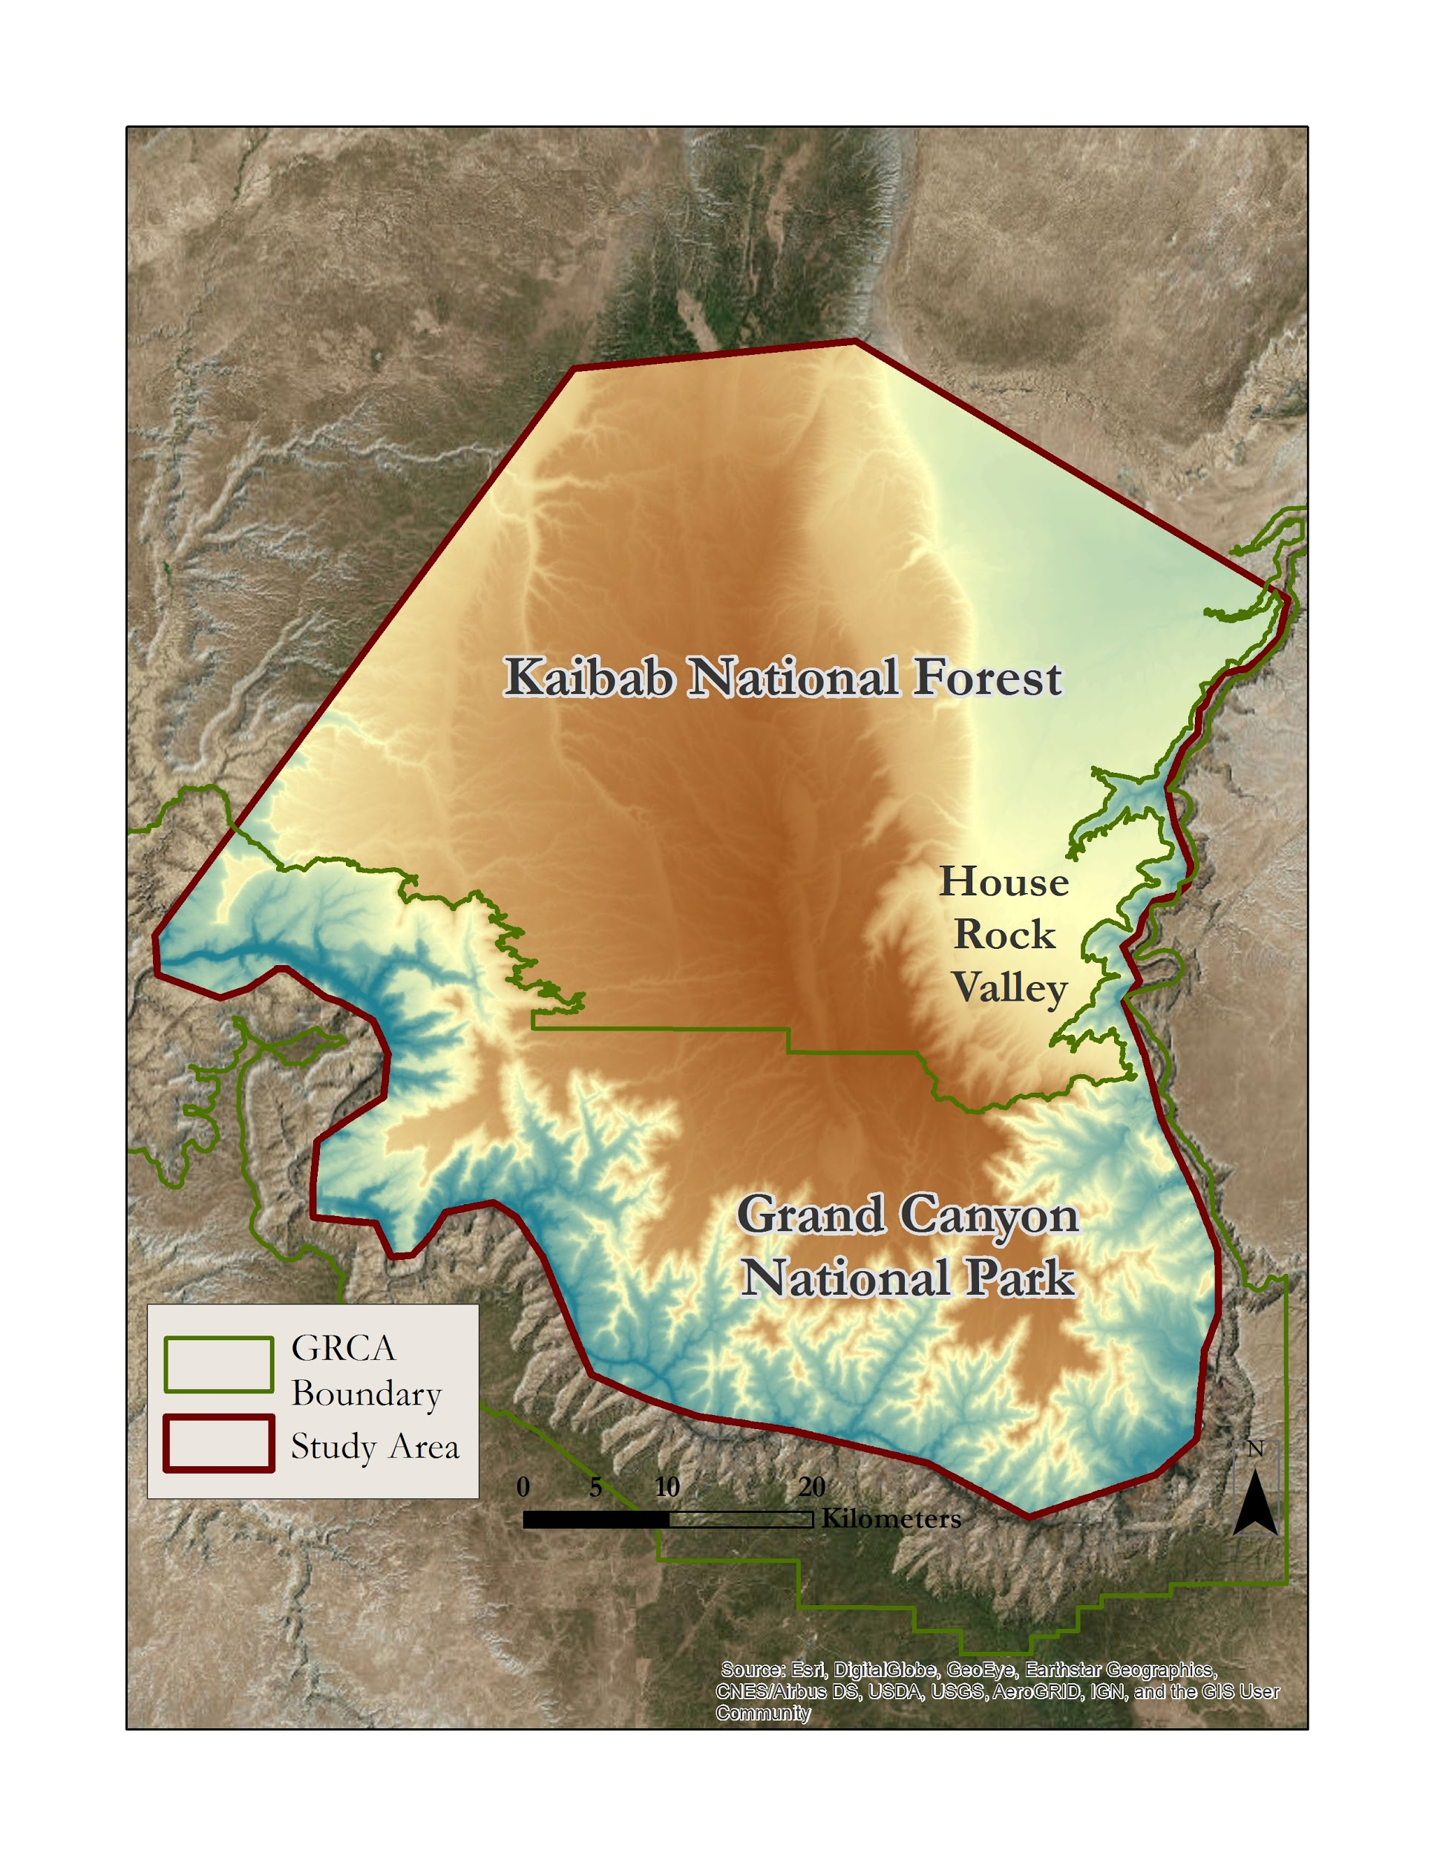
Figure 1. Geographic extent of the House Rock bison herd including House Rock Valley Wildlife Area, Kaibab National Forest and the North Rim of Grand Canyon National Park. Source: Original figure.

The Kaibab limestone is a porous formation of Permian age that covers the plateau, preventing precipitation runoff. Thus, the region is semiarid, receiving approximately 75 cm of precipitation per year with the southern portion of the plateau containing no permanent streams (Rasmussen, 1941). The bison rely on the small springs and ponds in the region for their main water sources (K. Schoenecker, personal communication, June 18, 2018). Within this semiarid region, water sources may be several miles apart (Rasmussen, 1941). Since forage quality is limited by access to available water sources, it is imperative to identify these sources in order to understand herd distribution across the landscape (Nippert et al., 2013). Knowing the severity and distribution of bison impacts will facilitate species management and ecological restoration efforts within the park.

Despite their significant influence, the bison herd is nonnative to the area. In the early 1900s, a private rancher introduced these bison to the HRVWA (National Park Service & Grand Canyon National Park, 2017). In 1926, the herd was sold to the State of Arizona to be managed by the Arizona Game and Fish Department for wildlife viewing and sport-hunting (Huffer, 2013). By the mid-1990s, the herd began to seasonally translocate southwest toward NPS land in GRCA (National Park Service & Grand Canyon National Park, 2017). This migration was driven both by hunting as well as by management practices by state agencies and the USFS (K. Schoenecker, personal communication, June 18, 2018). From 2008 onward, the bison have remained almost solely on NPS land on the southern part of the plateau, trampling and overgrazing the sensitive ecosystem (K. Schoenecker, personal communication, June 18, 2018). Managing bison populations within the park has proved to be problematic, as hunting is prohibited by the NPS and no natural bison predators reside in the region (K. Schoenecker, personal communication, June 18, 2018).

  - Project Partners & Objectives
The NPS within GRCA and the USGS are interested in monitoring and quantifying the impacts of the growing bison herd on the semi-arid meadows and water resources. The maps generated by this study provide detailed analysis of changes and disturbance that have occurred in non-forested areas. The resulting final map combined bison movement corridors and landscape changes to indicate regions where bison may be impacting the landscape.

We aimed to increase the information available for managing the park by (1) quantifying the magnitude of change in land cover after increased bison activity using NASA Earth observations, (2) identifying the point in time when significant impacts occurred to vegetation and water resources, (3) modeling bison distribution to compare between herd movement corridors and the impacted vegetation or water resources, and (4) generating maps that will allow management to assess the magnitude and timing of landscape disturbance surrounding known bison locations.

3. Methodology
Table 1. Satellites and Imagery
Platform & Sensor | Parameter(s) | Use
Landsat 5 TM | Surface reflectance, normalized difference vegetation index, normalized difference water index | This dataset provided a 30 m spatial resolution and 16 day temporal resolution necessary to create a Landsat time series analysis. This was used to analyze changes in vegetation health and water resources in GRCA related to increased bison activity.
Landsat 7 ETM+ | Surface reflectance, normalized difference vegetation index, normalized difference water index | This dataset provided a 30 m spatial resolution and 16 day temporal resolution necessary to create a Landsat time series analysis. This was used to analyze changes in vegetation health and water resources in GRCA related to increased bison activity.
Landsat 8 OLI | Surface reflectance, normalized difference vegetation index, normalized difference water index | This dataset provided a 30 m spatial resolution and 16 day temporal resolution necessary to create a Landsat time series analysis. This was used to analyze changes in vegetation health and water resources in GRCA related to increased bison activity.
Sentinel-2 MSI | TOA, normalized difference vegetation index, normalized difference water index, normalized difference moisture index, normalized burn ratio | This dataset provided a 20 m spatial resolution and 5 day temporal resolution necessary to discern land cover type. This was used to devise a percent of bare ground cover map for GRCA.
SRTM | Elevation, slope, aspect | This dataset was used to delineate high elevation bison habitat.

The team employed NASA Earth observations from Shuttle Radar Topography Mission (SRTM), Landsat 5 Thematic Mapper (TM), Landsat 7 Enhanced Thematic Mapper+ (ETM+), Landsat 8 Operational Land Imager (OLI), and Sentinel-2 Multi-Spectral Instrument to assess the changes in vegetation and water resources from 1984 – 2017 (Table 1). In order to accurately assess areas where bison potentially create wallows, we created a supervised classification to discriminate areas of forest, meadow, bare ground, and water. The area of study was incorporated into the Google Earth Engine (GEE) interface to create a Landsat time series analysis using the LandTrendr algorithm (Kennedy et al., 2018; Kennedy et al., 2010; Cohen et al., 2010).
3.1 Data Acquisition
We processed the Landsat Surface Reflectance Tier 1 datasets from Landsat 5 TM, Landsat 7 ETM+, and Landsat 8 OLI using the LandTrendr algorithm in the GEE interface. Imagery was selected for Path 37 Row 35 between July 1st and August 1st for each year between 1984 and 2017. These images provided annual spectral information to analyze trends and changes within the vegetation and water resources.

We retrieved cloud-free Landsat imagery through Earth Explorer (https://earthexplorer.usgs.gov/) from June 29th, 2017 to create a current supervised classification of land cover. The SRTM elevation dataset version 3 at 30 m resolution was also imported into the GEE interface. The southern boundary of the region of interest was restricted to not include elevations below 1,500 m on the Kaibab Plateau and in GRCA due to a lack of bison presence in steeper, lower elevation areas of GRCA. The northern boundary was defined to include the KNF and HRVWA.

Sentinel-2 MSI Level-1C data containing 13 UINT16 spectral bands representing TOA reflectance were used to create spectral indices necessary to devise a percentage of bare ground coverage map (Table A1). The finer spatial resolution of Sentinel-2 MSI improved the methods of locating potential bison wallows, which typically consist of a sub-pixel area. The NPS provided bison collar data from 2005, 2007, 2017, and 2018. GPS collars were placed on four individuals in 2005, four individuals in 2007, and then nine collars from 2017 which recorded data through April 2018. Signals were returned twice per day. The NPS also provided the locations of 23 water resources within the park.

3.2 Land Cover Classification
3.2.1 Supervised Classification
The team used the Landsat scenes from Path 37 Row 35 in 1984 and 2017 from USGS Earth Explorer to focus the analysis on our area of interest. The spectral bands were composited into a single raster and used to perform an interactive supervised classification using ESRI ArcMap’s Image Classification toolbar. The study area was refined to the meadows, forest, water, and bare ground classes derived from the resulting supervised classification (Table 2). Forested areas were removed from the area of interest because changes to ground vegetation are difficult to detect through dense canopy. Furthermore, the forested region is beyond the areas of our partner’s interest. Therefore, non-forested areas were isolated from the study area as the primary focus of our analysis. Data on existing water sources provided by the NPS were subsequently used to further delineate areas of interest related to water resources.

Table 2. Pixel counts of the four land cover classes used in training and final supervised classification.
Land Cover Type | Bare ground | Meadows | Forest | Water
Pixel Count in Training Data | 2,177 | 2,154 | 2,191 | 1,678
Pixel Count in Classification | 1,653,176 | 1,649,001 | 1,160,200 | 14,154

3.2.2 Opportunistic Sampling
A typical wallow created by bison is significantly smaller in area than a 30 m × 30 m Landsat pixel. In order to predict the presence or absence of bare ground at a finer scale, we performed opportunistic sampling in GEE on a Sentinel-2 MSI pixel grid (20 m × 20 m) to assess percent cover of each of the four classes. This process was guided by additional spatial data related to land cover, water resources, and the bison collar data. The grid was overlaid on NAIP imagery in Google Earth Engine. We used false color imagery to select specific Sentinel-2 MSI pixels that contained 90% or more of a particular land cover type to generate 1,000 sample points. Additionally, we generated 204 points with a mixed percentage of bare ground. Pixels selected for the partial-bare ground class were notated with an approximate percent ratio for bare ground and the remaining land cover type.

3.2.3 Random Forest
We generated spectral indices using Sentinel-2 MSI cloud-free imagery from 2017. We also used the values of the following Sentinel-2 MSI and SRTM parameters and indices that were extracted at each sampled point: aspect elevation, Normalized Burn Ratio (NBR), NDMI, Normalized Difference Vegetation Index (NDVI), Normalized Difference Water Index (NDWI), Soil Adjusted Vegetation Index (SAVI), SinAspect (Eastness), and slope. These indices were selected based on their established capability of highlighting topographic variation, water, vegetation, and bare ground, according to previous literature (Purevdorj et al., 1998). This information was exported and brought into RStudio to generate a random forest model (Breiman, 2001). We utilized the RStudio package, rfUtilities (2.1.2), to assess variable importance and remove covariates. After testing combinations of predictors and removing covariates, we selected our two top models. These variables were recorded and transferred to GEE. Using random forest in GEE, we generated two maps of percent bare ground for 2017: one with each of the top models.

To focus our analysis on the non-forested areas, we incorporated our initial supervised classification map into our percent cover of bare ground map generated by the random forest model. We used the supervised classification to mask out forested areas, leaving us with a percent cover of bare ground map within non-forested areas only.

3.3 Disturbance Analysis
LandTrendr is a recent addition to GEE that requires a mere fraction of the processing time required by other methods used for time series analysis (Kennedy et al., 2018). The translation of the GEE LandTrendr platform from its initial IDL-based code has streamlined its workflow due to GEE’s free access, broad user base, full access to the Landsat archive, straightforward management of time-series stacks, and ease of parallel processing to speed computation (Kennedy et al., 2018). Developed by Robert Kennedy, Zhiqiang Yang, and Justin Braaten in the Laboratory for Applications of Remote Sensing in Ecology at Oregon State University and the USDA Forest Service’s Pacific Northwest Research Station, it uses Landsat time-series stacks to capture short-duration events as well as smooth long-duration events (Kennedy et al., 2010). The software uses an algorithm to discriminate temporal trends from noise, identifying changes within every pixel. Sources of noise include changes in illumination, phenology, atmospheric condition and geometric registration (Kennedy et al., 2010). LandTrendr identifies landscape changes in a spectral index by quantifying the magnitude and timing of disturbance for each index.

LandTrendr begins by creating annual, cloud-free composites (see Figure B1 for LandTrendr workflow). We selected all available imagery between July 1st and August 1st to highlight vegetation just past the peak green-up. These dates were used to avoid comparing the peak greenness at the wettest point (removing June) in the season in order to compare more typical vegetation growth of the region. A cloud mask was applied to each image, and the median value of each pixel was taken from the given year. This was performed for each year between 1984 and 2017. Next, LandTrendr temporally segments and fits trends on a pixel by pixel basis across time, which helps to normalize drought and environmental anomalies. The user sets the LandTrendr parameters prior to running the algorithm, and the parameters we used are listed in Table 3. Parameters were selected and tailored to our region and timeframe of interest. Lastly, we mapped disturbance across the region. Specifically, we utilized the “greatest” disturbance mapping function in LandTrendr. Disturbance mapping requires setting a pre-value of the index used, a value that represents a single year disturbance, a value that represents a 20-year disturbance, and a minimum mapping unit (Table 3).

Table 3. LandTrendr and disturbance mapping parameters used for NDVI and NDMI.
LandTrendr Parameter | NDVI | NDMI | Disturbance Mapping Parameter | NDVI | NDMI
Max Segments | 6 | 6 | 1 Year Disturbance | 0.05 | 0.03
Spike Threshold | 0.75 | 0.75 | 20 Year Disturbance | 0.10 | 0.02
Vertex Count Overshoot | 3 | 3 | Prevalue  (min value of index to be considered) | 0.15 | 0.10
Prevent One Year Recovery | true | true
Recovery Threshold | 0.3 | 0.25 | Minimum Mapping Unit (mmu) | 2 | 5
P-value Threshold | 0.1 | 0.1 | Max Magnitude of Disturbance | 400 | 300
Best Model Proportion | 0.75 | 0.75 | Years of Disturbance Removed  (in post processing) | 1985, 2004 | 1985, 2000, 2004
Min Observations Needed | 6 | 6

3.3.1 Disturbances across the Full Region of Interest
We processed the LandTrendr disturbance outputs for each index across the full study area using the “greatest” disturbance mapping function. However, attributing disturbance requires more detailed knowledge of the landscape, which the NPS is better suited to carry out at the finer spatial scale associated with bison impacts. The process of classifying disturbance can be done through algorithms as well, but with less precision. To more accurately examine lower magnitude disturbances within areas bison have frequently visited, we selected a few primary areas of disturbance activity for further analysis.

3.3.2 Case Studies
In order to take a closer look at possible impacts from bison, three smaller regions were selected. To assess changes in water resources, we focused on the areas within 400m radius buffers around the twenty-three water resource locations provided by the NPS. In order to investigate changes and vegetation, we observed one meadow within a known burn extent and one meadow outside known burn extents. The locations of the 23 water resources and two meadows can be seen in Figure 2.
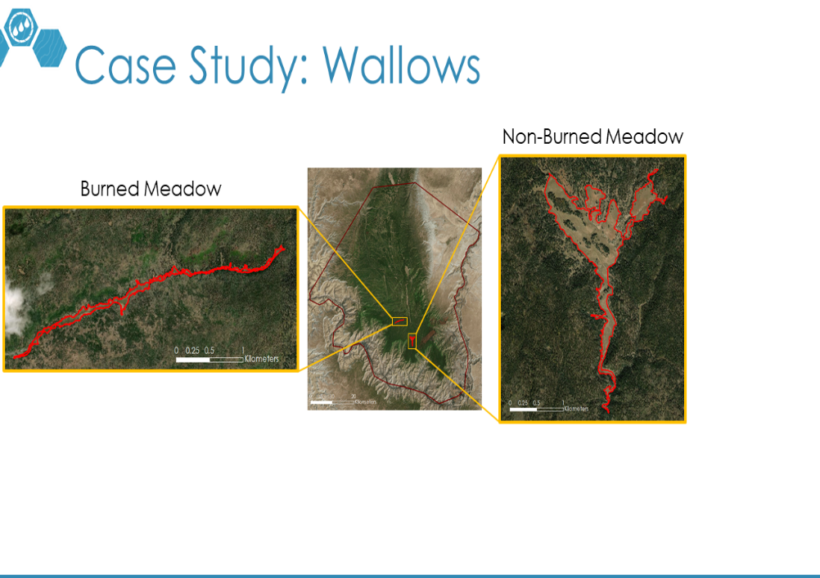
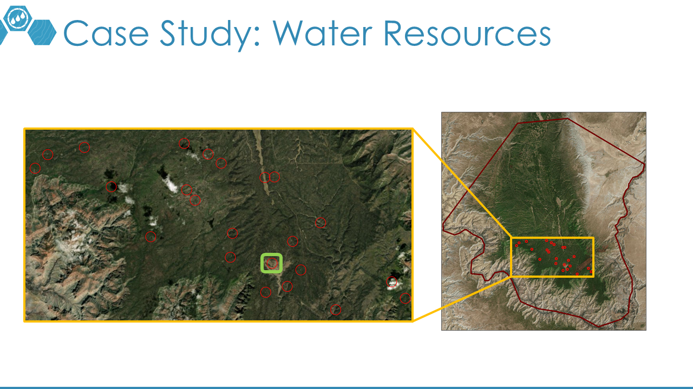
Figure 2. Sub-regions of interest used in case studies. Water resource (top) and the two meadows (bottom left, bottom right) where disturbances were further investigated.

For detecting changes in moisture in the extent of the water resource buffers, LandTrendr was set to detect disturbances in NDMI (Table 3). The outputs were thresholded to only show disturbances with a magnitude between 0 and 300 (NDMI * 1000) to remove disturbances related to wildfire. Fires were a concern for the region due to many of the water resources falling within burn extents of previous fires. To distinguish changes in vegetation health within meadow regions, LandTrendr was set to detect disturbances in NDVI (Table 3). The two meadows included in this case study were used to analyze whether or not the occurrence of past fires have had a significant impact on more minute disturbances detected by LandTrendr.

3.3.3 Case Studies Analysis
For post processing and further analysis, we removed 1985 disturbances from NDVI and NDMI due to an incredibly moist year in the region, which registered as multiple disturbances across the landscape. We removed disturbances in 2004 from NDVI and NDMI due to wildfire. For NDMI, we also removed the year 2000 due to wildfire. The 23 water resources include locations both within and outside burn extents; however, only one location outside a burn extent was selected for further analysis. Within the two meadows, six Landsat pixels were chosen in each for further investigation based on aerial imagery in GEE. For each meadow, three points with clear bare ground wallows and three points without such impacts were selected. This was examine the NDVI trends at the pixel level between wallows / non-wallows and burned / non-burned areas.

3.4 Bison Connectivity
Additionally, we used Circuitscape to delineate herd movement corridors from bison collar data. Circuitscape is a software package which models connectivity to predict movement and gene flow among both animal and plant populations. To execute this process, a resistance raster was created based on the environmental conditions at bison collar locations. The inputs for the resistance raster included distance from water sources, slope, slope variability, percent bare ground, land cover type, and elevation. The classes and predictors were outlined via partner communications (Table C1). We extracted values from each of these layers to bison collar points and identified trends in conditions in which bison typically congregate. Based on these trends, greater distance from water and higher slope were identified as providing greatest resistance (Table C1). Because Circuitscape does not tolerate resistance values of zero, categories of least resistance were assigned a resistance value of one. The maximum resistance value was 100, and was only assigned to categories in which bison displayed a strong preference for certain conditions.

Each resistance input was reclassified to its respective resistance value. The inputs were then combined through the addition of resistance values using ESRI ArcMap’s Raster Calculator. Once the resistance layer was created, we drew 10 polygons around clusters of 2017 bison points to identify core areas within the overall dataset of bison points. These clusters were drawn based on individual bison movements. Polygons were chosen because they provided more efficient processing time compared with using the individual bison points (McRae et al., 2008). We converted these polygons to raster since Circuitscape does not accept vector data. Circuitscape was then run in pairwise mode with the resistance layer set as resistance and subgroups set as the focal nodes. We chose pairwise mode because it is best suited to the relatively small number of core areas used in our analysis (McRae et al., 2008). The output was visually analyzed to evaluate output parsimony.

4. Results & Discussion

4.1 Analysis of Land Cover Classification
4.1.1 Supervised Classification
The supervised classification process created a parsimonious output depicting land classes throughout our study area. We used this to delineate where meadow and bare ground regions are, as well as to mask out forest for further analyses (Figure 3). This analysis proved more effective at identifying our four land classes than other methods such as reclassifying USGS NLCD land cover rasters.
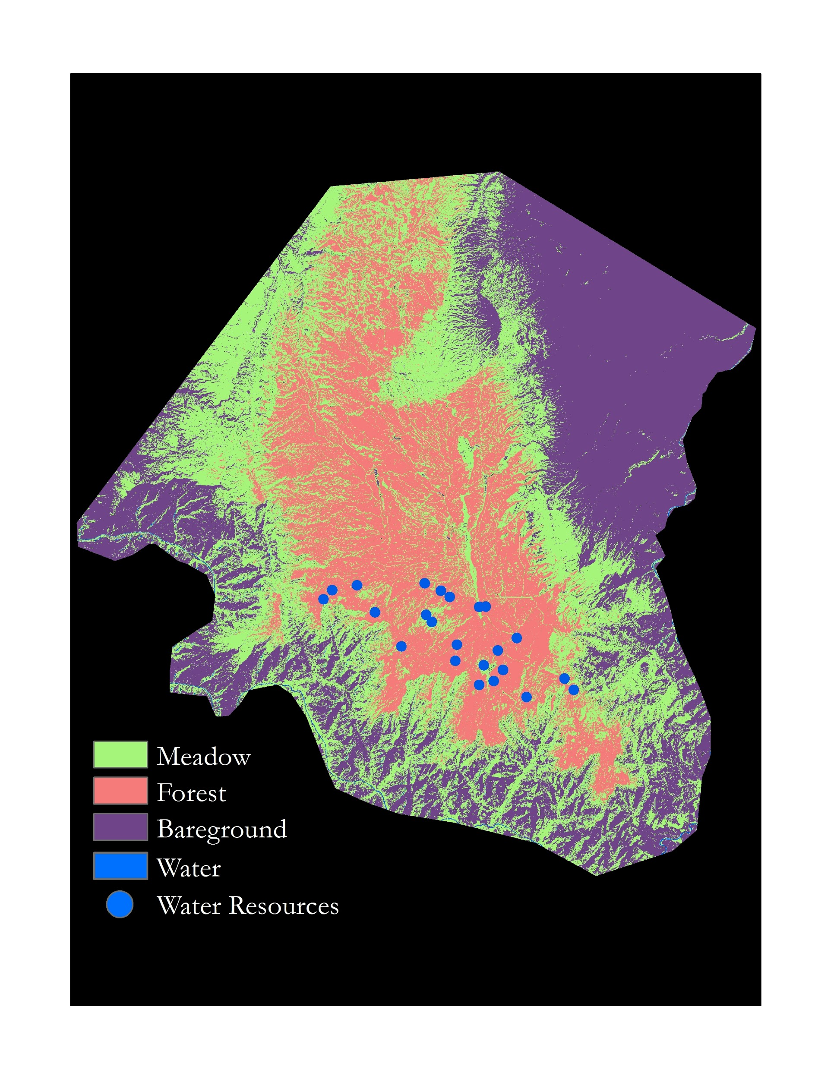
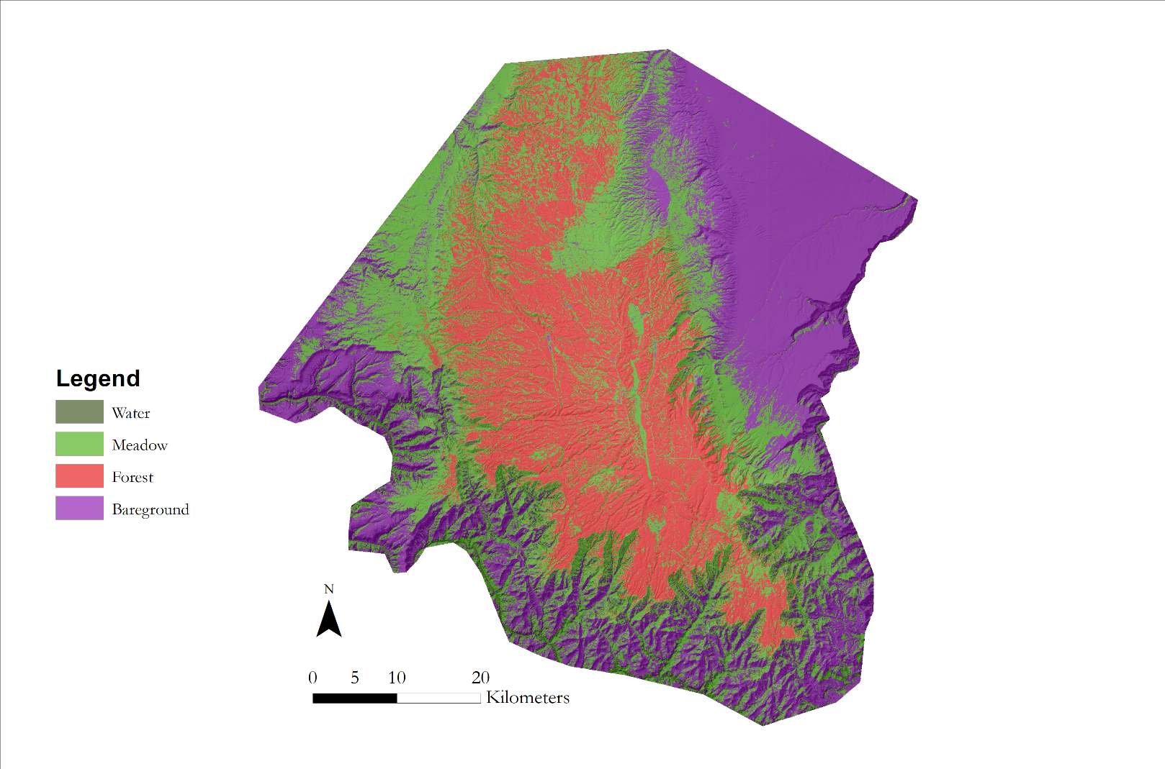
Figure 3. Supervised classification output, where forest (pink) regions were masked from the percent bare ground outputs.

4.1.2 Random Forest and Percent Bare Ground Cover
In decreasing order of importance, the top predictor variables for this model were NBR, slope, NDVI, and SAVI as seen in Figure 4. Despite NDVI having slightly higher variable importance, we selected SAVI as our third top predictor. The model using SAVI performed more accurately on the ground to predict forest and bare ground than the model using NDVI based on visual comparison to basemap imagery in GEE. The model with NDVI was more likely to predict a higher percent of bare ground than reasonable in forested areas. Both NDVI and SAVI had nearly the same variable importance as well as similar correlations with the other variables.

We selected our top predictors of NBR, slope, SAVI, and elevation, and then reproduced this random forest model in GEE to generate a map predicting the percentage of bare ground cover within each Sentinel-2 MSI pixel in our region of interest. For our final map, we masked out forest areas that were delineated by the initial supervised classification (Figure 4). As shown in Figure 5, the variance explained in this percent cover model was 0.9524. This model performed best in areas that were closest to 100% bare ground. This may be attributed to 500 sampled points consisted of more than 90% bare ground, and only 200 points were sampled for intermediate cover of bare ground.

Figure 4. Percent cover of bare ground map generated by the top model with forest areas masked out (green).
21 - 40
41 - 60
81 - 100
0 - 20
61 - 80

4.2 Analysis of Disturbance
4.2.1 Disturbances Detected Across the Region of Interest
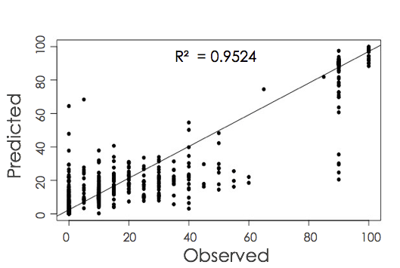
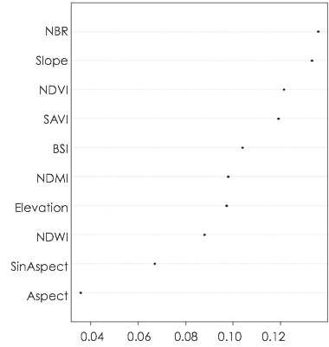
Figure 5. Variable importance ranking (left) for each predictor variable from Sentinel-2 MSI and SRTM indices generated to predict percent cover of bare ground. Predicted vs. observed (right) values from the top model used to create a map of percent cover of bare ground in 2017.

The LandTrendr output detected a variety of disturbances within the region of interest when using the “greatest” disturbance mapping parameter. Many of these disturbances were difficult to attribute to any one cause, and would require ground-truthing and historical knowledge of the landscape to validate these findings. The detected disturbances provide a base for understanding the general trends within the region of interest.

Within the non-forested regions, many of the disturbances occurred within fire burn extents. Due to the overwhelming high-magnitude disturbances of fires, we considered masking out fire extents to minimize noise on the landscape. However, by masking out fire, we discovered many areas containing known bison locations would have been eliminated from the analysis, potentially removing areas with bison disturbance (Figure D1). We concluded that the most effective method of identifying lower-magnitude, potential bison impacts was through manual identification of regions with known bison activity. Our defined areas allowed us to establish baseline trends in each index across the landscape (Figure F1, Figure F2), which provided the framework to analyze individual pixels with potential bison impacts.

4.2.2 Case Studies
We narrowed our study to three different regions: buffers around the 23 resources, a burned meadow, and a non-burned meadow (Figure 2). Using a historical disturbance output of NDMI for the water resource buffers and NDVI for the two meadows, we calculated the total number of acres that were marked by LandTrendr as disturbed in each year (Figure 6). There is no clear trend in area of land disturbed for any of the three regions and no clear difference between the three time periods noted: Pre-Migration (1985-1995), Migration (1996-2008), and Post-Migration (2009-2017). The clear difference in magnitude of acres disturbed for the burned meadow compared to the other two regions is likely attributable to its area, which is much smaller.
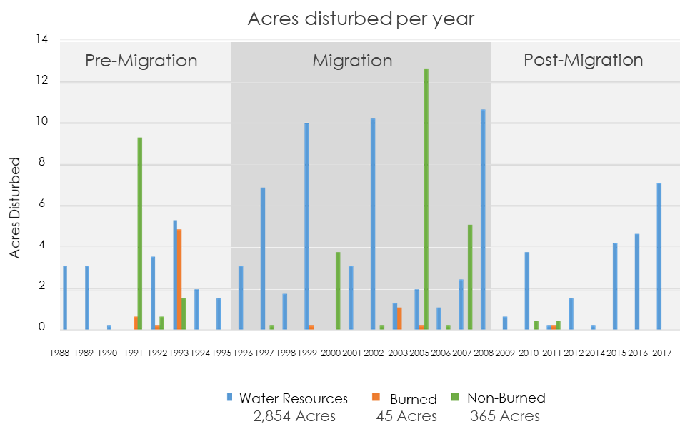

Figure 6. Acres of land disturbed within water resource buffers, the burned meadow, and the non-burned meadow for each year in the time series. The total area considered is listed below each region.

4.2.3 Water Resources
We chose to further investigate one of the 23 water resources to relate our findings back to the needs of our partners. For this additional analysis, we utilized a current disturbance output, which was generated during post-processing of the historical LandTrendr output to include only disturbances that have not recovered by 2018, focusing on the year of detection and magnitude (Figure H1, Figure H2).

Disturbance surrounding this water resource was thresholded to display primarily low to mid-level magnitude, which was consistent with the magnitude of impacts typical of bison activity (Figure H2). Additionally, all disturbance pixels were detected in 2017, making them more recent disturbances. An interesting aspect of this particular case study is, despite also obtaining bison locations from 2005 and 2007, only the bison locations from 2017 were found in this area, suggesting bison migrated to this meadow in recent years.

After reviewing the water resources case study, we believe that this tool can inform park managers on the ground, provided they have specific area of concern to analyze coupled with historical knowledge of the landscape. By establishing a severity of disturbance, a time of detection, and referencing bison activity, park managers can use this methodology to explore historical and current disturbance trends to isolate areas ideal for restoration.

4.2.4 Burned vs Non-burned Meadows
Using an extension of the LandTrendr algorithm, we were able to attain a pixel-level analysis of NDVI trends for two meadows in our region of interest. We compared the general historical and current NDVI trends for one meadow within a burn extent and one outside a burn extent. Additionally, we extended this analysis to compare known wallow locations with non-wallow locations.

We chose to analyze the trends for a total of 12 Landsat pixels, with three pixels each representing wallows, three representing non-wallows. This was done for both the burned and non-burned meadows, as NDVI values will vary based on these factors (Figure E1). Figure 7 shows four of these representative pixels and their trends from each of these four categories. The disturbances within both meadows showed a similar trend of a slight decrease in NDVI over time. We also found that within the burned meadow, there were no current disturbances taking place, suggesting either 1) this meadow has recovered from all disturbances in the past, or 2) LandTrendr is not detecting additional disturbances after a fire has taken place. However, LandTrendr did detect current disturbances within the non-burned meadow.

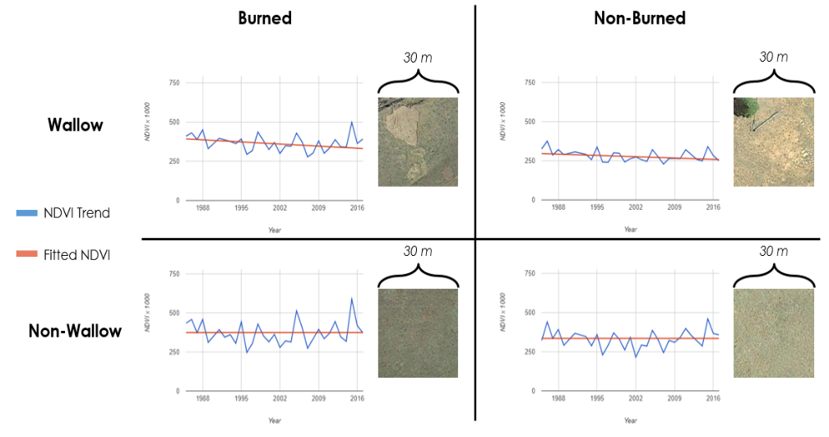
Figure 7. Raw and fitted trends of NDVI (* 1000) between 1984 and 2017 in a wallow and non-wallow within the burned and non-burn meadow case study.

Wallow and non-wallow points within the burned meadow tended to show higher NDVI values both in 1984 and in 2017 compared with those in non-burned areas (Figure 8, Figure E1). A significantly greater difference was found between 1984 and 2017 for the points in the burned meadow, particularly for the wallow points. Two of the three wallow points displayed a magnitude of NDVI (* 1000) loss greater than 130, while the third point saw a loss of 60. The non-wallow points within burned meadow showed minimal change of less than 30, with one point displaying no change at all.
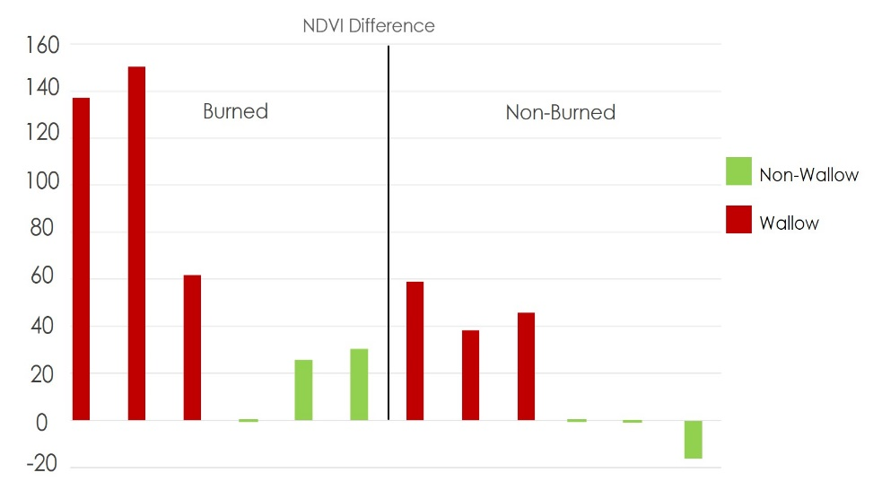

Figure 8. Difference in NDVI (* 1000) values between 1984 and 2017 for 12 selected pixels. Three non-wallow and three wallow pixels were selected for each the burned and non-burned meadow.

Within the non-burned meadow, the differences in NDVI values from 1984 - 2017 were significantly lower. The magnitude of NDVI loss for wallows were no more than 60, while two of the non-wallows showed no change and the third showed a slight recovery. Overall, the wallow points in both meadows have shown a general loss in NDVI for this timeframe, while non-wallow points have remained relatively consistent. While this sample size is very small, this trend warrants further investigation.

We created a median composite for all pixels within both meadows to observe baseline trends in NDVI throughout the whole meadow (Figure F1, Figure F2). The burned meadow experienced a slight decrease from 1984 to approximately 2003, followed by a steep decrease and steady recovery. The steady decline before 2003 is unrelated to fire, as there are a series of small fluctuations in NDVI health. The steep decrease seems to align with a fire that came through this area in 2003. The non-burned meadow has experience a slight increase since 1984, with minor fluctuations in NDVI. It is important to remember that these baseline trends are a median composite of all pixels within these meadows, and does not isolate localized disturbances.

To provide more current information for the NPS, we additionally generated current disturbances within the meadow regions. We overlaid the percent bare ground map (Figure 5) with our current disturbances in the non-burned meadow. Using this information, we generated a histogram showing the percentage of bare ground cover in currently disturbed pixels (Figure G1). The NPS may able to use the map of percent cover of bare ground to focus their efforts within meadow regions where bare ground cover falls within the 5 to 30% range. In contrast, the historical disturbance is shown in Appendix I (Figure I1, Figure I2). This information may be useful to monitor recovery of the vegetation and assess the efficacy of management actions.

4.3 Bison Connectivity
The pairwise mode in Circuitscape appeared to create an informative visual of bison connectivity (Figure J1). Highest bison connectivity was heavily concentrated within the park boundary, and the moderately-high level of connectivity between the subgroups of bison in GRCA and the northeastern-most subgroup in the House Rock Valley region fit with our knowledge of previous bison movements. Areas of highest bison connectivity represent areas that should be most heavily examined for bison-related disturbances in the future.

It is important to note that this output is intended to serve as an example of how Circuitscape can be informative to more effectively study bison-related disturbances (Figure J1). While the map effectively displays how well bison can move from one core area to another, more informed data on where bison subgroups form can lead to more informed core area polygons, which will mean the connectivity output is also more useful to focusing disturbance analysis (McRae et al., 2012). If more collars are placed on bison in the future, this tool can become more informative of the entire population in opposition to the few individuals currently represented. Overall, this connectivity map has the potential to provide greater insight for park managers to prioritize efforts on the ground in the locations where bison are causing disturbances in vegetation and water resources.

4.4 Future Work
This methodology may be useful to monitor bison impacts at other national parks. These methods may also provide a framework to monitor ecosystem impacts of other large mammals and ungulates. These methods can be adapted to encompass future Landsat imagery to continuously assess ecosystem health or even recovery. To look at more recent disturbances, it may be useful to adapt the framework developed with LandTrendr to work with Sentinel-2 MSI which would provide a finer resolution, closer to the average size of the impacts that were investigated.

The intuitive trends found in the case study of Landsat pixels with and without wallows warrant further investigation and ground-level validation. Using LiDAR data, it may be possible to produce a more informed classification of land cover types and isolate bare ground cover. LandTrendr can extend the utility of time series analyses to assess other environmental conditions like drought indications, insect outbreaks in forests, and urbanization through time (Kennedy et al., 2010). In addition to this, future research on bison impacts in GRCA can apply bison corridor analysis by combining the outputs generated through this study to more accurately target where bison impacts are occurring. Finally, this analysis should be repeated with the “least” disturbance mapping function when the code is available through GEE in order to capture the lower magnitude disturbances.

5. Conclusions
The goal of this project was to quantify both water and vegetation impacts caused by bison on the GRCA North Rim so that management and restoration efforts to sustain the park would be better informed. In particular, our partners at USGS and NPS are looking to calculate when, where, and how much the park has been impacted. Our methodology has provided a framework that can be used to identify disturbances related to both water and vegetation on the landscape, represented by trends through time. The ability to assess trends through time allows the user to not only cross-reference results with known historical ground data, but also to visualize the general health and prospective future of the landscape. With this assessment, it is possible to identify when and the magnitude of disturbance that has occurred in the park.

Water resources are extremely limited within our region of interest, and vegetation is predominately sparse. While these methods cannot describe where disturbance in water resources has taken place, having a location of interest predefined can allow the park managers to assess the magnitude and timing of changes. For continuous monitoring, analyzing the current and historical disturbance within a given area can provide further insight regarding recovery of the system and efficacy of management efforts.

We discovered that many of the registered, high-magnitude disturbances in this region are attributable to mountain pine beetle and wildfire. The key finding derived from our case study analysis on meadows was that NDVI appears to have a greater decline in wallows compared to non-wallows, and in burned areas compared to non-burned areas. These trends make sense ecologically; however, due to the small sample size, they should not be considered conclusive. This analysis does not consider behavioral factors related to bison; bison and other ungulates often migrate into regions post-fire, as greener and more accessible vegetation regenerate (K. Schoenecker, personal communication, June 18, 2018).

Although this analysis has considerable, potential implications, it is not without limitations. Given the size of a typical wallow being only a few meters across, we deduced that identifying wallows within a 30 m × 30 m Landsat pixel does not generate highly accurate results. Higher accuracy may be achieved by quantifying disturbances within known locations of bison impacts.

6. Acknowledgments

- Dr. Paul Evangelista, (Colorado State University, Natural Resource Ecology Laboratory)
- Dr. Catherine Jarnevich, (US Geological Survey)
- Nicholas Young, (Colorado State University, Natural Resource Ecology Laboratory)
- Tony Vorster, (Colorado State University, Natural Resource Ecology Laboratory)
- Brian Woodward, (Colorado State University, Natural Resource Ecology Laboratory)
- Steven Filippelli, (Colorado State University, Natural Resource Ecology Laboratory)
- Dr. Katheryn Schoenecker, (US Geological Survey)

Any opinions, findings, and conclusions or recommendations expressed in this material are those of the author(s) and do not necessarily reflect the views of the National Aeronautics and Space Administration.

This material is based upon work supported by NASA through contract NNL16AA05C and cooperative agreement NNX14AB60A.

7. Glossary

Earth observations – Satellites and sensors that collect information about the Earth’s physical, chemical, and biological systems over space and time
GEE – Google Earth Engine, coding interface for large spatial datasets based in javascript
GPS – Global Positioning System; an electronic system used for determining the geographic position of an entity.
LandTrendr – Landsat time series analysis algorithm first produced by Kennedy, Yang, & Cohen, 2010
NAIP – National Agriculture Imagery Program, 1-meter resolution aerial imagery acquired by the United States Department of Agriculture (USDA)
NBR – Normalized Burn Ratio (Table A1)
NDMI – Normalized Difference Moisture Index (Table A1)
NDVI – Normalized Difference Vegetation Index (Table A1)
NLCD – National Land Cover Dataset, 30-meter resolution land cover database provided by USGS
Mosaic – (mosaicked) merging separate images or rasters into a continuous image or raster
Random Forest – a machine learning algorithm developed by Breiman, 2001
Raster – data format used to store continuous data
TOA – Top of Atmosphere
Trampling – regarding bison, this refers to paths created across the landscape where vegetation is continually disturbed, and soil beneath is exposed. Large herds and repetitive use of a single path increases the amount of soil exposed and inhibits regeneration of vegetation.
Wallow – a depression in the landscape up to a few meters in diameter where ungulates, particularly bison in this case, dust-bathe. This typically destroys the vegetation underneath and continuous use prevents regeneration.
Wallowing – the act of bison rolling on their backs which creates a wallow. This includes dust-bathing in an established wallow.

8. References

Breiman, L., 2001. Random Forests. Machine Learning.. 45, 5–32

Cohen, W. B., Yang, Z., & Kennedy, R. (2010). Detecting trends in forest disturbance and recovery using yearly Landsat time series: 2. TimeSync — Tools for calibration and validation. Remote Sensing of Environment, 114(12), 2911-2924. doi:10.1016/j.rse.2010.07.010

Coopedge, B. R., & Shaw, J. H. (2000). Bisoniana 120. American bison Bison bison wallowing behavior and
wallow formation on tallgrass prairie. Acta Theriologica, 45(1), 103-110.

Huffer, D. J. (2013). A Spatial Analysis and Zooarchaeological Interpretation of Archaeological Bison Remains in the Southwest and the Wildlife Management Implications for the House Rock Valley Bison Herd in Grand Canyon National Park, Arizona. The University of Arizona. Retrieved from http://hdl.handle.net/10150/311670

Joy, S. M., Reich, R. M., & Reynolds, R. T. (2003). A non-parametric, supervised classification of vegetation
types on the Kaibab National Forest using decision trees. Journal of Remote Sensing, 24(9), 1835-1852.
https://doi.org/10.1080/01431160210154948

Kennedy, R. E., Yang, Z., & Cohen, W. B. (2010). Detecting trends in forest disturbance and recovery using
yearly Landsat time series: 1. LandTrendr — Temporal segmentation algorithms. Remote Sensing of Environment, 114(12), 2897-2910. doi:10.1016/j.rse.2010.07.008

Kennedy, R., Yang, Z., Gorelick, N., Braaten, J., Cavalcante, L., Cohen, W., & Healey, S. (2018).
Implementation of the LandTrendr Algorithm on Google Earth Engine. Remote Sensing, 10(5), 691. doi:10.3390/rs10050691

McRae, B. H., Dickson, B. G., Keitt, T. H., & Shah, V. B. (2008). Using circuit theory to model connectivity in ecology, evolution, and conservation. Ecology, 89(10), 2712-2724.

McRae, B. H., Hall, S. A., Beier, P., & Theobald, D. M. (2012). Where to restore ecological connectivity? Detecting barriers and quantifying restoration benefits. PloS one, 7(12), e52604.

Minard, A. (2003). Unwelcome Bison May Face a DNA Test. Science, 299(5614), 1835–1835. https://doi.org/10.1126/science.299.5614.1835

National Park Service, & Grand Canyon National Park. (2017). Finding no significant impact initial bison
herd reduction environmental assessment.

Nippert, J. B., Culbertson, T. S. F., Orozco, G. L., Ocheltree, T. W., & Helliker, B. R. (2013). Identifying the
water sources consumed by bison: Implications for large mammalian grazers worldwide. Ecosphere, 4(2), 1-13. https://doi.org/10.1890/ES12-00359.1

Purevdorj, T. S., Tateishi, R., Ishiyama, T., & Honda, Y. (1998). Relationships between percent vegetation cover and vegetation indices. International Jjournal of Remote Sensing, 19(18), 3519-3535.

Rasmussen, D. I. (1941). Biotic communities of Kaibab Plateau, Arizona. Ecological Monographs, 11(3), 229-
275. doi:10.2307/1943204

Reimondo, E. L. (2012). Ecological impacts and management implications of introduced bison in the grand canyon region (Order No. 1511516). ProQuest Dissertations & Theses Global. (1021049669). Retrieved from https://search.proquest.com/docview/1021049669?accountid=10223

Schoenecker, D. K. A. (2017). Estimating bison population size and distribution on the North Rim of Grand
Canyon National Park and determining resource impacts to guide the herd reduction project. Unpublished manuscript. Department of Ecosystem Science and Sustainability, Colorado State University, Colorado, United States of America.

United States Department of Agriculture Farm Service Agency, National Agriculture Imagery Program
(NAIP) [Image collection]. Retrieved from: https://code.earthengine.google.com/
U.S. Geological Survey Earth Resources Observation And Science Center. (2012). Landsat TM Level-2 Surface Reflectance (SR) Science Product [Data set]. U.S. Geological Survey. https://doi.org/10.5066/f7kd1vz9

U.S. Geological Survey Earth Resources Observation And Science Center. (2012). Landsat ETM+ Level-2
Surface Reflectance (SR) Science Product [Data set]. U.S. Geological Survey. https://doi.org/10.5066/f7q52mnk
US Geological Survey Earth Resources Observation and Science Center. (2014). Provisional Landsat OLI
Surface Reflectance. [Image collection]. Retrieved from https://dx.doi.org/10.5066/F78S4MZJ

This material contains modified Copernicus Sentinel data (2017), processed by ESA.

9. Appendices

Appendix A

Table A1.
Spectral Indices and Random Forest Predictor Variables
Index | Formula | Use
NDVI  Normalized Difference Vegetation Index | (NIR-Red)/(NIR+Red) | Used in LandTrendr to analyze disturbances in case-study meadows
NDMI  Normalized Difference Moisture Index | (NIR-MIR)/(NIR+MIR) | Used in LandTrendr to analyze disturbances in 400m buffers around water resources
SAVI  Soil Adjusted Vegetation Index | ((NIR-Red)/(NIR+Red+0.05))*1.05 | Identified by our Random Forest modeling as a top predictor of percent bare ground cover
NBR  Normalized Burn Ratio | (NIR-SWIR)/(NIR+SWIR) | Identified by our Random Forest modeling as a top predictor of percent bare ground cover
Elevation  (meters) | Provided by SRTM Version 3 data | Identified by our random forest model as a top predictor of percent bare ground cover
Slope | Derived from SRTM Version 3 elevation data | Identified by our random forest model as a top predictor of percent bare ground cover

Appendix B

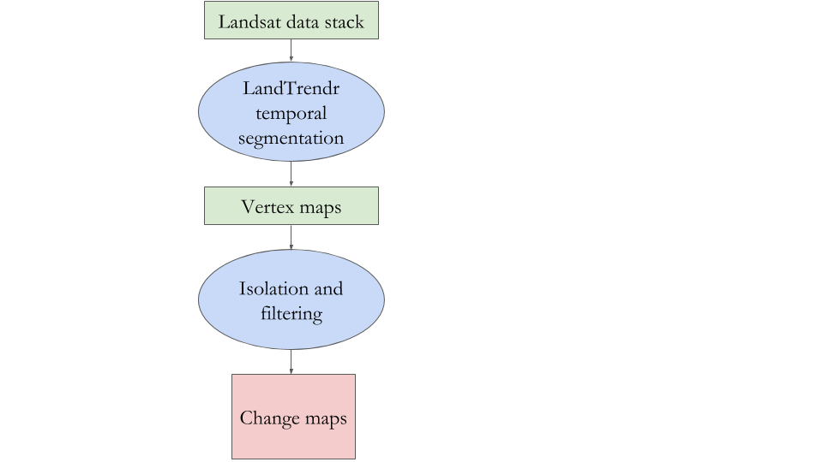
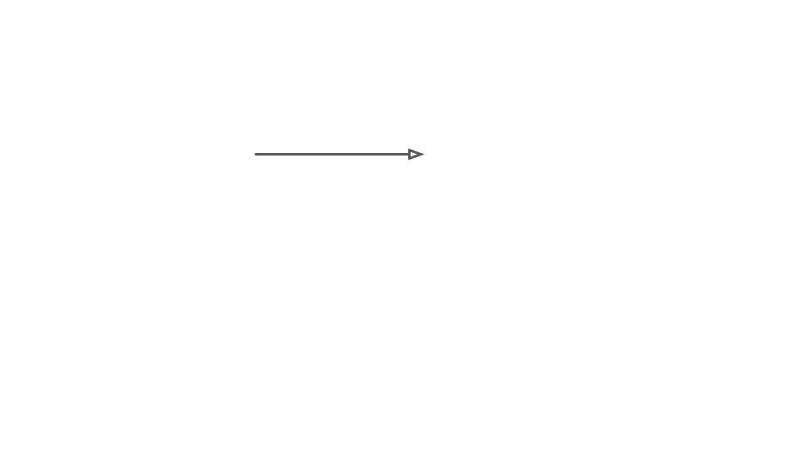
Images are acquired and “cleaned” resulting in the Landsat data stack.
Each pixel’s history is extracted into straight-line segments.

Product of segmentation that includes a set of vertex files that capture the endpoints of the straight-line segments.

Querying process.

Resulting change map.

Figure B1. LandTrendr processing workflow for disturbance outputs.

Appendix C
Table C1:
Circuitscape resistance raster inputs and associated resistance values.
Resistance Input | Category | Degree of Resistance | Resistance Raster Value
Elevation | 2300-2700 m | Least resistance | 1
 | 0-2300, >2700 m | Low resistance | 30
Land Cover Type | Meadow | Least resistance | 1
 | Forest | Low resistance | 25
 | Bare Ground, Water | Moderate resistance | 50
Slope | 0-5 | Least resistance | 1
 | 5-15 | Low resistance | 20
 | >15 | High resistance | 100
Slope Variability | 0-15 | Least resistance | 1
 | 15-30 | Moderate resistance | 40
 | >30 | High resistance | 90
Percent Bare Ground | 0-15 | Least resistance | 1
 | 15-100 | Moderate resistance | 60
Distance from Water | 0-1000 m | Least resistance | 1
 | 1000-2000 m | Low resistance | 20
 | >2000 m | High resistance | 100

Appendix D

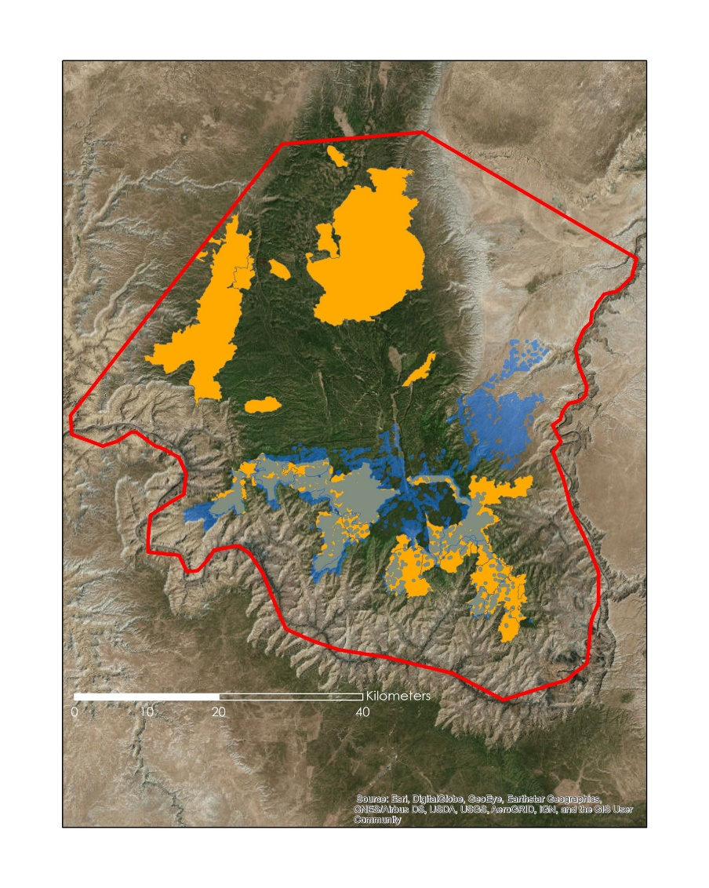
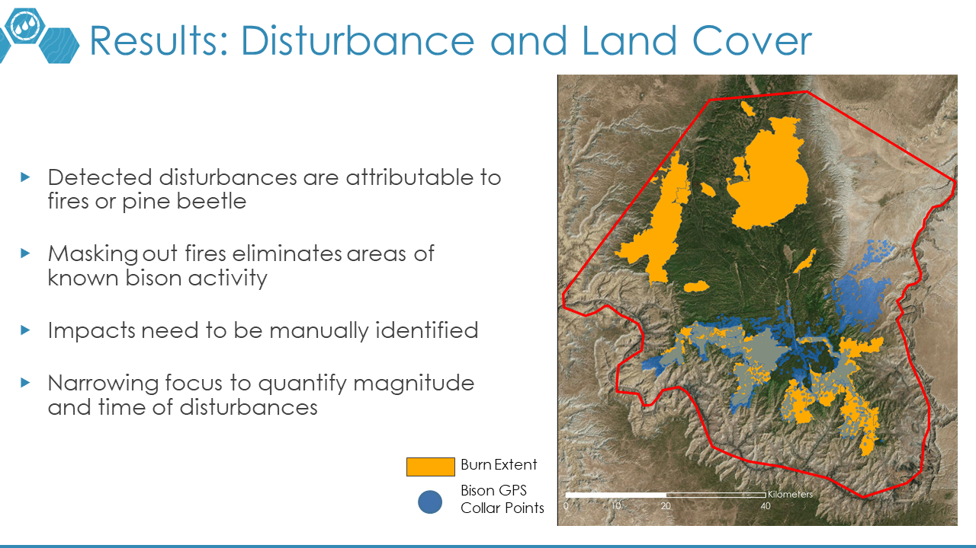
Figure D1: Bison GPS collar points overlaid with transparency over the burn extent of all fires that have occurred since 1984 within Kaibab National Forest.

Appendix E

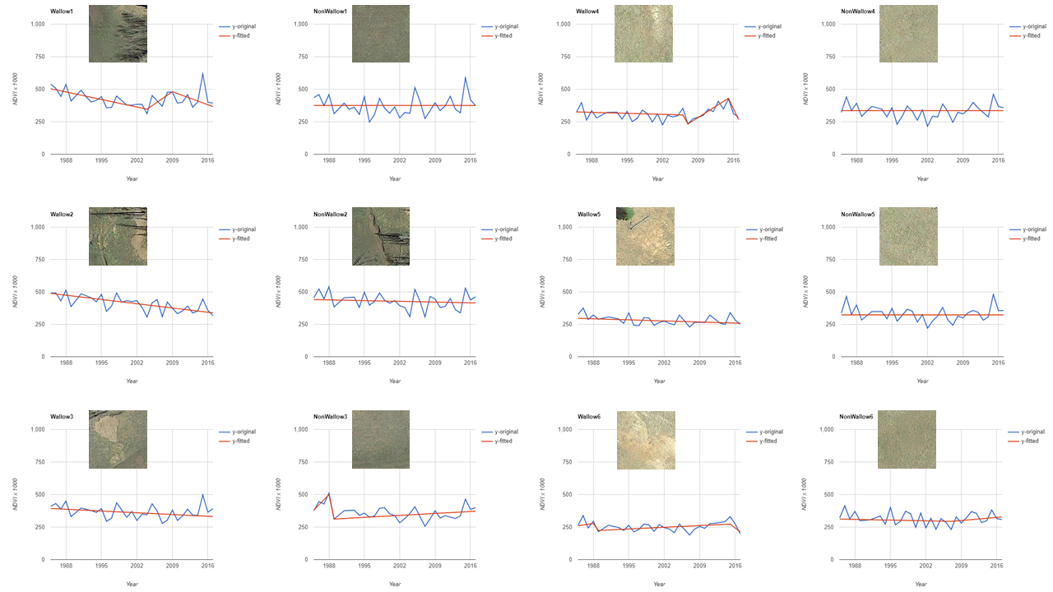
Figure E1: NDVI trends for all 12 points in burned and non-burned meadow case studies

Appendix F

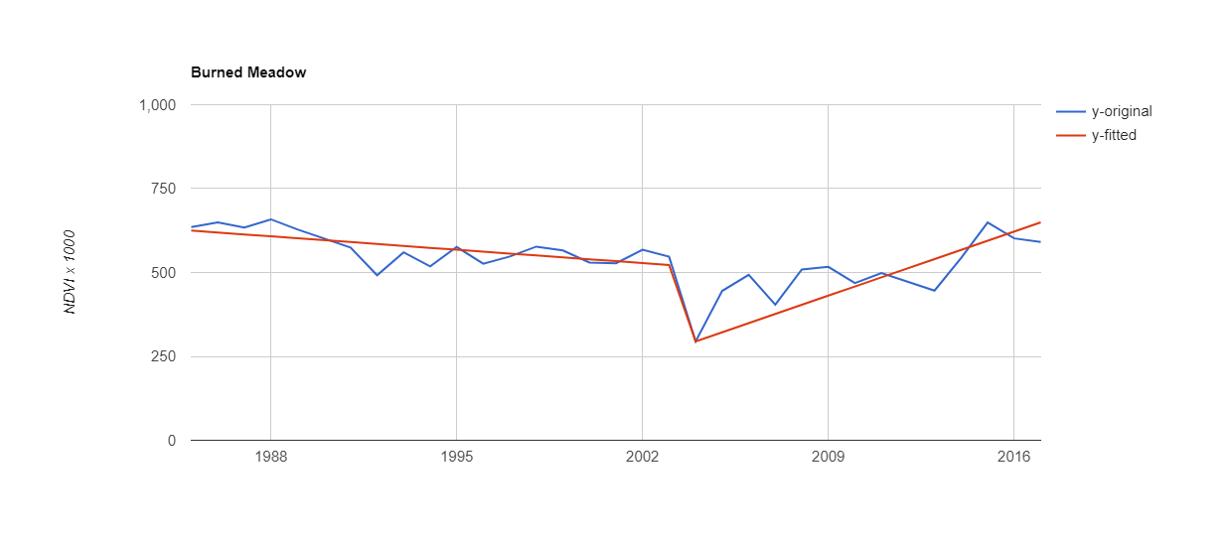
Figure F1: Baseline median NDVI trend for the burned meadow case study

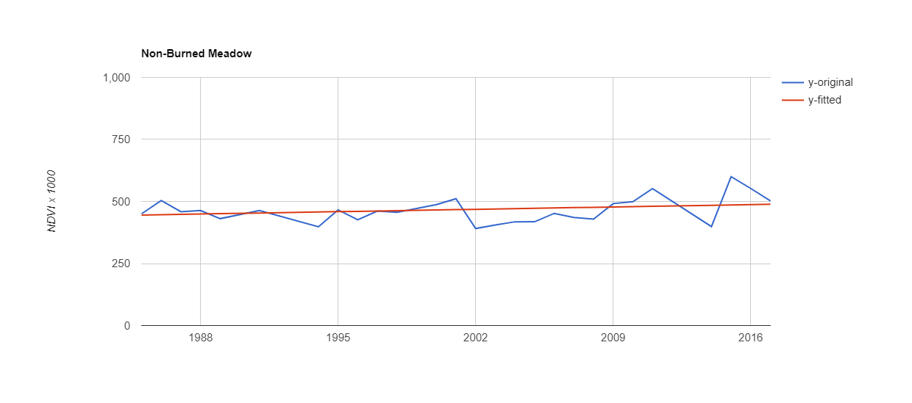
Figure F2: Baseline NDVI trend for the non-burned meadow case study

Appendix G

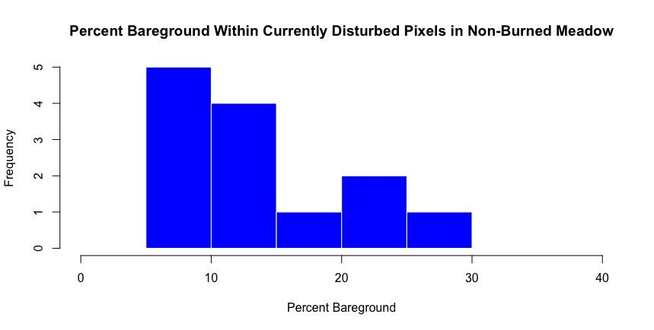
Figure G1: Histogram showing the percent bare ground classification of currently disturbed pixels in the non-burned meadow from the case study.

Percent Bare Ground
Frequency

Appendix H:
Recent disturbance and magnitude of disturbance within the water resource used in the case study.

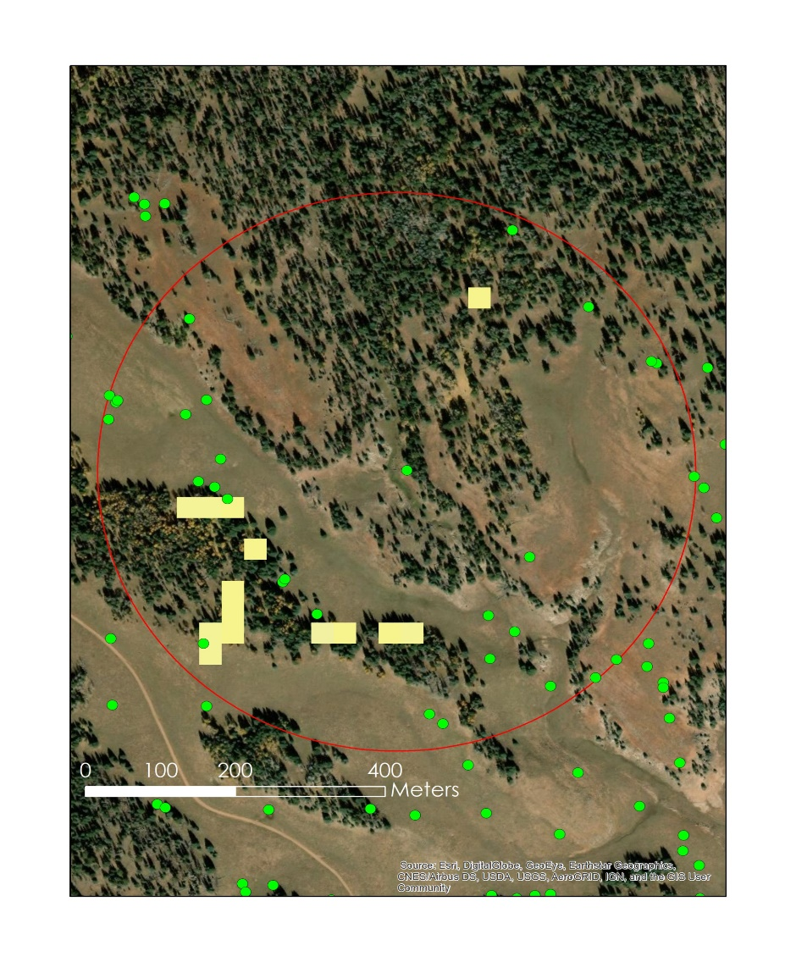
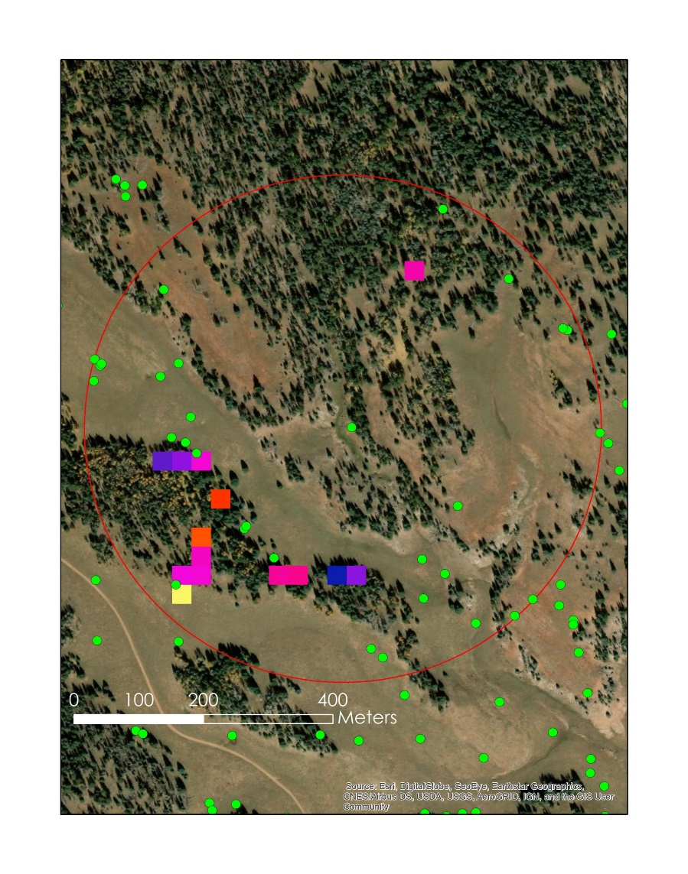
Figure H1: Year of disturbance
Figure H2: Magnitude of disturbance

Appendix I

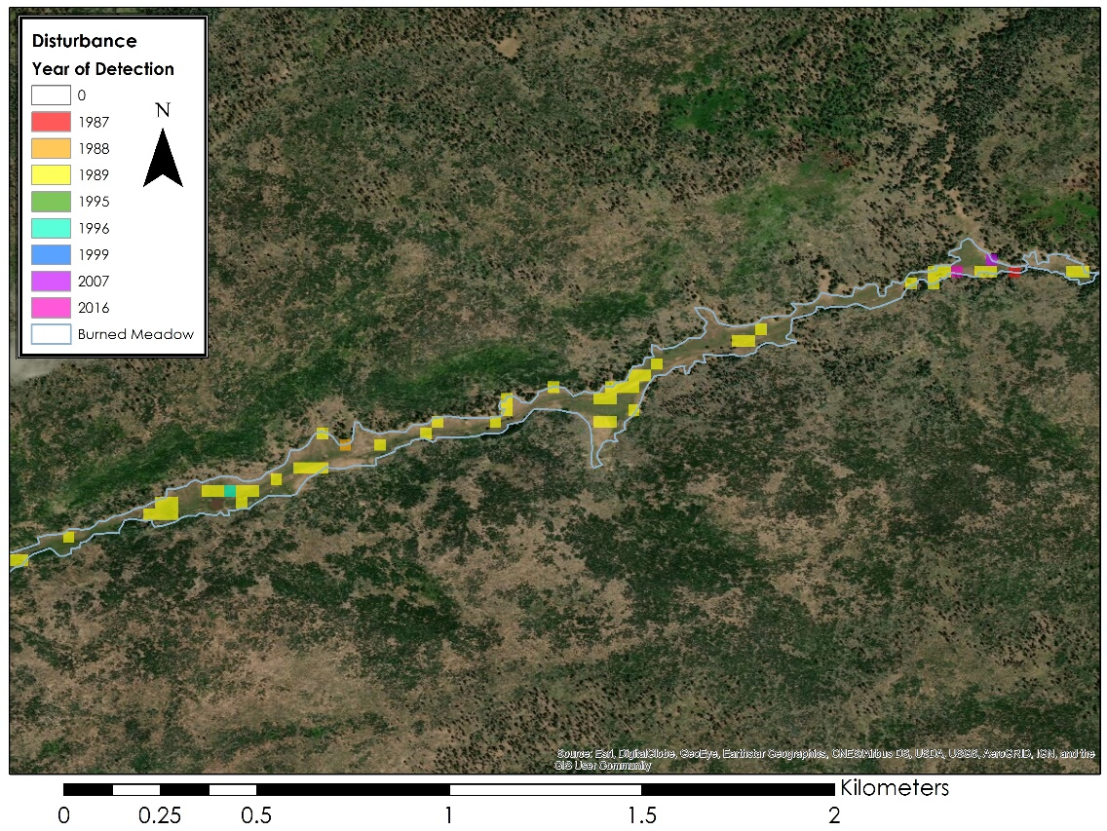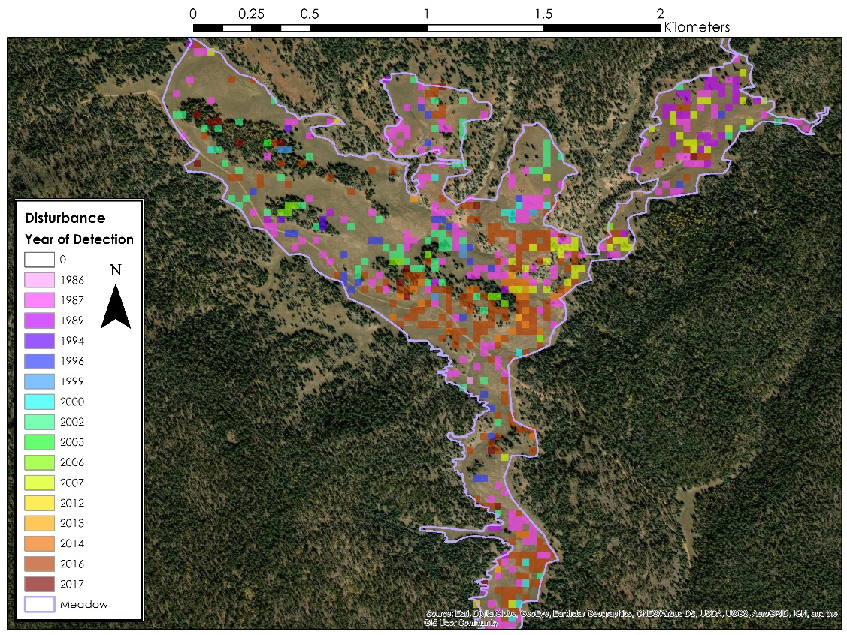

Figure I1: Year of disturbance mapped for all historical disturbances (including those that have recovered in present day) for the burned (top) and Figure I2: non-burned (bottom) meadow case study.

Appendix J.

Circuitscape output

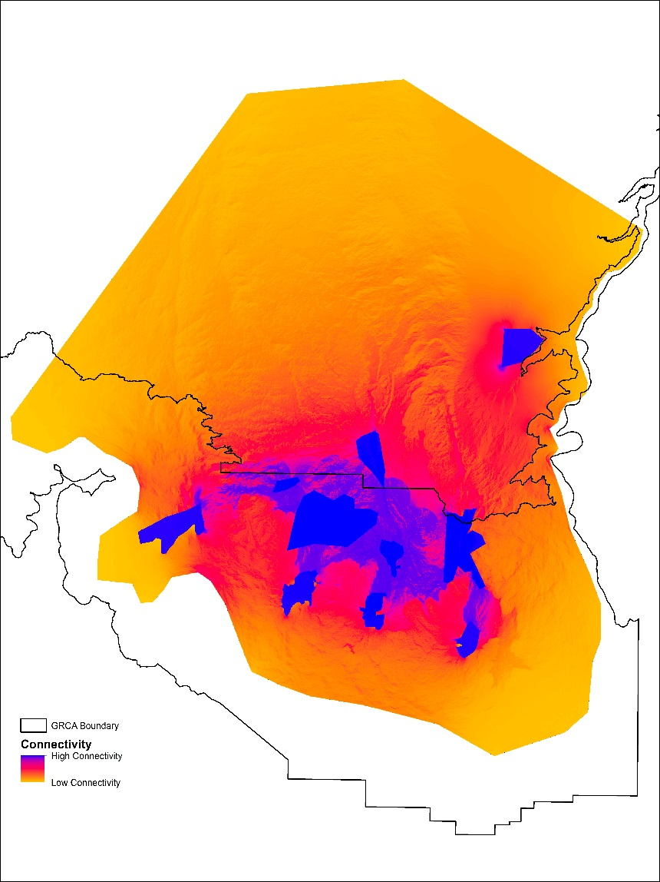
Figure J1: This map displays bison connectivity within Kaibab Plateau. Blue areas represent core areas and areas of highest connectivity. Yellow areas represent areas of least connectivity. The black line is the boundary for Grand Canyon National Park.

